Building engagement through thinking routines
Cultivating confidence and deepening understanding in the languages classroom

Contents
Introduction 3
Benefits of critical thinking 3
Expectations that help shape a culture of thinking 4
Focus on the learning versus the work 4
Teaching for understanding versus knowledge 4
Encourage deep versus surface learning strategies 5
Encourage independence versus dependence 5
Encourage a learning mindset 6
Cultural forces of a thinking classroom 8
Time 8
Language 9
Expectations 10
Relationships 11
Routines 12
Modelling 13
Environment 13
Opportunities 14
Thinking routines 16
See-think-wonder 16
5 whys 17
Question organiser 18
Peel the fruit 19
Jigsaw strategy 20
3-2-1 graphic organiser 21
10 × 2 strategy 22
Lenses 23
Hexagonal thinking 27
References 29

Introduction
This guide is based on the work of Project Zero, an initiative from Harvard University that focuses on creating a culture of thinking in the classroom. You can learn more at the Project Zero website.
We will explore some of the ideas and thinking tools from Project Zero, contextualised for the languages classroom. We will look at ways to make thinking ‘visible’, to deepen student understanding and enable and value contributions from all class members.
Consider: What does a ‘thinking’ languages classroom look like? What sorts of things do we see as evidence that students are thinking about what they are learning and how they are learning? It could be activities, resources, actions or interactions.
Implementing ideas in this guide can quickly change the culture in your classroom as visible thinking routines begin to replace routines regarding behaviour. You may find that classroom management issues decrease as students become more confident, more independent and more engaged learners. Their relationship with you and with each other may also grow as a result.

Benefits of critical thinking
Critical and creative thinking is a capability across NSW syllabuses: ‘The capability … gives students the tools to examine the world they live in, analyse their findings and reach conclusions using evidence’ (NESA 2025).
Critical and creative thinking encourages curiosity and builds skills in observation, reasoning, evaluation, planning and self-reflection. Providing students with the right tools and scaffolds can also foster independence.

Expectations that help shape a culture of thinking
Ron Ritchhart from Project Zero explains 5 expectations that help shape a culture of thinking.

Focus on the learning versus the work
The metaphor of work – learning as work, students as workers and classrooms as workplaces – is entrenched in our ideas of education. These metaphors organise our experiences and create realities. When teachers and students focus their attention on learning as the priority, then work becomes a means to an end, not the end itself.
 In languages, this could look like:
- celebrating learning progress through feedback, both formal and informal
- embedding regular opportunities for student self-reflection, with prompt questions focused on new learning, individual progress and real-world applications
- making communication, not assessment, the focus of learning.

Teaching for understanding versus knowledge
Understanding goes beyond possessing a set of skills or a collection of facts. It requires knowledge to be woven together in a web of connections, allowing us to put ideas to use in unfamiliar situations. This aligns closely with explicit teaching as we actively support students to make connections to prior learning and across knowledge, skills and understanding as well as to prior learning experiences.
In languages, this could look like:
- exploring language through different contexts, for different audiences and across a range of macro skills
- building connections between prior, present and future learning
- students personalising their use of the language and manipulating it to suit their own context.

Encourage deep versus surface learning strategies
Surface strategies focus on memory and knowledge gathering, whereas deep strategies help students develop understanding through making connections and delving deeper into content.
In languages, this could look like:
- using thinking routines for specific tasks, such as see-think-wonder, when analysing a text for understanding
- using learning routines for teaching and learning activities, such as one pen, one dice, for creating texts
- creating exploded sentences by gradually adding extra details to a simple sentence, such as conjunctions, adverbs and adjectives, to make more complex ones.

Encourage independence versus dependence
We want to develop independent learners who are intrinsically motivated to be reflective, resourceful and effective in their learning efforts, even when challenges arise. We want to see students develop the skills to be self-starters and who can persevere and work well both in groups and independently. We sometimes inadvertently foster dependence by ‘rescuing’ students and depriving them of the opportunity to develop initiative and resilience. Ask yourself: ‘Who is doing the thinking in this encounter?’ The answer should always be ‘the students’.
In languages, this could look like:
- modelling a sample response – what a good one looks like (WAGOLL) – for students to discuss and reflect on when creating their own texts
- completing self-reflections and learning journals to identify strengths and goals for language use as well as where students can use the language authentically in their context
- modelling how to find answers and encouraging students to find them themselves by asking questions such as, ‘How could you check that?’ or ‘What resources could help you find that?’
- encouraging students to create and use personalised anchor charts for vocabulary and language structures
- giving student choice in activities and tasks to allow for personalisation and differentiation
- providing scaffolding and templates to help students access the language at their point of need.

Encourage a learning mindset
How we view intelligence, ability and talent often determines how we approach new learning situations. Do we view intelligence as a fixed entity that we are born with or as something that grows and develops over a lifetime through our efforts?
Students who believe ability can improve with effort and strategy are more likely to see challenges as opportunities to learn. Students who believe they are just not good at languages or are just not smart enough tend to give up or be defeated by challenge.
Effective feedback is critical to nurturing a learning mindset. Praise for effort can help develop a learning mindset. A learning classroom is one where mistakes are data, effort is celebrated, and every student sees themselves as capable of improving.
In languages, this could look like:
- reassuring comments such as, ‘There are no mistakes, just learning opportunities’
- sharing stories of your own language learning mistakes and challenges and how you learned from them
- modelling your own vulnerability and how to recover from it, such as forgotten language
- giving feedback that emphasises process and effort, not ability
- setting specific and immediate goals such as using 3 new words this week or asking a question in class
- completing learning reflection journals
- promoting peer support in the classroom instead of comparison
- using learning mindset phrases such as, ‘You're not there yet, but you are getting closer,’ ‘What could you try differently next time?’ and ‘You are building new connections and that takes time.’
Figure 1 (editable version) below can be used to help maintain student confidence and resilience when learning languages by reframing their thinking using learning mindset phrases.
Figure 1 – reframing student thinking using learning mindset phrases
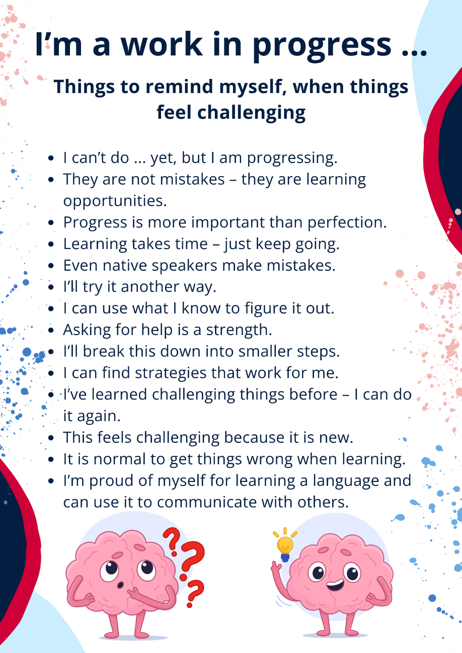

Cultural forces of a thinking classroom
A cultural force is a factor within the classroom environment that shapes students’ collective and individual thinking. Project Zero identifies 8 cultural forces to develop a culture of thinking in the classroom:
- time
- language
- expectations
- relationships
- routines
- modelling
- environment
- opportunities.

Time
Allow your students time to explore ideas and time to respond to questions. Remember to give a second wait time, allowing for students to reflect after a response is given.
To draw attention to thinking time, you could have a signal such as a push button light that shows it is thinking time, then turn it off for response time.
Thinking time is far more important than the number or correctness of responses. It could include brainstorming, discussion, quiet time, feedback (self, teacher and peer) and self-reflection opportunities for setting learning goals.
In languages, this could look like:
- Rather than have quick, one-word answers, give students time to build on their responses. When a student responds, ask others to add to the response. Consider using mini whiteboards or a shared online document or platform, or students could work individually in their books or own documents.
- Ask students to consider a response more deeply or to apply it in other ways, linking the response to other learning or to real-life scenarios. For example, when drilling adjectives with flashcards, ask students to think of synonyms or antonyms, to use it in a sentence or question, or to join it with another adjective using a conjunction or connective. Ask students to write their best sentence using the adjective and share with someone.
- Give students self-reflection time after completing mini-task progress checkpoints to compare their responses to summative task marking guidelines and feedback, connect learning, identify areas they are confident in and set learning goals.

Language
Language in this context means the words you are using, not the language the students are learning (although in an immersion class it could be the same). When we explicitly highlight and name the thinking, ideas and activities that are important in the learning process, we draw students’ attention to these concepts and practices.
In languages, this could look like:
Language of community – through using pronoun choices such as ‘we’, ‘us’ and ‘our’, we can create an inclusive and collaborative classroom for everyone. This gives the sense of ‘everyone is in it together’.
Language of identity – this involves students in the learning rather than being receivers of the information transmitted to them. In the languages classroom, students may be travellers, thinkers, writers, guides, linguists, reviewers, reporters and so on. By seeing themselves in a role, students connect more deeply with the content.
Language of noticing and naming – naming the thinking that students are doing helps students identify, engage in and reflect upon thinking as part of the learning process and directs them to further their thinking processes. Some examples may be justifying, examining, questioning, agreeing, reasoning, connecting and brainstorming.
Language of initiative – to help students become independent, flexible learners, language is a powerful tool in fostering initiative. Through asking questions such as, ‘Why did you use that grammatical structure?’ or ‘What do you think you might add to your writing?’ students can see that ideas don’t just come to them. They can plan and the learning is in their control. Using the words ‘could’ and ‘would’ can be helpful for thinking of alternatives.
Language of listening – discussing student ideas and progress with them through active listening, such as clarifying and extending questions, shows interest, builds positive relationships, makes you part of the learning process with the student, and gives opportunity for feedback in an informal way. Being constantly mobile in the classroom as students create, develop and brainstorm allows for discussions with them. Engagement and behaviour may improve through these personalised, informal interactions, giving your students a chance to share their learning. In the languages classroom, areas such as planning what content to review, how to extend sentences and discussing challenges are easily explored this way.
Language of knowing – keeping the language we use in the classroom to conditional rather than absolute forms keeps the discussions open and flexible, allowing for more thinking time, different options and deeper understanding. In the languages classroom, using conditional language such as, ‘How else could this structure be used?’ or ‘Are there other ways we could express this?’ shows the learning and communication are evolving. They are not absolute and just one-word or one-structure answers can open a world of possibility and peak curiosity in students. This helps students integrate their prior learning and understand new applications rather than just learn a word or structure.
Language of feedback and praise – being very specific about the language used in feedback in the classroom helps guide future learning. Sincere, descriptive, specific and action-orientated feedback helps students understand what they can do well and what they can action to develop further, fostering a growth mindset. Responding with, ‘That was a great use of conjunctions’ or ‘The ideas you came up with in your response will be really useful when travelling’ will help students to specifically identify what they can do and link their learning to authentic situations.

Expectations
Share clear expectations for the level of thought required for a learning activity. Let students know that you are after their best understanding and application, not their fastest completion. It is better for students to gain a deeper understanding of how to create a few responses with grammatical structures, conjunctions, sentence starters and opinions rather than race to complete 10 questions from the workbook. Incomplete questions or activities are okay if the learning has been deep in other ways.
Remember, the focus is on the learning and not the work so try and remove the word ‘work’ from your classroom vocabulary. This can be hard at first as we often say, ‘Do your work’ or ‘Have you finished your work?’ Instead, try to say something like, ‘I am looking forward to seeing the language and ideas you choose to include in your writing.’ This puts the emphasis on the students’ effort and their deep understanding of content rather than on racing to complete the ‘work’.
Empower your students to meet expectations of deep understanding.
In languages, this could look like:
Demonstrate to students what you expect in their responses and explore an example together. For example, make sentences more complex as outlined below:
- I like Indonesian food.
- I like Indonesian food because it is delicious.
- I like Indonesian food because it is delicious and spicy.
- I like Indonesian food because it is delicious and spicy but I don’t like klepon.
- I like Indonesian food because it is delicious and spicy but I don’t like klepon. I think it is too sweet.
Show students how to demonstrate a deeper understanding and incorporate ideas. As you move through each step, you’ll notice there will be further opportunity to stop and think. Students could offer up alternative vocabulary, structures or create their own sentences individually or in small groups.

Relationships
Create a safe place for thinking and sharing through collaborative inquiry and continual reaffirmation of the value of thinking.
In languages, this could look like:
Students and teachers can build positive relationships in the language classroom through the following ways:
- language game play
- group work on mini tasks
- peer assessment with feedback strategies such as 2 stars and a wish or traffic lights
- creating a learning environment where everyone feels respected and heard.
As you move around the classroom during thinking times, you can include surrounding students as appropriate in discussions to model how we can positively discuss feedback and build a sense of community.

Routines
Use thinking routines, patterns of conversation and other tools to make student thinking visible. Over time, these routines can become habits that will stay with students for a lifetime of learning.
Thinking tools and activities create a sense of confidence, community and independence as the students master the routines.
In languages, this could look like:
An example might be that each time a new sentence structure is introduced, students use mini whiteboards in small groups to write their best sentence incorporating that structure. Students then swap the boards with another group to add to it or give feedback. This allows students to build relationships, consider alternatives and engage in a thinking strategy that is easy to use on a regular basis.

Modelling
Model who you are as a thinker to your students. Share, discuss and make your own thought process visible.
In languages, this could look like:
- Openly discuss your thinking process with your students. Tell them why you make choices to add certain words or phrases, what your goals are for their learning and why, and how you plan and organise your time and resources on your languages journey. This includes you in the ‘we’ of the learning.
- When introducing a new task, take time to show students how you would go about planning for the task. Draw a planner on the board to brainstorm ideas for content and language, where you would go for help and context and audience alternatives. Have your students join in with you. Encourage them to add a variety of vocabulary and structures to their planner for different parts so they can apply them to their own context.
- Model different types of planners and reflection tools. Share your own successes and challenges and how you faced them.

Environment
Arrange your classroom or learning space to facilitate thoughtful interactions. The way a room is set up can say a lot to our students about whose ideas are valued. Everyone’s learning environment is very different, but with an open mind even the smallest spaces can be a thinking hive.
In languages, this could look like:
- a group of tables set up in your room
- online collaborative group work using Teams, Padlet, Flip or other online platforms
- workstations for students to rotate through on a daily or weekly basis, including group work, pair work, independent work and teacher time
- alternative spaces for class-based learning such as outside, computer rooms and virtual classrooms, or possibly connecting with another class learning the same language
- considering your own space in the classroom as the teacher. For example, do you stay out front or mostly at your desk? Do you even need a desk at the front? Interacting with the students during the lesson leads students to be more engaged, inquisitive, interactive and willing to take risks and ask questions. You can become better aware of students’ strengths, challenges, interests and preferred learning styles by spending more time with them. This will also allow you to become more involved in their thinking and learning process.

Opportunities
Create purposeful opportunities and activities to explore ideas and implement learning design that promotes inquiry. Students cannot deepen their thinking if they are only given shallow requests.
Think about the activities you do in your classroom – is it mostly textbook and workbook activities? Are the activities authentic? Do they challenge the students and offer opportunities for them to explore the language in areas of interest to them?
In languages, this could look like:
- Showing students the end goal of their learning at the start of each learning sequence or unit so they know where their learning is heading and understand its relevance. By backward mapping our units – starting with the final summative assessment task and designing the learning backwards from there – we’re ensuring every activity and language feature is relevant. Backward mapping enables you to plan mini tasks along the way, to gradually build the language and skills students need to adapt to different audiences, contexts and purposes.
- Giving students a choice in tasks and activities to nurture curiosity, create a sense of ownership over the content and ensure students are using language in areas of interest to them. The same outcomes can be achieved even though the context, purpose or audience may change.
- Providing differentiation to meet students at their point of need in language learning, including proficiency levels in the language, high potential and gifted students, and students with disability. Using the department’s Universal Design for Learning planning framework optimises learning for all students in the planning stage.
- Providing scaffolds and planners will assist students to make their thinking visible, set goals and gauge their progress and success.
Figure 2 (editable version) below summarises the 8 cultural forces of a thinking classroom.
Figure 2 – the 8 cultural forces of a thinking classroom
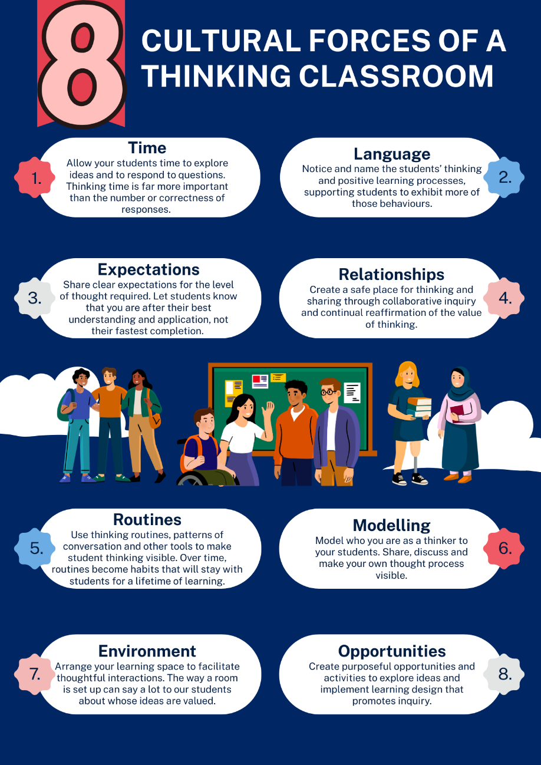

Thinking routines
In this section, we explore 8 thinking routines, linked to the sample units for Stages 4 and 5 on our website.
Thinking routines provide structures and scaffolds that must be deliberately activated first by the teacher and over time by the learner. They can be simple structures, for example, a set of questions or a short sequence of steps. What makes them routines as opposed to a strategy is that through regular use they become ingrained in classroom culture.
Thinking routines:
- help direct attention straight to the issue
- provide specific practices that can be easily employed
- make student thinking visible
- provide a platform to show what students can do
- encourage action and discussion around thinking
- connect easily to the other cultural forces.
Ask yourself:
- What sort of thinking do I need students to do with this content?
- How can I best scaffold that thinking?

See-think-wonder
This thinking routine provides a simple scaffold for students to explore new content:
- What do you see?
- What do you think?
- What do you wonder?
Responses can then be shared and compared in pairs, groups or via a class discussion.
This example from our Indonesian Stage 4 unit ‘What do you want to buy?’ encourages exploration of language and culture when shopping in Indonesia.
After watching the Jalan Malioboro Yogyakarta (6:50) video, think about your answers to the questions below.
See: What did you see or notice about shopping in Indonesia? What were some words and phrases you saw in the video that you could use when shopping in Indonesia?
Think: What do you think you would find most interesting if you went shopping in Indonesia? How do you think you could you use the words and phrases you identified when shopping in Indonesia? Write 3 examples.
Wonder: What do you wonder would be different or challenging for you if you went shopping in Indonesia? What do you wonder you could add to the words and phrases you identified to add extra meaning and complexity when communicating in Indonesian? In what other contexts do you wonder you can use this language?
Write your answers down and then share in a class discussion.

5 whys
The 5 whys routine is as simple as it seems … keep asking why!
You might not want to do 5. It could be 3 or any number to extend as far as you wish.
To build communication skills such as speaking and writing, this technique can help students go beyond a basic response. Students are encouraged to think more deeply about their answers, manipulate known language and extend responses with more detail.
This routine can also be used to help students deepen their understanding of the target language by delving deeper into information given in texts and encouraging different ideas, perspectives and justifications as they read or listen to texts. In the HSC examination, questions are assigned different marks according to the depth of understanding expected. Through adding the ‘why’ questions, we require students to think about these basic initial responses more deeply and even to evaluate and justify.
In the Italian Stage 5 unit ‘A typical week’, students are asked to create a short video describing their average week. One of the inclusions is to write a detailed description of at least 3 activities they regularly do after school or on the weekend with frequency and reasons why they do these activities.
Here is an example to consider deeper content and language use using the 5 whys thinking routine for an activity students could discuss in their video.
Starting statement: I play video games on the weekend.
Why? I like it.
Why? It is fun.
Why? I play with my friends.
Why? We all like Mario Party.
Why? There are cool characters and fun mini games.

Question organiser
As an alternative to 5 whys, consider 5 question words to change the thinking perspectives. For example, ‘Who?’ ‘Where?’ ‘When?’ ‘Why?’ and ‘How?’. Of course others like, ‘What?’ and ‘Which?’ can be included in the 5.
A graphic information organiser or table with spaces for answers can support students to scaffold their responses. A guide helps students to progressively delve deeper into a question or topic.
The questions you choose should support students to understand the scope and content of the activity or task.
For example, to support Stage 6 Continuers students prepare for a non-HSC-style oral assessment for the topic aspirations, students can create a portfolio with images and information of their post-graduation aspirations. The teacher uses this portfolio as a stimulus to ask students questions about their future plans as part of an oral assessment conversation.
Who? Students can discuss themselves, stating their aspirations and who else may be included in their plans. They may also include the perspectives of others about their plans such as their parents, teachers or friends.
Where? They can talk about where they plan to visit, study or work. This could include specific places such as a specific university or multiple places such as a working holiday overseas. They may discuss where they plan to live.
When? Time words such as dates, soon, next year, or after I graduate can be used. The duration of time might also be included, such as from January until March, or for 3 months after the New Year.
Why? Reasons for their choice in travel, study or work can be given related to interests and skills. Reasons for their choice in place can be given such as wanting to sightsee, having great academic courses or having a job that is satisfying and pays a good salary.
How? Students may discuss the pathway to get into their preferred course or work through subject selection. They may also discuss work experience, saving money and how they plan to travel.

Peel the fruit
Peel the fruit can be used to organise and map out deeper understanding.
Starting with the peel, which represents the surface ideas, students are asked to ‘get under the peel’ with deeper ideas regarding the topic or task. Students are then moved on to the flesh, the substance of the deeper idea, until finally they are asked to evaluate the idea at the core.
It would be very easy in this task for students to give very basic responses, but even at early stages of learning we can encourage deeper thinking and engagement with the language.
Let’s take a look at using this with the Auslan Stage 4 unit ‘Myself and my class’. Mini-task progress checkpoint 3 is a conversation to exchange information about names, ages, where you live, describing your identity and basic likes and dislikes. It also requires students to use non-manual features for effective communication.
At the peel, students are asked to tell us facts about themselves and their family, such as names, ages, where they are from, describing their identity (such as Deaf, CODA or hard of hearing) and basic likes and dislikes.
In the flesh, students are asked to provide a bit more detail. Perhaps they manipulate learned signs and phrases in a new way. Maybe they will add further language details such as adjectives, conjunctions and sentence starters. They will also consider the non-manual features used to enhance communication such as eye contact and body language.
At the core, we evaluate. This could be a reflection, an opinion or a reason. For example, ‘I like my sister because she is fun and happy,’ ‘I love pizza and cola because it is delicious,’ or ‘I love my town because it is peaceful and beautiful.’

Jigsaw strategy
The jigsaw strategy is achieved by forming groups with 5 to 6 students. Each student in their group must investigate and learn about a different piece of the overall task (jigsaw). They become the expert of that piece. If you have multiple groups, the experts from each group focusing on the same piece can join together in researching and attaining key insights before returning to their group to share.
Use of this strategy ensures that all students contribute equally to a group that is inclusive of all. It gives individuals autonomy and responsibility as well as the opportunity to become an ‘expert’ while being supported and guided by those around them.
This routine is completed using the following steps:
- Students are placed into a group of 5 to 6 students.
- Individuals within each group are given a ‘puzzle piece’ – it may be an inquiry question or topic.
- Students then find others from different jigsaw groups who have the same question or topic. They form an ‘expert group’.
- In their expert group, students discuss the question or topic. They should record prior knowledge and work together to plan and record the information required.
- When the time is up, students are to return to their jigsaw group with the information collected and present their puzzle piece to their group.
When all the puzzle pieces are put together students can then complete the task with a deeper understanding. Students may complete the task individually or as a group. The point is the deep thinking and understanding they collaboratively gain.
In the Japanese Stage 5 unit ‘Japanese travels’, the summative tasks require students to create 3 posts for an online travel blog about their holiday in Japan, one for a rural setting, one for a city setting and one about accommodation.
To support students to collaboratively brainstorm possible content to include, provide students with the following puzzle pieces:
- location, cultural and historical information about the place
- sightseeing activities
- transport
- places to eat
- accommodation.
While brainstorming in their expert groups, students should consider a variety of vocabulary and grammatical structures that can be used as well as content. Encourage students to think of how they could manipulate these further to produce more complex structures.

3-2-1 graphic organiser
A 3-2-1 graphic organiser helps students summarise information when researching by narrowing down the source to 3 things learned, 2 interesting facts and 1 new word. This process of narrowing down helps students in comprehending the source.
This graphic organiser can also ask students to locate many different words, facts or concepts depending on the topic and what the teacher would like them to identify.
In the Stage 4 German unit ‘What do you like to eat?’, there is an understanding activity where students listen to German students introduce themselves and what they like to eat.
This is the German and English transcript for one of the passages (0:23):
Ich heiße Saskia. Ich bin siebzehn Jahre alt. Ich wohne in Frankfurt aber ich komme aus München. Ich habe einen Bruder. Er heißt Max. Ich esse Müsli und Milch und trinke Kaffee zum Frühstück. Ich esse Nudeln und trinke eine Cola zum Mittagessen. Ich esse Brot und Schinken zum Abendessen.
Saskia is 17-years-old. She lives in Frankfurt but comes from Munich. She has one brother who is called Max. For breakfast, she eats muesli and drinks coffee. For lunch, she eats pasta and drinks cola. For dinner, she eats bread and ham.
The 3 things students can consider are:
- 3 grammatical structures they know
- 2 conjunctions
- 1 sentence they can change into a question.

10 × 2 strategy
In the 10 × 2 strategy, students are shown an image for 30 seconds and then asked to write down 10 words or phrases that come to mind regarding the picture. Once students have written their 10 words or phrases, they repeat the activity with another 30 seconds to look at the image again and then record another 10 words or phrases that are different from the first.
By using the 10 × 2 strategy, students can slow down and make more detailed connections to language.
They can use the graphic organiser provided to structure their thinking.
In the Japanese Stage 4 unit ‘Let’s go to a festival’, there is an understanding activity where students look at Japanese festival posters (student-facing) which include seasons, festivals and things they can do and eat at each event.
Looking at Figure 3 below for spring, students may record the following in each ‘take’:
Take 1: rain, star, Tanabata, fireworks, dancing, drum, yukata, August, tanzaku, Obon
Take 2: write tanzaku, it is the rainy season, watch fireworks, wear a yukata, it is fun, it is beautiful.

Figure 3 – Japanese festival poster for spring
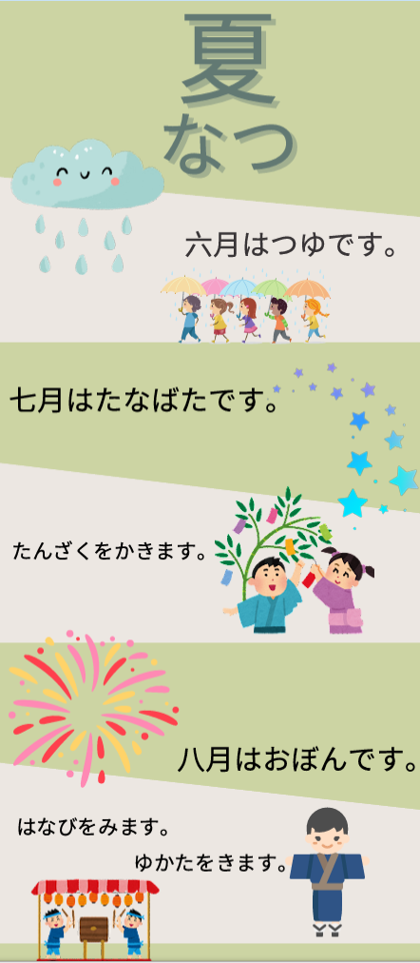
Note: these examples have been written in English for this resource, but students should try and write them in the language they are learning.

Lenses
By encouraging students to look at the language options through different lenses, they can consider applying the language in new situations. Making this a thinking routine as a regular part of your lessons, whether it be asking students to consider it verbally or taking time to brainstorm possibilities, will empower your students.
Looking at this assessment sample from the Japanese Stage 5 scope and sequence for the unit ‘I am what I wear’, students visit the Beams fashion website to first answer questions for understanding. Then they participate in an interaction to discuss clothing.
To support students to be able to respond in a broader range of situations, they can change the lens of the task with Figures 3 to 5 below. For example:
- Changing the audience lens
Figure 4 – audience lenses
- Changing the context lens
Figure 5 – context lenses
- Changing the purpose lens
Figure 6 – purpose lenses
This increases engagement and gives students ownership of their learning. It can also help support differentiation for high potential and gifted students. The department’s Differentiation Adjustment Tool is available to further support this.
When considering the Course Performance Descriptors and Common Grade Scale for languages, students are required to demonstrate their language skills for a range of audiences, contexts and purposes to achieve top bands – in other words, to look through different lenses.
Let’s look at this wording:
Course Performance Descriptors – A
- confidently manipulates [language] to convey meaning when exchanging information, ideas and opinions in a range of contexts
- demonstrates a very high level of skill in accessing and responding to information, and accurately interpreting and evaluating information in a range of texts
- applies extensive knowledge and understanding of grammatical and cultural features to compose texts for a range of purposes, audiences and contexts.
Common Grade Scale – A
The student has an extensive knowledge and understanding of the content and can readily apply this knowledge. In addition, the student has achieved a very high level of competence in the processes and skills and can apply these skills to new situations.
Other lenses that students could consider in communicating tasks might include:
- tenses
- negative and positive
- singular and plural.

Hexagonal thinking
In the department’s Digital Learning Selector, you can find the hexagonal thinking templates.
In a hexagonal thinking exercise, students are given hexagonal tiles with ideas, questions or facts which they arrange so related tiles are next to each other. With higher levels of understanding, students can explain the relationships between sets of tiles.
Hexagonal thinking can also be used to help plan a project or map out the problem-solving process. Students can fill in their own blank hexagons and arrange them to demonstrate their ideas. They could do this individually and then share with a group or the class, or do it as group work and go around and explore each other’s ideas. As the teacher, move around the room to discuss ideas and encourage students to expand and think through different perspectives.
Different coloured hexagons could be used for adjectives, verbs, nouns, structures or conjunctions.
In the French Stage 5 unit ‘In my free time’, students discuss their hobbies and leisure activity preferences during their free time as well as during different seasons. To develop ideas the hexagon clusters can be grouped as shown below in Figure 6. Of course, other hexagon clusters such as conjunctions, sentence starters and adjectives could be added too.
These could form an anchor chart for the unit to refer to during activities and when planning for assessment.

Figure 7 – hobby and leisure activities using hexagon clusters
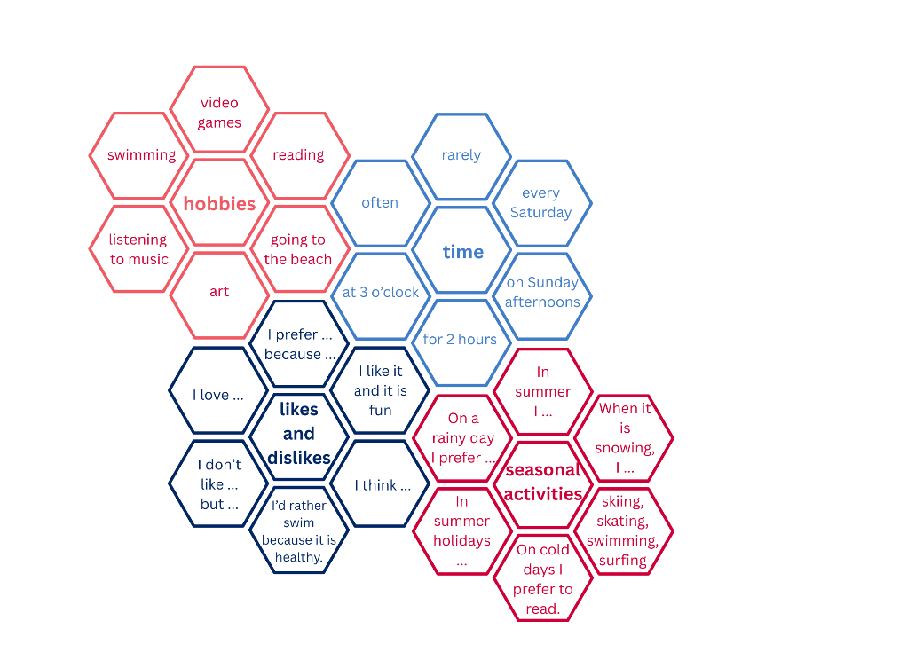

References
This resource contains NSW Curriculum and syllabus content. The NSW Curriculum is developed by the NSW Education Standards Authority. This content is prepared by NESA for and on behalf of the Crown in right of the State of New South Wales. The material is protected by Crown copyright.
Please refer to the NESA Copyright Disclaimer for more information https://educationstandards.nsw.edu.au/wps/portal/nesa/mini-footer/copyright.
NESA holds the only official and up-to-date versions of the NSW Curriculum and syllabus documents. Please visit the NSW Education Standards Authority (NESA) website https://educationstandards.nsw.edu.au and the NSW Curriculum website https://curriculum.nsw.edu.au.
NSW Education Standards Authority (NESA) (2025) Capabilities and priorities, NSW Education Standards Authority, accessed 1 December 2025.
Harvard Graduate School of Education (2022) PZ’s thinking routines toolbox, Project Zero website, accessed 1 December 2025

© State of New South Wales (Department of Education), 2025
The copyright material published in this resource is subject to the Copyright Act 1968 (Cth) and is owned by the NSW Department of Education or, where indicated, by a party other than the NSW Department of Education (third-party material).
Copyright material available in this resource and owned by the NSW Department of Education is licensed under a Creative Commons Attribution 4.0 International (CC BY 4.0) license.

This license allows you to share and adapt the material for any purpose, even commercially.
Attribution should be given to © State of New South Wales (Department of Education), 2025.
Material in this resource not available under a Creative Commons license:
- the NSW Department of Education logo, other logos and trademark-protected material
- material owned by a third party that has been reproduced with permission. You will need to obtain permission from the third party to reuse its material.
Links to third-party material and websites
Please note that the provided (reading/viewing material/list/links/texts) are a suggestion only and implies no endorsement, by the New South Wales Department of Education, of any author, publisher, or book title. School principals and teachers are best placed to assess the suitability of resources that would complement the curriculum and reflect the needs and interests of their students.
If you use the links provided in this document to access a third-party's website, you acknowledge that the terms of use, including licence terms set out on the third-party's website apply to the use which may be made of the materials on that third-party website or where permitted by the Copyright Act 1968 (Cth). The department accepts no responsibility for content on third-party websites.

