Modern History (Year 11) – teaching support resource
Historical investigation – Modern History 11–12 Syllabus (2024)

Contents
Overview 3
Suggested timeframe 3
Outcomes 4
Learning sequence 1 – acquiring historical information 5
Syllabus content 5
Learning intentions 5
Success criteria 5
Introduction to the historical investigation 6
Resource 1 – the process of historical inquiry (History 7–10) 6
The historical investigation assessment task 7
Resource 2 – sample assessment task 7
Choosing a topic 8
Resource 3 – topic selection table 8
Formulating historical questions 9
Resource 4 – characteristics of effective inquiry questions 9
Planning for research 10
Resource 5 – background research, narrow reading and close reading 10
Resource 6 – Wikipedia as a research tool 11
Identifying, selecting and analysing sources 13
Resource 7 – ‘See, Think, Wonder’ layered inference scaffold 13
Learning sequence 2 – processing historical information 15
Syllabus content 15
Learning intentions 15
Success criteria 15
Using evidence from sources 16
Resource 8 – stop-and-jot source analysis table 16
Resource 9 – double Venn diagram for source analysis 17
Resource 10 – triple Venn diagram for source analysis 18
Resource 11 – quadruple Venn diagram for source analysis 19
Problems associated with sources and evidence 20
Resource 12 – responding to Andy Kaladelfos on sources 20
Examining historical interpretations 21
Resource 13 – content analysis scaffold 21
Learning sequence 3 – communicating historical information 22
Syllabus content 22
Learning intentions 22
Success criteria 22
Presenting findings of historical investigation 23
Resource 14 – forms and technologies ranking table 23
Organising findings of historical investigation 24
Resource 15 – outline of the school’s preferred referencing system 24
Communicating findings of historical investigation 25
Resource 16 – exemplar clines 25
Resource 17 – ‘Judgement term’ cline template 26
Generic resources 27
Resource 18 – capacity matrix 27
Resource 19 – concept map 30
Resource 20 – timeline scaffold 31
Resource 21 – PEEL scaffold 32
Resource 22 – PMI chart 33
Resource 23 – KWLH chart 34
Resource 24 – Think-Pair-Share scaffold 35
Resource 25 – source analysis sample questions 36
References 38

Overview
This teaching support resource supports the associated learning program and should be considered in conjunction with the program and related resources. The activities provided for this learning sequence are designed to allow students to engage with the Historical investigation focus area.
The Historical investigation is designed to provide opportunities for all students to develop the historical skills that are the core of the historical inquiry process. The Historical investigation is designed to further develop relevant investigative, research and communication skills and should take place over a maximum of 20 indicative hours of course time. The investigation may be undertaken as a standalone study or integrated into any other focus area in the Year 11 course. The investigation should extend a particular area of individual student or group interest. It may be conducted individually or collaboratively.
Note: the investigation must not overlap with or duplicate significantly any option to be attempted in the Year 12 Modern History or History Extension courses. The historical concepts and skills content is to be integrated as appropriate.
Suggested learning intentions and success criteria have been provided to demonstrate how they might be written. Learning intentions and success criteria are most effective when they are contextualised to meet the needs of students. Teachers might edit those provided and can write and use additional learning intentions and success criteria. Learning intentions and success criteria are both an explicit teaching and formative assessment strategy.
Consider the Universal Design for Learning principles of engagement, representation and expression in conjunction with this teaching support resource when planning for teaching and learning. Students learning English as an additional language or dialect (EAL/D) and students new to education in Australia may need additional support to fully access the resources in this booklet.

Suggested timeframe
This learning sequence is designed to be completed over a period of approximately 15 hours. This duration can be adapted to suit the school context.

Outcomes
A student:
- MH-11-05 analyses different types of sources for evidence to support a historical account or argument
- MH-11-06 explains differing interpretations and representations of the past
- MH-11-07 communicates historical understanding, applying historical knowledge, terms and concepts
- MH-11-08 plans and conducts historical investigations and presents conclusions, using evidence from a range of sources
Modern History 11–12 Syllabus © NSW Education Standards Authority (NESA) for and on behalf of the Crown in right of the State of New South Wales, 2024.

Learning sequence 1 – acquiring historical information
Approximate duration 6 hours.

Syllabus content
The process of historical investigation
- Formulate historical questions and hypotheses relevant to the investigation.
- Identify and analyse sources to develop a view about a historical issue.

Learning intentions
Students learn about:
- the process of acquiring historical information and conducting historical investigations
- the process of analysing sources.

Success criteria
Students will be able to:
- prepare and plan for conducting a historical investigation
- identify and analyse a range of sources
- write 3 paragraphs explaining a perspective on a historical issue.

Introduction to the historical investigation

Resource 1 – the process of historical inquiry (History 7–10)
The process of historical inquiry
Through historical inquiry, students investigate and analyse historical events, individuals or themes, make connections, construct coherent accounts or interpretations of the past, and so deepening their knowledge and understanding of history.
Acquiring historical information
- Choose a specific historical event, an individual, a period or topic of interest
- Formulate appropriate historical questions
- Plan an inquiry that identifies appropriate historical methods and concepts
- Research and select relevant historical information from a range of appropriate sources
Processing historical information
- Draw conclusions about the value and limitations of sources, by assessing the purpose, context, reliability, credibility and perspective of the source
- Interpret sources, taking into account the intended audience and the historical context to support historical narratives and arguments
- Synthesise and organise information in selected forms, such as plans, narratives, explanations and arguments based on themes, to convey a thorough understanding of the focus area
Communicating historical information
- Present findings and ideas in a range of communication forms and technologies, using relevant and appropriate historical terms, concepts and information from sources to develop a historical inquiry
History 7–10 Syllabus © NSW Education Standards Authority (NESA) for and on behalf of the Crown in right of the State of New South Wales, 2024.

The historical investigation assessment task

Resource 2 – sample assessment task
The sample Historical investigation assessment task forms part of the Modern History 11–12 (2024) support package and is designed for use during implementation of the Historical investigation – sample program of learning. It should be considered in conjunction with the sample assessment schedule, program and related resources.
Access the sample Historical investigation assessment task here.

Choosing a topic

Resource 3 – topic selection table
Record all the topics you are interested in. Describe your level of interest in the topic and how well it connects to the requirements of the assessment task. Provide a final rank for each topic that summarises your level of interest in it and how well it connects to the historical investigation.
Table 1 – topic selection table
Topic | Level of interest | How well it connects | Rank

Formulating historical questions

Resource 4 – characteristics of effective inquiry questions
Use the text below to support an explanation of the characteristics of effective inquiry questions.
By using an inquiry question, you can:
- focus your research
- track your knowledge and understanding
- analyse and evaluate sources for a specific purpose
- communicate your findings as a thesis, or answer, to your question.
Effective inquiry questions will usually:
- start with an interrogative (how, why, what) or directive term (explain, assess)
- be open-ended – this means that it cannot be answered with a yes or no
- address issues related to history or historiography
- include a historical concept, for example, ‘significance’
- be tightly focused by mentioning historical information, such as people, time periods, locations or concepts, as limiting features.
Examples of effective inquiry questions:
- To what extent was the battle of Trafalgar a significant turning point in the Napoleonic wars?
- Assess the role of Suharto in changing the structure of the Indonesian Government.
- Explain how the history of Cyprus is remembered in Greece and Turkey.
Inquiry questions will often need to be refined after background research has been completed. This generates sub-questions that can support targeted source analysis, synthesis of information and evaluation of interpretations.

Planning for research

Resource 5 – background research, narrow reading and close reading
Use the text below to support an explanation of the differences between and significance of background research, narrow reading and close reading.
Background research is the information that you need to be familiar with so that you can understand the key inquiry question. If you are developing your own key inquiry question, you will need to undertake background research to extend your knowledge of the topic and identify relevant historical problems to research. Background research is based on consensus and is not contested. Background research involves the process of reading widely to support your understanding of the ‘big picture’.
Narrow reading or contextual research is the more detailed information that you need to know so that you can effectively analyse sources of information. When you are engaged in this type of research, you are strengthening your understanding of the context the source of information was published in. Contextual research will help you to analyse your sources of information more effectively.
Close reading is where you are engaged with detailed information from specific sources. You may be looking for what is left out, as well as what is included. This kind of research is most productive when undertaken as part of source analysis, once you are confident that you understand when, where and why your source of information was produced.

Resource 6 – Wikipedia as a research tool
Read the article Students are told not to use Wikipedia for research. But it’s a trustworthy source and generate short (1 to 2 sentence) responses to the following questions:
- Why is Wikipedia so reliable?
- How can Wikipedia be a tool for better media literacy?
- Have you ever looked at a ‘history’ page for a Wikipedia article? Discuss in a small group and record your responses.
- Have you ever looked at a ‘talk’ page for a Wikipedia article? Discuss in a small group and record your responses.
- Have you ever used Wikipedia to ‘fact check’ a claim online? Discuss in a small group and record your responses.
- Have you ever engaged with a ‘reference list’ on a Wikipedia page? Discuss in a small group and record your responses.
- How would you use Wikipedia to support background research?
- How would you use Wikipedia to support research on your topic area?

Identifying, selecting and analysing sources

Resource 7 – ‘See, Think, Wonder’ layered inference scaffold
Example: the student examined the image and then completed the sentences below.
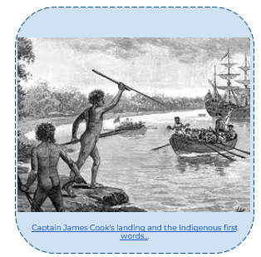
‘Australia: the first hundred years’ by Andrew Garran, 1886 is available in the public domain.
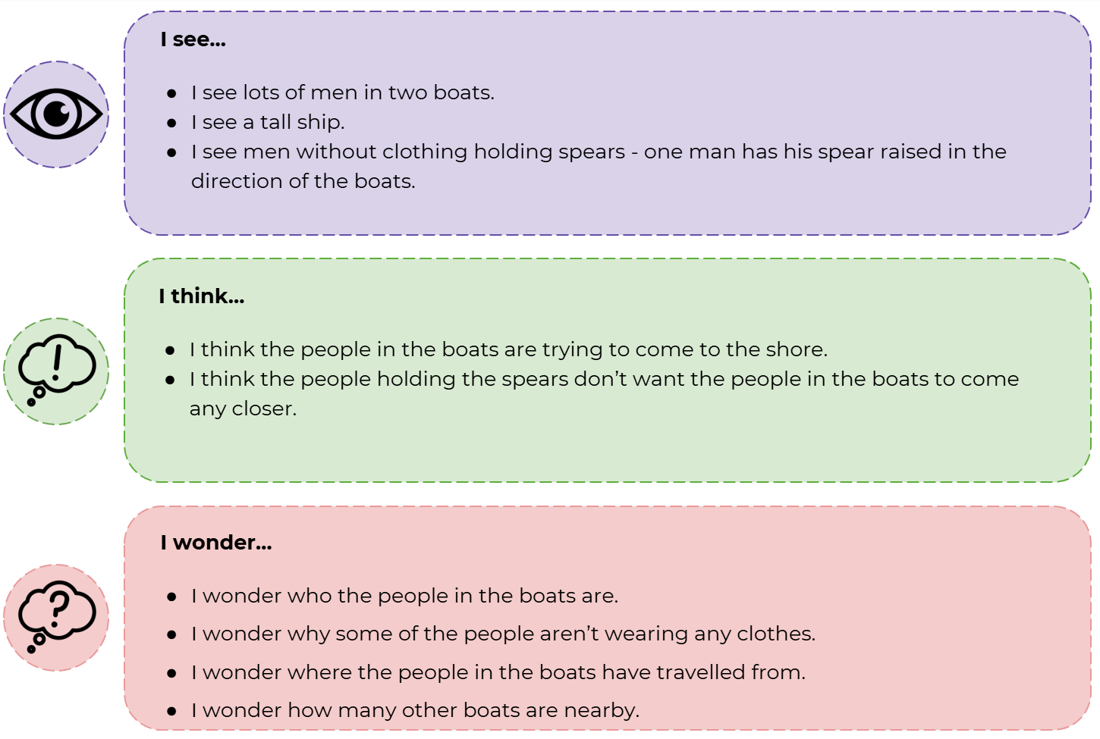
Activity scaffold: examine the source provided by your teacher and complete the scaffold below.
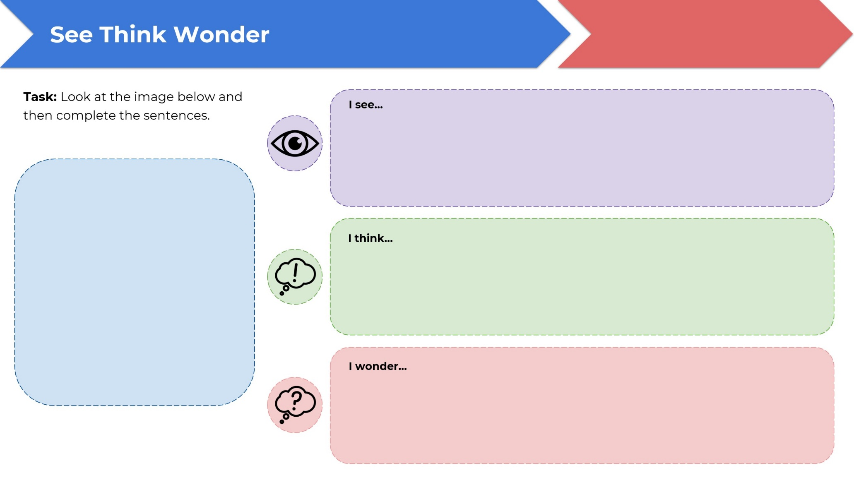

Learning sequence 2 – processing historical information
Approximate duration 5 hours.

Syllabus content
The process of historical investigation
- Develop and/or examine historical interpretations.
- Synthesise evidence and information from a range of sources to develop and support a reasoned historical account or argument.

Learning intentions
Students learn about:
- processes for developing and examining historical interpretations
- processes for synthesising evidence from a range of sources.

Success criteria
Students will be able to:
- create a table that synthesises evidence from at least 10 historical sources relevant to the historical investigation
- write a 3-paragraph comparison of 2 or more historical perspectives relevant to the historical investigation.

Using evidence from sources

Resource 8 – stop-and-jot source analysis table
When you find useful evidence in a source get in the habit of stopping and recording it. This habit is important for documenting where you found the idea so you can find it again and reference it in your essay. Complete the table below for 10 sources that inform your historical investigation.
Table 2 – stop-and-jot source analysis table
Source name | Responses
Bibliographic information
What is important?
Key evidence
Unanswered questions
Related sources

Resource 9 – double Venn diagram for source analysis
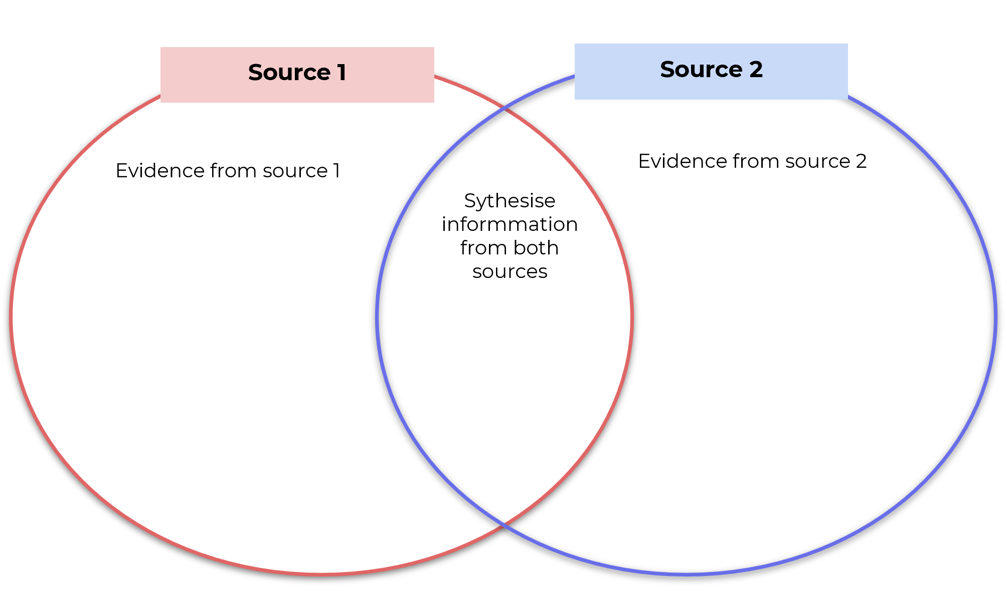

Resource 10 – triple Venn diagram for source analysis
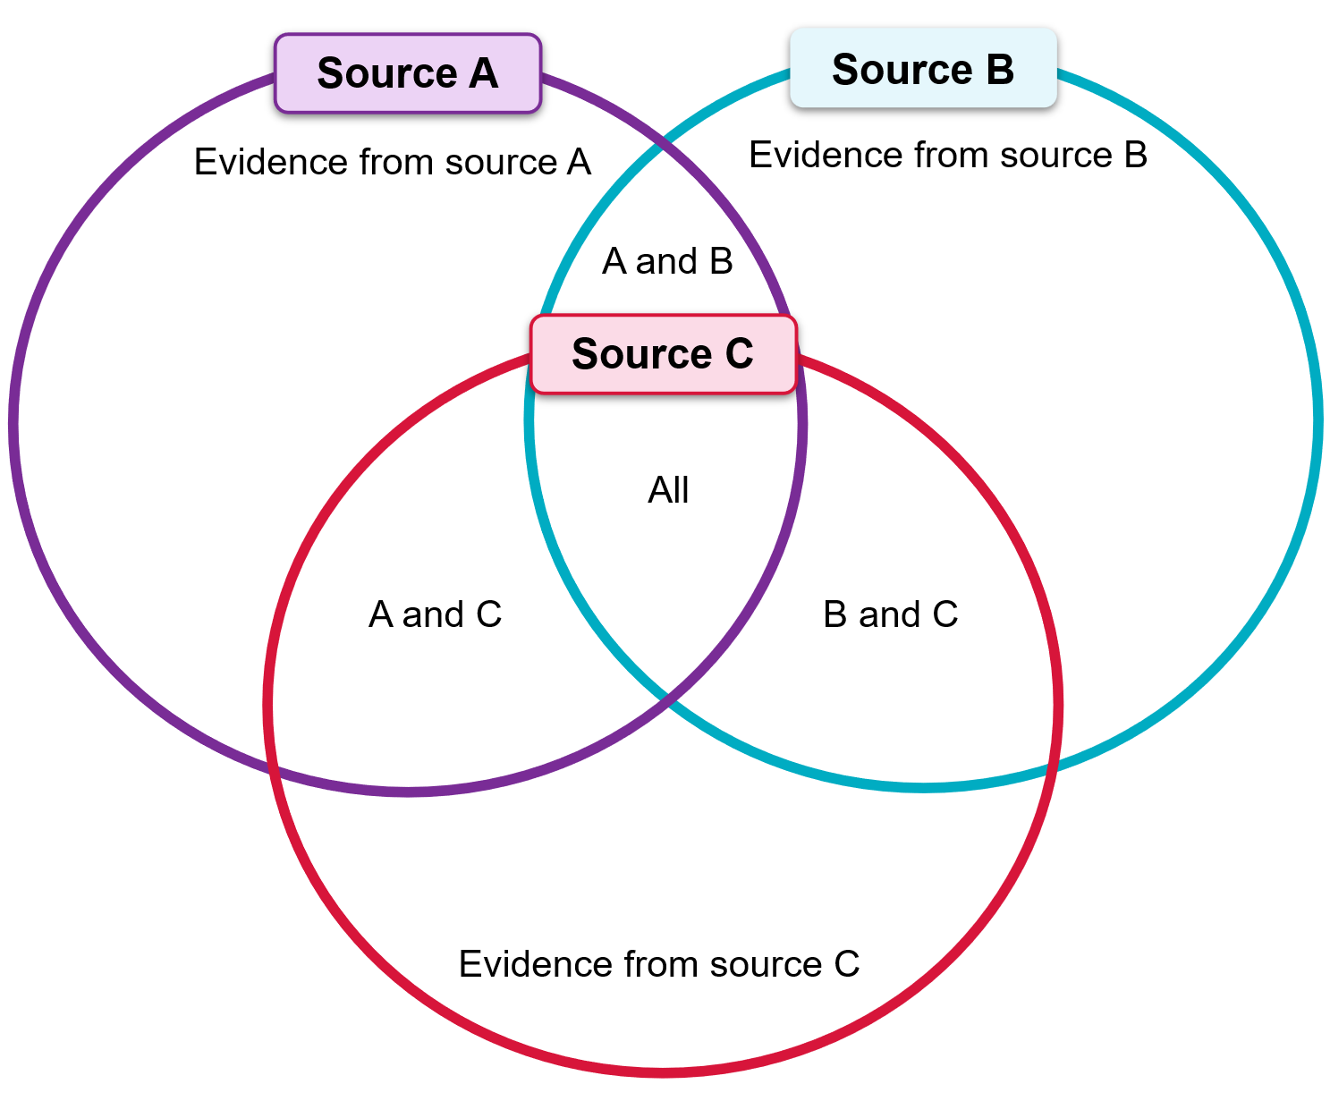

Resource 11 – quadruple Venn diagram for source analysis
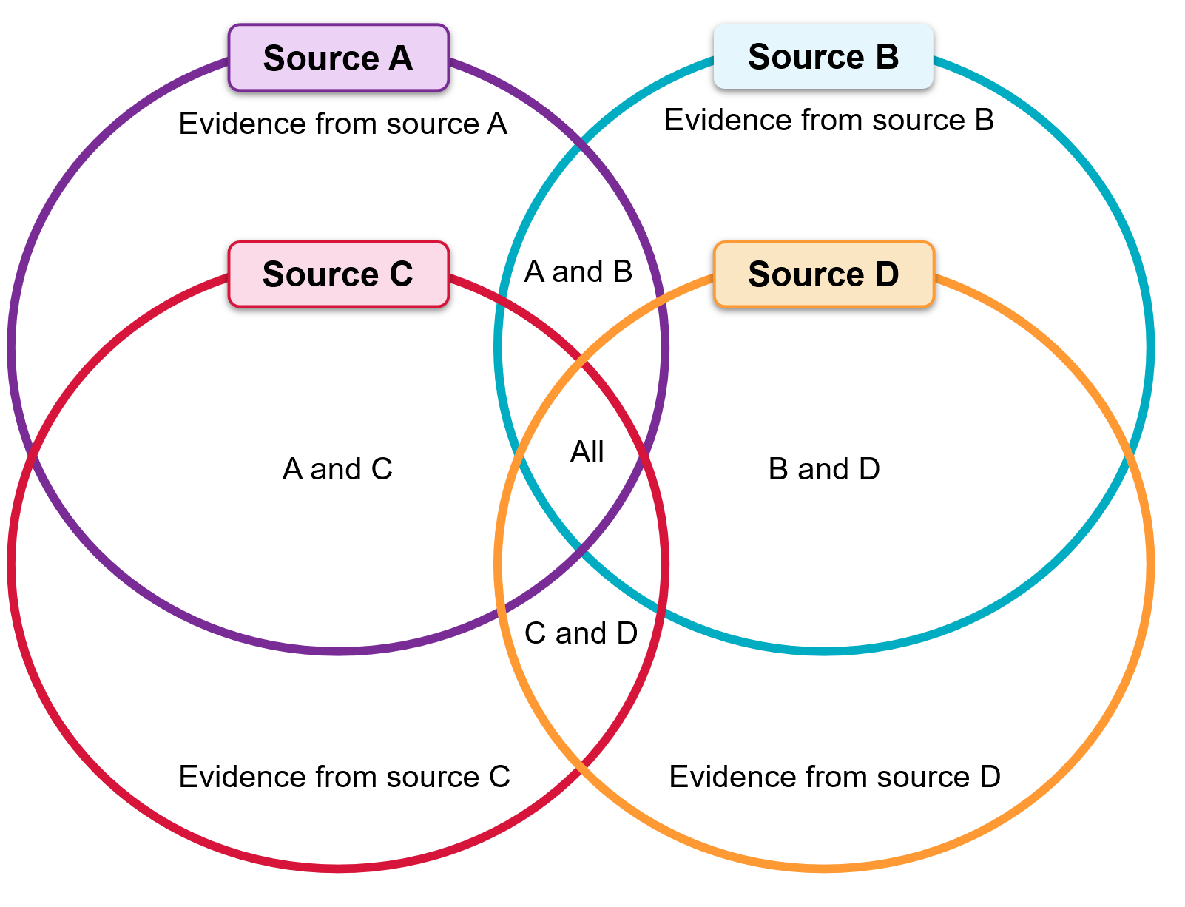

Problems associated with sources and evidence

Resource 12 – responding to Andy Kaladelfos on sources
Students should provide short written answers in response to Andy Kaladelfos on ‘Sources for researching histories of crime’ (3:37).
- What types of sources is evidence being drawn from?
- Describe the evidence that can be drawn from newspapers.
- Why are multiple types of sources used to provide evidence when researching histories of crime?

Examining historical interpretations

Resource 13 – content analysis scaffold
Content analysis is a research tool used to determine the presence of certain words, themes or concepts within some given qualitative data (that is, text). Using content analysis, researchers can quantify and analyse the presence, meanings and relationships of such certain words, themes or concepts (Columbia University 2025). For an extended definition see: Content Analysis Method and Examples | Columbia Public Health.
Table 3 – content analysis scaffold
Concepts | Frequency of concept | Context of concept
Concept 1:
Concept 2:
Concept 3:

Learning sequence 3 – communicating historical information
Approximate duration 4 hours.

Syllabus content
The process of historical investigation
- Use historical terms and concepts appropriately.
- Present and communicate the findings of a historical investigation using appropriate and well-structured forms.

Learning intentions
Students learn about:
- the correct use of historical terms and concepts in the context of historical arguments
- appropriate ways of presenting and communicating historical information.

Success criteria
Students will be able to:
- access and correctly apply terms from the glossary of the Modern History 11–12 Syllabus (2024)
- create and present a 5-slide PowerPoint presentation (or equivalent) summarising the findings to date in the historical investigation.

Presenting findings of historical investigation

Resource 14 – forms and technologies ranking table
Brainstorm all possible forms and technologies that might be used in a historical investigation. Record all the forms and technologies you are interested in using. Make a note of your level of interest in using the form or technology and the extent to which the form or technology enables you to clearly communicate your ideas, given the topic of your historical investigation.
Table 4 – form and technology selection table
Form or technology | Level of interest | Appropriateness | Ranking
Rank your forms and technologies on a scale of 1 to 5 (1 = inappropriate; 5 = very appropriate).

Organising findings of historical investigation

Resource 15 – outline of the school’s preferred referencing system
[Add an outline of the school’s preferred referencing system here.]

Communicating findings of historical investigation

Resource 16 – exemplar clines
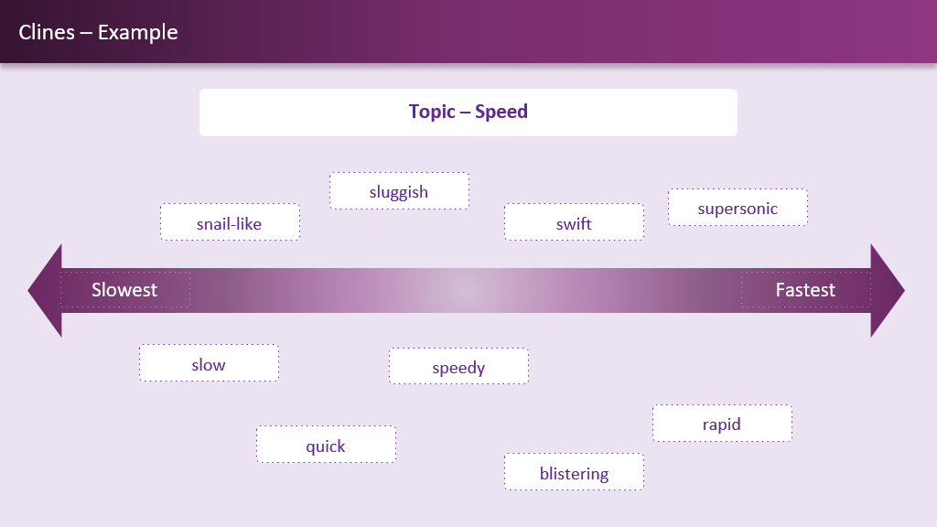
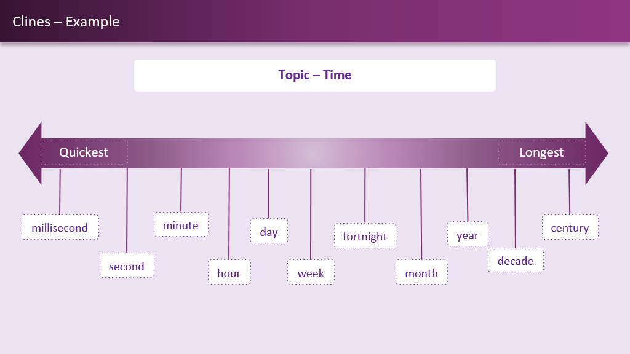

Resource 17 – ‘Judgement term’ cline template
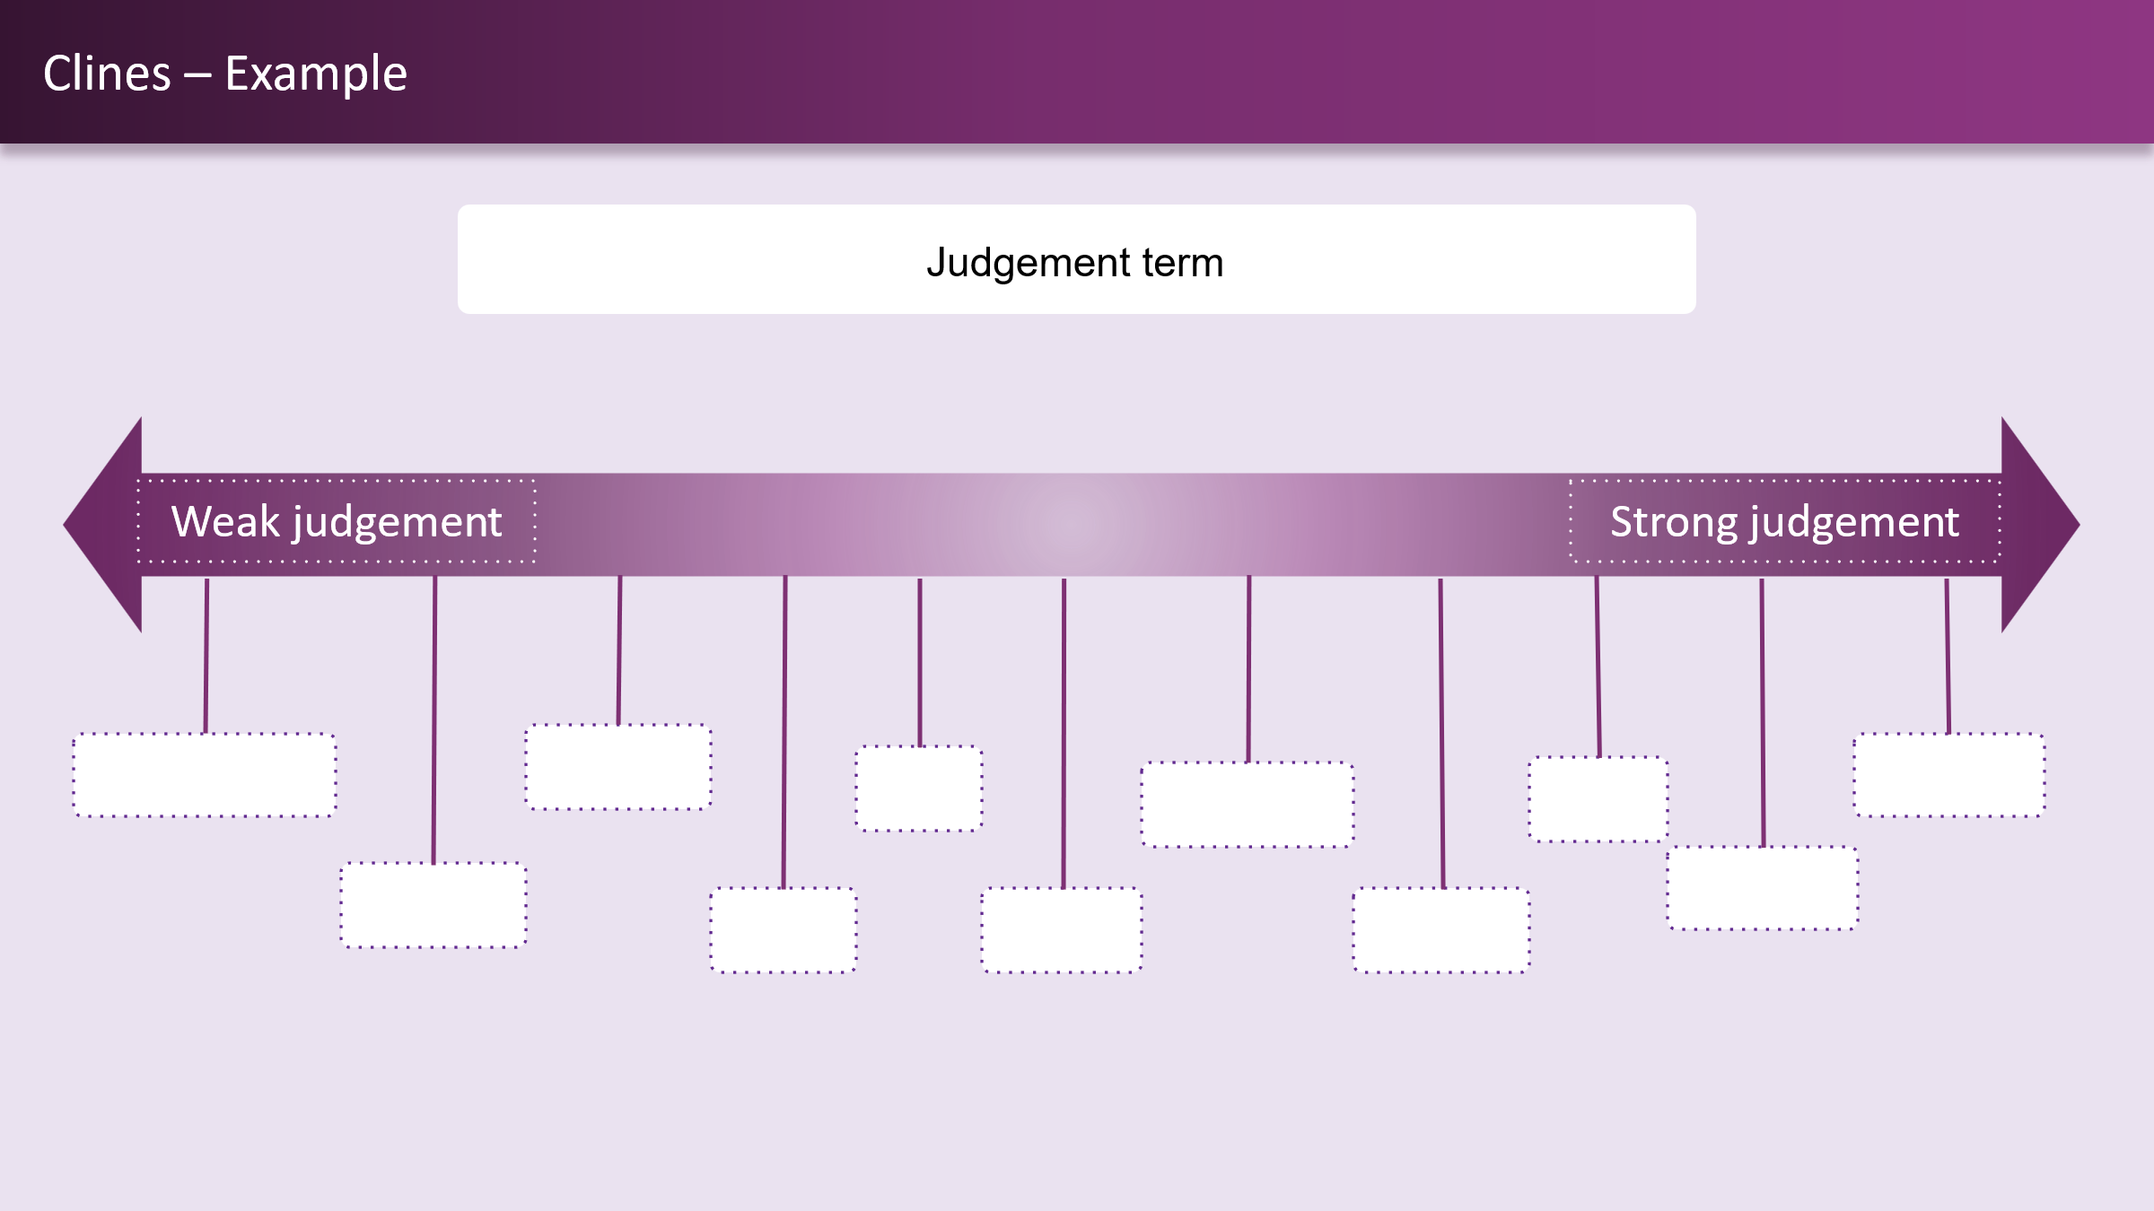

Generic resources

Resource 18 – capacity matrix
Note: a general concept and glossary list has been included. However, you might wish to add further terminology or skills to the matrix. Students should use different colours for the matrix criteria and shade or tick the category on the matrix that best represents their current level of understanding for each term.
- Information – at this level, you have heard of the term and/or you can recall basic facts about it.
- Knowledge – at this level, you can explain and know what the term or concept means.
- Know-how – at this level, you can draw connections between this geographical term or concept and relate it to other concepts or situations.
- Wisdom – at this level, you can use the term or concept in new contexts or teach others.
Teachers may need to explain ‘know-how’ and ‘wisdom’ to support students to engage with the matrix. When supporting EAL/D students to complete the matrix in their home language, teachers should remember that students may not understand key terms in their home language, or the translations may not be accurate.

Table 5 – sample capacity matrix
Term or concept | Information | Knowledge | Know-how | Wisdom
Authorship | ☐ | ☐ | ☐ | ☐
Bias | ☐ | ☐ | ☐ | ☐
Cause and effect | ☐ | ☐ | ☐ | ☐
Contestability | ☐ | ☐ | ☐ | ☐
Context | ☐ | ☐ | ☐ | ☐
Continuity and change | ☐ | ☐ | ☐ | ☐
Limitations | ☐ | ☐ | ☐ | ☐
Motivations | ☐ | ☐ | ☐ | ☐
Origin | ☐ | ☐ | ☐ | ☐
Perspective | ☐ | ☐ | ☐ | ☐
Purpose | ☐ | ☐ | ☐ | ☐
Reliability | ☐ | ☐ | ☐ | ☐
Significance | ☐ | ☐ | ☐ | ☐
Usefulness | ☐ | ☐ | ☐ | ☐
Validity | ☐ | ☐ | ☐ | ☐
Value | ☐ | ☐ | ☐ | ☐
Table 6 – blank capacity matrix
Term | Information | Knowledge | Know-how | Wisdom
 | ☐ | ☐ | ☐ | ☐
 | ☐ | ☐ | ☐ | ☐
 | ☐ | ☐ | ☐ | ☐
 | ☐ | ☐ | ☐ | ☐
 | ☐ | ☐ | ☐ | ☐
 | ☐ | ☐ | ☐ | ☐
 | ☐ | ☐ | ☐ | ☐
 | ☐ | ☐ | ☐ | ☐
 | ☐ | ☐ | ☐ | ☐
 | ☐ | ☐ | ☐ | ☐
 | ☐ | ☐ | ☐ | ☐
 | ☐ | ☐ | ☐ | ☐
 | ☐ | ☐ | ☐ | ☐
 | ☐ | ☐ | ☐ | ☐
 | ☐ | ☐ | ☐ | ☐
 | ☐ | ☐ | ☐ | ☐

Resource 19 – concept map
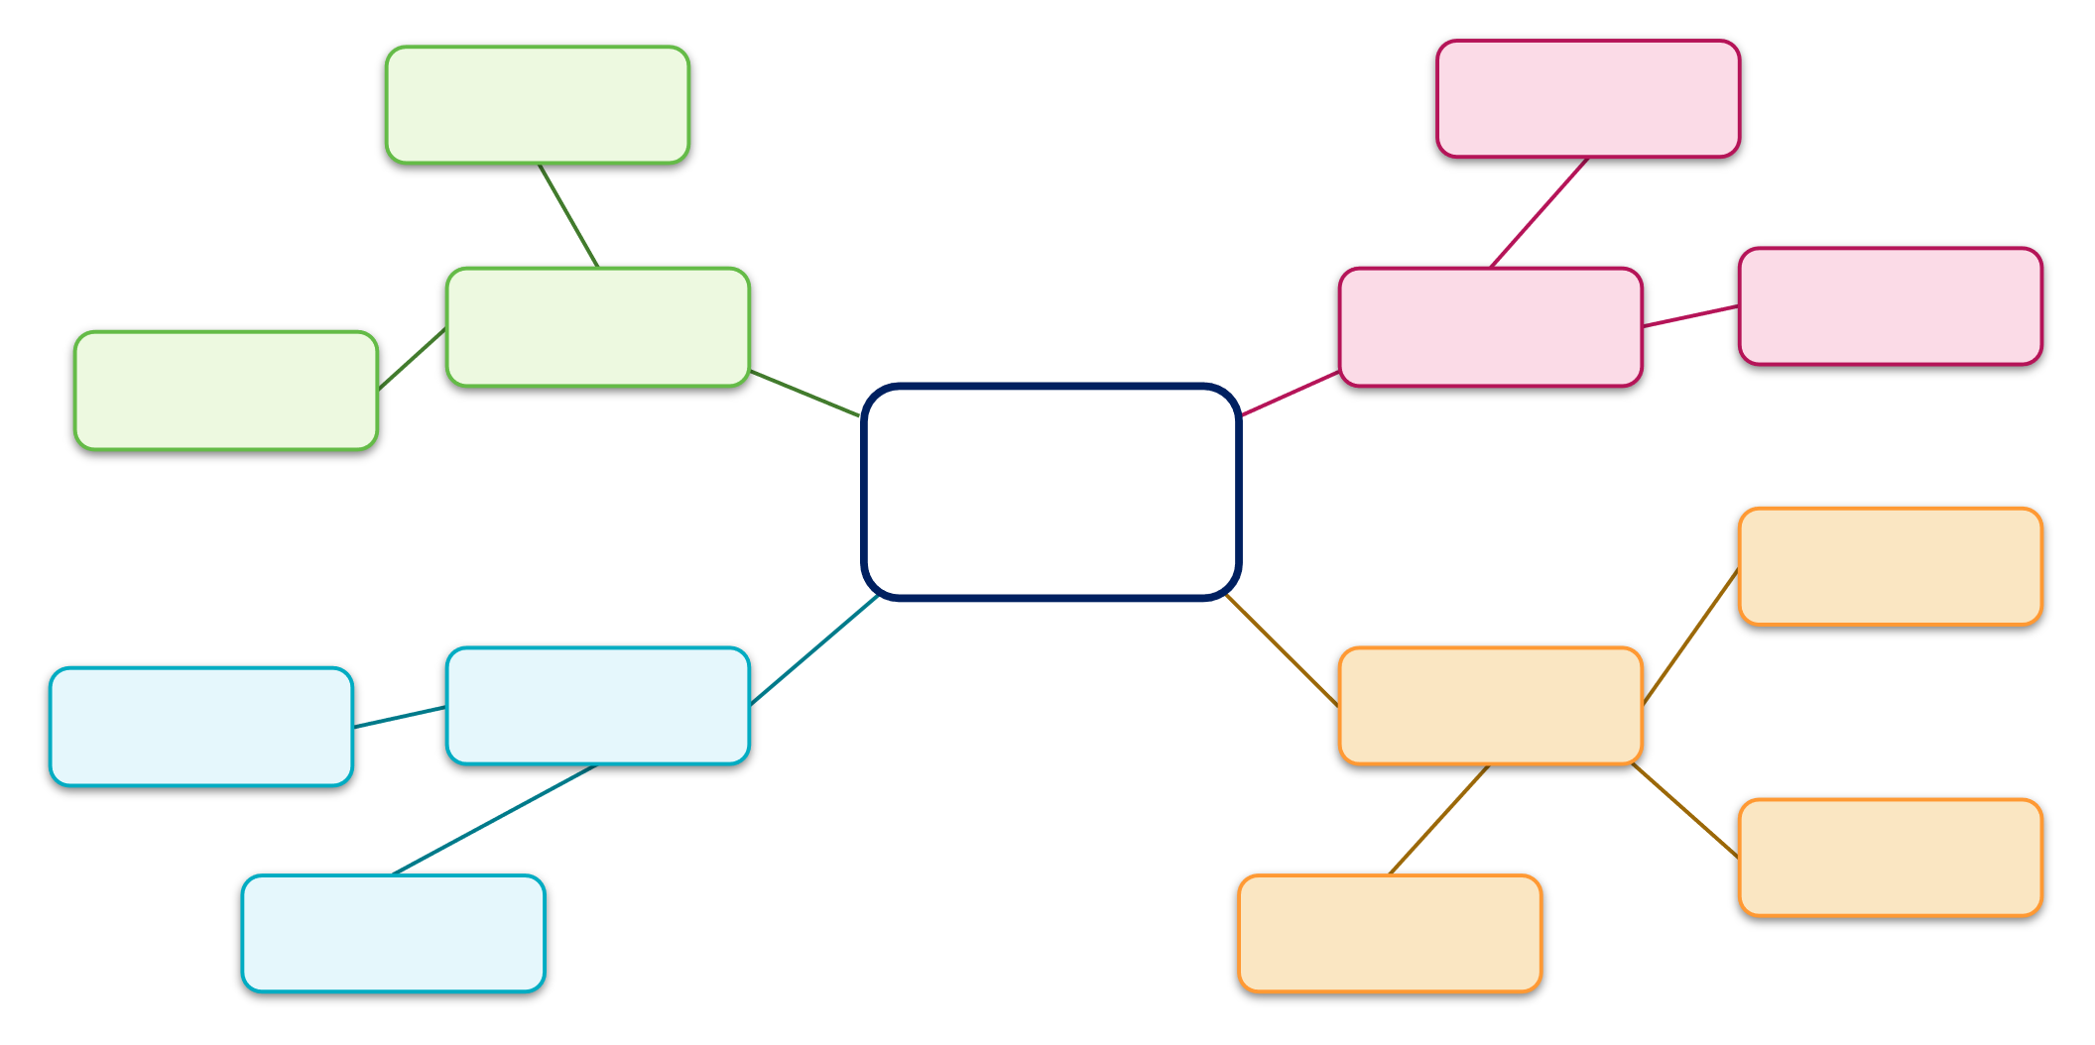

Resource 20 – timeline scaffold
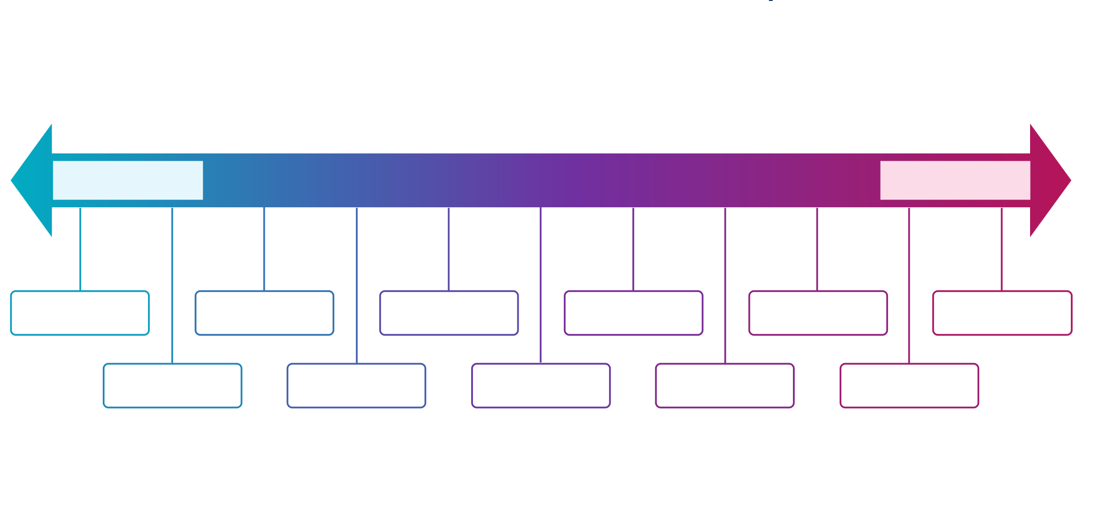

Resource 21 – PEEL scaffold
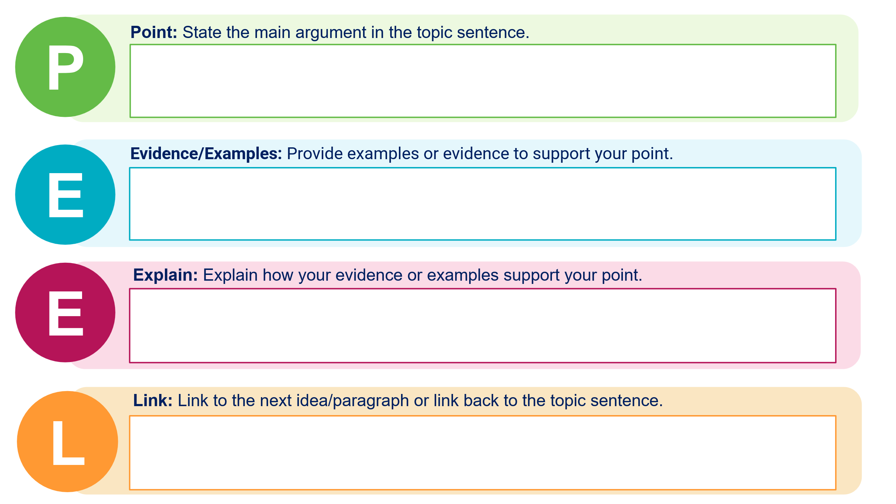

Resource 22 – PMI chart
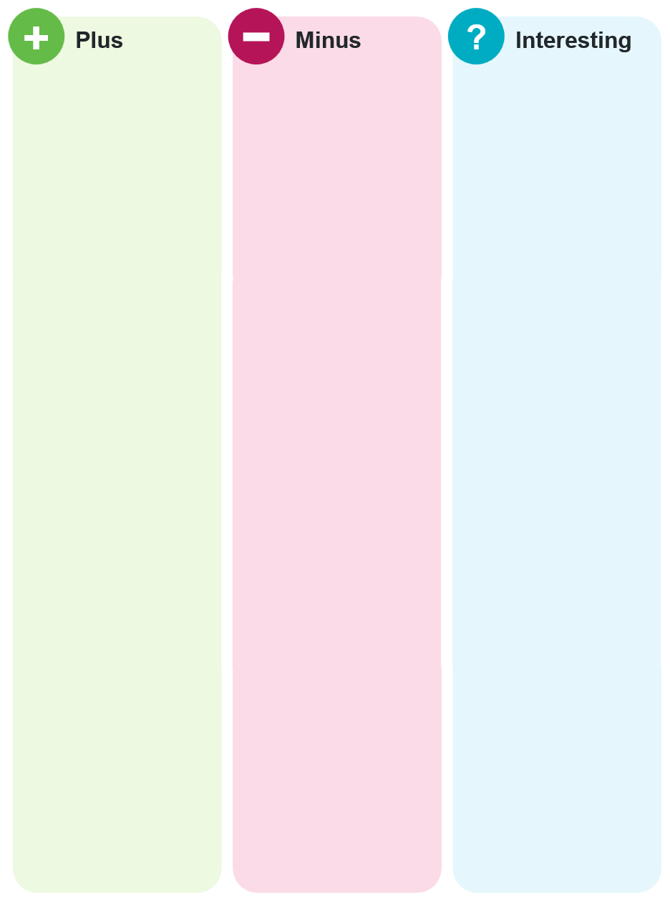

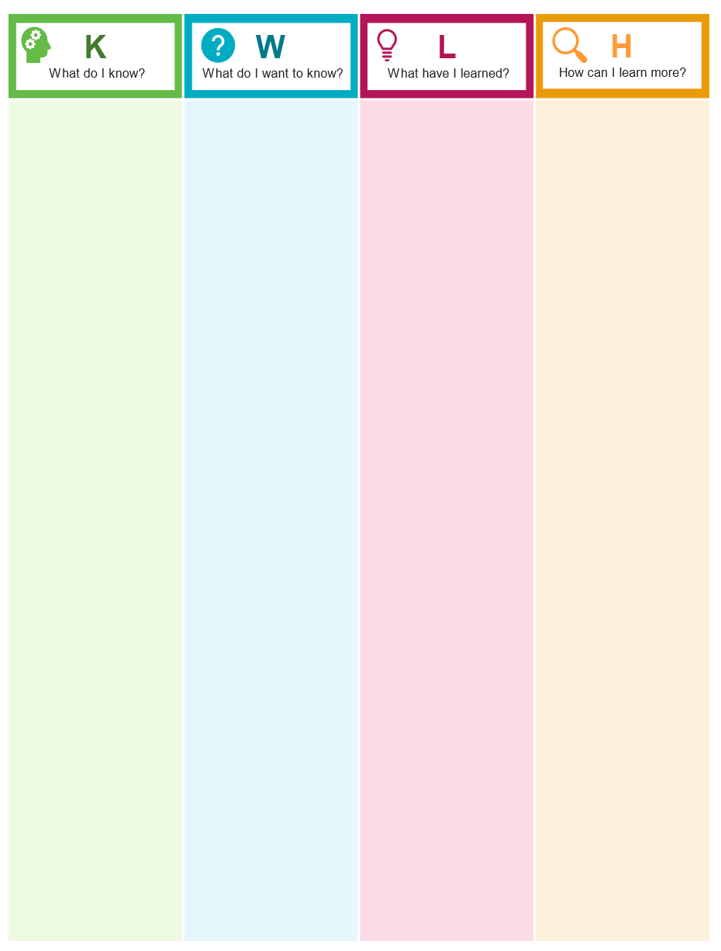
Resource 23 – KWLH chart

Resource 24 – Think-Pair-Share scaffold
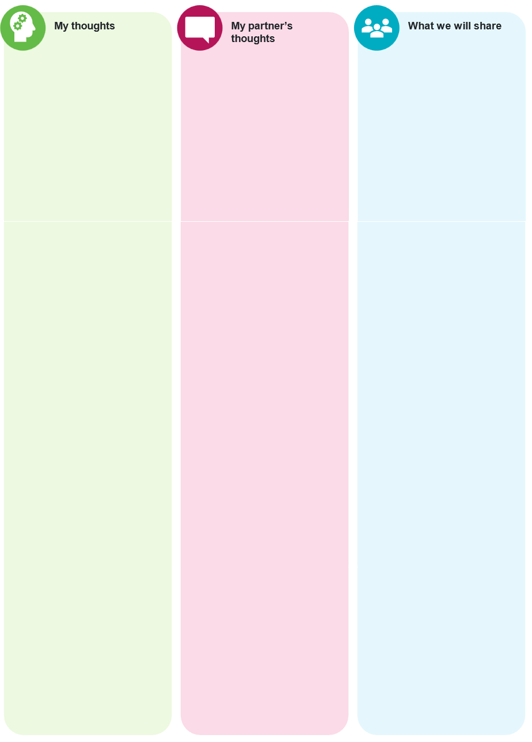

Resource 25 – source analysis sample questions
Table 7 – source analysis sample questions
Analysis and use of sources | Suggested questions
Origin | - When was the source made?  - Where was the source made?  - Who made the source?
Content | - What information does the source include about significant groups, individuals, ideas, beliefs, practices or events?  - Whose perspective is included in the source?  - Is there bias in the source?  - Are there omissions in the source?  - Does information from this source match information from other sources?  - How was the source made?  - What techniques are used in the source?
Context | - Where was the source found?  - When was the source found?  - What significant groups, individuals, ideas, beliefs, practices or events does the source relate to?
Purpose | - What type of source is this?  - Who was the source made for?  - Why was the source made?  - What was the source used for?
Reliability | - Based on the information about the origin, context and purpose of this source should historians trust the content?  - Does this source corroborate information from other sources?
Credibility | - Based on the information about the origin, context and purpose of this source should historians believe the content?
Limitations | - Is the source complete?  - Is there anything missing from the source?  - How could the origin, content, context, purpose, reliability and credibility of this source limit its usefulness in a historical inquiry?  - Could the information in the source by biased?  - In what ways is the source influenced by the perspective of its creator?
Value | - What historical inquiry questions could this source provide evidence for?  - How could this source be used in a historical inquiry?  - Does the source provide evidence relevant to our inquiry question?  - Does the source provide ideas for further research?

References
This resource contains NSW Curriculum and syllabus content. The NSW Curriculum is developed by the NSW Education Standards Authority (NESA). This content is prepared by NESA for and on behalf of the Crown in right of the State of New South Wales. The material is protected by Crown copyright.
Please refer to the NESA Copyright Disclaimer for more information https://www.nsw.gov.au/education-and-training/nesa/copyright.
NESA holds the only official and up-to-date versions of the NSW Curriculum and syllabus documents. Please visit NESA https://www.nsw.gov.au/education-and-training/nesa and NSW Curriculum https://curriculum.nsw.edu.au.
Modern History 11–12 Syllabus © NSW Education Standards Authority (NESA) for and on behalf of the Crown in right of the State of New South Wales, 2024.
History 7–10 Syllabus © NSW Education Standards Authority (NESA) for and on behalf of the Crown in right of the State of New South Wales, 2024.
AITSL (Australian Institute for Teaching and School Leadership Limited) (n.d.) Learning intentions and success criteria, AITSL website, accessed 20 September 2024.
CESE (Centre for Education Statistics and Evaluation) (2020) What Works Best 2025 – Evidence guide for excellent schools, NSW Department of Education website, accessed 20 September 2024.
CESE (2020) What Works Best 2025 – practical guides, NSW Department of Education website, accessed 20 September 2024.
Columbia University (2025) Content Analysis, Columbia University – Mailman School of Public Health website, accessed 29 June 2026.
NESA (NSW Education Standards Authority) (2022) ‘Selecting and sequencing’, Planning and supporting student learning, NESA website, accessed 20 September 2024.
——(2024) ‘Glossary’, Modern History 11–12 Syllabus, NESA website, accessed 23 June 2026.
Wiliam D (2013) ‘Assessment: The Bridge between Teaching and Learning’, Voices from the Middle, 21(2):15–20, doi:10.58680/vm201324461, accessed 20 September 2024.
Wiliam D (2017) Embedded Formative Assessment, 2nd edn, Solution Tree Press, Bloomington, IN.
Wisniewski B, Zierer K and Hattie J (2020) ‘The Power of Feedback Revisited: A Meta-Analysis of Educational Feedback Research’, Frontiers In Psychology, 10, doi:10.3389/fpsyg.2019.03087, accessed 20 September 2024.

© State of New South Wales (Department of Education), 2026
The copyright material published in this resource is subject to the Copyright Act 1968 (Cth) and is owned by the NSW Department of Education or, where indicated, by a party other than the NSW Department of Education (third-party material).
Copyright material available in this resource and owned by the NSW Department of Education is licensed under a Creative Commons Attribution 4.0 International (CC BY 4.0) license.

This license allows you to share and adapt the material for any purpose, even commercially.
Attribution should be given to © State of New South Wales (Department of Education), 2026.
Material in this resource not available under a Creative Commons license:
- the NSW Department of Education logo, other logos and trademark-protected material
- material owned by a third party that has been reproduced with permission. You will need to obtain permission from the third party to reuse its material.
Links to third-party material and websites
Please note that the provided (reading/viewing material/list/links/texts) are a suggestion only and implies no endorsement, by the New South Wales Department of Education, of any author, publisher, or book title. School principals and teachers are best placed to assess the suitability of resources that would complement the curriculum and reflect the needs and interests of their students.
If you use the links provided in this document to access a third-party's website, you acknowledge that the terms of use, including licence terms set out on the third-party's website apply to the use which may be made of the materials on that third-party website or where permitted by the Copyright Act 1968 (Cth). The department accepts no responsibility for content on third-party websites.

