Economics Year 12 – learning sequence
The Global Economy – protection – Economics Stage 6 Syllabus (2009)

Contents
Overview 3
Syllabus 4
Outcomes 4
Content 5
Vocabulary 5
Learning sequence 1 – reasons for protection 7
Learning intentions and success criteria 7
Activity 1 – defining protectionism 7
Activity 2 – activating prior knowledge 8
Activity 3 – reasons for protection Think-Pair-Share 8
Learning sequence 2 – methods of protection – tariffs 10
Learning intentions and success criteria 10
Activity 4 – defining tariffs 10
Activity 5 – interpreting tariff diagrams 11
Activity 6 – effects of tariffs 12
Learning sequence 3 – methods of protection – subsidies 14
Learning intentions and success criteria 14
Activity 7 – defining subsidy 14
Activity 8 – interpreting subsidy diagrams 15
Activity 9 – carousel activity costs and benefits of a subsidy 16
Activity 10 – short answer writing activity 18
Learning sequence 4 – methods of protection – quotas 19
Learning intentions and success criteria 19
Activity 11 – defining quota 19
Activity 12 – interpreting quota diagrams 20
Activity 13 – expert jigsaw effects of quotas 21
Activity 14 – mini debate 21
Learning sequence 5 – methods of protection – local content rules 23
Learning intentions and success criteria 23
Activity 15 – defining local content rules 23
Activity 16 – plus, minus, interesting (PMI) 24
Learning sequence 6 – methods of protection – export incentives 25
Learning intentions and success criteria 25
Activity 17 – defining export incentives 25
Activity 18 – effects of export incentives for Aboriginal and/or Torres Strait Islander peoples 26
Appendix 1 – activity 5 worked examples 27
Appendix 2 – activity 8 worked examples 29
Appendix 3 – activity 12 worked examples 30
References 31

Note: this resource has been developed to assist teachers in NSW Department of Education schools to create learning that is contextualised to their classroom. It can be used as a basis for the teacher’s own program, assessment or scope and sequence, or be used as an example of how the new curriculum could be implemented. The resource has suggested timeframes that may need to be adjusted by the teacher to meet the needs of their students.

Overview
This learning sequence addresses the reasons for protection and methods of protection from Higher School Certificate (HSC) Topic One: The Global Economy in the Year 12 economics course. The activities are designed to allow students to develop an understanding of the reasons for protection, the various methods of protection and their effects on the global economy. Throughout the resource, students will learn to interpret protectionist policies using graphical analysis and discuss the positive and negative effects of each.
Suggested learning intentions and success criteria have been provided to demonstrate how they may be written. Learning intentions and success criteria are most effective when they are contextualised to meet the needs of students. Teachers may edit those provided and can write and use additional learning intentions and success criteria. Learning intentions and success criteria are both an explicit teaching and formative assessment strategy.
Consider the Universal Design for Learning principles of engagement, representation and expression in conjunction with this teaching support resource when planning for teaching and learning.
Note: this resource includes topics that might be considered controversial or sensitive. Teachers are to respect the diverse views and experiences of all students and approach discussions in a manner that is impartial, free from harassment and discrimination, supportive of students’ wellbeing needs and aligned with the department’s Professional and ethical standards, Anti-racism policy, Controversial issues in schools procedures and Values in NSW public schools. Teachers should facilitate rational discourse and objective study while tailoring the content to meet the unique needs of their students. Where possible, teachers should consult with the school’s wellbeing team before using contexts that may be sensitive for some students.

Syllabus
The following syllabus outcomes and content is addressed if all the teaching activities are completed. Teachers are to use their professional judgement to ensure that the suggested syllabus content is addressed.

Outcomes
A student:
- H1 demonstrates understanding of economic terms, concepts and relationships
- H2 analyses the economic role of individuals, firms, institutions and governments
- H3 explains the role of markets within the global economy
- H4 analyses the impact of global markets on the Australian and global economies
- H5 discusses policy options for dealing with problems and issues in contemporary and hypothetical contexts
- H6 analyses the impact of economic policies in theoretical and contemporary Australian contexts
- H7 evaluates the consequences of contemporary economic problems and issues on individuals, firms and governments
- H8 applies appropriate terminology, concepts and theories in contemporary and hypothetical economic contexts
- H9 selects and organises information from a variety of sources for relevance and reliability
- H10 communicates economic information, ideas and issues in appropriate forms
- H11 applies mathematical concepts in economic contexts
- H12 works independently and in groups to achieve appropriate goals in set timelines
Economics Stage 6 Syllabus © NSW Education Standards Authority (NESA) for and on behalf of the Crown in right of the State of New South Wales, 2009.

Content
HSC Topic One – The Global Economy
Students learn to:
Examine economic issues
- discuss the effects of protectionist policies on the global economy
Students learn about:
Protection
- reasons for protection – infant industry argument, domestic employment, dumping, defence
- methods of protection and the effects of protectionist policies on the domestic and global economy – tariffs, subsidies, quotas, local content rules, export incentives

Vocabulary
Note: this part of the syllabus introduces a large amount of subject-specific vocabulary. Use the vocabulary tracker (Table 2) with students as new terms are introduced to support their growth in using economic terminology. The A to Z of economics | The Economist provides simple definitions of key terms. The table is referred to throughout the sequence.
Add any new terms that you learn while completing this learning sequence to the table below.
Table 2 – vocabulary tracker
Term | Definition | Example | Home language translation
protection
infant industry
dumping
defence
tariff
subsidy
quota
local content rules
export incentives
Differentiation: encourage students learning English as an additional language or dialect (EAL/D) to complete the home language column using their dominant language. Teachers should be aware that students may not know or understand the terms in their home language and that some English-language terms may not have an equivalent translation in a student’s home language. Alternative strategies to support EAL/D learners to understand complex or technical vocabulary include the use of visuals, verbal explanations and demonstrations.

Learning sequence 1 – reasons for protection
The following activities focus on the reasons for protection.

Learning intentions and success criteria
Note: these learning intentions and success criteria are general and should be contextualised to suit your school and students’ needs. Success criteria can be differentiated depending on the starting point of diverse students. For more information on this explicit teaching strategy, see Sharing success criteria.
Learning intention
Students learn about:
- the reasons for protectionist policies.
Success criteria
Students will be able to:
- define protection
- explain the reasons for protection.

Activity 1 – defining protectionism
As a class define the term ‘protectionism’ using The A to Z of economics | The Economist and complete the vocabulary tracker table.
Protectionism
A policy that attempts to promote companies based in the home country and discriminate against those from abroad.

Activity 2 – activating prior knowledge
Note: activate prior knowledge of free trade by Connecting learning. Ask students to imagine, ‘Australia is launching a new industry: producing electric cars. Overseas firms can already make them cheaply’. Should the government let local firms compete straight away and engage in free trade?
Conduct a Think-Pair-Share to the following questions.
- What happens to the price of cars in Australia if cheaper imports arrive?
- If consumers buy cheaper imports, what happens to the demand for locally made EVs?
- What happens to local jobs if cheaper imports arrive?
- If demand falls, what will local producers likely do with supply?
- Who gains most when cheaper imports enter the domestic economy, consumers or producers?

Activity 3 – reasons for protection Think-Pair-Share
Engage with What are the reasons for trade protectionism? (9:40) and while watching the video, consider the main reasons for trade protection. Pause if needed to support note taking.
Summarise your findings in Table 3 below. Describe each reason for protection and provide arguments for and against.
Table 3 – reasons for protection
Reason | Description | Arguments for | Arguments against
Infant industry argument
Domestic employment
Dumping
Defence
Conduct a Think-Pair-Share for the following questions.
- Why might a government use protection to respond to dumping?
- Explain why governments may only use the infant industry argument temporarily.
- Analyse the impact of protecting domestic employment on both local consumers and producers.
- Evaluate the economic arguments for and against protecting industries on defence grounds. Provide one example of an industry where this may be relevant.

Learning sequence 2 – methods of protection – tariffs
The following activities focus on tariffs as a protectionist policy and their economic effects.

Learning intentions and success criteria
Note: these learning intentions and success criteria are general and should be contextualised to suit your school and students’ needs. Success criteria can be differentiated depending on the starting point of diverse students. For more information on this explicit teaching strategy, see Sharing success criteria.
Learning intention
Students learn about:
- tariffs as a protection method and their economic effects.
Success criteria
Students will be able to:
- define tariffs
- interpret tariff diagrams
- calculate changes in price, demand, supply and government revenue as a result of tariffs
- explain the effects of tariffs on the domestic and global economy.

Activity 4 – defining tariffs
As a class define the term tariff using The A to Z of economics | The Economist and complete the vocabulary tracker table.
Tariffs
A tax imposed on imports. Tariffs are designed to support domestic producers but they result in higher prices for consumers.

Activity 5 – interpreting tariff diagrams
Using Question 21 from the Economics 2024 HSC exam pack, identify and annotate the following features on the tariff diagram.
Figure 1 – tariff diagram
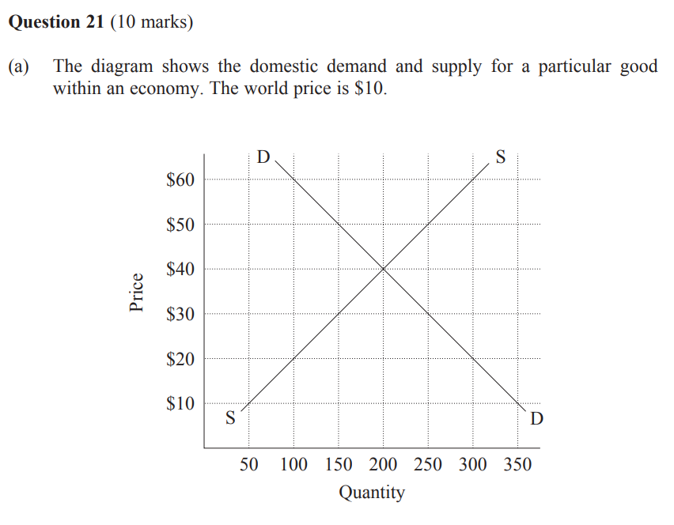
Note: pause after students attempt each question and ask all students to hold up their answers on mini whiteboards or in their exercise books. Scan the responses to see if most students are correct before moving on. If you see common errors, reteach that step immediately rather than continuing. For more information on this explicit teaching strategy, see Checking for understanding.
- Label the world price of $10 on the diagram.
- At the world price of $10 what is the quantity supplied domestically?
- At the world price of $10 what is the quantity demanded domestically?
- At the world price of $10 what is the level of imports?
- Label the tariff of $20 added to the world price.
- When the tariff of $20 is added to the world price, what is the new quantity supplied domestically? Calculate the change in the total level of supply.
- When the tariff of $20 is added to the world price, what is the new quantity demanded domestically? Calculate the change in the total level of demand.
- When the tariff of $20 is added to the world price, what is the new level of imports? Calculate the change in the total level of imports.
- When the tariff of $20 is added to the world price, calculate the government tariff revenue.
Differentiation: encourage High Potential and Gifted (HPGE) students to calculate consumer surplus, domestic producer surplus, foreign producer surplus and deadweight loss following the implementation of the tariff.

Activity 6 – effects of tariffs
Note: this activity introduces a large amount of subject-specific vocabulary. Teachers may need to explain terms such as average effective tariff rate, ‘reciprocal’ tariffs, draconian tariffs and asymmetric trade war before starting the activity. For EAL/D learners, consider pre-teaching key vocabulary and using visual aids or glossaries to support understanding. As both texts may be dense and conceptually complex, teachers could read the articles with the whole class and prompt students at different sections where answers can be found. Additionally, teachers might develop a simplified resource that condenses the content into a more accessible, learner-friendly format to help students focus on the most relevant ideas.
Read Understanding the Global Macroeconomic Impacts of Trump’s Tariffs and identify the effects of tariffs on the following groups:
- domestic consumers
- domestic producers
- government
- foreign producers.
Using the article Understanding the Global Macroeconomic Impacts of Trump’s Tariffs and What Are Tariffs and How Do They Affect You? to complete Table 4 below. Be sure to carefully consider both the short-term and long-term implications.
Table 4 – effects of tariffs
Group | Short-term | Long-term
Domestic consumers
Domestic producers
Government
Foreign producers

Learning sequence 3 – methods of protection – subsidies
The following activities focus on subsidies as a protectionist policy and their economic effects.

Learning intentions and success criteria
Note: these learning intentions and success criteria are general and should be contextualised to suit your school and students’ needs. Success criteria can be differentiated depending on the starting point of diverse students. For more information on this explicit teaching strategy, see Sharing success criteria.
Learning intention
Students learn about:
- subsidies as a protection method and their economic effects.
Success criteria
Students will be able to:
- define subsidy
- interpret subsidy diagrams
- calculate the size of the subsidy
- explain the effects of subsidies on the domestic and global economy.

Activity 7 – defining subsidy
As a class define the term subsidy using The A to Z of economics | The Economist and complete the vocabulary tracker table.
Subsidy
Money paid by a government, usually to one of 2 groups. The first is consumers, to encourage them to buy a product or to keep prices down. The second is businesses, either to keep them from going bust or to set up in a certain area.

Activity 8 – interpreting subsidy diagrams
Using Question 23 from the Economics 2020 HSC exam pack, identify and annotate the following features on the subsidy diagram.
Figure 2 – subsidy diagram
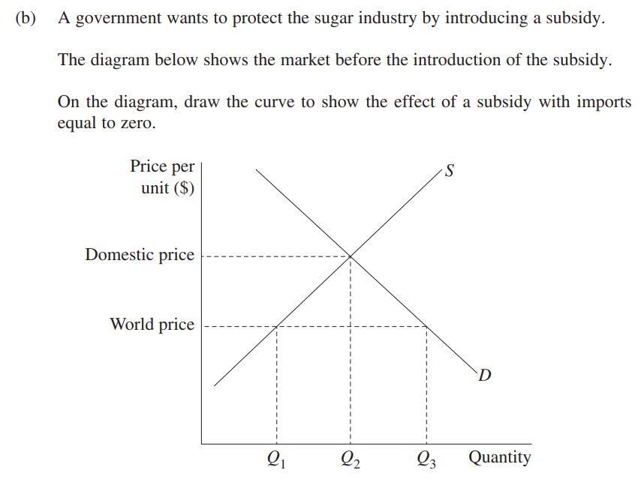
Note: pause after students attempt each question and ask all students to hold up their answers on mini whiteboards or in their exercise books. Scan the responses to see if most students are correct before moving on. If you see common errors, reteach that step immediately rather than continuing. For more information on this explicit teaching strategy, see Checking for understanding.
- Label the world price on the diagram.
- At the world price identify the quantity supplied domestically.
- At the world price identify the quantity demanded domestically.
- At the world price identify the level of imports.
- At the world price, what quantity level would result in zero imports?
- Draw a new supply curve to show the effect of a subsidy with imports equal to zero.
- Annotate the diagram to identify the size of the subsidy.

Activity 9 – carousel activity costs and benefits of a subsidy
You will be divided into groups of 3 to 4 to assess the costs and benefits of a subsidy. There will be 5 stations around the room and you will have 5 minutes to brainstorm responses to the guiding question at each station. Use the article Understanding Government Subsidies: Types, Benefits, and Drawbacks to help complete your response.
You must read the previous groups’ responses, then add new ideas, build on or challenge existing ones.
Table 5 – carousel station 1 – costs and benefits of a subsidy on consumers
Benefits of a subsidy | Costs of a subsidy
Table 6 – carousel station 2 – costs and benefits of a subsidy on domestic producers
Benefits of a subsidy | Costs of a subsidy
Table 7 – carousel station 3 – costs and benefits of a subsidy on foreign producers
Benefits of a subsidy | Costs of a subsidy
Table 8 – carousel station 4 – costs and benefits of a subsidy on government
Benefits of a subsidy | Costs of a subsidy
Table 9 – carousel station 5 – costs and benefits of a subsidy on the global economy
Benefits of a subsidy | Costs of a subsidy

Activity 10 – short answer writing activity
To consolidate learning from the carousel activity, complete an HSC style short answer writing activity for the following question:
- Analyse the costs and benefits of a subsidy on the domestic and global economy.
Note: teachers may need to model writing structure using ‘I do, we do, you do’, and Writing scaffolds can help support the completion of the activity. Checking for understanding is used throughout the modelling to inform the teacher if students are ready to move to the guided (we do) phase, or if the skill needs to be taught again. Worked examples can provide guidance for students to refer to throughout the ‘we do’ and ‘you do’ phases. Non-examples can also be used to clarify common errors and misconceptions. Question starters and prompts are provided in Table 10 for guided support. For more information on this explicit teaching strategy, see Gradual release of responsibility.
Question starters and prompts
- How do subsidies affect consumers in terms of prices and choice?
- How do subsidies affect domestic producers?
- How do subsidies help industries compete with cheaper imports?
- What are the financial costs to the government?
- Consider the opportunity cost, what else could the government spend that money on?
- How do subsidies in one country affect global prices and trade patterns?
- Consider how subsidies might distort global prices, affecting developing nations.

Learning sequence 4 – methods of protection – quotas
The following activities focus on quotas as a protectionist policy and their economic effects.

Learning intentions and success criteria
Note: these learning intentions and success criteria are general and should be contextualised to suit your school and students’ needs. Success criteria can be differentiated depending on the starting point of diverse students. For more information on this explicit teaching strategy, see Sharing success criteria.
Learning intention
Students learn about:
- quotas as a protection method and their economic effects.
Success criteria
Students will be able to:
- define quota
- interpret quota diagrams
- calculate the size of the quota
- explain the effects of quotas on the domestic and global economy.

Activity 11 – defining quota
As a class define the term quota using The A to Z of economics | The Economist and complete the vocabulary tracker table.
Quota
A trade barrier that limits the number, or monetary value, of goods that a country imports.

Activity 12 – interpreting quota diagrams
Using the diagram from Question 19 and 20 from the Economics 2019 HSC exam pack, identify and annotate the following features on the quota diagram.
Figure 3 – quota diagram
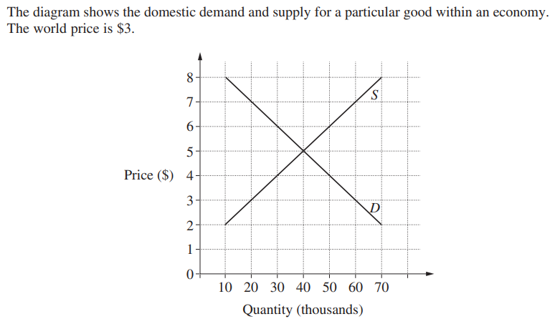
Note: pause after students attempt each question and ask all students to hold up their answers on mini whiteboards or in their exercise books. Scan the responses to see if most students are correct before moving on. If you see common errors, reteach that step immediately rather than continuing. For more information on this explicit teaching strategy, see Checking for understanding.
- Label the world price of $3 on the diagram.
- At the world price identify the quantity supplied domestically.
- At the world price identify the quantity demanded domestically.
- At the world price identify the level of imports.
- The import quota is 20,000 items. Label this on the diagram.
- At the quota of 20,000 units, what is the change in the total level of supply?
- At the quota of 20,000 units, what is the change in the total level of demand?

Activity 13 – expert jigsaw effects of quotas
You will be divided into 5 expert groups to assess the effects of quotas on your assigned stakeholder. Each group will engage with What Is a Quota? and analyse the positive and negative impacts of the quota on their stakeholder.
Each group will prepare a summary of their findings and make a balanced judgement about whether the overall effect was positive or negative. You will then be reorganised into new groups comprising one member from each expert group. In these new groups, you will teach your area of expertise to your peers.
- Group 1 – domestic consumers
- Group 2 – domestic producers
- Group 3 – foreign producers
- Group 4 – government
- Group 5 – overall domestic and global economy
Note: teachers may need to model using ‘I do, we do, you do’ to support the completion of the activity. One group from the list above can be completed as a class or as a modelled example. For more information on this explicit teaching strategy, see Gradual release of responsibility.

Activity 14 – mini debate
You will be divided into 2 groups and assigned one of the following:
- Group A – tariff advocates
- Group B – quota advocates
Each group will need to present a short summary to the following statement: ‘Are tariffs or quotas more effective at protecting domestic industries?’ Each group must:
- outline 3 reasons that support their argument
- use at least one diagram to support their argument
- present one real world example to support their argument.
Note: teachers are encouraged to adapt the number of groups to meet the learning needs of their students and classroom context. Facilitating multiple debates ensures all students are provided with meaningful opportunities to engage in collaborative discussion, critical thinking and the application of economic concepts.

Learning sequence 5 – methods of protection – local content rules
The following activities focus on local content rules as a protectionist policy and their economic effects.

Learning intentions and success criteria
Note: these learning intentions and success criteria are general and should be contextualised to suit your school and students’ needs. Success criteria can be differentiated depending on the starting point of diverse students. For more information on this explicit teaching strategy, see Sharing success criteria.
Learning intention
Students learn about:
- local content rules as a protection method and their economic effects.
Success criteria
Students will be able to:
- define local content rules
- explain the effects of local content rules on the domestic and global economy.

Activity 15 – defining local content rules
As a class define the term local content rules using Local Content – Quickonomics and complete the vocabulary tracker table.
Local content rules
Local content refers to the quota of locally sourced materials, products, labour and services that must be used in various industries, particularly within projects or operations that are foreign-funded or international.

Activity 16 – plus, minus, interesting (PMI)
Engage with the media article Australia has backed away from plans to introduce local quotas on streaming platforms – again and complete a Plus, Minus, Interesting (PMI) individually or in groups, covering the positive and negative effects of local content rules on streaming platforms.
Once you have completed this activity respond to the following questions:
- What are local content rules and what role have they historically played in Australia’s media industry?
- Should local content rules be introduced on streaming services in Australia? Why or why not?
- Who benefits the most from this policy and who might be disadvantaged? Why?

Learning sequence 6 – methods of protection – export incentives
The following activities focus on export incentives as a protectionist policy and their economic effects.

Learning intentions and success criteria
Note: these learning intentions and success criteria are general and should be contextualised to suit your school and students’ needs. Success criteria can be differentiated depending on the starting point of diverse students. For more information on this explicit teaching strategy, see Sharing success criteria.
Learning intention
Students learn about:
- identifying and explaining export incentives as a protection method and their economic effects.
Success criteria
Students will be able to:
- define export incentives
- explain the effects of export incentives on the domestic and global economy.

Activity 17 – defining export incentives
As a class define the term export incentives using Export Incentives –Quickonomics and complete the vocabulary tracker table.
Export incentives
Export incentives are economic policies or measures implemented by governments to encourage domestic companies to export goods and services abroad. Export incentives can take various forms, including tax reliefs, subsidies, direct financial support, access to cheaper financing and governmental assistance in meeting foreign regulatory requirements.

Activity 18 – effects of export incentives for Aboriginal and/or Torres Strait Islander peoples
Engage with the media article Cairns First Nations tourism operator welcomes the world, with a little help from Austrade to inform responses to the following:
- Describe how Austrade has used export incentives to support Aboriginal and/or Torres Strait Islander businesses.
- Explain 2 economic benefits of export incentives for Aboriginal and/or Torres Strait Islander businesses.
- Do you think the benefits of export incentives outweigh their costs to government? Justify your answer with reference to the article.

Appendix 1 – activity 5 worked examples
Note: the following are worked examples and solutions for the activities outlined in the learning sequence.
- Label the world price of $10 on the diagram.
Draw a horizontal line at $10 on the graph
- At the world price of $10 what is the quantity supplied domestically?
50 units
- At the world price of $10 what is the quantity demanded domestically?
350 units
- At the world price of $10 what is the level of imports?
350 - 50 = 300 units
- Label the tariff of $20 added to the world price.
World price $10 + tariff $20 = $30
Draw a horizontal line at $30 to show the new effective price
- When the tariff of $20 is added to the world price, what is the new quantity supplied domestically? Calculate the change in the total level of supply.
At $30, domestic supply is 150 units
Change in supply: 150 - 50 = 100 units
- When the tariff of $20 is added to the world price, what is the new quantity demanded domestically? Calculate the change in the total level of demand.
At $30, domestic demand is 250 units
Change in demand: 250 - 350 = -100 units
- When the tariff of $20 is added to the world price, what is the new level of imports? Calculate the change in the total level of imports.
At $30, imports are 250 - 150 = 100 units
Change in imports: 300 - 100 = 200 units
- When the tariff of $20 is added to the world price, calculate the government tariff revenue.
Revenue = tariff × imports: $20 × 100 = $2,000

Appendix 2 – activity 8 worked examples
- Label the world price on the diagram.
Draw a horizontal line at the level marked ‘World price’
- At the world price identify the quantity supplied domestically.
Q1
- At the world price identify the quantity demanded domestically.
Q3
- At the world price identify the level of imports.
Q3 to Q1
- At the world price, what quantity level would result in zero imports?
For imports to be zero, domestic supply must equal domestic demand, this happens at Q3
- Draw a new supply curve to show the effect of a subsidy with imports equal to zero.
Draw a new supply curve that intersects the demand curve at Q3
- Annotate the diagram to identify the size of the subsidy.
The subsidy per unit is the vertical distance between the original supply curve (S) and the new supply curve at quantity Q3

Appendix 3 – activity 12 worked examples
- Label the world price of $3 on the diagram.
Draw a horizontal line at $3 on the graph
- At the world price identify the quantity supplied domestically.
20,000 units
- At the world price identify the quantity demanded domestically.
60,000 units
- At the world price identify the level of imports.
60,000 - 20,000 = 40,000 units
- The import quota is 20,000 items. Label this on the diagram.
Draw a horizontal line between 30,000 and 50,000 quantities on the graph
- At the quota of 20,000 units, what is the change in the total level of supply?
30,000 - 20,000 = 10,000 units
- At the quota of 20,000 units, what is the change in the total level of demand?
50,000 - 60,000 = -10,000 units

References
This resource contains NSW Curriculum and syllabus content. The NSW Curriculum is developed by the NSW Education Standards Authority. This content is prepared by NESA for and on behalf of the Crown in right of the State of New South Wales. The material is protected by Crown copyright.
Please refer to the NESA Copyright Disclaimer for more information https://educationstandards.nsw.edu.au/wps/portal/nesa/mini-footer/copyright.
NESA holds the only official and up-to-date versions of the NSW Curriculum and syllabus documents. Please visit the NSW Education Standards Authority (NESA) website https://educationstandards.nsw.edu.au and the NSW Curriculum website https://curriculum.nsw.edu.au.
Economics Stage 6 Syllabus © NSW Education Standards Authority (NESA) for and on behalf of the Crown in right of the State of New South Wales, 2009.

© State of New South Wales (Department of Education), 2025
The copyright material published in this resource is subject to the Copyright Act 1968 (Cth) and is owned by the NSW Department of Education or, where indicated, by a party other than the NSW Department of Education (third-party material).
Copyright material available in this resource and owned by the NSW Department of Education is licensed under a Creative Commons Attribution 4.0 International (CC BY 4.0) license.

This license allows you to share and adapt the material for any purpose, even commercially.
Attribution should be given to © State of New South Wales (Department of Education), 2025.
Material in this resource not available under a Creative Commons license:
- the NSW Department of Education logo, other logos and trademark-protected material
- material owned by a third party that has been reproduced with permission. You will need to obtain permission from the third party to reuse its material.
Links to third-party material and websites
This resource contains material owned by NESA that is reproduced and made available for copying and communication by the NSW Department of Education and their schools for non-commercial educational purposes.
This resource may contain third-party copyright material that is not owned by NESA. Unless indicated otherwise, that third-party material has been copied and communicated to you under the statutory licence in section 113P of the Copyright Act 1968.
Please note that the provided (reading/viewing material/list/links/texts) are a suggestion only and implies no endorsement, by the New South Wales Department of Education, of any author, publisher, or book title. School principals and teachers are best placed to assess the suitability of resources that would complement the curriculum and reflect the needs and interests of their students.
If you use the links provided in this document to access a third-party's website, you acknowledge that the terms of use, including licence terms set out on the third-party's website apply to the use which may be made of the materials on that third-party website or where permitted by the Copyright Act 1968 (Cth). The department accepts no responsibility for content on third-party websites.

