Modern History (Year 12) – teaching support resource
Core study: Democracy and dictatorship 1919–1939

Contents
Overview 3
Planning considerations 3
Suggested timeframe 4
Outcomes 4
Learning sequence 1 – Context 5
Syllabus content 5
Learning intentions 5
Success criteria 5
The Paris Peace Conference and its consequences 6
Resource 1 – background to World War I discussion points 6
Resource 2 – the provisions of the Treaty of Versailles (1919) 7
Resource 3 – minor post-war treaties summary table 8
Learning sequence 2 – Interwar dictatorships 9
Syllabus content 9
Learning intentions 9
Success criteria 9
Key features of TWO dictatorships other than Germany that emerged in the interwar period 10
Resource 4 – key features of dictatorships table 10
Learning sequence 3 – The collapse of German democracy 11
Syllabus content 11
Learning intentions 11
Success criteria 11
Political, economic and social challenges to the Weimar Republic 1919–1933 12
Resource 5 – challenges to the Weimar Republic table 12
Learning sequence 4 – Source analysis: interpreting evidence for the Nazi regime in power 1933–1939 13
Syllabus content 13
Learning intentions 13
Success criteria 13
Resource 6 – double Venn diagram for source analysis 14
Resource 7 – quadruple Venn diagram for source analysis 15
The nature and role of Nazi ideology 16
Resource 8 – evidence of Nazi ideology in sources 16
Resource 9 – blackline map 17
The impact of Nazi ideology and policies on Jewish people and other minorities, women, youth and workers 18
Resource 10 – triple Venn diagram for source analysis 18
Methods of control: laws, censorship, propaganda, repression and terror 19
Resource 11 – evidence of Nazi propaganda in sources 19
Opposition to the Nazi regime 20
Resource 12 – comparison of opposition groups 20
Generic resources 21
Resource 13 – capacity matrix 21
Resource 14 – concept map 24
Resource 15 – timeline scaffold 25
Resource 16 – PEEL scaffold 26
Resource 17 – PMI chart 27
Resource 18 – KWLH chart 28
Resource 19 – Think-Pair-Share scaffold 29
Resource 20 – Frayer diagram 30
References 31

Overview
This teaching support resource supports the associated learning program and should be considered in conjunction with the program and related resources. The activities provided for this learning sequence are designed to allow students to engage with the Core Study: Democracy and dictatorship 1919–1939 focus area.
Through a focus on the nature of political authority between 1919 and 1939, students investigate the rise of authoritarian, fascist and militarist movements after the First World War, what drew people to these movements, and the regimes that emerged.
Through a study of Germany, students develop an understanding of how a democracy can collapse, the impact of dictatorship on a society, the elimination of individual freedoms, and the threats that dictatorships can pose to peace and security.
When investigating content in the Source analysis content group, students analyse and interpret a range of sources as evidence for the Nazi regime in power from 1933 to 1939.
The historical concepts and skills content is to be integrated as appropriate.
Suggested learning intentions and success criteria have been provided to demonstrate how they might be written. Learning intentions and success criteria are most effective when they are contextualised to meet the needs of students. Teachers might edit those provided and can write and use additional learning intentions and success criteria. Learning intentions and success criteria are both an explicit teaching and formative assessment strategy.
Consider the Universal Design for Learning principles of engagement, representation and expression in conjunction with this teaching support resource when planning for teaching and learning.

Planning considerations
Registration and evaluation of teaching and learning activities are useful to enhance student outcomes. Ensure registrations and evaluations are in line with school procedures, department policies and NESA requirements. Overall program evaluation advice is provided at the end of the sample program of learning.

Suggested timeframe
This learning sequence is designed to be completed over a period of approximately 30 hours. This duration can be adapted to suit the school context.

Outcomes
A student:
- MH-12-01 analyses continuity and change in the modern world
- MH-12-03 assesses the role and significance of forces, ideas, events, individuals and groups in shaping the past
- MH-12-04 analyses the different perspectives of individuals and groups in their historical context
- MH-12-05 evaluates different types of sources for evidence to support a historical account or argument
- MH-12-06 evaluates differing interpretations and representations of the past
- MH-12-07 communicates historical understanding, integrating historical knowledge, terms and concepts
Modern History 11–12 Syllabus © NSW Education Standards Authority (NESA) for and on behalf of the Crown in right of the State of New South Wales, 2024.

Learning sequence 1 – Context
Approximate duration 3 hours.

Syllabus content
- The Paris Peace Conference and its consequences

Learning intentions
Students learn about:
- the origin, purpose and content of the Paris Peace Conference which ended World War I
- the consequences of the Paris Peace Conference which ended World War I.

Success criteria
Students will be able to:
- analyse the events leading to the armistice of 11 November 1918
- write a one-paragraph analysis of each peace treaty that ended World War I including a list of the key consequences of each treaty and its relationship to internationalism.

The Paris Peace Conference and its consequences

Resource 1 – background to World War I discussion points
Note: teachers might use the notes below to support a co-creation of a concept map detailing students’ background knowledge of World War I.
Long-term causes include: nationalism, imperialism, militarism, colonial competition in East and West Africa, unresolved tensions from the Franco-Prussian War (1870), unification of Germany (1871), alliance system, secret diplomacy, increase in German naval power, decline of the Ottoman Empire in the Balkans, expansion of Austria-Hungary in the Balkans.
Short-term causes include: assassination of Archduke Franz Ferdinand of Austria-Hungary in Sarajevo on 28 June 1914, the so-called ‘blank cheque’ offered by Germany to Austria-Hungary on 5 July 1914, Austria-Hungary’s declaration of war against Serbia on 28 July 1914, mobilisation in Russia on 29 July 1914, German activation of the Schlieffen Plan on 1 August 1914 leading to a British declaration of war on 4 August 1914 to meet obligations under the Treaty of London (1839).
Geography: Western Front (France, Belgium), Eastern Front (Russia), Mediterranean (Gallipoli), the Atlantic (naval war), Africa (Egypt, North Africa, South-West Africa, East Africa, Cameroon, Togoland), the Balkans and Asia (Mesopotamia, Persia, Aden, Palestine, Pacific Islands).
Technology: aircraft (Zeppelin, aeroplanes, balloons), aircraft carriers, submarines, gas, tanks, periscope rifles, machine guns, trenches, undermining enemy positions.
Progression: conflict initially concentrated on the Western Front but gradually spread, introduction of unrestricted submarine warfare, Russian withdrawal from war, American entry to war, warfare at varying intensities over time and geography: high intensity conflict on Western and Eastern fronts during 1915–17 at Somme, Ypres, Passchendaele, Fromelles, Tannenberg, Masurian Lakes.
Conclusion: armistice favouring Germany between Russia and Central Powers on 15 December 1917 following Bolshevik Revolution with peace secured by Treaty of Brest-Litovsk on 3 March 1918, armistice favouring Entente Powers between Germany and Entente Powers on 11 November 1918 following the Hundred Days Offensive with peace secured by the Treaty of Versailles on 28 June 1919 (superseding Treaty of Brest-Litovsk).

Resource 2 – the provisions of the Treaty of Versailles (1919)
Table 1 – summary of the provisions of the Treaty of Versailles (1919)
Part | Article | Content
I | 1–26 | Establishes the League of Nations
II | 27–30 | Establishes the boundaries of Germany
III | 42–44 | Demilitarisation of Rhineland
 | 45–50 | Expropriation of coal from Saarland to France
 | 51–79 | Return of the territory of Alsace-Lorraine to France
 | 87–93 | Creation of the Polish Corridor (dividing East and West Prussia)
 | 100 | Creation of the free city of Danzig (Gdansk)
 | 116 | Establishment of independent Eastern European states
IV | 118 | Germany forfeits control over all colonial territories
V | 160 | German army limited in size to 100,000 soldiers
 | 179 | German military prohibited deployment outside of German territory
 | 181 | German military prohibited from possessing submarines
 | 198 | German military prohibited from maintaining an air force
VI | 214–226 | Agreement on the repatriation of prisoners of war
VII | 227–230 | Provision for the trial of German wartime leaders including the Kaiser
VIII | 231 | Germany accepts responsibility for World War I (the ‘war guilt clause’)
 | 232–244 | Germany agrees to pay reparations in the amount of 132 billion gold marks
 | 245 | Germany agrees to return loot seized during the Franco-Prussian War (1870-71)
XIV | 428–432 | Provision for French occupation of the Ruhr Valley
 | 433 | Germany agrees to abrogate (ignore) the Treaty of Brest-Litovsk (1918)
XV | 434–440 | Provisions for administering the Treaty of Versailles (1919)

Resource 3 – minor post-war treaties summary table
Table 2 – minor post-war treaties summary table
Treaty name | Date of signing | Parties to treaty | Key terms of treaty
Treaty of Saint-German-en-Laye
Treaty of Neuilly-sur-Seine
Treaty of Trianon
Treaty of Sèvres

Learning sequence 2 – Interwar dictatorships
Approximate duration 6 hours.

Syllabus content
- Conditions that enabled dictators to rise to power in the interwar period
- Key features of TWO dictatorships other than Germany that emerged in the interwar period

Learning intentions
Students learn about:
- how and why dictatorships emerged between World War I and World War II
- what the dictatorships that emerged between World War I and World War II were like.

Success criteria
Students will be able to:
- write a structured, logical and coherent 2-paragraph summary assessing how and why dictatorships emerged between World War I and World War II using key terms and evidence
- categorise and analyse the common and differing features of dictatorships using a table or similar graphic organiser.

Key features of TWO dictatorships other than Germany that emerged in the interwar period

Resource 4 – key features of dictatorships table
Table 3 – key features of dictatorships table with indicators
Category | Indicator | Soviet Union | Italy | Germany
Political | Political purges
 | Cult of personality
 | Patronage of allies
 | Electoral fraud
Social | Discriminatory policies
 | Manipulating demography
 | Distrust of private life
 | Public displays of loyalty
Economic | Centralisation
 | Nationalisation
 | Industrialisation
 | High expenditure on military
Cultural | Creation of official aesthetic
 | Regulation of cultural space
 | Control of universities
 | Rewriting national histories
Foreign policy | Irredentism
 | Promotion of xenophobia
 | Language policies
 | Requests for appeasement
Other

Learning sequence 3 – The collapse of German democracy
Approximate duration 6 hours.

Syllabus content
- Political, economic and social challenges to the Weimar Republic 1919–1933
- Reasons for the collapse of the Weimar Republic

Learning intentions
Students learn about:
- political, economic and social challenges to the Weimar Republic
- reasons for the collapse of the Weimar Republic.

Success criteria
Students will be able to:
- evaluate interpretations of the nature and extent of challenges to the Weimar Republic
- write a 3-paragraph assessment of how significant the collapse of the Weimar Republic was for the rise of Nazism with reference to reasons for the failure of democracy.

Political, economic and social challenges to the Weimar Republic 1919–1933

Resource 5 – challenges to the Weimar Republic table
Table 4 – challenges to the Weimar Republic summary table
Political challenges | Economic challenges | Social challenges

Learning sequence 4 – Source analysis: interpreting evidence for the Nazi regime in power 1933–1939
Approximate duration 15 hours.

Syllabus content
- The initial consolidation of Nazi power 1933–1934
- The nature and role of Nazi ideology
- The impact of Nazi ideology and policies on Jewish people and other minorities, women, youth and workers
- Methods of control: laws, censorship, propaganda, repression and terror
- Opposition to the Nazi regime

Learning intentions
Students learn about:
- Nazism in Germany to 1939 including rise to power, ideology and repression
- consequences of Nazism for minority groups, persecution and growth of opposition.

Success criteria
Students will be able to:
- use sources to analyse the nature and effects of Nazism in Germany to 1939
- write a 3-paragraph, evidenced evaluation of the consequences of Nazism.

Resource 6 – double Venn diagram for source analysis
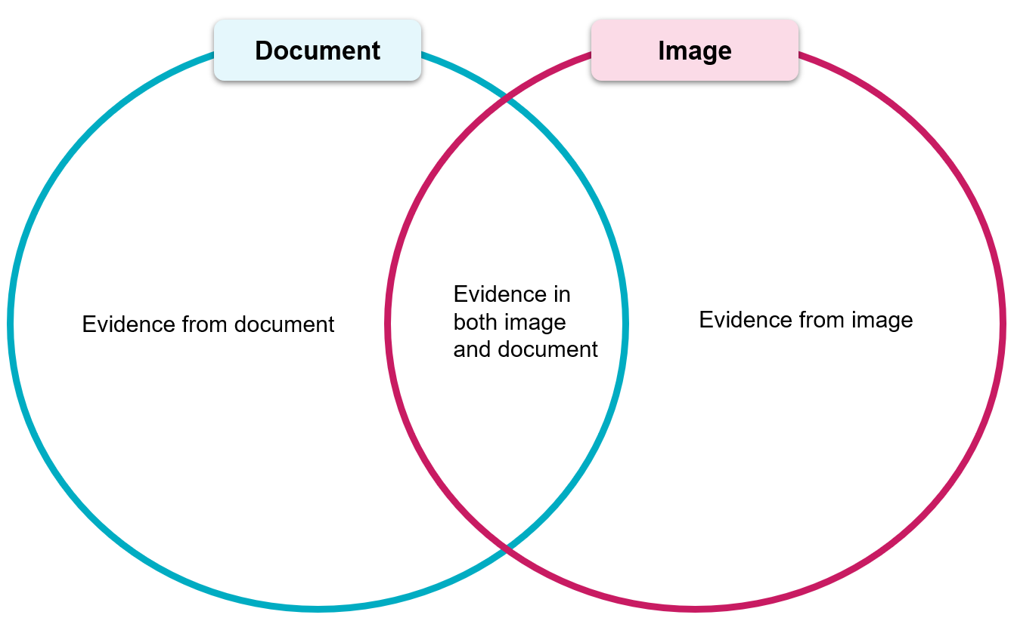

Resource 7 – quadruple Venn diagram for source analysis
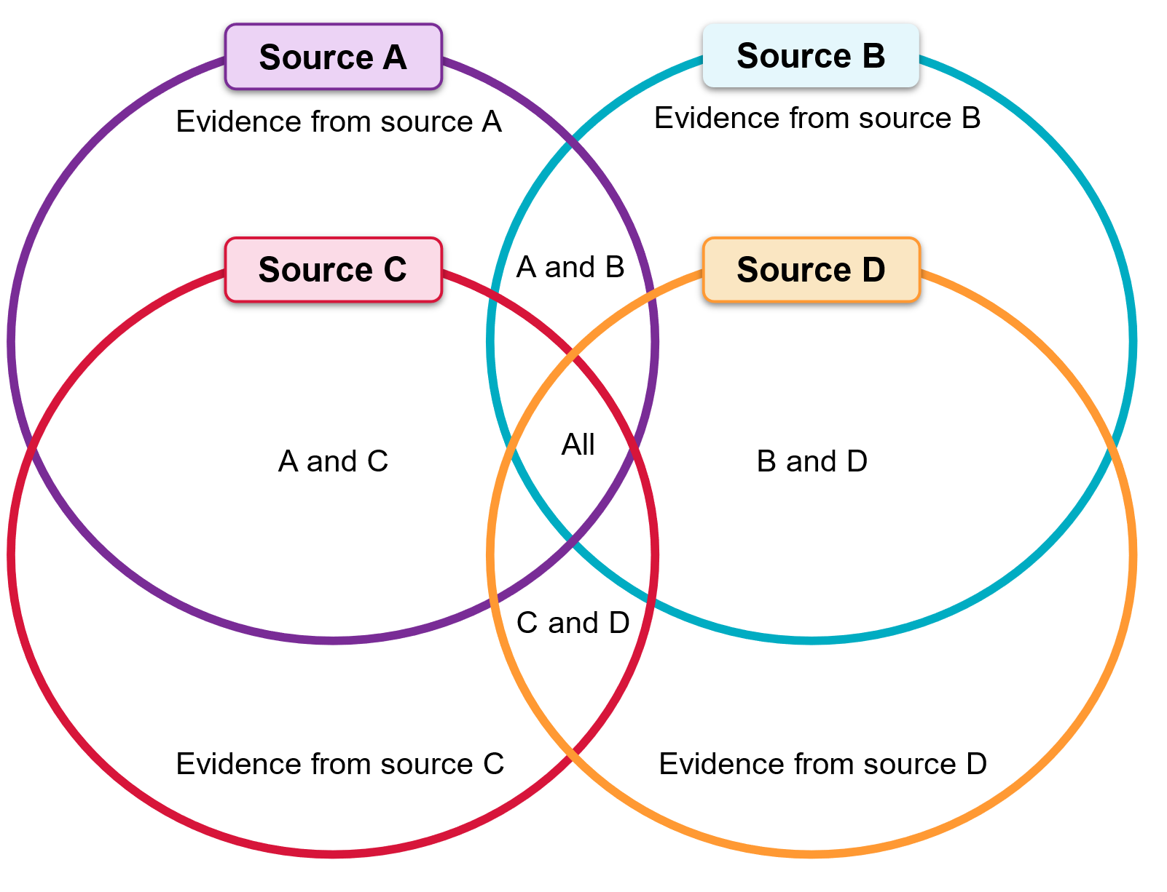

The nature and role of Nazi ideology

Resource 8 – evidence of Nazi ideology in sources
Table 5 – evidence of Nazi ideology in sources summary table
Source name | Evidence of ideology | Explanation of representation of ideology

Resource 9 – blackline map
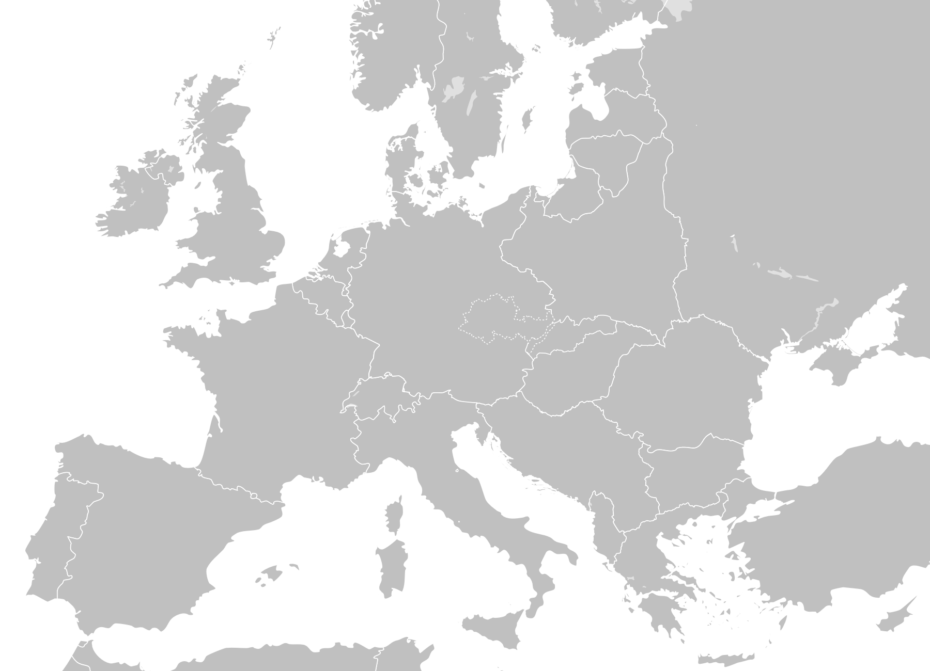
‘Blank map of Europe’ by Nordwestern is licensed under Attribution-Share Alike 4.0 International.

The impact of Nazi ideology and policies on Jewish people and other minorities, women, youth and workers

Resource 10 – triple Venn diagram for source analysis
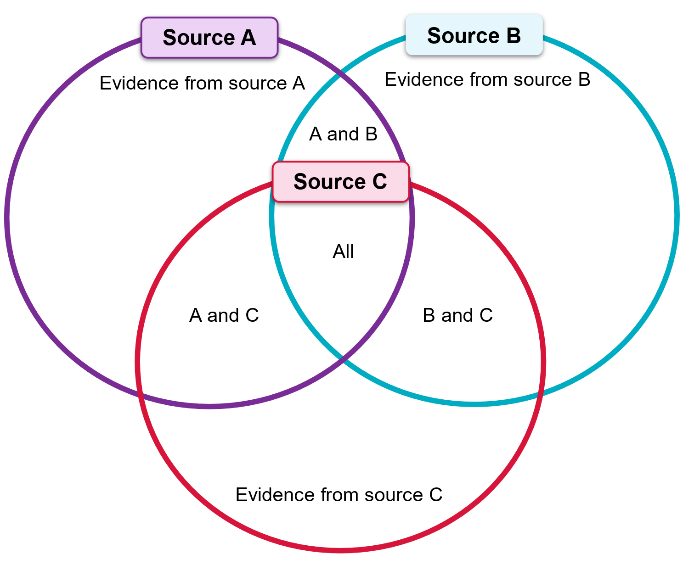

Methods of control: laws, censorship, propaganda, repression and terror

Resource 11 – evidence of Nazi propaganda in sources
Table 6 – evidence of Nazi propaganda in sources summary table
Source name | Evidence of propaganda | Analysis of intended effect of propaganda

Opposition to the Nazi regime

Resource 12 – comparison of opposition groups
Table 7 – comparison of opposition groups summary table
Attribute | Opposition group 1: ____________ | Opposition group 2: ____________
Key figures
Reasons for opposition to Nazism
Strategies used to oppose Nazism
Outcomes of opposition to Nazism

Generic resources

Resource 13 – capacity matrix
Note: a general concept and glossary list has been included. However, you might wish to add further terminology or skills to the matrix. Students should use different colours for the matrix criteria and shade or tick what they think they are according to the matrix categories for each term.
information – at this level, you have heard of the term and/or you can recall basic facts about it
knowledge – at this level, you can explain and know what the term or concept means
know-how – at this level, you can draw connections between this geographical term or concept and relate it to other concepts or situations
wisdom – at this level, you can use the term or concept in new contexts or teach others

Table 8 – sample capacity matrix
Term | Information | Knowledge | Know-how | Wisdom
Continuity and change | ☐ | ☐ | ☐ | ☐
Cause and effect | ☐ | ☐ | ☐ | ☐
Perspective | ☐ | ☐ | ☐ | ☐
Significance | ☐ | ☐ | ☐ | ☐
Contestability | ☐ | ☐ | ☐ | ☐
Authorship | ☐ | ☐ | ☐ | ☐
Bias | ☐ | ☐ | ☐ | ☐
Context | ☐ | ☐ | ☐ | ☐
Limitations | ☐ | ☐ | ☐ | ☐
Motivations | ☐ | ☐ | ☐ | ☐
Origin | ☐ | ☐ | ☐ | ☐
Purpose | ☐ | ☐ | ☐ | ☐
Reliability | ☐ | ☐ | ☐ | ☐
Validity | ☐ | ☐ | ☐ | ☐
Value | ☐ | ☐ | ☐ | ☐
Usefulness | ☐ | ☐ | ☐ | ☐
Table 9 – blank capacity matrix
Term | Information | Knowledge | Know-how | Wisdom
 | ☐ | ☐ | ☐ | ☐
 | ☐ | ☐ | ☐ | ☐
 | ☐ | ☐ | ☐ | ☐
 | ☐ | ☐ | ☐ | ☐
 | ☐ | ☐ | ☐ | ☐
 | ☐ | ☐ | ☐ | ☐
 | ☐ | ☐ | ☐ | ☐
 | ☐ | ☐ | ☐ | ☐
 | ☐ | ☐ | ☐ | ☐
 | ☐ | ☐ | ☐ | ☐
 | ☐ | ☐ | ☐ | ☐
 | ☐ | ☐ | ☐ | ☐
 | ☐ | ☐ | ☐ | ☐
 | ☐ | ☐ | ☐ | ☐
 | ☐ | ☐ | ☐ | ☐
 | ☐ | ☐ | ☐ | ☐

Resource 14 – concept map
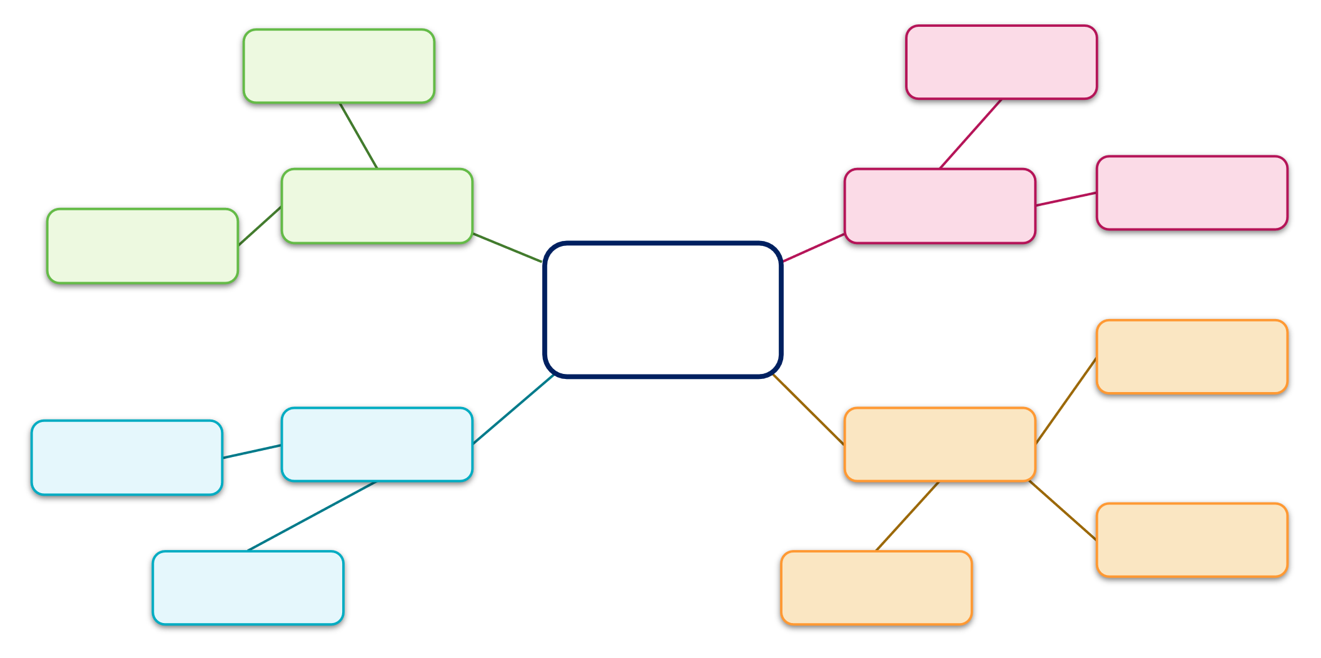

Resource 15 – timeline scaffold
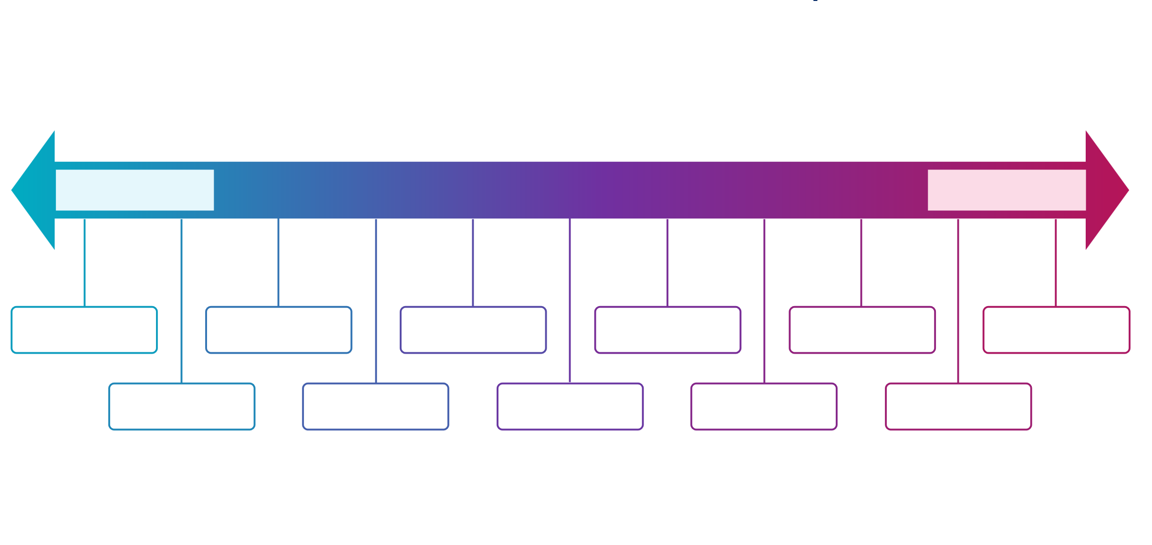

Resource 16 – PEEL scaffold
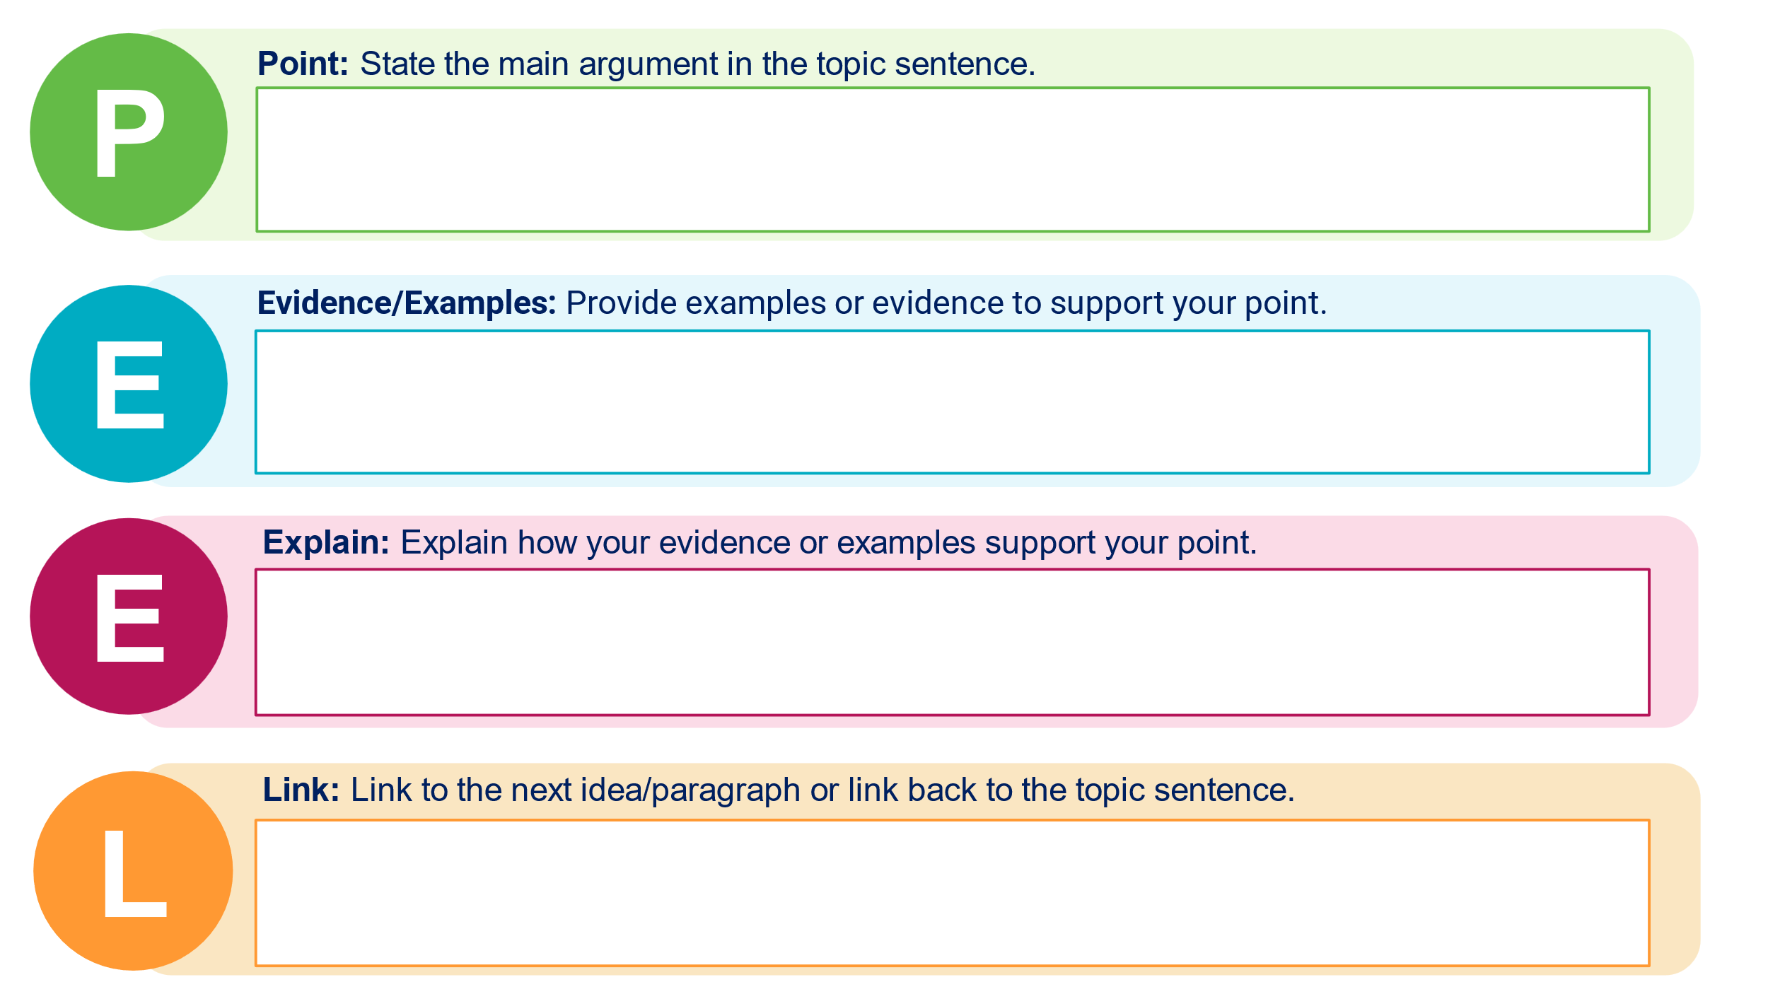

Resource 17 – PMI chart



Resource 18 – KWLH chart

Resource 19 – Think-Pair-Share scaffold


Resource 20 – Frayer diagram
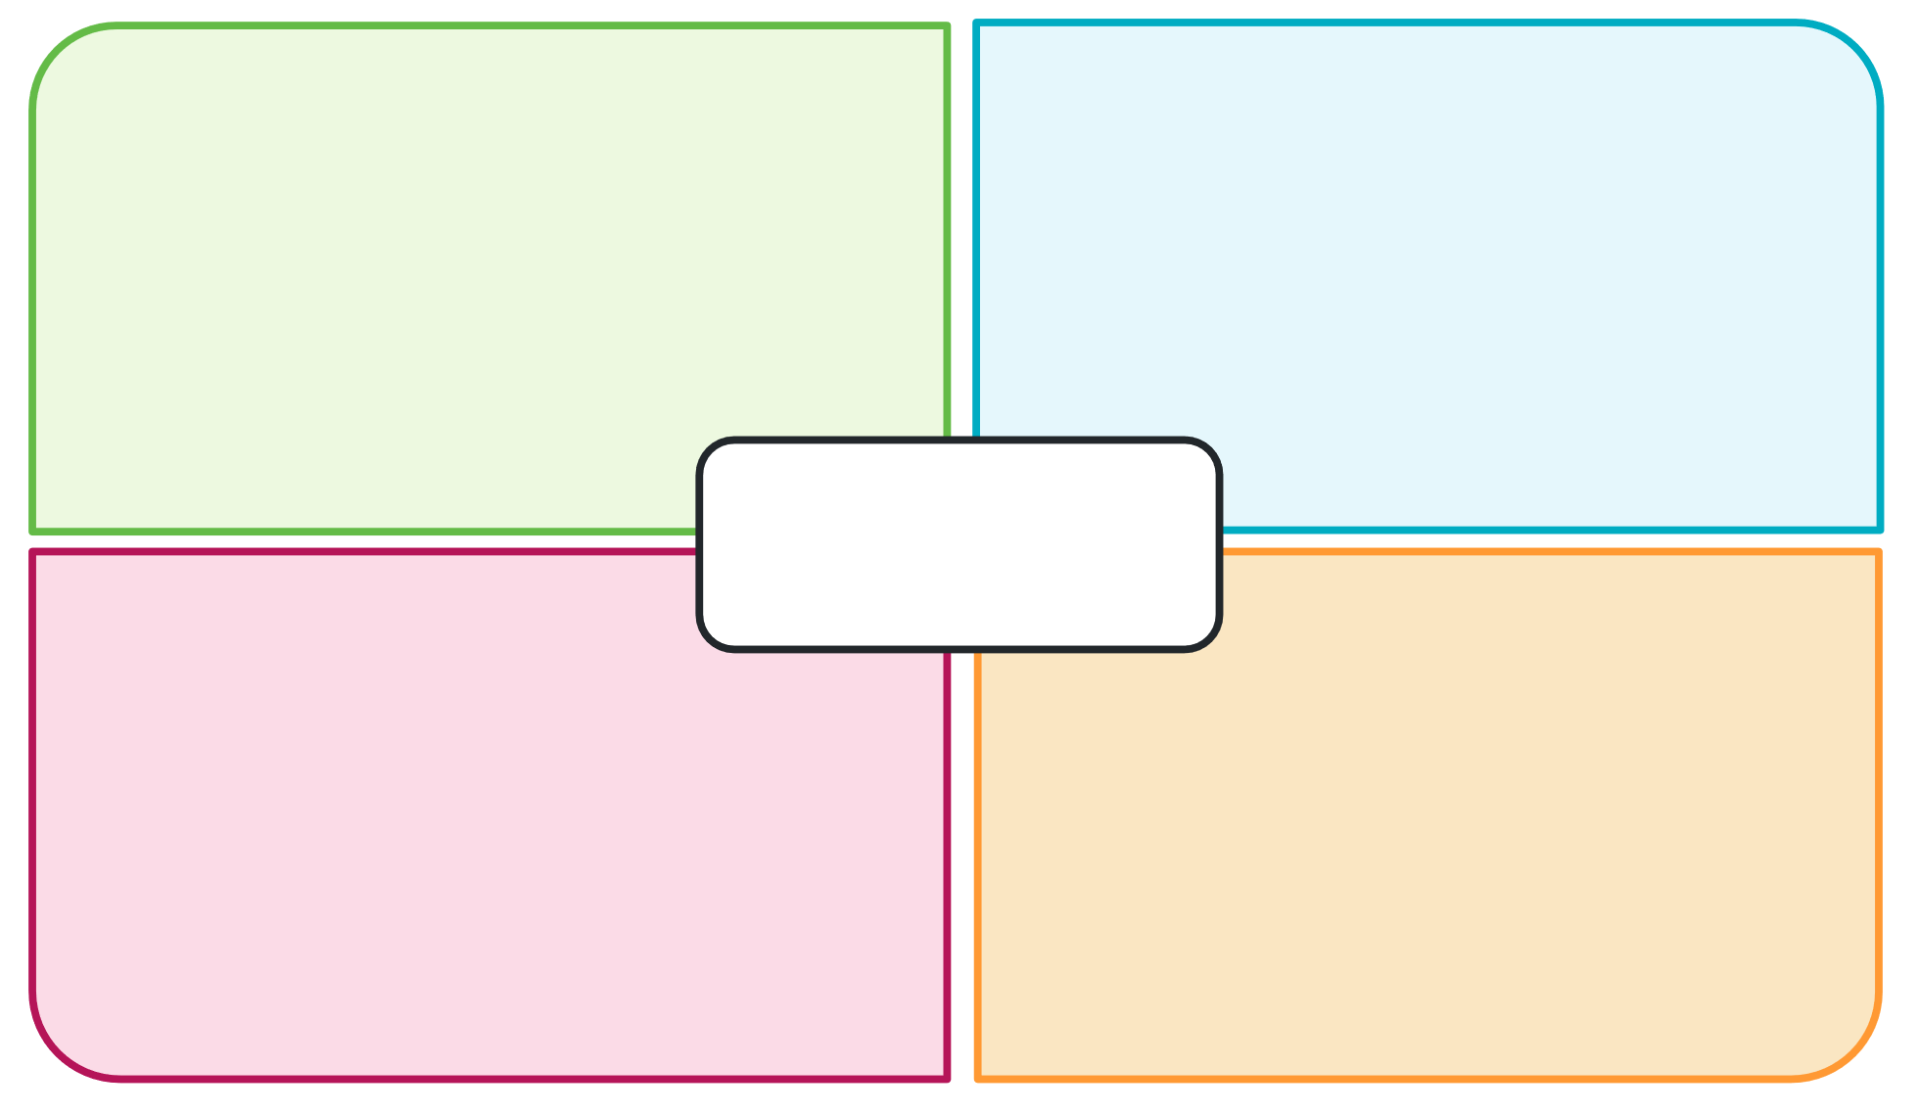

References
This resource contains NSW Curriculum and syllabus content. The NSW Curriculum is developed by the NSW Education Standards Authority. This content is prepared by NESA for and on behalf of the Crown in right of the State of New South Wales. The material is protected by Crown copyright.
Please refer to the NESA Copyright Disclaimer for more information https://educationstandards.nsw.edu.au/wps/portal/nesa/mini-footer/copyright.
NESA holds the only official and up-to-date versions of the NSW Curriculum and syllabus documents. Please visit the NSW Education Standards Authority (NESA) website https://educationstandards.nsw.edu.au and the NSW Curriculum website https://curriculum.nsw.edu.au.
Modern History 11–12 Syllabus © NSW Education Standards Authority (NESA) for and on behalf of the Crown in right of the State of New South Wales, 2024.
AITSL (Australian Institute for Teaching and School Leadership Limited) (n.d.) Learning intentions and success criteria [PDF 251 KB], AITSL website, accessed 20 September 2024.
AITSL (2017) ‘Feedback Factsheet’, AITSL website, accessed 20 September 2024.
Aly G and Heim S (2003) Architects of Annihilation: Auschwitz and the Logic of Destruction, Phoenix.
Arendt H (1951) The Origins of Totalitarianism, 1st edn, Schocken Books, New York.
Baranowski S (2011) Nazi Empire: German Colonialism and Imperialism from Bismarck to Hitler, 1st edn, Cambridge University Press, Cambridge.
Bergerson AS (2004) Ordinary Germans in Extraordinary Times: The Nazi Revolution in Hildesheim, 1st edn, Indiana University Press, Bloomington.
Bergmeier HJP and Lotz RE (1997) Hitler’s Airwaves: The Inside Story of Nazi Radio Broadcasting and Propaganda Swing, 1st edn, Yale University Press, New Haven.
Berman S (13 May 2021) ‘Revisiting “Civil Society and the Collapse of the Weimar Republic”’, HistPhil, accessed 20 September 2024.
Brookhart S (2011) How to Assess Higher-Order Thinking Skills in Your Classroom, Hawker Brownlow Education, Victoria.
Broszat M (2013) The Hitler State: The foundation and development of the internal structure of the Third Reich, Routledge, London.
Browning CR (2001) Ordinary Men: Reserve Police Battalion 101 and the Final Solution in Poland, Penguin, London.
CESE (Centre for Education Statistics and Evaluation) (2020) What works best: 2020 update, NSW Department of Education website, accessed 20 September 2024.
CESE (2020) What works best in practice, NSW Department of Education website, accessed 20 September 2024.
Cohrs P (2006) The Unfinished Peace After World War I: America, Britain and the Stabilisation of Europe 1919–1932, 1st edn, Cambridge University Press, Cambridge.
Evans RJ (2005) The Coming of the Third Reich: How the Nazis Destroyed Democracy and Seized Power in Germany, 1st edn, Penguin Press, New York.
Evans RJ (2006) The Third Reich in Power: How the Nazis Won Over the Hearts and Minds of a Nation, 1st edn, Penguin Press, New York.
Evans RJ (2009) The Third Reich at War, 1st edn, Penguin Press, New York.
Evans RJ (2024) Hitler’s People: The Faces of the Third Reich, 1st edn, Allen Lane, London.
Geddes B, Wright J and Frantz E (2018) How Dictatorships Work: Power, Personalization, and Collapse, 1st edn, Cambridge University Press, Cambridge.
Gellately R (2001) Backing Hitler: Consent and Coercion in Nazi Germany, 1st edn, Oxford University Press, Oxford.
Gellately R and Stoltzfus N (eds) (2018) Social Outsiders in Nazi Germany, 1st edn, Princeton University Press, Princeton.
German History in Documents and Images (GHDI) (2024) Nazi Germany 1933-1945, GHDI website, accessed 20 September 2024.
Gerwarth R (2017) The Vanquished: Why the First World War Failed to End, 1917-1923, 1st edn, Penguin Press, London.
Goldhagen DJ (1996) Hitler’s Willing Executioners: Ordinary Germans and the Holocaust, Little, Brown and Company, Boston.
Gresham College (2024) The First World War: 100th Anniversary Lectures, Gresham College website, accessed 20 September 2024.
Hathaway O & Shapiro S (2018) The Internationalists: How a Radical Plan to Outlaw War Remade the World, 1st edn, Simon & Schuster, New York.
Henig R (1995) Versailles and After, 1919-1933, 2nd edn, Routledge, London.
Hermann-Beck LEJ (eds) (2018) From Weimar to Hitler: Studies in the Dissolution of the Weimar Republic and the Establishment of the Third Reich, 1932-1934, 1st edn, Berghahn Books, Oxford.
Jackson P, Mulligan W and Sluga G (eds) (2023) Peacemaking and International Order after the First World War, 1st edn, Cambridge University Press, Cambridge.
Kershaw I (1987) The “Hitler myth”: Image and Reality in the Third Reich, 1st edn, Clarendon Press, Oxford.
Kershaw I (2008) Hitler, the Germans, and the Final Solution, 1st edn, International Institute for Holocaust Research, Yad Vashem, Jerusalem.
Lillian Goldman Law Library (2024) The Avalon Project – Documents in Law, History and Diplomacy, Yale Law School website, accessed 20 September 2024.
Macmillan M (2001) Peacemakers: The Paris Peace Conference of 1919 and Its Attempt to End War, 1st edn, John Murray, Toronto.
Macmillan M (2007) Paris 1919: Six Months That Changed the World, 1st edn, Random House Publishing, London.
McElligott A (2013) Rethinking the Weimar Republic: authority and authoritarianism, 1916-1936, 1st edn, Bloomsbury Publishing, London.
McKenzie F (2023) Rebuilding the Postwar Order: Peace, Security and the UN-System, 1941-1948, 1st edn, Bloomsbury Academic, London.
Meierhenrich J (2018) The Remnants of the Rechtsstaat: An Ethnography of Nazi Law, 1st edn, Oxford University Press, Oxford.
Mommsen H (ed) (2001) The Third Reich Between Vision and Reality: New Perspectives on German History 1918-1945, Berg, UK.
Moses AD (2021) The Problems of Genocide: Permanent Security and the Language of Transgression, Cambridge University Press, Cambridge.
NESA (NSW Education Standards Authority) (2022) ‘Advice on units’, Programming, NESA website, accessed 20 September 2024.
——(2022) ‘Proficient Teacher Standard Descriptors’, Achieve Proficient Teacher Accreditation, NESA website, accessed 20 September 2024.
——(2022) ‘Programming’, Understanding the curriculum, NESA website, accessed 20 September 2024.
Nicosia FR and Stokes LD (eds) (2015) Germans Against Nazism: Nonconformity, Opposition and Resistance in the Third Reich: Essays in Honour of Peter Hoffmann, 1st edn, Berghahn Books, Oxford.
Pedersen S (2015) The Guardians: The League of Nations and the Crisis of Empire, 1st edn, Oxford University Press, Oxford.
Rosenshine B (2012) ‘Principles of Instruction: Research-Based Strategies That All Teachers Should Know’, American Educator, 36(1):12–19, accessed 20 September 2024.
Satia P (2008) Spies in Arabia: The Great War and the Cultural Foundations of Britain's Covert Empire in the Middle East, 1st edn, Oxford University Press, Oxford.
Sharp A (1991) The Versailles Settlement: Peacemaking in Paris, 1919, 1st edn, St Martin’s Press, New York.
Shirane S (2022) Imperial Gateway: Colonial Taiwan and Japan’s Expansion in South China and Southeast Asia, 1895–1945, 1st edn, Cornell University Press, Ithaca.
Smith L (2018) Sovereignty at the Paris Peace Conference of 1919, 1st edn, Oxford University Press, Oxford.
Steiner Z (2005) The Lights that Failed: European International History 1919-1933, 1st edn, Oxford University Press, Oxford.
Steiner Z (2011) The Triumph of the Dark: European International History 1933-1939, 1st edn, Oxford University Press, Oxford.
TED-Ed (19 July 2016) ‘How did Hitler rise to power? – Alex Gendler and Anthony Hazard’ [video], TED-Ed, YouTube, accessed 20 September 2024.
TED-Ed (4 September 2019) ‘The secret student resistance to Hitler – Iseult Gillespie’ [video], TED-Ed, YouTube, accessed 20 September 2024.
The White Rose Project and the University of Oxford (2024) White Rose Project [website], accessed 20 September 2024.
Tooze A (2014) The Deluge: The Great War, America and the Remaking of the Global Order, 1916-1931, 1st edn, Penguin Publishing, New York.
Traverso E (2017) ‘Totalitarianism between history and theory’, History and Theory: Studies in the Philosophy of History, 56(4):97–118, doi.org/10.1111/hith.12040, accessed 20 September 2024.
United States Holocaust Memorial Museum (2024) ‘Holocaust Literature Guide’, Holocaust Lesson Plans, United States Holocaust Memorial Museum website, accessed 20 September 2024.
Vascik GS & Sadler MR (2016) The Stab-in-the-Back Myth and the Fall of the Weimar Republic: A History in Documents and Visual Sources, 1st edn, Bloomsbury Publishing, London.
Wiliam D (2013) ‘Assessment: The bridge between teaching and learning’, Voices from the Middle, 21(2):15–20, doi:10.58680/vm201324461, accessed 20 September 2024.
Wiliam D (2017) Embedded Formative Assessment, 2nd edn, Solution Tree Press, Bloomington, IN.
Wisniewski B, Zierer K and Hattie J (2020) ‘The Power of Feedback Revisited: A Meta-Analysis of Educational Feedback Research’, Frontiers In Psychology, 10:3087, doi:10.3389/fpsyg.2019.03087, accessed 20 September 2024.
Yad Vashem: The World Holocaust Remembrance Centre (28 October 2020) ‘Teaching the Holocaust’, Yad Vashem, accessed 20 September 2024.
© State of New South Wales (Department of Education), 2025
The copyright material published in this resource is subject to the Copyright Act 1968 (Cth) and is owned by the NSW Department of Education or, where indicated, by a party other than the NSW Department of Education (third-party material).
Copyright material available in this resource and owned by the NSW Department of Education is licensed under a Creative Commons Attribution 4.0 International (CC BY 4.0) license.

This license allows you to share and adapt the material for any purpose, even commercially.
Attribution should be given to © State of New South Wales (Department of Education), 2025.
Material in this resource not available under a Creative Commons license:
- the NSW Department of Education logo, other logos and trademark-protected material
- material owned by a third party that has been reproduced with permission. You will need to obtain permission from the third party to reuse its material.
Links to third-party material and websites
Please note that the provided (reading/viewing material/list/links/texts) are a suggestion only and implies no endorsement, by the New South Wales Department of Education, of any author, publisher, or book title. School principals and teachers are best placed to assess the suitability of resources that would complement the curriculum and reflect the needs and interests of their students.
If you use the links provided in this document to access a third-party's website, you acknowledge that the terms of use, including licence terms set out on the third-party's website apply to the use which may be made of the materials on that third-party website or where permitted by the Copyright Act 1968 (Cth). The department accepts no responsibility for content on third-party websites.

