Modern History (Year 12) – sample assessment task
Core study: Democracy and dictatorship 1919–1939

Contents
Overview 2
Assessment task – source-based short responses 3
Outcomes 3
Task description 3
Exemplar sources 4
Exemplar question paper 7
Core study: Democracy and dictatorship 1919–1939 (25 marks) 7
Marking guidelines 12
Support documentation 16
Triple Venn diagram 16
PEEL paragraph template 17
Checklist of content and skills to revise 18
Syllabus content 18
General skills identified in the syllabus 18
Steps to success 19
References 20

Overview
This assessment task forms part of the Scope and sequence – modern history 11–12 and is designed for use during implementation of Program – democracy and dictatorship, Year 12. It should be considered in conjunction with the sample assessment schedule, program and related resources.
The activities in this sample assessment task are designed to allow students to develop their skills in creating written texts in response to historical sources. Teachers should consider delivering this task under examination conditions to provide students with experience in responding to previously unseen sources. Teachers should consider delivering this task under examination conditions to provide students with experience in responding to previously unseen sources.
The sample questions, sources and marking criteria provide teachers and students with guidance as to the types of questions that might appear in a source-analysis task aligned to the Core study: Democracy and dictatorship 1919–1939. They are not meant to be prescriptive. Teachers should consult the annotated sample examination materials that are provided by NESA to understand how the HSC examination may be structured in this subject.
The NSW Department of Education publishes a range of curriculum support materials, including samples of lesson sequences, scope and sequences, assessment tasks, examinations, student and teacher resource booklets, and curriculum planning and curriculum evaluation templates. The samples are not exhaustive and do not represent the only way to complete or engage in each of these processes. Curriculum design and implementation is a dynamic and contextually-specific process. While mandatory components of syllabus implementation must be met by all schools, it is important the approach taken by teachers is reflective of their needs, and faculty or school processes.

Assessment task – source-based short responses
Type of task: source-based short responses
Suggested weighting: 20%
Date of task: [insert here as per school requirements]
Suggested time allocation: 50 minutes (45 minutes writing time, 5 minutes reading time)
Special requirements: [insert here as per school requirements]

Outcomes
A student:
- MH-12-04 analyses the different perspectives of individuals and groups in their historical context
- MH-12-05 evaluates different types of sources for evidence to support a historical account or argument
Modern History 11–12 Syllabus © NSW Education Standards Authority (NESA) for and on behalf of the Crown in right of the State of New South Wales, 2024.

Task description
This task will help to prepare you for Section 1 of the HSC examination. You will have 5 minutes reading time to familiarise yourself with the sources and questions associated with the task.
At the end of the reading time, you will have 45 minutes writing time to answer 4 questions related to the Core study: Democracy and dictatorship 1919–1939. In your answers, you will need to:
- integrate evidence from sources to support your response
- apply your knowledge of context content points where appropriate
- apply your understanding of historical concepts and skills.

Exemplar sources
Source A – a political poster produced by the Social Democratic Party of Germany (SPD) in 1932. The text on the poster reads: ‘The Third Reich!’.
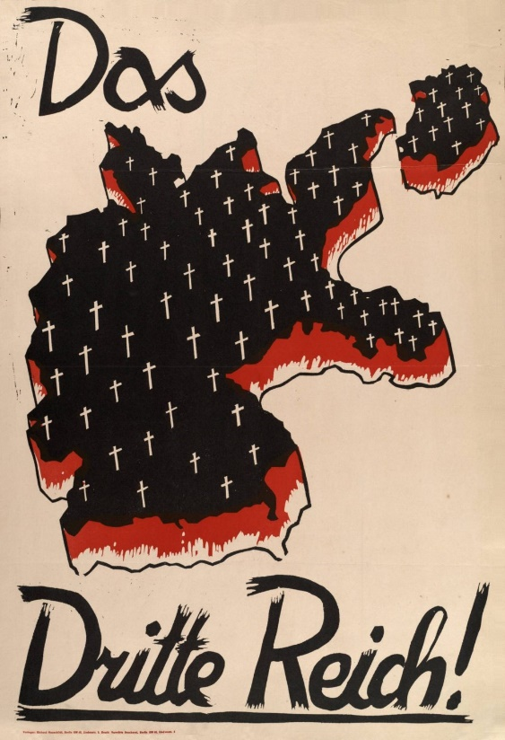
‘The Third Reich!’ by the Social Democratic Party of Germany (SPD) is available in the public domain.
Source B – ‘SS Command – A – No. 65’ (the ‘Engagement and Marriage Order’) issued by Reichsführer SS, Heinrich Himmler on 31 December 1931. Translated by the Office of United States Chief of Council for Prosecution of Axis Criminality.
- The SS is a band of German men of strictly Aryan descent.
- In accordance with National Socialist ideology, the future of our Volk [people] rests upon the preservation of the race through the selection and healthy inheritance of good blood, I hereby institute the ‘Marriage Certificate’ for all unmarried members of the SS, effective 1 January 1932.
- The desired aim is to create a hereditarily healthy clan of a strictly Aryan German sort.
- The marriage certificate will be awarded or denied solely on the basis of racial health.
- Every SS man who intends to get married must procure for this purpose the marriage certificate from the Reichsführer SS.
- SS members who marry despite having been denied marriage certificates will be expelled from the SS unless they terminate the marriage.
‘SS Command – A – No. 65’ (the ‘Engagement and Marriage Order’) by Heinrich Himmler and translated by the Office of United States Chief of Council for Prosecution of Axis Criminality is available in the public domain.
Source C – excerpts from the minutes (record) of a conference held in the Reich Chancellery, Berlin, on 5 November 1937 between Adolf Hitler and Field Marshal von Blomberg (War Minister), Colonel General Baron von Fritsch (Commander in Chief, Army), Admiral Dr. H.C. Raeder, (Commander in Chief, Navy), Colonel General Göring, (Commander in Chief, Luftwaffe) and Baron von Neurath (Foreign Minister).
Adolf Hitler: ‘The aim of German policy was to make secure and to preserve the people’s community and to enlarge it. It was therefore a question of space. The German racial community comprised over 85 million people and, because of their number and the narrow limits of habitable space in Europe, it constituted a tightly packed racial core such as was not to be met in any other country and such as implied the right to a greater living space than in the case of other peoples. To arrest the decline of Germanism in Austria and Czechoslovakia was as little possible as to maintain the present level in Germany itself. However, before turning to the question of solving the need for space, it had to be considered whether a solution holding promise for the future was to be reached by means of autarky or by means of an increased participation in the world economy.’
‘The minutes of a conference held in the Reich Chancellery, Berlin, on 5 November 1937’ by the Reich Cabinet and translated by the US Department of State is available in the public domain.
Source D – excerpts from Article 48 of the Constitution of the German Reich (Weimar Constitution), ratified on 11 August 1919.
Part 1: In the event of a State not fulfilling the obligations imposed upon it by the Reich Constitution or by the laws of the Reich, the president of the Reich may make use of the armed forces to compel it to do so.
Part 2: If public security and order are seriously disturbed or endangered within the German Reich, the president of the Reich may take measures necessary for their restoration, intervening if need be with the assistance of the armed forces. For this purpose he may suspend for a while, in whole or in part, the fundamental rights provided in Articles 114, 115, 117, 118, 123, 124 and 153.
‘Constitution of the German Reich (Weimar Constitution)’ is available in the public domain.
Source E – excerpt from the text: Wiesen SJ and Swett P (2024) Nazi Germany (1933-45).
Many of the book burnings were organized by university students, as members of the National Socialist German Students’ League (NSDStB). Younger party supporters, mobilized in the Hitler Youth, also orchestrated many of these acts of terror and cultural violence at their schools. The point of the bonfires was to do away with culture and learning that was thought to represent a ‘non-German spirit’. This attack was aimed at Jewish authors (based on Nazi categories) as well as non-Jewish authors whose ideas did not reflect National Socialist ideology.
For example, Erich Maria Remarque’s famous novel All Quiet on the Western Front was frequently targeted for its ‘pacifist’ critique of war. While book burnings culminated in the ‘Action against the Un-German Spirit’ orchestrated by the National Socialist German Students’ League in May 1933, National Socialist groups organized book burnings prior and after the ‘Action against the Un-German Spirit’ as well. In the city of Kaiserlautern, for example, members of the local NSDAP chapter publicly burned copies of All Quiet on the Western Front from the local library in late March, followed by another book burning in May, organized by the Hitler Youth.
‘Nazi Germany (1933-45)’ by Wiesen SJ and Swett P is licensed under CC BY-NC-ND 4.0.

Exemplar question paper

Core study: Democracy and dictatorship 1919–1939 (25 marks)
Task instructions:
- attempt Questions 1 to 4
- refer to the Sources A to E to answer Questions 1 to 4
- answer the questions in the spaces provided.
Your answer will be assessed on how well you:
- analyse the different perspectives of individuals and groups in their historical context
- evaluate different types of sources for evidence to support a historical account or argument
- evaluate differing interpretations and representations of the past
- communicate information that is relevant to the question in a logical manner
- use historical terms and concepts appropriately.
Question 1 (3 marks)
Describe the features of opposition to the Nazi regime. Use Source A to support your answer.
Question 2 (5 marks)
How do Sources B and C help historians to understand the nature and role of Nazi ideology in Nazi Germany?
Question 3 (6 marks)
What is the value and what are the limitations of Source D for an historian investigating reasons for the collapse of the Weimar Republic?
Question 4 (11 marks)
Evaluate the efforts of the Nazi party to establish a dictatorship in Germany. Integrate perspectives from at least 3 of Sources A, B, C, D and E in your answer.
End of paper

Marking guidelines
Note: these guidelines are designed to support teachers and should be adapted to meet the needs of students and the school context. Teachers should consider unpacking the marking criteria with students as part of sharing success criteria. Ensure effective feedback practices are used in conjunction with marking guidelines to support student learning. Using effective feedback provides guidance on explicit teaching feedback strategies.
Students will be marked on how well they meet the following requirements.
- Answer each source-based question using an appropriate amount of detail and depth.
- Answer each source-based question with detailed reference to the source.
- Demonstrate historical knowledge and understanding relevant to the question.
- Present well-structured answers.
- Use appropriate historical terms and concepts.
Question 1 (3 marks): Describe the features of opposition to the Nazi regime. Use Source A to support your answer.
Table 1 – assessment marking guidelines for Question 1
Grade | Marking guideline descriptors
A to B | - Clearly articulates relevant features of opposition to the Nazi regime  - Integrates evidence from Source A in support of the answer
C to D | - Identifies some features of opposition to the Nazi regime  - References Source A in support of the answer
E | - Makes a general statement about opposition to Nazism and/or makes a general statement about the source
Question 2 (5 marks): How do Sources B and C help historians to understand the nature and role of Nazi ideology in Nazi Germany?
Table 2 – assessment marking guidelines for Question 2
Grade | Marking guideline descriptors
A | - Clearly explains how Source B and Source C contribute to an historical understanding of the nature and role of Nazi ideology in Nazi Germany  - Supports the explanation with relevant details of the nature and role of Nazi ideology in Nazi Germany  - Communicates ideas logically using a range of appropriate historical terms and concepts
B | - Explains how Sources B and/or C contribute to understanding the nature and/or role of Nazi ideology in Nazi Germany  - Supports the explanation with some relevant details of the nature and role of Nazi ideology in Nazi Germany  - Communicates ideas using a range of appropriate historical terms and concepts
C | - Describes how Sources B and/or C relate to understanding the nature and/or role of Nazi ideology in Nazi Germany  - Provides a description of the nature and role of Nazi ideology in Nazi Germany  - Communicates ideas using appropriate historical terms and concepts
D | - Provides a limited description of the nature and role of Nazi ideology in Nazi Germany  - Uses some historical terms and concepts
E | - Makes statements relevant to Nazi Germany
Question 3 (6 marks): What is the value and what are the limitations of Source D for an historian investigating reasons for the collapse of the Weimar Republic?
Table 3 – assessment marking guidelines for Question 3
Grade | Marking guideline descriptors
A | - Clearly identifies the value and limitations of Source D for an historian investigating reasons for the collapse of the Weimar Republic  - Integrates relevant evidence from Source D to support the response  - Communicates ideas logically using a range of appropriate historical terms and concepts
B | - Identifies some of the value and limitations of Source D for an historian investigating reasons for the collapse of the Weimar Republic  - Integrates evidence from Source D to support the response  - Communicates ideas using a range of appropriate historical terms and concepts
C | - Identifies a value and/or limitation of Source D  - Provides evidence from Source D in the response  - Communicates ideas using some appropriate historical terms and concepts
D | - Provides a limited description of either Source D or reasons for the collapse of the Weimar Republic  - References some historical terms and concepts
E | - Makes statements relevant to the Weimar Republic

Question 4 (11 marks): Evaluate the efforts of the Nazi party to establish a dictatorship in Germany. Integrate perspectives from at least 3 of Sources A, B, C, D and E in your answer.
Table 4 – assessment marking guidelines for Question 4
Grade | Marking guideline descriptors
A | - Presents well-developed judgements about the efforts of the Nazi party to establish a dictatorship in Germany  - Effectively integrates perspectives from 3 or more chosen sources with relevant, detailed and accurate historical knowledge to support explanation of historical relationships  - Presents a well-structured, logical and cohesive response using appropriate historical terms and concepts
B | - Makes judgements about the efforts of the Nazi party to establish a dictatorship in Germany  - Integrates perspectives from chosen sources with relevant historical knowledge to support explanation of historical relationships  - Presents a structured response using appropriate historical terms and concepts
C | - Explains the efforts of the Nazi party to establish a dictatorship in Germany  - Uses perspectives from chosen sources and some historical knowledge to support explanation of historical relationships  - Presents a response using appropriate historical terms and concepts
D | - Makes statements about dictatorship and its establishment in Germany  - Refers to source(s) and may use some historical terms and concepts
E | - Makes statements relevant to dictatorship and/or Germany

Support documentation
This documentation is designed to support teachers with implementing the assessment task. It includes:
- Triple Venn diagram to equip students to compare and corroborate sources
- PEEL paragraph scaffold
- checklist of content and skills to revise
- ‘Steps to success’ suggestions to support student preparation for the task.

Triple Venn diagram
Figure 1 – Triple Venn diagram
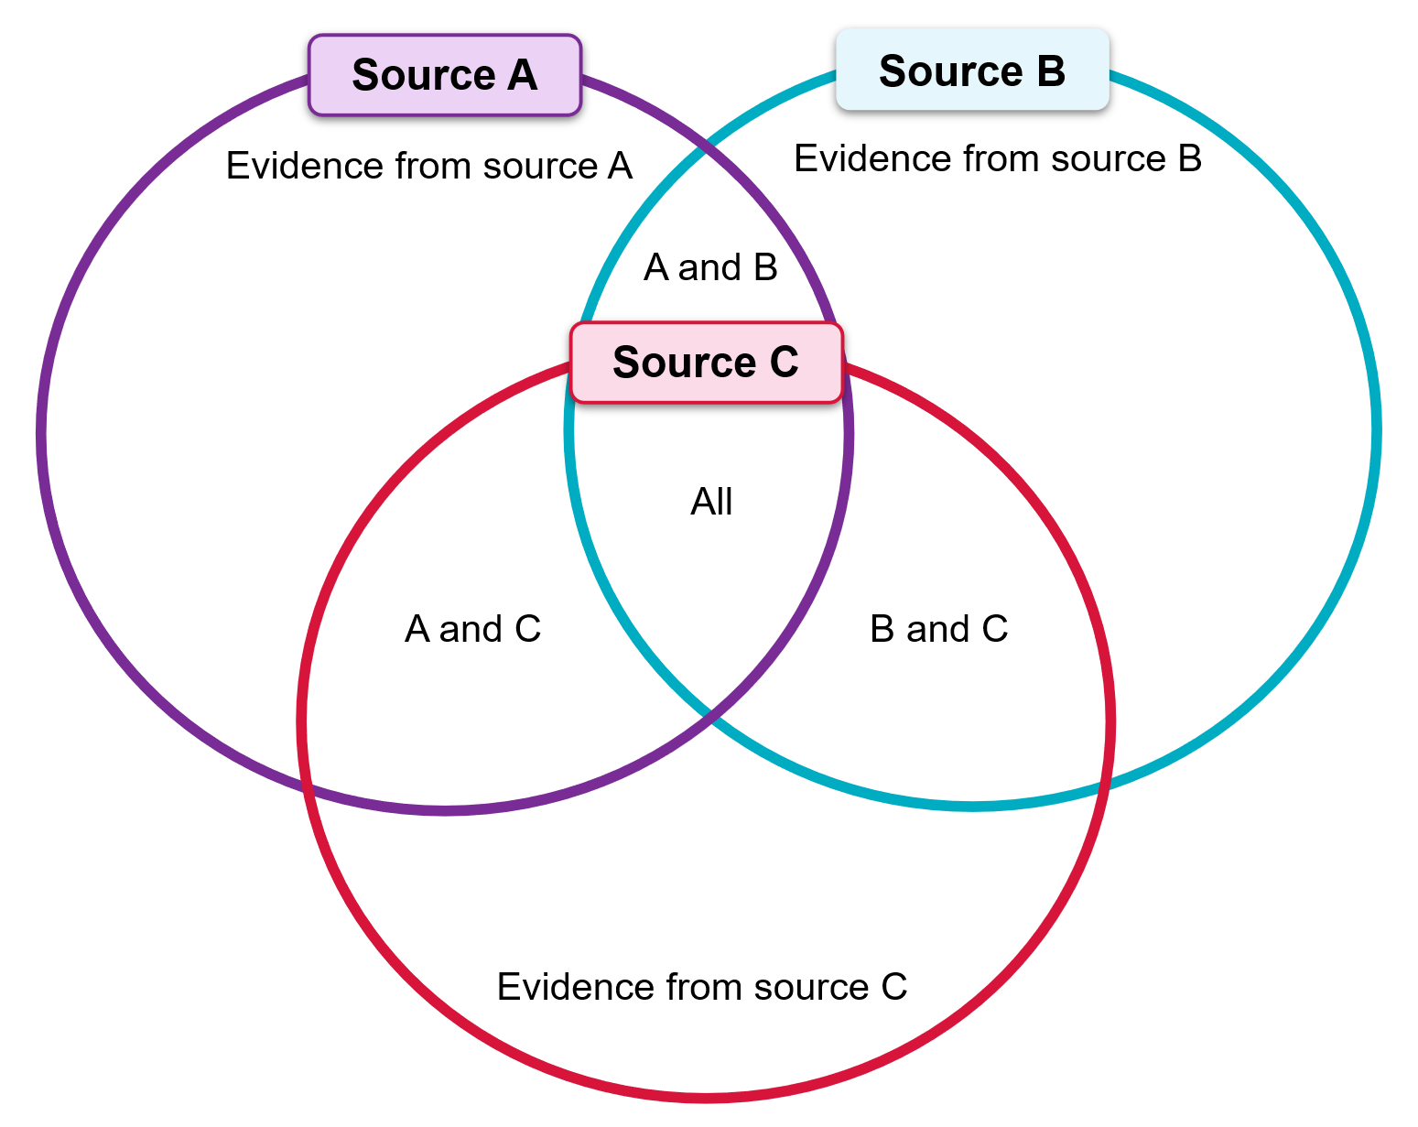

PEEL paragraph template
Figure 2 – PEEL paragraph scaffold
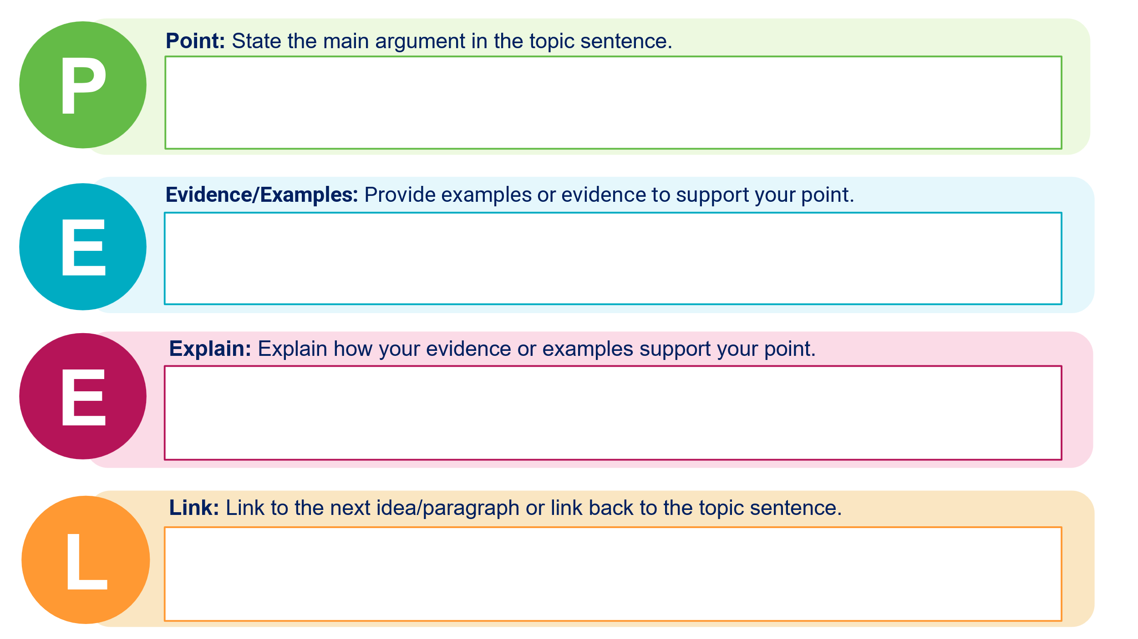

Checklist of content and skills to revise

Syllabus content
Context
- The Paris Peace Conference and its consequences
Interwar dictatorships
- Conditions that enabled dictators to rise to power in the interwar period
- Key features of TWO dictatorships other than Germany that emerged in the interwar period
The collapse of German democracy
- Political, economic and social challenges to the Weimar Republic 1919–1933
- Reasons for the collapse of the Weimar Republic
Source analysis: interpreting the evidence for the Nazi regime in power 1933–1939
- The initial consolidation of Nazi power 1933–1934
- The nature and role of Nazi ideology
- The impact of Nazi ideology and policies on Jewish people and other minorities, women, youth and workers
- Methods of control: laws, censorship, propaganda, repression and terror
- Opposition to the Nazi regime
Modern History 11–12 Syllabus © NSW Education Standards Authority (NESA) for and on behalf of the Crown in right of the State of New South Wales, 2024.

General skills identified in the syllabus
- Identification and analysis of perspectives contained within historical sources
- Evaluation of visual and written sources as evidence to support a historical account or argument in terms of content, origin, motive, audience, usefulness, value and limitations
- Assessment of the extent to which multiple sources corroborate one-another
- Synthesis of evidence from multiple sources to interpret and represent the past

Steps to success
Note: this schedule is designed to support students and is not for compliance. Students should not be penalised for not meeting interim times. This scaffold is designed for chunking and sequencing learning by breaking the task into smaller goals to reduce the complexity. The second column could be:
- determined by the teacher
- co-constructed with students.
Table 5 – assessment preparation schedule
What I need to do | When I need to do it
Revise course content
Revise source analysis skills
Study a range of relevant sources:
Internet Modern History Sourcebook: Nazism
Internet Modern History Sourcebook: Fascism in Europe
Study sample examination materials provided by NESA at:
Modern History 11–12 – Teaching and learning support
Complete practise task using PEEL paragraphs
Engage in self and peer marking of practise task
Submit practise task for teacher feedback

References
This resource contains NSW Curriculum and syllabus content. The NSW Curriculum is developed by the NSW Education Standards Authority. This content is prepared by NESA for and on behalf of the Crown in right of the State of New South Wales. The material is protected by Crown copyright.
Please refer to the NESA Copyright Disclaimer for more information https://educationstandards.nsw.edu.au/wps/portal/nesa/mini-footer/copyright.
NESA holds the only official and up-to-date versions of the NSW Curriculum and syllabus documents. Please visit the NSW Education Standards Authority (NESA) website https://educationstandards.nsw.edu.au and the NSW Curriculum website https://curriculum.nsw.edu.au.
Modern History 11–12 Syllabus © NSW Education Standards Authority (NESA) for and on behalf of the Crown in right of the State of New South Wales, 2024.
AITSL (Australian Institute for Teaching and School Leadership Limited) (n.d.) Learning intentions and success criteria [PDF 251 KB], AITSL website, accessed 20 September 2024.
AITSL (2017) ‘Feedback Factsheet’, AITSL website, accessed 20 September 2024.
Aly G and Heim S (2003) Architects of Annihilation: Auschwitz and the Logic of Destruction, Phoenix.
Arendt H (1951) The Origins of Totalitarianism, 1st edn, Schocken Books, New York.
Baranowski S (2011) Nazi Empire: German Colonialism and Imperialism from Bismarck to Hitler, 1st edn, Cambridge University Press, Cambridge.
Bergerson AS (2004) Ordinary Germans in Extraordinary Times: The Nazi Revolution in Hildesheim, 1st edn, Indiana University Press, Bloomington.
Bergmeier HJP and Lotz RE (1997) Hitler’s Airwaves: The Inside Story of Nazi Radio Broadcasting and Propaganda Swing, 1st edn, Yale University Press, New Haven.
Brookhart S (2011) How to Assess Higher-Order Thinking Skills in Your Classroom, Hawker Brownlow Education, Victoria.
Broszat M (2013) The Hitler State: The foundation and development of the internal structure of the Third Reich, Routledge, London.
Browning CR (2001) Ordinary Men: Reserve Police Battalion 101 and the Final Solution in Poland, Penguin, London.
CESE (Centre for Education Statistics and Evaluation) (2020) What works best: 2020 update, NSW Department of Education website, accessed 20 September 2024.
CESE (2020) What works best in practice, NSW Department of Education website, accessed 20 September 2024.
Cohrs P (2006) The Unfinished Peace After World War I: America, Britain and the Stabilisation of Europe 1919–1932, 1st edn, Cambridge University Press, Cambridge.
Evans RJ (2005) The Coming of the Third Reich: How the Nazis Destroyed Democracy and Seized Power in Germany, 1st edn, Penguin Press, New York.
Evans RJ (2006) The Third Reich in Power: How the Nazis Won Over the Hearts and Minds of a Nation, 1st edn, Penguin Press, New York.
Evans RJ (2009) The Third Reich at War, 1st edn, Penguin Press, New York.
Evans RJ (2024) Hitler’s People: The Faces of the Third Reich, 1st edn, Allen Lane, London.
Geddes B, Wright J and Frantz E (2018) How Dictatorships Work: Power, Personalization, and Collapse, 1st edn, Cambridge University Press, Cambridge.
Gellately R (2001) Backing Hitler: Consent and Coercion in Nazi Germany, 1st edn, Oxford University Press, Oxford.
Gellately R and Stoltzfus N (eds) (2018) Social Outsiders in Nazi Germany, 1st edn, Princeton University Press, Princeton.
German History in Documents and Images (GHDI) (2024) Nazi Germany 1933-1945, GHDI website, accessed 20 September 2024.
Gerwarth R (2017) The Vanquished: Why the First World War Failed to End, 1917-1923, 1st edn, Penguin Press, London.
Goldhagen DJ (1996) Hitler’s Willing Executioners: Ordinary Germans and the Holocaust, Little, Brown and Company, Boston.
Gresham College (2024) The First World War: 100th Anniversary Lectures, Gresham College website, accessed 20 September 2024.
Hathaway O & Shapiro S (2018) The Internationalists: How a Radical Plan to Outlaw War Remade the World, 1st edn, Simon & Schuster, New York.
Henig R (1995) Versailles and After, 1919-1933, 2nd edn, Routledge, London.
Hermann-Beck LEJ (eds) (2018) From Weimar to Hitler: Studies in the Dissolution of the Weimar Republic and the Establishment of the Third Reich, 1932-1934, 1st edn, Berghahn Books, Oxford.
Jackson P, Mulligan W and Sluga G (eds) (2023) Peacemaking and International Order after the First World War, 1st edn, Cambridge University Press, Cambridge.
Kershaw I (1987) The “Hitler myth”: Image and Reality in the Third Reich, 1st edn, Clarendon Press, Oxford.
Kershaw I (2008) Hitler, the Germans, and the Final Solution, 1st edn, International Institute for Holocaust Research, Yad Vashem, Jerusalem.
Lillian Goldman Law Library (2024) The Avalon Project – Documents in Law, History and Diplomacy, Yale Law School website, accessed 20 September 2024.
Macmillan M (2001) Peacemakers: The Paris Peace Conference of 1919 and Its Attempt to End War, 1st edn, John Murray, Toronto.
Macmillan M (2007) Paris 1919: Six Months That Changed the World, 1st edn, Random House Publishing, London.
McElligott A (2013) Rethinking the Weimar Republic: authority and authoritarianism, 1916-1936, 1st edn, Bloomsbury Publishing, London.
McKenzie F (2023) Rebuilding the Postwar Order: Peace, Security and the UN-System, 1941-1948, 1st edn, Bloomsbury Academic, London.
Meierhenrich J (2018) The Remnants of the Rechtsstaat: An Ethnography of Nazi Law, 1st edn, Oxford University Press, Oxford.
Mommsen H (ed) (2001) The Third Reich Between Vision and Reality: New Perspectives on German History 1918-1945, Berg, UK.
Moses AD (2021) The Problems of Genocide: Permanent Security and the Language of Transgression, Cambridge University Press, Cambridge.
NESA (NSW Education Standards Authority) (2022) ‘Advice on units’, Programming, NESA website, accessed 20 September 2024.
——(2022) ‘Proficient Teacher Standard Descriptors’, Achieve Proficient Teacher Accreditation, NESA website, accessed 20 September 2024.
——(2022) ‘Programming’, Understanding the curriculum, NESA website, accessed 20 September 2024.
NESA (NSW Education Standards Authority) (2022) ‘Programming’, Understanding the curriculum, NESA website, accessed 20 September 2024.
Nicosia FR and Stokes LD (eds) (2015) Germans Against Nazism: Nonconformity, Opposition and Resistance in the Third Reich: Essays in Honour of Peter Hoffmann, 1st edn, Berghahn Books, Oxford.
Pedersen S (2015) The Guardians: The League of Nations and the Crisis of Empire, 1st edn, Oxford University Press, Oxford.
Rosenshine B (2012) ‘Principles of Instruction: Research-Based Strategies That All Teachers Should Know’, American Educator, 36(1):12–19, accessed 20 September 2024.
Satia P (2008) Spies in Arabia: The Great War and the Cultural Foundations of Britain's Covert Empire in the Middle East, 1st edn, Oxford University Press, Oxford.
Sharp A (1991) The Versailles Settlement: Peacemaking in Paris, 1919, 1st edn, St Martin’s Press, New York.
Shirane S (2022) Imperial Gateway: Colonial Taiwan and Japan’s Expansion in South China and Southeast Asia, 1895–1945, 1st edn, Cornell University Press, Ithaca.
Smith L (2018) Sovereignty at the Paris Peace Conference of 1919, 1st edn, Oxford University Press, Oxford.
Steiner Z (2005) The Lights that Failed: European International History 1919-1933, 1st edn, Oxford University Press, Oxford.
Steiner Z (2011) The Triumph of the Dark: European International History 1933-1939, 1st edn, Oxford University Press, Oxford.
TED-Ed (19 July 2016) ‘How did Hitler rise to power? – Alex Gendler and Anthony Hazard’ [video], TED-Ed, YouTube, accessed 20 September 2024.
TED-Ed (4 September 2019) ‘The secret student resistance to Hitler – Iseult Gillespie’ [video], TED-Ed, YouTube, accessed 20 September 2024.
The White Rose Project and the University of Oxford (2024) White Rose Project [website], accessed 20 September 2024.
Tooze A (2014) The Deluge: The Great War, America and the Remaking of the Global Order, 1916-1931, 1st edn, Penguin Publishing, New York.
Traverso E (2017) ‘Totalitarianism between history and theory’, History and Theory: Studies in the Philosophy of History, 56(4):97–118, doi.org/10.1111/hith.12040, accessed 20 September 2024.
United States Holocaust Memorial Museum (2024) ‘Holocaust Literature Guide’, Holocaust Lesson Plans, United States Holocaust Memorial Museum website, accessed 20 September 2024.
Vascik GS & Sadler MR (2016) The Stab-in-the-Back Myth and the Fall of the Weimar Republic: A History in Documents and Visual Sources, 1st edn, Bloomsbury Publishing, London.
Wiliam D (2013) ‘Assessment: The bridge between teaching and learning’, Voices from the Middle, 21(2):15–20, doi:10.58680/vm201324461, accessed 20 September 2024.
Wiliam D (2017) Embedded Formative Assessment, 2nd edn, Solution Tree Press, Bloomington, IN.
Wisniewski B, Zierer K and Hattie J (2020) ‘The Power of Feedback Revisited: A Meta-Analysis of Educational Feedback Research’, Frontiers In Psychology, 10:3087, doi:10.3389/fpsyg.2019.03087, accessed 20 September 2024.
Yad Vashem: The World Holocaust Remembrance Centre (28 October 2020) ‘Teaching the Holocaust’, Yad Vashem, accessed 20 September 2024.
© State of New South Wales (Department of Education), 2025
The copyright material published in this resource is subject to the Copyright Act 1968 (Cth) and is owned by the NSW Department of Education or, where indicated, by a party other than the NSW Department of Education (third-party material).
Copyright material available in this resource and owned by the NSW Department of Education is licensed under a Creative Commons Attribution 4.0 International (CC BY 4.0) license.

This license allows you to share and adapt the material for any purpose, even commercially.
Attribution should be given to © State of New South Wales (Department of Education), 2025.
Material in this resource not available under a Creative Commons license:
- the NSW Department of Education logo, other logos and trademark-protected material
- material owned by a third party that has been reproduced with permission. You will need to obtain permission from the third party to reuse its material.
Links to third-party material and websites
Please note that the provided (reading/viewing material/list/links/texts) are a suggestion only and implies no endorsement, by the New South Wales Department of Education, of any author, publisher, or book title. School principals and teachers are best placed to assess the suitability of resources that would complement the curriculum and reflect the needs and interests of their students.
If you use the links provided in this document to access a third-party's website, you acknowledge that the terms of use, including licence terms set out on the third-party's website apply to the use which may be made of the materials on that third-party website or where permitted by the Copyright Act 1968 (Cth). The department accepts no responsibility for content on third-party websites.

