Geography Stage 6 (Year 12)
Global sustainability sample assessment task
Contents
About this resource 2
Purpose 2
Target audience 2
When and how to use this document 2
Task description 3
Content 3
Short answer question 1 (8 marks) 4
Short answer question 2 (7 marks) 6
Short answer question 3 (10 marks) 8
Marking guidelines and sample responses 10
Short answer question 1 (8 marks) 10
Short answer question 2 (7 marks) 12
Short answer question 3 (10 marks) 14
Support and alignment 16
References 17

About this resource

Purpose
This sample assessment task is designed to support teaching and learning in the global sustainability learning program. It is an in-class assessment with a time limit of 45 minutes. It includes 3 short answer questions and is worth a total of 30 marks.
Teacher note: some students may require reasonable adjustments for the 3 short answer questions depending on the resource.
This resource can also be used as:
- an in-class practise item, with teacher support and direction
- a formative assessment tool
- part of a larger assessment task
- a homework task.

Target audience
This resource can be used by teachers to support students studying the global sustainability program.

When and how to use this document
This task is designed to be used in conjunction with the Global sustainability learning program and resource booklet, which can be accessed on the Planning, programming and assessing geography 11–12 webpage.

Task description
Type of task: short answers
Outcomes:
- GE-12-02 analyses geographical processes and influences, at a range of scales, that form and transform places and environments
- GE-12-04 evaluates responses and management strategies, at a range of scales, for sustainability
- GE-12-08 applies mathematical ideas and techniques to analyse complex geographical data
Geography 11–12 Syllabus © NSW Education Standards Authority (NESA) for and on behalf of the Crown in right of the State of New South Wales, 2022.
Weighting: 15%
The task is an in-class assessment with a time limit of 45 minutes.
The task is worth a total of 25 marks.

Content
- Sustainability and sustainable development, including the four pillars of sustainability – social, economic, environmental and cultural
- Principles of ecologically sustainable development – precautionary principle, intergenerational principle, conservation of biological diversity and ecological integrity
- Opportunities and challenges in planning for and achieving global sustainability
- Evaluate the sustainability of one global economic activity, using one or more criteria

Short answer question 1 (8 marks)
Refer to Figure 1 to answer parts (a), (b) and (c).
Figure 1 – data for fish consumption and catch
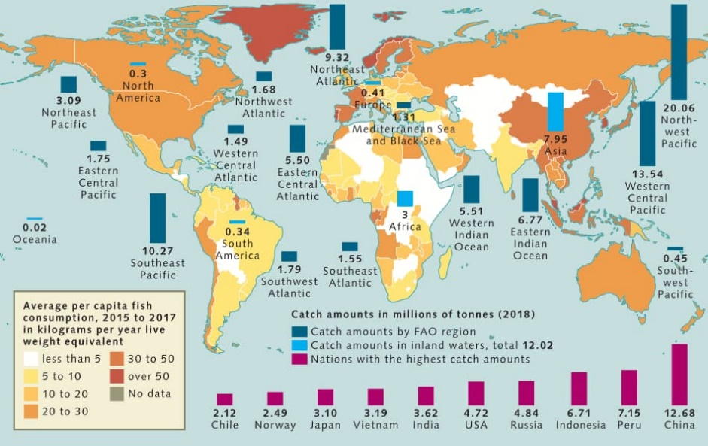
‘FAO, 2020’ by World Ocean Review 7 – chapter 3 and is licensed under CC BY 4.0.
- Which region of the ocean accounts for the highest catch in millions of tonnes of fish for 2020? (1 mark)
- Describe the spatial pattern of consumption of fish indicated by this diagram. (2 marks)

- Explain how the issue of climate change highlights the importance of ONE principle of ecologically sustainable development in managing agricultural practices sustainably. (5 marks)

Short answer question 2 (7 marks)
Refer to Figure 2 to answer parts (a) and (b)
Figure 2 – sustainable development goal 15 explainer
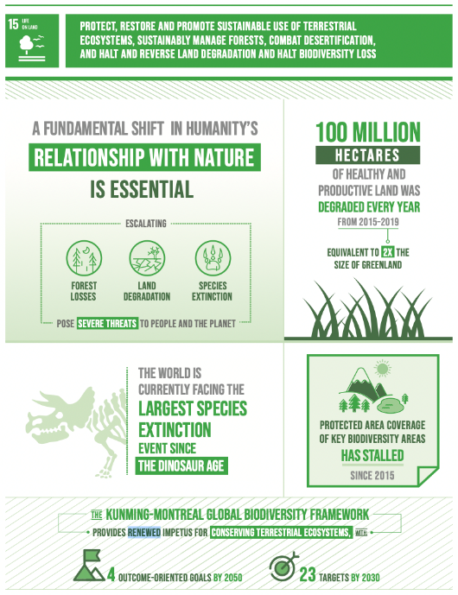
SDG 15 explainer by United Nations is licensed under Copyright © United Nations.
- Identify ONE appropriate geographical tool or fieldwork technique for assessing the biodiversity of an area, and outline how it could be used in a geographical investigation. (2 marks)
- Briefly evaluate how global forums, agreements and cooperation, including the sustainable development goals (SDGs), can address the loss of biodiversity. (5 marks)

Short answer question 3 (10 marks)
Refer to Figure 3 and Figure 4 to answer parts (a) to (d)
Figure 3 – Value of agricultural production, 2022
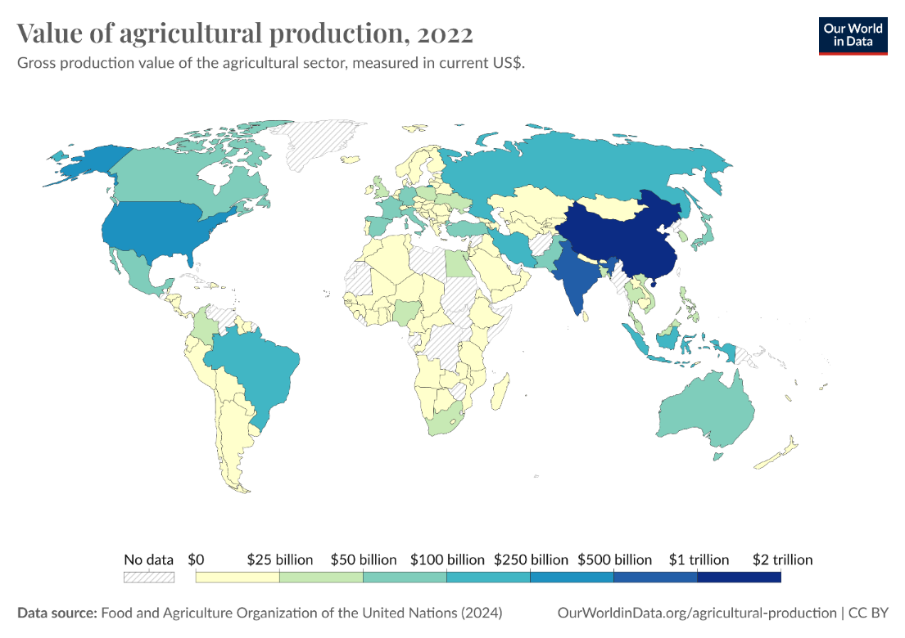
‘Value of agricultural production, 2022’ by Our World in Data is licensed under CC BY 4.0.
Figure 4 – Agricultural output, 1961 to 2019
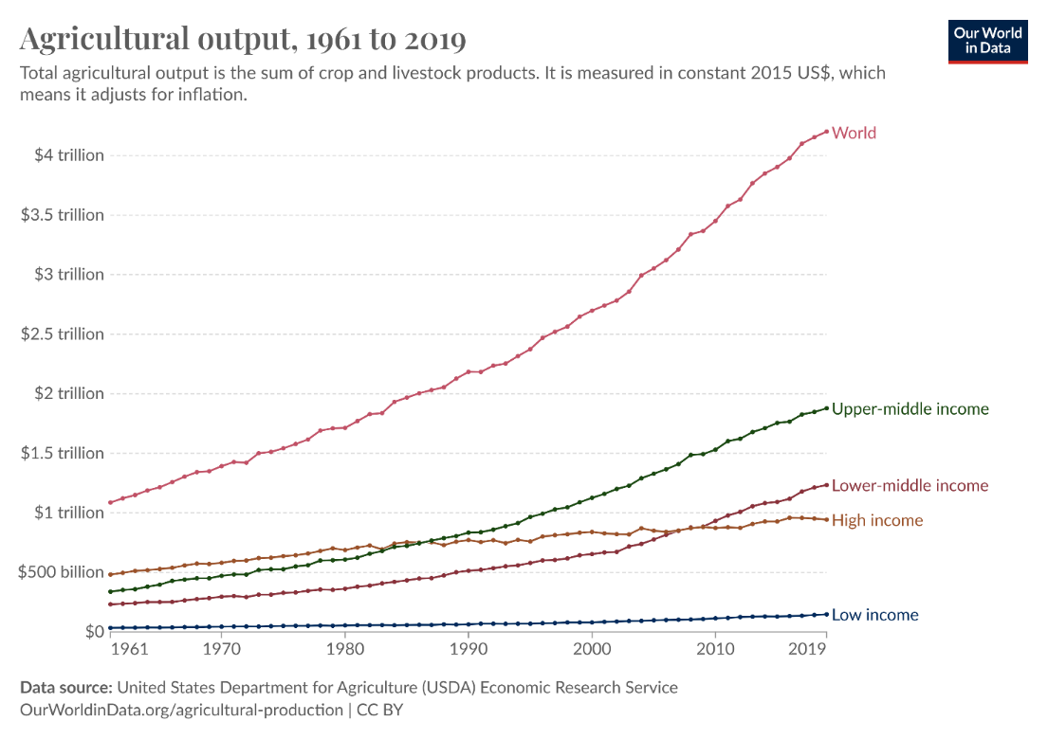
‘Agricultural output, 1961 to 2019’ by Our World in Data is licensed under CC BY 4.0.
- Use Figure 3 to describe the spatial patterns of agricultural production value in 2022. (2 marks)
- Use Figure 4 to identify which income bracket had the greatest total increase in agricultural output between 1961 and 2019. (1 mark)
- In 1970, world agricultural output was valued at $1.39 trillion. In 2019, world agricultural output was valued at $4.20 trillion. Calculate the percentage change increase or decrease in world agricultural production between 1970 and 2019. (2 marks)
- With reference to ONE global economic activity you have studied, analyse the sustainability of the global economic activity, using one or more criteria. (5 marks)

Marking guidelines and sample responses
Below are the marking guidelines and sample responses to the assessment.

Short answer question 1 (8 marks)
- Which region of the ocean accounts for the highest catch in millions of tonnes of fish for 2020? (1 mark)
North-West Pacific
- Describe the spatial pattern of consumption of fish indicated by this diagram. (2 marks)
Responses could include:
- Asia, specifically China and South-East Asia, North America, Australia and Western Europe and Scandinavian countries.
- The higher income nations of the world.
- Nations with significant ocean borders.
- Nations who also have high fish catch amounts.
- Explain how the issue of climate change highlights the importance of ONE principle of ecologically sustainable development in managing agricultural practices sustainably. (5 marks)
Sample answer:
Climate change highlights the importance of the principle of intergenerational equity in ecologically sustainable development. This principle emphasises the need to manage agricultural practices in a way that ensures future generations have access to the same resources and environmental quality as the current population. For example, increasing global temperatures and changing rainfall patterns are leading to more frequent and severe droughts. In Australia, agriculture is responsible for around 13% of the national greenhouse gas emissions, with the livestock sector contributing significantly to methane emissions. Adopting sustainable farming practices, such as improving soil carbon sequestration and reducing livestock emissions through improved feed practices, not only helps mitigate the immediate impacts of climate change but also ensures that agricultural resources remain practical for future generations. Without sustainable management, according to CSIRO the productivity of key farming regions could decrease by up to 50% by 2050 due to climate impacts, threatening both food security and the livelihoods of future populations.
Table 1 – assessment marking guidelines for short answer question 1
Marking guideline descriptors | Mark
- Demonstrates a thorough understanding of a principle of ecologically sustainable development and how climate change highlights its importance in managing agricultural practices sustainably  - Skilfully integrates facts, statistics or data | 5
- Demonstrates a sound understanding of a principle of ecologically sustainable development and how climate change highlights the importance of managing agricultural practices sustainably  - Integrates facts, statistics or data | 4
- Demonstrates a basic understanding of a principle of ecologically sustainable development and/or the need to manage agricultural practices sustainably  - References facts, statistics or data | 3
- Demonstrates a limited understanding of ecologically sustainable development or how climate change might impact managing agricultural practices  - May reference facts, statistics or data | 2
- Provides some relevant information | 1

Short answer question 2 (7 marks)
- Identify ONE appropriate geographical tool or fieldwork technique for assessing the biodiversity of an area, and outline how it could be used in a geographical investigation. (2 marks)
- Includes any ONE of: surveys, interviews, weather instruments, vegetation identification charts, compasses, clinometers, photographic devices, GPS, GIS, remote sensing, water and soil testing equipment, drones, quadrants, maps, graphs, statistics, spatial technologies, visual representations (1 mark)
- Gives at least one way this tool could be used in a geographical investigation (1 mark). For example, survey to tally number of species in an area, use GPS to access deforestation in an area.
- Briefly evaluate how global forums, agreements and cooperation, including the sustainable development goals (SDGs), can reverse the loss of biodiversity. (5 marks)
Sample answer:
Global forums, agreements, and international cooperation, such as the Sustainable Development Goals (SDGs), help reverse biodiversity loss by setting targets and coordinating global efforts. SDG goal 15, ‘Life on Land’ aims to halt biodiversity loss by 2030. The Convention on Biological Diversity established the Aichi Targets, target 11 aims to protect 17% of land. As of 2023, 16.8% of global land is currently protected according to United Nation (UN) data from 2023.
In Costa Rica, reforestation initiatives supported by international forums like the UN’s REDD doubled its forest cover from 26% in 1983 to over 52% in 2022 (World Bank, 2022). This highlights how cooperation can drive biodiversity recovery. Additionally, global agreements such as the Paris Agreement, which seeks to limit warming to 1.5°C, reduce climate impacts on ecosystems, further supporting biodiversity conservation.
In summary, international cooperation and agreements, through SDG 15 and related efforts, have led to increased protection of biodiversity, as seen in protected area growth and Costa Rica’s success in reforestation.

Table 2 – assessment marking guidelines for short answer question 2
Marking guideline descriptors | Mark range
- Provides an evaluation of how global forums, agreements and cooperation can assist in reversing biodiversity loss  - Integrates reference to the stimulus and/or includes statistics or data | 5
- Provides an explanation of how global forums, agreements and cooperation can assist in reversing biodiversity loss  - Integrates reference to the stimulus and/or includes statistics or data | 4
- Describes how global forums, agreements and cooperation can assist in reversing biodiversity loss  - References the stimulus and/or includes statistics or data | 3
- Identifies how global forums, agreements and cooperation can assist in reversing biodiversity loss  - May reference the stimulus and/or includes statistics or data | 2
- Makes general statements about global forums, agreements or biodiversity loss | 1

Short answer question 3 (10 marks)
- Use Figure 3 to describe the spatial patterns of agricultural production value in 2022. (2 marks)
The value of agricultural production in China and India was more than $1 trillion in 2022 while Africa was less than 50 billion. The spatial distribution of agricultural production is uneven.
- Use Figure 4 to identify which group of countries had the greatest increase in agricultural output between 1961 and 2019. (1 mark)
Upper middle income.
- In 1970, world agricultural output was valued at $1.39 trillion. In 2019, world agricultural output was valued at $4.20 trillion. Calculate the percentage change increase or decrease in world agricultural production between 1970 and 2019. (2 marks)
- To calculate the percentage increase, first find the increase by subtracting the original number from the new number ($Increase = New number - Original number)$. Then calculate the percentage increase by dividing the Increase by the original number and multiplying the answer by 100 ( $Percentage increase = Increase ÷ Original number × 100$).
Solution:
$$4.2 – 1.39 = 2.81$$
$$(\frac{2.81}{1.39}) × 100 = 390.59\% increase$$
- With reference to ONE global economic activity you have studied, evaluate the sustainability of the global economic activity. (5 marks)
- A global economic activity can be any one of – agriculture, energy production, fishing, forestry, manufacturing, mining, tourism
- The criteria can be any one of the 4 pillars of sustainability – social, economic, environmental, cultural or other measures such as OECD criteria of relevance, coherence, effectiveness, efficiency, impact, sustainability
Sample answer:
The sustainability of the global dairy industry can be evaluated using environmental and social criteria. Environmentally, dairy production accounts for approximately 4% of global greenhouse gas emissions, primarily from methane released by cows. For example, in New Zealand, dairy farming has led to significant water pollution issues, with 60% of monitored rivers unsafe for swimming due to nitrogen runoff. Efforts like regenerative farming and methane-reducing feed additives are emerging but are not yet widespread. Socially, the industry supports rural economies, providing 240 million jobs worldwide, particularly in developing countries. However, low wages and unsafe conditions for workers in regions like Southeast Asia highlight social sustainability issues. Thus, while the dairy industry has economic and social benefits, its environmental impact poses major sustainability challenges.
Table 3 – assessment marking guidelines for short answer question 3
Marking guideline descriptors | Mark
- Makes clear reference to a global economic activity  - Provides a detailed evaluation of the sustainability of the global economic activity | 5
- Makes reference to a global economic activity  - Provides an evaluation of the sustainability of the global economic activity | 4
- Identifies a global economic activity  - Attempts to make an evaluation of the sustainability of the global economic activity | 3
- May identify a global economic activity  - Describes sustainable practices in an economic activity | 2
- Provides some relevant information | 1

Support and alignment
Resource evaluation and support: all curriculum resources are prepared through a rigorous process. Resources are periodically reviewed as part of our ongoing evaluation plan to ensure currency, relevance and effectiveness. For additional support or advice, or to provide feedback, contact the HSIE Curriculum team by emailing hsie@det.nsw.edu.au
Differentiation: further advice to support Aboriginal and Torres Strait Islander students, EALD students, students with a disability and/or additional needs and High Potential and gifted students can be found on the Planning programming and assessing 7–12 webpage. This includes the Inclusion and differentiation 7–10 advice webpage.
Assessment: further advice to support formative assessment is available on the Planning programming and assessing 7–12 webpage. This includes the Classroom assessment advice 7–10. For summative assessment tasks, the assessment task advice 7–10 webpage is available.
Explicit teaching: further advice to support explicit teaching is available on the Explicit teaching webpage. This includes the CESE Explicit teaching – Driving learning and engagement webpage.
Consulted with: Curriculum and Reform, and Explicit Teaching.
Alignment to system priorities and/or needs: School Excellence Policy, Our Plan for NSW Public Education.
Alignment to the School Excellence Framework: this resource supports the School Excellence Framework elements of curriculum (curriculum provision) and effective classroom practice (lesson planning, explicit teaching).
Alignment to Australian Professional Teaching Standards: this resource supports teachers to address Australian Professional Teaching Standards, 2.2.2, 2.3.2, 5.1.2, 5.3.2.
Creation date: 20 September 2024
Rights: © State of New South Wales, Department of Education.

References
This document contains NSW Curriculum and syllabus content. The NSW Curriculum is developed by the NSW Education Standards Authority. This content is prepared by NESA for and on behalf of the Crown in right of the State of New South Wales. The material is protected by Crown copyright.
Please refer to the NESA Copyright Disclaimer for more information https://educationstandards.nsw.edu.au/wps/portal/nesa/mini-footer/copyright.
NESA holds the only official and up-to-date versions of the NSW Curriculum and syllabus documents. Please visit the NSW Education Standards Authority (NESA) website https://educationstandards.nsw.edu.au/ and the NSW Curriculum website https://curriculum.nsw.edu.au.
Geography 11–12 Syllabus © NSW Education Standards Authority (NESA) for and on behalf of the Crown in right of the State of New South Wales, 2022.
WOR (World Ocean Review) (2021) ‘Food from the sea’, The Ocean, Guarantor of Life – Sustainable Use, Effective Protection, Maribus, accessed 20 September 2024.
United Nations (2023) ‘15: Life on land’ Sustainable development goals, United Nations, accessed 20 September 2024.
Ritchie H, Rosado P and Roser M (2023) ‘Agricultural Production’, Our World in Data, accessed 20 September 2024.
© State of New South Wales (Department of Education), 2024
The copyright material published in this resource is subject to the Copyright Act 1968 (Cth) and is owned by the NSW Department of Education or, where indicated, by a party other than the NSW Department of Education (third-party material).
Copyright material available in this resource and owned by the NSW Department of Education is licensed under a Creative Commons Attribution 4.0 International (CC BY 4.0) license.

This license allows you to share and adapt the material for any purpose, even commercially.
Attribution should be given to © State of New South Wales (Department of Education), 2024.
Material in this resource not available under a Creative Commons license:
- the NSW Department of Education logo, other logos and trademark-protected material
- material owned by a third party that has been reproduced with permission. You will need to obtain permission from the third party to reuse its material.
Links to third-party material and websites
Please note that the provided (reading/viewing material/list/links/texts) are a suggestion only and implies no endorsement, by the New South Wales Department of Education, of any author, publisher, or book title. School principals and teachers are best placed to assess the suitability of resources that would complement the curriculum and reflect the needs and interests of their students.
If you use the links provided in this document to access a third-party's website, you acknowledge that the terms of use, including licence terms set out on the third-party's website apply to the use which may be made of the materials on that third-party website or where permitted by the Copyright Act 1968 (Cth). The department accepts no responsibility for content on third-party websites.

