Ancient history (Year 11) – teaching support resource
The investigation of ancient sites and sources – Ancient History 11–12 Syllabus
Contents
Overview 4
Suggested timeframe 4
Outcomes 4
Learning sequence 1 – ancient history and archaeology 6
Syllabus content 6
Introduction to ancient history 6
Advice 1 – vocabulary 6
Resource 1 – activate prior learning 7
Advice 2 – definitions 7
Resource 2 – changing archaeological perspectives 8
Resource 3 – archaeological procedures 9
Advice 3 – sample Venn diagram 11
Resource 4 – history or archaeology 12
Archaeology in practice 13
Resource 5 – steps in archaeology 13
Advice 4 – sample graphic representation 13
Resource 6 – identifying a site 14
Resource 7 – excavating a site 16
Resource 8 – excavation example 17
Resource 9 – processing and recording artefacts 18
Resource 10 – dating methods 19
Resource 11 – stratigraphy activity 22
Resource 12 – Speed dating 24
Advice 5 – sample scenarios 26
Resource 13 – dating methods check for understanding 26
Resource 14 – archaeological source analysis 27
Resource 15 – evidence from sources 29
Advice 6 – communicating findings 32
Resource 16 – PMI chart 33
Resource 17 – Frayer models 35
Advice 7 – mock excavation teacher guide 37
Learning sequence 2 – challenges with archaeological sources 39
Syllabus content 39
Source authenticity 39
Advice 8 – vocabulary building 39
Advice 9 – authenticity of sources 40
Advice 10 – methods of authenticity concept map 41
Advice 11 – historical inquiry group task 42
Resource 18 – research scaffold 45
Resource 19 – availability of sources 46
Resource 20 – incomplete or broken sources 48
Resource 21 – bias 50
Resource 22 – lack of literary sources 52
Resource 23 – jigsaw activity 57
Advice 12 – paragraph writing 58
Resource 24 – TAG feedback 59
Learning sequence 3 – value and limitations of sources 60
Syllabus content 60
Introduction to value and limitations 60
Resource 25 – value and limitations of sources 60
Resource 26 – literary and epigraphic sources 63
Ancient texts 64
Resource 27 – Suetonius’ account of Nero 64
Advice 13 – vocabulary support for Resource 27 66
Resource 28 – Suetonius source analysis 68
Inscriptions 69
Resource 29 – types of inscriptions 69
Iconography 72
Resource 30 – Persian Empire iconography 72
Summative activity 74
Resource 31 – using archaeological sources 74
Advice 14 – suggested teacher expositions 75
References 77

Overview
This teaching support resource supports The investigation of ancient sites and sources – program and should be considered in conjunction with the sample program and related resources. Teachers should adapt the resources to suit their school context and student learning needs.
Suggested learning intentions and success criteria have been provided to demonstrate how they may be written. They are carefully designed using syllabus outcomes and content. Learning intentions and success criteria are both an explicit teaching and formative assessment strategy.
Consider the Universal Design for Learning principles of engagement, representation and expression in conjunction with this teaching support resource when planning for teaching and learning.
These resources include heavy use of visual source material. Students with visual impairment can be supported to engage in these activities through use of 3D printed replicas and collaborative group work with sighted peers in a way that promotes equal participation with clearly defined rotating roles. If the student is supported by an Itinerant Support Teacher Vision (ISTV) they will have access to Braille and Large Print Services (BLPS). BLPS have a range of 3D prints that can support curriculum access. Schools can also download free or low-cost 3D designs to print at school. More information can be found on the Inclusive Practice hub.

Suggested timeframe
The sample program of learning is designed to be completed over approximately 15 hours. This duration can be adapted to suit the school context.

Outcomes
A student:
- AH-11-05 analyses different types of sources for evidence to support a historical account or argument
- AH-11-06 explains differing interpretations and representations of the past
- AH-11-07 communicates historical understanding, applying historical knowledge, terms and concepts
Ancient History 11–12 Syllabus © NSW Education Standards Authority (NESA) for and on behalf of the Crown in right of the State of New South Wales, 2024.

Learning sequence 1 – ancient history and archaeology
This learning sequence is designed to be completed in approximately 7 hours. The support provided in this section aligns with Learning sequence 1 in the program.

Syllabus content
- The changing nature of archaeological excavation, recording techniques and methods of analysis

Introduction to ancient history

Advice 1 – vocabulary
HSC minimum standard – Vocabulary provides teaching strategies that can be used to explicitly teach unfamiliar vocabulary throughout this program. The following templates could also be used:
- Frayer diagrams
- Clines and continuums.
The following resources can be used to build teacher knowledge of explicit vocabulary instruction.
- Three tier framework for considering vocabulary (4:50)
- Improving reading comprehension Years 3 to 10 (staff only)
- Guide for planning and implementing explicit vocabulary instruction (staff only)

Resource 1 – activate prior learning
Table 1 – history and archaeology statements
Statement | Discipline
The discovery of evidence of the past through the excavation of sites. | Archaeology
Studying, interpretating and evaluating records of the human past. | History
The methodical scientific examination of artefacts from the past. | Archaeology
The study of human behaviour and cultures through material remains. | Archaeology
The analysis and interpretation of written evidence to construct narratives about the past. | History

Advice 2 – definitions
Sample definitions:
- History: the investigation and evaluation of past events, primarily through analysis of written records, documents and oral testimonies. It aims to develop insights into past societies, particularly the political, economic and religious conditions that existed.
- Archaeology: the scientific study of human history through the excavation and analysis of material remains, such as artefacts and structures. It aims to reconstruct daily life, cultures and environments by examining physical evidence from the past.

Resource 2 – changing archaeological perspectives
Source 1
Quote by Giovanni Belzoni describing his archaeological methods in Egypt in 1817.
‘… when my weight bore on the body of an Egyptian, it crushed it like a band-box. I naturally had recourse to my hands to sustain my weight, but they found no better support; so that I sunk altogether among the broken mummies, with a crash of bones, rags, and wooden cases … every step I took I crushed a mummy in some part or other … The purpose of my researches was to rob the Egyptians of their papyri; of which I found a few hidden in their breasts, under their arms, in the space above the knees, or on the legs, and covered by the numerous folds of cloth ...’
Source: Narrative of the Operations and Recent Discoveries Within the Pyramids, Temples, Tombs, and Excavations, in Egypt and Nubia by Giovanni Battista Belzoni, 1835, is available in the public domain.
Source 2
Quote by W.M. Flinders Petrie about archaeology in the late 19th century and early 20th century.
‘Archaeology is the latest born of the sciences … It is still attracted by pretty things, rather than by real knowledge … All other sciences deal with the things around us; with subjects which may, or may not, affect us … But the science which enquires into all the products and works of our own species, which shows what man has been doing in all ages and under all conditions, which reveals his mind, his thoughts, his tastes, his feelings, – such a science touches us more closely than any other … A complete archaeological training would require a full knowledge of history and art, a fair use of languages, and a working familiarity with many sciences …’
Source: Methods & Aims in Archaeology by W.M. Flinders Petrie, 1904, is available in the public domain.
Note: the sources above are examples. Teachers should select approximately 8 quotes from archaeologists across the 20th and 21st centuries. Additional support is available in the HSIE Statewide Staffroom (staff only).

Resource 3 – archaeological procedures
Suggested list of procedures
- Excavating an ancient site
- Determining the age of an artefact
- Translating an ancient papyrus
- Using scientific soil analysis
- Translating an ancient document
- Comparing 2 ancient historians’ views
- Studying ancient coins
- Reconstructing an ancient building
- Translating an ancient tomb inscription
Table 2 – procedures table template
Historical procedures | Archaeological procedures
Answers: refer to Table 3 – procedures table sample answers.
Table 3 – procedures table sample answers
Historical procedures | Archaeological procedures
Translating an ancient papyrus | Excavating an ancient site
Translating an ancient document | Determining the age of an artefact
Comparing 2 ancient historians’ views | Using scientific soil analysis
Translating an ancient tomb inscription | Studying ancient coins
 | Reconstructing an ancient building

Advice 3 – sample Venn diagram
Figure 1 – sample history and archaeology Venn diagram
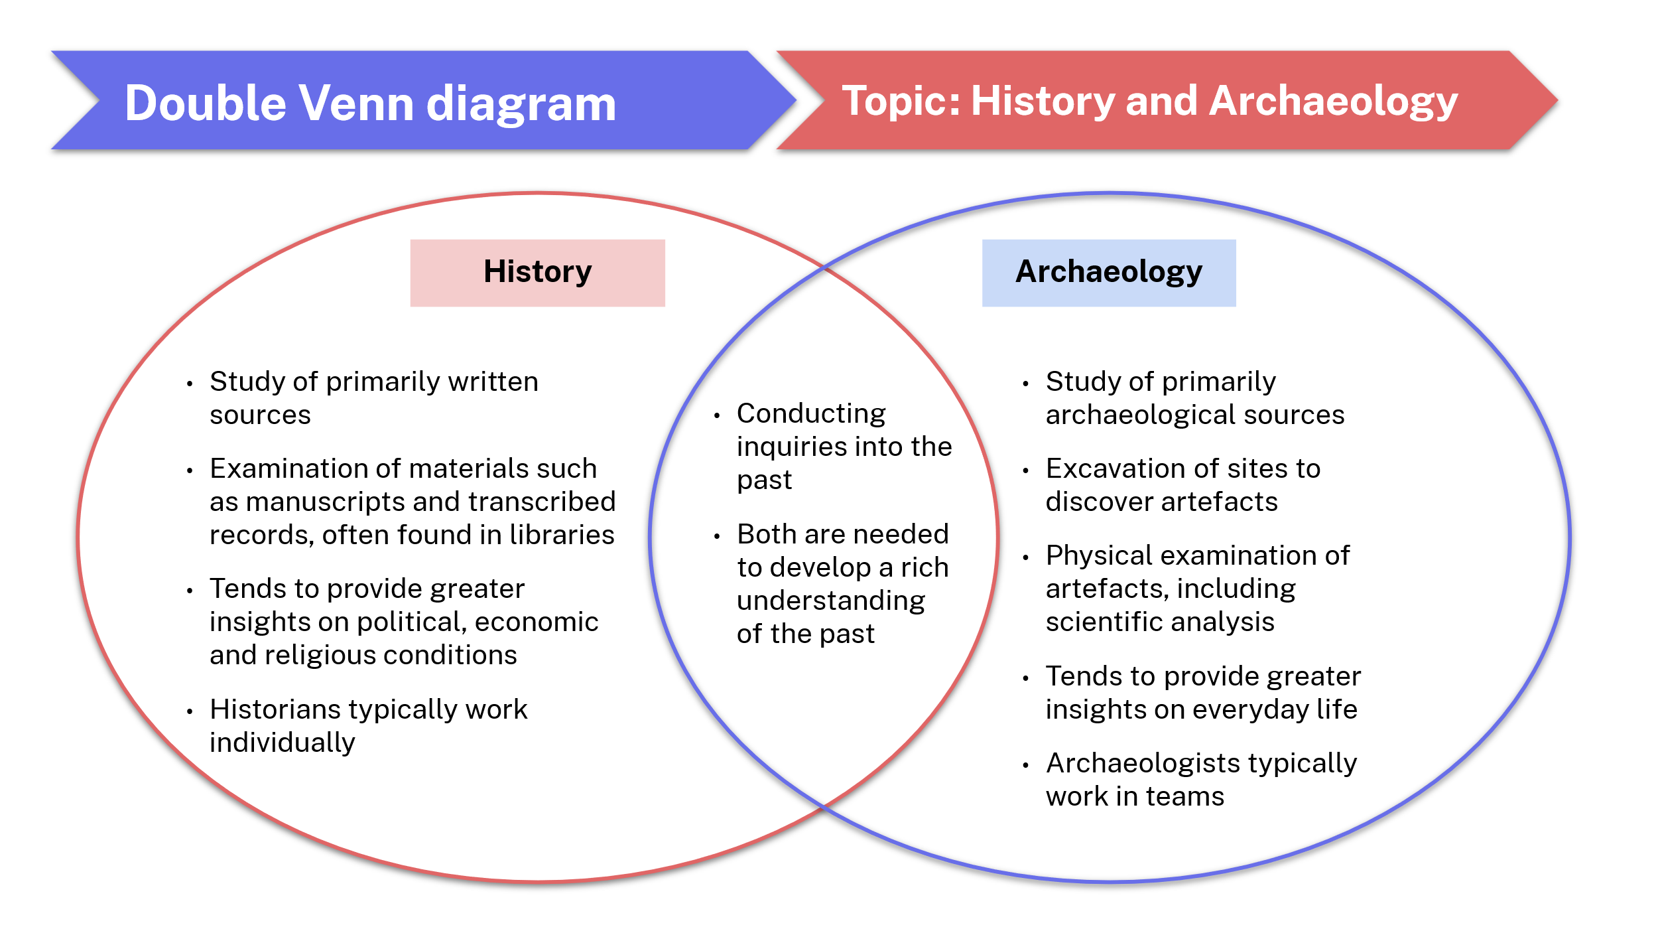

Resource 4 – history or archaeology
Table 4 – check for understanding statements
Statement | Response
Studying, interpretating and evaluating records of the human past. | History
Translating ancient texts. | History
The discovery of evidence of the past through the excavation of sites. | Archaeology
Conducting inquiries into the past. | Both
Studies daily life of everyday people from ancient times. | Archaeology
Ethical study of the human past. | Both
The analysis and interpretation of written evidence to construct narratives about the past. | History
Tends to provide insight on politics, religion and the economy | History
Uses scientific methods to determine the age of an artefact. | Archaeology
Constructs interpretations of the ancient past through analysis of sources of evidence. | Both

Archaeology in practice

Resource 5 – steps in archaeology
- Identify a site.
- Excavate the site.
- Process and record artefacts.
- Analyse and interpret sources.
- Communicate findings.

Advice 4 – sample graphic representation
Figure 2 – sample graphic representation of archaeological steps
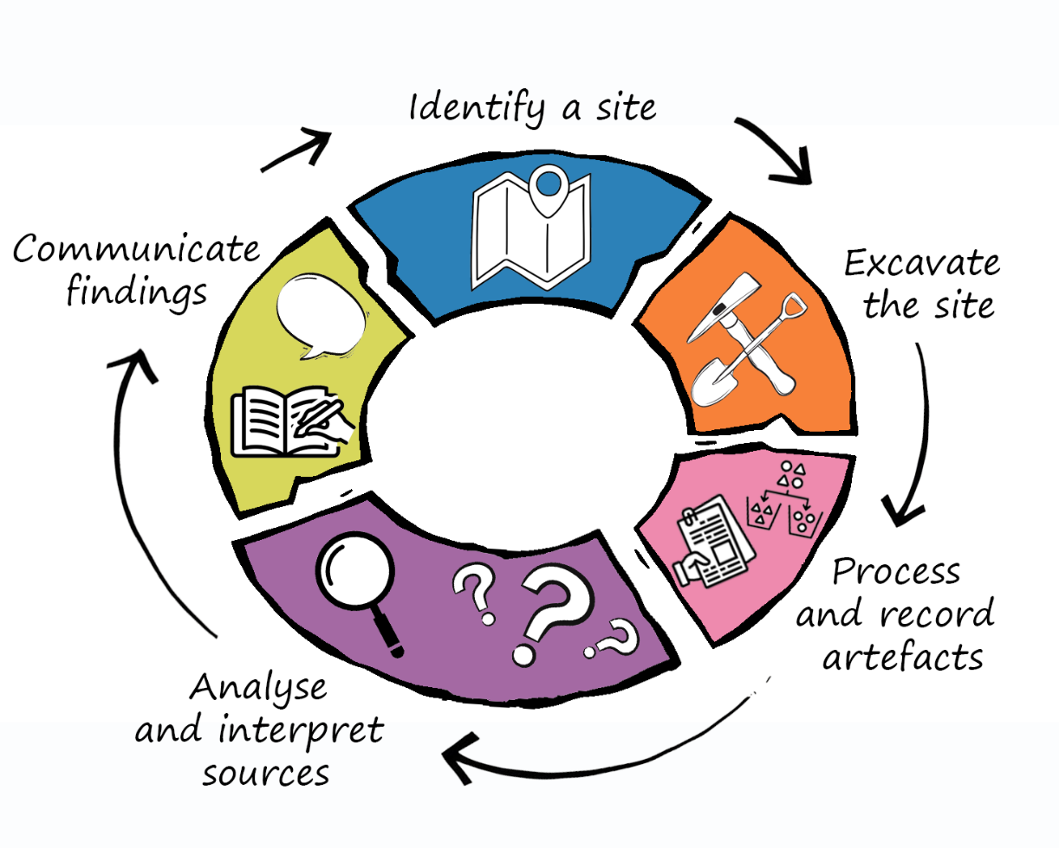

Resource 6 – identifying a site
Identifying a particular archaeological site will vary, according to location and visibility. Some sites are still in full view as their ruins remain above ground, such as the Roman Colosseum, Athenian Acropolis, city of Ephesus in Türkiye, and Machu Pichu in Peru. Some sites were found by chance (known as accidental finds) and others by a particular methodology being applied. From non-invasive techniques like crop marks and aerial photography to more direct methods such as trial trenches and probes, archaeologists can gather critical data that informs their research and preservation efforts.

Written evidence
Historical documents, such as maps, letters and records, provide valuable information about past settlements and activities. These documents can guide archaeologists to potential sites and help contextualise findings. Local archives and libraries are essential resources for this method.

Ground surveys
Ground surveys involve archaeologists walking across a designated area to conduct a systematic examination of the landscape. They identify artefacts and features and often use sampling techniques to record findings.

Aerial photography

Aerial photography captures images of landscapes from above, revealing structures, pathways and other archaeological features not visible from the ground. Technology is rapidly changing this method. Drones can integrate high-resolution photography with other technologies like ground penetrating radar (GPR), and platforms such as Google Earth allow archaeologists to access aerial photography remotely, reducing the need for physical presence at the site during identification.

Crop marks
Remains of buildings and large artefacts beneath the ground affect soil moisture and nutrient levels, which can affect vegetation growth. This is sometimes visible in different crop growth sizes and colour, known as crop marks. Aerial photography is often used to capture these marks, allowing archaeologists to identify potential sites without excavation.

Ground Penetrating Radar (GPR)
This technique uses radar pulses to develop images of the subsurface. It can detect buried structures, artefacts and changes in soil composition, providing a detailed view of what lies beneath the surface. It can then be determined if it is valuable to excavate the site.

Light Detection and Ranging (LiDAR)
LiDAR uses laser light to measure distances and create detailed topographical maps. LiDAR can penetrate vegetation, revealing hidden archaeological features in dense forest areas. The high-resolution data produced can identify potential sites and historical landscape changes.

Magnetometry
Magnetometry measures variations in the Earth’s magnetic field caused by metallic objects, such as shipwrecks, submerged structures and terrestrial archaeological features. This non-invasive method can help identify potential archaeological sites both underwater and on land, providing valuable insights without disturbing the environment.

Probes
Probes are long, slender tools used to test soil composition and locate buried artefacts or features. Archaeologists insert probes into the ground at intervals to gather information without extensive digging. This is useful for assessing site potential before deciding on larger excavations.

Trial trenches
Trial trenches involve digging small exploratory pits in areas of interest so archaeologists can examine subsurface materials and confirm the presence of archaeological features. Although more invasive than other methods, it provides concrete evidence of human activity.

Sound navigation and ranging (Sonar) technology
Sonar can be used to identify submerged objects, such as shipwrecks. Sound waves are sent to the seabed, which bounce back, creating detailed images of the underwater landscape.

Remote Operated Vehicles (ROVs)
ROVs are unmanned underwater vehicles equipped with cameras and sensors. They allow archaeologists to explore and document underwater sites without the need for divers.

Resource 7 – excavating a site
Early archaeologists in the 19th and early 20th centuries were generally treasure hunters, hoping to find rare and valuable artefacts. There was little thought to conservation and restoration. These scavenging hunts were often financed by the great museums of the world, such as the British Museum and the Louvre in Paris. Ancient sites were excavated in the Near East, Greece, Rome and Central and South America, with anything of value quickly removed. The focus was on excavating to whatever level the archaeologist was interested in, often destroying upper levels of settlement and unethically removing artefacts. Schliemann’s excavations at Troy, the removal of the Elgin marbles from the Athenian Parthenon by Lord Elgin, and relocation of a complete temple Bergama in Türkiye to the Pergamon Museum in Berlin are notable examples from this period.
In modern times, the excavation and study of sites is changing quickly. Scientific and technological advances are shaping new archaeological methodologies. Field excavations remain the main form of archaeological methodology, yet digital, experimental and visual reconstructions are increasingly used for research and interpretation. Through technologies such as 3D printing, laser-scanning, drones, satellite imagery and virtual reality, archaeologists can develop and explore reconstructed sites with greater accuracy, even when physically distant from the archaeological site.
While processes and tools are evolving over time, there are 2 primary field excavation methods:
- Open area excavation: this involves digging up large sections of soil to reveal an entire area all at once. Archaeologists typically uncover one layer of soil (strata) at a time. This method is especially helpful for examining large sites or settlements because it lets archaeologists see how artefacts and features from the same time are arranged across a broader area. Archaeologists can learn more about the layout of ancient buildings, how activities were organised, and how different parts of a site interacted, which helps them understand how people lived in the past.
- Grid-system excavation: a more controlled and systematic approach where archaeologists split the site into smaller squares or grids. This method supports accurate recording of where each artefact was found to understand the context of finds and how artefacts relate to each other. It allows detailed documentation of the different strata (soil layers). By digging one grid square at a time, archaeologists can closely examine each strata, giving them useful information about the order of activities and how the site was used over time.

Resource 8 – excavation example
Figure 3 – check for understanding image
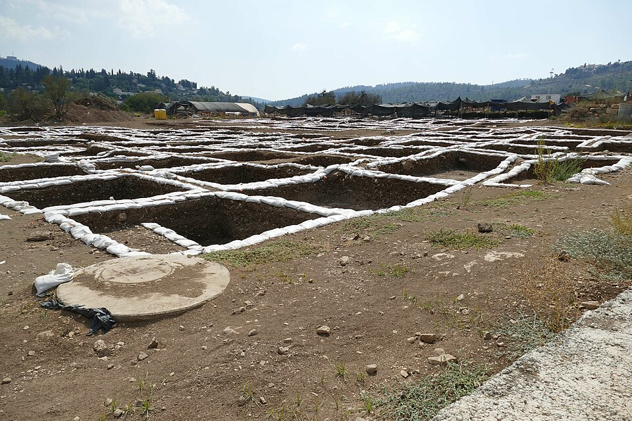
Source: Moza-449 by Bukvoed is licensed under CC BY 4.0.

Resource 9 – processing and recording artefacts
Table 5 – Introduction to Archaeology: Recording Methods (2:41) note-taking scaffold
Topic | Bullet summary of key words
Context sheet
Photography
Laser scanning
Using your bullet points, write a one paragraph summary of the video.

Resource 10 – dating methods

Relative dating methods
Relative dating determines the age of an artefact to an approximate time period or chronological order. These methods are easier to apply but are imprecise and cannot provide exact dates.
Stratigraphy is based on the Law of Superposition; strata (singular: stratum) located closer to the Earth’s surface are from a more recent time period than those found further down. In most instances, artefacts found in deeper strata are older than those found in layers closer to the surface, and artefacts found in a stratum are from the same time period. However, intrusions caused by earth movements or human intervention, such as digging deep foundations, can result in artefacts from a newer time period appearing in deeper strata.
Seriation involves determining a chronological order for artefacts of a similar type. By examining a collection of similar objects from a culture, archaeologists estimate a chronological sequence based on the evolution of styles and designs over time. This method is often applied to types of pottery, weapons and decorative items from a specific cultural period.
Fluorine dating is a method for dating artefacts made of bone. It measures the amount of fluorine the bones have absorbed from the surrounding soil over time. By comparing the fluorine levels in bones found within the same stratum, archaeologists can establish whether they are of similar age.

Absolute dating methods
Absolute dating methods give a specific age or date range for an artefact or site, often expressed in years. It is more precise, but more complicated and costly than relative dating methods.
Carbon dating (Radiocarbon dating) measures the decay of carbon-14, a radioactive isotope found in all living organisms. Once an organism dies, the amount of carbon-14 in the remains decays at a predictable rate. This method is suitable for dating organic materials like wood, bone and shell, but cannot be used for inorganic materials like metals or pottery. Currently, artefacts older than 50,000 years may not yield accurate results due to difficulty accurately measuring the low remaining carbon-14 levels, although technological advancements are improving accuracy. A sample of the organic material needs to be removed from the artefact for testing.
Potassium-argon dating measures the ratio of radioactive potassium-40 to its decay product, argon-40, in volcanic rock. A piece of the artefact needs to be removed to undertake this analysis. This method is effective for dating geological materials that are over 100,000 years old, such as volcanic rock layers surrounding early hominid fossils. However, it cannot be used for dating artefacts made of organic materials or sedimentary layers.
Thermoluminescence dates crystalline materials by measuring the light released when a sample from the artefact is heated. This technique can date materials ranging from about 100 to 500,000 years old, making it useful for analysing pottery, burnt flint and other heated materials. However, there are many factors that can reduce the accuracy of results. Thermoluminescence cannot be used for organic materials or artefacts that haven’t been heated in the past.
Optically stimulated luminescence (OSL) measures the last time sediment was exposed to light. This method is effective for dating buried sediments, such as those associated with human activity found in archaeological sites. This method cannot be used for directly dating artefacts; it only dates the sediments in which artefacts are found.
Dendrochronology is based on the study of tree rings, where each ring corresponds to a year of growth. By counting the rings, archaeologists can date wooden artefacts or construction sites, such as wooden beams from ancient structures, ship timbers or wooden tools.
Table 6 – dating methods PCQ chart
Dating method | Pros | Cons | Questions
Stratigraphy
Seriation
Fluorine dating
Carbon dating
Thermoluminescence
Optically stimulated luminescence (OSL)
Dendrochronology

Resource 11 – stratigraphy activity
The following is a list of potential sources you may provide students to include in their stratigraphy models.
- A mosaic floor
- Stone tools
- Stone loom weights
- Simple clay pots or pottery fragments
- A tablet showing ancient hieroglyphics
- A gold necklace
- A car tyre
- Bronze arrowheads
- Grinding stone
- Stone house foundation
- Iron arrowhead
- Glass bottle
- Sheets of newspaper
- Woven cloth
- Carved stone idol
- Carved bone from an extinct animal
- Human bones showing sword wounds
Figure 4 – sample stratigraphy diagram
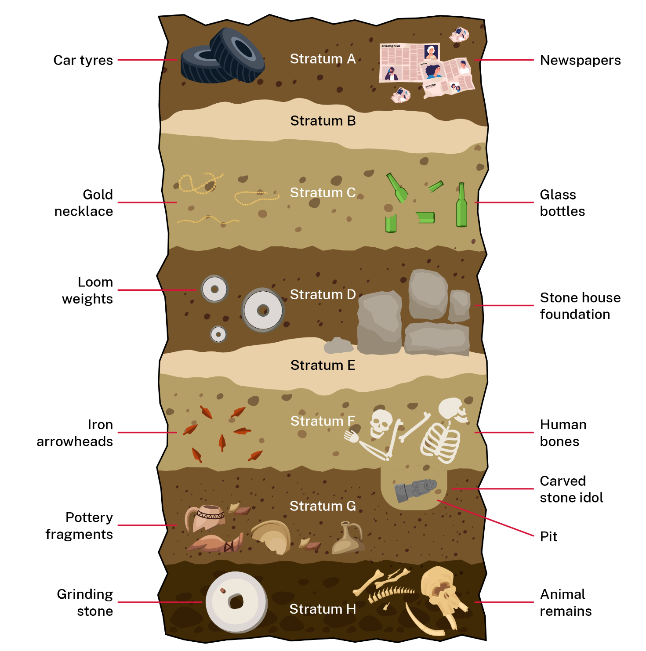

Resource 12 – Speed dating
Note card – round 1
Scenario:
My selected dating method:
I selected this method because:
My partner selected:
The dating method I think is best after our discussion:
I’ve selected this method because:

Note card – round 2
Scenario:
My selected dating method:
I selected this method because:
My partner selected:
The dating method I think is best after our discussion:
I’ve selected this method because:

Note card – round 3
Scenario:
My selected dating method:
I selected this method because:
My partner selected:
The dating method I think is best after our discussion:
I’ve selected this method because:

Note card – round 4
Scenario:
My selected dating method:
I selected this method because:
My partner selected:
The dating method I think is best after our discussion:
I’ve selected this method because:

Advice 5 – sample scenarios
- A ring found near coins with dates inscribed on them
- A stone axe
- A wooden water well
- A necklace with a carved bone pendant
- A pottery urn
- Human remains
- A drum made from wood and animal hide

Resource 13 – dating methods check for understanding
Table 7 – sample dating method statements
Statement | Answer
Absolute dating method for use on organic material less than 50,000 years old. | Carbon dating
This dating method uses the law of superposition to relatively date artefacts. | Stratigraphy
Relative dating method that is only useful for bone artefacts. | Fluorine dating
Dating a weapon by comparing it to other weapons from that cultural period. | Seriation
Dating timber objects by measuring tree rings. | Dendrochronology
Used to date sediment. | Optically stimulated luminescence (OSL)

Resource 14 – archaeological source analysis
Table 8 – archaeological source analysis scaffold
Question | Response
What is it?
What is it made from?
What size is it?
Who made it?
When was it made?
Where was it found?
What was found near it?
What do we see in the source?
What could this mean?
What was its function?
What is its significance?
Why do we think this?

Resource 15 – evidence from sources
What might the following sources reveal about ancient times?
Table 9 – examples of archaeological sources
Sources | Potential evidence
Coins | - Date of manufacture  - Currency values used for bartering and trading  - Important political figures and cultural icons  - Individual and communal wealth  - Manufacturing tools and techniques  - Mineral resources available
Statues
Tomb inscriptions
Temples
A skeleton
House foundations
Pottery
Ancient graffiti
Aboriginal stone axe-head

Advice 6 – communicating findings
Note: the following sources can be used as stimulus material for the jigsaw activity in the sample program of learning. Teachers should select appropriate extracts to suit programmed timing and student learning needs.
- Journal article: Fingerprints on Figurines from Thonis-Heracleion
- Podcast: The Portus Magnus of Alexandria: 25 years of underwater archaeological research (1:09:14)
- Video: #18 What is your favorite discovery in Thonis-Heracleion (Discovering underwater archaeology) (1:59)
- Lecture: Webinar: Diving into History with Franck Goddio (1:00:17)
- Media release: Colossal Statues from Thonis-Heracleion in Grand Egyptian Museum
- Website: Finds - The stories behind them

Resource 16 – PMI chart
Table 10 – PMI chart
Communication medium | Plus | Minus | Interesting
Journal article
Podcast
Video
Lecture
Media release
Website

Resource 17 – Frayer models
Figure 5 – Frayer diagram for ‘interpretations’
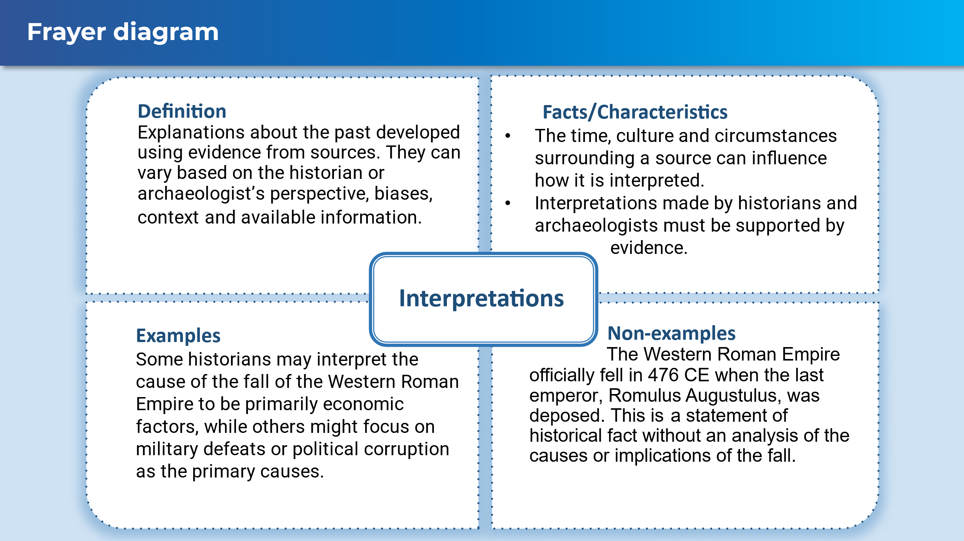
Figure 6 – Frayer diagram for ‘representations’
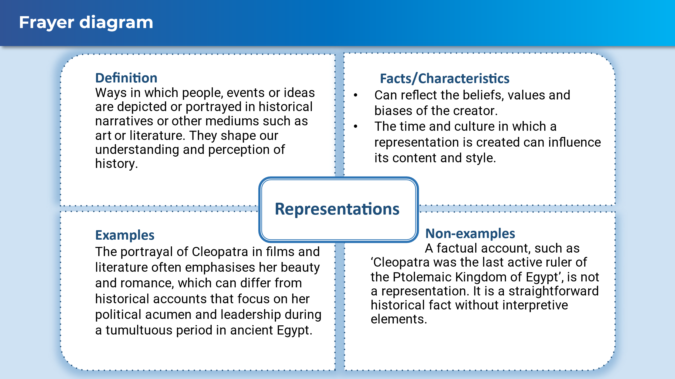

Advice 7 – mock excavation teacher guide
Note: a risk assessment is recommended before undertaking this activity. Ensure the weight of the filled tubs does not exceed what can be moved safely and follow safe lifting practices when moving. Ensure all artefacts do not have sharp edges for student safety.
Required equipment:
- one clear tub for each group
- 2 to 3 groups of small, related artefacts for each tub, such as pottery pieces, toys and kitchen utensils (no knives or scissors)
- 2 to 3 different coloured soil-like material, such as dirt, coloured sand or fine gravel
- gloves for each student
- excavation tools for each group, such as small scoops, spoons, picks, paint brushes, toothbrushes, string, ruler, tweezers and a camera
- tubs for soil collection, and artefact collection and cleaning.
Teacher preparation:
- Sort artefacts into groups and consider what conclusions could be drawn by students about why these artefacts were located together. Record these suggested inclusions for use during the communication part of the activity.
- Add one soil type and one artefact group into the tub at a time to create strata layers. Lightly compact each layer. Aim for high contrast between soil types to support students identifying new strata layers during excavation.
Note: if time permits, plant fast growing grass seeds in the top layer. Crop marks may be visible.
Excavation tips:
- Check for understanding: have students present their plan for excavating the site and processing and recording artefacts to you before they begin the excavation. Use this opportunity to provide corrective feedback.
- Having separate collection tubs for each soil type supports reusing for future excavation tubs.
- Suggest students assign roles, such as lead archaeologist, photographer, processing specialist and recorder.
- Using digital tools, such as a OneNote notebook section, for recording is recommended. Students can take images of artefacts in-situ and after excavation, upload them to OneNote and store them with typed record notes.

Learning sequence 2 – challenges with archaeological sources
This learning sequence is designed to be completed in approximately 5 hours. The support provided in this section aligns with Learning sequence 2 in the program.

Syllabus content
- Problems of authenticity and methods of authentication
- Challenges associated with reconstructing the past using archaeological sources

Source authenticity

Advice 8 – vocabulary building
Authentic: a true representation or an item of undisputed origin. It is an original, not a copy.
Fake: a false representation or deliberately misrepresented item. Could by a copy of an original that may be accurate or inaccurate.
Figure 7 – sample word cline
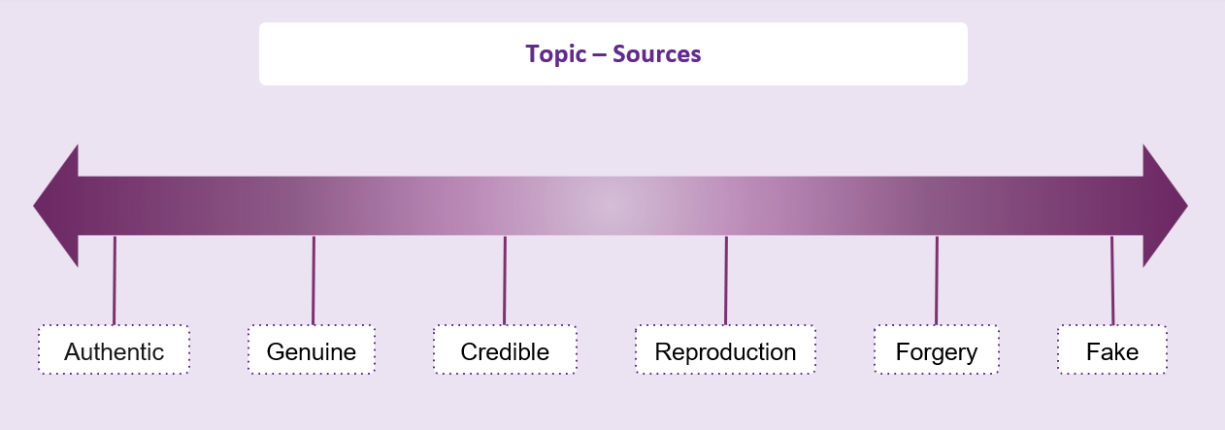

Advice 9 – authenticity of sources
Note: the following text is designed to support teacher exposition on authenticity of sources.
When dealing with ancient sources, either written or archaeological, the question of authenticity must be asked. Fake and forged artefacts have been produced and sold since archaeological excavation began, usually for sale on dubious black markets to private collectors. Some have even ended up in world-class museums such as the Louvre in Paris, the British Museum and the New York Metropolitan Museum.
A fake artefact is a copy of an actual artefact. This includes replicas. A fake is not necessarily bad, if it is known to be a fake. Forgeries are items created to deceive. They are not reproductions, rather they are modern creations presented as historical artefacts. Forgeries can lead to inaccurate interpretations of the past, which may significantly impact our historical understanding.
Archaeologists and historians need to question the authenticity of sources. Often this can be difficult and contested. An example is the Gosford Glyphs located at Kariong in NSW. The site has approximately 300 ancient Egyptian-style hieroglyphs which were first reported in 1975. It is contested whether these are forgeries or authentic Egyptian inscriptions.
Figure 8 – photograph of a section of the Gosford Glyphs
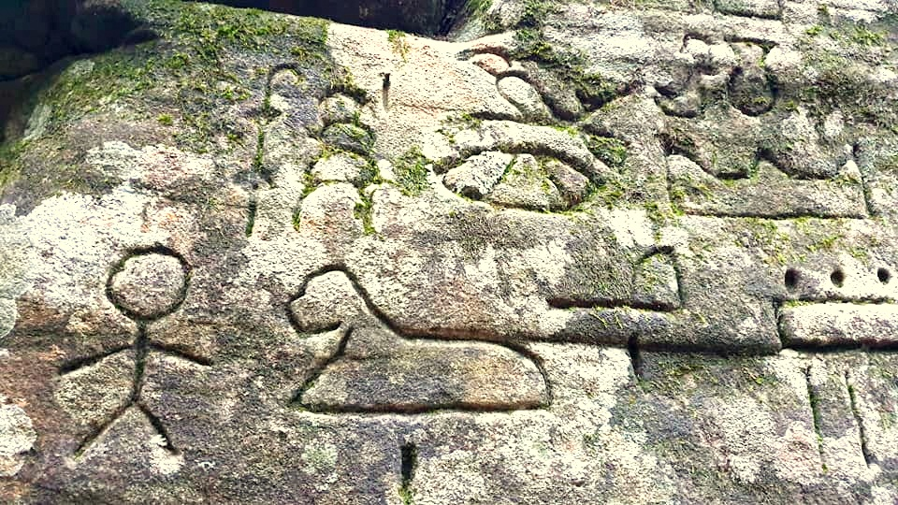
Source: Gosford glyphs by Zroota is licensed under CC BY-SA 4.0.

Advice 10 – methods of authenticity concept map
Figure 9 – sample concept map
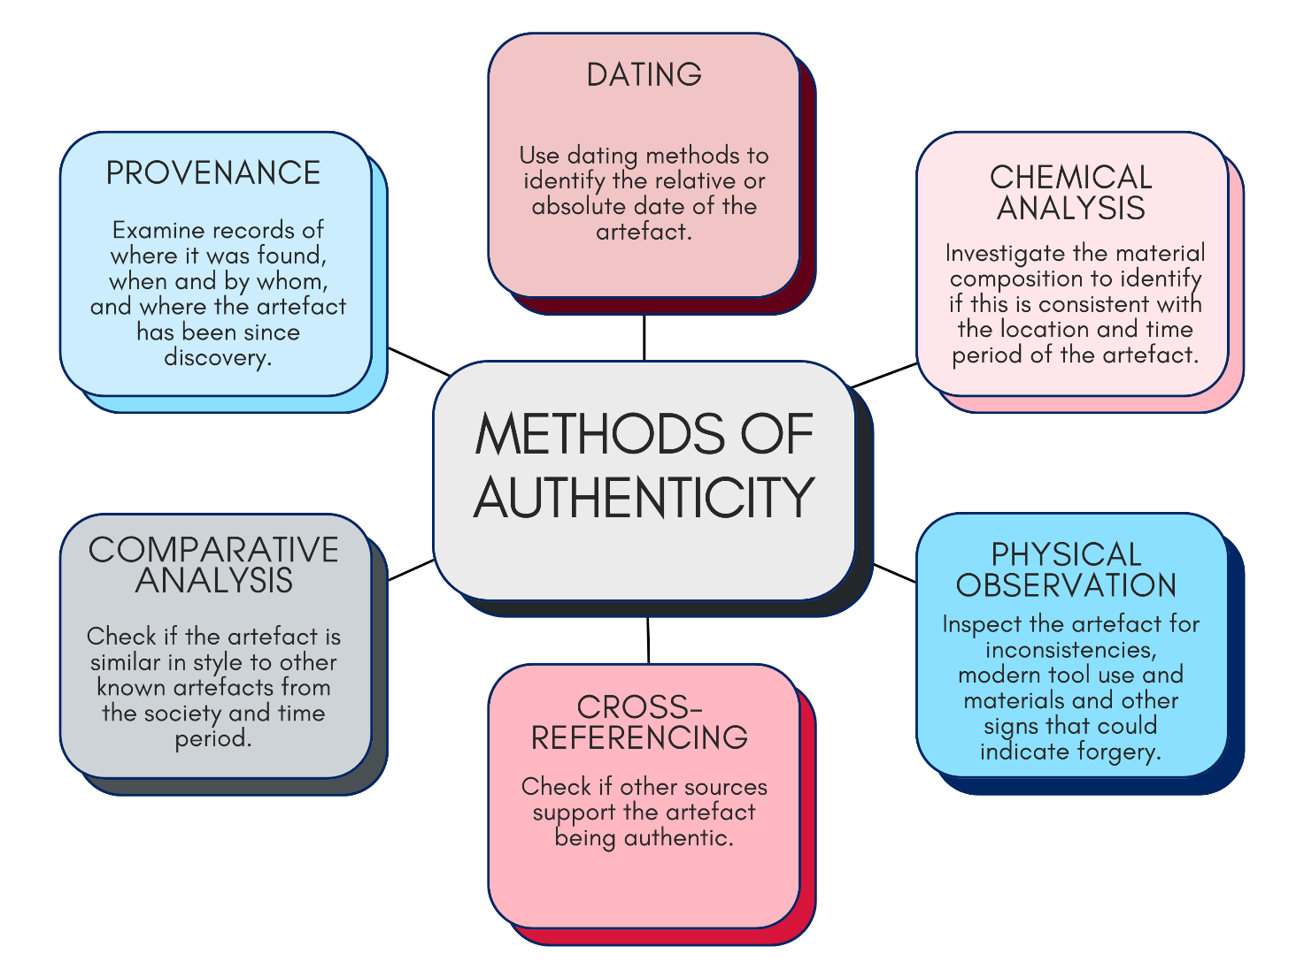

Advice 11 – historical inquiry group task
Teacher thinks aloud to develop a key inquiry question for the Etruscan terracotta warriors.
Suggested think aloud script:
‘I want to know the how the Etruscan terracotta warriors were proven to be a forgery and the impact they could have had on interpretations about the past if they hadn’t been discovered to be forgeries.
My key inquiry question should start with an interrogative or directive verb. NESA’s glossary of key words is a great place for me to select an appropriate verb. It is helpful because it clearly shows what these verbs mean and how to use them.
[Display NESA’s glossary of key words on screen if able to.]
I’m going to select ‘investigate’ because this verb matches exactly what I need my research to achieve. I will plan, inquire into and draw conclusions about the issue of the Etruscan terracotta warrior’s authenticity.
[Write ‘investigate’ on the board.]
Next, I need to base my question on an historical concept and skill. The syllabus provides concepts and skills relevant to our learning, so let’s have a look at those.
[Display Historical concepts and skills 11–12.]
The most appropriate concept is ‘contestability’ because that’s about whether historical sources and interpretations are questioned or challenged. I’ll use the skill ‘Identify and analyse problems relating to sources in the investigation of the past’ as I’m specifically examining the problems of authenticity of a source.
[Write ‘contestability’ and ‘authenticity’ on the board.]
Last, I need to ensure I am specific about my research. I am investigating the Etruscan terracotta warriors. Naming the source I’m investigating will keep my inquiry clear, precise and manageable.
[Write ‘Etruscan terracotta warriors’ on the board.]
I’m looking at how this source may have influenced interpretations of Etruscan society, so using the word interpretations will further narrow the focus of my question.
[Write ‘interpretations’ on the board.]
Now I’ll put these terms together to create my key inquiry question.
[Write on board then read out.]
Investigate the potential impacts of the Etruscan terracotta warriors on interpretations of the past if their authenticity had not been contested.
By thoughtfully selecting an appropriate verb, targeting specific historical concepts and skills, and including words to refine the focus, I’ve created a clear, purposeful and manageable inquiry question. This sets me up effectively for conducting historical research.’
Teacher thinks aloud creating sub-questions to support research.
Suggested think aloud script:
‘To answer my key inquiry question effectively, I need to break it down into smaller, more manageable sub-questions. These sub-questions help make sure that my research is detailed, structured, and thorough. To develop sub-questions, I consider what I will need to know to answer the question. The terms who, what, when, where, why and how are useful when breaking down your inquiry question.
I need to gather some important background information about the source itself. Historical sources always have a context. Context is who made the source, when and why it was created, and how it was discovered. Understanding context is essential to determining authenticity. So, a sub-question could be: What is the context of the Etruscan terracotta warriors?
[Write ‘What is the context of the Etruscan terracotta warriors?’ on the board.]
I also need to understand the methods used to prove it was a forgery. This means identifying exactly what evidence and scientific methods archaeologists or historians used to confirm they were not genuine. For this, a sub-question could be: How was it determined that the Etruscan terracotta warriors are a forgery?
[Write ‘How was it determined that the Etruscan terracotta warriors are a forgery?’ on the board.]
To answer the key inquiry question, I also need to look at interpretations. Historical interpretations involve how historians understand, explain and represent the past based on available evidence. This means thinking about how these terracotta warriors could have shaped our views if their authenticity was never questioned. A sub-question for that could be: What interpretations about that period in history could have been made using the Etruscan terracotta warriors as evidence?
[Write ‘What interpretations about that period in history could have been made using the Etruscan terracotta warriors as evidence?’ on the board.]
By clearly breaking down my inquiry question into these sub-questions, covering context, authenticity analysis and historical interpretations, I’m setting up a structured and thorough approach for my historical inquiry. Each sub-question helps me organise research effectively and ensures I comprehensively address the inquiry question.’

Resource 18 – research scaffold
Table 11 – historical inquiry research scaffold
Inquiry sub-question | Sources | Research notes

Resource 19 – availability of sources
Read the following information.
Not all artefacts from the ancient past have survived to modern times. Survival can be based on:
- Material composition: artefacts made from durable materials, such as stone, metal and ceramics, are more likely to survive. Organic materials are prone to decay without other factors preserving them. This includes plant products and human and animal remains.
- Climatic conditions: dry, arid climates can help preserve organic materials. Humid, wet environments can accelerate decay and corrosion. Freezing temperatures can preserve organic material, however, rapid decay occurs when removed from these conditions.
- Soil type: metals, glass, bones and plaster degrade rapidly while most organic material will be preserved in acidic soil, such as peat bogs. Soil with high salinity or volcanic ash also preserve artefacts, such as the site of Akrotiri preserved by the Minoan eruption on the volcanic island Thera.
- Burial: intentionally buried artefacts often have a higher chance of survival due to the protective layers of soil and lack of disturbance. Items exposed to the elements or discarded have a lower chance due to environmental and human impacts, such as vandalism.
- Cultural significance: significant items, such as religious idols, tend to be well looked after and preserved, while less significant items may have been broken, recycled or repurposed.
- Water conditions: many artefacts have been preserved in aquatic environments, particularly salt water. This includes sunken ships and their cargo, as well as ancient cities.
- Human activities: construction, agriculture and looting can lead to the destruction of archaeological sites, resulting in the loss of artefacts. Conservation efforts and legal protections can help preserve artefacts, but these are not always in place or effective.
- Archaeological practices: artefacts have been unintentionally destroyed or broken due to past archaeological practices. Modern practices have improved, but we cannot undo the damage of the past.
We cannot know what evidence has been lost from the artefacts that did not survive from ancient time. This creates gaps in our understanding and increased risk of misinterpretations as judgements are made based on what has survived.
Consider the following objects. Write them in a list from most likely to survive to least likely to survive. Share your response with your group.
- Metal spearhead in a peat bog
- Wooden bowl buried under the floor of a house
- Human remains buried in a tomb in the desert
- Leather shoe in a rubbish pit
- Egyptian papyrus left exposed to the elements
- Human waste in an underground sewerage system
- Food left as a ritual offering in an ancient temple
- Ancient clothing
- Sunken shipwreck
- Copper axe head
- Animal remains in a glacier
- Bronze statue of a king
- Wall painting (fresco) on a building covered by a volcanic eruption
- Grinding stone in an abandoned settlement not reinhabited in modern times
Discuss the following as a group.
- How are interpretations and representations of the past limited by the different rates of survival?
- In what ways could interpretations and representations change if all artefacts survived?

Resource 20 – incomplete or broken sources
Read the following information.
Often archaeological sources are found broken or incomplete. This can be due to:
- Natural causes: weathering, earthquakes and other natural processes.
- Ancient human activities: deliberate or accidental breakages; abandonment of incomplete items.
- Modern human activities: construction, agriculture, looting and poor archaeological practices. For example, Howard Carter dismembered Tutankhamun’s remains when studying him. This has made it difficult for modern archaeologists to determine what happened to his body in ancient times and what the impacts of Howard Carter’s autopsy were.
Broken and incomplete sources can significantly impact interpretations of the ancient past. Our understanding of the artefact’s purpose, context and meaning is limited, and misinterpretations are more likely. Archaeologists and historians often try to recreate the artefact so they can analyse it. Some strategies they use include:
- Comparative analysis: patterns and similarities found by comparing artefacts from sites from the same culture or time period can be used to support reconstruction.
- Physical recreation: the broken pieces are put back together by analysing how they best fit. They may be temporarily or permanently affixed in this process. This can risk damaging the artefact and destroying evidence in the process.
- Digital recreation: modern technology can support virtual reconstruction of broken artefacts. Repaired replicas can be produced through 3D printing.
- Digital analysis: artificial intelligence is being used to analyse data, such as photographs and CT scans to support digital recreations. This can process a wide variety of data from the site and others to support a likely reconstruction in a short time, such as the RePAIR Project using AI and robotics to analyse a large collection of pottery fragments and piece them back together.

Try reconstructing this broken artefact.
Figure 10 – broken artefact
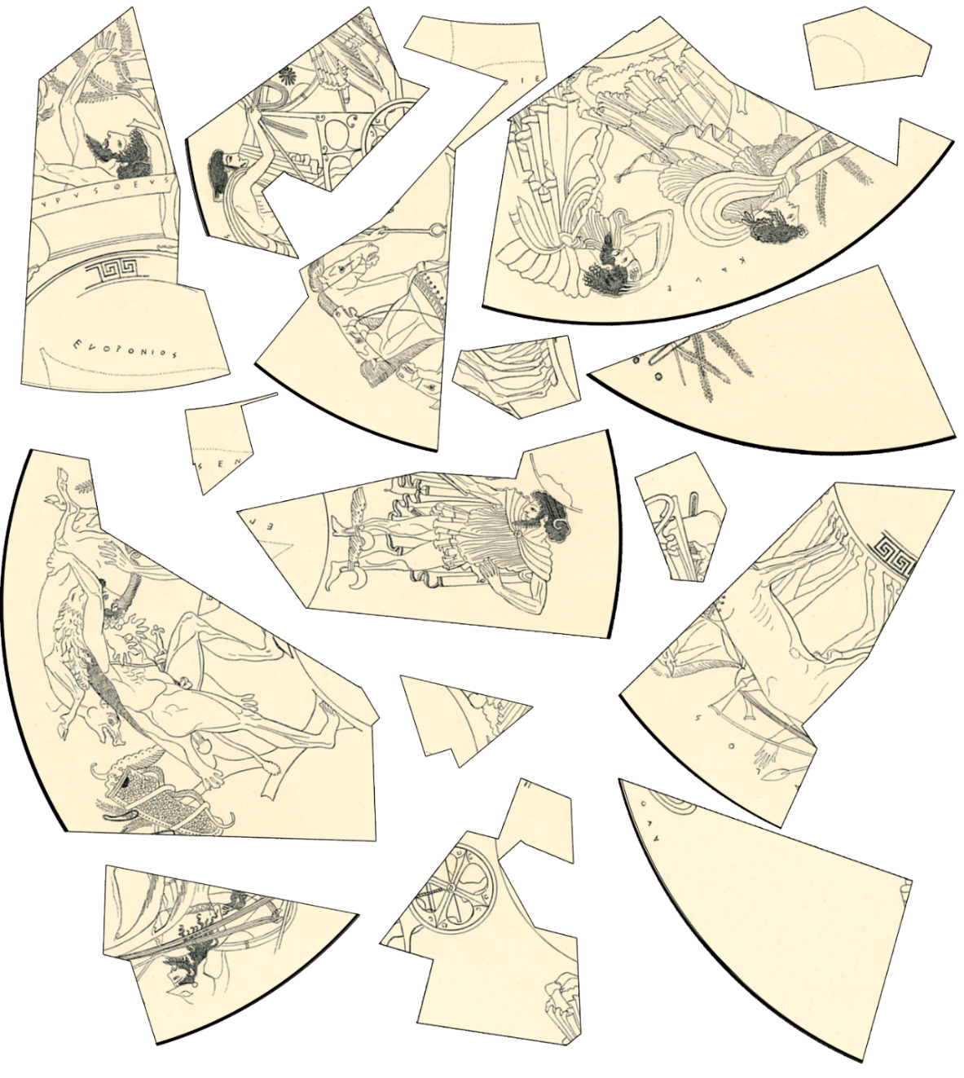
Source: Adapted from Herakles and Eurystheus; after an Attic red-figure kylix by MCAD Library licensed under CC BY 2.0.
Discuss the following as a group.
- How do you know your reconstruction is accurate?
- Could it be reconstructed in a different way?
- How confident can we be interpreting this artefact?

Resource 21 – bias
Examine the fresco in Source 3 and list the food you see.
Source 3
Figure 11 – still life fresco from Pompeii Regio IX.10
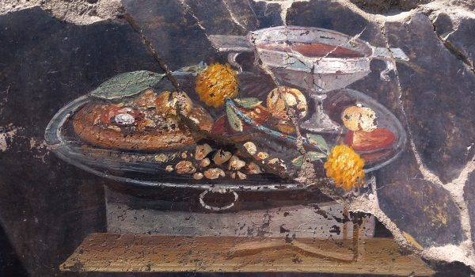
Source: Via Plinio 26, 80045 © Archaeological Park of Pompeii. Reproduced and made available for copying and communication by the State of New South Wales (Department of Education) and their schools for non-commercial educational purposes courtesy of the Ministry of Culture – Archaeological Park of Pompeii. Further reproduction or duplication by any means is prohibited.
I can see:

Read the following information.
Did you think there was a pizza in the fresco? Many people think that too, with modern news media publicising the image as evidence ancient Romans ate pizza. However, archaeologists interpret the fresco as containing a flat focaccia used to support a range of fruits. They also note spices and condiments such as moretum (a type of pesto) may be indicated by the ochre and yellow dots.
Why do many people who view this fresco think it is pizza? This is an unintended bias in their interpretation. They are drawing on their prior knowledge to make sense of the source. Historians and archaeologists need to be aware of bias to prevent it impacting their interpretations.
Bias refers to a tendency to favour one perspective over another, which can influence how information is presented or interpreted. Both archaeological finds and written records can exhibit bias due to the backgrounds, beliefs and intentions of those creating or interpreting them. It is important archaeologists and historians consider if bias influenced the construction of an artefact, such as a statue made for a political purpose, when conducting an historical inquiry.
Bias can also be present when analysing a source, including:
- Interpretive bias: when archaeologists interpret findings using their own theoretical frameworks or cultural backgrounds.
- Preservation bias: some materials survive better than others, leading to an incomplete picture of ancient life.
- Excavation bias: the methods and areas chosen for excavation can influence what is discovered. Certain sites may be prioritised over others based on funding or research interests.
Bias can impact our interpretations in many ways, including misrepresentation of cultures, creation of inaccurate stereotypes and skewed historical narratives.
Discuss the following as a group.
- How can modern bias change our interpretations of the past?
- Can we detect bias when analysing archaeological sources?
- How can we prevent our own bias when conducting an historical inquiry?

Resource 22 – lack of literary sources
Inspect these sources from the site of Çatalhöyük. Write a brief interpretation using the sentence starters provided. The first has been completed as an example.
Table 12 – source collection
Source | Initial interpretation
Source 4  Figure 12 – Çatalhöyük figurine  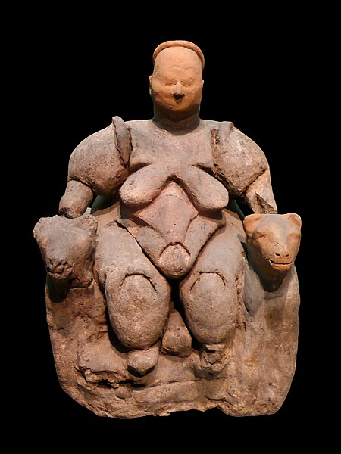  Source: Seated Woman of Çatalhöyük on black background by Nevit Dilmen is licensed under CC BY-SA 3.0. | - This source shows a woman seated with her hands on 2 large felines.  - This source may have been a religious relic, showing a mother goddess taming 2 strong felines.  - I think this because there have been other similar figures found in other ancient cultures that have been interpreted as statuettes of the ‘mother goddess’.
Source 5  Figure 13 – sharp-edged flint attached to bone  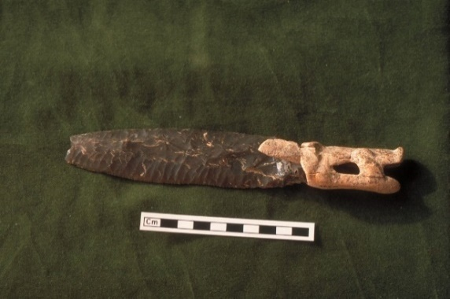  Source: PCD2228_017 1 by Remixing Çatalhöyük is licensed under CC BY-NC 2.0. | - This source shows …  - This source may have been …  - I think this because …
Source 6  Figure 14 – a bone pin stuck in a clump of green-coloured pigment  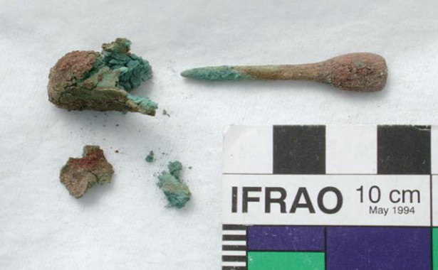  Source: 063001_083740 by Remixing Çatalhöyük is licensed under CC BY-NC 2.0. | - This source shows …  - This source may have been …  - I think this because …
Source 7  Figure 15 – replica of a wall painting  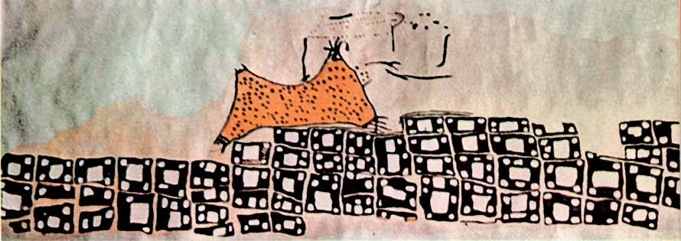  Source: 0606feature1 by Remixing Çatalhöyük is licensed under CC BY-NC 2.0. | - This source shows …  - This source may have been …  - I think this because …
Source 8  Figure 16 – carved bone  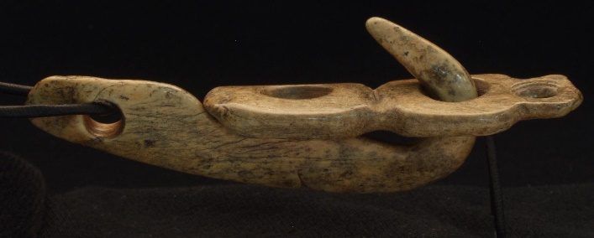  Source: BACH2002 by Remixing Çatalhöyük is licensed under CC BY-NC 2.0. | - This source shows …  - This source may have been …  - I think this because …
Source 9  Figure 17 – replica of a wall painting  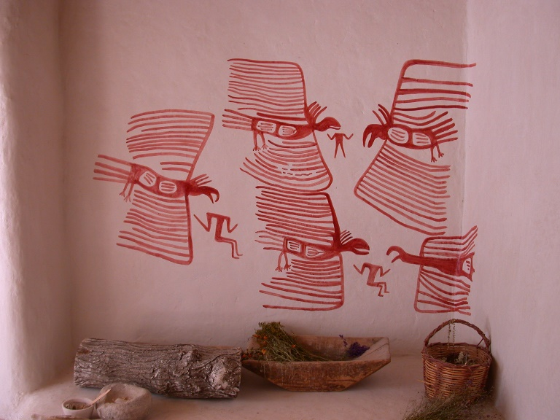  Source: 20020715_jpq_119 by Remixing Çatalhöyük is licensed under CC BY-NC 2.0. | - This source shows …  - This source may have been …  - I think this because …
Source 10  Figure 18 – brown vessel  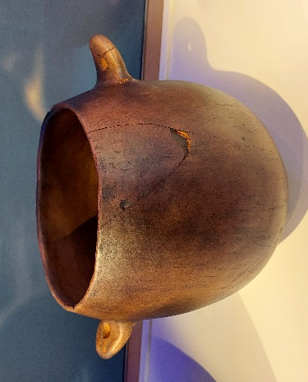  Source: Çatalhöyük image 1 by Jennifer Lawless is licensed under CC BY 4.0. | - This source shows …  - This source may have been …  - I think this because …
Source 11  Figure 19 – plastered skull  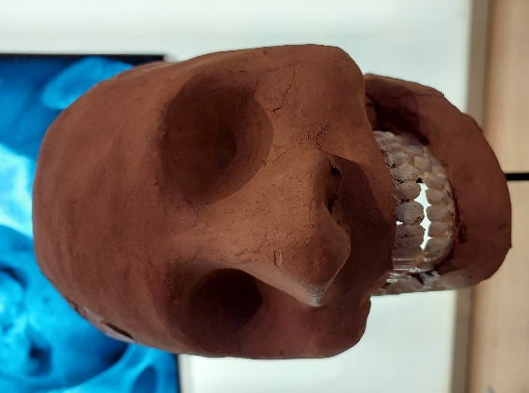  Source: Çatalhöyük image 2 by Jennifer Lawless is licensed under CC BY 4.0. | - This source shows …  - This source may have been …  - I think this because …

Read the following overview of Çatalhöyük.
This ancient site, located on the Konya plain in southern Anatolia, Türkiye, was first excavated in 1961. It has revealed 18 levels of Neolithic settlements dating from circa 7400 to 6200 BCE. It is one of the oldest inhabited sites in the world. As a prehistoric settlement, we do not have literary sources to support our interpretation of artefacts found at the site. Archaeologists need to interpret the sources using their context and similarities in artefacts across the site.
Rectangular mud-brick houses have been excavated. The houses are built close together and have entrances through the roof, rather than a door. Hearths, ovens and platforms for sleeping or sitting have been found inside. Grain, nuts, fruit and condiments were stored in special bins deep inside the house, such as Source 10.
Burials beneath the floor have been found in many houses. Source 6 was found in a burial of a baby under Building 3. Other archaeological sources include reliefs, sculptures, pottery, figurines and skulls plastered to resemble a face, such as Source 11, have been found in the buildings. Rubbish and debris were located outside the settlement.
Some buildings appear to have been religious shrines. The plastered walls were decorated with various paintings and re-plastered frequently. These paintings include many animals such as wild bulls and leopards, and geometric designs. Source 7 is one of these paintings, often interpreted as the oldest map in the world showing the houses in their neat rows in the shadow of Hasan Dağ, the erupting double-peaked volcano in the north-east.
Trade with far off peoples may have occurred. While 90 per cent of edged tools found were made of obsidian; some rare tools used flint traced to Syria. Obsidian may have been traded with other settlements for this flint and other goods, such as seashells from the Mediterranean.
Discuss the following as a group.
- Were you confident in your interpretations of the sources?
- Did reading about Çatalhöyük change your interpretation of any sources?
- If literary evidence was discovered at the site, what more could we learn about life in this prehistoric settlement?
- What might we never know about Çatalhöyük given there are no primary literary sources?

Resource 23 – jigsaw activity
Table 13 – key findings
Challenges with archaeological sources | Key points
Availability of sources
Incomplete or broken sources
Bias
Lack of literary sources

Advice 12 – paragraph writing
Note: clearly explain each PEEL component as you write. Using different colour markers to show the elements of a paragraph supports students understanding the PEEL scaffold. Use appropriate colour contrast to support learners with colour blindness. The example teacher modelled paragraph is coloured as a guide. As students’ skills develop, gradually remove explicit PEEL prompts and ask students to independently identify each section of their own paragraphs. Gradually introduce increasingly complex paragraphs, showing how students can maintain structure without explicit scaffolding. Encourage students to critically reflect on how each sentence contributes to the clarity and strength of the argument. Year 11 students should be working towards removing their use of this scaffold as their writing skills develop and writing tasks become more complex.
Example teacher-modelled paragraph:
Different rates of deterioration impact the variety of artefacts available when interpreting the ancient past. Archaeological sites like Akrotiri provide a variety of preserved artefacts, however most sites only provide a sample of the artefacts that would have existed in the society. The material composition and cultural significance of an item plays a strong role in whether it has survived to modern times. Environmental factors, such as climatic conditions, soil type and water conditions, and human impacts, including burial, construction, farming and archaeological practices, all contribute to the preservation or decay of ancient artefacts. Archaeologists and historians need to make judgements based on this incomplete evidence, risking gaps in our understanding and potential misrepresentation of the past.

Resource 24 – TAG feedback
Figure 20 – TAG peer feedback scaffold
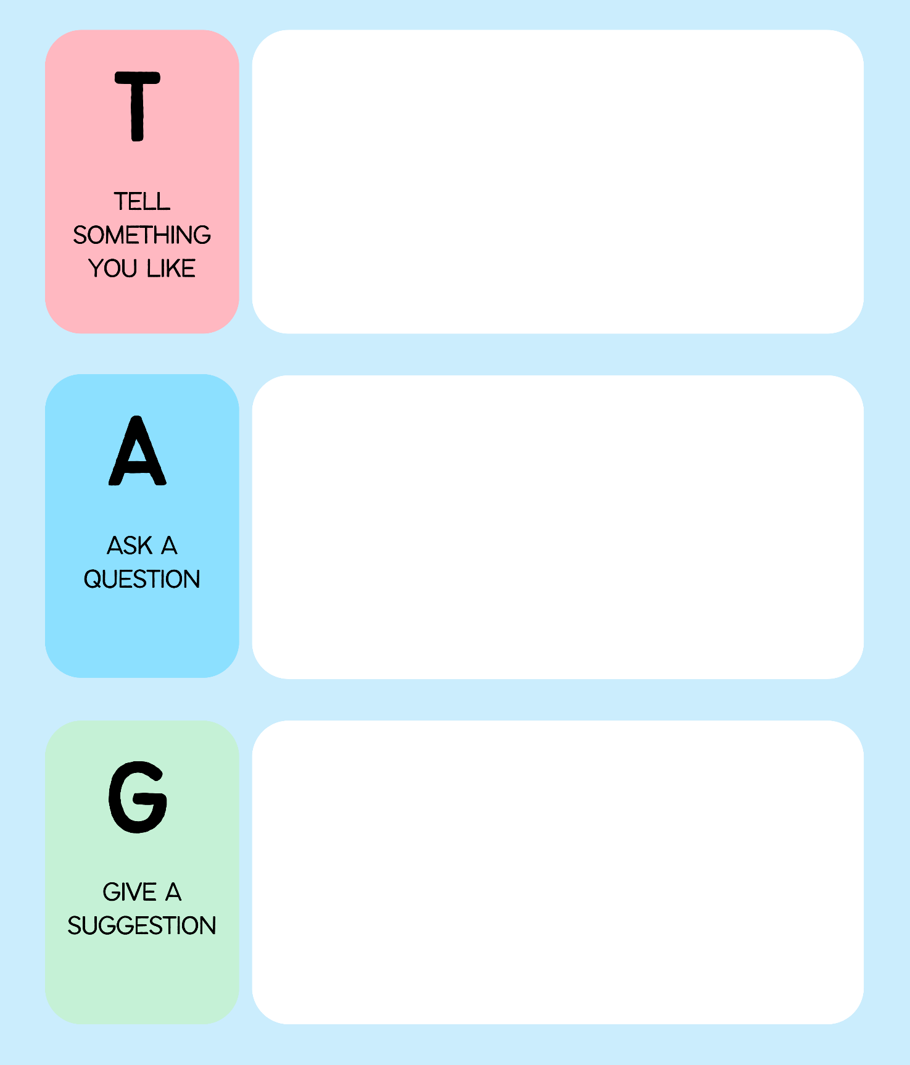

Learning sequence 3 – value and limitations of sources
This learning sequence is designed to be completed in approximately 3 hours. The support provided in this section aligns with Learning sequence 3 in the program.

Syllabus content
- The value and limitations of ancient texts, inscriptions, petroglyphs and iconography to an understanding of the ancient past

Introduction to value and limitations

Resource 25 – value and limitations of sources
Table 14 – value and limitations of sources
Source type | Value | Limitations
Archaeological sources
Ancient texts
Inscriptions
Petroglyphs
Iconography

Resource 26 – literary and epigraphic sources
Table 15 – literary and epigraphic source types
Type | Description
Ancient texts | Written records from the past, often on materials like papyrus or parchment. A large range of ancient texts have survived, including histories, biographies, poems, plays and myths. All vary enormously in the amount of historical evidence that they provide. There’s also a range of ancient texts that have not survived, creating gaps in our source material. It is thought between 100,000 to 700,000 manuscripts were lost in the destruction of the Alexandrian Library in Egypt around the 1st Century BCE. We will never know the full extent of writings from the ancient world.
Inscriptions | Texts engraved or carved into materials such as stone, metal or pottery. They come in a range of forms and lengths. They may be found on temple, palace or city walls, statues and stone steles such as tombs. Some can be quite short in length. The author of inscriptions is often unknown.
Petroglyphs | Ancient rock art made by engraving a rock surface through hammering or chipping at the surface to create an image. They may also appear with pictographs: images painted on rock surfaces using minerals such as charcoal, clay, chalk and ochre of red-brown, yellow and white colours. There are more than 100,000 significant rock art sites around Australia.
Iconography | The visual images and symbols used by a culture to represent particular ideas, themes or narratives. For example, ancient rulers often promoted their power through iconography, such as depicting themselves larger than others, as warriors or with images of strong animals such as lions. These symbols were often used in ancient societies where most people could not read as the icons were easily understood. Over time, the meaning of many of this iconography has been lost.

Ancient texts

Resource 27 – Suetonius’ account of Nero
Nero was a Roman Emperor from 54 to 68 CE. Early in his rule, he had a reputation for his artistic ambitions, promoting the arts and participating in public performances. However, he became increasingly tyrannical through his reign. Dissent was caused by his extravagant spending, political purges and the persecution of Christians. He was accused by some as causing the Great Fire of Rome in 64 CE to clear land for his grand palace. Nero’s reign ended in chaos, leading to a revolt that resulted in his suicide, making him a symbol of the excesses of imperial power.
Suetonius was a Roman historian and biographer who lived during the early second century CE. As a member of the Roman elite, Suetonius was influenced by the political and social dynamics of his time. His accounts reflect the perspective of the senatorial class, who were often critical of Nero due to his populist policies, extravagant lifestyle and brutal repression of dissent.
Extracts from The Lives of the Twelve Caesars
Petulancy, lewdness, luxury, avarice, and cruelty, he practised at first with reserve and in private, as if prompted to them only by the folly of youth, but, even then, the world was of opinion that they were the faults of his nature, and not of his age. After it was dark, he used to enter the taverns disguised in a cap or a wig, and ramble about the streets in sport, which was not void of mischief. He used to beat those he met coming home from supper; and, if they made any resistance, would wound them, and throw them into the common-sewer. He broke open and robbed shops; establishing an auction at home for selling his booty. In the scuffles which took place on those occasions, he often ran the hazard of losing his eyes, and even his life; being beaten almost to death by a senator, for handling his wife indecently. After this adventure, he never again ventured abroad at that time of night, without some tribunes following him at a little distance. In the day-time he would be carried to the theatre incognito in a litter, placing himself upon the upper part of the proscenium, where he not only witnessed the quarrels which arose on account of the performances, but also encouraged them. When they came to blows, and stones and pieces of broken benches began to fly about, he threw them plentifully amongst the people, and once even broke a praetor’s head.
Source: Suetonius: The Lives of the Twelve Caesars; An English Translation – Chapter 26 by Alexander Thomson is licensed under CC BY-SA 3.0 US.
He began the practice of parricide and murder with Claudius himself; for although he was not the contriver of his death, he was privy to the plot. Nor did he make any secret of it; but used afterwards to commend, in a Greek proverb, mushrooms as food fit for the gods, because Claudius had been poisoned with them.
Source: Suetonius: The Lives of the Twelve Caesars; An English Translation – Chapter 33 by Alexander Thomson is licensed under CC BY-SA 3.0 US.
In stature he was a little below the common height; his skin was foul and spotted; his hair inclined to yellow; his features were agreeable rather than handsome; his eyes grey and dull, his neck was thick, his belly prominent, his legs very slender, his constitution sound. For, though excessively luxurious in his mode of living, he had, in the course of fourteen years, only three fits of sickness; which were so slight, that he neither forbore the use of wine, nor made any alteration in his usual diet. In his dress, and the care of his person he was so careless, that he had his hair cut in rings, one above another; and when in Achaia, he let it grow long behind; and he generally appeared in public in the loose dress which he used at table, with a handkerchief about his neck, and without either a girdle or shoes.
Source: Suetonius: The Lives of the Twelve Caesars; An English Translation – Chapter 51 by Alexander Thomson is licensed under CC BY-SA 3.0 US.
He had an insatiable desire to immortalize his name, and acquire a reputation which should last through all succeeding ages; but it was capriciously directed. He therefore took from several things and places their former appellations, and gave them new names derived from his own. He called the month of April, Neroneus, and designed changing the name of Rome into that of Neropolis.
Source: Suetonius: The Lives of the Twelve Caesars; An English Translation – Chapter 55 by Alexander Thomson is licensed under CC BY-SA 3.0 US.

Advice 13 – vocabulary support for Resource 27
Table 16 – vocabulary support
Term | Definition | Synonym | Antonym
purge | Removal or execution of people who are considered undesirable | Cleansing, removal | Addition, inclusion, protection
persecution | Hostile treatment or punishment of a person, usually due to their race, religion or political affiliation | Oppression, mistreatment | Protection, support
populist policies | Political actions aimed at appealing to ordinary people | Democratic, grassroots policies | Elitist policies
extravagant | Extreme and unnecessary spending | Excessive, lavish | Frugal, fiscally responsible
repression | The act of holding back or controlling, often using force | Suppression, restraint | Freedom, release
dissent | Disagreement or difference of opinion | Opposition, disagreement | Agreement, consensus
petulancy | Childish, sulky or bad-tempered behaviour | Irritability, crankiness | Good natured
lewdness | Acting in a sexually inappropriate or offensive way | Indecency, obscenity | Purity, modesty
luxury | A state of great comfort or elegance, often involving expensive items | Opulence, indulgence | Necessity, simplicity
avarice | Extreme greed for wealth or material gain | Greed, cupidity | Generosity, philanthropy
incognito | Concealing or hiding your identity | Undercover, disguised | Identified, known
proscenium | The part of a theatre stage in front of the curtain (the frame around the stage) | Stage front, acting area | No known antonym
praetor | A title for a Roman official who had judicial power | Magistrate, judge | No known antonym
parricide | Killing of a parent or close relative | No known synonym | No known antonym
insatiable | Impossible to satisfy; always wanting more | Unquenchable, ravenous | Satisfied, content
immortalize  (immortalise) | To make someone or something remembered forever | Eternalise, commemorate | Forget, erase
capriciously | Acting in a way that is impulsive and unpredictable | Erratically, whimsically | Predictable, steadily
appellations | Names or titles by which someone or something is known | Labels, designations | No known antonym

Resource 28 – Suetonius source analysis
Table 17 – Suetonius source analysis
Fact | Opinion

Inscriptions

Resource 29 – types of inscriptions

Graffiti
Source 12
Translation of graffiti found at the Quarry of Hatnub: ‘Year 20 of the nomarch Aha-nakht, his son Khnum-iqer’ (above the figure). ‘What was said by the scribe Khnum-iqer: I am a scribe according to his [i.e. a superior’s] heart’s desire, with a cool body, who displaces heat, praised by all whom he meets, and free from blasphemy. I have come here to Hatnub to fetch calcite alabaster for making monuments to (the goddess) Unut, the Lady of Unu, for the health of Aha-nakht; may he live [and] be prosperous and healthy’.
Source: Writing Wherever Possible and Meaningful: Graffiti Culture in Ancient Egypt. Context, Terminology, Documentation by Ursula Verhoeven is licensed under CC BY-NC-ND 4.0.

Burial inscription
Source 13
Figure 21 – grave stela
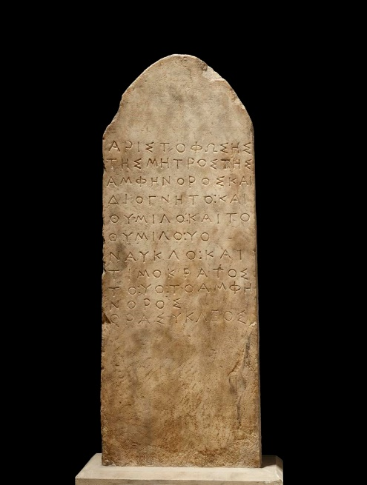
Source: 1613407194 © The Trustees of the British Museum. Shared under a Creative Commons Attribution-NonCommercial-ShareAlike 4.0 International (CC BY-NC-SA 4.0) licence.
Translation: (Memorial) of Aristophosa, mother of Amphenor and Diognetos and Thymilos, and (memorial) of Thymilos, son of Nauklos, and (memorial) of Timokrates, son of Amphenor. (Memorial) of Thrasykles.
Source: Grave stele of the family of Aristophosa by Robert Pitt is licensed under CC BY-SA 3.0.

Temple inscription
Source 14
Figure 22 – inscription on the Temple of Rome and Augustus
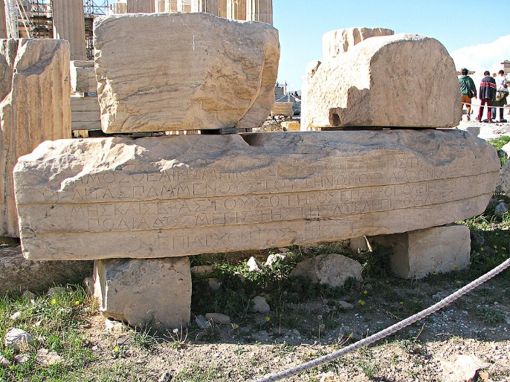
Source: Temple of Rome and Augustus inscription, Athens Acropolis by Lourakis is licensed under CC BY-SA 4.0.
Translation: The People (dedicated this temple) to the Goddess Roma and ⟦Augustus Soter⟧ «Augustus Caesar», when the hoplite general was Pammenes son of Zenon of Marathon, priest of the Goddess Roma and Augustus Soter on the Acropolis, when the priestess of Athena Polias was Megiste daughter of Asklepiades of Halai, in the archonship of Areios son of Dorion of Paiania.
Source: Dedicatory inscription on the temple of Roma and Augustus by Chris de Lisle is licensed under CC BY-SA 3.0.

Building inscription
Source 15
Translation: Of the presiding committee Menestratos of Aixone was putting to the vote. Eukrates son of Aristotimos of Piraeus proposed: for the good fortune of the Athenian People, the lawmakers shall decide: if anyone rises up against the People for a tyranny or joins in establishing a tyranny or overthrows the Athenian People or the democracy at Athens, whoever kills anyone who does any of these things shall be without guilt.
Source: Extract of Law against tyranny by Stephen Lambert is licensed under CC BY-SA 3.0.

Foreign correspondence inscription
Source 16
Amarna letter EA 271 translation: (o 001) Speak to the king, my lord, my god, my Sun god, a message from Milki-ʾili, your servant, the dust of your feet. I fall at the feet of the king, my lord, my god, my Sun god, seven times (and) seven times.
(o 009) The king, my lord, should know that the hostility towards me and against Šuwardata is severe, so may the king, my lord, rescue his land from the might of the habiru. If not, send chariots, O king, my lord, in order to take us away lest our servants attack us.
(r 022) Something else: The king, my lord, should ask Yanḥamu, his servant, about what is being done in his land.
(rest of reverse blank)
Source: EA 271. Gezer [client letter] by Jacob Lauinger and Tyler Yoder is licensed under CC-BY-SA 3.0.

Iconography

Resource 30 – Persian Empire iconography
Table 18 – Persian Empire iconography research
Icon | Image | Description | Meaning
Faravahar
Lion-bull motif
Worshipping scenes with the sacred fire
Eagles
Lotus flowers
Depictions of the king

Summative activity

Resource 31 – using archaeological sources
Figure 23 – Partenope and Metiox mosaic
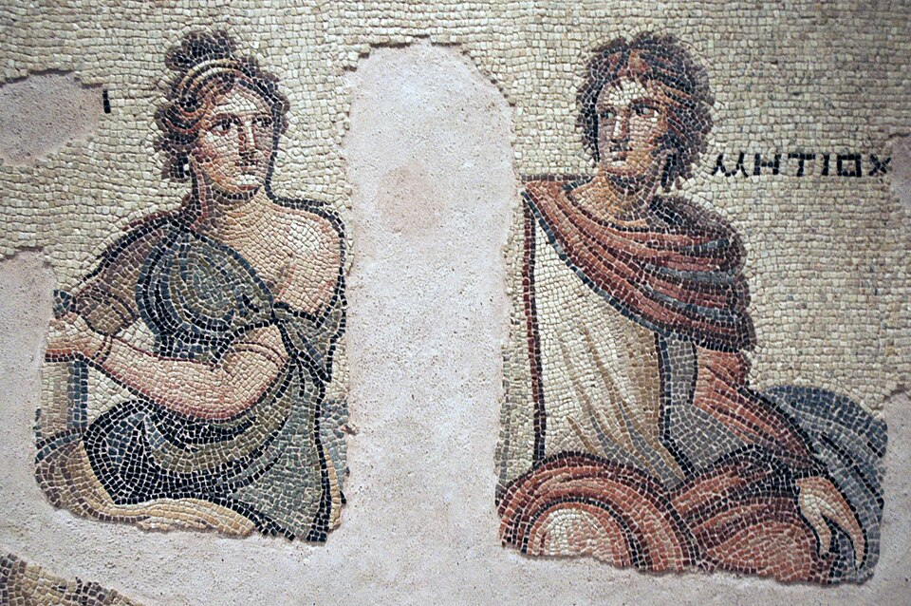
Source: Gaziantep Zeugma Museum Methiokos mosaic 8142 by Dosseman is licensed under CC BY-SA 4.0.

Advice 14 – suggested teacher expositions
Question 1 – What initial questions would you ask to support your analysis of this source?
We’ve identified some important questions about the provenance of this source. This mosaic is one of the Zeugma mosaics. The Zeugma mosaics were discovered at the ancient city of Zeugma in modern-day Türkiye. The site dates from the Hellenistic period into the Roman era, around the 2nd century BCE to the 3rd century CE.
Major excavations at the Zeugma site occurred in the late 1990s and early 2000s. The mosaics were initially discovered through site surveys. Archaeologists used traditional excavation methods, carefully removing soil layers by hand to preserve fragile artworks. Advanced recording techniques such as digital mapping and high-resolution photography were also used to document the site during emergency excavations which took place before the site was flooded for the Birecik Dam project.
This particular mosaic, however, was not found through these excavations. In 1993, it was determined that part of a floor mosaic was stolen by smugglers. Local residents stated the torso parts of the figures were stolen in 1964. After an investigation, the smuggled pieces were discovered in the Menil Collection at Rice University in Houston, USA, by Canadian mosaic expert Sheila Campbell. After a period of negotiation, the pieces were returned to the Gaziantep Museum and the source was reconstructed and put on display.
Question 2 – What problems could you face when using this source in an historical inquiry?
Source authenticity is a key problem to consider for all sources. The authenticity of the Zeugma mosaics is supported by stratigraphic evidence at the site and stylistic comparisons to other Roman period artworks.
Availability of other sources is another potential problem. While many mosaics were discovered at the Zeugma site, gaps exist because only a portion of the city could be excavated before flooding. This makes it difficult to determine the full context of this mosaic. Underwater archaeology may provide additional evidence in the future, but the conditions under the water impact on the preservation of artefacts at the site.
Question 3 – What can you see in the source?
This mosaic is interpreted as a graphic depiction of the ‘hero lovers’ in the ancient Greek novel Metiochus and Parthenope. Only fragments of this novel have survived. Modern historians have attempted to reconstruct the story using references to the story found in Roman sources, including this source and a Syrian mosaic also depicting these protagonists. Based on interpretations so far, the story consists of Metiochus (Metiox), the eldest son of Miltiades, fleeing to his distant relative Polycrates on the island of Samos as his stepmother is plotting against him. He meets Polycrates’s daughter, Parthenope (Partenope) and they fall in love instantly. Polycrates invites Metiochus to a symposium where there are discussions of love.
Question 4 – What are the limitations of this source?
The missing sections may have contained images and even text that could lead to a different interpretation of the meaning of the mosaic. Other limitations include the incomplete excavation of the site, and a possible bias in interpretations of Zeugma towards elite society, as the mosaics were located in wealthy homes rather than common areas. This makes it harder to reconstruct a full picture of everyday life for ordinary people at Zeugma.
Question 5 – What is the value of this source?
This mosaic is extremely valuable for understanding Roman art, mythology, domestic life and cultural influences in the eastern provinces of the Roman Empire. It reveals themes from the mythology of Partenope and Metiox and provides insight into the wealth and tastes of Roman citizens at Zeugma.

References
This resource contains NSW Curriculum and syllabus content. The NSW Curriculum is developed by the NSW Education Standards Authority. This content is prepared by NESA for and on behalf of the Crown in right of the State of New South Wales. The material is protected by Crown copyright.
Please refer to the NESA Copyright Disclaimer for more information https://educationstandards.nsw.edu.au/wps/portal/nesa/mini-footer/copyright.
NESA holds the only official and up-to-date versions of the NSW Curriculum and syllabus documents. Please visit the NSW Education Standards Authority (NESA) website https://educationstandards.nsw.edu.au and the NSW Curriculum website https://curriculum.nsw.edu.au.
Ancient History 11–12 Syllabus © NSW Education Standards Authority (NESA) for and on behalf of the Crown in right of the State of New South Wales, 2024.
Archaeological Park of Pompeii (2023) Via Plinio 26, 80045 [image] in Pompeii: a still life discovered by the new excavations of Regio IX, Pompeii Sites website, accessed 5 May 2025.
Belzoni GB (1835) Narrative of the Operations and Recent Discoveries Wwithin the Pyramids, Temples, Tombs, and Excavations, in Egypt and Nubia, Google Books, accessed 8 April 2025.
Bukvoed (2018) File:moza-449.jpg [image], Wikimedia Commons website, accessed 8 April 2025.
Cartwright M (18 November 2012) Pompeii: Graffiti, Signs & Electoral Notices, World History Encyclopedia website, accessed 9 April 2025.
de Lisle C (13 March 2018) IGII34 10 Dedicatory inscription on the temple of Roma and Augustus, Attic Inscriptions Online website, accessed 9 April 2025.
Dilmen N (8 March 2012) File:Seated Woman of Catalhöyük on black background.jpg [image], Wikimedia Commons website, accessed 9 April 2025.
Dosseman (21 March 2004) File:Gaziantep Zeugma Museum Methiokos mosaic 8142.jpg [image], Wikimedia Commons website, accessed 28 April 2025.
Lambert S (10 December 2012) IGII31 320 Law against tyranny, Attic Inscriptions Online website, accessed 9 April 2025.
Lauinger J and Yoder T (n.d.) EA 271. Gezer [client letter], Oracc: The Open Richly Annotated Cuneiform Corpus website, accessed 9 April 2025.
Lawless J (2024a) Çatalhöyük image 1 [image], Çatalhöyük Archaeological Museum, Konya, Türkiye.
Lawless J (2024b) Çatalhöyük image 2 [image], Çatalhöyük Archaeological Museum, Konya, Türkiye.
Lourakis (11 November 2016) File:Temple of Rome and Augustus inscription, Athens Acropolis.jpg [image], Wikimedia Commons website, accessed 9 April 2025.
MCAD Library (14 December 2012) Herakles and Eurystheus; after an Attic red-figure kylix [image], Flickr website, accessed 9 April 2025.
Petrie WMF (1904) Methods & Aims in Archaeology, Project Gutenberg website, accessed 8 April 2025.
Pitt R (6 April 2022) AIUK46 no. 1 Grave stele of the family of Aristophosa, Attic Inscriptions Online website, accessed 9 April 2025.
Remixing Çatalhöyük (20 September 2007a) 20020715_jpq_119 [image], Flickr website, accessed 9 April 2025.
——(20 September 2007b) BACH2002 [image], Flickr website, accessed 9 April 2025.
——(27 September 2007a) 0606feature1 [image], Flickr website, accessed 9 April 2025.
——(27 September 2007b) 063001_083740 [image], Flickr website, accessed 9 April 2025.
——(27 September 2007c) PCD2228_017 1 [image], Flickr website, accessed 9 April 2025.
The British Museum (n.d.) stela; tombstone, The British Museum website, accessed 9 April 2025.
Thomson A (1889a) C. Suetonius Tranquillus, Nero – Chapter 26, Perseus Digital Library website, accessed 9 April 2025.
——(1889b) C. Suetonius Tranquillus, Nero – Chapter 33, Perseus Digital Library website, accessed 9 April 2025.
——(1889c) C. Suetonius Tranquillus, Nero – Chapter 51, Perseus Digital Library website, accessed 9 April 2025.
——(1889d) C. Suetonius Tranquillus, Nero – Chapter 55, Perseus Digital Library website, accessed 9 April 2025.
Verhoeven U (2023) Writing Wherever Possible and Meaningful: Graffiti Culture in Ancient Egypt. Context, Terminology, Documentation, De Gruyter Brill website, accessed 28 April 2025.
Zroota (28 September 2020) File:Gosford glyphs.jpg [image], Wikimedia Commons website, accessed 9 April 2025.

© State of New South Wales (Department of Education), 2025
The copyright material published in this resource is subject to the Copyright Act 1968 (Cth) and is owned by the NSW Department of Education or, where indicated, by a party other than the NSW Department of Education (third-party material).
Copyright material available in this resource and owned by the NSW Department of Education is licensed under a Creative Commons Attribution 4.0 International (CC BY 4.0) license.

This license allows you to share and adapt the material for any purpose, even commercially.
Attribution should be given to © State of New South Wales (Department of Education), 2025.
Material in this resource not available under a Creative Commons license:
- the NSW Department of Education logo, other logos and trademark-protected material
- material owned by a third party that has been reproduced with permission. You will need to obtain permission from the third party to reuse its material.
Links to third-party material and websites
Please note that the provided (reading/viewing material/list/links/texts) are a suggestion only and implies no endorsement, by the New South Wales Department of Education, of any author, publisher, or book title. School principals and teachers are best placed to assess the suitability of resources that would complement the curriculum and reflect the needs and interests of their students.
If you use the links provided in this document to access a third-party's website, you acknowledge that the terms of use, including licence terms set out on the third-party's website apply to the use which may be made of the materials on that third-party website or where permitted by the Copyright Act 1968 (Cth). The department accepts no responsibility for content on third-party websites.

