History 7–10 (Stage 5) – supporting resources
Historical context 4 (core): The making of the modern world (1750–c.1945)

Contents
Overview 3
Outcomes 3
Learning sequence 1 – forces of change: the Industrial Revolution and the movement of people 5
Resource 1 – the Industrial Revolution ‘See Think Wonder’ 5
Resource 2 – Industrial Revolution timeline 7
Resource 3 – check for understanding 9
Resource 4 – cause and effect of the Industrial Revolution 10
Resource 5 – PEEL paragraph scaffold 11
Resource 6 – nature of imperialism 12
Resource 7 – consequences of imperialism 14
Resource 8 – push and pull factors 15
Resource 9 – British imperialism and Australia 16
Resource 10 – Aboriginal and/or Torres Strait Islander perspectives 19
Resource 11 – impact of movement of people 21
Resource 12 – writing scaffold 22
Resource 13 – the transatlantic slave trade 24
Resource 14 – map of the transatlantic slave trade 26
Resource 15 – impacts of the transatlantic slave trade 28
Learning sequence 2 – revolutions, human rights and the rise of nation-states 29
Resource 16 – key revolutions of the 1700s 29
Resource 17 – key documents of the revolutions 31
Resource 18 – modern day human rights, rule of law in governance and democratic ideals 33
Resource 19 – analysing sources 34
Resource 20 – overview of the rise of nation-states 35
Resource 21 – nationalism and the rise of the nation state video worksheet 38
Resource 22 – source analysis scaffold: assessing values and limitations 40
Learning sequence 3 – World War I, peace and the rise of new ideologies 41
Resource 23 – World War I timeline 41
Resource 24 – MAINS causes of World War I 43
Resource 25 – militarism as a cause of World War I 44
Resource 26 – alliances as a cause of World War I 45
Resource 27 – alliances and the domino effect 46
Resource 28 – imperialism as a cause of WWI – PMI 47
Resource 29 – significant individuals and events that caused WWI 48
Resource 30 – the Paris Peace Conference video worksheet 50
Resource 31 – source analysis group task: the impact of the Paris Peace conference 51
Resource 32 – political ideologies in the interwar period jigsaw task 56
Appendix 1 – glossary of key vocabulary 58
Appendix 2 – caricature, chain of friendships 60
References 61

Overview
This Supporting resource supports Learning sequence 1 to 3 in Historical context 4 (core): The making of the modern world (1750–c. 1945) available on Planning, programming and assessing History 7–10 (2024). Ways this student resource pack can be used include:
- using the resources as worksheets, samples and models, tailoring them to address contextual needs and specific learning objectives
- reviewing the resources during faculty meetings or planning days, jointly planning opportunities for team teaching, mentoring, lesson observation, and sharing of student samples
- employing the examples of resources and/or activities as a blueprint for designing student-specific tasks that cater to individual learning styles and needs
- leveraging the strategies, texts, assessment practices, pedagogical practices, and/or syllabus planning as an opportunity to backward map, ensuring a cohesive and comprehensive learning experience in History 7–10 (2024).
Note: this resource includes topics that might be considered controversial or sensitive. Teachers are to respect the diverse views and experiences of all students and approach discussions in a manner that is impartial, free from harassment and discrimination, supportive of students’ wellbeing needs and aligned with the department’s Professional and ethical standards, Anti-racism policy, Controversial issues in schools procedures and Values in NSW public schools. Teachers should facilitate rational discourse and objective study while tailoring the content to meet the unique needs of their students. Where possible, teachers should consult with the school’s wellbeing team before using contexts that might be sensitive for some students.

Outcomes
A student:
- HI5-CON-01 accounts for continuity and change over a period of time in relation to a historical context
- HI5-CPP-01 accounts for different contexts and perspectives of the past
- HI5-INQ-01 assesses the value and limitations of sources as part of a historical inquiry
History 7–10 Syllabus © NSW Education Standards Authority (NESA) for and on behalf of the Crown in right of the State of New South Wales, 2024.

Learning sequence 1 – forces of change: the Industrial Revolution and the movement of people

Resource 1 – the Industrial Revolution ‘See Think Wonder’
Complete the ‘See Think Wonder’ table below as your teacher presents image on the Industrial Revolution.
Source 1
Figure 1 – workers inside the Fuse Factory, Woolwich Arsenal
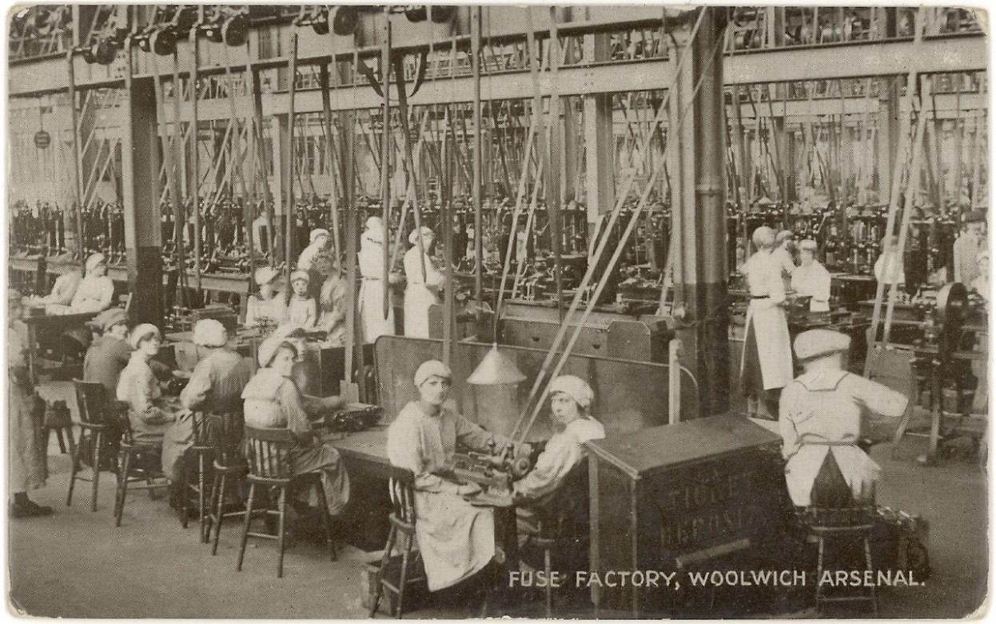'' ‘Workers in the fuse factory Woolwich Arsenal’ from Flickr is available in the public domain.
Table 1 – See Think Wonder
See, Think, Wonder | notes
What I see

What I think

What I wonder

Resource 2 – Industrial Revolution timeline
Sequence the important events of the Industrial Revolution to understand how change unfolded over time. Cut along the lines and place the event cards into chronological order

Introduction of the steam engine by James Watt
1776
A powerful engine that helped factories run machines more efficiently.

Start of the Industrial Revolution in Britain
Circa 1760
This is when new machines and factory production began changing how people worked.

Growth of factory towns and cities
Late 1700s – Early 1800s
Many people moved to cities to work in factories, causing rapid urban growth.

First Factory Act passed regulating working hours
1833
The government introduced laws regulating the working hours for children.

Introduction of schooling for working children
Late 1800s
Laws were passed to ensure children went to school instead of working.

Child labour widely used in factories
Early 1800s
Children were employed in dangerous and long factory jobs.

Poor working conditions noted and start of labour reform movements
Mid-1800s
People began speaking out about hard working conditions and unfair hours.

Improvements in sanitary conditions in cities
Late 1800s
Efforts were made to clean up cities and improve public health.

Development of railways and improved transport
1830s–1840s
Railways expanded, making it easier to move goods and people.

Resource 3 – check for understanding
Recall and understanding
- What was the significance of James Watt’s steam engine invention?
- Why did many people move from rural areas to factory towns and cities during the Industrial Revolution?
- What kinds of jobs did children do in factories?
- What was the purpose of the first Factory Act passed in 1833?
Analysis and comparison
- How did living conditions in cities change during the Industrial Revolution?
- Compare working conditions before and after the Factory Act. How did the law improve workers’ lives?
- How did the development of railways affect people’s lives and the economy?
Critical thinking and reflection
- Why do you think people started to push for laws to regulate working hours and child labour?
- How might life be different today if these reforms during the Industrial Revolution had not happened?
- What do you think was the most important event in the timeline? Explain your answer.

Resource 4 – cause and effect of the Industrial Revolution
As you watch the video The Impact of the Industrial Revolution (3:42), complete the cause-and-effect table to show the impact of the Industrial Revolution on the people’s working and everyday life.
Table 2 – cause-and-effect table
Cause (what happened) | Effect (what was the result)
Sample – introduction of factory machinery | More goods were produced quickly but workers had to work long hours.

Resource 5 – PEEL paragraph scaffold
Use the scaffold below to plan your response for the question: Explain the consequences of the Industrial Revolution on both living and working conditions
Table 3 – consequences of the Industrial Revolution PEEL paragraph scaffold
Point/topic sentence | Example/evidence | Explanation/effect | Link
Sentence that introduces the main idea and reflects the language of the question. Explain. | Specific information including events, names, key terms and evidence from sources (causes). | What impact did the events of the Industrial Revolution have on the living and working conditions (effects)? | Link back to the question and your main point.
Sample sentence starter:  The Industrial Revolution had significant impacts on … | Sample sentence starter:  During this period living conditions in urban areas became … | Sample sentence starter:  This led to … because … | Sample sentence starter:  As a result/therefore …

Resource 6 – nature of imperialism
European nations expanded their empires for 2 main reasons. Economic gain and strategic control. This expansion created a massive demand for people to move – sometimes voluntarily, but often by force.
Table 4 – purpose of imperialism
Motivation | Type: Economic or strategic?
Needing rubber and gold to boost industry
Establishing naval bases to protect ships
Preventing rival nations from taking land
Securing cheap labour for plantations
Figure 2 – map of imperialism 1800
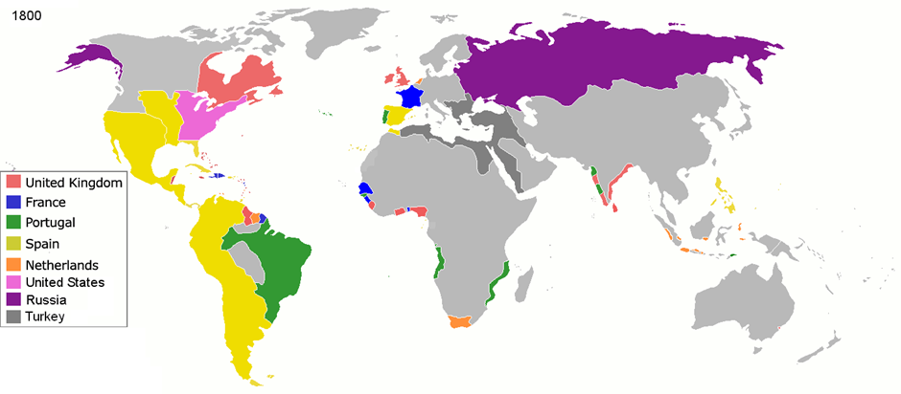
'Jluisrs' from Wikimedia Commons is available in the public domain.
Figure 3 – map of imperialism 1914
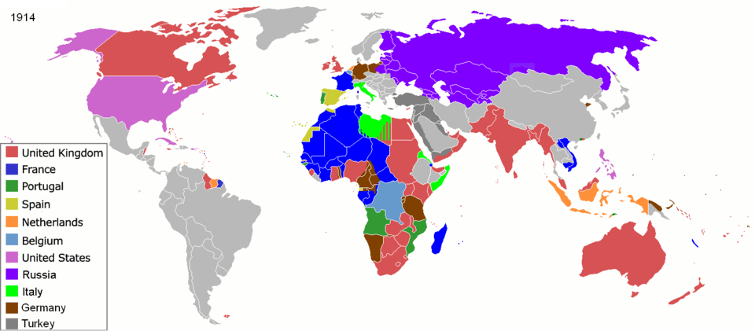
‘ArdadN’ from Wikimedia Commons is available in the public domain.
Questions:
- Based on the maps provided, who controlled most of the world:
- 1800?
- 1914?
- What do you notice about Asia, Africa and the Pacific?
- Account for the increase in imperialism in Figure 3 – map of imperialism 1914.
- Why might these imperial powers be competing?
- How could this set the stage for global conflict?
- Develop one inquiry question this map raises about the movement of people.

Resource 7 – consequences of imperialism
Use the words in the word bank to complete the paragraph below:
resources | colonies | migration | power | forced | global
European nations competed for (1) __________ and prestige by establishing (2) __________ across Africa, Asia, and the Pacific. To make these territories profitable, empires needed to extract natural (3) __________ like minerals and crops.
This led to a massive wave of (4) __________, as people were moved around the world to provide labour. While some moved for a better life, many others were (5) __________ to move against their will. This era created the (6) __________ networks that connect our modern world today.
Types of migration: conduct research to complete the table below. Use the following links to assist with your research:
- British Empire facts – National Geographic Kids
- The transatlantic slave trade overview – BBC Bitesize
- Indentured labor – Britannica.
Table 5 – different types of migrants
Migrant group | Destination | Freedom Status | Main motivation for Empire
British free settlers | Australia/Canada | Voluntary/free | Economic – search for new resources
Enslaved Africans
Indentured labourers

Resource 8 – push and pull factors
Push factors: reasons that force or encourage people to leave their home
Pull factors: reasons that attract people to a new location
Check your understanding
For each scenario below, identify if the migration is driven by a push or pull factor by circling the correct option.
- A British farmer moves to Australia because the government offers him free land and better farming opportunities.
- push factor
- pull factor
- A family in Ireland leaves their home because a potato shortage has caused a massive famine and there is no food.
- push factor
- pull factor
- An Indian worker is recruited to work in the Caribbean sugar plantations because there is a high demand for cheap labour.
- push factor
- pull factor
- A young man flees his country because of a violent war between rival imperial powers.
- push factor
- pull factor

Resource 9 – British imperialism and Australia
Australia was colonised for specific imperial reasons. Initially, it served as a penal colony to relieve overcrowding in British prisons. Later, the government encouraged free settlers to arrive for sheep grazing and farming.
Use Sources 2 and 3 to complete Table 6 – source analysis below.
Source 2
Extract from the letters of a settler in Australia
It is a noble property to look at; and ‘20,000 acres in a ring fence,’ sounds very well in England; but here, such a property possesses no exchangeable value. The reason is plain: there are millions upon millions of acres, as fertile as mine, to be had for nothing; and what is more, there are not people to take them. (103)
Source: "On Systematic Colonisation and Culture of Settler Colonialism: Edward Gibbon Wakefield’s A Letter from Sydney (1829)" by Philip Steer is licensed under CC BY 3.0.
See Source 3 on next page.

Source 3
Figure 4 – European settlement: pioneer Settler Lucy Sawtell in front of a cottage with her children, 1895 – 1917
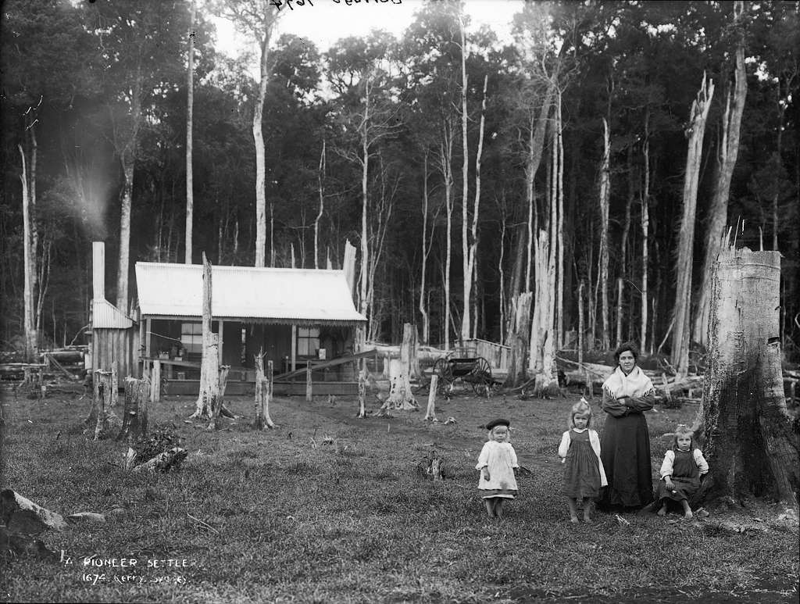
‘A pioneer settler’ from Powerhouse Museum is available in the public domain.

Table 6 – source analysis
Questions | Source 2 | Source 3
Who created the source?
When was it created?
What is the content of the source?
What perspective does it show?
What does it reveal about free settlers or convicts’ experiences AND impact?
How valuable is this source?
Written response:
Using the source analysis template above, write 2 paragraphs for the following question:
- How do Sources 2 and 3 help us understand both migrant experiences AND the impact on Aboriginal and/or Torres Strait Islander Peoples in Australia? Use information from the sources to support your response.

Resource 10 – Aboriginal and/or Torres Strait Islander perspectives
From the British perspective, migration to Australia represented opportunities for expansion and the acquisition of valuable resources. However, for Aboriginal and/or Torres Strait Islander Peoples, this migration was an invasion that ignored their deep and enduring connection to the land. The Doctrine of Terra Nullius, which wrongly declared the land as belonging to no one, led to the widespread dispossession and disruption of their ancestral lands, cultures, and ways of life. This contrasting viewpoint highlights the lasting impact of colonisation/invasion on Aboriginal and Torres Strait Islander Communities.
Define the term Terra Nullius based on teacher explanation and class discussion.
Source 4
Extract from A complete Account of Settlement at Port Jackson showing Tench’s observations of Aboriginal Peoples living around Port Jackson
The natives appear to be divided into families, who derive their subsistence from fishing and hunting. Their manner of life is simple, and their wants few.
Source: Tench, W. (1793). A Complete Account of the Settlement at Port Jackson. London. Public domain via the National Library of Australia.
Source 5
Extract from A complete Account of Settlement at Port Jackson documenting conversations and interactions between British settlers and Aboriginal Peoples
‘They took our land and drove us away from the places where we hunted.’
Source: Tench, W. (1793). A Complete Account of the Settlement at Port Jackson. London. Public domain via the National Library of Australia.

Questions:
- What perspectives do Sources 4 and 5 present?
- What does Source 4 suggest about how Europeans viewed Aboriginal and/or Torres Strait Islander Peoples?
- According to Source 5, how might Aboriginal and/or Torres Strait Islander Peoples have experienced these events differently?

Resource 11 – impact of movement of people
Imperialism didn't just move Europeans to Australia; it forced the displacement of Aboriginal and/or Torres Strait Islander Peoples within Australia. Many were moved onto ‘missions’ or ‘reserves’, often far away from their traditional Country, language groups and families. This was a form of internal migration forced upon them by the imperial government.
Define the key terms below:
- displacement
- missions
- reserves.
Contrast the migration experience of a British settler with the displacement experience of Aboriginal and/or Torres Strait Islander Peoples during the 19th century. Use the table below to brainstorm your ideas.
Table 7 – comparison of settler and Aboriginal experience
Feature | British Settler | Aboriginal and/or Torres Strait Islander Peoples
Reason for moving | Seeking opportunity/land | Forced removal by authorities
Connection to land
Emotional impact

Resource 12 – writing scaffold
Writing task: using Sources 4 and 5 and your own knowledge, write a PEEL paragraph addressing the following question:
Explain the impact of the movement of peoples on the Aboriginal and/or Torres Strait Islander Peoples. Use the scaffold to plan your response.
Table 8 – PEEL paragraph scaffold
Structure | What to include | Sentence starters | Student response
P – Point | State the main impact of the movement of peoples. | One significant impact of the movement of peoples on Aboriginal and/or Torres Strait Islander Peoples was …
E – Evidence | Use a historical source or example to support your point. | Evidence of this impact can be found in ….
E – Explain | Explain how the evidence supports the point and what it shows about the impact. | This has a significant impact because …
L – Link | Link the explanation back to the question. | Therefore, the movement of people had a major impact on Aboriginal and/or Torres Strait Islander Peoples because ….
Suggested response:
One significant impact of the movement of peoples on Aboriginal and/or Torres Strait Islander Peoples was the loss of access to their traditional lands and resources. For example, an account written by Watkin Tench in A Complete Account of the Settlement at Port Jackson (1793) recorded an Aboriginal perspective: ‘They took our land and drove us away from the places where we hunted.’ This evidence shows that the arrival of Europeans disrupted Aboriginal peoples’ connection to Country. As settlers established farms and settlements around Port Jackson, Aboriginal groups were forced to leave areas they had traditionally used for hunting and gathering. This made it more difficult for communities to access food and maintain their traditional way of life. Therefore, the movement of peoples to Australia had a significant impact on Aboriginal and/or Torres Strait Islander Peoples because it led to the loss of land and disrupted traditional cultural and economic practices.

Resource 13 – the transatlantic slave trade
Watch the following video The Atlantic Slave Trade: Crash Course World History (0:00–5.44) and complete the questions below.
Questions:
- What was the transatlantic slave trade, and why did European colonies rely on enslaved labour?
- Explain the ‘Triangular Trade’. What goods, people and resources were exchanged between Africa, Europe and the Americas?
- Describe the conditions enslaved Africans experienced during the ‘Middle Passage’.
- Why were death rates so high on the slave ships?
- What often happened to enslaved Africans when they arrived in the Americas?

- Describe the types of work enslaved people were forced to complete on plantations. How did plantation owners control enslaved people, and how did enslaved Africans resist slavery?

Resource 14 – map of the transatlantic slave trade
Figure 5 – the slave trade routes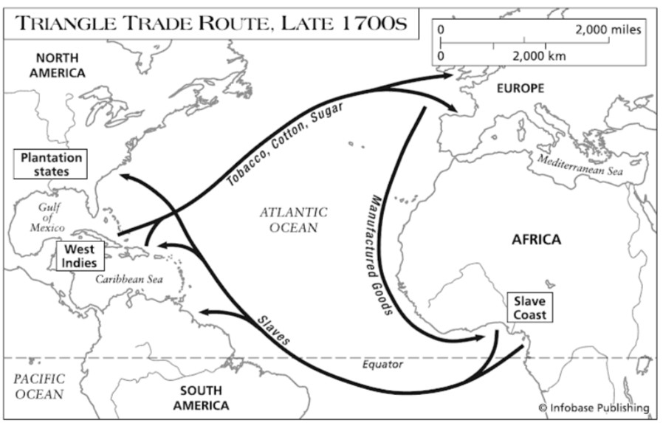
‘Slave route’ by Dorothy Schneider and Carl J. Schneider is licensed under CC BY-SA 4.0.
Activity:
Label the following continent and resources on the blank world map below
Table 9 – transatlantic trade routes
Continent | Resources
Europe to Africa | goods
Africa to Americas | enslaved Africans
Americas to Europe | Sugar, cotton, raw materials
Figure 6 – blank world map
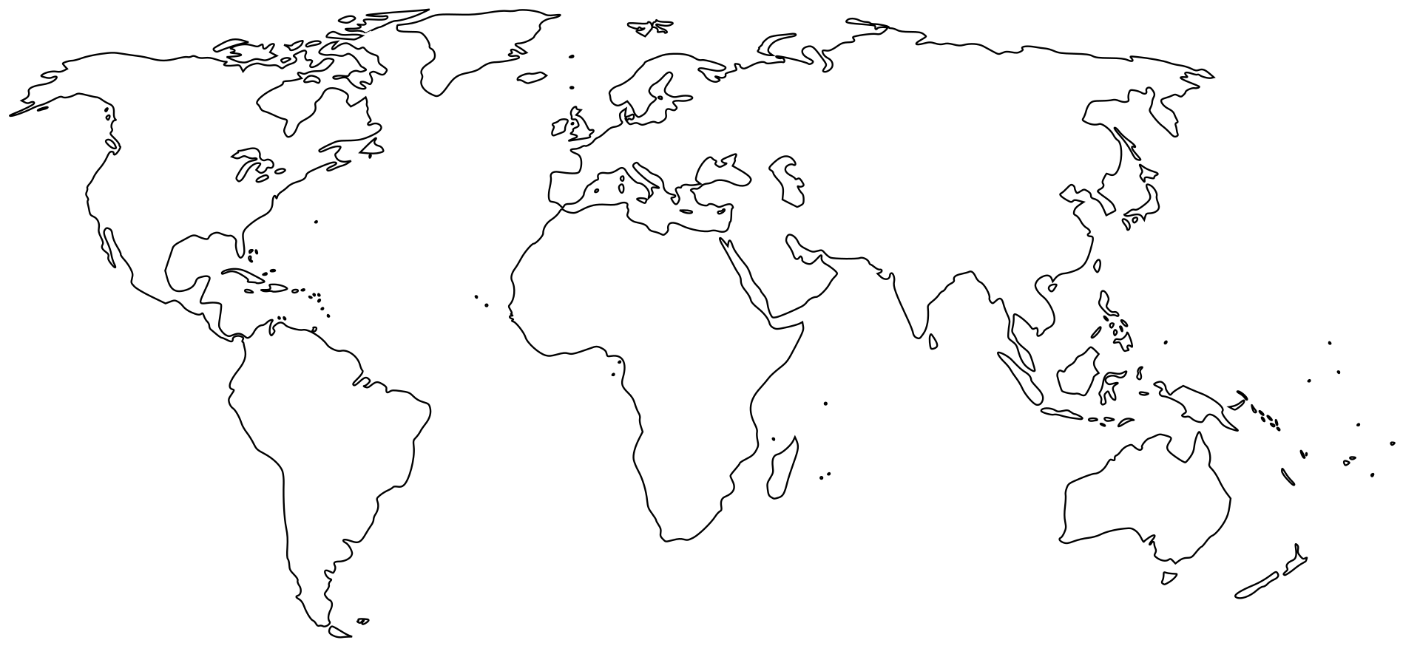
‘Simplified blank world map without Antarctica’ by skimel is available in the public domain.

Resource 15 – impacts of the transatlantic slave trade
Read the article Transatlantic Slave Trade Causes and Effects.
Highlight key points related to the impacts of slavery and record your findings of the short-term and long-term impacts in the T chart below
Table 10 – comparison table of short-term and long-term impacts of the slave trade
Short-term impacts | Long-term impacts

Learning sequence 2 – revolutions, human rights and the rise of nation-states

Resource 16 – key revolutions of the 1700s
Read the summaries of the 2 revolutions below and complete the table to compare the causes, key ideas and documents
American Revolution
The American Revolutionary War (1775–1783) was a conflict between the 13 American colonies and Britain. The colonies were ruled by Britain but had no representation in the British Parliament, which led to anger over taxes and political control.
Colonists believed they deserved the same rights as British citizens. Influenced by Enlightenment ideas about natural rights and freedom, they began protesting British rule.
In 1776, the colonies issued the United States Declaration of Independence, mainly written by Thomas Jefferson. The document declared that all people have natural rights, including life, liberty and the pursuit of happiness, and that governments gain power from the consent of the governed.
After winning the war, the colonies formed the United States, creating a government based on democratic principles and constitutional law.

French Revolution
The French Revolution (1789–1799) began in France due to economic problems, social inequality and political dissatisfaction.
France was ruled by an absolute monarch, Louis XVI, while society was divided into 3 estates. The Third Estate, which included peasants and the middle class, paid most of the taxes but had little political power.
Inspired partly by the American Revolution and Enlightenment ideas, people demanded greater equality and political representation. In 1789 revolutionaries created the Declaration of the Rights of Man and of the Citizen, which stated that all citizens are equal before the law and have rights such as liberty, property, and security.
The revolution eventually overthrew the monarchy and led to the establishment of a republic, spreading ideas of liberty, equality and popular sovereignty.
Table 11 – comparing revolutions
Revolution | Causes | Key ideas | Important documents
American Revolution
French Revolution

Resource 17 – key documents of the revolutions
Define the key terms below:
- rights
- government power
- democracy
- equality
Source 6
Extract from the American Declaration of Independence (1776)
‘We hold these truths to be self-evident, that all men are created equal, that they are endowed with certain unalienable Rights, that among these are Life, Liberty and the pursuit of Happiness.
That to secure these rights, Governments are instituted among Men, deriving their just powers from the consent of the governed.’
Source: ‘Declaration of Independence: a transcription’(1776) America’s Founding Documents, US National Archives and Records Administration.
Source 7
Extract from the Declaration of the Rights of Man and of the Citizen (1789)
‘Men are born and remain free and equal in rights. Social distinctions may be founded only upon the general good.
The aim of all political association is the preservation of the natural and imprescriptible rights of man. These rights are liberty, property, security, and resistance to oppression.’
Source: ‘Declaration of the Rights of Man and of the Citizen’ (1789) National Constituent Assembly of France, La Maison Élysée.
Use Sources 6 and 7 to complete the table below.
Table 12 – key documents of the revolutions
Document | Rights mentioned | Ideas about government | Key quote
Declaration of Independence
Rights of Man
Complete the Venn diagram below to compare the similarities and difference between the Declaration of Independence and the Rights of Man.
Figure 7 – Venn diagram
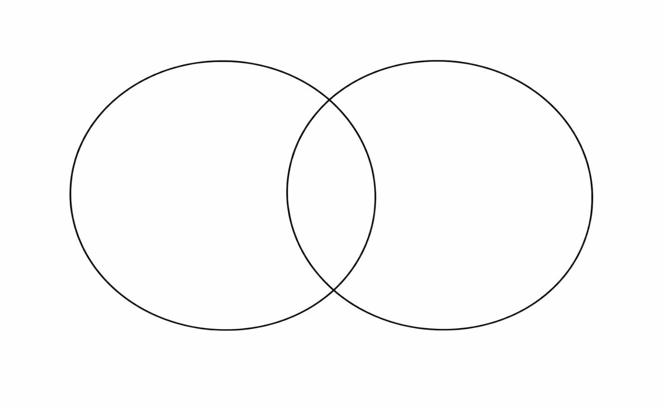

Resource 18 – modern day human rights, rule of law in governance and democratic ideals
Complete the table below by adding examples of each revolutionary idea from modern society
Table 13 – connections between revolutionary ideas and modern society
Revolutionary Idea | Example from revolution | Modern example
human rights | Rights declared in revolutionary documents
rule of law | Equality before the law
democracy | Government based on consent of the people
Exit ticket: writing task
- How did the American and French Revolutions influence modern democracy?
- Use the sentence starter scaffold below and 2 keywords from the word bank to support your response.
human rights | rule of law | equality
liberty | democracy | government power
- The American and French Revolutions influenced modern democracy by introducing ideas such as ________________________.
- One important idea was ________________________, which means ________________________.
- This idea is still important today because ________________________.

Resource 19 – analysing sources
Read the source below and complete the source analysis questions
Source 8
Excerpt from the United States Declaration of Independence (1776)
‘Governments derive their just powers from the consent of the governed.’
- Identify
What does this source say about where government power comes from?
- Interpret
How does this idea challenge the power of kings?
- Explain
How could this idea lead to the creation of nation-states?

Resource 20 – overview of the rise of nation-states
Read the text about the rise of nation-states. For each statement:
- decide if the statement is True (T) or False (F)
- find a sentence or phrase in the text that supports your answer
During the late 18th and 19th centuries, many societies began to move away from systems where power was held by kings and emperors. Ideas from the Enlightenment and major revolutions challenged the belief that monarchs should rule with absolute authority. Events such as the American Revolutionary War and the French Revolution promoted new ideas about government, including that people have rights and that governments should rule with the consent of the citizens. These ideas encouraged the development of political systems where power was linked more closely to the people rather than to a single ruler.
At the same time, the growth of nationalism encouraged people who shared a common language, culture or history to see themselves as part of a nation. Many groups believed they should govern themselves within their own state. This belief contributed to the creation of new nation-states in Europe, including those formed through the Unification of Germany and the Unification of Italy. By the late nineteenth century, nationalism had become an important force in shaping new political systems and identities.
Nationalism also played a significant role in shaping political borders and the way people identified with their country. As nationalist movements grew stronger, people increasingly showed loyalty to their nation rather than to a monarch or empire. Governments began to promote shared symbols such as national flags, anthems and common histories to strengthen a sense of national identity. While nationalism helped unify some groups into nation-states, it also created tensions where different cultural or ethnic groups lived within the same borders, influencing political conflicts and debates about national identity.
Table 14 – nation-states true or false
Literal (facts from the text)
Statement | T/F | Evidence from text
- Many societies were originally ruled by kings or emperors.
- The American and French Revolutions supported the idea that governments should represent the people.
- Nationalism encouraged people with shared culture or language to see themselves as part of a nation.
- Nationalism had no influence on the creation of new countries in Europe.
Interpretative (understanding ideas)
Statement | T/F | Evidence from text
- Revolutionary ideas challenged the belief that monarchs should rule with absolute power.
- Nationalism helped people develop a stronger sense of national identity.
- The rise of nation-states meant that loyalty shifted from kings to citizens and nations.
- Nationalism only had positive effects on societies.
Inferential (historical thinking)
Statement | T/F | evidence from text
- National symbols such as flags and anthems can strengthen a sense of national identity.
- Nationalism sometimes caused tensions between different cultural groups within the same borders.
- The idea that government power comes from the people helped shape modern democratic governments.

Resource 21 – nationalism and the rise of the nation state video worksheet
Watch the video on Imagined Communities and Real Power: How Nationalism Shaped the Modern World (0:00–6: 00)
Complete the questions below:
Segment 1: concept of nation and differing perspectives (1:03–2:40)
- Define the term nation.
- Describe the different perspectives of nation offered by Anderson and Gellner.
Segment 2: What existed before the nation-state? (2:20–3:30)
- How did seek identity before the existence of the nation state?
- Explain the statement: ‘political authority was personal and local, not national’
Segment 3: the impact of the French Revolution (3:30–4:30)
- Define the term sovereignty.
- Describe the changes to identity that occurred a s a result of the formation of the nation-state.
Segment 4: nationalism as a strategies tool for leaders (4.30–5:00)
- How were nationalism and unity used by leaders of the time?
Segment 5: Impact of nationalism on ordinary citizens (5:00–6:00)
- Explain the impact of nationalism on citizens of nation-states.
Segment 6: annotate the source below as you watch the video (5:40–6:00).

Source 9
Figure 8 – Liberty Leading the People
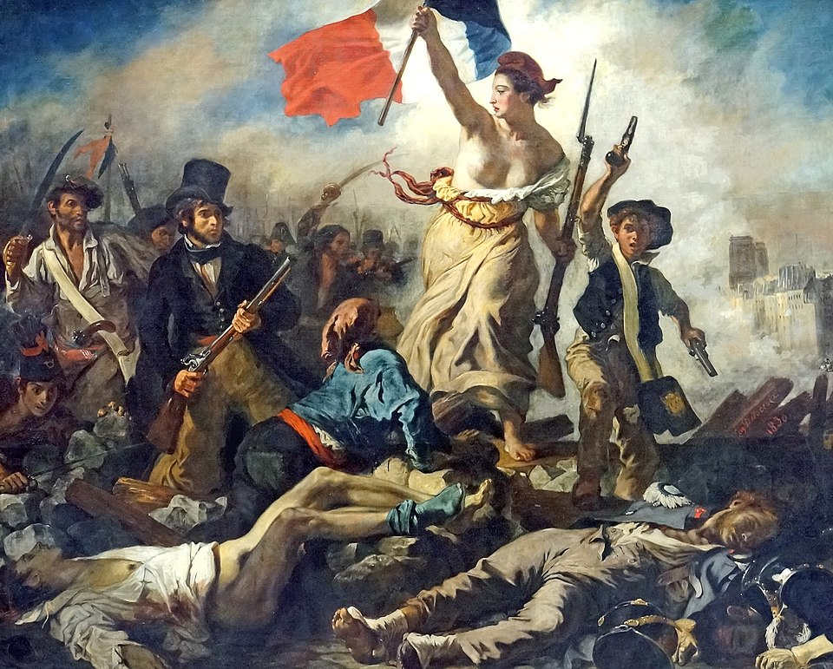
‘Liberty Leading the People’ by Eugene Delacroix is licensed under CC BY-SA 2.0.

Resource 22 – source analysis scaffold: assessing values and limitations
Conduct a source analysis of Liberty Leading the People by Eugene Delacroix
Focus question: assess the value and limitations of the painting Liberty Leading the People by Eugene Delacroix for an understanding of the rise of nation-states and nationalism.
Table 15 – source analysis scaffold for Liberty Leading the People
 | Prompts
Origin | Who created it?  When was it created?
Purpose | What is its intended purpose?  What message does the creator want to convey?
Content | Who is shown in the painting?  What symbols do you notice?  What actions are taking place?
Perspective | What opinion or perspective is being expressed?  What does the creator seem to believe about government?  Are there any perspectives missing?
Values | How does this source help us to understand the rise of the nation-state?  What does the source reveal about people’s views about government?
Limitations | Is there bias present?  Are all views represented?  Does the nature of the source impact the value?

Learning sequence 3 – World War I, peace and the rise of new ideologies

Resource 23 – World War I timeline
Organise the dates and events below into correct chronological order in the blank table.
As you complete this task take note of the following questions:
- What patterns do you notice about tensions in Europe before WWI?
- Do you think an assassination alone caused the war, or were there deeper problems already present?
Table 16 – jumbled timeline of World War I
Day | Month | Year | Jumbled timeline
- | Nov | 1917 | The USSR withdraws from the war
- | Aug | 1914 | The Schlieffen Plan fails
20 | May | 1882 | The Triple Alliance signed
6 | April | 1917 | The USA enters the war
28 | July | 1914 | Austria attacks Serbia
21 | Mar | 1918 | The Ludendorff Offensive
1 | July | 1916 | The Battle of the Somme
11 | Nov | 1918 | The Armistice
28 | June | 1919 | The Treaty of Versailles signed
25 | Dec | 1914 | The Christmas Day Truce
28 | June | 1914 | Assassination of Archduke Ferdinand
31 | Aug | 1907 | The Triple Entente signed
Table 17 – timeline of World War I
Day | Month | Year | Chronological order

Resource 24 – MAINS causes of World War I
Table 18 – an easy way to remember the causes of World War I is with the MAINS acronym
Causes | Overview
Militarism | Major European powers were competing for military dominance through an arms race and ‘the race to the sea’. Increase of their armies and navy.
Alliances | Agreements between countries to support each other, especially in times of war. In WWI alliances meant that if one country went to war, its allies would also join.
Imperialism | Powerful European nations (alliance members) were travelling to new lands and colonising or conquering these to acquire power and new resources.
Nationalism | Nationalism is to do with one’s pride for their nations. Militarism and imperialism drove national pride. European nations became competitive with one another.
Significant individuals and events | Significant events, such as the assassination of Archduke Franz Ferdinand acted as a catalyst (event that speeds something up) for the start of WWI.
Source activity: Identify some of these causes on World War I in the source below
Source 10
Figure 9 – caricature – chain of friendships
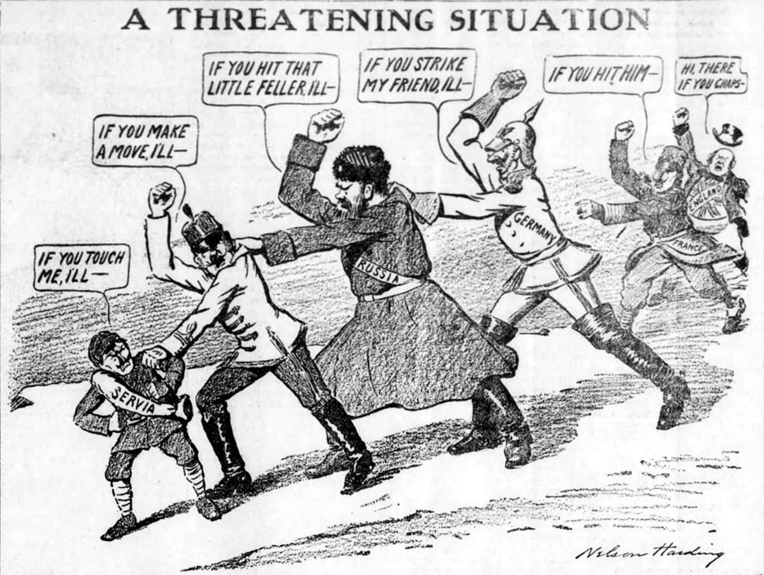
‘Chain of friendship cartoon’ by Nelson Harding is available is available in the public domain.

Resource 25 – militarism as a cause of World War I
Watch the video: Causes of WWI: Militarism (2:01) and write down 3 to 4 VIPs (very important points) about militarism, providing relevant examples.
- ____________________________________________________________________________________________________________________________________________________
- ____________________________________________________________________________________________________________________________________________________
- ____________________________________________________________________________________________________________________________________________________
- ____________________________________________________________________________________________________________________________________________________
Check for understanding writing task
Complete the sentence using the information you have gained about militarism:
Include the following in your response:
- a definition
- an example
- the impact.
Militarism contributed to the outbreak of World War I because …

Resource 26 – alliances as a cause of World War I
Figure 10 – alliances during WWI
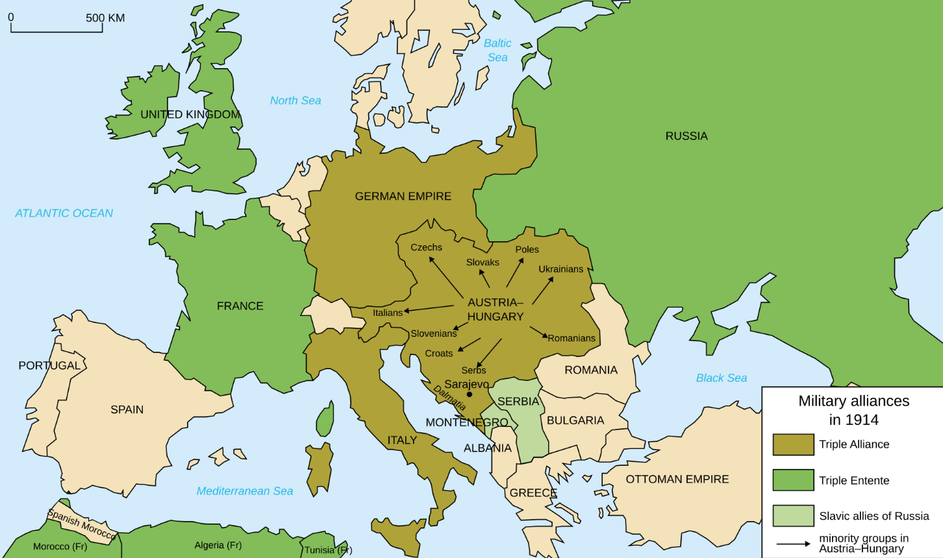
‘Map Europe alliances 1914-en.svg’ by Fluteflute & User:Bibi Saint-Pol is licensed under CC BY-SA 2.0.
Task: use the map to list the key participants of each alliance in Table 19 below.
Table 19 – alliances in World War I
Triple Entente | Triple Alliance

Resource 27 – alliances and the domino effect
Before World War I, many European countries formed alliances, which were agreements to support each other in times of conflict. These alliances were meant to provide security and protection, but they also increased tensions between countries.
By 1914, Europe was divided into 2 major alliance groups:
- Triple Alliance
- Triple Entente
Because these countries had promised to defend each other, a conflict between 2 nations could quickly involve many others. When Austria-Hungary declared war on Serbia in 1914, its allies and Serbia’s allies became involved. This created a chain reaction, turning a regional conflict in the Balkans into a large-scale international war.
Alliances worked like dominoes. When one country went to war, others were pulled into the conflict.
Enter the names of countries to show how the war spread in the scenario chain below.
Serbia → _______________ → _______________ → _______________ → _______________
Questions:
- What do you notice about how the war spreads between countries?
- Why did alliances make the conflict grow so quickly?

Resource 28 – imperialism as a cause of WWI – PMI
Observe the map of the key imperial powers of the world in 1914. Complete the questions and PMI below.
- Which countries appear to control the largest empires?
- Which countries appear to have few colonies?
- Why might countries with fewer colonies feel frustrated or competitive?
- How might this have increased tensions and contributed to the unstable situation in Europe?
Figure 11 – imperialism in 1914
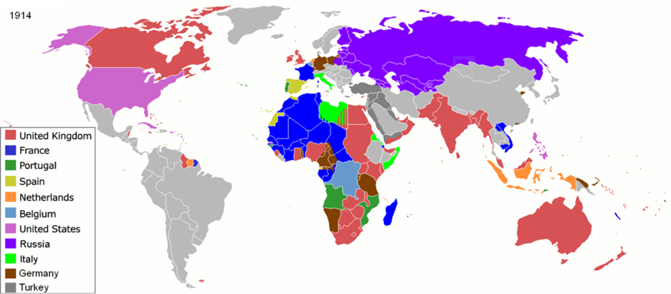
‘Colonisation 1914’ by ArdadN is available in the public domain.
Table 20 – PMI map of imperialism 1914
Plus | Minus | Interesting

Resource 29 – significant individuals and events that caused WWI
Watch the video A shot that changed the world – The assassination of Franz Ferdinand (8:11) and sequence the events below in order of events that occurred.
Table 21 – events leading to the assassination of Archduke Franz Ferdinand
Number order | Events
 | A group called the Black Hand, a Serbian nationalist organisation, plans to assassinate Archduke Franz Ferdinand.
 | Archduke Franz Ferdinand travels to Sarajevo in Bosnia with his wife Sophie.
 | Several assassins are positioned along the motorcade route, waiting for a chance to attack.
 | One assassin throws a bomb at the Archduke’s car, but it misses and injures others instead.
 | The Archduke decides to continue his visit and later changes plans to visit those injured in hospital.
 | The driver takes a wrong turn and stops the car near one of the conspirators.
 | Gavrilo Princip steps forward and shoots the Archduke and his wife.
 | Austria-Hungary blames Serbia, leading to the start of a wider conflict.

Resource 30 – the Paris Peace Conference video worksheet
Watch the video Outcome of World War I (5:39) and complete the questions below.
- What were some of the major political changes that occurred after World War I?
- What was the League of Nations and what were its aims?
- What was the Treaty of Versailles and what where its terms for Germany in the aftermath of the war?
- What impact did World War I have on national borders in Europe?
- When did the war officially come to an end?

Resource 31 – source analysis group task: the impact of the Paris Peace conference
Using established groups, the teacher will assign each group one major political ideology that emerged during the interwar period. Each group will become the ‘expert’ group for their assigned ideology, investigating its key features and explaining why it gained support during this time.
Students will then complete the relevant worksheet page using the source allocated to their group.
- Group 1 – Source 11: political cartoon showing Germany being squeezed by the Treaty of Versailles’s harsh terms.
- Group 2 – Source 12: political cartoon on the League of Nations.
- Group 3 – Source 13: excerpt from the Treaty of Versailles text.
- Group 4 – Source 14: excerpt from Woodrow Wilson’s speech.
Source 11
Figure 12 – a cartoon showing USA resisting Woodrow Wilson’s attempt to join the League of Nations,1919
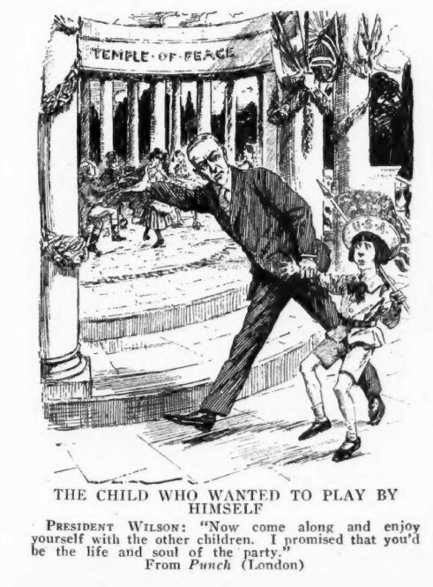
Source: ‘USA resists League of Nations 1919’ by Punch Magazine is available in the public domain.
Table 22 – source analysis scaffold
Analysis | Prompts
Origin | Who is the author? When was it created?
Content | What is the source about? Is there any symbolism shown?
Perspectives of the source | What idea or message is being conveyed and from whose perspective?
How valuable is this source in building an understanding of the impact of the Paris Peace conference? | What ideas are conveyed about the changes to the world after WWI?
Source 12
Figure 13 – political cartoon 1921: view of World War I Germany reparations
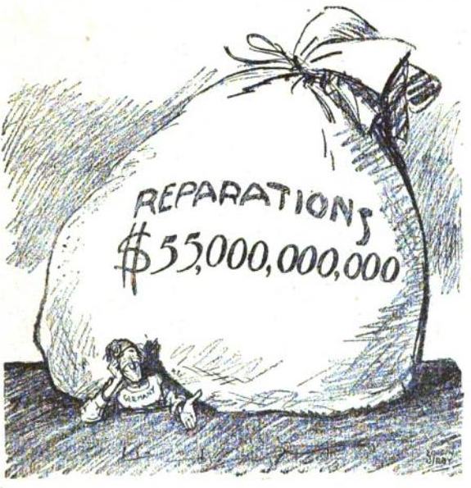
‘Treaty of Versailles Reparations’ by New York World is available in the public domain.
Table 23 – source analysis scaffold
Analysis | Prompts
Origin | Who is the author? When was it created?
Content | What is the source about? Is there any symbolism shown?
Perspectives of the source | What idea or message is being conveyed and from whose perspective?
How valuable is this source in building an understanding of the impact of the Paris Peace conference? | What ideas are conveyed about the changes to the world after WWI?
Source 13
Simplified excerpt from the Treaty of Versailles – Article 231 ‘War Guilt Clause’
‘Germany accepts responsibility for causing the war and must pay for damages to the Allies. Many of Germany’s lands are given to other countries, and its army is made much smaller’
Table 24 – source analysis scaffold
Analysis | Prompts
Origin | Who is the author? When was it created?
Content | What is the source about? Is there any symbolism shown?
Perspectives of the source | What idea or message is being conveyed and from whose perspective?
How valuable is this source in building an understanding of the impact of the Paris Peace conference? | What ideas are conveyed about the changes to the world after WWI?
Source 14
Simplified excerpt from Woodrow Wilson speech to the Paris Peace conference, 1919
‘I believe in the principal of self-determination. All peoples should have the right to choose their rulers. We must create a League of Nations to keep peace and help nations work together’
Table 25 – source analysis scaffold
Analysis | Prompts
Origin | Who is the author? When was it created?
Content | What is the source about? Is there any symbolism shown?
Perspectives of the source | What idea or message is being conveyed and from whose perspective?
How valuable is this source in building an understanding of the impact of the Paris Peace conference? | What ideas are conveyed about the changes to the world after WWI?

Resource 32 – political ideologies in the interwar period jigsaw task
Each group will be allocated a political ideology. In your group complete the following research questions.
- What is the ideology?
- Why did it become popular after World War I and the interwar period?
- How did economic, social and political factors contribute to its rise?
- What examples can you find of where and/or how it was adopted.
Jigsaw activity: complete this summary in your mixed groups after listening to experts present their political ideology researched.
Table 26 – summary of political ideologies in the interwar period
Ideology | Main beliefs and values | Reasons for proliferation (increase or rise) | Countries (examples)
fascism

communism

liberal democracy

nationalism

Appendix 1 – glossary of key vocabulary
Use the glossary to record definitions of new subject-specific terms introduced throughout this unit. You can add extra rows as you learn and encounter new vocabulary.
Table 27 – glossary
Glossary word | What I think it means | Dictionary definition | Examples of its use or synonyms
alliances
citizenship
colonisation
constitution
declaration
democracy
displacement
Equality
exploitation
fascism
geopolitical
human rights
ideology
imperialism
immigration
Liberal democracy
liberty
migration
militarism
migration
monarchy
nation-state
nationalism
proliferation
reform
revolution
Rule of law
sovereignty
subjugation

Appendix 2 – caricature, chain of friendships
Figure 14 – caricature – chain of friendships
‘Chain of Friendship cartoon’ by Nelson Harding is available in the public domain.

References
This resource contains NSW Curriculum and syllabus content. The NSW Curriculum is developed by the NSW Education Standards Authority (NESA). This content is prepared by NESA for and on behalf of the Crown in right of the State of New South Wales. The material is protected by Crown copyright.
Please refer to the NESA Copyright Disclaimer for more information https://www.nsw.gov.au/education-and-training/nesa/copyright.
NESA holds the only official and up-to-date versions of the NSW Curriculum and syllabus documents. Please visit NESA https://www.nsw.gov.au/education-and-training/nesa and NSW Curriculum https://curriculum.nsw.edu.au.
History 7–10 Syllabus © NSW Education Standards Authority (NESA) for and on behalf of the Crown in right of the State of New South Wales, 2024.
BBC Bitesize (n.d.) The transatlantic slave trade overview, BBC Bitesize, accessed 22 June 2026.
Breuilly J, Halikiopoulou D and Höglund K (2022) The rise of the nation-state during the Age of Revolution: Revisiting the debate on the roots of nations and nationalism. Nations and Nationalism, 28(4), 1137–1159.
CrashCourse (5 July 2012) ‘The Atlantic Slave Trade: Crash Course World History #24’ [video], CrashCourse, YouTube, accessed 22 June 2026.
Delacroix E (c.1830) Liberty Leading the People [artwork], Wikimedia Commons, accessed 22 June 2026.
Harding N (1916) Chain of friendships [political cartoon], Wikimedia Commons, accessed 22 June 2026.
Kerry, C. H., & Co. (1907). A pioneer settler [Photograph]. Wikimedia Commons. https://commons.wikimedia.org/wiki/File:A_pioneer_settler_(2362700123).jpg
National Constituent Assembly of France (1789) Declaration of the Rights of Man and of the Citizen, La Maison Élysée, accessed 22 June 2026.
National Geographic Kids (n.d.) British Empire facts, National Geographic Kids, accessed 22 June 2026.
Schneider D and Schneider CJ (2014) Slavery in America, Infobase Publishing.
Steer P (n.d.) "On systematic colonisation and the culture of settler colonialism: Edward Gibbon Wakefield’s A letter from Sydney (1829)" BRANCH: Britain, Representation and Nineteenth-Century History, in DF Felluga (ed) Extension of Romanticism and Victorianism on the Net, accessed 22 June 2026.
Tench W (1793) A complete account of the settlement at Port Jackson, Project Gutenberg EBook, accessed 22 June 2026.
The Editors of Encyclopaedia Britannica (n.d.) Indentured labor, Encyclopaedia Britannica, accessed 22 June 2026.
The Editors of Encyclopaedia Britannica (23 November 2020) Transatlantic slave trade causes and effects, Encyclopaedia Britannica, accessed 22 June 2026.
US National Archives and Records Administration (1776) ‘Declaration of Independence: a transcription’, America’s Founding Documents, accessed 22 June 2026.
Wikimedia Commons (1919) USA resists League of Nations [political cartoon – artist unknown], Wikimedia Commons, accessed 22 June 2026.
Wikimedia Commons (c.1921) Treaty of Versailles reparations – Let’s see you collect [political cartoon – artist unknown], Wikimedia Commons, accessed 22 June 2026.
Wikimedia Commons (28 February 2026) Workers in the fuse factory Woolwich Arsenal, [photograph], Wikimedia Commons, accessed 17 May 2026.
Wikimedia Commons (27 April 2026) Map Europe alliances 1914-en.svg, Wikimedia Commons, accessed 17 May 2026.

© State of New South Wales (Department of Education), 2026
The copyright material published in this resource is subject to the Copyright Act 1968 (Cth) and is owned by the NSW Department of Education or, where indicated, by a party other than the NSW Department of Education (third-party material).
Copyright material available in this resource and owned by the NSW Department of Education is licensed under a Creative Commons Attribution 4.0 International (CC BY 4.0) license.

This license allows you to share and adapt the material for any purpose, even commercially.
Attribution should be given to © State of New South Wales (Department of Education), 2026.
Material in this resource not available under a Creative Commons license:
- the NSW Department of Education logo, other logos and trademark-protected material
- material owned by a third party that has been reproduced with permission. You will need to obtain permission from the third party to reuse its material.
Links to third-party material and websites
Please note that the provided (reading/viewing material/list/links/texts) are a suggestion only and implies no endorsement, by the New South Wales Department of Education, of any author, publisher, or book title. School principals and teachers are best placed to assess the suitability of resources that would complement the curriculum and reflect the needs and interests of their students.
If you use the links provided in this document to access a third-party's website, you acknowledge that the terms of use, including licence terms set out on the third-party's website apply to the use which may be made of the materials on that third-party website or where permitted by the Copyright Act 1968 (Cth). The department accepts no responsibility for content on third-party websites.

