Geography (Stage 5) – resource booklet
Biomes and sustainable agriculture – Geography 7–10 Syllabus (2024)
Contents
Overview 4
Outcomes 4
Learning sequence 1 – Biomes and productivity 6
Lesson 1 – distribution and characteristics of biomes part 1 6
Lesson 2 – distribution and characteristics of biomes part 2 11
Lesson 3 – zonation of biomes 19
Lessons 4 and 5 – Brunswick Heads field study 24
Lesson 6 – ecosystem services 24
Lesson 7 – factors that influence the productivity of Earth’s biomes 26
Lesson 8 – scatter graphs 29
Lesson 9 – technology used to increase food production 32
Lesson 10 – the value of biomes as a natural resource 34
Lesson 11 – geographical inquiry part 1 36
Lesson 12 – geographical inquiry part 2 38
Lesson 13 – geographical inquiry part 3 41
Lesson 14 – geographical inquiry part 4 43
Lesson 15 – geographical inquiry part 5 51
Lesson 16 – geographical inquiry part 6 53
Lesson 17 – geographical inquiry part 7 55
Lesson 18 – geographical inquiry part 8 58
Lesson 19 – geographical inquiry part 9 60
Lesson 20 – geographical inquiry part 10 61
Lesson 21 – geographical inquiry part 11 62
Lessons 22 to 24 – geographical inquiry part 12 67
Learning sequence 2 – Factors influencing food production 69
Lesson 1 – human alterations to biomes to maximise food production 69
Lesson 2 – environmental, social, economic and technological factors that influence the supply of and demand for food in Australia and Asia part 1 72
Lesson 3 – environmental, social, economic and technological factors that influence the supply of and demand for food in Australia and Asia part 2 74
Lesson 4 – environmental impacts of food production 76
Learning sequence 3 – Towards food security 77
Lessons 1 and 2 – the nature and spatial patterns of food security part 1 77
Lesson 3 – the nature and spatial patterns of food security part 2 81
Lesson 4 – factors that impact food security 81
Lesson 5 – sustainable practices for improving global food security part 1 83
Lesson 6 – sustainable practices for improving global food security part 2 86
Lesson 7 – sustainable practices for improving global food security part 3 87
Lesson 8 – sustainable practices for improving global food security part 4 88
Lessons 9 and 10 – Aboriginal Peoples’ Knowledges and collaborative practices that can inform sustainable and resilient food systems for the future 91
Lesson 11 – sustainable practices for improving global food security part 5 94
Lesson 12 – Potluck revision game 95
Appendix 1 – blank world map 96
Appendix 2 – PEEL paragraph template 97
Appendix 3 – peer assessment 98
Appendix 4 – Australia blank map 99
Appendix 5 – Think-Pair-Share 100
Appendix 6 – brainstorming template 101
Appendix 7 – sample correlation graphs 102
Appendix 8 – SWOT template 103
Appendix 9 – KWLH template 104
Appendix 10 – graph peer assessment template 105
Appendix 11 – farmer Robbie’s interview transcript 106
Appendix 12 – student scaffold – choropleth map 111
Appendix 13 – Y chart template 113
Appendix 14 – Frayer diagram template 114
References 115

Overview
This resource booklet is not a standalone resource. It has been designed for use by teachers in conjunction with the Geography (Stage 5) – sample program of learning – Biomes and sustainable agriculture. The material in this resource booklet is a sample and is intended to support teachers as they develop contextually appropriate teaching and learning resources that meet their students’ needs. It is not intended to be taught exactly as presented in its current format. There are instructions for both the teacher and students throughout the resource. Teachers using this resource should edit and refine these to suit their students’ needs, interests, abilities and the tasks selected.
The content in this resource booklet has been prepared by the HSIE curriculum team, unless otherwise credited. The HSIE curriculum team have created a range of support resources for Geography 7–10, including sample assessment schedules, scope and sequences, learning sequences and assessment tasks. The Geography (Stage 5) – sample program of learning – Biomes and sustainable agriculture contains key information to complement this resource.
Some of the information in this resource booklet is collated from relevant NESA and department documentation. It is important that all users review and cross-reference the relevant syllabus, assessment and reporting information hyperlinked throughout. This ensures the content is an accurate reflection of the most up-to-date syllabus content. Links contained within this resource were correct as of 24 April 2025.

Outcomes
A student:
- GE5-DFC-01 explains how the diverse features and characteristics of a range of places and environments change over time
- GE5-PRI-01 analyses the processes and interactions that transform people, places and environments
- GE5-PER-01 accounts for the perspectives of people and organisations on a range of geographical opportunities and challenges
- GE5-MAN-01 assesses different approaches to the management and protection of places and environments
- GE5-APC-01 analyses how Aboriginal Peoples’ Custodianship of Country supports environmental management and enhances Community wellbeing
- GE5-TAP-01 applies and evaluates a range of geographical tools to acquire and process geographical information
- GE5-COM-01 selects and applies concepts and terminology to communicate geographical information for a range of purposes, audiences and contexts
Geography 7–10 Syllabus © NSW Education Standards Authority (NESA) for and on behalf of the Crown in right of the State of New South Wales, 2024.

Learning sequence 1 – Biomes and productivity

Lesson 1 – distribution and characteristics of biomes part 1

1.1.1 – defining biomes
- Write a definition for biome.
- Write a definition for climate.

1.1.2 – categories of biomes
Record your observations from What is a biome? - Environmental Science - Categories of biomes (7:30) in Table 1.
Table 1 – characteristics of biomes
Environment | Animal | Plant | Climate

1.1.3 – how biomes differ
You are going to complete a Concept map with the central question ‘What makes a biome different to other biomes?’. Write the question in the centre of a blank page. From the central question branch off ideas of factors that make one biome different to another. An example to start you off would be ‘climate’.

1.1.4 – spatial distribution of the world’s biomes
Use Biomes of the world maps or National Geographic Mapmaker Biomes and Appendix 1 – blank world map to complete a world map illustrating the spatial distribution of the world’s biomes. Title your map ‘Spatial distribution of biomes’.
Use your completed map and further research to describe the distribution and characteristics of earth’s major biomes. Use Table 2 to record your findings.
Table 2 – biome descriptions
Biome | Description and characteristics
Desert
Polar
Savannah
Temperate rainforest
Tropical rainforest
Tundra

1.1.5 – getting familiar with terminology used in Biomes and sustainable agriculture
Use the capacity matrix for ‘Biomes and sustainable agriculture’ to identify the extent of information, knowledge, know-how and wisdom you have for each glossary term identified. The Key classification will assist your self-assessment.
Key classification
- Information – recall basic facts or heard of this before
- Knowledge – can explain and know what it means
- Know-how – can draw connections between this geographical term or concept and relate them to other concepts or situations
- Wisdom – can use the term or concept in new contexts or teach others
Shade or tick information, knowledge, know-how and wisdom as you progress with your understanding of the geographical concept or term. At the end of the learning sequence, reflect on your progress and discuss with your teacher if you observe any areas you can improve.
Table 3 – capacity matrix
Glossary word | Information | Knowledge | Know-how | Wisdom
Aboriginal and Torres Strait Islander Peoples
Aboriginal songlines
agricultural production
altitude
biodiversity
biome
choropleth maps
climate
climate change
climate graphs
communication forms
consumption
contour lines
country
cross-section
culture
custodians
development
dot maps
Elders
environmental change(s)
flow charts
flowline maps
food security
geographic information system (GIS)
global positioning system (GPS)
Great Dividing Range
human wellbeing
Indigenous Australians
Indigenous cultural and intellectual property (ICIP)
intellectual property
insolation
interconnections
latitude and longitude
productivity
rain shadow
scale
scatter plot
spatial distribution
spatial patterns
spatial technologies
sustainability
topographic maps
transect
urbanisation
virtual or digital map
weather
weather map or synoptic chart
yarning circle

Lesson 2 – distribution and characteristics of biomes part 2

1.2.1 – defining biodiversity
Use a PEEL writing scaffold to write a paragraph describing the concept biodiversity.
Figure 1 – PEEL writing scaffold
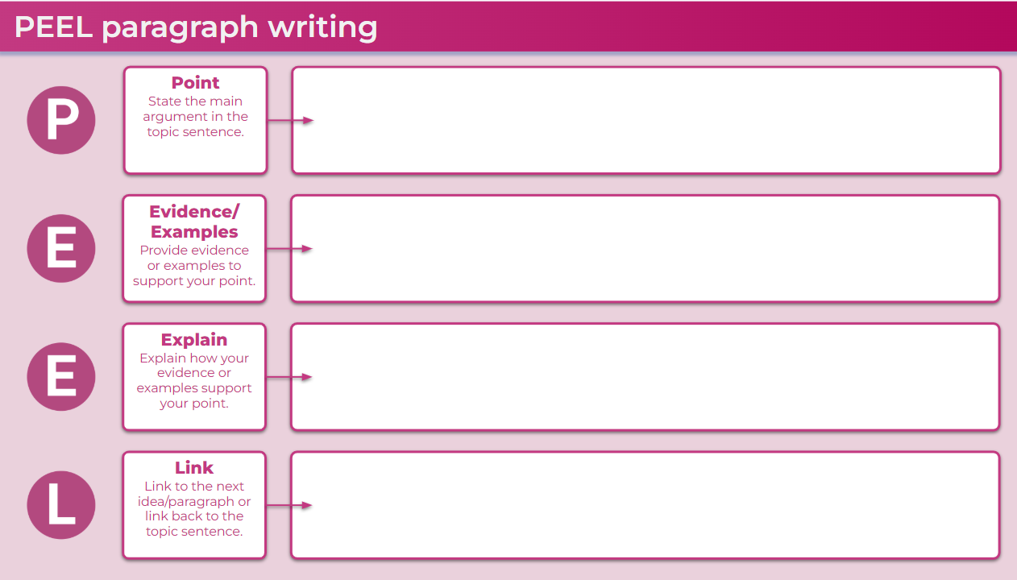
Watch What is Biodiversity? (3:04) (from 0:01–0:44) and revisit your description. How accurate is your description? Do you need to add anything further to your definition?

1.2.2 – revisit prior learning
Reflect on what you learned in the previous lesson. Write a paragraph summarising what you learned about biomes. The following questions may prompt your response:
- What factors influence the nature and type of biomes around the world?
- What type of biome do you live in?
- Which biomes might have the most biodiversity (variety of plants and animals)?
- Predict which biome might have the most difficulty recovering from interference.
- Describe the spatial distribution of the world’s biomes.
Exchange your paragraph with a peer and suggest 2 ways to improve. Complete a self-assessment of your paragraph by highlighting the sentence or sentences that you are most pleased with and with another colour highlight any part of the paragraph you are uncertain you did well.

1.2.3 – revisiting latitude and longitude
Use Figure 1 and the map you produced last lesson to identify the biomes located at the following latitudes:
- Equator (0°)
- Tropic of Cancer (23.5°N)
- Tropic of Capricorn (23.5°S)
- Arctic Circle (66°34’N).
Figure 2 – latitude and longitude
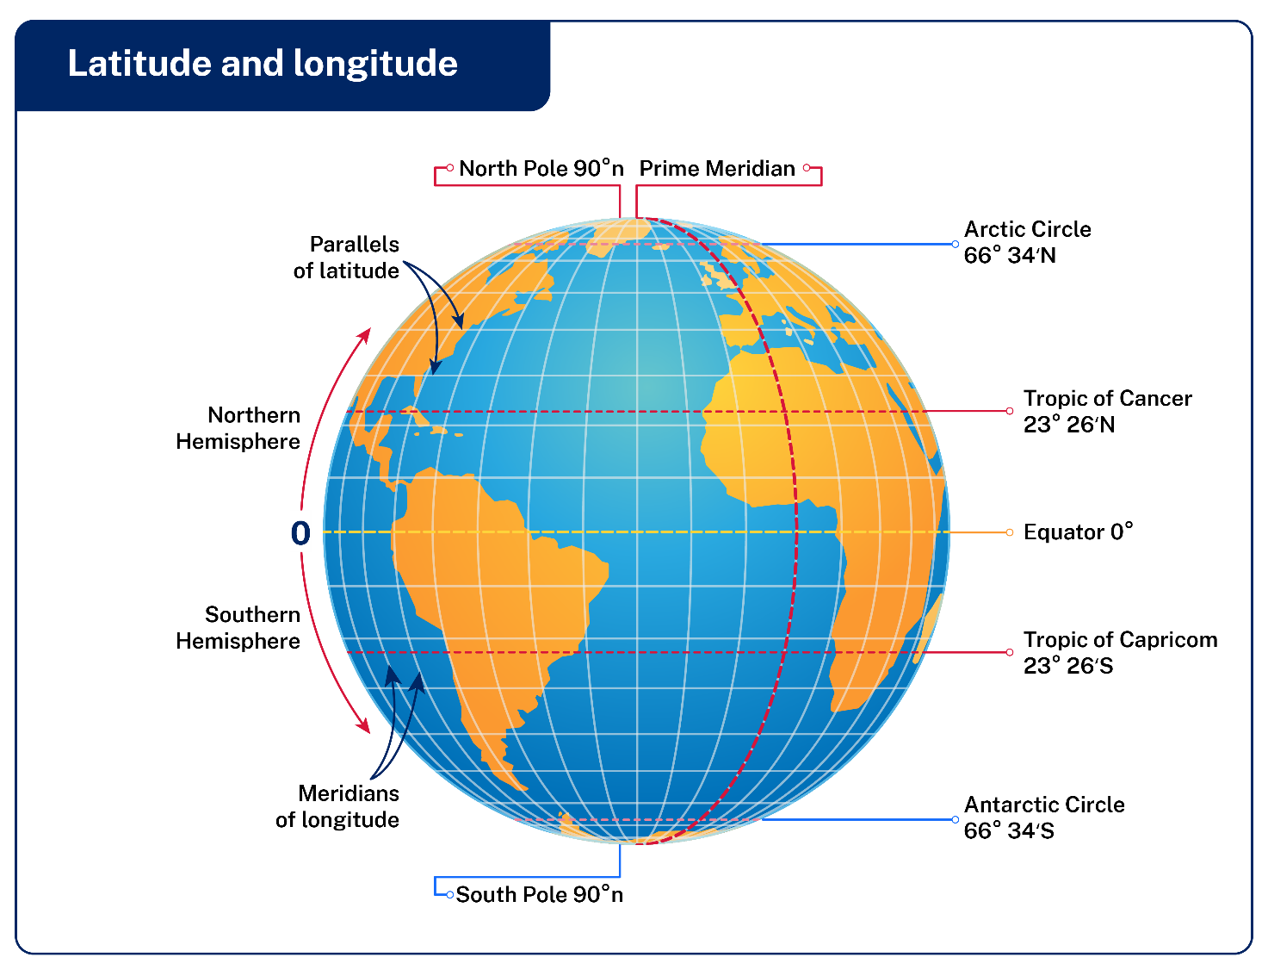
Label the lines of latitude on your map of the world’s biomes created in the previous lesson. Including the:
- Equator (0°)
- Tropic of Cancer (23.5°N)
- Tropic of Capricorn (23.5°S)
- Arctic Circle (66°34’N).

1.2.4 – insolation
Your teacher will dictate a passage to you. On the first round, list key words you hear. On the second round, add any other key words you missed. Use the key words to reconstruct the passage in your own words.
Use Figure 2 to write 2 paragraphs describing how insolation varies temperature around the world.
Figure 3 – insolation diagram
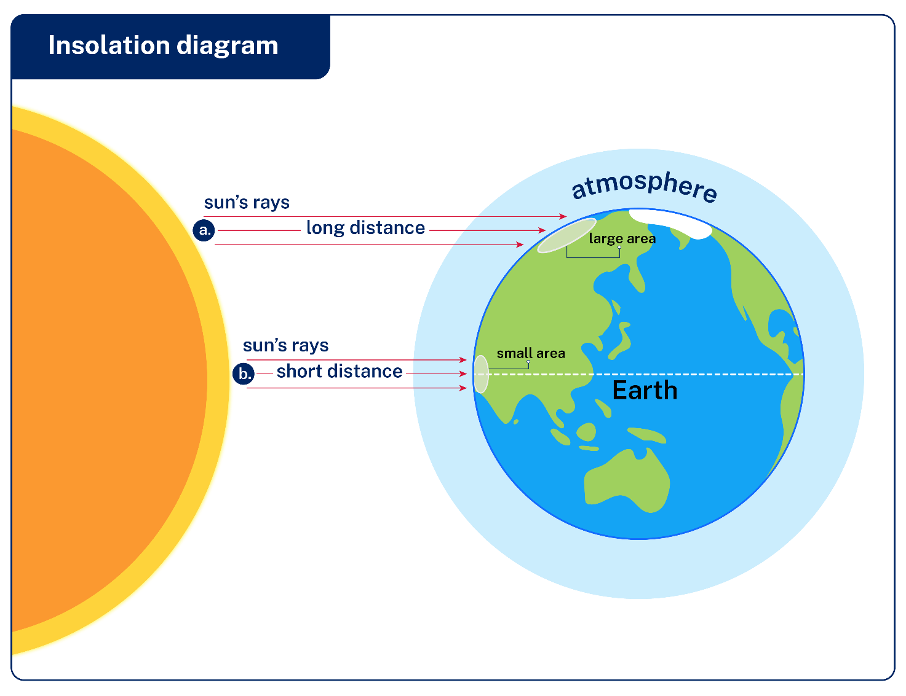

1.2.5 – biomes of the world
Use Figure 3 to complete the following sentences:
- As you move from the equator towards the poles, biomes shift dramatically due to variations in [insert student response]
- Near the equator, tropical rainforests thrive with high biodiversity due to consistent [insert student response]
- You will not encounter tundra environments near [insert student response]
Figure 4 – biomes of the world
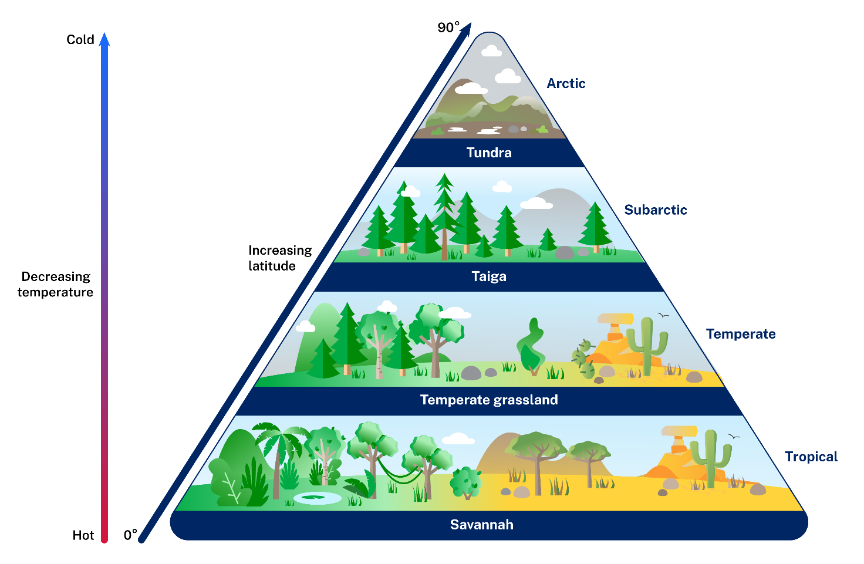

1.2.6 – features of climate graphs
Using Figure 5 or a climate graph from your local context, identify the key climate characteristics.
Figure 5 – features of climate graphs
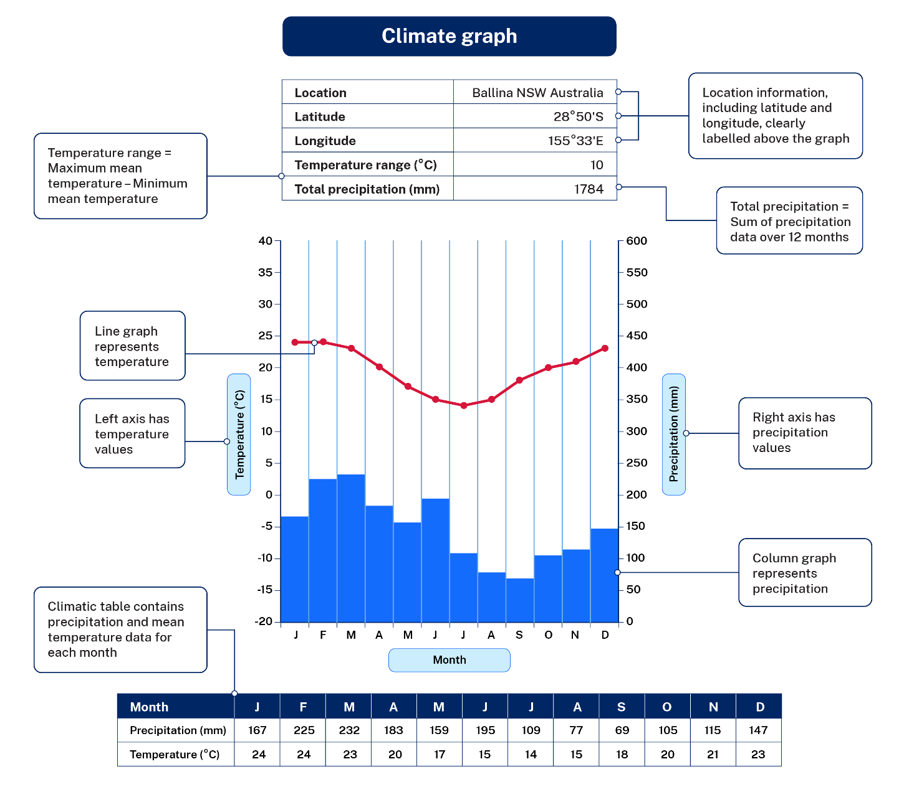
Review Figure 5 or the climate graph from your local context. What location would you suggest Figure 6 would be collected from? (Hint: regional area, northern or southern hemisphere).
Figure 6 – climate data
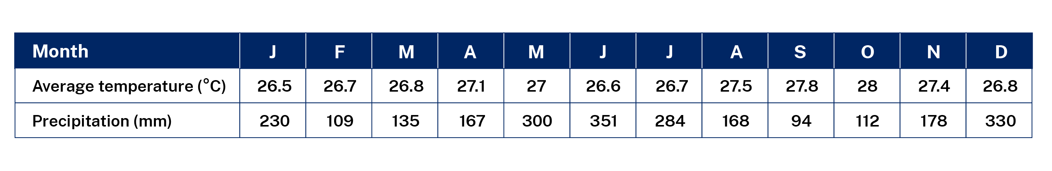
A climate graph that would represent an equatorial location would appear similar to Figure 6.
Figure 7 – equatorial region climate graph
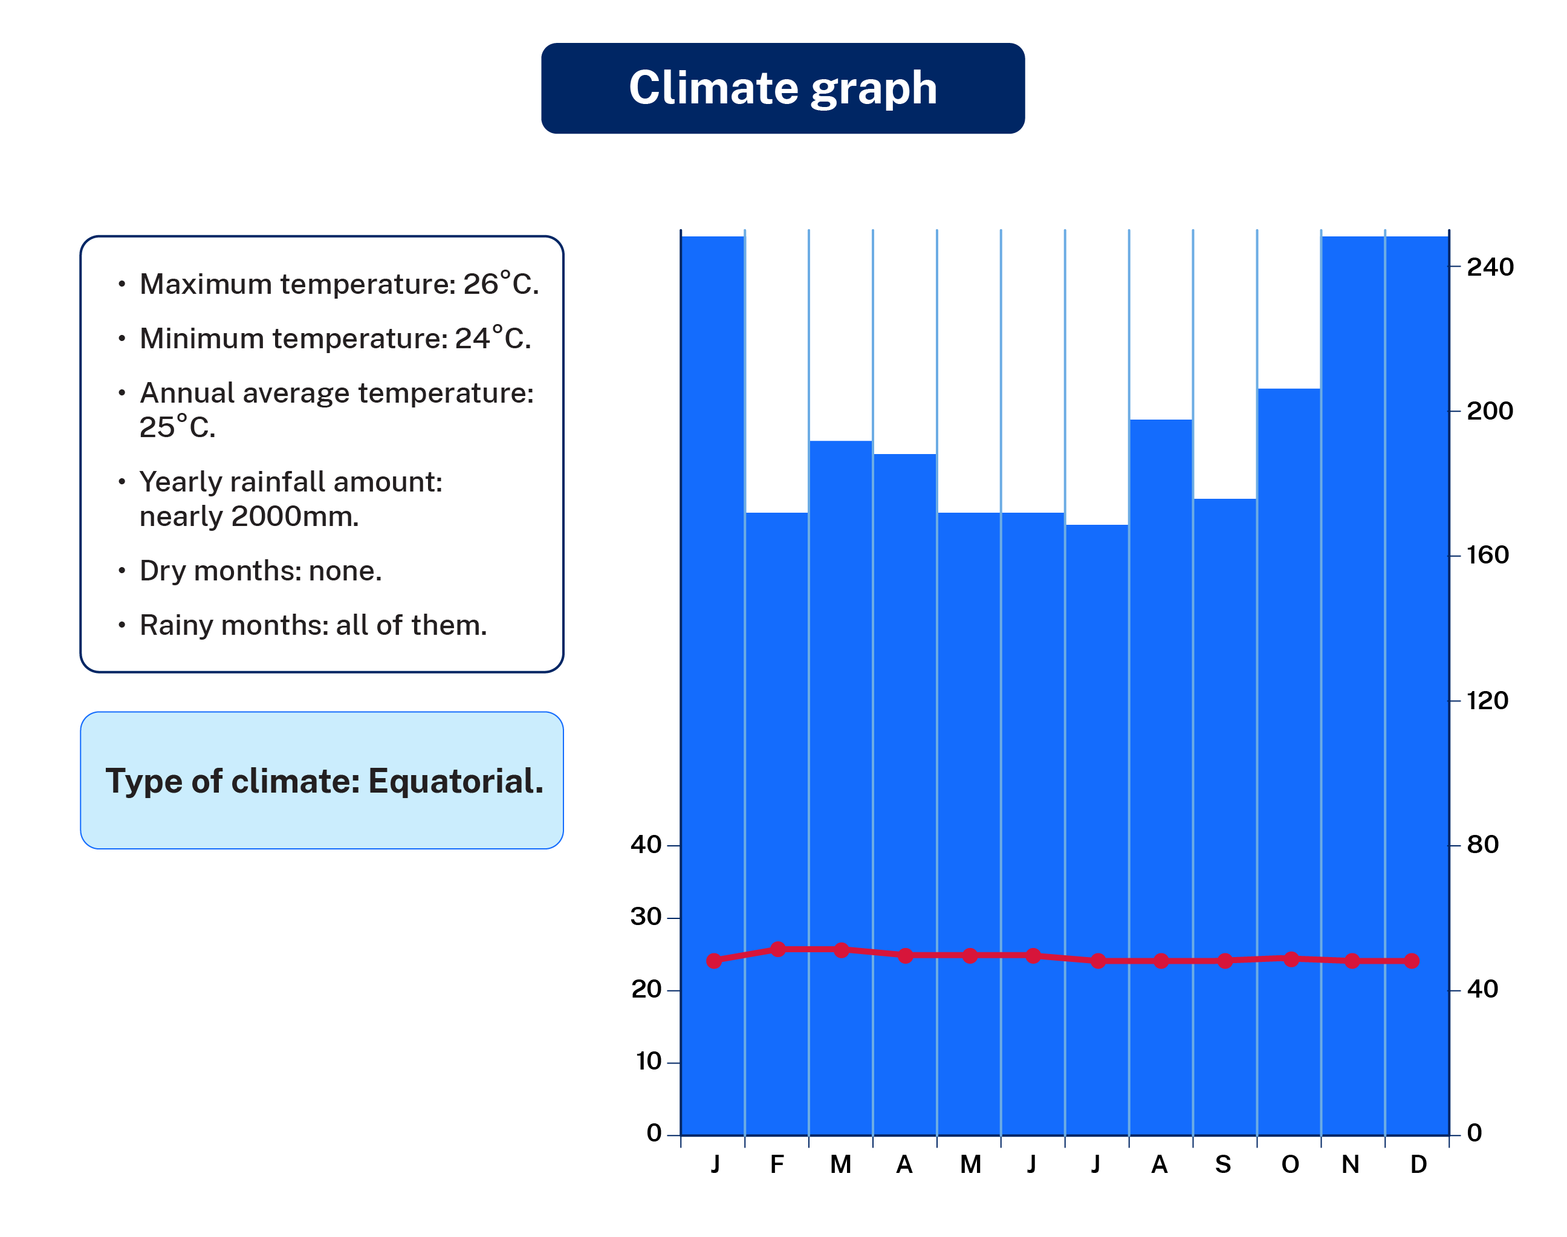
Working with a partner match the following climatic zones to Figure 8.
- Hot desert climate
- Tropical rainforest
- Savannah grassland
- Cold desert climate
- Temperate climate graph
- Mediterranean climate

Figure 8 – climate variations blank
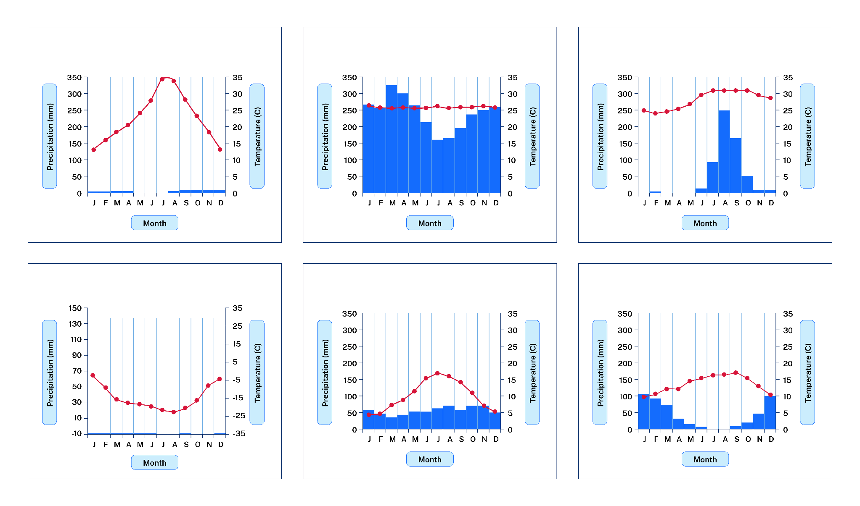
Complete an Exit ticket and use Figure 6 to complete the following questions:
- Calculate the mean temperature (hint: the total sum of temperature divided by 12).
- Calculate the total rainfall (hint: the total sum of rainfall for the 12 months of the year).
- Calculate the temperature range (hint: the highest average temperature minus the lowest average temperature).

Lesson 3 – zonation of biomes

1.3.1 – estimated global coverage of major biomes
Use the data presented in Table 4 to construct a pie graph illustrating the world coverage of biomes.
Steps to take:
- Convert data into degrees using the formula.
- Draw a circle using a compass.
- From the centre of the circle rule a straight line to 12 o’clock.
- Use a protractor to measure the degrees from 12 o'clock starting with the largest percentage.
- Colour or illustrate each sector and add in a title and appropriate labels.
Table 4 – estimated global coverage of major biomes
Biome type | Global coverage (%) | Calculate degrees (°)
Marine (ocean, coral reefs and estuaries) | 68
Freshwater (ponds, rivers and lakes) | 3
Grassland | 12
Tropical rainforest | 2
Temperate forest | 3
Tundra | 5
Desert | 7
Total | Must total 100% | Must total 360°
Conduct a peer assessment of the pie chart using marking criteria in Appendix 3 – peer assessment.

1.3.2 – vertical and latitudinal zonation
Use Figure 9 to construct an explanation of vertical zonation and explain how altitude results in changing biomes.
Figure 9 – vertical zonation
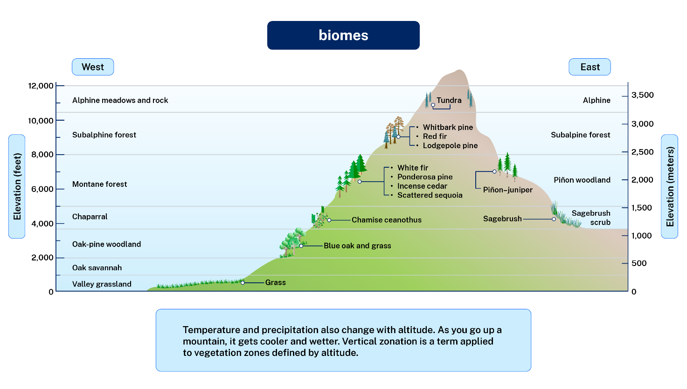
Use Figure 10 to describe latitudinal zonation and explain how it results in changing biomes.
Figure 10 – latitudinal zonation applied to biomes
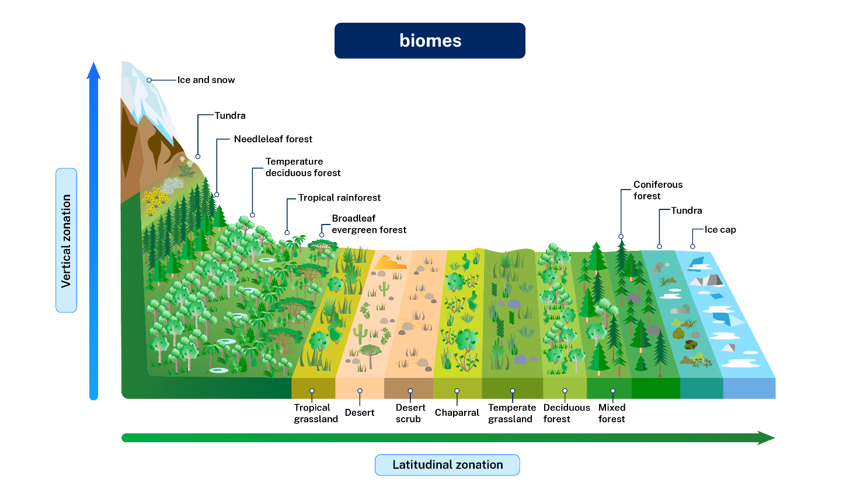

1.3.3 – Australia’s biomes
On the map in Appendix 4 – Australia blank map reproduce the Australia – Habitats, Animals and Activities Australia’s biomes. Ensure you include a legend to illustrate the various biomes.

1.3.4 – energy flows in ecosystems
Complete the following sentences:
- Plants need energy from …
- Photosynthesis occurs in …
- Examples of primary producers in the environment would include …
- Examples of secondary producers in the environment would include …
- Food webs show us …
- A carnivore will only eat …
- A herbivore will only eat …
- An omnivore will eat …
- Examples of decomposers in an ecosystem would include …
- Productivity in the environment refers to …
- The most productive biomes would consist of the following conditions …

1.3.5 – food webs
Read the article Food Web and complete these multiple-choice questions:
- An inverted pyramid of biomass is seen in
- Grassland ecosystem
- Forest ecosystem
- Desert
- Aquatic ecosystem
- If the carbon atoms fixed by producers already have passed through 3 species, then the trophic level of the last species would be?
- Tertiary producer
- Scavenger
- Secondary consumer
- Tertiary consumer
- Which of the following may occupy more than one trophic level in the same ecosystem at the same time?
- Sparrow
- Lion
- Frog
- Snake
- A mass of living matter at a trophic level in an area at any time is called?
- Humus
- Detritus
- Standing crop
- Standing state
- A pyramid of numbers is:
- Always inverted
- Always upright
- Neither upright nor inverted
- Either upright or inverted
Note: ask your teacher for the correct answers.

1.3.6 – writing assessment
Complete a writing assessment answering the following prompts:
- What is a biome? In your response, describe characteristics of at least 2 biomes.
- Construct one cohesive, sustained and well-structured paragraph. In your response, you should
- use geographical terms and concepts
- use subject-specific vocabulary and noun groups
- demonstrate geographical knowledge of the topic
- describe examples in your response.

Lessons 4 and 5 – Brunswick Heads field study
Complete Brunswick Heads Field Study Investigating Mangroves and Littoral Rainforest in northern NSW.

Lesson 6 – ecosystem services

1.6.1 – differences between biomes and ecosystems
Use Difference Between Biome and Ecosystem, Difference Between Biome and Ecosystem and Ecosystems and biomes (7:32) to complete a Venn diagram that informs the reader about the key differences between a biome and ecosystem.
Figure 11 – example Venn diagram
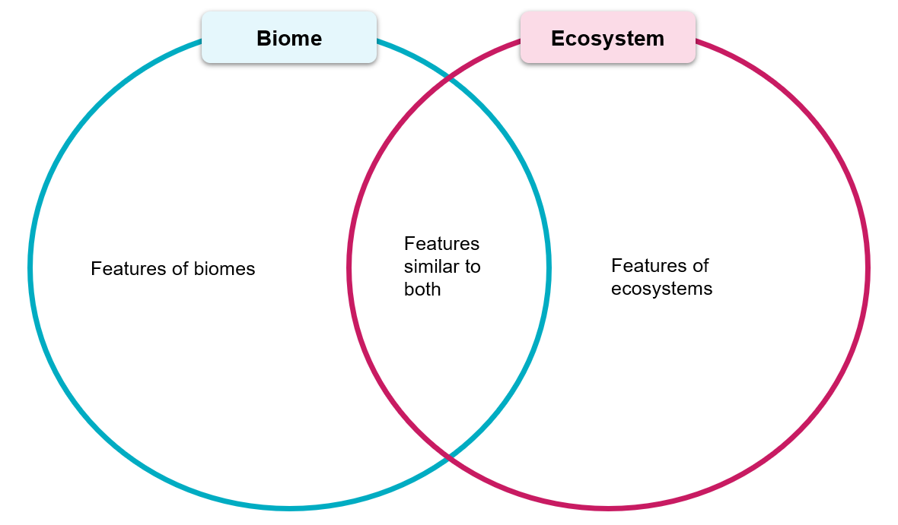

1.6.2 – ecosystem services
Use What Are Ecosystem Services? and Figure 2 in Ecosystem Services: Categories and valuation to complete a summary table outlining the characteristics of provisioning services, regulating services, supporting services and cultural services that ecosystems and biomes provide.
Table 5 – summary of ecosystem services
Ecosystem services | Summary
provisioning services
regulating services
supporting services
cultural services

1.6.3 – habitable land area
Use the column graph Breakdown of habitable land area, World, 2015 to 2019 to record percentage (%) change of world agricultural use and forests between 2015 and 2019.
Table 6 – habitable land area, World, 2015 to 2019
Habitable land area | 2015 | 2016 | 2017 | 2018 | 2019
world agriculture
world forests

1.6.4 – Think-Pair-Share
Use your record of (%) change of world agriculture and observation that can be drawn from Breakdown of habitable land area, World, 2015 to 2019 to Appendix 5 – Think- Pair- Share the following questions:
- Identify the trends that can be observed for world agriculture and world forests.
- Discuss potential short-term and long-term implications for changing habitable land area.

1.6.5 – small group work
Work in small groups to develop a concept map Appendix 6 – brainstorming template summarising the ecosystem services provided in the following biomes:
- marine (ocean, coral reefs and estuaries)
- freshwater (ponds, rivers and lakes)
- grassland
- tropical rainforest
- temperate rainforest
- tundra.

Lesson 7 – factors that influence the productivity of Earth’s biomes

1.7.1 – group work and visual representation
Figure 12 – factors influencing biomes
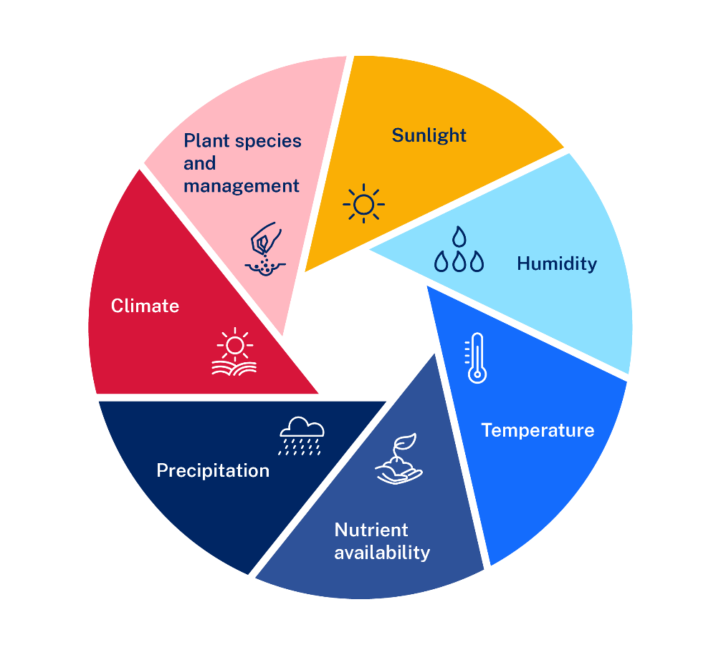
Your teacher will allocate you to work in a group.
You will be allocated one factor from Figure 12 to investigate. Your teacher will provide you with suggested resources appropriate to your factor.
In your group develop 3 to 5 key summary points. Transfer your summary points onto sticky notes and share these findings with the class.
Note: working in pairs, you will create a visual representation titled ‘Factors that contribute to variations in the productivity of Earth’s biomes’. You will need:
- a A3 piece of paper
- a A3 piece of card
- coloured pencils
- compass
- glue stick.
Use the following steps to develop a visual representation titled ‘Factors that contribute to variations in the productivity of Earth’s biomes’:
- Use a compass to draw a large circle on a piece of paper (15 centimetres in diameter).
- Repeat on a piece of cardboard.
- Divide the paper into equal pie segments.
- Colour and label each of the pie segments: sunlight, humidity, temperature, nutrient availability, precipitation, climate and plant species and management.
- Divide the carboard into the same sized segments as you did on the paper.
- On the cardboard record the notes accumulated on the class poster or whiteboard.
- Cut the paper segments out and glue or staple above the relevant summary. Ensure you can still read the summary notes.

1.7.2 – ecosystem primary productivity
Use Appendix 5 – Think-Pair-Share responses to the following prompts:
- Identify the most productive ecosystem.
- What characteristics of this ecosystem would make it more productive than a tundra or extreme desert?
- Suggest reasons why agricultural land is less productive statistically than tropical rainforests.
Figure 13 – ecosystem primary productivity (billion kcal per year)
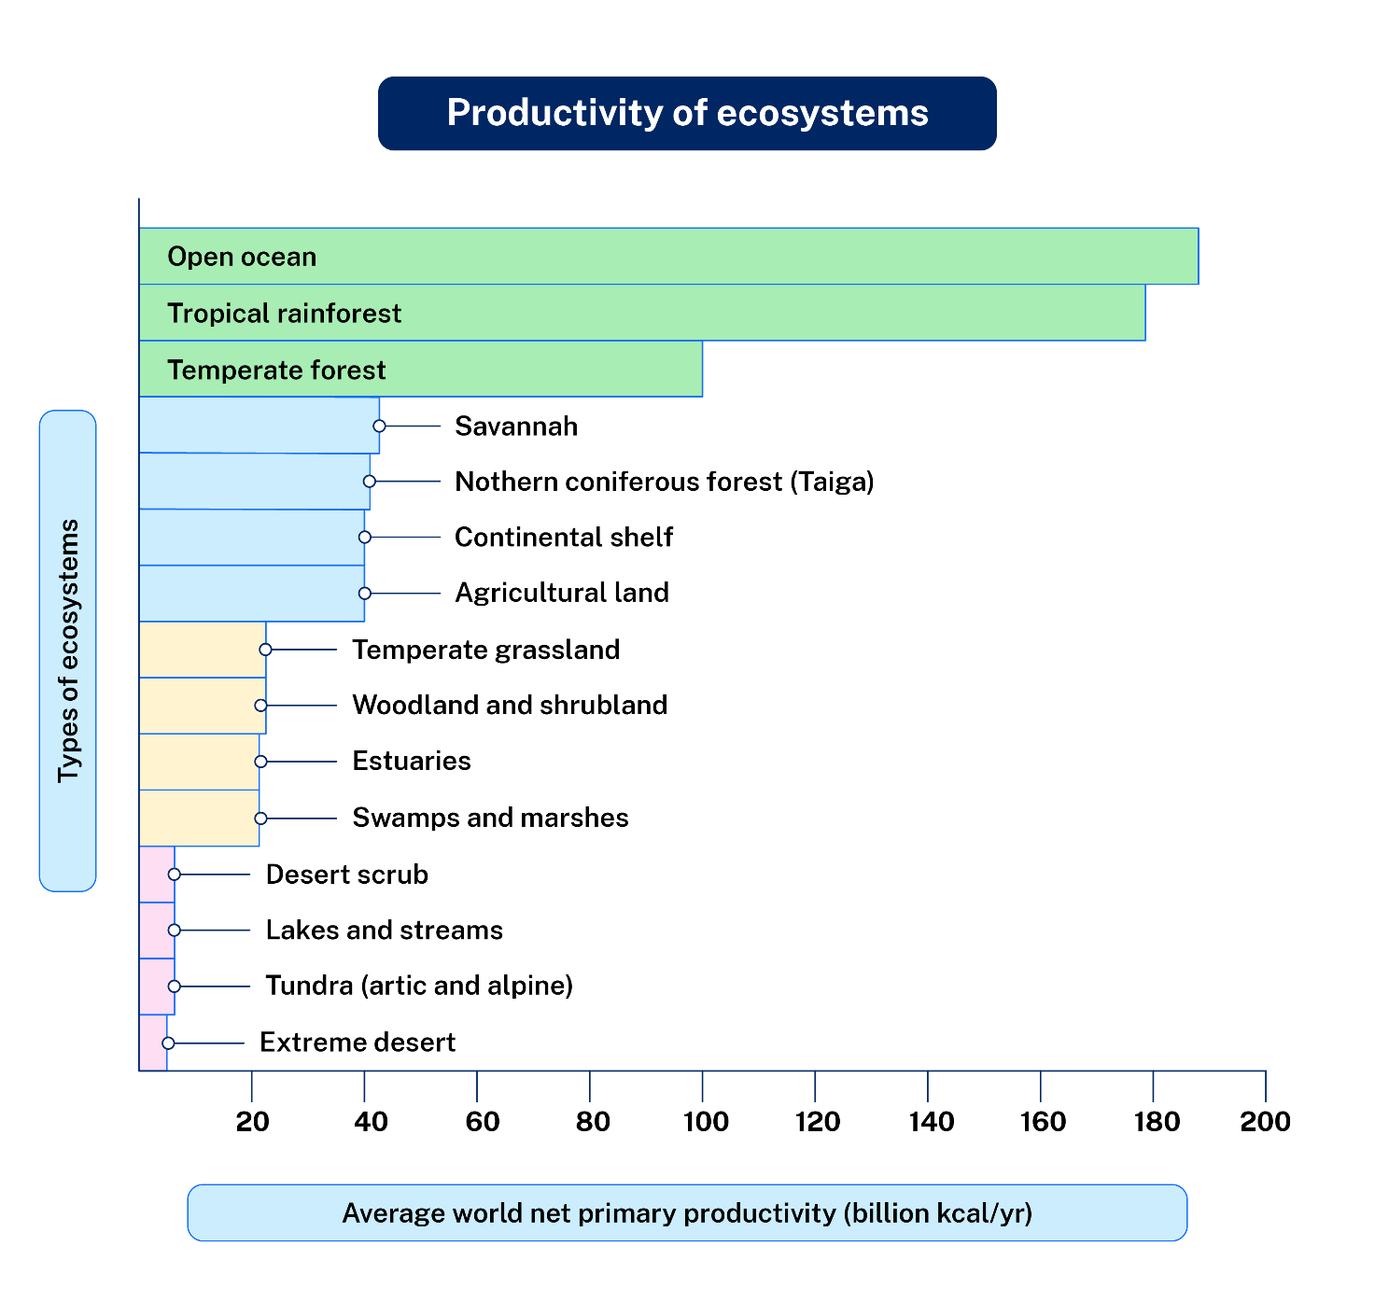

Lesson 8 – scatter graphs

1.8.1 – features of a scatter graph
Use Figure 14 to identify key features of scatter graphs.
Figure 14 – scatter graph example
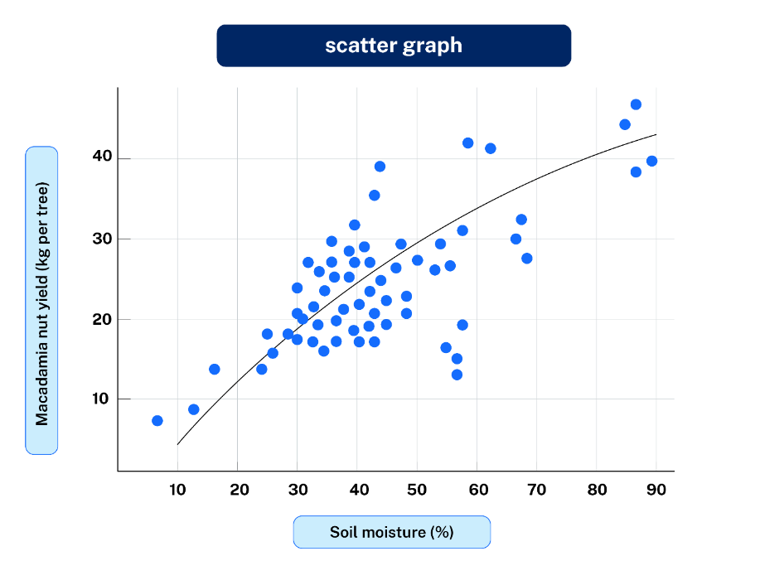
Note: Appendix 7 – sample correlation graphs will support your understanding of the following learning activities.

1.8.2 – scatter graph glossary
Read the glossary of scatter graph key terms.
Table 7 – scatter graph glossary of key terms
Term | Definition
correlation | Describes the strength and direction of the relationship between 2 variables (positive, negative, no correlation)
dependent variable | A factor that changes in response (for example, plant growth)
independent variable | A factor that causes change (for example, rainfall)
negative correlation | When one variable increases, the other decreases (for example, temperature and soil moisture)
Net Primary Productivity (NPP) | The rate at which plants produce biomass or organic matter
no correlation | No clear relationship between 2 variables
positive correlation | When one variable increases, the other also increases (for example, rainfall and NPP)
productivity | The rate of generation of biomass in an ecosystem
scatter graph | A graph used to investigate the relationship between 2 sets of data

1.8.3 – drawing scatter graphs – teacher demonstration
Observe your teacher’s explanation of how to draw a scatter graph using Dataset 1 (simple, clear positive correlation) – rainfall and Net Primary Productivity (NPP).
Table 8 – rainfall and NPP (I do) exercise
rainfall (mm/year) | 200 | 400 | 600 | 800 | 1000
NPP (g/m²/year) | 150 | 300 | 450 | 600 | 750
Steps to construct a scatter graph:
- Draw clearly labelled horizontal (rainfall – independent variable) and vertical axes (NPP – dependent variable).
- Establish clear scales on axes (increments of 200 mm rainfall and increments of 150 g/m² for NPP).
- Plot each coordinate clearly (rainfall vs NPP).
- Draw a line of best fit.
- Give the graph an appropriate title.

1.8.4 – We do (guided practice, students work in pairs)
Draw a scatter graph to illustrate Dataset 2 (moderate complexity, negative correlation) – average temperature and soil moisture.
Table 9 – average temperature and soil moisture
average temperature (°C) | 10 | 15 | 20 | 25 | 30
soil moisture (%) | 80 | 70 | 60 | 45 | 30
Discuss and label axes clearly (independent: temperature; dependent: moisture), plot data points, identify and interpret negative correlation.

1.8.5 – You do (independent practise)
Choose one dataset from the 2 options below.
Dataset 3 (simple dataset, clear positive correlation) – hours of sunlight and plant height growth.
Table 10 – sunlight and plant height growth
sunlight (hrs/day) | 2 | 4 | 6 | 8 | 10
plant Growth (cm/week) | 2 | 5 | 8 | 11 | 14
Dataset 4 (complex dataset, weak/no correlation) – altitude and species biodiversity.
Table 11 – altitude and species biodiversity
altitude (m) | 100 | 300 | 500 | 700 | 900
species biodiversity (number of species) | 15 | 13 | 14 | 12 | 12

Lesson 9 – technology used to increase food production

1.9.1 – circle of viewpoints
Watch Floating Farm Takes Sustainable Agriculture to the Next Level (3:15) and conduct a Circle of Viewpoints routine.
- Brainstorm a list of different perspectives that may be taken regarding the floating farm.
- Choose one perspective to explore, using these sentence-starters
- I am thinking of … [the topic] … from the viewpoint of … [the viewpoint you have chosen]
- I think … [describe the topic from your viewpoint]
- A question I have from this viewpoint is … [ask a question from this viewpoint].

1.9.2 – 4 C’s routine
Read 10 Examples Of Modern Technology In Food Production and complete a 4 C’s routine answering the following questions.
- What connections do you draw between the text and your own life or your other learning?
- What ideas, positions or assumptions do you want to challenge or argue with the text?
- What key concepts or ideas do you think are important and worth holding onto from the text?
- What changes in attitudes, thinking or action are suggested by the text, either for you or others?

1.9.3 – Oakridge Farm
Work in small groups to engage with The future of the food industry: Food tech explained and conduct further research to develop a technology savvy farm management plan for the farmer in the following scenario.
Significant geographical question: ‘What challenges might farmers face when trying to balance productivity and sustainability?’
Oakridge Farm, a 500-acre cattle farm in New South Wales, has been operating for generations but is now struggling with sustainability issues. The farm is experiencing poor soil health due to overharvesting, weed infestations that are reducing available grazing land, and water shortages affecting both crops and cattle. The farmer, Sam Mitchell, is looking to make Oakridge Farm more viable for cattle grazing while also improving the long-term sustainability of the land. Sam has heard about emerging technologies that might help but isn’t sure which ones to invest in.
Key Problems:
- soil degradation – years of overharvesting have stripped nutrients from the soil, leading to poor pasture growth
- weed infestation – invasive weeds have spread across large sections of the farm, reducing available grazing space
- water management – the farm relies on a few large stock dams, but unpredictable rainfall means water shortages are a growing concern
- cattle monitoring – managing herd health and feeding efficiency is becoming difficult as the farm expands.
Sam is seeking student input to analyse the farm’s current challenges and recommend sustainable solutions using modern agricultural technologies.
Work in groups to create a SWOT analysis using Appendix 8 – SWOT template of Oakridge Farm based on the scenario.
Use 5 New Technologies for Beef Producers (Successful Farming magazine) and further research to discuss ways new technologies could help Oakridge farm.
In groups students choose 2 technologies and evaluate how the technology addresses Oakridge Farm’s issues.
As a class discuss the following questions:
- Which solutions seem most practical?
- How do modern technologies shape the future of sustainable biomes and agriculture?
Write a 500-word synopsis outlining a management plan for Oakridge farm.

Lesson 10 – the value of biomes as a natural resource

1.10.1 – KWLH chart – uses of biomes
Complete Appendix 9 – KWLH chart on uses of biomes as providers of natural resources.

1.10.2 – concept map
Complete a Concept map summary using Appendix 6 – brainstorming template that illustrates the relationship of biodiversity to our survival.

1.10.3 – biomes produce food
Engage with Biomes that produce our food, industrial materials and fibre (5:02) and answer the following:
- Identify foods and fibres produced in Australia as outlined in the video.
- Identify climatic characteristics described in the video that are most appropriate to produce these foods and fibres.
- Identify ways farmers are contributing to sustainability in the video.

1.10.4 – how to draw a choropleth map
Steps to draw a choropleth map:
- Gather the data you need to present.
- Next, find the range of your values and develop a shading scale. Between 4 and 8 shading bands should be appropriate. Ensure the shading bands get darker as values increase.
- Source a base map of the area(s) or region(s) you are presenting data for. Include the key and title on your map.
- Shade the areas/regions according to where they fit on the scale.
You can also create choropleth maps in a range of software including Google Sheets (see the Internet Geography tutorial), Microsoft Excel and Arc GIS.

1.10.5 – use data and a map to draw a choropleth map
Use Table 12 and Appendix 1 – blank world map to construct a choropleth map.
Table 12 – daily supply of calories per person
Country or area | kcal
Afghanistan | 2,198
Argentina | 3,341
Australia | 3,454
Bangladesh | 2,614
Brazil | 3,299
Cambodia | 2,811
Denmark | 3,584
Egypt | 3,127
Ethiopia | 2,470
Fiji | 2,876
Haiti | 2,076
India | 2,569
Mexico | 3,278
United States | 3,911

1.10.6 – capacity matrix
Return to the capacity matrix from lesson 1.1.5 and highlight any new learning about concepts covered in the learning sequence so far.

Lesson 11 – geographical inquiry part 1

1.11.1 – latitude and longitude
Your teacher will guide you through an ‘I do, We do, You do’ routine using Figure 15.
Figure 15 – eastern QLD and northern NSW
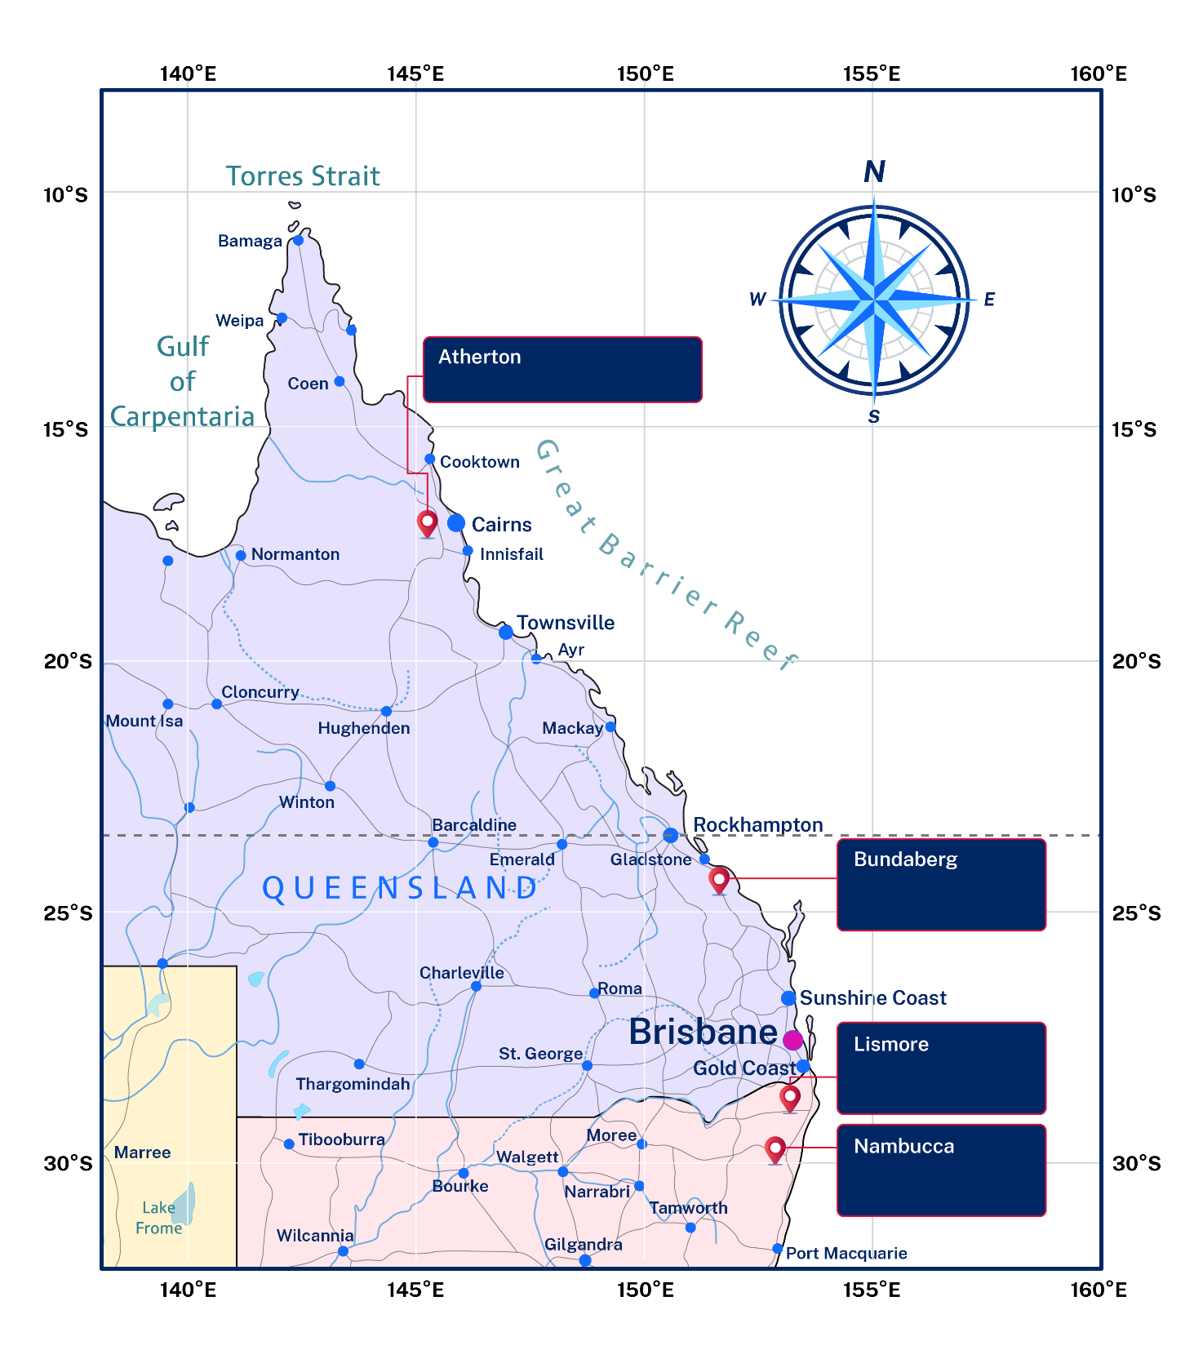

1.11.2 – mapping exercise
Locate and label Atherton, Bundaberg, Lismore and Nambucca on Appendix 4 – Australia blank map. Identify the biome each is located in using National Geographic Mapmaker Biomes.

1.11.3 – constructing climate graphs
Construct a climate graph for each of the following locations using the mean maximum temperature.
- Atherton Climate statistics for Australian locations
- Bundaberg Climate statistics for Australian locations
- Lismore Climate statistics for Australian locations
- Nambucca Heads Nambucca Heads Long-Term Averages
Working in pairs answer the following questions:
- Do our climate graphs look similar and are they accurate?
- In which hemisphere is each place located?
- What is the proximity of each location to the equator?
- Describe the seasonal distribution of rainfall for each town.
- How many dry months does each town have?
- How is the climate different between Atherton and Nambucca Heads?
- Revisit your tropical, subtropical and temperate regions of Australia map and identify the characteristics of climate relevant to each.

Lesson 12 – geographical inquiry part 2

1.12.1 – Australia’s Great Dividing Range
Review Figure 16.
Figure 16 – Australia's Great Dividing Range
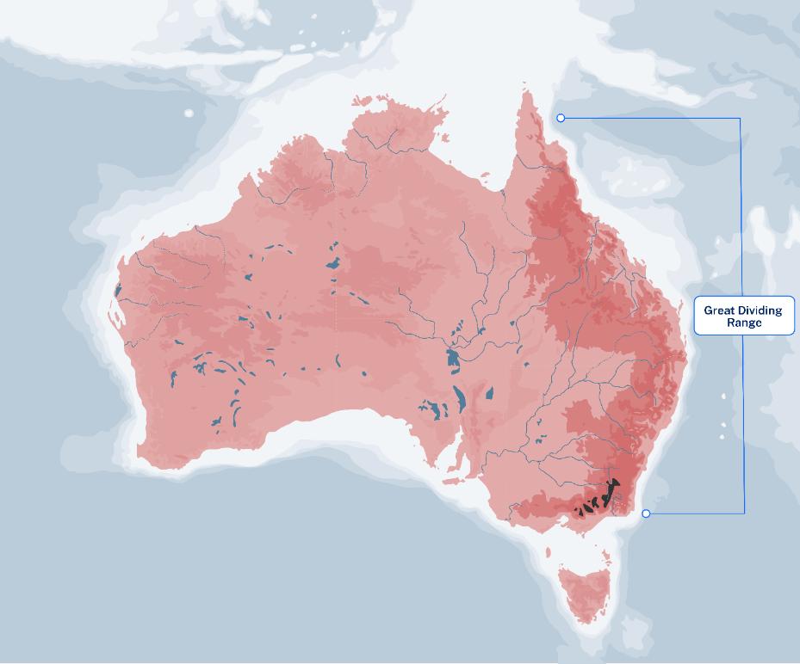
Use Figure 16 and your map of Australia’s biomes to record the location and distribution of the Great Dividing Range.

1.12.2 – Think, Puzzle, Explore
- What do you know about tectonic plates and the formation of the Great Dividing Range and Australia’s continental landscapes?
- What questions do you have about the formation of the Great Dividing Range and Australia’s continental landscapes and how this influences biomes that exist?
- How might you explore your questions about this topic?

1.12.3 – Slow Complexity Capture
Use Writing scaffolds such as PEEL or similar and the Glossary of key words definition of explain to answer one of the following prompts.
- Evaluate how the topography of the Great Dividing Range influences the variety and productivity of biomes across eastern NSW.
- Analyse why changes in elevation across the Great Dividing Range create diverse conditions for different biomes.
- Discuss how elevation and climate variations caused by the Great Dividing Range affect biome productivity.
- Explain how the formation and topographical characteristics of the Great Dividing Range result in variations in biome productivity.
- Assess the relationship between elevation, climate conditions and biodiversity within biomes found along the Great Dividing Range.
Environment and location (3:57), Water a journey westward (6:37) and Figure 17 will support your response.
Figure 17 – generalised illustration of a cross-section the Great Dividing Range
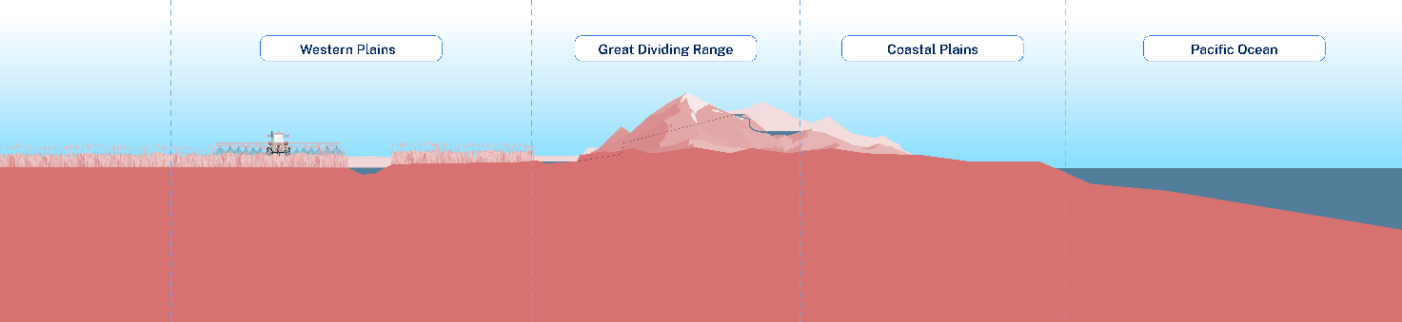
Identify any new ideas or questions you have about the Great Dividing Range.

1.12.4 – rain shadow effect
Review Figure 18.
Figure 18 – rain shadow effect
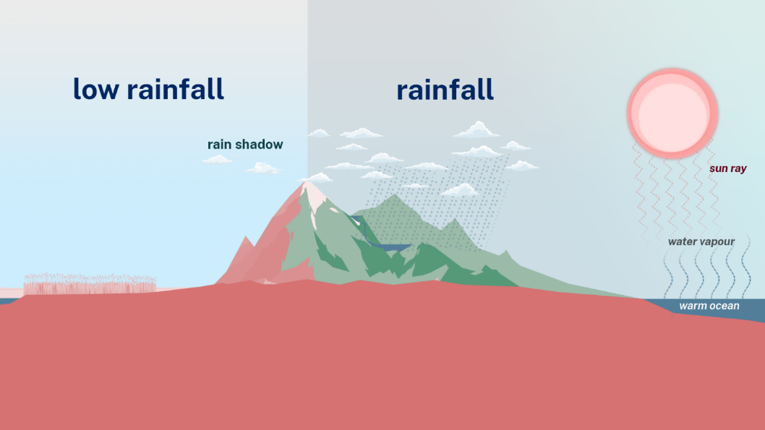
Use Appendix 5 – Think-Pair-Share for the following activities.
- Choose 3 locations along Figure 16 and predict how rainfall and temperature would vary.
- Use Climate Classification of Australia to identify 3 locations across a transect of the Great Dividing Range and identify the variation in climate that exists.

1.12.5 – the Great Dividing Range dividing our rainfall
Use Figure 17, Figure 18 and the Glossary of key words definition of explain to answer the following question: ‘Explain how the altitude and climate would influence biomes that exist on the eastern side of the Great Dividing Range, plateau (top) and the western side of the Great Dividing Range’.
Use a C3B4ME routine to provide feedback on a peer’s response:
- review and provide feedback to 3 peers in your class
- review and improve your response based on feedback from 3 peers in your class.

Lesson 13 – geographical inquiry part 3

1.13.1 – types of soils
As you view the video Types of Soil (Quiz Edition) (7:24) answer the following questions:
- What are the components of soil?
- What is humus?
- Soil is incredibly important to plants because it is their primary source of minerals, nutrients and what?
- Why does sandy soil often appear dry?
- True or False – clay soil is ideal for plant roots because it allows air to pass through easily.
- Which soil type is best for growing plants?
- Loamy soil is made up of a mix of sand, silt and also some what?
- Which type of soil has the smallest rock particles?

1.13.2 – ternary graphs
Use Figure 19 to identify 3 key features of a ternary graph.
Figure 19 – ternary graph
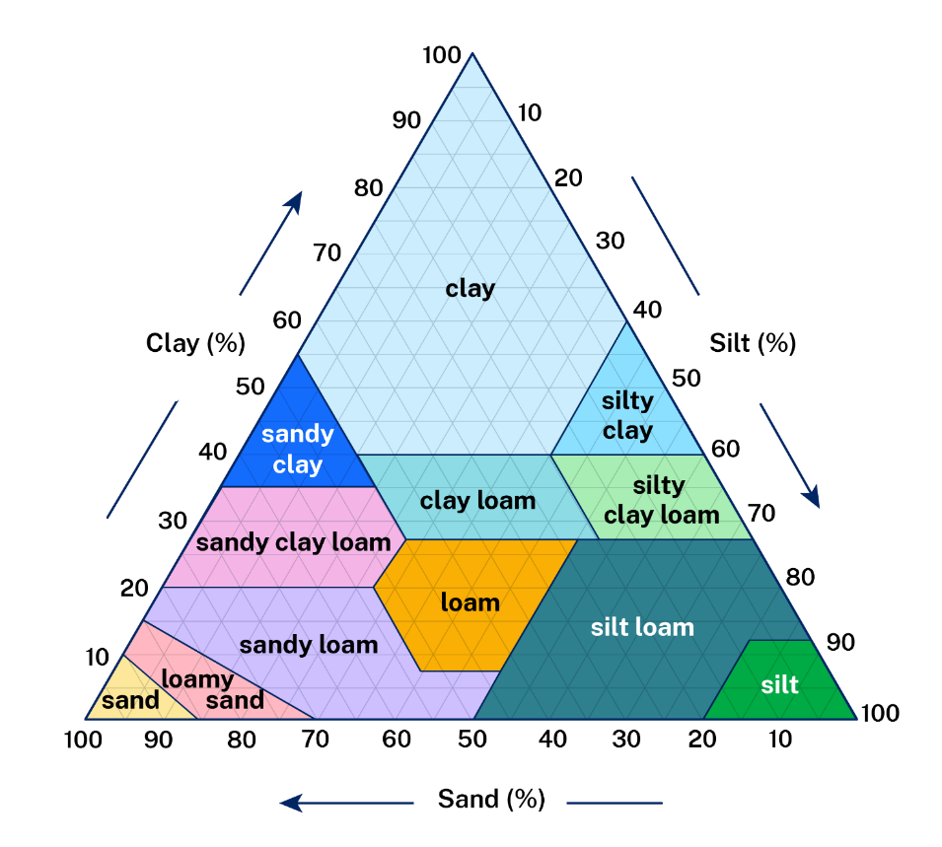
- What percentage do the 3 soil texture types need to add up to?
- Identify the 3 variables illustrated in Figure 19.
Undertake an ‘I do, We do, You do’ routine answering the following questions using Figure 19:
- I do – teacher answers the following question: ‘What is the soil texture classification for a sample that is 10% sand, 60% silt and 30% clay.’
- We do – class works in small groups or in pairs to answer the following question: ‘What is the soil texture classification for a sample that is 60% sand, 10% silt and 30% clay.’
- You do – independently answer the following question: ‘What is the soil texture classification for a sample that is 20% sand, 20% silt and 60% clay.’

1.13.3 – Australian soil classifications
Engage with Soil Profile and Soil Horizons (3:11) and draw an annotated diagram that illustrates a soil profile and the horizons.
Use The Australian Soil Classification to identify soil characteristics for the soil types identified in Table 13.
Table 13 – soil characteristics and distribution
Soil type | Characteristics | Do they exist along The Great Dividing Range
Vertosol
Dermosol
Sodosol
Use Table 13 to answer the following question: ‘What are some common soil characteristics of the tropical, subtropical and temperate regions of the east coast of Australia?’

Lesson 14 – geographical inquiry part 4

1.14.1 – flora and fauna bingo
Use Table 14 to become familiar with subtropical flora found in north-eastern NSW.
Table 14 – subtropical flora summary sheet
Common name | Scientific name | Description
bird’s nest fern | Asplenium australasicum | fern growing on trees
Bangalow palm | Archontophoenix cunninghamiana | tall palm with purple flowers and red fruits
weeping lilly pilly | Waterhousia floribunda | tree with white flowers, wavy leaves
red lilly pilly | Syzygium hodgkinsoniae | small tree found near streams
yellow satinheart | Bosistoa transversa | small tree, related to citrus family
gympie nut | Macadamia ternifolia | native macadamia nut tree
white booyong | Argyrodendron trifoliolatum | tall tree with large roots and creamy flowers
lawyer vine | Calamus muelleri | climbing plant with sharp hooks
wonga wonga vine | Pandorea floribunda | woody vine with white flowers
Use Table 15 to become familiar with subtropical fauna found in north-eastern NSW.
Table 15 – subtropical fauna summary sheet
Common name | Scientific name | Description
three-toed snake-tooth skink | Coeranoscincus reticulatus | skink with very small limbs and 3 toes
large-eared pied bat | Chalinolobus dwyeri | bat that eats insects
Coxen’s fig-parrot | Cyclopsitta diophthalma coxeni | rare small green parrot
Richmond birdwing butterfly | Ornithoptera richmondia | large butterfly, colourful males
giant barred frog | Mixophyes iteratus | large frog with striped legs
grey-headed flying-fox | Pteropus poliocephalus | large bat with grey head
red-legged pademelon | Thylogale stigmatica | small marsupial with reddish-brown legs
Use Lowland subtropical rainforest, North Coast bioregion and further research to identify common flora and fauna found in the north-eastern region of the NSW subtropical biome. As you come across any flora and fauna in your research mark it off on your bingo card.
Your teacher will allocate you a bingo card 1, 2 or 3.

Figure 20 – subtropical biomes bingo – card 1
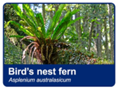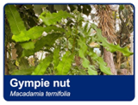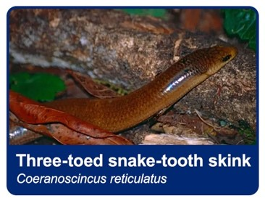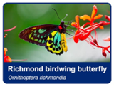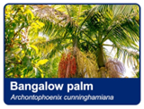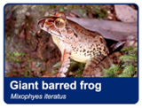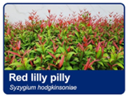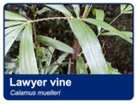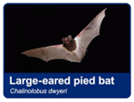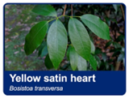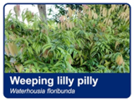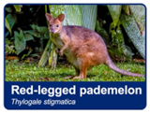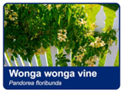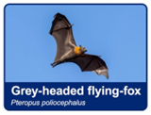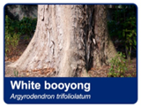

Figure 21 – subtropical biomes bingo – card 2

Figure 22 – subtropical biomes bingo – card 3

1.14.2 – food web
Use your bingo card to draw a Food Web that illustrates the interconnecting and overlapping food chains within a subtropical community.

1.14.3 – quick write
Quick write a response to the following question: ‘Would you describe the subtropical biome of north-eastern NSW as rich in biodiversity? Justify your response.’

1.14.4 – decoding text exercise

Guiding questions for decoding
- What was the original extent of the Big Scrub, and why was it reduced?
- Why is the Big Scrub significant in terms of biodiversity?
- What are some methods being used to restore the Big Scrub?
- What role do humans play in both the decline and the restoration of the Big Scrub?
- Can the Big Scrub realistically return to its original state? Explain your response.
Table 16 – decoding the Big Scrub texts
Step | Activity or prompt | Student response
1 | Identify and define 3 new terms from the reading.
2 | Summarise the original state and size of the Big Scrub.
3 | Explain 2 human activities that led to the clearing of the Big Scrub.
4 | Describe 2 current restoration strategies being used in the Big Scrub.
5 | Is the Big Scrub recovering successfully? Provide evidence from the text.
Table 17 – glossary of key terms for the Big Scrub
Term | Definition
assisted natural regeneration | helping a natural area recover faster by removing threats (for example, weeds) and allowing natural growth to occur
biodiversity | the variety of living things (plants, animals, insects, fungi) within an area
biodiversity richness | having many different species living together in one ecosystem, indicating a healthy environment
ecological restoration | the process of helping damaged ecosystems recover to a healthy, natural state
endangered ecological community | a group of plants and animals in danger of disappearing completely due to habitat loss or damage
fragmentation | breaking a large natural habitat into smaller, isolated patches
subtropical rainforest | a dense forest that grows in warm areas with high rainfall and mild climates
regeneration | the natural recovery and regrowth of plants in an area after disturbance or damage

1.14.5 – visual representation
Complete Figure 23 by identifying and summarising the characteristics of subtropical biomes.
Figure 23 – subtropical biomes summary
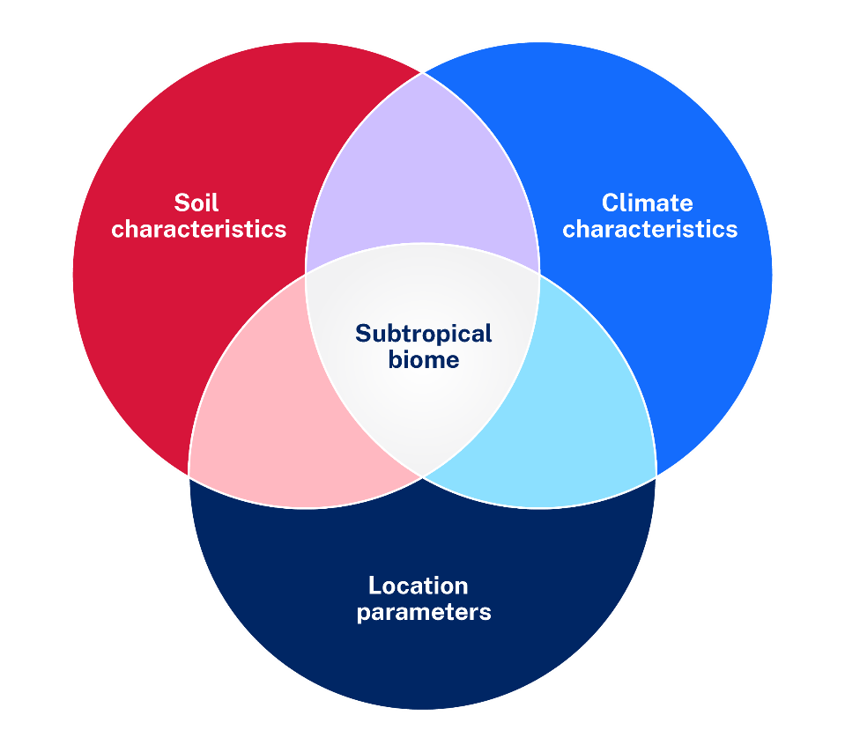
Complete a 3-2-1 routine using Exit tickets – 3 things you learnt in the lesson, 2 questions you now have about subtropical biomes and 1 thing you think was important to learn.

Lesson 15 – geographical inquiry part 5
Your teacher will guide you through using the MCT Wild Macadamias App.

1.15.1 – exploring the MCT Wild Macadamias App
Use the National Macadamia Tree Crop Map and MCT Wild Macadamias App to identify the key macadamia nuts cultivation regions. Revisit your Australian biomes map and Think-Pair-Share the following questions:
- What biome do native Australian macadamia nut trees commonly grow?
- In what biome are Australian macadamias being commercially cultivated?
- What similarities can be drawn between the native Australian macadamia nut trees and Australian commercially cultivated macadamia nut orchards?

1.15.2 – threats to wild macadamia nut trees
Engage with Saving Australia’s native macadamia nuts (6:16) and MCT Wild Macadamias App to identify threats to native macadamia trees in southern Queensland and northern NSW.
Access the Guide to Wild Macadamia Conservation on the Wild Macadamia Conservation Trust webpage and add any other threats to your list.

1.15.3 – macadamia nuts’ unique value infographic
Watch Great Australian Stuff – Series 1 Episode 1 Food (58:00) (from 11:33–17:45), An Australian legend – History and industry, Australian macadamias: history in a nutshell and An Australian legend – The macadamia legend.
Think-Pair-Share a response to the following prompt: ‘Outline how the macadamia nut, a native Australian plant, is unique and valuable culturally, economically and environmentally’.
Use Canva for Education or a similar digital tool to create an infographic that illustrates your response.

1.15.4 – line graph
Plot a line graph for Australian macadamia production, 2017 to 2024 (MT – metric ton), using Table 18. You will need to choose an appropriate scale, label the axis and choose an appropriate title.
Table 18 – macadamia nut production in Australia (MT) 2017–2024
Year | Macadamia nut production in Australia (MT)
2019 | 43 000
2020 | 47 000
2021 | 52 000
2022 | 54 000
2023 | 48 000
2024 | 50 000
This activity has been adapted from the Australian Macadamia Society website.
Conduct a peer assessment for your line graphs using the marking criteria in Appendix 10 – graph peer assessment template.
Use your line graph to answer the following:
- Describe the general trend in Australian macadamia nut productivity.
- Predict the likely trend for Australian macadamia orchards if the current trends persist.
- Predict possible challenges that may impact Australian macadamia production.
- Suggest implications for supply and demand if production continues to follow the same trend over the coming decade.

Lesson 16 – geographical inquiry part 6

1.16.1 – 3-2-1 routine
Complete a 3-2-1 routine based on the last lesson:
- record 3 things you learnt
- record 2 things you found interesting
- record 1 question you still have about GIS, line graphs or macadamia nut production.

1.16.2 – pie chart
Use the data provided in Table 19 to construct a pie chart that illustrates the top macadamia nut exports by country.
Table 19 – top macadamia nut exports by country
Country | Percentage | Degrees
South Africa | 37
Australia | 25
Kenya | 8
China | 6
United States | 3
Other | 21

1.16.3 – flowline diagram
Access Facts and Figures world tree nut trade flows flowline diagram and answer the following:
- Identify the countries Australia is exporting macadamia shelled nuts to.
- Identify the countries Australia is importing macadamia shelled nuts from.
- Identify which nut variety is the USA’s major export and where it is flowing to.
- Suggest reasons why Australia would be importing macadamia nuts.
- Predict challenges Australian macadamia producers may have.

1.16.4 – concept map
Engage with What makes a top-performing farm: Macadamia case study (5:22), NRs Macadamia farms to become lifestyle blocks or large scale operations, Macadamia common pests and diseases, Top Pests & Diseases of Macadamia Trees: Management Tips and Reducing erosion and other soil degradation in macadamia orchards, and use Appendix 6 – brainstorming template to summarise the key challenges to macadamia production.

Lesson 17 – geographical inquiry part 7

1.17.1 – cause and effect
With a partner engage with About the Macadamia Industry, The macadamia industry in Australia: A lucrative sector of the agricultural industry and Going nutty: the macadamia industry.
Discuss the cause-and-effect relationships of macadamia nut production for the Australian economy, society and environment.
Complete Table 20 to illustrate the interconnections you have discussed. Examples of linking statements could include ‘resulted in’, ‘led to’, ‘caused’, ‘had the effect of’, ‘will cause’, ‘ended in’, ‘will lead to’.
Table 20 – cause and effect explanation table
Cause | Linking phases | Effect

1.17.2 – sketch to stretch
Use a Sketch to Stretch strategy to illustrate your understanding of the geographical concept ‘sustainability’.

1.17.3 – concept map
Engage with Our Sustainable Approach and construct a concept map using Appendix 6 – brainstorming template that identifies ways the industry is improving green growing methods. At the centre include the title ‘Australian Macadamias sustainability strategies’.

1.17.4 – biological control
Use the following resources and further research to complete Table 21.
- Bugs for Bugs
- Good Bugs
- Biological Control of Macadamia Nut Borer (5:59)
- Macadamias: Industry overview
- Gardening Australia: Pollinating Macadamia Trees (2:08)
- Why macadamia farmers love owls
Table 21 – biological control in macadamia farming
Biological control | Description | Purpose
Trichogramma wasp
Native bees
Native barn owls
Revisit Table 20 and add in any new information acquired about pests and biological control methods.

1.17.5 – Think-Pair-Share
Engage with Australian Macadamia nut farmers set out to improve sustainability and complete a Think-Pair-Share on the following prompts:
- Identify the natural characteristics of the macadamia tree that make it a more sustainable agricultural product.
- How are consumers from Australia and around the world influencing the production of macadamia nuts in Australia?
- How important are sustainable farming practices to your choice and consumption of products?
- Identify ways sustainable macadamia production benefits the producers.
Engage with Simpleshow explains the Carbon Footprint (2:00) and Australian Macadamia nut farmers set out to improve sustainability, then answer the following:
- What is a carbon footprint and why is it important?
- Outline ways macadamia farmers have reduced the carbon footprint from macadamia production in Australia.

1.17.6 – extension task
Note: the following learning activities may be used as an extension exercise.
Access Kenya Current climate Climatology and use the climatic column graph to answer the following:
- Look at the overall shape of the graph. Is the temperature line steep or gentle? Does it change throughout the year or look almost flat?
- Look for extremes – quote the highest and lowest temperature and rainfall, as well as the month in which it occurs. Remember to quote units, for example, Celsius or millimetres.
- Calculate the temperature range by subtracting the lowest figure from the highest figure.
- Add the rainfall totals for each month together to work out the total annual rainfall.
Engage with Macadamia Farmers: Macadamia industry promising for Kenyan economy (2:28) and complete 3 separate statements:
- 3 things I didn’t know before watching this video
- 2 things that surprised me in this video
- 1 thing I still do not understand or 1 thing I want to do with my new knowledge.
Use Table 22 to plan a draft response to the following: ‘Provide a sustained and logical argument to peasant farmers in Kenya as to why they should participate in macadamia production’.
Table 22 – exposition scaffold
Exposition | Characteristics
Opening paragraph | Outline the perspective of your overall argument. What should they do? Overview of arguments being presented.
Argument 1 | Factual information, example, personal point of view
Argument 2 | Factual information, example, personal point of view
Argument 3 | Factual information, example, personal point of view
Conclusion | Summary, positive reinforcement of opening statement
Use a C3B4ME routine to provide feedback on a peer’s paragraph. Review and improve your response based on feedback.

Lesson 18 – geographical inquiry part 8

1.18.1 – geographical inquiry process
Review Figure 24 and Geographical inquiry video (2:59).
Figure 24 – geographical inquiry process
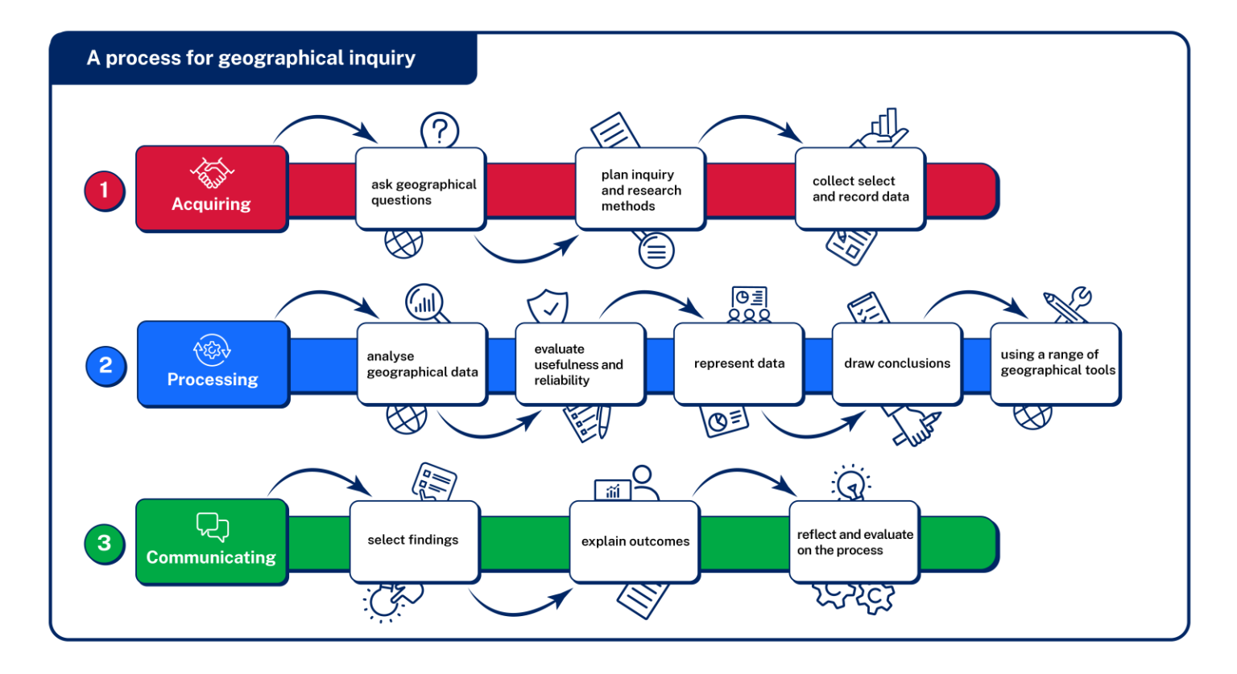
Reflect on a previous geographical inquiry you have engaged with. What aspect of geographical inquiry do you feel you excelled in and what aspects do you think you can improve on?

1.18.2 – introducing Robbie’s farm
Read Appendix 11 – Robbie’s farm Interview transcript and identify an issue, problem or challenge.

1.18.3 – developing a hypothesis for research
Use the teacher explanation provided and the following sentence starters to develop a hypothesis appropriate for researching Robbie’s farm.
Sentence starters to support the development of a hypothesis
- We expect that …
- It is predicted that …
- As [variable) increases/decreases, [outcome) will …
Evaluate your hypotheses using guiding prompts, such as:
- Is the hypothesis clear and easily understood?
- Are geographical concepts and terms clearly included?
- Is the hypothesis specific enough to test?
- Does it clearly state or imply a relationship between variables?

1.18.4 – Options Explosion
Use an Options Explosion to propose an inquiry that identifies appropriate and potential geographical methods.
- List 2 to 3 obvious geographical methods.
- Brainstorm all sorts of different options to find the ‘hidden options’.
- Ask: ‘What have we learned about the situation from identifying these options?’
Use the options explosions to choose 2 appropriate geographical fieldwork methods.

1.18.5 – soil science Australia
Read the Soil Science Australia Learning Resources: Getting to Know Your Garden Soil resource and familiarise yourself with the fieldwork methods.

Lesson 19 – geographical inquiry part 9

1.19.1 – fieldwork
Observe the soil profile provided by your teacher. Draw a detailed sketch of your soil profile outlining the different colours present in each horizon.
Based on your soil profile and the ‘What colour is your soil’ section of Soil Science Australia Learning Resources: Getting to Know Your Garden Soil resource, describe the typical properties of each horizon and potential for drainage.
Test soil texture using the following instructions:
- Collect a sample of soil sufficient to fit comfortably in the palm of your hand. Remove any rocks and organic matter (plant material).
- Gradually add water if required.
- Knead the soil to make a small ball that sticks together.
- Press the soil between your thumb and forefinger to make a ribbon.
- Measure the length of the part of the ribbon that is not broken.
- Use the texture grade table to identify your soil type from the Soil Science Australia Learning Resources: Getting to Know Your Garden Soil resource.
Observe your location, soil profile and ribbon test. How well would you describe your soil sample structure? Refer to the following in your short response:
- water entry into the soil
- runoff of water
- permeability (ease of movement) of water and air in the soil
- root penetration
- seedling emergence
- resistance to erosion
- workability
- drainage.

Lesson 20 – geographical inquiry part 10

1.20.1 – soil tests
Use a soil sample to test your soil pH level and identify what the results indicate about your sample.
Conduct a soil dispersive test using the following steps:
- Half fill a clear plastic dish with deionised water or rainwater.
- Place 3 soil aggregates (3 to 5 mm in diameter) into the plastic dish.
- Leave for 10 minutes, compare to the soil plates illustrated in Soil Science Australia Learning Resources: Getting to Know Your Garden Soil resource.
Read the following description of Ferrosol (Krasnozems) soil:
The Ferrosols were the traditional soil type used for Macadamia culture, partly because Macadamia occur naturally on these soils. Ferrosols are derived from basalt rock and are characterised by a friable consistency and a reddish-brown colour and commonly occur in high rainfall regions in SEQ and NNSW. These soils are high in iron oxide and can contain manganese oxides. The metal oxides in Ferrosol impart some unusual properties to the soil, such as high phosphate fixation, high anion exchange capacity at low pH, risk of manganese (Mn) toxicity during waterlogging, and a variable organic matter content. The organic matter results in good aggregation and water holding capacity, but poor management can result in loss of OM, crusting and compaction.
Based on the description of Ferrosol soil and your soil observations and tests, complete a Venn diagram illustrating any commonalities or differences you have observed (an example Venn diagram was provided in activity 1.6.1).

Lesson 21 – geographical inquiry part 11

1.21.1 – soil pH on Robbie’s farm
Robbie had his soil agronomist take soil tests in his orchards. Table 23 shows the results for pH levels at each location.
Table 23 – Robbie's farm pH results
Site number | pH
Site 1 | 5
Site 2 | 6
Site 3 | 4
Revisit Appendix 11 – farmer Robbie’s interview transcript and suggest what action is required to ensure these sites are improving soil quality to increase tree health.

1.21.2 – interpreting LiDAR images 1
Use Figure 25 to familiarise yourself with the layout of Robbie’s orchard. Locate the following using the legend:
- Roads
- Buildings
- The dam and creeks
- Contour lines
- Lower points of elevation
- Higher points of elevation.
Figure 25 – McLean Ridges farm plan
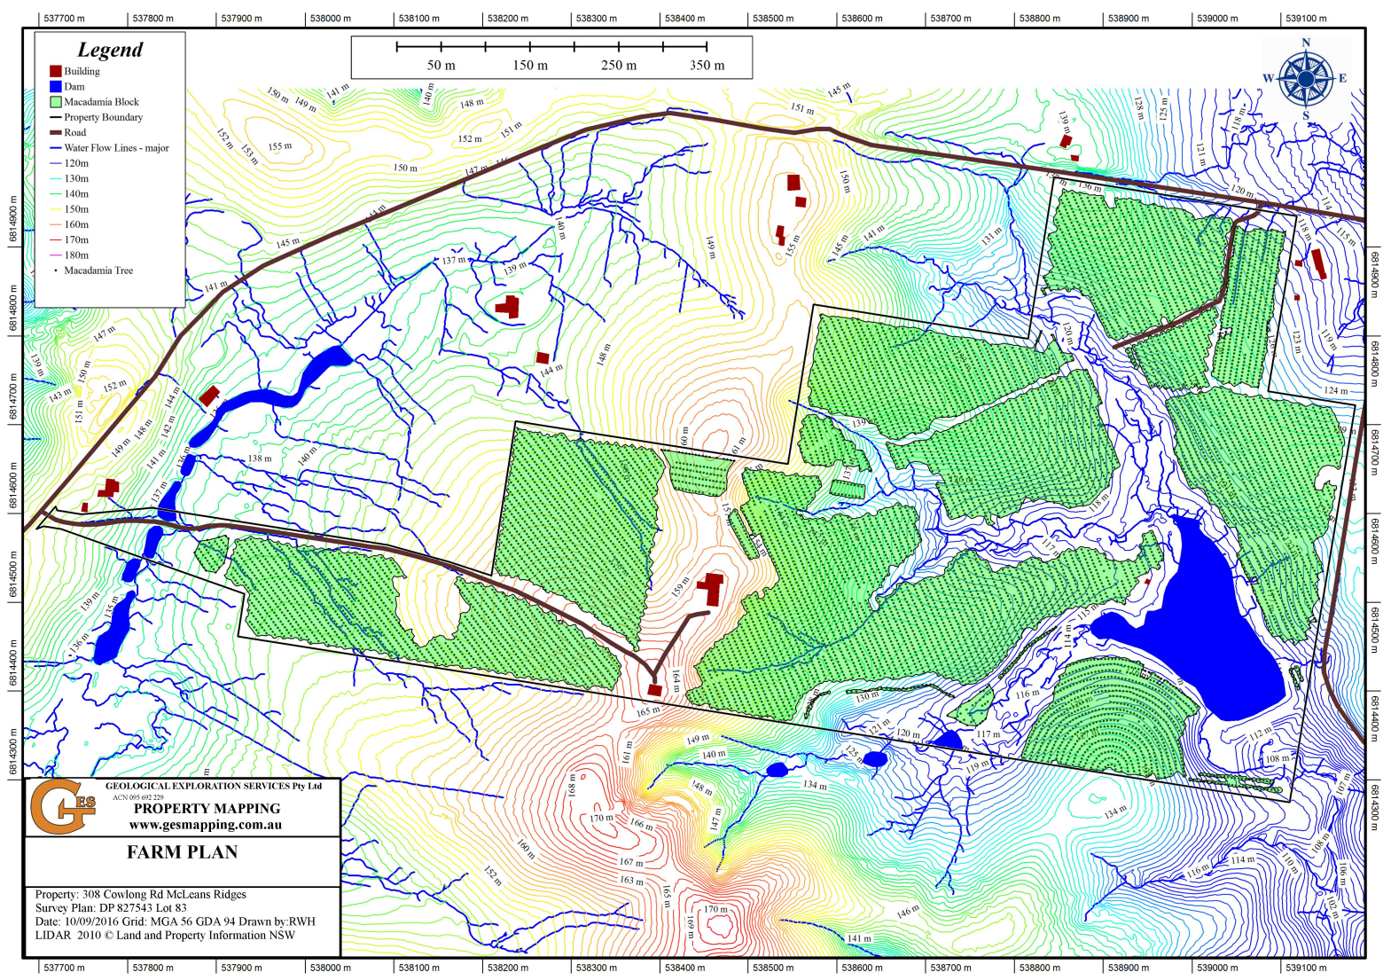

1.21.3 – interpreting LiDAR images 2
Robbie used a drone to monitor unhealthy trees in his orchard. Use Figure 26 to identify locations in the orchard with unhealthy trees.
You should be looking for:
- gaps in the orchard rows
- brown colouring to tree canopy indicating unhealthy trees
- deep green colouring to tree canopy indicating healthy trees.
Figure 26 – McLean Ridges aerial photograph
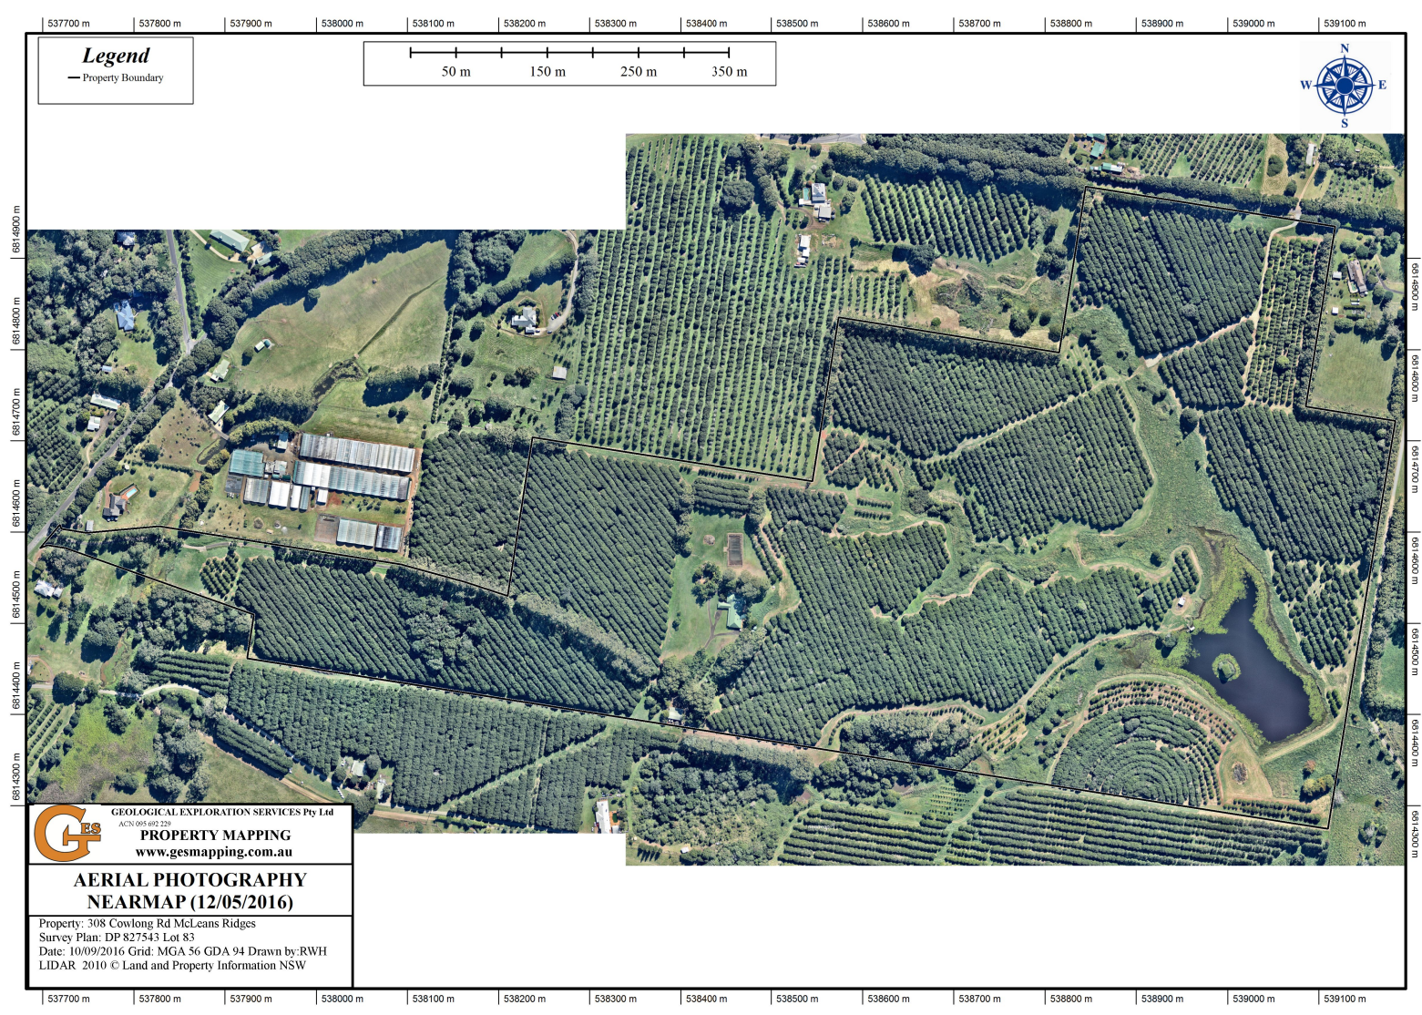

1.21.4 – interpreting LiDAR images 3
Note: a 15 degree slope is described as moderately steep. For every horizontal run, the elevation increases by 79 cm.
Use Figure 27 to identify areas in Robbie’s orchard that have a slope steeper than 15 degrees.
Figure 27 – McLean Ridges slope
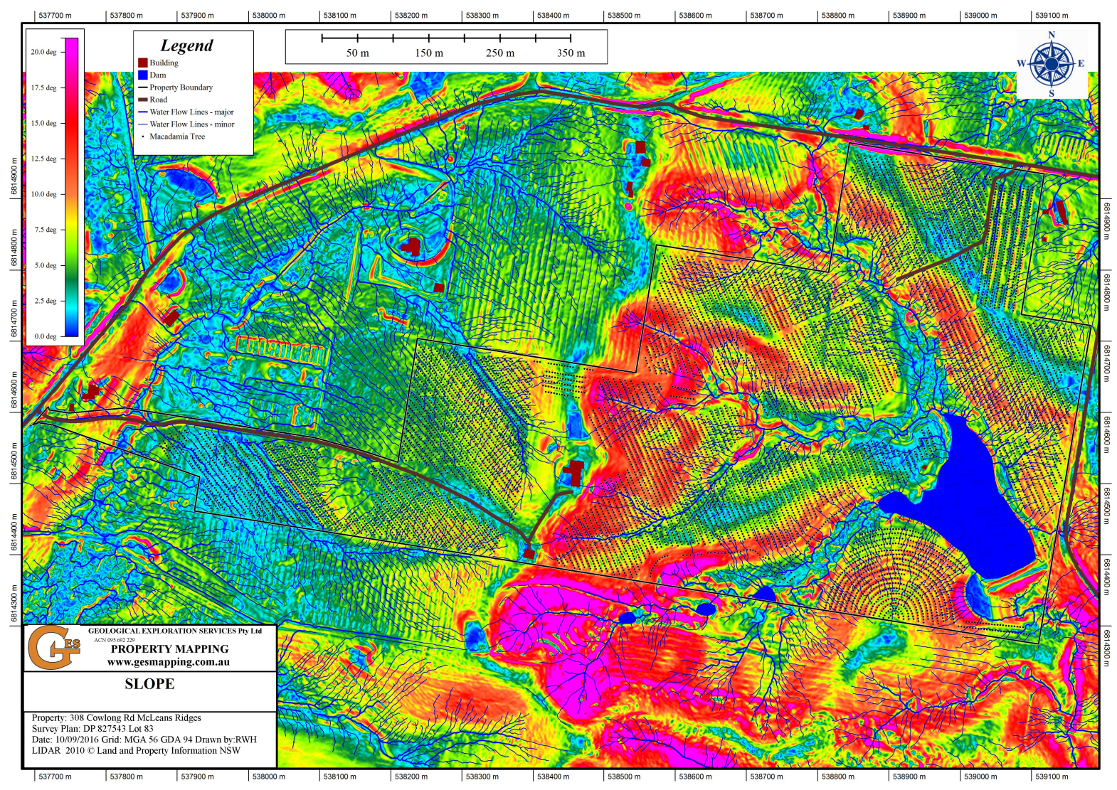

1.21.5 – interpreting LiDAR images 4
Use Figure 28 to identify macadamia tree density in locations across the orchard. What correlation exists between slope and macadamia canopy?
Figure 28 – McLean Ridges vegetation
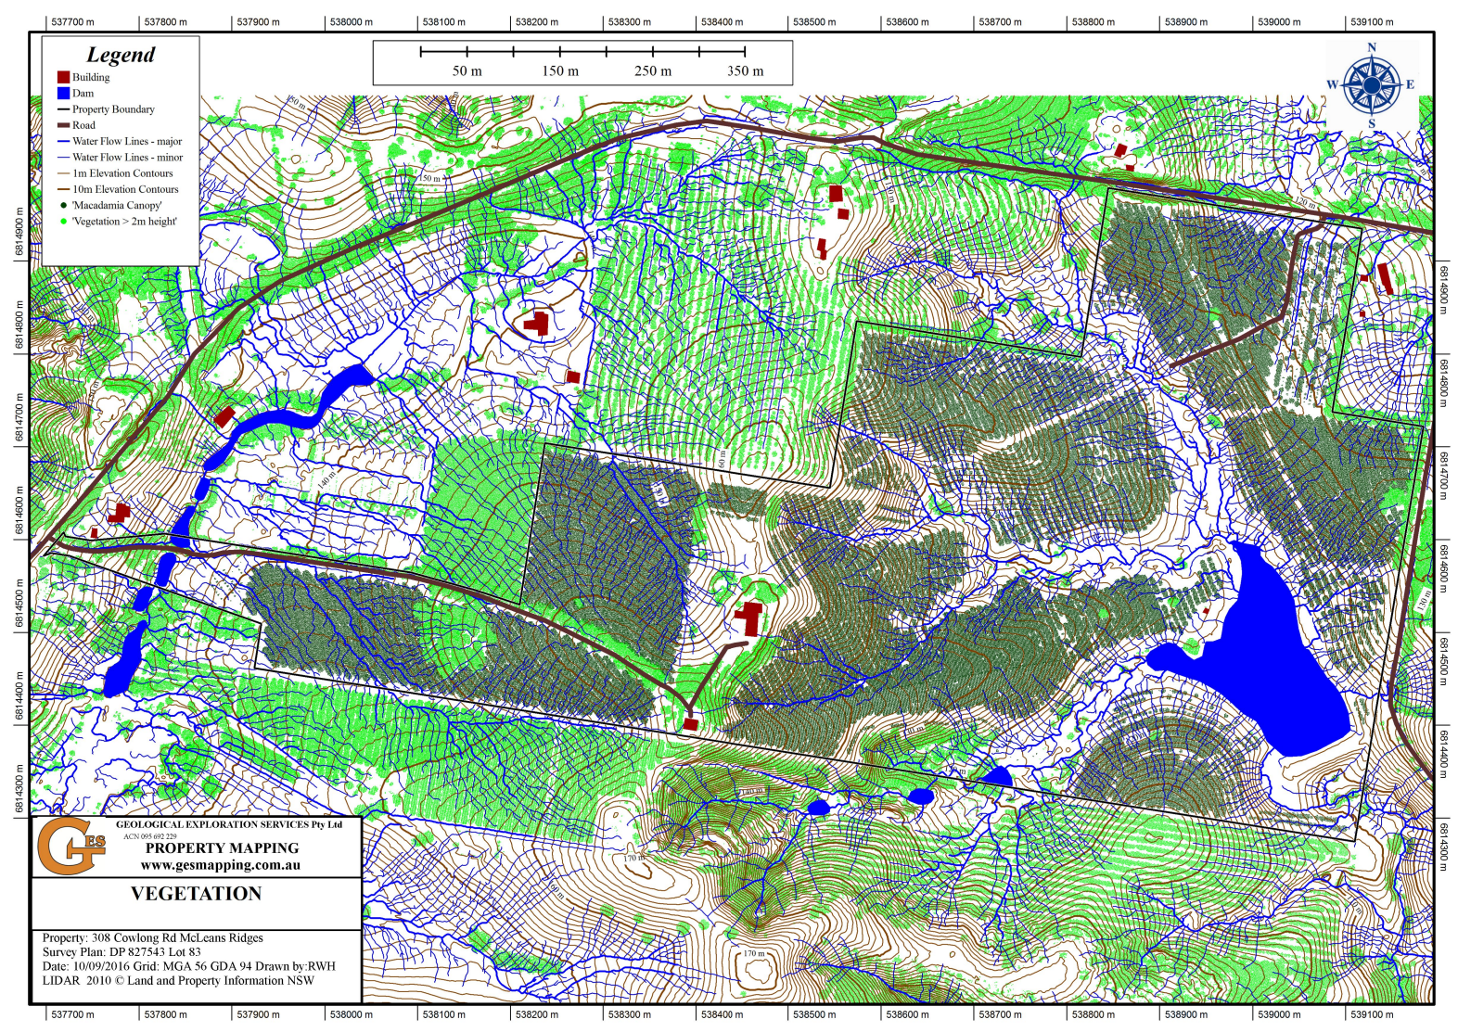

1.21.6 – interpreting LiDAR images 5
If you were asked to develop a scatter graph illustrating the correlation between slope and canopy, which variable would you identify as causing the change and therefore be plotted along the X axis?
Suggest why the macadamia canopy is lessened in areas that have greater than 15 degrees slopes.

1.21.7 – conclusions
What conclusions based on the soil pH, slope and erosion can be drawn about the health of trees in Robbie’s orchard?

1.21.8 – application questions
Working in small groups highlight key points from the Appendix 11 – farmer Robbie's interview transcript. Break back to independently answer the following application questions:
- Can you provide an example of a time when you have seen the use of drone technology? Describe the experience.
- Can you think of a recent news story where agriculture is using new technologies to improve production?
- How could you use the information you have learnt from Robbie in your own day to day life?

Lessons 22 to 24 – geographical inquiry part 12
Explore the processes that influence and challenge macadamia production on Robbie’s farm. In your response, make sure to:
- locate McLean Ridges using Google Maps to identify the latitude and longitude
- identify the biome Robbie’s farm is situated in and what characteristics are common in that biome
- draw connections to the relevance of the biome to the location, distribution and challenges of macadamia nut production
- construct a scatter graph that illustrates tree % cover and slope using either Figure 26 and 27 or data presented in Table 24
- include a choropleth map to visually communicate patterns related to macadamia production at Robbie’s farm. This map will clearly show geographical patterns, using shaded colours to represent differences in macadamia tree health. Appendix 12 – student scaffold – choropleth map will support your development of the choropleth map.
Table 24 – dataset for Robbie's farm
slope (degrees) | 5 | 7.5 | 8 | 15 | 20
tree cover (%) | 100 | 96 | 90 | 85 | 82
Illustrate your findings in a structured report using the subheadings:
- Location description
- short description using latitude and longitude
- map illustrating location
- Farm description
- irrigation need (Robbie’s interview)
- pest species
- natural hazards
- Farm challenges
- erosion and loss of organic matter
- soil pH
- Farm management strategies.
Use any of the following multimodal options to communicate your report.
Multimodal options:
- digital text (video)
- written report
- interactive website
- artwork
- oral presentation or performance
- alternative option (discuss with teacher).

Learning sequence 2 – Factors influencing food production

Lesson 1 – human alterations to biomes to maximise food production

2.1.1 – See, Think, Wonder
Your teacher will provide you with an image to complete a See, Think, Wonder routine.
- Describe exactly what you see. Do not try to articulate at this point what you think is going on. Don’t describe what you think you see.
- Explain what you think you’re seeing.
- Wonder – what else is going on here and what do you see that makes you say that?

2.1.2 – the age of agriculture
Engage with From Hunter Gatherer to Farmer...in five minutes or less (3:51), From Hunters and Gatherers to Farmers (3:20) and What Is The Environmental Impact Of Agriculture?. Use the information to construct a table and sort information into categories under the headings ‘social’, ‘environmental’ and ‘ecological’.

2.1.3 – class brainstorm
Your teacher will lead a class brainstorm session. Be prepared to think about ways humans have changed biomes for agriculture.

2.1.4 – class presentation
Working in small groups contribute to a class presentation on ‘Ways humans alter biomes to maximise food production’.
Table 25 – suggested resources
Group | Suggested resources
Desert | A genius way to restore dead soil (10:13)  How Africa Is Fighting The Sahara Desert In A Race To Plant The Great Green Wall (7:06)  How Spain is Turning it’s Deserts into a Farmland Oasis (9:12)  China Just Turned Its Biggest Desert into a Lush Forest (10:21)
Polar | Vertical Farming In Arctic Research Stations: Supporting Polar Science  Vertical Farming In Polar Regions: Overcoming Extreme Light Conditions  Vertical Farming 2024 – 3 Different Types Of Vertical Farms (4:08)  Antarctica Is Getting a Farm That Can Grow Produce Even When It’s -100 Degrees Fahrenheit Outside — Take a Look
Savannah | The Savannah Biome - Biomes #2 (8:44)  Aboriginal fire stick farming: close-to-home carbon offsetting  Traditional Aboriginal Burning in Modern Day Land Management  Landline: Fire’s role in the Australian environment (4:11)  Big Weather: Benefits of Indigenous fire practices (2:44)  Indigenous fire methods protect land before and after the Tathra bushfire – ABC Australia (11:00)  Australia’s 20 largest regions for cattle population  The Cattle Country: A Look at Australia’s Booming Cattle Industry
Temperate rainforest | Modern Agriculture Cherry Farm! Cherry Cultivation, Harvesting and Processing (10:03)  Innovations & Challenges in Sustainable Cherry Farming  How Much Water Does a Cherry Tree Need Per Day to Thrive and Produce Fruit  Touring a Michigan Montmorency Cherry Orchard (2:43)  Sustainability in Cherry Farming Reducing Water Use and Carbon Footprint  Climate Change and Cherry Farming Challenges and Adaptation Strategies
Tropical rainforest | The Tropical Rainforest Climate - Secrets of World Climate #1 (8:57)  Agriculture in the rainforest  Deforestation in the tropical rainforest  Deforestation and forest degradation  Rainforest Deforestation (3:12)  What is palm oil and why is it thought to be bad?  What is Sustainable Agriculture?
Tundra | What Are Tundras? National Geographic (2:17)  Warming Temperatures Are Driving Arctic Greening  Farming in the Arctic: It Can Be Done  Alaska Farmer Turns Icy Patch Of Tundra Into A Breadbasket  Tundra Food Chain  Effects of degradation on the tundra landscape  How tundra plants respond to climate change and what it means for future ecosystems (2:23)  Tundra Threats Explained

Lesson 2 – environmental, social, economic and technological factors that influence the supply of and demand for food in Australia and Asia part 1

2.2.1 – review class presentation
Review the class presentation and identify examples of environmental, social, economic and technological factors that influence the supply and demand for food.

2.2.2 – locating Bangladesh
Use this map of Asia or an atlas to record the location of Asia and Australia on a world map, you could use Appendix 1 – blank world map. On the world map locate and label Bangladesh.

2.2.3 – using Google Maps
Use Google Maps or an atlas to locate the capital of Bangladesh, Dhaka. Identify Dhaka’s latitude and longitude.
Use Google Maps or an atlas to locate the capital of Australia, Canberra. Identify Canberra’s latitude and longitude.

2.2.4 – Think-Pair-Share
Think-Pair-Share a response to the following questions:
- How does the latitudinal location of Bangladesh compare to Australia?
- How will the different latitudinal locations of Bangladesh and Australia influence climate?
- How might these latitudes influence the different biomes found in Bangladesh and Australia?

2.2.5 – construct a climate graph
Use Table 26 construct a climate graph.
Table 26 – climate data for Dhaka
 | J | F | M | A | M | J | J | A | S | O | N | D
Average temperature (°C) | 25.4 | 28.1 | 32.4 | 33.8 | 32.9 | 32.2 | 31.4 | 31.6 | 31.8 | 31.6 | 29.6 | 26.4
Precipitation (mm) | 7 | 25 | 63 | 154 | 341 | 337 | 373 | 316 | 314 | 175 | 34 | 15
Use your climate graph and climate variations to answer the following:
- Identify the key climate characteristics for Bangladesh (hint: observe the months that receive the most rainfall and distinct seasonal variations).
- Identify the climatic region of Bangladesh.

2.2.6 – prominent biome
Use National Geographic Mapmaker Biomes and your climate graph to determine the prominent biome that exists in Bangladesh.
Engage with Tropical and Subtropical Moist Broadleaf Forests and construct a Concept map that illustrates the characteristics of tropical and subtropical moist broadleaf forests.

2.2.7 – population data
Engage with Population of Bangladesh and record the current population data for Bangladesh.
Engage with Population of Australia and record the current population data for Australia.
Engage with 234 Countries table from the Total Population by Country 2025 webpage and record Bangladesh and Australia’s population density per kilometres squared (KM²).
Use Quick writes responding to the following:
- Use the photograph provided in Bangladesh faces serious hunger as floods ruin farmlands: UN to suggest potential impacts of the high population density and geographic location of Bangladesh on supply and demand for food.

Lesson 3 – environmental, social, economic and technological factors that influence the supply of and demand for food in Australia and Asia part 2

2.3.1 – Who we are World Food Programme
Engage with Bangladesh: One in five people live below poverty line (2:13), Extreme Poverty - Bangladesh - Short Documentary (8:53) and Who we are World Food Programme. Think-Pair-Share responses to the following:
- Identify challenges faced by individuals living below the poverty line in accessing sufficient and nutritious food.
- Describe how organisations like the World Food Programme (WFP) address food supply issues, and what challenges do they encounter?

2.3.2 – factors influencing food supply and demand
Working in pairs complete Table 27. The following resources and further research will inform your response.
- 3 projects keeping food on the table in Bangladesh
- A severe food crisis looms for Bangladesh
- Problems Caused by Overpopulation in Bangladesh
- Floating farms in Bangladesh help farmers survive floods (2:07)
- Nearly one-third of Bangladesh affected by monsoon floods (2:16)
- Bangladesh’s garment factories pollute rivers, affecting residents’ health (2:35)
- Horror bushfire season cost Aussie farmers up to $5 billion
- The effects of drought and climate variability on Australian farms
- Drought, disaster and rural support
- Food waste in Australia
- Self sustainable zero waste productive home in Melbourne demonstrates future (8:54)
Table 27 – comparing factors influencing food supply and demand, Australia and Bangladesh
 | Environmental | Social | Economic | Technological
Australia
Bangladesh
As a class complete a Venn diagram to compare and contrast Australia and Bangladesh supply and demand for food.

2.3.3 – comprehension questions
Use the summary table and your class Venn diagram to inform a response to the following:
- Compare approaches to the management and protection of the environment in Bangladesh and Australia.
- Identify how approaches to management and protection of the environment in Bangladesh has impacted food supply and demand.

2.3.4 – create a written text
‘Assess different approaches to the management and protection of the environment and the implications for food supply and demand in Australia and Bangladesh.’ Your response should be structured using Writing scaffolds such as PEEL or similar and consist of no less than 4 paragraphs.
Use a C3B4ME routine to provide feedback on a peer’s paragraph. Review and improve your response based on feedback.

Lesson 4 – environmental impacts of food production

2.4.1 – ecosystem services
Use Figure 2 on the Ecosystem Services: Categories and valuation webpage to identify the ecosystem service bees provide.
Develop an infographic or Public Service Announcement (PSA) aimed at informing the public about the importance of bees to sustainable agriculture and the environmental impacts that hinder the bees’ ecosystem service. The suggested resources and further research below will inform your response.
- Natural disasters impacting honeybee industry across Australia (5:41)
- Landline – Series 2023: honey bee (56:00) (from 1:36–13:58)
- Why bees are essential to people and planet
- The Role of Bees in Biodiversity: What You Need to Know
- Bee Friendly Farming at Macadamia Farm Management

2.4.2 – capacity matrix
Return to the Capacity matrix in Lesson 1.1.5 and highlight any new learning about the concepts covered in the learning sequence.

2.4.3 – exit ticket
Complete an exit ticket answering the following questions:
- Why are bees essential to maintaining global biodiversity?
- What challenges exist for beekeepers in Australia?
- Explain the relationship between bees, agriculture and food security.

Learning sequence 3 – Towards food security

Lessons 1 and 2 – the nature and spatial patterns of food security part 1

3.1.1 – Y-chart
Complete Appendix 13 – Y chart template that provides a description of food security, including what the food security looks, feels and sounds like.

3.1.2 – Frayer diagram
Engage with What is food insecurity? An explanation (1:38) and complete a Appendix 14 – Frayer diagram template for ‘Food insecurity’.

3.1.3 – short response question
Based on the definition of food insecurity used in your Frayer diagram and Infographic: Hunger and food insecurity in maps and charts account for why Australians might experience food insecurity.

3.1.4 – Atlas exercise
Use Global Food Insecurity and an atlas to answer the following:
- Identify the countries that are currently recorded as ‘Area of concern’ for food insecurity by Geopolitical futures.
- Suggest reasons why these nations are included in the ‘Area of concern’ category.
- How many people in Ethiopia are recorded as living in crisis, emergency and catastrophic food insecurity circumstances?
- Use ‘Food insecurity trends in most critical countries’ to identify common trends.
- Given the pattern of trends, predict the pattern of food insecurity for Afghanistan and Nigeria. Justify your predictions.

3.1.5 – global food security index 2022 interactive
Note: you will need to select the Rank column in the Ranking and trends table to reveal each countries’ specific data in more detail.
Engage with Global Food Security Index 2022 and create a concept map using Appendix 6 – brainstorming template that summarises the key findings. Use Global Food Security Index 2022 Rankings and trends to complete Table 28.
Table 28 – global food security rankings and trends
Country | Rank | Percentage of children malnourished | Prevalence of obesity | Sustainability and adaptation
Finland
United Kingdom
United States
New Zealand
Australia
China
Myanmar
Bangladesh
Ethiopia
Haiti
Syria

3.1.6 – presentation
Using data presented under Score detail on the Global Food Security Index 2022 webpage, choose 2 countries to compare. Present your comparison as a Google Slide, Microsoft Power Point Online, PowToon Edu or something similar.
Table 29 – global food security presentation structure
Slide | Presentation structure | Sentence starters
Title slide | Clearly state your comparison and your chosen countries.  Example – A comparison of food security in Ethiopia and Australia.
Introduction and key definitions | Define food security and food insecurity.  Briefly introduce your chosen countries and why you selected them for comparison. | Food security can be defined as …  We chose these countries because …
Comparison overview | Clearly present key data points such as overall rank, percentage of children stunted, prevalence of obesity and sustainability and adaptation scores. | As illustrated by the data, [Country A] ranks significantly higher/lower than [Country B] in terms of …  Notably, the percentage of stunted children in [Country A] is ..., compared to [Country B] ...
Analysis of trends and patterns | Identify and analyse common trends and notable differences between the 2 countries based on the data you provided.  Discuss how geographic, economic and social factors contribute to these patterns. | The data clearly indicates a trend where …  [Country A] demonstrates significantly greater sustainability due to …  A key factor explaining the differences between these countries is …
Impacts and consequences | Explain the impacts of food insecurity or food security in each country.  Use geographical concepts such as place, interconnection, environment and sustainability. | Food insecurity in [Country A] leads to impacts such as …  Conversely, high food security in [Country B] positively affects …  Environmental factors such as ... significantly influence the food security levels in ...
Conclusions | Summarise main points of comparison.  Consider some realistic strategies for improving food security based on your findings. | Based on our analysis, it is evident that …  To improve food security, [Country A/B] should consider …  Future actions that might enhance food security include …
Self-assess your presentation using the marking rubric in Table 30.
Table 30 – just an A marking rubric – towards food security
Grade | Criteria
A | - Demonstrates extensive knowledge of the nature and impact of food security  - Displays sophisticated skills to assess the trends of global food security  - Communicates comprehensive geographical information in a sophisticated and engaging manner, using a variety of strategies

Lesson 3 – the nature and spatial patterns of food security part 2

3.3.1 – oral presentation in class
Present Global Food Security Index 2022 comparative presentations to peers. Complete a marking rubric for peers in your class Table 30.
Exit ticket: ‘Do you think food security for everyone is possible?’.

Lesson 4 – factors that impact food security

3.4.1 – class jigsaw
Your teacher will allocate you a group to work with. Each group will research a factor that impacts food security using Table 31.
Table 31 – factors that impact food security
Factor | Suggested resources
Poverty | Food security and poverty reduction  Your experiences of child food poverty (4:17)  Food security: Pillars, Determinants and Factors Affecting It  Poverty  Are you living in a food desert? These maps suggest it can really affect your health  Sustainable Development Goals  End poverty in all its forms everywhere  Atlas of Sustainable Development Goals 2023
Conflicts | How Conflict Causes Food Insecurity (3:15)  Ukraine war effects add to Kenyan food insecurity crisis (1:40)  Food security in times of armed conflict: What you need to know  Conflict in Ukraine and the unsettling ripples: implications on food systems and development in North Africa
Climate change | Climate Change and Food Security (4:30)  Feeding Nine Billion Video 6: Climate Change and Food Security (4:59)  End poverty in all its forms everywhere – Target 1.5.1  Atlas of Sustainable Development Goals 2023  NASA’s Earth Minute: Sea Level Rise (1:30)  Food security threatened by sea-level rise  Sea level rising, coast under threat
Land competition | Sydney’s food futures  Land and Food Security  People-Land Relationships On The Path To Sustainable Food Security  Impact of transnational land acquisitions on local food security and dietary diversity  How land grabbing effect food production in Africa (1:23)
Export-focused policies | Food security - The impact of export restrictions  Food security: the role of international trade and support  How Importing and Exporting Impacts the Economy  Protectionism: Examples and Types of Trade Protections  Balance of Trade (BOT): Definition, Calculation, and Examples  Australia in the World - 2025 Snapshot  Cultivating Conflict: The Impact of Tariffs on Global Food Security
Your group presents a graphic display in a class gallery walk.
When reviewing the gallery walk respond to the following:
- Identify ways food security is threatened by human activity.
- Identify ways food security is threatened by natural environmental processes.
- Construct a well-reasoned paragraph on the cause and effect of food insecurity.

Lesson 5 – sustainable practices for improving global food security part 1

3.5.1 – flow chart
Read ‘Explainer: What Is Food Waste?’ and complete the following from the text:
- list 3 key words from the article
- write 3 statistics that stood out to you
- define 3 new words from the article
- create a flowchart linking 3 concepts or ideas
- ask 3 questions you have after reading the article.

3.5.2 – quick write
Use a Quick writes routine. What is meant by the following terms, using examples ‘food waste’ and ‘food loss’?

3.5.3 – Venn diagram
Use a Venn diagram to illustrate the differences and commonalities of food waste and food loss. Read Food loss and food waste: What’s the difference? and add any new information to the Venn diagram.

3.5.4 – quick writes routine
Participate in another Quick writes routine to answer the following question: ‘Do you think people waste food in the same way in different parts of the world? Explain.’

3.5.5 – choropleth mapping exercise
Use the A World of Waste (Choropleth map) on the A world that is plagued by "garbage", a huge and festering problem that is difficult to cure? webpage to describe the spatial distribution of food wastage using the PQE method. Note: food waste is expressed in kilograms per year per person in each country.
- Patterns – elaborate on the patterns, trends and relationships.
- Quantify – use specific data and information as evidence.
- Exceptions – identify and describe any exceptions or anomalies evident (if applicable).

3.5.6 – pie chart
Use data presented in Table 32 to construct a pie chart to visually represent where food waste occurs in Australia. Using the following steps:
- Calculate degrees by multiplying each by 3.6.
- Convert data into degrees using the formula.
- Draw a circle using a compass.
- From the centre of the circle rule a straight line to 12 o’clock.
- Use a protractor to measure the degrees from 12 o’clock starting with the largest percentage.
- Colour or illustrate each sector and add in a title and appropriate labels.
Table 32 – food waste in Australia
Industry sector | Percentage (%) | Calculated degrees (°)
Primary production | 22
Processing | 17
Distribution | 3
Wholesale – retail | 7
Hospitality | 16
Institutions | 3
Households | 32

3.5.7 – visible thinking routine
Connect, extend and challenge by answering the following questions.
- How does this pie graph connect to something you already know about?
- What new ideas or perspectives do you have that extended your thinking in new directions?
- What is challenging or confusing about the pie graph? What do you wonder about?

3.5.8 – exit ticket
Complete an Exit ticket using part of a 3-2-1 Bridge routine:
- 3 things you learnt
- 2 questions you have from this
- 1 reason for why it’s important to learn these things.

Lesson 6 – sustainable practices for improving global food security part 2

3.6.1 – Think-Pair-Share
Think-Pair-Share impacts of food waste. Categorise their ideas into social, economic or environmental impacts.
Table 33 – impacts of food waste
Social | Economic | Environmental

3.6.2 – percentage bar graph
With reference to the horizontal graph in Food waste is responsible for 6% of global greenhouse gas emissions, what observations can be drawn in relation to food waste and greenhouse gas emissions?

3.6.3 – food waste and climate change
Engage with Food loss and waste is one of the biggest contributors to climate change (3:02) and record summary notes under the following headings, resources, carbon emissions, methane emissions and food security.

3.6.4 – PMI summary
Read What happens to organic material in landfill?, How Does Food Waste Affect the Environment? and conduct further research. Use the readings and further research to complete a Plus, Minus, Interesting (PMI) summary.

3.6.5 – infographic
Develop an infographic to show the environmental impacts of organic waste. Include at least 3 statistics in the infographic and visual representations to display your information. Canva Simple infographic templates can be used to develop the infographic. Peer review infographics using Guided Feedback Chat method.
- Identify a specific point of feedback you are looking for.
- Have a peer provide feedback on that specific point.
- Decide the next step you will take to enact the feedback from your peer.

Lesson 7 – sustainable practices for improving global food security part 3

3.7.1 – organic food waste on farms
Analyse the data about Crop loss/waste on Australian horticulture farms, 2022–23 and answer the following questions:
- Which 5 types of farms have the most food waste?
- What are the main causes for the food waste?
- What is done with the food waste?

3.7.2 – solutions to unwanted produce
Engage with Food waste warriors redirect unwanted produce to homes, charities (22:33) and It’s time to embrace imperfect food (2:43). Use Table 34 to summarise the problems and solutions of unwanted produce as explained in the videos.
Table 34 – food waste problems and solutions
Problems (food waste) | Solutions (sustainable practices)

3.7.3 – food waste campaign
Working in small groups, design a product or campaign to solve the problem of organic food waste from farms. Each group will pitch their design idea to the class. Create Google Slides outlining the following:
- Statistics or facts about the problem the campaign is addressing.
- A detailed description of the product or campaign including how it works.
- A SWOT matrix using Appendix 8 – SWOT template, including the strengths, weaknesses, opportunities and threats related to their product and campaign.
Complete a traffic light reflection evaluating your design including the following – I need to improve on, I am still working on and I am most proud of.

Lesson 8 – sustainable practices for improving global food security part 4

3.8.1 – opinion continuum
Stand on the line 1–10 ranking ‘How green do you think our school is?’ and discuss the justification of the ranking.

3.8.2 – whole school waste audit
As a class, each day collect and weigh the food waste that would normally be thrown into landfill bins at school. Use the following steps and Tables 35, 36 and 37 to observe and record data.
Each day for 5 days:
- A bin (with a lid) will be provided to collect all class organic food waste.
- At the end of each day the bin will be weighed.
- Add weight to the table provided in the template.
At the end of the week:
- Calculate the ‘Week total’ by adding the five weights together.
- Divide the ‘Week total’ by the number of students in the class to find the amount per student.
- Multiply the ‘Week total per student’ by the number of students in the school to find the whole school waste per week.
- Multiply the ‘Whole school waste per week’ by 40 school weeks to find the amount of whole school food waste per year.
Table 35 – bin waste weight (kg) daily
Day 1 (kg) | Day 2 (kg) | Day 3 (kg) | Day 4 (kg) | Day 5 (kg) | Week total | Week total (kg)
Calculate the approximate whole school waste for a week and record in Table 36.
Table 36 – whole school waste calculation for a week (kg)
Calculate whole school waste per week | Whole school food waste per week (kg)
[Week total per student divided by total in class times by whole school population.]
Calculate the approximate whole school waste for a year and record in Table 37.
Table 37 – whole school waste for a year (kg)
Calculate whole school waste per year | Whole school food waste per year (kg)
[Whole school food waste per week times 40 school weeks in a year.]
Engage with Kids Compost – High School Kids (5:46) and read Compost factsheets. Use information presented to complete Appendix 14 – Frayer diagram template for the term ‘compost’.

3.8.3 – action plan
In pairs, develop an action plan for implementing a composting system at your school. Use Table 38 to outline steps you recommend to achieve the objective of either improving current practices or implementing a new approach.
Table 38 – action plan
Target | Action | Timeline | Person responsible | Budget or resource required | Monitoring | Success criteria

3.8.4 – 5 whys
Based on the learning of the last few lessons, complete a 5 whys thinking routine. Start with the statement: ‘We need to compost our organic food waste’ adding various reasons why to each statement.

Lessons 9 and 10 – Aboriginal Peoples’ Knowledges and collaborative practices that can inform sustainable and resilient food systems for the future

3.9.1 – legal statement of ethics
Use your class discussion, Table 39 and the following sentence to develop your legal statement of ethics. ‘In our geography classroom, we recognise and respect the importance of Aboriginal Peoples’ knowledge and commit to …’
Use Table 39 to discuss and record how this can be achieved in your classroom.
Table 39 – legal statement of ethics for respecting Indigenous Cultural Intellectual Property (ICIP)
Ethical principle | Class prompt (we will) | Class discussion (how)
ownership | Acknowledge that Aboriginal Peoples have the primary rights to their Cultural and intellectual knowledge.
consent | Seek informed consent from Aboriginal communities before using Cultural stories or Knowledge.
Cultural integrity | Represent Aboriginal Knowledge accurately without altering its original meaning or context.
Cultural protocols | Respect Cultural protocols outlined by Aboriginal Peoples when learning from or referring to their knowledge.
reciprocal benefit | Ensure Aboriginal Peoples benefit from the use of their Cultural and intellectual property.
consultation and collaboration | Seek ongoing guidance and collaboration with Aboriginal Communities to ensure respectful practices.
Reflect on your legal statement of ethics and identify which part you feel is the most important and why. How might this ethical statement change the way we study geography?

3.9.2 – Murnong study
Note: Aboriginal and Torres Strait Islander Peoples should be aware that links in this resource may contain images, voices and names of deceased persons. First Nations readers are also advised that some of these resources contain references to colonial violence against First Nations People.
Murnong is a Woiwurrung word for the plant, used by the Wurundjeri Peoples.
Engage with ⁠Murnong. Use the subheadings on the webpage to create a timeline covering the pre-colonial cultivation and usage of Murnong, European invasion and its impact and the contemporary revival.

3.9.3 – AIATSIS Map
Use the resource Indigenous names of murnong to identify the different names for this plant across Australia. Use the AIATSIS Map of Indigenous Australia and Appendix 4 – Australia blank map to locate and identify the places this plant is found across Australia.
Discuss ‘Why it is important to preserve language names and how these connect to Indigenous identity and knowledge systems’.

3.9.4 – characteristics of the Murnong plant
Use the following resources and further research to inform your responses for the next set of learning activities:
- SBS Food: This native superfood is 8 times as nutritious as potato and tastes as sweet as coconut
- Gardening Australia: Plant profile: Murnong (Yam daisy) (1:28)
- WWF Australia video: Cooking Murnong (Daisy Yam) with Nathan from Black Duck Foods (0:58).
Work in pairs to create diagrams showing the differences between Murnong, dandelions and flatweed, including notes about the plants’ growth environments and key characteristics such as leaf shape and flower structure.
Explore and report the traditional and contemporary culinary uses of the Murnong plant.
Research traditional cooking methods used by Aboriginal Peoples, such as earth ovens. Contribute to a class T-chart that compares the traditional methods with contemporary techniques used by chefs today.

3.9.5 – class discussion
Use what you have learnt about Murnong and the role of Aboriginal Peoples in sustainable agriculture so far to engage in a class discussion. Record your own preparation for the discussion in column 2 of Table 40.
Table 40 – discussion preparation and record
Discussion questions | My notes | Class discussion (notes)
What traditional techniques did Aboriginal peoples use to cultivate Murnong, and how did these ensure the sustainability of the crop?
What was the effect of European livestock, such as sheep and cattle, on the Murnong and its cultivation?
What efforts are being made to revive traditional agricultural knowledge, and what benefits does this have for environmental conservation?
In what ways does the inclusion of native ingredients benefit Indigenous communities economically and culturally?

Lesson 11 – sustainable practices for improving global food security part 5

3.11.1 – the perfect farm
Working in small groups design the perfect farm. In your design consider the following:
- Location – pick a location for the farm that maximises sustainability, taking into account weather, rainfall, soil quality and urban proximity.
- Design the farm layout – sketch the farm’s layout, including relevant fields, paddocks, proximity to water supply, green energy sources and native animal habitats. Ensure you include appropriate mapping conventions BOLTSS and scale (4:06).
- Select your sustainable farming practices – organic farming product, native plant orchards, use of traditional ecological knowledge and farming practices.
Present your perfect farm to the class explaining the location and why it was chosen, key sustainability features and how the farm will interact with urban centres.

Lesson 12 – Potluck revision game

3.12.1 – Potluck
Your teacher will divide the class into 2 teams and instruct you on the game Potluck.

Appendix 1 – blank world map
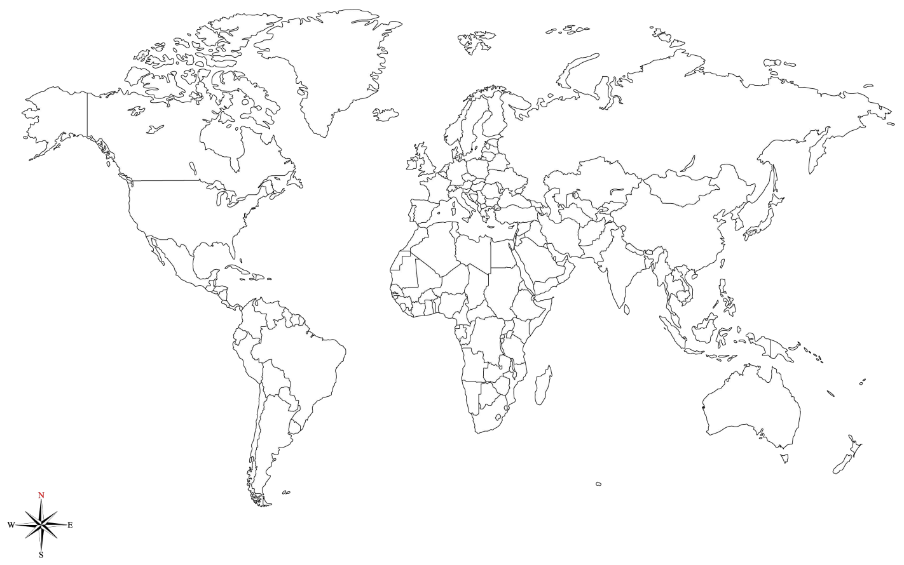

Appendix 2 – PEEL paragraph template
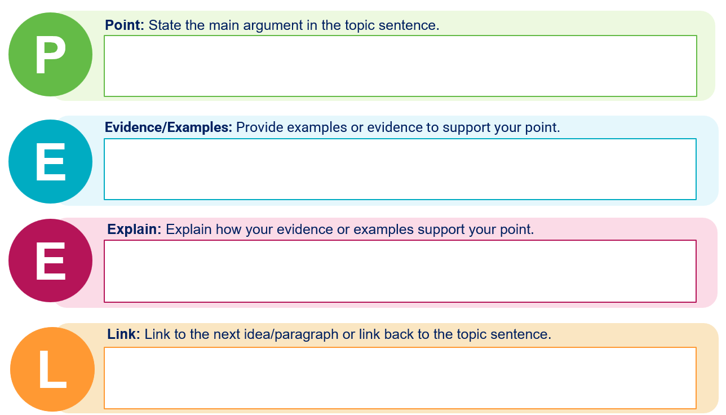

Appendix 3 – peer assessment
Criteria | Yes | No | Feedback
Title clear and concise
Angles measured accurately
Pie chart presented
Correct spelling
Chart illustrated neatly

Appendix 4 – Australia blank map
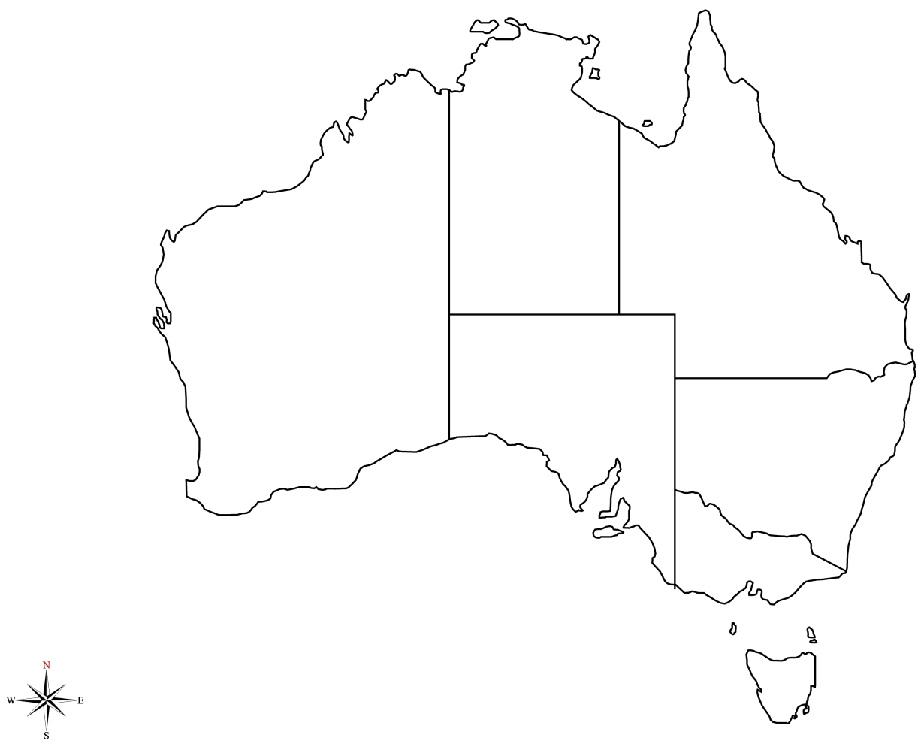

Appendix 5 – Think-Pair-Share
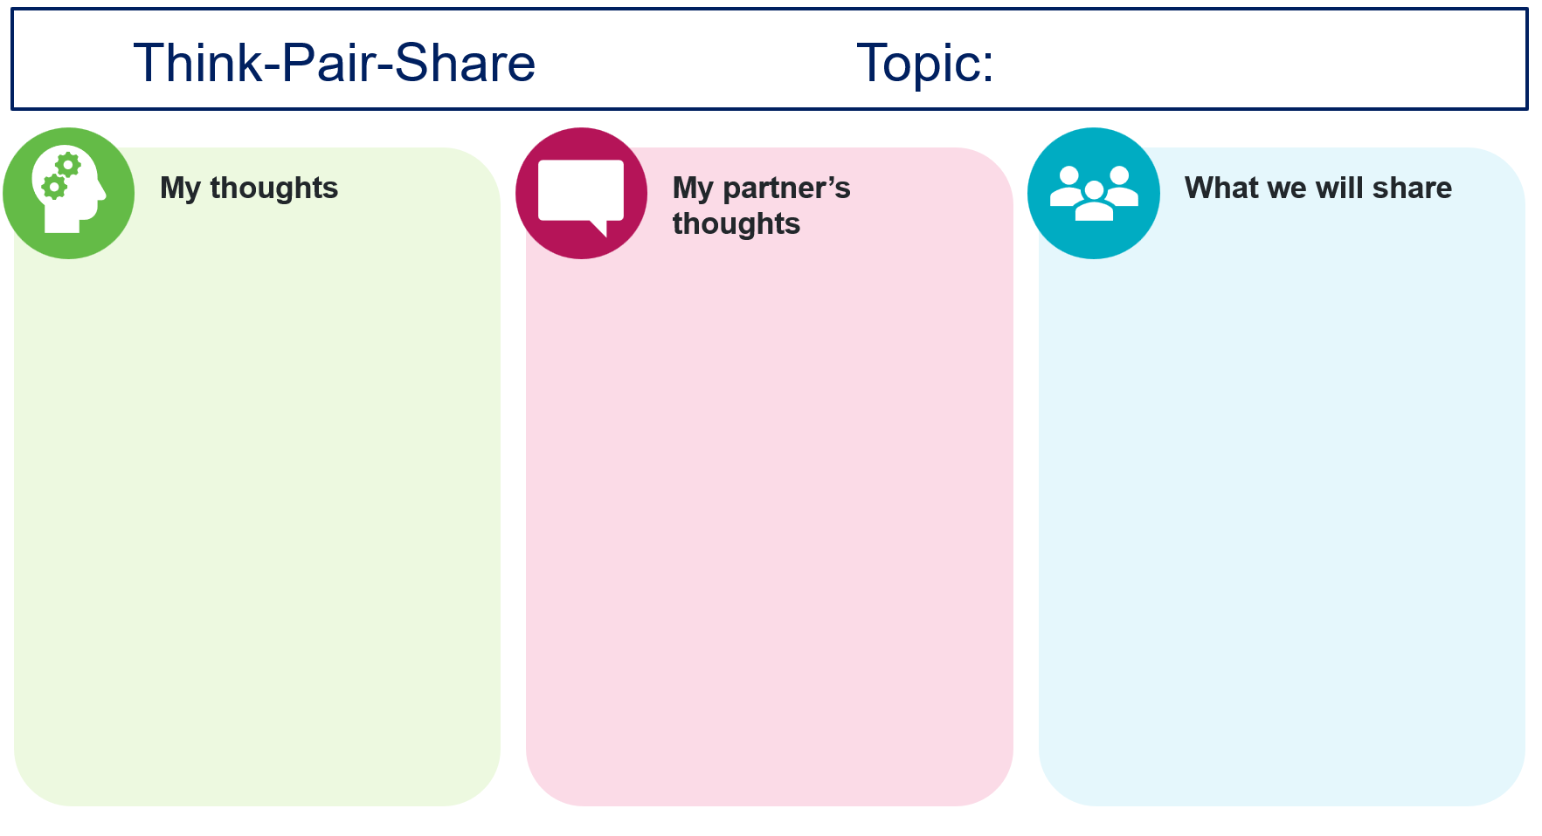

Appendix 6 – brainstorming template
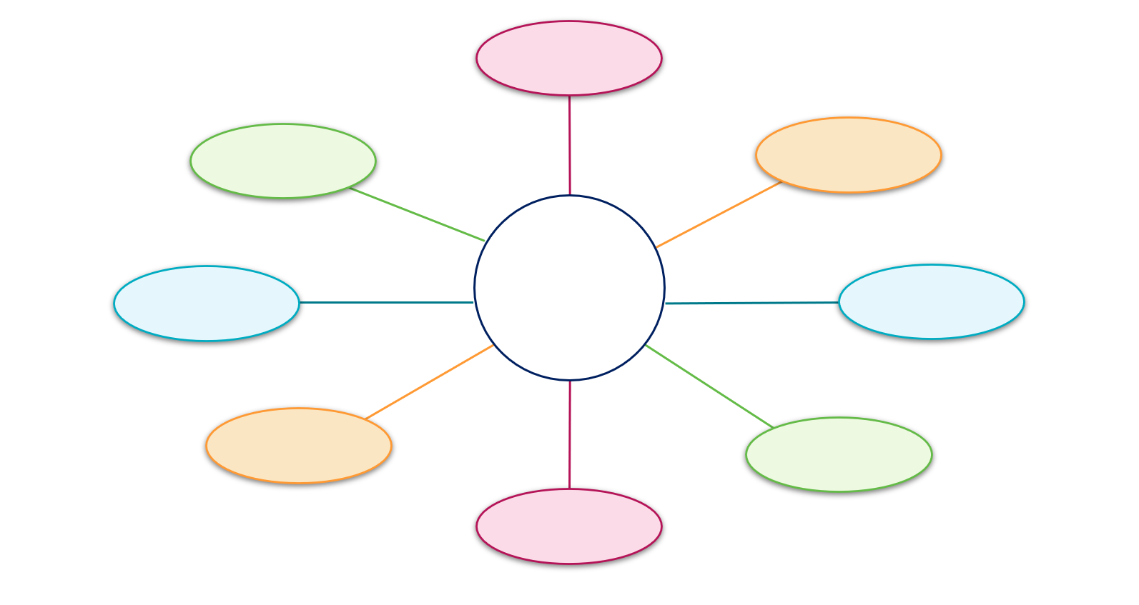

Appendix 7 – sample correlation graphs
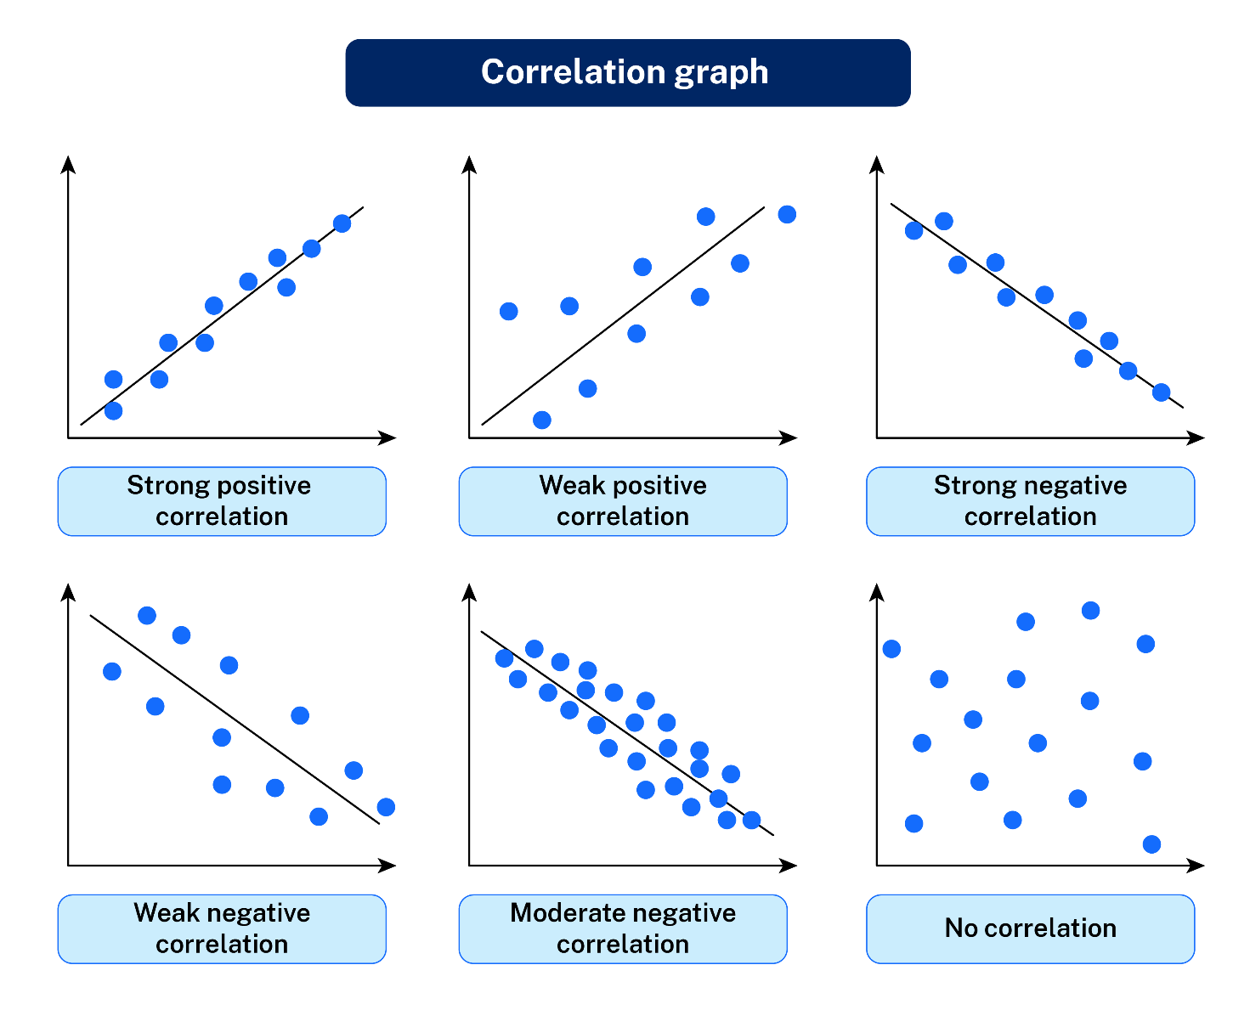

Appendix 8 – SWOT template
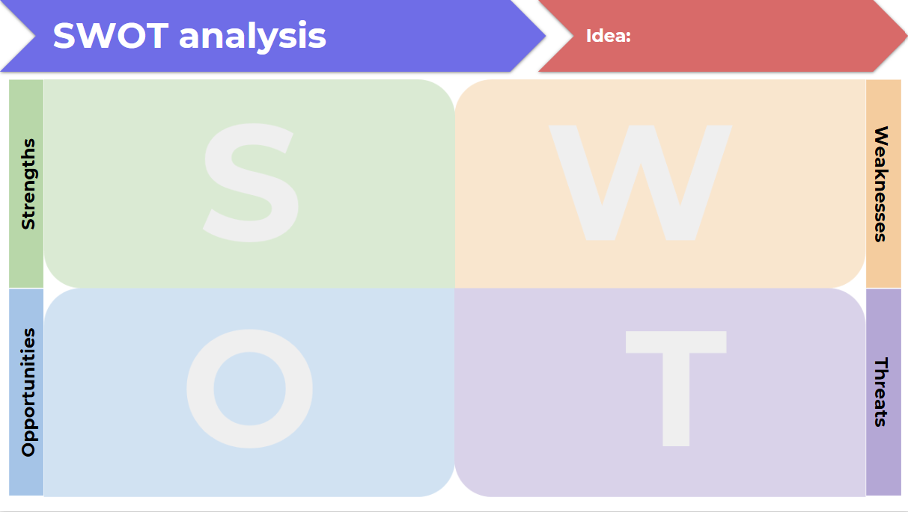

Appendix 9 – KWLH template
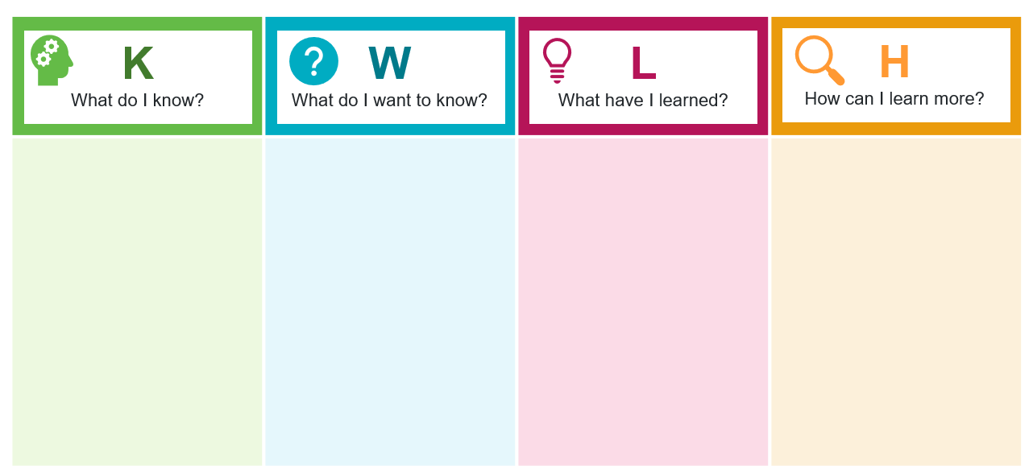

Appendix 10 – graph peer assessment template
Criteria | Yes | No | Comments
Title clear and concise
Axis labelled correctly
Correct graph represented
Scale of measurement on axis appropriate
Spelling correct
Graph illustrated neatly

Appendix 11 – farmer Robbie’s interview transcript
Date: 24 March 2025

Interviewee – Robbie Commens
- What is your role title and what are some of your key responsibilities with this role?
- Farm manager
- My key responsibilities are to manage soil health, tree health and nut production.
- Currently managing 70,000 trees on 188 hectares.
- Do you have uniformly healthy trees in your orchard?
No. There is a variation in the soil, environment and aspect of slope. We carefully screen all incoming nursery trees prior to planting. Weaker trees are removed based on our nursery specifications. The long-term goal is uniformly healthy trees.
- What challenges do you experience with macadamia tree health?
Like all orchards we have diseases, pests (insects, nut borer, monolepta beetle, fruit spotting bug, macadamia lace bug), soil health, nutrition, major weather events (flooding, cyclone and drought). As well as erosion on the hilly terrain sections of the farm.
- Of those challenges what is the most significant?
Soil health is the most significant.
- How do you overcome these challenges? (If pH is too high? If OM has been lost? If pests have invaded the orchard? If erosion is becoming an issue? In drought? In extreme long periods of rainfall, phytophthora slow decline.)
- Increasing the organic matter
- Buying mulch or compost
- Growing green manure crop (grass sorghum in the middle of the rows)
I like to explain it like an analogy of a 3-legged stool. A combination of chemical, biological and physical attributes, the goal is to improve all 3.
- Physical improvement – reducing compaction
- Chemical improvement – improving soil pH with lime
- Biological improvement – adding compost that has beneficial fungus and bacteria in it
If pH is too low, add lime. Goal is to be 7. Macadamia nut trees prefer 5.5 pH to 6.5 ph. Often finding the pH is low and the solution is adding lime. Very rarely do we find alkaline soil issues.
If pests have invaded, we assess the economic impact and then implement an IPM (Integrated Pest Management) system.
- We identify if the cost of treating the pest is worth the investment as foliar sprays can be expensive.
- We identify our economic thresholds and what the best solution is in relation to the 3 options: chemicals, insecticides or pruning.
- Pruning involves removing the infected part of the tree and reducing density as pest insects like dark spaces.
- What test are you undertaking in the orchard to monitor soil, pests and health of the trees?
We use a qualified agronomist who does annual soil tests, weekly pest inspections and monthly health assessments.
We conduct annual soil testings. In the past we have done a grid farm sample. This is great because it shows the uniform improvement over time.
We also have leaf samples collected twice a year.
- Is there a very clear correlation between the tree health and nut yield on your orchard?
Yes, there is a clear correlation between tree health and yield. This is why uniform tree health is the long-term goal.
- Why is the subtropical climate suitable for growing macadamia plantations?
Macadamia is a subtropical species that originate in rainforests. They have a high-water requirement and no tolerance to frosts. The frost intolerance greatly restricts its productive areas around the world. This is why Africa, China, Vietnam and parts of South America have taken up production. This is also why there is not any production in North America or Canada.
- Do other managers of orchards report similar challenges in your region and how do these compare to the orchards recently being attempted closer to the coast or as far north as Bundaberg?
Yes, other growers report similar challenges. The NSW Department of Primary Industries and Macadamia Society are supporting growth and understanding of these challenges and solutions.
We can group macadamia orchards into 3 main types:
- high rainfall hills not irrigated
- low rainfall irrigated zone (Bundaberg)
- high rainfall flood plains (coastal plains of NSW).
All 3 macadamia growing areas have solved the water issue differently, but all do not experience frosts. Where almonds and pecans are grown in locations prone to frost which make those areas incompatible with macadamia nut orchards.
- What technology do you currently use to improve productivity of the orchard?
We use a few different technologies, many of which are relatively new:
- drone technology to capture individual tree health through a contractor and service provider
- LiDAR mapping to identify high-risk erosion sites based on topography
- GPS guided machinery to ensure accurate heights of drainage systems.
An irrigated farm will use soil moisture sensor technology but this farm in northern NSW does not have irrigation or water issues.
- What technology do you plan on investigating for use in the future?
Currently trialling automated tractors with Swarm Farm company. These include driverless tractors that will spray trees and weeds, complete the slashing and mowing of grass with a long-term goal of them completing harvest as well. This is important for students studying geography, science and technology in school. The future of agriculture will directly link to technology, engineering and economics.
- Market prices have been very low for macadamia growers over previous years can you explain why this occurred?
Ultimately it was a supply and demand imbalance. The industry is focused on increasing demand to improve prices as our supply increases. With the main opportunities being India and macadamia kernel, as well as food manufacturing companies to include macadamias, for example, a snickers bar with a macadamia.
- Will the large planting of macadamia orchards overseas have a negative or positive impact on Australian macadamia industry? Can you explain why?
Potentially if we don’t improve our supply and demand ratio. Increase in macadamia demand in Africa and China will ultimately improve all macadamia demand and pricing.
To include macadamia in Sustain breakfast cereal the industry needs to prove the ability to supply significant volume of kernel consistency. Therefore, the significant increase in orchard plantings in Australia has the potential to achieve this outcome.
This will mean it shifts from a snack-based market to a snack and ingredient-based industry.
- Why has increase in profits occurred in 2025?
The industry has seen an increase in nut prices this year. This has largely been driven by a decrease in our currency from $0.69 in 2024 to $0.62 in 2025.
The Indian market has emerged which has increased demand, but the international inventory has been depleted because the price was low for some time. There is a demand now to restock and we can see a market value increase.
- How important is sustainability in your industry? What suggestions do you have for improving sustainability of macadamia orchards?
Sustainability is important to the consumers. It is important to growers. Therefore, it is important across the supply chain.
Environmental sustainability for production has and always will be important. It’s a no brainer for the grower. Consumers are demanding and rewarding sustainability, so it is being valued differently throughout the supply chain.
The macadamia industry is also more sustainable than intensive industries, like sugarcane, for example. We are replacing the intensive agriculture with long-term sustainable orchards.

Appendix 12 – student scaffold – choropleth map
Step 1 – choose your data set
Decide what specific geographical factor from Robbie’s farm you will map. You will have to choose either tree productivity or health.
Further research would be required to create a map illustrating other influencing factors, such as:
- pest infestations (for example, nut borer)
- moisture levels
- soil pH levels.
Step 2 – prepare base map
Using a provided template (or a digital map base), clearly label Robbie’s farm areas (for example, orchard sections, boundaries, slope areas).
Ensure you have a clear, neat outline of each area you will represent.
Step 3 – choose colour or shading scale
Choose 3 to 5 clearly distinguishable shades of one colour (such as light green to dark green) to represent low to high values.
Label clearly what each shade represents in the legend.
Example shading scale – soil pH:
- light brown = unhealthy
- light green = moderately healthy
- dark green = healthy.
Step 4 – create your legend and title
Your legend should clearly explain what each shade or colour means.
Your title should clearly describe your map, and the data presented (for example, ‘Distribution of healthy trees on Robbie’s Macadamia Farm’).
Step 5 – map your data
Carefully shade each farm area according to your data.
Keep shading consistent and neat.
Step 6 – check for accuracy and completeness
Use the table below to review the criteria.
Is your map clearly labelled?
Does your shading clearly match the legend?
Have you included clear geographical terms in annotations or your legend?
Criteria | Explanation
Title and legend | Includes an accurate, clear title and a legend clearly explaining the shading used.
Spatial accuracy | Accurately shows location, boundaries and relevant farm sections clearly.
Use of shading/colour | Uses a clear and logical shading scale to show differences in data values effectively.
Data representation | Accurately and clearly represents data relevant to macadamia farming (for example, soil quality, pest presence, yield).
Geographical terminology | Appropriate geographic terms (for example, distribution, concentration, high/low density, clusters) used clearly in title, legend or annotations.

Appendix 13 – Y chart template
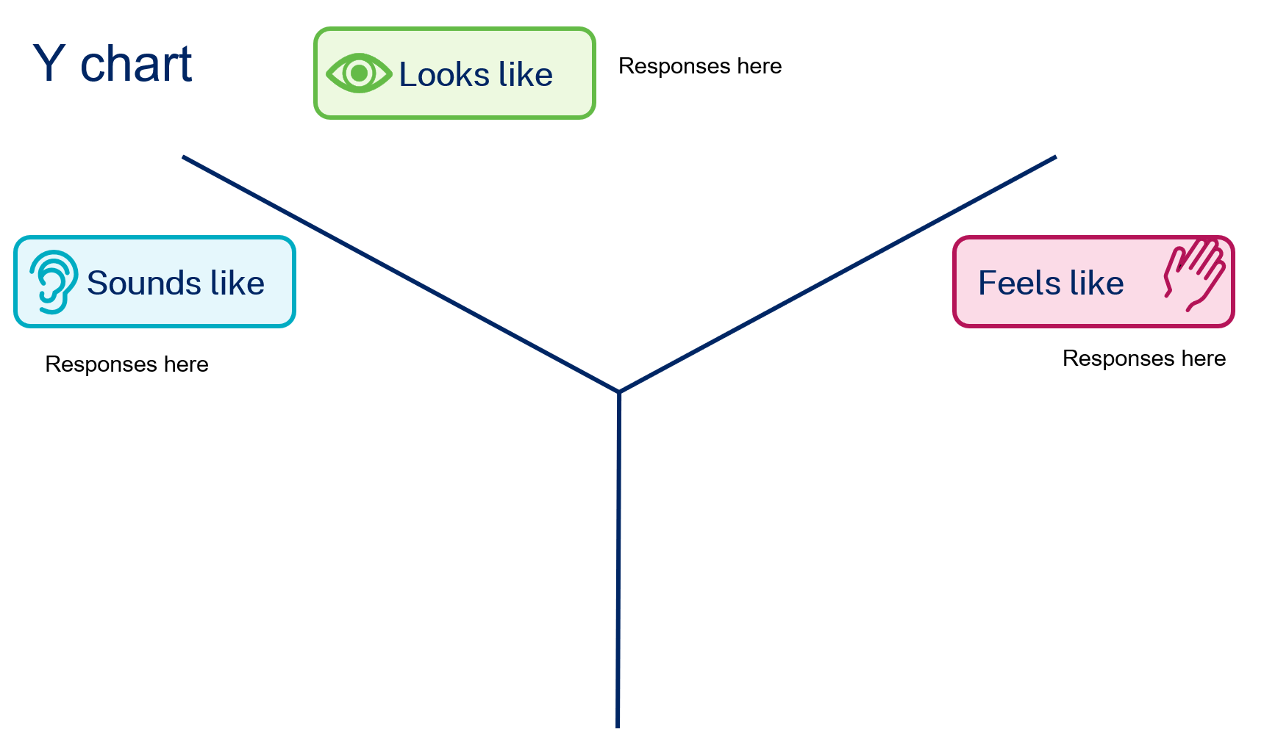

Appendix 14 – Frayer diagram template
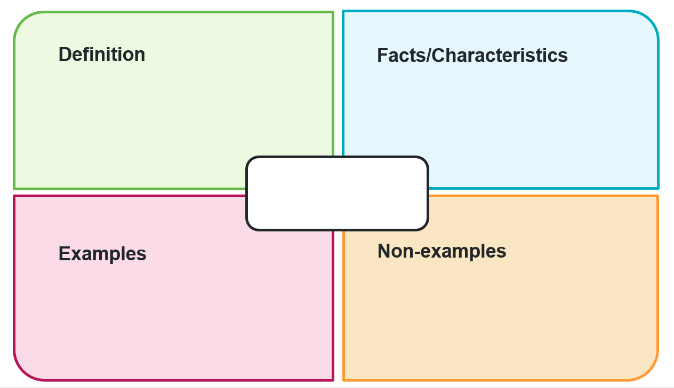

References
This resource contains NSW Curriculum and syllabus content. The NSW Curriculum is developed by the NSW Education Standards Authority. This content is prepared by NESA for and on behalf of the Crown in right of the State of New South Wales. The material is protected by Crown copyright.
Please refer to the NESA Copyright Disclaimer for more information https://educationstandards.nsw.edu.au/wps/portal/nesa/mini-footer/copyright.
NESA holds the only official and up-to-date versions of the NSW Curriculum and syllabus documents. Please visit the NSW Education Standards Authority (NESA) website https://educationstandards.nsw.edu.au and the NSW Curriculum website https://curriculum.nsw.edu.au.
Geography 7–10 Syllabus © NSW Education Standards Authority (NESA) for and on behalf of the Crown in right of the State of New South Wales, 2024.

© State of New South Wales (Department of Education), 2025
The copyright material published in this resource is subject to the Copyright Act 1968 (Cth) and is owned by the NSW Department of Education or, where indicated, by a party other than the NSW Department of Education (third-party material).
Copyright material available in this resource and owned by the NSW Department of Education is licensed under a Creative Commons Attribution 4.0 International (CC BY 4.0) license.

This license allows you to share and adapt the material for any purpose, even commercially.
Attribution should be given to © State of New South Wales (Department of Education), 2025.
Material in this resource not available under a Creative Commons license:
- the NSW Department of Education logo, other logos and trademark-protected material
- material owned by a third party that has been reproduced with permission. You will need to obtain permission from the third party to reuse its material.
Links to third-party material and websites
Please note that the provided (reading/viewing material/list/links/texts) are a suggestion only and implies no endorsement, by the New South Wales Department of Education, of any author, publisher, or book title. School principals and teachers are best placed to assess the suitability of resources that would complement the curriculum and reflect the needs and interests of their students.
If you use the links provided in this document to access a third-party's website, you acknowledge that the terms of use, including licence terms set out on the third-party's website apply to the use which may be made of the materials on that third-party website or where permitted by the Copyright Act 1968 (Cth). The department accepts no responsibility for content on third-party websites.

