Geography (Stage 5) – sample assessment task 1 – support material
Biomes and sustainable agriculture – Geography 7–10 Syllabus (2024)
Contents
Overview 2
Steps to success 2
My plan for geographical investigation 4
Research scaffold 6
Selecting appropriate tools for inquiry 8
WAGOLL scatter graph 13
Geographical fieldwork tools – definitions and student advice 14
References 18

Overview
This resource is designed to support teachers and students when implementing the Geography (Stage 5) – sample assessment task 1 notification – Biomes and sustainable agriculture. It should be considered in conjunction with the sample program and sample assessment task 1 for resource context and teaching guidance. This support material:
- provides teacher notes and outlines the steps for success for students attempting sample assessment task 1 notification – Biomes and sustainable agriculture
- includes a plan for geographical investigation (see Table 2) and research scaffold (see Table 3)
- support the selection of appropriate tools (see Tables 4 to 11)
- includes sample scatter graph.

Steps to success
Note: this schedule is designed to support students and is not for compliance. Students should not be penalised for not meeting interim times. This scaffold is designed for chunking and sequencing learning by breaking the task into smaller goals to reduce the complexity. The second column could be:
- determined by the teacher
- co-constructed with students.
Table 1 – assessment preparation schedule
What I need to do | When I need to do it
Complete Table 2 – plan for geographical investigation | Prior to commencing secondary and primary research
Conduct secondary research on a chosen biome | Ongoing
Conduct primary research on a chosen biome | On the day of fieldwork
Organise data and information collected in the field | In class post-fieldwork
Represent data in a scatter graph | In class post-fieldwork
Represent the spatial distribution using a choropleth map | In class post-fieldwork
Reflect on and evaluate the findings of the inquiry to suggest solutions to a challenge confronting the sustainable agriculture production selected | In class post-fieldwork
Write a draft geographical investigation and share with teacher for feedback | Prior to the due date in consultation with teacher
Enact feedback from draft and submit your geographical investigation | On or before the due date

My plan for geographical investigation
Use Table 2 to plan the mini geographical investigation.
Table 2 – plan for geographical investigation
Plan | Student response
The biome and agricultural production I plan to investigate | Sample response – Subtropical biomes and macadamia nut production
My significant geographical question
What kind of data am I collecting?
Who could I potentially interview?
When will I collect the data?
Where will I collect the data?
How will I collect the data and what equipment is required?
How will I record the data?
What data presentations will I use? (What types of graphs, maps or other geographical tools will I use to illustrate research findings?)
Are there any specific geographical tools identified in the task description and marking rubric I must include?
How am I going to present my geographical investigation?
How can I reflect on the success of my research?

Research scaffold
Use Table 3 to guide your research for the mini geographical investigation.
Table 3 – research scaffold
What I need to do | Hints | Research findings
Propose a significant geographical question | Identify an issue, problem or challenge you aim to investigate in relation to a biome and sustainable agriculture
Collect, select and record data | Soil test, field observations and interview questions for an expert in the field
Use geographical tools to process data | Create a scatter graph, choropleth map and tables to represent data  Analyse LiDAR maps or similar
Reflect and evaluate | Reflect and evaluate the research process  Reflect and evaluate the research findings  Reflect and evaluate the ethical practices applied during the research process
Present findings | Choose a form of communication to present findings using relevant geographical concepts. Examples of multimodal communication:  - PowerPoint presentation  - written report  - video  - poster.

Selecting appropriate tools for inquiry
Note: students have an opportunity to justify their selection to demonstrate their understanding of the inquiry process and ethical research.
Use Table 4 to support the selection of appropriate tools for your chosen geographical inquiry.
Table 4 – geographical fieldwork tools (measuring equipment)
Measuring equipment | Explanation | Justification
Tape measure | Measures short distances accurately, typically up to several metres
Trundle wheel | Measures longer distances by rolling along the ground, often used to measure field lengths or road distances
Altimeter | Measures altitude or elevation above sea level
Clinometer | Measures angles of slope or incline
Quadrat | A square frame used to sample and analyse plant populations within a specific area
Table 5 – geographical fieldwork tools (weather instruments)
Weather instrument | Explanation | Justification
Wind vane | Indicates wind direction
Rain gauge | Measures precipitation or rainfall amounts
Thermometer | Measures temperature of air, water or soil
Digital weather station | Provides multiple weather readings (temperature, wind speed, humidity) digitally and simultaneously
Beaufort wind scale | Estimates wind speed based on observable environmental effects
Hygrometer | Measures humidity or moisture content in the air
Barometer | Measures atmospheric pressure, useful for weather prediction
Anemometer | Measures wind speed
Light meter | Measures intensity or brightness of light
Sound level meter | Measures the level of noise in decibels
Table 6 – geographical fieldwork tools (identification charts)
Type of chart | Explanation | Justification
Wildlife charts | Helps identify different animal species
Vegetation charts | Helps identify different plant species
Canopy cover charts | Measures the percentage of area covered by tree or plant canopies
pH scale charts | Visual reference to identify the acidity or alkalinity of samples like soil or water
Cloud charts | Identifies cloud types and conditions for weather observation
Soil classification charts | Helps classify and identify soil types based on properties and composition
Table 7 – geographical fieldwork tools (testing equipment)
Testing equipment | Explanation | Justification
Soil pH test kit | Tests the acidity or alkalinity of soil
Soil thermometer | Measures soil temperature, which affects plant growth and soil processes
pH water test strips | Tests the acidity or alkalinity of water samples
Turbidity tube | Measures clarity or cloudiness of water samples
Table 8 – geographical fieldwork tools (photographic devices)
Photographic device | Explanation | Justification
360-degree cameras | Specialised cameras capable of capturing panoramic views in 360 degrees
Video recording devices | Devices specifically designed to record moving images and sound
Drones | Remotely controlled devices for aerial photography and observation
Table 9 – geographical fieldwork tools (spatial technologies)
Spatial technology | Explanation | Justification
GPS (Global Positioning System) | Device that provides precise geographic location coordinates
GIS (Geographic Information System) | Software systems that capture, store, manipulate, analyse and display geographical data
Table 10 – geographical fieldwork (tools)
Fieldwork tool | Explanation | Justification
Compass | Tool used to determine geographic direction and bearing
Fieldwork transects | A line or path along which systematic observations or measurements are made

WAGOLL scatter graph
Use Figure 1 as an example scatter graph.
Figure 1 – WAGOLL scatter graph
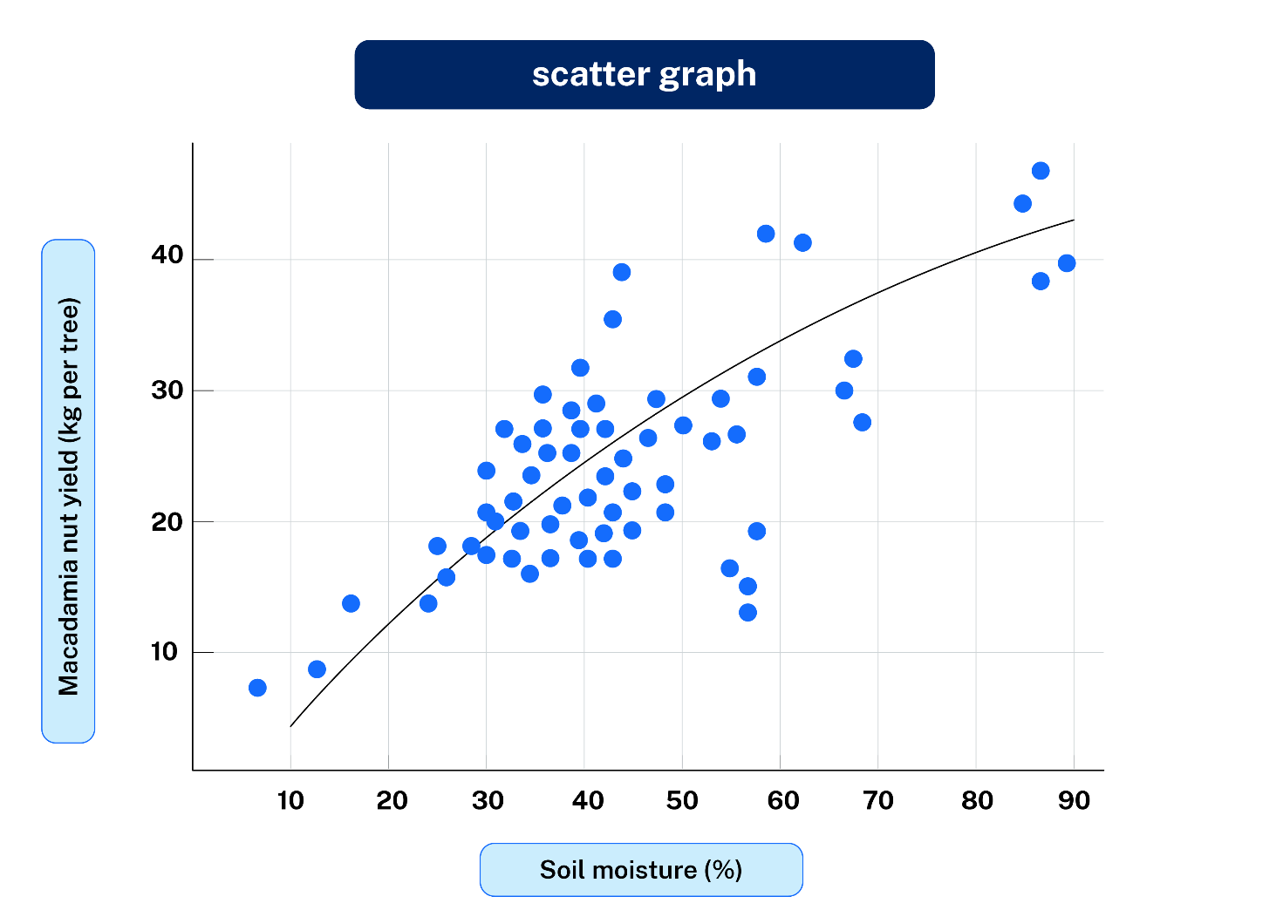

Geographical fieldwork tools – definitions and student advice
Use the definitions and advice provided in Table 11 to plan which geographical fieldwork tools you intend to use.
Table 11 – geographical fieldwork tools student advice
Technique | Definition | Advice for effective use
Field sketch | An annotated sketch made on-site that records important geographical features | Clearly label and annotate key geographical features (for example, landforms, vegetation types). Include a clear title, orientation (compass direction), date and location
Field journal | A structured diary used to record observations, thoughts, data and processes during fieldwork | Clearly date each entry and record detailed observations, data and reflections. Include clear sketches, measurements and personal insights
Photography | Capturing images to visually document geographical features or evidence during fieldwork | Clearly label photos with date, location and what is shown. Include a brief description of how each image supports your inquiry
Data collection sheets | Structured forms used to record systematically collected geographical data during fieldwork | Clearly label all sheets with date, location and method used. Keep consistent units of measurement and clearly organised data
Sampling techniques (random, systematic, stratified) | Methods used to select representative samples for study in the field | Choose a technique clearly justified by the nature of your study: random (no bias), systematic (regular intervals) or stratified (proportionate samples from distinct areas)
Quadrat sampling | Using a square frame to sample and analyse species or features within a designated area | Clearly justify quadrat size and placement to ensure broad representation. Record and annotate each quadrat location clearly
Transect sampling | Observing or measuring geographical features along a defined linear path | Clearly mark and justify the transect location. Collect and record systematic observations at regular intervals
Vegetation identification | Using charts or keys to accurately determine plant species | Clearly cross-reference plants with an identification chart and record accurate species names in your data sheets
Species counting | Counting individual organisms of particular species within a defined area | Be systematic and consistent in counting method. Clearly record and double-check counts for accuracy
Population estimates | Calculating approximate numbers of individuals within a species in a given area | Use clearly documented counting and sampling methods. Clearly record assumptions and justify your estimation method
Interviewing | Structured conversations to collect detailed qualitative information from individuals or experts | Clearly prepare relevant questions in advance. Obtain informed consent and record answers accurately and ethically
Questionnaires/surveys | A structured set of questions distributed to collect specific quantitative or qualitative data from participants | Clearly phrase questions to avoid bias. Provide clear instructions and include a range of question types (open-ended and closed)
Soil testing | Analysing soil samples to determine properties such as pH, texture and moisture content | Clearly follow instructions on testing kits. Record detailed results and repeat tests for accuracy
Water testing | Analysing water samples to measure quality factors like pH, turbidity and temperature | Clearly document sample locations and conditions. Ensure tests are repeated for reliability and accuracy
Observation checklists | Structured lists used to systematically record specific observations in the field | Clearly outline what observations are required beforehand. Complete checklists systematically and promptly in the field
Traffic and pedestrian counts | Counting and recording the number of vehicles or people passing a specific location over time | Clearly define the counting location, intervals and duration of counting periods. Work systematically and use multiple counts for reliability

General advice when using geographical fieldwork tools
- Clearly select techniques aligned explicitly with your geographical inquiry question.
- Justify your choices clearly, describing why the chosen method is appropriate for your inquiry.
- Ensure you clearly follow ethical research practices (for example, consent for interviews, minimal environmental disturbance).
- Keep clear and organised records to support analysis and reporting.

References
This resource contains NSW Curriculum and syllabus content. The NSW Curriculum is developed by the NSW Education Standards Authority. This content is prepared by NESA for and on behalf of the Crown in right of the State of New South Wales. The material is protected by Crown copyright.
Please refer to the NESA Copyright Disclaimer for more information https://educationstandards.nsw.edu.au/wps/portal/nesa/mini-footer/copyright.
NESA holds the only official and up-to-date versions of the NSW Curriculum and syllabus documents. Please visit the NSW Education Standards Authority (NESA) website https://educationstandards.nsw.edu.au and the NSW Curriculum website https://curriculum.nsw.edu.au.
Geography 7–10 Syllabus © NSW Education Standards Authority (NESA) for and on behalf of the Crown in right of the State of New South Wales, 2024.

© State of New South Wales (Department of Education), 2025
The copyright material published in this resource is subject to the Copyright Act 1968 (Cth) and is owned by the NSW Department of Education or, where indicated, by a party other than the NSW Department of Education (third-party material).
Copyright material available in this resource and owned by the NSW Department of Education is licensed under a Creative Commons Attribution 4.0 International (CC BY 4.0) license.

This license allows you to share and adapt the material for any purpose, even commercially.
Attribution should be given to © State of New South Wales (Department of Education), 2025.
Material in this resource not available under a Creative Commons license:
- the NSW Department of Education logo, other logos and trademark-protected material
- material owned by a third party that has been reproduced with permission. You will need to obtain permission from the third party to reuse its material.
Links to third-party material and websites
Please note that the provided (reading/viewing material/list/links/texts) are a suggestion only and implies no endorsement, by the New South Wales Department of Education, of any author, publisher, or book title. School principals and teachers are best placed to assess the suitability of resources that would complement the curriculum and reflect the needs and interests of their students.
If you use the links provided in this document to access a third-party's website, you acknowledge that the terms of use, including licence terms set out on the third-party's website apply to the use which may be made of the materials on that third-party website or where permitted by the Copyright Act 1968 (Cth). The department accepts no responsibility for content on third-party websites.

