History (Stage 4) – sample assessment task 2 notification
Depth study (option) – Ancient China
History 7–10 Syllabus (2024)

Contents
Overview 2
Assessment task – perspectives and significance –– Wu Zetian source analysis 3
Outcomes 3
Syllabus content 3
Task description 3
Submission details 4
Marking guidelines 5
Support documentation 7
Sources 11
References 14

Overview
This assessment task is designed for use during implementation of History 7–10 (Stage 4) – sample program of learning: Depth study (option) – Ancient China. It should be considered in conjunction with the sample program and related resources.

Assessment task – perspectives and significance –– Wu Zetian source analysis
Type of task: In-class written task
Suggested weighting: 25%

Outcomes
A student:
- HI4-CPP-01 describes different contexts and perspectives of the past
- HI4-SOU-01 uses evidence from sources to support historical accounts and explanations about the past

Syllabus content
- Use relevant historical concepts and skills
- The actions and significance of a chosen individual in ancient China
History 7–10 Syllabus © NSW Education Standards Authority (NESA) for and on behalf of the Crown in right of the State of New South Wales, 2024.

Task description
You will use a set of historical sources to respond to a question in 3 PEEL paragraphs. These sources will present different perspectives of Wu Zetian’s rule.
You will be given the question in advance. The sources will not be provided in advance and will be given to you during the assessment.
Question – Describe different perspectives about Wu Zetian’s rule as empress of Ancient China and why they differ. In your response, use your own knowledge and at least 2 sources to support your answer.

Submission details
Students will complete an in-class written task worth 20 marks.
Students will write 3 PEEL paragraphs using evidence from the sources provided and their own knowledge.
Students will be given the assessment question in advance. The sources will not be provided prior to the assessment and will be given to students on the day of the task.
The task will be completed individually under teacher supervision in a 60-minute lesson, consisting of 10 minutes for reading and planning, and 50 minutes for writing.

Marking guidelines
Table 1 – assessment marking guidelines
Grade | Marking guideline descriptors
A | - Demonstrates extensive historical knowledge through a clear and sustained description of different perspectives about Wu Zetian’s rule  - Clearly describes multiple perspectives and what each perspective suggests about her rule  - Clearly describes why these perspectives differ  - Uses evidence from at least 2 sources accurately and effectively to support ideas  - Effectively applies the PEEL structure to develop a well-organised and coherent response
B | - Demonstrates thorough historical knowledge through clear description of different perspectives about Wu Zetian’s rule  - Describes different perspectives and what they suggest about her rule  - Describes why perspectives differ  - Uses evidence from at least 2 sources to support ideas  - Applies the PEEL structure with clear organisation
C | - Demonstrates sound historical knowledge through basic description of perspectives about Wu Zetian’s rule  - Identifies different perspectives about Wu Zetian  - Uses evidence from at least one or 2 sources  - Uses the PEEL structure with some organisation
D | - Demonstrates basic historical knowledge of Wu Zetian  - Identifies a perspective with limited detail  - Uses evidence from one source or makes limited reference to sources  - Attempts to structure a response
E | - Demonstrates limited historical knowledge  - Makes simple or unclear statements about Wu Zetian

Support documentation
This documentation is designed to support teachers with implementing the assessment task.
Note: teachers may choose to provide the following scaffolds and sentence starters to support student understanding and response development, depending on the needs, ability levels and context of their class.
The use of scaffolds can assist students in structuring their responses using the PEEL framework.
Teachers should exercise professional judgement in determining the level of support provided.
Paragraph scaffold
Paragraph 1 – perspective 1
You need to:
- identify one perspective about Wu Zetian’s rule
- describe whether this perspective is
- positive
- negative
- mixed
- describe what this perspective suggests about her leadership (for example strong, harsh, effective).
You must:
- refer to one source
- identify a specific piece of evidence (for example quote, detail, feature)
- describe what this evidence shows
- include your own knowledge
- describe how the evidence and knowledge support the perspective.
Paragraph 2 – perspective 2
You need to:
- identify a different perspective about Wu Zetian’s rule
- describe whether this perspective is
- positive
- negative
- mixed
- describe what this perspective suggests about her leadership.
You must:
- refer to another source
- identify a specific piece of evidence
- describe what this evidence shows
- include your own knowledge
- describe how the evidence and knowledge support the perspective.
Paragraph 3 – difference in perspectives
You need to:
- describe why the perspectives are different.
You must:
- refer to sources
- use evidence to support your ideas
- describe reasons for the differences, for example
- different opinions about her rule
- when the source was written
- the purpose of the source.
Sentence starters
Paragraph 1 – perspective 1
- One perspective about Wu Zetian’s rule is that she was …
- This perspective is (positive/negative/mixed) because …
- Source ___ shows that …
- This is shown by …
- This shows that Wu Zetian …
- This suggests her leadership was …
- This supports the idea that Wu Zetian was …
Paragraph 2 – perspective 2
- Another perspective about Wu Zetian’s rule is that she was …
- This perspective is (positive/negative/mixed) because …
- Source ___ shows that …
- This is shown by …
- This shows that Wu Zetian …
- This suggests her leadership was …
- This supports the idea that Wu Zetian was …
Paragraph 3 – difference in perspectives
- The perspectives about Wu Zetian are different because …
- One difference between the perspectives is …
- This difference can be seen in Source ___, which shows …
- This suggests that …
- The perspectives may differ because …
- One reason for this difference is …
- This could be due to …
- This shows that people had different views about Wu Zetian because …

Sources
Note: ensure you have removed the sources before distributing the notification to students.
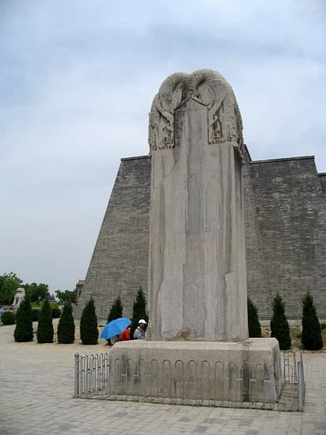
‘Wu Zetian’s Stele’ by 国家公园网 (GJGY.com), uploaded by Ibolya Horváth, via World History Encyclopedia, is licensed under the Creative Commons Attribution-ShareAlike (CC BY-SA) licence.
Source 1: Wu Zetian's Stele
This stone monument (stele) stands at the tomb of Wu Zetian. Unlike most monuments of this kind, it has no inscription describing her achievements.
Note: Stele were usually carved with inscriptions praising the achievements of rulers.

Source 2
‘The Empress was intelligent and decisive, but she also used harsh punishments and many feared her authority.’
This source has been adapted from Zizhi Tongjian by Sima Guang (11th century)
Source 3
’The Empress employed officials to report on others and punished those who opposed her. Many lived in fear during her rule.’
This source has been adapted from Old Book of Tang (Jiu Tang Shu), 10th century CE
Source 4
Empress Wu used the intelligence she gathered to pressure some high-ranking officials who were not performing well to resign; others she simply banished or had executed. She reformed the structure of the government and got rid of anyone she felt was not carrying out their duties and so reduced government spending and increased efficiency. In their place, she appointed intellectuals and talented bureaucrats without regard to family status or connections.
Excerpt from ‘Wu Zetian’ by Emily Mark (2016), World History Encyclopedia, is licensed under the Creative Commons Attribution-NonCommercial-ShareAlike (CC BY-NC-SA) licence.

Source 5
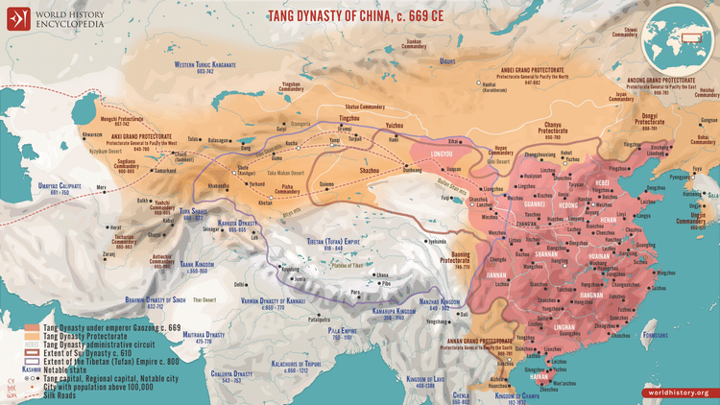
‘Map of the Tang Dynasty of China, c. 669 CE’ by Simeon Netchev (2025), World History Encyclopedia, is licensed under the Creative Commons Attribution-NonCommercial-NoDerivs (CC BY-NC-ND) licence.
This map shows the extent of the Tang Empire during Wu Zetian’s rule, following earlier expansion.

References
This resource contains NSW Curriculum and syllabus content. The NSW Curriculum is developed by the NSW Education Standards Authority (NESA). This content is prepared by NESA for and on behalf of the Crown in right of the State of New South Wales. The material is protected by Crown copyright.
Please refer to the NESA Copyright Disclaimer for more information https://www.nsw.gov.au/education-and-training/nesa/copyright.
NESA holds the only official and up-to-date versions of the NSW Curriculum and syllabus documents. Please visit the NSW Education Standards Authority (NESA) website https://educationstandards.nsw.edu.au and the NSW Curriculum website https://curriculum.nsw.edu.au.
NESA holds the only official and up-to-date versions of the NSW Curriculum and syllabus documents. Please visit NESA https://www.nsw.gov.au/education-and-training/nesa and NSW Curriculum https://curriculum.nsw.edu.au.
History 7–10 Syllabus © NSW Education Standards Authority (NESA) for and on behalf of the Crown in right of the State of New South Wales, 2024.

© State of New South Wales (Department of Education), 2026
The copyright material published in this resource is subject to the Copyright Act 1968 (Cth) and is owned by the NSW Department of Education or, where indicated, by a party other than the NSW Department of Education (third-party material).
Copyright material available in this resource and owned by the NSW Department of Education is licensed under a Creative Commons Attribution 4.0 International (CC BY 4.0) license.

This license allows you to share and adapt the material for any purpose, even commercially.
Attribution should be given to © State of New South Wales (Department of Education), 2026.
Material in this resource not available under a Creative Commons license:
- the NSW Department of Education logo, other logos and trademark-protected material
- material owned by a third party that has been reproduced with permission. You will need to obtain permission from the third party to reuse its material.
Links to third-party material and websites
Please note that the provided (reading/viewing material/list/links/texts) are a suggestion only and implies no endorsement, by the New South Wales Department of Education, of any author, publisher, or book title. School principals and teachers are best placed to assess the suitability of resources that would complement the curriculum and reflect the needs and interests of their students.
If you use the links provided in this document to access a third-party's website, you acknowledge that the terms of use, including licence terms set out on the third-party's website apply to the use which may be made of the materials on that third-party website or where permitted by the Copyright Act 1968 (Cth). The department accepts no responsibility for content on third-party websites.

