History (Stage 4) – student resource pack
Historical context 1 (core): The ancient past
History 7–10 Syllabus (2024)

Contents
Overview 3
Outcomes 3
Learning sequence 1 – How do we know about the ancient past? 5
Activity 1 – evidence and the past – How do we know? 5
Activity 2 – How do we know early humans moved around the world? 7
Activity 3 – historians and archaeologists 10
Activity 4 – What clues did ancient societies leave behind? 11
Activity 5 – historical inquiry – Lake Mungo 13
Activity 6 – Knowledges of Country – Kakadu rock art 15
Learning sequence 2 – How is history recorded, organised and investigated? 18
Activity 7 – citizenship in antiquity 18
Activity 8 – historical profiles 21
Activity 9 – history telephone (oral versus written comparison activity) 25
Activity 10 – dating methods 27
Activity 12 – time vocabulary sorting and sequencing 32
Activity 13 – timeline construction 33
Activity 14 – Why is there no year zero? 38
Learning sequence 3 – Why does the past matter today? 41
Activity 15 – lost, threatened and preserved – the Terracotta Warriors of Xi’an 41
Activity 16 – To dig or protect? Decisions about the Terracotta Warriors 46
Activity 17 – gallery walk 49
Activity 18 – comparing 2 ancient places 50
Activity 19 – Think-Pair-Share 51
Activity 20 – guided reading – ‘The story of Mungo Man’ 52
Activity 21 – values compass – ‘Mungo Man – Why does he matter?’ 53
Activity 22 – museum board simulation – ‘Where should Mungo Man be?’ 54
Activity 23 – end of unit exit ticket 60
Appendix 1 62
Appendix 2 64
Appendix 3 67
Appendix 4 69
References 71

Overview
This student resource pack supports Learning sequences 1 to 3 in Historical context 1 (core): The ancient past. It should be considered in conjunction with the sample program, History (Stage 4) – sample program of learning – Historical context 1 (core): The ancient past, for resource context and teaching guidance. Ways this student resource pack can be used include:
- using the resources as worksheets, samples and models, tailoring them to address contextual needs and specific learning objectives
- reviewing the resources during faculty meetings or planning days, jointly planning opportunities for team teaching, mentoring, lesson observation, and sharing of student samples
- employing the examples of resources and/or activities as a blueprint for designing student-specific tasks that cater to individual learning styles and needs
- leveraging the strategies, texts, assessment practices, pedagogical practices, and/or syllabus planning as an opportunity to backward map, ensuring a cohesive and comprehensive learning experience in History.
Note: this resource includes topics that might be considered controversial or sensitive. Teachers are to respect the diverse views and experiences of all students and approach discussions in a manner that is impartial, free from harassment and discrimination, supportive of students’ wellbeing needs and aligned with the department’s Professional and ethical standards, Anti-racism policy, Controversial issues in schools procedures and Values in NSW public schools. Teachers should facilitate rational discourse and objective study while tailoring the content to meet the unique needs of their students. Where possible, teachers should consult with the school’s wellbeing team before using contexts that might be sensitive for some students.

Outcomes
A student:
- HI4-CON-01 describes continuity and change over a period of time in relation to a historical context
- HI4-CPP-01 describes different contexts and perspectives of the past
- HI4-INQ-01 explains the meaning and context of sources as part of a historical inquiry
History 7–10 Syllabus © NSW Education Standards Authority (NESA) for and on behalf of the Crown in right of the State of New South Wales, 2024.

Learning sequence 1 – How do we know about the ancient past?
The following activities will be completed in Learning sequence 1.

Activity 1 – evidence and the past – How do we know?
Table 1 – What is a source?
Key term | Student-friendly definition | How a source gives us information
Source | Something we get information from – it is a clue that tells us about the past.  For example, bones, tools, paintings, photos, old objects. | ‘I can get information from this photograph. It tells me that in the past these buildings were here.’  Note: the source can give us some information, but it may not be able to tell us everything.
Primary source | A primary source comes from the actual time we are studying. It was made or used at the time, so it gives first-hand clues.  For example, stone tools, fossils, footprints, cave art. | ‘This diary is a primary source that shows what daily life was like at the time, according to a young woman from Sydney.’  ‘To confirm the date of the battle, we examined several primary sources, including military records.’
Secondary source | A secondary source is information created by someone who was not there at the time to explain events.  For example, textbooks, models, documentaries. | ‘The documentary is a secondary source because it was made after the events it describes.’  ‘We compared 3 secondary sources to see how different historians interpreted the event.’
Evidence | Information taken from historical sources to help us understand what happened in the past and why. | ‘By looking closely and analysing the pots found in the dig, the historians had evidence that early people lived here and cooked food in large groups.’
Refer to Appendix 1 for sources.
Table 2 – identifying sources
Source | Type of Source | What does it show?
Aboriginal rock art (Kakadu) | Primary | Animals, stories, Culture and Connection to Country
Ancient ruins, Palace of Knossos
Lascaux cave art (France)
Human migration map
Table 3 – glossary
Word | Meaning
Evidence | What we learn from sources
Primary source | Made at the time being studied
Secondary source | Created later to explain the past, or by someone not there at the event
Source | A clue about the past

Activity 2 – How do we know early humans moved around the world?
Part A
- Watch the video Map Shows How Humans Migrated Across The Globe (2:23).
- As a class, verbally respond to the following questions:
- How long ago did the movement of peoples first begin?
- From which region of the world did the first humans begin to migrate?
Part B
Look closely at Figure 1 and consider the following questions:
- In which part of the world did the movement of people begin?
- In which directions did people travel?
- Which continents were reached?
- What is one thing that stayed the same and one thing that changed as humans migrated over time?
You may think about:
- where people started
- how far they travelled
- the types of environments they moved into.
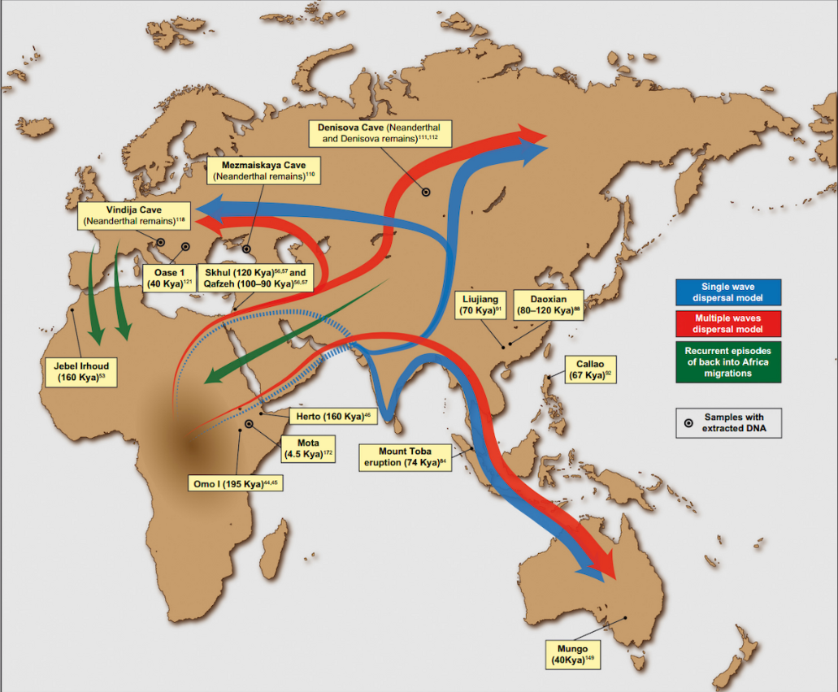
Figure 1 – early human migration map
‘Putative migration waves out of Africa’ by Saioa López, Lucy van Dorp and Garrett Hellenthal is licensed under CC BY 3.0.
Part C
As a class, read the following adapted passage to answer the questions below.
Where did early humans first live?
Humans like us, called Homo sapiens, began in Africa about 200,000 years ago. From there, they moved to other parts of the world, such as Europe and Asia.
Old ideas about human origins
Scientists used to wonder if humans started in one place (such as Africa) or if they developed in many places at the same time. Two main ideas were:
- Out of Africa – humans started in Africa and then spread out to the rest of the world
- Multiregional – early humans spread out a long time ago and then changed over time in different places.
The Out of Africa model
This is the most popular idea today. It says that humans came from Africa about 200,000 years ago. They moved to the Middle East around 100,000 years ago and reached other continents, such as Europe and Asia, around 50,000 years ago. When they spread, they replaced other older human groups, such as Neanderthals and Homo erectus, but might have mixed a little with them.
The Multiregional model
This idea says that early humans spread out about 2 million years ago and evolved in different parts of the world but stayed one species by mixing and breeding with each other over time.
What scientists think now
New discoveries show that modern humans mostly came from Africa about 60,000 years ago, but they also mixed with other local human groups, such as Neanderthals and Denisovans, when they moved to new areas. This mixing helped humans survive and spread.
Scientists are still studying how humans evolved in Africa. Some think humans came from many groups mixing together in Africa, not just one small group.
Why is Australia important?
Australia is an important part of early human migration because it was one of the first places outside Africa where humans settled. Studying how people got there helps us understand how humans spread around the world.
What evidence do scientists use?
Scientists look at fossils (old bones) and DNA (the code in our cells) to understand where humans came from and how they moved.
This passage was adapted from the article When and where did our species originate? By Fran Dorey for the Australian Museum.
- Where did early humans first live?
- Which model do scientists now mostly agree is correct?
- Complete the following sentences.
- Early humans started spreading out of Africa about ___________ years ago.
- DNA evidence helps scientists because it shows that ___________________.
- What is one type of evidence scientists use to learn about early humans?
- Why is Australia important in the story of early human migration?
Exit ticket
Choose one source you looked at in today’s lesson. Write 3 sentences to the following questions:
- Say whether your source is a primary source or a secondary source.
- Write one thing the source shows about early humans or migration.

Activity 3 – historians and archaeologists
As a class, define the terms ‘archaeologist’ and ‘historian’. You may use the following sentence starters:
- An archaeologist is …
- A historian is …
In the table below, match each task to the correct expert by writing the letter ‘H’ for Historian and ‘A’ for Archaeologist in the second column.
Table 4 – historians or archaeologists
Task | Who does it? (H or A)
Studies ancient artefacts found at a dig site
Writes about how people lived in the past
Examines human remains to learn about diet and health
Reads old letters or newspapers to find information
Question: How might an archaeologist and a historian describe the past differently? Think about the types of sources each one uses and what kind of information they focus on.

Activity 4 – What clues did ancient societies leave behind?
Physical sources and artefacts
Complete the following table. The first source has been completed for you. Sources can be found in Appendix 2.
Table 5 – physical sources
Source | Type of source | What it shows
Egyptian wall art | Art | Shows religion, stories or everyday life
Hieroglyphics
Stone tools
Stamp seal
Pyramids of Giza
Oral sources
People in some ancient societies did not have a system of writing. They shared knowledge through spoken stories. These stories are called oral traditions.
These stories can show:
- how people lived
- what they believed
- what was important to them.
Note: in this text, some words, such as ‘fertile’ and ‘renewal’, may be unfamiliar to students. Explicitly teach these words before or during reading to support comprehension. Understanding key vocabulary will help students make meaning from the text and connect natural events, beliefs and traditions. You may wish to pre-teach these terms, display them on the board, and refer back to them during discussion.
Definitions:
- Fertile: land or soil that is rich in nutrients and able to support the growth of plants and crops.
- Renewal: when something begins again or becomes new after ending or changing.
Part A
Listen to the story:
Long ago, people believed that certain natural events, such as the yearly flooding of a great river, were gifts from the gods that made the land ready for farming. They told stories about gods who controlled these events and helped bring life to the land by making the soil rich and fertile.
They also told stories about gods or spirits who represented cycles of life, death and renewal, connecting these ideas to the changes in nature. These stories helped explain how the world worked and kept important traditions alive.
Part B
What does this story show?
Draw one thing from the story that shows what was important to people in this ancient society.
Exit ticket
After engaging with the different types of sources and artefacts in the table above, answer the following questions:
- Which clues tell us about daily life?
- Which clues tell us about beliefs or ceremony?
- Which clues tell us about technology or environment?

Activity 5 – historical inquiry – Lake Mungo
Note: Aboriginal and/or Torres Strait Islander Peoples should be aware that links in this post may contain images, voices and names of deceased persons.
You will complete a historical inquiry using the Lake Mungo virtual excursion as your main source of information.
Use the instructions below or Appendix 3 to guide how you investigate, think about evidence and explain your ideas.
Instructions
- Access the Lake Mungo virtual excursion.
- In this activity, you will investigate Lake Mungo to identify sources of evidence that show Aboriginal Histories and Cultures in the ancient past.
- View selected sections of the virtual excursion. As you explore the excursion, focus on the following sections:
- Mungo Lady and Mungo Man and burial customs
- Look for evidence from human remains and burial practices, such as cremation, ceremonial burial and the use of ochre.
- Use the structure below to record what this evidence shows about Aboriginal beliefs and Cultural practices. The first one has been completed for you as a worked example: type of evidence and what it shows about beliefs and Cultural practices. For example, cremation practices indicate rituals related to death and transformation.
- Ancient people
- Look for artefacts and evidence, such as stone tools, food remains, trade materials and fossilised footprints.
- Think about what this evidence shows about daily life, movement and how resources were used.
- Identify sources of evidence.
- Look for different types of evidence from Lake Mungo, such as
- human remains and burial practices
- artefacts, food remains and footprints.
- Identify sources of evidence and answer the following questions:
- What types of evidence are shown in these sections of the virtual excursion?
- Which of these are archaeological sources?
- Which sources provide information about Aboriginal Histories and Cultures?
- Interpret the evidence and answer the following questions:
- What does this evidence show about how Aboriginal people lived at Lake Mungo?
- What does the evidence suggest about beliefs, practices or Connections to Country?
- Explain the source’s significance by answering the following question:
- Why are these sources important for understanding Aboriginal Histories and Cultures in Australia?

Activity 6 – Knowledges of Country – Kakadu rock art
Aboriginal rock art tells stories about Cultures, identity and Connections to Country.
In this activity, you will look closely at images of rock art from Kakadu National Park and consider what the art shows us about Aboriginal life and Knowledges.
Figure 2 – Kakadu rock art
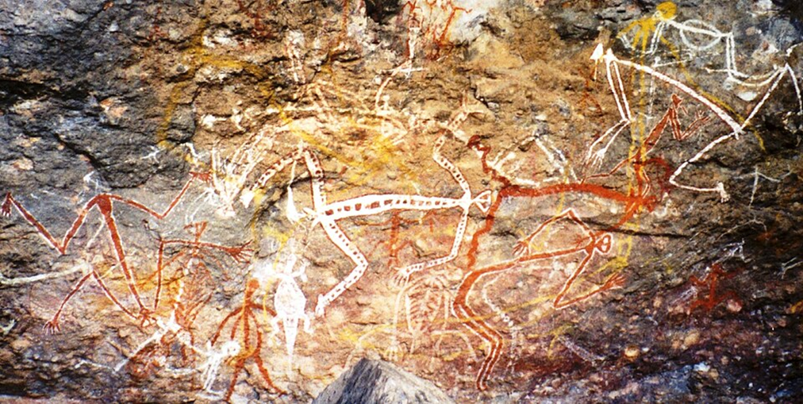
‘Anbangbang gallery Mimi rock art’ by Dustin M. Ramsey is licensed under CC BY-SA 2.5.
After viewing the image above respond to the following prompts:
- What shapes or figures do you notice?
- Describe the people, animals or symbols you can see in the artwork.
- What colours, patterns or actions are shown?
Complete the following steps to explore more examples of rock art.
- Open the following links:
- Burrungkuy
- Nanguluwurr
- Ubirr.
- Look closely at the pictures.
- Read the short explanation text under the images.
- Fill in your worksheet:
- What do you see (shapes, animals, people, symbols, colours, patterns)?
- What does it tells us (stories, Knowledges, daily life, Connections to Country)?
Table 6 – types of artworks
Image | What can you see in the artwork? | What does this tell us about Aboriginal Cultures, Knowledges or connections to Country?
- X-ray-style barramundi fish (Ubirr, Kakadu) | The fish is drawn showing bones and internal organs. | Aboriginal people had detailed Knowledge of food sources and the environment. The art shows Connection to water and Country.
Sentence starters
Table 7 – sentence starters
What I see | What it tells us
I can see … | This shows that people …
The artwork shows … | This tells us that Country is important because …
The artist has drawn … | This suggests knowledge about …
The symbol represents … | This artwork helps teach …
Exit ticket
After completing the worksheet, think about the following question and discuss with a partner: What is one thing this artwork shows about life or Knowledge on Country?

Learning sequence 2 – How is history recorded, organised and investigated?
The following activities will be completed in Learning sequence 2.

Activity 7 – citizenship in antiquity
In the ancient world, different societies had different rules about who belonged, who had power and what rights and responsibilities people had. You will compare 4 ancient societies to determine their similarities and differences.
The 4 societies are:
- ancient Egypt
- ancient China
- ancient Greece (Athens)
- ancient Rome.
Step 1: read the information
Read each of the 4 information sections carefully. As you read, think about:
- who could belong and have power
- who was excluded
- what rights people had
- what responsibilities people had.
Key definitions
Assembly: a meeting of citizens where they discussed important issues and voted to make decisions about laws and how their society was run.
Democracy: a system of government where the people have the power to make decisions, usually by voting.
Hierarchy: a system where people are ranked from highest to lowest based on their power or importance.
Nobles: wealthy and powerful people who helped the ruler govern and often owned land.
Pharaoh: the king or ruler of ancient Egypt. The pharaoh had total power and was believed to be chosen by the gods.

Information: ancient Egypt
In ancient Egypt, most of the power belonged to the pharaoh who was seen as both a king and a god. Society was organised in a strict hierarchy. At the top were the pharaoh and nobles, followed by priests and officials. Most people were farmers, labourers and craftspeople.
People did not have ‘citizenship’ in the modern sense. Instead, they were subjects of the pharaoh. Ordinary people did not vote or make laws. Their main responsibility was to work, pay taxes and obey the pharaoh. In return, the state provided protection, food storage and order.
Only a small group of elite officials had political power and special rights.
Information: ancient China
In ancient China, the emperor ruled and was believed to have the Mandate of Heaven, meaning the right to govern. Society was organised into classes, with scholar officials at the top, followed by farmers, then artisans and merchants.
Citizenship was not equal for all. Political power was held by educated men who passed exams and became government officials. These officials had the right to help make decisions and run the empire.
Most people’s responsibilities were to obey the law, work, pay taxes and show loyalty to the emperor. Women and peasants had few political rights and no role in government.
Information: ancient Greece (Athens)
In ancient Athens, citizenship was limited. Only free adult men born to Athenian parents could be citizens. Women, children, enslaved people and metics (foreign residents) were excluded.
Citizens had the right to vote in the Assembly, speak in debates and serve on juries. They also had responsibilities, such as military service and taking part in government.
Athens is important because it developed one of the earliest forms of democracy, but this system only applied to a small part of the population.
Information: ancient Rome
In ancient Rome, citizenship was more widespread than in Greece but still unequal. Freeborn Roman men were full citizens. Some freed people and people in conquered areas could gain limited or full citizenship over time. Enslaved people were not citizens.
Citizens had legal rights, such as the right to a trial and protection under Roman law. They could also vote (although rich citizens had more power). Responsibilities included paying taxes and serving in the army. Roman citizenship slowly expanded, showing change over time in who could belong.
Step 2: complete the comparison table
Complete Table 8 for all 4 societies. For each one, write:
- who belonged
- who was excluded
- one right
- one responsibility.
Use information from the text to help you. The first row has been completed as a model. Use this example to help you complete the remaining rows for ancient China, ancient Greece (Athens) and ancient Rome in the same way.
Table 8 – citizen or not a citizen
Society | Who belonged? | Who was excluded? | One right | One responsibility
Ancient Egypt | Pharaoh, nobles, priests and government officials. | Farmers, labourers, women and enslaved people. | Elite officials could own land and work in government. | People had to obey the pharaoh, pay taxes and work for the state.
Ancient China
Ancient Greece (Athens)
Ancient Rome
Step 3: continuity and change
Using your completed table to answer the following questions:
- What is one similarity (continuity) in citizenship across these ancient societies?
- What is one difference (change) in how citizenship worked in these societies?
Exit ticket
Answer one of the questions in the table below in one sentence.
Table 9 – exit ticket
Question (choose one) | Your answer
Who could belong in one ancient society that you studied?
What is one similarity in who had rights across ancient societies?

Activity 8 – historical profiles
You will learn how different people in the past recorded history and how their background and role in society shaped what they chose to record.
Step 1: choose your profile
You will read all 4 profile cards about:
- Herodotus
- Tacitus
- Sima Qian
- an Aboriginal Knowledge Holder (oral tradition).
Read each profile carefully, then highlight or underline:
- how this person recorded history (written or oral)
- what they believed was important about history.
Step 2: use the website to help you
If needed, use the links for Herodotus, Tacitus, Sima Qian and Australian Aboriginal Elders and oral tradition to find out:
- where and when each person lived
- what their job or role in society was
- how they recorded or shared history.
Step 3: answer the following questions for all 4 profiles
- Who
- Who was this person and where did they live?
- What was their role in society?
- How
- How did they record or share history? (Written or oral.)
- Perspective
- What part of society does their account mainly show?
- Whose voices might be missing?
Use your answers to complete Table 11 for all 4 profiles.
Table 10 – historical profiles
Image | Description
Figure 3 – Herodotus  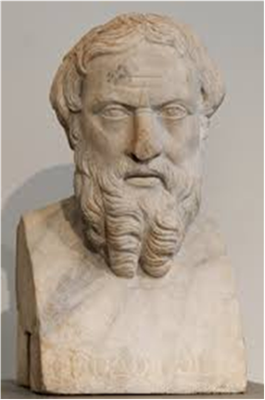  ‘Herodotus’ by Marie-Lan Nguyen is licensed under CC BY 4.0. | Herodotus  Where and when: ancient Greece, 5th century BCE.  How he recorded history: he wrote long stories about wars, travels and cultures.  Why he is important: he tried to ask questions and check information, not just tell myths.  Key idea: history should be investigated and not just told.  Famous work: The Histories.
Figure 4 – Tacitus  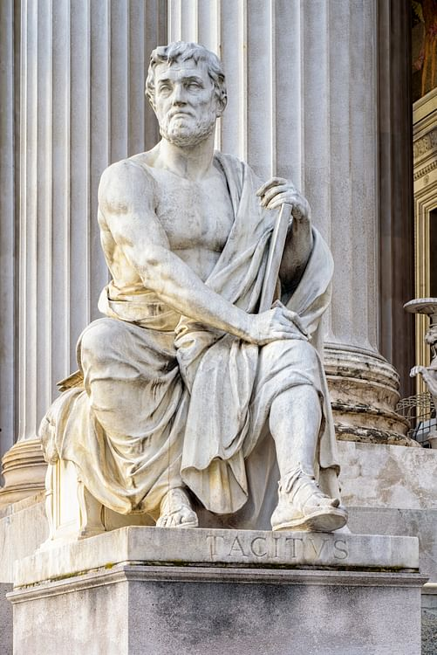  ‘Modern Statue of Tacitus’ by SPÖ Presse und Kommunikation is licensed under CC BY-ND 4.0). | Tacitus  Where and when: ancient Rome, 1st–2nd century CE.  How he recorded history: he wrote about emperors and politics.  Why he is important: he believed history should expose corruption and tell uncomfortable truths.  Key idea: history should be critical, not flattering.  Famous works: Annals, Histories.
Figure 5 – Sima Qian  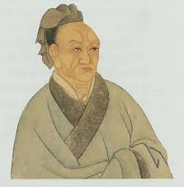  ‘Sima Qian’ by ZazaPress is licensed under CC BY-NC-SA 4.0. | Sima Qian  Where and when: ancient China, 2nd century BCE.  How he recorded history: he collected letters, stories, inscriptions and oral sayings.  Why he is important: he recorded history through biographies, showing why people acted and not just what happened.  Key idea: history should teach moral lessons.  Famous work: Records of the Grand Historian (Shiji).
Aboriginal Knowledge Holder (Elder)
Where and when: Australia – many Language groups, ongoing for at least 65,000+ years.
How Histories are kept: through oral traditions – stories, songlines, dance, art, performance – and Connection to Country.
Why they are important: Knowledge is living, shared through community, passed down carefully and respectfully across generations.
Key idea: History is something you live, speak and care for, and not just write down.
Table 11 – how historians recorded history
Historian | How they recorded history (written or oral) | What they thought was important | Perspective shown
Herodotus | Written – long stories about wars, travel and different cultures | Explaining events and learning about other peoples; checking stories | Viewpoint of an educated Greek traveller interested in comparing cultures

Activity 9 – history telephone (oral versus written comparison activity)
Take a moment to think about the question: How do people today record important events or stories?
Write a few examples (for example, photos, videos, social media posts, books or family stories).
Different methods of recording the past can preserve information, but they can also change stories in different ways. The following activity will show that.
Steps
- Method A: oral chain (no writing)
- Teacher whispers the story to Student 1.
- Student 1 whispers it to Student 2, and so on.
- The final student retells the story aloud to the class.
- Method B: written chain (summary + rewrite)
- Teacher gives Student 1 the story in writing to read silently.
- Student 1 writes a 2 to 3 sentence summary from memory and passes only the summary to Student 2.
- Student 2 reads the summary, then writes a new 2 to 3 sentence summary and passes it on.
- The final student reads their version aloud to the class.
- Original story
- Now listen carefully as the original story is shown. Do not write yet.
- Pay attention to
- what information is included
- how it is explained
- any details or descriptions.
- You will use this original message to compare
- the oral version
- the written version
- what stayed the same or changed.
- As a class, compare the final oral and written versions.
- What parts stayed the same?
- What details changed or disappeared?
- What changed more: facts or descriptions, feelings, motives?
- How did the method affect what was kept or lost?
- What are some values and limitations of oral recording?
- What are some values and limitations of written recording?
Story
Read the short story example below before completing the Venn diagram.
Short story example
A long time ago, a small community lived beside a river. They gathered shellfish, caught fish with woven nets and shared food at night. The river was important for travel and for stories passed from elders to children. People carved symbols on nearby rocks to record animals and seasons.
Complete the Venn diagram. In the Venn diagram:
- on the left side, write facts about written history
- on the right side, write facts about oral knowledge
- in the middle, write what they both do to help people remember and share the past.
Exit ticket
Answer one of the questions in the table below in one sentence.
Table 12 – exit ticket
Question (choose one) | Your answer
What is one strength of oral storytelling?
What is one strength of written records?
How are oral and written traditions similar?

Activity 10 – dating methods
Watch the video Archaeological Dating Methods Explained - Relative and Absolute (7:16). Some terms that will be shown in the video include:
- Relative dating
- Stratigraphy: deeper = older; higher = newer.
- Typology: comparing styles or shapes of tools/objects across time.
- Absolute dating
- Carbon dating: measures radioactive carbon in organic remains.
- Dendrochronology: counts tree rings to find exact years.
- Thermoluminescence: measures stored energy in heated objects (for example, pottery) to estimate when they were last heated.
After watching the video, answer the following prompts:
- What is the difference between a relative dating method and an absolute dating method?
- Name one relative dating method and explain how it helps archaeologists.
- Name one absolute dating method and explain how it helps archaeologists.
Working in pairs or a small group, read each example below:
- You find 2 pots in different soil layers.
- You want to know the age of a piece of burnt wood in a fire pit.
- You compare spearhead shapes to see which came first.
- You study tree rings in an old wooden post.
- You test a broken pottery shard to find out when it was last heated.
Sort the examples into the table below.
Table 13 – relative or absolute dating
Scenario | Relative or absolute? | Which method is used?
Read the below cloze passage carefully. Use the word bank to fill in the missing words. Make sure each word makes sense in the sentence. Check your answers by asking yourself:
- Does this sentence explain how the dating method works?
Archaeologists and historians both study the past, but they use different types of ________ to learn about it.
Archaeologists often ________ or study sites, objects and artefacts, while ________ study written records and stories.
To work out how old something is, archaeologists can use ________ dating, which tells us if one object is ________ or younger than another. They can also use ________ dating, which gives an estimate of how many ________ old something is. For example, ________ ________ is a method used to find the age of things that were once alive, such as wood or bone.
Archaeologists may also ________ objects such as pottery styles to see how they changed over time. Both archaeologists and historians work together to understand the past more clearly.
Word bank
Table 14 – cloze passage word bank
archaeologists | historians | evidence | relative | absolute
older | years | dig | compare | carbon dating
Activity 11: reading the layers – What can the past tell us?
Carefully study the stratigraphy diagram (see Figure 6). Each layer (stratum) shows objects left behind by people over time. The deepest layers are the oldest and the top layers are the newest. Use the diagram to answer the questions in the table below.
Figure 6 – stratigraphy diagram
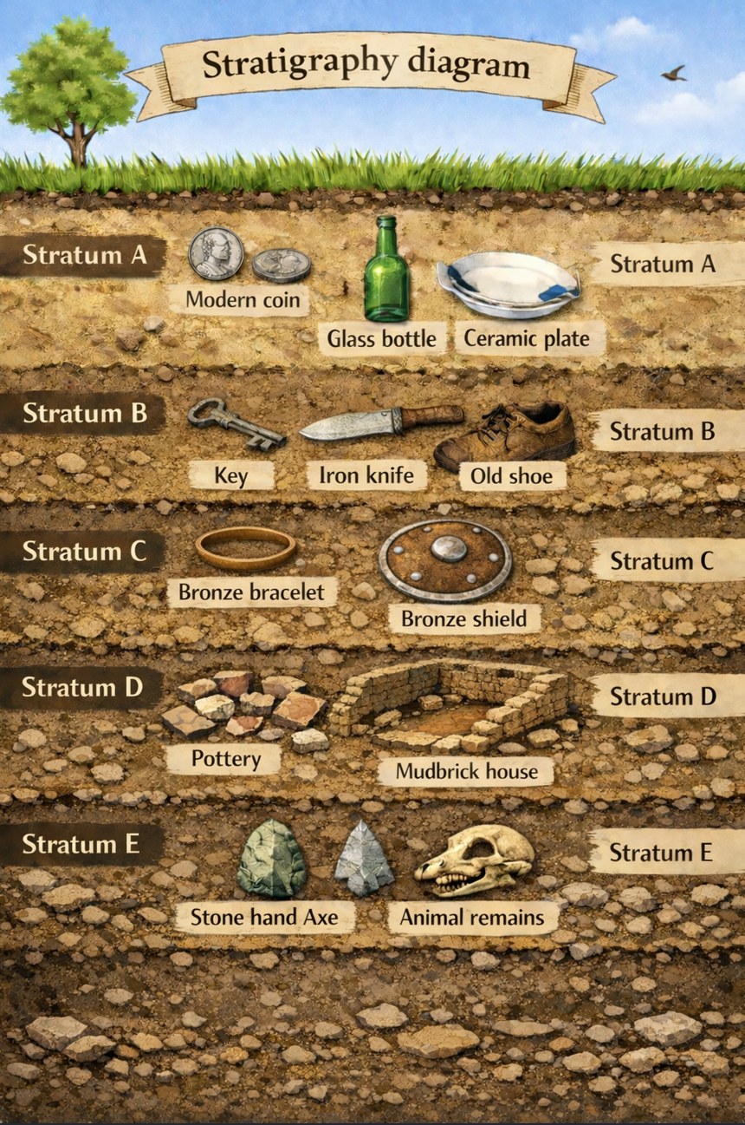
Understanding the diagram – See, Think, Wonder
Table 15 – See, Think, Wonder
See (What objects can you observe?) | Think (What might these objects tell you?) | Wonder (What questions do you have?)
Choose any 2 strata and complete the table below. The first one has been completed for you as an example.
Table 16 – stratum level
Stratum letter | Objects found | What do these objects tell us about how people lived at the time?
D | Pottery, mudbrick house | This suggests people lived in permanent homes and made storage and cooking vessels.
- Look at Stratum E, D and C.
- What objects can you see in each of these layers?
- What is one clear difference between the objects in Stratum E and the objects in Stratum D?
- Some layers have more objects than others. Choose one explanation from the list below and use the image to support it:
- Fewer people lived there at that time.
- A natural event (such as flooding or erosion) may have affected what was left behind.
- Some objects may not survive well over long periods of time.
- Another explanation you can justify from what you see in the diagram.
- Look at the mudbrick house and pottery in Stratum D.
- What do these remains suggest about how people were living at this time?
- How is this different from what the objects in Stratum E suggest about earlier ways of life?
- Imagine that a mobile phone was found in Stratum B.
- Why would a mobile phone in this layer be unexpected when you look at the other objects in Stratum B?
- What might this suggest about what happened to the layers after they were originally formed?
- How could this make it difficult for archaeologists to correctly date objects using stratigraphy?
Exit ticket
Using the stratigraphy diagram, write one sentence describing one change you can see between an older layer and a newer layer, and another sentence to describe how a dating method helps you work this out.

Activity 12 – time vocabulary sorting and sequencing
Review the glossary below before completing the sorting and sequencing activity. This will help you understand the key time-related terms you will be using, including less familiar terms such as millennium and periodisation.
Table 17 – glossary
Word | Meaning
BCE/CE | Before Common Era/Common Era – same time frame as BC/AD
BC/AD | Before Christ/Anno Domini (in the year of the Lord)
Chronology | The order in which events happened
Periodisation | Dividing history into periods for easier study and comparison
Decade | A period of 10 years
Century | A period of 100 years
Millennium | A period of 1,000 years
Timeline | A diagram that shows when events happened in order
- Provide each pair of students with a set of cards containing the following terms:
- Minute
- Hour
- Day
- Week
- Month
- Year
- Decade
- Century
- Millennium.
- Ask students to:
- sort the cards from the shortest to the longest duration
- check their order with another group.
- Once sorted, students:
- glue their order onto a piece of A3 poster paper to display in class
- add one example under each unit of time (for example, ‘10 years = decade’).

Activity 13 – timeline construction
- On your individual timeline sheet, place the following dates in order:
- 10,000 BCE
- 2008 CE
- 54 BCE
- 33 CE
- 1008 CE
- 2008 BCE.

Figure 7 – timeline sheet
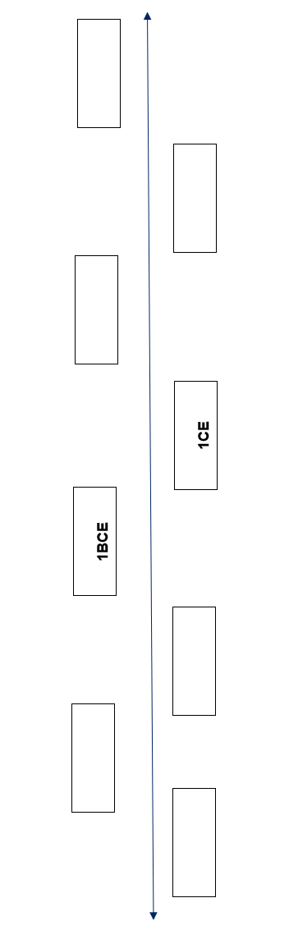
- Create a timeline of 5 major events from your life.
- Draw a straight line across your page using a ruler or use the blank timeline on the next page.
- Choose your scale: 1 year = 5 cm.
- Mark your birth at the start of the line.
- Measure and plot each event at the correct distance from your birth year using the scale.
- Label each event clearly with
    - the year
    - a short description (for example, ‘Started primary school’, ‘Moved house’, ‘First overseas trip’).
- Add a title and arrow showing the direction of time.

Figure 8 –blank timeline

Activity 14 – Why is there no year zero?
Read the information below, which provides a brief explanation of BCE and CE.
The calendar we use today is called the Gregorian calendar.
It is based on a system created by a Christian monk named Dionysius Exiguus in the 6th century.
He decided to count years based on the birth of Jesus, using BC (Before Christ) and AD (Anno Domini – Latin for ‘In the year of the Lord’).
At the time, zero was not used in European number systems, so the calendar runs from 1 BCE straight to 1 CE with no year zero.
The following adapted passage is based on the article Keeping time: The history, origin and meanings of B.C. and A.D. Read the passage with a partner.
Keeping track of time
When you read history books or stories about archaeology, you often see the letters BC and AD next to dates. These letters help us divide time into 2 parts: before and after the birth of Jesus Christ. Sometimes, people use BCE (Before Common Era) and CE (Common Era) instead, which are more neutral terms.
What does AD and BC mean?
AD stands for Anno Domini, a Latin phrase that means ‘in the year of the Lord’. It counts the years after Jesus Christ was born.
BC means ‘Before Christ’. It counts the years before Jesus was born.
For example, the year 500 BC was 500 years before Jesus was born, and the year AD 2024 is 2,024 years after.
Where did this system come from?
Around the year 525 AD, a monk named Dionysius Exiguus created this system to keep track of years. He wanted to count the years starting from the time he thought Jesus was born.
Before Dionysius, people counted years from the rule of different emperors or important events. Dionysius’ method became more popular because it helped Christians organise their calendar and celebrations, such as Easter.
What about BC?
The term BC was added about 200 years later by a historian named Bede. He started to count backwards to show the years before Jesus’ birth.
Why is there no year zero?
In this system, there is no year zero. The year before AD 1 is 1 BC. This is because the number zero wasn’t commonly used in Europe when the system was created.
Why do some people say BCE and CE?
Some people prefer using BCE (Before Common Era) and CE (Common Era) instead of BC and AD. This is because these terms don’t refer to Jesus Christ directly, making them easier for people of different religions to use.
While reading, use the guided note-taking sheet below.
Table 18 – note-taking sheet
Question | Notes (students write in dot points)
Who created the BC/AD system?
When did they create it?
What was the system based on?
Why wasn’t zero used in the timeline?
What changed when BCE/CE was introduced?
Writing task
Using the article Keeping time: The history, origin and meanings of B.C. and A.D. and your own knowledge, describe why there is no year zero. To help structure your response use the scaffold below.
Table 19 – PEEL
Section | Prompt
P – Point | What is your answer to the question?
E – Evidence | Who created the calendar? When? What didn’t exist yet?
E – Example | How does the timeline show there is no year zero?
L – Link | How does this affect how historians work today?
Exit ticket
Answer the following prompt: Place the dates 54 BCE and 33 CE in order from earliest to most recent.

Learning sequence 3 – Why does the past matter today?
The following activities will be completed in Learning sequence 3.

Activity 15 – lost, threatened and preserved – the Terracotta Warriors of Xi’an
Inquiry question: How have the Terracotta Warriors of Xi’an been lost, threatened and protected, and why is it important to preserve them?
Figure 9 – the Terracotta Army, Shaanxi Province
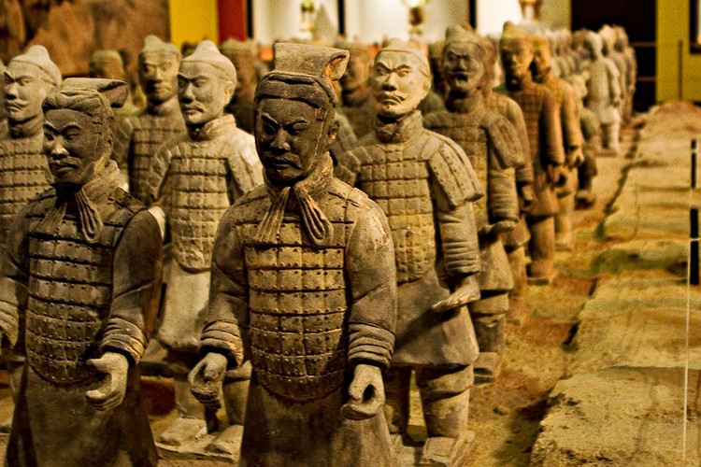
‘The Terracotta Army, Shaanxi Province’ by Shawn Kinkade is licensed under CC BY-NC-SA 4.0.
Part A – Lost – How did the Terracotta Warriors disappear?
Read the article Mar 29, 1974 CE: Terra-Cotta Warriors Found.
What happened to the Terracotta Warriors?
The Terracotta Warriors are thousands of life-size clay soldiers buried near the city of Xi’an in China. They were created more than 2,200 years ago to protect Qin Shi Huang, the first emperor of a united China, in the afterlife.
After the emperor’s death, the warriors were buried underground as part of a large tomb complex. Over time, the location of the site was forgotten. For many centuries, the warriors were hidden and no longer known to people.
In 1974, farmers digging a well discovered broken pieces of clay. This led archaeologists to uncover large underground pits filled with thousands of life-sized soldiers, horses and chariots. now known as the Terracotta Army.
This shows that the site had disappeared from human knowledge, even though it still existed underground.
Use the article Mar 29, 1974 CE: Terra-Cotta Warriors Found and the adapted reading passage to answer the following questions:
- Why were the Terracotta Warriors originally built?
- Why did the site disappear from people’s knowledge?
- How was the site rediscovered?
Part B – Threatened – What is putting the Terracotta Warriors at risk today?
Read the article The Terracotta Warriors.
What can damage the Terracotta Warriors today?
When the Terracotta Warriors were buried, the soil helped protect them. Once archaeologists began to excavate the site, new problems appeared.
The original painted colours on the warriors can peel or fade when they are exposed to air and light. Changes in temperature and humidity can cause the clay to crack or weaken.
Dust and air pollution can slowly damage the surface of the figures.
Large numbers of visitors also affect the site. Movement, vibrations and changes in air inside the buildings can place stress on the fragile statues. Even the process of excavation can be risky if the figures are uncovered too quickly.
This shows that the site is now threatened by both the environment and people.
Answer the following questions:
- What environmental factors threaten the Terracotta Warriors after they are uncovered?
- How can visitors and human activity threaten the site?
- Why can excavation itself be a threat to ancient sites?
Part C – Protected – How are the Terracotta Warriors cared for today?
Read the article Mausoleum of the First Qin Emperor.
How are the Terracotta Warriors cared for today?
The Terracotta Warriors are recognised as an extremely important ancient site. The tomb complex is listed as a UNESCO World Heritage Site. This means the site is protected for the benefit of people around the world.
Large protective buildings have been built over the excavation pits to control temperature and humidity. Scientists monitor the figures to detect cracks and damage early.
Special conservation methods are used to strengthen broken figures and protect remaining paint.
Many areas of the site are still left buried. Archaeologists wait until better technology is available so that the figures can be uncovered more safely.
Visitors must stay behind barriers and are not allowed to touch the statues.
This shows how the site is being protected and preserved.
Answer the following questions:
- What actions are being taken to protect and preserve the Terracotta Warriors?
- Why is leaving some parts of the site buried an important protection strategy?
- How does World Heritage listing help protect ancient sites?
Part D – Evidence – Terracotta warrior
Look at the image of the Terracotta Warriors below.
Figure 10 – Chinese Terracotta Warriors
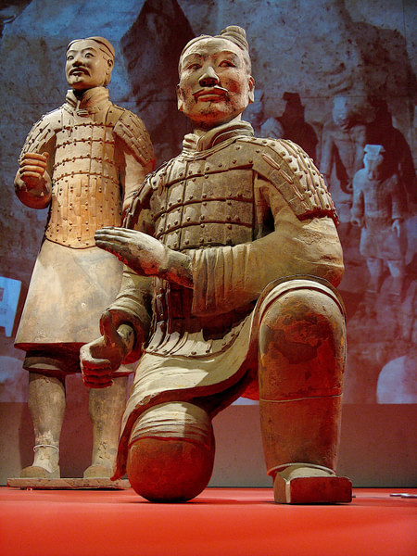
‘Chinese Terracotta Warrior’ by glancs is licensed under CC BY-NC-SA 4.0.Table 20 – artefact analysis
Look and think | Responses
What material is the figure made from?
What details can you see in the:
clothing
hair
armour?
Is the figure life-size?
What does this suggest about its importance?
What role might this figure represent?
What does this figure suggest about beliefs about the afterlife?
In one sentence: What does this artefact tell us about ancient Chinese society?
Final task – reflection
Using the PEEL structure, write one short paragraph answering: How have the Terracotta Warriors of Xi’an disappeared, been threatened, and been protected and preserved?
Include:
- how the site disappeared from human knowledge
- one example of how the site was preserved
- one example of a threat to the site today
- one example of how the site is being protected
- one reason why preserving this site helps us learn about the past.

Activity 16 – To dig or protect? Decisions about the Terracotta Warriors
Inquiry question: Should archaeologists continue excavating the Terracotta Warriors or should they focus on protecting and preserving the warriors that have already been uncovered?
Step 1 – warm-up – What can Xi’an (Terracotta Warriors) teach us?
In your book, write the first 4 headings as seen in Table 21 below. As we discuss, write at least one idea under each.
Table 21 – evaluating excavation and preservation of the Terracotta Warriors
Focus area | Prompts
Reasons to continue excavating the Terracotta Warriors | What new evidence might be discovered? How could this help historians learn more about ancient China and the emperor’s army?
Reasons to prioritise protection and preservation | What evidence has already been uncovered? How could further excavation damage the clay figures or their painted surfaces?
Evidence from today’s sources | Which specific sources (for example, Terracotta Warrior figure, readings about conservation, UNESCO information) support each viewpoint? What do they show?
Decision and justification | Based on the evidence, should archaeologists continue excavating more warriors or focus on protecting what has already been uncovered? Explain your decision using evidence.
Step 2 – form debate teams
The class will be divided into 2 teams:
- Team A – continue excavation
- Team B – prioritise protection and preservation.
In your groups, you will need to choose one of the roles from the table below.
Table 22 – roles and responsibilities
Role | Your job
Researchers | Collect information from class notes and sources.
Speakers | Present your team’s ideas clearly.
Rebuttal specialists | Respond to the other team’s points.
Note-takers | Record key ideas during discussion.
Evidence managers | Make sure your team uses sources as evidence.
Timekeepers/coordinators | Keep the group organised and on task.
Step 3 – prepare your argument
Use the sentence starters in the table below to help you.
Table 23 – sentence starters
Purpose | Sentence starters you can use
State your argument | Our team believes … because …
Use evidence | One piece of evidence that supports this is …
Explain significance | This matters because it helps us understand…
Rebut the other team | However, another perspective is …  This point does not consider that …
Step 4 – debate rounds
The debate will follow the structure below:
- Round 1: Team A presents reasons to continue excavating the Terracotta Warriors.
- Round 2: Team B presents reasons to prioritise protection and preservation of the existing site.
- Round 3: rebuttals (each team responds using evidence).
- Round 4: open floor questions from the class.
Exit ticket – Why are the Terracotta Warriors significant?
Before you leave, write one sentence answering the question: Why are the Terracotta Warriors significant for historians?
Choose one of the sentence starters below, if you need help:
- The Terracotta Warriors are significant because they help us understand …
- One important thing we learn from the Terracotta Warriors is …
- The Terracotta Warriors matter to historians because they show …

Activity 17 – gallery walk
Purpose: to explore how evidence from 2 ancient sites helps us understand past and present cultures. Images can be found in Appendix 4.
Move around the room to view the images and short texts about:
- Xi’an (Terracotta Warriors)
- Brewarrina Fish Traps (Baiame’s Ngunnhu)
- preservation and conservation methods.
At each station, use the table below to note down:
- one thing you can see (evidence)
- one thing you learn (what it shows about life or culture)
- one question you have.
Table 24 – See, Think, Wonder
Station | See (objects, buildings, images, materials) | Think (what it shows about life, culture, beliefs, technology and so on) | Wonder (one question I have)
Xi’an (Terracotta Warriors)
Brewarrina Fish Traps (Baiame’s Ngunnhu)
Preservation and conservation methods
Rotate stations every 3 to 4 minutes. After completing the gallery walk, in your book write a response to the question: How does the context of each site influence how it is cared for today?
Think about:
- what the historical and cultural context of each site is (when it was created, whether it is still in use, how it was discovered or maintained)
- how that context influences who makes decisions about the site today
- how the site is cared for or managed
- whose knowledge, responsibilities or authority guide those decisions
- why different groups might value the site in different ways because of its context.
Write 2 to 3 sentences explaining your thinking.

Activity 18 – comparing 2 ancient places
Complete the table below by recording what each site shows about:
- how people lived
- what was valued
- how the site is protected today.
Table 25 – comparing 2 ancient places
Place | What the evidence shows about how people lived | Why this place is significant today | How it is protected or managed
Xi’an (Terracotta Warriors)
Brewarrina Fish Traps (Baiame’s Ngunnhu)
Use the following sentence starters, if needed:
- This evidence shows that people …
- This place is significant because …
- This site is protected today by … with help from …

Activity 19 – Think-Pair-Share
Use the Think-Pair-Share scaffold to answer the question: What would we lose if places such as Xi’an (Terracotta Warriors) and Baiame’s Ngunnhu were not protected?
Steps
- Think
- Write 1 to 2 sentences answering the focus question: What might be lost if places like Xi’an (Terracotta Warriors) or Baiame’s Ngunnhu are not protected or respected?
- Use evidence from either Xi’an (Terracotta Warriors) or Baiame’s Ngunnhu to support your answer. You may think about
- loss of historical knowledge
- loss of cultural knowledge and practice
- loss of identity or connection to place.
- Pair – share your response with a partner.
- Ask
- Did you focus on the same type of loss, or a different one?
- Did you use the same place, or a different place, as evidence?
- Share – selected pairs share their ideas with the class.
- As you listen, think about
- How does the context of Baiame’s Ngunnhu shape who has authority over decisions?
- How does the context of Xi’an shape who manages the site?
- Whose knowledge is connected to each place?
- Can a place be culturally alive even if it is very old? Why or why not?
Exit ticket
Choose one site you studied today and in 1 to 2 sentences answer the question: Describe how the context of the site shapes how it is managed today.

Activity 20 – guided reading – ‘The story of Mungo Man’
Reading summary adapted from Mungo Man: What to do next with Australia's oldest human remains (28:43).
Mungo Man lived around 42,000 years ago on the shores of Lake Mungo. It is one of the oldest known human remains ever found in Australia. His discovery in 1974 by geologist Jim Bowler completely changed historians’ understanding of how long Aboriginal peoples have lived on Country. Before this, many believed Aboriginal Histories were relatively short. Mungo Man proved that Aboriginal Cultures are one of the oldest continuing cultures in the world, dating back tens of thousands of years and comparable in age to early cultures in Africa and Europe.
However, the significance of the discovery extended beyond academic understanding and touched deeply on Cultural and spiritual issues for the Aboriginal communities connected to the land. The removal of Mungo Man’s remains caused deep distress for many Aboriginal communities. The traditional owners of the Willandra Lakes, the Mutthi Mutthi, Barkandji and Ngyiampaa peoples, believed their ancestors should rest undisturbed on their own land. Some felt the remains had been taken without proper consultation or respect. While scientists viewed the discovery as important for research and understanding human history, Aboriginal communities saw it as the disturbance of sacred burial grounds. This difference in perspectives led to tension between scientists and Aboriginal peoples.
Despite these tensions, scientific study of Mungo Man’s remains proceeded, revealing fascinating insights into life in ancient Australia. Scientific studies of Mungo Man revealed important details about his life and Culture. He was well-built and strong, and signs of severe arthritis in his elbow suggest he used a spear thrower throughout his life, showing that hunting tools and daily life were highly developed. His burial was especially significant because his body was sprinkled with red ochre. This shows that complex burial rituals and spiritual beliefs already existed in Aboriginal Cultures more than 40,000 years ago.
With time, recognition grew that scientific research and Aboriginal Cultural values need not be in opposition, leading to improved cooperation. Over time, relationships between scientists and Aboriginal communities improved. In the 1980s, Aboriginal groups stopped further removal of skeletal remains and called for collaboration and respect. Eventually, after many years of discussion and negotiation, ancestral remains including Mungo Man, were returned to Country. The return showed the importance of Cultural respect, healing and Connection to Country. It recognised that Aboriginal ancestors are not scientific objects but deeply respected members of living Cultures.
Paragraph 1 questions:
- Why is Mungo Man important for understanding how long Aboriginal peoples have lived on Country?
- How did the discovery change historians’ thinking?
Paragraph 2 questions:
- Why were some Aboriginal communities upset about the removal of Mungo Man?
- What different perspectives appear in this part of the text?
Paragraph 3 questions:
- What does the red ochre burial tell us about Cultural practices?
- What does the spear-thrower evidence show about daily life?
Paragraph 4 questions:
- How did relationships between scientists and Aboriginal communities change over time?
- What does the return of ancestral remains show about values such as Cultural respect and Connection to Country?

Activity 21 – values compass – ‘Mungo Man – Why does he matter?’
Complete the following activity.
- From the reading, highlight phrases or ideas that connect to values.
- Place each idea onto the compass where it best fits. For example:
- ‘red ochre burial’ → Cultural respect/spiritual belonging
- ‘revealed complex ancient rituals’ → scientific knowledge
- ‘return to Country ceremony’ → Connection to Country
- Stop once your compass has 6 to 10 ideas placed on it.
Figure 11 – values compass
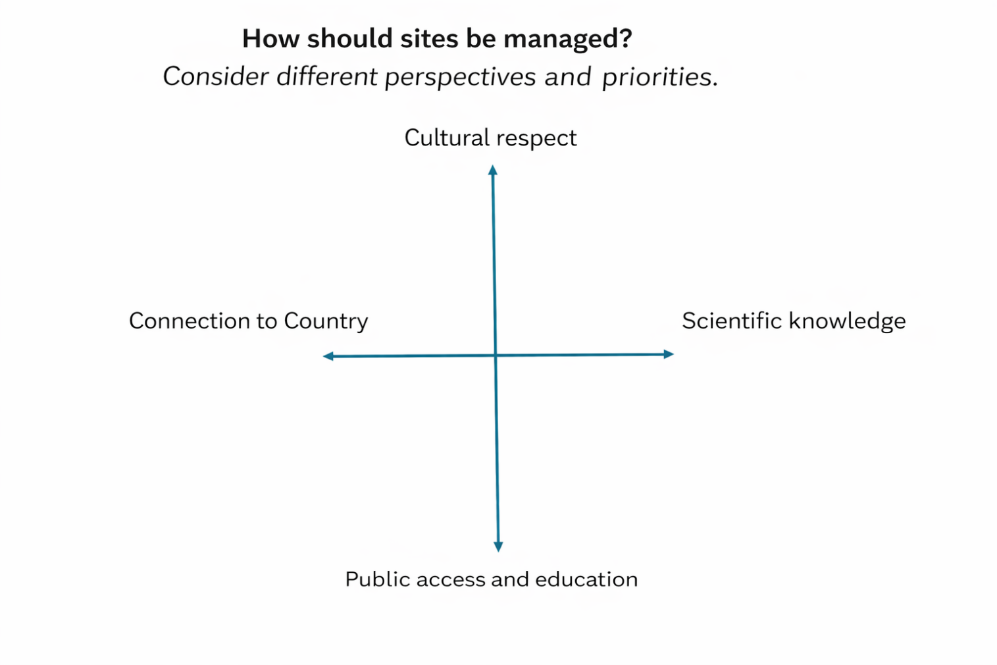

Activity 22 – museum board simulation – ‘Where should Mungo Man be?’
You will be working in groups to decide where Mungo Man should be cared for today. Each person in your group will take on a different role and speak from that role’s perspective.
This is not a debate. This is about listening, understanding values and making a thoughtful group decision.
Step 1 – your role
You will be given one of these roles:
- Community Elder
- Cultural Heritage Officer
- Archaeologist
- Museum Director
- Government Representative
- Historian.
Your role card explains:
- what you value
- what matters most to you
- how you might respond to the decision.
Stay in character during the discussion.
Step 2 – use your values compass
Look at your values compass from the last activity. Use ideas from the reading and your values compass to guide what you say.
Step 3 – discuss as a group
Speak from the perspective of your assigned role. Listen to others. Explain why your values matter. Use respectful sentence starters such as:
- From my perspective …
- I understand your point, however …
- The value I must prioritise is …
Step 4 – make a group decision
Your group must choose one option from the table below.
Table 26 – group decision
Option | What it means
A. Rest permanently on Country | Mungo Man is reburied and not publicly displayed.
B. Temporary display on Country | A Cultural centre shares his story before he returns to Country.
C. Display in a major museum | He is displayed for research and public learning.
Step 5 – complete your decision sheet
Record the following on a decision sheet.
- your group’s chosen option (A, B or C)
- two to 3 reasons for your decision
- the values your group prioritised
- the values your group did not prioritise – and why
Step 6 – share back
One person from your group will present your decision in 1 to 2 sentences, staying in character.
Example format:
‘As the Cultural Heritage Officer, our group supports Option B because it respects Connection to Country while still allowing public education.’
Remember to:
- speak respectfully
- listen carefully
- stay in character
- base ideas on values plus evidence, not personal opinion.
Role cards
Community Elder
I speak for my ancestors and my community.
Mungo Man is an ancestor, not an object.
The most important values for me are:
- Cultural respect
- Connection to Country.
I believe Mungo Man should rest where he belongs, on his own Country, cared for by his people.
Cultural Heritage Officer
I work to protect Cultural Knowledges and community identity.
My job is to make sure Culture is respected and passed on to the next generation.
The most important values for me are:
- Cultural respect
- public education.
I want decisions that teach others while still respecting Culture.
Archaeologist
I study the past by examining physical evidence.
Mungo Man helps us understand human history.
The most important value for me is:
- scientific knowledge.
I believe it is valuable for researchers to have access to the remains so we can learn from them.
Museum Director
I help the public learn about culture and history.
A museum display could allow millions of people to learn Mungo Man’s story.
The most important value for me is:
- public education.
I want the story to be shared widely so people understand its importance.
Government Representative
I must make decisions that balance the needs of many groups.
No one group can be ignored.
The most important value for me is:
- balancing all 4 values.
I look for compromise that is respectful, practical and supported by all sides.
Historian
I help people understand how the past shapes identity today.
Mungo Man’s story changes how Australians understand history.
The most important values for me are:
- scientific knowledge
- public education.
I want the story to be told accurately and respectfully.
Group decision sheet – ‘Where should Mungo Man be?’
Group members:
Roles in group:
Step 1 – your group’s decision
We choose option (circle one):
A – Rest permanently on Country.
B – Temporary display on Country.
C – Display in a major museum.
Step 2 – our reasons for this decision
Write 2 to 3 clear reasons that support your choice.
Use ideas from the reading plus your values compass and role perspectives.
Step 3 – values we prioritised
Tick the values your group decided were most important in making this decision.
Table 27 – values table
Value | Tick
Cultural respect | ☐
Connection to Country | ☐
Scientific knowledge | ☐
Public education | ☐
Explain why these values were prioritised.
Step 4 – values we considered but did not choose
Which value(s) were less prioritised, and why?
Step 5 – group statement (1 to 2 sentences)
Write the sentence your group will say aloud to the class.
Stay in character.
Example: ‘As the Cultural Heritage Officer, our group supports Option B because it respects Connection to Country while still allowing public education.’
Write your statement in the box below:
Exit ticket
You are to respond to the following questions in 1 to 2 sentences:
- Which value most influenced your group’s decision about Mungo Man, and why?
- What might be lost if a different decision had been made?

Activity 23 – end of unit exit ticket
Complete the exit ticket.
- Write the names of your 3 favourite lessons from this unit.
- For each one, write 1 or 2 sentences explaining why it was your favourite (for example, what you learned, what you enjoyed or what helped you understand).
- Write one new thing you learned about the ancient past in this unit.

Appendix 1
Activity 1 – evidence and the past – How do we know?
Figure 12 – Aboriginal art
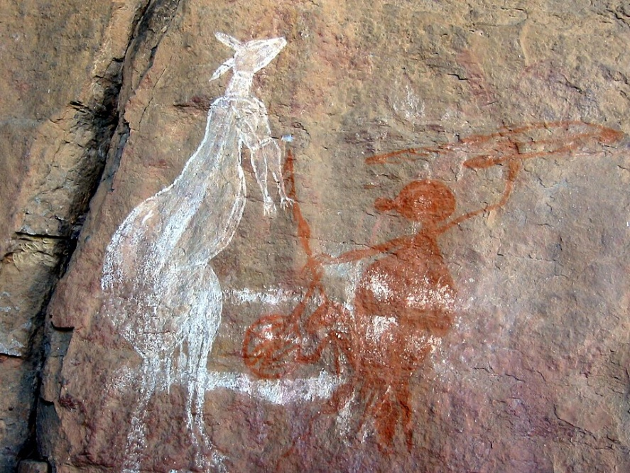
‘Aboriginal Art Australia’ by Thomas Schooch is licensed under CC BY-SA 4.0.
Figure 13 – Palace of Knossos
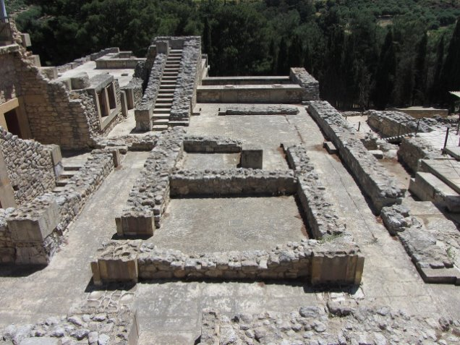
‘Ruins, Palace of Knossos (Minoans)’ is licensed under Pixabay Content License.
Figure 14 – Lascaux cave painting
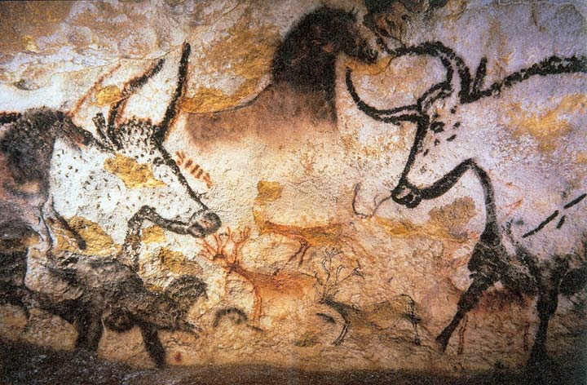
‘Cave Painting in Lascaux’ by Prof saxx is licensed under CC BY-NC-SA 3.0.
Figure 15 – early human migrations map
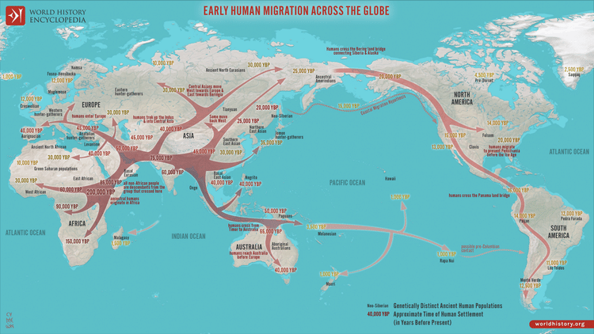
‘Map of Early Human Migrations’ by Simeon Netchev is available in the public domain.

Appendix 2
Activity 4 – What clues did ancient societies leave behind?
Figure 16 – Egyptian hunting painting
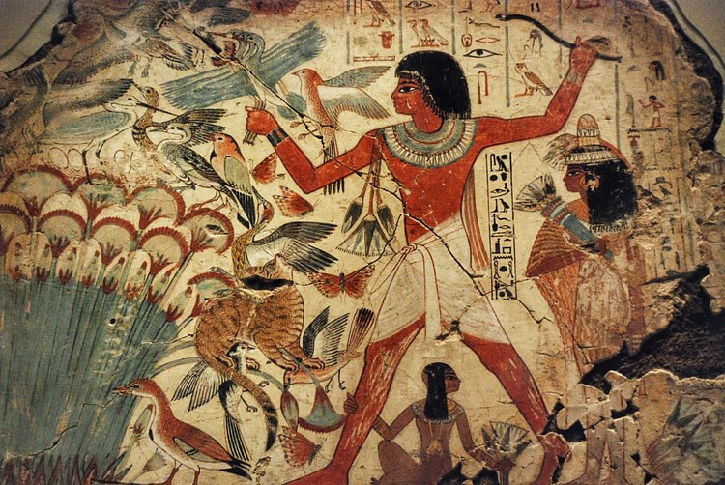 ‘Egyptian Hunting in the Marshes’ by Jan van der Crabben is licensed under CC BY-NC-SA 3.0.
Figure 17 – Egyptian hieroglyphics
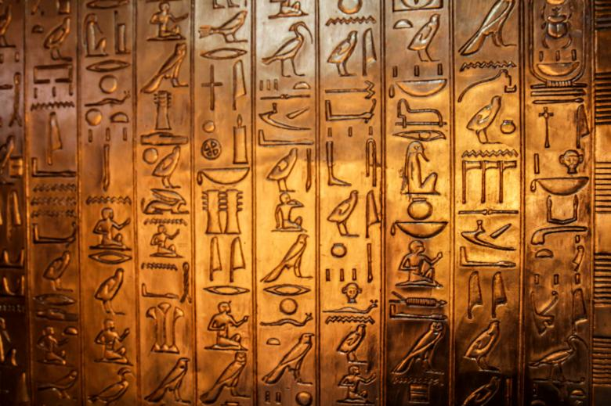
‘Hieroglyphics’ is licensed under Pixabay Content License.
Figure 18 – stone tools
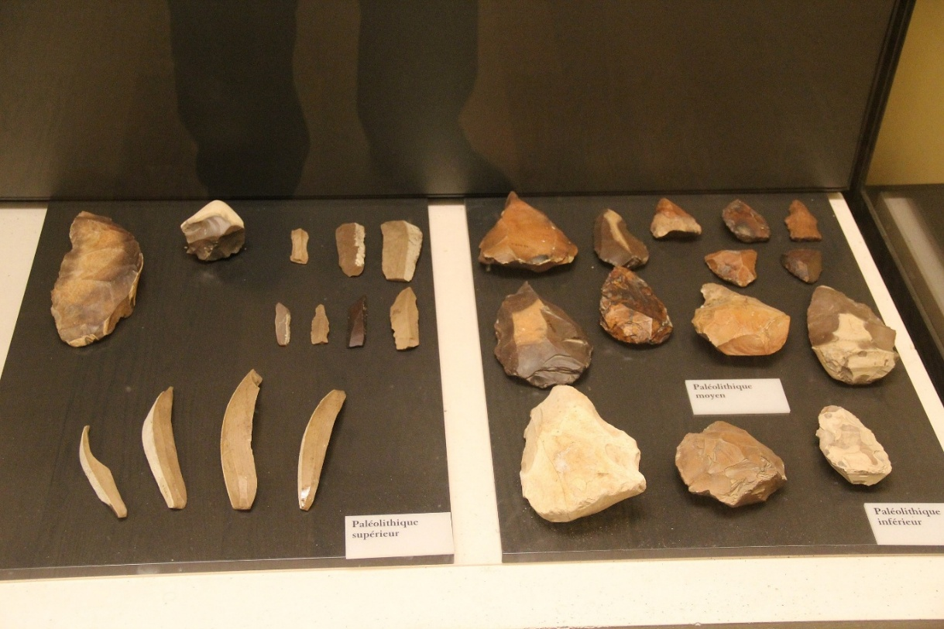
‘Ancient Egypt Paleolithic Stone Tools’ by Gary Todd is available in the public domain.
Figure 19 – stamp seal
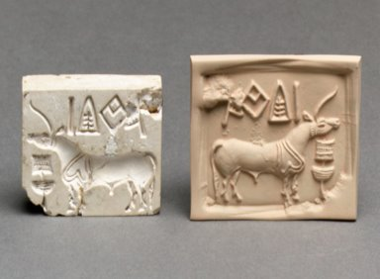
‘Stamp seal and modern impression: unicorn and incense burner (?)’ from The Metropolitan Museum of Art collection is available in the public domain.
Figure 20 – Pyramids of Giza
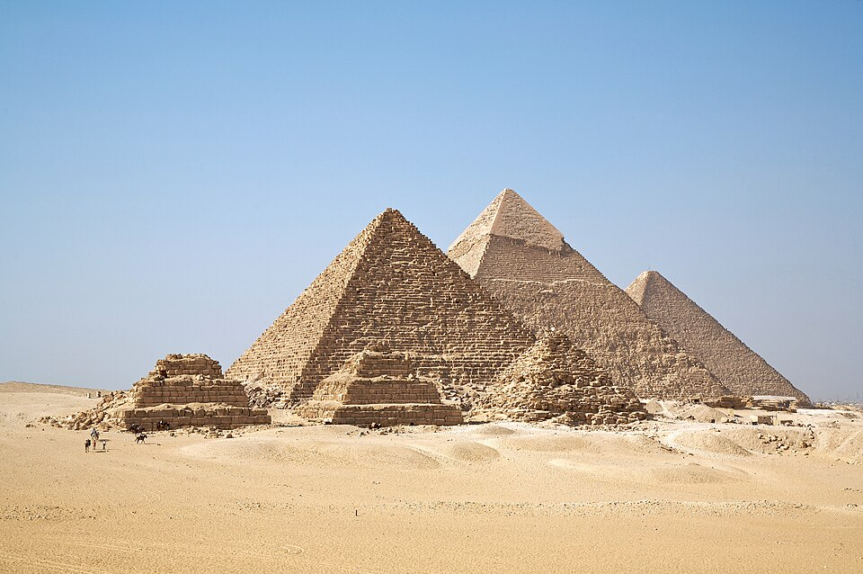
‘All Gizah Pyramids’ by Ricardo Liberato is licensed under CC BY-SA 4.0.

Appendix 3
Activity 5 – historical inquiry – Lake Mungo
Note: this plain English version of the historical inquiry process is provided to support student understanding for this task. Over time, students will be supported to use subject-specific historical language independently.
When historians learn about the past, they ask questions, investigate evidence and explain what they find. This process helps us understand how people lived in the past and why this history is important today.
In this task, you will use the Lake Mungo virtual excursion as evidence to investigate Aboriginal Histories and Cultures.
Acquiring historical information
This is how you gather information for your inquiry.
Focus your inquiry
You are investigating Lake Mungo to find sources of evidence about Aboriginal Histories and Cultures.
Ask inquiry questions
Think about questions such as:
- What evidence has been found at Lake Mungo?
- What does this evidence tell us about how people lived?
Use sources
Engage with the Lake Mungo virtual excursion and identify information from:
- human remains and burial practices
- artefacts, food remains and footprints
- features of the landscape that help preserve evidence.
Processing historical information
This is how you make sense of what the evidence shows.
Interpret evidence
Look closely at the evidence shown in the virtual excursion and think about what it reveals about:
- Aboriginal life
- Culture
- beliefs.
Use evidence to support ideas
- When explaining your ideas, refer directly to the evidence from Lake Mungo.
- Explain how the evidence supports what you are saying.
Organise your thinking:
You may organise information using dot points, tables or short paragraphs to clearly link evidence to conclusions.
Communicating historical information
This is how you show what you have learned.
Explain your findings
Use historical terms such as ‘source’, ‘evidence’, ‘culture’ and ‘significance’ to explain what the evidence from Lake Mungo shows.
Answer the inquiry
Why are these sources important for understanding Aboriginal Histories and Cultures in Australia?

Appendix 4
Activity 17 – gallery walk
Figure 21 – The Terracotta Army Panorama
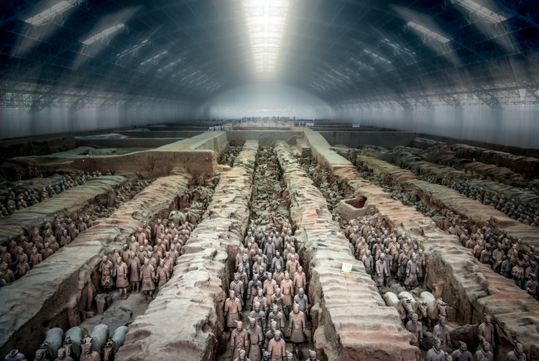
‘The Terracotta Army Panorama’ by Bernd Thaller is licensed under CC BY-NC-SA 4.0.
This panoramic view of the Terracotta Army in Shaanxi Province shows thousands of life-size clay soldiers arranged in rows to guard the tomb of China’s first emperor. Each figure was made with different faces and details, showing the skill and organisation of the craftsmen who created them. The site shows how power, the afterlife and military strength were important ideas in ancient Chinese society.
Figure 22 – Brewarrina fish traps
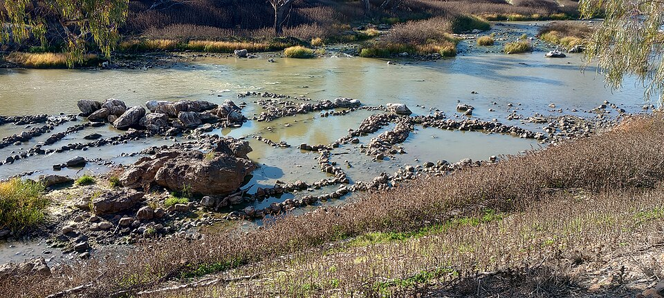
‘Brewarrina fish traps, 2023’ by Dippiljemmy is licensed under CC BY-SA 4.0.
These stone fish traps were built by Aboriginal peoples long before European settlement. They were designed to trap fish in the river and share food across the community. The traps are still connected to living Cultures and Country today.

References
This resource contains NSW Curriculum and syllabus content. The NSW Curriculum is developed by the NSW Education Standards Authority (NESA). This content is prepared by NESA for and on behalf of the Crown in right of the State of New South Wales. The material is protected by Crown copyright.
Please refer to the NESA Copyright Disclaimer for more information https://www.nsw.gov.au/education-and-training/nesa/copyright.
NESA holds the only official and up-to-date versions of the NSW Curriculum and syllabus documents. Please visit NESA https://www.nsw.gov.au/education-and-training/nesa and NSW Curriculum https://curriculum.nsw.edu.au.
History 7–10 Syllabus © NSW Education Standards Authority (NESA) for and on behalf of the Crown in right of the State of New South Wales, 2024.

© State of New South Wales (Department of Education), 2026
The copyright material published in this resource is subject to the Copyright Act 1968 (Cth) and is owned by the NSW Department of Education or, where indicated, by a party other than the NSW Department of Education (third-party material).
Copyright material available in this resource and owned by the NSW Department of Education is licensed under a Creative Commons Attribution 4.0 International (CC BY 4.0) license.

This license allows you to share and adapt the material for any purpose, even commercially.
Attribution should be given to © State of New South Wales (Department of Education), 2026.
Material in this resource not available under a Creative Commons license:
- the NSW Department of Education logo, other logos and trademark-protected material
- material owned by a third party that has been reproduced with permission. You will need to obtain permission from the third party to reuse its material.
Links to third-party material and websites
Please note that the provided (reading/viewing material/list/links/texts) are a suggestion only and implies no endorsement, by the New South Wales Department of Education, of any author, publisher, or book title. School principals and teachers are best placed to assess the suitability of resources that would complement the curriculum and reflect the needs and interests of their students.
If you use the links provided in this document to access a third-party's website, you acknowledge that the terms of use, including licence terms set out on the third-party's website apply to the use which may be made of the materials on that third-party website or where permitted by the Copyright Act 1968 (Cth). The department accepts no responsibility for content on third-party websites.

