History (Stage 4) – sample assessment task notification
Historical context 1 (core): The ancient past
– History 7–10 Syllabus (2024)

Contents
Overview 2
Assessment task – how the past is protected and preserved 3
Outcomes 3
Task description 3
Content 3
Skills 4
Submission details 9
Marking guidelines 10
References 12

Overview
This assessment task is designed for use during the implementation of the Historical context (core): The ancient past program of learning. It should be considered in conjunction with the sample assessment schedule, program and related resources.

Assessment task – how the past is protected and preserved
Type of task: in-class extended writing
Suggested weighting: 20%

Outcomes
A student:
- HI4-CON-01 describes continuity and change over a period of time in relation to a historical context
History 7–10 Syllabus © NSW Education Standards Authority (NESA) for and on behalf of the Crown in right of the State of New South Wales, 2024.

Task description
You will use the provided 4 historical sources showing the Abu Simbel temples to respond to an unseen question. You will describe the steps that were taken to protect the temples and how they are now preserved.
You will use evidence from the sources and your own knowledge to describe:
- the actions taken to protect the Abu Simbel temples
- how the temples are preserved in their current state.

Content
Ancient sites that have disappeared, been threatened or have been protected and preserved.

Skills
This task will assess your ability to use and describe information from sources to understand how the past is protected and preserved.
Note: ensure you have removed the question before distributing the notification to students.
Task: Describe the steps that were taken to protect the Abu Simbel temples since the 1950s and how these steps helped preserve the temples for today. In your response, you must use evidence from the 4 sources provided and your own knowledge.
Note: ensure you have removed the paragraph structure before distributing the notification to students.
Paragraph 1 – describing the steps taken to protect the temples (150 to 200 words)
This paragraph should describe:
- what was happening to the Abu Simbel temples during the protection process
- the steps being taken to keep the temples safe
- evidence from the first 3 sources that show what actions were carried out over time
- information from your own knowledge that helps describe these steps
- clear details that link back to the question.
Paragraph 2 – describe how the temples are now preserved (150 to 200 words)
This paragraph should describe:
- what the Abu Simbel temples look like today, including how Source 4 shows differences compared to Source 1
- how the temples are being cared for or preserved in their current location
- evidence from Source 4 showing the present condition of the temples
- information from your own knowledge that helps describe the preserved state of the temples
- details that link back to the question.
Source 1
Figure 1 – model of the Abu Simbel temples in their original location
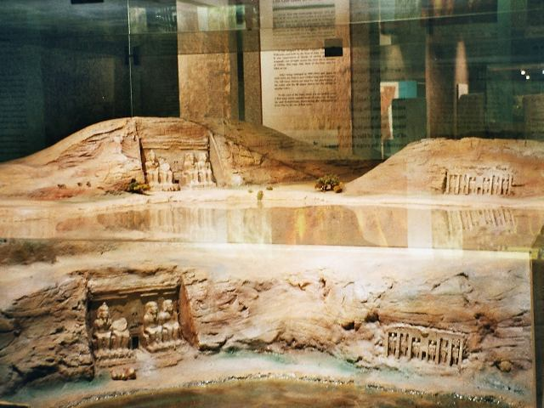
This image has been adapted from ‘Egypt Abu Simbel.03’ by Hajor (2005) is licensed under CC BY-SA 3.0.
This model shows the Abu Simbel temples before they were moved. The temples are carved into the rock beside the Nile River. The lower area around the temples represents land that was later covered by water. This source helps show where the temples were originally located and the environment around them at that time.

Source 2
Figure 2 – model of the Abu Simbel temples in their new location
This image has been adapted from ‘Egypt Abu Simbel.03’ by Hajor (2005) is licensed under CC BY-SA 3.0.
This model shows the Abu Simbel temples after they were moved to a higher location. The temples are still carved into rock but are now positioned further away from the river. This model is part of a museum display and shows how the temples were placed in a new setting to keep them safe. The source helps show how the location of the temples changed over time.

Source 3
Figure 3 – Abu Simbel – work in progress
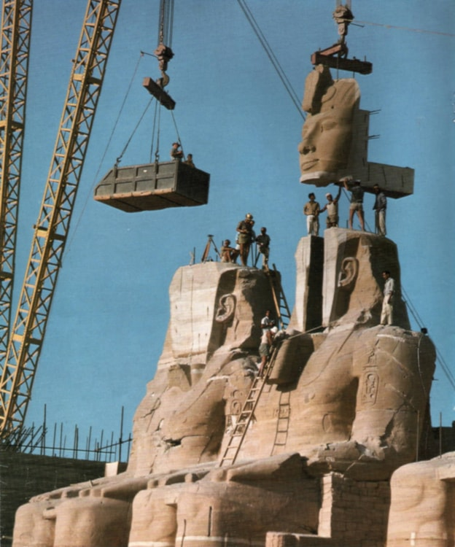
‘Abu Simbel – Work in Progress’ by Per-Olow Andersen is licensed under CC BY-SA 3.0.
This photo shows workers using cranes and large machinery to lift and move a carved section of the Abu Simbel statue. Several workers stand on the statue, guiding the piece. Scaffolding can be seen in the background, along with the machinery used in the work. The image was taken during the project that involved moving parts of the temple.
Source 4
Figure 4 – Abu Simbel – after relocation (2025)
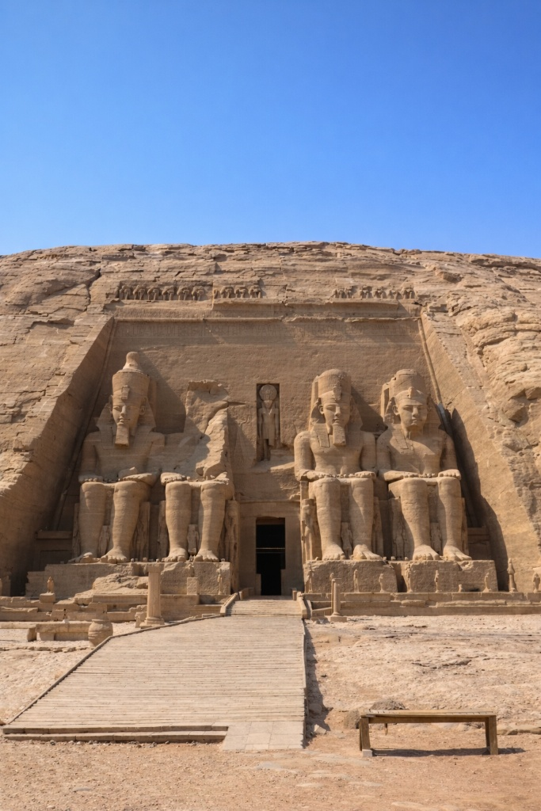
‘Abu Simbel temples, Egypt’ photograph by Cimen Fevzi (2025) is used with permission.
This photo shows the Abu Simbel temples in 2025, in their current location. The front of the temple is carved into a large rock cliff, and the statues appear complete and undamaged. A wide, open area is visible in front of the temple. The temple is now positioned higher than its original location. This source shows what the site looks like today.
Note: providing students with access to the sources approximately 2 weeks prior to the assessment is recommended as a minimum to support familiarisation. Schools and teachers should adjust this timeframe, as appropriate, to suit their local context and student needs.
The suggested breakdown of the lesson is 10 minutes for reading and planning and 50 minutes for writing. Teachers may adjust the timing as required to best support their students and context.

Submission details
Students will complete an in-class written task worth 20 marks.
Students will write 2 source-based paragraphs using evidence from the 4 sources provided and their own knowledge.
Students will have access to the 4 sources 2 weeks prior to the assessment to support familiarisation with the material. The task and paragraph structure will be unseen until the assessment begins.
The task will be completed individually under teacher supervision in a 60-minute lesson, consisting of 10 minutes for reading and planning and 50 minutes for writing.
Note: ensure marking guidelines are removed before distributing the assessment notification to students. If a school’s policy requires marking guidelines to be distributed with the notification, schools should follow their assessment policy.

Marking guidelines
Table 1 – assessment marking guidelines
Grade | Marking guideline descriptors
A | - Demonstrates extensive knowledge and understanding of the steps taken to protect the Abu Simbel temples  - Demonstrates extensive knowledge and understanding of how the Abu Simbel temples are now preserved  - Consistently and effectively uses evidence from all required sources to describe the protection and preservation of the temples, including what has changed over time and what has remained the same  - Communicates ideas in a cohesive, logical and well-organised structure, using precise historical terminology
B | - Demonstrates thorough knowledge and understanding of the steps taken to protect the Abu Simbel temples  - Demonstrates thorough knowledge and understanding of how the Abu Simbel temples are now preserved  - Uses evidence from the required sources effectively to describe the protection and preservation of the temples, including what has changed over time and what has remained the same  - Communicates ideas clearly and logically, using appropriate historical terminology
C | - Demonstrates sound knowledge and understanding of the steps taken to protect the Abu Simbel temples  - Demonstrates sound knowledge and understanding of how the Abu Simbel temples are now preserved  - Uses evidence from some required sources to describe aspects of the protection and preservation of the temples, including some changes over time  - Communicates ideas in a generally clear structure, using some historical terminology
D | - Demonstrates basic knowledge and understanding of the steps taken to protect the Abu Simbel temples  - Demonstrates basic knowledge and understanding of how the Abu Simbel temples are now preserved  - Uses limited or partially accurate evidence from the sources to describe the protection or preservation of the temples, including a basic description of change over time  - Communicates ideas in a simple structure with minimal use of historical terminology and concepts
E | - Demonstrates limited knowledge and understanding of the steps taken to protect the Abu Simbel temples  - Demonstrates limited knowledge and understanding of how the Abu Simbel temples are now preserved  - Attempts to refer to the sources but provides little or no relevant evidence to describe the protection or preservation of the temples, with little reference to change over time  - Communicates ideas with significant difficulties, showing little control of structure or historical terminology and concepts

References
This resource contains NSW Curriculum and syllabus content. The NSW Curriculum is developed by the NSW Education Standards Authority (NESA). This content is prepared by NESA for and on behalf of the Crown in right of the State of New South Wales. The material is protected by Crown copyright.
Please refer to the NESA Copyright Disclaimer for more information https://www.nsw.gov.au/education-and-training/nesa/copyright.
NESA holds the only official and up-to-date versions of the NSW Curriculum and syllabus documents. Please visit NESA https://www.nsw.gov.au/education-and-training/nesa and NSW Curriculum https://curriculum.nsw.edu.au.
History 7–10 Syllabus © NSW Education Standards Authority (NESA) for and on behalf of the Crown in right of the State of New South Wales, 2024.

© State of New South Wales (Department of Education), 2026
The copyright material published in this resource is subject to the Copyright Act 1968 (Cth) and is owned by the NSW Department of Education or, where indicated, by a party other than the NSW Department of Education (third-party material).
Copyright material available in this resource and owned by the NSW Department of Education is licensed under a Creative Commons Attribution 4.0 International (CC BY 4.0) license.

This license allows you to share and adapt the material for any purpose, even commercially.
Attribution should be given to © State of New South Wales (Department of Education), 2026.
Material in this resource not available under a Creative Commons license:
- the NSW Department of Education logo, other logos and trademark-protected material
- material owned by a third party that has been reproduced with permission. You will need to obtain permission from the third party to reuse its material.
Links to third-party material and websites
Please note that the provided (reading/viewing material/list/links/texts) are a suggestion only and implies no endorsement, by the New South Wales Department of Education, of any author, publisher, or book title. School principals and teachers are best placed to assess the suitability of resources that would complement the curriculum and reflect the needs and interests of their students.
If you use the links provided in this document to access a third-party's website, you acknowledge that the terms of use, including licence terms set out on the third-party's website apply to the use which may be made of the materials on that third-party website or where permitted by the Copyright Act 1968 (Cth). The department accepts no responsibility for content on third-party websites.

