Geography (Stage 4) – sample assessment task 1 notification – support material
Landscapes and landforms – Geography
7–10 Syllabus (2024)
Contents
Overview 2
Steps to success 2
Research scaffold 4
Sample research scaffolds 6
Whakaari (White Island), New Zealand sample research scaffold 6
Table 3 reference list 9
Purnululu National Park (Bungle Bungles), Australia sample research scaffold 10
Table 4 reference list 13
Sample written response(s) WAGOLL 14
Question 1 14
Sample A-range submission for Question 1 14
Sample C-range submission for Question 1 15
Question 3 15
Sample A-range submission for Question 3 16
Sample C-range submission for Question 3 17
Stimulus booklet resources 18
References 21

Overview
This resource is designed to support teachers and students when implementing the Geography (Stage 4) – sample assessment task 1 notification – Landscapes and landforms. It should be considered in conjunction with the sample program and sample assessment task 1 for resource context and teaching guidance. This support material:
- provides teacher notes and outlines the steps for success for students attempting sample assessment task 1 notification – Landscapes and landforms
- includes a copy of the research scaffold (see Table 2)
- provides 2 completed samples of the research scaffold (see Table 3 and Table 4) using Whakaari (White Island) and Purnululu National Park (Bungle Bungles). These have been framed for students and are based on the marking guidelines. They can be used to support unpacking the marking criteria with students as part of sharing success criteria.
- includes sample written responses developed using the information from Table 3 and Table 4. Teachers may like to unpack these sample responses alongside the marking criteria during specific phases of the assessment, or as part of a feedback cycle.

Steps to success
Note: this schedule is designed to support students and is not for compliance. Students should not be penalised for not meeting interim times. This scaffold is designed for chunking and sequencing learning by breaking the task into smaller goals to reduce the complexity. The second column could be:
- determined by the teacher
- co-constructed with students.
Table 1 – assessment preparation schedule
What I need to do | When I need to do it
Complete Table 2 | Prior to my in-class pre-test.
Bring completed Table 2 to class | On the day of my in-class pre-test.
Participate to the best of my ability in the pre-test | On the day of my in-class pre-test.
Reflect on the pre-test questions:  - Is there something more you could have included in your first attempt of Table 2?  - What were the tools and skills assessed in the pre-test?  - The creating written text questions will be the same in the post-teach in-class test. Is there any way you can prepare for these questions to be prepared in the next test? | Revisit the questions as I learn new things about landscapes and landforms over the term.
Complete Table 2 a second time | Prior to my in-class post-test.
Bring completed Table 2 to class | On the day of my in-class post-test.
Participate to the best of my ability in the post-test | On the day of my in-class post-test.

Research scaffold
Note: the advice below is framed for students and is based on the marking guidelines. It can be used to support unpacking the marking criteria with students as part of sharing success criteria. Ensure effective feedback practices are used in conjunction with marking guidelines to support student learning. Using effective feedback provides guidance on explicit teaching feedback strategies.
Use Table 2 to guide research for a landscape or landform of your choice. Notes for your research findings should be in summary (dot-point) form.
Table 2 – landscapes and landforms research scaffold
What I need to do | Hints | Research findings
Locate a landscape or landform. | Locate using latitude and longitude coordinates.  Describe the location where the landscape or landform is found (for example, continents, northern or southern hemisphere, country, state or territory, Country or Community).  Include a map to identify the location.
Describe the features of the landscape or landform. | Provide a definition of the landscape or landform using the key features.  What does your landform look like?
Describe the formation of a landscape or landform. | Physical (geomorphic) processes:  - tectonic activity  - weathering, erosion or deposition.
Explain the value and significance of the landscape or landform. | Find examples that explain the following values:  - environmental (for example, what is unique about the ecosystem?)  - economic (for example, is income generated from activities?)  - recreational (for example, what kind of leisure activities take place?)  - cultural (for example, does the landscape or landform have a significant meaning for a particular group?).  Consider how these values may influence the significance of the landscape or landform.
Outline the protection and management of the landscape or landform. | Provide examples of protection at various scales (local, state, national or international levels).  Include examples of the Knowledges and Practices used by Aboriginal Peoples to manage and care for Country.

Sample research scaffolds
Note: the advice below is framed for students and is based on the marking guidelines. It can be used to support unpacking the marking criteria with students as part of sharing success criteria.

Whakaari (White Island), New Zealand sample research scaffold
Table 3 can be used to demonstrate the process of research to students (LISC and WAGOLL).
Table 3 – landscapes and landforms research WAGOLL
What I need to do | Hints | Research findings
Locate a landscape or landform. | Locate using latitude and longitude coordinates.  Describe the location where the landscape or landform is found (for example, continents, northern or southern hemisphere, country, state or territory, Country or Community).  Include a map to identify the location. | Latitude: 37.52° S  Longitude: 177.18° E  Location: located in the Bay of Plenty off the coast of North Island, New Zealand  Continent: Oceania  Hemisphere: Southern Hemisphere  Country: New Zealand  Community: an active volcanic island with cultural significance to the Ngāti Awa iwi  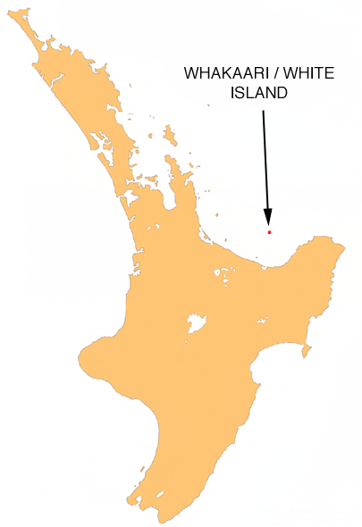  ‘NZ-Whakaari White’ by Moriori is available in the public domain.
Describe the features of the landscape or landform. | Provide a definition of the landscape or landform using the key features.  What does your landform look like? | - Active volcano with a large, steaming crater and sulphur deposits  - Rugged terrain and few plants because the soil is acidic from volcanic gases  - Known for frequent eruptions, gas emissions and hot steam vents  - Bright yellow sulphur deposits give the island its unique appearance
Describe the formation of a landscape or landform. | Physical (geomorphic) processes:  - tectonic activity  - weathering, erosion or deposition. | - Formed by tectonic activity at the boundary where the Pacific plate meets the Indo-Australian plate  - Magma rises from this boundary, causing eruptions and building the volcanic cone  - Eruptions of ash, lava and gases shape the landscape  - Acidic rain from volcanic gases weathers the rocks, giving Whakaari its rugged look  - sulphur deposits and steam vents result from ongoing volcanic activity
Explain the value and significance of the landscape or landform. | Find examples that explain the following values:  - environmental (for example, what is unique about the ecosystem?)  - economic (for example, is income generated from activities?)  - recreational (for example, what kind of leisure activities take place?)  - cultural (for example, does the landscape or landform have a significant meaning for a particular group?)  Consider how these values may influence the significance of the landscape or landform. | - Environmental: important for studying active volcanoes and their effects on nearby ecosystems  - Economic: previously a tourist destination, with visitors generating income for local businesses (now restricted after the 2019 eruption)  - Recreational: known for guided volcano tours and scenic views (limited now for safety)  - Cultural: sacred to the Ngāti Awa iwi, who view the island as an important ancestral site
Outline the protection and management of the landscape or landform. | Provide examples of protection at various scales (local, state, national or international levels).  Include examples of the Knowledges and Practices used by Aboriginal Peoples to manage and care for Country. | - Managed by GNS Science and New Zealand’s Department of Conservation to monitor volcanic activity  - Ngāti Awa iwi are involved in decision-making about the island’s access and preservation  - Tourist access is restricted due to safety concerns, especially after the 2019 eruption  - Ongoing monitoring by global volcanic research institutions helps protect people and the environment

Table 3 reference list
GNS Science (n.d.) ‘Whakaari/White Island’ Volcanic Alert Levels, GeoNet website, accessed 10 January 2025.
Reuters (9 December 2019) ‘New Zealand volcano erupts: 5 killed, about two dozen missing’, International Business Times, accessed 10 January 2025.
Venzke E (ed) (2024) ‘Global Volcanism Program: Whakaari/White Island (241040)’ [Database], Volcanoes of the World (version 5.2.5; 23 Dec 2024), Smithsonian Institute website, accessed 10 January 2025
Wikipedia contributors (11 December 2024) ‘Whakaari / White Island’, Wikipedia, The Free Encyclopedia website, accessed 10 January 2025.

Purnululu National Park (Bungle Bungles), Australia sample research scaffold
Table 4 can be used to demonstrate the process of research to students (LISC and WAGOLL).
Table 4 – landscapes and landforms research WAGOLL
What I need to do | Hints | Research findings
Locate a landscape or landform. | Locate using latitude and longitude coordinates.  Describe the location where the landscape or landform is found (for example, continents, northern or southern hemisphere, country, state or territory, Country or Community).  Include a map to identify the location. | Latitude: 17.4671° S  Longitude: 128.5580° E  Location: Kimberley region of Western Australia  Continent: Australia  Hemisphere: Southern Hemisphere  Country: Australia  Traditional Owners: significant to the Kija and Jaru peoples  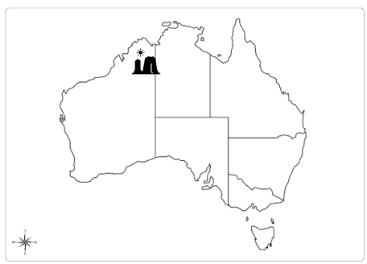
Describe the features of the landscape or landform. | Provide a definition of the landscape or landform using the key features.  What does your landform look like? | - The size is 240,000 hectares  - There are tall, dome-shaped rocks with black and orange stripes  - The domes rise up to 300 meters and look like giant beehives  - The stripes are caused by layers of different materials and bacteria that protect the rock  - Contains cliffs, gorges and small natural pools that fill with water during the rainy season
Describe the formation of a landscape or landform. | Physical (geomorphic) processes:  - tectonic activity  - weathering, erosion or deposition. | - Formed around 350 million years ago from sand and river deposits  - Sand and gravel compacted to form sandstone over time  - Seasonal rains erode the rock, shaping the domes and gorges  - Hot temperatures and moisture weather the rocks into their current shape  - Layers of bacteria and minerals create the black and orange stripes on the surface
Explain the value and significance of the landscape or landform. | Find examples that explain the following values:  - environmental (for example, what is unique about the ecosystem?)  - economic (for example, is income generated from activities?)  - recreational (for example, what kind of leisure activities take place?)  - cultural (for example, does the landscape or landform have a significant meaning for a particular group?)  Consider how these values may influence the significance of the landscape or landform. | - Environmental: unique plants and animals that have adapted to the dry climate (for example, the Northern Nail tail Wallaby)  - Economic: tourism (tours, accommodations and local businesses) – more than 30,000 tourists each year  - Recreational: popular for hiking, camping and scenic helicopter flights over the domes  - Cultural: sacred to the Traditional Owners ( Kija and Jaru peoples), who consider it important in their Dreamtime stories (for example, the Frog and the Brolga)  Significance  - Supports unique species (13 species of spinifex, more than anywhere in Australia and one endemic lizard species, Lerista bungle bungle, a very rare small skink)  - Geological formations provide important information on sedimentary rock formation and erosion processes over millions of years  - Income revenue to local and regional economies supports further investment in conservation  - Indigenous cultural value promotes broader recognition of Aboriginal heritage and strengthens national and international significance
Outline the protection and management of the landscape or landform. | Provide examples of protection at various scales (local, state, national or international levels).  Include examples of the Knowledges and Practices used by Aboriginal Peoples to manage and care for Country. | - Protected within Purnululu National Park by the Western Australian Government  - Recognised as a United Nations Educational, Scientific and Cultural Organization (UNESCO) World Heritage Site (2003), helping to preserve its unique features  - Managed in collaboration with culturally appropriate groups who provide cultural insights  - Access to certain areas is controlled to protect the fragile environment, especially during the wet season

Table 4 reference list
Department of Biodiversity, Conservation and Attractions (n.d.) ‘Purnululu National Park World Heritage area’, World Heritage areas, Government of Western Australia website, accessed 10 January 2025.
Marshall A (29 June 2024) ‘Gija creation story recognised for the first time at World Heritage-listed Purnululu National Park’, ABC (Australian Broadcasting Corporation) News, accessed 10 January 2025.
UNESCO (United Nations Educational, Scientific and Cultural Organization) (n.d.) ‘ Purnululu National Park’, World Heritage List, UNESCO World Heritage Convention website, accessed 10 January 2025.

Sample written response(s) WAGOLL
Sample written responses have been developed using the information from Table 3 and Table 4. Teachers may like to unpack these sample responses alongside the marking criteria during specific phases of the assessment, or as part of a feedback cycle.

Question 1
Select ONE landform or landscape from the list below and explain the physical processes involved in the formation. How have these processes resulted in unique characteristics that make this environment different from other landscapes and landforms?
- Mt Kosciuszko
- Mt Fuji
- Mt Everest
- Machu Picchu (Andes Mountains)
- Mt Kilimanjaro.
Have a discussion with your teacher to add another landform you are familiar with.

Sample A-range submission for Question 1
Whakaari, located in New Zealand’s Bay of Plenty, is an active stratovolcano formed by tectonic processes at the boundary of the Pacific and Indo-Australian plates. At this convergent boundary, the Pacific plate subducts beneath the Indo-Australian plate, creating intense pressure and heat. As the Pacific plate melts, magma forms and rises through cracks in the Earth's crust, eventually erupting at the surface. These frequent eruptions deposit layers of ash and lava, gradually building Whakaari’s cone-shaped landform and giving it a steep, rugged terrain. This process, common in the Pacific Ring of Fire, illustrates how volcanic landscapes are created and continuously reshaped by tectonic forces.
Whakaari’s ongoing volcanic activity has resulted in several unique features that set it apart from other landscapes. Its large central crater emits sulphur dioxide, which gives parts of the island a distinctive yellow colour, contrasting with the dark ash-covered terrain. The acidic gases and sulphur deposits create a harsh environment, leaving the island mostly barren with few plants able to survive. Whakaari’s dynamic landscape is characterised by hot springs and frequent eruption, making it unique among volcanic sites within the Ring of Fire, as similar landforms such as Mt Fuji (see Figure 2) or Mt St. Helens are less continuously active. This distinctive combination of volcanic features, shaped by intense tectonic processes, makes Whakaari a rare and significant landscape.

Sample C-range submission for Question 1
The Bungle Bungles are located in Purnululu National Park in Western Australia. They formed over millions of years because of erosion, weathering and sedimentation. Long ago, rivers carried sand and gravel to this area, where they built up in layers to form sandstone rock. Over time, rain and rivers slowly wore away the sandstone, creating the round formations we see today. The hot temperatures also caused cracks in the rock, which helped shape the domes.
The Bungle Bungles are easily recognised by their orange and black stripes. These stripes are created by different layers of minerals and bacteria. The orange parts contain more silica, while the black stripes are made by a type of bacteria that protects the rock. The rounded shapes and striped colours make the Bungle Bungles very different from other places in Australia, like the steep cliffs in the Blue Mountains. These natural processes make the Bungle Bungles a special and important landscape in Australia.

Question 3
There are 2 parts to this question:
Part A
Explain how different landscapes and landforms are valued.
Part B
Explain how these values influence the protection and management of a landscape or landform.

Sample A-range submission for Question 3

Part A
Landscapes and landforms are valued for various reasons, which contribute to their significance both locally and globally. Purnululu National Park in Western Australia is valued environmentally as a unique geological formation, economically as a tourist destination, recreationally for activities like hiking and scenic flights, and culturally as a sacred site for the Kija and Jaru peoples. These values reflect the distinct features of the Bungle Bungles, such as its striped sandstone domes formed through natural processes of erosion and weathering over millions of years. Similarly, other landscapes, such as Uluru in Australia is considered extremely valuable due to its cultural significance while the Great Barrier Reef is known for its biodiversity, thus demonstrate diverse values based on their unique physical characteristics and human significance.

Part B
The value of landscapes and landforms often influences how they are protected and managed, with environmental, cultural, economic and recreational interests shaping management strategies. In Purnululu National Park, environmental value requires careful conservation to protect its fragile ecosystems and rare sandstone formations, while the cultural significance for the Kija and Jaru peoples calls for respectful preservation of sites associated with the Dreaming. These intersecting values are managed through the national park’s joint management approach, which integrates Indigenous Knowledges and Practices with scientific conservation methods. This helps to ensure that the landscape is preserved, both as a natural wonder and a sacred cultural site.
Differing values can lead to contested management approaches, as seen with Uluru (Figure 3). Uluru’s cultural value to the Anangu people led to restrictions on climbing the rock to respect their traditions. Although Uluru was previously accessible to climbers, this practice conflicted with the cultural values of the Anangu as ongoing custodians of the land. The ban on climbing in 2019 demonstrates how cultural significance can lead to protective policies that better support Indigenous values.
Overall, landscapes and landforms are protected and managed through an understanding of their diverse values. Environmental, cultural and economic interests are interwoven into conservation strategies that vary across different landscapes. When managed thoughtfully, landscapes and landform like the Bungle Bungles and Uluru can be preserved in ways that respect their unique significance, addressing competing or complementary values through collaborative and adaptive management approaches.

Sample C-range submission for Question 3

Part A
Landscapes and landforms are important for different reasons, like their environment, culture, economy and recreation. Whakaari/White Island is valued for its active volcanic activity, which helps scientists learn about how volcanoes work. It is also very important to the Māori people, especially the Ngāti Awa iwi, who consider it a sacred place. Before the eruption in 2019, Whakaari was also important economically because it attracted many tourists who came to visit the volcano. Other places, like Uluru in Australia (Figure 3), are also valued for cultural reasons and as tourist attractions.

Part B
The different values of Whakaari affect how the island is looked after. Because of its importance for science, the island is monitored by experts who watch for volcanic activity and warn people of any danger. The Ngāti Awa iwi, who consider the island sacred, also play a role in making decisions about how it is managed. This means that both the safety of visitors and respect for the culture of the Māori people are important.
Whakaari was also valued as a tourist site, but the 2019 eruption led to stricter rules about visiting the island to keep people safe. Before the eruption, people could visit the volcano on tours, but now, only certain areas are open to tourists to reduce the risks. This shows how Whakaari's different values need to be balanced to protect both the island and the people who visit it.
This example shows how different values need to be considered when managing a landscape or landform like Whakaari. The goal is to protect the environment, respect cultural beliefs and keep people safe while still allowing people to enjoy the place.

Stimulus booklet resources
Teachers may choose to provide a stimulus-based resource similar to the following to prompt student memory for responding to the questions in the test. The stimulus material can be used in both pre- and post-tests.
Figure 1 – Mount Everest (Himalayas), a fold mountain
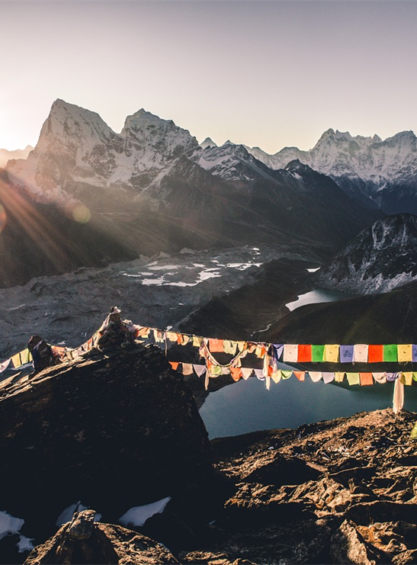
Mt Everest region image by Glorious Himalaya Trekking Pvt Ltd is licensed under Pixabay Content License.
Figure 2 – Mt Fuji (Japan), a stratovolcano
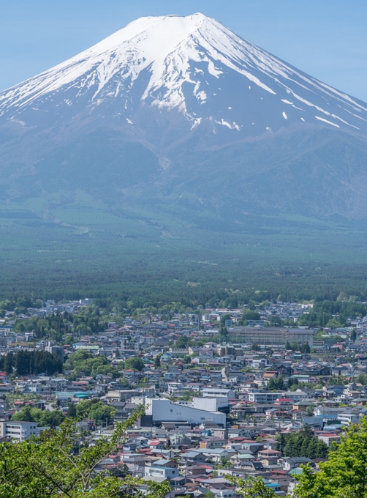
Mt Fuji image by Thanapat Pirmphol is licensed under Pixabay Content License.
Figure 3 – the warning sign at Mala Parking at Uluru
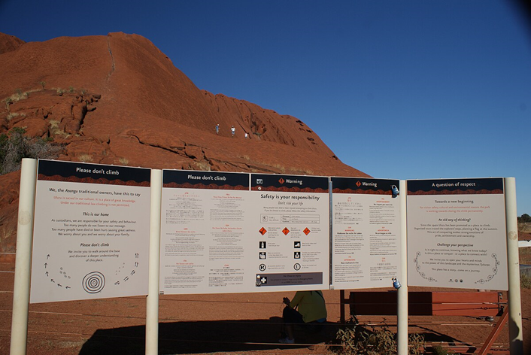
‘The warning sign at Mala Parking at Uluru’ by Maulemon is licensed under CC-BY-SA-4.0.
Figure 4 – Yellowstone National Park, Wyoming, USA
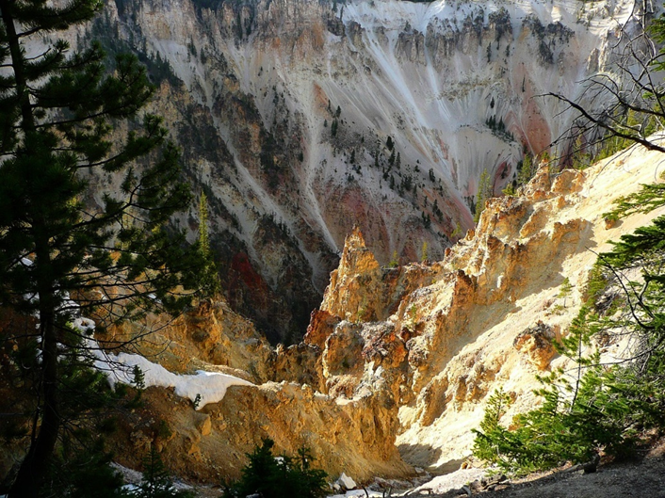
'Yellowstone National Park Canyon' image by ArtTower is licensed under Pixabay Content License.

References
This resource contains NSW Curriculum and syllabus content. The NSW Curriculum is developed by the NSW Education Standards Authority. This content is prepared by NESA for and on behalf of the Crown in right of the State of New South Wales. The material is protected by Crown copyright.
Please refer to the NESA Copyright Disclaimer for more information https://educationstandards.nsw.edu.au/wps/portal/nesa/mini-footer/copyright.
NESA holds the only official and up-to-date versions of the NSW Curriculum and syllabus documents. Please visit the NSW Education Standards Authority (NESA) website https://educationstandards.nsw.edu.au and the NSW Curriculum website https://curriculum.nsw.edu.au.
Geography 7–10 © NSW Education Standards Authority (NESA) for and on behalf of the Crown in right of the State of New South Wales, 2024.
Department of Biodiversity, Conservation and Attractions (n.d.) ‘Purnululu National Park World Heritage area’, World Heritage areas, Government of Western Australia website, accessed 10 January 2025.
GNS Science (n.d.) ‘Whakaari/White Island’ Volcanic Alert Levels, GeoNet website, accessed 10 January 2025.
Marshall A (29 June 2024) ‘Gija creation story recognised for the first time at World Heritage-listed Purnululu National Park’, ABC (Australian Broadcasting Corporation) News, accessed 10 January 2025.
Reuters (9 December 2019) ‘New Zealand volcano erupts: 5 killed, about two dozen missing’, International Business Times, accessed 10 January 2025.
UNESCO (United Nations Educational, Scientific and Cultural Organization) (n.d.) ‘ Purnululu National Park’, World Heritage List, UNESCO World Heritage Convention website, accessed 10 January 2025.
Venzke E (ed) (2024) ‘Global Volcanism Program: Whakaari/White Island (241040)’ [Database], Volcanoes of the World (version 5.2.5; 23 Dec 2024), Smithsonian Institute website, accessed 10 January 2025
Wikipedia contributors (11 December 2024) ‘Whakaari / White Island’, Wikipedia, The Free Encyclopedia website, accessed 10 January 2025.

© State of New South Wales (Department of Education), 2025
The copyright material published in this resource is subject to the Copyright Act 1968 (Cth) and is owned by the NSW Department of Education or, where indicated, by a party other than the NSW Department of Education (third-party material).
Copyright material available in this resource and owned by the NSW Department of Education is licensed under a Creative Commons Attribution 4.0 International (CC BY 4.0) license.

This license allows you to share and adapt the material for any purpose, even commercially.
Attribution should be given to © State of New South Wales (Department of Education), 2025.
Material in this resource not available under a Creative Commons license:
- the NSW Department of Education logo, other logos and trademark-protected material
- material owned by a third party that has been reproduced with permission. You will need to obtain permission from the third party to reuse its material.
Links to third-party material and websites
Please note that the provided (reading/viewing material/list/links/texts) are a suggestion only and implies no endorsement, by the New South Wales Department of Education, of any author, publisher, or book title. School principals and teachers are best placed to assess the suitability of resources that would complement the curriculum and reflect the needs and interests of their students.
If you use the links provided in this document to access a third-party's website, you acknowledge that the terms of use, including licence terms set out on the third-party's website apply to the use which may be made of the materials on that third-party website or where permitted by the Copyright Act 1968 (Cth). The department accepts no responsibility for content on third-party websites.

