Deep dive into the Human Society and its Environment K–6 Syllabus
Participant workbook
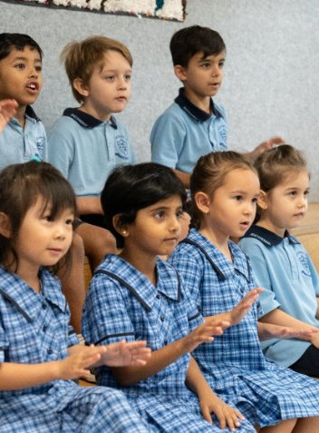
Contents
About this workbook 2
Introduction 2
Explore and evaluate geographical information and historical sources as evidence in the HSIE K–6 Syllabus to draw evidence-based conclusions 3
Learning outcomes 3
Activity 1 – identifying geographical information 4
Activity 2 – using maps and images as geographical information 5
Activity 3 – using the additional teaching advice in history 8
References 11

About this workbook
This workbook is designed to guide your thinking, reflections and plans for future action. Your facilitator will guide you through the activities.
This workbook can be printed double-sided or used digitally.

Introduction
This workshop will support teachers to deepen their understanding of the Human Society and its Environment K–6 (HSIE) Syllabus.
Participants will:
- explore and evaluate geographical information and historical sources as evidence in the HSIE K–6 Syllabus to draw evidence-based conclusions.

Explore and evaluate geographical information and historical sources as evidence in the HSIE K–6 Syllabus to draw evidence-based conclusions
Please use the HSIE K–6 Syllabus to support your learning in this session.

Learning outcomes
By completing this professional learning, you will:
- understand how geographical information is used in the HSIE K–6 Syllabus
- explore historical sources as evidence in the HSIE K–6 Syllabus.

Activity 1 – identifying geographical information
- Locate the geography outcomes and content in the Human Society and its Environment K–6 digital syllabus for one stage.
- Identify all sources of geographical information identified in content points that students are expected to use.
- Record each source listed in the table below. Early Stage 1 has been completed as an example.
Early Stage 1 | Stage 1 | Stage 2 | Stage 3
Dreaming stories and languages
Data displays
Globes
Images
World maps

Activity 2 – using maps and images as geographical information
Match the title and the description from the tables below to the image in the first column on the following pages. You can copy and paste the text into the table.
Name of map or image
Physical map | Choropleth map | Political map | Relief map | Road map
Freight map | Grid map | Oblique aerial image | Satellite image | Vertical aerial image

Description
Shows key freight routes, typically main roads and rails | Shows natural features, for example, oceans and deserts
An aerial image taken from directly above with equal scale | Thematic map, shaded to show quantitative information across regions
Shows human features, for example, state borders | Shows the roads in an area, for example, a street map
Shows variation in the height of land, using colour, shading or pattern | Divided by vertical and horizontal lines, for example, latitude and longitude
Satellite images are images of earth collected by satellites | An aerial image taken at an angle, providing a more 3D perspective

Image | Name | Description
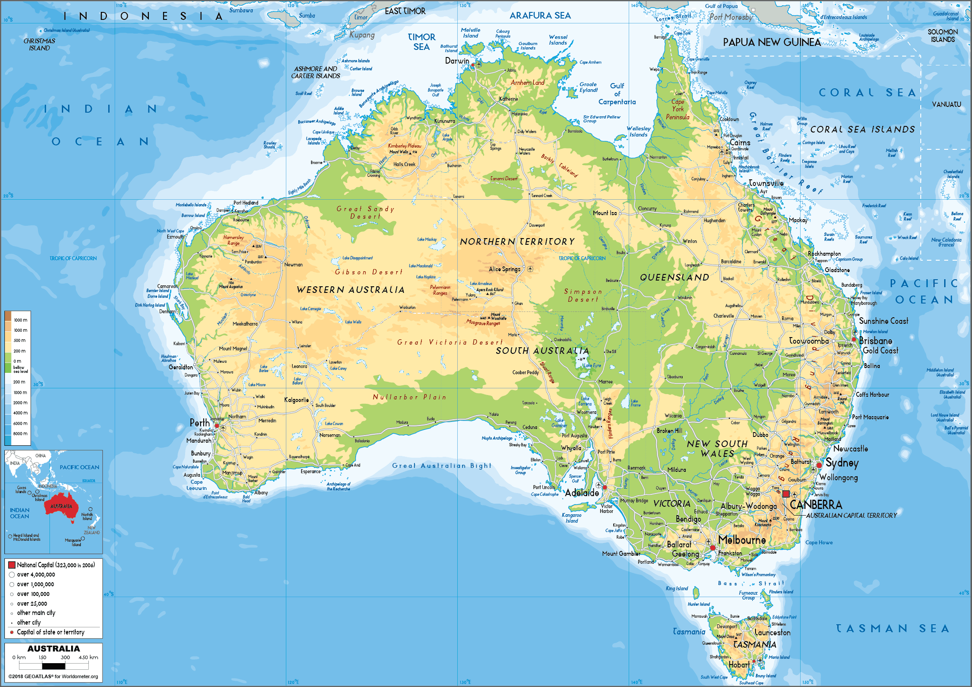
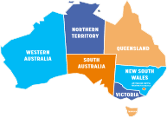
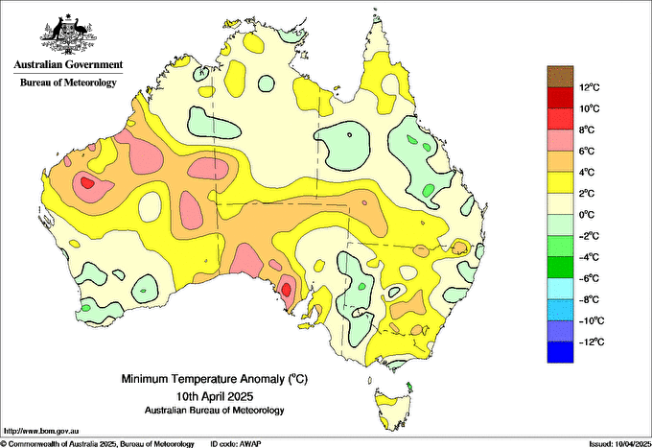
Bureau of Meteorology, © Commonwealth of Australia. Licensed from the Commonwealth of Australia under a Creative Commons Attribution 4.0 International licence
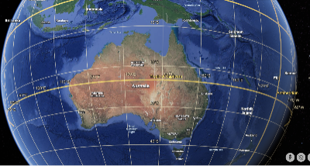
Map data ©2021 Google Earth
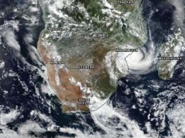
NASA Worldview (2025)
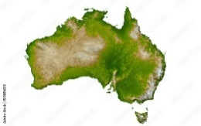
‘Australia relief map’ by M&M Baciu is licensed under Adobe Stock license information.
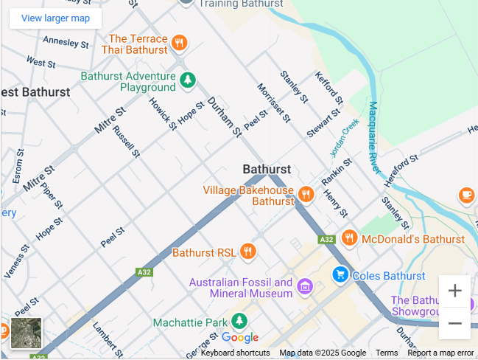
Map data © 2009 Google
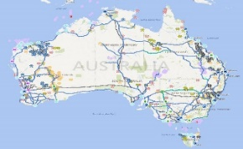
© Commonwealth of Australia
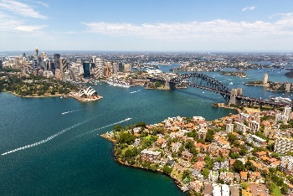
‘Sydney harbour and city aerial image’ by Steve Munro is licensed under Adobe Stock license information.
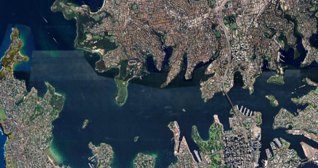
Map data © 2025 Google

Notes

Activity 3 – using the additional teaching advice in history
- Use the Teaching advice (additional) and consider the sources of evidence and ideas that are provided to support teaching the identified content points.
- Reflect on how the teaching advice suggests students acquire, process and communicate information using historical sources and record the ideas in the table on the next page.
HS1-HIS-01 – People use stories, images, objects and sites to understand the ancient past​
- Identify and compare ancient objects from China, Egypt, Greece and Rome
- Identify and describe designs, sites and structures from ancient times that endure today
HS2-HIS-01 – Sources provide evidence of how people lived in the past: Mesoamerica and the Andes
- Locate places identified as ancient Maya, Aztec and Inca civilisations using maps, globes and images
- Identify and describe objects, designs, sites and structures from Mesoamerica and the Andes that endure today
HS3-HIS-01 – People have developed Australia as a nation
- Describe significant events and people that led to Australia becoming a federated nation on 1 January 1901, using sources as evidence
- Describe how and why symbols and emblems connected to Australian identity have changed over time since Federation
Early Stage 1 example
HSE-HIS-01 – People use stories, images and objects to show changes over time
- Compare features of daily life that have changed over time using stories, images and objects
- Describe how transport has changed over time, using stories, images and objects
Acquire:
- Limiting the number of images or objects
- Selecting sources from distinctly different time periods
- Invite guest speakers
Process:
- Compare objects and engage students in discussion
- Encourage careful observation
- Ask and answer questions
Communicate:
- Draw conclusions
- Use prompts. For example, ‘Look closely at the image/object, describe what you see.’ ‘What does this image/object tell us about life now or in the past?’

Stage:
Outcome:
Content group:
Content points:
Acquire:

Process:

Communicate:

Notes:

References
This resource contains NSW Curriculum and syllabus content. The NSW Curriculum is developed by the NSW Education Standards Authority. This content is prepared by NESA for and on behalf of the Crown in right of the State of New South Wales. The material is protected by Crown copyright.
Please refer to the NESA Copyright Disclaimer for more information https://educationstandards.nsw.edu.au/wps/portal/nesa/mini-footer/copyright.
NESA holds the only official and up-to-date versions of the NSW Curriculum and syllabus documents. Please visit the NSW Education Standards Authority (NESA) website https://educationstandards.nsw.edu.au and the NSW Curriculum website https://curriculum.nsw.edu.au.
Human Society and its Environment K–6 Syllabus © NSW Education Standards Authority (NESA) for and on behalf of the Crown in right of the State of New South Wales, 2024.
Carroll K (2020) 'Exploring historical consciousness with Australian school children', Historical Encounters, 7(3):33–47, doi:10.52289/hej7.300.
Commonwealth of Australia 2025, Bureau of Meteorology (n.d.) Bureau of Meteorology [website], accessed 14 May 2025.
Commonwealth of Australia (n.d.) ‘Freight & supply chains’, Infrastructure, transport & vehicles, Australian Government Department of Infrastructure, Transport, Regional Development, Communications, Sports and the Arts website, accessed 14 May 2025.
Google (2021) Google Earth [website], accessed 16 May 2025.
——(2009) Google Maps [website], accessed 14 May 2025.
Ofsted (Office for Standards in Education, Children's Services and Skills) (29 April 2021) Research review series: science, Gov.UK, accessed 8 May 2025.
NASA (National Aeronautics and Space Administration) (2013–2025) NASA Worldview: Explore Your Dynamic Planet [website], accessed 15 May 2025.

© State of New South Wales (Department of Education), 2025
The copyright material published in this resource is subject to the Copyright Act 1968 (Cth) and is owned by the NSW Department of Education or, where indicated, by a party other than the NSW Department of Education (third-party material).
Copyright material available in this resource and owned by the NSW Department of Education is licensed under a Creative Commons Attribution 4.0 International (CC BY 4.0) license.

This license allows you to share and adapt the material for any purpose, even commercially.
Attribution should be given to © State of New South Wales (Department of Education), 2025.
Material in this resource not available under a Creative Commons license:
- the NSW Department of Education logo, other logos and trademark-protected material
- material owned by a third party that has been reproduced with permission. You will need to obtain permission from the third party to reuse its material.
Links to third-party material and websites
Please note that the provided (reading/viewing material/list/links/texts) are a suggestion only and implies no endorsement, by the New South Wales Department of Education, of any author, publisher, or book title. School principals and teachers are best placed to assess the suitability of resources that would complement the curriculum and reflect the needs and interests of their students.
If you use the links provided in this document to access a third-party's website, you acknowledge that the terms of use, including licence terms set out on the third-party's website apply to the use which may be made of the materials on that third-party website or where permitted by the Copyright Act 1968 (Cth). The department accepts no responsibility for content on third-party websites.

