History elective (Years 7–10) – sample assessment task notification
Topic 1: History, Heritage and Archaeology – History Elective Years 7–10 Syllabus (2019)

Contents
Overview 2
Assessment task – underwater archaeology inquiry 3
Outcomes 3
Content 3
Task description 3
Submission details 5
Marking guidelines 6
Support documentation 8
Historical inquiry process 8
Peer feedback scaffold 9
Sample annotation 11
References 12

Overview
This assessment task is designed for use during implementation of the learning sequence Underwater archaeology – Topic 1: History, Heritage and Archaeology. It should be considered in conjunction with the sample learning sequence and related resources.
This resource has been designed to support teachers by providing a range of tasks based on syllabus content and can be modified to suit individual school contexts and procedures as required.

Assessment task – underwater archaeology inquiry
Type of task: Inquiry-based research and presentation
Suggested weighting: 25%

Outcomes
A student:
- HTE5-1 applies an understanding of history, heritage, archaeology and the methods of historical inquiry
- HTE5-6 identifies and evaluates the usefulness of historical sources in an historical inquiry process
- HTE5-8 selects and analyses a range of historical sources to locate information relevant to an historical inquiry
History Elective Years 7–10 Syllabus © NSW Education Standards Authority (NESA) for and on behalf of the Crown in right of the State of New South Wales, 2019.

Content
Topic 1: History, Heritage and Archaeology
Issues related to the study of the past
Students:
- identify and examine the various means of collecting sources, displaying the past and reconstructing the past

Task description
Conduct an historical inquiry examining how an underwater archaeological site of your choosing has supported reconstruction of the past.
The inquiry must address:
- how the site was found
- key sources discovered at the site
- ways these sources have been useful for reconstructing the past.
The selected underwater archaeological site needs to be negotiated with your teacher prior to commencing the inquiry. Appropriate sites include:
- Murujuga
- Thonis-Heracleion
- Ulu Burun
- Ming Dynasty shipwrecks in the South China Sea
- Lost city of Kane
- Pavlopetri
- Kublai Khan’s lost fleet.
The Titanic site is not permitted due to the extent it is addressed in class.
You will communicate your findings and an overview of your historical inquiry process in a format of your choosing. Suggested formats are:
- multi-modal presentation
- video
- written report
- podcast
- website.
Feedback on your presentation will be provided by your peers and the teacher.
You must include a reference list using a consistent referencing style, such as APA or Harvard. You need to annotate 3 sources. Each annotation should address the usefulness of the source for your inquiry in a maximum of 150 words.

Submission details
Students can complete this task individually or in small groups. Follow school procedures for late assessment task submissions. Adjustments should be made to ensure students with disability can access the task. A peer marking scaffold is included in the student support material.
Note: providing students with a model submission and completing a WAGOLL reflection prior to the task is recommended as effective assessment practice. The WAGOLL reflection can also be used for student self-assessment prior to submission.
Guidance on effective group work, including delegating tasks and time management, should be provided if completing the task in groups.
Providing students access to an online reference generator, such as MyBib or Cite This For Me, is recommended to support referencing in this task.

Marking guidelines
These marking guidelines align with Course performance descriptors for History Elective Years 7–10 (2019).
Table 1 – assessment marking guidelines
Grade | Marking guideline descriptors
A | - Comprehensively applies the historical inquiry process to investigate an appropriate underwater archaeological site  - Analyses a wide range of relevant historical sources to gather information for the historical inquiry  - Demonstrates extensive understanding of how historical meaning can be constructed through underwater archaeology  - Evaluates the usefulness of 3 sources used in the historical inquiry
B | - Effectively applies the historical inquiry process to investigate an appropriate underwater archaeological site  - Analyses a range of relevant historical sources to gather information for the historical inquiry  - Demonstrates strong understanding of how historical meaning can be constructed through underwater archaeology  - Assesses the usefulness of 3 sources used in the historical inquiry
C | - Applies the historical inquiry process to investigate an underwater archaeological site  - Organises relevant information from a number of sources to undertake historical inquiry  - Demonstrates sound understanding of how historical meaning can be constructed through underwater archaeology  - Identifies ways 3 sources were useful for the historical inquiry
D | - Attempts to use the historical inquiry process  - Locates relevant information from sources to answer historical questions  - Demonstrates basic understanding of how historical meaning can be constructed  - Identifies sources that were useful for the historical inquiry
E | - Exhibits limited use of the historical inquiry process  - Locates information from sources  - Demonstrates elementary understanding of how historical meaning can be constructed  - May identify useful sources for the historical inquiry

Support documentation
This documentation is designed to support teachers with implementing the assessment task.

Historical inquiry process
Figure 1 – historical inquiry process
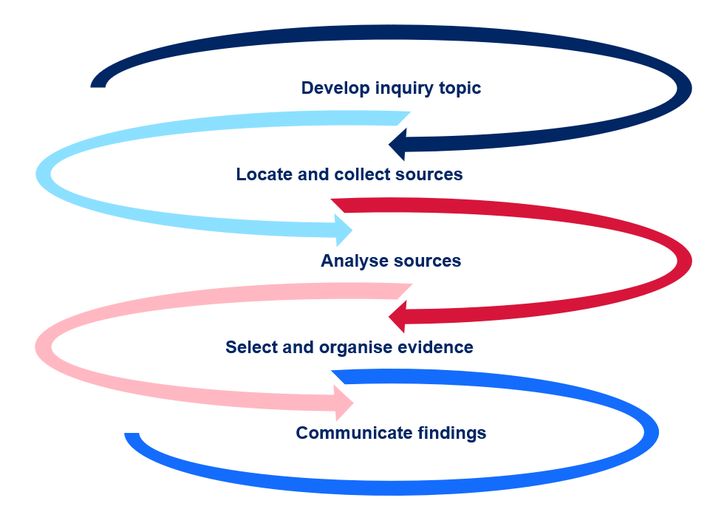

Peer feedback scaffold
Note: the success criteria should be developed through a class brainstorm using the task description and marking guidelines. Introducing student peer assessment provides further guidance on using peer assessment effectively.
Provide feedback for each success criteria. Sentence starters are provided in Table 3. Colour the stars to indicate a rating for the presentation against each criteria.
Table 2 – peer feedback scaffold
Success criteria | Rating
- [insert criteria]  Feedback: | ☆☆☆☆☆
- [insert criteria]  Feedback: | ☆☆☆☆☆
- [insert criteria]  Feedback: | ☆☆☆☆☆
- [insert criteria]  Feedback: | ☆☆☆☆☆

Table 3 – feedback starters
What went well | Even better if
- You did a good job when …  - I like the way you …  - Something you did well was …  - It was interesting when you …  - What really stood out was …  - The best bit was …  - I learned a lot from …  - You put a lot of thought into … | - Have you considered …  - You could seek help with …  - This could be better if you added …  - It was unclear to me when you …  - It may be more useful to …  - I’d like to see more of …  - Next time you could …  - I’d like to learn more about …

Sample annotation
Reuters/AFP (18 May 2023) Titanic shipwreck visualised on the seabed for first time in 3D scan, ABC News, accessed 13 September 2023.
This source was useful for my inquiry because it described the process used to digitally excavate the Titanic. It provided specific details including the names of the submersibles and the 16 terabytes of data collected.
This source could have been more useful if it included how this digital reconstruction has changed our understanding of the Titanic sinking. I had to conduct further research in this area.
A reliability issue of this source is it does not have an author’s name. ABC News is a trusted website, however, the lack of attribution to an author makes it difficult to assess potential bias in the source.

References
This resource contains NSW Curriculum and syllabus content. The NSW Curriculum is developed by the NSW Education Standards Authority. This content is prepared by NESA for and on behalf of the Crown in right of the State of New South Wales. The material is protected by Crown copyright.
Please refer to the NESA Copyright Disclaimer for more information https://educationstandards.nsw.edu.au/wps/portal/nesa/mini-footer/copyright.
NESA holds the only official and up-to-date versions of the NSW Curriculum and syllabus documents. Please visit the NSW Education Standards Authority (NESA) website https://educationstandards.nsw.edu.au and the NSW Curriculum website https://curriculum.nsw.edu.au.
History Elective Years 7–10 Syllabus © NSW Education Standards Authority (NESA) for and on behalf of the Crown in right of the State of New South Wales, 2019.
Chegg Inc. (n.d.) Cite This For Me [website], accessed 13 September 2023.
GitHub (n.d.) MyBib [website], accessed 13 September 2023.
NESA (NSW Education Standards Authority) (n.d.) ‘Adjustments’, Diversity in learning, NESA website, accessed 13 September 2023.
NESA (n.d.) ‘Course performance descriptors for History Elective Years History Elective 7–10 (2019)’, History Elective 7–10, NESA website, accessed 13 September 2023.
NESA (2022) ‘Proficient Teacher Standard Descriptors’, The Standards, NESA website, accessed 13 September 2023.
Reuters/AFP (18 May 2023) Titanic shipwreck visualised on the seabed for first time in 3D scan, ABC News, accessed 13 September 2023.
State of New South Wales (Department of Education) (2023) Digital Learning Selector, NSW Department of Education website, accessed 13 September 2023.

© State of New South Wales (Department of Education), 2025
The copyright material published in this resource is subject to the Copyright Act 1968 (Cth) and is owned by the NSW Department of Education or, where indicated, by a party other than the NSW Department of Education (third-party material).
Copyright material available in this resource and owned by the NSW Department of Education is licensed under a Creative Commons Attribution 4.0 International (CC BY 4.0) license.

This license allows you to share and adapt the material for any purpose, even commercially.
Attribution should be given to © State of New South Wales (Department of Education), 2025.
Material in this resource not available under a Creative Commons license:
- the NSW Department of Education logo, other logos and trademark-protected material
- material owned by a third party that has been reproduced with permission. You will need to obtain permission from the third party to reuse its material.
Links to third-party material and websites
Please note that the provided (reading/viewing material/list/links/texts) are a suggestion only and implies no endorsement, by the New South Wales Department of Education, of any author, publisher, or book title. School principals and teachers are best placed to assess the suitability of resources that would complement the curriculum and reflect the needs and interests of their students.
If you use the links provided in this document to access a third-party's website, you acknowledge that the terms of use, including licence terms set out on the third-party's website apply to the use which may be made of the materials on that third-party website or where permitted by the Copyright Act 1968 (Cth). The department accepts no responsibility for content on third-party websites.

