Geography (Stage 4) – sample program of learning
Liveability of places – Geography 7–10 Syllabus (2024)

Contents
Overview 3
Planning considerations 3
Suggested timeframe 4
Outcomes 4
Learning sequence 1 – perceptions of liveability 5
Learning sequence 2 – influences and impacts of liveability 38
Learning sequence 3 – enhancing liveability 71
Appendix 1 – capacity matrix 83
Appendix 2 – Think-Pair-Share WAGOLL 86
Appendix 3 – land use map WAGOLL 87
Appendix 4 – living in Casino, NSW WAGOLL 88
Appendix 5 – marking criteria stand-alone assessment 89
Teacher instructions 90
Appendix 6 – Edging Valley map 98
Appendix 7 – challenges of living in megacities (WATCHES) 99
Appendix 8 – Paceworth map 100
Appendix 9 – Dreamouth Siding map 101
Appendix 10 – vocabulary self-assessment 102
Appendix 11 – connecting terms 103
Overall program evaluation 105
References 106

Overview
This sample program of learning addresses Liveability of places. The activities are designed to allow students to apply geographical concepts and use relevant geographical tools to engage in geographical inquiry explaining the liveability of places. Additional support for this program, including sample teaching resources, is available on Planning, programming and assessing geography 7–10 (2024). Throughout the program, reference has been made to the use of specific geographical skills and tools (videos and resources) found on the department’s webpage. These skills have varying levels of complexity and teachers should ensure they are using explicit teaching strategies, such as check for understanding and gradual release of responsibility, to support student understanding and application when thinking and working geographically.

Planning considerations
Consider the Universal Design for Learning principles of engagement, representation and expression in conjunction with this sample program of learning when planning for teaching and learning.
Suggested learning intentions and success criteria have been provided to demonstrate how they may be written. Learning intentions and success criteria are most effective when they are contextualised to meet the needs of students. Teachers may edit those provided and can write and use additional learning intentions and success criteria. Learning intentions and success criteria are both an explicit teaching and formative assessment strategy.
Program registration and evaluation supports enhanced student outcomes. Evaluation is an important, ongoing part of the programming cycle and must be considered before program implementation. Evaluating teaching and learning programs for HSIE 7–12 provides advice to support this process. Ensure registrations and evaluations are in line with school procedures, department policies and NESA requirements.

Suggested timeframe
This sample program of learning is designed to be completed over a period of approximately 10 weeks in 60-minute lesson sequences. This duration can be adapted to suit the school context.

Outcomes
A student:
- GE4-DFC-01 locates the diverse features and describes the characteristics of a range of places and environments
- GE4-PRI-01 explains the processes and interactions that change people, places and environments
- GE4-PER-01 examines and describes the perspectives of people and organisations on a range of geographical issues
- GE4-MAN-01 explains the management and protection of places and environments
- GE4-APC-01 explains Aboriginal Peoples’ Custodianship, care and management of Country
- GE4-TAP-01 selects and uses geographical tools to acquire and process geographical information
- GE4-COM-01 uses concepts and terminology to communicate geographical information for a range of purposes, audiences and contexts
Geography 7–10 Syllabus © NSW Education Standards Authority (NESA) for and on behalf of the Crown in right of the State of New South Wales, 2024.

Learning sequence 1 – perceptions of liveability
The following learning sequence is designed to be completed in approximately 18 hours. It aligns to Term 2 Weeks 1–5 in the Geography Stage 4 scope and sequence.
Table 1 – Learning sequence 1 details
Outcomes and content | Teaching and learning activities | Registration
Outcome  GE4-DFC-01, GE4-PRI-01, GE4-PER-01, GE4-MAN-01, GE4-APC-01, GE4-TAP-01, GE4-COM-01  Content  Perceptions of liveability  - Environmental, social, economic and political factors that affect the liveability of places  - Diverse experiences and different perceptions of the liveability of places  - Methods used to measure, assess or rank liveability  Geographical tools  Maps:  Identify key features on a map using cartographic conventions  Identify physical and human features on a map  Identify spatial patterns using a range of maps  Use a range of large-scale and small-scale maps  Determine direction using a 16-point compass  Locate features on a map using latitude and longitude coordinates in degrees  Locate features on a map using area and grid references  Measure distances on a map using a linear scale  Fieldwork:  Develop geographical questions and plan an inquiry  Identify, collect and record geographical information  Develop and conduct surveys and interviews  Use fieldwork tools to collect geographical information  Draw conclusions from the data collected  Reflect on the fieldwork study  Data and graphs:  Construct and interpret data tables and graphs  Use a range of graphs and tables  Spatial technologies: Interpret geographical information using a range of spatial technologies  Describe land use of an area using virtual or digital maps  Identify the latitude, longitude and altitude of locations using relevant spatial technologies  Determine connections, impacts and change to places using virtual or digital maps and satellite images  Additional geographical representations:  Interpret photographs and satellite images to determine how a place has changed over time  Document experiences of places and spaces using photographs  Identify and describe spatial patterns and changes using a variety of geographical representations  Geographical concepts:  - Interconnection  - Scale | Learning intentions  Students learn about:  - the environmental, social, economic and political factors that affect liveability to understand how these factors influence the movement of people  - diverse experiences and perceptions of liveability to understand that people experience and perceive the liveability of places differently based on their individual and community contexts  - how liveability can be measured, assessed or ranked to understand the methods used to assess and compare liveability  - the influence of social, cultural and community connections, and access to services and facilities to understand how connections with others and access to services and facilities contribute to the liveability of places.  Success criteria  Students will be able to:  - explain the meaning of liveability and describe how different factors influence it  - identify and interpret geographical tools (for example, maps, graphs, interviews) to investigate liveability  - examine how perceptions of liveability differ among individuals and groups  - use appropriate geographical terminology and tools to communicate findings about liveability.  Teaching and learning activity – Lesson 1  Note: teachers can access the Resource booklet on the Planning, programming and assessing geography 7–10 (2024) webpage.  Student resource booklet activities 1.1.1, 1.1.2, 1.1.3.  Note: this resource includes topics that may be considered controversial or sensitive. Teachers are to respect the diverse views and experiences of all students and approach discussions in a manner that is impartial, free from harassment and discrimination, supportive of students’ wellbeing needs and aligned with the department’s Professional and ethical standards, Anti-racism, Controversial issues in schools procedures, and Values in NSW public schools. Teachers should facilitate rational discourse and objective study while tailoring the content to meet the unique needs of their students.  Students will require sticky notes for the following learning activity.  Instruct students that they will be timed for 3 minutes. Students identify thoughts on the perfect place to live. As they write their ideas they call out and throw down the sticky note. The students can not repeat an idea that has already been thrown down. Instruct the class to organise the sticky notes under categories of environmental, social, economic and political.  Note: support the discussion with the following prompt examples: walkability, parks and access to public transport.  Display images of the world’s most liveable cities The world’s most liveable cities for 2025 - and what it’s really like to live there and lead a class discussion answering the question: ‘What are some of the characteristics you might observe in one of the world’s most liveable cities?’ Have the students use the definition of liveability from the syllabus Glossary to generate a visual representation of the term.  Note: there are a variety of ways Appendix 1 – capacity matrix could be applied in the program. Teachers may allow students to monitor their own understanding, draw student attention to the matrix at relevant times or provide a blank matrix and have students add the terms as they progress through the focus area. Teachers need to clarify how the matrix will be used with the class.  Explain the purpose and how to use Appendix 1 – capacity matrix for Liveability of places.  Use Connecting learning to activate prior knowledge of mapping conventions (BOLTSS) and latitude and longitude through a short quiz.  - What does the acronym BOLTSS stand for?  - What are the imaginary parallel lines that run east to west around the world on maps called?  - What are the imaginary lines that run north to south around the world on maps called?  - Which is always recorded first? Latitude or longitude?  - What is the tip to remember this?  Answers: Q1: Border, orientation, legend, title, scale and source. Q2: Lines of latitude. Q3: Lines of longitude. Q4: Lines of latitude. Q5: Latitude is always recorded first because we follow the rule of alphabetical order in geography ‘la’ before ‘lo’.  Reteach where required using BOLTSS and scale video (4:06), Latitude and longitude video (4:24) or Slide deck 3 – Landscapes and landforms.  Identify for the class the categories the Economist Intelligence Unit (EIU) use to measure and rank liveability (stability, healthcare, culture and environment, education and infrastructure).  Students locate and label the world’s most liveable cities (Activity 1.1.3).  Students complete an Exit ticket answering the following questions:  - The assessment of the quality of a place is called …  - Three examples of the world’s most liveable cities include …  - The EUI rank cities in the world based on their …  - Australian cities often rank well for liveability because …  Exit ticket answers:  Q1: Liveability.  Q2: Refer to list from table.  Q3: Stability, healthcare, culture and environment, education and infrastructure.  Q4: Australia has a high standard of living with very high healthcare and education systems.  Teaching and learning activity – Lesson 2  Student resource booklet activities 1.2.1, 1.2.2.  Note: teachers may consider using the Maps used in geography Pre and post assessments to assess student prior knowledge of types of maps used in Geography prior to commencing the following activities. Geographical tools such as maps, help students to visualise and analyse the spatial distribution of services, facilities and environmental features that influence how liveable a place is. By using maps, students can identify patterns and inequalities in access that shape people’s experiences of liveability.  Activate prior knowledge Connecting learning through teacher-led short response questions.  - What types of maps are commonly used in geography? Possible answers – topographic maps, weather maps (synoptic charts), choropleth maps.  - What are mapping conventions? Prompt question: What features must exist on all maps? Answer – BOLTSS.  Reteach where required using Introduction to maps video (3:39) and BOLTSS and scale video (4:06).  Note: teachers will need to provide students with an example of maps commonly used in geography. You may wish to include examples of physical, political, gazetteer, street directory, topographic, thematic, choropleth, dot and synoptic. The classroom will require grouped working stations for this activity. At each station place a different type of map. Have students regularly move to another station and record features of the different types of maps.  Working through each workstation students note the key features of the different types of maps. Have students identify and highlight the map type(s) best suited to showing liveability factors (environmental, social, economic and political).  Note: teachers use Slide deck 1 – Liveability of places, which can be found on the Planning, programming and assessing geography 7–10 (2024) webpage, at this stage in the learning sequence. Access Dot Maps: Map Design with Dots for further explanation of dot maps. The following supports the National Numeracy Progression (IRD) – IRD3 and IRD4.  Students complete Activity 1.2.2 in the Resource booklet.  Activity 1.2.2 answers:  Q1: There are dots showing the distribution of people (phenomenon).  Q2: Missing border, orientation, title and scale.  Q3: 1,000.  Q4: In capital cities and along the eastern coastline.  Q5: The centre of Australia is isolated and arid, coastal areas have plenty of rainfall, access to facilities such as hospitals and schools.  Teaching and learning activity – Lesson 3  Note: teachers might like to access Area and grid reference, geography 7–10 and Area and grid reference video (3:32) for more examples and instructions for teaching area and grid reference. The following learning activities focus on using area reference to locate places on a map. Teachers may consider using the Area reference Pre and post assessments to assess student prior knowledge of mapping prior to commencing the follow activities. The following supports the National Numeracy Progression (POL) – POL4.  Student resource booklet activities 1.3.1, 1.3.2, 1.3.3, 1.3.4.  Note: Bundjalung language is used in Resource booklet. The Bundjalung nation occupies land from north-east NSW to south-east Queensland. The NSW AECG Languages App contains all words used in the map. Permission to use the traditional Bundjalung language was sought and approved by the NSW Aboriginal Education Consultative Group (AECG).  A universal method of describing an exact location on the earth, is by giving coordinates of latitude and longitude. When working from maps, especially of a small area, this can be very inconvenient and prone to error. The lines of latitude and longitude are usually marked at the edges of maps. The system is awkward when it comes to a precise location, because degrees of latitude and longitude are divided up into 1/60ths (minutes) and again into 1/60ths (seconds). For maps on a scale of 1:250,000 down to 1:25,000, the common system is to mark the whole map with a grid of squares, using horizontal and vertical grid lines at equal intervals. The intervals are chosen to suit the scale of the map. The following supports the National Numeracy Progression (POL) – POL5.  Read aloud to the class: ‘Area reference is used when we want to describe the general location of a place on a map. Area reference has 4 digits. The first 2 digits are the numbers for the easting. The last 2 digits are the numbers for the northing.’ Use Slide deck 2 – Liveability of places at this point in the learning sequence to complete a Gradual release of responsibility exercise modelling ‘I do, we do, you do’ for area and grid reference.  Note: return to Slide deck 1 Planning, programming and assessing geography 7–10 (2024) at this point in the program. You may need to clarify the term proximity for students. The following supports the National Literacy Progression UnT8.  Students use data to construct a dot map for Edging Valley School (Activity 1.3.3). Students use the map to answer the question: ‘Where do most Edging Valley School students live?’  Define and describe the concept ‘spatial patterns’ from the Glossary for the class. Students record the definition of the concept ‘spatial patterns’ in their notes. Students Think-Pair-Share their observations of the spatial patterns of Edging Valley School students.  Revisit the dot map of Australia in Slide deck 1 – Liveability of places. Think-Pair-Share the following questions:  - Where do most Australians live?  - Suggest reasons why Australians live in densely populated regions.  Teaching and learning activity – Lesson 4  Student resource booklet activities 1.4.1, 1.4.2, 1.4.3.  Note: teachers might like to outline Assessment task notification 2 – Liveability of places at this stage in the learning sequence which can be found on the Planning, programming and assessing geography 7–10 (2024) webpage.  Display Figure 1 and have students complete Activity 1.4.1 in the Resource booklet.  Figure 1 – factors that affect liveability  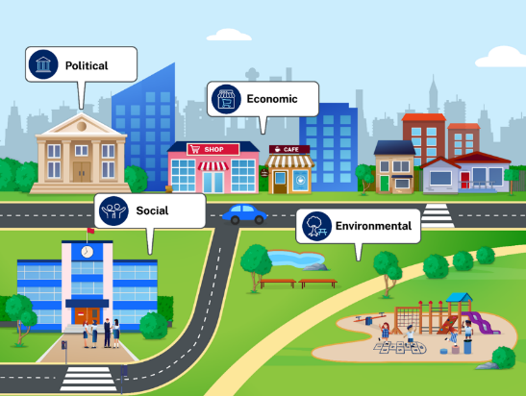  Note: teachers may use Appendix 2 – Think-Pair-Share WAGOLL to prompt student responses.  Students Think-Pair-Share examples that can be applied to liveability environmental, social, economic and political factors (Activity 1.4.1).  Lead a class discussion answering the question: ‘Which type of map would best illustrate the factors that influence liveability in your town, suburb or city?’ Students may need to refer to the Table in Activity 1.2.1 they developed in Lesson 2.  Discussion possible answer: a thematic map. A land use map is a thematic map that focuses on the distribution and patterns of different land uses in an area. Thematic maps use colours, symbols or shading to represent different land use categories, such as recreational, residential or commercial land use.  Note: teachers may consider fieldwork at this point in the learning sequence and conduct a land use survey of the area surrounding the school or local central business district. Access Excursions and variations of routine for direction and guidance on planning and managing excursions, including incursions and other variations of routine.  Have students use the table in Activity 1.4.1 to highlight the factors that contribute to liveability in their town, suburb or city. Students respond to the question: ‘What factors might have influenced your carers’ choice to live where you do?’  Note: students will require access to computers and Google Maps My Maps to complete the following activity. Teachers may consider the Gradual release of responsibility exercise modelling ‘I do, we do, you do’ structure or stages they want to target when developing a land use map using Google Maps. Use Appendix 3 – land use map WAGOLL to demonstrate the characteristics of an effective land use map. The following supports the National Numeracy Progression PoL3 and IrD3 and National Literacy Progression CrT9 and CrT10.  Engage with How to create a Land Use Survey on Google Maps (6:58). Students develop a land use map of a local town, suburb or city (Activity 1.4.2). In 2 to 3 paragraphs students identify and describe the benefits of living in the suburb, town or city. Use Appendix 4 – living in Casino, NSW WAGOLL to support student responses.  Teaching and learning activity – Lesson 5  Note: this resource addresses topics that might be considered controversial or sensitive. Follow school protocols and Controversial issues in schools procedures when using these resources.  Student resource booklet activities 1.5.1, 1.5.2, 1.5.3, 1.5.4, 1.5.5.  Note: teachers may need to prompt the questions in the See, Think, Wonder routine. Ensure students are only describing what they are observing, for example, a house with a corrugated iron roof. Then ask ‘What else is going on here?’ or ‘What do you see that makes you say that?’. At this point students are needing to articulate what else they need to know or are interested in. The following supports the National Literacy Progression UnT8, UnT9 and CrT8.  Conduct a See, Think, Wonder routine using photographs. Ask students: ‘Where would you prefer to live? Explain why.’  Explain to the class that both images were taken in Port Villa, Vanuatu. Lead a discussion asking the question: ‘How can liveability in a place vary for different people?’  Teachers extend the discussion to include the concept of human wellbeing Glossary. When the quality of life of a population is affected by liveability factors in a negative way human wellbeing can be impacted. Have students work with a partner to complete a Frayer diagram (Activity 1.5.2) for the concept human wellbeing.  Allocate students to work in small groups to research factors that affect liveability. Students complete a table summarising factors that affect liveability (Activity 1.5.3).  Students use the table their group produced for ‘Factors that affect liveability’ to identify:  - factors that would make people want to move away from a place  - factors that would make people want to move to a place.  Engage with Push and Pull factors as drivers of migration (2:56). Have students use an Affinity diagram to organise factors of liveability under 2 headings ‘Push’ and ‘Pull’ (Activity 1.5.4).  Note: the following writing assessment can be accessed through MS Forms SA133 - Geography - Writing about characteristics of liveability. The link in Appendix 5 – marking criteria stand-alone assessment offers advice on teacher-led feedback, peer feedback or self-assessment, and teacher marking and includes a sample marking rubric. The following supports the National Literacy Progression CrT8 and CrT9. Students complete a writing assessment SA133 - Geography - Writing about characteristics of liveability. Responding to the prompt: ‘Define liveability and describe characteristics of liveability you have studied.’  Teaching and learning activity – Lesson 6  Student resource booklet activities 1.6.1, 1.6.2, 1.6.3, 1.6.4, 1.6.5.  Note: this lesson has been adapted from the Data 1 teacher resource. The full resource includes learning sequence materials and resources, illustrations of practice, teaching advice and assessment opportunities. This following supports the National Numeracy Learning Progression – Interpreting and representing data (IRD) – IRD3, IRD4 and IRD5.  Teachers may choose to engage with Online assessment Numeracy - Data prior to commencing the following learning activities, during the learning activities as a check for understanding or at the conclusion of Lesson 7 as a summative assessment tool.  Navigate through Activity 1.6.1 and 1.6.2 – Types of data using the Background knowledge classroom slides. Have students consolidate their understanding for census, sample and sample bias in the Frayer diagrams (Activity 1.6.5).  Teaching and learning activity – Lesson 7  Student resource booklet activities 1.7.1, 1.7.2, 1.7.3.  Note: this lesson has been adapted from the Data 1 teacher resource. Access Background knowledge classroom slides for the relevant classroom slides.  Using background knowledge classroom slides 17 to 20, to lead students through the different types of questions which can be used in a survey.  Note: when looking at the examples of the different question types, discuss with students the type of data to be collected. Using a Think-Pair-Share strategy can support student understanding.  Using the Background knowledge classroom slides , display slide 21, and discuss the listed survey topics and what type of questions could be used to survey participants. A sample survey has been included on slide 22 on the topic of homework.  Students work in pairs or small groups to write at least 5 survey questions on a chosen aspect of the liveability topic and then survey 10 people and record their responses (Activity 1.7.1). Students consolidate understanding by completing Surveying student interactive (Activity 1.7.2).  Use Background knowledge classroom slides 23 to 45 to show each data display and briefly explain the key points. Students attempt Types of data matching game.  Teaching and learning activity – Lesson 8  Student resource booklet activities 1.8.1, 1.8.2, 1.8.3.  Note: factors affecting liveability according to the Geography 7–10 Syllabus include environmental, social, economic and political.  Activate prior knowledge of the term liveability from the Glossary with the class by using a Think-Pair-Share cold calling routine with students. Ask students to think about a response to the question and share their answer with a partner. Explain that you will cold call on random pairs to share their response. Students define liveability and outline 2 factors that affect liveability.  Review the image included in Activity 1.8.1 with the class. Have students identify possible challenges that may arise for groups of people and how these challenges would impact the liveability of places.  Note: teachers may like to access NUMBEO for more detailed information about cost of living and understanding Quality of Indexes. The following supports the National Numeracy Progression (IRD) – IRD6.  Students complete the first 2 prompts of a KWL chart for the topic ‘Cost of living’ as a class. Students use fictional profiles and locations to make decisions based on calculations for the cost of living (Activity 1.8.3). Students Think-Pair-Share responses to the following questions:  - Which costs increased the most?  - How has each person’s liveability changed from 2020 to 2025?  - Would they need to make changes to where they currently live?  - How might liveability change if they lived in a different location? Why?  Revisit the KWL chart. Complete the last prompt of the KWL: ‘What we learned about the cost of living’.  Teaching and learning activity – Lesson 9  Student resource booklet activities 1.9.1, 1.9.2, 1.9.3, 1.9.4.  Introduce perceptions of liveability using a narrative about the different needs of people, how this influences their choice of place to live and their perception of the liveability of a place. People tend to congregate in areas where their needs are met. This tends to lead to trends of people with similar circumstances living in similar locations. For example, a university student may choose to rent close to the campus to save on travel time and costs. Demographically that area will likely have more university students living there. Perceptions of the liveability of place is directly linked to a person’s needs. Define the terms demographic and perception for the class.  Students use Which Sydney suburb is meant for you? to establish an understanding of what their personal needs are in relation to liveability (Activity 1.9.1).  Note: the following supports the National Numeracy Progression (PoL) – PoL5.  Use Slide deck 3 Planning, programming and assessing geography 7–10 (2024) to introduce large and small scale maps.  Check for understanding by asking the following true or false questions:  - 1:100,000 is an example of ratio scale.  - 1:250,000 is an example of linear scale.  - 1 centimetre represents 5 kilometres is an example of scale in words.  - The following image is an example of a scale in ratio.  Figure 2 – linear scale  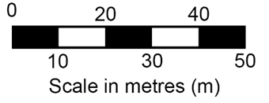  Answers:  Q1: 1:100,000 is an example of a ratio scale = True.  Q2: 1:250,000 is an example of a linear scale = False  Q3: 1 centimetre represents 5 kilometres is an example of scale in words = True  Q4: The following image is an example of scale in ratio = False.  Engage with Introduction to maps video (from 2:54–3:39) and discuss the scale of Appendix 6 – Edging Valley map. Check for understanding by asking the choral response question: ‘This is an example of [student response] scale map’.  Answer: large scale map. The geographic area covered is small, more detail is shown on the map (the detail is ‘large’), the scale ratio number is small (1:2,500), examples – map of a city, map of a local area, map of a neighbourhood. Responsively teach where required using Slide deck 3.  Display blank map of the world Miscellaneous templates. Check for understanding by asking choral response question: ‘This is an example of [student response] scale map.’  Answer: small scale map. Larger geographic area or region with less detail. Responsively teach where required using Slide deck 3.  Have students use the zoom function on Google maps to produce a small scale map of Sydney’s greater region and a large scale map of a suburb (Activity 1.9.2).  Review the process of geographical inquiry with the class (Activity 1.9.3). Ask students to identify the first step in the geographical inquiry process. Discuss the term ‘acquiring’ (act of gathering information). Describe the first step in a geographical inquiry process:  - ask geographical questions  - plan inquiry and research methods  - collect, select and record data.  Discuss what it means to ask a significant geographical question.  Teacher think-aloud example: in geography, we don’t just learn about places – we ask questions to help us understand why the world looks and feels the way it does. A good geography question is called a significant geographical question. It helps guide a deep investigation into an issue, challenge or pattern we can observe in the real world.  For example, instead of asking ‘Is Sydney a good place to live?’, we might ask ‘What things make people see Sydney as a liveable place?’, or ‘What factors influence people’s perception of liveability in different parts of Sydney?’ These are better questions because they are not just answered by a simple yes or no. A good geographical inquiry question is open-ended, allows for different perspectives and connects to our lives and experiences. When we ask big, thoughtful questions we can learn much more about the world around us.  Note: teachers might like to access General Guidelines for Conducting Research Interviews for further guidance. The following supports the National Literacy Progression – InT5 and InT6.  Provide the class with the significant geographical question: ‘What environmental, economic, social and political factors influence a person’s perception of liveability of a place?’ Have students Think-Pair-Share 3 to 5 minor geographical inquiry questions that would accompany the significant geographical question. Students can use Asking Geographical Questions to prompt their thinking.  Outline for students that they are going to select, collect and record geographical information by conducting an interview (Activity 1.9.4). Support students with the design of interview questions through providing a bank of question stems (for example, ‘What do you like most about …?’). Break down a significant geographical inquiry question through modelling how to turn a topic into a question. Use graphic organisers to plan and categorise questions (for example, transport, safety and accessibility). Extend students by asking them to compare questions across the class and categorise these into themes to respond to the question: ‘How does the way we design interview questions help us to recognise that liveability is made up of multiple, interconnected factors?’  Students develop 8 to 10 potential interview questions to ask a resident in Sydney about their perception of the liveability of Sydney. Use the WAGOLL interview questions in the Resource booklet to identify which of the questions best help answer the significant geographical inquiry question: ‘What environmental, economic, social and political factors influences a person’s perception of liveability of a place? Justify why.’  Students use the WAGOLL Interviewee 1 – liveability of Japan and Sydney in the Resource booklet to identify where their 8 to 10 interview questions can be improved.  Teaching and learning activity – Lesson 10  Student resource booklet activities 1.10.1, 1.10.2.  Discuss the key aspects of processing geographical information, students can refer to the geographical inquiry image in Activity 1.9.3 in the Resource booklet. Have students review the interview transcripts. Students use the transcripts to complete a summary of different perceptions of liveability in Ballina (Australia), Jakarta (Indonesia), Tokyo (Japan) and Sydney (Australia).  Note: students will need access to Dollar Street. Students select the Visit this family link on the right side of the individual families’ webpage, to access more information about each family. There is also a map on the right side indicating where in the world each country is located. From the In The World drop down menu, students choose one country from each of the 4 global regions listed. This resource addresses topics that might be considered controversial or sensitive. Follow school protocols and Controversial issues in schools procedures when using these resources. The following supports the National Literacy Progression – UnT7.  Students engage with Dollar Street and complete a comparison of families from around the world (Activity 1.10.2).  Use Dollar street the drop down menu In The World to have students choose one country from each of the 4 global regions for an investigative study. Students use Dollar Street to complete an investigative study (Activity 1.10.2).  Generate a discussion around the positives and negatives of liveability of different places from around the world Plus, Minus, Interesting (PMI).  Teaching and learning activity – Lesson 11  Student resource booklet activities 1.11.1, 1.11.2.  Note: the following supports the National Literacy Progression – CrT8 and CrT9.  Allocate students to small groups. Working in groups students develop a poster that illustrates liveability in each of the following locations, Sydney, Tokyo, Jakarta, Ballina and a rural or remote example in Australia (Activity 1.11.1).  Display group posters as a Gallery walk. Students use the information to construct a paragraph answering the prompt: ‘Outline how liveability of an area can be perceived by different people, and what factors influence these perceptions’ (Activity 1.11.2).  Feedback options might include teacher-led group feedback, peer feedback or self-assessment, for teacher marking use Appendix 5 – marking criteria stand-alone assessment.  Teaching and learning activity – Lesson 12  Student resource booklet activities 1.12.1, 1.12.2, 1.12.3, 1.12.4, 1.12.5.  Define the terms rank and measurement for the class. Check student understanding of rank and measurement using choral responses for the following questions:  - My teacher told me that I was [student response] first in class.  - In the cross country I was [student response] fifth.  - Estimating the number of people living in my suburb is an example of [student response] in geography.  - Geographers use ranking systems to [student response] liveability of places.  - Melbourne is consistently [student response] highly by EIU liveability [student response].  Answers: Q1: Ranked. Q2: Ranked. Q3: Measurement. Q4: Measure. Q5: Rank and measurement.  Note: students will need to be provided with images of places from around the world, use the Dollar Street website. Limit the selection of images to under 12. This resource addresses topics that might be considered controversial or sensitive. Follow school protocols and Controversial issues in schools procedures when using these resources. The following supports the National Numeracy Progression (IRD) – IRD2 and IRD3. The following supports the National Literacy Progression – UnT7 and UnT9.  Have the class review images of urban places from around the world. Students choose one image to explore in detail. For the chosen image students identify the environmental, social, economic and political factors that would influence the liveability of place (Activity 1.12.1).  Students conduct research on challenging places to live, for example, hottest places on earth, coldest places on earth (Activity 1.12.2).  Note: teachers will need to set up the classroom to accommodate the opinion continuum activity (Activity 1.12.3) Teaching Strategy: Opinion Continuum. Provide students with a line that transitions from strongly agree to strongly disagree. Read each question aloud and have students move along the continuum. Choose a student to explain their opinion after each question. After each explanation students can choose to move along the continuum if their opinion has shifted. The following supports the National Literacy Progression – SpK5.  Ask students the following questions and have them move along the continuum to preference points.  - Urban living: Would you choose to live in a bustling city if you had to commute over 2 hours each day to get to work? Would you live in a metropolitan area if public transportation was unreliable, and you couldn’t afford a car?  - Rural living: Would you prefer living in a remote countryside if you had limited access to grocery stores and other essential services? Would you settle in a small town if the only job opportunities were in manual labour and paid significantly less than urban jobs?  - Work environment: Would you accept a job in a high-stress corporate environment if it meant sacrificing work-life balance and personal time? Would you work in a field that required constant travel if it meant being away from home and family for long periods?  - Suburban living: Would you choose a suburban lifestyle if it meant having a larger home but limited access to cultural and social activities? Would you live in a suburban neighbourhood if you had to rely on a single grocery store with high prices and limited selection?  - Education access: Would you move to a city with a high cost of living if it meant your children could attend top-rated schools with excellent resources? Would you choose to live in a region with limited higher education options if it meant enjoying a lower cost of living and a slower pace of life?  - Healthcare access: Would you live in a community with a low cost of living if it meant having to travel long distances for quality healthcare? Would you stay in a city with high rent but exceptional medical facilities, knowing it would impact your financial situation?  Have students write a 1 to 2 paragraph description of how the perception of liveability varied across the class.  Revisit the world’s most liveability cities rankings and discuss Melbourne’s ranking.  Note: the following activity could be scaffolded further to support students’ construction of a response or provided to students ready for extension tasks. The following supports the National Literacy Progression – CrT9 and SpK5.  Considering Melbourne’s ranking in the Economist Intelligence Unit’s Global Liveability Index, discuss how access to education, healthcare and cultural activities contribute to the overall quality of life. Ask students: ‘Would you prioritise these factors over aspects like cost of living or job opportunities when evaluating a city’s liveability?’  Note: this resource addresses topics that might be considered controversial or sensitive. Follow school protocols and Controversial issues in schools procedures when using these resources.  Discuss Table 18 – least liveable cities in the world, 2025 (EUI) (Activity 1.12.5) with the class. Students use Google Earth to complete a See, Think, Wonder routine.  Teaching and learning activity – Lessons 13 and 14  Student resource booklet activities 1.13.1.  Note: students require Assessment task notification 2 – Liveability of places and Assessment support – liveability of places, which can be found on the Planning, programming and assessing geography 7–10 (2024) webpage, at this point in the learning sequence.  Students complete Assessment support – liveability of places pre fieldwork learning activities.  Students are required to collect ground level photographs in the assessment. Teachers may need to activate prior knowledge Connecting learning of types of photographs used in geography (Activity 1.18.1). Responsively teach using Slide deck 1 – Landscapes and landforms Planning, programming and assessing geography 7–10 (2024).  Teaching and learning activity – Lesson 15  Student resource booklet activities 1.15.1.  Note: access NESA’s advice on engaging in fieldwork – Teaching advice (additional): Stage 4 and 5 – Fieldwork in Geography 7–10 Access Excursions and variations of routine for direction and guidance on planning and managing excursions. The suggested fieldwork is estimated to require 2 hours in the field. The following supports the National Literacy Progression – InT6.  Students participate in local fieldwork evaluating the liveability of a local suburb, town or city.  Students complete Assessment support – Liveability of places fieldwork worksheet in the field Planning, programming and assessing geography 7–10 (2024).  Teaching and learning activity – Lesson 16s and 17  Student resource booklet activities 1.16.1.  Note: the post fieldwork learning activities may need to be adapted to each school context and student individual learning needs.  Students complete the Post fieldwork learning activities in Assessment support – Liveability of places Planning, programming and assessing geography 7–10 (2024).  Teaching and learning activity – Lesson 18  Student resource booklet activities 1.18.1.  Note: the following supports the National Numeracy Progression – NPV10.  Define megacity for the class and check for understanding by asking the following ‘Yes’ or ‘No’ questions.  - Can Melbourne be classified as a megacity with a population of 4.9 million?  - Can Brisbane be classified as a megacity with a population of 2.4 million?  - Can Tokyo-Yokohama, Japan be classified as a megacity with a population of 37 million?  - Can Delhi, India be classified as a megacity with a population of 32 million?  - Can Dhaka, Bangladesh be classified as a megacity with a population of 23 million?  Answers: Q1: No, population is under 10 million. Q2: No, population is under 10 million. Q3: Yes, population is over 10 million. Q4: Yes, population is over 10 million. Q5: Yes, population is over 10 million.  Connecting learning by activating prior knowledge of types of photographs by asking students to identify the different types of photographs used in geography. Responsively teach using Slide deck 1 Landscapes and landforms – geography 7–10.  Note: this resource addresses topics that might be considered controversial or sensitive. Follow school protocols and Controversial issues in schools procedures when using these resources.  Have students identify the type of photograph ‘The view from above’ is on the Drone photos capture the staggering inequality in Mumbai webpage.  Answer: aerial photograph.  Students use Economic Inequality – Our World in Data to complete an annotated bibliography exercise (Activity 1.18.1).

Learning sequence 2 – influences and impacts of liveability
The following learning sequence is designed to be completed in approximately 16 hours. It aligns to Term 2 Weeks 6–9 in the Geography Stage 4 scope and sequence.
Table 2 – Learning sequence 2 details
Outcomes and content | Teaching and learning activities | Registration
Outcome  GE4-DFC-01, GE4-PRI-01, GE4-PER-01, GE4-MAN-01, GE4-APC-01, GE4-TAP-01, GE4-COM-01  Content  Influences and impacts on liveability  - Influences of social, cultural and community connections on liveability  - Access to services and facilities that influence the liveability of places  - Physical and human influences that impact environmental quality and the liveability of places  Geographical tools  Maps:  Identify spatial patterns using a range of maps  Use a range of large-scale and small-scale maps  Measure distances on a map using a linear scale  Fieldwork:  Develop geographical questions and plan an inquiry  Identify, collect and record geographical information  Develop and conduct surveys and interviews  Use fieldwork tools to collect geographical information  Draw conclusions from the data collected  Reflect on the fieldwork study  Data and graphs:  Construct and interpret data tables and graphs  Interpret population profiles  Use a range of graphs and tables  Spatial technologies:  Describe land use of an area using virtual or digital maps  Additional geographical representations:  Document experiences of places and spaces using photographs  Identify and describe spatial patterns and changes using a variety of geographical representations  Geographical concepts:  - Interconnections  - Scale | Learning intentions  Students learn about:  - environmental, social, economic and political factors to understand how they influence the liveability of places and shape people’s experiences and responses to change  - how population characteristics and urbanisation affect access to housing, transport, services and opportunities to understand differences in liveability between urban and rural contexts  - the perspectives of individuals and communities who experience disadvantage to understand how responses to liveability challenges (such as climate vulnerability and inequality) are shaped by differing needs and priorities  - Aboriginal Peoples’ perspectives on liveability and custodianship of Country to understand the role of cultural connection in creating inclusive and sustainable places  - how to interpret population pyramids, analyse cost-of-living data and design interview questions to understand how to investigate and communicate perceptions of liveability  - how to use maps, graphs and data displays to understand how to clearly present geographical information and findings about liveability.  Success criteria  Students will be able to:  - describe how liveability is influenced by environmental, social, economic and political factors  - interpret and compare data sources, including graphs and population pyramids, to analyse spatial and social variations in liveability  - assess how different groups experience and respond to changes in liveability  - identify how Aboriginal Peoples’ knowledge and custodianship inform liveability planning  - design and interpret geographical tools to communicate findings about liveability issues.  Teaching and learning activity – Lesson 1  Note: teachers can access the Resource booklet on the Planning, programming and assessing geography 7–10 (2024) webpage.  Student resource booklet activities 2.1.1, 2.1.2, 2.1.3.  Note: the following activity embeds vocabulary instruction in a GIST (Gather background knowledge and vocabulary, Identify the topic, Summarise the text, Top and Tail sentences) reading comprehension explicit instruction. An explanation, examples and templates to support GIST are available from Main idea teaching strategies for years 7 to 8. The following supports the National Literacy Progression – UnT9, CrT9 and CrT10.  Share the article The 20 Minute City: We Shape Our Cities, Then Our Cities Shape Us with students (Activity 2.1.1). Draw students’ attention to the author and publication date of the source. Review the purpose of the informative text: to explain to or inform the reader of factual information. Model skimming and scanning the text for structural clues including:  - use of headings and subheadings  - use of data  - abbreviations  - quotes that highlight appropriate research  - visual representations that enhance understanding.  Direct students to gather information and key vocabulary by identifying essential vocabulary, unfamiliar vocabulary and repeated vocabulary. Collate these terms and share with the whole class. ‘Say, write, define’ the key words the class has identified as unfamiliar vocabulary. ‘Clarify’ the terms in the context of the text. Checking for understanding students construct 2 to 3 paragraphs outlining the benefits of a 20-minute city model.  Use the Geography 7–10 Syllabus (2024) Glossary to define culture and human wellbeing for the class.  Note: teachers may need to prompt the concept map discussion. For example, consider customs, habits, beliefs or spirituality and social organisation.  Lead a class discussion of the ways culture shapes a community, summarise the discussion as a concept map (Activity 2.1.2).  Designate students to work in small groups (Activity 2.1.3). Students design a visual representation (poster, infographic, digital slide) of the ‘cultural characteristics’ of a community. Students present the visual representations as a Gallery walk.  Teaching and learning activity – Lesson 2  Student resource booklet activities 2.2.1, 2.2.2, 2.2.3, 2.2.4.  Note: the following supports the National Numeracy Progression – PrT2 and IRD6.  Use Slide deck 5 – Liveability of places Planning, programming and assessing geography 7–10 (2024) to explain the key features of population profiles. Students use the sentence scaffold to construct a paragraph that analyses the population profile. Students calculate the percentage of Australia’s population aged between 30 and 39 (Activity 2.2.2).  Answers: total male 7.28%; total female 8%; total Australian population aged between 30 and 39 years – 15.28%.  Engage with Population pyramids: Powerful predictors of the future – Kim Preshoff (5:01). In 2 to 3 paragraphs students respond to the prompt: ‘Describe how population pyramids can inform community decisions’ (Activity 2.2.3). Prompting questions might include:  - What do the different parts of the graph mean?  - Why might geographers, governments or planners use this information?  Extension exercise: provide students with multiple population graphs from around the world. Have students use the analysis scaffold to construct a paragraph for each place.  Students complete a 3-2-1 Exit ticket (Activity 2.2.4).  Teaching and learning activity – Lesson 3  Student resource booklet activities 2.3.1, 2.3.2, 2.3.3, 2.3.4.  Note: teachers may need to explain the term anomalies (plural noun) something that deviates from what is standard, normal or expected prior to commencing this learning activity. The following learning activity could be adapted to fit a Backchannel discussion exercise based on the technological skills of the class. The following National Literacy Progression – CrT9 and UnT9, and National Numeracy Progression – NPV10.  Engage with the introduction chapter I Built the Population of the World! (again...) (from 0:00–0:25) ask the students what they predict they will observe in the video. Divide the class into small groups and allocate each group a chapter in the video to review 00:24 North America, 01:03 Central America and the Caribbean, 03:29 South America, 04:54 Europe, 08:06 Africa, 11:56 Oceania, 13:33 Asia. Each group must complete questions identified in Activity 2.3.1. Engage with the Overview chapter I Built the Population of the World! (again...) (from 21:08–23:23) and ask students if their prediction at the beginning of the lesson was accurate.  Define population pressure for the class. Identify and record ways populations place pressure on the liveability of places including housing shortages, traffic and transport problems, strain on services, environmental damage, job competition and cost of living increases.  Check for understanding by asking the following true or false questions (Activity 2.3.2).  - Population pressure means there are fewer people living in an area.  - Overcrowding can lead to housing shortages.  - A growing population usually makes traffic better.  - Hospitals and schools can be affected when too many people live in one place.  - More people in an area means there is usually less pollution.  - Population pressure can make it harder for people to find jobs.  - A higher population can cause the cost of living to go down.  - Population pressure always improves the liveability of a place.  Answers: Q1: False. Q2: True. Q3: False. Q4: True. Q5: False. Q6: True. Q7: False. Q8: False.  Note: Creating places that support wellbeing and community participation has been included for the purpose of providing the 20-minute city image at this point in the program. The text is not stage appropriate and should only be used where appropriate.  Connecting learning by activating prior knowledge of challenges confronting urban communities by sharing the image of a 20-minute city Creating places that support wellbeing and community participation with students. Outline ways a 20-minute city might reduce the negative effects of population pressure. Have students construct a 2 to 3 paragraph response to the question: ‘How could the 20-minute city idea help reduce the negative effects of population pressure and improve the liveability of a place?’  The following prompt questions will support responses:  - What is a 20-minute city?  - How does population pressure affect housing, transport and services?  - How could having everything close by (schools, shops, parks, jobs) help resolve some of these problems?  Have students exchange their response with a peer in the class and complete a peer assessment using the TAG template. Students complete an Exit ticket exercise (Activity 2.3.4).  Teaching and learning activity – Lesson 4  Student resource booklet activities 2.4.1, 2.4.2, 2.4.3.  Use the Geography 11–12 Syllabus (2022) Glossary to define ‘megacity’ for the class.  Activate prior knowledge of megacities by Connecting learning. Share city population statistics from around the world. Students respond ‘Yes’ or ‘No’ to the query ‘Am I a megacity?’:  - Tokyo, Japan with a population of 37 million?  - London, England with a population of 9.8 million?  - Sydney, Australia with a population of 5.2 million?  - Port Vila, Vanuatu with a population of 62.8 thousand?  - Mumbai, India with a population of 22.1 million?  - Nairobi, Kenya with a population of 5.8 million?  Answers: Q1: Yes. Q2: No. Q3: No. Q4: No. Q5: Yes. Q6: No.  Display Appendix 7 – challenges of living in megacities (WATCHES). Have students consider each of the challenges facing megacities and identify one example for each challenge.  Note: students are required to analyse an aerial photograph. Teachers may need to activate prior knowledge Connecting learning of types of photographs used in geography. Reteach where required using Slide deck 1 – Landscapes and landforms Planning, programming and assessing geography 7–10 (2024).  Review the first photograph used in Drone photos capture the staggering inequality in Mumbai and identify what type of photograph has been taken with the class. Provide students with a copy of the first paragraph from Drone photos capture the staggering inequality in Mumbai. Read aloud the first paragraph and have students highlight any new or unfamiliar terms. Define and discuss the new and unfamiliar terms identified by the class.  Lead a class discussion: ‘Describe the challenges people living in shanty towns or informal settlements in megacities face, particularly in relation to accessing services and facilities such as clean water, sanitation, education and healthcare.’ Summarise the key points from the discussion and identify any patterns or shared issues.  Allocate students to work in small groups to discuss strategies or actions taken by governments, NGOs or local communities to improve access to services and facilities in these areas.  Allocate students to work with a partner to construct a paragraph in response to the question: ‘Describe how limited access to services and facilities in megacities affects the liveability of a place. Include one example of how this issue is being managed or addressed.’  Note: this resource addresses topics that might be considered controversial or sensitive. Follow school protocols and Controversial issues in schools procedures when using these resources.  Use Khayelitsha – Toilets and the Most Vulnerable (1:07) to stimulate a discussion about the access to services and facilities in megacities. Allocate students to work in small groups. Students develop a podcast script (3 to 4 minutes) that identifies key challenges faced by residents in a selected megacity. Describe examples of inequality in access to services and explain how local governments, communities or organisations are managing and responding to these challenges (Activity 2.4.3).  Teaching and learning activity – Lesson 5  Student resource booklet activities 2.5.1, 2.5.2, 2.5.3, 2.5.4.  Have students engage with Mapped: The World’s Largest Megacities by 2100 (from 0:00–0:24). Pause the video and label on a blank world map (Miscellaneous templates), the current location of the world’s megacities. Pause the video at 1:07 and label the predicted location megacities in 2100 on another blank world map (Miscellaneous templates).  Allocate students to work in small groups to conduct a Brainstorming exercise. Students use a group brainstorming template to identify ways the increase in megacities will prove challenging for future populations (Activity 2.5.2). Students investigate ways megacities can be better managed to ensure access to services and facilities (Activity 2.5.3). Students complete an Exit ticket exercise. Students create a visual representation of what they have learned about megacities in the lesson.  Teaching and learning activity – Lesson 6  Student resource booklet activities 2.6.1, 2.6.2, 2.6.3, 2.6.4.  Connecting learning by activating prior knowledge.  - What does the BOLTSS acronym stand for?  - What does the term orientation mean?  - What are the 4 cardinal points?  - What mnemonic helps you to remember the 4 cardinal points?  Answers: Q1: Border, Orientation, Legend, Title, Scale and Source. Q2: Direction from north or the way you are facing. Q3: The 4 cardinal points are the 4 main directions on a compass North (N), East (E), South (S), West (W). Q4: Never Eat Sour Worms.  Note: the easiest way of explaining the direction of one place from another, either on a map or on the ground, is to use the points of a compass. North (N), south (S), east (E) and west (W) are the 4 main points of a compass. They are called the cardinal points. North-east (NE), south-east (SE), south-west (SW) and north-west (NW) are in between each of the cardinal points. They are called intermediate points. Access Directions and bearings, geography 7–10 for relevant lesson strategies. Bearings are not the focus of the following activities. Understanding of the tool is not required until Stage 5.  Engage with Directions and bearings video (from 0:00–0:52). Explain the image of the 16-point compass to the class (Activity 2.6.1). Have students answer the following questions:  - What compass point lies in the opposite direction to north?  - What direction is opposite of east?  - What direction is halfway between north and east?  - What direction is opposite of north-west?  Answers: Q1: south (S). Q2: west (W). Q3: north-east (NE). Q4: south-east (SE).  Display the Map of Indigenous Australia and locate the local language, social or nation group. With the class, identify direction between key places. For example, ‘Kamilaroi – What is the direction of Inverell from Gunnedah?’  Provide students with How ancient Aboriginal star maps have shaped Australia’s highway network, read aloud to the class and discuss ways ancient Aboriginal star maps have influenced liveability in Australia.  Connecting learning by activating prior knowledge, ask students the following questions:  - What are some ways scale can be represented?  - What does a linear scale look like?  Answers: Q1: Ratio, in words, linear. Q2: A line that has equal measurements.  Have the class engage with Area and distance video (from 0:00–1:45) and explain that we use linear scale on a topographic map to find out how far it is between 2 places in real life.  Note: provide a printed copy of Appendix 8 – Paceworth map to students. Do not resize the image as it is set to scale for the answers provided. Use a Gradual release of responsibility to teach measuring straight line distances on maps. The following supports the National Numeracy Progression – UuM6.  Use Paceworth map (Activity 2.6.2) to demonstrate (I do) measuring the distance for the following map:  - Measure the straight-line distance in centimetres (cm) between the information centre and the bora ring.  - Use the scale on the map to calculate the real-life distance between the information centre and the bora ring.  Answers: Q1: 9.6 cm. Q2: 9.6 km.  Note: ‘we do’ activities include 1 to 3. ‘You do’ activities include 4 to 5. Students will need a printed copy of Appendix 9 – Dreamouth Siding map. Do not resize the image as it is measured for scale and resizing will impact answers. The following supports the National Numeracy Progression – UuM6 and IRD5.  Students use Dreamouth Siding map to measure and calculate the straight-line distances from:  - Point A to Point D (We do)  - Point C to Point E (We do)  - Point B to Point D (We do)  - Point B to Point E (You do)  - Point D to Point E (You do).  Answers: original scale: 1 cm represents 100 m.  Q1: 700 m. Q2: 800 m. Q3: 840 m. Q4: 320 m. Q5: 1.16 km.  Discuss the distance across Australia. Discuss the challenges the distance between places would pose in access to services and facilities. Students create a visual representation that summarises the class discussion.  Prior to engaging with the video Royal Flying Doctors, students answer the following questions:  - Who do the Royal Flying Doctors help?  - Before the Royal Flying Doctors began how did people in remote areas reach a doctor?  - What might the perspective of people living in remote areas be regarding access to healthcare?  Engage with Royal Flying Doctors (3:34) and answer the following questions:  - On average, how often does the Royal Flying Doctors help someone?  - On what Australian banknote does the founder of the Royal Flying Doctors feature?  Answers: Q1: Rate of one person every 2 minutes. Q2: $20.  Review the Royal Flying Doctor Service Spatial Distribution Patterns map and have students Think-Pair-Share responses to comprehension questions (Activity 2.6.4).  Teaching and learning activity – Lesson 7  Student resource booklet activities 2.7.1, 2.7.2, 2.7.3, 2.7.4.  Note: the following supports the National Numeracy Progression – IRD 6 and IRD7.  Read the Profile of First Nations people first paragraph aloud. Have students describe the diverse nature of Australia’s First Nations peoples. Read the second paragraph beginning with ‘Colonisation is recognised as …’ aloud. Have students identify cultural factors that contribute to First Nations people’s health and wellbeing. Read the Population size and location section aloud. Have students explain why it has been difficult to get accurate census data on First Nations peoples. Display Figure 1: Proportion of First Nations people in the Census, 2001 to 2021 from Profile of First Nations people to the class. Have the students complete Activity 2.7.2.  Answers: Q1: Proportion of First Nations people in the Census, 2001 to 2021. Q2: ABS 2003, 2008, 2013, 2018, 2022b. Q3: Yes, the ABS and the AIHW are both valid and reliable Australian government agencies. Q4: Column graph. Q5: Increasing numbers of First Nations peoples as a percentage of the Australian population – from 2.4% in 2001 to 3.8% in 2021.  Note: according to the census data, the population of First Nations peoples in Australia was around 812,700 people in 2021. Students will need access to Slide deck 5 to support their response to question 5.  Display Figure 2 from Profile of First Nations people to the class. Students complete Activity 2.7.2. Students use Figure 27 – WAGOLL analysing a profile in the Resource booklet to support analysis of a population profile.  Note: this resource addresses topics that might be considered controversial or sensitive. Follow school protocols and Controversial issues in schools procedures when using these resources.  Read aloud the key messages from 3.14 Access to services compared with need and discuss:  - What does the data say about how far people must travel for healthcare?  - What is the difference in waiting times for elective surgery between Indigenous and non-indigenous Australians?  - Why might someone not go to the doctor even when they need to?  - How does geography (city versus remote) affect a person’s healthcare options?  - How might the lack of access to healthcare services influence the perception of liveability in rural and remote areas in Australia? What might be required to change these perspectives?  Answers: Q1: For many areas it was at least one hour’s drive and at least 100 km. Q2: 49 days for Indigenous and 40 days for non-indigenous. Q3: Lack of service availability and long wait times, no transport service and distance too far away. Q4: Geography significantly affects healthcare access in Australia. Indigenous Australians in remote areas face limited services, fewer specialists, high travel costs and reduced access to culturally safe care – leading to poorer health outcomes compared to those in cities. Urban areas offer more comprehensive, accessible and culturally appropriate healthcare options. Q5: The lack of access to healthcare in rural and remote Australia can significantly diminish perceptions of liveability, as it raises concerns about personal wellbeing and emergency support. To shift these perspectives, investment in telehealth, mobile clinics and incentives for healthcare professionals to work in these regions is essential.  Note: the writing assessment can be accessed through MS Forms SA133 - Geography – Liveability of Places. Access Appendix 5 for teacher-led feedback, peer feedback or self-assessment strategies and teacher marking guidelines.  Students create a written text answering the prompt: ‘Describe the impact of healthcare facilities on the liveability of rural areas in New South Wales’ (Activity 2.7.4).  Teaching and learning activity – Lesson 8  Student resource booklet activities 2.8.1, 2.8.2, 2.8.3.  Have the class contribute to a word cloud for the terms ‘culture’, ‘Country’ and ‘spirituality’. Use Culture, Country & spirituality to define the terms for the class. Ask students to decide if their word clouds accurately reflect the definitions. Remove and replace any sticky notes to consolidate the final product. Students use the 3-word clouds to write their own definitions of ‘culture’, ‘Country’ and ‘spirituality’.  Display and discuss the ‘Connection to homelands and Country’ section of Culture, Country and spirituality. Have the students categorise supporting and adverse factors in response to the question: ‘What factors help or hinder connections to culture, Country and spirituality?’ The following list may be used to prompt student thinking:  - cultural education  - languages under threat  - time spent on Country  - participating in ceremonies  - services that are not culturally safe  - restricted access to Elders and knowledge holders.  Note: teachers will need a long role of brown paper for the Projecting Across Time routine. This routine encourages learners to view topics from the vantage of a broader timescale, than what they have learned from the media, or experienced in their own lifetime. Often, ideas (for example, childhood, debt, happiness), phenomena (for example, the internet, migration), or problems (for example, lack of access to clean water, terrorism), can look very different depending on how far back in history or how far forward into the future we look. It is important teachers pay close attention to the class discussion and carefully correct any misconceptions or misinformation that arises in the discussion. The following supports the National Numeracy Progression – MeT6.  Engage with Connection To Country – Why is it important to Aboriginal and Torres Strait Islander people? (1:15) and the SBS Podcast Understanding the profound connections First Nations have with the land (9:22) and complete a Projecting Across Time routine (Activity 2.8.2).  Students use an Exit ticket to explain what they have learned about the influence of social, cultural and community connections on liveability for our First Nations peoples.  Teaching and learning activity – Lesson 9  Student resource booklet activities 2.9.1, 2.9.2, 2.9.3.  Note: this resource addresses topics that might be considered controversial or sensitive. Follow school protocols and Controversial issues in schools procedures when using these resources.  While displaying the images of the LA fires Before and after: See the destruction caused by the LA fires, explain the event to the class. In January 2025, powerful Santa Ana winds fuelled wildfires across Los Angeles County. The Palisades and Eaton fires alone destroyed over 16,000 structures and forced more than 200,000 people to evacuate.  Ask students to observe the images and share their immediate thoughts.  - What do you notice about these places before and after the fires?  - How do you think people felt seeing their homes and communities like this?  Note: the following activity embeds the SEEC (Select, Explain, Explore, Consolidate) model of explicit vocabulary instruction. This vocabulary routine supports the National Literacy Learning Progression – Understanding texts UnT 6–10.  Use What are natural hazards? to define ‘natural hazard’ for students. Students use What are natural hazards? to make summary notes of the different types of hazards (Activity 2.9.1). Use What are natural hazards? Flashcards to consolidate student understanding of the term natural hazards. Students complete the Quiz on the What are natural hazards? webpage and share their results with the teacher. Students complete a Frayer diagram for the term natural hazard.  Note: teachers will need to lead a brief discussion that revisits the concept of ‘liveability’ and how it can be affected by natural hazards. Use the Glossary definition of liveability where required.  Students identify the key impacts of the wildfires on liveability using the stimulus Before and after: See the destruction caused by the LA fires (Activity 2.9.2).  Answers: destruction of homes, displacement of residents, economic losses, emotional and psychological effects on the community.  Think-Pair-Share a concept map that summarises ways the LA wildfires impacted on liveability.  Note: prior to commencing the rapid-fire writing exercise read aloud the stimulus to the class. Rapid-fire writing is a structured fast-paced independent writing activity. It uses timed phases of writing and self-reflection to scaffold students’ understanding of the main ideas in a topic. Outline the protocol for learners. It can be useful to display the phases of the activity and associated times, along with a timer for each phase. The resource Bushfire uses several complex terms. Students may require further unpacking of these terms, for example, ignition and combustion.  Use rapid fire writing with the stimulus Bushfire (Activity 2.9.3).  Use an Exit ticket to answer the question: ‘How do natural hazards influence the liveability of places?’  Teaching and learning activity – Lesson 10  Student resource booklet activities 2.10.1, 2.10.2.  Note: use Gradual release of responsibility modelling a think aloud – today we are going to use a tool to help us assess or measure our word knowledge. By understanding how much we know, and don’t know, about a word we can build our depth of word knowledge. Then, when we hear or see that word, we may be able to comprehend its meaning and use the new vocabulary in our own texts. Teachers may need to allow students learning English as an additional language or dialect (EAL/D) to use bilingual dictionaries to support this learning activity.  Provide students with Appendix 10 – vocabulary self-assessment. Read and discuss each level to familiarise students with the tool and its purpose.  Fill in the topic ‘Climate change’ and provide students with the vocabulary list, greenhouse gases, global warming, carbon footprint, fossil fuels, renewable energy, sea level rise and deforestation. Model how to check understanding of the first word and add the word to the relevant level. For example:  - I have heard this word before … I think it means … but I am not certain.  - I know the meaning of ‘XXX’ is …  - A synonym for this word is …  - I know this word relates to …  - I know this word has more than one meaning …  - I can use this word in a sentence …  Assign greenhouse gases to the relevant level. Students repeat for the other 6 words in the vocabulary list.  Students choose one word from level 3 or 4 and build on that knowledge by completing the following:  - use the Geography 7–10 Glossary or an online dictionary to build understanding of the word  - generate synonyms for the vocabulary selected  - write a student-friendly definition  - use the word in a sentence  - generate a visual representation of the vocabulary selected.  Students retake the self-assessment to demonstrate how word knowledge has deepened. Check for understanding by cold calling students. Ask students to demonstrate understanding by creating a sentence using the word correctly. Using the self-assessment, students assign the remaining words to the column which best reflects their level of understanding.  In small groups, students compare their understanding of each word. Students support their group by explaining their understanding of word meanings. For example, if Student A understands ‘fossil fuels’, but Student B and C do not, Student A explains the word meaning, using examples, including synonyms to support.  As a class, identify the words which were most challenging and unfamiliar. (These may be words which rated at level 1 to 2 for most students). Ask students to share and explain their new understanding to support the class. After the discussion, students could retake the self-assessment to note how their word knowledge has deepened.  Note: Activity 2.10.2 provides optional tasks and teachers should apply according to school context.  Option 1 – students engage with Climate change. Answer the questions outlined in the resource and check their responses against the answers provided.  Option 2 – as a class use Causes and Effects of Climate Change to complete Figure 3 below. Then use Causes and Effects of Climate Change and Appendix 11 – connecting terms to construct 5 sentences that communicate the cause and effect of climate change.  Figure 3 – cause and effect scaffold  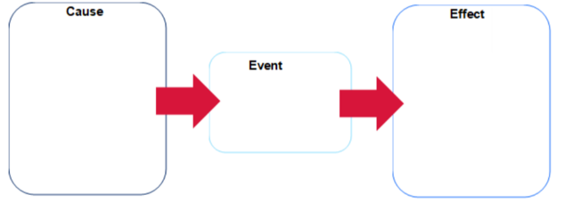  Teaching and learning activity – Lessons 11 and 12  Student resource booklet activities 2.11.1, 2.11.2, 2.11.3, 2.11.4.  Have students engage with The World’s First Climate Refugees (4:22) and Sun Come Up (2:23) and complete guided questions (Activity 2.11.1). Have students use an atlas or online map to locate and label the Carteret Islands on a blank world map Miscellaneous templates and construct a paragraph describing the location of Carteret Island (Activity 2.11.2).  Conduct an image search of the Carteret Islands with the class. Choose one image to use as a base for a photo sketch Photo sketch video (2:06). Students complete a photo sketch and construct a paragraph describing the physical environment of the Carteret Islands. Have students turn and talk to a partner answering the question: ‘How might the location of Carteret Islands influence the liveability of the island residents?’ (Activity 2.11.3).  Note: some of the language used in Environmental Refugee may need unpacking with students. For example, Geneva Convention and provincial may be unfamiliar and students could benefit from guided discussion or contextual explanation.  Use Environmental Refugee to define the term for the class. Read ‘Refugee Status’ Environmental Refugee aloud to the class. Discuss how the residents of Carteret Islands would not have refugee status and the challenges this would present residents. Students complete a Think-Pair-Share addressing the impact of climate change on the liveability of Carteret Islands.  Lead a class discussion, summarising as a Concept map, outlining ways the Carteret Islands are being managed to reduce the impact of sea level change.  Read aloud to the class Community-led relocation effort by the Carteret Islanders who face extinction from climate change impacts and extreme weather events and guide a discussion answering the following questions.  - How does displacement affect identity, culture and community?  - What are the main challenges faced by relocated communities?  Allocate students to work in small groups to devise a 3-point plan to help the Carteret Islanders. Have groups present their 3-point plan to the class.  Students choose one of the following roles: a Carteret Islander, a PNG government official, a UN advisor or an aid organisation worker. Students write a brief statement (4 to 5 sentences) explaining their point of view on the relocation and what they think matters most in supporting the community. Have students share their perspective with a peer in a different role.  Read ‘Refugee Status’ Environmental Refugee aloud to the class. Discuss how the residents of Carteret Islands would not have refugee status and the challenges this would present residents.  Teaching and learning activity – Lesson 13  Student resource booklet activities 2.13.1, 2.13.2, 2.13.3.  Provide students with a list of environmental factors that influence the liveability of places (air quality, access to green spaces, water quality, urban planning and infrastructure, noise pollution, pollution levels, climate and weather conditions). Have students generate a Concept map that illustrates environmental factors that influence the liveability of places.  Provide students with access to Cleanest Countries in the World 2025 and explore the Environmental Performance Index (EPI) scores from around the world. Outline for the class the EPI indicators for a healthy environment: climate change mitigation, air pollution and waste management, sustainability of fisheries and agriculture, deforestation and biodiversity protection.  Instruct students to navigate between the EPI Score map and the EPI 10-Year Change 2014-2024 map to identify 3 to 5 countries that have improved their EPI. Have students explore The Top 10 Cleanest Countries section of Cleanest Countries in the World 2025 and summarise strategies that have been used to improve environmental quality (Activity 2.13.2).  Students work in pairs to develop a photo collage that illustrates the characteristics of the top 10 cleanest countries in the world.  Students complete an Exit ticket (Activity 2.13.3).  Teaching and learning activity – Lesson 14  Student resource booklet activities 2.14.1.  Teacher-led discussion connecting the previous lesson: ‘How does being a clean country improve liveability for people living there?’  Connecting learning by activating prior knowledge of megacities by asking the following true or false questions.  - A megacity is defined as an urban area with a population of over one million people.  - Most megacities are located in developing countries.  - Tokyo is currently the world’s largest megacity by population.  - All megacities experience high levels of liveability due to modern infrastructure.  Answers: Q1: False – a megacity has a population of over 10 million people. Q2: True – the majority of megacities are in Asia, Africa and South America. Q3: True – as of 2025, Tokyo remains the most populous megacity. Q4: False – many megacities face challenges such as overcrowding, pollution and informal settlements.  Engage with Jakarta, Indonesia: Racing to Save the World’s 2nd Largest MEGACITY (20:57). Break down the video into manageable chunks for the students by asking the question: ‘Identify why residents of Jakarta intend to remain and not relocate to another city (from 14:11–20:57)’.  Engage with The Cleanest City in the World? Exploring Singapore (13:53). Break down the video into manageable chunks. Have students complete Activity 2.14.1. Have students complete a Venn diagram Simple graphic organisers comparing the liveability of Jakarta to Singapore. Students use the Venn diagram to develop 3 to 5 recommendations for ways Jakarta can improve liveability of their city.  Teaching and learning activity – Lessons 15 and 16  Student resource booklet activities 2.15.1, 2.15.2, 2.15.3, 2.15.4.  Pre fieldwork – students use the syllabus Glossary, dictionary or online dictionary to define the key terms relevant to the pollution fieldwork including pollution, environmental quality, liveability, noise pollution, water pollution and air pollution (Activity 2.15.1).  Students use the Appendix 1 – capacity matrix to identify their extent of information, knowledge, know-how and wisdom for each term identified in the lesson.  Note: teachers may consider fieldwork at this point in the learning sequence and conduct a pollution survey of a place. Access Excursions and variations of routine for direction and guidance on planning and managing excursions, including incursions and other variations of routine. Inclusion of an excursion will require remediation of the following lesson to accommodate time removed from the classroom.  Provide the class with the significant geographical question: ‘What types of pollution exist in our local area, and how do they affect liveability?’ (Activity 2.15.2). Have students use the significant geographical question to pose a hypothesis: ‘I think the most common type of pollution will be [student response] because [student response]’. Students share their hypothesis with a peer and discuss.  Students use Google maps or similar to develop a map of the study area. Alternatively, students can draw a line sketch of the study area. Students conduct a litter survey along a 10-metre section of ground at 2 separate locations in the study area. Students observe noise pollution at 2 separate locations in the study area. Students record their survey results. Students complete a water and air pollution checklist (Activity 2.15.3). Students choose one location to complete a Field sketch Conducting a field sketch video (4:50).  Post fieldwork (Activity 2.15.4):  - Students draw a pollution hotspot map showing where pollution was highest.  - Students conduct data analysis.  - What was the most common type of pollution in your study area?  - Where was pollution the worst? Why do you think that is?  - Were there any anomalies in your research results?  - Students revisit their hypothesis and explain whether their predictions were accurate or inaccurate.

Learning sequence 3 – enhancing liveability
The following learning sequence is designed to be completed in approximately 6 hours. It aligns to Term 2 Weeks 9–10 in the Geography Stage 4 scope and sequence.
Table 3 – Learning sequence 3 details
Outcomes and content | Teaching and learning activities | Registration
Outcome  GE4-DFC-01, GE4-PRI-01, GE4-PER-01, GE4-MAN-01, GE4-APC-01, GE4-TAP-01, GE4-COM-01  Content  Enhancing liveability  - Roles and actions of community groups in enhancing liveability  - Planning strategies used to enhance the liveability of a place for groups of people  - Benefits of caring for Country to enhance liveability for Aboriginal Peoples  Geographical tools  Maps:  Identify physical and human features on a map  Use a range of large-scale and small-scale maps  Data and graphs:  Use a range of graphs and tables  Spatial technologies:  Describe land use of an area using virtual or digital maps  Additional geographical representations:  Multimedia  Geographical concepts:  - Interconnections  - Scale | Learning intentions  Students learn about:  - the roles and actions of community organisations and local governments to understand how they make places more accessible, inclusive and sustainable  - planning and design strategies used in urban areas to understand how liveability can be enhanced for different groups, including youth, families and people experiencing homelessness  - caring for Country and initiatives like Indigenous Protected Areas to understand how they enhance liveability for Aboriginal Peoples and all Australians by supporting ecological and cultural wellbeing  - diverse perceptions of liveability to understand how benefits from planning strategies can vary depending on individual and community needs and priorities  - how to conduct local fieldwork and interpret visual and graphical data (for example, maps, homelessness data) to understand how to evaluate and communicate strategies that improve liveability.  Success criteria  Students will be able to:  - explain how liveability is enhanced through planning and targeted strategies  - evaluate the role of community groups and governments in improving liveability for diverse groups  - describe how caring for Country contributes to sustainable and liveable environments  - use fieldwork, digital maps and graphs to analyse how liveability is being improved in specific places  - communicate findings about liveability enhancement using appropriate geographical language and formats.  Teaching and learning activity – Lesson 1  Note: teachers can access the Resource booklet on the Planning, programming and assessing geography 7–10 (2024) webpage.  Student resource booklet activities 3.1.1, 3.1.2.  Engage with Creating Sustainable Cities (4:21) and brainstorm what a ‘more liveable’ place looks like. Students categorise the brainstorm for what a ‘more liveable’ place looks like under the factors that affect liveability headings. Discuss the meaning of the term ‘enhancing’. What synonyms can be applied to the term?  Answers: improving, increasing, boosting, upgrading, raising, strengthening, developing, refining, elevating, advancing.  Extend students by asking them to identify context specific synonyms for liveability.  Answers: making more liveable, enriching, revitalising, transforming, modernising, sustaining, optimising, enhancing quality of life.  Allocate students to work in pairs. Students choose a place that they have studied in the Focus area – Liveability of places and design a liveable city plan. Students share visual representations with the class as a Gallery walk.  Teaching and learning activity – Lesson 2  Student resource booklet activities 3.2.1.  Note: teachers will need to choose an appropriate community in NSW as their focus for the following learning activities. For example, Casino NSW Richmond Valley Council. The following are designed to focus on a local place relevant to your school context. Teachers may want to consider conducting an incursion at this point in the learning sequence and inviting a town planner to speak to the class about ways the council is enhancing liveability and strategically planning. The following lesson supports the National Literacy Progression – UnT9 and CrT9.  Think-Pair-Share the following questions:  - What is your local council responsible for?  - How do they influence liveability?  Note: explain to the class they are going to be exploring ways their local council is working to make local places more liveable. Teachers will need to provide the class with the local council website or relevant website page and documentation.  Provide students with links to appropriate local council websites to explore. Students find and review one of the following types of documents (pending availability):  - community strategic plan  - liveability strategy or urban planning strategy  - youth action plan, housing strategy or transport plan.  Students complete the following questions for their local council:  - Name of local council.  - Title of the plan reviewed.  - List 3 key goals in the plan.  - Target group identified.  - Identify 2 actions or projects currently being implemented.  - Outline how these actions aim to improve liveability in your council area.  Pair students to form small groups to share what they have learned and answer the following questions:  - Did the council plans address the liveability issues you have observed in your local area?  - What would you add to your local council’s plan?  - Identify ways young people can be actively involved in shaping liveable communities.  - Develop a SWOT analysis of the council’s plan and share back to the class your group’s final thoughts.  Extension: extend this activity by comparing the local council liveability plans with another council in another NSW town. Have students complete a Venn diagram and write a short response comparing and contrasting liveability issues and enhancement strategies.  Teaching and learning activity – Lessons 3 and 4  Student resource booklet activities 3.3.1, 3.3.2.  Note: the following supports the National Numeracy Progression – PoL4.  Read aloud Indigenous Protected Areas and record the definition for Indigenous Protected Areas. Have students locate and annotate IPAs on a map of NSW (Activity 3.3.1). Think-Pair-Share commonalities between the 4 IPAs.  Answers: located in NSW, manage both ecological and cultural values, owned and managed by traditional owner groups, protect key habitats and culturally significant sites and part of Australia’s National Reserve System.  Have students construct 1 to 2 sentences describing the nature and role of IPAs in NSW.  Have students engage with Overview of the Indigenous Protected Areas (2:04) and identify how IPAs benefit Indigenous communities by contributing to care and management of Country. Have students respond to the following in 1 to 2 sentences: ‘Describe the nature and role of IPAs in NSW. In your response refer to Aboriginal Peoples’ Custodianship, care and management of Country.’  Note: students will need to be provided with copies of Stories from Country 2022 – National Indigenous Australians Agency on the Indigenous Protected Areas webpage, to complete the following learning activities. Teachers will need to divide the class into smaller groups to complete a Jigsaw exercise.  Allocate students to one of the following groups: Keeping Culture strong, Keeping Country strong, Keeping Communities strong or Making economies strong. Each group is responsible for becoming an expert in their section of the Stories from Country’s resource. Students work in groups to develop a Concept map that summarises the section they have been allocated. Instruct students to use their concept map to develop a way to communicate their group summary to the class (Activity 3.3.2). As a class, categorise the factors that enhance liveability for Aboriginal Peoples.  Note: teachers may need to unpack the directive verb ‘explain’ Glossary of key words.  Students respond in 2 to 3 paragraphs to the question: ‘Explain how Indigenous Protected Areas (IPAs) contribute to the liveability of places for Aboriginal Peoples. In your answer, refer to their role in the custodianship, care and management of Country.  Teaching and learning activity – Lessons 5 and 6  Student resource booklet activities 3.5.1, 3.5.2, 3.5.3, 3.5.4, 3.5.5, 3.5.6, 3.5.7.  Note: this resource addresses topics that might be considered controversial or sensitive. Follow school protocols and Controversial issues in schools procedures when using these resources.  Provide students with one of the images of the Lee Anthony expressway residence or Katie Blackman’s bush camp from Australia’s homeless hidden in plain sight and complete a See, Think, Wonder routine: ‘Describe exactly what you see, describe what you think about what you are seeing and describe what you are wondering about the image; what questions do the images provoke?’  Use Homelessness and rough sleeping to provide students with the definitions for primary homelessness, secondary homelessness and tertiary homelessness. Identify and describe for the class the social, economic and health-related factors that result in homelessness:  - poverty and financial disadvantage  - undersupply of affordable and appropriate housing  - domestic violence and relationship issues  - mental illness and substance abuse  - other factors such as inadequate transfer of care, transition from custody, lack of support, discrimination.  Complete Activity 1 – slow reveal column graphs Data 1 – resource package with the class. Show the video ‘Constructing a column graph’ Data 1 – resource package and review the steps to draw a column graph. Check for understanding by asking the following true or false questions:  - A column graph is best used for displaying categorical data, such as favourite fruits or types of pets.  - In a column graph, the height of each column represents how many items are in that category.  - Column graphs should be used when data is grouped into number ranges, like scores out of 100.  Answers: Q1: True. Q2: True. Q3: False.  Note: teachers might like to share ‘Graph 1. Counts of people experiencing homelessness by sex, Australia, 2006 to 2021’ from Estimating Homelessness: Census and provide as a WAGOLL for the following learning activity. The following supports the National Numeracy Progression – IRD3.  Students construct a column graph that illustrates the Counts of people experiencing homelessness by sex, Australia, 2006 to 2021. Students use their graph to respond to graph analysis and interpretation questions (Activity 3.5.4).  Differentiation: teachers might like to extend students’ technology skills by having them create graphs using Microsoft Excel or Google Sheets. Instruction on constructing column graphs using technology can be found in the Data 1 teacher resource under column graphs.  Conduct a class discussion answering the question: ‘How does homelessness affect the liveability of a city or community for both the people experiencing it and the wider population? What responsibilities do governments and communities have to improve this?’  Prompting questions might include:  - How can not having a safe and stable home affect a person’s health and daily life?  - How does the experience of homelessness in a city affect whether it can be considered a liveable place for everyone?  - What roles do local councils, state governments and citizens play in creating more inclusive and liveable places?  Students develop a PSA – Public Service Announcement for promoting strategies to reduce homelessness in Sydney (Activity 3.5.6). The announcement should be based on information obtained from the following resources and student research:  - Further efforts needed to reduce homelessness  - Homelessness  - Homelessness services in Sydney  - Sleepout at Our 20th Anniversary.  Have students share their PSA with the class and provide a Two stars and a wish feedback.  Students return to the Appendix 1 – capacity matrix and highlight any concepts covered in the previous lessons. Students complete an Exit ticket answering the following questions:  - How can community groups help improve the liveability of a place?  - Give one example of a planning strategy that helps make a place more liveable for a specific group, for example, young people, families, people experiencing homelessness.  - How does caring for Country help improve liveability for Aboriginal Peoples and others?

Appendix 1 – capacity matrix
Note: a general concept and glossary list has been outlined. However, you may wish to add further terminology or skills to the capacity matrix.
Key classification
- Information – recall basic facts or heard of this before
- Knowledge – can explain and know what it means
- Know-how – can draw connections between this geographical term or concept and relate them to other concepts or situations
- Wisdom – can use the term or concept in new contexts or teach others
Shade or tick information, knowledge, know-how and wisdom as you progress with your understanding of the geographical concept or term. At the end of the learning sequence, reflect on your progress and discuss with your teacher if you observe any areas you can improve.
Glossary word | Information | Knowledge | Know-how | Wisdom
accessibility
belonging
citizenship
climate
community
culture
demography
discrimination
environment
ethnicity
ghetto
heritage
infrastructure
liveability
liveability criteria
multiculturalism
neighbourhood
open spaces
place-making
private space
public space
transport

Appendix 2 – Think-Pair-Share WAGOLL
Environmental | Social | Economic | Political
Climate  Quality of urban design  Architecture  Streetscapes  Parks and gardens  Maintenance of public gardens  Cultural places, for example, community centres, places of worship, galleries and libraries  Reliable utilities, for example, rubbish collection and water storage  Cycle ways and paths | Law and order, for example, low crime rates, little graffiti and vandalism, personal safety  Education, for example, choice of schools, opportunities post school for further education  Healthcare, for example, access to doctors, dentists, aged care facilities | Employment opportunities  Affordable housing  Access to shops and department stores  Service stations and mechanics  Hardware outlets  Personal services, for example, hairdressers | Local councils maintaining quality roads and community facilities such as pools and parks  Maintenance of public schools and hospitals  Peaceful place with no war or conflict

Appendix 3 – land use map WAGOLL
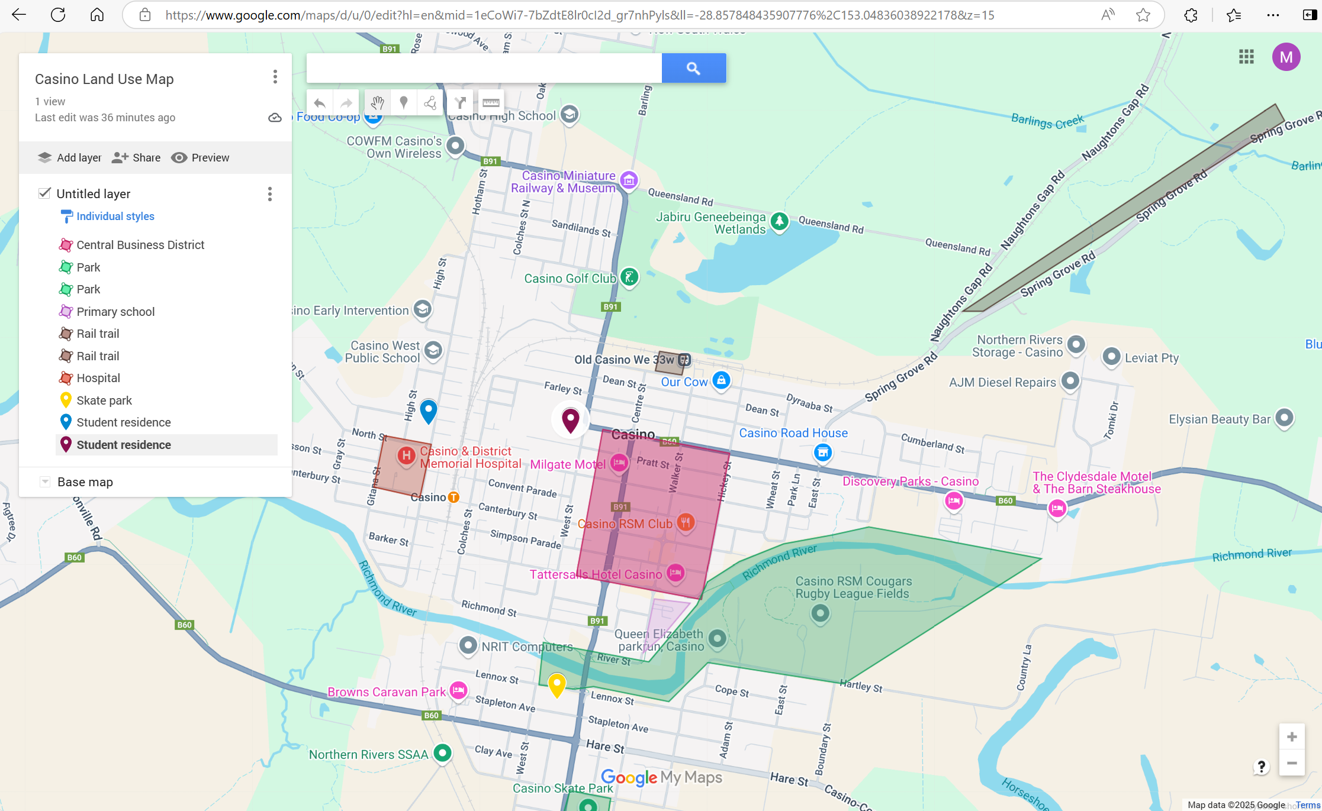
Map data © 2025 Google.

Appendix 4 – living in Casino, NSW WAGOLL
Living in Casino, NSW, offers several features that contribute to its liveability. One important aspect is the strong sense of community. Many residents know each other, which helps create a friendly and welcoming environment. The town also has access to fresh, clean water, which is essential for health and daily life.
Casino has many parks and green spaces where people can enjoy the outdoors and spend time with others. These areas are used for walking, biking and relaxing, supporting a healthy lifestyle. The land use map in Appendix 3 shows how close these parks, as well as schools and shops, are to where people live, making it convenient to access important services.
Transport is another key feature of Casino’s liveability. The town is connected by roads and rail, which allows people to travel easily to nearby places like Lismore and Grafton.
Casino is also known for events like Beef Week, which includes food, music and activities that bring people together. The town’s strong agricultural industry provides fresh food and jobs for many locals, helping to support the economy and connect people to the land.
In summary, Casino’s liveability is shaped by its strong community, natural spaces, access to services, transport links, local events and agriculture.

Appendix 5 – marking criteria stand-alone assessment
The following supports assessing the stand-alone assessment SA133 - Geography – Liveability of Places.
Grade | Marking guideline descriptors
A | - Presents a clear and detailed definition of liveability  - Integrates relevant examples of characteristics of liveability  - Communicates ideas in a structured, logical response written in third person with effective application of connectives  - Uses a range of appropriate geographical terms and concepts
B | - Presents a clear definition of liveability  - Integrates examples of characteristics of liveability  - Communicates ideas in a structured response written primarily in third person with application of connectives  - Uses appropriate geographical terms and concepts
C | - Presents a simple definition of liveability  - Provides an example(s) of characteristics of liveability  - Communicates ideas in a clear response, which may be written in third person and/or use connectives  - Uses geographical terms and concepts
D | - Presents some ideas related to liveability  - May list examples of characteristics of liveability  - May attempt a structured response and/or to write in third person and/or to use connectives  - May use some terms or concepts
E | - Makes general statements

Teacher instructions
There are many options for delivering the feedback below. Teachers may select one or multiple of these options to support students to consider developing their capability to respond to questions in written forms.
Teacher led group feedback
Teachers display the sample response along with the marking criteria and use the notes provided to guide students to understand the application of marking criteria to the sample response. To support mixed ability classes, the teacher may repeat this process with both the A-range response and the C-range response or may choose the response most appropriate to the class context.
Peer feedback or self-assessment
Students use the sample response and annotations to understand the application of the marking criteria (this may be led by the teacher). Students then read their own or a peer’s response and annotate it according to the marking criteria, noting specific features of the response and how they align with each criterion. Alternatively, students may use the checklist provided to identify features of the work. If engaging in peer feedback, the response should then be delivered to the student author with an explanation of feedback, either verbally or in writing. If engaging in self-assessment, the student may write or discuss with a peer or teacher the justification of the feedback they have provided.
Teacher marking
The teacher may apply the marking criteria to student work, supported by the sample responses and annotations. The teacher may use this to categorise, grade or mark student responses to use for formative assessment or reporting purposes.
Sample responses
The sample responses provided are indicative and have been formed in relation to the Common Grade Scale, syllabus advice documents and the National Literacy Learning Progressions. Students may produce different responses based on their learning context and variable factors such as how much time is spent on the task. In some cases, it may be more relevant for teachers to use genuine sample responses from students in the class for group feedback activities.
The following sample responses and annotations have been highlighted to show their connection to the marking criteria.
Sample A-range response
Liveability refers to how easy it is to live in a particular area. This is influenced by the availability of services and facilities such as healthcare, education, outdoor spaces and transportation. For example, Wollongong is a city with characteristics that add to its liveability. Wollongong has many services and facilities such as hospitals, schools and the University of Wollongong, allowing residents access to healthcare and education. Furthermore, Wollongong is surrounded by beaches and national parks, providing residents with opportunities for outdoor recreation and making it a beautiful place to live. Wollongong’s close proximity to Sydney and connecting trainline also make it convenient for people who work or travel between cities. All of these characteristics contribute to Wollongong’s liveability. Therefore, the strong availability of healthcare, education and outdoor spaces promotes wellbeing for residents and makes Wollongong a highly liveable city.
Annotation
This sample response meets the marking criteria for an A-range response. It provides a clear and detailed definition of liveability, and provides specific examples of characteristics of liveability through descriptions of healthcare, education, outdoor spaces and public transport facilities in Wollongong. The response applies effective communication by using appropriate sentences, accurate grammar and connectives to add structure. It maintains third person throughout. It effectively applies a range of terms and concepts (services, education, wellbeing).
Marking criteria – A- range response
Grade | Marking guideline descriptors
A | - Presents a clear and detailed definition of liveability  - Integrates relevant examples of characteristics of liveability  - Communicates ideas in a structured, logical response written in third person with effective application of connectives  - Uses a range of appropriate geographical terms and concepts
B | - Presents a clear definition of liveability  - Integrates examples of characteristics of liveability  - Communicates ideas in a structured response written primarily in third person with application of connectives  - Uses appropriate geographical terms and concepts
C | - Presents a simple definition of liveability  - Provides an example(s) of characteristics of liveability  - Communicates ideas in a clear response, which may be written in third person and/or use connectives  - Uses geographical terms and concepts
D | - Presents some ideas related to liveability  - May list examples of characteristics of liveability  - May attempt a structured response and/or to write in third person and/or to use connectives  - May use some terms or concepts
E | - Makes general statements
Sample C-range response
Liveability is whether or not a place is a good place to live. In class we have studied Wollongong, and I think it is a liveable place. Wollongong Hospital is important for liveability because when people get sick or hurt they need to be able to get help. There are a lot of schools in Wollongong, which means that people can choose which one they want to go to. Wollongong is also right on the beach which is nice because you can go for a swim or a surf whenever you like. Wollongong also has a train that goes to Sydney. This is convenient for people who work there. In conclusion, Wollongong has characteristics of liveability.
Annotation
The sample response meets the marking criteria for a C-range response. It provides a simple definition of liveability and accurately describes information about a number of facilities that improve liveability in Wollongong (hospitals, schools, beaches, trains). The response clearly communicates the author’s ideas and uses a connective. It is mostly written in first and second person rather than third person, with repeated use of personal pronouns (we, I, you) which makes the tone of the response less formal. The response uses some basic geographical terms (liveability, characteristics).

Marking criteria – C-range response
Grade | Marking guideline descriptors
A | - Presents a clear and detailed definition of liveability  - Integrates relevant examples of characteristics of liveability  - Communicates ideas in a structured, logical response written in third person with effective application of connectives  - Uses a range of appropriate geographical terms and concepts
B | - Presents a clear definition of liveability  - Integrates examples of characteristics of liveability  - Communicates ideas in a structured response written primarily in third person with application of connectives  - Uses appropriate geographical terms and concepts
C | - Presents a simple definition of liveability  - Provides an example(s) of characteristics of liveability  - Communicates ideas in a clear response, which may be written in third person and/or use connectives  - Uses geographical terms and concepts
D | - Presents some ideas related to liveability  - May list examples of characteristics of liveability  - May attempt a structured response and/or to write in third person and/or to use connectives  - May use some terms or concepts
E | - Makes general statements
Student self-assessment checklist
Review your response, and select all elements you can identify:
- Presenting a clear and detailed response to the questions
- Use of words from the question in your response (liveability, characteristics)
- Use of topic sentence and/or concluding sentence
- Integrating relevant information and examples
- Providing a definition for liveability
- Integration of relevant characteristics of liveability (for example, healthcare, environmental quality, employment, education, cultural activities, transportation)
- Integration of relevant information about the specific features of these characteristics in a specific place (for example, health facilities, schools, universities, jobs, childcare, public transport, festivals)
- Use of geographical terminology and concepts
- Using some words specific to this topic (for example, services and facilities, healthcare, recreation)
- Application of a geographical concept (for example, wellbeing, quality of life)
- Communication
- Written in third person (no use of personal pronouns such as ‘I’, ‘we’ or ‘you’)
- Use of connectives (furthermore, additionally, also, therefore)
- Appropriate use of sentences (including capital letters and full stops)
- Appropriate response length (at least 4 sentences).

Appendix 6 – Edging Valley map
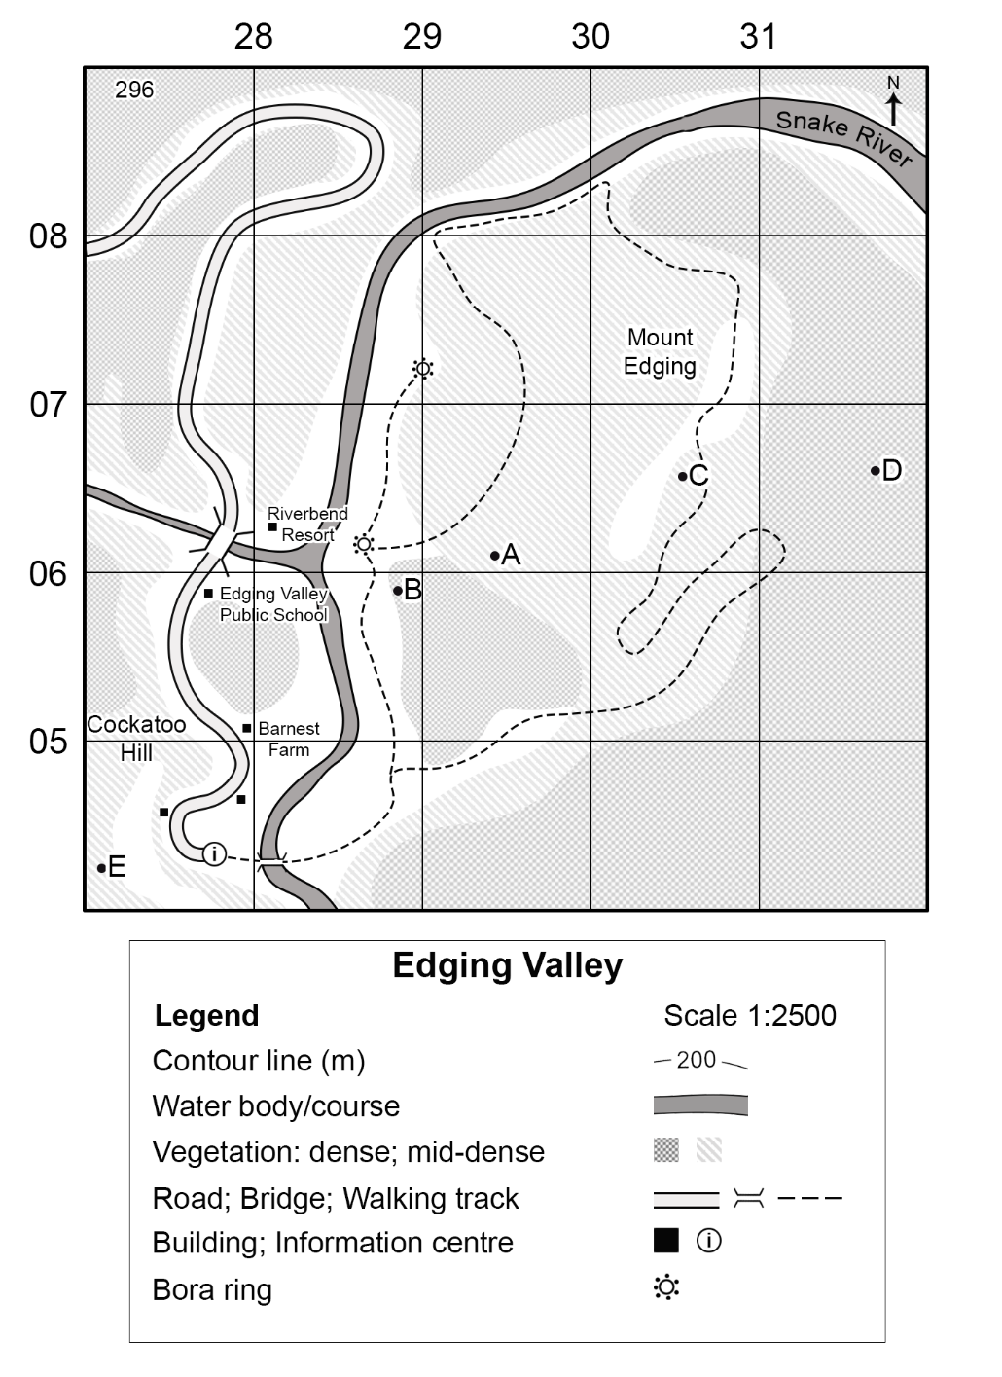

Appendix 7 – challenges of living in megacities (WATCHES)
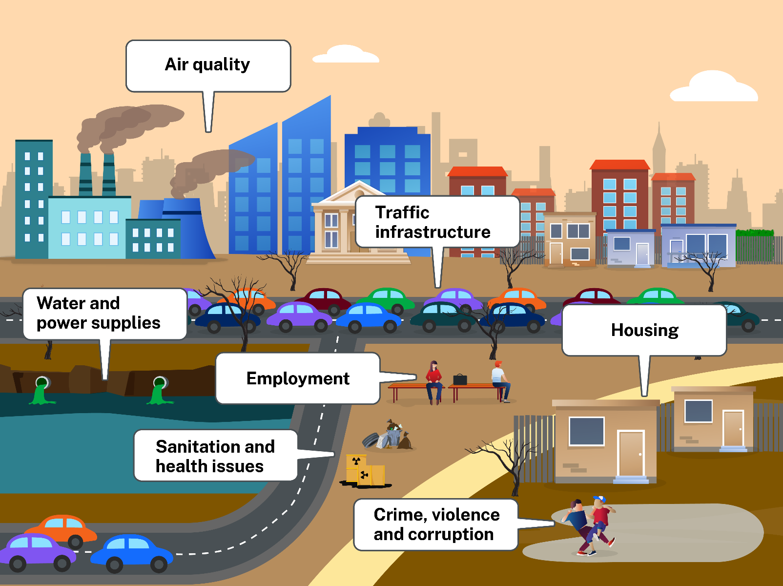

Appendix 8 – Paceworth map
Note: Paceworth map is to scale. Do not resize this map.
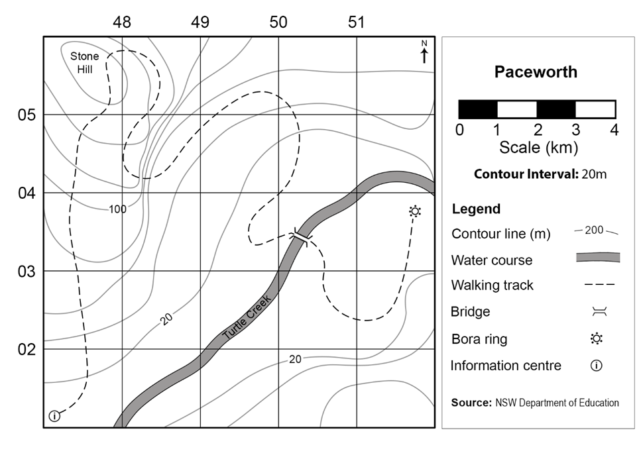

Appendix 9 – Dreamouth Siding map
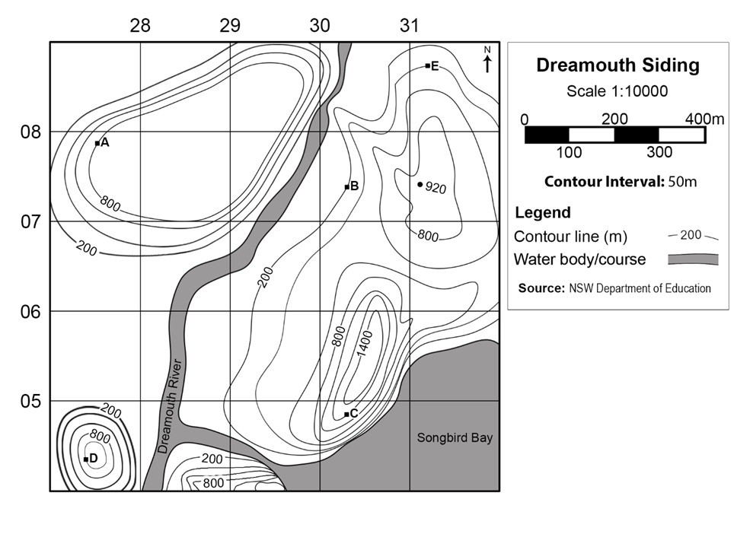

Appendix 10 – vocabulary self-assessment
Criteria | Yes/No
I have not heard or seen the word before.
I have heard/seen the word before but cannot define it.
I can use the word in a sentence, but not confidently.
I can explain the meaning of the word and provide synonyms/antonyms.
I can define the word including its key concepts and features.
I can confidently and completely use the word when speaking and in my own texts.

Appendix 11 – connecting terms
Cause … effect | Effect … cause
An outcome of  As a consequence of  As a result of  Consequently  Conveys  Creates  Generates  Gives rise to  Leads to  Owing to  Provoked  Results in  Results in  Reveals  Thus | Accordingly  Arose out of  Brought about  Caused by  Due to  Is a result of  Is an effect of  Is an outcome of  Is influenced by  Is inspired by  Is produced by  Shaped by  So that  Stems from  Therefore

Overall program evaluation
This section has been provided for teacher evaluation notes. Evaluating teaching and learning programs for HSIE 7–12 provides advice to support this process.

References
This resource contains NSW Curriculum and syllabus content. The NSW Curriculum is developed by the NSW Education Standards Authority. This content is prepared by NESA for and on behalf of the Crown in right of the State of New South Wales. The material is protected by Crown copyright.
Please refer to the NESA Copyright Disclaimer for more information https://educationstandards.nsw.edu.au/wps/portal/nesa/mini-footer/copyright.
NESA holds the only official and up-to-date versions of the NSW Curriculum and syllabus documents. Please visit the NSW Education Standards Authority (NESA) website https://educationstandards.nsw.edu.au and the NSW Curriculum website https://curriculum.nsw.edu.au.
Geography 7–10 Syllabus © NSW Education Standards Authority (NESA) for and on behalf of the Crown in right of the State of New South Wales, 2024.
© State of New South Wales (Department of Education), 2025
The copyright material published in this resource is subject to the Copyright Act 1968 (Cth) and is owned by the NSW Department of Education or, where indicated, by a party other than the NSW Department of Education (third-party material).
Copyright material available in this resource and owned by the NSW Department of Education is licensed under a Creative Commons Attribution 4.0 International (CC BY 4.0) license.

This license allows you to share and adapt the material for any purpose, even commercially.
Attribution should be given to © State of New South Wales (Department of Education), 2025.
Material in this resource not available under a Creative Commons license:
- the NSW Department of Education logo, other logos and trademark-protected material
- material owned by a third party that has been reproduced with permission. You will need to obtain permission from the third party to reuse its material.
Links to third-party material and websites
Please note that the provided (reading/viewing material/list/links/texts) are a suggestion only and implies no endorsement, by the New South Wales Department of Education, of any author, publisher, or book title. School principals and teachers are best placed to assess the suitability of resources that would complement the curriculum and reflect the needs and interests of their students.
If you use the links provided in this document to access a third-party's website, you acknowledge that the terms of use, including licence terms set out on the third-party's website apply to the use which may be made of the materials on that third-party website or where permitted by the Copyright Act 1968 (Cth). The department accepts no responsibility for content on third-party websites.

