Geography (Stage 4) – resource booklet
Liveability of places – Geography 7–10 Syllabus (2024)
Contents
Overview 7
Learning sequence 1 – perceptions of liveability 8
Lesson 1 – introduction to liveability and place 8
1.1.1 – the 3-minute throw down 8
1.1.2 – capacity matrix 8
1.1.3 – the Global Liveability Index (2025) and world’s most liveable cities 10
Lesson 2 – types of maps commonly used in geography 12
1.2.1 – features of maps commonly used in geography 12
1.2.2 – dot maps 12
Lesson 3 – mapping – area and grid reference 13
1.3.1 – finding area reference on a map 13
1.3.2 – finding grid reference on a map 14
1.3.3 – construct a dot map 15
Lesson 4 – factors that affect liveability of places 1 16
1.4.1 – factors that affect liveability 16
1.4.2 – land use survey using Google maps 17
1.4.3 – identify and describe the benefits of living in your suburb, town or city 18
Lesson 5 – factors that affect liveability of places 2 19
1.5.1 – See, Think, Wonder 19
1.5.2 – Frayer diagram 20
1.5.3 – table summary – factors that affect liveability 20
1.5.4 – affinity diagram 22
1.5.5 – writing assessment 22
Lesson 6 – types of data 23
1.6.1 – data types dominos 23
1.6.2 – consolidation 23
1.6.3 – heads or tails – sample or census 23
1.6.4 – heads or tails – sample bias 24
1.6.5 – Frayer diagram – census, sample and sample bias 24
Lesson 7 – surveying and different data displays 24
1.7.1 – surveys 24
1.7.2 – surveying student interactive 24
1.7.3 – types of data matching game 24
Lesson 8 – diverse experiences of liveability 25
1.8.1 – liveability of places for individuals 25
1.8.2 – KWL 25
1.8.3 – fictional profiles 26
Lesson 9 – perceptions of liveability 1 27
1.9.1 – my needs in relation to liveability 27
1.9.2 – small and large scale maps 27
1.9.3 – geographical inquiry 28
1.9.4 – interview 28
Lesson 10 – perceptions of liveability 2 33
1.10.1 – processing geographical information 33
1.10.2 – perceptions of liveability 35
Lesson 11 – perceptions of liveability 3 38
1.11.1 – illustrating liveability 38
1.11.2 – gallery walk and short response 40
Lesson 12 – measuring and ranking liveability 42
1.12.1 – ranking liveability 42
1.12.2 – challenging places to live 42
1.12.3 – opinion continuum 43
1.12.4 – class discussion 43
1.12.5 – worlds least liveable cities 43
Lesson 13 and 14 – pre fieldwork – measuring liveability 45
1.13.1 – assessment task 45
Lesson 15 – fieldwork – measuring liveability 45
1.15.1 – fieldwork 45
Lesson 16 and 17 – post fieldwork – measuring liveability 45
1.16.1 – post fieldwork assessment 45
Lesson 18 – annotated bibliography 45
1.18.1 – types of photographs used in geography 46
Learning sequence 2 – influences and impacts of liveability 49
Lesson 1 – influence of social, cultural and community connections on liveability 49
2.1.1 – reading and comprehension 49
2.1.2 – concept map 49
2.1.3 – visual representation ‘cultural characteristics’ 49
Lesson 2 – population profiles 50
2.2.1 – population profile paragraph analysis 50
2.2.2 – population profile analysis 51
2.2.3 – population profile powerful predictors of the future 52
2.2.4 – exit ticket 52
Lesson 3 – population pressures on liveability 52
2.3.1 – world population and liveability 52
2.3.2 – population pressure 53
2.3.3 – 20-minute city 53
2.3.4 – exit ticket 54
Lesson 4 – access to services and facilities that influence the liveability of places (megacities) 54
2.4.1 – challenges of living in megacities 54
2.4.2 – Mumbai 55
2.4.3 – small group work (podcast) 56
Lesson 5 – access to services and facilities that influence the liveability of places – megacities solutions 56
2.5.1 – mapping the world’s megacities 56
2.5.2 – future challenges of megacities 56
2.5.3 – investigative study – megacities 57
2.5.4 – exit ticket 58
Lesson 6 – access to services and facilities that influence the liveability of places – Australia’s health 1 58
2.6.1 – activate prior knowledge 58
2.6.2 – scale on maps 59
2.6.3 – class discussion 61
2.6.4 – Royal Flying Doctors 62
Lesson 7 – access to services and facilities that influence the liveability of places – Australia’s health 2 63
2.7.1 – read aloud exercise 63
2.7.2 – graph analysis 63
2.7.3 – access to services 64
2.7.4 – creating written texts 65
Lesson 8 – Aboriginal and Torres Strait Islander Peoples’ social, cultural and community connections 65
2.8.1 – defining culture, Country and spirituality 65
2.8.2 – projecting across time 66
2.8.3 – exit ticket 67
Lesson 9 – natural hazards and liveability 67
2.9.1 – defining natural hazards 67
2.9.2 – Los Angeles wildfires 67
2.9.3 – bushfires 67
Lesson 10 – climate change 68
2.10.1 – vocabulary self-assessment 68
2.10.2 – optional exercise 69
Lesson 11 and 12 – Carteret Islands case study 70
2.11.1 – climate refugees 70
2.11.2 – mapping Carteret Islands 70
2.11.3 – photo sketch Carteret Islands 71
2.11.4 – environmental refugee 71
Lesson 13 – environmental quality and liveability of places 72
2.13.1 – environmental factors that influence liveability 72
2.13.2 – environmental performance index 72
2.13.3 – exit ticket 73
Lesson 14 – human processes impacting liveability in Jakarta 73
2.14.1 – comparing liveability 73
Lesson 15 and 16 – pollution in my area (fieldwork) 75
2.15.1 – defining terms 75
2.15.2 – hypothesis 75
2.15.3 – fieldwork 76
2.15.4 – post fieldwork 77
Learning sequence 3 – enhancing liveability 78
Lesson 1 – enhancing liveability – ways to improve liveability overview 78
3.1.1 – brainstorm 78
3.1.2 – designing a sustainable city 78
Lesson 2 – planning strategies used to enhance the liveability of place for groups of people 79
3.2.1 – local government role in planning for liveability 79
Lesson 3 and 4 – benefits of caring for Country to enhance liveability for Aboriginal Peoples 81
3.3.1 – NSW Indigenous Protected Areas (IPAs) 81
3.3.2 – small group work 82
Lesson 5 and 6 – strategies used to enhance liveability of a place for groups of people 83
3.5.1 – See, Think, Wonder 83
3.5.2 – defining homelessness 83
3.5.3 – column graphs 83
3.5.4 – construct a column graph 84
3.5.5 – class discussion 85
3.5.6 – develop a Public Service Announcement (PSA) 85
3.5.7 – capacity matrix 85
Appendix 1 – world map 87
Appendix 2 – Think-Pair-Share template 88
Appendix 3 – PMI (Plus, Minus, Interesting) 89
Appendix 4 – TAG template 90
Appendix 5 – Frayer diagram template 91
Appendix 6 – vocabulary self-assessment tool 92
References 93

Overview
This resource booklet is not a standalone resource. It has been designed for use by teachers in conjunction with the Geography (Stage 4) – sample program of learning – Liveability of places. The material in this resource booklet is a sample and is intended to support teachers as they develop contextually appropriate teaching and learning resources that meet their students’ needs. It is not intended to be taught exactly as presented in its current format. There are instructions for both the teacher and students throughout the resource. Teachers using this resource should edit and refine these to suit their students’ needs, interests, abilities and the tasks selected.
The content in this resource booklet has been prepared by the HSIE curriculum team, unless otherwise credited. The HSIE curriculum team have created a range of support resources for Geography 7–10, including sample assessment schedules, scope and sequences, learning sequences and assessment tasks. The Geography (Stage 4) – sample program of learning – Liveability of places contains key information to complement this resource.
Some of the information in this resource booklet is collated from relevant NESA and department documentation. It is important that all users review and cross-reference the relevant syllabus, assessment and reporting information hyperlinked throughout. This ensures the content is an accurate reflection of the most up-to-date syllabus content. Links contained within this resource were correct as of 25 June 2025.

Learning sequence 1 – perceptions of liveability

Lesson 1 – introduction to liveability and place

1.1.1 – the 3-minute throw down
You have 3 minutes to write down on sticky notes as many ideas as you can about the perfect place to live. As you throw down an idea call it out. You cannot repeat an idea that has already been thrown down.
As a class organise the ideas that have been thrown down under the categories of environmental, social, economic and political. Turn and talk to a partner about your understanding of the term ‘place’. Use the definition of ‘liveability’ and ‘place’ from the syllabus Glossary to generate an illustration that explains the terms.

1.1.2 – capacity matrix
Review the capacity matrix and identify your current understanding of the terms ‘liveability’ and ‘place’ using the key classification:
- information – recall basic facts or heard of this before
- knowledge – can explain and know what it means
- know-how – can draw connections between this geographical term or concept and relate them to other concepts or situations
- wisdom – can use the term or concept in new contexts or teach others.
As a class discuss the characteristics you might observe in one of the world’s most liveable cities.
Table 1 – glossary of concepts and terms
Glossary word | Information | Knowledge | Know-how | Wisdom
accessibility
belonging
citizenship
climate
community
culture
demography
discrimination
environment
ethnicity
ghetto
heritage
infrastructure
liveability
liveability criteria
multiculturalism
neighbourhood
open spaces
place
place-making
private space
public space
transport

1.1.3 – the Global Liveability Index (2025) and world’s most liveable cities
Identify categories the Economist Intelligence Unit (EIU) use to measure and rank liveability.
Use Table 2 and Google maps or an atlas to locate and label the world’s most liveable cities on Appendix 1 – world map. Include appropriate mapping conventions (BOLTSS) and record the latitude and longitude of each city.
Table 2 – the most liveable cities in the world, 2025 (EUI)
City and country | Rank | Stability  (100 = ideal) | Healthcare | Culture and environment | Education | Infrastructure
Copenhagen (Denmark) | 1 | 100 | 95.8 | 95.4 | 100 | 100
Vienna (Austria) | 2 | 95.0 | 100 | 93.5 | 100 | 100
Zurich (Switzerland) | 2 | 95.0 | 100 | 96.3 | 100 | 96.4
Melbourne (Australia) | 4 | 95 | 100 | 95.8 | 100 | 96.4
Geneva (Switzerland) | 5 | 95 | 100 | 94.9 | 100 | 96.4
Sydney (Australia) | 6 | 95.0 | 100 | 694.4 | 100 | 96.4
Osaka (Japan) | 7 | 100 | 100 | 86.8 | 100 | 96.4
Auckland (New Zealand) | 7 | 95.0 | 95.8 | 97.9 | 100 | 92.9
Adelaide (Australia) | 9 | 95.0 | 100 | 91.4 | 100 | 96.4
Vancouver (Canada) | 10 | 95.0 | 95.8 | 97.2 | 100 | 92.9
‘Global Liveability Index 2025’ by Economist Intelligence Unit is available in the public domain.
Complete the following sentences as an Exit ticket:
- The assessment of the quality of a place is called …
- Three examples of the world’s most liveable cities include …
- The EUI ranks cities in the world based on their …
- Australian cities often rank well for liveability because …

Lesson 2 – types of maps commonly used in geography

1.2.1 – features of maps commonly used in geography
Note the key features of the different types of maps commonly used in geography.
Table 3 – key features of the different types of maps used in geography
Map | Features
choropleth
dot
gazetteer
physical
political
street directory
synoptic
thematic
topographic
Highlight the map type(s) best suited to showing liveability factors (social, economic, environmental and political).

1.2.2 – dot maps
Review Figure 1 and answer the following questions:
- Why is this a dot map?
- What mapping conventions are missing on this map?
- What population number does each dot represent on the map?
- Where do the majority of Australian’s live?
- Suggest reasons why Australians live in these locations and not in central Australia.
Figure 1 – dot map used in geography
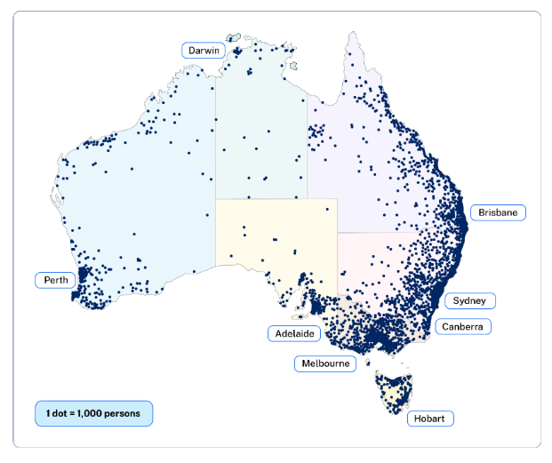
Table 4 – ratios used on dot maps
Type of ratio | Rank
1:1 | One dot represents a single phenomenon. In this case, one dot might represent one person. (Phenomenon – observable event.)
1:M | One dot represents multiple phenomena. For instance, one dot might represent 1,000 people.

Lesson 3 – mapping – area and grid reference

1.3.1 – finding area reference on a map
Note: teacher will demonstrate the ‘I do, we do, you do’ routine using Slide deck 2 – Liveability of places.
For maps on a scale of 1:250,000 down to 1:25,000, the common system is to mark the whole map with a grid of squares, using horizontal and vertical grid lines at equal intervals. The intervals are chosen to suit the scale of the map, for example, Figure 2.
Figure 2 – eastings and northings
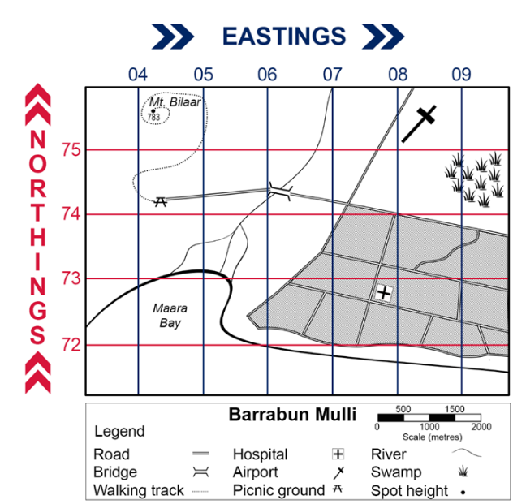
- I do – teacher will model how to find Mt Bilaar on Figure 2.
- We do – what is located at AR0875 and AR0772 on Figure 2?
- You do – your teacher will cold call. What is the area reference for Maara Bay, the bridge and the main swamp on Figure 2?

1.3.2 – finding grid reference on a map
I do – teacher will model how to find Mt Bilaar grid reference.
Figure 3 – Mt. Bilaar grid reference
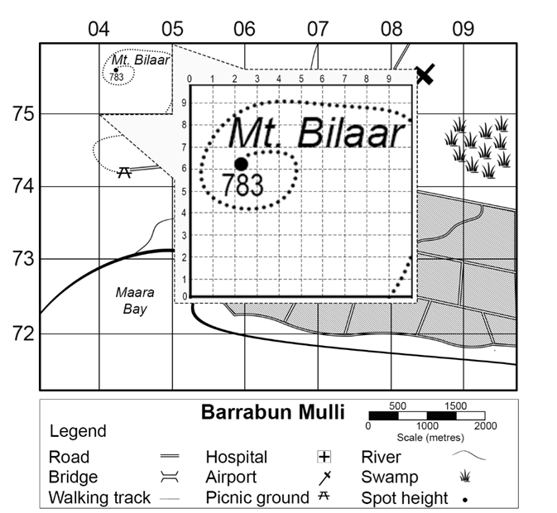
Use Figure 4 to answer the following with your teacher. We do – what is located at GR328188, GR332198 and GR357154?
You do – your teacher will cold call. What is the grid reference for the police station, fire station, hospital and heliport?
Figure 4 – grid reference map
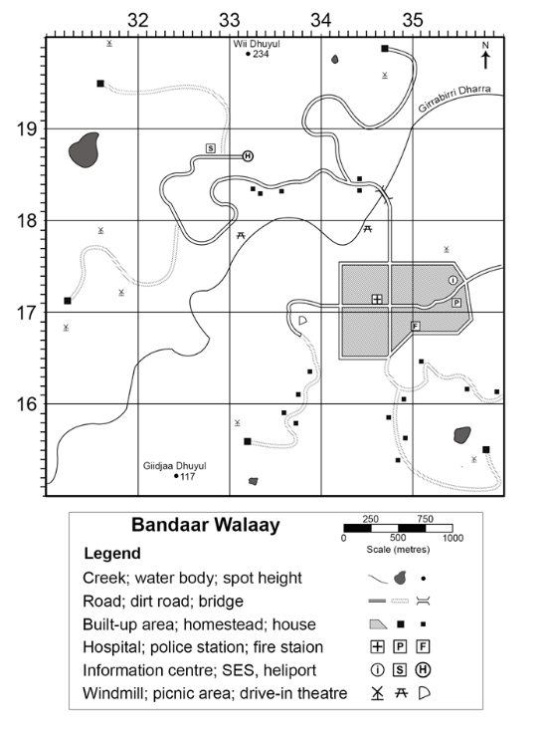

1.3.3 – construct a dot map
Use data provided in Table 5 and Figure 5 to create a dot map.
Table 5 – Edging Valley school student location and population
Location | Student population
Mount Edging AR3007 | 25
Cockatoo Hill AR2705 | 15
Riverbend Resort AR2806 | 40
Snake River AR3108 | 5
Use the map you created to answer the following question: ‘Where do most Edging Valley school students live?’
Record the definition of the concept ‘spatial patterns’ provided by your teacher. Think-Pair-Share your observations of the spatial patterns of Edging Valley school students.
Figure 5 – Edging Valley map
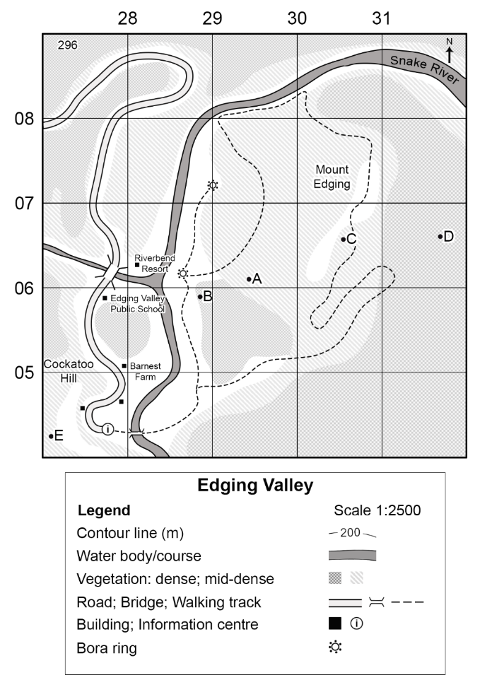1.3.4 – thinking about spatial patterns
Revisit Figure 1 and Think-Pair-Share the following questions:
- Where do most Australians live?
- Suggest reasons why Australians live in densely populated regions.

Lesson 4 – factors that affect liveability of places 1

1.4.1 – factors that affect liveability
Complete Figure 6.
Figure 6 – factors that affect liveability
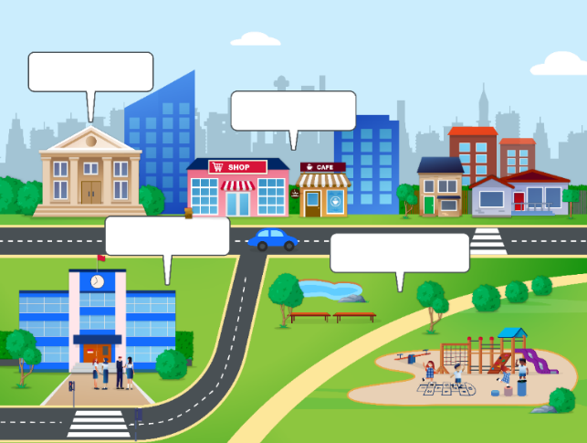
Brainstorm examples that apply to the liveability factors and Think-Pair-Share to complete Table 6 as a class.
Table 6 – liveability factors
Environmental | Social | Economic | Political
Using Table 6 highlight the factors that contribute to liveability in your town, suburb or city.
Answer the question: ‘What factors might have influenced your carers’ choice to live where you do?’

1.4.2 – land use survey using Google maps
Engage with How to create a Land Use Survey on Google Maps (6:58), Figure 7 and the following instructions to develop a land use map of your town, suburb or city.
Drawing a land use map using Google Maps
Open Google My Maps.
- Create a new map.
- Search for your town, suburb or city.
- Zoom in to see the part of the map you want and more details.
- Name your map by selecting Untitled map and name appropriately.
- Identify the key land use features you want to identify, for example, the central business district (CBD), parks, bike tracks, major sporting fields.
- Use the Draw a line button to draw around the area you want to illustrate. Name the polygon with an appropriate name and click save. Change the polygon colour to suit your land use feature.
- Repeat for all the other land use features you want to map.
- Use the Add marker button to locate any important specific locations, for example, a school, student residences.
- When complete screen grab, snip or print your land use map.
Figure 7 – WAGOLL land use map
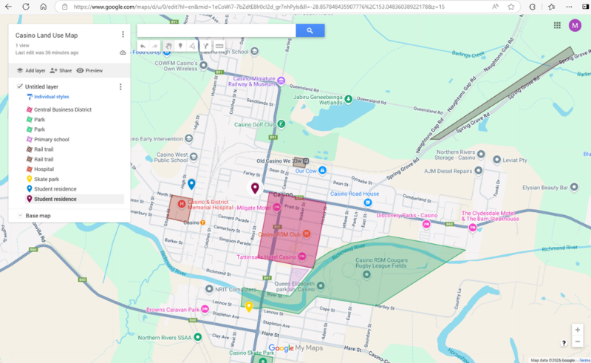
Map data ©2025 Google

1.4.3 – identify and describe the benefits of living in your suburb, town or city
Identify and describe the benefits of living in your suburb, town or city. In your response, refer to specific features identified in your land use map.
WAGOLL Living in Casino, NSW
Living in Casino, NSW, offers several features that contribute to its liveability. One important aspect is the strong sense of community. Many residents know each other, which helps create a friendly and welcoming environment. The town also has access to fresh, clean water, which is essential for health and daily life.
Casino has many parks and green spaces where people can enjoy the outdoors and spend time with others. These areas are used for walking, biking and relaxing, supporting a healthy lifestyle. The land use map in Figure 7 shows how close these parks, as well as schools and shops, are to where people live, making it convenient to access important services.
Transport is another key feature of Casino’s liveability. The town is connected by roads and rail, which allows people to travel easily to nearby places like Lismore and Grafton.
Casino is also known for events like Beef Week, which includes food, music and activities that bring people together. The town’s strong agricultural industry provides fresh food and jobs for many locals, helping to support the economy and connect people to the land.
In summary, Casino’s liveability is shaped by its strong community, natural spaces, access to services, transport links, local events and agriculture.

Lesson 5 – factors that affect liveability of places 2

1.5.1 – See, Think, Wonder
Conduct a See, Think, Wonder routine using Figure 8 and Figure 9.
- Describe exactly what you see, not what you think you see.
- Describe what you think about what you are seeing.
- What questions remain for you?
Figure 8 – See, Think, Wonder image 1
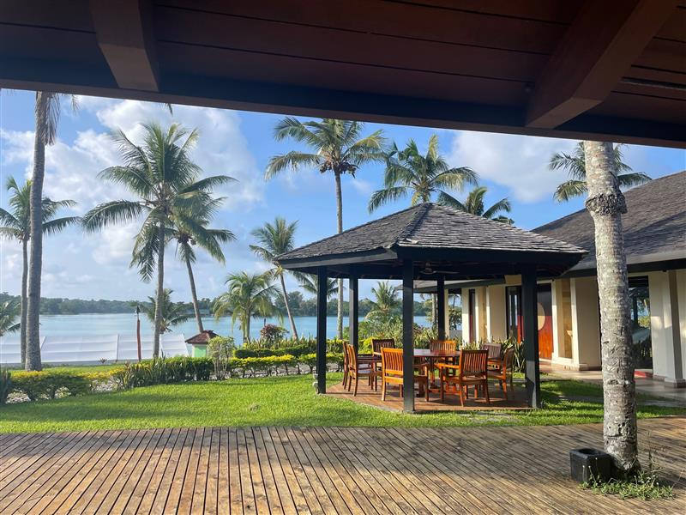
Figure 9 – See, Think, Wonder image 2
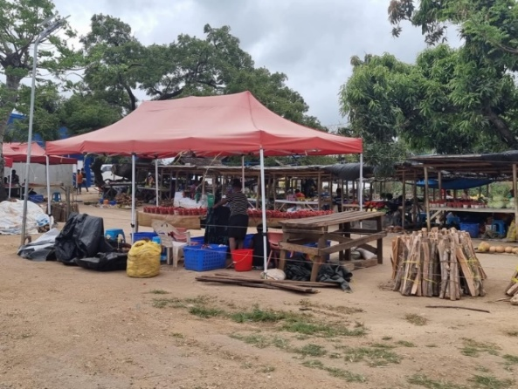
As a class discuss how liveability in a place can vary for different people.

1.5.2 – Frayer diagram
Work with a partner to complete a Frayer diagram for the concept human wellbeing Glossary.
Figure 10 – sample Frayer diagram
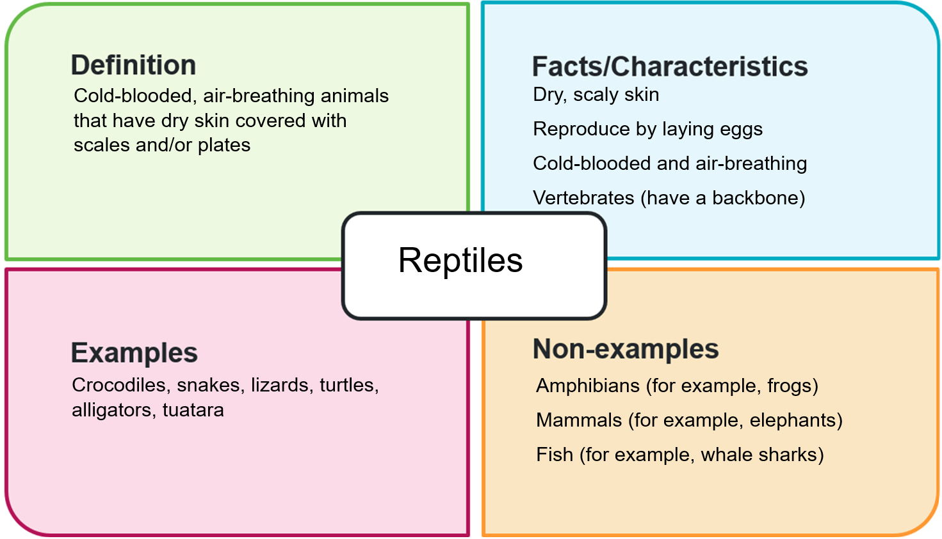

1.5.3 – table summary – factors that affect liveability
Your teacher will allocate you to work in small groups. In your group complete Table 7.
Table 7 – factors that affect liveability
Factor | Definition | Impact on liveability | Example place that has this factor | Image illustrating this factor
Environmental quality
Climate | The average types of weather experienced by a place or region over a long period of time.
Cultural landmarks
Crime
Employment
Recreational areas
Education |  |  | Vienna (Austria)
Healthcare |  |  | Australia
Human wellbeing | The quality of life of a population.
Infrastructure |  |  | Copenhagen (Denmark)
Use the table your group produced for ‘Factors that affect liveability’ to identify:
- Factors that would make people want to move away from a place.
- Factors that would make people want to move to a place.

1.5.4 – affinity diagram
Use an Affinity diagram (Figure 11) to organise factors of liveability under 2 headings ‘Push’ and ‘Pull’.
Figure 11 – sample affinity diagram
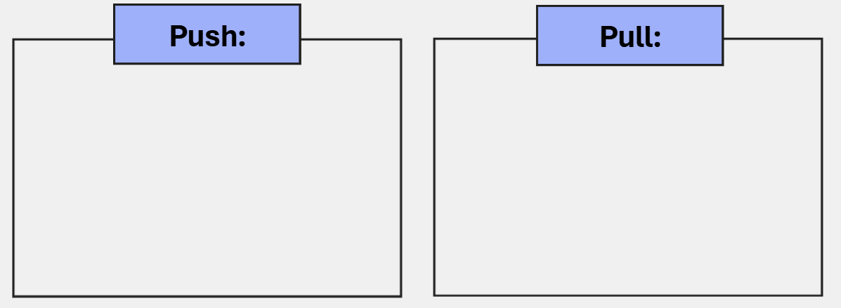

1.5.5 – writing assessment
Define liveability and describe characteristics of liveability you have studied.
In your response, you should:
- Use geographical terms and concepts. For example, liveability, education, climate.
- Write in third person and use connectives. For example, a liveable city provides …, environmental quality is important because …
- Demonstrate geographical knowledge of the topic.
- Describe examples in your response. For example, North Queensland weather is desirable for those who enjoy warm summers and mild winters.

Lesson 6 – types of data

1.6.1 – data types dominos
Note: teachers provide students with Data types dominoes handouts from the Data 1 teacher resource.

1.6.2 – consolidation
Consolidate your learning of the different data types by independently working through the Types of data interactive.

1.6.3 – heads or tails – sample or census
Play a game of heads and tails by choosing heads if what is read is a census or choosing tails if it is a sample. The teacher will read the statements to the class one at a time.
- The heights of 13-year-olds in Australia and measuring the heights of one hundred 13-year-olds in every state.
- The number of people living in each house in Australia and survey only New South Wales.
- The favourite colour of everyone in your household and asking everyone who lives in your house their favourite colour.
- How students travelled to school by asking the first 100 students through the school gate.
- The number of books sold daily during May for a bookstore.
- A group of teachers were selected to give feedback on the school hall.
- Every person at a school was asked to vote for the new school captain.
- All exam marks recorded for every student.

1.6.4 – heads or tails – sample bias
Play a game of heads and tails by choosing heads if what is read is sample bias or choosing tails if it is not sample bias. The teacher will read the statements to the class one at a time.
- Selecting 50 students from each year when requiring a student perspective about the school.
- Door knocking people in your street for information about garbage collection in your council area.
- Surveying residents in a nursing home about building a bike track in the town.
- Contacting every fifth person on a school list about factors to influence the school.
- Asking people at a basketball game about their favourite sport.

1.6.5 – Frayer diagram – census, sample and sample bias
Complete Frayer diagrams for census, sample and sample bias.

Lesson 7 – surveying and different data displays

1.7.1 – surveys
Work in pairs or small groups to write at least 5 survey questions on a chosen topic and then survey 10 people and record their responses.

1.7.2 – surveying student interactive
Consolidate your understanding by completing Surveying student interactive.

1.7.3 – types of data matching game
Attempt the Types of data matching game.

Lesson 8 – diverse experiences of liveability

1.8.1 – liveability of places for individuals
Review Figure 12 and identify possible challenges that may arise for particular groups of people and how these challenges would impact the liveability of places.
Figure 12 – diverse experiences of liveability
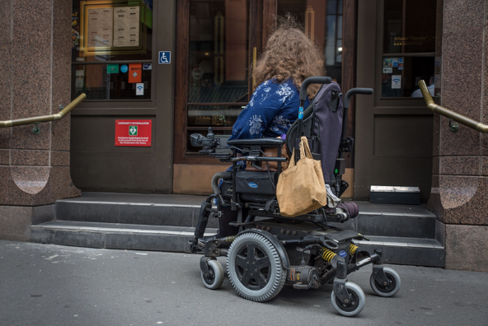
‘Powerchair user unable to access a cafe due to stairs’ by AccessMattersNZ is licensed under CC BY-NC-SA 2.0.

1.8.2 – KWL
View Figure 13 and complete the first 2 columns of Table 8.
Figure 13 – cost of living

- What do I know about the cost of living?
- What do I wonder about the cost of living?
Table 8 – KWL chart
Know | Wonder | Learned

1.8.3 – fictional profiles
Review Table 9 and Table 10.
Choose a place for each fictional person to live.
Use the weekly incomes to calculate:
- how much money they would have left after paying basic costs (rent, groceries and transport)
- what they might need to sacrifice when deciding on where to live.
Table 9 – fictional profiles
Person | Description | Weekly income
Layla | Single mum, part-time retail worker | $800
Brendan | University student, casual worker | $500
Wilson family | Two adults, 2 children, both full-time workers | $2,500
Table 10 – cost of living table 2020
Location | Rent  (weekly) | Groceries  (weekly) | Transport  (weekly)
Sydney | $500 | $150 | $40
Newcastle | $330 | $140 | $30
Dubbo | $240 | $130 | $15
Use Table 11, compare cost-of-living changes for each person’s liveability by completing a Think-Pair-Share responding to the following questions:
- Which costs increased the most?
- How has each person’s liveability changed from 2020 to 2025?
- Would they need to make changes to where they currently live?
- How might liveability change if they lived in a different location? Why?
Table 11 – cost of living table 2025
Location | Rent  (weekly) | Groceries  (weekly) | Transport  (weekly)
Sydney | $650 | $180 | $50
Newcastle | $400 | $160 | $35
Dubbo | $280 | $150 | $20
Revisit the KWL chart commenced at the beginning of the lesson. Complete the last prompt of the KWL ‘Cost of living’, what we learned about the cost of living.

Lesson 9 – perceptions of liveability 1

1.9.1 – my needs in relation to liveability
Use Which Sydney suburb is meant for you? to establish an understanding of what your personal needs are in relation to liveability. Identify the suburbs the Domain website suggested you would prefer in Sydney.

1.9.2 – small and large scale maps
Use Google Maps to produce a small scale map of Sydney’s greater region and a large scale map of the suburb the Domain website recommended would suit your liveability preferences.

1.9.3 – geographical inquiry
Use Figure 14 to identify the first step in the geographical inquiry process.
Figure 14 – geographical inquiry
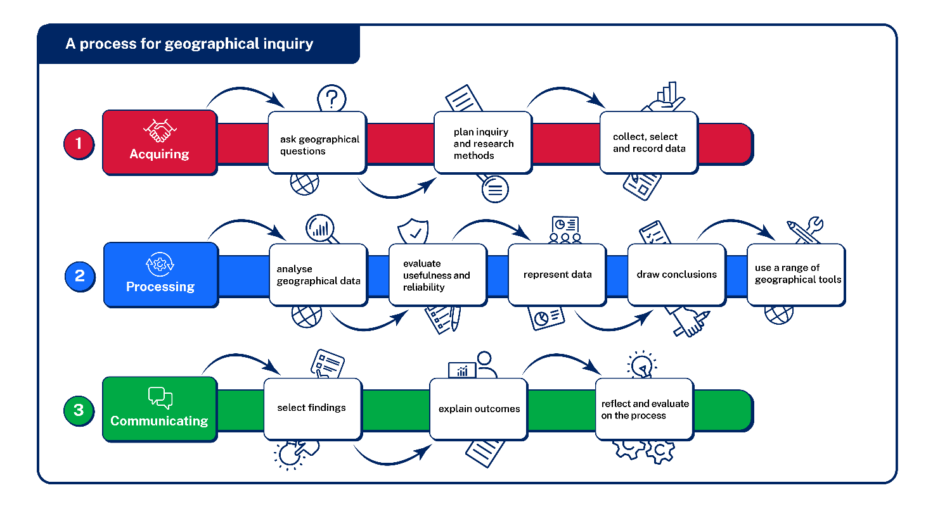
Review the significant geographical question: ‘What environmental, economic, social and political factors influence a person’s perception of liveability of a place?’
Use Appendix 2 – Think-Pair-Share template to compose 3 to 5 minor geographical inquiry questions that would accompany the significant geographical question. Use Asking Geographical Questions to prompt your thinking.

1.9.4 – interview
Review Figure 15.
Figure 15 – steps involved in conducting an interview
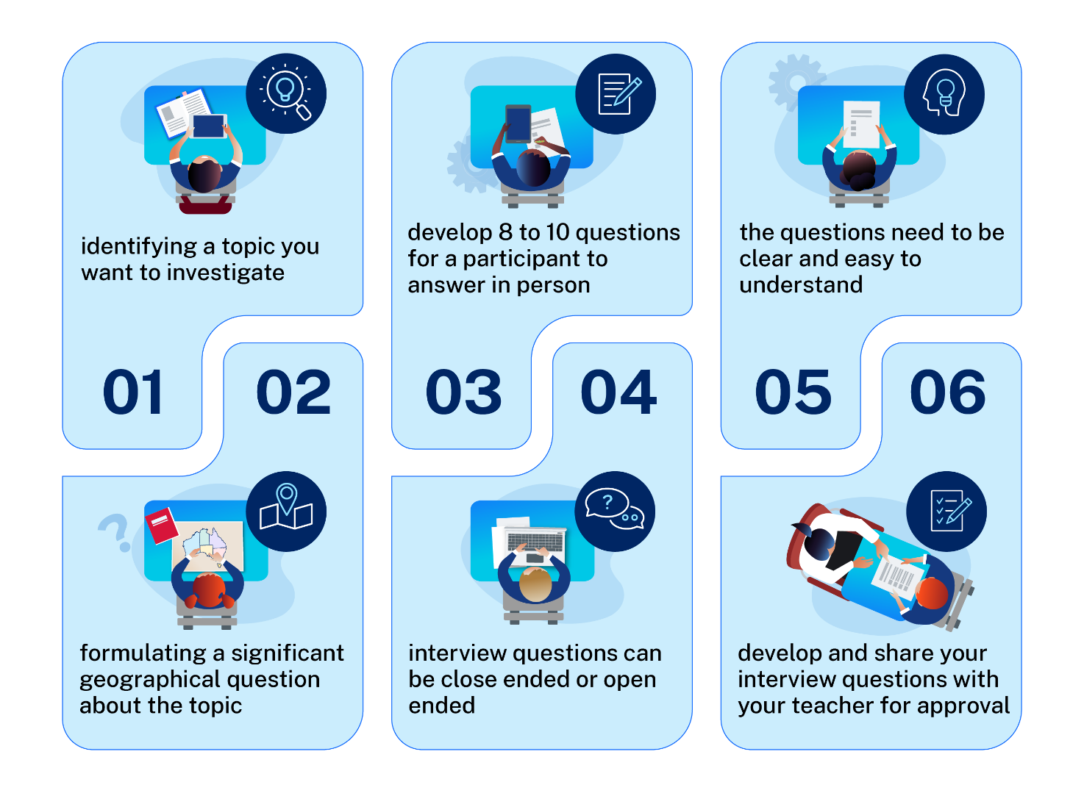
Develop 8 to 10 potential interview questions to ask a resident in Sydney about their perception of the liveability of Sydney.
Review the WAGOLL interview questions developed for interview participants:
- Where were you born?
- Where do you currently live?
- What are some other locations you have lived in?
- Which location would you consider the most liveable?
- Where have you lived most of your life?
- What are some positive characteristics of where you currently live?
- What are some negative attributes of where you currently live?
- Which is more important to you? (cultural destinations, retail, cafes and restaurants, public transport, walk to work, low crime, education, telecoms, open spaces, tree cover, walkability, beach nearby, low traffic, topography, airport noise, ocean views).
- I’d like you to compare a place you have lived previously to where you live now.
- Identify 3 to 5 things you would like to change about where you live.
Using the WAGOLL interview questions identify which of the questions best help answer the significant geographical inquiry question: ‘What environmental, economic, social and political factors influences a person’s perception of liveability of a place?’ and justify why.
Use the WAGOLL interview questions and Interviewee 1 – liveability of Japan and Sydney below to identify where your 8 to 10 interview questions can be improved.
Interviewee 1 – liveability of Japan and Sydney
Where do you currently live?
Sydney, Australia. I was born in Sydney.
What are some other locations you have lived in?
Well, I was born in Sydney.
I started school in New Zealand, though we lived over there for a while and then returned to Sydney and I’ve lived here most of my life apart from when I lived in Japan, so I’ve lived in a few different places. I’ve definitely lived in Sydney for the majority of my life.
From these places which do you think is the most liveable and why?
In New Zealand, I lived in Auckland. Which is kind of similar to Sydney. In Japan, I lived in a city called Gifu which is quite a rural area in Japan. So that’s the most different place that I’ve lived.
It’s tricky, I think, because they’re all different. They kind of have different things that were good and different things that were hard.
It’s hard because thinking about Sydney, that’s where family and friends are. In terms of some of those social aspects, they make Sydney more liveable. But if I try to remove some of those things then I can see in some ways Japan was more liveable.
Japan is a convenient place to live, and one thing that comes to mind is definitely transportation. Their transportation system is so convenient, and their public transport system is just fantastic and it’s so reliable if you think about something like trains.
Being late to work because of a train isn’t a valid excuse. To the extent whereby if your train is more than 2 minutes late, they will hand you a slip. That gives you an idea of how reliable it is. Late transport just doesn’t happen and if you compare that to Sydney trains, it’s pretty different.
Where have you lived the majority of your life?
Sydney.
What are some positive attributes of where you currently live?
It’s not that things are always close, but nothing’s far, like it’s not far to get to the beach. It’s not far to get to the shops or to get to anything that you need, like anything that you need or want is kind of 15 to 20 minutes away, and that’s convenient to be able to access that. I think it gives a real sense of security. If something goes wrong or if something’s inconvenient, it’s going to be fairly easy to fix. Sydney is a lovely place to live, but I think it’s become harder as the cost of living has risen. Yeah, that that’s kind of been, I guess, a challenge. As you get older and you become more aware of these things.
What are some negative attributes of where you currently live?
It has become very expensive to live in Sydney. All those things that contribute to the cost of living. I think transportation is also a problem in Sydney. And it’s just hard with such a high population and a complex layout to the city, like whether it’s by car or whether it’s by public transportation. It’s not always easy to get to where you need to go, and it can be really time consuming.
That’s hard. You know, to be spending a bunch of time just to get to somewhere. And it’s been interesting, even looking at projects like the Metro, which people have been enthusiastic about. And I, I mean, don’t get me wrong. I think that the metro is great, but. I was living in Japan and the metro would be just an average train in Japan where they have the Shinkansen and they have so many other options for transportation that is so much faster. I find myself being a little bit underwhelmed by things like the metro or changes that are being made because I’ve seen it done much better. It’s a bit tricky.
Which is more important to you?
The environment. I think that I’d really struggle to live somewhere with high pollution or really poor air quality where it was really hard to spend time being outside and in some kind of natural space. So that’s a bit of a deal breaker for me. I also feel somewhat concerned about living somewhere where there’s not good access to healthcare.
I feel like I could do it for a while. At my kind of age, I’m young, I’m in good health, but I think depending on your situation, that’s not a luxury that you have. I think that they’re 2 really big ones.
I’d like you to compare a place you have lived previously to where you live now.
Japan is a safe place to live as well because of those things. I think, though that Japanese culture is very specific as well. And some of those are economic factors actually in some ways it means that things are very reliable things, very consistent. They’re great. But in other ways. The economic factors make it hard for people who are in the workplace. They have a very different culture around work in Japan and that can lead to people feeling quite isolated, feeling quite stressed about their career. There’s a lot of pressure for people. I remember talking to friends over there about getting a good entry position job because there’s less mobility between
I feel in Japan there is a lot of pressure from an early age to be doing well at school, to be doing well at university to be getting into a good job at a good company. That’s kind of different as well. Whereas in Australia, I know a lot of people who have taken a while to find their way into a career or what they want to do and it’s quite easy to change between jobs if you’re not happy.
There are benefits to both, but there’s other things that make it a bit tricky. I think that there’s a lot of like pride in that being part of Japan is that there’s a real honesty there. It was very funny when I lived there. I had my bicycle stolen, which is almost unheard of. My Japanese friends were really horrified. They took me to the police station and insisted that I report it. There was this whole police report that was kind of like a missing person’s report. But it was just for this dingy bicycle. I got a call from the police a couple of weeks later and they said, we’ve located your bicycle. It was found at this location. We’re returning it to you. And it was really interesting because even though I was a very unusual victim of crime the response to it was very, very thorough, which is maybe different from some other places in the world as well.
It I think it was a bit tricky for me making a comparison because it was unusual for me living in quite a rural area in Japan compared to an urban area in Australia, and so that was another difference that I wasn’t used to as well as all the kind of cultural differences as well. There were some facilities that weren’t available.
As well as that, there’s just some systems that are different too.
At least where I lived in Japan, I kind of can’t speak to, you know, all of Japan or what it’s like now. But when I lived there, they didn’t have the same kind of medical system like we have in Australia. You had to go to the hospital for most things, even if it was minor and the hospital system was great and it was set up for that. But again, it was just a bit different from having a local doctor, who you know and knows your family. A person who has that kind of familiarity, so that was really different.
Obviously, you know as someone non-Japanese living in Japan. There were different barriers with language and culture and feeling a sense of isolation that were hard as well. But the facilities were great. It was also unusual, you know, moving from somewhere like Sydney, where you have the beaches and the outdoor areas.
Identify things you would like to change about where you live.
Sydney’s transportation system.
Cost of living.
Those are the 2 main things.

Lesson 10 – perceptions of liveability 2

1.10.1 – processing geographical information
Revisit Figure 14 and describe the features of processing geographical information
Review the interviews Interviewee 1 – liveability of Japan and Sydney (from previous lesson) and Interviewee 2 – liveability of Ballina and Jakarta below.
Interviewee 2 – liveability of Ballina and Jakarta
Where do you currently live?
Ballina, NSW, Australia.
What are some other locations you have lived in?
Gold Coast QLD, Jakarta Indonesia, Gwang Ju South Korea.
From these places which do you think is the most liveable and why?
Ballina, the beaches, grew up there, community, fresh air, nice environment. Jakarta was very crowded and I had to travel hours to decent surf and the air pollution was really bad. I worried while I lived there that my health would be impacted. The restaurants were great in Jakarta though and it was a busy paced place to live.
Where have you lived the majority of your life?
Ballina, NSW, Australia.
What are some positive attributes of where you currently live?
Beaches, quiet lifestyle yet all you need in terms of facilities and shops, not much traffic, clean air, cheaper housing compared to major cities.
What are some negative attributes of where you currently live?
Lack of events commonly found in the big city (concerts, festivals) and surf quality sometimes.
Which is more important to you?
Most important to me is the beach nearby, low crime, I can ride a bike to work which saves money and is good for my health and the environment. Topography because I like the coastline and enjoy surfing and coastal walks. Open spaces because I don’t like living in crowded places.
I’d like you to compare a place you have lived previously to where you live now.
Comparison with Jakarta. Ballina has less traffic, better air quality and close to beach are positives. Less restaurants and events are negatives.
Identify 3 to 5 things you would like to change about where you live.
Dredge the Richmond River to increase sand on the beaches, this will protect the shoreline and improve surf conditions. More festivals and events for younger people. A feasible public transport system (buses) and reduced petty crime.
Use Table 12 and the interview transcripts to complete a summary of the different perceptions of liveability in Ballina, Jakarta, Gifu and Sydney.
Table 12 – processing interviews
Person | Attributes preferred | Attributes least preferred | Conclusions about interviewees’ perception of the liveability of places
For each interview critically reflect on the usefulness and reliability of interview transcripts as a source of information.

1.10.2 – perceptions of liveability
Engage with Dollar Street and complete a comparison of families from around the world.
Table 13 – family comparison
Prompts | Africa | Asia | Europe | The Americas
Name of country | Ethiopia
What is the monthly income range for families in this country? | $306 to $872 a month
On average how many bedrooms does each household have? | 2 bedrooms (range 1 to 3 bedrooms)
What are some of the positive features identified for living in this country? | Cool environment  Can grow most of their own food  Live close to their families and workplace
What are some of the challenges of living in this country? For example, access to amenities and infrastructure. | Unreliable electricity  Drinking water not always available in the house  Toilets often outside the house  Transport (many saving for a motor bike)
What is the most common challenge faced by families in this country? | Access to reliable electricity
Note: from the In The World drop down menu, students choose one country from each of the 4 global regions listed.
Use Table 14 to complete a Dollar Street investigative summary by following these steps:
- Choose one country from each of the 4 global regions to investigate.
- To learn more about each family, select the Visit this family link on the right side of the page.
- Use the map also on the right side to identify where in the world each country is located.
- Engage with the photos supplied for each family – consider what each family considers valuable to them.
- Review the living conditions for some families (for example, toilets, bathrooms, flooring). How might these features affect the liveability of the different places?
- Consider what other issues these families might face (for example, safety and access to education).
Table 14 – Dollar Street investigative summary
Details | Notes
Name of country
What I learned about the family
Where in the world my country is located
What things the family considers valuable
Ways the family liveability is impacted
What other issues the family might face
As a class, complete Appendix 3 – PMI (Plus, Minus, Interesting) template to generate a discussion around the positives and negatives of liveability of different places from around the world.

Lesson 11 – perceptions of liveability 3

1.11.1 – illustrating liveability
Work in small groups to develop a poster that illustrates liveability in each of the following locations:
- Sydney, Australia
- Tokyo, Japan
- Jakarta, Indonesia
- Ballina, Australia
- rural example in Australia (student choice).
Use Table 15 to assist the planning. Not all questions need a response. Use the guiding questions to prompt research.
Table 15 – research scaffold
Factor | Guiding questions | Location assigned to your group
Economic | Employment opportunities – Are there job opportunities within the area?  Cost of living – Is housing affordable compared to income levels?  Local economy – Is the local economy diverse and thriving?
Environmental | Air quality – Is the air clean and free from pollution?  Water quality – Is the drinking water safe and clean?  Green spaces – Are there parks, gardens or natural reserves nearby?  Noise levels – Is the area generally quiet or excessively noisy?
Social | Transport options – Are there public transport options (buses, trains)?  Walkability – Are the streets safe and easy to walk around?  Proximity to amenities – How close are schools, shops and healthcare services?  Crime rate – Is the area known for low crime rates?  Community programs – Are there community safety programs in place?  Emergency services – How accessible are police, fire and medical services?  Community engagement – Are there local events or activities to participate in?  Cultural diversity – Is there a variety of cultural experiences and communities?  Access to arts and recreation – Are there theatres, galleries and sports facilities available?  Healthcare facilities – Are there hospitals and clinics accessible nearby?  Mental health services – Are there resources for mental health support?  Healthy lifestyle options – Are there fitness centres, healthy food options and recreational activities?  Quality of schools – Are the local schools well-rated and accessible?  Access to libraries – Are there libraries or learning resources in the area?  Extracurricular opportunities – Are there clubs and activities for students?
Political | How stable is the local government?  Are there policies or programs supporting infrastructure, environment or public safety?

1.11.2 – gallery walk and short response
Participate in a Gallery walk of your class illustrative posters of liveability in each location, use the information to inform a response to construct a paragraph answering the prompt: ‘Outline how liveability of an area can be perceived by different people, and what factors influence these perceptions. Provide an example from at least one place you have studied.’
In your response, you should:
- use geographical terms and concepts
- use subject-specific noun groups
- demonstrate geographical knowledge of the topic
- describe examples in your response.
Table 16 – marking criteria
Grade | Marking guidelines descriptors
A | - Presents a clear and detailed definition of liveability  - Integrates relevant examples of characteristics of liveability  - Communicates ideas in a structured, logical response written in third person with effective application of connectives  - Uses a range of appropriate geographical terms and concepts
B | - Presents a clear definition of liveability  - Integrates examples of characteristics of liveability  - Communicates ideas in a structured response written primarily in third person with application of connectives  - Uses appropriate geographical terms and concepts
C | - Presents a simple definition of liveability  - Provides an example(s) of characteristics of liveability  - Communicates ideas in a clear response, which may be written in third person and/or use connectives  - Uses geographical terms and concepts
D | - Presents some ideas related to liveability  - May list examples of characteristics of liveability  - May attempt a structured response and/or write in third person and/or use connectives  - May use some terms or concepts
E | - Makes general statements

Lesson 12 – measuring and ranking liveability

1.12.1 – ranking liveability
As a class review the images provided by your teacher. Choose one image to explore in detail. For the chosen image identify the environmental, social, economic and political factors that would influence the liveability of place.

1.12.2 – challenging places to live
Conduct research on challenging places to live. Record your findings in Table 17.
Table 17 – challenging places to live
Prompts | Place name | Challenges to liveability | Would you live there?
Identify the hottest place on earth
Identify the coldest place on earth
Identify the most populated city in the world
Identify Australia’s most isolated town
Identify the most isolated town in the world

1.12.3 – opinion continuum
Your teacher will read out statements. You choose where you want to stand along the continuum: strongly agree, agree, neutral, disagree or strongly disagree. Be prepared to justify you position on the continuum. Feel free to adjust your position on the continuum after listening to other students’ justifications.
Write a 1 to 2 paragraph description of how the perception of liveability varied across the class.
Revisit Table 1 from Lesson 1. Identify where Melbourne was ranked according to the EUI.

1.12.4 – class discussion
Engage with Figure 16. Discuss each category with a peer in your class.
Figure 16 – measuring liveability
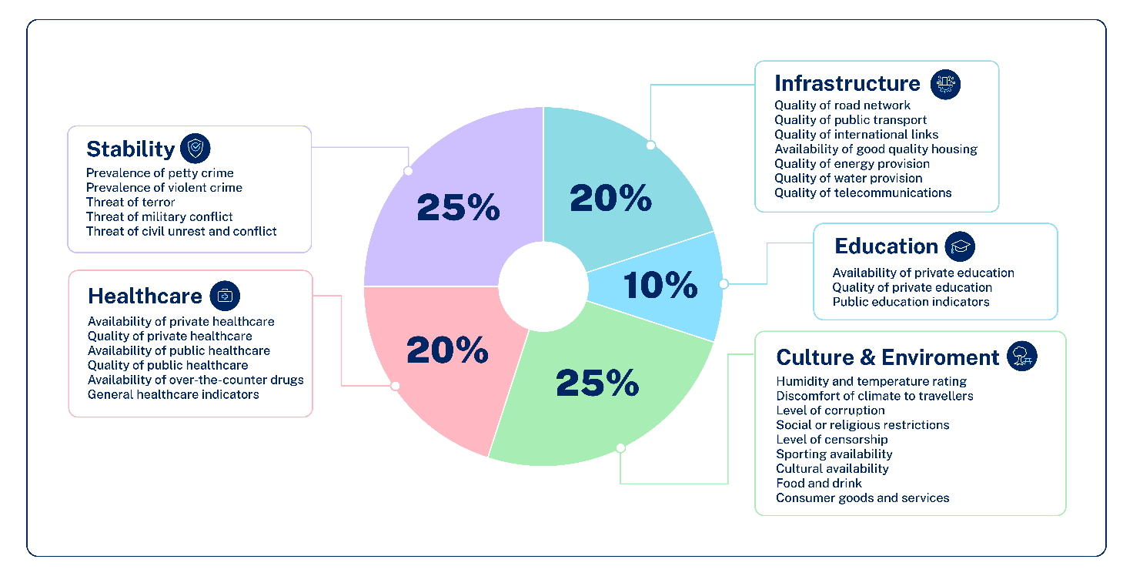
With your partner, consider Melbourne’s ranking in the Economist Intelligence Unit’s Global Liveability Index. Discuss how access to education, healthcare and cultural activities contribute to the overall quality of life in a city. Would you prioritise these factors over aspects like cost of living or job opportunities when evaluating a city’s liveability? Explain your reasoning to the class.

1.12.5 – worlds least liveable cities
Note: this resource includes topics that may be considered controversial or sensitive. Teachers are to respect the diverse views and experiences of all students and approach discussions in a manner that is impartial, free from harassment and discrimination, supportive of students’ wellbeing needs and aligned with the department’s Code of ethics and conduct, Anti-racism, Controversial issues in schools procedures, and Values in NSW public schools. Teachers should facilitate rational discourse and objective study while tailoring the content to meet the unique needs of their students. Where possible, teachers should consult with the school’s wellbeing team before using contexts that may be sensitive for some students.
Use Google Earth to navigate the top 3 least liveable cities. Choose one city to conduct a See, Think, Wonder routine:
- Describe exactly what you see, not what you think you see.
- Describe what you think about what you are seeing.
- What questions remain for you?
Table 18 – least liveable cities in the world, 2025 (EUI)
City and country | Rank
Damascus, Syria | 1
Dhaka, Bangladesh | 2
Lagos, Nigeria | 3
Tripoli, Libya | 4
Algiers, Algeria | 5
Port Moresby, Papua New Guinea | 6
Karachi, Pakistan | 7
Harare, Zimbabwe | 8
Douala, Cameroon | 9
Dakar, Senegal | 10

Lesson 13 and 14 – pre fieldwork – measuring liveability

1.13.1 – assessment task
With the guidance of your teacher complete Assessment support – liveability of places pre fieldwork learning activities.

Lesson 15 – fieldwork – measuring liveability

1.15.1 – fieldwork
Participate in local fieldwork evaluating the liveability of a local suburb, town or city.
Complete Assessment support – Liveability of places fieldwork worksheet in the field.

Lesson 16 and 17 – post fieldwork – measuring liveability

1.16.1 – post fieldwork assessment
Complete Assessment support – Liveability of places post fieldwork learning activities provided by your teacher.

Lesson 18 – annotated bibliography
Note: this resource includes topics that may be considered controversial or sensitive. Teachers are to respect the diverse views and experiences of all students and approach discussions in a manner that is impartial, free from harassment and discrimination, supportive of students’ wellbeing needs and aligned with the department’s Code of ethics and conduct, Anti-racism, Controversial issues in schools procedures, and Values in NSW public schools. Teachers should facilitate rational discourse and objective study while tailoring the content to meet the unique needs of their students. Where possible, teachers should consult with the school’s wellbeing team before using contexts that may be sensitive for some students.

1.18.1 – types of photographs used in geography
Complete Figure 17.
Figure 17 – types of photographs
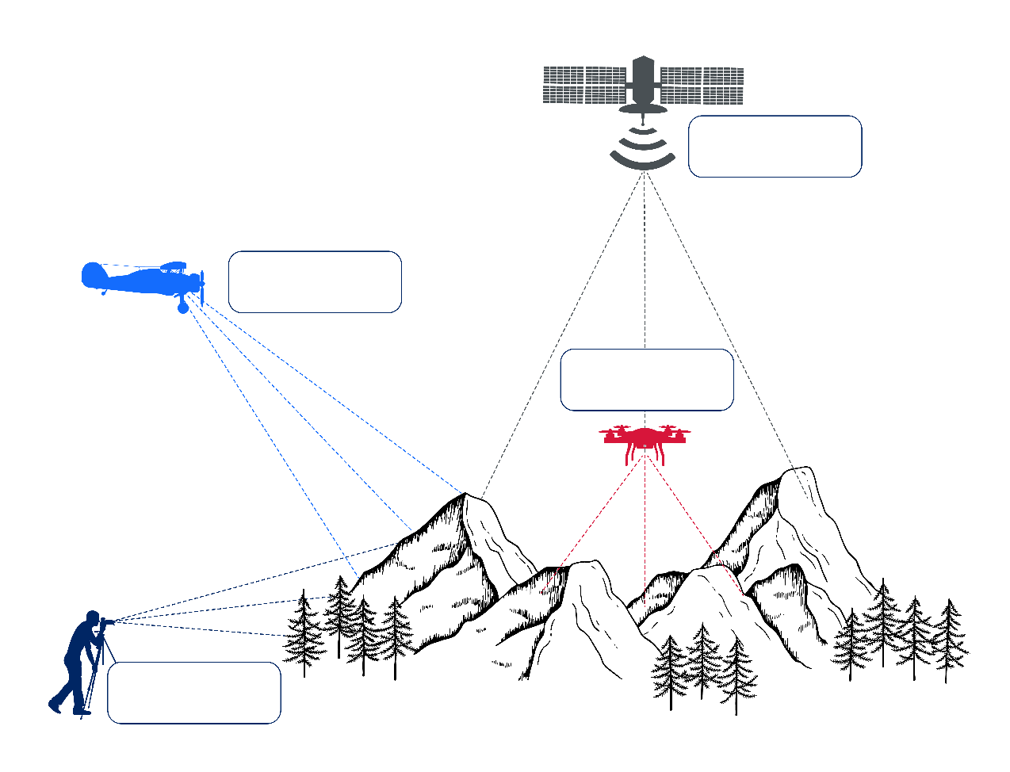
Answer: Figure 18.
Figure 18 – types of photographs answers
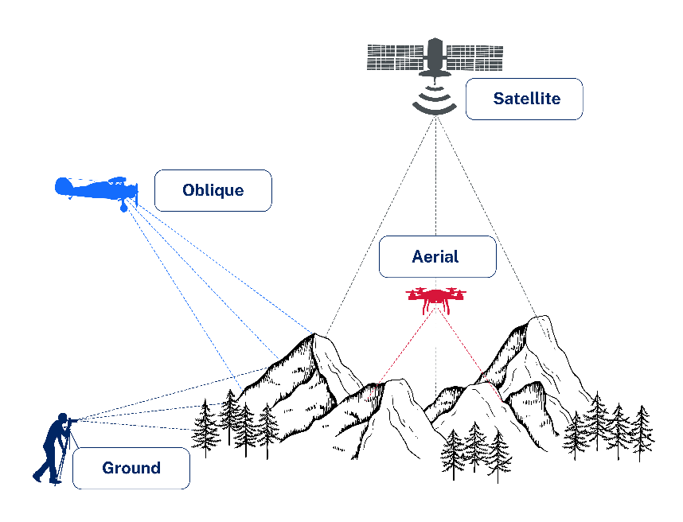
Identify the type of photograph ‘The view from above’ is on the Drone photos capture the staggering inequality in Mumbai webpage.
Use Economic Inequality to complete an annotated bibliography exercise. Table 19 and Table 20 will support your response.
Table 19 – parts of an annotation scaffold
Scaffold | Notes
Summary of the information presented in the source
Evaluation of the source’s usefulness
See Table 20 to support your understanding for this section.
Type of source, relevance, authority
Citation
Follow your school’s preferred citation method
Use Table 20 to support the evaluation of the usefulness, validity and reliability of a source.
Table 20 – usefulness, validity, reliability of a source
Term | Definition
Usefulness | Is the source useful in understanding the concepts being researched?  Does this information help you explain your geographical inquiry topic to others?
Validity | How accurate is the information provided?  Does the data and information presented seem credible?  Does the data and information presented align with other sources?
Reliability | Where did the information originate from?  Are the researchers credible?  Is the source recent (published in the last 5 years)?
WAGOLL annotated bibliography has been provided as an example to assist in your understanding of an annotated bibliography.
WAGOLL annotated bibliography
Source: https://beeaware.org.au – Bee aware (2024) Varroa mite.
This document describes what the varroa mite is, what it does to bees and bee hives and how it spreads between bees and different hives. This source is quite useful for learning about the mite. We have to know what is causing the problem and how it works to properly understand its effect on the industry and environment. The website is an Australian organisation so one could assume that it is a reliable source. The piece isn’t opinionated so we can infer that there is little to no bias present. This will be a good source to use as it gives facts about the issue without a prejudiced perspective.

Learning sequence 2 – influences and impacts of liveability

Lesson 1 – influence of social, cultural and community connections on liveability

2.1.1 – reading and comprehension
Your teacher will guide you through a reading and comprehension exercise using the article The 20 Minute City: We Shape Our Cities, Then Our Cities Shape Us.
Gather information and key vocabulary by identifying essential vocabulary, unfamiliar vocabulary and repeated vocabulary. Collate these terms and share with your class.
Construct 2 to 3 paragraphs outlining the benefits of a 20-minute city model.

2.1.2 – concept map
As a class create a concept map of the ways culture shapes a community. Consider:
- customs
- habits
- beliefs or spirituality
- social organisation.

2.1.3 – visual representation ‘cultural characteristics’
Working in small groups design a visual representation (poster, infographic, digital slide) of the ‘cultural characteristics’ of your community.
The class will present the visual representations as a Gallery walk.
While you review your class visual representations answer the following questions:
- How do the cultural characteristics shown influence people’s sense of belonging and connection to community?
- In what ways might these social and cultural connections improve the liveability of our local community?
- What examples can you see of community participation that contribute to wellbeing and liveability in the representations?
- Do all groups in the community seem equally represented? Why does that matter for liveability?

Lesson 2 – population profiles

2.2.1 – population profile paragraph analysis
Work through the following scaffold for interpreting the population profile (Figure 19).
- This graph shows …
- There are 2 horizontal bar graphs that show …
- The shape of the graph shows …
- In the future, Australia is likely to …
- In Australia, the gender balance is fairly equal except …
Put these sentences together in the right order to construct a paragraph.
Figure 19 – Australia population profile 2024
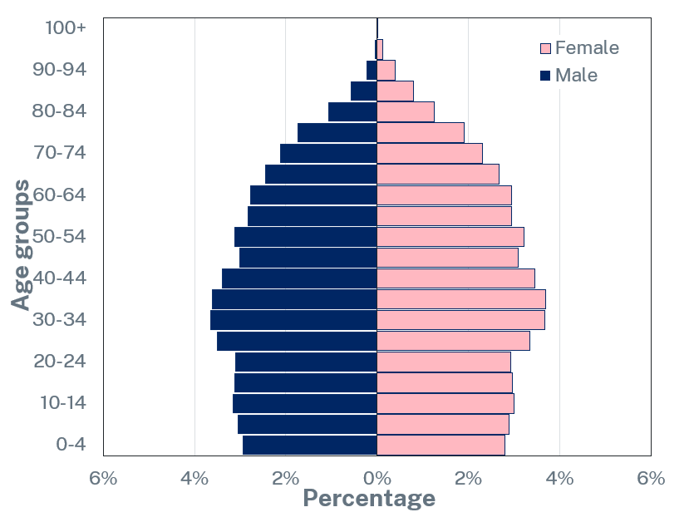

2.2.2 – population profile analysis
Calculate the percentage of Australia’s population aged between 30 and 39 using the steps below.
- Find the title of the vertical scale.
- Identify the number of years the scale illustrates.
- Identify the percentage (%) of Australia’s female population that has reached the age of 100 years.
- Identify the population aged between 30–39 years.
- Total the percentage (%) of male population between the ages of 30–39 years by adding 3.66 and 3.62 together.
- Total the percentage (%) of female population aged between 30–39 years by adding 4 and 4 together.
- Total the percentage population in Australia aged between 10–39 by adding the number of males and females together (7.28 plus 8).
- Ask your teacher for the answers.

2.2.3 – population profile powerful predictors of the future
Engage with the video Population pyramids: Powerful predictors of the future – Kim Preshoff (5:01). In 2 to 3 paragraphs, describe how population pyramids can inform community decisions.
The following prompting questions will support your response:
- What do the different parts of the graph mean?
- Why might geographers, governments or planners use this information?

2.2.4 – exit ticket
Complete a 3-2-1 Exit ticket:
- list 3 things you learned today
- list 2 questions you have about these things
- give 1 reason why learning about population profiles is important.

Lesson 3 – population pressures on liveability

2.3.1 – world population and liveability
Your teacher will share the introduction to the video I Built the Population of the World! (again...) (from 0:00–0:25) and ask the class what they predict they will observe in the remainder of the video.
Your teacher will allocate you to work in a small group. Your group will be allocated a chapter from the video I Built the Population of the World! (again...) (23:23). Your group must complete the following for their chapter:
- Identify the population number for your region of the world.
- Did you observe any anomalies?
- Predict the population change that will occur in the next 10 years for your allocated region.
- Identify the potential challenges your allocated region may be facing regarding environmental, social, economic and political factors.
- Nominate a spokesperson to report your findings to the class.
- Engage with the Overview chapter I Built the Population of the World! (again...) (from 21:08–23:23) to see if your prediction at the beginning of the lesson was accurate.

2.3.2 – population pressure
Your teacher will call out True or False for the following questions:
- Population pressure means there are fewer people living in an area.
- Overcrowding can lead to housing shortages.
- A growing population usually makes traffic better.
- Hospitals and schools can be affected when too many people live in one place.
- More people in an area means there is usually less pollution.
- Population pressure can make it harder for people to find jobs.
- A higher population can cause the cost of living to go down.
- Population pressure always improves the liveability of a place.

2.3.3 – 20-minute city
Discuss ways a 20-minute city might reduce the negative effects of population pressure. Construct a 2 to 3 paragraph response to the question: ‘How could the 20-minute city idea help reduce the negative effects of population pressure and improve the liveability of a place?’ The following prompt questions will support your response:
- What is a 20-minute city?
- How does population pressure affect housing, transport and services?
- How could having everything close by (schools, shops, parks, jobs) help resolve some of these problems?
Exchange your response with a peer and complete a peer assessment using Appendix 4 – TAG template.

2.3.4 – exit ticket
Complete a visual representation of population pressure as an Exit ticket exercise.

Lesson 4 – access to services and facilities that influence the liveability of places (megacities)

2.4.1 – challenges of living in megacities
Complete Figure 20 using information provided by your teacher.
Figure 20 – WATCHES illustration blank
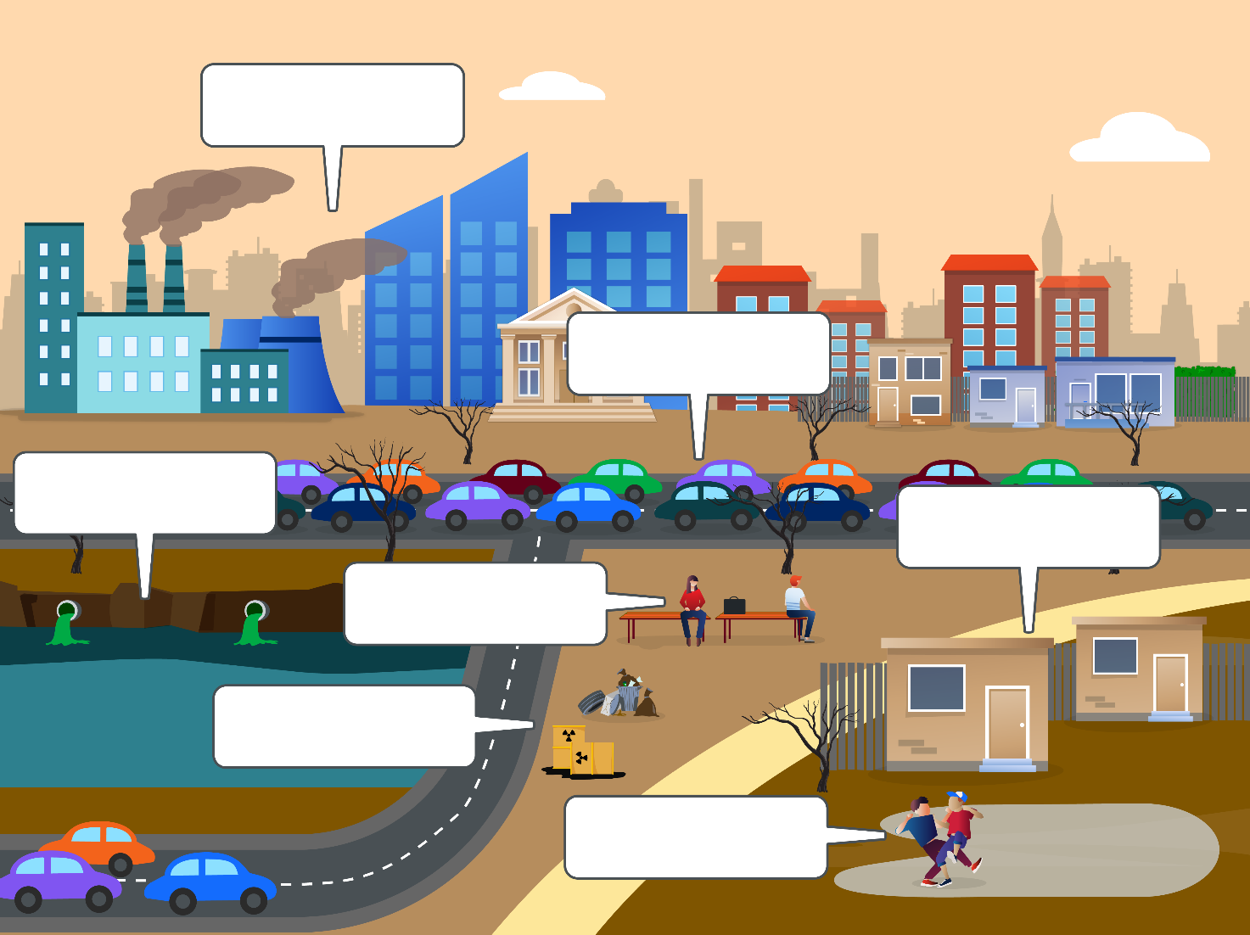
Figure 21 – WATCHES labelled
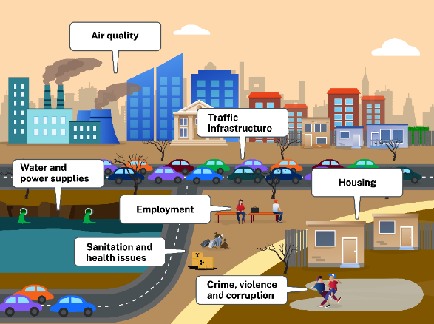

2.4.2 – Mumbai
Review the first photograph used in Drone photos capture the staggering inequality in Mumbai and identify what type of photograph has been taken.
Your teacher will guide you through a read aloud exercise. Using the paragraph provided by your teacher highlight any new or unfamiliar terms.
As a class, describe the challenges people living in shanty towns or informal settlements in megacities face, particularly in relation to accessing services and facilities such as clean water, sanitation, education and healthcare.
Summarise the key points from the discussion and identify any patterns or shared issues.
In small groups, discuss strategies or actions taken by governments, NGOs or local communities to improve access to services and facilities in these areas.
Work with a partner to construct a paragraph in response to the following question: ‘Describe how limited access to services and facilities in megacities affects the liveability of a place. Include one example of how this issue is being managed or addressed’.

2.4.3 – small group work (podcast)
Work in small groups to develop a podcast script (3 to 4 minutes) that outlines the challenges confronting residents in megacities and the inequality that exists to accessing services and facilities. Ensure your podcast includes:
- an introduction that is engaging and ‘hooks’ the audience
- the main challenges faced by residents (WATCHES)
- a brief discussion of inequality including a brief comparison of people in wealthy areas and poorer areas within the same city
- a conclusion that summarises the episode and calls the audience to ‘tune’ into the next podcast.

Lesson 5 – access to services and facilities that influence the liveability of places – megacities solutions

2.5.1 – mapping the world’s megacities
Engage with Mapped: The World’s Largest Megacities by 2100 (2:26).
On Appendix 1 – world map, label the location of current megacities.
Using a different colour label the predicted location of megacities in 2100.

2.5.2 – future challenges of megacities
Your teacher will allocate you to work in small groups. In your group contribute to a brainstorm on ‘ways the increase in world megacities will prove challenging for future populations’.

2.5.3 – investigative study – megacities
Use the suggested resources to investigate ways megacities can be better managed to ensure access to services and facilities:
- Sustainable Cities: Crash Course Geography #49 (11:19)
- Singapore: Designing a Megacity in Harmony with Nature (13:31)
- How to Build Sustainable Megacities of the Future?
- How China is designing flood-resistant cities (6:49)
Note: the following articles may be used for extension in this learning activity.
- Green City 101: Designing Sustainable Urban Futures
- Transforming our world: the 2030 Agenda for Sustainable Development
Record your findings in Table 21 will support your investigation:
Table 21 – solutions to megacity challenges
Category | Investigative findings
Maximising existing space
Water saving
Green spaces, gardens and urban farming
Transport
Renewable energy
Housing

2.5.4 – exit ticket
Complete an Exit ticket. Create a visual representation what you have learned about megacities in the lesson. Figure 22 is an example of a visual representation.
Figure 22 – visual representation megacities solutions WAGOLL


Lesson 6 – access to services and facilities that influence the liveability of places – Australia’s health 1

2.6.1 – activate prior knowledge
Attempt the following questions:
- What does the BOLTSS acronym stand for?
- What does the term ‘orientation’ mean?
- What are the 4 cardinal points?
- What mnemonic helps you to remember the 4 cardinal points?
Review Figure 23.
Figure 23 – 16-point compass
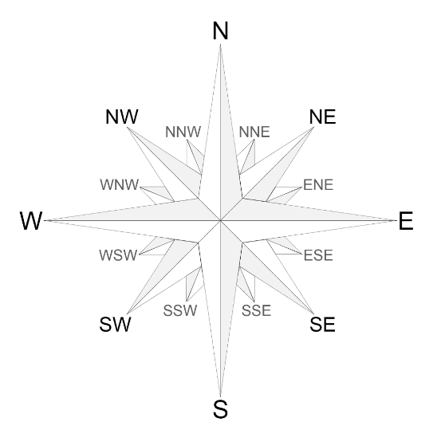
Use the compass to answer the following questions:
- What compass point lies in the opposite direction to north?
- What direction is opposite of east?
- What direction is halfway between north and east?
- What direction is opposite of north-west?
Use the Map of Indigenous Australia to locate your local language, social or nation group. With your peers, identify direction between key places. For example, ‘Kamilaroi – What is the direction of Inverell from Gunnedah?’

2.6.2 – scale on maps
Activate prior knowledge of scale on maps by answering the following questions:
- What are ways scale can be represented on a map?
- What does a linear scale look like?
- I do: your teacher will demonstrate how to measure distance using Figure 24.
- Measure the straight-line distance in centimetres (cm) between the information centre and the bora ring.
Use the scale on the map to calculate the real-life distance between the information centre and the bora ring.
Note: teachers, do not resize Figure 24.
Figure 24 – Paceworth map
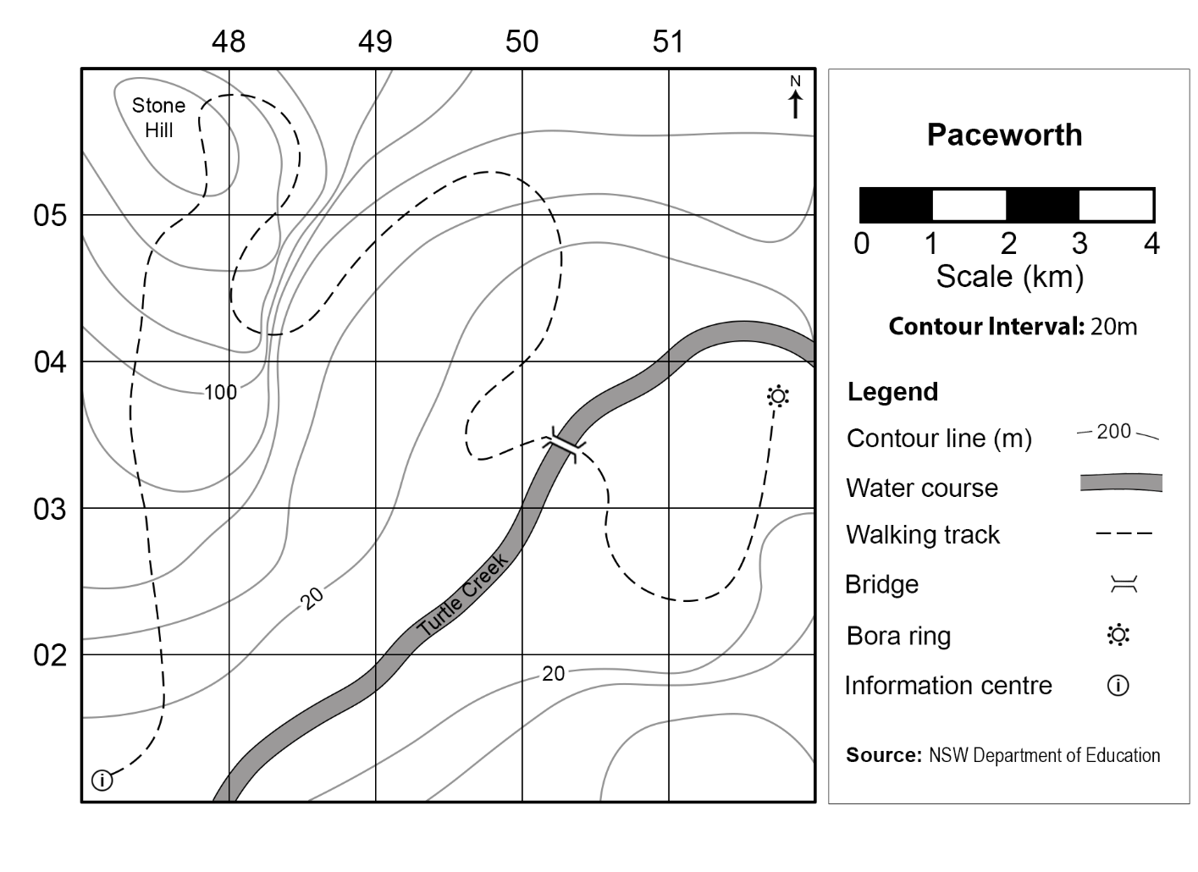
We do: as a class use Figure 25 to measure and calculate the straight-line distances from:
- Point A to Point D
- Point C to Point E
- Point B to Point D.
Note: teachers, do not resize Figure 25.
Figure 25 – Dreamouth Siding map
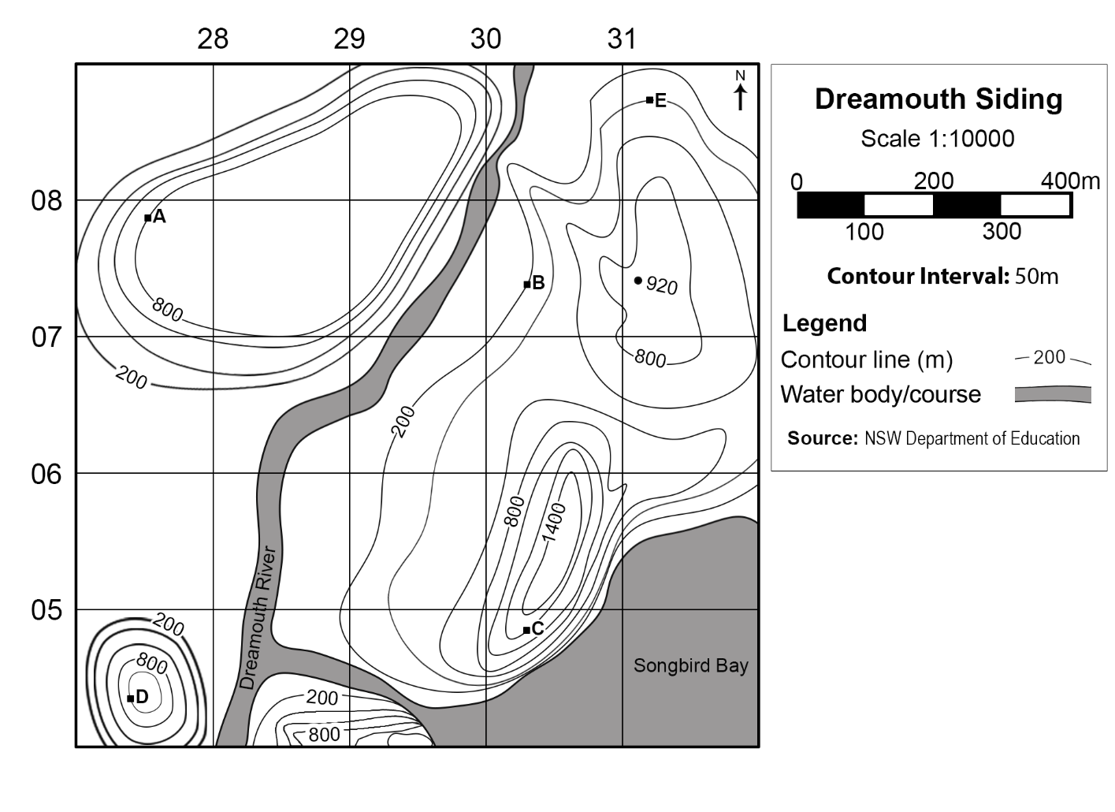
You do: using Figure 25 find the distance between:
- Point B to Point E
- Point D to Point E.

2.6.3 – class discussion
Review Figure 26 and discuss the challenges the distance between places would pose in access to services and facilities in Australia.
Figure 26 – distance across Australia’s mainland
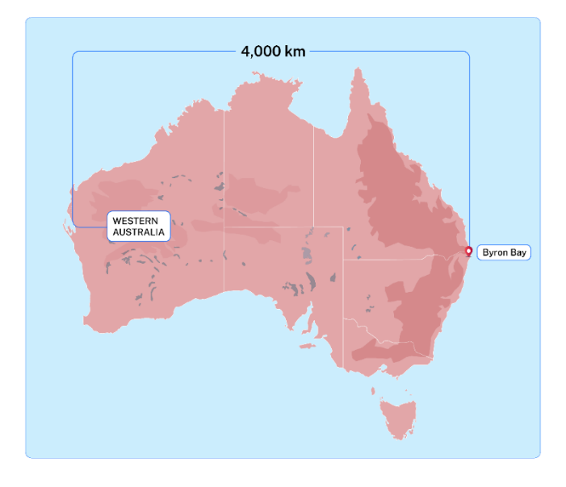
Create a visual representation that summarises the class discussion.

2.6.4 – Royal Flying Doctors
Prior to engaging with the video Royal Flying Doctors answer the following questions:
- Who do the Royal Flying Doctors help?
- Before the Royal Flying Doctors began how did people in remote areas reach a doctor?
- What might the perspective of people living in remote areas be regarding access to healthcare?
Engage with Royal Flying Doctors (3:34) and answer the following questions:
- On average how often does the Royal Flying Doctors help someone?
- On what Australian banknote does the founder of the Royal Flying Doctors feature?
Review the Royal Flying Doctor Service’s Spatial Distribution Patterns map and use Appendix 2 – Think-Pair-Share template to respond to the following questions:
- How many primary healthcare facilities are located across rural and remote areas of Australia?
- How many aeromedical bases are located across rural and remote areas of Australia?
- According to this map if you lived near Tennant Creek in the Northern Territory how many medical services would you have access to?
- How would the access to medical services affect human wellbeing in rural and remote areas of Australia?
- How could the liveability of rural and remote areas of Australia be improved?
- How does the availability of the Royal Flying Doctor service improve the liveability of remote places in Australia?

Lesson 7 – access to services and facilities that influence the liveability of places – Australia’s health 2

2.7.1 – read aloud exercise
Your teacher will instruct you how to complete a read aloud exercise.
- Describe the diverse nature of First Nations peoples in Australia.
- Identify cultural factors that contribute to First Nations peoples’ health and wellbeing.
- Explain why it has been difficult to get accurate census data on First Nations peoples.

2.7.2 – graph analysis
Your teacher will display a graph to the class. Using the graph, answer the following questions:
- What is the title of this graph?
- What is the source of this graph?
- Is the source a reliable source?
- What type of graph is this?
- What is the common trend for the population of First Nations peoples in Australia?
Your teacher will display another graph to the class. Using the graph answer the following questions:
- What is the title of this graph?
- What is the source of this graph?
- Is the source a reliable source?
- What type of graph is this?
- Complete an analysis of the First Nations population profile, Figure 27 will support your response.
Figure 27 – WAGOLL analysing a profile
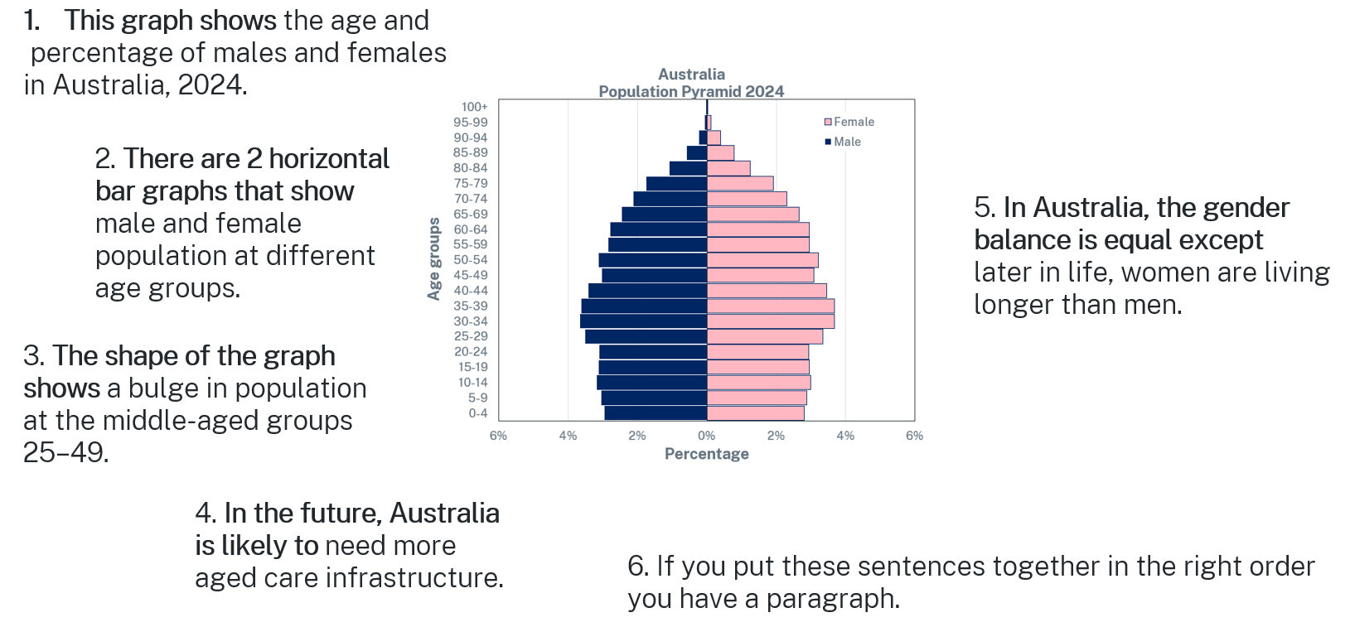

2.7.3 – access to services
Your teacher will read aloud the key messages from 3.14 Access to services compared with need. As a class discuss the following questions:
- What does the data say about how far people must travel for healthcare?
- What is the difference in waiting times for elective surgery between Indigenous and non-indigenous Australians?
- Why might someone not go to the doctor even when they need to?
- How does geography (city versus remote) affect a person’s healthcare options?
- How might the lack of access to healthcare services influence the perception of liveability in rural and remote areas in Australia? What might be required to change these perspectives?

2.7.4 – creating written texts
Describe the impact of healthcare facilities on the liveability of rural areas in New South Wales.
In your response, you should:
- use geographical terms and concepts
- write in third person and use connectives
- demonstrate geographical knowledge of the topic
- describe examples in your response.

Lesson 8 – Aboriginal and Torres Strait Islander Peoples’ social, cultural and community connections

2.8.1 – defining culture, Country and spirituality
Note: students will need 3 different coloured sticky notes for the following activity.
Contribute to a class word cloud for each of the following terms:
- culture
- Country
- spirituality.
Your teacher will define ‘culture’, ‘Country’ and ‘spirituality’ for the class. Decide if your word clouds accurately reflect the definitions. Remove and replace any sticky notes to consolidate the final product.
Use the 3-word clouds to write your own definition of ‘culture’, ‘Country’ and ‘spirituality’.
Review and discuss the Connection to homelands and Country section of Culture, Country and spirituality.
Note: students will need to categorise supporting and adverse factors into Table 22. Teachers will need to provide space for the task when reproducing the resource booklet.
Table 22 – connecting to Country
Supporting factors | Adverse factors
For example, cultural education | For example, languages under threat
Respond to the question: ‘What factors help or hinder connections to culture, Country and spirituality?’

2.8.2 – projecting across time
Your teacher will guide you through the following activity:
- At the centre of the page, using one colour, identify what you already know about Aboriginal and Torres Strait Islander Peoples’ social, cultural and community connections in contemporary Australia.
- Reach back in time, and in a second colour, identify what you know about Aboriginal and Torres Strait Islander Peoples’ social, cultural and community connections in the past 100 years in Australia.
- Reach further back in time, and use a third colour, to identify what you know about ancient Aboriginal and Torres Strait Islander Peoples’ social, cultural and community connections.
- Reach forward in time, and use a fourth colour, to outline what you think will play out 10 years into the future? 100 years? 1,000 years?

2.8.3 – exit ticket
Complete an Exit ticket. Turn and talk to your partner and explain what you have learned about the influence of social, cultural and community connections on liveability for First Nations peoples in Australia.

Lesson 9 – natural hazards and liveability

2.9.1 – defining natural hazards
Use What are natural hazards? to make summary notes of the different types of hazards:
- tectonic hazards
- atmospheric hazards
- geomorphological hazards
- biological hazards.
Use What are natural hazards? Flashcards to consolidate your understanding of the term natural hazards.
Complete the Quiz on What are natural hazards? and share your results with the teacher.
Complete Appendix 5 – Frayer diagram template for the term ‘natural hazard’.

2.9.2 – Los Angeles wildfires
Identify the key impacts of the wildfires on liveability using the stimulus Before and after: See the destruction caused by the LA fires.
Appendix 2 – Think-Pair-Share template and construct a concept map that summarises ways the LA wildfires impacted liveability.

2.9.3 – bushfires
Use rapid fire writing with the stimulus Bushfire.
- Spend one minute independently reflecting on the stimulus.
- Write continuously about the stimulus for 3 minutes.
- Re-read your work for one minute and circle your 3 main ideas (words or phrases).
- Write continuously about the stimulus again for 2 minutes – don’t stop writing.
- Re-read your work again for 30 seconds and place a square around the main idea of your work (single word or phrase).
- Write continuously about this main idea for one minute without stopping.
- In small groups, share your final idea and reflect on how you reached this opinion.
Complete an Exit ticket answering the question: ‘How do natural hazards influence the liveability of places?’

Lesson 10 – climate change

2.10.1 – vocabulary self-assessment
Your teacher will explain how to use Appendix 6 – vocabulary self-assessment tool and provide you with a list of terms to reflect on.
Choose one word from level 3 or 4 and build on that knowledge by completing the following:
- Use the Geography 7–10 Glossary or an online dictionary to build understanding of the word.
- Generate synonyms for the vocabulary selected.
- Write a student-friendly definition.
- Use the word in a sentence.
- Generate a visual representation of the vocabulary selected.
Re-take the self-assessment to demonstrate how your word knowledge has deepened.

2.10.2 – optional exercise
Note: teacher will clarify which option will be attempted by the class.
Option 1 – engage with Climate change. Answer the questions outlined in the resource and check your responses against the answers provided.
Option 2 – as a class use Causes and Effects of Climate Change to complete Figure 28. Then use Causes and Effects of Climate Change and the connecting terms table (Table 23) to construct 5 sentences that communicate the cause and effect of climate change.
Figure 28 – cause and effect scaffold
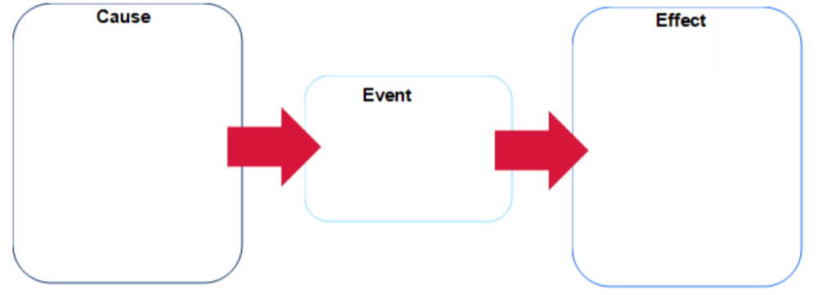
Table 23 – connecting terms
Cause … effect | Effect … cause
An outcome of  As a consequence of  As a result of  Consequently  Conveys  Creates  Generates  Gives rise to  Leads to  Owing to  Provoked  Results in  Results in  Reveals  Thus | Accordingly  Arose out of  Brought about  Caused by  Due to  Is a result of  Is an effect of  Is an outcome of  Is influenced by  Is inspired by  Is produced by  Shaped by  So that  Stems from  Therefore

Lesson 11 and 12 – Carteret Islands case study

2.11.1 – climate refugees
Engage with Sun Come Up (2:23). Use the guided questions to take notes as you watch the video:
- What is happening to the islands?
- Why is rising sea level a problem here?
- How are people responding?

2.11.2 – mapping Carteret Islands
Use an atlas or online map to locate and label the Carteret Islands on Appendix 1 – world map.
Use your map and Google Maps to construct one paragraph describing the location of Carteret Islands. Ensure you state the latitude and longitude of the islands in your response.

2.11.3 – photo sketch Carteret Islands
Conduct an image search of the Carteret Islands. Choose one image to use as a base for a photo sketch Photo sketch video (2:06). Use your photo sketch to construct a paragraph describing the physical environment of the Carteret Islands.
Turn and talk to a partner answering the following question: ‘How might the location of Carteret Islands influence the liveability for the island residents?’

2.11.4 – environmental refugee
Record the definition for Environmental Refugee provided by your teacher.
Your teacher will read Refugee Status Environmental Refugee aloud to the class. Discuss how the residents of Carteret Islands would not have refugee status and the challenges this would present residents.
Use Table 24 to Think-Pair-Share the impact of climate change on the liveability of Carteret Islands. The following resources will support your thinking:
- Understanding the Human Side of Climate Change Relocation
- In a Noah’s Ark move, PNG migrants bring thousands of trees to safer ground
- The Last Islanders: rising sea levels in Papua New Guinea
- Sea level rises forcing community to relocate from Carteret Islands in Papua New Guinea.
Table 24 – liveability factors
Environmental | Social | Economic | Political
Contribute to a class concept map that outlines ways the Carteret Islands are being managed to reduce the impact of sea level change. Use the concept map to construct 1 to 2 paragraphs explaining how the Carteret Islands are being managed to protect the people, place and environment for current and future generations.
Your teacher will read aloud to the class Community-led relocation effort by the Carteret Islanders who face extinction from climate change impacts and extreme weather events and guide a discussion answering the following questions:
- How does displacement affect identity, culture and community?
- What are the main challenges faced by relocated communities?
Your teacher will allocate you to work in small groups. Your teacher will provide each group with a scenario card:
- You are advisors to the PNG government or the United Nations.
- Devise a 3-point plan to help the Carteret Islanders:
- Where will they live?
- How will they earn an income?
- How will their culture and sense of community be preserved?
- Groups present your 3-point plan.
Choose one of the following roles: a Carteret Islander, a PNG government official, a UN advisor or an aid organisation worker. Write a brief statement (4 to 5 sentences) explaining your point of view on the relocation and what you think matters most in supporting the community.

Lesson 13 – environmental quality and liveability of places

2.13.1 – environmental factors that influence liveability
Use the environmental factors identified by your teacher to generate a Concept map that illustrates environmental factors that influence liveability of places.

2.13.2 – environmental performance index
Access Cleanest Countries in the World 2025 and explore the Environmental Performance Index (EPI) scores from around the world.
Record notes on EPI indicators for a healthy environment provided by your teacher.
Navigate between the EPI Score map and the EPI 10-Year Change 2014-2024 map and identify 3 to 5 countries that have improved their EPI.
Explore The Top 10 Cleanest Countries section of Cleanest Countries in the World 2025 and summarise into Table 25 the strategies that have been used to improve environmental quality.
Table 25 – the top 10 cleanest countries
Country | Strategies used to improve environmental quality
Work in pairs to develop a photo collage that illustrates the characteristics of the top 10 cleanest countries in the world.

2.13.3 – exit ticket
Students complete an Exit ticket answering the following questions:
- Name one of the cleanest countries in the world.
- Identify one thing that makes a country clean and sustainable.
- On a scale of 1 to 5, how inspired are you to take action to help your own community become cleaner?

Lesson 14 – human processes impacting liveability in Jakarta

2.14.1 – comparing liveability
Engage with Jakarta, Indonesia: Racing to Save the World’s 2nd Largest MEGACITY (20:57). Answer the following questions:
- Identify challenges confronting the megacity of Jakarta (from 0:00–1:09).
- Describe the physical characteristics of the megacity (from 1:09–2:44).
- Describe how rapid urbanisation has impacted the liveability of the city (from 2:44–7:27).
- Explain the economic and environmental challenges facing residents of Jakarta (from 7:27 -- 11:31).
- Explain ways the government intends to mitigate the challenges of liveability in Indonesia (from 11:32–14:11).
- Explain why residents of Jakarta intend to remain and not relocate to another city (from 14:11–20:57).
Engage with The Cleanest City in the World? Exploring Singapore (13:53). Answer the following questions:
- Identify ways Singapore has improved its liveability (from 0:00–1:58).
- How has the design and planning for Singapore embraced the country’s unique culture and history (from 1:58–2:51)?
- Describe how Singapore is planning to overcome challenges predicted to arise in the future (from 2:51–7:05).
Complete a Venn diagram comparing the liveability of Jakarta to Singapore.
Figure 29 – Venn diagram
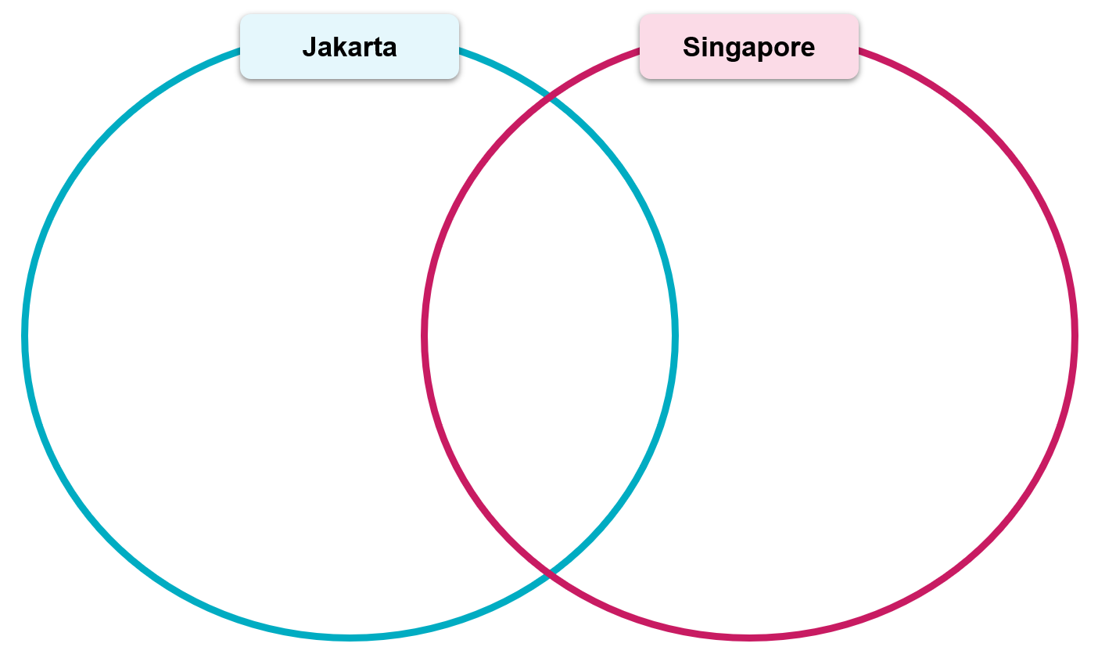
Use your Venn diagram to develop 3 to 5 recommendations for ways Jakarta can improve the liveability of their city.

Lesson 15 and 16 – pollution in my area (fieldwork)

2.15.1 – defining terms
Use the syllabus Glossary, a physical dictionary or an online dictionary to define the key terms relevant to the pollution fieldwork:
- pollution
- environmental quality
- liveability
- noise pollution
- water pollution
- air pollution.
Use the capacity matrix to identify your extent of information, knowledge, know-how and wisdom for each term identified in the lesson.

2.15.2 – hypothesis
What types of pollution exist in our local area, and how do they affect liveability?
Use the significant geographical question to pose a hypothesis. ‘I think the most common type of pollution will be [student response] because [student response].’
Share your hypothesis with a peer and discuss.
Use Google Maps or similar to develop a map of the study area. Alternatively, you can draw a line sketch of the study area.

2.15.3 – fieldwork
Conduct a litter survey along a 10-metre section of ground at 2 separate locations in the study area. Record survey results in Table 26.
Table 26 – litter survey
Location | Plastic | Paper | Cans or glass | Food waste | Other
Spot 1
Spot 2
Observe noise pollution at 2 separate locations in the study area. Record survey results in Table 27.
Table 27 – noise pollution
Location | Type of noise | Duration | How loud? (1 equals not loud – 5 equals very loud) | Notes
Spot 1
Spot 2
Complete a water and air pollution checklist.
Table 28 – water and air pollution checklist
Location | Water looks clean (yes or no) | Water observations | Air smells clean (yes or no) | Vehicle fumes visible (yes or no)
Spot 1
Spot 2
Choose one location to complete a field sketch Conducting a field sketch video (4:50).

2.15.4 – post fieldwork
Draw a pollution hotspot map showing where pollution was highest.
Complete a data analysis:
- What was the most common type of pollution in your study area?
- Where was pollution the worst? Why do you think that is?
- Were there any anomalies in your research results?
- Revisit the hypothesis and explain whether your predictions were accurate or inaccurate.

Learning sequence 3 – enhancing liveability

Lesson 1 – enhancing liveability – ways to improve liveability overview

3.1.1 – brainstorm
Engage with Creating Sustainable Cities (4:21) and brainstorm what a ‘more liveable’ place looks like.
Categorise the brainstorm for what a ‘more liveable’ place looks like under the factors that affect liveability headings in Table 29.
Table 29 – factors that affect liveability
Environmental | Social | Economic | Political
Discuss the meaning of the term ‘enhancing’. What synonyms can be applied to the term?

3.1.2 – designing a sustainable city
Working in pairs choose a place that you have studied in the Focus area – Liveability of places. This could be one of the following:
- Ballina (NSW, Australia)
- Jakarta (Indonesia)
- Sydney (NSW, Australia)
- Gifu (Japan).
For your chosen place complete the following.
Part 1 – identify challenges
- Identify 3 key challenges to liveability in this place.
- Identify the groups of people most affected by these challenges.
- Identify what has already been done to improve liveability in this place.
Part 2 – design a future city
Reflect on your responses in Part 1 to design a future city. Ensure you include features that enhance liveability across all 4 factors (social, cultural, economic, political).
Part 3 – share your visual representation with the class as a Gallery walk. Use sticky notes to provide peer feedback:
- one positive feature
- one question you have
- one suggestion for improvement.

Lesson 2 – planning strategies used to enhance the liveability of place for groups of people

3.2.1 – local government role in planning for liveability
Think-Pair-Share the following questions:
- What is your local council responsible for?
- How do they influence liveability?
Your teacher will assist you in finding your local council’s website and appropriate site pages to explore.
Find and review one of the following types of documents (depending on availability):
- community strategic plan
- liveability strategy or urban planning strategy
- youth action plan, housing strategy or transport plan.
Complete the following questions for your local council:
- Name of local council.
- Title of the plan reviewed.
- List 3 key goals in the plan.
- Target group identified.
- Identify 2 actions or projects currently being implemented.
- Outline how these actions aim to improve liveability in your council area.
Your teacher will allocate you to work in small groups. Share your responses to the previous questions and collectively answer the following questions:
- Did the council plans address the liveability issues you have observed in your local area?
- What would you add to your local council’s plan?
- Identify ways young people can be actively involved in shaping liveable communities.
- Develop a SWOT analysis of the council’s plan and share back to the class your group’s final thoughts.
Figure 30 – SWOT
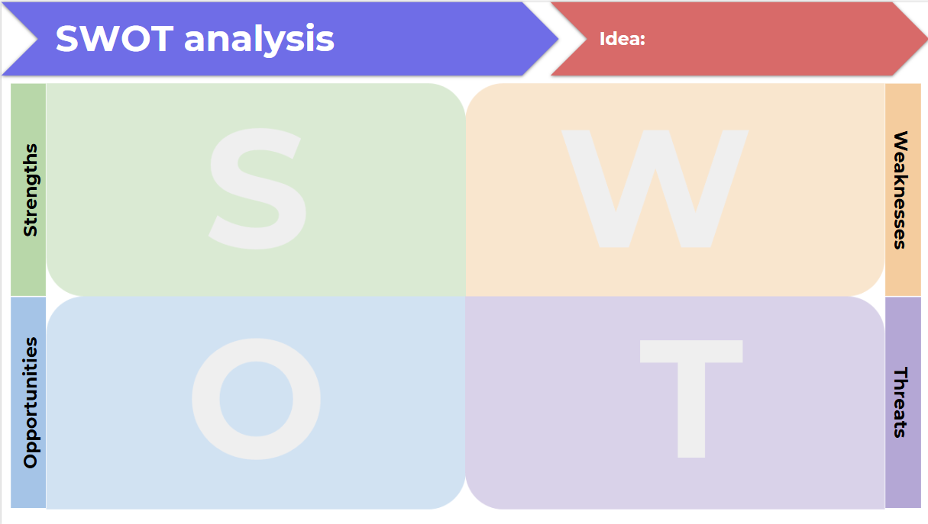

Lesson 3 and 4 – benefits of caring for Country to enhance liveability for Aboriginal Peoples

3.3.1 – NSW Indigenous Protected Areas (IPAs)
Record a definition for Indigenous Protected Areas (IPAs).
On the map of Australia, locate and annotate each of the following IPAs:
- Brewarrina Ngemba Billabong IPA
- Boorabee and The Willows IPA
- Gumma IPA
- Minyumai IPA and Jahnala Yenbalehla Rangers.
Use Appendix 2 – Think-Pair-Share template to discuss the commonalities between the 4 IPAs.
Figure 31 – blank map of Australia
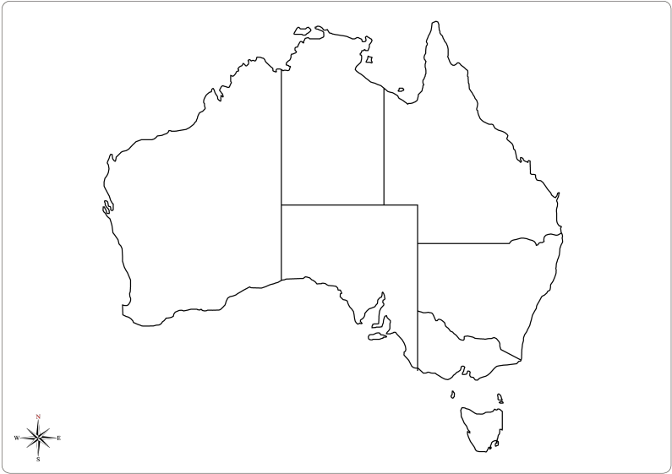
Engage with Overview of the Indigenous Protected Areas (2:04) and explain how IPAs benefit Indigenous communities by contributing to care and management of Country.
Construct 1 to 2 sentences describing the nature and role of IPAs in NSW. In your response, refer to Aboriginal Peoples’ Custodianship, care and management of Country.

3.3.2 – small group work
Note: students will need to be provided with access to Stories from Country 2022 – National Indigenous Australians Agency on the Indigenous Protected Areas webpage. Each group is responsible for becoming an expert in their section of the Stories from Countries resource.
Your teacher will allocate you to one of the following groups:
- keeping culture strong
- keeping Country strong
- keeping communities strong
- making economies strong.
Develop a Concept map that summarises the section your group has been allocated.
Using your concept map develop a way to communicate your group summary to the class. The aim is to ensure they best remember the stories you are sharing. Strategies to help your peers remember your Stories from Country best might include:
- narrating in the form of a children’s story book
- podcast
- visual representation
- slide show.
As a class, categorise the factors that enhance liveability for Aboriginal Peoples into Table 30.
Table 30 – factors that enhance liveability for Aboriginal Peoples
Environmental | Social | Economic | Political
Using Table 30 and your learning about IPAs and caring for Country construct 1 to 3 paragraphs answering the following question: ‘Explain how Indigenous Protected Areas (IPAs) in New South Wales enhance the liveability of places for Aboriginal Peoples. In your response, refer to specific examples and explain how caring for Country strengthens culture, community and the environment’.
Note: the following sentence starters may be used where appropriate.
- An Indigenous Protected Area (IPA) is a part of land or sea managed by …
- In New South Wales, several IPAs such as …
- These areas are important because they allow …

Lesson 5 and 6 – strategies used to enhance liveability of a place for groups of people

3.5.1 – See, Think, Wonder
Your teacher will provide you with one of the images of Lee Anthony expressway residence or Katie Blackman’s bush camp from Australia’s homeless hidden in plain sight. Use the image to complete a See, Think, Wonder routine:
- describe exactly what you see
- describe what you think about what you are seeing
- describe what you are wondering about the image; what questions do the images provoke?

3.5.2 – defining homelessness
Make a note of the definitions for primary homelessness, secondary homelessness and tertiary homelessness provided by your teacher.

3.5.3 – column graphs
Answer the following true or false questions:
- A column graph is best used for displaying categorical data, such as favourite fruits or types of pets.
- In a column graph, the height of each column represents how many items are in that category.
- Column graphs should be used when data is grouped into number ranges, like scores out of 100.

3.5.4 – construct a column graph
Construct a column graph that illustrates the counts of people experiencing homelessness by sex, Australia, 2006 to 2021.
Table 31 – counts of people experiencing homelessness by sex, Australia, 2006–2021
Year | Males | Females | All people experiencing homelessness
2006 | 51,164 | 38,567 | 89,733
2011 | 57,689 | 44,746 | 102,439
2016 | 67,407 | 49,017 | 116,427
2021 | 68,516 | 53,974 | 122,494
‘Estimating Homelessness: Census’ by the Australian Bureau of Statistics is licensed under CC BY 4.0.
Use your graph to inform your response to the following questions.
- Describe the overall trend in the number of people experiencing homelessness
- males between 2006 and 2021
- females between 2006 and 2021.
- Which gender experienced a larger increase or decrease in homelessness numbers over this period? Provide approximate values from the graph to support your answer.
- Identify one 5-year segment (for example, 2011–2016 or 2016–2021) where female homelessness numbers saw a significant change. How did male numbers compare in that same time frame?
- Based on the trends shown from 2006 to 2021, what might you predict for the counts of homelessness among males and females in 2026?

3.5.5 – class discussion
Contribute to a class discussion answering the question: ‘How does homelessness affect the liveability of a city or community for both the people experiencing it and the wider population. What responsibilities do governments and communities have to improve this?’

3.5.6 – develop a Public Service Announcement (PSA)
Develop a Public Service Announcement for promoting strategies to reduce homelessness in Sydney. The announcement should be based on facts and information obtained from the following resources and your own research.
- Further efforts needed to reduce homelessness
- Homelessness
- Homelessness Services in Sydney
- Sleepout at Our 20th Anniversary
Share your PSA with your class and provide a Two stars and a wish feedback for a peer.

3.5.7 – capacity matrix
Return to Activity 1.1.2 – capacity matrix and highlight any concepts covered in the previous lessons.
Complete an Exit ticket answering the following questions:
- How can community groups help improve the liveability of a place?
- Give one example of a planning strategy that helps make a place more liveable for a specific group, for example, young people, families, people experiencing homelessness.
- How does caring for Country help improve liveability for Aboriginal Peoples and others?

Appendix 1 – world map
Miscellaneous templates world map.
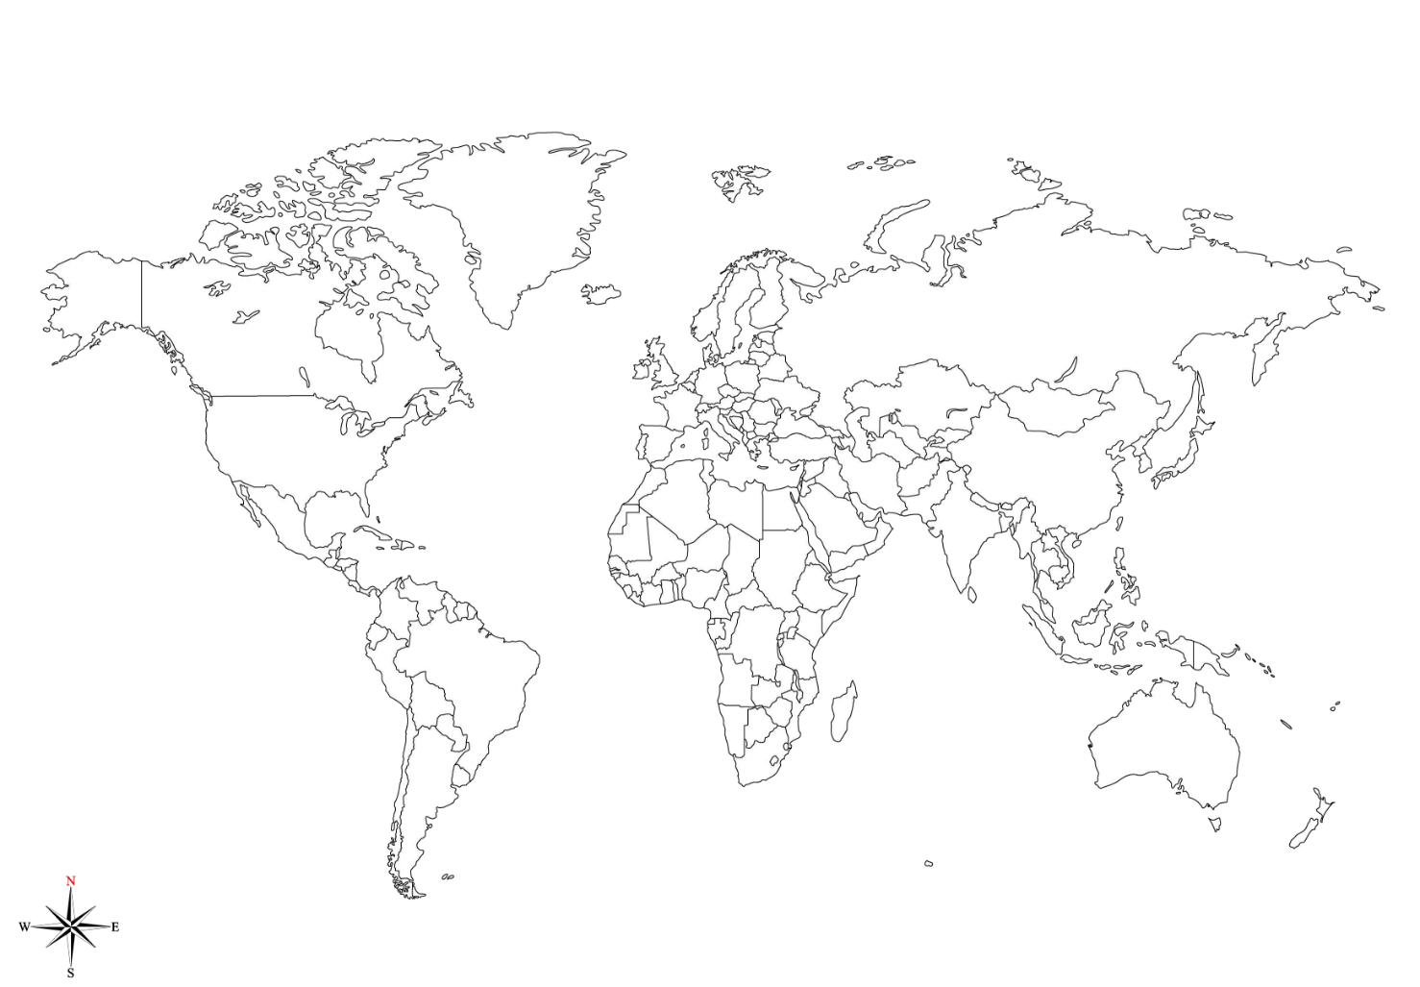

Appendix 2 – Think-Pair-Share template
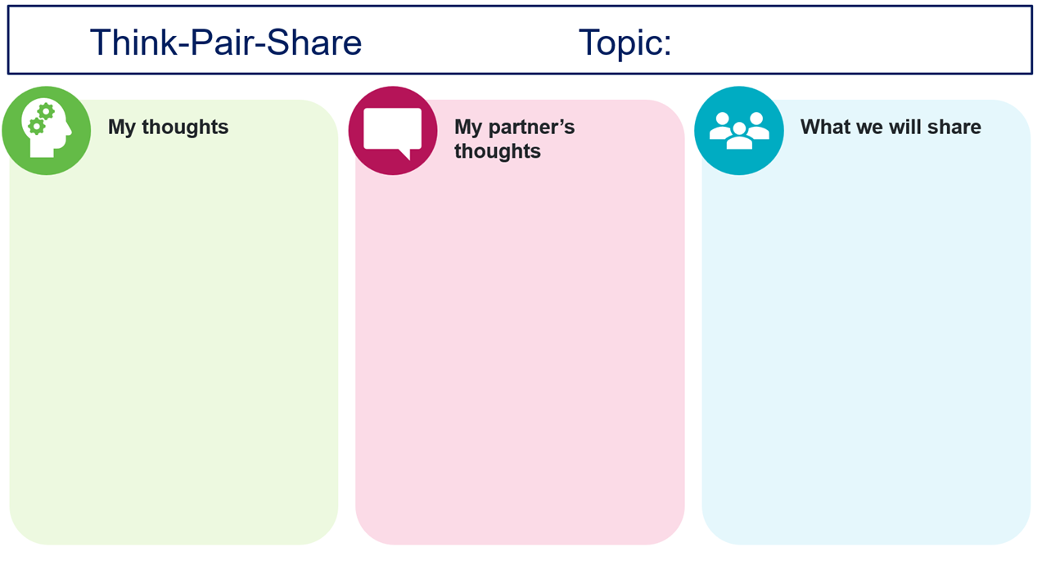

Appendix 3 – PMI (Plus, Minus, Interesting)
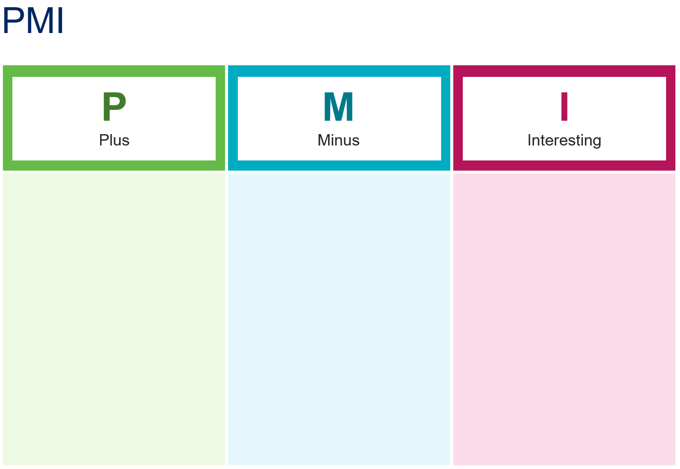

Appendix 4 – TAG template
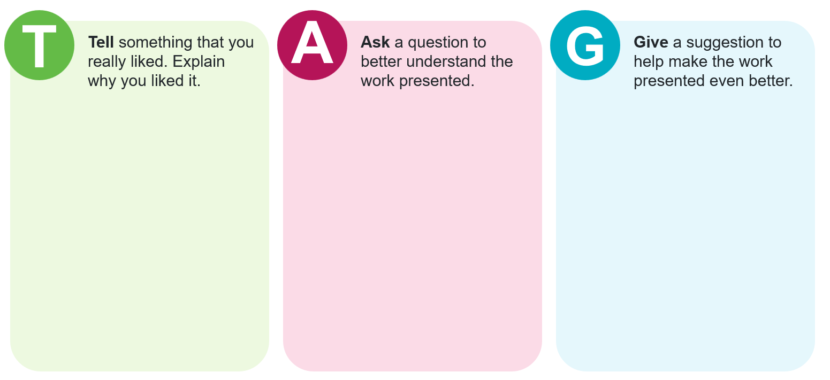

Appendix 5 – Frayer diagram template
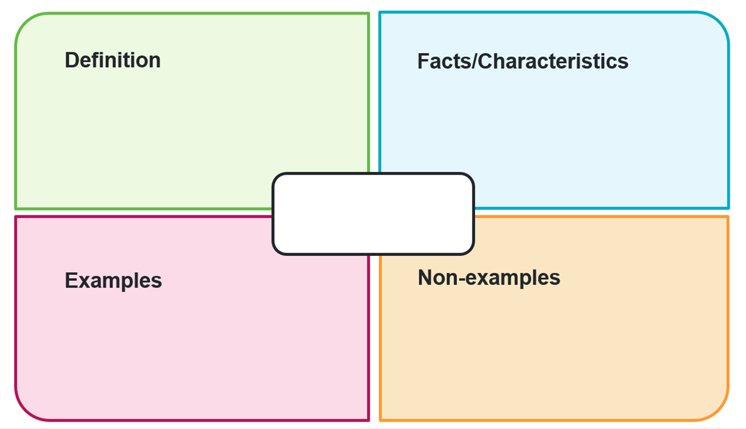

Appendix 6 – vocabulary self-assessment tool
Criteria | Yes/No
I have not heard or seen the word before.
I have heard/seen the word before but cannot define it.
I can use the word in a sentence, but not confidently.
I can explain the meaning of the word and provide synonyms/antonyms.
I can define the word including its key concepts and features.
I can confidently and completely use the word when speaking and in my own texts.

References
This resource contains NSW Curriculum and syllabus content. The NSW Curriculum is developed by the NSW Education Standards Authority. This content is prepared by NESA for and on behalf of the Crown in right of the State of New South Wales. The material is protected by Crown copyright.
Please refer to the NESA Copyright Disclaimer for more information https://educationstandards.nsw.edu.au/wps/portal/nesa/mini-footer/copyright.
NESA holds the only official and up-to-date versions of the NSW Curriculum and syllabus documents. Please visit the NSW Education Standards Authority (NESA) website https://educationstandards.nsw.edu.au and the NSW Curriculum website https://curriculum.nsw.edu.au.
Geography 7–10 Syllabus © NSW Education Standards Authority (NESA) for and on behalf of the Crown in right of the State of New South Wales, 2024.
The Economist Intelligence Unit Limited (2025) An EIU report – The Global Liveability Index 2025, The Economist Intelligence Unit website, accessed 3 October 2025.

© State of New South Wales (Department of Education), 2025
The copyright material published in this resource is subject to the Copyright Act 1968 (Cth) and is owned by the NSW Department of Education or, where indicated, by a party other than the NSW Department of Education (third-party material).
Copyright material available in this resource and owned by the NSW Department of Education is licensed under a Creative Commons Attribution 4.0 International (CC BY 4.0) license.

This license allows you to share and adapt the material for any purpose, even commercially.
Attribution should be given to © State of New South Wales (Department of Education), 2025.
Material in this resource not available under a Creative Commons license:
- the NSW Department of Education logo, other logos and trademark-protected material
- material owned by a third party that has been reproduced with permission. You will need to obtain permission from the third party to reuse its material.
Links to third-party material and websites
Please note that the provided (reading/viewing material/list/links/texts) are a suggestion only and implies no endorsement, by the New South Wales Department of Education, of any author, publisher, or book title. School principals and teachers are best placed to assess the suitability of resources that would complement the curriculum and reflect the needs and interests of their students.
If you use the links provided in this document to access a third-party's website, you acknowledge that the terms of use, including licence terms set out on the third-party's website apply to the use which may be made of the materials on that third-party website or where permitted by the Copyright Act 1968 (Cth). The department accepts no responsibility for content on third-party websites.

