Geography 7–10 – guide
to teaching mapping – cross-sections

Contents
Overview 2
Outcomes 2
Learning sequence 1 – topographic maps – drawing cross-sections 3
Syllabus content 3
Learning intentions and success criteria 3
Learning intentions 3
Success criteria 3
Working with maps 4
Topographic maps 4
Topographic cross-section 6
Vertical exaggeration 9
Transects 12
Using spatial technologies 13
Appendix 1 – mapping tools 18
Appendix 2 – cross-section answers 20
Appendix 3 – transect template 22
References 23
This resource has been developed to assist teachers in NSW Department of Education schools to create learning that is contextualised to their classroom. It can be used as a basis for the teacher’s own program, assessment, or scope and sequence, or be used as an example of how the new curriculum could be implemented. The resource has suggested timeframes that may need to be adjusted by the teacher to meet the needs of their students.

Overview
Description: this teaching support resource addresses Thinking and working geographically, providing examples of how students can engage with the the geographical tool of maps. The lessons in this resource are designed to allow students to build understanding of this geographical tool through a range of learning activities and can be applied where appropriate across Geography 7–10.
Duration: this learning sequence is designed to be completed in approximately 2 hours.

Outcomes
A student:
- GE4-TAP-01 selects and uses geographical tools to acquire and process geographical information
- GE5-TAP-01 applies and evaluates a range of geographical tools to acquire and process geographical information
Geography 7–10 Syllabus © NSW Education Standards Authority (NESA) for and on behalf of the Crown in right of the State of New South Wales, 2024.

Learning sequence 1 – topographic maps – drawing cross-sections
Note: the guide to teaching mapping – drawing cross-sections is designed to be used as a support resource for teachers addressing Thinking and working geographically. This resource is not guiding teaching and learning of a specific topic content in the Geography 7–10 Syllabus; rather, it provides resources and strategies that can be applied contextually at any point.

Syllabus content
Maps are to be integrated into Stage 4 and Stage 5 as appropriate: large-scale maps and small-scale maps, relief maps, special-purpose maps, physical maps, political maps, sketch maps, précis maps, topographic maps, land use maps and thematic maps, such as choropleth maps, isoline maps, cartogram maps, dot maps, flowline maps, weather maps or synoptic charts, graduated or proportional symbol maps.

Learning intentions and success criteria
Note: these learning intentions and success criteria are general and should be contextualised to suit your school and students’ needs.

Learning intentions
Students learn about:
- key features of topographic cross-sections
- the different representations of landforms using contour lines.

Success criteria
Students will be able to:
- interpret contour lines to describe the topography of a landscape
- construct a topographic cross-section.

Working with maps
Note: teachers who are not familiar with topographic maps and contours may find the video Cross-sections and transects (2:53) useful in explaining the geographical tool. The video may be used as a stimulus in lessons if required.
Provide students with topographic maps for learning activities in this sequence. Geoscience Australia provides a variety of topographic maps useful for this activity. Teachers need to be aware of the ratio scale on the Geoscience Australia maps. The recommended print sizes are A1 for Geoscience Australia 1:50000 maps. Topographic maps from NSW Spatial Services are more complicated but include linear scale and can be printed on A3 paper.

Topographic maps
Maps are to be integrated into Stage 4 and Stage 5 as appropriate: large-scale maps and small-scale maps, relief maps, special-purpose maps, physical maps, political maps, sketch maps, précis maps, topographic maps and thematic maps, such as choropleth maps, isoline maps, cartogram maps, dot maps, flowline maps, weather maps or synoptic charts.
Note: Figure 1 is a fictional location used for illustrative purposes. The map is not to scale in this document.
Figure 1 – annotated topographic map
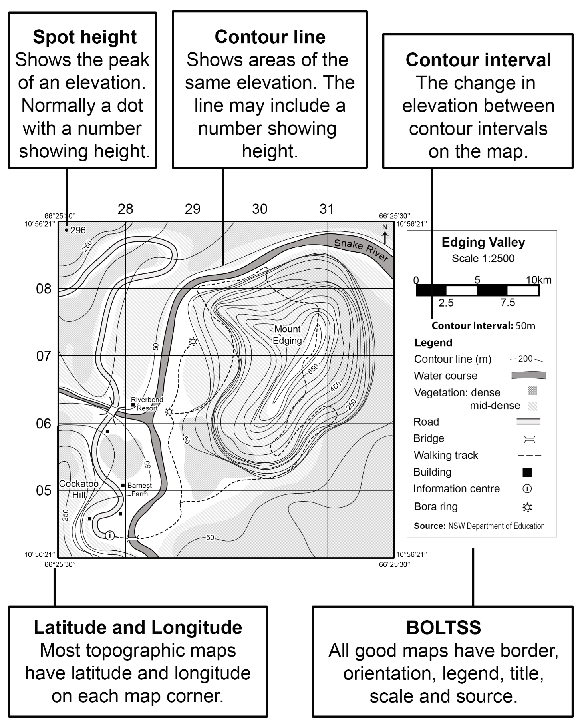

Topographic cross-section
Topographic cross-sections are diagrams of a vertical slice of the landscape made using contour lines on a topographic map. They are used in geography to show the landscape profile. Figure 2 shows an annotated cross-section.
Figure 2 – cross-section example
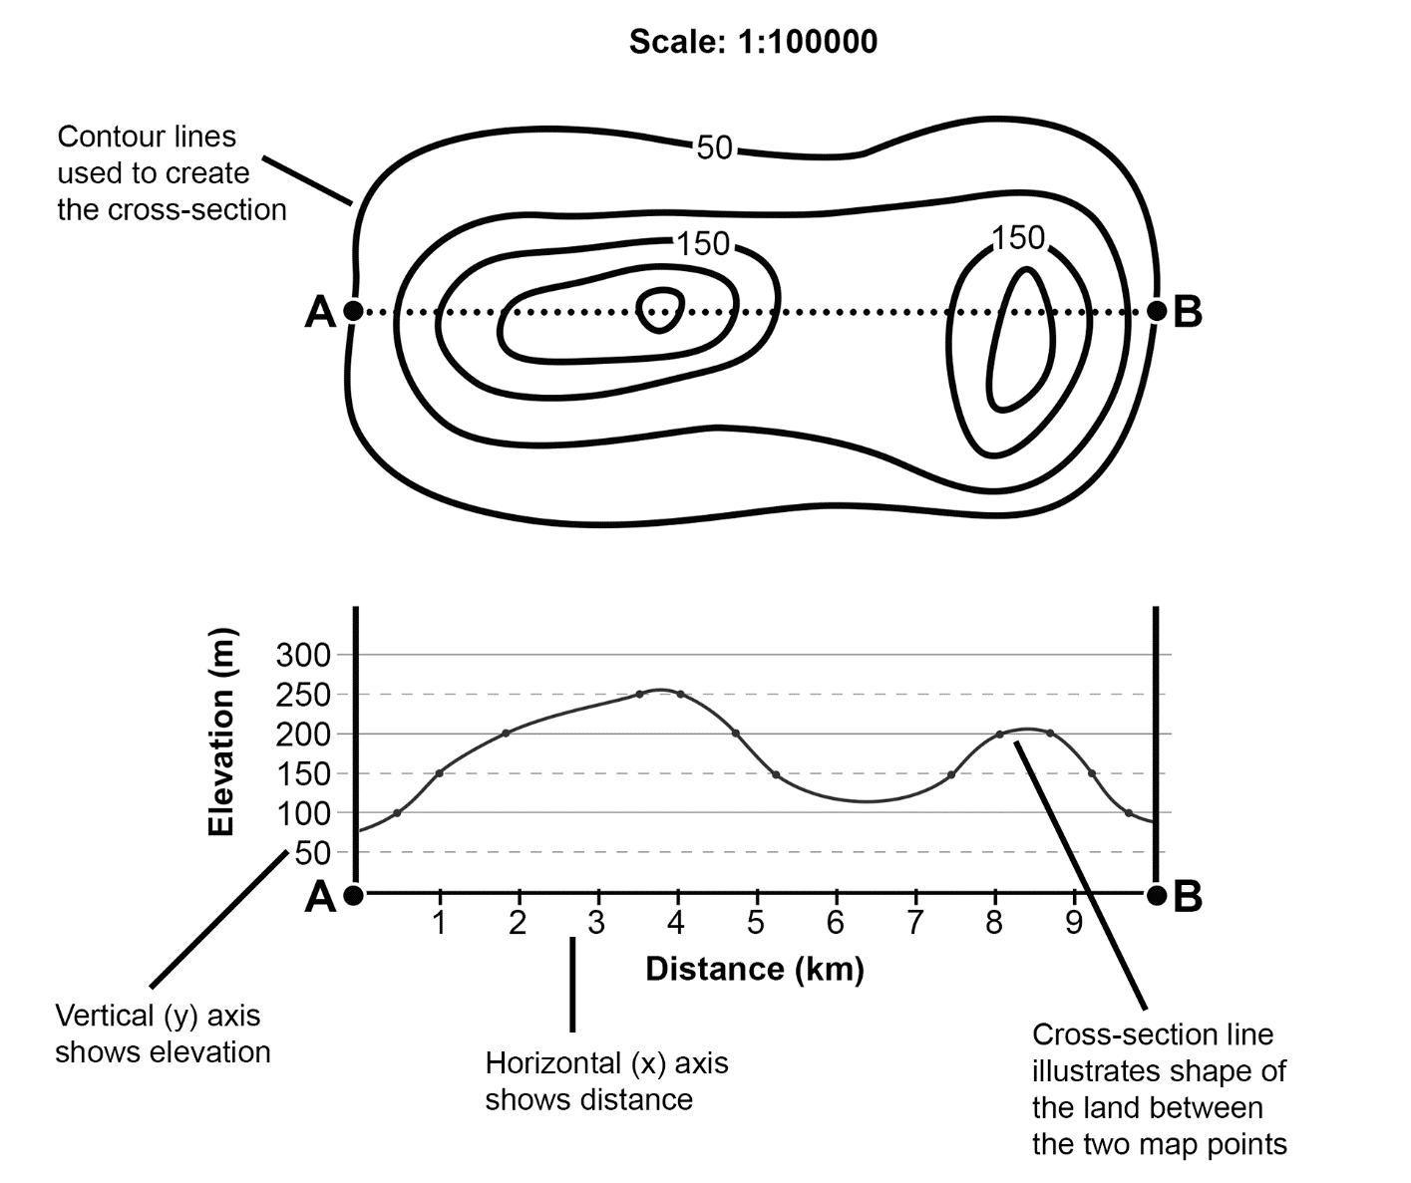
Follow the steps below to create cross-sections for Figure 3 and Figure 4 on the graph provided in each figure.
- Locate points A and B on the map.
- Place an edge of a sheet of paper along the transect between A and B. Write the heights of points A and B on the paper.
- Work carefully from left to right and mark where each contour line meets the edge of the paper.
- Record the height of each contour under the mark.
- Use the contour heights to plot each point on the graph.
- Starting from the left vertical axis, join the points with a smooth line.
- Give the cross-section a title and label each axis.
Figure 3 – cross-section activity 1
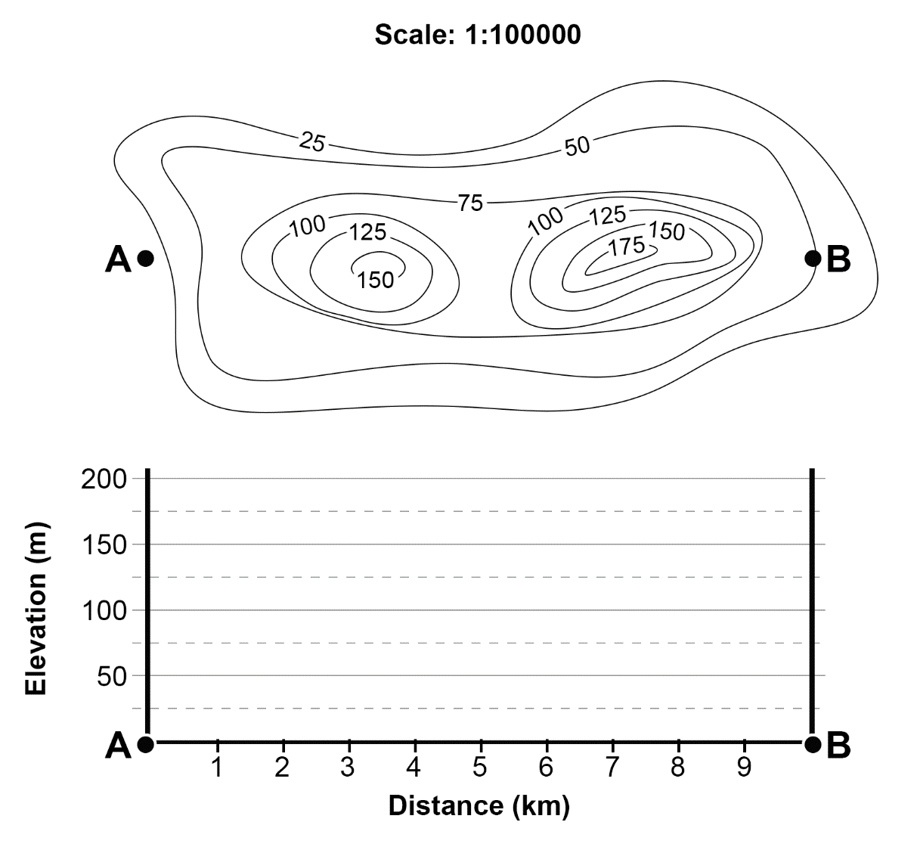
Figure 4 – cross-section activity 2
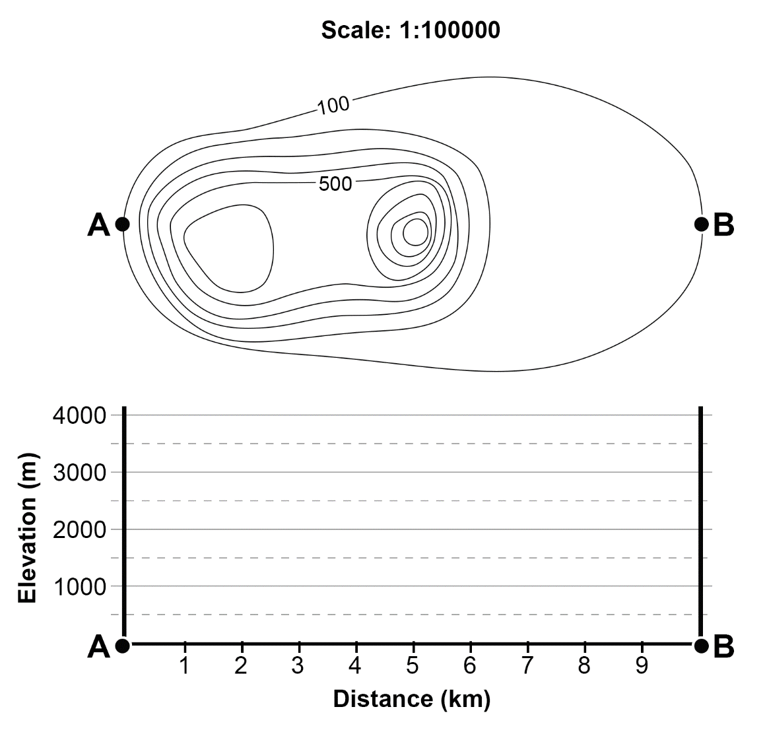
Check your cross-sections using Appendix 2 – cross-section answers.
Conduct a Parts, Purposes, Complexities thinking routine using the cross-sections in Figures 2 to 4.
- What are the parts of a cross-section?
- What is the purpose of a cross-section?
- What are the complexities of a cross-section?
Note: probing questions for the Parts, Purposes, Complexities thinking routine include:
- Looking at the contour lines only, which one has the highest change in elevation?
- Looking at the cross-sections, which one appears to be the flattest?
- What feature in a cross-section can change or distort its appearance?

Vertical exaggeration
Because the horizontal distance is nearly always significantly longer than the vertical height being shown on a cross-section, different scales will be used for the horizontal and vertical axes to provide a better visual of the topography (shape of the land). This is shown by the cross-sections in Figures 2 to 4. Figures 2 to 3 use a larger vertical scale compared to the horizontal scale. The peaks and valleys in these cross-sections are clearly visible. Figure 4 uses the same vertical and horizontal scale. As a result, this cross-section appears as a relatively flat line with the peaks and valleys not visible.
The proportional difference in scale used for the vertical and horizontal axes is called ‘vertical exaggeration’. As the name suggests, the vertical exaggeration indicates how much the vertical axis has been exaggerated in the cross-section. It is calculated as the number of times larger the vertical axis is compared to the horizonal axis.
Every landscape is unique, and each cross-section has a different purpose, so there is no standard vertical exaggeration. Because of this, it is important to calculate the vertical exaggeration when examining a cross-section to ensure you have an accurate understanding of the landscape.
Use the following steps to calculate the vertical exaggeration for Figures 2 to 3.
- Calculate what 1 cm on the horizontal scale represents in metres. You can use the scale of the map or measure with your ruler against the horizontal axis.
- Calculate what 1 cm on the vertical scale represents in metres by placing your ruler against the vertical axis and recording the change in elevation for each centimetre.
- Divide the result for Step 1 (horizontal distance) by the result for Step 2 (vertical distance). The answer is the vertical exaggeration.
Answer: in Figure 2, the horizontal distance is 1000 m, the vertical distance is 100 m and the vertical exaggeration is 1000 ÷ 100 = 10. Therefore, the vertical scale is 10 times larger than the horizontal scale.
In Figure 3, the horizontal distance is 1000 m, the vertical distance is 50 m and the vertical exaggeration is 1000 ÷ 50 = 20. Therefore, the vertical scale is 20 times larger than the horizontal scale.
Note: the vertical exaggeration formula requires student understanding of how to divide ratios and is recommended only for use with students in Year 10 or above.
Figure 5 shows the formula for vertical exaggeration. When using this formula, it is important to remember that you are dividing the vertical scale as a ratio by the horizontal scale as a ratio.
Figure 5 – vertical exaggeration formula
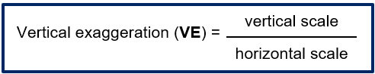
Note: Figure 6 is a fictional location used for illustrative purposes.
Use the following steps to construct a cross-section of Figure 6.
- Locate any 2 points on the map, for example A to C.
- Place an edge of a sheet of paper along the transect between the chosen points. Mark the chosen points and write their elevation (if known) underneath the mark.
- Working carefully from left to right, mark where each contour line meets the edge of the paper. Record the height of each contour under the mark.
- Draw a graph to plot the contours. The horizontal axis should be the same length as the ruler distance between your 2 chosen points on the map.
- Choose a suitable scale for the vertical axis. Record the vertical exaggeration you have selected on a separate piece of paper.
- Use the paper marks to plot each contour height on the graph. Join the points with a smooth line.
- Give the cross-section a title and label each axis.
Figure 6 – Dreamouth Siding topographic map
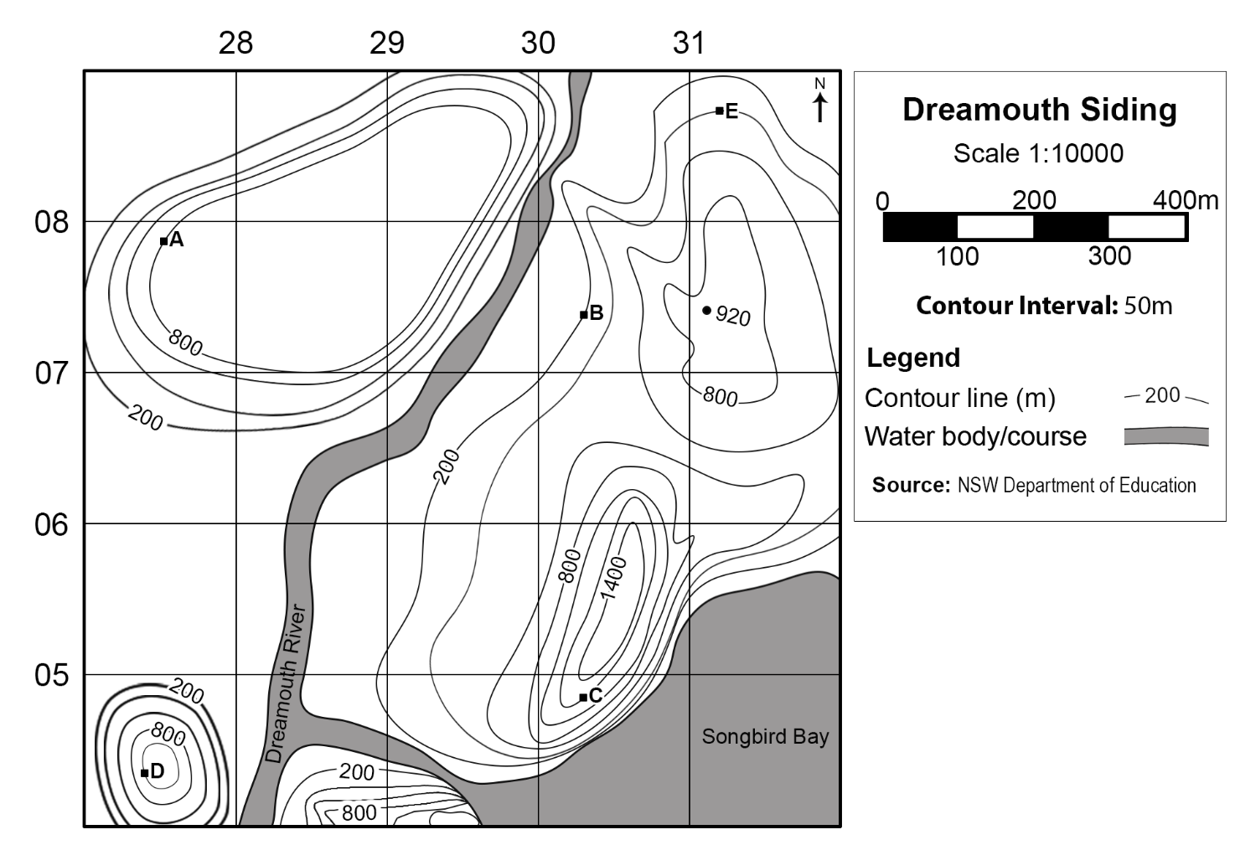
Swap your cross-section with a peer in the class. Calculate the vertical exaggeration of their cross-section and provide feedback using the following marking criteria.
Table 1 – peer marking rubric for cross-section
Criteria | Yes | No | Comments
Title is clear and concise | ☐ | ☐
Axis is labelled correctly | ☐ | ☐
Cross-section is presented | ☐ | ☐
Scale of measurement on axis is appropriate | ☐ | ☐
Spelling is correct | ☐ | ☐
Cross-section is illustrated neatly | ☐ | ☐
Note: high potential and gifted education (HPGE) students may benefit from being provided with a full topographic map and relevant grid reference points to construct more complex cross-sections. Geoscience Australia provides a variety of topographic maps useful for this activity. Teachers need to be aware of the ratio scale on the Geoscience Australia maps. The recommended print sizes are A1 for Geoscience Australia 1:50000 maps. Topographic maps from NSW Spatial Services are more complicated but include linear scale and can be printed on A3 paper. Including calculation tasks for vertical exaggeration will also extend students’ numeracy and geographical tools knowledge.

Transects
A transect is a cross-sectional view between 2 points, which shows changes that occur along this line in physical and human geography. Transects can be very simple, illustrating one feature such as vegetation or a complex diagram illustrating a great variety of information. Figure 7 is an example of a transect.
Figure 7 – transect of Launceston
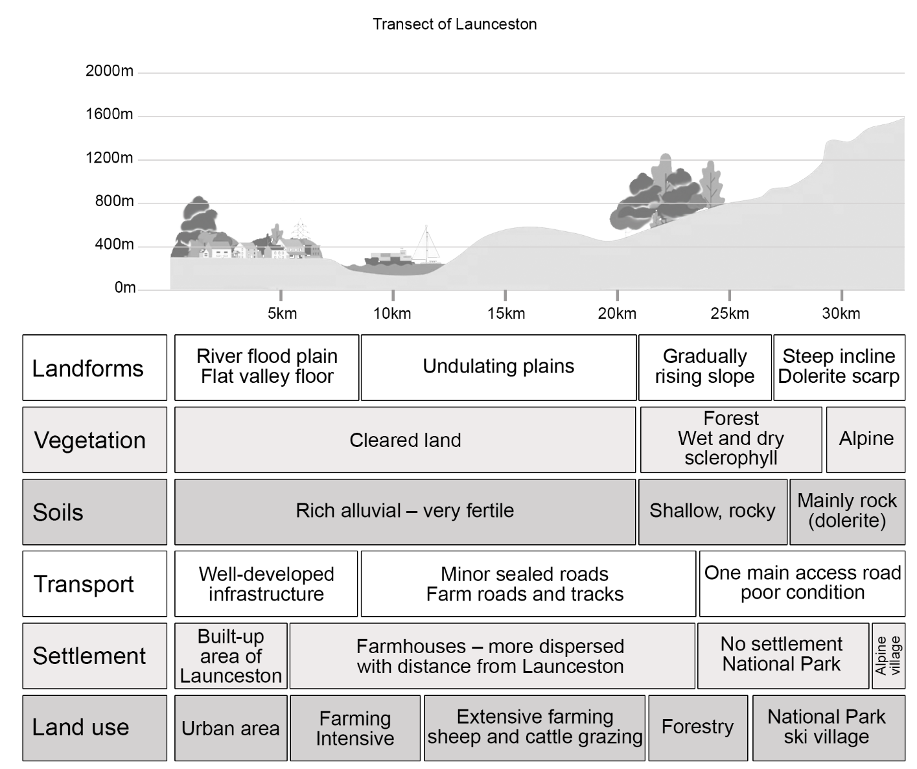

Using spatial technologies
Note: the following learning activity requires Google Earth Pro. Google Earth web edition does not develop elevation profiles at time of publishing. Google Earth Pro is available for free download and authorised for use on department devices. Seek support from your school administration team or EdConnect if installing on department devices.
Explore Google Earth Pro and select a location with the following features:
- at least one built-up area
- at least 2 different types of vegetation profiles.
Use the following instructions to create a transect of the chosen location:
Create a path using the Add Path button as shown in Figure 8. Alternatively, you can use the Add menu and select Path as shown in Figure 9.
Figure 8 – Google Earth Pro instructions Set 1
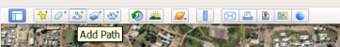
Image by © Google 2023.
Figure 9 – Google Earth Pro instructions Set 2
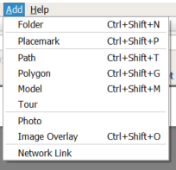
Image by © Google 2023.
Select the start and end point for your cross-section to make the path, as shown in Figure 10. Drag the dialogue box to move it if needed. Do not close the dialogue box.
Figure 10 – Google Earth Pro instruction Set 3
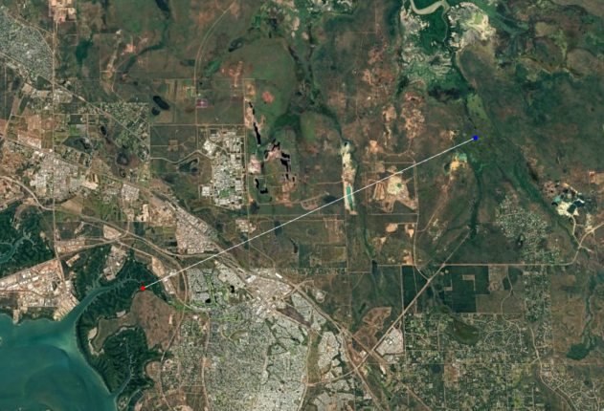
Image by © Google 2023.
Name the path ‘Cross-section’ in the dialogue box, as shown in Figure 11, and select OK.
Figure 11 – Google Earth Pro instructions Set 4
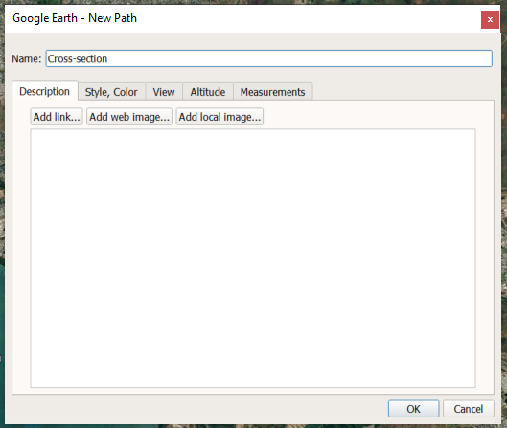
Image by © Google 2023.
Right-click on the new path, ‘Cross-section’, in the Places menu on the left of the screen, as shown in Figure 12. Select Show Elevation Profile.
Figure 12 – Google Earth Pro instruction Set 5
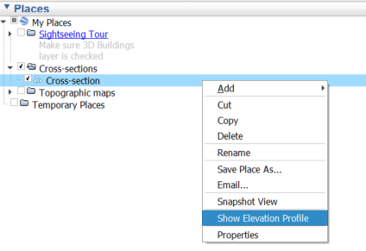
Image by © Google 2023.
Activate the snipping tool on your computer. Take a screenshot of the cross-section and save the image.
Open the image in your preferred image editing software, such as Microsoft Paint 3D or Adobe Photoshop.
Explore your cross-section path in Google Earth Pro. Record the types of landforms, vegetation, transport, settlement and land use you notice in your workbook. In the image editing software, add simple drawings to your cross-section image to represent these observations. You can explore specific sections of your cross-section by double-clicking the section on the elevation profile. Once complete, save your image as a new file called ‘Transect of (location)’.
It is good practice to show your transect with a map of the location it is based on. Open the File menu, as shown in Figure 13. Select Save, then select Save Image. Alternatively, you can use the shortcut Ctrl + Alt + S (for Microsoft devices) on your keyboard.
Figure 13 – Google Earth Pro instruction Set 6
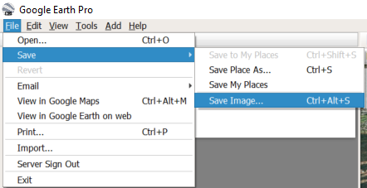
Image by © Google 2023.
You can now add a title and description for your map by selecting the Untitled Map box on the top-right of the map, as shown in Figure 14.
Figure 14 – Google Earth Pro instruction Set 7
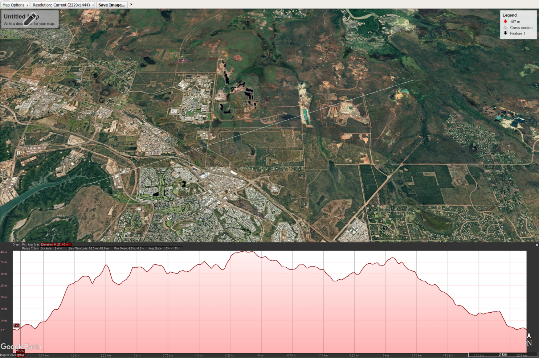
Image by © Google 2023.
Select Save image and store the image in an appropriate location. This will save the map only.
Insert the transect and map images into the template provided in Appendix 3 – transect template. Add a title for the transect.
Record the different features shown on the transect in the annotation table in Appendix 3. Merge and adjust the width of cells in each row to match the transect. Refer to Figure 7 as a guide for completing these annotations.
Present your transect in a Gallery walk.
Differentiation: to extend this activity, students can explore digital soil maps to add a soil profile to their transect. A local area could be used for the transect with a follow-up fieldwork excursion to the site. Students can compare their observations in the field to the transect they developed using Google Earth Pro.

Appendix 1 – mapping tools
The following page contains images of a ruler, protractor, compass and a 1 cm × 1 cm grid to support students when completing paper-based mapping skills tasks. It should be printed on A4 transparency sheets. Do not scale the page when printing.

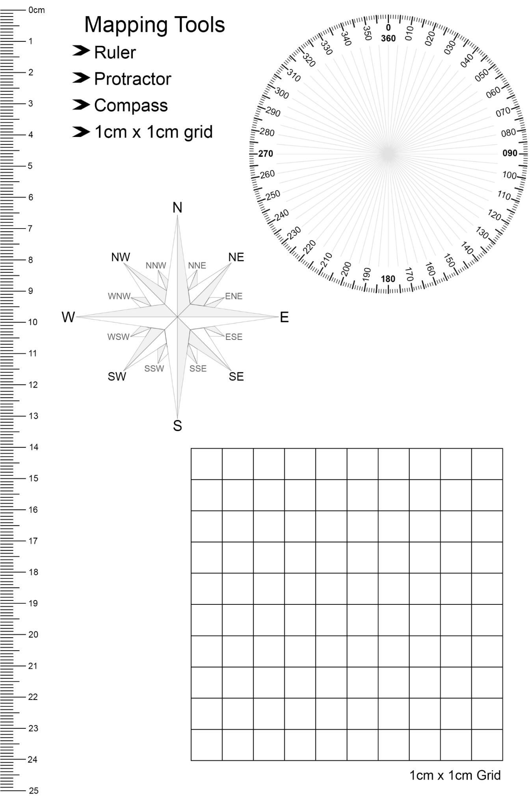

Appendix 2 – cross-section answers
Cross-section Activity 1 answer
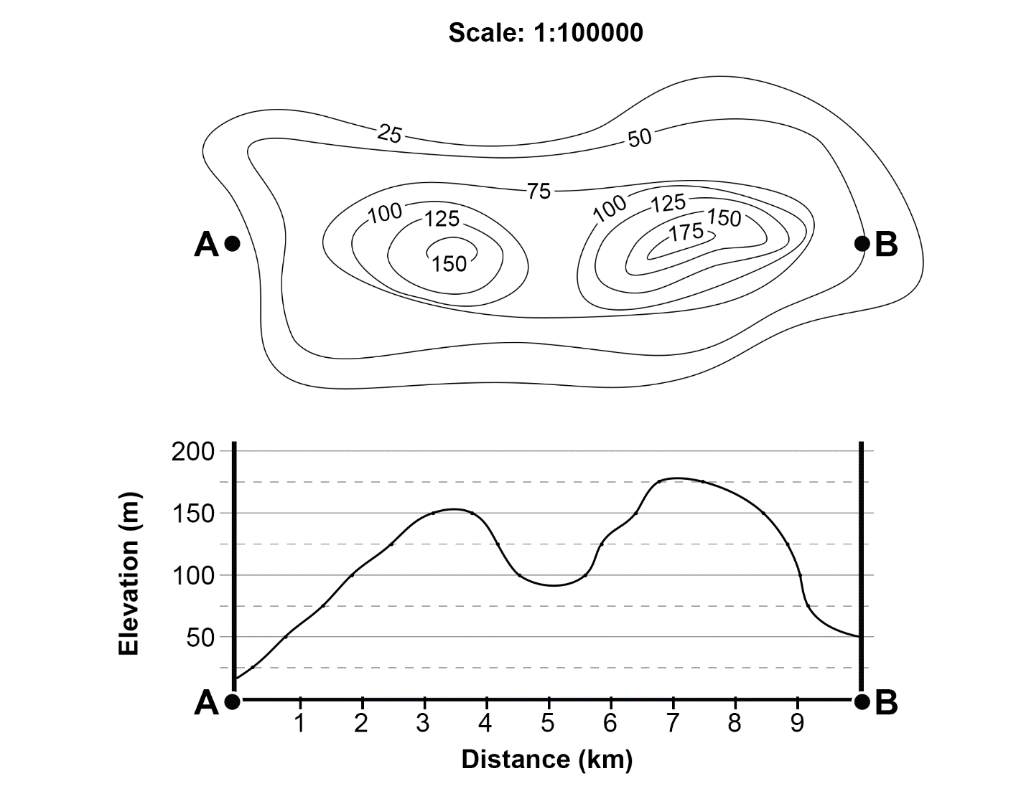

Cross-section Activity 2 answer
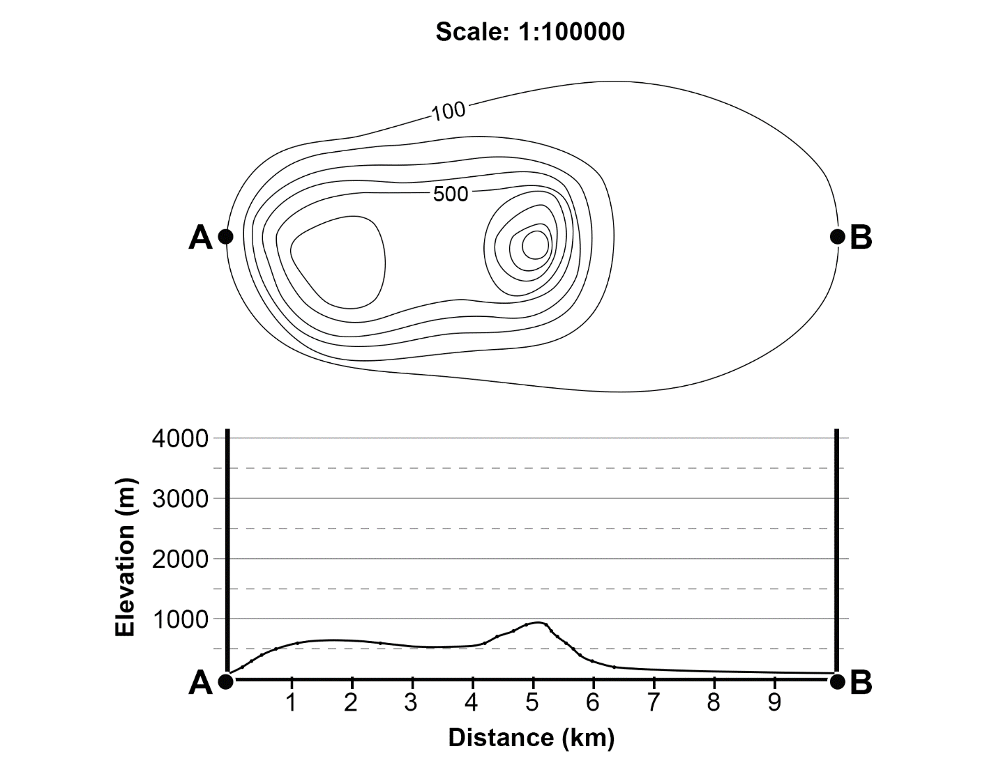

Appendix 3 – transect template
Type in transect title
Insert location map with transect marked.

Insert transect diagram.

Landforms
Vegetation
Transport
Settlement
Land use

References
This resource contains NSW Curriculum and syllabus content. The NSW Curriculum is developed by the NSW Education Standards Authority. This content is prepared by NESA for and on behalf of the Crown in right of the State of New South Wales. The material is protected by Crown copyright.
Please refer to the NESA Copyright Disclaimer for more information https://educationstandards.nsw.edu.au/wps/portal/nesa/mini-footer/copyright.
NESA holds the only official and up-to-date versions of the NSW Curriculum and syllabus documents. Please visit the NSW Education Standards Authority (NESA) website https://educationstandards.nsw.edu.au and the NSW Curriculum website https://curriculum.nsw.edu.au.
Geography 7–10 Syllabus © NSW Education Standards Authority (NESA) for and on behalf of the Crown in right of the State of New South Wales, 2024.
AIATSIS (The Australian Institute of Aboriginal and Torres Strait Islander Studies) (n.d.) Map of Indigenous Australia, AITSIS website, accessed 24 August 2023.
Australian Government Geoscience Australia (2023) Topographic Maps, Geoscience Australia website, accessed 21 August 2023.
NESA (NSW Education Standards Authority) (2022) ‘Proficient Teacher Standard Descriptors’, The Standards, NESA website, accessed 20 July 2023.
NSW Aboriginal Education Consultative Group (2023) NSW AECG Languages App, WellMob website, accessed 21 August 2023.
NSW Government Spatial Services (2023) Topographic Maps, Spatial Services website, accessed 21 August 2023.

© State of New South Wales (Department of Education), 2024
The copyright material published in this resource is subject to the Copyright Act 1968 (Cth) and is owned by the NSW Department of Education or, where indicated, by a party other than the NSW Department of Education (third-party material).
Copyright material available in this resource and owned by the NSW Department of Education is licensed under a Creative Commons Attribution 4.0 International (CC BY 4.0) license.

This license allows you to share and adapt the material for any purpose, even commercially.
Attribution should be given to © State of New South Wales (Department of Education), 2024.
Material in this resource not available under a Creative Commons license:
- the NSW Department of Education logo, other logos and trademark-protected material
- material owned by a third party that has been reproduced with permission. You will need to obtain permission from the third party to reuse its material.
Links to third-party material and websites
Please note that the provided (reading/viewing material/list/links/texts) are a suggestion only and implies no endorsement, by the New South Wales Department of Education, of any author, publisher, or book title. School principals and teachers are best placed to assess the suitability of resources that would complement the curriculum and reflect the needs and interests of their students.
If you use the links provided in this document to access a third-party's website, you acknowledge that the terms of use, including licence terms set out on the third-party's website apply to the use which may be made of the materials on that third-party website or where permitted by the Copyright Act 1968 (Cth). The department accepts no responsibility for content on third-party websites.

