Geography 7–10 – guide to teaching mapping – area and grid reference

Contents
Overview 2
Outcomes 2
Learning sequence 1 – area and grid reference 3
Syllabus content 3
Learning intentions and success criteria 3
Learning intention 3
Success criteria 3
Working with maps 4
Maps 4
Finding places using area reference 4
Snake in the grass game 7
Finding places using a grid reference 9
Appendix 1 – snake in the grass 15
References 16
This resource has been developed to assist teachers in NSW Department of Education schools to create learning that is contextualised to their classroom. It can be used as a basis for the teacher’s own program, assessment, or scope and sequence, or be used as an example of how the new curriculum could be implemented. The resource has suggested timeframes that may need to be adjusted by the teacher to meet the needs of their students.

Overview
Description: this teaching support resource addresses Thinking and working geographically, providing examples of how students can engage with the geographical tool of maps. The lessons in this resource are designed to allow students to build understanding of this geographical tool through a range of learning activities and can be applied where appropriate across Geography 7–10.
Duration: this learning sequence is designed to be completed in approximately 2 hours.

Outcomes
A student:
- GE4-TAP-01 selects and uses geographical tools to acquire and process geographical information
- GE5-TAP-01 applies and evaluates a range of geographical tools to acquire and process geographical information
Geography 7–10 Syllabus © NSW Education Standards Authority (NESA) for and on behalf of the Crown in right of the State of New South Wales, 2024.

Learning sequence 1 – area and grid reference
Note: this guide to teaching area and grid reference is designed to be used as a support resource for teachers addressing the tools continuum. This resource provides resources and strategies that can be applied at any point in Geography 7–10 where relevant to syllabus content.

Syllabus content
Maps take many forms and include digital and non-digital mediums. Examples include, but are not limited to, pictorial maps, large-scale and small-scale maps, relief maps, choropleth maps, flowline maps, cadastral maps, isoline maps, land use maps, physical maps, political maps, précis maps, cultural mapping, road maps, thematic maps, tactile maps, topographic maps and special-purpose maps.
Maps are used to locate, visualise, represent, display and record spatial data.

Learning intentions and success criteria
Note: these learning intentions and success criteria are general and should be contextualised to suit your school and students’ needs.

Learning intention
Students learn about:
- finding places and identifying features on maps using coordinates.

Success criteria
Students will be able to:
- use 4-figure area references to find and describe features on maps
- use 6-figure grid references to find and describe features on maps.

Working with maps
Note: teachers will need to provide students with a topographic map for learning activities in this sequence. Geoscience Australia and NSW Spatial Services provide a variety of topographic maps useful for this activity. Teachers need to be aware of the representative fraction scale on the Geoscience Australia maps and the recommended print sizes are A1 for Geoscience Australia 1:50000 maps. NSW Topographic Maps from Spatial Services include a linear scale and can be printed on A3 paper.
The activities in this sequence are aligned with PoL4 and PoL5 of the National Numeracy Learning Progressions Version 3.

Maps
Maps are used in geography to communicate information about places. Geographers use many different types of maps. They are used as a tool to find places, understand the patterns of natural and human features, and discover relationships between features. Imaginary grid lines are used with numbers and letters to assist in finding features and places more easily. Alphanumeric grid systems use letters and numbers to form a reference point. Area reference, also known as 4-figure grid reference, is a set of 4 numbers which can be used to find places on a topographic map.

Finding places using area reference
Area reference is used when we want to describe the general location of a place on a map.
Area reference has 4 digits. The first 2 digits are the numbers for the easting. These are shown in blue in Figure 1. The last 2 digits are the numbers for the northing. These are shown in red in Figure 1.
Note: Bundjalung language is used in Figure 1. The Bundjalung nation occupies land from north-east NSW to south-east Queensland. The NSW AECG Languages App contains all words used. Permission to use the traditional Bundjalung language was sought and approved by the NSW Aboriginal Education Consultative Group (AECG). Figure 1 is a fictional location used for illustrative purposes.
Figure 1 – map illustrating eastings and northings
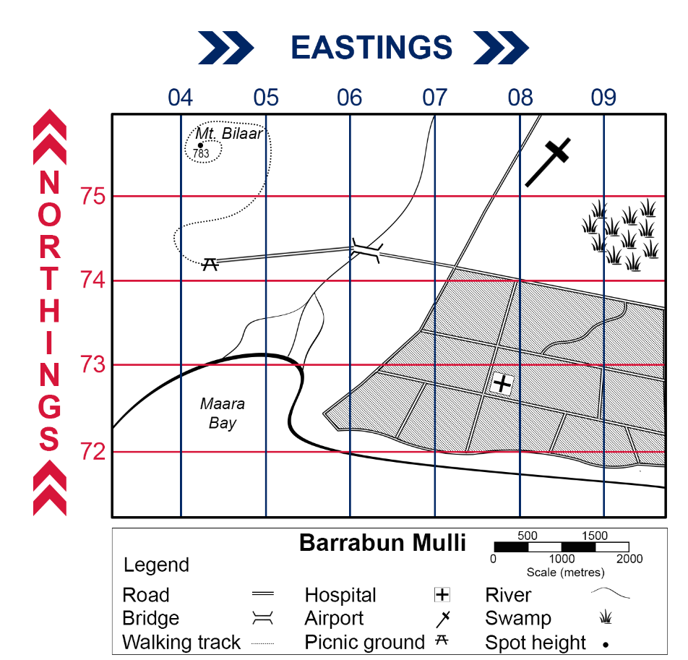
Bundjalung language used with permission of NSW AECG.
Engage with Area and grid reference (3:32) and review Figure 1. Answer the questions below with a partner.
- What is located in the following area references on your map?
- AR0475
- AR0875
- AR0772.
- What is the area reference for the following?
- Maara Bay
- the bridge
- the main area of the swamp.
Answers:
1.
- AR0475 – Mt Bilaar
- AR0875 – airport
- AR0772 – hospital
2.
- Maara Bay – AR0472
- the bridge – AR0674
- main swamp area – AR0974
Your teacher will provide you with a topographic map and allocate you to a group of 4 to 5 students. In your group, develop a quiz to contribute to a gallery walk. The quiz must include 6 to 8 questions based on your allocated topographic map for your peers to answer. When constructing your questions, ensure that your peers have an opportunity to:
- use an area reference to find a location
- provide an area reference for a location
- identify a feature from the legend in a specific area reference.
Use the maps presented by your peers in the gallery walk to answer the quiz questions. At the conclusion of the activity, groups share the correct answers for each quiz.
Differentiation: Differentiating learning – Flexible student grouping options provides useful grouping strategies that promote student social support.

Snake in the grass game
Note: this activity takes approximately 15 minutes per round. Students play the game in pairs. Each student requires a:
- game sheet (Appendix 1 – snake in the grass) – printed or digital
- pen or digital device
- divider, such as a book, to hide their game sheet.
Your teacher will provide you with equipment to play a game of ‘snake in the grass’. Follow the instructions to participate in the game.
Mark snakes in the ‘My yard’ panel on your game sheet using the letters shown for each snake in the legend. Each snake must be marked in a straight horizontal or vertical line using one letter per grid square. An example is provided in Figure 2.
Figure 2 – ‘My yard’ example
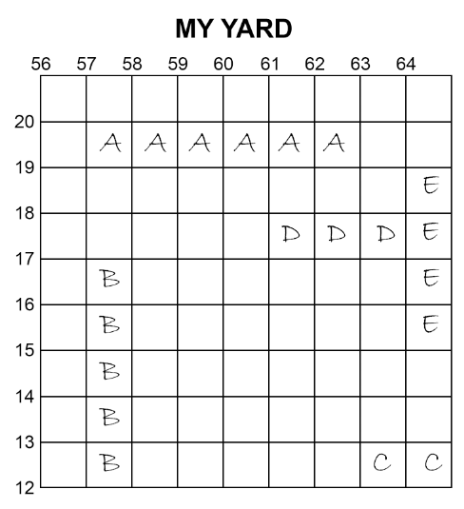
To decide who plays first:
- close your hand to make a fist
- count to 3
- on 3, use your fingers to show a number from zero to 5
- the first person to call the correct sum of the fingers becomes the first player.
On each turn:
- the player says an area reference
- the other player responds:
- ‘Safe’ if the area reference is empty
- ‘Catch’ if the area reference has part of a snake (they put a cross over the grid square to show that part of the snake has been caught)
- ‘You caught my [snake name]’ if the area reference was the last remaining grid square for that snake
- the player marks the result of their guess in ‘Opponent’s yard’ on their game sheet and ends their turn.
Note: if the area reference is not given correctly, for example, if the numbers are provided in an incorrect order, the player misses their turn.
The game continues until one player has caught all their opponent’s snakes. That player is the winner.

Finding places using a grid reference
Note: additional support should be provided in the following activity for students requiring numeracy interventions, particularly around understanding decimals. The video Number Line Tenths (3:11) could be useful when explaining tenths and aligns with progression NPV6 of the National Numeracy Learning Progressions Version 3.
A 6-figure grid reference is used to give the exact location of a place on a map. A 6-figure grid reference has 6 digits. The first 2 digits tell us the easting on the left-hand side of the location. The third digit tells us how many tenths to the right of the easting the feature is located. The fourth and fifth digits are the northing below the location. The final digit tells us how many tenths above the northing this point is. Figure 3 illustrates a 6-figure grid reference on a topographic map. The grid reference for Mt. Bilaar is GR042756.
Figure 3 – map with grid reference example
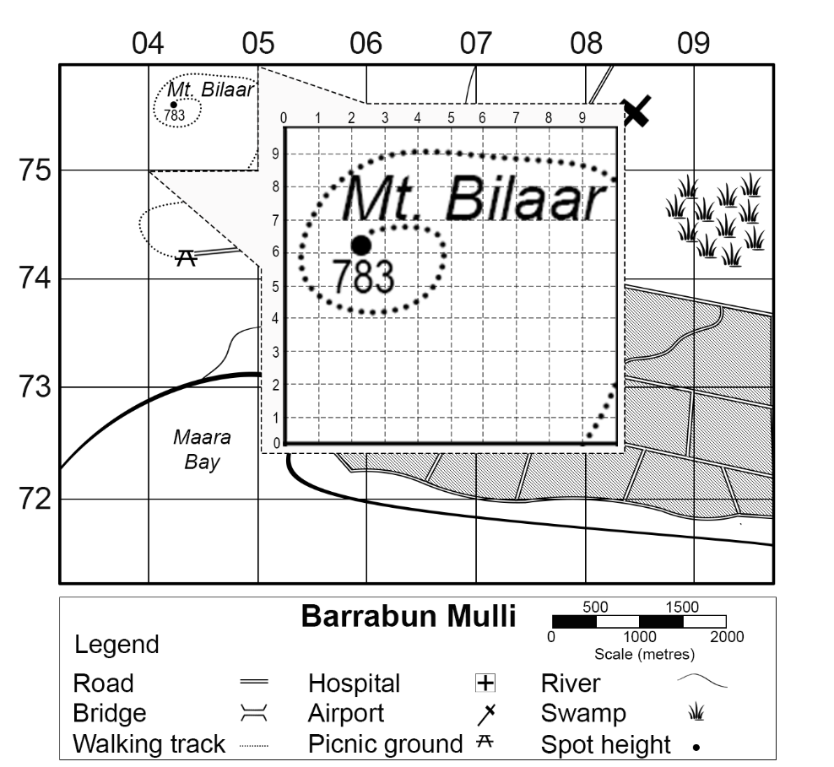
Bundjalung language used with permission of NSW AECG.
Note: students will need to be provided with Figure 4 to answer the following learning activities. Gamilaraay language is used in Figure 4. Gamilaraay nation is located in north-eastern NSW and south-western Queensland. The NSW AECG Languages App contains all words used. Permission to use the traditional language of Gamilaraay was sought and approved by the NSW Aboriginal Education Consultative Group (AECG). Figure 4 is a fictional location used for illustrative purposes.

Figure 4 – Bandaar Walaay
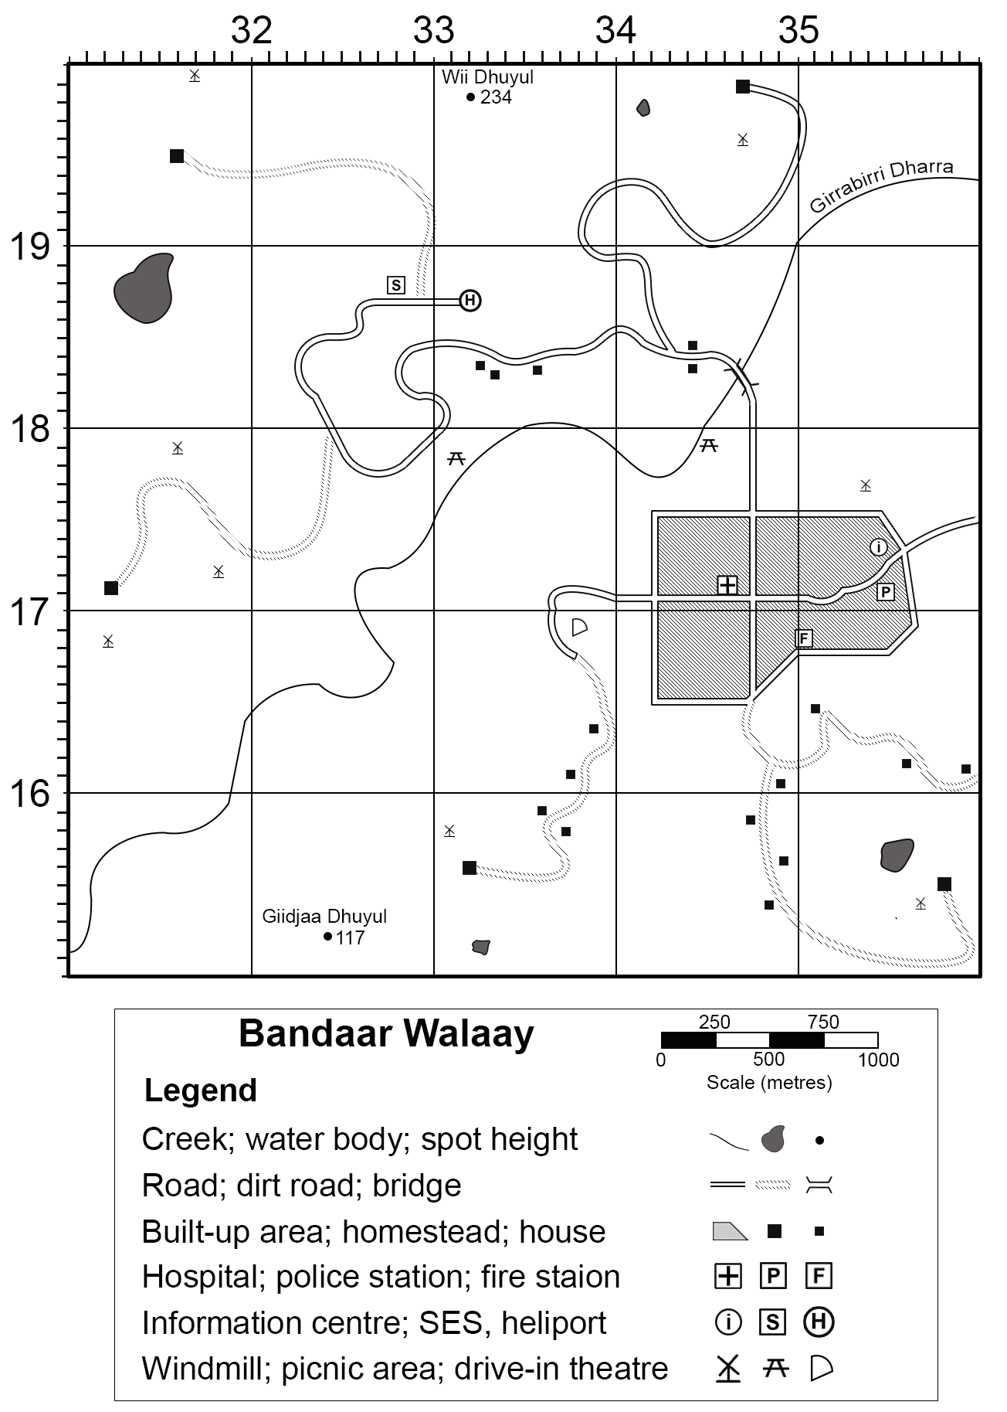
Gamilaraay language used with permission of NSW AECG.

Use Figure 4 to answer the following questions.
- What is located at the following grid references?
- GR328188
- GR332198
- GR345179
- GR357154.
- Give a 6-figure grid reference for the following features on Figure 4:
- police station
- fire station
- hospital
- heliport.
Answers:
1.
- GR328188 – SES
- GR332198 – Wii Dhuyul peak
- GR345179 – picnic area
- GR357154 – windmill
2.
- police station – GR355171
- fire station – GR350168
- hospital – GR346171
- heliport – GR332187.
Note: divide students into small groups for the following learning activity. Provide each group with a different NSW Spatial Services Topographic map and narrative scenario. Example scenarios include bush fire, local marathon, Scout camp, bank robbery or great race. Each group are instructed to create a story based on their scenario using their allocated topographic map. Groups develop a cloze passage by removing grid and area references, then swap the story for peers in their class to decipher.
Your teacher will allocate you to a group. Each group will be given a narrative scenario to write about using a topographic map to tell the story. Your narrative should include:
- at least 6 locations on the map
- a variety of locations referring to area or grid references
- a cloze passage of your narrative with the area and grid references removed.
Swap the cloze passage with another group in the class to decipher.
Note: when using formative assessment in the classroom, peer and self-assessment is an effective approach to enhance the learning of students. Explicitly teaching students how to assess their own work, and the work of their peers, has many benefits. It promotes student understanding of their learning and provides opportunities for critical analysis of their own efforts, encouraging them to become more autonomous learners. The following learning activities provide an example of self-assessment. More information on this aspect of formative assessment is available at Peer and self-assessment for students.
Use Table 1 to reflect on your learning and understanding of using area and grid reference to find and describe places on maps.
Table 1 – self-assessment tool
Reflective question | Response
What did we do in class today?
Why did we do it?
What did I learn today?
How can I apply it?
What questions do I have about it?

Appendix 1 – snake in the grass
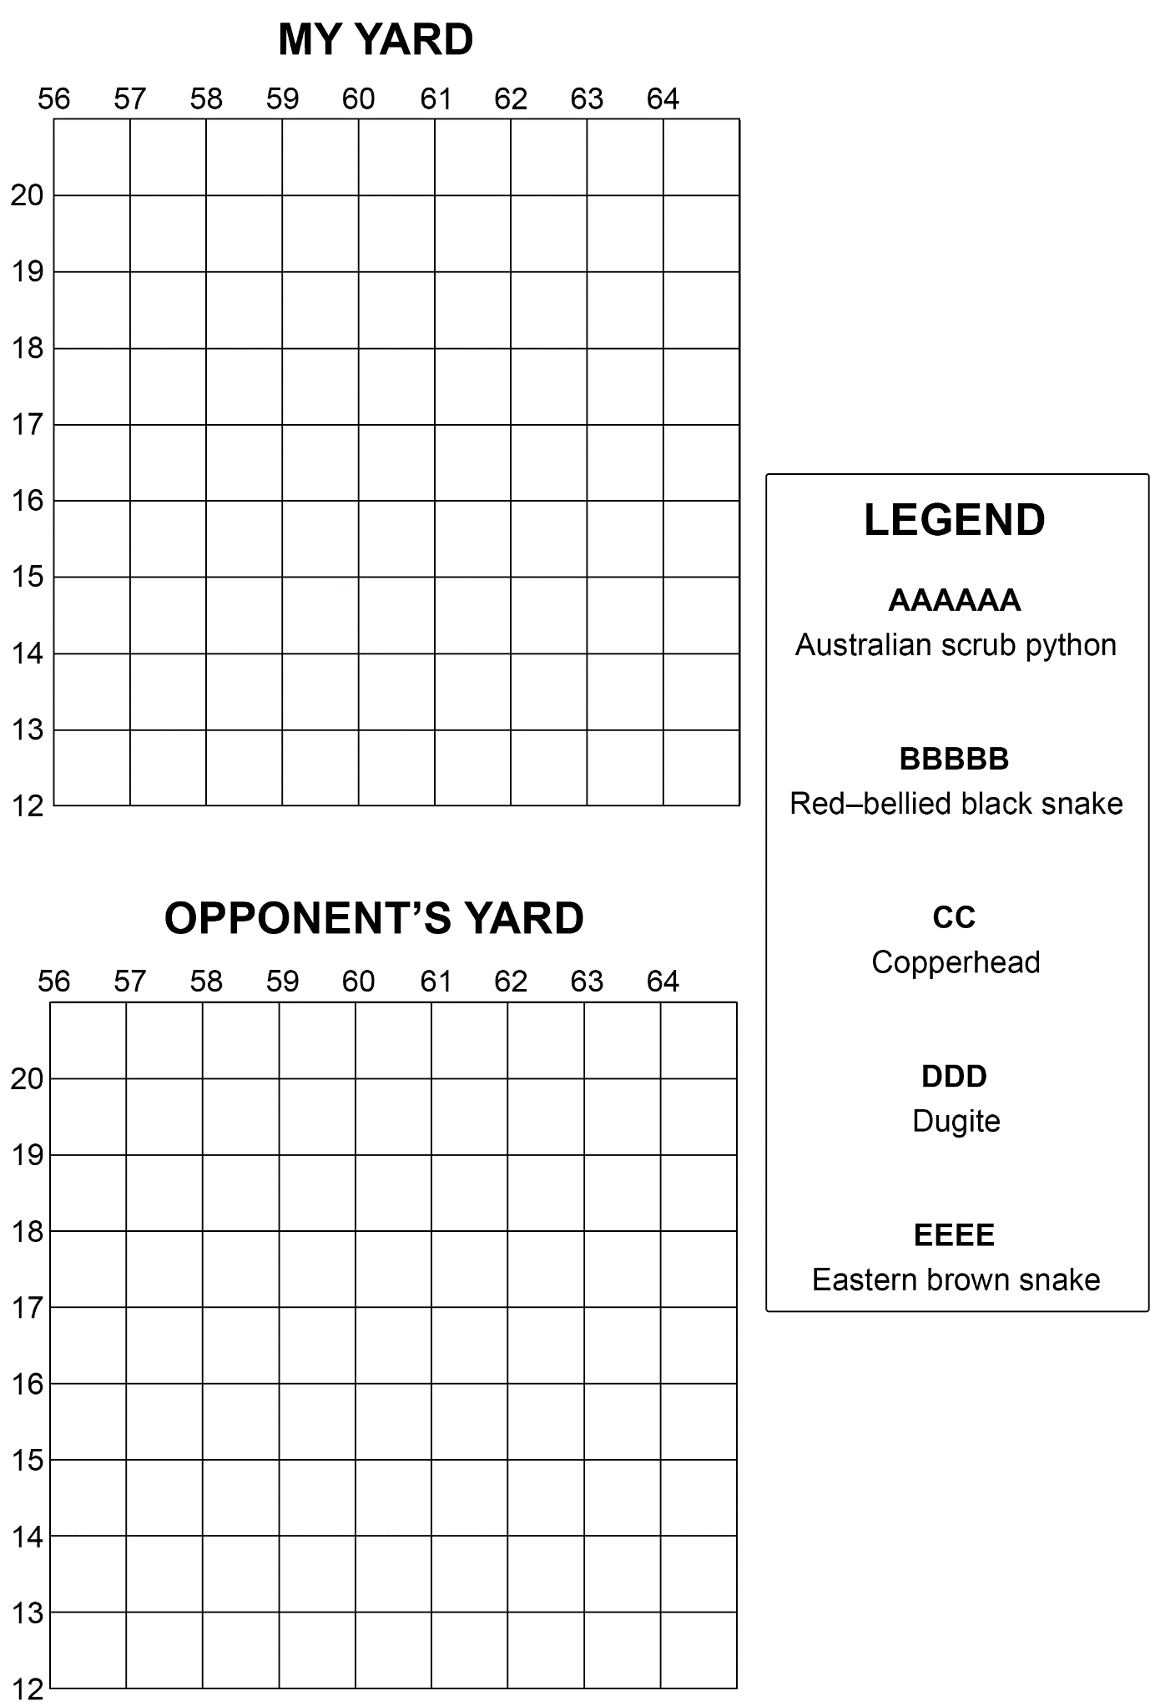

References
This resource contains NSW Curriculum and syllabus content. The NSW Curriculum is developed by the NSW Education Standards Authority. This content is prepared by NESA for and on behalf of the Crown in right of the State of New South Wales. The material is protected by Crown copyright.
Please refer to the NESA Copyright Disclaimer for more information https://educationstandards.nsw.edu.au/wps/portal/nesa/mini-footer/copyright.
NESA holds the only official and up-to-date versions of the NSW Curriculum and syllabus documents. Please visit the NSW Education Standards Authority (NESA) website https://educationstandards.nsw.edu.au and the NSW Curriculum website https://curriculum.nsw.edu.au.
Geography 7–10 Syllabus © NSW Education Standards Authority (NESA) for and on behalf of the Crown in right of the State of New South Wales, 2024.
National Numeracy Learning Progression © Australian Curriculum, Assessment and Reporting Authority (ACARA) 2010 to present, unless otherwise indicated. This material was downloaded from the Australian Curriculum website (National Numeracy Learning Progression) (accessed 11 December 2023) and was not modified. This material is licensed under CC BY 4.0.
Edpuzzle Curriculum (4 September 2019) ‘Number Line Tenths’ [video], Edpuzzle Curriculum, YouTube, accessed 21 August 2023.
Geoscience Australia (2023) ‘Topographic Maps’, Topographic information, Geoscience Australia website, accessed 21 August 2023.
NESA (NSW Education Standards Authority) (2022) ‘Proficient Teacher Standard descriptors’, Teacher accreditation, NESA website, accessed 20 July 2023.
NSW Aboriginal Education Consultative Group (2023) NSW AECG Languages App, WellMob website, accessed 21 August 2023.
NSW Government Spatial Services (2023) ‘Topographic Maps’, Products and Services, Spatial Services website, accessed 21 August 2023.

© State of New South Wales (Department of Education), 2025
The copyright material published in this resource is subject to the Copyright Act 1968 (Cth) and is owned by the NSW Department of Education or, where indicated, by a party other than the NSW Department of Education (third-party material).
Copyright material available in this resource and owned by the NSW Department of Education is licensed under a Creative Commons Attribution 4.0 International (CC BY 4.0) license.

This license allows you to share and adapt the material for any purpose, even commercially.
Attribution should be given to © State of New South Wales (Department of Education), 2025.
Material in this resource not available under a Creative Commons license:
- the NSW Department of Education logo, other logos and trademark-protected material
- material owned by a third party that has been reproduced with permission. You will need to obtain permission from the third party to reuse its material.
Links to third-party material and websites
Please note that the provided (reading/viewing material/list/links/texts) are a suggestion only and implies no endorsement, by the New South Wales Department of Education, of any author, publisher, or book title. School principals and teachers are best placed to assess the suitability of resources that would complement the curriculum and reflect the needs and interests of their students.
If you use the links provided in this document to access a third-party's website, you acknowledge that the terms of use, including licence terms set out on the third-party's website apply to the use which may be made of the materials on that third-party website or where permitted by the Copyright Act 1968 (Cth). The department accepts no responsibility for content on third-party websites.

