History Stage 4
Depth Study 2 – ancient Egypt contacts and conflict

Contents
Overview 3
Outcomes 3
Learning sequence 1 – contacts and conflict 4
Syllabus content 4
Learning intentions and success criteria 5
Significant contacts and conflicts 6
Consequences of contacts 8
Legacy of ancient Egypt 10
Mathematical legacy of ancient Egypt 11
Appendix 14
Appendix 1 – Egypt’s neighbours 15
Appendix 2 – Egypt’s neighbours source cards 18
Nubia 19
Libya 20
Sinai 21
Canaan 22
Hittite empire 23
Mitanni 24
Punt 25
Greece 26
Appendix 3 – contacts and conflicts quiz 27
Appendix 4 – math like an Egyptian 30
Addition 30
Multiplication 31
Division 31
Support and alignment 32
References 33
Works of art 35

This resource has been developed to assist teachers in NSW Department of Education schools to create learning that is contextualised to their classroom. It can be used as a basis for the teacher’s own program, assessment, or scope and sequence, or be used as an example of how the new curriculum could be implemented. The resource has suggested timeframes that may need to be adjusted by the teacher to meet the needs of their students.

Overview
Description: this learning sequence addresses the key inquiry question ‘What have been the legacies of ancient societies?’ through Depth Study 2 option 2a Egypt. It is designed to build student understanding of the historical concepts of cause and effect, and significance. It supports students to develop the historical skills of analysis and use of sources. General capabilities of critical and creative thinking, literacy and numeracy are also addressed.
Duration: this learning sequence is designed to be completed in approximately 5 hours.

Outcomes
A student:
- HT4-3 describes and assesses the motives and actions of past individuals and groups in the context of past societies
- HT4-9 uses a range of historical terms and concepts when communicating an understanding of the past
History K–10 Syllabus © NSW Education Standards Authority (NESA) for and on behalf of the Crown in right of the State of New South Wales, 2012.

Learning sequence 1 – contacts and conflict
This learning sequence is designed to take 5 hours. Students will draw on knowledge from previous content in depth study 2 – the geographical setting of ancient Egypt. An understanding of key terms such as consequences, trade, warfare, conquest, diplomacy and vassal state is needed. Merriam-Webster Kid’s Dictionary and Collins Dictionary are useful for age-appropriate definitions to support student literacy. This learning sequence is designed to support student numeracy skills in number sense and algebra – additive strategies, multiplicative strategies, and number patterns and algebraic thinking.
Consider the following when adapting this learning sequence to your school context:
- What pre-teaching of background knowledge, vocabulary or skills are needed for students to access the learning activities?
- What adjustments are needed to meet individual student learning needs?
- How can this learning sequence be adapted to meet whole-school priorities?

Syllabus content
Contacts and conflicts within and/or with other societies, resulting in developments such as the conquest of other lands, the expansion of trade and peace treaties (ACDSEH034, ACDSEH037, ACDSEH040).
Students:
- identify contacts and conflicts of peoples within the ancient world
- describe significant contacts with other societies through trade, warfare and conquest
- explain the consequences of these contacts with other societies, eg developments in trade, the spread of religious beliefs, the emergence of empires and diplomacy
- explain the legacy of the chosen ancient society.

Learning intentions and success criteria
Note: these learning intentions and success criteria are general and should be contextualised to suit your school and students’ needs.
Students learn to:
- identify contacts and conflicts ancient Egyptian peoples had with other societies
- describe significant contacts with other societies based on evidence
- explain and assess the consequences of these contacts for ancient Egypt
- explain the legacy of ancient Egypt in ancient and modern times.
Students will be able to:
- provide a description of ancient Egypt’s relationships with other societies supported by evidence
- create a written assessment of the consequences of Egypt’s contacts and conflicts
- explain the legacies of ancient Egypt through discussion and written reflection.

Significant contacts and conflicts
Figure 1 shows the general location of Egypt’s key neighbours in ancient times. The size and strength of these neighbours changed over time.
Use Figure 1 to complete the direction column in Appendix 1 – Egypt’s neighbours. A sample response has been provided.
Figure 1 – Ancient Egypt and its neighbours map
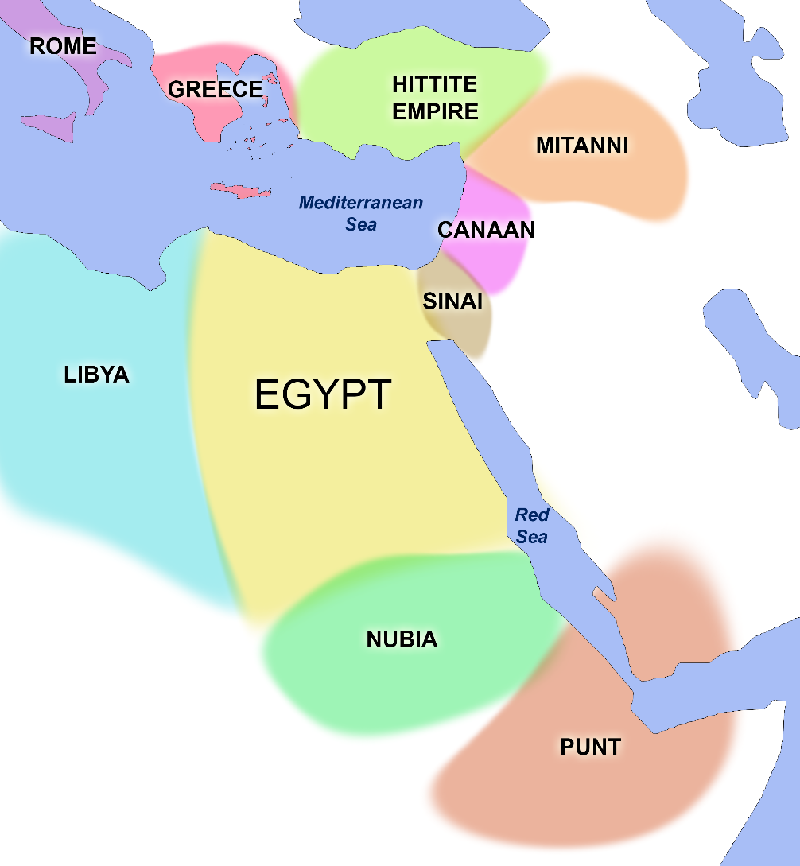
Note: provide each group with a unique card from Appendix 2 – Egypt’s neighbours source cards. If the class size does not support formation of 8 groups, use teacher judgement to determine suitable neighbours for the activity.
An open space is recommended for the presentations. The teacher represents Egypt. Visible markers for Egypt’s borders are recommended, such as chalk lines or sports cones. Figure 1 can be used to support students.
The teacher begins the presentations, stating the key goods Egypt traded – gold, linen, rope, papyrus and grains such as wheat, barley and flax – then selects the first group to present. Presentation order can be selected by teacher or students during the activity. A talking stick or soft ball can be used to identify the presenting group.
The activity concludes with a formative assessment quiz. Appendix 3 – contacts and conflicts quiz provides suggested questions and responses. The quiz can be delivered through an online platform; see Digital Learning Selector – Learning tools for options.
Differentiation: Differentiating learning – Flexible student grouping options provides useful grouping strategies. To extend, pose questions about how a specific neighbour might react to scenarios such as if Egypt stopped trading wheat with them, or asked them for support in a war against another neighbour.
In small groups, use your assigned neighbour source card to complete the relevant row in Appendix 1 – Egypt's neighbours.
- Present your findings to the class.
- Move to a position to correctly show your assigned neighbour’s geographic location relative to Egypt (your teacher).
- When it is your turn, describe your assigned neighbour’s relationship with Egypt. Support the description with source evidence about trade and conflict.
- Take notes in Appendix 1 – Egypt's neighbours during other group’s presentations.
- Compare notes with other group members at the end of the presentations.
- Participate in the contacts and conflicts class quiz.

Consequences of contacts
Complete a 5 Whys for the question: Why did Egypt have contact with its neighbours?
Note: a cost-benefit analysis encourages critical and numerical thinking. Cost-Benefit Analysis – Let’s Talk Science provides useful templates for this activity. Encourage students to manually calculate the overall score then check their result with a calculator.
Watch Why did Ancient Egypt Collapse? (11:34) (start at 3:21). Use Table 1 to take notes during the video.
Table 1 – Why did Ancient Egypt Collapse video notes
Question | Notes
What internal struggles changed Egypt’s relationships with its neighbours?
In what ways did contacts with neighbours lead to the decline of ancient Egypt?
Using your learning so far, conduct a cost-benefit analysis of ancient Egypt’s contacts with its neighbours:
- brainstorm the costs (negative consequences) and the benefits (positive consequences) for Egypt
- give a value weighting from −5 (high cost) to +5 (high benefit) for each idea
- calculate the overall score
- using the score, decide if Egypt should, or should not, have had contact with its neighbours
- share your results in a class discussion.
Write a paragraph answering the question: Explain the consequences of Egypt’s interactions with its neighbours. Support your paragraph with 2 specific examples of positive and/or negative consequences.
Differentiation: physical manipulatives, such as counters or blocks, should be offered to students with low numeracy skills for the cost-benefit analysis. Providing students with a writing scaffold, such as PEEL for paragraph writing and a ‘What a good one looks like’ (WAGOLL) example, prepares them for success in writing.
To extend, conduct a prepared debate on the topic.

Legacy of ancient Egypt
Note: How ANCIENT Egyptians Influenced The World TODAY! (10:00) covers a range of ancient Egyptian legacies in a short video. The first viewing should be a passive watch without note taking to allow students to absorb the information. The Watch-Think-Write format is recommended for the second viewing to solidify knowledge and understanding.
Watch How ANCIENT Egyptians Influenced The World TODAY! (10:00) then complete a 3-2-1 discussion with a partner, including:
- 3 things you learned from the video
- 2 things you found interesting and would like to know more about
- 1 question you have after watching the video.
Re-watch the video while taking notes using the following scaffold in Table 2.
Table 2 – legacies of ancient Egypt
Legacy | Key facts and evidence
Bowling
Door locks
Toothpaste
Glass making
Wigs
Paper
The alphabet
Mathematics
Medical literature
Think-Pair-Share the following:
- What other legacies of ancient Egypt are still evident today?
- Create a rank of the top 10 legacies of ancient Egypt.
- How significant is the legacy of ancient Egypt today?

Mathematical legacy of ancient Egypt
Note: Appendix 4 – math like an Egyptian supports activities in this section. This section incorporates the general capability of numeracy through evidence-based strategies aligned with AdS2 and MuS7 of the National Numeracy Learning Progressions Version 3. Students use ancient Egyptian mathematical techniques identified from sources including the Rhind Mathematical Papyrus then reflect on the experience to build their understanding of the legacy.
The Rhind Mathematical Papyrus demonstrates what ancient Egyptians knew about mathematics. Egypt was the first recorded civilisation to use a base 10 number system, which is the foundation of modern mathematics. The papyrus shows Egyptian problem-solving methods including multiplication, fractions and geometry. Evidence such as the Rhind Mathematical Papyrus suggests many ancient Greek mathematical theories we use today may have developed from contact with the Egyptians. For example, the Greek Pythagorean Theorem used to find side lengths in right-angled triangles may be based on the 3-4-5 rope system Egyptian builders used to check right-angles in building projects. Without their strong mathematical understanding, Egypt’s grand pyramids, tombs and temples would not have been possible.
View the Rhind Mathematical Papyrus on the British Museum website and read the description.
- Complete a See-Think-Wonder routine about the Rhind Mathematical Papyrus.
- Test this number trick developed by a modern mathematician based on his study of the Rhind Mathematical Papyrus with 3 different numbers to see if it is always true.
- Pick a number.
- Add 6.
- Double the answer (multiply by 2).
- Subtract 4.
- Halve the answer (divide by 2).
- Subtract the original number.
- The answer will be 4.
- Discuss why this trick could be important for our understanding of mathematics.
Discussion points: helps identify number patterns, starting point for algebra (understanding unknown numbers).
Note: students work in pairs for the following activities.
Solve the addition problems in Appendix 4 – math like an Egyptian within one minute. Discuss with your partner:
- Do Egyptian hieroglyphics make addition easier or harder for you?
- Why do you think ancient Egyptians wrote their numbers in this way?
- Why don’t you think we use this way of writing numbers today?
Watch Learn How to Multiply like the Ancient Egyptians (2:24).
- Spend one minute re-teaching (or re-learning) ancient Egyptian multiplication with your partner.
- Solve the multiplication problems in Appendix 4 – math like an Egyptian within 5 minutes.
Note: model ancient Egyptian division on the board. Mathematics in ancient Egypt and Easy Math Trick No One Taught You – How Ancient Egyptians Divided Numbers (4:26) are useful resources.
- Swap roles with your partner and re-teach (or re-learn) ancient Egyptian division in one minute.
- Solve the division problems in Appendix 4 – math like an Egyptian within 5 minutes.
Participate in Four Corners to show whether you strongly agree, agree, disagree or strongly disagree with the following statements. Justify your decision in a short class discussion for each statement.
- Ancient Egyptian numbers are easier to use than modern numbers.
- I will use ancient Egyptian methods to solve maths problems in the future.
- Our modern understanding of mathematics is based on what the ancient Egyptian peoples discovered.
- Ancient Egypt’s mathematical legacy is still relevant today.
Create a concept map as a class about why mathematics is important. Consider the role mathematics plays in areas such as engineering and construction, medical science and technology.
Using ideas from the concept map, create a T-chart as a class addressing the impacts of ancient Egyptian mathematics with the headings:
- Impacts on ancient world
- Impacts on modern world.
Write a learning log entry to reflect on your understanding of the mathematical legacy of ancient Egypt.
Differentiation: physical manipulatives, such as counters or blocks, should be offered to students with low numeracy skills. Providing additional time can also support low numeracy students. Partner low numeracy students with students with stronger numeracy skills for social support.
To extend, students attempt teacher-identified questions from the Rhind Mathematical Papyrus using ancient Egyptian techniques and compare their answer to the actual script. The Rhind Mathematical Papyrus, Volume 1 contains a translation of the problems and solutions.

Appendix
The resources on the following pages are designed to support learning activities in the lesson sequence. They can be printed or provided digitally to students.

Appendix 1 – Egypt’s neighbours
Use Figure 1 and Resource 2 – Egypt’s neighbours source cards to complete Table 3 below.
Table 3 – Egypt's neighbours – student notes
Egypt’s neighbours | Direction from Egypt | Evidence of trade | Evidence of conflict
Nubia | South (S)
Libya
Sinai
Canaan
Hittite empire
Mitanni
Punt
Greece

Appendix 2 – Egypt’s neighbours source cards
Note: the following pages contain source cards that can be used to support the table titled Egypt’s neighbours. Provide a different source card to each group.

Nubia
Nubia was an important trading partner for Egypt. Nubia first appeared in Egyptian trading accounts in 2300 BCE. Egyptians imported products from Nubia such as gold, copper and semi-precious stones and used trade routes through Nubia to access imports from tropical Africa including incense, ebony, ivory and exotic animals. One of the most important trade centres in Nubia was Yam from which Egypt obtained wood, gold and ivory. Nubian mercenaries were often used in the Egyptian army. Nubian and Egyptian cultures were so closely linked, perhaps even sharing a common language and religion, that some historians see them as one cultural group.
Despite mutual cultural exchange and strategic marriages, Nubia’s relationship with Egypt was far from peaceful. By the Middle Kingdom, conflicts were regular. Nubia became a vassal state after being defeated by Egypt – for a short time during the Middle Kingdom and for a longer period during the New Kingdom. Controlling Nubia allowed Egypt to strengthen its control over trade routes and demand tribute to the pharaoh. One recorded tribute to Thutmose III included a mass of Nubian gold, cattle, ivory, ostrich feathers and slaves. Figure 2 shows a relief from the Temple of Beit el-Wali containing scenes of Ramses II attacking the Nubians followed by the Nubians offering him tribute. As Egypt became more unstable during the Third Intermediate Period, the Nubians invaded. Nubian pharaohs ruled during the 25th Dynasty until they were defeated by the Assyrians in 664 BCE.
Figure 2 – Wall Painting of Temple of Beit el-Wali (Plaster Cast), which Ramses II Constructed in Nubia – British Museum
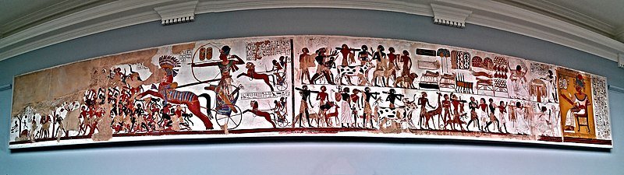
‘Wall Painting of Temple of Beit el-Wali (Plaster Cast), which Ramses II Constructed in Nubia – British Museum’ by Andres Rueda on Wikimedia Commons is licensed under CC BY 2.0.

Libya
The Egyptians called their Libyan neighbours Tjehemu. There is little evidence of a relationship with Libya until the reign of Akhenaten. Tribute scenes from his reign depict Libyans in a prominent place at tribute ceremonies with other independent trading partners such as Punt. The Libyans are shown offering the pharaoh ostrich feathers and eggs. Libya was important for Egypt’s trade with Mediterranean civilisations such as Greece because Egypt’s trade ships travelled via the Libyan coast. It is during Akhenaten’s reign we see the first large appearance of Greek pottery in Egypt which may be related to the increased relationship between Egypt and Libya.
Egypt’s relationship with Libya did not remain peaceful. The Great Karnak Inscription mentions the Battle of Perire, a conflict between Egypt and Libya in 1208 BCE. Egypt was victorious after the death of Libyan leader Meryey during the battle. Conflict arose again during the reign of Ramses VI’s which resulted in a short military campaign. Egypt was victorious, with a statue of Ramses VI holding a Libyan prisoner by the hair produced to commemorate the victory (Figure 3). The lion between the Libyan’s legs symbolises royal power, suggesting the prisoner is Libyan royalty. Despite this, Libyan migrants later gained influence in Egypt resulting in a series of pharaohs of Libyan descent in the 22nd Dynasty.
Figure 3 – Museum Luxor: Statue Ramses VI
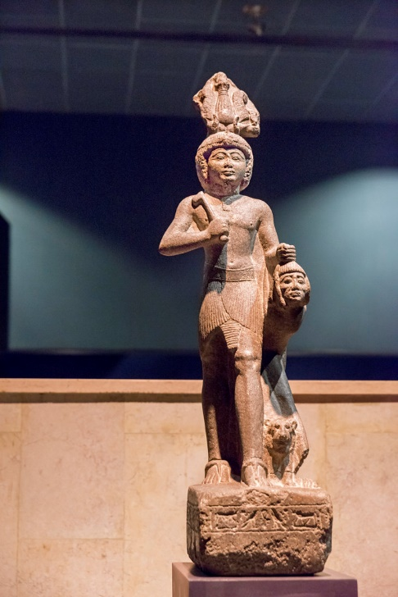
‘Museum Luxor: Statue Ramses VI’ by kairoinfo4u on Flickr is licensed under CC BY-NC-SA 2.0.

Sinai
Sinai was located on the land bridge connecting Egypt to Asia making it an important part of Egypt’s trade with its eastern neighbours. The main trade route ran along Sinai’s north coast. Sinai’s mines were Egypt’s main source of turquoise, a popular semi-precious stone used in jewellery. Figure 4 is an example of turquoise jewellery discovered in the tomb of Djer, a 1st Dynasty pharaoh. It is the earliest known of its kind in Egypt, suggesting Egypt’s trade with Sinai began during his reign. Turquoise was such an important part of their trade that the ancient Egyptians called Sinai Mafkat or ‘country of turquoise’. The Egyptians also controlled lead, tin, galena and gold mines in the Sinai Peninsula.
Sinai’s mines and trade routes were so important to the Egyptians they built fortresses to protect them. These fortresses had additional uses for Egypt, such as Tjaru in western Sinai which was used as a place to banish Egyptian criminals. By 3100 BCE, Egypt had taken control of the Sinai Peninsula as a vassal state and maintained that control until the end of the New Kingdom. Egypt also used Sinai as a military route and buffer from enemies to support their campaigns against their Asian neighbours, including the Hittites.
Figure 4 – Pectoral of a Princess, reign of Senusret II. Metropolitan Museum of Art
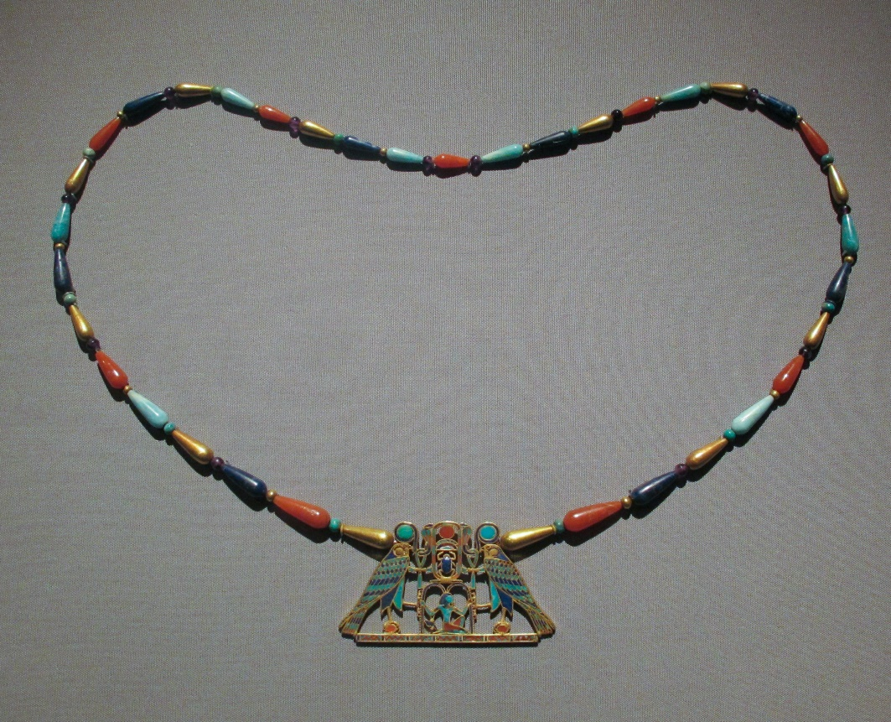
‘Pectoral of a Princess, reign of Senusret II. Metropolitan Museum of Art’ by Ismoon on Wikimedia Commons is licensed under CC BY-SA 4.0.

Canaan
Canaan exported pottery, cedar (timber) and oil to Egypt. Canaanite pottery found in Egyptian royal tombs from the 1st and 2nd dynasties, such as those shown in Figure 5, indicates trade from at least 3000 BCE. This pottery is called Abydos Ware as it was found in the royal tombs at Abydos, Egypt.
Evidence suggests Egypt controlled Canaan as a vassal state. This was because it provided a buffer between Egypt and its powerful north-eastern rivals, such as the Hittites. Amarna Letter EA8, a letter from Burna-Buriaš, a Babylonian king, asking Amenhotep III to investigate the killing of Babylonian merchants in Canaan, supports this control. Burna-Buriaš states ‘Canaan is your country and its kings are your servants’.
Canaan was difficult to control as it was home to a range of different ethnic groups. One of these groups, the Hyksos, gained control of Lower Egypt during the Second Intermediate Period. This was the first time Egypt was occupied by a foreign power. The Hyksos were eventually driven out by Ahmose I, beginning the New Kingdom in Egypt. Scrawled notes on the Rhind Mathematical Papyrus provide evidence of the campaign removing the Hyksos from Egypt.
After the Hyksos expulsion, Egypt took stronger control of Sinai and Canaan to protect itself from future invading forces. There were benefits from Egypt’s contact with the Hyksos. Hyksos technology such as the horse-drawn war chariot, composite bow and the Khopesh – a sickle-shaped sword – were adopted by the Egyptians. Through advancing these technologies, Egypt secured their power in the region during the New Kingdom.
Figure 5 – Pottery Abydos Ware, Arad, 3000-2650 BC
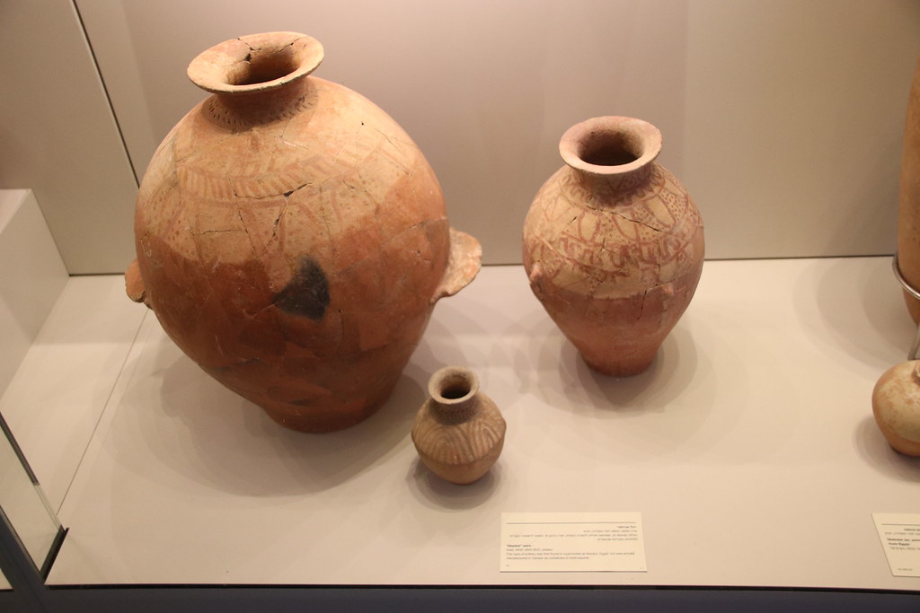
‘Pottery Abydos Ware, Arad, 3000-2650 BC’ by Gary Lee Todd, Ph.D. on Flickr is licensed under CC0 1.0.

Hittite empire
The Hittite empire’s main export was iron. There is evidence of Hittite iron in Egypt including an iron dagger found in Tutankhamun’s tomb. Some historians think Hittite iron may have been imported through another country, an intermediary, because the Egyptians had a hostile relationship with the Hittites.
The Hittites’ rise to power became a threat to Egypt during pharaoh Akhenaten’s reign because they invaded states under Egypt’s influence, such as Mitanni. This is evidenced by requests for protection against Hittite invasion found in several Amarna Letters. Hittite invasions impacted Egypt’s influence in the region and control over trade routes into Asia.
Conflict between the 2 powers lasted close to 100 years, including the Battle of Kadesh in 1274 BCE. Both sides claimed victory and tensions remained for almost another 20 years. The growing threat of invasion by the Assyrians led the Hittites and the Egyptians to develop the world’s first peace treaty, the Treaty of Kadesh (Figure 6), in 1258 BCE. This was an important step forward in diplomacy for ancient civilisations. Peace appears to have been maintained until the Hittites were conquered by the Assyrians.
Figure 6 – Kadesh Peace Treaty
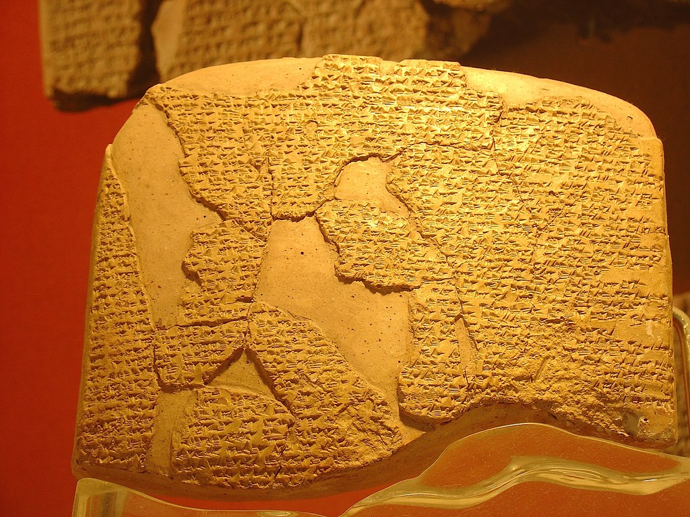
‘Kadesh Peace Treaty’ by Andy Miah on Flickr is licensed under CC BY-SA 2.0.

Mitanni
There is limited evidence about trade between Mitanni and Egypt due to the destruction of Mitanni in ancient times. Mitanni was a very fertile region and may have exported food and animals with its neighbours, including Egypt. Mitanni also connected Egypt to trade routes under its control along the Euphrates and Tigris rivers.
Initially Mitanni and Egypt had some conflict over the Canaan region. After a few conflicts, the Mitanni sought to build an alliance instead which resulted in peace between the 2 civilisations. Together with Babylonia and Hatti (the Hittites) they formed what modern historians call the ‘Great Powers Club’ – a collection of the most powerful civilisations during the New Kingdom. Several Amarna Letters show a friendly relationship between the Mitanni and Egyptian rulers, such as the one shown in Figure 7. They document the exchange of gifts and arranged marriages to strengthen their alliance.
During the 18th dynasty the Hatti’s empire-building conquests threatened Mitanni’s safety. Egypt provided support to Mitanni initially. However, as the Hittites grew in power, Egypt withdrew its forces from Mitanni resulting in the Hittites conquering the civilisation. Later, the Assyrians invaded Mitanni lands to attack the Hittites, destroying the once great cities and almost erasing Mitanni from history.
Figure 7 – Amarna letter EA27 from Tushratta king of Mitanni to the Egyptian Pharaoh Amenhotep III circa 1370 BCE.
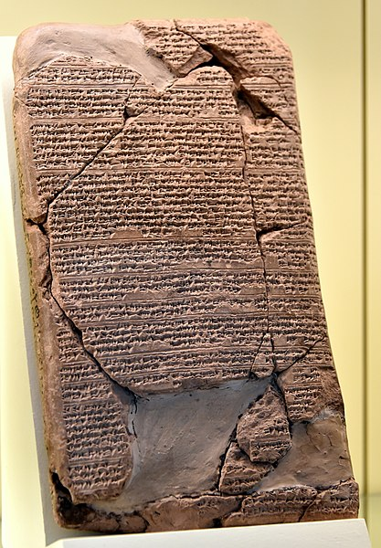
‘One of the Amarna letters. A letter from Tushratta king of Mitanni to the Egyptian Pharaoh Amenhotep III. Circa 1370 BCE. Akkadian cuneiform text. From Tell el-Amarna, Egypt. Vorderasiatisches Museum, Berlin’ by Osama Shukir Muhammed Amin on Wikimedia Commons is licensed under CC BY-SA 4.0.

Punt
Trade with Punt gave Egypt access to exotic goods that weren’t available in Egypt or its close neighbours. The first recorded Egyptian trade expedition to Punt occurred during the 5th dynasty, although evidence shows Punt gold may have been in Egypt before this time. Punt exported a wide range of goods to Egypt including incense, frankincense and myrrh trees, ebony, ivory, animal skins and wild animals such as baboons. Kohl – used for eye make-up by the Egyptians – was also imported from Punt.
Trade with Punt was initially through caravans along land trade routes. In the 18th dynasty, Hatshepsut built a fleet of ships for a Punt trade expedition. Reliefs in her mortuary temple depict this as a grand achievement (Figure 8). Ship materials and building instructions found in the Mersa Gawasis caves along the Red Sea support the use of ships for trade from at least the 18th dynasty. Steering oars like those depicted in Hatshepsut’s reliefs and inscriptions referring to Punt expeditions have been found in the caves.
There is no evidence of conflict between Punt and Egypt. Egyptian records often refer to Punt as the ‘Land of the Gods’. Some historians theorise that Punt was where early Egyptians migrated from and as such was seen as a homeland for the Egyptians. Records in Hatshepsut’s Punt expedition found in her mortuary temple suggest Chancellor Nehsi was sent to make Punt pledge its allegiance to Egypt and pay tribute to the pharaoh. However, modern historians believe this was propaganda – a story told in Egypt to secure Hatshepsut’s power – and that Egypt always had a peaceful trading partnership with Punt.
Figure 8 – close-up of painted relief depicting Hatshepsut’s expedition to Punt
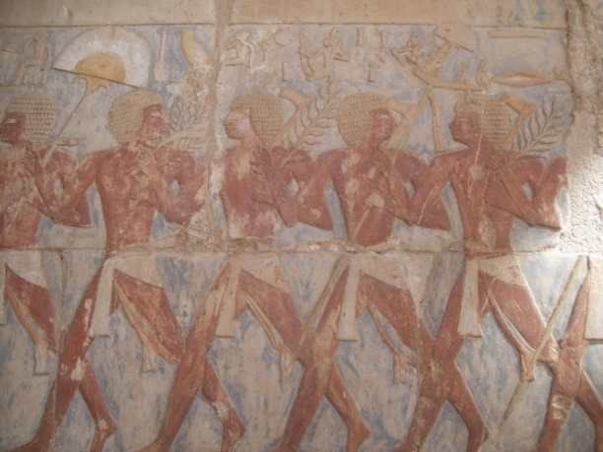
‘Reliefs at Deir el-Bahri (XXIII) (8030679467)’ by the Institute for the Study of the Ancient World from New York, United States of America on Wikimedia Commons is licensed under CC BY-SA 2.0.

Greece
Early Greek civilisation – Mycenae – established a trade relationship with Egypt. While this trade declined after the Mycenean collapse, it grew again in the middle 7th century BCE as Greek traders, mercenaries and craftsmen began travelling to Egypt. Greece exported wine, olive oil, timber, bronze work, pottery and mercenaries to Egypt. The trading port at Naucratis became the centre of Egypt’s trade with Greece, with some Greeks settling in the region and adopting Egyptian customs including burial practices. The Histories by Herodotus records flourishing trade between Greece and Egypt. He also claims Greeks were the first foreigners allowed to live in Egypt because of their strong relationship.
Egypt’s relationship with the Greeks before the Persian invasion of Egypt was positive. Greek mercenaries were used by pharaohs to support their armies and increase their control in the region. Conflict arose due to the Persian conquest of Egypt in 525 BCE. The Greeks wanted to remove Persian control from the region following Persian attacks on Greece between 499 and 449 BCE. When Alexander the Great marched on Egypt to claim it from the Persians in 332 BCE, the Egyptians praised him as their saviour. Alexander was crowned as pharaoh and founded a new capital – Alexandria. Following his death, Egypt was ruled by the Ptolemaic dynasty – pharaohs of Greek descent. The Rosetta Stone is evidence from this period (Figure 9). The decree from King Ptolemy V was written in hieroglyphics, Egyptian demotic script and ancient Greek. The use of Greek language on the decree shows the strong Greek influence over Egypt during the Ptolemaic dynasty.
Figure 9 – Rosetta Stone
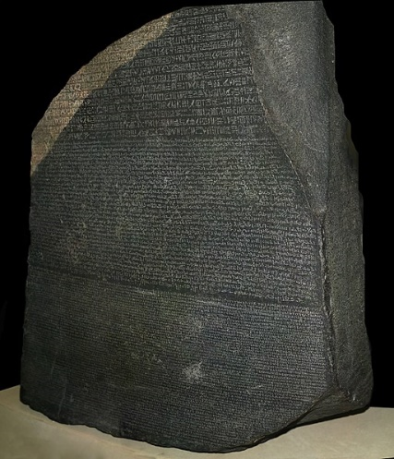
‘Rosetta Stone’ by Hans Hillewaert on Wikimedia Commons is licensed under CC BY-SA 4.0.

Appendix 3 – contacts and conflicts quiz
- Which neighbour was located west of Egypt?
- Nubia
- Punt
- Libya
- Canaan
- Which neighbour was almost erased from history after Egypt stopped defending it from a Hittite invasion?
- Nubia
- Sinai
- Greece
- Mitanni
- For which trading neighbour is there no evidence of conflict?
- Punt
- Mitanni
- Canaan
- Sinai
- What is the name of the first known peace treaty, made between Egypt and the Hittite Empire?
- Amarna Peace Treaty
- Rosetta Stone
- Great Powers Club
- Treaty of Kadesh
- Which neighbour did Abydos Ware come from?
- Canaan
- Libya
- Sinai
- Nubia
- What was a key material Egypt imported from Sinai?
- Gold
- Turquoise
- Iron
- Ivory
- Which neighbour ruled Egypt after rescuing the civilisation from Persian rule?
- Punt
- Greece
- Nubia
- Hittite Empire
- Which of the following was not a vassal state of Egypt?
- Nubia
- Sinai
- Libya
- Canaan
- Where was Yam, an important trade centre, located?
- Mitanni
- Punt
- Greece
- Nubia
- From whom did Egypt adopt technology, such as the horse-drawn war chariot, composite bow and the Khopesh from? (Hint: they were an ethnic group from Canaan who invaded Egypt.)
- Amarna
- Hyksos
- Hittites
- Assyrians
Answer key – 1:c, 2:d, 3:a, 4:d, 5:a, 6:b, 7:b, 8:c, 9:d, 10:b.

Appendix 4 – math like an Egyptian
Table 4 – ones values in Hieroglyphics
1 | 2 | 3 | 4 | 5 | 6 | 7 | 8 | 9
 | 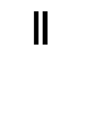 | 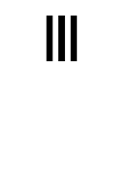 | 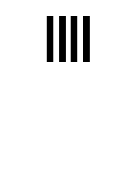 | 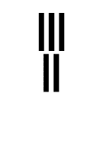 | 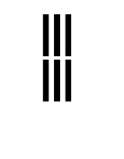 | 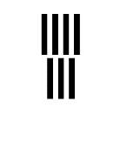 | 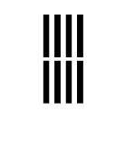 | 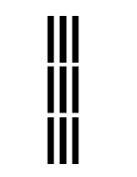
Table 5 – tens values in Hieroglyphics
10 | 20 | 30 | 40 | 50 | 60 | 70 | 80 | 90
 |  | 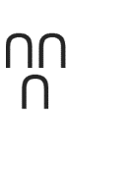 |  | 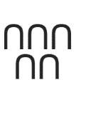 |  | 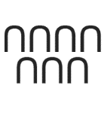 |  | 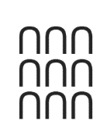
Table 6 – hundreds values in Hieroglyphics
100 | 200 | 300 | 400 | 500 | 600 | 700 | 800 | 900
 | 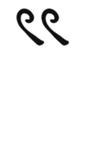 | 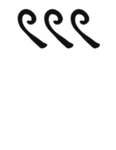 | 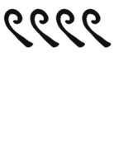 | 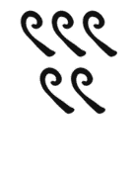 | 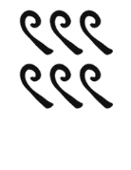 | 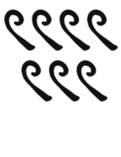 | 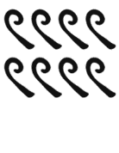 | 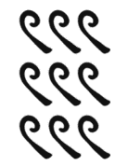

Addition
Solve the following problems in ancient Egyptian hieroglyphics. Write your answer in hieroglyphics and modern numbers.
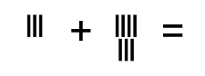
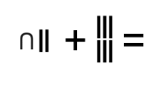
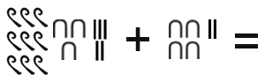

Multiplication
Solve the following questions using the ancient Egyptian method. Check your answers with a calculator when complete.
- $10×58=$
- $12×63=$
- $37×102=$

Division
Solve the following questions using the ancient Egyptian method. Check your answers with a calculator when complete.
- $65÷13=$
- $243÷27=$
- $352÷32=$

Support and alignment
Resource evaluation and support: all curriculum resources are prepared through a rigorous process. Resources are periodically reviewed as part of our ongoing evaluation plan to ensure currency, relevance and effectiveness. For additional support or advice, or to provide feedback, contact the HSIE Curriculum team by emailing hsie@det.nsw.edu.au.
Differentiation: further advice to support Aboriginal and Torres Strait Islander students, EALD students, students with a disability and/or additional needs and High Potential and gifted students can be found on the Planning programming and assessing 7–12 webpage. This includes the Inclusion and differentiation 7–10 advice webpage.
Assessment: further advice to support formative assessment is available on the Planning programming and assessing 7–12 webpage. This includes the Classroom assessment advice 7–10. For summative assessment tasks, the assessment task advice 7–10 webpage is available.
Explicit teaching: further advice to support explicit teaching is available on the Explicit teaching webpage. This includes the CESE Explicit teaching – Driving learning and engagement webpage.
Consulted with: Curriculum and Reform and subject matter experts.
Alignment to system priorities and/or needs: School Excellence Policy, Our Plan for NSW Public Education.
Alignment to the School Excellence Framework: this resource supports the School Excellence Framework elements of curriculum (curriculum provision) and effective classroom practice (lesson planning, explicit teaching).
Alignment to Australian Professional Standards for Teachers: this resource supports teachers to address Proficient Teacher Standard Descriptors 3.2.2, 3.3.2.
Creation date: May 2023

References
This resource contains NSW Curriculum and syllabus content. The NSW Curriculum is developed by the NSW Education Standards Authority. This content is prepared by NESA for and on behalf of the Crown in right of the State of New South Wales. The material is protected by Crown copyright.
Please refer to the NESA Copyright Disclaimer for more information https://educationstandards.nsw.edu.au/wps/portal/nesa/mini-footer/copyright.
NESA holds the only official and up-to-date versions of the NSW Curriculum and syllabus documents. Please visit the NSW Education Standards Authority (NESA) website https://educationstandards.nsw.edu.au and the NSW Curriculum website https://curriculum.nsw.edu.au.
History K–10 Syllabus © NSW Education Standards Authority (NESA) for and on behalf of the Crown in right of the State of New South Wales, 2012.
Blooket (2023) Blooket [website], accessed 4 May 2023.
CESE (Centre for Education Statistics and Evaluation) (2020a) What works best: 2020 update, CESE, NSW Department of Education, accessed 4 May 2023.
CESE (2020b) What works best in practice, CESE, NSW Department of Education, accessed 4 May 2023.
Chace AB, Manning HP and Archibald RC (1927) ‘The Rhind Mathematical Papyrus: British Museum 10057 and 10058’, Mathematical Association of America, Wikimedia Commons website, accessed 8 May 2023.
Collins Dictionary (2023) Collins Dictionary website, accessed 4 May 2023.
Curzon P (2020) Ancient Egyptian Numerals, Teaching London Computing: A Resource Hub from CAS London & CS4FN website, accessed 5 May 2023.
Da Vinci (17 February 2018) ‘Learn How to Multiply like the Ancient Egyptians | mathXplosion’ [video], Da Vinci, YouTube, accessed 8 May 2023.
Folkerts M, Fraser CG, Gray JJ, Berggren JL and Knorr WR (2023) ‘Mathematics in ancient Egypt’, Mathematics, Encyclopædia Britannica website, accessed 5 May 2023.
Gonzalez J (2015) The Big List of Class Discussion Strategies, Cult of Pedagogy website, accessed 8 May 2023.
Kahoot! (2023) Kahoot! website, accessed 4 May 2023.
Knowledgia (15 October 2019) ‘Why did Ancient Egypt Collapse?’ [video], Knowledgia, YouTube, accessed 4 May 2023.
Let’s Talk Science (2023) Teaching Stem – Cost-Benefit Analysis, Let’s Talk Science website, accessed 4 May 2023.
Math Videos that Motivate (20 February 2020) ‘The Egyptian Numeration System’ [video], Math Videos that Motivate, YouTube, accessed 8 May 2023.
Mentimeter (2023) Mentimeter website, accessed 5 May 2023.
Merriam-Webster (2023) Student Dictionary for Kids, Merriam-Webster website, accessed 4 May 2023.
MindYourDecisions (10 April 2015) ‘Easy Math Trick No One Taught You - How Ancient Egyptians Divided Numbers’ [video], MindYourDecisions, YouTube, accessed 8 May 2023.
Naporano N (2021) Ancient mathematics: Triangles in Egypt, A World of Women in STEM website, accessed 5 May 2023.
Origins Explained (27 July 2018) ‘How ANCIENT Egyptians Influenced The World TODAY!’ [video], Original Explained, YouTube, accessed 4 May 2023.
Pierce R (2022a) Number Bases, Math is Fun website, accessed 5 May 2023.
Pierce R (2022b) Pythagoras’ Theorem, Math is Fun website, accessed 5 May 2023.
Serrato MG (23 August 2016) ‘Watch-Think-Write’ and Other Proven Strategies for Using Video in the Classroom, KQED website, accessed 4 May 2023.
State of New South Wales (Department of Education) (2022) ‘Differentiating learning’, Refining Practice, NSW Department of Education, accessed 4 May 2023.
State of New South Wales (Department of Education) (2023) Digital Learning Selector, NSW Department of Education, accessed 4 May 2023.
The Teacher Toolkit (n.d.) ‘3-2-1’, The Teacher Toolkit website, accessed 4 May 2023.

Works of art
Amin O (2019) One of the Amarna letters. A letter from Tushratta king of Mitanni to the Egyptian Pharaoh Amenhotep III. Circa 1370 BCE. Akkadian cuneiform text. From Tell el-Amarna, Egypt. Vorderasiatisches Museum, Berlin [photograph of a stone tablet], Wikimedia Commons, accessed 10 May 2023.
British Museum (1550 BC) The Rhind Mathematical Papyrus [papyrus], The British Museum, UK.
Hillewaert H (2007) Rosetta Stone [photograph of a stone tablet], Wikimedia Commons, accessed 11 May 2023.
Institute for the Study of the Ancient World (2009) Reliefs at Deir el-Bahri (XXIII) (8030679467) [photograph of a relief], Wikimedia Commons, accessed 11 May 2023.
Ismoon (2020) Pectoral of a Princess, reign of Senusret II. Metropolitan Museum of Art [photograph of a necklace], Wikimedia Commons, accessed 10 May 2023.
kairoinfo4u (2017) Museum Luxor: Statue Ramses VI [photograph of a statue], Flickr, accessed 11 May 2023.
Miah A (2007) Kadesh Peace Treaty [photography of a stone tablet], Flickr, accessed 10 May 2023.
Rueda A (2012) Wall Painting of Temple of Beit El-Wali (Plaster Cast), which Ramses II Constructed in Nubia - British Museum [photograph of a wall painting], Wikimedia Commons, accessed 9 May 2023.
Todd GL (2018) Pottery Abydos Ware, Arad, 3000-2650 BC [photograph of pottery], Flickr, accessed 10 May 2023.
© State of New South Wales (Department of Education), 2024
The copyright material published in this resource is subject to the Copyright Act 1968 (Cth) and is owned by the NSW Department of Education or, where indicated, by a party other than the NSW Department of Education (third-party material).
Copyright material available in this resource and owned by the NSW Department of Education is licensed under a Creative Commons Attribution 4.0 International (CC BY 4.0) license.

This license allows you to share and adapt the material for any purpose, even commercially.
Attribution should be given to © State of New South Wales (Department of Education), 2024.
Material in this resource not available under a Creative Commons license:
- the NSW Department of Education logo, other logos and trademark-protected material
- material owned by a third party that has been reproduced with permission. You will need to obtain permission from the third party to reuse its material.
Links to third-party material and websites
Please note that the provided (reading/viewing material/list/links/texts) are a suggestion only and implies no endorsement, by the New South Wales Department of Education, of any author, publisher, or book title. School principals and teachers are best placed to assess the suitability of resources that would complement the curriculum and reflect the needs and interests of their students.
If you use the links provided in this document to access a third-party's website, you acknowledge that the terms of use, including licence terms set out on the third-party's website apply to the use which may be made of the materials on that third-party website or where permitted by the Copyright Act 1968 (Cth). The department accepts no responsibility for content on third-party websites.

