
Developing consistent teacher judgement –

Part 1: collaborative assessment design and implementation
Participant workbook
Contents
About this workbook 2
Workshop overview 3
Learning intention and success criteria 3
Alignment to the Australian Professional Standards for Teachers 3
Alignment to the School Excellence Framework 4
Alignment to Our Plan for NSW Public Education 5
Part A – learn 6
Workshop notes 6
Part B – do 12
Implementation guide 12
Planning and implementation notes 14
Part C – reflect 16
Workshop notes 16
Planning for ongoing implementation and growth 19
Where to next? 22
Feedback 22
References 23

About this workbook
This workbook is designed to complement the ‘Developing consistent teacher judgement − Part 1: collaborative assessment design and implementation’ workshop and guide you to engage with the content. It is structured to support your application of the ‘Learn, Do, Reflect’ professional learning cycle.
In this workbook, you will find:
- an overview of key messages and note-taking pages to record learning
- activity pages and templates to support you to collaborate with colleagues and consider how you can apply the content in your school context. Your facilitator will guide you through the activities
- planning pages, with considerations, to guide the implementation of the strategy or practices
- reflection questions to guide discussion after the strategy or practices have been implemented and to determine next steps.
This workbook can be printed double-sided or used digitally.

Workshop overview
‘Developing consistent teacher judgement – Part 1: collaborative assessment design and implementation’ will enable participants to develop an understanding of how consistent teacher judgement practices can strengthen assessment. It focuses on collaborative practices that occur before and during assessment opportunities.
This workshop uses the ‘Learn, Do, Reflect’ professional learning cycle.
Figure 1 – Learn, Do, Reflect professional learning cycle
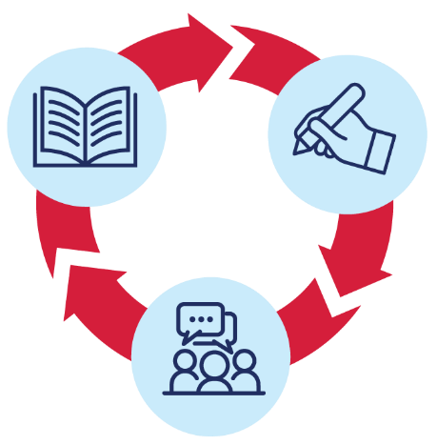

Learning intention and success criteria
By the end of the presentation, participants will:
- develop an understanding of how consistent teacher judgement practices can strengthen assessment.
To demonstrate learning, participants will:
- explain how collaborative assessment design
- promotes a shared understanding of assessment criteria and standards
- improves the accuracy and fairness of assessing student achievement.
- contribute to the collaborative development or refinement of assessment tasks to ensure consistency across different classes or groups.

Alignment to the Australian Professional Standards for Teachers
This presentation aligns with the following standards:
- 5.1.2 Develop, select and use informal and formal, diagnostic, formative and summative assessment strategies to assess student learning.
- 6.2.2 Participate in learning to update knowledge and practice, targeted to professional needs and school and/or system priorities.
- 6.3.2 Contribute to collegial discussions and apply constructive feedback from colleagues to improve professional knowledge and practice.

Alignment to the School Excellence Framework
This professional learning session aligns with the following elements of the School Excellence Framework:

Excellence in learning
- Curriculum
- Teaching and learning programs
- Assessment
- All themes
- Reporting
- Whole school reporting
Excellence in teaching
- Effective classroom practice
- Lesson planning
- Data skills and use
- Data use in teaching
- Learning and development
- Collaborative practice and feedback

Alignment to Our Plan for NSW Public Education
This professional learning session aligns with the following focus areas and actions of Our Plan for NSW Public Education.
Deliver outstanding leadership, teaching and learning
- Deliver effective teaching practices including explicit teaching and effective feedback underpinned by high expectations
- Strengthen high-quality assessment
- Improve how data is used to inform teaching.

Part A – learn
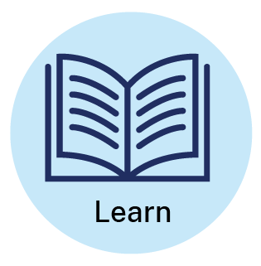

Workshop notes
Consistent teacher judgement
- Consistent teacher judgement in assessment requires teachers to share a common understanding of assessment criteria and syllabus standards to accurately evaluate students' knowledge and abilities.
- Consistent teacher judgement processes enable teachers to develop a collective understanding of what learning looks like before, during and after assessment takes place. 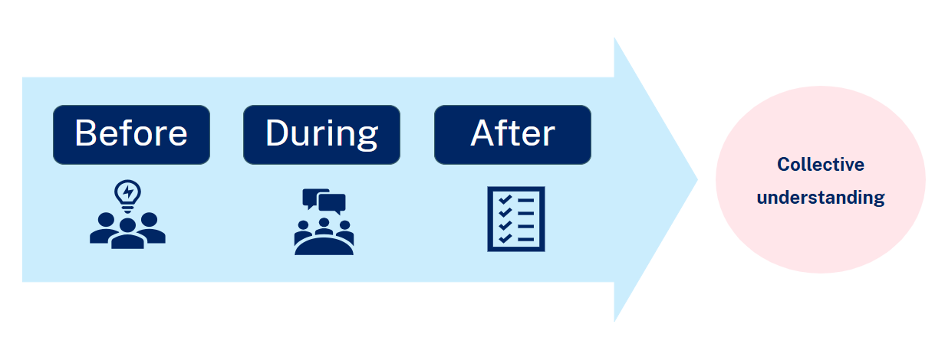
- Effective consistent teacher judgement processes support teachers to make accurate holistic on-balance judgements of student learning and achievement.

Notes:

Activity 1 – discussion: exploring existing practice
In our school or community of schools …
What processes are currently in place to support teachers’ consistent judgement of student achievement?
How is a shared understanding of expected student achievement developed?

Collaborative assessment design
Consistent teacher judgement processes begin before a period of assessment and/or teaching and learning. It is most successful when assessments are designed collaboratively.
Strategies to support collaborative assessment design
- Design assessment tasks when collaboratively planning units of work or teaching and learning programs. This supports the development of a shared understanding of task requirements and ensures a clear and strong connection between syllabus outcomes, teaching and learning activities, and assessment demands.
- Develop assessment rubrics or marking criteria through a collaborative process, and with close reference to the syllabus and the standards. By discussing and clarifying expected levels of achievement and how these could be demonstrated by students, teachers can provide guidance on the extent to which achievement of success criteria by individual students has been demonstrated.
- Trial draft assessment rubrics or marking criteria before implementation. This may involve considering possible unexpected student responses and how the assessment of student achievement using the draft assessment rubric or marking criteria may be applied.
- Revisit and discuss the assessment rubric or marking criteria prior to implementing the task. This may ensure a shared understanding of its application by teachers across the grade, year group, stage or faculty.
- Collaborate with staff from other schools to strengthen consistency within and across communities of schools. This is particularly pertinent for small and unique schools, which benefit from shared resources and collective expertise.

Notes:

Activity 2 – discussion: enablers and barriers
In our school or community of schools ...
What are the current enablers and barriers for collaborative assessment design processes?
What are some possible solutions to these barriers?
Collaborative assessment implementation
Consistent teacher judgement processes should occur during a period of learning.
Intentional, ongoing discussions throughout a period of learning enable teachers to build on and strengthen consistency of teacher judgement.
Practical steps to enable this process include:
  - dedicated time for collaborative planning at the beginning of a learning period
  - a shared understanding of the syllabus outcomes and content
  - the identification of summative assessments and significant work samples for ongoing professional discussion
  - intentional, planned opportunities for these discussions to support consistency and improve learning outcomes.
While individual activities and tasks may vary classroom to classroom, there are often tasks in common that can be used to support consistent teacher judgement.
Notes:

Activity 3 – reflection: triangle, circle, square
Use the triangle, circle, square strategy to reflect on today’s session.
Triangle – What are 3 points you will take away from today?
Circle – What questions are still circling around in your head?
Square – What is something that squared or aligned with your thinking?

Part B – do

Use the following prompts to plan for and implement Part B – do.

Implementation guide

Setting the scene
- Meet with your grade, stage, faculty or community of schools
- Review content from Part A – learn, and the relevant ‘Consistent teacher judgement’ chapters of Effective assessment practices – a guide for teachers and leaders
- Consider
- What aspects of the presentation will your team focus on?
- What further information, support or resources do you need?
- Complete the self-evaluation on page 15
- Engage in further reading as needed
- Consistent teacher judgement – advice from NSW Department of Education
- Assessment and reporting – advice from NESA.

Choosing the focus
- Review a current unit or teaching and learning program
- Select a lesson or activity in which all students will engage
- Identify relevant syllabus outcomes and content
- Consider
- When will you implement this teaching strategy or professional practice?
- Can the strategy or practice be embedded within current routines? How?
- How will implementing this practice support student needs?

Expectations of learning
- Discuss what students will achieve or demonstrate in the selected lesson or activity
- Establish a consistent understanding of ‘what a good one looks like’. This could include in-depth discussion of the relevant syllabus outcomes and content, developing a quality example and determining explicit quality criteria.

Implementation and reflection
- Implement the lesson or activity
- Meet with your team: share and review student work samples, discuss observations
- Complete the self-evaluation below
- Identify additional information, support or resources required for ongoing growth.

Planning and implementation notes
Self-evaluation
Before implementation:
On a scale of 1 to 5, how well do you already implement this practice?
1 | 2 | 3 | 4 | 5
☹️ |  | 😐 |  | 😀
With your team, plan how you will implement the practice:
Notes:
Record any adjustments made during implementation of the practice:
Notes:

Evaluation:
Notes:
After implementation:
On a scale of 1 to 5, how well did you implement this practice?
1 | 2 | 3 | 4 | 5
☹️ |  | 😐 |  | 😀

Part C – reflect
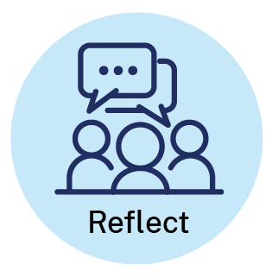

Workshop notes

Activity 4 – sorting activity
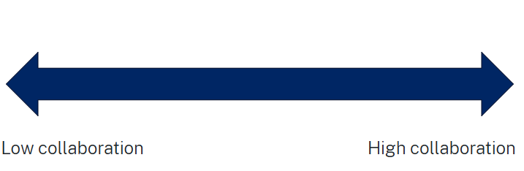
Sort the following assessment approaches from least collaborative to most collaborative:
- Approach 1 – each teacher develops their own assessment for their class. Assessments are based on the same syllabus content and unit/teaching and learning program.
- Approach 2 – teachers collaboratively design assessment and develop explicit quality criteria for teachers and students during a stage meeting that is to be used across all classes.
- Approach 3 – a teacher shares draft assessment design with their stage/faculty team for feedback and suggestions and then independently finalises assessment. Assessment is used across classes.
- Approach 4 – teachers select from a pre-existing bank of assessments created by different teachers over time. They can either use these assessments as is, or modify them to suit their specific class needs.
- Approach 5 – different teachers take responsibility for designing specific parts of the assessment (for example, multiple-choice section, essay question, project). These parts are then combined into a single, cohesive assessment used across all classes.
Notes:

Activity 5 – reflection protocol
Reflect on Part B – do.
What worked well? How do you know?
What did not work well? Why?

How did the strategy or practice impact student learning and engagement?

Planning for ongoing implementation and growth

Activity 6 – successes, challenges, opportunities
Use the framework below to plan for ongoing implementation and sustained growth in your area of focus.
Table 1 − successes, challenges and opportunities
Successes | Challenges | Opportunities

Activity 7 – keep, add, improve, remove
Use the ‘keep, add, improve, remove’ framework to consider how you will plan for ongoing implementation and growth.
Table 2 − keep, add, improve, remove
Keep | Add
Improve | Remove

Activity 8 – plan for ongoing implementation and growth
Table 3 − plan for ongoing implementation and growth
Prompt | Notes
Why is this practice important? How does it support student learning?
What will we implement:
- this semester?
- this year?
- over the next 3 years?
What are the key factors or resources that will help us sustain and build on this practice?
How will we know we are successful?

Where to next?
Would you like to learn more? The links below provide additional learning and resources.
- Effective assessment practices – a guide for teachers and leaders – a practical resource for teachers and leaders K−10.
- Consistent teacher judgement – provides advice and guidance on consistent teacher judgement.
- Australian Institute for Teaching and School Leadership: The Essential Guide to Professional Learning: Collaboration – explores the importance of collaborative professional learning as well as the role of the school leader in supporting a collaborative learning culture.
- NSW Education Standards Authority (NESA): Assessment and Reporting.

Feedback
We value your feedback. Please complete the Effective assessment practices facilitated workshop – participant feedback survey to help us provide further support.
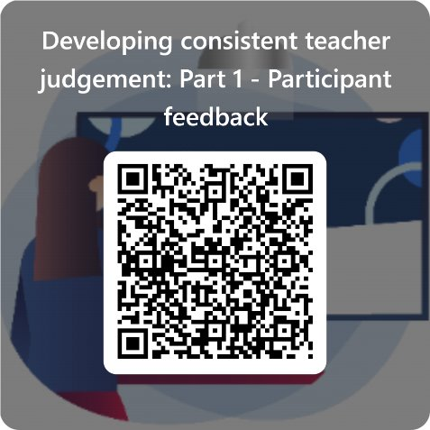

References
AITSL (Australian Institute for Teaching School and School Leadership) (2017) The Essential Guide to Professional Learning: Collaboration, AITSL website, accessed 18 September 2024.
CESE (Centre for Education Statistics and Evaluation) (2020a) What works best 2020 update, NSW Department of Education, accessed 18 September 2024.
CESE (Centre for Education Statistics and Evaluation) (2020b) What works best in practice, NSW Department of Education, accessed 18 September 2024.
Grainger P, Adie L and Weir K (2016) ‘Quality assurance of assessment and moderation discourses involving sessional staff’, Assessment and Evaluation in Higher Education, 41(4):548−559, doi:10.1080/02602938.2015.1030333, accessed 18 September 2024.
Maxwell S (2002) Discussion paper: Moderation of Teacher Judgements in Student Assessment [PDF 299 KB], The University of Queensland, accessed 18 September 2024.
NESA (NSW Education Standards Authority) (2024) Assessment and Reporting, NESA website, accessed 18 September 2024.
——(2021) ‘Proficient Teacher Standard descriptors’, The Standards, NESA website, accessed 4 December 2024.
——(2012) Assessment, NESA website, accessed 18 September 2024.
QCAA (Queensland Curriculum and Assessment Authority) (2018) Attributes of quality assessment, QCAA website, accessed 18 September 2024.
——(2021a) Consistency of Teacher Judgement [PDF 157 KB], Queensland Government, accessed 22 October 2024.
——(2021b) Making judgements [PDF 311 KB], QCAA, accessed 22 October 2024.
State of New South Wales (Department of Education) (2024) Effective assessment practices: A guide for teachers and leaders, NSW Department of Education website, accessed 21 June 2024.

© State of New South Wales (Department of Education), 2025
The copyright material published in this resource is subject to the Copyright Act 1968 (Cth) and is owned by the NSW Department of Education or, where indicated, by a party other than the NSW Department of Education (third-party material).
Copyright material available in this resource and owned by the NSW Department of Education is licensed under a Creative Commons Attribution 4.0 International (CC BY 4.0) license.

This license allows you to share and adapt the material for any purpose, even commercially.
Attribution should be given to © State of New South Wales (Department of Education), 2025.
Material in this resource not available under a Creative Commons license:
- the NSW Department of Education logo, other logos and trademark-protected material
- material owned by a third party that has been reproduced with permission. You will need to obtain permission from the third party to reuse its material.
Links to third-party material and websites
Please note that the provided (reading/viewing material/list/links/texts) are a suggestion only and implies no endorsement, by the New South Wales Department of Education, of any author, publisher, or book title. School principals and teachers are best placed to assess the suitability of resources that would complement the curriculum and reflect the needs and interests of their students.
If you use the links provided in this document to access a third-party's website, you acknowledge that the terms of use, including licence terms set out on the third-party's website apply to the use which may be made of the materials on that third-party website or where permitted by the Copyright Act 1968 (Cth). The department accepts no responsibility for content on third-party websites.

