

Developing consistent teacher judgement

Part 1: collaborative assessment design and implementation

Facilitator guide
Contents
About this guide 2
Workshop overview 3
Learning intention and success criteria 3
Alignment to the Australian Professional Standards for Teachers 3
Alignment to the School Excellence Framework 4
Alignment to Our Plan for NSW Public Education 4
Delivery method 5
Participant workbook 6
Preparation 6
Prior to Part A – learn 7
During Part B – do 8
After Part C – reflect 9
Presentation notes 10
Part A – learn 10
Part B – do 56
Part C – reflect 60
Additional resources 78
Where to next? 79
References 80

About this guide
This guide has been developed to assist leaders in facilitating the ‘Developing consistent teacher judgement Part 1: Collaborative assessment design and implementation’ professional learning cycle. The purpose of this guide is to:
- demonstrate alignment with the Australian Professional Standards for Teachers, the School Excellence Framework and Our Plan for NSW Public Education
- provide an overview of the presentation
- support the facilitator to prepare for the delivery of the presentation
- unpack the use of the ‘Learn, Do, Reflect’ professional learning cycle
- provide activities to support participants to strengthen teaching practice
- offer links to additional resources to support further professional development.
If you have questions about the workshop, please email contactcurriculumreform@det.nsw.edu.au using the subject line ‘Effective assessment practices’.

Workshop overview
‘Developing consistent teacher judgement – Part 1: Collaborative assessment design and implementation’ will enable participants to develop an understanding of how consistent teacher judgement practices can strengthen assessment. It focuses on collaborative practices that occur before and during assessment opportunities.

Learning intention and success criteria
By the end of this professional learning cycle, participants will:
- develop an understanding of how consistent teacher judgement practices can strengthen assessment.
To demonstrate learning, participants will:
- Explain how collaborative assessment design
- promotes a shared understanding of assessment criteria and standards
- improves the accuracy and fairness of assessing student achievement.
- Contribute to the collaborative development or refinement of assessment tasks to ensure consistency across different classes or groups.

Alignment to the Australian Professional Standards for Teachers
This professional learning workshop cycle aligns with the following standards:
- 5.1.2 Develop, select and use informal and formal, diagnostic, formative and summative assessment strategies to assess student learning.
- 6.2.2 Participate in learning to update knowledge and practice, targeted to professional needs and school and/or system priorities.
- 6.3.2 Contribute to collegial discussions and apply constructive feedback from colleagues to improve professional knowledge and practice.

Alignment to the School Excellence Framework
This professional learning cycle aligns with the following elements of the School Excellence Framework:

Excellence in learning
- Curriculum
- Teaching and learning programs
- Assessment
- All themes
- Reporting
- Whole school reporting
Excellence in teaching
- Effective classroom practice
- Lesson planning
- Data skills and use
- Data use in teaching
- Learning and development
- Collaborative practice and feedback

Alignment to Our Plan for NSW Public Education
This professional learning cycle aligns with the following focus areas and actions of Our Plan for NSW Public Education.
Deliver outstanding leadership, teaching and learning
- Deliver effective teaching practices including explicit teaching and effective feedback underpinned by high expectations
- Strengthen high-quality assessment
- Improve how data is used to inform teaching.

Delivery method
This workshop utilises the ‘Learn, Do, Reflect’ professional learning cycle.
Figure 1 – Learn, Do, Reflect professional learning cycle


Part A – learn
45 minute facilitated session
During Part A – learn, participants will explore:
- the evidence base for consistent teacher judgement
- key concepts and strategies for consistent teacher judgement practices
- how the information presented aligns with current practice.

Part B – do
Suggested implementation period 2 to 3 weeks, period to be determined by school-based facilitator
During Part B – do, participants will:
- meet with colleagues, for example stage, faculty or network team
- determine an area of focus and plan for implementation
- implement the area of focus over an agreed period of time
- record observations, reflections and evaluations.

Part C – reflect
45 minute facilitated session
During Part C – reflect, participants will:
- share their observations and reflections recorded in the participant workbook
- discuss and analyse what worked well, what didn’t, and why
- plan for ongoing, sustained shift in practice.

Participant workbook
The participant workbook is designed to complement the presentation ‘Developing consistent teacher judgement Part 1: collaborative assessment design and implementation’ and guide participant to engage with the content. It is structured to support the application of the ‘Learn, Do, Reflect’ professional learning cycle.
In the participant workbook, you will find:
- an overview of key messages and note-taking pages
- activity pages or templates to support participants to collaborate and consider how the content can be applied in the school context. You as the facilitator will guide participants through the activities.
- planning pages, with considerations, to guide the implementation of the strategy or practices
- reflection questions to guide discussion after the strategy or practices have been implemented and to determine next steps.
This workbook can be printed double-sided or used digitally.

Preparation
You should be familiar with the course structure and content prior to delivering the professional learning session.

Prior to Part A – learn

As the facilitator, you are the ‘expert’ on the content. It is important that you are a credible and knowledgeable presenter. Deep understanding of the evidence base and course content is essential. Follow the prompts below to prepare for the session.
- Complete pre-reading: ‘What is consistent teacher judgement?’ section of Effective assessment practices – a guide for teachers and leaders
- Optional additional reading
- NSW Department of Education: Consistent teacher judgement
- AITSL: The Essential Guide to Professional Learning: Collaboration.
- Familiarise yourself with the slide deck, facilitator guide and participant workbook.
Note: the slide deck includes some transitions, signalled in the speaker notes by the word ‘[CLICK]’. This slide deck also contains a primary and secondary specific example of practice in the form of scenarios. Select the scenario that suits your school context.
- Consider how the content of the workshop aligns with your school context, for example
- your School Excellence Plan and strategic directions
- the needs of your teams and teachers.
- Record additional notes to strengthen alignment between the course content and your school context.
- Ensure all participants have access to the participant workbook (either printed or downloaded and completed electronically on a device)
- Play any video or multimedia on your browser to ensure they have loaded for your session
- Consider room or equipment set up for the day.
School planning considerations
School leaders will need to provide guidance and context to this activity in relation to your school’s School Excellence Plan (SEP).

During Part B – do

- Ensure each stage, faculty and/or network team has selected an area of focus and have a detailed plan for implementation
- Support stage, faculty and/or network leaders by
- providing additional guidance as needed
- monitoring progress
- discussing barriers to implementation.
- Use appropriate communication channels to ensure implementation timelines are visible.

After Part C – reflect

- Ensure all participants complete evaluation via the QR code
- Collaborate with your leadership team to plan for whole school, ongoing, sustained shift in practice.

Presentation notes

Part A – learn
Part A – learn should take approximately 45 minutes to complete. We recommend following the structure below.
Table 1 – agenda for Part A – learn
Item | Duration
Acknowledgement of Country and welcome | 2 minutes
About this workshop | 4 minutes
Consistent teacher judgement | 10 minutes
Collaborative assessment design | 14 minutes
Collaborative assessment implementation | 10 minutes
Overview of Part B – ‘Do’ | 5 minutes

Facilitator notes
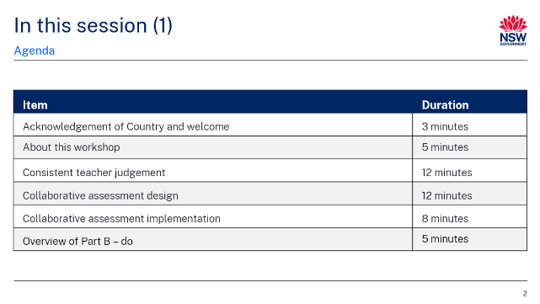
Purpose: overview of session
Duration: [00:30]
Speaker notes
In this workshop, we will:
- set the scene for consistent teacher judgement processes
- explore what consistent teacher judgement is
- engage with collaborative assessment design processes and practices
- investigate collaborative assessment implementation
- explore the ‘do’ component of this workshop.

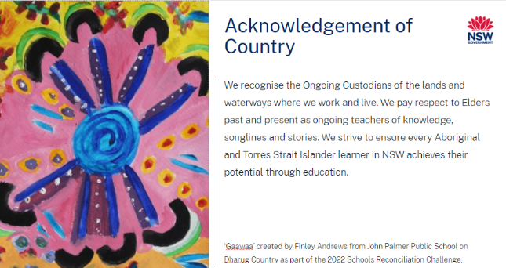
Purpose: Acknowledgement of Country
Duration: [01:00]
Speaker notes
I would like to begin by acknowledging that we are learning on [insert] Country today.
I recognise the Ongoing Custodians of the lands and waterways where we work and live. We pay respect to Elders past and present as ongoing teachers of knowledge, songlines and stories. We strive to ensure every Aboriginal and Torres Strait Islander learner in NSW achieves their potential through education.
Facilitator note: facilitator to deliver personalised Acknowledgment if they wish.

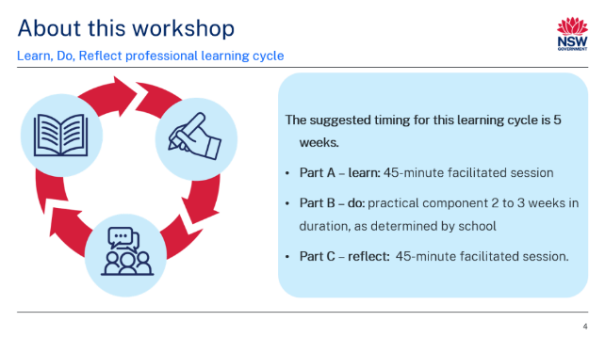
Purpose: inform participants of the structure of the workshop
Duration: [01:00]
Speaker notes
This workshop utilises the ‘Learn, do, reflect’ professional learning cycle.
In Part A – learn, we will explore:
- the evidence base for consistent teacher judgement
- key concepts and strategies for consistent teacher judgement practices
- how the information presented aligns with current practice.
In Part B – do, we will:
- meet with colleagues, for example stage, faculty or network teams
- determine an area of focus and plan for implementation
- implement the area of focus over an agreed period of time
- record observations, reflections and evaluations.
In Part C – reflect, we will:
- share observations and reflections recorded in the participant workbook
- discuss and analyse what worked well, what didn’t and why
- plan for ongoing, sustained shift in practice.

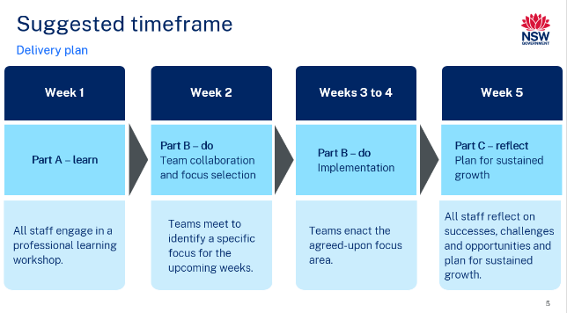Purpose: recommended timing for the professional learning cycle
Duration: [01:00]
Speaker notes
The recommended timeframe for the professional learning is 5 weeks:
- Week 1: Part A – learn – the entire staff engages in a school-led facilitated workshop
- Week 2: Part B – do (team collaboration and focus selection) – teams meet to identify a specific focus for the upcoming weeks and undertake further reading
- Weeks 3 to 4: Part B – do (implementation) – teams enact the agreed-upon focus area
- Week 5: Part C – reflect – all staff reflect on successes, challenges and opportunities, and plan for sustained growth
Facilitator note: update the timing to suit your school professional learning needs. For example, Part B – do can be extended over a longer period of time, with regular scheduled reflection.
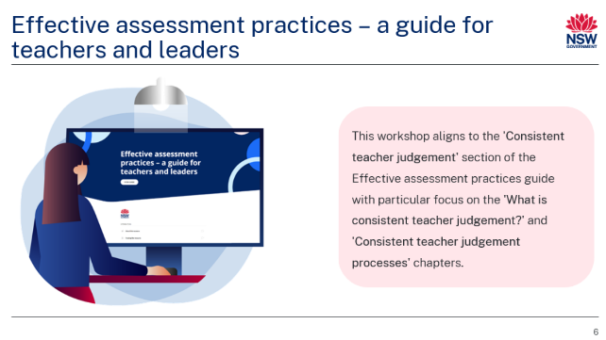
Purpose: introduce Effective assessment practices guide and demonstrate alignment with workshop
Duration: [01:00]
Speaker notes
To support teachers and leaders in implementing and strengthening assessment, the department has developed the Effective assessment practices guide for teachers and leaders. This workshop has been designed to delve deeper into the 'Consistent teacher judgement' section of the guide, with a particular focus on the 'What is consistent teacher judgement?' and 'Consistent teacher judgement processes’ chapters.
This workshop also aligns to Standards 5 and 6 within the Australian Professional Standards for Teachers and to Our Plan for NSW Public Education through the agreed actions within the focus area ‘Deliver outstanding leadership, teaching and learning’.

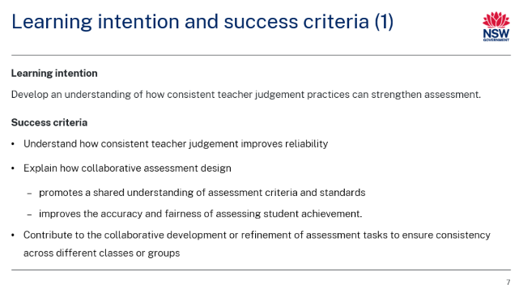
Purpose: introduce learning intention and success criteria
Duration: [01:00]
Speaker notes
In this workshop, we will develop an understanding of how consistent teacher judgement practices can strengthen assessment.
As a result of this workshop, you will:
- understand how consistent teacher judgement improves reliability.
- explain how collaborative assessment design
- promotes a shared understanding of assessment criteria and standards
- improves the accuracy and fairness of assessing student achievement.
- contribute to the collaborative development or refinement of assessment tasks to ensure consistency across different classes or groups.
A strong theme throughout this workshop is collaboration. Collaboration is the backbone of effective consistent teacher judgement practices, and we will be exploring this in depth throughout this workshop.
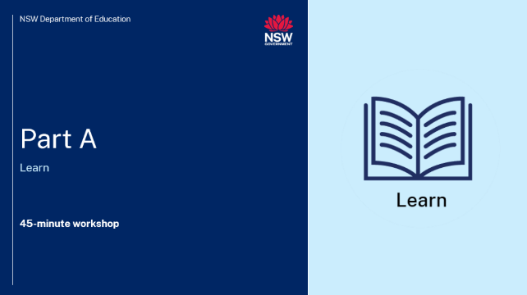
Purpose: introduce Part A – learn
Duration: [00:30]
Speaker notes
We are now going to dive into Part A, the 'learn' component of the workshop. We will build a shared understanding of consistent teacher judgement and explore effective processes for collaborative assessment design. This learning will equip us with the knowledge and insights needed to successfully engage with the 'do' component of the professional learning.

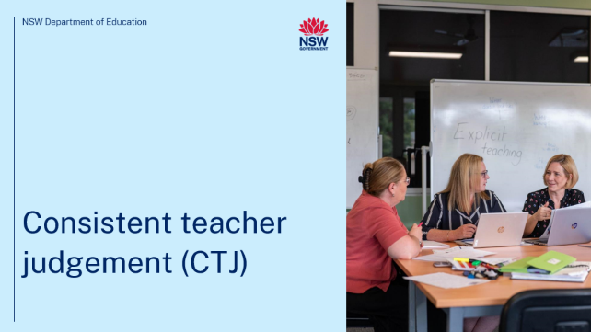Purpose: introduction to section
Duration: [00:15]
Speaker notes
Let's begin by defining consistent teacher judgement.

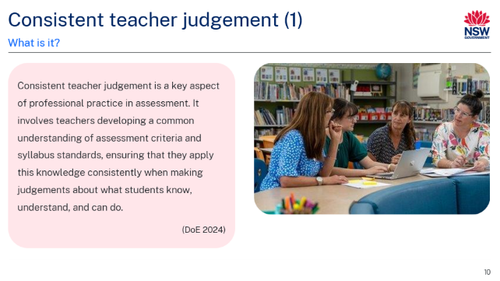
Purpose: define consistent teacher judgement
Duration: [01:00]
Speaker notes
Read the description of consistent teacher judgement, often referred to as CTJ, from the Effective assessment practices guide, on screen now.
Teachers’ collaboration and participation in consistent teacher judgement processes are critical to achieving consistency. Through intentional professional dialogue and collaboration opportunities, teachers refine their interpretations of achievement standards and ensure that their judgments align not only with syllabus expectations, but also across different contexts and assessment conditions. This collaboration further enhances transparency in the assessment process and fosters trust among students, parents, and the broader education community.

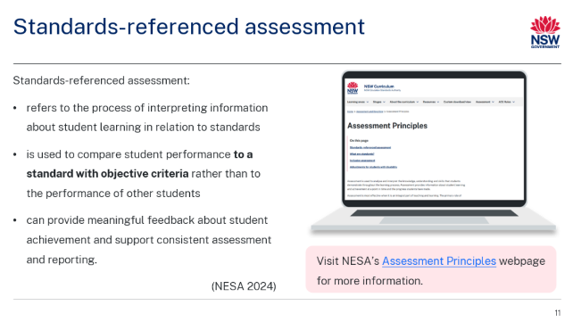
Purpose: define standards-referenced assessment
Duration: [00:30]
Speaker notes
In NSW, we use a standards-referenced approach to assess and report on student achievement. This approach consists of 2 components:
- syllabus outcomes and content describe what students are expected to learn
- how well students demonstrate achievement is described in performance standards such as the Common Grade Scale (NESA 2024).
Key to the success of a standards-referenced approach is a shared understanding of the objective criteria, or standards, on which students are being assessed. This is where consistent teacher judgements come into play.
Effective consistent teacher judgement processes enable teachers to develop a core, shared understanding.

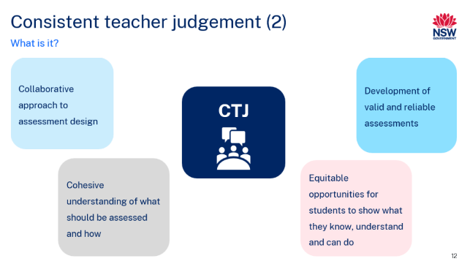
Purpose: further define consistent teacher judgement
Duration: [01:00]
Speaker notes
Consistent teacher judgement processes are essential for designing assessments that accurately capture student learning and promote equitable educational outcomes. Effective implementation of these processes includes:
[CLICK]
Collaborative approach to assessment design
Teachers work together to create assessments that align with curriculum goals, ensuring consistency and clarity in measuring student learning across subjects and classrooms.
[CLICK]
Cohesive understanding of what should be assessed and how
Teachers establish a shared understanding of learning objectives and criteria, ensuring assessments accurately reflect core skills and knowledge.
[CLICK]
Development of valid and reliable assessments
Assessments are created to be both accurate in measuring intended skills (valid) and consistent across different contexts (reliable), providing trustworthy data on student performance.
[CLICK]
Equitable opportunities for students to demonstrate knowledge, understanding and skills
Assessments are designed to allow all students to showcase their strengths through various formats, ensuring fair and inclusive measurement of their abilities.

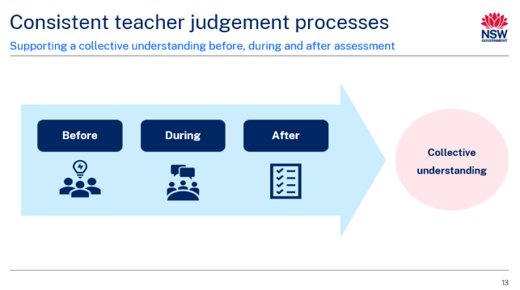
Purpose: introduce consistent teacher judgement processes
Duration: [01:00]
Speaker notes
Consistent teacher judgement processes enable teachers to develop a collective understanding of what learning looks like before, during, and after assessment takes place. Critical to the success of CTJ are the professional practices that occur before and during assessment activities.
Consistent teacher judgement is underpinned by intentional, ongoing discussions about the syllabus and the ways students can be assessed that allow them to demonstrate what they know or can do in relation to syllabus outcomes.
This session explores the consistent teacher judgement processes that occur before and during assessment, encompassing formative and summative assessment practices, and including the collaborative planning and design of assessment tasks and ongoing professional dialogue and collaboration during a period of teaching and learning.

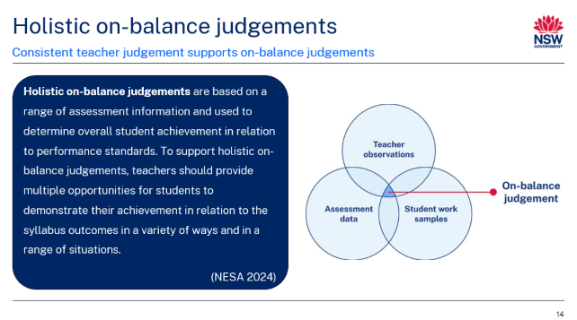
Purpose: demonstrate how CTJ supports on-balance judgements
Duration: [01:00]
Speaker notes
Consistent teacher judgement processes support teachers to make holistic on-balance judgements which are based on a range of assessment information, as stated in the assessment advice from NESA.
[CLICK]
Teachers develop an image of a student's knowledge and understanding by using formative and summative assessment. Information about student learning should be gathered through observations, work samples, and assessment data. This image of student learning is constantly revised and updated, with teachers refining and adjusting their judgements based on new information. Teachers must evaluate what a student knows, understands and can do in relation to syllabus outcomes, in a consistent and equitable manner that is free of bias. This is where rigorous consistent teacher judgement processes come into play.

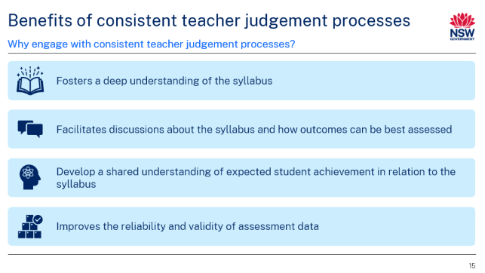
Purpose: benefits of consistent teacher judgement processes
Duration: [02:00]
Speaker notes
There are many benefits to establishing and maintaining effective consistent teacher judgement processes within a school. Consistent teacher judgement processes:
Foster a deep understanding of the syllabus
- Deep understanding of the syllabus can be developed when teachers thoroughly engage with outcomes and content, and collectively determine instructional priorities and assessment practices.
Facilitate discussions about the syllabus and how outcomes can be assessed
- Discussions about syllabus outcomes and content allow teachers to explore diverse assessment strategies that align with intended learning goals
- These conversations enable teachers to design inclusive lessons and assessments that allow students to demonstrate what they know, understand and can do in relation to syllabus outcomes.
Develop a shared understanding of expected student achievement in relation to the syllabus
- Shared understanding of expected student achievement in relation to syllabus outcomes ensures teachers make consistent judgements when evaluating student learning
- Clear understanding of these expectations enables teachers to accurately assess student progress, provide targeted feedback, and adjust teaching and learning to meet student needs.
Improve the reliability and validity of assessment data
- Consistent teacher judgement processes improve the validity and reliability of assessment data (QCAA 2018)
- A reliable assessment enables consistently accurate judgements to be made about student achievement in relation to criteria and performance standard and should do so over time with different learners and teachers
- A valid assessment accurately reflects students’ knowledge and skills in relation to specific learning outcomes.

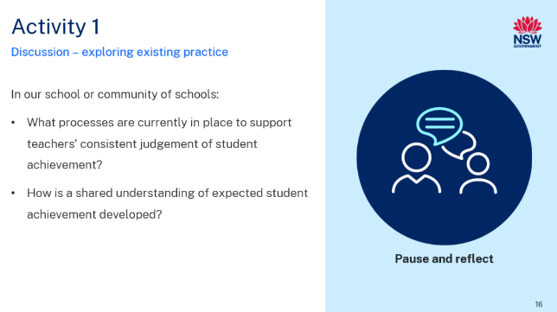Purpose: introduce Activity 1 – discussion
Duration: [04:00]
Speaker notes
Let’s take a moment to reflect on the processes currently in place at our school or community of schools that support consistent, evidence-based judgements of student achievement. You can record your thoughts on page 7 your participant workbook.
Facilitator notes: small schools may wish to reflect on the processes of their community of schools.
Consider providing participants with sticky notes to capture responses. These can be displayed on a board or butcher’s paper to create a collective view of how staff perceive the school’s current practices for facilitating consistent teacher judgement.

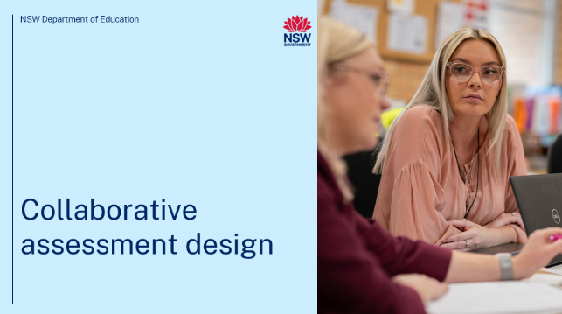
Purpose: introduction to section
Duration: [00:15]
Speaker notes
We are now going to investigate collaborative assessment design and the important part it plays in developing effective consistent teacher judgement processes and practices.

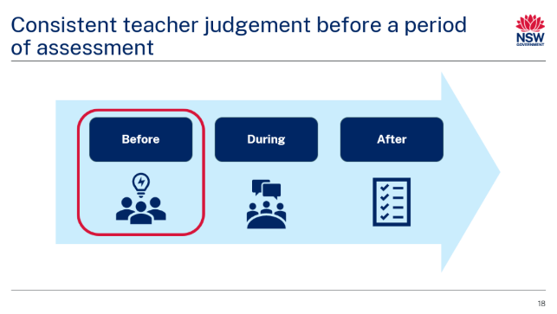Purpose: highlight consistent teacher judgement processes that take place before a period of assessment
Duration: [01:00]
Speaker notes
Consistent teacher judgement processes begin before a period of assessment and/or teaching and learning.
Consistent teacher judgement is most successful when assessments are designed collaboratively. Consistent teacher judgement processes develop a collective understanding of what learning looks like before, during and after assessment takes place, supported by a shared understanding of the syllabus and expected student achievement in relation to relevant syllabus outcomes.
When planning and designing assessment, it is important that teachers have a shared understanding of what students are expected to learn and how they may show that learning in relation to the syllabus standards. This includes effectively differentiating tasks to allow all students to demonstrate what they know and can do. It should also include a discussion of potential unexpected responses or interpretations of the task stimulus or criteria – this supports validity.
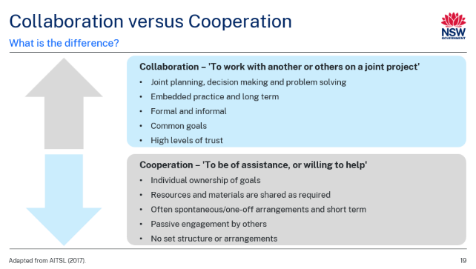Purpose: define collaboration and cooperation
Duration: [01:00]
Speaker notes
Collaborative practice can sometimes be confused with cooperative practices, but there are key distinctions between the 2. In collaborative practice, individuals work together to co-create, share responsibility and contribute equally to a common goal, often engaging in deeper dialogue and joint decision-making.
In contrast, cooperative practice involves dividing tasks among individuals who work independently and later combine their work, with less emphasis on shared decision-making or co-construction of knowledge. Collaborative practice focuses on mutual accountability and building consensus, while cooperative practice often prioritises efficiency and task completion. Both approaches can be useful in different contexts, but in this instance, we are emphasising collaboration as a key enabler of consistent teacher judgement processes.
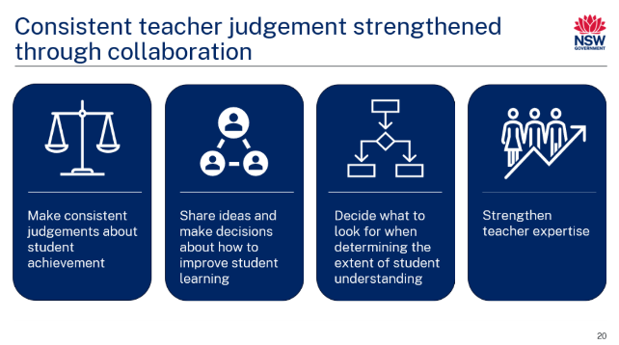Purpose: highlight how collaboration supports consistent teacher judgement
Duration: [01:00]
Speaker notes
Consistent teacher judgement is supported and strengthened by authentic collaborative practices.
When developing assessment opportunities, including the intentional selection of formative assessment strategies and the planning of lessons that generate quality work samples, teachers can work collaboratively to develop a shared understanding of student progress and achievement in relation to the syllabus. This can be achieved in a small school setting through planned collaboration with other schools. This shared understanding enables teachers to make more consistent judgments across classes and ensures that assessment practices are fair and equitable for all students (DoE 2024).
Working collaboratively can assist teachers to:
- make consistent judgements about student achievement
- share ideas and make decisions about how to improve student learning
- decide what to look for when determining the extent of student understanding
- strengthen teacher expertise (NESA 2024).
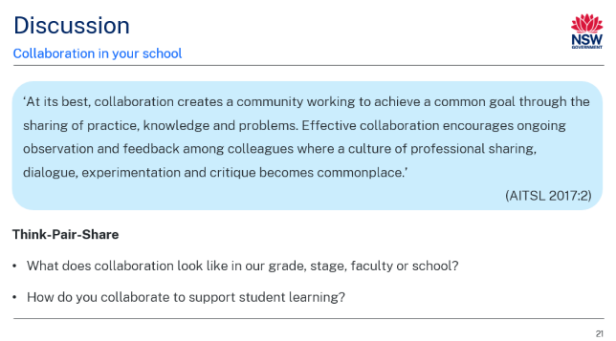
Purpose: reflect on current collaboration practices
Duration: [04:00]
Speaker notes
Take a moment to read the excerpt from AITSL’s Essential Guide to Professional Learning Collaboration on the slide. [Allow participants time to read]
[CLICK]
With this in mind, engage in a Think-Pair-Share discussion with a colleague to explore the questions you can see on the slide.

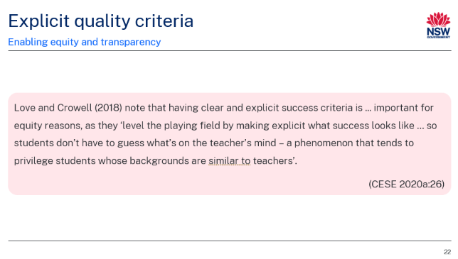
Purpose: align to elements of effective assessment
Duration: [01:00]
Speaker notes
Explicit quality criteria, and a shared understanding of these criteria for both teachers and students, support consistent teacher judgement.
When collaboratively designing assessment opportunities, both formal and informal, teachers should develop explicit quality criteria to support student learning.
Clear, purposeful criteria outline what is expected for students to achieve a high-quality response. Use of explicit quality criteria supports equity and transparency. Consider the quote on screen. [allow participants time to read the quote or read aloud as appropriate]. Use of explicit quality criteria means that students don’t have to play ‘guess what’s in the teacher head’ to be successful in an activity or lesson.
When teachers collaboratively develop these criteria before an assessment period, they develop a shared understanding of what success looks like across groups of students, for example, a class, grade or stage. This can then be translated into the classroom with teachers sharing consistent messaging to students what achievement and success looks like in the form of quality success criteria, including student-facing rubrics, and ‘WAGOLLS’ (What a good one looks like).
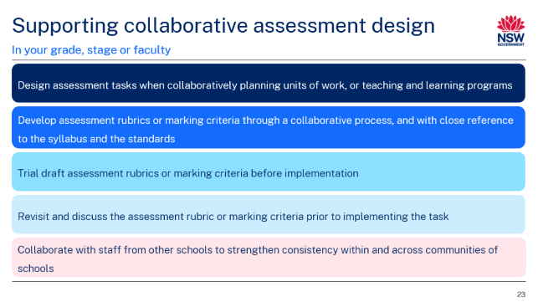Purpose: provide strategies to support collaborative assessment design
Duration: [02:00]
Speaker notes
The following strategies can support effective collaborative assessment design within a grade, stage or faculty.
[CLICK]
Design assessment tasks when collaboratively planning units of work or teaching and learning programs
This supports the development of a shared understanding of task requirements and ensures a clear and strong connection between syllabus outcomes, teaching and learning activities, and assessment demands.
[CLICK]
Develop assessment rubrics or marking criteria through a collaborative process and with close reference to the syllabus and the standards
By discussing and clarifying expected levels of achievement and how these could be demonstrated by students, teachers can provide guidance on the extent to which achievement of success criteria by individual students has been demonstrated.
[CLICK]
Trial draft assessment rubrics or marking criteria before implementation
This may involve considering possible unexpected student responses and how the assessment of student achievement using the draft assessment rubric or marking criteria may be applied.
[CLICK]
Revisit and discuss the assessment rubric or marking criteria prior to implementing the task
This may ensure a shared understanding of its application by teachers across the grade, year group, stage or faculty.
[CLICK]
Collaborate with staff from other schools to strengthen consistency within and across communities of schools
This is particularly pertinent for small and unique schools, which benefit from shared resources and collective expertise.

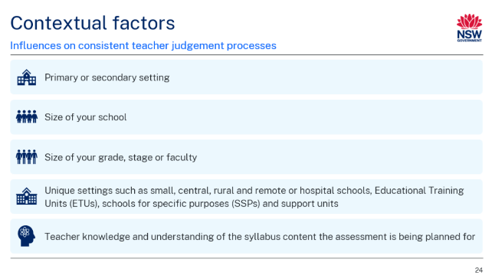Purpose: acknowledge contextual factors that can influence collaborative assessment design
Duration: [01:00]
Speaker notes
Consistent teacher judgement processes, such as collaborative assessment design, can be influenced by a range of factors.
Successful implementation of collaborative assessment design involves careful planning of intentional strategies. Collaborative assessment design can look different in different schools depending on the school context. Factors to take into consideration that can influence and shape approaches to collaborative assessment design include:
- primary or secondary setting
- size of your school
- size of your grade, stage or faculty
- unique settings such as small, central, rural and remote or hospital schools, Educational Training Units (ETUs), schools for specific purposes (SSPs) and support units
- teacher knowledge and understanding of the syllabus content the assessment is being planned for. This is important to consider when engaging with or enacting a new syllabus.
Facilitator note: you may choose to focus on one or more of these contextual factors that are relevant to your school.

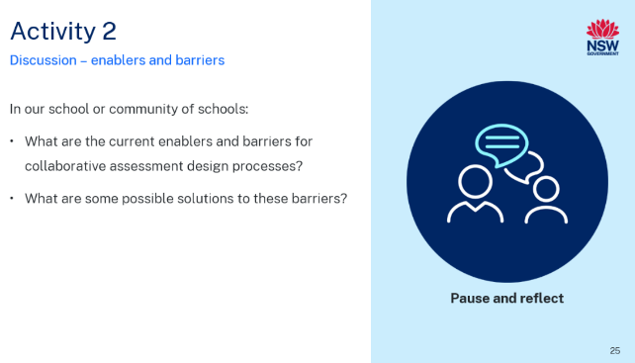Purpose: participants reflect in workbook
Duration: [04:00]
Speaker notes
Let’s take a moment to reflect on the current enablers and barriers for collaborative assessment design. You can record your thoughts on page 9 of your participant workbook as you engage in this discussion with a partner or your table.

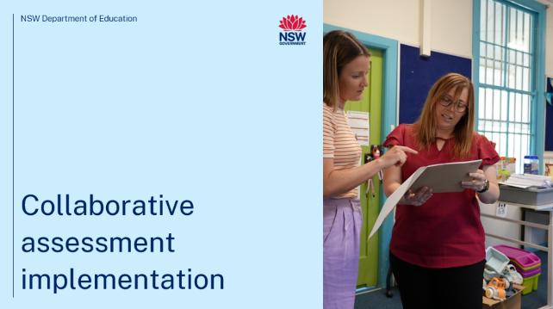
Purpose: introduction to section
Duration: [00:15]
Speaker notes
We will now investigate collaborative assessment implementation and the important factor it plays in developing effective consistent teacher judgement processes and practices.
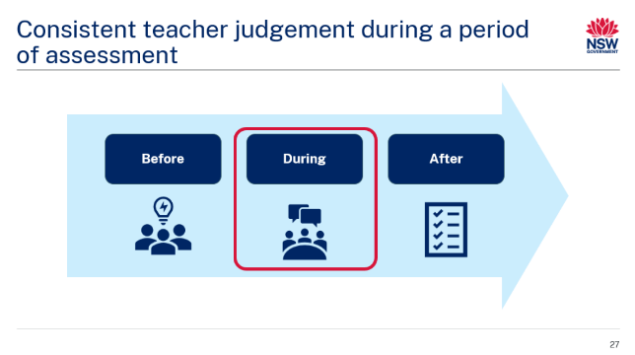Purpose: consistent teacher judgement during a period of assessment
Duration: [01:00]
Speaker notes
During a period of learning and assessment, teachers of the stage or grade should meet regularly to discuss student progress and ensure there is ongoing alignment of teaching and learning with assessment tasks.
In these meetings, using student work samples or other evidence of learning can support a collective understanding of student strengths and guide differentiation of future learning activities. The data collected in these meetings may also allow an analysis of which activities and approaches are most successful with that cohort of learners. Rich conversations about the data collected may support all teachers to make evidence-based decisions to improve student learning outcomes.
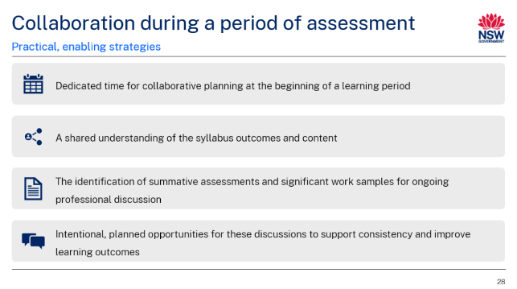
Purpose: explore enabling strategies to support collaboration during a period of assessment
Duration: [01:00]
Speaker notes
Another critical component of consistent teacher judgment is intentional, ongoing professional dialogue regarding student learning. This involves revisiting the initial collaborative planning discussions, including the development of summative assessments and the identification of important work samples that will guide these conversations.
To implement this effectively, teachers should identify key tasks throughout the unit for discussion. This practice ensures that a shared understanding of syllabus outcomes, content delivery and student progress is maintained, particularly in the context of curriculum reform.
Practical steps to enable this process include:
- dedicated time for collaborative planning at the beginning of a learning period
- a shared understanding of the syllabus outcomes and content
- the identification of summative assessments and significant work samples for ongoing professional discussion
- intentional, planned opportunities for these discussions to support consistency and improve learning outcomes.
While individual activities and tasks may vary classroom to classroom, there are often tasks in common that can be used to support consistent teacher judgement.

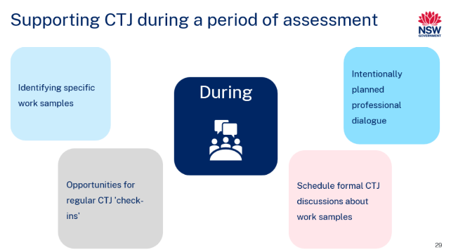
Purpose: strategies to support consistent teacher judgement during a period of assessment
Duration: [01:00]
Speaker notes
When collaboratively planning units or teaching and learning programs, teams should identify specific work samples they aim to discuss over the course of the assessment period.
A faculty or stage leader should intentionally create opportunities for discussions about student learning throughout the term. These discussions should be anchored in the pre-identified work samples and learning experiences.
Consistent teacher judgement processes can be supported during a period of learning through:
- [CLICK] identifying specific work samples to discuss and use during moderation processes
- [CLICK] creating opportunities for regular CTJ ‘check-ins’ during the period of assessment
- [CLICK] intentionally planning for the provision of professional dialogue amongst colleagues
- [CLICK] scheduling formal CTJ discussions about work samples. These work samples can be ‘identified’ or ‘deidentified’.

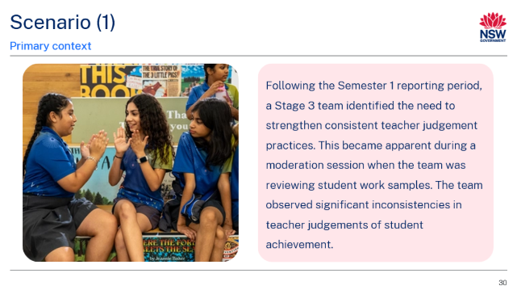
Purpose: model and scenario for consistent teacher judgement processes (primary context)
Duration: [00:30]
Speaker notes
Let’s now consider this scenario in a primary setting that demonstrates consistent teacher judgement in practice with a focus on collaborative assessment design and implementation:
Following the Semester 1 reporting period, a Stage 3 team identified the need to strengthen consistent teacher judgement practices. This became apparent during a moderation session when the team was reviewing student work samples. The team observed significant inconsistencies in teacher judgements of student achievement.
Facilitator note: you may adjust this sample scenario to suit your school context.

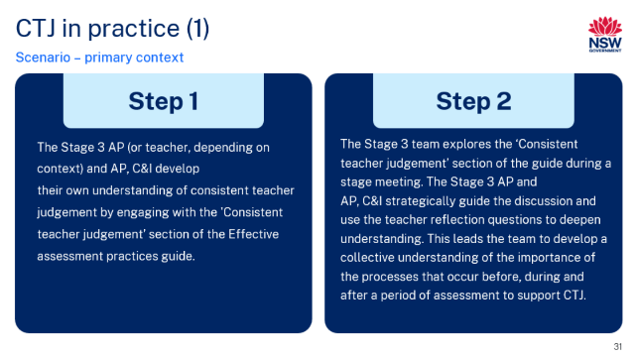
Purpose: model and scenario for primary setting
Duration: [01:00]
Speaker notes:
Step 1: the Stage 3 assistant principal (or teacher, depending on context) and AP, C&I develop their own understanding of consistent teacher judgement by engaging with the 'Consistent teacher judgement’ section of the Effective assessment practices guide. They also engage with the reflection questions for leaders and familiarise themselves with the reflection questions for teachers.
[CLICK]
Step 2: to develop their capabilities, the Stage 3 team explores the ‘Consistent teacher judgement’ section of the Effective assessment practices guide during a stage meeting. The Stage 3 assistant principal and AP, C&I strategically guide the discussion and use the teacher reflection questions to deepen understanding. This leads the team to develop a collective understanding of the importance of the processes that occur before, during and after a period of assessment to support CTJ.
The Stage 3 assistant principal and AP, C&I also draw attention to the printable moderation reflection activity and flag that they will use it at the end of the period of assessment. This ensures that the team is informed and has a shared understanding of consistent teacher judgement moving forward.

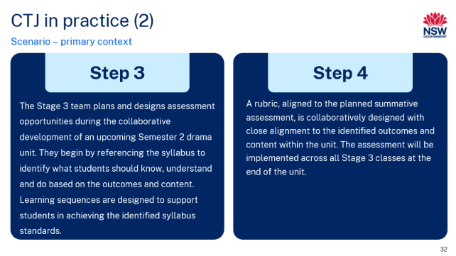
Purpose: model and scenario for primary setting
Duration: [01:00]
Speaker note
Step 3: the Stage 3 team plans and designs assessment opportunities during the collaborative development of an upcoming Semester 2 drama unit. They begin by referencing the syllabus to identify what students should know, understand and do based on the outcomes and content. Learning sequences are designed to support students in achieving the identified syllabus standards.
[CLICK]
Step 4: a rubric, aligned to the planned summative assessment, is collaboratively designed with close alignment to the identified outcomes and content within the unit. The assessment will be implemented across all Stage 3 classes at the end of the unit.

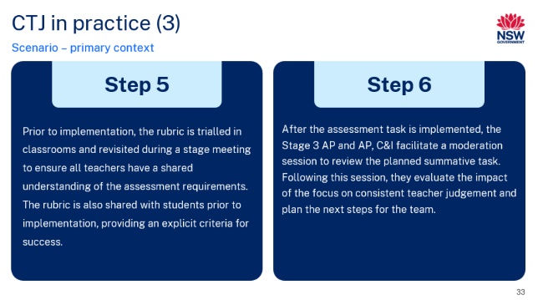
Purpose: model and scenario for primary setting
Duration: [01:00]
Speaker notes
Step 5: prior to implementation, the rubric is trialled in classrooms and revisited during a stage meeting to ensure all teachers have a shared understanding of the assessment requirements. This may involve considering possible unexpected student responses and how the assessment of student achievement using the draft assessment rubric or marking criteria may be applied. The rubric is also shared with students prior to implementation, providing an explicit criteria for success.
[CLICK]
Step 6: after the assessment task is implemented, the Stage 3 assistant principal and AP, C&I facilitate a moderation session to review the planned summative task. They use the moderation reflection activity embedded in the Effective assessment practices guide. The team notices that there are fewer discrepancies in their judgements of student achievement.

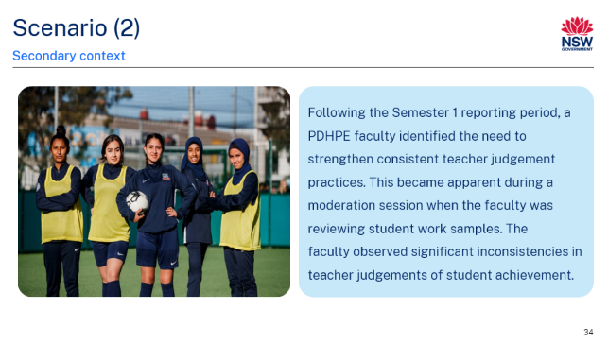
Purpose: model and scenario for consistent teacher judgement processes (secondary context)
Duration: [00:30]
Speaker notes
Let’s now consider this scenario in a secondary setting that demonstrates consistent teacher judgement in practice with a focus on collaborative assessment design and implementation:
Following the Semester 1 reporting period, a PDHPE faculty identified the need to strengthen consistent teacher judgement practices. This became apparent during a moderation session when the faculty was reviewing student work samples. The faculty observed significant inconsistencies in teacher judgements of student achievement.
Facilitator note: you may adjust this sample scenario to suit your school context.

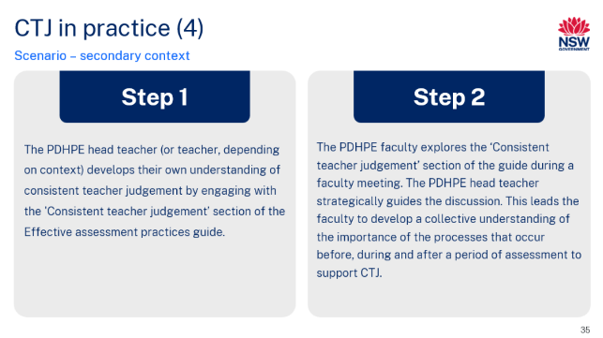
Purpose: model and scenario for secondary setting
Duration: [01:00]
Speaker notes
Step 1: the PDHPE head teacher (or teacher, depending on context) develops their own understanding of consistent teacher judgement by engaging with the 'Consistent teacher judgement’ section of the Effective assessment practices guide. They also engage with the reflection questions for leaders and familiarise themselves with the reflection questions for teachers.
[CLICK]
Step 2: to develop their capabilities, the PDHPE faculty explores the ‘Consistent teacher judgement’ section of the Effective assessment practices guide during a faculty meeting. The PDHPE head teacher strategically guides the discussion and uses the teacher reflection questions to deepen understanding. This leads the faculty to develop a collective understanding of the importance of the processes that occur before, during and after a period of assessment to support CTJ.
The PDHPE head teacher also draws attention to the printable moderation reflection activity and flags that they will use it at the end of the period of assessment. This ensures that the faculty is informed and has a shared understanding of consistent teacher judgement moving forward.
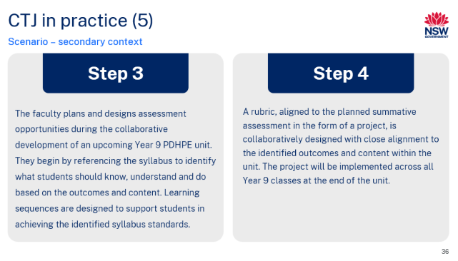
Purpose: model and scenario for secondary setting
Duration: [01:00]
Speaker notes
Step 3: the faculty plans and designs assessment opportunities during the collaborative development of an upcoming Year 9 PDHPE unit. They begin by referencing the syllabus to identify what students should know, understand and do based on the outcomes and content. Learning sequences are designed to support students in achieving the identified syllabus standards.
[CLICK]
Step 4: a rubric, aligned to the planned summative assessment in the form of a project, is collaboratively designed with close alignment to the identified outcomes and content within the unit. The project will be implemented across all Year 9 classes at the end of the unit.

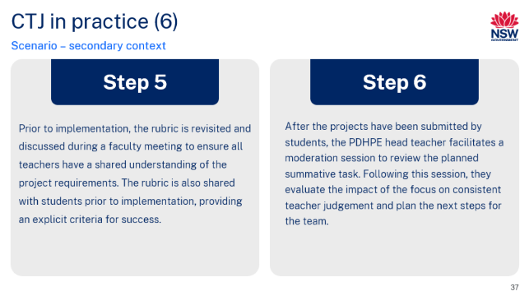
Purpose: model and scenario for secondary setting
Duration: [01:00]
Speaker notes
Step 5: prior to implementation, the rubric is revisited and discussed during a faculty meeting to ensure all teachers have a shared understanding of the project requirements. This may involve considering possible unexpected student responses and how the assessment of student achievement using the draft marking criteria may be applied. The rubric is also shared with students prior to implementation, providing an explicit criteria for success.
[CLICK]
Step 6: after the projects have been submitted by students, the PDHPE head teacher facilitates a moderation session to review the planned summative task. The faculty use the moderation reflection activity embedded in the Effective assessment practices guide. The faculty notices that there are fewer discrepancies in their judgements of student achievement.

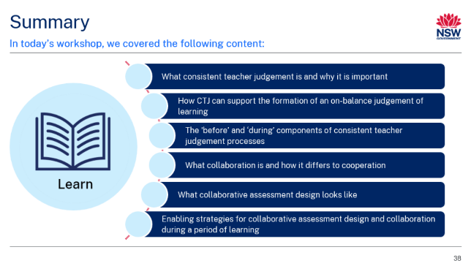Purpose: provide an overview of Part A – learn
Duration: [00:15]
Speaker notes
Here is a brief summary of the main concepts covered today.

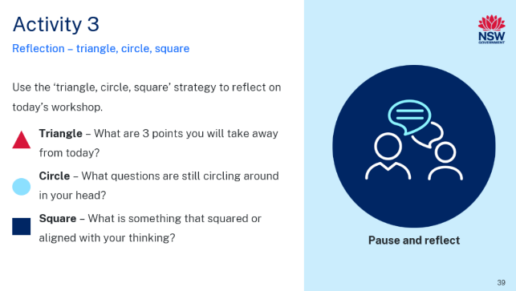Purpose: introduce Activity 3 – reflection
Duration: [03:00]
Speaker notes
To conclude Part A of our workshop, we are now going to take some time to reflect using the triangle, circle, square strategy. This is on page 11 of your participant workbook.
- Triangle – What are 3 points you will take away from today?
- Circle – What questions are still circling around in your head?
- Square – What is something that squared or aligned with your thinking?
Facilitator note: provide participants time to complete the reflection activity.
Introduce Part B – do in this session.

Part B – do

Facilitator notes
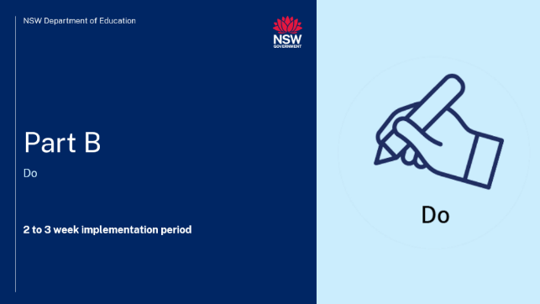Purpose: introduction to Part B
Duration: [00:15]
Speaker notes
We are now going to explore the Part B – do component of the workshop.
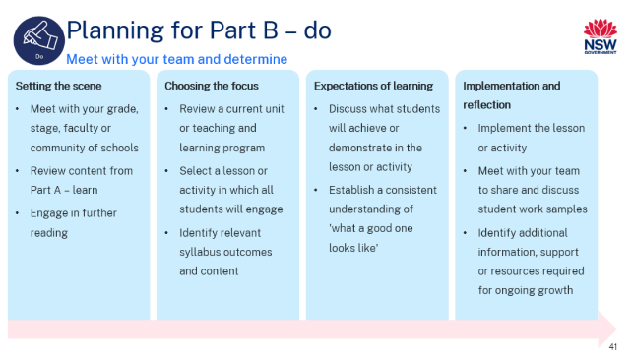Purpose: overview of 'Do' component
Duration: [03:00]
Speaker notes
We are now going to explore the process for Part B – do. This is where we will apply our learning from Part A. This can be found on pages 12 to 13 of your participant workbook.
Facilitator note: talk through information on the slide in detail. Consider how the suggested timing may work within your school’s timetabling/scheduling requirements.
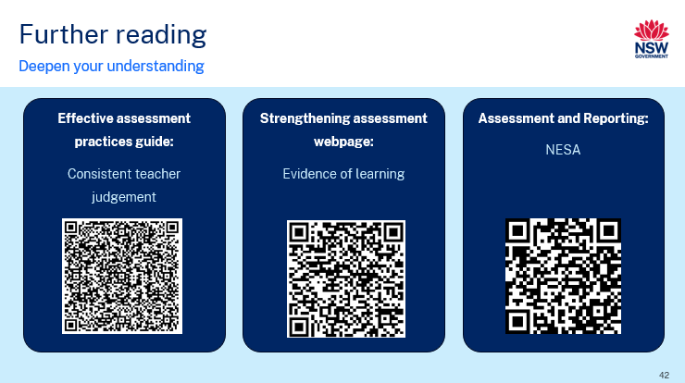Purpose: provide participants with further readings to support Part B – do
Duration: [01:00]
Speaker notes
To support you to further develop your understanding of Part A, here is a list of further reading materials you can engage with when you meet as a team. You can find links to these materials on page 12 of your participant workbook.
- The Effective assessment practices guide has an entire section dedicated to consistent teacher judgement. You may wish to explore this section in depth with your team. Key content from the 'What is consistent teacher judgement?' and 'Consistent teacher judgement processes' chapters have been unpacked in Part A. The QR code you can see on the slide will take you directly to the guide.
- The Effective assessment advice webpage explores key principles and important considerations for consistent teacher judgement processes and practices. The QR code you can see on the slide will take you directly to this section of the webpage.
- Finally, your team may wish to explore the recently updated NESA Assessment and Reporting advice. The QR code will take you to this webpage.
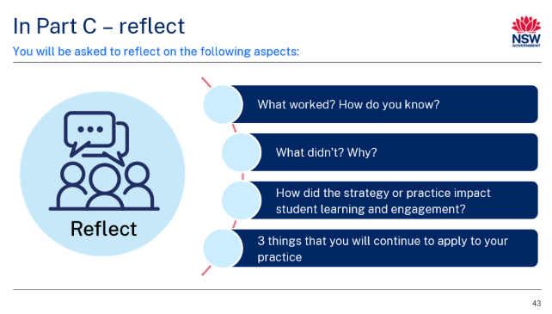Purpose: overview of Part C: 'Reflect'
Duration: [00:30]
Speaker notes
When we meet for the next session, you will be asked to reflect on the following aspects:
- What worked? How do you know?
- What didn’t? Why?
- How did the strategy or practice impact student learning and engagement?
- Three things that you will continue to apply to your practice
END OF WORKSHOP

Part C – reflect
Part C – reflect should take approximately 45 minutes to complete. We recommend following the structure below.
Table 2 – agenda for Part C – reflect
Item | Duration
Acknowledgement of Country and welcome | 3 minutes
Recap Part A – learn and Part B – do | 10 minutes
Reflection activities | 16 minutes
Planning for sustained implementation and growth | 16 minutes

Facilitator notes
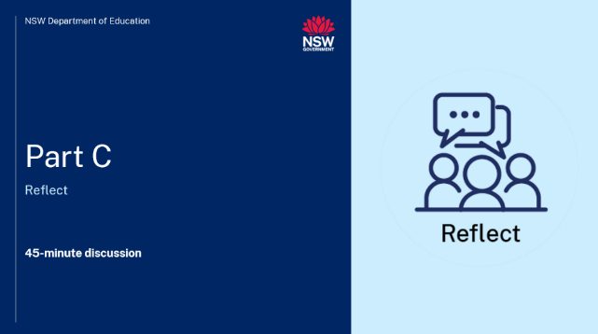Purpose: introduction to Part C
Duration: [00:15]
Speaker notes
The learning we have undertaken in Part A – learn has equipped us with the knowledge and insights required to successfully engage with the 'Do' component of this workshop. We are now going to engage with Part C, the ‘Reflect' component of the workshop.
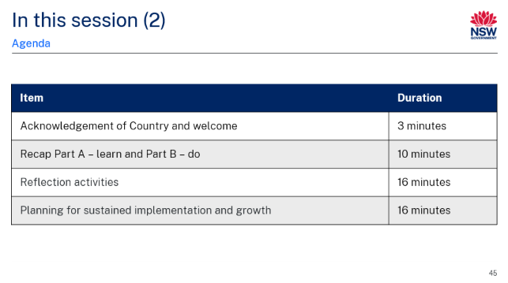Purpose: overview of session
Duration: [00:30]
Speaker notes
In this session, we will:
- recap Part A – learn and Part B – do
- engage in reflection activities
- plan for sustained implementation of growth of consistent teacher practices in our school.
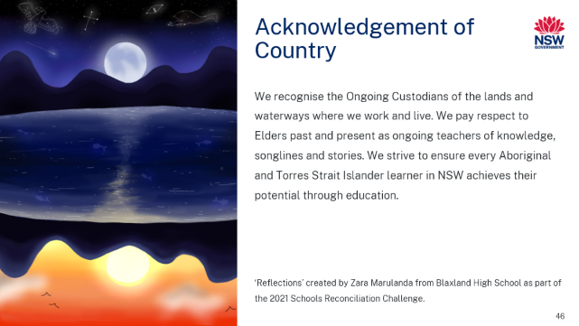
Purpose: Acknowledge Country
Duration: [00:30]
Speaker notes
I would like to begin by acknowledging that we are learning on [insert] Country today.
I recognise the Ongoing Custodians of the lands and waterways where we work and live. We pay respect to Elders past and present as ongoing teachers of knowledge, songlines and stories. We strive to ensure every Aboriginal and Torres Strait Islander learner in NSW achieves their potential through education.
Facilitator note: facilitator to deliver personalised Acknowledgment if they wish.
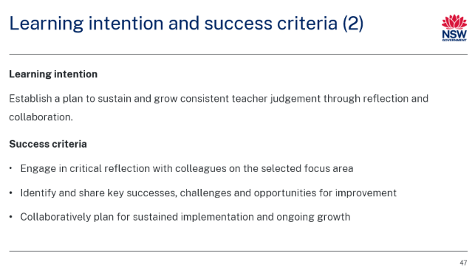Purpose: introduce learning intention and success criteria
Duration: [01:00]
Speaker notes
In this reflection session, we will establish a plan to sustain and grow consistent teacher judgement through reflection and collaborative practice.
By the end of this session, we will:
- engage in critical reflection with colleagues on the selected focus area
- identify and share key successes, challenges and opportunities for improvement
- collaboratively plan for sustained implementation and ongoing growth.
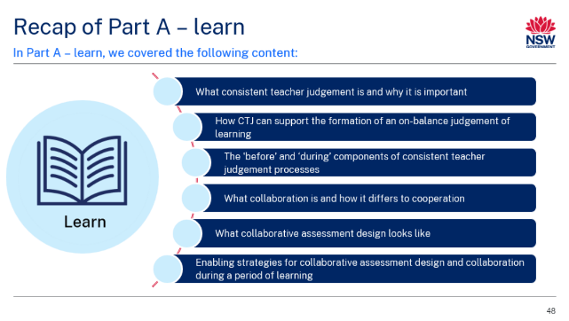Purpose: review content of Part A
Duration: [00:30]
Speaker notes
On screen is a summary of our learning from Part A – learn. We then applied this learning to Part B – do.

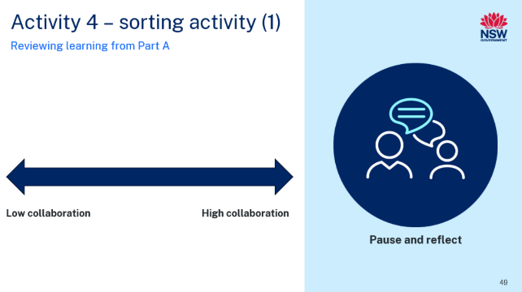Purpose: introduce Activity 4 – sorting activity
Duration: [05:00]
Speaker notes
We will apply and review our understanding of collaborative assessment design with a sorting activity. On page 16 of your workbook, you will find 5 different approaches to assessment design. Your task is to arrange these approaches on a continuum from low to high collaboration.
These approaches are:
- Approach 1: each teacher develops their own assessment for their class. Assessments are based on the same syllabus content and unit/teaching and learning program.
- Approach 2: teachers collaboratively design assessment and develop explicit quality criteria for teachers and students during a stage meeting that is to be used across all classes.
- Approach 3: a teacher shares draft assessment design with their stage/faculty team for feedback and suggestions and then independently finalises assessment. Assessment is used across classes.
- Approach 4: teachers select from a pre-existing bank of assessments created by different teachers over time. They can either use these assessments as is or modify them to suit their specific class needs.
- Approach 5: different teachers take responsibility for designing specific parts of the assessment (for example, multiple-choice section, essay question, project). These parts are then combined into a single, cohesive assessment used across all classes.
I encourage you to engage in meaningful discussions with colleagues at your table to justify your choices. You have 3 minutes for this task, after which we’ll regroup to share our thoughts.
Facilitator note: facilitator may provide participants with pre-cut assessment design approaches in a zip lock bag for them to physically sort. A template for this activity can be found on page 78 of the facilitator guide.

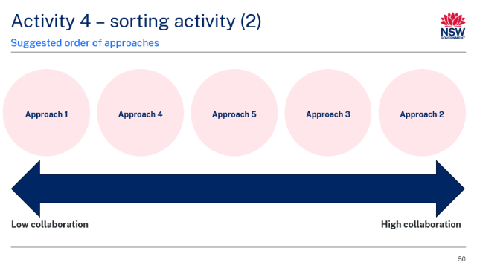Purpose: share suggested order of assessment approaches
Duration: [03:00]
Speaker notes
This is a suggested order of the assessment design approaches from lowest to highest collaboration.
[CLICK]
The approach with the lowest level of teacher collaboration is Approach 1 ‘Each teacher develops their own assessment for their class. Assessments are based on the same syllabus content and unit/teaching and learning program’. This approach has low teacher collaboration because each teacher independently creates their own assessment without input from colleagues, leading to minimal shared decision-making or alignment.
[CLICK]
Next on the continuum is Approach 4 ‘Teachers select from a pre-existing bank of assessments created by different teachers over time. They can either use these assessments as is or modify them to suit their specific class needs’ This approach also has low teacher collaboration because teachers individually select and modify pre-existing assessments without working together in real time to create or refine them. While assessments are shared, there is no ongoing collaborative process in designing or improving them.
[CLICK]
With medium collaboration is Approach 5 ‘Different teachers take responsibility for designing specific parts of the assessment (for example, multiple-choice section, essay question, project). These parts are then combined into a single, cohesive assessment used across all classes’. This approach has medium teacher collaboration because teachers work together by contributing specific parts of the assessment, but each teacher works independently on their assigned section. While there is shared responsibility in creating the final assessment, full collaboration in design and decision-making across all parts is limited. This approach may also be viewed more as teachers cooperating rather than collaborating.
[CLICK]
Next on the continuum is Approach 3 ‘A teacher shares draft assessment design with their stage or faculty team for feedback and suggestions and then independently finalises assessment. Assessment is used across classes’. This approach has medium to high collaboration because the teacher seeks feedback from the team on the draft assessment, allowing for input and suggestions, but the final decision and design remain with the individual teacher. While there is some collaborative discussion, the process is not fully shared or co-created.
[CLICK]
With high collaboration is Approach 2 ‘Teachers collaboratively design assessment and develop explicit quality criteria for teachers and students during a stage meeting that is to be used across all classes’. This approach has high collaboration because teachers work together to design the assessment and establish clear quality criteria, engaging in a shared decision-making process. The collective effort ensures alignment across classes and promotes consistent standards, with input from all involved throughout the design process.

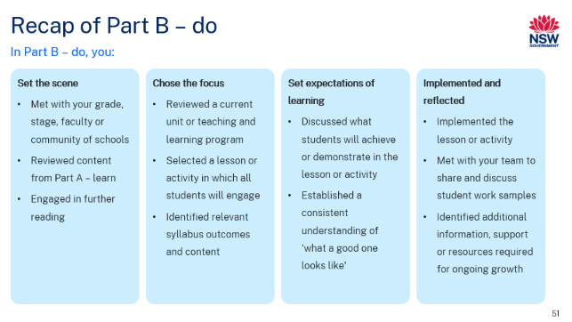Purpose: review of Part B – do
Duration: [01:00]
Speaker notes
Over the last couple of weeks, you have engaged with your team/stage/faculty to undertake the 'Do' component of this workshop.
Facilitator note: facilitator to talk through steps of processes as displayed on the slide to review Part B – do.
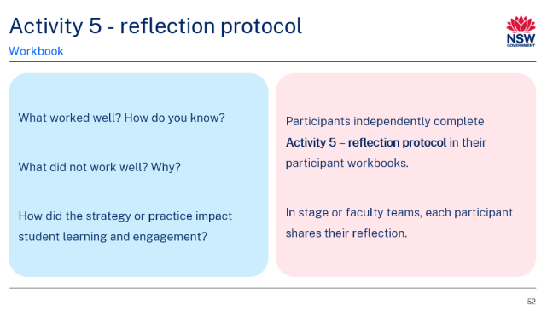 Purpose: introduce Activity 5 – reflection protocol
Duration: [08:00]
Speaker notes
On page 17 of your participant workbook is a reflection protocol for you to complete. In light of your implementation of Part B, consider:
- What worked? How do you know?
- What didn’t? Why?
- How did the strategy or practice impact student learning and engagement?
You will have 5 minutes to complete this in your workbook and then 3 minutes to share your responses with your stage or faculty team.
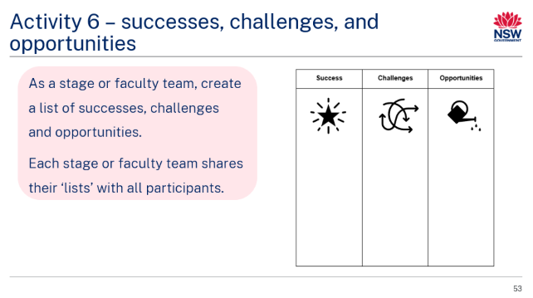Purpose: introduce Activity 6 – successes, challenges and opportunities
Duration: [08:00]
Speaker notes
Now we will create a list of successes, challenges and opportunities your team experienced throughout the Part B – do component. Please complete this as a stage or faculty. On page 19 of your participant workbook is the template for you to record your team's responses.
You will have 5 minutes to complete this as a team and then we will feedback our 'list' to the group.
Facilitator note: facilitator to rove the room and support participants as required.
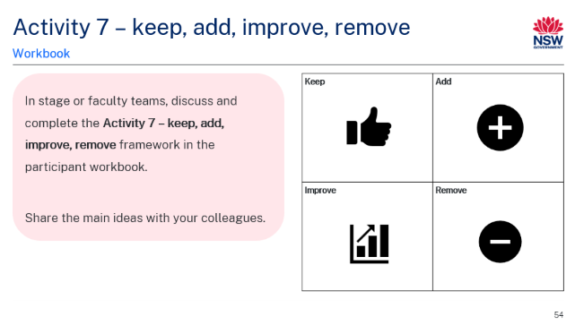Purpose: introduce Activity 7 – keep, add, improve, remove
Duration: [08:00]
Speaker notes
We will now use the 'Keep, add, improve, remove' framework (on page 20 of your workbooks) to consider how we will plan for sustained growth in consistent teacher judgement practices. This is a great tool to support thinking about:
- Keep: What component(s) of your existing teaching practice will you 'keep' in line with what you have learnt about consistent teacher judgement practices?
- Add: Considering our learning in Part A and Part B, what new elements to your teaching practice will you introduce?
- Remove: What is something you will stop doing as it is no longer effective or relevant when effectively implementing consistent teacher judgement processes and practices?
- Improve: What adjustments/refinements will you make to your teaching practice as a result of the learning from this workshop?
You will have 5 minutes to complete this in your workbook and then 3 minutes to share your responses with your stage or faculty team.
Facilitator notes: facilitator roves the room to support participants as required. Consider providing participants with sticky notes to capture responses. These can be displayed on a board or butcher’s paper to create a collective view.

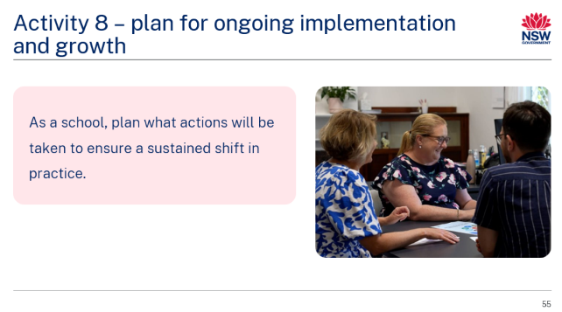Purpose: collaborative discussion for sustaining the practice
Duration: [08:00]
Speaker notes
We will now plan how the consistent teacher judgement processes and practices we have explored and implemented can be sustained to promote an ongoing shift in practice. Complete the activity on page 21 of the participant workbook and be ready to share your ideas with your colleagues.
Facilitator note: facilitator leads discussion with group. Use the suggested guiding questions below as appropriate:
- What are the key factors or resources that will help us maintain and build on this shift in practice?
- How can we support ongoing professional development to keep these practices evolving?
- How will we measure success or progress in sustaining these practices over time?
- What should we watch out for as potential risks to the sustainability of these strategies?
- How do we see this practice evolving over the next term, semester and year?
- What do we need to put in place now to ensure continued growth and development?
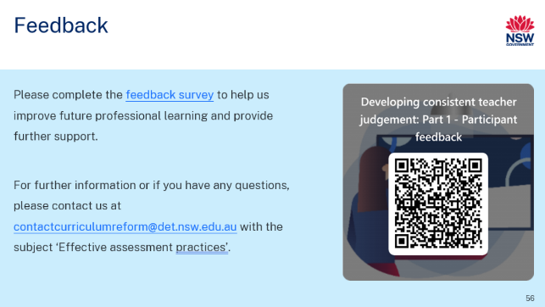Purpose: share feedback
Duration: [01:00]
Speaker notes
Please complete the feedback form, available via the QR code on screen and on page 22 of the participant workbook.

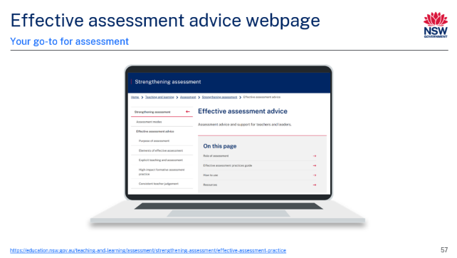Purpose: introduce the Effective assessment advice webpage
Duration: [01:00]
Speaker notes
The Effective assessment advice webpage is your 'go to' for assessment. Housed on the strengthening assessment webpage, it provides advice regarding:
- purpose of assessment
- elements of effective assessment
- explicit teaching and assessment
- high-impact formative assessment practice
- consistent teacher judgement.
END OF SESSION

Additional resources
Approach 1  Each teacher develops their own assessment for their class. Assessments are based on the same syllabus content and unit or teaching and learning program. | Approach 2  Teachers collaboratively design assessment and develop explicit quality criteria for teachers and students during a stage meeting that is to be used across all classes.
Approach 3  A teacher shares draft assessment design with their stage or faculty team for feedback and suggestions and then independently finalises assessment. Assessment is used across classes. | Approach 4  Teachers select from a pre-existing bank of assessments created by different teachers over time. They can either use these assessments as is or modify them to suit their specific class needs.
Approach 5
Different teachers take responsibility for designing specific parts of the assessment (for example, multiple-choice section, essay question, project). These parts are then combined into a single, cohesive assessment used across all classes.

Where to next?
Would you like to learn more? The links below provide additional learning and resources. These may assist you in developing future professional learning sessions to respond to the needs of your team.
- Effective assessment practices – a guide for teachers and leaders – a practical resource for teachers and leaders K–10
- Consistent teacher judgement – provides advice and guidance on consistent teacher judgement
- Australian Institute for Teaching and School Leadership: The Essential Guide to Professional Learning: Collaboration – explores the importance of collaborative professional learning as well as the role of the school leader in supporting a collaborative learning culture
- NSW Education Standards Authority (NESA): Assessment and Reporting – provides information on assessment and reporting

References
AITSL (Australian Institute for Teaching School and School Leadership) (2017) The Essential Guide to Professional Learning: Collaboration, AITSL website, accessed 18 September 2024.
CESE (Centre for Education Statistics and Evaluation) (2020a) What works best 2020 update, NSW Department of Education, accessed 18 September 2024.
CESE (Centre for Education Statistics and Evaluation) (2020b) What works best in practice, NSW Department of Education, accessed 18 September 2024.
Grainger P, Adie L and Weir K (2016) ‘Quality assurance of assessment and moderation discourses involving sessional staff’, Assessment and Evaluation in Higher Education, 41(4):548−559, doi:10.1080/02602938.2015.1030333, accessed 18 September 2024.
Maxwell S (2002) Discussion paper: Moderation of Teacher Judgements in Student Assessment [PDF 299 KB], The University of Queensland, accessed 18 September 2024.
NESA (NSW Education Standards Authority) (2024) Assessment and Reporting, NESA website, accessed 18 September 2024.
(2021) ‘Proficient Teacher Standard descriptors’, The Standards, NESA website, accessed 4 December 2024.
(2012) Assessment, NESA website, accessed 18 September 2024.
QCAA (Queensland Curriculum and Assessment Authority) (2018) Attributes of quality assessment, QCAA website, accessed 18 September 2024.
(2021a) Consistency of Teacher Judgement [PDF 157 KB], Queensland Government, accessed 22 October 2024.
(2021b) Making judgements [PDF 311 KB], QCAA, accessed 22 October 2024.
State of New South Wales (Department of Education) (2024) Effective assessment practices: A guide for teachers and leaders, NSW Department of Education website, accessed 21 June 2024.

© State of New South Wales (Department of Education), 2025
The copyright material published in this resource is subject to the Copyright Act 1968 (Cth) and is owned by the NSW Department of Education or, where indicated, by a party other than the NSW Department of Education (third-party material).
Copyright material available in this resource and owned by the NSW Department of Education is licensed under a Creative Commons Attribution 4.0 International (CC BY 4.0) license.

This license allows you to share and adapt the material for any purpose, even commercially.
Attribution should be given to © State of New South Wales (Department of Education), 2025.
Material in this resource not available under a Creative Commons license:
- the NSW Department of Education logo, other logos and trademark-protected material
- material owned by a third party that has been reproduced with permission. You will need to obtain permission from the third party to reuse its material.
Links to third-party material and websites
Please note that the provided (reading/viewing material/list/links/texts) are a suggestion only and implies no endorsement, by the New South Wales Department of Education, of any author, publisher, or book title. School principals and teachers are best placed to assess the suitability of resources that would complement the curriculum and reflect the needs and interests of their students.
If you use the links provided in this document to access a third-party's website, you acknowledge that the terms of use, including licence terms set out on the third-party's website apply to the use which may be made of the materials on that third-party website or where permitted by the Copyright Act 1968 (Cth). The department accepts no responsibility for content on third-party websites.

