English Studies (Year 11) – resources and activities
11.1 – ‘Reading to write: Transition to English Studies’
This document contains the resources and activities that accompany the teaching and learning program ‘Reading to write: Transition to English Studies’ – Year 11, Term 1.

Contents
About this resource 4
Purpose of this resource 4
Target audience 5
When and how to use 5
Core texts and text requirements 6
Pre-reading – supporting all learners 6
Approach to conceptual programming – Reading to write: Transition to English Studies 6
Codes and conventions of poetry 7
Codes and conventions of manga 7
Codes and conventions of short imaginative texts 8
Phase 1 – engaging with the unit, the learning community and the focus area 10
Phase 1, activity 1 – using reading strategies 11
Phase 1, activity 2 – understanding the English Studies course 13
Phase 1, resource 1 – introducing the writing journal 15
Phase 1, resource 2 – letter to the class sample 17
Phase 1, activity 3 – letter to the teacher scaffold 18
Phase 1, activity 4 – 5 Whys 20
Phase 1, resource 3 – literary and non-literary texts 22
Phase 2 – discovering and engaging with the conceptual heart of the focus area and the connection to the texts 27
Phase 2, activity 1 – understanding the assessment task 28
Phase 2, activity 2 – setting SMART goals 29
Phase 2, activity 3 – applying punctuation to the core text 31
Phase 2, activity 4 – ‘I run’ 3-level guide 33
Phase 2, activity 5 – making inferences 36
Phase 2, activity 6 – perspective and context – exploring connections 38
Phase 2, activity 7 – experimenting with metaphor 43
Core formative task 1 – developing a personal metaphor 45
Phase 3 – engaging personally, analytically and critically with texts 47
Phase 3, activity 1 – activating prior knowledge of visual language 48
Phase 3, resource 1 – literal and figurative representation 51
Phase 3, activity 2 – using visual text to enhance written text 52
Phase 3, activity 3 – Queenie Chan’s identity 57
Phase 3, activity 4 – my identity 58
Phase 3, activity 5 – experimenting with sentence structure 59
Core formative task 2 – drafting a hybrid text 64
Phase 3, activity 6 – editing checklist 68
Phase 4 – connecting critically and deepening conceptual understanding of the focus area and the texts 70
Phase 4, resource 1 – preparing readers for the text 71
Phase 4, resource 2 – knife and fork 77
Phase 4, activity 1 – six-word summaries 79
Phase 4, activity 2 – quote mingle for ‘The Marron’ 80
Phase 4, activity 3 – representation in the core text 84
Phase 4, activity 4 – creating succinct and elaborated noun groups 87
Phase 4, activity 5 – editing nouns and noun groups 89
Phase 4, activity 6 – representations of identity in the core texts 91
Phase 4, resource 3 – narrative pyramid example for ‘The Marron’ 95
Core formative task 3 – narrative plan and extract 97
Phase 5 – composing critically and creatively in response to the focus area and texts 103
Phase 5, activity 1 – using the marking criteria to evaluate own work 104
Core formative task 4 – reflecting on and responding to feedback 106
Phase 6 – preparing the assessment 108
Phase 6, activity 1 – comparing student work samples 109
Phase 6, activity 2 – using the marking guidelines and annotations to refine a work sample 115
Phase 6, resource 1 – definitions for reflective vocabulary 118
Phase 6, activity 3 – reflection scaffold 121
Core formative task 5 – sharing writing 127
References 129

Updating the table of contents
Want to update the table? Have you added content to the document and noticed the page numbers have changed? As you add content to this report, you can update the table of contents to accurately reflect the page numbers within the resource. To update the table:
- Right click on the table and select ‘Update table of contents’ (in the browser version) or ‘Update field’ (in the desktop app). In the browser version, it will automatically update the entire table.
- In the desktop app, you will then need to select ‘Update entire table’. Your table numbers should then update to reflect your changes.

About this resource
This resource booklet aligns with a sample teaching and learning program. It has been developed to assist teachers in NSW Department of Education schools to create learning experiences that are contextualised to their students’ needs, interests and abilities for the English Studies 11–12 Syllabus (NESA 2024). It provides an example of one way to approach resource and activity development through a conceptual lens. The materials have been created by the English curriculum 7–12 team unless otherwise attributed. More information is available via How to use the sample senior English programs.

Purpose of this resource
This resources and activities booklet is not a standalone resource aligns with the following support materials for the Year 11 program ‘Reading to write: Transition to English Studies’:
- Assessment resources: Assessment – 11.1; Student assessment samples – 11.1; Core formative tasks – 11.1
- Programming resources: Program – 11.1
- Resource and activities support in Word: Core texts – 11.1
- Resources and activities in PowerPoint: Phase 1 – understanding the English Studies course – 11.1; Phase 2 – punctuation in poetry – 11.1; Phase 3 – visual metalanguage revision – 11.1; Phase 3 – hybrid texts – 11.1; Phase 3 – literal and figurative representation – 11.1; Phase 3 – sentence variation – 11.1; Phase 3 – subject–verb agreement and use of tense – 11.1; Phase 4 – text annotations – Norton-Lodge – 11.1; Phase 6 – supporting editing – 11.1
- Scope and sequence: English Studies Year 11–12
- Assessment schedule: English Studies Year 11–12.
All documents associated with this resource can be found on the Planning, programming and assessing English 11–12 webpage.

Target audience
This resource booklet is intended to support teachers and curriculum leaders as they develop contextually appropriate teaching and learning resources for the English Studies 11–12 Syllabus (NESA 2024). Teacher-facing material has been included as a ‘resource’, while student-facing material has been labelled ‘activity’ in this booklet.

When and how to use
These resources have been designed for Term 1 of Year 11. This resource booklet provides opportunities for the teacher to develop rapport with their class while getting to know their needs, interests and abilities.The program and associated materials can be used as a basis for the teacher’s own program, assessment or scope and sequence, or be used as an example of how the English Studies 11–12 Syllabus (NESA 2024) can be implemented.
The program and associated resources are not intended to be taught exactly as is presented in their current format. Teachers using this program and the associated materials should adapt these to suit their students’ needs, interests, abilities and the texts selected. The resources should be used with timeframes that are created by the teacher to meet the overall assessment schedules.
Some of the information is collated from relevant NESA and department documentation. It is important that all users re-read and cross-reference the relevant syllabus, assessment and reporting information hyperlinked throughout. This ensures the content is an accurate reflection of the most up-to-date syllabus content.
Teacher note: the blue feature boxes include instructions for the classroom teacher engaging with the activities and resources. They provide suggestions for how content could be delivered and links to additional resources. These notes should be removed before distributing activities and resources to students.
Student note: the pink feature boxes include information for students to develop and clarify their understanding about why they are engaging with specific activities. These notes could be edited or modified to suit the needs of students within your context.

Core texts and text requirements
The core texts and their alignment to the text requirements are provided in their entirety or as the licensed extracts in the Core texts booklet. The name and details of each text, the syllabus requirement being addressed, points of note and a succinct overview of the texts and the reasons for their use in the teaching and learning program is provided.

Pre-reading – supporting all learners
The resources contained in this section are designed to support teachers in preparing for this teaching and learning program.

Approach to conceptual programming – Reading to write: Transition to English Studies
Below is a graphic demonstrating the lead and supporting concepts at the heart of the ‘Texts, culture and value’ sample materials.
Figure 1 – conceptual programming outline for ‘Reading to write: Transition to English Studies’
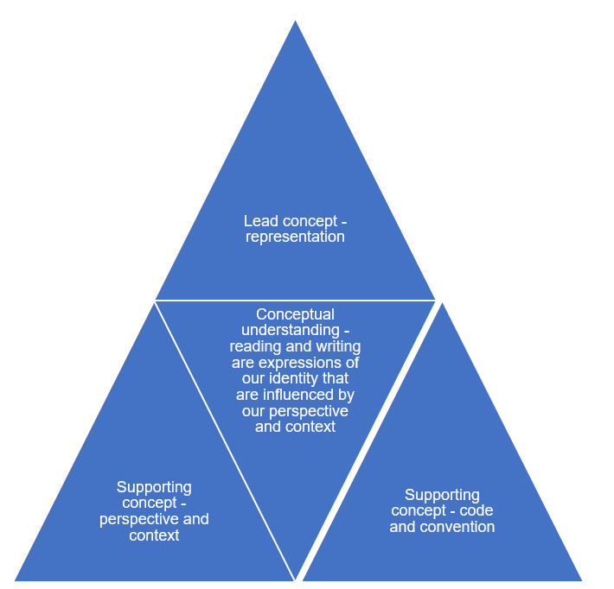

Codes and conventions of poetry
A poem is a stylised text that focuses on language and imagery to express a point of view. Slam poetry and song lyrics usually come under this category. The main conventions of this literary form are summarised below.
Table 1 – codes and conventions of a poem
Codes and conventions of a poem
A poem usually:
- explores a topic important to the speaker or persona
- focuses on intense emotions, settings and ideas rather than narrative structure or character development
- focuses on a single moment, image or feeling
- has line lengths are determined by the poet
- has lines grouped together to form stanzas
- uses language patterns to create compression of meaning
- uses word connotations to create many layers of meanings in a poem
- widely uses imagery, similes, metaphors and symbolism
- uses rhyme and rhyme schemes (or lack of) to impact meaning
- sound devices to create meaning in the poem.
Poems can:
- be intensely political in purpose, or descriptive or personal and reflective
- be written in a variety of forms.
(Beardwood 2022)

Codes and conventions of manga
Manga is a form of graphic novel that originated in Japan. The word manga comes from 2 Japanese words:
- man – which means ‘whimsical or impromptu’
- ga – which translates to ‘pictures’.
It is a combination of visuals and text. The main conventions of this literary form are summarised below.
Table 2 – codes and conventions of manga
Codes and conventions of manga
Manga texts usually:
- contain a narrative sequence
- use fast-paced and action-packed dialogue and images
- use symbolism and onomatopoeia
- follow the Japanese conventions of reading from left to right
- use a layout of image ‘panels’ of varying size and shapes
- use a variety of cinematic visual devices of shots and angles.
(Sly 2022)

Codes and conventions of short imaginative texts
A short work of fiction is sometimes called a short story. The main conventions of this literary form are summarised below.
Table 3 – codes and conventions of short imaginative texts
Codes and conventions of a short story
A short story usually:
- spans a short time frame
- has one main setting
- focuses on one main character and a maximum of 2 minor characters
- focuses on one specific situation or event
- has a concentrated narrative structure – conflict, rising tension, climax, resolution (or ends with uncertainty)
- uses precise and purposeful language choices
- is written in third-person omniscient, third-person limited or first person.
(Beardwood 2022)

Phase 1 – engaging with the unit, the learning community and the focus area
In the ‘engaging with the unit, the learning community and the focus area’ phase, students are supported to develop an understanding of classroom routines and develop positive relationships with their peers. This can help create an optimal learning environment. Students engage personally with a variety of literary and non-literary texts to explore the value of reading and enhance their understanding of the Year 11 English Studies course. Initially, they explore a core text using strategies to support reading comprehension such as prediction and summarising. Students consider the practical value of the skills developed in subject English for their post-school lives.
As students familiarise themselves with the English Studies course structure, they use writing journals to experiment with writing, track their progress and cultivate a strong writing culture in the classroom. They also practise identifying language features through the core text. They compose personal texts to foster classroom connections and to begin an exploration of the concept of identity which is central to this program. Students are given the opportunity to navigate the digital syllabus to encourage ownership of their learning and deepen their understanding of the expectations and requirements of the English Studies course.

Phase 1, activity 1 – using reading strategies
Teacher note: Sketch to stretch (Glasswell et al. 2016) is a comprehension strategy that allows students to visualise and demonstrate their understanding of text through drawing. It values creativity, diverse perspectives and encourages discussion.
- Consider the image below. What do you
- See
- Think
- Wonder?
Figure 2 – image of a runner – photo by Getty Images on Unsplash

Images licensed under Unsplash License.
- Based on the following extracts, what do you think a performance poem titled ‘I run’ will be about?
- ‘my heart thumping …’
- ‘… tune out …’
- ‘… run through rivers …’
- ‘… my problems find me …’
- ‘Run into a blur of horizons of sadness …’
- ‘Bathe me clean …’
Sketch to stretch
- Engage with the performance of ‘I run’ by Melanie Mununggurr. Engage with the performance a second time, and as you do, draw images and symbols that represent your understanding of the text.
- Share your sketches with a small group of peers. Are there any images or symbols that are common? Why do you think this is? If there are not, why do you think this is?
- Return to the predictions you made about the text earlier. Were your predictions accurate? What ideas are emerging?
Six-word summary
- Write a summary of the poem in exactly 6 words. Draw on the words and images from the See, Think, Wonder and Sketch to stretch activities to help you. For example, ‘Running from struggle towards my freedom’.
- Compare your summary with 3 of your peers.
- Identify similarities and differences.
- Contribute to a class discussion about why the summaries of the same text may be different.

Phase 1, activity 2 – understanding the English Studies course
Teacher note: this worksheet should be made available electronically to students so that they can click on the links to take them to the relevant place in the syllabus. Completing this activity in class will require access to devices and the internet.
Visit the English Studies 11–12 Syllabus to find the answers to the questions below.
Organisation of English Studies 11–12
- In Year 11, you will complete Elective focus areas and which other focus area?
- In Year 12, what are the names of the 2 focus areas that are NOT Elective focus areas?
Course description
Identify whether the following statements are true or false. Provide evidence to support your response. This can be through a link to where you found the information or by providing a small screenshot.
- Reading to write: Transition to English Studies must be completed as the first unit of work in Year 11.
- You will study 3 prescribed texts in Year 11.
- You will be required to study a print text. This could be prose fiction, nonfiction, poetry or drama.
Elective focus areas
- In groups of 4, read through 4 different Elective focus areas. You may like to allocate a different focus area for each group member to read and then summarise for the rest of the group, or you may like to take turns to read the descriptions aloud.
- Choose one of the Elective focus areas you explored and complete the following details
- Elective focus area title: ___________________________________
- Give a 6-word summary of the focus area: _________________________________
- Would you like to study this Elective focus area? Why or why not? _____________________________________________________________________
Assessment
Identify whether the following statements are true or false. Provide evidence to support your response. This can be through a link to where you found the information or by providing a small screenshot.
School-based assessment
- Grades awarded at the end of the Year 11 English Studies course are based on formal assessment only.
HSC examinations
- There is no compulsory HSC external examination in English Studies 11–12.
- English Studies students may choose to complete an optional HSC examination.
- Students who do not sit the optional HSC examination are still eligible for an Australian Tertiary Admission Rank (ATAR).
Reading to write: Transition to English Studies
- Students read only literary texts in English Studies.
- Students will deepen their understanding of themselves through this focus area.
- Students will use their experiences of reading to develop their skills as writers.
- Students will not be expected to analyse or evaluate the texts they read in English Studies.

Phase 1, resource 1 – introducing the writing journal
Teacher note: the writing journal is a crucial tool for students in this focus area, promoting language development and personal expression. It offers a space to reflect on learning, experiment with vocabulary and sentence structures, and engage critically with texts. Through regular journal entries throughout the program, students will enhance their writing skills, develop their unique voice and deepen their understanding of language, empowering them to articulate their thoughts and feelings effectively in both written and spoken forms.
Introducing the writing journal
Explain the concept
- Begin by explaining to students the purpose of the writing journal. Emphasise that it is a safe space for them to explore their ideas, document their learning journey and practise their writing skills. Highlight the importance of personal expression and reflection in their language development.
Set expectations
- Outline clear expectations for the writing journal, including
- frequency of entries (daily, weekly)
- length of entries (a paragraph or 2)
- types of writing (reflections, responses to readings, vocabulary experimentation).
Using the writing journal
Regular writing prompts
- In addition to prompts called out in the program, you may choose to introduce regular writing prompts to guide students in their journal entries. Prompts can include
- reflecting on a specific text read in class
- exploring a new vocabulary word and using it in a sentence
- responding to a discussion or group activity.
Model an entry
- Provide a model entry to demonstrate what a journal entry might look like. Highlight how to incorporate personal thoughts, feelings and the specifics of any prompt.
Encourage experimentation
- Encourage students to experiment with language in their journal. This can involve trying out new sentence structures, using descriptive language and incorporating rhetorical devices. Remind them that the journal is a space for practise, where mistakes are part of the learning process.
Share and discuss
- Create opportunities for students to share their journal entries in small groups or with the class. This promotes a sense of community and allows students to learn from each other. Encourage constructive feedback and discussion around their writing.
Reflect on progress
- Periodically, have students review their journal entries to reflect on their growth as writers and language learners. This can include identifying improvements in their vocabulary, sentence structures and overall writing style.

Phase 1, resource 2 – letter to the class sample
Teacher note: the text below is provided as a sample. It is recommended that the teacher shares with students their own letter. This can build strong, positive relationships with the students as they learn more about their teacher and in return, may be more willing to share aspects of themselves.
Dear Year 11,
Welcome to English Studies! I’m Ms Evans. I am so excited to get to know you as senior students and to explore English together in a fun and meaningful way. For many of you, English might not have been your favourite class during 7–10 – and that’s okay. There were a lot of demands and expectations in those years. While we’ll still treat each other with respect and take our learning seriously, I like to think this course can be more enjoyable and more focused on what you are interested in.
A little about me – when I’m not at a Matildas game or at school, or spending time with family and friends, I’m usually outdoors. I love going on long hikes with my German Shepherd, Bronte. She’s incredibly loyal, a little bit dramatic and super smart.
Recently, I picked up quite a random hobby: building custom keyboards. Turns out, there’s a whole world out there of switches, keycaps and RGB. I’ve been down the rabbit hole ever since. Currently, I’m building the perfect setup for gaming – for the past few years I have had a side gig reviewing games on Steam.
I became an English teacher because, as corny as it sounds, I genuinely believe stories shape the way we see the world. Whether they come from films, video games, graphic novels, books or a classic novel. Stories cross generations, languages, backgrounds and literacy levels. They connect us in ways that nothing else can. Whether we’re reading them or writing our own.
This term won’t be about writing essays just for the sake of it. It’s about building your confidence, finding what you actually enjoy reading and writing, and giving you the tools to express your ideas clearly and creatively. You might even surprise yourself with how much you have to say.
I can’t wait to get started and learn more about each of you.
Let’s go!
Ms Evans

Phase 1, activity 3 – letter to the teacher scaffold
- Use the scaffold below to help you write a letter to your teacher in your writing journal. The sentence stems are suggestions only. You are encouraged to use your own voice in this task.
- Try to mimic (this means to imitate or replicate) the style and structure of the teacher’s letter to you. Some tips for this task include
- be honest and genuine – give your teacher an insight into your personality
- use a friendly, conversational and respectful tone
- keep your paragraphs short and related to one idea
- re-read your letter and correct any spelling, grammar or punctuation errors – although this is not the focus of the task, it does not hurt to form good habits!
Table 4 – letter to the teacher scaffold
Content | Example
Greeting  Start with a friendly greeting. | ‘Dear Ms Evans’ or ‘Hi Ms Evans’
Introduction  Introduce yourself and provide a little bit about your background. | ‘My name is … and I feel … to be in English Studies.’
Personal interests  Share some information about what you like to do in your free time. | ‘In my free time I like to …’  ‘Outside of school I like to …’  ‘When I am not at school you can find me …’
Previous experience with English  Reflect on your past experiences in English in 7–10. What did you enjoy? What did you find challenging? This should be related to specific texts or topics explored. | ‘English in junior school was …’  ‘… has been challenging for me in English’  ‘I really enjoyed … in English’
Expectations for the course  Share what you hope to gain from this course. This should be related to skills and knowledge. | ‘I hope the English Studies course will …’  ‘This year in English I would like …’
Conclusion  End your letter on a positive note. | ‘I am looking forward to …’  ‘I am excited by …’

Phase 1, activity 4 – 5 Whys
- Use the scaffold to guide your response to the statement that ‘reading is important’.
- Summarise your arguments in the final table cell.
- An example has been provided as a model.
Table 5 – 5 Whys model
Reading is important | Why?
Reading helps us understand our world better. | Why?
Because it helps us see things from the perspective of others. | Why?
When we see things from the perspectives of others, we can develop empathy. | Why?
Developing empathy can improve our relationships with others. | Why?
Strong relationships can create a more harmonious and productive society. | Reading is important because it helps us learn, understand different perspectives, develop empathy and build strong relationships, which contribute to a harmonious and productive community.

Your response:
Table 6 – 5 Whys student response
Reading is important | Why?
 | Why?
 | Why?
 | Why?
 | Why?
 | [Summarise your ‘whys’ to present a clear argument about why reading is important.]

Phase 1, resource 3 – literary and non-literary texts
Teacher note: an accessible resource for English Studies students is The School Magazine. The ‘Touchdown (Year 6)’ sample magazine can be used to expose students to a variety of texts. If your school has a subscription, you could offer a selection of magazines to your students for this activity. If using the texts provided below, consider printing a set of these texts for groups to be able to physically move them into categories. Model this process using a think-aloud such as, for the graffiti, ‘the colour is eye-catching and the font that is used is artistic. It is not providing me with information, but it is a bit of an observation of life and humanity. The idea of beauty contrasts with the rundown building that the words are painted on. It is different from the advertisement because it is not trying to get me to do something like “leave my films here”. I will put it in a category with the Pride and Prejudice extract because they both contain a version of the truth – the “Everything has beauty but not everyone can see it” and “a single man … must be in want of a wife”.’
After students have categorised the following texts, invite them to share their observations and thinking behind their categories. As they contribute these, record on the board in 2 columns – one for the features of literary texts and the other for non-literary texts. Students may draw on these notes to develop their own definition of ‘literary’ and ‘non-literary’ texts.
Table 7 – features of literary and non-literary texts
Literary texts | Non-literary texts
Creative | Practical
Have a story | Provide information
Contain characters | Objective and technical
Use language in creative ways | Meaning is explicit and aimed at a specific audience
Use language that can be interpreted in several ways | Language is precise and unambiguous
Entertaining or thought-provoking | The message is more important than creativity with language
Prompt an emotional response from the reader | May persuade or inform
The sample magazine ‘Touchdown (Year 6)’ includes the following texts:
- comic strip
- narrative
- feature article
- poetry
- puzzle
- play script.
Visual texts
- Graffiti art
Figure 3 – everything has beauty wall graffiti (photo by Annie Spratt on Unsplash)
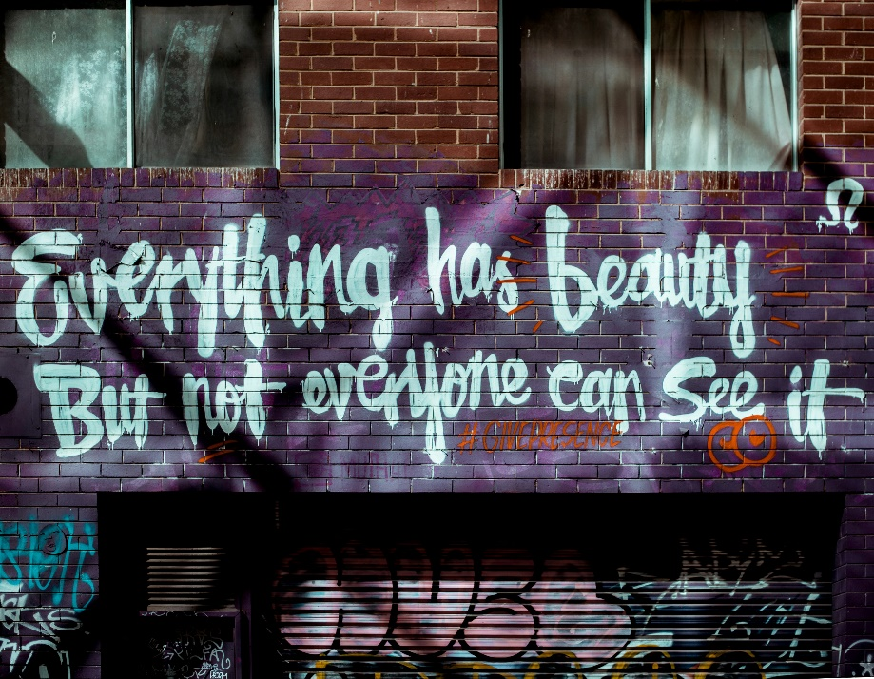
Images licensed under Unsplash License.
- Advertisement
Figure 4 – Kodak advertisement (photo by Museums Victoria on Unsplash)

Images licensed under Unsplash License.
- Instructional or procedural texts
Furniture construction
Figure 5 – instructional diagram (Photo by Dennis Scherdt on Unsplash)
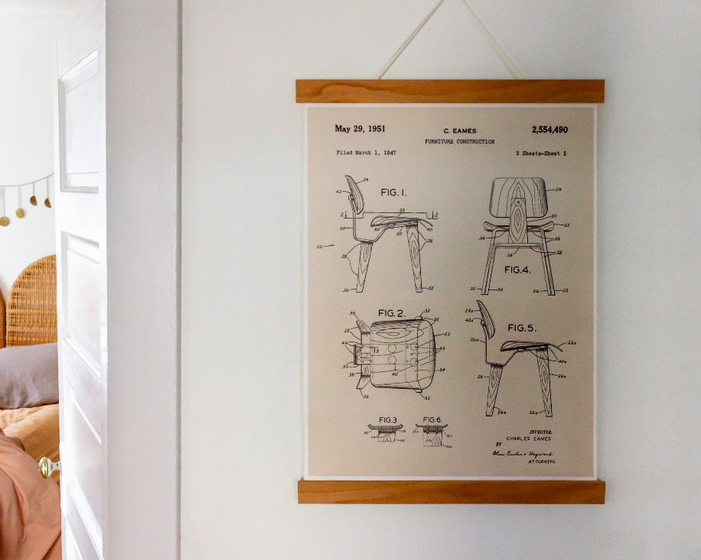
Images licensed under Unsplash License.
- Recipe
One, Two, Three, Four Cake (Gurney 1914)
1 cup of butter
2 cups of sugar
3 cups of flour
4 eggs
2/3 cup of milk
2 teaspoons of Cream of Tartar
1 teaspoon of soda
- Cream the butter and sugar together.
- Add the well-beaten eggs and beat all.
- Add milk; beat again.
- Sift the cream of tartar and the soda into the flour; stir all together.
- Bake in a slow oven. This will make two loaves.
- Literature – Jane Austen Pride and Prejudice – extract
Chapter I.
It is a truth universally acknowledged, that a single man in possession of a good fortune must be in want of a wife.
However little known the feelings or views of such a man may be on his first entering a neighbourhood, this truth is so well fixed in the minds of the surrounding families, that he is considered as the rightful property of some one or other of their daughters.
‘My dear Mr. Bennet,’ said his lady to him one day, ‘have you heard that Netherfield Park is let at last?’
Mr. Bennet replied that he had not.
‘But it is,’ returned she; ‘for Mrs. Long has just been here, and she told me all about it.’
Mr. Bennet made no answer.
‘Do not you want to know who has taken it?’ cried his wife, impatiently.
‘You want to tell me, and I have no objection to hearing it.’
- Mary Shelley Frankenstein – extract
Chapter 5
It was on a dreary night of November that I beheld the accomplishment of my toils. With an anxiety that almost amounted to agony, I collected the instruments of life around me, that I might infuse a spark of being into the lifeless thing that lay at my feet. It was already one in the morning; the rain pattered dismally against the panes, and my candle was nearly burnt out, when, by the glimmer of the half-extinguished light, I saw the dull yellow eye of the creature open; it breathed hard, and a convulsive motion agitated its limbs.

Phase 2 – discovering and engaging with the conceptual heart of the focus area and the connection to the texts
In the ‘discovering and engaging with the conceptual heart of the focus area and the connection to the texts’ phase, students build on the appreciation for the practical value of subject English developed in Phase 1. They extend this to understand how the skills developed in English Studies will support them to become efficient communicators. They enhance their understanding of how representation in texts is influenced by perspective and context, and they begin to experiment with their own representations using the core text as a source of inspiration. They strengthen inferential reading skills and practise supporting a personal interpretation with evidence from a text.
Students explore the requirements of the assessment task, reflecting on their strengths and establishing goals to support their success in the task.
Phase 5 activities are integrated throughout this phase to provide students the opportunity to experiment in their own compositions with the language codes and conventions they have explored in the core text.

Phase 2, activity 1 – understanding the assessment task
Teacher note: to make this activity more engaging, consider using the questions to create a Kahoot or Mentimeter.
- Read English Studies (Year 11) assessment – 11.1.
- Locate the information in the notification to answer the following questions.
- What date has the task been issued?
- When is the task due?
- What is the weighting of the task?
- Where will the task be submitted?
- What is the required number of words?
- Who is the audience for your writing for this task?
- How many of your pieces of writing will you submit for this task?
- What 3 forms of writing will you submit for Part A of your task?
- What do you need to do in Part B of the assessment task?
- When will you start composing your pieces for the portfolio of writing?

Phase 2, activity 2 – setting SMART goals
Student note: setting effective goals is a skill that can support success in senior school. They can help you stay motivated, manage your time efficiently and monitor your progress.
- Read the following goals and identify which goal is more effective.
- I will do well in my task.
- I will improve the clarity and precision of my language by seeking teacher and peer feedback on my draft. I will rewrite my draft at least a week before the task is due and compare my use of language in my first and final drafts to see the improvement in my expression.
- What makes the second goal more effective?
- Complete the table below by identifying how the second goal uses the SMART framework. The first 2 rows have been completed as an example.
Table 8 – SMART goal example
SMART goal | Example
S – specific | improve the clarity and precision of my language
M – measurable | compare my use of language in my first and final drafts
A – achievable
R – relevant
T – time-bound
- In the table below, write your own SMART goal to support your success in the assessment task.
Table 9 – a blank SMART goal template
SMART goal | Example
S – specific
M – measurable
A – achievable
R – relevant
T – time-bound

Phase 2, activity 3 – applying punctuation to the core text
Teacher note: for the following activity, all students should add commas to extracts 1 and 2. Some students may add the missing apostrophes for contraction in extract 2 and identify where enjambment can be used purposefully.
Extract 1 from ‘I run’
- Engage with Melanie Mununggurr’s performance of the poem ‘I run’. Add commas where appropriate to the extract provided below.
I run from all my problems tune out all sounds of the day and life
Until the only sound I’m left with is my feet hitting the tarmac carrying
me away
My heart thumping deep within the lonely hollow cavity of my chest
I run
I do fun-runs and marathons to escape cyclonic turmoil Run through rivers
in the hope my scent will get lost in the currents
Extract 2 from ‘I run’
- Insert the 3 missing apostrophes for contraction in the extract below.
I like to call myself a runner
Cos thats what I do
When life attacks me from all angles like Im a paper bag in a
thunderstorm
I run
I run from all my problems, tune out all sounds of day and life
Until the only sound Im left with is my feet hitting the tarmac, carrying
me away

Phase 2, activity 4 – ‘I run’ 3-level guide
Teacher note: the questions in this activity formatively assess literal, inferential and evaluative levels of comprehension. The NSW Department of Education’s website contains syllabus-aligned resources to support reading for Stage 5 reading – Literal comprehension, Stage 5 reading – Inference and Stage 5 reading – Main idea and theme. A suggested response has been provided in the first row of the literal and inferential statements table. Remove this if not required.
Student note: the following activity will help you to practise supporting an argument with evidence from a text. This is a skill that you need to explain your thinking. The first 3 statements require literal comprehension skills – you will find the answers directly in the text. The next 3 statements require inferential reading skills – this means that you will draw your own conclusion from the information that is given because the answer will not be stated directly. The final statement requires you to evaluate. This means that you consider all the evidence in the text and make a judgement based on what you think and believe about the text.
- Use the echo reading strategy to refamiliarise yourself with Core text 1 – ‘I run’ by Melanie Mununggurr.
- Indicate whether the statements in the first column of the table below are true or false, or if there is not enough information given to take a stance (there will only be one of these).
- Provide evidence from the text to support your argument. Some of these statements can be either true or false. Your use of evidence from the text is what is important.
Literal statements
These statements are predominantly ‘what’ statements and require you to be able to identify information that is easily located in the text.
Table 10 – literal statements for 3-level guide
Statement | True or false | Evidence
The persona is a runner. | True | ‘I like to call myself a runner/Cos that’s what I do’
The persona runs towards her problems.
The poet uses similes in the poem.
Inferential statements
These statements require you to make inferences based on the information provided in the text. It should be possible to make an argument that the statement is true or false. The value of these statements is that they help you to make an argument and support it with textual evidence.
Table 11 – inferential statements for 3-level guide
Statement | True or false | Evidence
The persona loves running. | False | She does not run because she loves it, but because she is trying to escape. This is reflected in ‘I run from all my problems …’
The persona is proud of her identity.
The poet represents the natural world in a positive way.
Evaluative statement
This statement requires you to move beyond the text to consider what you think and believe in relation to the text. Again, there is generally no right or wrong answer – the purpose of this style of questioning is to support you to justify your thinking using evidence from the text.
Table 12 – evaluative statement for 3-level guide
Statement | True or false | Evidence
The poet is exploring more in the text than literal running.

Phase 2, activity 5 – making inferences
Student note: inference or reading inferentially or making inferences is the process of drawing conclusions based on evidence and using background knowledge. For example, if someone is rubbing their eyes and yawning, we could infer that they are tired; we do not necessarily need to be told.
- Use the table below to record the inferences you can make from Melanie Mununggurr’s performance poem ‘I run’. The first row has been completed as an example.
Table 13 – making inferences
Clues from the text | My own background knowledge | My inference
‘I run’ | Running can be a metaphor or symbol for escape or freedom. | The persona is escaping from problems and challenges.
‘But like a black tracker, my problems find me’ | A black tracker is a First Nations Australian who is skilled in navigating the land. Trackers were enlisted by British colonial authorities, particularly police forces to locate missing persons, criminals and lost property.
‘Hold me captive the way this country holds asylum seekers …’
‘I run to the hills and sing my praises to my inner child cos she reminds
me of the beauty of a rainbow in the rain …’
‘My salty sweat from all that I have run from
Will one day
Bathe me clean.’

Phase 2, activity 6 – perspective and context – exploring connections
Teacher note: an overview of the core concepts can be accessed at English K–12 – Textual concepts. Perspective and Context are explored in this phase.
Through Stage 4 and Stage 5, you developed your understanding of perspective and context. In this activity, you will explore the connections between these in Melanie Mununggurr’s performance poem ‘I run’.
Perspective: a lens through which we learn to see the world. Perspective provides a dynamic basis for the relationship between composer, text and responder.
Context: to understand context we look beyond the text to consider the world in which it was produced and the worlds of its reception. Different contexts can have an effect on the meanings and values of similar content.
- In the table below, identify the connections between Mununggurr’s context and the perspective presented in the poem.
- Identify aspects of your own context that influence the way that you respond to the poem. The first 2 rows have been completed as a model.
Table 14 – context and perspective
Composer’s context | Composer’s perspective | My context | My response
From Darwin | The natural world has the potential to heal.  ‘I run to the ocean where all my tears from years past have collected,  knowing that if I blow it a kiss the least it will do is wave back.’ | From the city | I don’t feel a strong connection to the ocean, but the poem makes me regret that.
Possible personal experiences | Challenges can make us stronger and lead to a greater sense of identity.  ‘When life attacks me from all angles … I run.’ | Challenge of moving schools | Mununggurr’s perspective is similar to mine – I experienced the challenge of changing schools. This led to my discovery that I am introverted and have to work hard to make friends. It also showed me that I like having just a few very close friends rather than a big group of people I only know a little bit. So, this challenge resulted in greater understanding of myself and my identity.
Djapu writer from Yirrkala in East Arnhem Land
Slam poetry champion
Mother
34 years old at the time of composing ‘I run’
- Listen to The Drawing Room podcast.
- What issues are important to Mununggurr?
- Evaluate the aspect of Mununggurr’s context that you believe has had the biggest influence on the poem ‘I run’. Use the following model and sentence stems to help you.
- The greatest influence on ‘I run’ is the writer’s possible personal experiences. The themes of resilience and empowerment that run through the poem reflect challenges faced in confronting unfair stereotypes such as ‘nice girl’ and ‘bitch’. Mununggurr conveys the struggle to escape these stereotypes and social expectations through the admission of being ‘stuck trying to run’ from a version of themselves that is difficult to accept.
- The most influential aspect of Mununggurr’s context in her poem ‘I run’ is … because …
- In ‘I run’, Melanie Mununggurr’s context is evident in …
- The fact that Mununggurr is … significantly influences the poem ‘I run’ because …

Phase 2, activity 7 – experimenting with metaphor
Teacher note: consider projecting this table onto the board and having students complete the activity in their writing journal.
- Use the style and structure of Melanie Mununggurr’s performance poem ‘I run’ to draft some ideas for your own performance poem that explores an aspect of your identity. The middle column ‘I dance’ provides an example for you to follow. The questions and language devices in brackets give suggestions for your content.
- Use the words and images brainstorm on your own perspective and context to develop a metaphor based on something that you value or that represents part of your identity.
Table 15 – experimenting with metaphor
‘I run’ key ideas and images | ‘I dance’ key ideas and images | ‘I …’
I run | I dance
When life attacks me  (When does the persona run?) | when I feel there is a better version of me
‘like I’m a paper bag in a thunderstorm’  (simile) | a candle flickering in a gentle breeze
‘I run from all my problems’  (Why does the persona run?) | to be someone else
‘until the only sound I’m left with is my feet hitting the tarmac, carrying me away’  (Focus on a specific sound or feeling associated with the activity.) | The beat of the music and muscles stretching
‘My heart thumping deep within the lonely, hollow cavity of my chest’  (Focus on a connection between the activity and your physical being.) | Brain moving quickly – feet trying to keep up
‘I do fun-runs and marathons’  (Be more specific about the activity.) | Performing for my teacher, an audience and myself
‘Run through rivers’  (How can the activity be metaphorical?) | Dancing costume is a new skin

Core formative task 1 – developing a personal metaphor
- Re-read or revisit Melanie Mununggurr’s performance poem ‘I run’.
- Use the scaffold you completed in Phase 2, activity 7 – experimenting with metaphor to support you to record ideas about an aspect of your identity.
- For this task, you should complete the activity that best reflects the highest level of achievable challenge for you. You may choose one of the following options
- Create a collage, illustration or image sequence with words and visual text that represents an aspect of your identity.
- Compose and perform a short text using video and/or audio that uses a metaphor to represent an aspect of your identity.
- Compose 2 stanzas of a performance poem, or 2 paragraphs of a personal extended response that begins with a literal description of an aspect of your identity and moves towards a metaphorical representation. Use Core text 1 – ‘I run’ by Melanie Mununggurr and the scaffold completed in Phase 2, activity 7 – experimenting with metaphor for inspiration.
Draft response
The following draft was developed after Phase 2, activity 7 – experimenting with metaphor was completed.
‘I dance’
I have always called myself a dancer.
I dance to feel a better version of me.
When the world is windy and I am a candle I dance to make my flame bright again.
I dance and dance until the only thing I feel is the beat of the music and the glorious pain of muscles stretched beyond the limits that I believed existed.

I dance while my brain races and my feet and legs try desperately to keep up.
I dance for my teacher.
I dance for my audience.
I dance for me.
I dance for the new and improved version of myself that I become when I shed my old skin and slip on my new one – pale pink chiffon and silver sequins.
I dance to find my feet and find my feet to find my voice and find my voice to find myself.
I am a dancer.

Phase 3 – engaging personally, analytically and critically with texts
In the ‘engaging personally, analytically and critically with texts’ phase, students revise and refine their understanding of visual language and how it can be used to enhance written text through textual hybridity. They develop critical thinking skills through exploring both literal and figurative representation in the core text. They continue to develop understanding of identity and consider how reading and writing can be expressions of this.
The core text is used to strengthen literacy skills as students develop understanding of how to create cohesion in their writing. They engage analytically with the core text to deepen understanding of sentence structure and how this can be used to develop a personal writing voice.
Students build understanding of and appreciation for the different stages of the writing process. They engage closely with the planning to write and drafting stages of the writing process to support the completion of a second core formative task. Through engaging with self and peer feedback , they refine their editing skills and develop appreciation for the value of the editing process.
Phase 5 and Phase 6 activities have been integrated into this phase to support students to develop their compositions in preparation for the formal assessment task.

Phase 3, activity 1 – activating prior knowledge of visual language
- The extract below from Core text 2 – What the doctor recommended by Queenie Chan uses visual language to represent ideas. Label the following language features used
- juxtaposition
- symbolism
- vectors
- positioning
- contrast
- style
- body language
- facial expression
- allusion.
Figure 6 – extract 1 – visual text from ‘What the doctor recommended’
- Based on this extract, and the language features you have identified, what do you think the text will be about?
- Consider the title of the text and the additional extracts from the text included in the table below. Do they support your original prediction? Add to or refine your prediction by identifying the ideas that will be explored in the text.
Table 16 – extracts from Core text 2 – What the doctor recommended by Queenie Chan
Extract
‘Many books that change lives often come with two people attached – the one who wrote the book, and the one who pressed that book into your hand, urging you to read it.’
‘By day, Doctor Munn is a mild-mannered emergency room (ER) doctor … By night, he is a wellspring of information on manga, anime and video games.’
Figure 7 – extract 2 – visual text from ‘What the doctor recommended’
‘I knew what kind of art and stories I liked, and this was neither’.
‘So many things can seem dull at first glance’.
Figure 8 – extract 3 – visual text from ‘What the doctor recommended’

Phase 3, resource 1 – literal and figurative representation
Students use a ‘thumbs up’ for figurative and a ‘thumbs down’ for literal, to indicate which of the following descriptions are figurative and which are literal.
- The cat sat on the mat.
- He has a heart of stone.
- The flowers bloomed in the spring.
- I have been waiting for you for eternity!
- The test was a piece of cake.
- The stars danced in the night sky.
- The chocolate melted in my mouth.

Phase 3, activity 2 – using visual text to enhance written text
- Read the extract from Core text 2 – What the doctor recommended by Queenie Chan.
Extract from the written text
In order to talk about the book that made me, I must first talk about my cousin Munn.
If Munn was not quite the person who made me, then he was the person who gave me the tools to shape myself into who I am today.
Many books that change lives often come with two people attached – the one who wrote the book, and the one who pressed that book into your hand, urging you to read it. Cousin Munn was one of the latter, and he had caught me at that most formative time of my life – when I was a young teenager.
By day, Doctor Munn is a mild-mannered emergency room (ER) doctor working at Queen Mary Hospital, in Pok Fu Lam, Hong Kong. By night, he is a wellspring of information on manga, anime and video games. He’s the type of guy who is always “in the know”. He knows all about the latest popular trends, and whatever he’s into at the moment, he will sell it to you like he’s a guru pitching spiritual enlightenment.
(He’s actually a really good salesman. Looks like the world gained a good doctor, but lost a potential cult leader.)
I was born in Hong Kong, in 1980. For the first few years of my life, I was reared on manga and anime, the Japanese terms for comics and cartoons. When I migrated to Australia in 1986, I lost touch with Doraemon, Urusei Yatsura and countless other manga, until my family started taking yearly trips back to Hong Kong. This started when I was ten years old, and it continues to this day.
On some of these trips, Cousin Munn would meet us at the airport, to take the kids out shopping for the latest cartoon books. This was in the mid-1990s, and he would take us to massive, four-storey shopping centres in Mong Kok, where every. single. shop. sold either manga, anime or video games.
(The adults, meanwhile, would gratefully check into the nearest hotel, eager to sleep off the jet lag. We would return from our shopping trip, and my parents would wake to find the hotel room wall to wall with all my new manga and video game purchases.)
As an overly serious ten year old, I looked up to Cousin Munn (the man!) as an arbiter of good taste. I knew that whenever he pointed his finger at anything pop culture related, there was bound to be something fun and interesting in that direction.
Not a mad scientist, not Doctor Who, but a medical doctor.
A surgeon, in fact. The surgeon’s name was Black Jack, which was, not coincidentally, also the name of the manga series.
Well, it’s no surprise that a doctor would recommend a manga about a doctor; people love seeing themselves reflected in fiction. However, my own interests sat squarely in fantasy – knights, wizards and demon kings battling it out in epic battles of good and evil. I was around fifteen at the time, and in the Queenie-verse, manga was only ever about two things: swords and sorcery fantasy realms, or high school romances (with or without vampires).
- Consider the extracts from the visual text that accompanies the written text. Cut out the frames and place them next to where you think they belong in relation to the written text.
- Compare the placement of the images in your response to 2 of your peers’ responses. As a group, decide on the best placement for each image.
- Identify an example of literal representation in the images – that is, an image that illustrates what is communicated in the written text.
- Identify an example of figurative representation in the images – that is, an image that adds layers of meaning to the written text.
Extracts from the visual text
Figure 9 – extract 1 from ‘What the doctor recommended’
Figure 10 – extract 2 from ‘What the doctor recommended’
Figure 11 – extract 3 from ‘What the doctor recommended’
Figure 12 – extract 4 from ‘What the doctor recommended’
Figure 13 – extract 5 from ‘What the doctor recommended’
Figure 14 – extract 6 from ‘What the doctor recommended’
Figure 15 – extract 8 from ‘What the doctor recommended’

Phase 3, activity 3 – Queenie Chan’s identity
- Complete the concept map below by making inferences from your reading of Core text 2 – What the doctor recommended by Queenie Chan.
Figure 16 – brainstorm for Chan’s reading choices
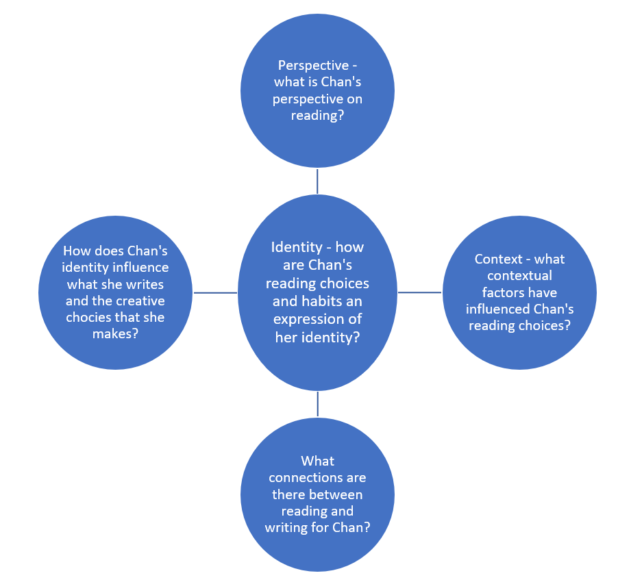

Phase 3, activity 4 – my identity
Teacher note: if students have an electronic copy of this resource, they can type their responses in the blue circles. Otherwise, project the map and have students replicate it in their writing journal to complete the task.
- Complete the concept map below based on your own identity.
Figure 17 – brainstorm about identity

Phase 3, activity 5 – experimenting with sentence structure
Student note: the PowerPoint Phase 3 – sentence variation – 11.1 should support you to complete these activities.
- Rewrite the following extract from Core text 2 – What the doctor recommended by Queenie Chan as a series of simple sentences. The first sentences have been completed as a model. Continue this activity in your writing journal.
In order to talk about the book that made me, I must first talk about my cousin Munn.
If Munn was not quite the person who made me, then he was the person who gave me the tools to shape myself into who I am today.
Many books that change lives often come with two people attached – the one who wrote the book, and the one who pressed that book into your hand, urging you to read it. Cousin Munn was one of the latter, and he had caught me at that most formative time of my life – when I was a young teenager.
Rewritten in simple sentences
I will talk about a book. This book made me. I will first talk about my cousin Munn.
- Use the checklist below to ensure that you have used ONLY simple sentences. Compare your series of sentences with a partner. Highlight where you have used identical or very similar sentences.
Table 17 – checklist for simple sentences activity
Simple sentence feature | Yes/No
Is there a finite verb in each sentence?
Is there only one independent clause in each sentence? (Hint: look for a verb. There should be only one in a simple sentence.)
Does each sentence contain one complete thought? (Watch out for sentence fragments such as ‘in order to talk about the book’.)
- The following extract has been adapted from Core text 2 – What the doctor recommended by Queenie Chan as a series of simple sentences. In your writing journal, rewrite the extract using a combination of sentence structures. You must include at least 2 compound sentences and one complex sentence. The first sentences have been completed as a model. Continue this activity in your writing journal.
Black Jack was a series of short stories. It had recurring characters. Munn was right. He called it riveting. There were no formulas in the world of Black Jack. At least none that I could easily predict. The endings were not always happy. Black Jack cured patients. Sometimes they didn’t want to be cured.
In short, these were stories about humanity. They were about people. These people behaved in unpredictable ways. People often behave in unpredictable ways. They may not understand why.
Rewritten with greater sentence variation
Black Jack was a series of short stories and it featured recurring characters. When Munn called it riveting, he was right.
Coordinating and subordinating conjunctions
- Use the table below to help you create compound sentences (with coordinating conjunctions) and complex sentences (with subordinate conjunctions).
- Compare your rewritten extract with a partner. Highlight where you have used identical or very similar sentences.
Table 18 – coordinating and subordinating conjunctions
Coordinating conjunctions (compound sentences) | Subordinating conjunctions (complex sentences)
for, and, nor, but, or, yet, so | after, as, before, once, since, until, when, whenever, while, where, wherever, although, as, as if, because, since
Experimenting with sentences in manga frames
- Use a combination of sentence structures to write alternate text to accompany the following frames from Core text 2 – What the doctor recommended by Queenie Chan. The text can be for an entirely new manga – you do not need to re-create the original text.
Figure 18 – extract 1 from core text with written text removed
Figure 19 – extract 2 from core text with written text removed
Figure 20 – extract 3 from core text with written text removed
Reflecting on voice
- Consider the extracts you have rewritten. Which extract created a more personal voice?
- How will you apply this learning for your portfolio of writing compositions?
- Use the ‘because, but, so’ structure to explain the value of sentence variation in writing
- Sentence variation is important in writing because …
- Sentence variation is important in writing but …
- Sentence variation is important in writing so …

Core formative task 2 – drafting a hybrid text
Teacher note: it is useful to share with students the visual representation of the writing process so that they can keep track of their progress and how each activity fits into the process.
Student note: the figure below represents the stages of the writing process. Core formative task 2 – drafting a hybrid text focuses on developing your skills in the first 2 stages of the writing process: planning and drafting and composing.
Figure 20 – the writing process
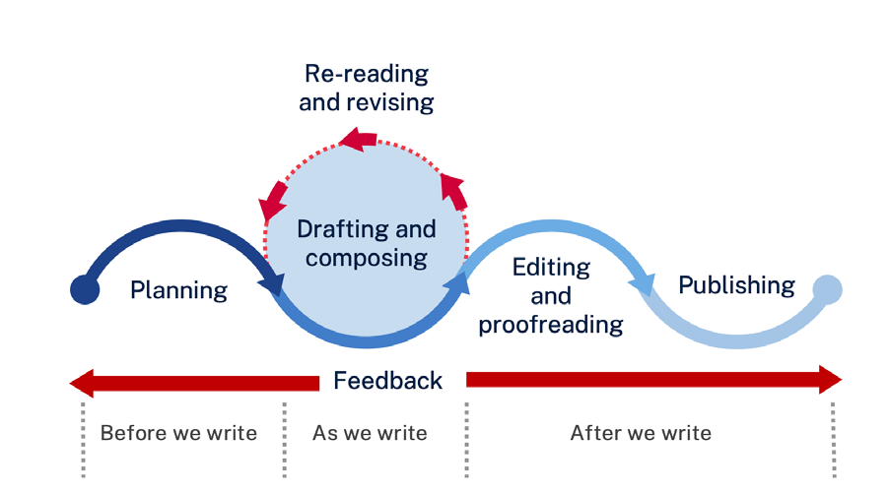
Planning to compose
Spending time in the planning stage of the writing process can make your task easier and your writing more effective.
Use the adapted WWWWWH chart below to generate ideas for your hybrid text about someone who has significantly influenced your identity. An example has been completed as a model based on Core text 2 – What the doctor recommended by Queenie Chan.
Table 19 – model WWWWWH chart
WWWWWH | Ideas
Who? | Cousin Munn – emergency doctor, manga, anime and video game fan, good salesman, took us kids shopping, Chan looked up to him.
What? | Introduced the writer to Black Jack. Tried to persuade her that she would like Black Jack. Explained Black Jack was written by the same author of Astro Boy. He described Black Jack as ‘riveting’.
When? | In the mid-1990s – when the writer was a teenager
Where? | Hong Kong and Sydney
Why? | The writer believed that she knew what she liked and was interested in and Black Jack did not appeal to her. When she finally engaged with this manga, it changed the way she thought about storytelling. She also began to understand the importance of sharing books with other people and how you need to ‘sell’ them in the right way to convince others of the value of engaging with these texts.
How? | The writer’s life was transformed through this experience as she wrote and illustrated her own published manga called The Dreaming.
- Complete the table below to help you plan your writing. You may like to reflect on the piece that you composed in Core formative task 1 – developing a personal metaphor to find inspiration.
Table 20 – student WWWWWH chart
WWWWWH | Ideas
Who?
(Who is the person you will write about? What details about this person are important and engaging for the reader to know?)
What?
(Pick a specific moment or event that explains how this person influenced you.)
When?
(How old were you? You could refer to markers such as primary school, or ‘in Year 9’.)
Where?
(Where were you when this pivotal moment occurred?)
Why?
(Why was this person and this moment so influential?)
How?
(How has your life and/or your identity been shaped by this person and/or experience?)
Drafting your hybrid text
- Use the information in the WWWWWH table to develop a hybrid text about someone who has significantly influenced your identity. The writing style should be personal and informative like Core text 2 – What the doctor recommended by Queenie Chan. To make your text hybrid, you could enhance the meaning of the text by
- incorporating 4 to 6 frames of visual text
- incorporating 6 to 8 lines of poetry.
- Try to apply the learning from this program by paying close attention to your use of
- punctuation for effect
- sentence variation
- subject–verb agreement
- tense.

Phase 3, activity 6 – editing checklist
- Use the checklist in the table below to support you through the process of editing your hybrid text draft. Give an example from your composition. If you cannot find an example, edit your work so that the specified feature is included.
Table 21 – editing checklist
Feature | Evidence in own text
Visual text or poetry is used to enhance meaning
An aspect of identity is clearly represented
Simple, compound and complex sentences are used purposefully
Subject–verb agreement rules are followed
Use of tense is consistent
- When you have completed the checklist and refined your writing, swap your text with a peer. They will complete the feedback table below for your hybrid text draft and you will complete their feedback table for their hybrid text draft.
Table 22 – peer feedback table
Feature | Evidence in peer’s text
Visual text or poetry is used to enhance meaning
An aspect of identity is clearly represented
Simple, compound and complex sentences are used purposefully
Subject–verb agreement rules are followed
Use of tense is consistent
- When the feedback and your hybrid text is returned to you, make further refinements in response to the feedback. Submit Core formative task 2 – drafting a hybrid text to the teacher.

Phase 4 – connecting critically and deepening conceptual understanding of the focus area and the texts
In the ‘connecting critically and deepening conceptual understanding of the focus area and the texts’ phase, students deepen their understanding of representation and its role in narrative construction. Reading skills are strengthened through preparing students for the core text by building the field, activating interest making predictions and drawing on reading strategies to engage with the text. Collaborative activities support them to represent key ideas and make inferences, promoting critical thinking about perspective.
As students consolidate their understanding of representation, they consider how ordinary and extraordinary events are portrayed in the core text. They analyse the use of language in constructing these representations – with a focus on nouns and noun groups. This analysis encourages them to experiment with their own writing, creating precise and impactful representations through informed language choices.
Students compare the representations of identity within the core texts, reading to analyse meaning and establish connections between different narratives. This analysis informs their own writing goals for the assessment task.
Throughout this phase, students strengthen their revising and editing skills, ensuring their compositions reflect an understanding of representation and narrative elements.
Phase 5 and Phase 6 activities have been integrated into this phase to support students to develop their compositions in preparation for the formal assessment task.

Phase 4, resource 1 – preparing readers for the text
Teacher note: Quigley (2020) outlines the important role that a student’s background knowledge plays in understanding a text. He says that ‘… our comprehension can be bounded by the limits of our experience’ and that ‘the degree of difficulty’ of a text ‘is … mediated by what the pupil knows and their past reading experiences’. Activating background knowledge involves building the field by providing the content and language knowledge that students will need to access the text.
Building the field
- Display the following images in class. Ask students to identify which one is a snip from a picture of a marron.
Figure 22 – image 1

Image licensed under Unsplash License.
Figure 23 – image 2
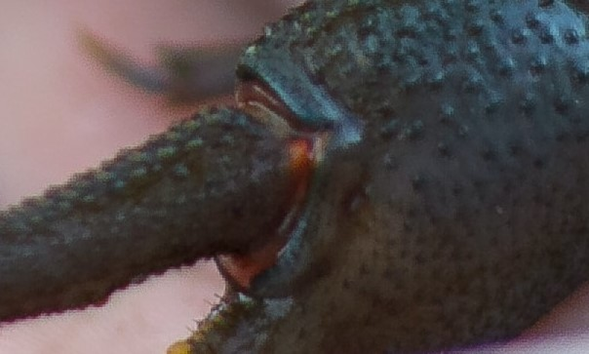
Image licensed under Unsplash License.
Figure 24 – image 3

Image licensed under Unsplash License.
Activating interest
- Display the following images and ask students which image depicts the most interesting story. Follow up with the ‘What makes you say that?’ effective questioning strategy.
Figure 25 – image 1

Image licensed under Pixabay Content License.
Figure 26 – image 2
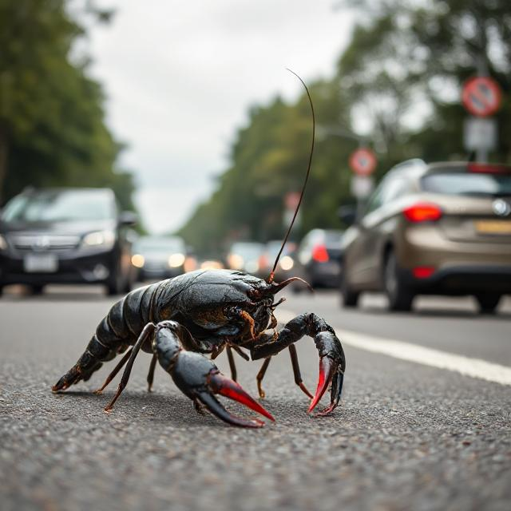
This work was generated using DeepAI. Any copyright subsisting in this work is owned by © State of New South Wales (Department of Education), 2024.
Figure 27 – image 3
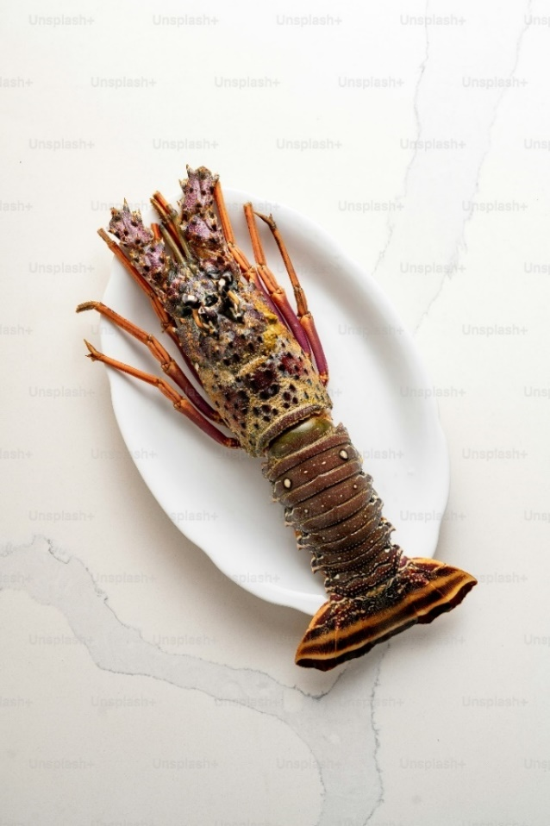
Image licensed under Unsplash License.
Figure 28 – image 4
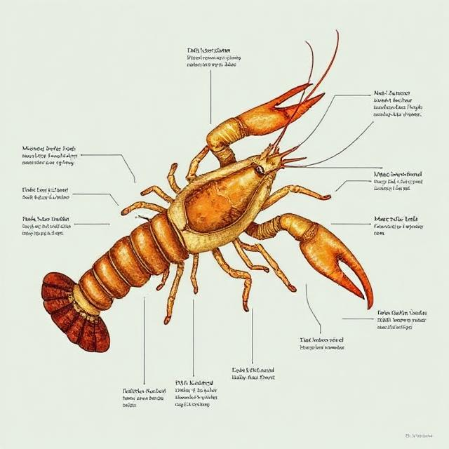
This work was generated using DeepAI. Any copyright subsisting in this work is owned by © State of New South Wales (Department of Education), 2024.
Making predictions
- Provide students with the first sentence of Core text 3 – ‘The Marron’ by Zoe Norton-Lodge: ‘One evening at the age of ten, Georgia had been assigned hunting and gathering duties’. Invite students to make predictions about the kind of text the sentence comes from.
- Provide students with the following keywords and phrases from the text and ask them to predict what the text will be about
- hunting and gathering
- unfairness
- take-away diners
- the creature
- shiny black car.
Reading to retrieve information
- Students explore 2 to 3 of the following websites
- 'Recreational fishing guides' (Marron guide)
- The True Marron 101
- Discover Australian Marron.
- Allocate pairs or small groups the following information to locate on the websites
- What sort of animal is a marron?
- Where can you find marrons in their natural habitat?
- What threatens a marron’s survival?
- What is one interesting fact you have discovered about marrons from exploring the websites?
Researching to build contextual understanding
- Arrange students into small groups.
- Allocate one of the following references from Core text 3 – ‘The Marron’ by Zoe Norton-Lodge for students to research and report back to the class.
- Kerouac – Who is Jack Kerouac? What is his most famous work? Who are his fans?
- ASIO – What is ASIO? What is its role?
- Dali – Who is Salvador Dali? How would you describe his art?
- Annandale – Where is Annadale? Look at some images of this location – how would you describe it?
Creating vocabulary bookmarks
- Prepare the text for readers by identifying vocabulary that students may find challenging. The following table provides suggestions of words that may present challenges. Use your knowledge of your students to add to this list or omit words that will not present a barrier to comprehension.
- Create categories for students to use to highlight words in the text. For example, students may highlight in one colour words that are used to describe the marron, words they are familiar with but not confident to use themselves in another colour, words they have never come across before in another colour, and words they find interesting and would like to understand more in another colour.
Vocabulary bookmarks example
Words used to describe the marron
Familiar words
Unfamiliar words
Interesting words
The shellfish was a handsome creature with significant black pincers stretching out in front of it. It walked with a sense of purpose, as though it should have been carrying a miniature top hat and cane.
Table 23 – vocabulary from ‘The Marron’
Vocabulary from Core text 3 – ‘The Marron’ by Zoe Norton-Lodge
vantage, summoned, wading, tendencies, lolling, pincers, precedent, undeviating, metronomic, gait, moot, stifling, domesticity, gentrified

Phase 4, resource 2 – knife and fork
Teacher note: the following instructions provide a model for the explicit teaching strategy chunking and sequencing. The process of the activity is ‘chunked’ and checking for understanding strategies are embedded throughout.
- Explain the rules of the game – in this non-verbal game students will work in small groups to use their bodies to create a representation of an object.
- Check for understanding – use gesture voting (thumbs up for ‘yes’ and thumbs down for ‘no’) when asking students ‘Is this a verbal game?’
- Model how to represent an object using your body. For example, a ball, a tree or a bird. Invite students to guess. Model a second object explaining to students that you will call on individual students to guess the object.
- Check for understanding – use the ‘cold call’ strategy to ask individual students ‘What object am I?’ and ‘How did you know?’
- Students work in small groups to create representations of concrete objects such as a knife and fork, a bunch of flowers, the Sydney Opera House, Uluru. Where students have taken different approaches, allow the groups to observe each other’s representations. Discuss how different creative choices have been made to represent the same object.
- Define ‘abstract ideas’. You may like to create a mind map on the board that outlines the qualities of abstract ideas such as
- concepts or notions not tied to concrete or physical objects
- they cannot be seen or touched
- they include thoughts, feelings and/or qualities
- examples include courage, wisdom, love, beauty.
- Check for understanding – ask students to define ‘abstract ideas’. They may use mini-whiteboards to record a definition or to give examples of abstract ideas. Reteach the content if checking for understanding indicates that it is required.
- Model how to represent an abstract idea using your body. For example, love, bravery or connection. Invite students to guess. Model a second abstract idea explaining to students that you will call on individual students to guess the object.
- Students work in small groups to create representations of abstract ideas related to Core text 3 – ‘The Marron’ by Zoe Norton-Lodge such as family, sibling rivalry, identity, self-discovery, understanding and change. Where students have taken different approaches, allow the groups to observe each other’s representations. Discuss how different representations of the same idea reflect different perspectives.

Phase 4, activity 1 – six-word summaries
- In the table below, write a 6-word summary for each section of Core text 3 – ‘The Marron’ by Zoe Norton-Lodge. The first row has been completed as an example.
Table 22 – six-word summary
Extract from ‘The Marron’ | Six-word summary
‘One evening … I happened upon a shellfish walking down the street’. | Siblings navigate freedom, unfairness and surprise.
‘Amongst the evening’s take-away diners … we … began to wonder where its … journey was heading’. | __________ siblings ____________ a ___________ shellfish.
‘Perhaps the creature has escaped … it made a purposeful right-hand turn’.
‘Perhaps it was off to see the minister … or simply heading to the bus stop on Booth Street, to catch the 270 back to the sea.’
‘While we were trying to work out what was going on … it scratched its pincers at her as if to say “Why?”’
‘We came home that day with … a simple matter of crustacean trauma’.

Phase 4, activity 2 – quote mingle for ‘The Marron’
Teacher note: ‘The quote mingle’ (Boas and Kerin 2021) has numerous possibilities for application. Students are given a quotation or extract from a text. These can be selected according to the focus of the learning; they may piece together the plot, reveal key concepts, characters, theme, setting or they may highlight the author’s style or may be stand-alone quotes that contain a life lesson. The quote mingle provides an opportunity for students to practise reading and listening and well as encouraging movement around the classroom.
This activity gives you an opportunity to bring together your understanding of context and skills in making inferences that you were practising when we were exploring ‘I run’ by Melanie Mununggurr.
- You will be allocated a quotation from the table below. Read the quotation and clarify with a peer or your teacher the meaning of any word with which you are unfamiliar.
- Practise reading it aloud several times. Imagine you are rehearsing for a performance, and this is your key line.
- Move around the classroom while your teacher plays music. When the music stops, read your quotation to the person closest to you. They will read their quotation to you.
- Discuss with your partner the ideas explored in the quotation and what it reveals about perspective and context – this may be the context of the writer, the characters or your own context. Add these observations to the table.
- Continue the quote mingle until you have discussed each of the quotations from the text. If a peer has been allocated the same quotation as you, compare and add to your responses. The first 2 rows have been completed as a model. The third row should be completed together as a class.
Table 25 – quote mingle
Quotation | Inferences about perspective, context and ideas explored
Up until I finished Year Six, Mamma had insisted on walking me to school in the mornings and picking me up in the afternoons. | - The use of the word ‘insisted’ suggests contextual values such as family and safety.  - The use of the word ‘Mamma’ indicates that the time and place may be different from our own as this is not a commonly used name for a mother.  - ‘walking me to school’ indicates that the characters belong to a small community as the school is in walking distance.
Somewhat predictably Georgia’s world was a lot more relaxed than mine, and, at the age of ten she was deemed perfectly capable of the financial and physical responsibilities involved in a solo trip to the fish-and chip-shop. | - How does the narrator feel about the different treatment that Georgia receives? What language choices tell this to the reader?  - What does the reference to the ‘fish-and chip-shop’ tell us about the socio-economic context of the characters?  - What do the vocabulary choices reveal about the education level of the narrator?  - How would Georgia’s experience in this family have influenced her?
At any rate, the unfairness was not lost on me, and out of pettiness I insisted on going with her. Whilst it promised no particular joy to me, minimising Georgia’s freedom was a little pleasure unto itself.
Amongst the evening’s take-away diners, potential trivia guests lolling into the pub, and the late night patients off to see the Johnston Street doctor with varying imagined and real middle-class diseases, amongst them all, and Georgia and me, walking down the street was a shiny black shellfish.
Having no precedent for what to do when coming upon a shellfish in Annandale, Georgia decided she wanted to follow it.
Maybe the shellfish had just told its wife and son that it was stepping out for a packet of fags and a carton of milk, never to return to the stifling domesticity it must own a part in creating.
Maybe it was in search of a soapbox onto which it would climb to protest about Council plans to allow more high-density apartment blocks to be built in the old Children’s Hospital or the lack of shellfish crossing signs on Trafalgar Street.
We could have been bearing witness to the stupidest of all the Biblical plagues or perhaps we were simply trapped in a lesser known Salvador Dali painting.
Georgia looked at her new friend, and then out onto the gentrified wasteland, and then to me for a rare moment of sisterly guidance. I shrugged, not really giving a shit.
Years of bearing witness to countless strange and unholy maritime-related deaths in our fish tank had hardened me to the harsh realities of the wild, but Georgia was a mere babe in this regard, and the culinary fate of this strange little friend she had met walking down the street weighed heavily on her mind.
To this day, Georgia remains a vegetarian. And though she can recite a catalogue of ethical reasons informing her lifestyle choice, I’m pretty sure it’s a simple matter of crustacean-trauma.

Phase 4, activity 3 – representation in the core text
- Use the Think-Pair-Share thinking routine to identify ordinary events and extraordinary events in Core text 3 – ‘The Marron’ by Zoe Norton-Lodge.
- Record your observations in the table below. An example of an ordinary event and an extraordinary event has been provided in the first row.
Table 26 – Think-Pair-Share table for representation in ‘The Marron’
Think-Pair-Share | Ordinary event | Extraordinary event
Think (your own observations) | - Two sisters collecting dinner from the fish and chip shop for the family | - A shellfish is walking down a busy Sydney street
Pair (add to the table as you discuss with a partner)
Share (add to the table as you engage in class discussion)
- In the table below, provide an example where language is used to represent an ordinary event so that it seems extraordinary. The first 2 rows have been completed as a model.
- In the table below, provide an example where language is used to represent an extraordinary event so that it seems ordinary. The first 2 rows have been completed as a model.
Table 27 – using language to create representations
Event | Extract from the text | Effect of the use of language
Ordinary – collecting dinner for the family | ‘One evening at the age of ten, Georgia had been assigned hunting and gathering duties’ | Using the metaphor ‘hunting and gathering duties’ to describe a visit to the fish and chip shop elevates the significance of this ordinary situation, making it seem extraordinary.
Extraordinary – seeing a marron walking down a busy street in an inner-city suburb | ‘… Georgia and I happened upon a shellfish walking down the street’. | The casual tone in ‘happened upon a shellfish’ suggests that finding a shellfish walking down the street is not an unusual occurrence.
Ordinary – a range of different kinds of people walking around the streets
Extraordinary – following the marron through the city streets
Ordinary –
Extraordinary –

Phase 4, activity 4 – creating succinct and elaborated noun groups
Good writing uses a variety of nouns and noun groups. Writing using exclusively elaborated noun groups can be as monotonous as writing only using succinct noun groups. For example, Zoe Norton-Lodge uses succinct noun groups in ‘The Marron’ such as ‘the creature’ as well as elaborated noun groups such as ‘a handsome creature with significant black pincers stretching out in front of it’. In your own writing, you should aim for a combination of succinct and elaborated noun groups.
- Complete the Venn diagram below for the noun groups in ‘The Marron’.
Figure 28 – Venn diagram for noun groups in ‘The Marron’
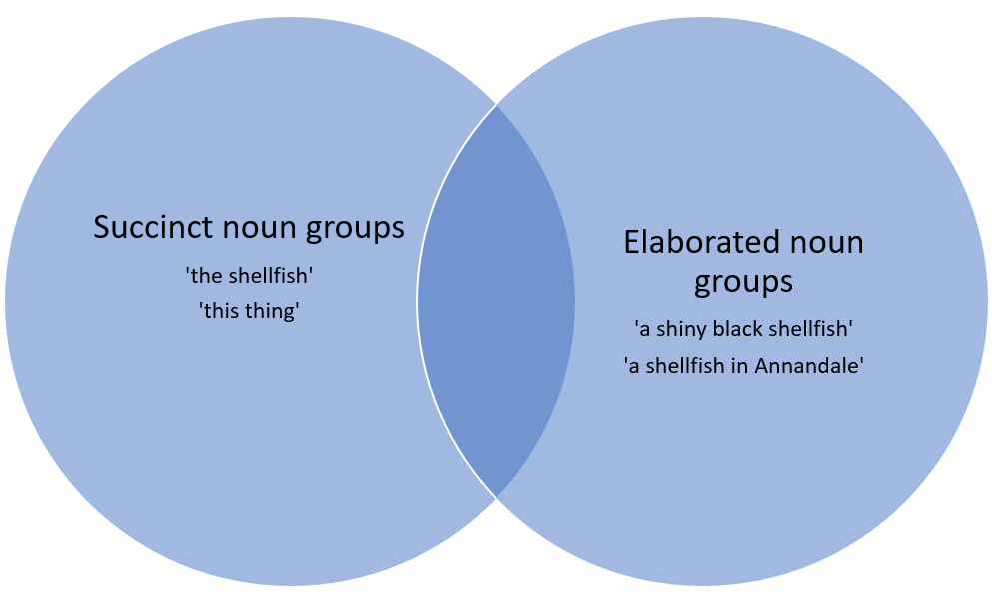
- In your writing journal, experiment with succinct and elaborated noun groups. Use at least one succinct noun group and one elaborated noun group to rewrite the opening of ‘The Marron’ from the point of view of the marron – How did it end up on the streets of Annandale?
- Complete the Venn diagram below for your chosen image from the ‘Applying understanding of noun groups’ slide in the PowerPoint Phase 4 – text annotations – Norton-Lodge – 11.1.
Figure 29 – Venn diagram for applying understanding of noun groups
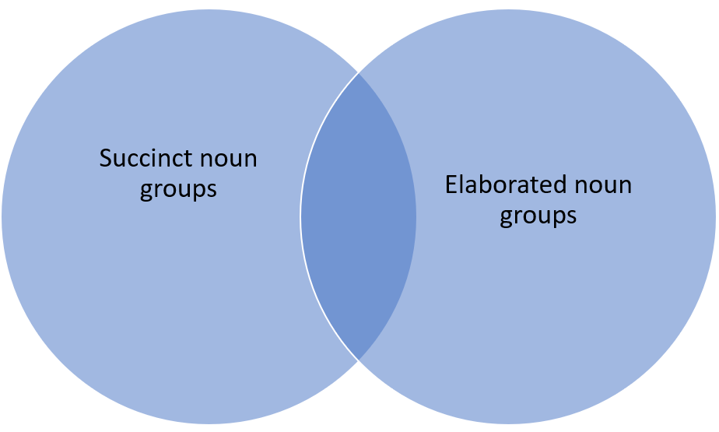

Phase 4, activity 5 – editing nouns and noun groups
Apply your understanding of nouns and nouns groups to edit and improve an existing composition. This should strengthen your unique and personal writing voice.
- In the first column, identify opportunities to refine your writing using noun groups.
- In the second column, write your new and improved version. The first row has been completed as an example.
- Work with your class to complete the second row.
- Use the blank cells for examples from your own work.
Table 28 – editing noun groups
Original | Edited version
‘When the world is windy and I am a candle’ | When the chaotic world is windy and I am a fragile candle
‘I dance while my brain races and my feet and legs try desperately to keep up’
3-2-1 exit ticket
- Complete the following tasks in your writing journal to submit to the teacher
- 3 – write 3 examples of nouns.
- 2 – write 2 examples of noun groups (one succinct and one elaborated).
- 1 – explain how using noun groups can improve your writing.

Phase 4, activity 6 – representations of identity in the core texts
Teacher note: clarify reading goals as suggested by Quigley’s (2020) REAL acronym (reading to retrieve, enjoy, analyse or link). Here, students read to analyse meaning. In the second stage of this activity, students will be reading to link – to make connections between texts.
When arranging groups for the jigsaw reading activity, use like-ability grouping and allocate texts appropriate to each group. Students who require further support may be given a bank of language features from the text that they can identify.
Student note: in the first part of this activity, your REAL reading goal is to (A) analyse. In the second part of the activity, you will be reading to (L) link – to make connections between the texts.
Jigsaw reading activity
Part 1
- With your group, re-read your allocated core text.
- Work together to identify the language features used by the composer to represent identity. An example from each of the core texts has been provided in the first row.
- As a group, decide which are your best 2 examples of the language features used by the composer to represent identity. You will share these with your new group.
Table 29 – jigsaw reading activity Part 1
Representation of identity | Language features
‘I like to call myself a runner’ (‘I run’)  ‘I was born in Hong Kong, in 1980. For the first few years of my life, I was reared on manga and anime, the Japanese terms for comics and cartoons. (‘What the doctor recommended’)  ‘… minimising Georgia’s freedom was a little pleasure …’ (‘The Marron’) | The declarative sentence represents the way that the speaker perceives their identity.  The factual detail of time and place provides context and explanation of the narrator’s identity. The cultural context of her Asian heritage has influenced her preference for manga and anime.  The emotive language in this honest reflection provides insight into the character as mischievous and playful.
Part 2
- You are now an ‘expert’ on how identity is represented in your allocated core text. Your group will now be re-formed to include an ‘expert’ on each of the core texts.
- Work with your new group to share your expertise and use theirs to complete the table below by identifying how each of the texts uses language to represent identity.
- When your table is complete, highlight in one colour language features that are common across the texts and in a different colour, language features that are unique to each text.
Table 30 – jigsaw reading activity Part 2
Core text | Representation of identity | Language features
‘I run’ by Melanie Mununggurr
What the doctor recommended by Queenie Chan
‘The Marron’ by Zoe Norton-Lodge

Phase 4, resource 3 – narrative pyramid example for ‘The Marron’
Teacher note: the example below can be used to differentiate this activity. Some students may benefit from providing a word bank from this completed example to support them to complete the pyramid.
Figure 30 – narrative pyramid example for ‘The Marron’
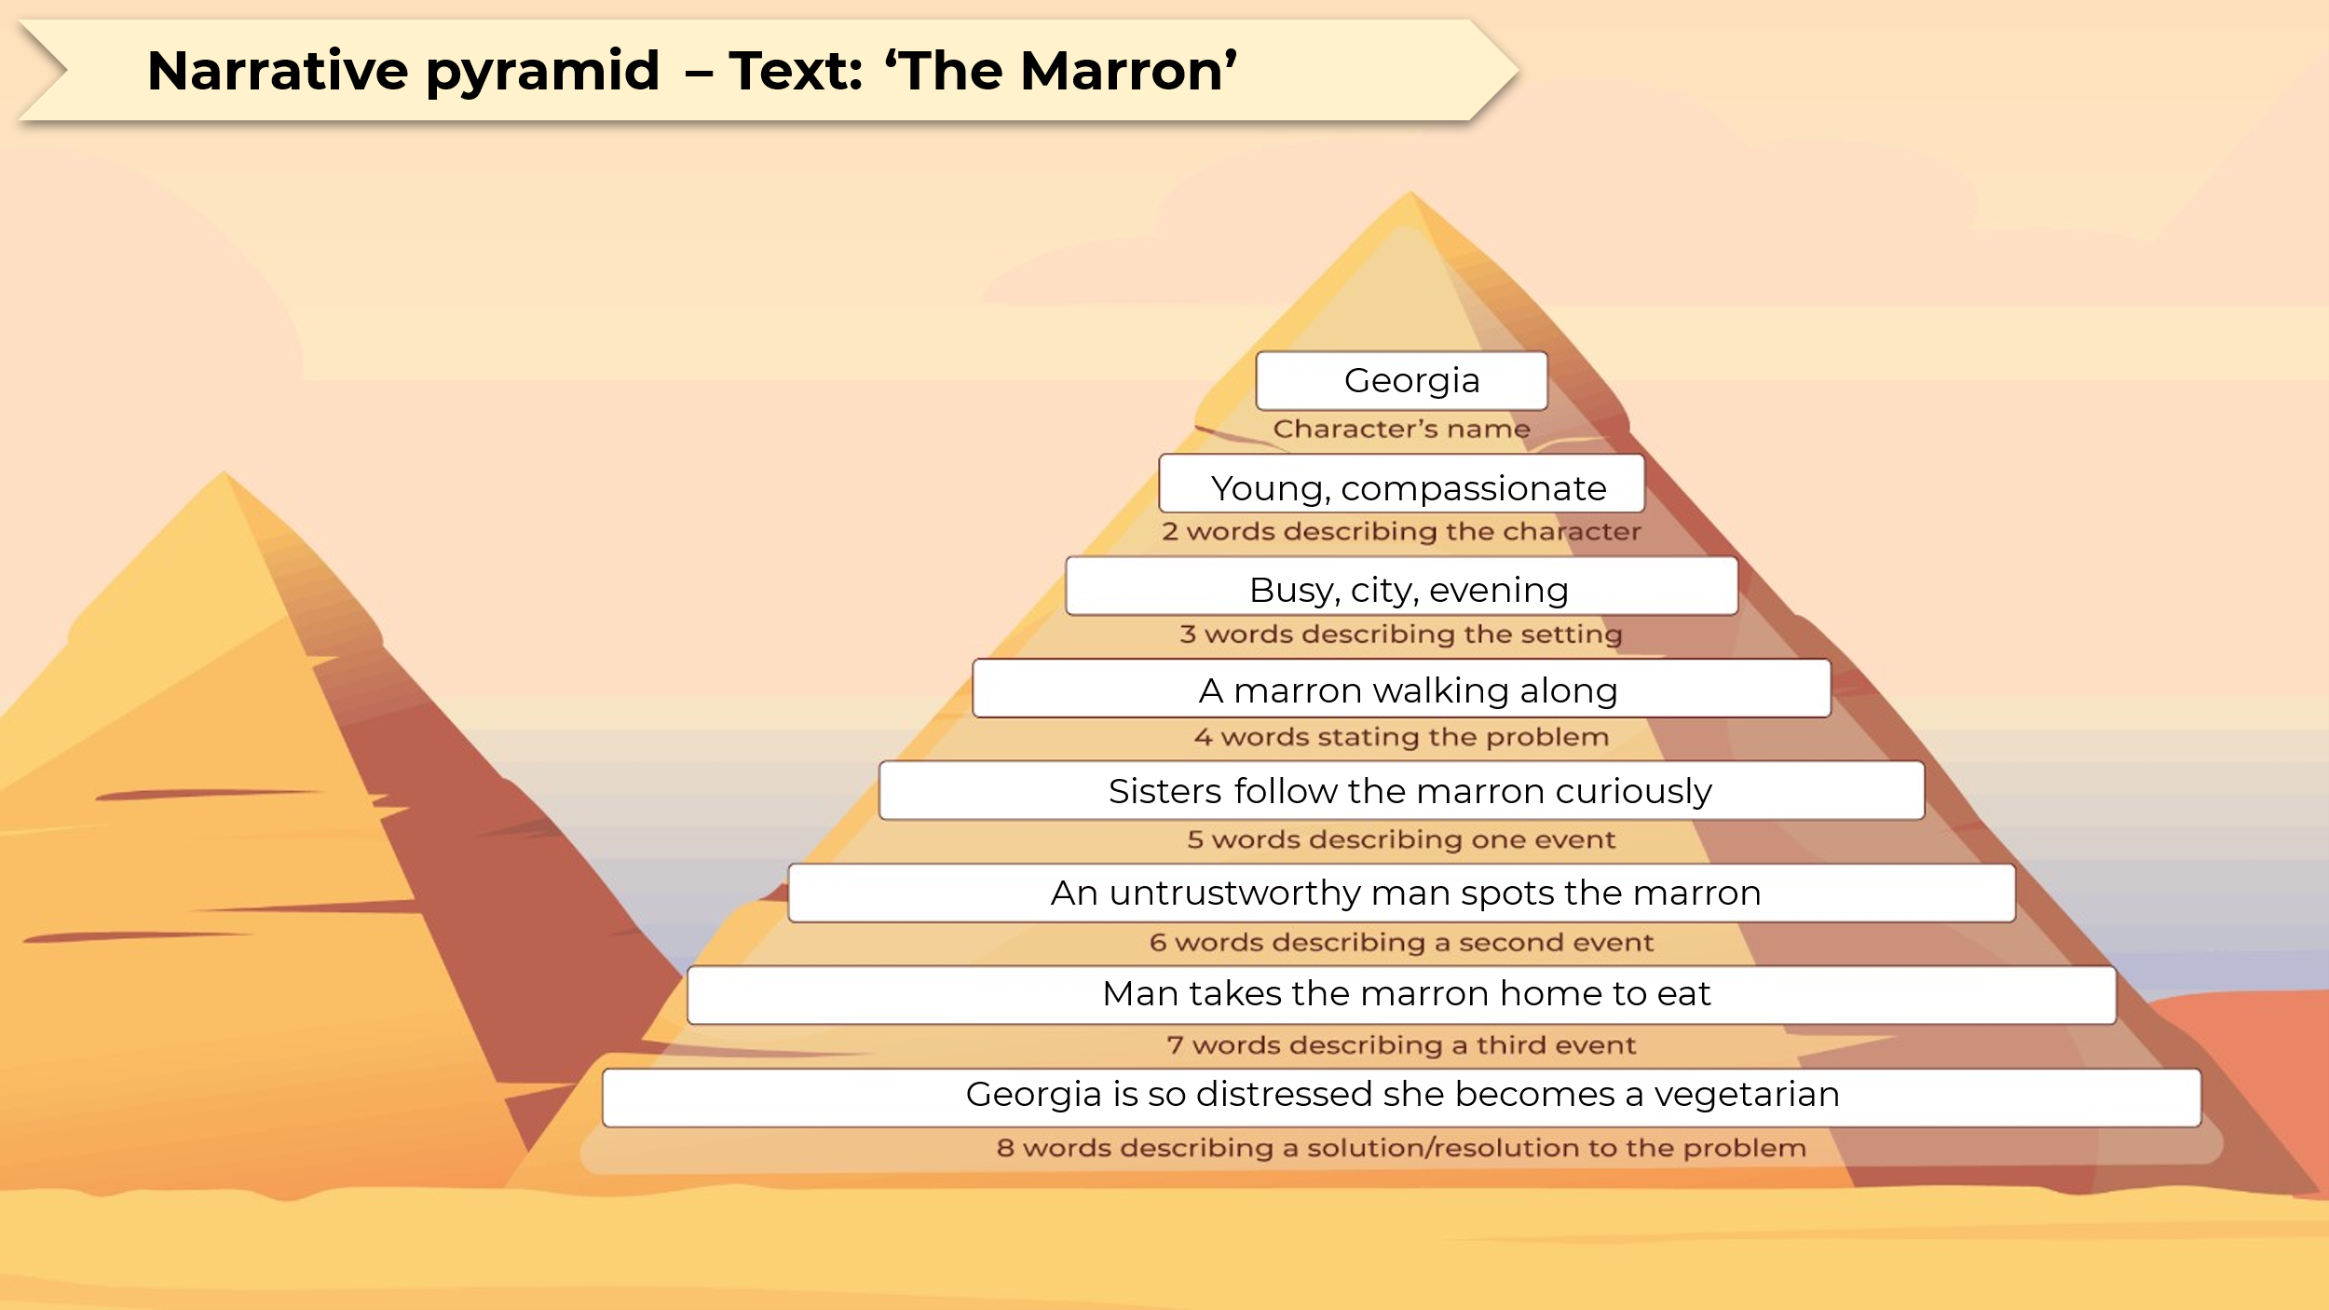

Core formative task 3 – narrative plan and extract
Teacher note: Figure 31 and Figure 32 should be printed for students. Alternatively, the template can be downloaded as an editable PowerPoint from Writing scaffolds (imaginative) in the Digital Learning Selector.
Student note: in Core formative task 2 – drafting a hybrid text you spent time in the planning and drafting stages of the writing process. You will do this again for Core formative task 3 – narrative plan and extract using a different strategy appropriate to the narrative text type.
- Use the Narrative pyramid template to identify key moments or events in Core text 3 – ‘The Marron’ by Zoe Norton-Lodge.
Figure 31 – narrative pyramid template for ‘The Marron’
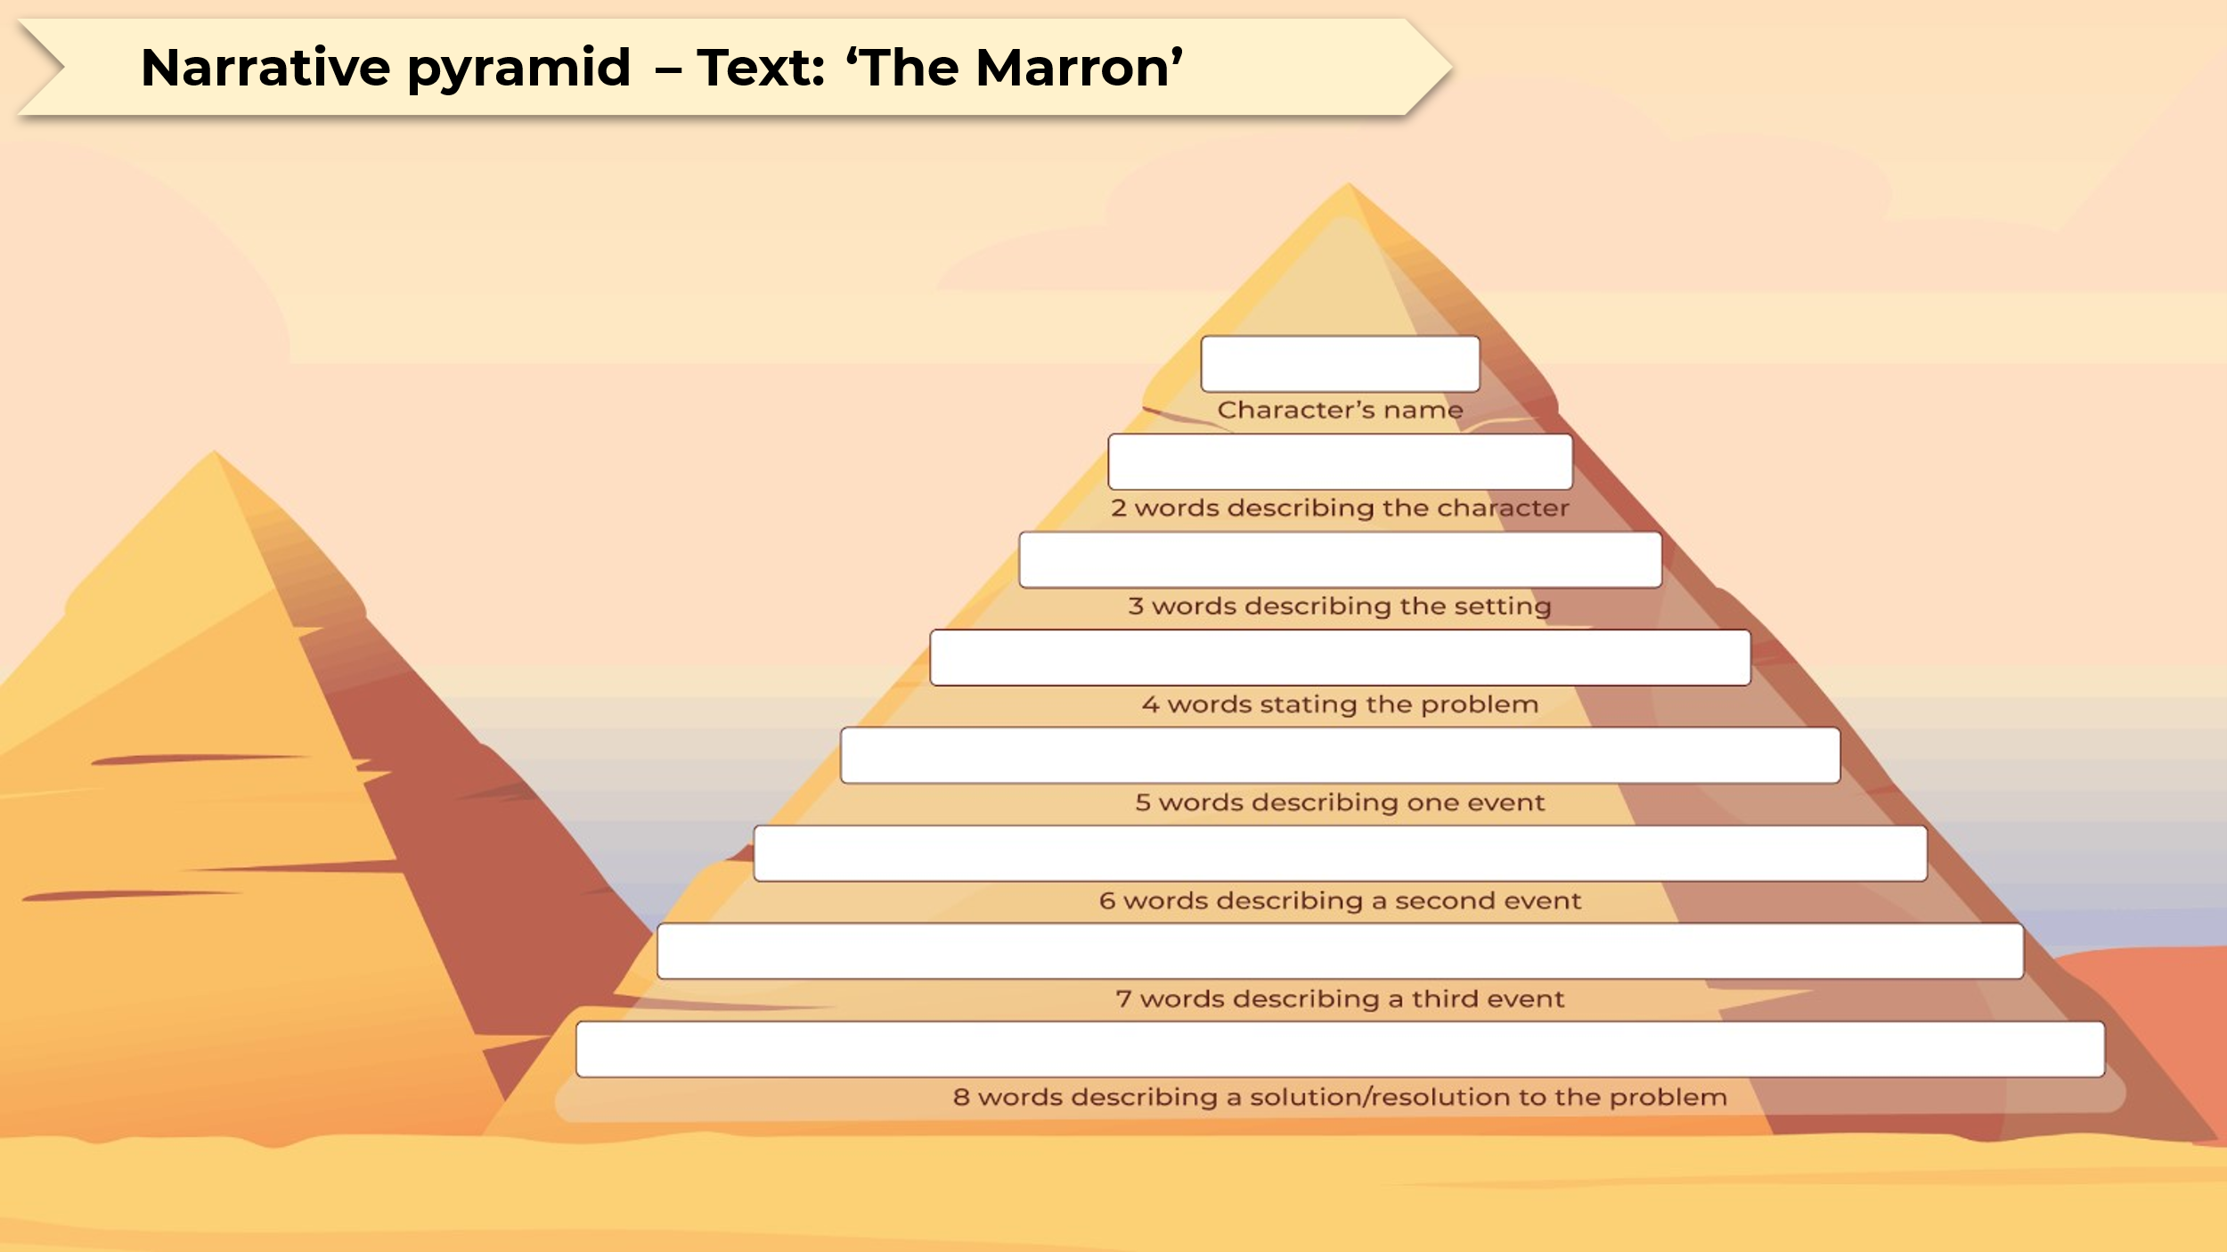

Planning to write
- For Core formative task 3 – narrative plan and extract, you will create a plan for a short narrative about a simple but extraordinary event in an ordinary setting that has a significant impact on the identity of a character.
- Use the blank Narrative pyramid template on the following page to plan your own narrative.
Figure 32 – narrative pyramid template
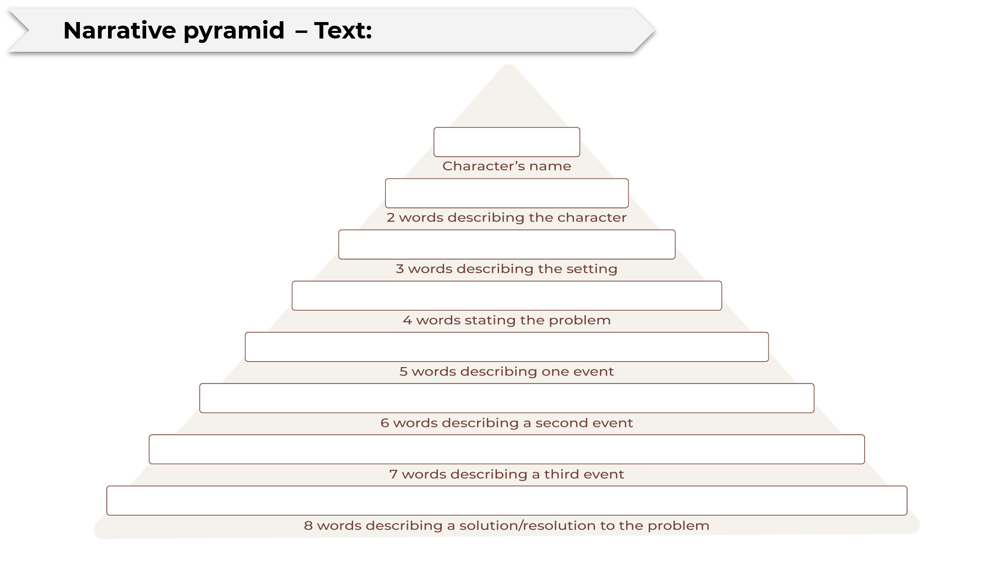
Drafting your response
- Write an extract from your narrative using the lines below. Use the narrative pyramid you have completed to support you to choose the extract to write. For example, you might write an extract about the setting, or you might write your extract about the second event you described in the narrative pyramid template. You should aim to write 150 to 200 words.

Revising and editing
- Revise your writing, paying particular attention to your use of noun groups. Look for opportunities to develop your personal voice by incorporating interesting noun groups as you did in Phase 4, activity 5 – editing nouns and noun groups.
- Use the Venn diagram below to revise your use of succinct and elaborated noun groups. You should aim for a combination of both.
Figure 33 – Venn diagram of noun groups for Core formative task 3
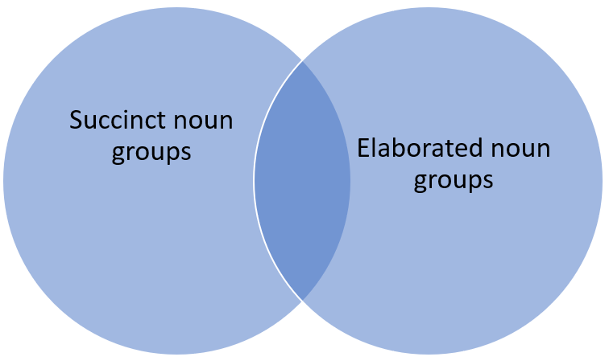

Phase 5 – composing critically and creatively in response to the focus area and texts
In the ‘composing critically and creatively in response to the focus area and texts’ phase, students explore and experiment with the core texts as a source of inspiration for their own compositions as they experiment with specific stylistic and language features that they have analysed in those texts. Phase 5 activities are integrated throughout Phases 2, 3 and 4 to provide students the opportunity to experiment with the language codes and conventions in their own compositions. Time in this phase is also dedicated to developing the pieces of writing from the first 3 core formative tasks. Students refine and edit their work during this phase as they draw on a range of editing strategies and feedback previously provided to improve their work.
Phase 5 activities have generally been integrated throughout Phases 2 to 4 in this program as students respond critically and creatively to the core texts. The learning sequence below is designed to provide structure to a series of lessons in which students should be developing and refining their portfolio of writing.

Phase 5, activity 1 – using the marking criteria to evaluate own work
- Use the marking criteria or the student-facing rubric to assess your portfolio of writing pieces by highlighting where your piece of writing reflects the features described.
- Give each one of your portfolio of writing pieces a grade.
- Use the table below to guide a reflection that will support you to select which piece of writing should be nominated for marking.
Table 31 – scaffold to support evaluation of own compositions
Reflections on your writing | Performance poem | Hybrid text |  | Narrative
What grade have you given this piece of writing?
What have you done well?
What could you improve?
How would you improve this piece?
How does this piece compare to your 2 other portfolio of writing pieces?
- Explain which piece of writing you will nominate to be marked for your portfolio of writing and why.

Core formative task 4 – reflecting on and responding to feedback
- Share with a small group of your peers (2 to 3) your current draft of the piece for your portfolio of writing that you will nominate for marking. Your groups’ members will share their piece with you.
- Use the Two stars and a wish protocol to provide feedback on the work of your peers and receive their feedback on your own work. Select an aspect of the learning from the program that you would like your peers to focus on in their feedback. For example, you may ask them to comment on your use of noun groups, the effectiveness of your use of metaphor, your use of textual hybridity or narrative elements. An example has been provided in the table below.
Table 32 – Two stars and a wish feedback
Me | Peer | Me
I would like feedback that I receive to be focused on my use of noun groups. | Star: I like the use of the noun group ‘glorious pain’ because it seems to be contradictory.  Star: I like the noun group ‘pale pink chiffon’ because it creates a very vivid image.  Wish: I wish you could add more information about your ‘brain’. Is it tired? Or alert? Or something else? | In response to this feedback, I will experiment with an elaborated noun group to describe my ‘brain’ in the poem.
I would like feedback that I receive to be focused on … | Star:  Star:  Wish: | In response to this feedback, I will …
- Use the sentence stems in the second row of the table to guide your interaction with your peer. As you engage with them about your work annotate your draft to record the feedback provided.
- Complete an entry in your writing journal documenting the changes you have made to your draft based on the feedback provided by your peers. If you choose not to action feedback provided, indicate the reason(s).

Phase 6 – preparing the assessment
In the ‘preparing the assessment’ phase, students strengthen the skills required for success in the assessment task. Students draw on a range of strategies to support them to edit their compositions and reflect on the writing process. This phase presents opportunities for students to provide, receive and action feedback on their work. Students deepen their understanding of the expectations for success in the assessment task by exploring a range of work samples and assessing these against the marking criteria and/or the student-facing rubric. Students build upon prior understanding of the purpose and features of reflective writing.
Phase 6 activities have generally been integrated throughout Phases 3 to 5 in this program as students strengthen the skills required for success in the assessment task. The learning sequence below is designed to be delivered after students have completed their draft pieces for the portfolio of writing.

Phase 6, activity 1 – comparing student work samples
Teacher note: to support students navigate the work samples, consider formatting the work samples in 2 columns. Alternatively, if completing this activity in small groups, make A3 copies for students to use. The first sample is reflective of a C-range response and the second sample is reflective of an A-range response.
- Read the 2 student sample responses below.
- Use the marking guidelines provided in the assessment notification to annotate the work sample. Highlight the features in the response that reflect the descriptions in the marking criteria.
Sample 1
Part A – performance poem ‘I game’
I game,
and the screen are glowing,
where different worlds meet,
and pixels turn my dreams real.
My fingers tapped the keys,
making sounds like music,
where I was the hero,
the one who decides what happens.
I game,
with the friends online,
we talking through headsets,
laughing and making plans,
as we beat levels,
build our teams,
and face tough challenges.
I game,
in my quiet room,
the noise outside fades away,
lost in adventures and battles,
every win feels good,
every lossed teaches me,
shapes who I am,
like the characters I played.
I game,
when I was feeling unsure,
when life felt tough,
I escape to places where I’m strong,
where I can fly,
where I can be,
who I want to be,
even if it’s just for a little while.
I game,
and in this space,
I find bits of meself,
the thinker, the fighter,
the friend, the dreamer,
I’m more than just a player,
I am alive,
I am here,
I game.
Sample 2
Part A – performance poem ‘I game’
I game
I game,
in the light of the screen,
where worlds come together,
and pixels make my dreams real.
My fingers tap on keys,
making sounds like music,
that becomes the soundtrack for an epic adventure
where I’m the hero,
the one who decides my fate.

I game,
with friends online,
we talk through headsets,
sharing laughs and plans,
as we beat levels,
build our teams,
and tackle hard challenges.

I game,
in my quiet room,
the outside noise disappears,
lost in adventures and fights,
every win feels great,
every loss teaches me,
shaping who I am,
like the characters I play.

I game,
when it’s late at night,
the stars are my friends,
the moon watches me,
as I celebrate wins and learn from losses,
the heartbeats of my characters,
feel like my own.

I game,
when I’m feeling unsure,
when life feels heavy,
I escape to places where I’m strong,
where I can soar,
where I can be,
who I want to be,
even if it’s just for a bit.

I game,
and in this space,
I find parts of myself,
the thinker, the fighter,
the buddy, the dreamer,
each character is a piece of me,
tied together,
in this fun world.

I game,
and while everything outside keeps going,
I make my own stories,
I create my own path,
with every pixel,
every quest,
I’m more than just a player,
I am alive,
I am here,
I game.

Phase 6, activity 2 – using the marking guidelines and annotations to refine a work sample
Teacher note: apply the table structure provided in this activity to create a separate table for the 2 remaining work samples. Provide copies of the tables for the hybrid text sample and the imaginative text sample. Use professional teacher judgement to determine how much support to include for students. The table below can be used as a guide.
- Read the work sample for the type of text you have decided you will nominate for marking.
- Use the student-facing rubric to support you to make notes on the work sample by highlighting what the student has done well and where they could improve.
- Read the annotations provided in the ‘suggestions for improvement’ column.
- Implement the suggestions provided to improve the student work sample in the table below. An example has been provided in the first and last rows.
Table 33 – refining the student work sample
Extract from work sample | Suggestions for improvement | Edited work sample
I game,  and the screen are glowing,  where different worlds meet,  and pixels turn my dreams real. | Experiment with more precise language choices to explore your perspective.  Apply consistent verb agreement – ‘are glowing’. | I game  The glowing screen is an arena  Where diverse worlds meet  And pixels breathe life into my hopes and aspirations.
My fingers tapped the keys,  making sounds like music,  where I was the hero,  the one who decides what happens. | Maintain consistent tense – the narrative changes from present to past tense.  Use punctuation for effect – consider where commas could be left out of your composition or where other punctuation types such as a dash, may affect the delivery of the text with greater purpose.
I game,  with the friends online,  we talking through headsets,  laughing and making plans,  as we beat levels,  build our teams,  and face tough challenges. | Clearer expression of thoughts and ideas about how these activities shape the composer would improve this stanza.  Use consistent verb agreement.  Experiment with language features to create a sense of connection in this stanza.
I game,  in my quiet room,  the noise outside fades away,  lost in adventures and battles,  every win feels good,  every lossed teaches me,  shapes who I am,  like the characters I played. | Maintain consistent tense – ‘lost’ and ‘lossed’ and ‘played’.  Consider incorporating language features from other core texts in your composition to extend your ideas and use of stylistic features.
I game,  when I was feeling unsure,  when life felt tough,  I escape to places where I’m strong,  where I can fly,  where I can be,  who I want to be,  even if it’s just for a little while. | Aim to incorporate more precise language to convey your perspective. | I game  When uncertainty weighs me down.  When life is challenging  I escape into different realms where I am powerful  Where I can soar  Where I can embody  Who I aspire to be  Even if only briefly.

Phase 6, resource 1 – definitions for reflective vocabulary
The following table can be used as a reference tool for students to develop vocabulary for reflective writing. It may also be adapted and used as a matching or information gap activity.
Table 34 – definitions for reflective vocabulary
Reflective vocabulary | Definition
challenging | Use this to describe difficulties encountered during your writing. For instance, ‘The task was challenging, pushing me to think critically’.
confusing | Use this word to describe aspects of the writing process that were unclear. For example, ‘Some of the feedback was confusing at first, leading to initial misunderstandings. I didn’t know what it meant to include more detail. When I asked questions about this, I understood it more’.
decision | This word can describe choices made during the writing process. For example, ‘The decision to include elaborated noun groups helped me to write with clarity and precision’.
enjoyable | This word can express positive feelings about certain aspects of the writing process. For example, ‘Sharing my writing with my peers was enjoyable because I was excited to hear what they thought about my ideas’.
expanded | Use this word when discussing how your ideas or understanding have grown over time. For example, ‘My understanding of the writing process expanded after planning my composition before drafting it’.
in comparison | Use this phrase to highlight differences or similarities between 2 aspects of your writing. For example, ‘In comparison to my imaginative task, the performance poem felt more engaging for the reader’.
modelled | This can refer to imitating or learning from examples. For instance, ‘I modelled my writing style after Melanie Mununggurr whose performance poem I enjoyed’.
ongoing | This word is useful for indicating processes or learning that continues over time. For example, ‘My learning is ongoing as I seek to improve my writing skills’.
perspective | This word can be used to discuss your viewpoint or insights gained. For example, ‘Gaining a new perspective on my identity helped shape my writing and the way I represented this to readers’.
practise | Use this to indicate the repetition of skills to improve writing. For example, ‘I practised my writing skills by completing multiple drafts of my compositions’.
reflective | Use this word to indicate moments of contemplation about your experiences. For example, ‘I had a reflective moment when considering what aspect of my identity I would share in my writing’.
repetitive | This can describe aspects of your writing process that required revisiting or redoing. For instance, ‘The editing process felt repetitive, but it was necessary to improve my writing’.
rewarding | This word expresses a sense of fulfilment after completing a task. For example, ‘Completing the project was rewarding, as I learned so much’.
supportive | Use this when referring to external help or feedback received during your writing. For example, ‘My peers were supportive, providing valuable insights during group discussions’.
unfortunately | This word introduces negative aspects or outcomes. For example, ‘Unfortunately, I did not complete the hybrid text because I was on work placement when we worked on this in class’.
whereas | Use this conjunction to contrast 2 different ideas or experiences. For example, ‘My previous writing assessments were mostly stories I made up whereas this one was about myself’.

Phase 6, activity 3 – reflection scaffold
Student note: Part B of your assessment requires you to write a reflection. Use the evaluative verbs and adverbs as well as the scaffold and support below to structure and refine your reflection.
Using evaluative verbs and adverbs
- Read the following extract from the student work sample:
‘I used the core text’s idea of focusing on a childhood memory as inspiration, and used my own imagined version that allowed me to show personal change in a relatable and humorous way.’
- This extract can be improved by including evaluative verbs and adverbs such as:
‘I effectively used the core text’s idea of focusing on examining a childhood memory as inspiration, and used my own imagined version that allowed me to show celebrate personal change in a relatable and humorous way.’
- Read the next extract from the same student work sample:
‘I tried to use a strong personal voice and make the story sound like how I would actually talk.’
- Include evaluative verbs and/or adverbs in the suggested spaces to improve the response.
‘I tried to use a strong personal voice to ___________and make the story sound like how I would actually talk_______________.’
- Read the next extract from the same student work sample:
‘I also want to keep developing my personal voice so that the reader can really understand how I see things.’
- Identify opportunities to include evaluative verbs and/or adverbs to improve the response and make the changes.
Scaffold for reflection
- Consider the guiding questions below to frame your thinking as you complete Part B of your assessment task.
- How and why did you select this piece for your final submission?
- What aspect of your identity did you explore in your composition?
- How did you use the core text to guide your own creation? Use explicit examples of structure and language features from the core text and your own composition to justify your authorial choices.
- How did each stage of the writing process support you to write your composition?
- How did you use the recursive writing process to refine your work?
- What has this task taught you about personal voice?
- There is no set structure for reflective writing, however, the scaffold below may help you organise your ideas. Use the prompts to draft your reflection in the middle column.
- Include some of the sentence starters and vocabulary provided below in your reflection.
Table 35 – sentence starters and vocabulary
Sentence starters | Vocabulary suggestions
My first choice was to …  The process of writing my …  Throughout the process …  I carefully …  Without applying the feedback I received … | challenging, confusing, decision, enjoyable, expanded, in comparison, modelled, ongoing, perspective, practise, reflective, repetitive, rewarding, supportive, unfortunately, whereas

- Make sure you have included the language features from the third column in your reflection. Do this by highlighting each feature in your work.
Table 36 – reflection scaffold
Structure | Your reflection | Language features
Introduction  Introduce the piece of work you are submitting for your final submission.  State which core text was its inspiration.  Explain why you selected this piece rather than the other pieces. |  | First person  Evaluative language – verbs and adverbs  Variety of correctly structured sentences (simple, compound and complex)  Correct subject–verb agreement  Consistent use of tense  Vocabulary choice is appropriate to a reflective response
Body paragraph 1  Identify the theme of your composition and how it reflects your identity. |  | First person  Evaluative language – verbs and adverbs  Variety of correctly structured sentences (simple, compound and complex)  Correct subject–verb agreement  Consistent use of tense  Vocabulary choice is appropriate to a reflective response
Body paragraph 2  How did you use the core text to guide your own creation? Use explicit examples of structure and language features from the core text and your own composition to justify your authorial choices. |  | First person  Evaluative language – verbs and adverbs  Variety of correctly structured sentences (simple, compound and complex)  Correct subject–verb agreement  Consistent use of tense  Vocabulary choice is appropriate to a reflective response
Body paragraph 3  How did each stage of the writing process support you to write your composition? How did you use the recursive writing process to refine your work? |  | First person  Evaluative language – verbs and adverbs  Variety of correctly structured sentences (simple, compound and complex)  Correct subject–verb agreement  Consistent use of tense  Vocabulary choice is appropriate to a reflective response
Conclusion  How do you feel about your submitted composition? What has this task taught you about personal voice? |  | First person  Evaluative language – verbs and adverbs  Variety of correctly structured sentences (simple, compound and complex)  Correct subject–verb agreement  Consistent use of tense  Vocabulary choice is appropriate to a reflective response

Core formative task 5 – sharing writing
Teacher note: this task is designed to consolidate strong connections between students in the classroom. It should be an opportunity to celebrate the achievements of the students in their first term of English Studies. If appropriate for your context, consider running this task as a literature reading event where students mingle and read the work of their peers. Ideally, students will have the opportunity to read work composed by each of their peers for this core formative task. If class size or time does not allow for this, assign work from at least 6 peers to each student to read.
Student note: it is noted on your assessment task that building strong connections in the classroom is essential for success in Senior high school. The first assessment task has been designed to support you to share aspects of your identity so that the teacher and your peers can get to know you better. This final core formative task for this program will support you to consolidate your understanding of your peers and celebrate your achievements in this first term of Year 11.
- Share the piece from your portfolio of writing with your peers. Your teacher may organise hard copies or require you to share a ‘view only’ digital copy to a specified online location.
- Read the work of your peers.
- On each piece of writing that you read, indicate
- one aspect of the writing that you liked
- one question you have about the writing or the content
- one thing you notice about how it has been written
- one connection to the core text that you can see.
- Nominate one of the pieces you have read for publication in the school newsletter.
- Provide an explanation in your final entry in your writing journal for explaining why you have nominated that piece. Use the following questions to guide your response
- What makes the main idea(s) of this piece engaging and relevant for the target audience?
- How does the piece demonstrate originality or creativity?
- How does the writer use language to connect with their audience?
- Why did this piece resonate with you personally?
- What specific aspects of the text made you want to nominate it?
- Why do you think others in the school community would enjoy reading this text?

References
This resource contains NSW Curriculum and syllabus content. The NSW Curriculum is developed by the NSW Education Standards Authority. This content is prepared by NESA for and on behalf of the Crown in right of the State of New South Wales. The material is protected by Crown copyright.
Please refer to the NESA Copyright Disclaimer for more information https://educationstandards.nsw.edu.au/wps/portal/nesa/mini-footer/copyright.
NESA holds the only official and up-to-date versions of the NSW Curriculum and syllabus documents. Please visit the NSW Education Standards Authority (NESA) website https://educationstandards.nsw.edu.au/ and the NSW Curriculum website https://curriculum.nsw.edu.au.
English Studies 11–12 Syllabus © NSW Education Standards Authority (NESA) for and on behalf of the Crown in right of the State of New South Wales, 2024.
Austen J (1894) Pride and Prejudice, Project Gutenberg website, accessed 28 March 2025. This work is in the public domain.
Beardwood R (2022) Literature Handbook: A Guide To Literary Analysis, Insight Publications, Australia.
Boas E and Kerin R (2021) Novel ideas: teaching fiction in the middle years, Australian Association for the Teaching of English, Kensington Gardens, SA.
CESE (Centre for Education Statistics and Evaluation) (2018) Cognitive load theory in practice, NSW Department of Education website, accessed 25 September 2024.
Chan Q (2016) What the doctor recommended, Australia. Reproduced and made available for copying and communication by NSW Department of Education for its educational purposes with the permission of Queenie Chan. The text contained in this resource is licensed up until 30 June 2030.
Glasswell K, Mostert W, Judd L and Mayn L (2016) Powerful Practices for Reading Improvement, ACER Press, Victoria.
Gurney L (1914) ‘One, Two, Three, Four Cake’ in Things Mother Used to Make, Project Gutenberg website, accessed 28 March 2025. This work is in the public domain.
Harvard Graduate School of Education (n.d.) Project Zero Thinking Routines Toolbox, Project Zero website, accessed 9 June 2025.
Hochman J and Wexler N (2017) The Writing Revolution: A Guide to Advancing Thinking Through Writing in All Subjects and Grades, Jossey-Bass, San Francisco.
McGraw A and Mason M (2022) Activating Reading Capabilities in English, Victorian Association for the Teaching of English (VATE), Collingwood.
Moss C and Brookhart S (2019) Advancing Formative Assessment in Every Classroom: A Guide for Instructional Leaders, 2nd edn, Association for Supervision and Curriculum Development (ASCD), United States.
Mununggurr M (6 November 2018) ‘Melanie Mununggurr – Australian Poetry Slam Champion 2018 “I Run”’ [video], Australian Poetry Slam, YouTube, accessed 10 April 2025.
Mununggurr M (2019) ‘I run’ in Stavanger D and Te Whiu A (eds) Solid Air: Australian and New Zealand Spoken Word, University of Queensland Press, St Lucia, Queensland. Reproduced and made available for copying and communication by NSW Department of Education for its educational purposes with the permission of Melanie Mununggurr. This resource is licensed up until 31 July 2030.
Norton-Lodge Z (2015) ‘The Marron’ in Almost Sincerely, The Giramondo Publishing Company Pty Ltd, Artarmon. ISBN: 9781922146854. Reproduced and made available for copying and communication by NSW Department of Education for its educational purposes with the permission of The Giramondo Publishing Company Pty Ltd. This resource is licensed up until 30 October 2026.
Quigley A (2020) Closing the Reading Gap, Routledge, Oxfordshire, UK.
State of NSW (Department of Education) (2020) ‘Touchdown (Year 6)’ in The School Magazine, Teaching Learning and Student Wellbeing Directorate, The School Magazine website, accessed 28 March 2025.
State of NSW (Department of Education) (2023) ‘Phases approach to conceptual programming’, Planning, programming and assessing English 7–10, NSW Department of Education website, accessed 13 September 2024.
——(2024) Teach NSW Goal Setting Resource, NSW Department of Education website, accessed 4 June 2025.
——(2025) ‘Engaging in critical thinking in English 7–10’, Planning, programming and assessing English 7–10, NSW Department of Education website, accessed 13 May 2025.
——(2025) ‘Explicit teaching strategies’, Explicit teaching, NSW Department of Education website, accessed 13 May 2024.
Shelley M (1818) Frankenstein, Project Gutenberg website, accessed 28 March 2025. This work is in the public domain.
Sly C (2022) ‘Guide to a better understanding and appreciation of manga texts’ in Scan: The journal for educators, 41(1):12–20, accessed 17 July 2025.

© State of New South Wales (Department of Education), 2025
The copyright material published in this resource is subject to the Copyright Act 1968 (Cth) and is owned by the NSW Department of Education or, where indicated, by a party other than the NSW Department of Education (third-party material).
Copyright material available in this resource and owned by the NSW Department of Education is licensed under a Creative Commons Attribution 4.0 International (CC BY 4.0) license.

This license allows you to share and adapt the material for any purpose, even commercially.
Attribution should be given to © State of New South Wales (Department of Education), 2025.
Material in this resource not available under a Creative Commons license:
- the NSW Department of Education logo, other logos and trademark-protected material
- material owned by a third party that has been reproduced with permission. You will need to obtain permission from the third party to reuse its material.
Links to third-party material and websites
Please note that the provided (reading/viewing material/list/links/texts) are a suggestion only and implies no endorsement, by the New South Wales Department of Education, of any author, publisher, or book title. School principals and teachers are best placed to assess the suitability of resources that would complement the curriculum and reflect the needs and interests of their students.
If you use the links provided in this document to access a third-party's website, you acknowledge that the terms of use, including licence terms set out on the third-party's website apply to the use which may be made of the materials on that third-party website or where permitted by the Copyright Act 1968 (Cth). The department accepts no responsibility for content on third-party websites.

