English Stage 5 (Year 9) – resource booklet – engage, orient, apply and evaluate
Exploring the speculative – Phases 1, 2, 5 and 6
This document contains the teacher-facing resources and activities that accompany the Year 9 teaching and learning program ‘Exploring the speculative’.

Contents
About this resource 4
Purpose of resource 4
Target audience 4
When and how to use 4
Texts and resources 5
Phase 1 – engaging with the unit and the learning community 9
Core formative task 1 – generating ideas 10
Phase 1, activity 1 – sharing ideas 11
Phase 1, resource 1 – exit ticket 12
Phase 1, activity 2 – Cornell note-taking method 13
Phase 1, resource 2 – definitions of genre 14
Phase 1, activity 3 – writing for different genres 16
Phase 1, activity 4 – building vocabulary 17
Phase 1, activity 5 – what’s the difference? 19
Phase 1, activity 6 – applying critical thinking 21
Phase 1, activity 7 – think, pair, share 23
Phase 1, activity 8 – concentric circle discussion prompts 24
Phase 1, resource 3 – concentric circle conversations 25
Phase 1, activity 9 – reading about the speculative fiction genre 26
Phase 1, activity 10 – conventions of speculative fiction 29
Phase 1, resource 4 – websites for researching sub-genres 30
Phase 1, activity 11 – researching sub-genres 31
Phase 1, activity 12 – comparing sub-genres 33
Phase 1, resource 5 – summaries of iconic speculative fiction texts 34
Phase 1, resource 6 – the evolution of speculative fiction 37
Phase 1, resource 7 – contextual influences timeline 39
Phase 1, activity 13 – understanding the structure of a timeline 40
Phase 1, activity 14 – connections between texts and contexts 41
Phase 1, resource 8 – extracts from speculative fiction texts 43
Phase 1, activity 15 – jigsaw reading activity 54
Phase 2 – unpacking and engaging with the conceptual focus 59
Core formative task 2 – reflecting on self-selected texts 60
Phase 2, resource 1 – short speculative fiction texts 62
Phase 2, activity 1 – visual language and stylistic features 64
Phase 2, resource 2 – visual language and stylistic features 67
Phase 2, activity 2 –The Giant and the Sea front cover 70
Phase 2, resource 3 – extract from The Giant and the Sea 71
Phase 2, activity 3 – identifying the themes in the picture book 72
Phase 2, activity 4 – identifying conventions of speculative fiction 73
Phase 2, activity 5a – modelled deconstruction of The Giant and the Sea 74
Phase 2, resource 4 – annotation of sample paragraph 77
Phase 2, activity 5b – guided deconstruction of The Giant and the Sea 79
Phase 2, activity 5c – independent deconstruction of The Giant and the Sea 81
Phase 2, activity 6 – identifying the audience and purpose 83
Phase 2, activity 7 – 3, 2, 1 exit ticket 84
Phase 2, activity 8 – engaging with the assessment task notification 85
Phase 2, activity 9 – word clines 87
Phase 5 – engaging critically and creatively with model texts 89
Phase 5, activity 1 – speedy circles 90
Phase 5, resource 1 – ‘exquisite corpse’ 92
Phase 5, activity 2 – character profile 94
Phase 5, activity 3 – planning for imaginative writing 97
Phase 5, activity 4 – guided discussion 99
Phase 5, resource 2 – our school in 2250 sample 102
Phase 5, activity 5 – our school in 2250 105
Phase 5, resource 3 – debate topics 110
Phase 6 – preparing the assessment task 111
Phase 6, resource 1 – elements of a feature article 112
Phase 6, activity 1 – feature article headlines 115
Phase 6, resource 2 – how to hyperlink 117
Phase 6, resource 3 – sample responses 119
The future is now: the potential power of speculative fiction on young readers 119
Boys and their feelings 122
Phase 6, activity 2 – using the student-facing rubric 125
Phase 6, activity 3 – exploring the annotated sample assessment 127
Phase 6, activity 4 – self-feedback 128
Phase 6, activity 5 – peer feedback 133
Phase 6, activity 6 – actioning feedback 141
Phase 6, activity 7 – student-teacher conference 143
References 147

Updating the table of contents
Want to update the table? Have you added content to the document and noticed the page numbers have changed? As you add content to this report, you can update the table of contents to accurately reflect the page numbers within the resource. To update the table:
- Right click on the table and select ‘Update table of contents’ (in the browser version) or ‘Update field’ (in the desktop app). In the browser version, it will automatically update the entire table.
- In the desktop app, you will then need to select ‘Update entire table’. Your table numbers should then update to reflect your changes.

About this resource
This teacher resource booklet is not a standalone resource. It has been designed for use by teachers in connection to Year 9 resources designed by the English curriculum team for the English K–10 Syllabus (NESA 2022). These include the Year 9 scope and sequence, Year 9 ‘Exploring the speculative’ program and the Year 9 Term 4 sample assessment task, which includes a student work sample. All documents associated with this resource can be found on the Planning, programming and assessing English 7–10 webpage.

Purpose of resource
The content in this resource booklet has been prepared by the English curriculum team, unless otherwise credited. Some of the information is collated from relevant NESA and department documentation. It is important that all users re-read and cross-reference the relevant syllabus, assessment and reporting information hyperlinked throughout. This ensures the content is an accurate reflection of the most up-to-date syllabus content. Links contained within this resource were correct as of 16 February 2024.

Target audience
These samples are intended to support teachers as they develop contextually appropriate teaching and learning resources for their students’ needs. The program and associated resources are not intended to be taught exactly as is presented in their current format. There are instructions for the teacher and instructions for the student throughout the resources and activities. Teachers using this resource booklet should edit and refine these to suit their students’ needs, interests, abilities and the texts selected.

When and how to use
This resource booklet, which includes resources and activities for Phases 1, 2, 5 and 6, has been designed for the Term 4 Year 9 teaching and learning program – Exploring the speculative. It provides opportunities for the teacher to introduce the conceptual focus of the teaching and learning program and prepare for assessment before exploring substantial text(s) in Phases 3 and 4.
The teaching and learning activities within Phases 1 and 2 should be used to introduce the program and its conceptual focus. The activities in Phases 5 and 6 can be used alongside or after the delivery of the teaching and learning activities contained in English Stage 5 (Year 9) – teaching and learning program – television series – Exploring the speculative – Phases 3a and 4a – Crazy Fun Park and English Stage 5 (Year 9) – teaching and learning program – Exploring the speculative – Phases 3b and 4b – The Giver and their associated resource booklets.
Teacher-facing material has been included as a ‘resource’, while student-facing material has been labelled ‘activity’ in this booklet. The resources and activities can be used as an example and adapted for the teacher’s own design of resources. The booklet also serves as an example of how resources and activities can be designed for the English K–10 Syllabus (NESA 2022). The resources and activities should be used with timeframes that are created by the teacher to meet the faculty and school assessment schedules.

Texts and resources
A succinct overview of the texts required for the teaching and learning program are outlined in the table below. This brief overview provides the name and details of each text, the syllabus requirement being addressed and points of note.
Table 1 – core texts and their alignment to the text requirements
Text | Text requirement | Annotation and overview
Jamieson T and Cai R (2020) The Giant and the Sea, Lothian Children’s Books, Australia and New Zealand.  The extracts included in this resource have been reproduced and made available for copying and communication by NSW Department of Education for its educational purposes with the permission of Hachette Australia. We are grateful for their support in the development of this resource. This resource is licensed up until May 2027. | This text is a moderately complex text as per the National Literacy Learning Progressions (NLLP) (V3), due to the visual features which add subtlety to text meaning.  EN5-RVL-01 requires students to use a range of personal, creative and critical strategies to engage with complex texts. The picture book meets the Text requirements for English 7-10 as students are required to study a range of text types which give them experiences of a range of cultural, social and gender perspectives, including from popular and youth cultures. | This picture book uses both print and visual features to explore the generational impact of climate change. The lack of organic colour, colour inversion and compositional axis will allow students to explore how layers of meaning are shaped in texts. Engaging with this text will help introduce students to and build an awareness of speculative fiction conventions.
Lowry L (2014) The Giver, HarperCollins Children’s Books, London.  No extracts have been included from The Giver. | This text is a complex text as per the NLLP (V3). The text contains some complex figurative language such as euphemism. Effective imagery is used throughout, the ideas explored are challenging and inferential reading is required to understand implicit meaning.  EN5-RVL-01 requires students to use a range of personal, creative and critical strategies to engage with complex texts. The novel supports the requirement for students to study at least 2 works of extended prose (including at least one novel) as outlined in the Text requirements for English 7–10. | This novel falls into the utopian and dystopian sub-genre of speculative fiction. It explores real-world concerns such as eugenics, limiting the human experience and the tension between conformity and individuality. Symbolism is integral to world building in this text, which will support students to develop their understanding of the conventions of speculative fiction. The text explores some mature themes, such as euthanasia and the murder of children. The impact of these representations on students and context should be considered before selecting this text.
Verso N and Hickey S (directors) (2023) Crazy Fun Park [television series], ABC, Melbourne.  The series trailer, episodes 4, 9, 10 and an extract from episode 3 have been reproduced and made available for use by NSW Department of Education for its educational purposes with the permission of Australian Children’s Television Foundation. We are grateful for their support in the development of this resource. This resource is licensed up until March 2029. | This television series is a complex text as per the NLLP (V3). The text explores complex, abstract concepts using historical and cultural allusion to create subtle inferences and implied meanings. The structure includes shifts in time to represent ideas that can be challenging or unconventional.  EN5-RVL-01 requires students to use a range of personal, creative and critical strategies to engage with complex texts. This text meets several of the requirements outlined in the Text requirements for English 7-10; the series can be considered as one of ‘at least 2 films’, as well as meeting the requirement for students to have experiences of a range of cultural, social and gender perspectives, including from popular and youth cultures. | This 10-episode speculative fiction television series explores a range of themes pertinent to teenagers such as belonging, friendship, grief and growing up. The series draws on the conventions of a range of genres including horror, comedy and mystery. This allows students to explore genre hybridity. The television series explores mature themes of teenage death and feelings of grief and loss. The impact of these representations on students and context should be considered before selecting this text.

Phase 1 – engaging with the unit and the learning community
The focus of the ‘engaging with the unit and the learning community’ phase is to introduce students to the speculative fiction genre. They will develop an understanding of the different characteristics of speculative fiction texts. Students will explore how the genre has evolved in response to different contexts. They will engage in a writing task intended to stimulate their thinking and speculate about what the future could involve.

Core formative task 1 – generating ideas
Teacher note: speculative fiction is a genre that encompasses a range of sub-genres. It is important to note that not all speculative fiction is set in the future. However, the purpose of this core formative task is to develop students’ understanding of the process of speculation in a low-stakes and engaging context.
The purpose of this first core formative task is to provide you with the opportunity to speculate on the future in a low-stakes and engaging context.
- What if you could travel through time? Imagine that you have just returned from a world-first voyage through time. You have visited the year 2250. What is the world like? You have been asked to communicate your experiences to your peers.
- You may represent your ideas through:
- a written description
- a storyboard or comic strip
- a completed graphic organiser
- an alternative form negotiated with your teacher.
- You have 20 minutes to complete this task.

Phase 1, activity 1 – sharing ideas
- Find at least one other student who included one of the same features as you did in your vision of the future. If you cannot find a student who included the same feature as you, connect with a peer whose vision of the future was very different from your own.
- Engage in a brief discussion with your partner where you question each other about your visions of the future using the ‘What makes you say that’ thinking routine asking each other:
- What’s going on?
- What makes you say that?
- Infer from the data collected by the teacher, and the discussion with your peer, what is the issue that teenagers are most concerned about for the future?

Phase 1, resource 1 – exit ticket
Teacher note: the following table is adapted from the Exit ticket stub template found on the Digital Learning Selector.
- Reflect on your learning by completing the exit ticket in the table below.
Table 2 – adapted exit ticket stub
Question | Student reflection
What part of the lesson did you enjoy the most?
What would you like to learn next?
How did you contribute to today’s lesson?

Phase 1, activity 2 – Cornell note-taking method
Teacher note: the Cornell note-taking method has been explored in detail in Year 9 Term 2 – Shining a new (stage) light in Phase 5. Access these resources for revision if necessary.
Student note: You should be familiar with the Cornell note-taking method; it was introduced in Year 9 Term 2 – Shining a new (stage) light in Phase 5.
- Use the template below to record summary notes of your learning as you engage with a range of texts that explore the textual concept of genre.
Table 3 – Cornell note-taking method template
Key words, comments and questions | Notes
New language and its definition (make sure the definition is relevant to the topic)
Most important ideas
Summary – what have I learnt?

Phase 1, resource 2 – definitions of genre
English textual concepts definition
What it is
Genre simply means ‘type’ or ‘kind’ and refers to groups of texts that have similarities in form and function.
Genres are not prescribed categories but have developed through trial and error as the most effective way to achieve a purpose. Some aspects of genres may remain stable and recognisable while others may grow and change over time to reflect new concerns and new values. Similarly, as new media emerge, genres adapt to new technologies.
So, to take the example of the ‘adventure’ genre, the pattern of the plot may remain the same but the character and the action will change according to the context: the medieval knight slaying a dragon transforms into the sheriff ridding a town of a malicious gun-slinger or into the spy outmanoeuvring a political foe or into the scientist averting a threat to the planet from outer space.
Most texts are not pure examples of a genre but contain elements of several:
- the ‘adventure’ stories above could also be classified respectively as medieval romance, western, thriller, or science fiction
- ‘real life’ documentaries are usually structured as narratives
- a medium such as a web page will combine various genres to achieve its purpose.
Why is it important?
All kinds of texts, imaginative, persuasive and informative, follow recognisable genres. There is a sense of ease and pleasure in the familiarity of a genre and a way of categorising likes and dislikes.
The study of genre enables us to see relationships between texts, the ways they are similar and the ways they are different or even innovative. It allows us to support students in analysing texts and in writing particular kinds of texts as it provides guidelines for structure, identifiable features and ways to deviate from conventional approaches.
The more students read in a genre, the more they are aware of the expectations it sets up. These expectations may be realised or disappointed, so confirming or challenging the ways that generic conventions are used to represent the world.
NESA definition
According to the NESA glossary, ‘genre’ refers to the categories into which texts are grouped. The term has a complex history within literary and linguistic theory and is often used to distinguish texts on the basis of, for example, their subject matter (detective fiction, romance, science fiction, fantasy fiction) and form and structure (poetry, novels, short stories).

Phase 1, activity 3 – writing for different genres
- Using your knowledge of the common features found in texts belonging to the same genre, respond to the following writing prompts.
- Write a single sentence romance story.
- Write what happens next in this horror story: ‘I was sure I was not alone…’
- Describe the landscape of a planet that could be used as the setting for a science fiction film.
- What is one thing a character might say in an historical fiction story?
- Think of a tagline that could be used for a comedy film.
- Describe the protagonist and antagonist of a superhero comic.
- In pairs, take turns to read a section from one of your responses aloud. Your partner should correctly identify the genre. Your partner should provide verbal feedback about the conventions of genre that they identified.

Phase 1, activity 4 – building vocabulary
Teacher note: this table could be used throughout this program to support students in developing their vocabulary if they encounter unfamiliar words. For EAL/D learners and learners with additional needs, consider including some relevant images to support their understanding and guide their completion of the task.
- Complete the table below for the word ‘speculate’.
Table 4 – building vocabulary
Definition strategy | Student answer
Word | Speculate
Dictionary definition
Own definition
Use in a sentence
Synonyms
Antonyms
Word root
Other forms of the word

Phase 1, activity 5 – what’s the difference?
You will reflect on some of the vocabulary you have been using through your study of the speculative fiction genre to gain a better understanding of how and when it is most appropriate to use them.
- For each term in Table 5 – vocabulary definitions below, write a definition and sentence that reflects your current understanding of what each term means in the ‘My definition and an example of how it can be used in a sentence’ row.
- Walk around the classroom and find a peer to compare your definitions and examples with. Record peer definitions and examples in the ‘Peer 1: definition and an example of how it can be used in a sentence’ row.
- Discuss any similarities or differences in your understanding of the terms as well as any challenges faced in the process of defining them, noting these in the ‘Discussion points’ row.
- Repeat the process above with another peer and record definitions and examples in the ‘Peer 2: definition and an example of how it can be used in a sentence’ row.
- Share your ideas in the class discussion facilitated by your teacher and copy the generated class definition in the final row of the table.
Table 5 – vocabulary definitions
Term | Speculate | Predict | Extrapolate
My definition and an example of how it can be used in a sentence
Peer 1: definition and an example of how it can be used in a sentence
Peer 2: definition and an example of how it can be used in a sentence
Discussion points
Class definition

Phase 1, activity 6 – applying critical thinking
In this activity, you will critically apply your understanding of the nuances of the terms ‘speculate’, ‘predict’ and ‘extrapolate’.
- Read the article ‘17 Times The Simpsons Accurately Predicted the Future’.
- Read the article for a second time. On this reading, choose the 3 examples that you find most interesting and complete the first 3 columns of the table below.
Table 6 – 17 times The Simpsons accurately predicted the future
The Simpsons example | Term I think best suits this example:  speculate  predict  extrapolate | Justify your choice of term | Notes
Teacher note: you may choose to change the peer discussion format outlined below to better suit the needs of your class. For example, you may choose the 3 examples from the article and put students in smaller groups to discuss or choose examples to discuss as a class.
- When prompted by your teacher, find a peer who has selected one of the examples that you have. Together, discuss your chosen terms and justifications. Note any differences or interesting points made in the final column of Table 6. You may also like to discuss the use of ‘predicted’ in the title of the article.
- Repeat this process until you have discussed all your chosen examples. Make sure you find a new peer each time; do not discuss more than one example with the same peer.
- Read through and reflect on your initial thoughts and any notes you have made for the examples after discussion with your peers. Contribute your thoughts to the class discussion when prompted by your teacher.
- Write a brief reflection on what you have learned from this activity. You may like to consider some of these prompts to get you started:
- How confident were you in your initial completion of the table? Why?
- Did your thoughts on any terms you allocated to examples change once you discussed them with your peers? Why or why not?
- Did anything about the activity surprise you? Explain.
- Is there anything you are still unsure about? Explain.
- What have you learned about vocabulary from this activity?
- How might this influence your use of or thoughts around vocabulary in the future?

Phase 1, activity 7 – think, pair, share
Use the Think, Pair, Share thinking routine to respond to the following questions about speculative fiction:
- Now that you understand what it means to ‘speculate’ or to be ‘speculative’, what do you think speculative fiction is?
- How many texts have you engaged with that could be considered to belong to the speculative fiction genre?
- Why do you think that speculative fiction is such a popular genre?

Phase 1, activity 8 – concentric circle discussion prompts
- Read the following discussion prompts.
- Record your personal response to the prompts.
Concentric circle discussion prompts
- Knowing what ‘speculation’ means, where have you seen speculation occur in texts?
- What have you seen or read that could be considered ‘speculative’?
- In texts that you have identified as speculative, what are the concerns upon which the composer has speculated?
- What do you think has inspired this speculation?
- Thinking about one of the texts you have discussed, what comment do you think the composer was trying to make through the text?
- What purpose do you think the composer was trying to achieve?
- Was the composer successful in achieving the purpose? Why or why not?

Phase 1, resource 3 – concentric circle conversations
Teacher note: concentric circle conversations or discussions can encourage all students to participate as active listeners and speakers. Minimising the pressure of sharing ideas in a larger group, such as in a class discussion, can support all students to develop confidence in articulating their ideas.
- Provide students with the concentric circle conversation prompts. Allow them time to make notes in response to the prompts.
- Students are arranged in 2 concentric circles. Students on the inside and outside circles should face each other.
- Students will have 3 minutes (this time may be adjusted according to the needs of the class) to discuss their response to the first prompt. It may be useful to provide further structure such as allocating one minute for the student in the inside circle to speak, one minute for the student in the outside circle to speak, and then the final minute for both students to ask clarifying questions and expand upon the ideas they have contributed or that they have heard.
- After the time is up, instruct students in the outside circle to move 2 places in an anti-clockwise direction. They will face a new partner and repeat the process with a new discussion prompt.
- Continue this process until each of the prompts have been discussed.

Phase 1, activity 9 – reading about the speculative fiction genre
Teacher note: Quigley (2020) suggests using vocabulary bookmarks to help record key vocabulary.
Student note: the table that you develop for this activity should help you when you are composing your feature article for the assessment task for this program.
In pairs, you will read the article ‘What is Speculative Fiction?’ and complete a summary table noting key information and features of the speculative fiction genre.
- Read the article with your partner. Take turns to read a section of the article aloud.
- You will categorise the vocabulary in the article. Decide with your partner what categories you will use for this task. Examples could include challenging words, topic specific vocabulary, transition words, new words, colloquial words and expressions, and descriptive language.
- Organise the vocabulary from the article into the table below. It is not necessary to categorise every word from the article. You should aim for at least 4 to 8 words in each category. A sample table has been included as a model.
Table 7 – vocabulary bookmarks activity
Category 1 | Category 2 | Category 3 | Category 4
Table 8 – vocabulary bookmark activity model
Challenging words | Topic specific vocabulary | Transition words | Descriptive language
Dominant  Elemental  Byproduct  Scope  Apocalyptic  Triumvirate | Speculative  Science fiction  Character  World-building  Genres  Sub-genres | Therefore  So  Another example  Now  If | Terrifying  Overwhelming  Complicated  Limitless  Mysterious
- Share your table with another pair of students.
- Observe the different choices that were made when creating the categories and organising the words.

Phase 1, activity 10 – conventions of speculative fiction
- Use your prior knowledge, your class discussions and your understanding of the article ‘What is Speculative Fiction?’ to complete the template below. Some initial ideas have been provided as an example.
Figure 1 – conventions of speculative fiction
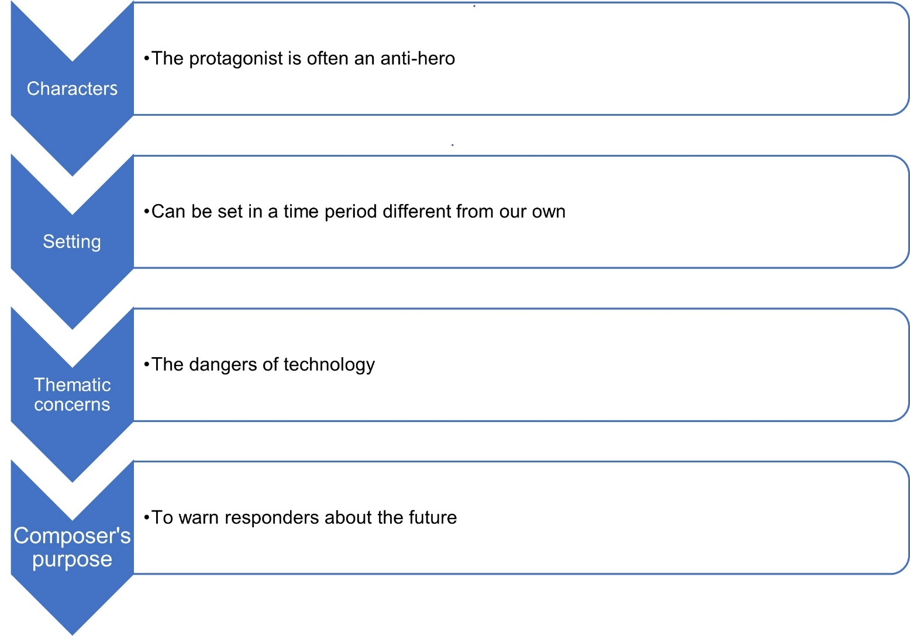

Phase 1, resource 4 – websites for researching sub-genres
Students may be directed to the following websites for researching sub-genres of speculative fiction:
- What Is Speculative Fiction? Defining and Understanding the Different Genres of Speculative Fiction – (MasterClass)
- Types of Speculative Fiction Novels, With Examples for Each Subgenre (cornettfiction.com)
- Speculative fiction (Wikipedia)
- Exploring Speculative Fiction: Your Guide to this Super-Genre (TCK Publishing)
- Understanding Our World: Speculative Fiction Through the Ages (campfirewriting.com)

Phase 1, activity 11 – researching sub-genres
Teacher note: the following activity can be used to introduce students to lateral reading as a strategy to develop effective research skills. This is a brief introduction only which will be used to a greater extent in Phase 4. Further information on this strategy can be found on the Civic Online Reasoning’s Intro to Lateral Reading webpage.
Student note: it is important to develop effective research skills. This involves using strategies to help you consider critically the information that you find during the research process. Lateral reading can help you to evaluate the accuracy, value and authority of information that you find.
- The teacher will demonstrate or guide you through the process of lateral reading by conducting an internet search using the phrase ‘sub-genres of speculative fiction’.
- The teacher will open or instruct you to open 3 to 4 of the search results in different tabs.
- You will move from one tab to the next, reading laterally rather than vertically from top to bottom as you would in a book.
- Use the Think, Pair, Share thinking routine to respond to the questions below.
- How many sub-genres of speculative fiction were identified in each of the articles?
- Which sub-genres were excluded from one or more of the articles?
- Why is the information not identical across all the articles?
- If you had read only the first article, how would your understanding be impacted?
- How do you know which of the articles provides the correct information?
- You will be allocated one of the following sub-genres of speculative fiction to research:
- Science fiction
- Horror
- Utopian and dystopian
- Alternate history
- Post-apocalyptic
- Fantasy
- Supernatural
- Superhero
- Magical realism.
- Use the lateral reading strategy, consulting at least 3 different websites, to complete the table below.
Table 9 – sub-genres of speculative fiction
Conventions of the sub-genre | Three interesting facts about the sub-genre | Examples of texts belonging to the sub-genre

Phase 1, activity 12 – comparing sub-genres
- Work in a small group with 2 to 3 peers who researched a different sub-genre to you. For example, you researched fantasy and are in a group with a student who researched horror and another student who researched science fiction.
- Compare the findings from your research (Phase 1, activity 11 – researching sub-genres) with the findings from your peers’ research by completing the following table.
Table 10 – comparing sub-genres
Sub-genre 1  Conventions, facts, examples | Sub-genre 2  Conventions, facts, examples | Sub-genre 3  Conventions, facts, examples
- Discuss with your group the following questions:
- What are the similarities between the sub-genres?
- What are the differences between the sub-genres?
- How can they all be considered to belong to the speculative fiction genre?
- Could a speculative fiction text also belong to the crime fiction genre?

Phase 1, resource 5 – summaries of iconic speculative fiction texts
The following table contains very brief summaries of speculative fiction texts that are significant in Western culture. Some of these have been included in Phase 1, resource 6 – the evolution of speculative fiction.
Table 11 – summaries of speculative fiction texts
Text | Summary
Ancient myths and legends | Myths are oral stories involving gods and fantastic creatures, such as Pegasus and Cerberus. They are told to explain natural phenomena such as earthquakes or lightning. Legends are narratives about an historical person or event that may have been embellished. Legends usually reflect cultural values; for example, the legend of Robin Hood represents the fair distribution of wealth.
Tales of the Arabian Nights | Often involving magical elements and moral lessons, the collection of stories that are Tales of the Arabian Nights were told by Scheherazade to King Shahryar to delay her execution. The stories encompass a wide range of genres such as fantasy, adventure and romance.
Utopia by Thomas More | Written during the reign of King Henry VIII, Utopia is a satirical essay that explores a range of social, political, economic and religious ideas. The fictional island of Utopia is a society in which citizens enjoy simple, communal living with no private property. The utopians are peaceful and morally self-governing and there exists no poverty in this society.
Frankenstein by Mary Shelley | Considered one of the first science-fiction novels, Frankenstein tells the story of a scientific genius who creates and brings to life a monster assembled from human body parts. In response to rejection by his creator, the monster takes revenge by turning against the ambitious scientist.
The War of the Worlds by HG Wells | Set in Victorian England, The War of the Worlds recounts the destructive invasion of Earth by Martians. The attack destabilises society by removing social hierarchies. This leads to chaos as people turn on each other, using the absence of social order as an excuse for violence and destruction.
Peter Pan by JM Barrie | First produced in 1904, Peter Pan is a play about a mischievous boy who refuses to grow up. He lives in Neverland where he leads a group of Lost Boys (children who fell out of their prams when their parents were not looking), fights pirates including Captain Hook and interacts with mythical creatures such as mermaids and fairies.
1984 by George Orwell | Written in 1948, this famous work of dystopian fiction presents a warning against abuses of power by totalitarian governments. In the world created in the novel, citizens are monitored at all times and punished for daring to think critically.
The Lion, the Witch and the Wardrobe by CS Lewis | CS Lewis’ novel follows the adventures of 4 siblings who stumble across a magical land through the portal of a wardrobe. The siblings work together with a noble lion to overthrow the oppressive rule of the White Witch. The novel explores ideas about power, courage and sacrifice.
Fahrenheit 451 by Ray Bradbury | Fahrenheit 451 presents a future society in which books are forbidden and it is the job of ‘firemen’ to burn books. The novel explores themes of censorship and the demise of the appreciation of literature because of the advent of electronic media.
The Incredible Hulk by Marvel Comics | First published in 1962, The Incredible Hulk introduced the stoic nuclear scientist Robert Bruce Banner. While saving teenager Rick Jones, Banner, inventor of the gamma bomb, absorbs a vast quantity of gamma rays. Consequently, Banner begins to transform into the Hulk – a manifestation of the darkest, angriest and most destructive parts of Banner’s personality.
Star Wars by George Lucas | The original Star Wars film was released in 1977 and is set in a ‘galaxy far, far away’ where humans co-exist with aliens and robots. Space travel is common and the intergalactic conflicts involving republics and the Empire provide the backdrop.
Bladerunner by Ridley Scott | Based on the science-fiction novel Do Androids Dream of Electric Sheep? Ridley Scott’s 1982 film Bladerunner questions what it means to be human and the ethical implications of artificial intelligence.
The Giver by Lois Lowry | In a seemingly utopian society, negative feelings and experiences such as pain and sadness have been eradicated. Social order is achieved through conformity and restricting aspects of humanity such as access to memory and free will.
Futurama by Matt Groening | An animated science-fiction television series that first aired in 1999, Futurama is set at the turn of the 31st century. This is a time characterised by technological wonders – the protagonist Philip J Fry has been revived after being cryogenically preserved for 1000 years. The series comments satirically on real-world concerns such as global warming and artificial intelligence.
Oryx and Crake by Margaret Atwood | Oryx and Crake is set in a post-apocalyptic world where most of humanity has perished as a result of a genetically engineered plague. The novel explores real-world issues such as bioethics, environmental collapse and exploitation of the natural world.
The Hunger Games by Suzanne Collins | Published in 2008, but set in an unspecified time in the future, The Hunger Games presents a dystopian world where children are forced to compete in a televised battle to the death as punishment for the rebellion of their ancestors. Through the journey of young female protagonist, Katniss Everdeen, Collins explores themes such as the ethics of entertainment, inequality and rebellion against authority.

Phase 1, resource 6 – the evolution of speculative fiction
Teacher note: the following timeline represents a very brief overview of the evolution of speculative fiction. A PDF version of this timeline is accessible on the Planning, programming and assessing English 7-10 webpage.
The timelines for this resource were created on Canva using a timeline template. All Department of Education teachers have a Canva account so the timelines can be adapted to suit the needs of your students. This might include modification or pre-teaching of vocabulary.
Figure 2 – the evolution of speculative fiction timeline
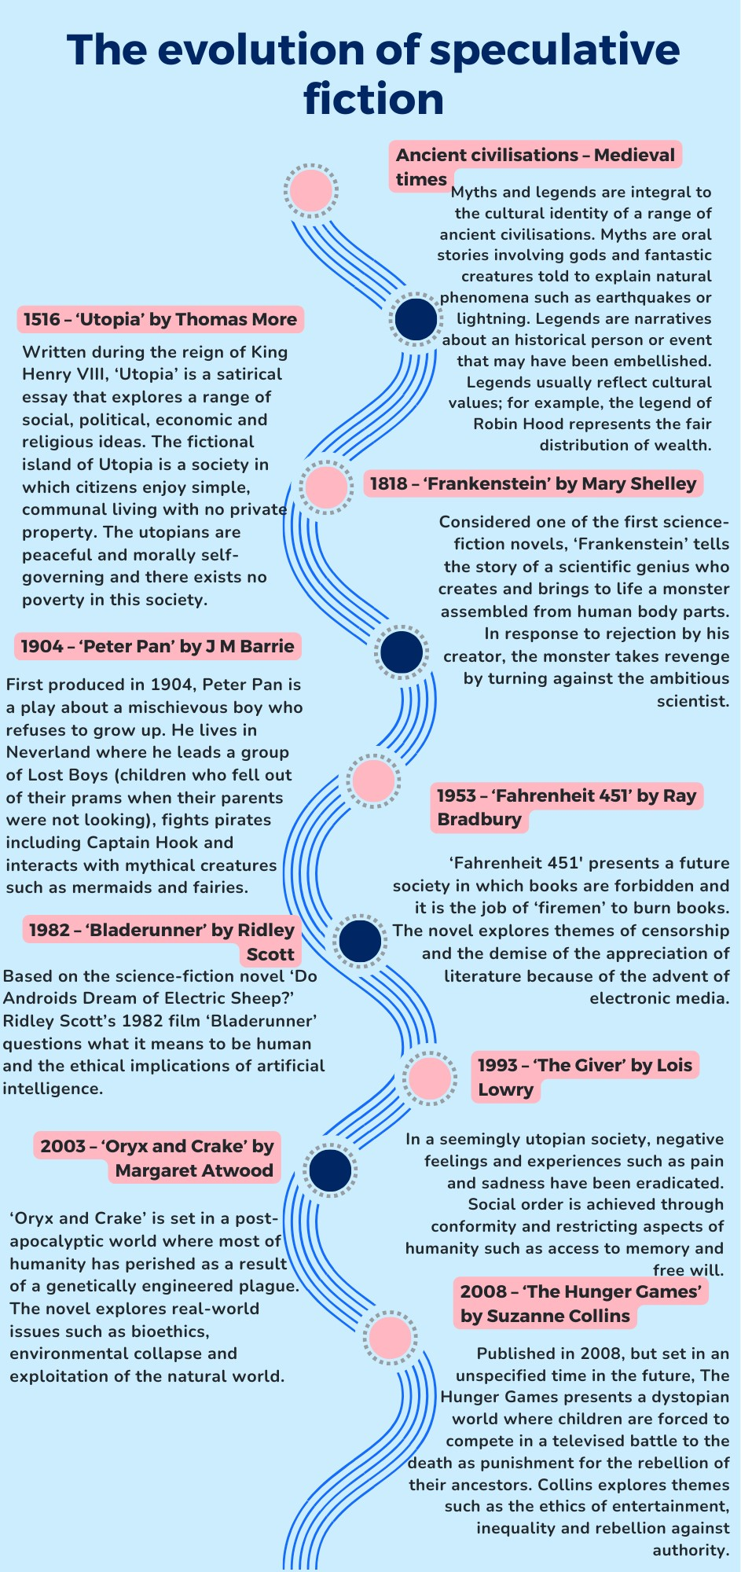

Phase 1, resource 7 – contextual influences timeline
Teacher note: the timeline below represents a very condensed representation of the significant contextual influences on Western literature. A PDF version of this timeline is accessible on the Planning, programming and assessing English 7-10 webpage.
Figure 3 – timeline of significant contextual influences on Western literature
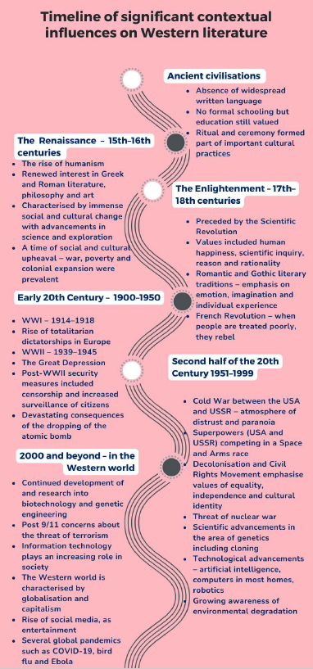

Phase 1, activity 13 – understanding the structure of a timeline
Teacher note: to support students to answer the questions in this activity, you could ask them to consider the knowledge that they may have already about the features of timelines from their studies in history, geography and other subjects. This will further support students in developing an understanding about the transferability of knowledge and skills across subjects.
- Explore Phase 1, resource 6 – the evolution of speculative fiction and Phase 1, resource 7 – contextual influences timeline and answer the following:
- What features are used to organise the information in these timelines?
- What is the purpose of the line that runs down the centre of the page?
- Describe your reading path through the text. Do you read the information top to bottom and left to right?
- If you take a different reading path, how does your understanding of the information and purpose of the text change?

Phase 1, activity 14 – connections between texts and contexts
Teacher note: the 3-level guide comprehension strategy is useful to teach students to use evidence to support an argument. Sometimes known as ‘here, hidden and head’, the first questions should be literal (here), the next questions should be inferential (hidden) and the last question should be evaluative (head).
What it is: levelled reading is a way to comprehend, interpret and apply difficult texts by working at the literal, interpretive and applied levels.
What it does: levelled reading helps readers to go beyond the surface of a text in a step-by-step way.
- Use the information in Phase 1, resource 6 – the evolution of speculative fiction and Phase 1, resource 7 – contextual influences timeline to decide whether the following statements are true, false, or if there is not enough information given to take a stance (there will only be one of these). You must provide evidence from the texts to support your argument. Some of these statements can be either true or false. Your use of evidence from the text is what is important.
3-level guide statements
Level 1 – literal
- Ancient civilisations used myths and legends to teach.
- Frankenstein by Mary Shelley was written before Sir Thomas More’s Utopia.
- Fahrenheit 451 was written by Ray Bradbury.
Level 2 – inferential
- None of the speculative fiction texts on the timeline explore similar concerns.
- Writers of speculative fiction often explore the relationship between humanity and technology.
- The Hunger Games explores concerns of the context in which it was composed.
- Oryx and Crake has a female protagonist.
- The information in the timelines reveals that cultural values do not change over time.
Level 3 - evaluative
- The speculative fiction genre will continue to evolve.
- Synthesise your understanding of the evolution of the speculative fiction genre by completing the following ‘because, but, so’ sentences:
- We know that speculative fiction texts are influenced by context because…
- We know that speculative fiction texts are influenced by context but…
- We know that speculative fiction texts are influenced by context so…

Phase 1, resource 8 – extracts from speculative fiction texts
Teacher note: the following extracts are suggestions only. More extracts than are required for this activity have been provided so that teachers may select those most appropriate to the needs of their students. Four to 6 extracts are recommended for this activity.
Extract from Utopia by Thomas More
From ‘Of the travelling of the utopians’
Teacher note: if the class will be studying The Giver by Lois Lowry as a core text for this program, the following extract from Utopia by Thomas More may be valuable to introduce ideas of community and conformity.
“It is certain that all things appear incredible to us in proportion as they differ from known customs; but one who can judge aright will not wonder to find that, since their constitution differs so much from ours, their value of gold and silver should be measured by a very different standard; for since they have no use for money among themselves, but keep it as a provision against events which seldom happen, and between which there are generally long intervening intervals, they value it no farther than it deserves—that is, in proportion to its use. So that it is plain they must prefer iron either to gold or silver, for men can no more live without iron than without fire or water; but Nature has marked out no use for the other metals so essential as not easily to be dispensed with. The folly of men has enhanced the value of gold and silver because of their scarcity; whereas, on the contrary, it is their opinion that Nature, as an indulgent parent, has freely given us all the best things in great abundance, such as water and earth, but has laid up and hid from us the things that are vain and useless.
“If these metals were laid up in any tower in the kingdom it would raise a jealousy of the Prince and Senate, and give birth to that foolish mistrust into which the people are apt to fall—a jealousy of their intending to sacrifice the interest of the public to their own private advantage. If they should work it into vessels, or any sort of plate, they fear that the people might grow too fond of it, and so be unwilling to let the plate be run down, if a war made it necessary, to employ it in paying their soldiers. To prevent all these inconveniences they have fallen upon an expedient which, as it agrees with their other policy, so is it very different from ours, and will scarce gain belief among us who value gold so much, and lay it up so carefully. They eat and drink out of vessels of earth or glass, which make an agreeable appearance, though formed of brittle materials; while they make their chamber-pots and close-stools of gold and silver, and that not only in their public halls but in their private houses. Of the same metals they likewise make chains and fetters for their slaves, to some of which, as a badge of infamy, they hang an earring of gold, and make others wear a chain or a coronet of the same metal; and thus they take care by all possible means to render gold and silver of no esteem; and from hence it is that while other nations part with their gold and silver as unwillingly as if one tore out their bowels, those of Utopia would look on their giving in all they possess of those metals (when there were any use for them) but as the parting with a trifle, or as we would esteem the loss of a penny! They find pearls on their coasts, and diamonds and carbuncles on their rocks; they do not look after them, but, if they find them by chance, they polish them, and with them they adorn their children, who are delighted with them, and glory in them during their childhood; but when they grow to years, and see that none but children use such baubles, they of their own accord, without being bid by their parents, lay them aside, and would be as much ashamed to use them afterwards as children among us, when they come to years, are of their puppets and other toys.”
Extract from The Strange Case of Dr Jekyll and Mr Hyde by Robert Louis Stevenson
From ‘Henry Jekyll’s full statement of the case’
I hesitated long before I put this theory to the test of practice. I knew well that I risked death; for any drug that so potently controlled and shook the very fortress of identity, might, by the least scruple of an overdose or at the least inopportunity in the moment of exhibition, utterly blot out that immaterial tabernacle which I looked to it to change. But the temptation of a discovery so singular and profound at last overcame the suggestions of alarm. I had long since prepared my tincture; I purchased at once, from a firm of wholesale chemists, a large quantity of a particular salt which I knew, from my experiments, to be the last ingredient required; and late one accursed night, I compounded the elements, watched them boil and smoke together in the glass, and when the ebullition had subsided, with a strong glow of courage, drank off the potion.
The most racking pangs succeeded: a grinding in the bones, deadly nausea, and a horror of the spirit that cannot be exceeded at the hour of birth or death. Then these agonies began swiftly to subside, and I came to myself as if out of a great sickness. There was something strange in my sensations, something indescribably new and, from its very novelty, incredibly sweet. I felt younger, lighter, happier in body; within I was conscious of a heady recklessness, a current of disordered sensual images running like a millrace in my fancy, a solution of the bonds of obligation, an unknown but not an innocent freedom of the soul. I knew myself, at the first breath of this new life, to be more wicked, tenfold more wicked, sold a slave to my original evil; and the thought, in that moment, braced and delighted me like wine. I stretched out my hands, exulting in the freshness of these sensations; and in the act, I was suddenly aware that I had lost in stature.
Extract from The Wonderful Wizard of Oz by Frank L Baum
From Chapter XII – The Search for the Wicked Witch
But the wicked creature was very cunning, and she finally thought of a trick that would give her what she wanted. She placed a bar of iron in the middle of the kitchen floor, and then by her magic arts made the iron invisible to human eyes. So that when Dorothy walked across the floor she stumbled over the bar, not being able to see it, and fell at full length. She was not much hurt, but in her fall one of the Silver Shoes came off; and before she could reach it, the Witch had snatched it away and put it on her own skinny foot.
The wicked woman was greatly pleased with the success of her trick, for as long as she had one of the shoes she owned half the power of their charm, and Dorothy could not use it against her, even had she known how to do so.
The little girl, seeing she had lost one of her pretty shoes, grew angry, and said to the Witch, “Give me back my shoe!”
“I will not,” retorted the Witch, “for it is now my shoe, and not yours.”
“You are a wicked creature!” cried Dorothy. “You have no right to take my shoe from me.”
“I shall keep it, just the same,” said the Witch, laughing at her, “and someday I shall get the other one from you, too.”
This made Dorothy so very angry that she picked up the bucket of water that stood near and dashed it over the Witch, wetting her from head to foot.
Instantly the wicked woman gave a loud cry of fear, and then, as Dorothy looked at her in wonder, the Witch began to shrink and fall away.
“See what you have done!” she screamed. “In a minute I shall melt away.”
“I’m very sorry, indeed,” said Dorothy, who was truly frightened to see the Witch actually melting away like brown sugar before her very eyes.
“Didn’t you know water would be the end of me?” asked the Witch, in a wailing, despairing voice.
“Of course not,” answered Dorothy. “How should I?”
“Well, in a few minutes I shall be all melted, and you will have the castle to yourself. I have been wicked in my day, but I never thought a little girl like you would ever be able to melt me and end my wicked deeds. Look out—here I go!”
With these words the Witch fell down in a brown, melted, shapeless mass and began to spread over the clean boards of the kitchen floor. Seeing that she had really melted away to nothing, Dorothy drew another bucket of water and threw it over the mess. She then swept it all out the door. After picking out the silver shoe, which was all that was left of the old woman, she cleaned and dried it with a cloth, and put it on her foot again. Then, being at last free to do as she chose, she ran out to the courtyard to tell the Lion that the Wicked Witch of the West had come to an end, and that they were no longer prisoners in a strange land.
Extract from Animal Farm by George Orwell
From Chapter 1
All the animals were now present except Moses, the tame raven, who slept on a perch behind the back door. When Major saw that they had all made themselves comfortable and were waiting attentively, he cleared his throat and began:
"Comrades, you have heard already about the strange dream that I had last night. But I will come to the dream later. I have something else to say first. I do not think, comrades, that I shall be with you for many months longer, and before I die, I feel it my duty to pass on to you such wisdom as I have acquired. I have had a long life, I have had much time for thought as I lay alone in my stall, and I think I may say that I understand the nature of life on this earth as well as any animal now living. It is about this that I wish to speak to you.
"Now, comrades, what is the nature of this life of ours? Let us face it: our lives are miserable, laborious, and short. We are born, we are given just so much food as will keep the breath in our bodies, and those of us who are capable of it are forced to work to the last atom of our strength; and the very instant that our usefulness has come to an end we are slaughtered with hideous cruelty. No animal in England knows the meaning of happiness or leisure after he is a year old. No animal in England is free. The life of an animal is misery and slavery: that is the plain truth.
"But is this simply part of the order of nature? Is it because this land of ours is so poor that it cannot afford a decent life to those who dwell upon it? No, comrades, a thousand times no! The soil of England is fertile, its climate is good, it is capable of affording food in abundance to an enormously greater number of animals than now inhabit it. This single farm of ours would support a dozen horses, twenty cows, hundreds of sheep—and all of them living in a comfort and a dignity that are now almost beyond our imagining. Why then do we continue in this miserable condition? Because nearly the whole of the produce of our labour is stolen from us by human beings. There, comrades, is the answer to all our problems. It is summed up in a single word—Man. Man is the only real enemy we have. Remove Man from the scene, and the root cause of hunger and overwork is abolished for ever.
"Man is the only creature that consumes without producing. He does not give milk, he does not lay eggs, he is too weak to pull the plough, he cannot run fast enough to catch rabbits. Yet he is lord of all the animals. He sets them to work, he gives back to them the bare minimum that will prevent them from starving, and the rest he keeps for himself. Our labour tills the soil, our dung fertilises it, and yet there is not one of us that owns more than his bare skin. You cows that I see before me, how many thousands of gallons of milk have you given during this last year? And what has happened to that milk which should have been breeding up sturdy calves? Every drop of it has gone down the throats of our enemies. And you hens, how many eggs have you laid in this last year, and how many of those eggs ever hatched into chickens? The rest have all gone to market to bring in money for Jones and his men. And you, Clover, where are those four foals you bore, who should have been the support and pleasure of your old age? Each was sold at a year old—you will never see one of them again. In return for your four confinements and all your labour in the fields, what have you ever had except your bare rations and a stall?
"And even the miserable lives we lead are not allowed to reach their natural span. For myself I do not grumble, for I am one of the lucky ones. I am twelve years old and have had over four hundred children. Such is the natural life of a pig. But no animal escapes the cruel knife in the end. You young porkers who are sitting in front of me, every one of you will scream your lives out at the block within a year. To that horror we all must come—cows, pigs, hens, sheep, everyone. Even the horses and the dogs have no better fate. You, Boxer, the very day that those great muscles of yours lose their power, Jones will sell you to the knacker, who will cut your throat and boil you down for the foxhounds. As for the dogs, when they grow old and toothless, Jones ties a brick round their necks and drowns them in the nearest pond.
"Is it not crystal clear, then, comrades, that all the evils of this life of ours spring from the tyranny of human beings? Only get rid of Man, and the produce of our labour would be our own. Almost overnight we could become rich and free. What then must we do? Why, work night and day, body and soul, for the overthrow of the human race! That is my message to you, comrades: Rebellion! I do not know when that Rebellion will come, it might be in a week or in a hundred years, but I know, as surely as I see this straw beneath my feet, that sooner or later justice will be done. Fix your eyes on that, comrades, throughout the short remainder of your lives! And above all, pass on this message of mine to those who come after you, so that future generations shall carry on the struggle until it is victorious.
Extract from Nineteen Eighty-four by George Orwell
From Part One Chapter 1
It was a bright cold day in April, and the clocks were striking thirteen. Winston Smith, his chin nuzzled into his breast in an effort to escape the vile wind, slipped quickly through the glass doors of Victory Mansions, though not quickly enough to prevent a swirl of gritty dust from entering along with him.
The hallway smelt of boiled cabbage and old rag mats. At one end of it a coloured poster, too large for indoor display, had been tacked to the wall. It depicted simply an enormous face, more than a metre wide: the face of a man of about forty-five, with a heavy black moustache and ruggedly handsome features. Winston made for the stairs. It was no use trying the lift. Even at the best of times it was seldom working, and at present the electric current was cut off during daylight hours. It was part of the economy drive in preparation for Hate Week. The flat was seven flights up, and Winston, who was thirty-nine and had a varicose ulcer above his right ankle, went slowly, resting several times on the way. On each landing, opposite the lift-shaft, the poster with the enormous face gazed from the wall. It was one of those pictures which are so contrived that the eyes follow you about when you move. BIG BROTHER IS WATCHING YOU, the caption beneath it ran.
Inside the flat a fruity voice was reading out a list of figures which had something to do with the production of pig-iron. The voice came from an oblong metal plaque like a dulled mirror which formed part of the surface of the right-hand wall. Winston turned a switch and the voice sank somewhat, though the words were still distinguishable. The instrument (the telescreen, it was called) could be dimmed, but there was no way of shutting it off completely. He moved over to the window: a smallish, frail figure, the meagreness of his body merely emphasized by the blue overalls which were the uniform of the party. His hair was very fair, his face naturally sanguine, his skin roughened by coarse soap and blunt razor blades and the cold of the winter that had just ended.
Outside, even through the shut window-pane, the world looked cold. Down in the street little eddies of wind were whirling dust and torn paper into spirals, and though the sun was shining and the sky a harsh blue, there seemed to be no colour in anything, except the posters that were plastered everywhere. The black-moustachio'd face gazed down from every commanding corner. There was one on the house-front immediately opposite. BIG BROTHER IS WATCHING YOU, the caption said, while the dark eyes looked deep into Winston's own. Down at street level another poster, torn at one corner, flapped fitfully in the wind, alternately covering and uncovering the single word INGSOC. In the far distance a helicopter skimmed down between the roofs, hovered for an instant like a bluebottle, and darted away again with a curving flight. It was the police patrol, snooping into people's windows. The patrols did not matter, however. Only the Thought Police mattered.
Behind Winston's back the voice from the telescreen was still babbling away about pig-iron and the overfulfilment of the Ninth Three-Year Plan. The telescreen received and transmitted simultaneously. Any sound that Winston made, above the level of a very low whisper, would be picked up by it, moreover, so long as he remained within the field of vision which the metal plaque commanded, he could be seen as well as heard. There was of course no way of knowing whether you were being watched at any given moment. How often, or on what system, the Thought Police plugged in on any individual wire was guesswork. It was even conceivable that they watched everybody all the time. But at any rate they could plug in your wire whenever they wanted to. You had to live—did live, from habit that became instinct—in the assumption that every sound you made was overheard, and, except in darkness, every movement scrutinized.
Extract from The War of the Worlds by H.G. Wells
From Book One: The coming of the Martians – the eve of the war
No one would have believed in the last years of the nineteenth century that this world was being watched keenly and closely by intelligences greater than man’s and yet as mortal as his own; that as men busied themselves about their various concerns they were scrutinised and studied, perhaps almost as narrowly as a man with a microscope might scrutinise the transient creatures that swarm and multiply in a drop of water. With infinite complacency men went to and fro over this globe about their little affairs, serene in their assurance of their empire over matter. It is possible that the infusoria under the microscope do the same. No one gave a thought to the older worlds of space as sources of human danger, or thought of them only to dismiss the idea of life upon them as impossible or improbable. It is curious to recall some of the mental habits of those departed days. At most terrestrial men fancied there might be other men upon Mars, perhaps inferior to themselves and ready to welcome a missionary enterprise. Yet across the gulf of space, minds that are to our minds as ours are to those of the beasts that perish, intellects vast and cool and unsympathetic, regarded this earth with envious eyes, and slowly and surely drew their plans against us. And early in the twentieth century came the great disillusionment.
The planet Mars, I scarcely need remind the reader, revolves about the sun at a mean distance of 140,000,000 miles, and the light and heat it receives from the sun is barely half of that received by this world. It must be, if the nebular hypothesis has any truth, older than our world; and long before this earth ceased to be molten, life upon its surface must have begun its course. The fact that it is scarcely one seventh of the volume of the earth must have accelerated its cooling to the temperature at which life could begin. It has air and water and all that is necessary for the support of animated existence.
Yet so vain is man, and so blinded by his vanity, that no writer, up to the very end of the nineteenth century, expressed any idea that intelligent life might have developed there far, or indeed at all, beyond its earthly level. Nor was it generally understood that since Mars is older than our earth, with scarcely a quarter of the superficial area and remoter from the sun, it necessarily follows that it is not only more distant from time’s beginning but nearer its end.
The secular cooling that must someday overtake our planet has already gone far indeed with our neighbour. Its physical condition is still largely a mystery, but we know now that even in its equatorial region the midday temperature barely approaches that of our coldest winter. Its air is much more attenuated than ours, its oceans have shrunk until they cover but a third of its surface, and as its slow seasons change huge snowcaps gather and melt about either pole and periodically inundate its temperate zones. That last stage of exhaustion, which to us is still incredibly remote, has become a present-day problem for the inhabitants of Mars. The immediate pressure of necessity has brightened their intellects, enlarged their powers, and hardened their hearts. And looking across space with instruments, and intelligences such as we have scarcely dreamed of, they see, at its nearest distance only 35,000,000 of miles sunward of them, a morning star of hope, our own warmer planet, green with vegetation and grey with water, with a cloudy atmosphere eloquent of fertility, with glimpses through its drifting cloud wisps of broad stretches of populous country and narrow, navy-crowded seas.
And we men, the creatures who inhabit this earth, must be to them at least as alien and lowly as are the monkeys and lemurs to us. The intellectual side of man already admits that life is an incessant struggle for existence, and it would seem that this too is the belief of the minds upon Mars. Their world is far gone in its cooling and this world is still crowded with life, but crowded only with what they regard as inferior animals. To carry warfare sunward is, indeed, their only escape from the destruction that, generation after generation, creeps upon them.
Extract from Peter Pan [Peter and Wendy] by J.M. Barrie
From Chapter XVII – When Wendy grew up
Teacher note: if the class will be studying Crazy Fun Park by Nicholas Verso as a core text for this program, the following extract from Peter Pan by JM Barrie may be valuable to introduce ‘the lost boys’ and the reluctance to grow up explored in both texts.
Mrs. Darling came to the window, for at present she was keeping a sharp eye on Wendy. She told Peter that she had adopted all the other boys, and would like to adopt him also.
“Would you send me to school?” he inquired craftily.
“Yes.”
“And then to an office?”
“I suppose so.”
“Soon I would be a man?”
“Very soon.”
“I don’t want to go to school and learn solemn things,” he told her passionately. “I don’t want to be a man. O Wendy’s mother, if I was to wake up and feel there was a beard!”
“Peter,” said Wendy the comforter, “I should love you in a beard;” and Mrs. Darling stretched out her arms to him, but he repulsed her.
“Keep back, lady, no one is going to catch me and make me a man.”
“But where are you going to live?”
“With Tink in the house we built for Wendy. The fairies are to put it high up among the tree tops where they sleep at nights.”
“How lovely,” cried Wendy so longingly that Mrs. Darling tightened her grip.
“I thought all the fairies were dead,” Mrs. Darling said.
“There are always a lot of young ones,” explained Wendy, who was now quite an authority, “because you see when a new baby laughs for the first time a new fairy is born, and as there are always new babies there are always new fairies. They live in nests on the tops of trees; and the mauve ones are boys and the white ones are girls, and the blue ones are just little sillies who are not sure what they are.”
“I shall have such fun,” said Peter, with eye on Wendy.
“It will be rather lonely in the evening,” she said, “sitting by the fire.”
“I shall have Tink.”
“Tink can’t go a twentieth part of the way round,” she reminded him a little tartly.
“Sneaky tell-tale!” Tink called out from somewhere round the corner.
“It doesn’t matter,” Peter said.
“O Peter, you know it matters.”
“Well, then, come with me to the little house.”
“May I, mummy?”
“Certainly not. I have got you home again, and I mean to keep you.”
“But he does so need a mother.”
“So do you, my love.”
“Oh, all right,” Peter said, as if he had asked her from politeness merely; but Mrs. Darling saw his mouth twitch, and she made this handsome offer: to let Wendy go to him for a week every year to do his spring cleaning.
Extract from The Picture of Dorian Gray by Oscar Wilde
From Chapter VIII
A feeling of pain came over him as he thought of the desecration that was in store for the fair face on the canvas. Once, in boyish mockery of Narcissus, he had kissed, or feigned to kiss, those painted lips that now smiled so cruelly at him. Morning after morning he had sat before the portrait wondering at its beauty, almost enamoured of it, as it seemed to him at times. Was it to alter now with every mood to which he yielded? Was it to become a hideous and loathsome thing, to be hidden away in a locked room, to be shut out from the sunlight that had so often touched to brighter gold the waving wonder of the hair? The pity of it! the pity of it!
For a moment he thought of praying that the horrible sympathy that existed between him and the picture might cease. It had changed in answer to a prayer; perhaps in answer to a prayer it might remain unchanged. And, yet, who, that knew anything about Life, would surrender the chance of remaining always young, however fantastic that chance might be, or with what fateful consequences it might be fraught? Besides, was it really under his control? Had it indeed been prayer that had produced the substitution? Might there not be some curious scientific reason for it all? If thought could exercise its [52] influence upon a living organism, might not thought exercise an influence upon dead and inorganic things? Nay, without thought or conscious desire, might not things external to ourselves vibrate in unison with our moods and passions, atom calling to atom, in secret love or strange affinity? But the reason was of no importance. He would never again tempt by a prayer any terrible power. If the picture was to alter, it was to alter. That was all. Why inquire too closely into it?
For there would be a real pleasure in watching it. He would be able to follow his mind into its secret places. This portrait would be to him the most magical of mirrors. As it had revealed to him his own body, so it would reveal to him his own soul. And when winter came upon it, he would still be standing where spring trembles on the verge of summer. When the blood crept from its face, and left behind a pallid mask of chalk with leaden eyes, he would keep the glamour of boyhood. Not one blossom of his loveliness would ever fade. Not one pulse of his life would ever weaken. Like the gods of the Greeks, he would be strong, and fleet, and joyous. What did it matter what happened to the colored image on the canvas? He would be safe. That was everything.

Phase 1, activity 15 – jigsaw reading activity
Teacher note: while the text complexity of the extracts provided are best suited to HPGE students, this activity could be adapted using extracts from contemporary speculative fiction texts such as The Hunger Games by Suzanne Collins. You may like to include extracts from films such as Into the Spiderverse or short films such as El Empleo (6:24).
You will work with a group to develop an understanding of an allocated extract from a speculative fiction text. Each group member will be responsible for creating a series of questions about the extract, which you will then swap with a different member of your group. Your peers will then answer the questions you created.
- Conduct some brief research to learn the following details about your text:
- Who wrote it?
- When was it written?
- What is the text about? Give a brief summary of the plot.
- What real-world issues are explored in the text?
- Read the extract allocated to your group. You may choose to read silently or to share the reading aloud among the group.
- Individually, complete the table below by composing questions about the extract. Examples of the types of questions you could ask have been provided for you in the final column of the table.
Student note: the four types of questions that you will compose for this part of the activity are:
- knowledge and comprehension questions – ask for information, description, explanation and understanding
- application questions – require you to show or illustrate knowledge
- analysis questions – require you to examine, compare and analyse
- synthesising and evaluating questions – ask you to design, imagine, argue and justify.
Table 12 – four questions activity
Question type | Useful verbs | Example questions
Knowledge and comprehension | Tell  List  Describe  Find  State  Name  Explain | Describe what happens in the extract.
Application | Show  Illustrate  Examine  Solve | Examine the description provided in the extract and use it to draw either a character or a setting featured in the extract.
Analysis | Analyse  Compare  Contrast  Investigate  Explore | Compare the world represented in the extract to the real world. What is similar?
Synthesising and evaluating | Create  Invent  Construct  Design  Imagine  Justify  Argue  Discuss | Argue that the world presented in the extract is a better place to live than our own world.
- Give your questions to another student in your group. They will answer your questions individually, in complete sentences, in their English book.
- When each student in your group has completed the questions composed by another group member, discuss the extract using the questions and answers to guide you.
- When you have consolidated your understanding of the extract and the text from which it is taken, re-form the groups so that there is one student from each of the original groups combined to form a new group.
- Take turns to teach the other group members about the extract and text that you were allocated in your original group. Listen carefully to each of the ‘experts’ and take relevant summary notes about each of the texts explored.
Table 13 – summary notes for text extracts
Text | Summary notes
- Use your summary notes to complete the following ‘because, but, so’ sentences:
- Speculative fiction texts will always be popular because…
- Speculative fiction texts will always be popular but…
- Speculative fiction texts will always be popular so…
- Use your ‘because, but, so’ sentences to compose a blurb to appear on the back cover for an anthology of speculative fiction in which all the extracts you have engaged with appear.

Phase 2 – unpacking and engaging with the conceptual focus
In this phase, students begin to explore the conceptual focus of the program. Students will engage with the concepts of genre and perspective and context. They will study the picture book The Giant and the Sea to develop an understanding of how genre can represent larger ideas and concerns. They will explore and identify the ways in which composers use speculative fiction to comment on real-world concerns. The teaching and learning activities will focus on identifying the speculative elements in the core text. Students will have an opportunity to apply this knowledge when exploring a self-directed text. They will reflect on reading through group discussion. The assessment task for this program is a feature article, and the assessment notification will be issued at the end of this phase.

Core formative task 2 – reflecting on self-selected texts
Teacher note: this core formative task will be assessed via a group discussion at the end of this phase. However, for students to engage in this task, they will need to be prepared with prior knowledge of a self-selected text. This point in the program is an opportune time to set this reading of a self-selected text as a homework task. An exit ticket for this activity has been included in Phase 2, activity 7 – 3, 2, 1 exit ticket.
Student note: as you engage in this task, consider the similarities and differences between the texts that you and your peers choose. You may choose to refer to texts of your own choosing in your assessment task. This activity provides you with an opportunity to start considering the impact that speculative fiction texts can have on you as a reader.
This core formative task requires you to engage with a text of your own choosing that conforms to the conventions of the speculative fiction genre. Once you have chosen and engaged with the text, you will participate in a discussion with your peers about your chosen texts.
Preparing for group discussion
- Select a text that conforms to the conventions of speculative fiction. This text can fit within any of the sub-genres of speculative fiction and the type of text (for example short story or film) is up to you.
- Read, listen to or view your chosen text.
- Draft some speaking notes in response to the following questions. You may need to do some research to help you prepare.
- What is the title of the text, its author and its form?
- Who is the target audience for the text, and how can you tell?
- What is the text about? For example, what is its plot and who are the main characters?
- What features of the text make it speculative?
- What is the sub-genre of the text? For example, is the text science fiction, fantasy, gothic, dystopian, or historical fiction?
- The Giant and the Sea provides an allegorical representation of climate change. How does your text represent a real-world issue or experience?
- Is this a good example of speculative fiction? Why or why not?
- Would you recommend this text to somebody else to read or watch? Why or why not?
Engaging in group discussion
- Organise yourselves into small groups of 3 to 4 students. Try to group with students who have prepared a text that is different to yours.
- One student takes on the role of questioner and another takes on the role of responder. Using the questions above, the first student asks questions and the second student responds about their chosen text.
- Repeat this process, changing the roles each time, until everybody in the group has had a chance to discuss their text.

Phase 2, resource 1 – short speculative fiction texts
Teacher note: this resource provides a short list of texts that could be provided to students to select from for the purpose of their own reading. When recommending texts to students, it is important that teachers have read, listened to or viewed the text in its entirety first to ensure appropriateness for students and context.
Table 14 – short speculative fiction texts.
Text | Where the text can be located | Brief overview
‘Clatter Tongue’ – Karen Wyld | This text is published in This All Come Back Now: An anthology of First Nations speculative fiction, edited by Mykaela Saunders. | This is a magical realism short story. It explores the internalisation and continued impact of colonisation on the protagonist, a female Aboriginal teenager.
‘Myth this!’ – Lisa Fuller | This text is published in This All Come Back Now: An anthology of First Nations speculative fiction, edited by Mykaela Saunders. | This short story combines elements of the gothic genre and Aboriginal legend. Set in the Australian wilderness, it represents the importance of understanding and being respectful of our natural surroundings. Note: this story contains an expletive.
‘A Sound of Thunder’ – Ray Bradbury | This short story was originally published in 1952 and can be found in various anthologies. It can also be found online. | This science fiction text is set in the future. It explores the impact and consequences of human actions, in a plot driven by time travel.
‘There Will Come Soft Rains’ – Ray Bradbury | This short story was originally published in 1950. This text could be provided to students in audio form by using the BBC Radio dramatisation of the short story. | This is another science fiction text by Bradbury that is set in the future and contains advanced technology. The story considers the consequences of developments in nuclear warfare.
‘The Lottery’ by Shirley Jackson. | This text was published in The New Yorker on 18 June 1948. Audio and text versions are both available. | This short story explores a utopia and dystopia dichotomy within a fictional world. It considers the dangers of conforming without question to laws, rules and traditions.
The Arrival by Shaun Tan | This picture book was initially published in 2006. Shaun Tan’s website contains additional information about this text. Alternate Shaun Tan texts that could work for this activity include The Lost Thing, The Rabbits and Cicada. | This picture book uses conventions of the fantasy genre to present a representation of the challenges faced by refugees.
The Island by Armin Greder | This picture book was initially published in 2007. Additional teaching resources can be found on the Allen & Unwin website. | This picture book is distinct in its use of white space and charcoal illustrations. It explores allegorical representations of refugees, racism and xenophobia.
El Empleo by Santiago Bou Grasso and Patricio Plaza | This multiple award-winning short film is available on YouTube (6:24) and Vimeo (6:25). | This short film combines cartoon with elements of physical comedy and dystopia. It provides a bleak representation of the human workforce.
A Trip to the Moon by Georges Méliès | This silent, black and white film was created in 1902. It is available on YouTube (12:52). | This short film is considered one of and possibly the first science-fiction film ever created. It focuses on a group of men travelling to the moon.

Phase 2, activity 1 – visual language and stylistic features
Teacher note: the visual language and stylistic features listed in the table below are suggestions. Edit to suit the needs of your class. You may choose to support students through providing a partially completed table. This would particularly benefit EAL/D learners develop subject-specific vocabulary and students with a range of learning needs. Draw from the completed version of the table in Phase 2, resource 2 – visual language and stylistic features to make this modification.
- Complete the middle column of the table below by finding definitions of the visual and stylistic features.
- Fill out the last column of the table by writing a potential impact that the visual and stylistic features may have on viewers.
Table 15 – visual language and stylistic features
Visual language or stylistic feature | Definition | Potential impact on viewer
Salience
Gaze
Lighting
Facial expressions and body language
Symbolism
Vectors
Reading path
Composition (background, middle ground and foreground)
Colour
Juxtaposition
Text

Phase 2, resource 2 – visual language and stylistic features
Table 16 – visual language and stylistic features answers
Visual language or stylistic feature | Definition | Potential impact on viewer
Salience | Salience refers to the feature in a composition that most grabs your attention. A feature can be made salient through placement, colour, size, focus, distance or a combination of these. | A salient feature will draw the viewer’s eye to what is important in the image.
Gaze | Gaze refers to where the figure in the image is looking. | Demanding gaze – term used when a figure in the image ‘gazes’ (looks) directly out of the page at the responder. This establishes a connection between subject and viewer.  Offering gaze – a term used when a figure gazes at another object in the image, encouraging us to look at that object; the viewer is a detached onlooker.
Lighting | The use of lighting in an image helps create mood. There are 3 main different types of lighting: high key, low key and backlighting. | High key lighting – characterised by bright whites and yellows. Can represent hope, inspiration, positivity and so on.  Low key lighting – characterised by dark tones and shadows. Can represent fear, despair, negativity and so on.  Backlighting – characterised by a light source behind a figure. This can produce a dramatic contrast between the subject and their background.
Facial expressions and body language | Facial expression refers to what emotions are evident on the subject’s face. Body language refers to how their body is positioned. | Posture, gesture and expression give information about what individuals are thinking and feeling. These help convey emotions, set mood, and establish relationships and interactions.
Symbolism | A symbol is an object, character or sign that is used to represent a larger idea, action or feeling. Dependent on context, symbols can mean different things to different people. | Symbols can be used in visual texts to communicate meaning to a responder without the composer needing to rely on text.
Vectors | A vector is a line that leads your eye from one element to another; it can be visible or invisible. Vectors may be objects or parts of objects or invisible lines such as the direction of gaze. | Similar to a reading path, vectors assist the viewer in deciphering the images. This allows the composer to control the viewer’s understanding and draws focus to key features.
Reading path | Reading paths refer to the path you take through a visual text. The path moves from the most salient to the least salient elements.  It is the movement of the viewer’s gaze around a visual text. It can be influenced by elements such as vectors, salience, gaze and so on. | Similar to vectors, reading paths assist the viewer in deciphering the images and allows the composer to control the viewer’s understanding.
Composition (background, middle ground and foreground) | Composition refers to the way that the various elements within an image or frame are structured and are placed in relationship to each other and the viewer. | The way an image is composed helps to provide information about the key features of the text such as setting. It can also be used to demonstrate relationships between characters.
Colour | Colour is a broad term, and the colours used within a text could be considered in regard to features such as saturation, hue, or how different colours combine to work together on a page. | Colour evokes moods and feelings; note that contextual differences may impact this. Colour associations can quickly communicate messages or ideas to viewers. They can help establish the tone and mood of a text.
Juxtaposition | Juxtaposition refers to the placement of visual images, which are often opposite or contrasting, next to each other. | Juxtaposition helps to highlight contrast, interaction or difference.
Text | Text refers to any written text that appears as part of an image. Features of text to consider include content, literary devices, size, colour, font and so on. | Text can complement visual aspects of a text. It can be used to communicate and clarify ideas.

Phase 2, activity 2 –The Giant and the Sea front cover
Use the following Think, Pair, Share questions to consider the front cover of The Giant and the Sea.
Think
- Consider the cover of the picture book carefully. What do you notice? Record your thoughts below.
Pair
- Share your ideas with a peer. Record your peer’s thoughts here.
Share
- Share your ideas with the class. Add any interesting ideas shared by other students below.

Phase 2, resource 3 – extract from The Giant and the Sea
Figure 4 – extract from The Giant and the Sea
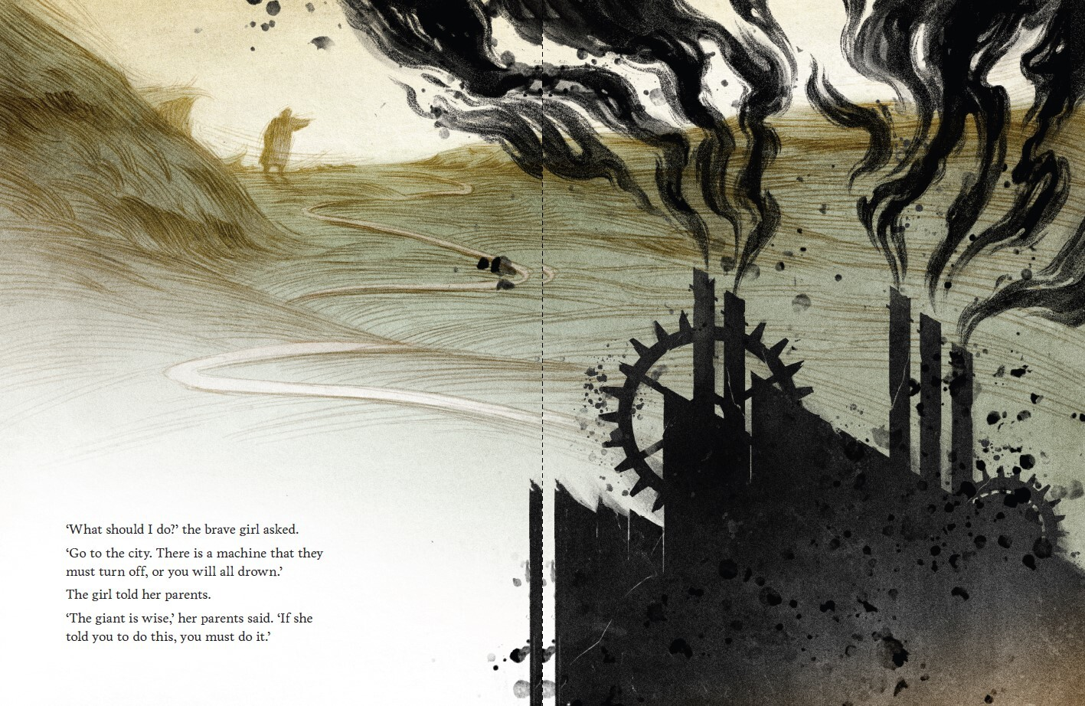

Phase 2, activity 3 – identifying the themes in the picture book
- What do you think this picture book is about? What do you see that makes you say that?
- Complete the table below to identify some of the thematic messages presented through the text.
Table 17 – thematic messages presented through The Giant and the Sea
Thematic message | Supporting examples from the text
Pollution is destroying the planet. | This is represented by the image of the machine that is introduced on the third double-page spread. The machine takes up a large proportion of the page. It is presented using dark colours and billowing smoke, in contrast to the bright colours used to depict the beach.

Phase 2, activity 4 – identifying conventions of speculative fiction
- Complete the table below by providing information about the characters, setting and plot of the picture book.
- In the middle column, explain how the text’s characters, setting and plot conform to the conventions of speculative fiction.
- In the third column, explain how the characters, setting and plot are representative of real-world people, places and events.
Table 18 – identifying conventions of speculative fiction
Features of the picture book | How the text conforms to the conventions of speculative fiction | What is represented about the real world
Characters

Setting
Plot

Phase 2, activity 5a – modelled deconstruction of The Giant and the Sea
- View the image and identify the key visual language and stylistic features.
Figure 5 – extract from The Giant and the Sea
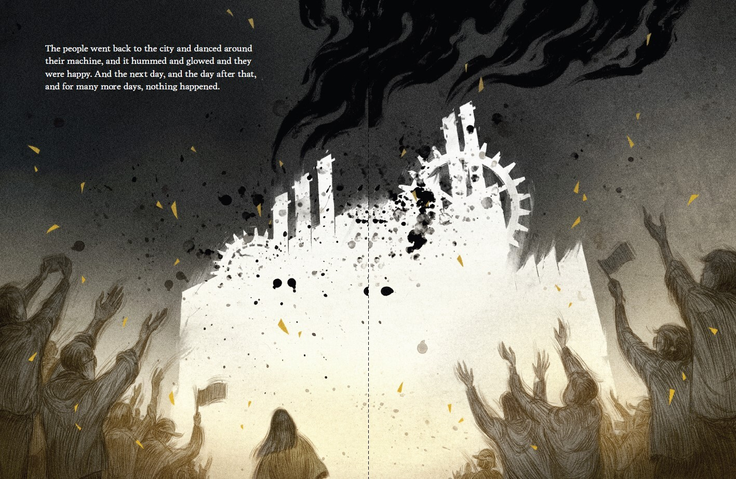
- Complete the table below by:
- explaining how the visual language and stylistic features emphasise a convention of speculative fiction
- analysing the language and stylistic features by explaining how the example represents a thematic message about the real world.
Table 19 – modelled analysis of extract
Examples of visual language and stylistic features | Connection to speculative fiction | Analysis
Salience – the machine at the centre of the page | The machine is the dominant feature of this image. This suggests that this society is driven by technology and industrialisation, which is a key feature of speculative fiction texts. | This salient image serves to metaphorically represent the dominance of technology within 21st century society.
Vectors and body language – the raised hands of the people | The raised hands further reinforce the control of technology in this society. They also indicate mass conformity to technological advancement, which is a common feature of societies in speculative fiction texts. | The vectors created by the body language of the citizens is intended to criticise and satirise the devotion towards and overreliance on technology and industry in our current society.
Juxtaposition – the brightness of the machine contrasted against the darkness of the smoke and surrounding environment | The light and the dark connect to the utopia versus dystopia dichotomy that is often present in speculative fiction texts. | The darkness of the smoke, in contrast to the brightness of the machine, emphasises the negative and dangerous consequences of pollution.
- Combine your analysis into a short paragraph that explores how this page uses conventions of speculative fiction to communicate real-world concerns.
Table 20 – analysing a page
Writing about the page
The image displaying the citizens worshipping the machine is intended to criticise modern society’s devotion towards and overreliance on technology and industry. The machine is the salient feature of this page because of its brightness and the vectors of the hands directing the reading path towards it. This metaphorically represents the dominance of industry and manufacturing in the 21st century. However, the juxtaposition of the dark smoke, in contrast to the brightness of the machine, emphasises the dangerous consequences that pollution can have on the environment. This page uses the speculative setting and hyperbolic conformity of its citizens to provide a warning to audiences about the dangers that are posed to the environment as a result of industrialisation.

Phase 2, resource 4 – annotation of sample paragraph
Teacher note: the table in this resource contains an annotation of the sample paragraph in Phase 2, activity 5a – modelled deconstruction of The Giant and the Sea. You may wish to provide this directly to your students, or use it to annotate the paragraph as a class.
Table 21 – annotation of sample paragraph
Sentence from sample paragraph | Annotation
The image displaying the citizens worshipping the machine is intended to criticise modern society’s devotion towards and overreliance on technology and industry. | The opening sentence provides a succinct description of the image and draws a connection to one of the key thematic messages of the picture book.  The precise verb ‘criticise’ helps to capture the author’s purpose.
The machine is the salient feature of this page because of its brightness and the vectors of the hands directing the reading path towards it. | This complex sentence combines multiple ideas. The use of conjunctions ‘because’ and ‘and’ connect the ideas together cohesively.  The sentence refers to multiple visual and stylistic features to strengthen the quality of analysis – ‘salience… brightness… vectors’.
This metaphorically represents the dominance of industry and manufacturing in the 21st century. | The word ‘this’ to open the sentence creates internal cohesion with the previous sentence by serving as a pronoun for the salient feature.  ‘Metaphorically represents’ connects to the allegorical nature of speculative fiction texts.  Nominalisation elevates the complexity of the vocabulary – ‘dominance… industry… manufacturing’.
However, the juxtaposition of the dark smoke, in contrast to the brightness of the machine, emphasises the dangerous consequences that pollution can have on the environment. | The opening conjunction ‘however’ indicates to readers that a new point is being made.  Nominalisation and elaborated noun groups elevate the complexity of vocabulary and ideas – ‘juxtaposition of the dark smoke… brightness of the machine’.
This page uses the speculative setting and hyperbolic conformity of its citizens to provide a warning to audiences about the dangers that are posed to the environment as a result of industrialisation. | This concluding sentence makes direct reference to the text’s speculative genre.  Direct reference to audience and purpose.

Phase 2, activity 5b – guided deconstruction of The Giant and the Sea
- View the image and identify the key visual language and stylistic features.
Figure 6 – extract from The Giant and the Sea
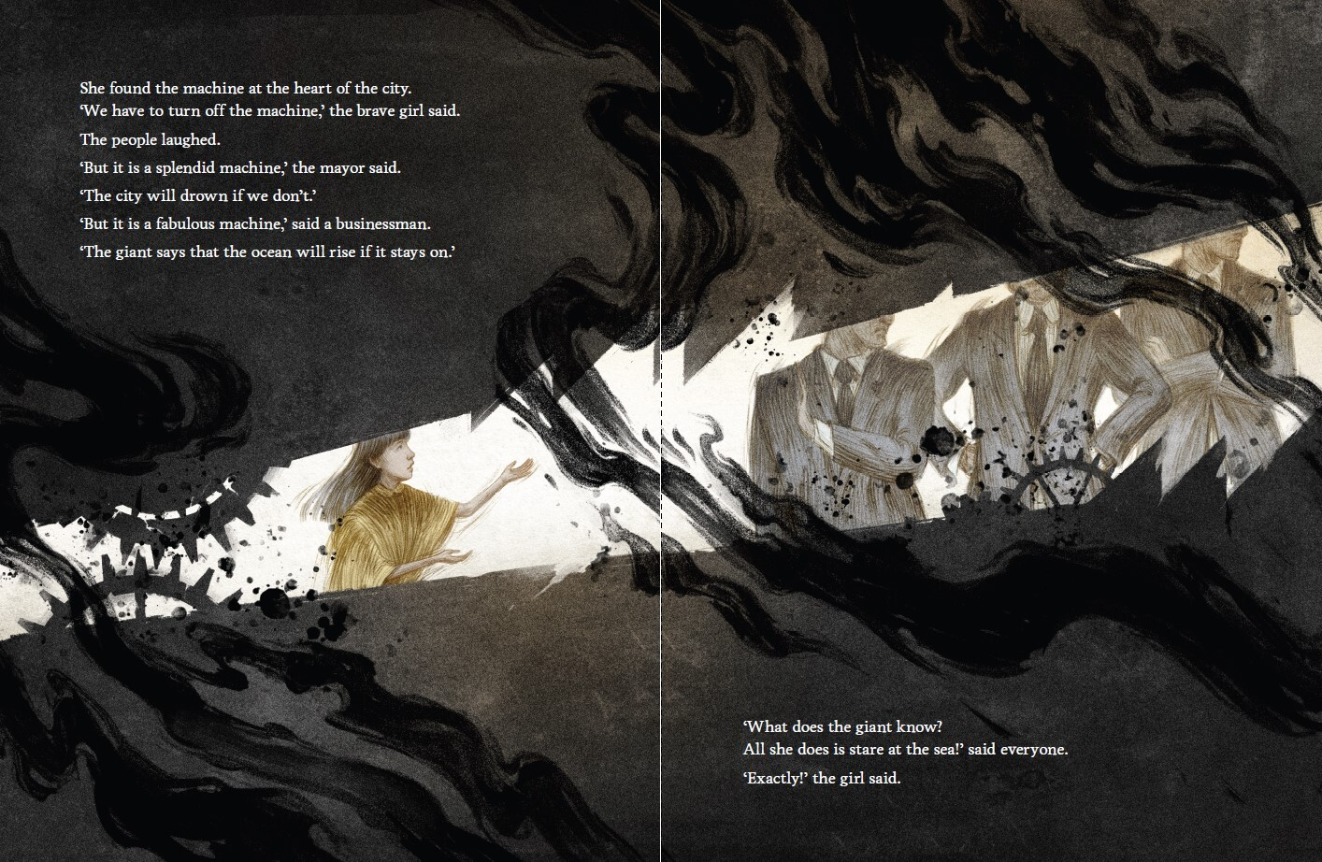
- Complete the table below by:
- identifying the important visual language and stylistic features on the page and adding them into the first column
- explaining how the visual language and stylistic features emphasise a convention of speculative fiction
- analysing the language and stylistic features by expressing what their purpose is.
Table 22 – guided analysis of extract
Examples of visual language and stylistic features | Connection to speculative fiction | Analysis
- Combine your analysis into a short paragraph that explores how this page uses conventions of science fiction to communicate real-world concerns.

Phase 2, activity 5c – independent deconstruction of The Giant and the Sea
- Select a page from The Giant and the Sea.
- Complete the table below by:
- identifying the important visual language and stylistic features on the page and adding them into the first column
- explaining how the visual language and stylistic features emphasise a convention of speculative fiction
- analysing the language and stylistic features by expressing what their purpose is.
Table 23 – independent analysis of extract
Examples of visual language and stylistic features | Connection to speculative fiction | Analysis

Phase 2, activity 6 – identifying the audience and purpose
Answer the following questions.
Identifying the target audience
- The most common audience of picture books is young children. Do you think that The Giant and the Sea is designed for young children, or do you think it is for someone else?
- What is an example of a line of text that uses vocabulary that is suited for the target audience you have identified? What makes it suitable?
- What is an example of an image that is suited for the target audience you have identified? What makes it suitable?
Connecting thematic messages to the target audience
- Why do you think the author chose to deliver the thematic messages to the target audience you have identified? Support your answer with at least one example from the text.

Phase 2, activity 7 – 3, 2, 1 exit ticket
- Complete the table below to reflect on what you have learned as part of your group discussion.
Table 24 – 3, 2, 1 exit ticket
Reflection prompt | Student reflection
What are 3 things you have learned about texts discussed in your group today?
What are 2 questions you have about either the texts that your peers shared, or about the speculative fiction genre?
What is one reason that it might be important to read speculative fiction texts?

Phase 2, activity 8 – engaging with the assessment task notification
Teacher note: issuing the assessment task for any program of learning within the first few weeks is good practice. The research findings and learnings in the What works best: 2020 update (CESE 2020) draw important connections between quality assessment and teaching and learning. As the research suggests, using data to inform instruction and differentiation should be an iterative process and should support students in all stages of their learning.
In addition to the assessment task notification, which includes the task details, marking criteria, steps to success and an annotated student work sample, a range of support resources have been provided in Phase 6. While these resources are included in that phase, it is recommended that the assessment task support resources are integrated into the other phases, in a purposeful and strategic way, to support the learning needs of your students.
Integrating the assessment support resources will demonstrate to students that writing is a recursive process and establishes expectations for writing throughout the program.
You have explored the assessment task notification as a class. In the table below:
- summarise what the task is asking you to do
- create a bullet list of steps you think you will need to take to complete the task
- identify 2 strengths that you have as a writer that will help you to complete the task
- identify one area of weakness that you would like to work on so that you can succeed in this task – indicate how you might address this weakness. For example, ‘I will ask one of my peers to check my sentence construction’.
Table 25 – reflecting on the assessment
Questions | Student response
What is the task asking you to do?
What steps do you think you will need to take to complete the task?
What are 2 strengths that you have as a writer that will help you to complete the task?
What is one area, from previous assessment tasks and writing activities, that you want to focus on improving?

Phase 2, activity 9 – word clines
Teacher note: this task has been designed in response to the marking criteria. Depending on which criteria format you choose, you may wish to repeat the activity with the student-facing rubric.
- Create a word cline for each marking criteria. The first one has been completed for you in the table below.
Figure 7 – sample word cline

- What does this word cline suggest about what you need to do to achieve an ‘A’ response’? Add your thoughts to the ‘Notes’ box below.
Hint
You might like to look up definitions for particular words. For example, the verb ‘discuss’ is defined in the English K–10 Glossary as ‘identify issues and provide points for and/or against’. The word ‘discuss’ appears in the A, B and C criteria but not the D and E criteria. Consider what this tells you about the response. Consider what this tells you about what you need to do.
Table 26 – reflection notes
Notes
- Repeat this process for each bullet point within the marking criteria.

Phase 5 – engaging critically and creatively with model texts
In this phase, students apply their understanding of genre, characterisation and the core texts to respond critically and creatively to representations of speculative fiction. Students use modelled, guided and independent learning structures to respond critically and create texts. They will experiment with and apply their knowledge of the speculative fiction genre through low-stakes writing activities. They will receive peer and teacher feedback to share ideas while deepening understanding and skills. Students will experiment with medium and form to convey a response to the ideas and issues explored in the texts and learning activities with which they have engaged. They will reflect on their learning throughout the program and use this reflection to inform and inspire the creation of their own texts.

Phase 5, activity 1 – speedy circles
- You will have 90 seconds to turn each of the circles below into a unique image. Challenge yourself to be creative and avoid the obvious.
Figure 8 – circle template

- You will be arranged into groups to discuss and reflect on:
- commonly occurring images
- the level of detail in images
- any unique images
- your creative decision-making process (why you did what you did)
- the factors that influenced your creative decision-making, for example timing, particular areas of interest, contextual influences and artistic skill level.

Phase 5, resource 1 – ‘exquisite corpse’
Teacher note: this resource will need to be edited before distributing to students if a text other than Crazy Fun Park has been studied.
- You will create a character to be introduced into the Crazy Fun Park television series using the ‘exquisite corpse’ drawing game.
- Each member of your group contributes to drawing a different body part of the character anonymously. The result is revealed to all members when the corpse is complete. You may like to visit The Museum of Modern Art website to see some examples of this strategy in action, or alternatively you could do a Google image search.
You will need:
- a lead pencil
- a rubber
- coloured pens, pencils or crayons
- a piece of A4 paper.
Follow the instructions below to create your character:
- In your group, you will need to decide who will draw the head, the torso and the lower body. Once you have decided, the group member drawing the head should go first.
Student note: it is important that you do not watch the other members of your group while they are drawing their section of the character. Your creative contribution should not be influenced by the previous image and the result should be a surprise. Remember that this is a character to be introduced into Crazy Fun Park. Keep the features of speculative fiction and the world of the text at the forefront of your mind.
- Your teacher will inform you of how much time you will have to draw the head. Once you have completed this section, fold the A4 piece of paper down to conceal almost all of the image. You should leave a very small section of the bottom of the head visible to give the group member drawing the torso a starting point. Pass the paper onto the next group member.
- The group member drawing the torso should go next and complete their section in the time allocated. Once complete, repeat the process above by folding the A4 piece of paper down leaving a small section visible. Pass the paper onto the next group member.
- The group member drawing the lower body should finish the image using the time allocated. Once complete, unfold the paper to reveal your group’s exquisite corpse.
- Have a group discussion about the character you created and the choices you made for the different sections. Use the See, Think, Wonder strategy to guide your conversation. You may choose to use some of the prompts in the table below.
Table 27 – see, think, wonder prompts
Section | Question prompts
See | - What can you see?  - What distinctive character features can you see?  - What speculative fiction conventions can you see?
Think | - What do you think about the character  - What do you think about the different features?  - Do you think this character would fit into the speculative fiction genre?
Wonder | - What does this character make you wonder?  - Do you wonder how this character will fit into the Crazy Fun Park television series? Explain.

Phase 5, activity 2 – character profile
- Complete the table below to develop a profile for your ‘exquisite corpse’ character.
- This will assist you in composing an imaginative piece of writing where your character is introduced into the Crazy Fun Park television series. Keep the context of the series in mind as you work through the table.
Student note: for further reading and prompts on how to create a character profile, you may like to visit the How to Create a Detailed Character Profile website.
Table 28 – character profile
Prompt | Notes
Basic statistics
- Name
- Age
- Gender
- Residence
- Education
Personal relationships and history
- Consider your character’s family background.
- What is their family composition?
- What is their relationship with their family like?
- How might their family relationship impact them?
Hobbies and interests
- Briefly outline some of your character’s interests.
- Consider what these interests say about your character or how they may manifest in other areas of their life.
How your character ended up trapped in Crazy Fun Park
- Briefly outline the accident and the circumstance(s) that led to them joining the Fun Kids.
Physical appearance and style
- Focus on any distinctive or unique features of your character.
- Connect physical appearance to the character’s accident.
Mannerisms
- Think about how your character moves and speaks.
- Ensure these are consistent with their physical appearance and their accident.
Character relationships
- What are your character’s positive relationships?
- What are your character’s negative relationships?
- How do these relationships impact on your character?
- Choose 2–3 characters and briefly address the above.
Additional information

Phase 5, activity 3 – planning for imaginative writing
Teacher note: narrative arc templates to support step 2 in the below activities can be found on the Digital Learning Selector webpage Writing scaffolds (imaginative).
You will write a 500 to 700 word imaginative piece in which the exquisite corpse character you have created is injected into the world of Crazy Fun Park. Follow the steps below to guide you:
- Choose a focus for your composition. Some suggestions include:
- your character’s introduction into the series
- the backstory of how your character ended up trapped in the theme park
- a day in the life of your character living in the theme park
- a conflict between your character and an existing character
- your character reflecting on a particular event in their past.
- Once you have chosen a focus, plan your response using a narrative arc template.
- Start writing! You may choose to hand write or type your composition.
- Seek feedback.
- Re-read your composition and think about what you would like feedback on, then record this in the first row of the table below.
- Share your composition with a peer and ask them to fill in the second row.
- Reflect on the peer feedback provided and complete the third row.
Table 29 – guided feedback
Student | Feedback section
You | I would like feedback on…
Peer | My feedback is…
You | After receiving this feedback, my next steps are…
- Action the peer feedback and finalise your response.
- Submit for teacher feedback.
- Action teacher feedback.
- Re-submit the final version of your composition to your teacher. It will be kept for use in the next activity.

Phase 5, activity 4 – guided discussion
Teacher note: the reading circle structure below has been taken from The Reading Agency’s resource How to run a reading circle. You may choose to allocate roles to students or allow them to choose their own. This should be done prior to the activity to ensure students have time to read their group’s compositions and make notes depending on their allocated role. Depending on the size and needs of your class, adapt the roles below to ensure they are suitable.
Student note: before engaging in this activity, you should have viewed your group members’ ‘exquisite corpse’ characters, read their imaginative compositions, and made comments based on your allocated role (role descriptions can be found in the table in this activity)
In your groups, follow the instructions below to run your reading circle:
- Get organised.
- Where possible, find a space and arrange chairs into a circle so all members are facing each other.
- Ensure all group members have a copy of each member’s ‘exquisite corpse’, imaginative composition and their notes and that there is a copy of the role descriptions available for reference.
- Start the discussion.
- The Leader should start the discussion; they might like to use some of the conversation starters in the table below.
- Share ideas.
- The Leader should move the discussion by calling on The Summariser.
- If there is a natural end to The Summariser’s contribution, The Leader should move the discussion along. The Leader may like to ask for any final thoughts or comments on what has been said before moving on. There is no order of speakers that must be followed but the order of roles in the table below is a logical sequence to follow.
- The Leader should continue to facilitate the discussion until all members have contributed.
- The Leader should wrap up the discussion by asking if there are any further comments or questions about anything that has been shared.
Table 30 – reading circle roles
Role | Description | Conversation starters
The Leader | - leads the discussion – calls on the different group members to contribute  - has prepared some general questions to prompt discussion | - What is one aspect of the ‘exquisite corpse’ that interested you and why?  - What was everyone’s initial reaction to this composition?
The Summariser | - gives an outline of the plot  - highlights key moments | - This composition focuses on the introduction of [character name], and they are introduced through …  - Some of the key moments in this composition are …
The Word Master | - selects and comments on vocabulary that may be new (providing definitions), unusual or interesting. | - Some of the vocabulary that stood out to me in this composition are …  - The definition of [word] is …  - Are there any words that I have missed that stood out to others?
The Passage Person | - selects and discusses a particular passage of interest | - The passage that interested me was [reads selected passage].  - This passage interested me because [outline reasons or justify your choice of passage].  - Does anyone have a different passage that stood out to them? Tell us about it.
The Connector | - makes connections between the text and the speculative fiction genre  - draws from the discussion and makes connections between the story and the wider world and/or world of Crazy Fun Park | - I think the features of speculative fiction that are present in this composition are ...  - I think what this composition has done well to connect to Crazy Fun Park is …  - I think some real-world connections this composition lends itself towards are …

Phase 5, resource 2 – our school in 2250 sample
Engage with the sample FutureGram post and annotations below to clarify your understanding of what you are expected to produce for the next activity.
Figure 9 – FutureGram sample post
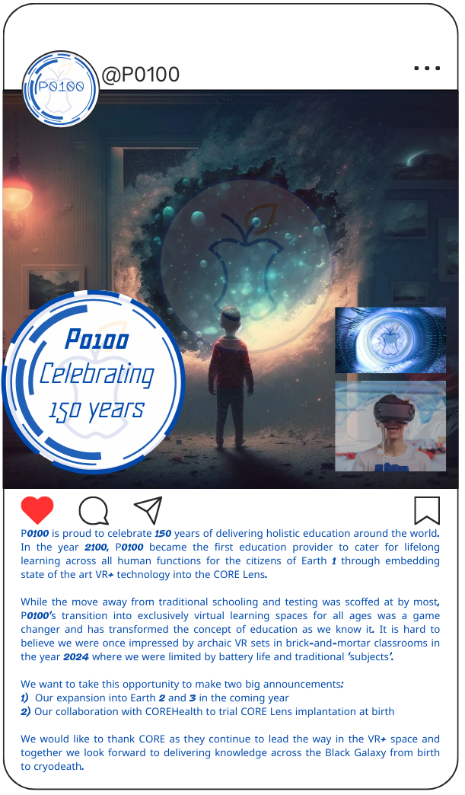
Images licensed under Pixabay Content License.
Table 31 – annotations for FutureGram sample post
Features | Annotation
Social issue explored | Evolution of VR technology in education.
Speculative fiction features | - Futuristic setting – a portal into a galaxy, utopian and dystopian elements.  - Technology permeating life.  - Rooted in current issues and technologies.  - Asking ‘What if?’
Colour and lighting | The colours in the FutureGram post are devoid of natural tones; cold blues and dark tones dominate. This signals a change in the environment of 2250 to one that is lived in a more ‘unnatural’ space. Low key lighting dominates much of the image which allows attention to be drawn to the centre of the galaxy and the close up of the eye (representing the CORE Lens). The use of high key lighting for these 2 elements implies that technology has lit a path into the future.
Symbolism and composition | The transparent ‘CORE’ logo occurs throughout the visual; in the ‘school’ logo, in the extreme close-up of the eye and in the galaxy the child is looking out into it acts as the salient image. This reinforces the idea that technology has taken over all aspects of education in the year 2250.  The young child in the centre of the image is a symbol of the future and is connected to the CORE technology’s power to influence growing minds.  The galaxy in the centre represents endless possibilities.  The image of a young boy with a VR headset is buried in the bottom right-hand corner of the image; its transparency indicates that it is fading from relevancy. It is topped by the bright blue and white close up of the Core Lens (the eye), implying its superiority.
Text and font | The text font used throughout the image is blocky and robotic. It reminds viewers that traditional aspects of education (such as handwritten materials) are now outdated.  The school is called P0100, a number rather than a ‘name’ as is traditionally expected. This signals a shift in who controls the education space in 2250 and is a marked difference from 2024.
Caption | The caption is written from the perspective of the ‘school’ and reads like a promotional post, highlighting its successes and intentions for the future. The comparison of the past to the present emphasises the impact of CORE technology on Earth 1 and the boastful tone makes it clear that this is viewed as a positive change for the human race. The CORE, a clear reference to Apple, is a relatable reference for audiences to anchor their opinions on – is this a utopian or dystopian vision of the future?
Image sourcing | This FutureGram post has been created by drawing from a range of sources and compiled using the Canva website. The image of the young boy looking into a galaxy was sourced from Pixabay as was the close up of the eye and the image of a young boy with a VR headset. The social media template and the additional visual elements were created using the features available through Canva.

Phase 5, activity 5 – our school in 2250
Teacher note: the headings in the figures and table below can be edited to suit the needs of the class. Alternative graphic organiser templates can be found through the department’s Digital Learning Selector.
Provide students with a link to a consistent and suitable Instagram template, or hyperlink the word ‘Canva’ below if you intend on distributing this activity electronically.
The comments left on peers’ posts should be appropriate for the classroom and the context of the task. Create a feedback protocol with students and encourage the use of constructive commentary. If necessary, refer to the department’s Behaviour code for students.
For this activity you will draw on the ideas developed in Core formative task 1 and your knowledge of the societal issues that the speculative fiction genre explores to create a social media post on the fictional platform, FutureGram. Your post for FutureGram should depict what you think your school might look like in the year 2250.
Follow the instructions below to guide the creation of your FutureGram social media post.
- Gather ideas.
Reflect on what you created for Core formative task 1 and think about the societal issues explored in the texts you have studied. What impact(s) could these have on your school in the year 2250? Contribute your thoughts to the class discussion and use the brainstorm template below to note ideas from your peers that may assist you in this activity.
Figure 10 – brainstorm template
My school in 2250
Issue 1
Issue 2
Issue 3
Issue 4
Potential impact
Potential impact
Potential impact
Potential impact
Another option is for you to use the table below to record your ideas.
Table 32 – brainstorming ideas
Issue | Potential impact on the school in 2250
- Choose a focus.
Select the idea that interests you most from the class brainstorm and develop it further using the prompts on the graphic organiser below.
Figure 11 – thinking wheel graphic organiser
My school in 2250
Visual literacy devices
Impact of issue on the school
Purpose of the post
Speculative fiction genre features
Caption ideas
Issue
- Draft your post (visual).
You may like to refer to the following resources and activities to assist you:
- Phase 2, activity 1 – visual language and stylistic features
- Phase 2, activity 3 – identifying the themes in the picture book
- Phase 2, activity 5a – modelled deconstruction of The Giant and the Sea
Using the FutureGram template below, sketch a plan for your visual element, annotating the visual language features you will include and any speculative fiction elements.
- Draft your post (caption).
On the same template, draft a 200 to 300 word caption to complement your visual design. The caption should provide an insight into the impact your chosen issue has had on your school in the year 2250. Provide any necessary details to aid viewers in understanding the purpose of your post. Keep in mind who the audience for your post may be as this will impact your use of tone and register.
Figure 12 – FutureGram template

- Seek peer feedback.
Once you have finished drafting your post, you should seek peer feedback before submitting for teacher feedback using the ‘see 3 before me’ table below:
Table 33 – see 3 before me template
Peer | Feedback
Peer 1 | Area of strength:  Area for improvement:
Peer 2 | Area of strength:  Area for improvement:
Peer 3 | Area of strength:  Area for improvement:
- Apply peer feedback to your FutureGram template.
- Submit updated template for teacher feedback.
- Action teacher feedback and finalise your post.
Use the template provided and create the final version of your FutureGram post. Remember to apply the feedback provided by your teacher and peers as you refine and finalise the creation of your post.
- Share your FutureGram posts.
Once your post is complete, your teacher will ask you to transfer it to a class Canva template where everyone’s posts can be viewed.
- Use the features of the FutureGram platform to react to your peers’ ideas of what your school might look like in 2250.
You could ‘like’ the post and make a thoughtful comment using emojis, slang and common online abbreviations.

Phase 5, resource 3 – debate topics
Students will be divided into teams and allocated either the affirmative or negative sides of a debate. Teachers could allocate one of the following debate topics:
- Today’s speculative fiction will still be popular 100 years from now.
- Speculative fiction is the most important genre of literature.
- Characters in speculative fiction are more memorable than those from other genres.
- Speculative fiction texts are more about educating and warning us about the dangers of our world than they are about entertaining us.
- The world around us today was predicted by the composers of speculative fiction of the past.
- Speculative fiction is too negative.
- Speculative fiction texts have an expiry date.
- The most important element of speculative fiction is its capacity to hold a mirror up to society.
- Speculative fiction texts are more about the present than the past or the future.
- More than any other genre, speculative fiction needs to evolve to remain relevant.
- Speculative fiction is most engaging when it is combined with another genre.
- If we want to learn about the values of the past, we should read speculative fiction from that era.

Phase 6 – preparing the assessment task
In this phase, students are supported to develop skills that will support them in understanding and preparing for the demands of the assessment task. The strategies in this phase are designed to support both the preparation for the formal summative task and the implementation of feedback. They are not meant to be completed consecutively, nor are they a checklist. They should be introduced when required, running concurrently within the other phases. Some may take a few minutes in a once-off lesson, others will need to be repeated. Some may require an entire lesson. All will need to be adapted to the class context.
The teacher recognises students’ prior understanding of assessment practices but should use this phase as an opportunity to deepen awareness of aspects that may have challenged students during the preparation of prior assessment tasks. These may include understanding instructions, being aware of the demands of marking criteria, or using samples to improve your response.

Phase 6, resource 1 – elements of a feature article
Definition
A feature article is a non-fiction text that focuses on a topic, idea or issue that is commonly relevant to the context in which it is written. A feature article approaches its chosen topic from a certain angle or perspective.
Purpose of a feature article
A feature article aims to provide more information than a regular news article does. While a newspaper article is intended to provide readers with information and facts, a feature article intends to build a broader understanding of a topic. This could be done by telling a story, or expressing opinions and emotions. A feature article is more complex than a news article because it needs to achieve a balance between telling a story and reporting facts.
Style
A feature article tends to use a more relaxed, conversational tone than a newspaper article. Elements of humour are often included. They can be written in first or third person and often use descriptive and subjective language. Most feature articles maintain an active voice, which helps to maintain audience engagement.
Audience
The audience of the feature article is wholly dependent on the topic of the feature article and its place of publication. Generally, feature articles are written for an audience who already possess some knowledge and understanding of the focus topic and are looking to build upon their understanding further.
Structure
The key structural features of a feature article are included in the table below.
Table 34 – structural features of a feature article
Features | Explanation
Headline | The headline of a feature article is often longer than that of a newspaper article. It should provide some connection to the topic of the article and evoke curiosity from potential readers. It should use specific language that connects to the contents of the article.
Subheading | This sentence comes directly after the headline and provides a brief synopsis or overview of the article. On news websites, this will often appear underneath the headline on the main page of the website as a way to provide additional information about the nature of the article.
Byline | This is the name of the author. The date of composition is sometimes included in the byline.
Introduction | The opening paragraph of a feature article aims to engage or ‘hook’ the reader emotionally or intellectually with the chosen topic. The introduction of a feature article helps to ‘set the scene’ and can include features such as thought-provoking questions, a quote, a quirky fact or an anecdote.
Body paragraphs | Body paragraphs in a feature article tend to be short in order to support the reading pathway of the reader. Each paragraph focuses on one idea. Aim for at least one interesting fact, statistic, quote or anecdote per paragraph.
Conclusion | The conclusion of a feature article is important. It is not simply a summary of the main ideas explored in the article. It should be thought-provoking and inspire the reader to consider the ideas of the feature article further.
Images | Most feature articles will contain images that support or illustrate the ideas explored. All images used should have a caption that describes what the image shows.
Feature quotes and callout boxes | Feature articles will often include a couple of important quotes from the article in larger font to stand out from the rest. These feature quotes are standalone sentences positioned between paragraphs and are intended to break up the larger chunks of text.
Hyperlinking | For online feature articles, key words or ideas are hyperlinked to reputable online sources. These sources may also be additional articles on a similar topic. They allow the reader the option to find out more information if they wish. They also add credibility and authority to the feature article as they demonstrate evidence of research.

Phase 6, activity 1 – feature article headlines
- Read the headlines and subheadings for the feature articles in the table below.
- In the second column of the table, predict what you think the article might be about based on the information provided in the heading and subheading.
- Select one to 2 articles to read and reflect upon your prediction – did you accurately identify the feature article’s topic and content? Identify by ticking or highlighting which of your predictions were correct.
Table 35 – feature article headings
Feature article heading and subheading | Prediction
‘Happy Kending: why righteous anger might be the role that wins Ryan Gosling an Oscar
Gosling’s statement of disappointment about the lack of nominations for Barbie colleagues Greta Gerwig and Margot Robbie is honourable, earnest – and a total masterstroke’
‘Ash Barty’s 2022 Australian Open win was a defining moment for blak women in sport
With cameos from Evonne Goolagong Cawley and Cathy Freeman, Barty gave us a myth-making night full of celebration and blak joy’
‘When landscapes come alive: ‘New weird’ stories speculate about the eerie natural world in a climate crisis
In the shadow of the climate crisis, a wave of speculative stories ask what it means to live in a world where everything is not an extractable resource — and where humans are not in control.’
‘Science fiction builds mental resiliency in young readers
Fantasy fiction provides more than escapism for young readers.’

Phase 6, resource 2 – how to hyperlink
Student note: the following instructions provide a step-by-step guide on how to hyperlink text. This is a skill that you should demonstrate in the feature article you write for your assessment task. This example uses the NSW Department of Education’s genre webpage as an example.
- Identify the website you would like to hyperlink from.
- Type a sentence in your Word document that includes text that you would like to hyperlink. In your sentence you should:
- use the title of the webpage or key words from the webpage to make it clear to the audience where the link will be taking them
- avoid using generic words or phrases such as ‘click here’.
For example: the NSW Department of Education’s genre webpage contains a video recording and a PDF document that help to define and explain what genre is.
- Highlight the text that is found in the URL bar of the website. This can be found right at the top of the website (please see the screenshot below).
Figure 13 – screenshot from the Department of Education’s genre page
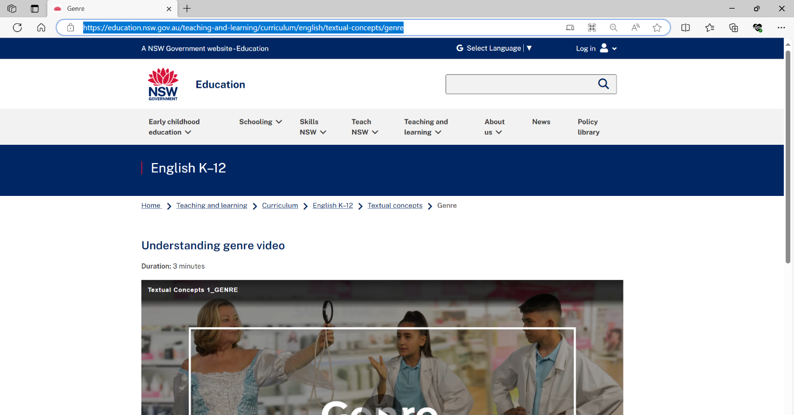
- Copy the text. This can be done using 2 separate methods:
- right click with your mouse and select the ‘Copy’ option
- hold down the ‘ctrl’ key on your keyboard and press the letter c key at the same time.
- Highlight the text in the sentence in your Word document that you wish to hyperlink. In the example provided above, the appropriate words would be ‘genre webpage’.
- Right click with your mouse and select the ‘Link’ option. You could use your keyboard to do this by holding down the ‘ctrl’ key and the letter k key at the same time to open the hyperlink option, and the ‘ctrl’ and the letter v key to paste.
- Where it asks for an address, paste in the URL that you have copied. You can do this in 2 ways:
- right click with your mouse and select the ‘Paste’ option
- hold down the ‘ctrl’ key on your keyboard and press the letter v key at the same time.
- Click on the ‘OK’ button.

Phase 6, resource 3 – sample responses
Teacher note: the 2 student responses below are quite different from one another. However, they both demonstrate the A-range criteria. This could present a good opportunity to discuss with students the range of approaches that could be taken with the formal assessment task. Alternatively, if you are only using one of The Giver and Crazy Fun Park, you may wish to just provide the sample that is relevant to your core text. If you are using your own core text, you could use these samples as a model to write your own sample for your class.

The future is now: the potential power of speculative fiction on young readers
How speculative fiction is creating a generation of children who aren’t afraid to speak up for what they believe in.
By Jessica Sonatos
Have you ever wondered what the world might look like in the year 2250? Will humanity have achieved some form of enlightenment that has cured our world of its ills – poverty, disease, environmental destruction all cured! Or will we have driven ourselves to the brink of extinction, through the destruction of the habitable environment, catastrophic war, food shortages or overpopulation? Or will we all be kowtowing at the feet of new overlords in the form of artificial intelligence or aliens?
Historically significant texts within the speculative fiction genre are grounded in metaphoric warnings about the real world. Frankenstein captures the fears of societal rejection and ‘playing God’ in a way that still resonates today. 50 years after its release, 2001: A Space Odyssey is reflected on as a movie that has had a significant influence on the scientific world. In fact, many speculative fiction texts throughout history have actually been successful in influencing and predicting the future.
More recently, climate fiction, or ‘cli-fi’ has saturated the literary world, particularly Young Adult fiction. Series such as The Hunger Games, Divergent and The Maze Runner are all incredibly popular with young readers, and share common representations of dystopian worlds and societies that have grown out of the rubble of cataclysmic environmental destruction.
‘It is no wonder that young readers are increasingly being drawn to literature that represents what the future may look like as we continue to destroy the planet.’
It is unquestionable that as a society we are careening towards irreversible climate and environmental damage. It is no wonder that young readers are increasingly being drawn to literature that represents what the future may look like as we continue to destroy the planet.
Do speculative fiction authors then have a greater weight of responsibility compared to authors of other genres? Not only do they have to entertain, but they also shoulder the responsibility of warning and educating.
The Giant and the Sea is a picture book that does just this. In our real world, sea levels are rising and some islands have been lost completely because of climate change. Trent Jamieson and Rovina Cai’s picture book makes the dangers of rising sea levels palatable and understandable for young readers. There is a clear contrast between the light colours they use to depict the natural environment and the dark colours to depict that pollutant machine that is placing humanity at risk.
When the sea rises and completely eradicates all those who worship the machine and don’t heed the giant’s warning, it is very clear what message is being delivered to readers – do something to stop climate change or reap the disastrous consequences of inaction. It is significant that this message is being delivered to a young audience – while some may see this as indoctrination, many others would argue that young people need to consider the future of the planet and challenge authority before this future becomes impossible.
Figure 14 – youth protesters marching in protest of government inaction on climate change
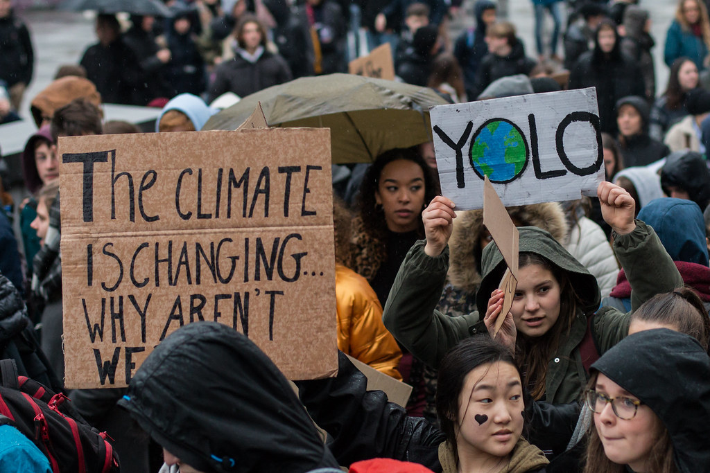
. "Youth for Climate - March for a better future" by European Greens is licensed under CC BY 2.0.
Challenging authority is a key feature of contemporary young adult speculative fiction. Having recently celebrated its 30th anniversary, Lois Lowry’s seminal text The Giver presents readers with a main character in Jonas who sacrifices his own comfort and safety to help a child, Gabriel, who has no agency to protect himself. Because of his selflessness, Jonas is branded as a fugitive, a criminal who poses an immense threat to society.
Lowry crafts a utopian world of privilege where citizens don’t know about, and don’t care enough to find out, about the dystopic mechanisms that control their society. We as an audience are meant to fully support Jonas’ rebellion, and see as heroic his refusal to accept the trauma that facilitates his utopia as a necessary evil.
This is where Lowry, and many speculative fiction writers, invites readers to consider their own humanity It is quite easy for us, from the comfort of our own homes, to not think about the existential challenges faced by those in other parts of the world. Challenges that either facilitate our comfort or are a direct consequence of it.
‘It is quite easy for us, from the comfort of our own homes, to not think about the existential challenges faced by those in other parts of the world.’
But characters like Jonas and like the young girl in The Giant and the Sea are inspiring more and more young activists to fight for their future, even if that means facing the ire of society.
And therein lies the power and potential of speculative fiction. Spec fic encourages its readers to ask questions, to challenge authority and to stand up for their morals.

Boys and their feelings
Graham Martin reflects on how speculative fiction makes it okay to cry
When little-known ABC TV show Crazy Fun Park was awarded Outstanding children’s program at the 2023 Logie awards, beating competition that included the immensely popular Bluey, I, like many people, was left scratching their head. What is this show, and why does it deserve the accolades that it has received?
For the uninitiated, Crazy Fun Park is a 10-episode series that is currently freely available on ABC iview. Drawing inspiration from texts like Peter Pan and The Lost Boys, the ragtag group of main characters consist of the ‘Fun Kids’ – teenagers who have all tragically died and are confined in a state of ageless purgatory. The group are discovered by the main character Chester as he mourns the death of his best friend Mapplethorpe, who has joined the undead posse in the abandoned fun park that is their purgatorial prison.
Reading the show’s plot summary, my mind jumped immediately to the 2016 Dreamworld accident and the 1979 Luna Park fire and the negligence of some of the deaths in the show definitely echoes these real-world tragedies.
However, the heart and soul of the show sits not within the setting but within the platonic love between Chester and Mapplethorpe and the immense grief that envelops both of them as they grapple with what Mapplethorpe’s death means for their friendship.
Figure 15 – Chester and Mapplethorpe from Crazy Fun Park
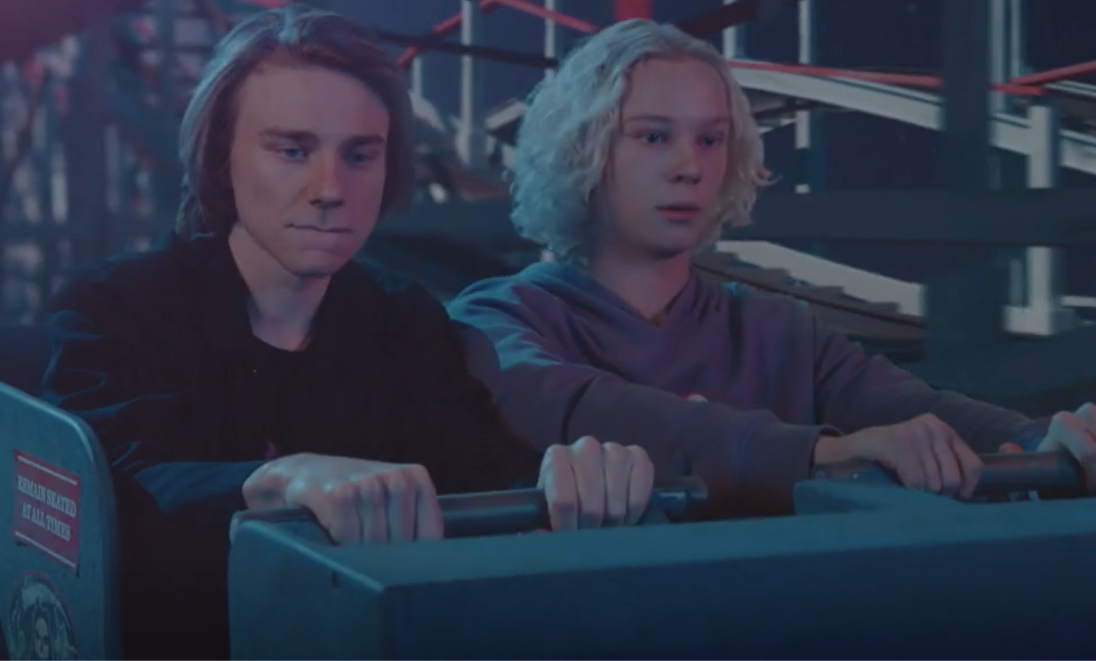
In an article for ABC, the director Nicholas Verso said the inspiration for the show was the emotional turmoil of losing some close friends as a teenager himself.
“I never really spoke about it. There was no language for a teenage boy to process grief and what happens when you watch somebody’s life get ripped away from them. So I wanted to create a show that dealt with grief and loss but was also a fun, explosive celebration of life and spirit and how that energy can live on in our memories.”
‘One of the enduring benefits of the speculative fiction genre is its ability to hold a mirror up to our own society and allow us the opportunity to reflect on deep and often existential topics.’
One of the enduring benefits of the speculative fiction genre is its ability to hold a mirror up to our own society and allow us the opportunity to reflect on deep and often existential topics. Through Mapplethorpe’s death and Chester’s immense and prolonged grief, Crazy Fun Park gives its young viewers an important opportunity to reflect upon the way that they and their loved ones may suffer from grief. Data from the Australian Institute of Health and Welfare indicates that the leading causes of death in people aged 15–44 are suicide and accidents, and males are more than 3 times more likely to die by these causes than women.
Mapplethorpe’s accidental death – falling from the top of a broken-down rollercoaster – is a hyperbolic representation of the risk taking behaviours that take too many young lives. The deaths of other young males in the park are revealed to be the result of similarly reckless behaviours. Verso captures through these fictional characters the senseless loss of young lives to warn us about risktaking behaviours in a way that isn’t patronising.
The series’ plot, after Mapplethorpe’s death, is driven by the conflicting emotions felt by Chester. Chester’s behaviour exhibits all of the symptoms of grief that the Australian government’s healthdirect website suggest people should get help for. He becomes increasingly isolated from his family and friends, his nightly visits to the fun park means he isn’t sleeping properly and he feels immense guilt about his mate’s death.
It reaches a crescendo in the penultimate episode of the season, where Chester battles with his desire to stay in the fun park after sunrise. If he does this, he will be unable to leave, essentially becoming a zombie like the rest of the Fun Kids and ceasing to exist in the real world.
It all sounds quite dark, doesn’t it? The season definitely does explore some serious themes, and its handling of these sensitive themes are one of the reasons it defeated Bluey for the Logie.
But this is the power of speculative fiction. By allegorically representing real-life experiences in fictitious worlds, composers allow us audiences to look in, witness and consider things from a distance. Complex emotions and experiences are presented to us, and to young audiences, in accessible and understandable ways.
Crazy Fun Park shows us that it is important for us to check in on those around us, particularly in times of grief and loss. Importantly, it shows us that it is okay for us, and for boys in particular, to cry and to mourn and to feel.
And that sure sounds like award winning material to me.
If you or anybody you know needs assistance in processing grief, go to the griefline website or call their toll-fee helpline on 1300 845 745.

Phase 6, activity 2 – using the student-facing rubric
Teacher note – for this activity you will also need to provide students with the student work sample from the assessment notification, one of the samples from Phase 6, resource 3 – sample responses and the marking criteria you are using for their assessment task. There are 2 different types of criteria provided in the assessment notification – a teacher-facing marking criteria and student-facing rubric. This activity would benefit most from the use of a student-facing rubric.
Student note: comparing sample responses will prompt you to consider not only how to address the marking criteria but will also encourage you to think deeply about what your teacher is looking for in an ‘A’ grade response. By the end of the group activity, you will be in a position to make connections between this evaluative process and your own compositions. Using the student-facing rubric will help you to make sense of the marking criteria and how it is applied by your teacher.
In this activity you will be completing a detailed side-by-side comparison of 2 student work samples.
Individually
- Read through the 2 student work samples individually and annotate them by labelling any feature article language and structural features that you can identify.
Group work
Working in groups of 4 you will need the following resources:
- the 2 student work samples
- different coloured highlighters
- sticky notes.
- As a group, read both student work samples. Discuss and compare the work samples. What are your initial impressions? Which sample do you think is better and why?
Step 2 – combining your annotations
- Combine all of your annotations together onto one version of the sample. In your annotations, make sure you’ve commented on:
- language and structural features appropriate to a feature article
- connections to the assessment prompt – What impact does speculative fiction have on audiences? What is the place and purpose of speculative fiction in the real world?
- successful or unsuccessful attempts at creating an engaging voice
- references to the core text(s)
- control of language.
Use a different coloured highlighter for each of the categories in the above list. Use the margins around each sample to make your annotations.
Step 3 – exploring and grading the work samples
Now that you have compared and annotated each work sample it is time to ‘grade’ each sample.
- Using the student-facing rubrics below, decide to what extent each student work sample meets the criteria of the student-facing rubric. For example, for the first criteria, your group may decide that student work sample 1 aligns with the criteria in the ‘thorough’ column.
- Allocate a grade from each criteria row (there are 4) to each work sample.
Step 4 – reflection
- You are going to work independently to reflect on this activity and write a list of possible challenges you think you might encounter when doing this task. Make sure that you also make a note of how you might address these challenges in a ‘to do’ list.
- Discuss your list with a peer. Perhaps you can provide suggestions as to how your peer might address the challenges they think they will face.

Phase 6, activity 3 – exploring the annotated sample assessment
Teacher note: for this activity you will also need to provide students with a copy of the annotated C range student work sample. This can be found in the assessment notification document.
Student note – comparing the sample annotated response and the marking criteria will prompt you to consider not only how to address the marking criteria but will also encourage you to think deeply about what your teacher is looking for in your response. By the end of the group activity, you will be in a position to make connections between this evaluative process and, later, your own compositions. Using the student-facing rubric will help you to make sense of the marking criteria and how it is applied by your teacher.
Group activity
You will be working in groups to complete this activity. Once you have been given a copy of the annotated sample assessment, do the following.
- Take it in turns to read the annotated student work sample, one row at a time.
- Stop at the end of each row and read the annotations.
- Review the annotations together with the marking criteria.
- As a group decide what grade you think the teacher would give the student work sample.
Class activity
- Contribute to class discussion, justifying why your group gave that grade to the student work sample.

Phase 6, activity 4 – self-feedback
Writing is a recursive process. This means you plan, draft, seek feedback, revise and refine. At this stage of learning, you have planned, researched and drafted your work. What next? Self-editing!
Use this activity to edit your own draft response. Before you pass on your work to a peer or the teacher for feedback, you should edit and refine your own writing. This will avoid receiving feedback about things you could have fixed yourself. To guide the self-editing process, use the tables provided in Phase 6, activity 4 – self-feedback and Phase 6, activity 5 – peer feedback. You could also add annotations to your draft as you work with the checklist in the table.
Table 36 – self-editing checklist
Checkpoints | What can you improve? | How can you improve?
Words, sentences and paragraphs – spelling
Consider homonyms, contractions, double syllables and any other ‘issues’ you may normally experience
Words, sentences and paragraphs – vocabulary
Consider word choices, difficulty level, variation, suitability, and so on.
Words, sentences and paragraphs – punctuation
Consider variation, accuracy, purposefulness and so on. Double-check use of speech marks, apostrophes and run on sentences.
Words, sentences and paragraphs – grammar
Consider tense, agreement, syntax, verb choices, noun choices, use of adverbs (avoid too many), use of adjectives, and so on.
Words, sentences and paragraphs – sentence types
Consider if you have used a variety of sentence types (question, exclamation, truncated and so on). Also check if you could use more (or less) complex and compound sentences.
Words, sentences and paragraphs – paragraphing
Consider if your ideas are organised into paragraphs that develop your purpose. Think about where you could experiment with paragraphing in a purposeful way.
Feature article features – headline, subheading and byline
Does your article have a clear headline that introduces the focus of the article in a relevant and engaging way? Have you provided some additional information through a subheading, byline or both?
Feature article features – engaging introduction
Does your feature article begin with an engaging opening paragraph using a strategy like an anecdote? Does your opening paragraph clearly indicate that this is a feature article and not a persuasive or analytical composition?
Feature article features – images and captions
Have you included at least one relevant image in your article in a suitable place? Have you given the image a caption? Could you possibly include more than one image?
Feature article features – hyperlinking
Have you included hyperlinking to other sources throughout your article? Is it clear from the words you have hyperlinked where the link will take readers to? Have you checked that all of your hyperlinks work?
Feature article features – feature quotes
Have you used any feature quotes in your article? If so, have you selected quotes that best capture the main discussion points in your article? Have you placed them in suitable positions on the page?
Feature article features – discursive language and personal voice
Have you used features of discursive language throughout to maintain an engaging personal voice?
Feature article features – conclusion
Does your conclusion leave readers with something to think about as they finish reading your article?
Textual knowledge – focus on genre
Does your article predominantly focus on the power of the genre, or does it focus more on the texts? Where have you demonstrated your clear understanding of the power of speculative fiction? Could you be more obvious or explicit?
Textual knowledge – referring to core text(s)
Does your article use examples from your core text(s) to support your discussion of the power of speculative fiction? Have you referred to the articles in a discursive way, or have you been more analytical? If it’s the latter, what can you do to adjust your response?

Phase 6, activity 5 – peer feedback
Collaboration with your peers can be a very effective way to learn. You will gain feedback and also see another person’s view of your composition. In this activity, you are going to ask your peer to be an editor to check for your use of the mechanics of writing.
Step 1 – peer feedback on the mechanics of writing
Give this resource and a draft response to your peer. Ask them to read your response and to complete the table below, focusing on the mechanics of writing.
Student note – one of the aspects that you are asked to provide feedback on in this activity is ‘agreement’. This involves commenting on the subject-verb agreement and noun-pronoun agreement in your peer’s writing.
Subject-verb agreement is the rule that the ‘subject’ of a sentence and the ‘verb’ that describes the action of the sentence match or ‘agree’. To agree, a single subject must be joined by a single verb. Similarly, a plural subject must be joined to a plural verb. For example, ‘Rebecca (single) lives (single) in Sydney.’ and ‘Rebecca and Sarah (plural) live (plural) in Sydney.’ Note that the single subject Rebecca ‘lives’ and the plural subjects Rebecca and Sarah ‘live’.
The sentences ‘Rebecca live in Sydney’ and ‘Rebecca and Sarah lives in Sydney’ are awkward because they do not demonstrate subject-verb agreement.
Similarly, there must be agreement between nouns and pronouns. For example, ‘Rebecca (noun) lives in Sydney. Her (pronoun) house is in Parramatta.’ and ‘Rebecca and Sarah (noun) live in Sydney. Their (pronoun) house is in Parramatta.’ are examples of sentences that demonstrate noun-pronoun agreement. ‘Rebecca lives in Sydney. Their house is in Parramatta.’ does not.
Key for using the tables
- Example from the response – provide an example from the writing to support your assertion.
- Advice – what steps should your peer take to improve their writing? Be specific.
Table 37 – peer feedback on the mechanics of writing
Reflection prompts | Yes – at times – no | Example from the response | Advice
Vocabulary
Accuracy – does your peer consistently use vocabulary accurately in their writing?
Variety – does your peer use a variety of vocabulary to make their writing more interesting and engaging?
Experimentation – does your peer use vocabulary in an interesting way to engage the reader and/or convey meaning?
Spelling
Accuracy – are all words consistently spelt accurately?
Punctuation
Accuracy – is punctuation used accurately and appropriately throughout the writing?
Variety – is a variety of punctuation used through the writing to create interest and engage the reader?
Experimentation – is punctuation used in an interesting way to engage the reader and/or convey meaning?
Sentence types
Accuracy – are sentences consistently formatted accurately throughout the writing?
Variety – are a variety of sentences used purposefully throughout the writing to create interest and engage the reader?
Experimentation – are sentence structures used in an interesting way to engage the reader and/or convey meaning?
Paragraphing
Accuracy – are paragraphs formatted accurately throughout the writing?
Experimentation – are paragraphs used in an interesting way to engage the reader and/or convey meaning?
Tense
Consistency – is tense used consistently throughout the writing? If there are shifts in the tense, are these purposeful and appropriate in the writing?
Agreement
Subject-verb – do all sentences demonstrate subject-verb agreement? Are there any awkward sentences caused by a disagreement with the plural forms of subjects and verbs?
Noun-pronoun – do all sentences demonstrate noun-pronoun agreement? Are there any awkward sentences caused by a disagreement with the nouns and pronouns of subjects?
Additional observations
Are there additional areas of your peer’s writing that you have noticed and would like to comment on?
Step 2 – peer feedback on the content
Table 38 – peer feedback on the content of the writing
Reflection prompts | Yes – at times – no | Example from the response | Advice
Headline, byline and subheading
Is it clear from the headline, byline and subheading what the focus of the article is going to be? Does the headline capture your attention and interest?
Opening paragraph
Does the opening paragraph introduce the content in an interesting and engaging way? Is the voice of this opening paragraph engaging?
Main thesis
Is it clear within the opening few paragraphs what the article is about? Does it relate clearly to the assessment prompt about the impact of speculative fiction on audiences and its place and purpose in the real world?

Cohesion and connectedness
Does the discussion throughout the feature article progress in a logical and cohesive manner?
Conclusion
Do you think the final paragraph is effective in concluding the article? Does it leave you with a message or something to think about?
Hyperlinks
Does the article contain hyperlinks to other sources? Does the hyperlinked text make the link destination clear? Do all of the links work?
Images and captions
Have appropriate images been selected for the article, and are they captioned? Does their location in the article make sense?
Feature quotes
Have feature quotes been used? Do you think the best sentences from the article have been used? Are they located appropriately?
Textual references
Does the article make reference to texts appropriately throughout? Are the texts used to support a larger discussion about the power of speculative fiction?

Phase 6, activity 6 – actioning feedback
Teacher note: the traffic lights strategy used in this activity is an expansion of the strategy as referenced on the department’s Strategies for student peer assessment webpage. This webpage contains a variety of feedback strategies that could be used in the classroom.
To begin editing and finalising a response you have written during this program for the assessment task, you need to carefully consider all the feedback you have received and begin the process of revising, refining and rewriting your response.
What you need
- your response
- green highlighter and green sticky notes for your ‘do’ annotations
- orange highlighter and orange sticky notes for your ‘fix’ annotations
- red or pink highlighter and red or pink sticky notes for your ‘ask’ annotations.
Fine tuning your writing
The ‘traffic lights’ method will help you to reflect, revise and rewrite. Use this strategy to engage with written feedback you have received about your response. This will enhance your understanding of your own composition and position you to act on the feedback you have received.
Step 1 – revise
- Read and highlight in green the sections of your response where you have done well. On a green sticky note, outline how you can carry the content or approach you applied forward.
- Read and highlight in orange the sections of your work that were identified as needing improvement, which you know how to improve. On an orange sticky note, explain how you will refine your writing to implement the feedback provided.
- Read and highlight in red the sections of your work that were identified as needing improvement, which you don’t know how to improve. That is, you will need to ask clarifying questions about what you can do to act on the feedback. On a red sticky note labelled ‘ask’, write questions to ask your teacher and a peer marker.
Step 2 – refine and rewrite
Refine your response based on the traffic light strategy. Seek clarification or advice from your peer on areas that you have highlighted in red. Alternatively, discuss these issues with your teacher during your student-teacher conference.

Phase 6, activity 7 – student-teacher conference
This planning sheet is to help you and your teacher identify the strengths of your writing and those areas that need further attention. A one-on-one conference allows your teacher to focus on your writing and suggest strategies and revision activities that can help you develop a plan to refine these aspects of your writing.
To get the most out of your conference, there are some tasks you need to complete.
Step 1 – before the conference
Which draft from your writing portfolio or journal do you want to seek feedback on during a teacher-student conference?
- Revisit the feedback you received for this draft from your peer or your teacher.
- Complete the ‘traffic lights’ strategy to reflect on your writing.
- Aim to improve your draft using observations made from the feedback and the self-evaluation below.
Step 2 – Self-evaluation
Complete the following questions.
- My feature article was inspired by a model text (identify the feature article which inspired you):
- My feature article discusses the following idea(s) related to the impact of speculative fiction on audiences:
- I have used these distinctive features of a feature article:
- I think I have done these things well:
- Some questions I need to ask are:
Step 3 – student-teacher conference
Date of conference:
Complete the following sections with your teacher during the conference:
- The strengths of my response are:
- Areas for improvement:
- My plan moving forward:
- The strategies I am going to use to reach my goals:
Step 4 – revise and refine
- Use the feedback from your student-teacher conference to refine your feature article.

References
This resource contains NSW Curriculum and syllabus content. The NSW Curriculum is developed by the NSW Education Standards Authority. This content is prepared by NESA for and on behalf of the Crown in right of the State of New South Wales. The material is protected by Crown copyright.
Please refer to the NESA Copyright Disclaimer for more information https://educationstandards.nsw.edu.au/wps/portal/nesa/mini-footer/copyright.
NESA holds the only official and up-to-date versions of the NSW Curriculum and syllabus documents. Please visit the NSW Education Standards Authority (NESA) website https://educationstandards.nsw.edu.au and the NSW Curriculum website https://curriculum.nsw.edu.au.
English K–10 Syllabus © NSW Education Standards Authority (NESA) for and on behalf of the Crown in right of the State of New South Wales, 2022.
ACARA (Australian Curriculum, Assessment and Reporting Authority) (2020) Version 3 of National Literacy and Numeracy Learning Progressions, ACARA website, accessed 16 February 2024.
ABC Publicity Media Room (29 November 2022) ‘Welcome to Crazy Fun Park!’, ABC, accessed 2 February 2024.
Albert S, Grinham A, Gibbes B, Leon J and Church J (7 May 2016), ‘Sea-level rise has claimed five whole islands in the Pacific: first scientific evidence’ The Conversation, accessed 26 February 2024.
Allen & Unwin (n.d.) Allen & Unwin [website], accessed 26 February 2024.
Australian Institute of Health and Welfare (11 July 2023) Deaths in Australia, Australian Institute of Health and Welfare website, accessed 26 February 2024.
Barrie JM (1904) Peter Pan [Peter and Wendy], Project Gutenberg, United States, eBook #16.
Baum FL (1900) The Wonderful Wizard of Oz, Project Gutenberg, United States, eBook #55.
Boas E and Gazis S (eds) (2016) The Artful English Teacher, The Australian Association for the Teaching of English, Kensington Gardens, South Australia.
Bracken H (2023) ‘The War of the Worlds’, Encyclopaedia Britannica, accessed 10 January 2024.
Bradbury R (1952) ‘A Sound of Thunder’, Sci-Fi Stories, My Short Stories website, accessed 26 February 2024.
CESE (Centre for Education Statistics and Evaluation) (2020) What works best: 2020 update, NSW Department of Education, accessed 26 February 2024.
Collins S (n.d.) The Hunger Games, Suzanne Collins website, accessed 26 February 2024.
COR (Civic Online Reasoning) (n.d.) ‘Intro to Lateral Reading’, Curriculum, COR website, accessed 26 February 2024.
Cregan-Reid V (2023) ‘Utopia’, Encyclopaedia Britannica, accessed 9 January 2024.
Crow D, Kaye D, Saavedra J and George J (20 September 2023) ‘14 Sci-Fi Movies That Predicted the Future’, Den of Geek, accessed 26 February 2024.
Dashner J (n.d.) The Maze Runner Series, James Dashner website, accessed 26 February 2024.
Fuge L (17 October 2018) ‘Fifty years later, scientists reflect on the influence of 2001: A Space Odyssey’, Cosmos, accessed 26 February 2024.
Fuller L (2022) ‘Myth This!’ in Saunders M (ed) This All Come Back Now: An anthology of First Nations speculative fiction, University of Queensland Press, Queensland.
Greder A (2007) The Island, Allen & Unwin Childrens, Australia.
Gregersen E (2024) ‘Ray Bradbury’, Encyclopaedia Britannica, accessed 10 January 2024.
Griefline (n.d.) Griefline [website], accessed 26 February 2024.
Hachette Australia (n.d.) The Arrival, Hachette Australia website, accessed 26 February 2024.
Hachette Australia (n.d.) The Giant and the Sea, Hachette Australia website, accessed 26 February 2024.
Harvard Graduate School of Education (2015) ‘Connect, Extend, Challenge’, Project Zero’s Thinking Routine Toolbox, Project Zero website, accessed 22 March 2023.
Harvard Graduate School of Education (n.d.) 'See, Think, Wonder', Project Zero’s Thinking Routine Toolbox, Project Zero website, accessed 26 February 2024.
Healthdirect Australia Limited (n.d.) Grief and loss, healthdirect website, accessed 15 February 2024.
Heritage S (24 January 2024) ‘Happy Kending: why righteous anger might be the role that wins Ryan Gosling an Oscar’, The Guardian, accessed 26 February 2024.
Jackson S (18 June 1948) ‘The Lottery’, The New Yorker, accessed 26 February 2024.
Jamieson T (2020) The Giant and the Sea (Cai R illus), Lothian Children’s Books, Australia and New Zealand. The extracts included in this resource have been reproduced and made available for copying and communication by NSW Department of Education for its educational purposes with the permission of Hachette Australia. We are grateful for their support in the development of this resource. This resource is licensed up until May 2027.
Jolly P (16 November 2022) ‘When landscapes come alive: ‘New weird’ stories speculate about the eerie natural world in a climate crisis’, The Conversation, accessed 26 February 2024.
Jones E (11 May 2020) ‘Science fiction builds mental resiliency in young readers’ The Conversation, accessed 26 February 2024.
Koubaridis A and Craw V (26 October 2016) ‘Fatal incident at Dreamworld on the Gold Coast’, news.com.au, accessed 26 February 2024.
Kubrick S (1968) ‘2001: A Space Odyssey,’ Warner Bros. Entertainment, Burbank, California.
Laurence R (13 June 2018) ‘Why Frankenstein is the story that defines our fears’, BBC Culture, accessed 26 February 2024.
Lowne C (n.d.) ‘Nineteen Eighty-four’, Encyclopaedia Britannica, accessed 10 January 2024.
Lowne C and Bauer P (n.d.) 'Peter Pan', Encyclopaedia Britannica, accessed 22 January 2024.
Lowry L (2024) Lois Lowry [website], accessed 26 February 2024.
Ma W (31 July 2024) ‘Logie awards 2023: Crazy Fun Park beats Blue, Sonia Kruger takes gold and Tony Armstrong’s back-to-back win’, The Guardian, accessed 26 February 2024.
Martin M, Sanderson P & Mangels A (2009) ‘Incredible Hulk’, Encyclopaedia Britannica, accessed 22 January 2024.
McCluskey M (9 March 2017) ‘17 Times 'The Simpsons' Accurately Predicted the Future’, Time, accessed 16 February 2024.
McLaughlin J (2001) Edible English, Edible Publishing, Evans Head.
Moon B (2005) Literary Terms: A Practical Glossary, Chalkface Press, Cottesloe.
More T (1516) Utopia, Project Gutenberg, United States, eBook #2130.
Murphy-Oates L (18 January 2024) ‘Ash Barty’s Australian Open win was a defining moment for blak women in sport’, The Guardian, accessed 26 February 2024.
Museum of Modern Art (2024) ‘Exquisite Corpse’, Art terms, MOMA website, accessed 16 February 2024.
Neugebauer A (24 March 2014) ‘What Is Speculative Fiction?’, Annie Neugebauer, accessed 15 December 2023.
Ojo Raro (1 May 2011) 'El Empleo' [video], Ojo Raro, YouTube, accessed 23 January 2024.
Open Culture (28 November 2016) 'A Trip to the Moon - the 1902 Science Fiction Film by Georges Méliès' [video], Open Culture, YouTube, accessed 26 February 2024.
Orwell G (1945) Animal Farm, Project Gutenberg, Australia, eBook No: 0100011h.html.
Orwell G (1945) Nineteen Eighty-four, Project Gutenberg, Australia, eBook No.: 0100021h.html.
Pain N (presenter) (12 September 1962) ‘There Will Come Soft Rains by Ray Bradbury’ [radio dramatisation], BBC Third Programme, BBC Radio, accessed 26 February 2024.
Quigley A (2020) Closing the Reading Gap, Taylor & Francis, London.
Roth V (n.d.) Divergent, Veronica Roth website, accessed 26 February 2024.
Saunders M (ed) (2022) This All Come Back Now: An anthology of First Nations speculative fiction, University of Queensland Press, Queensland.
Shulman D (2023, last updated 5 March 2023) ‘Frankenstein; or The Modern Prometheus’, Encyclopaedia Britannica, accessed 9 January 2024.
State of New South Wales (Department of Education) (n.d.) 'Clines and Continuums', Digital Learning Selector, NSW Department of Education website, accessed 13 December 2023.
State of New South Wales (Department of Education) (n.d.) ‘Strategies for student peer assessment’, Peer and self-assessment for students, NSW Department of Education website, accessed 26 February 2024.
State of New South Wales (Department of Education) (2022) Digital Learning Selector, NSW Department of Education website, accessed 26 February 2024.
State of New South Wales (Department of Education) (2022) ‘Genre’, Textual concepts, NSW Department of Education website, accessed 26 February 2024.
State of New South Wales (Department of Education) (2024) Behaviour code for students, NSW Department of Education website, accessed 26 February 2024.
Stevenson R L (1886) The Strange Case of Dr Jekyll and Mr Hyde, Project Gutenberg, United States, eBook #43.
Tan S (n.d.) The Arrival, Shaun Tan website, accessed 26 February 2024.
The Editors of Encyclopaedia Britannica (2024) ‘The Lord of the Rings’, Encyclopaedia Britannica, accessed 10 January 2024.
The Reading Agency (n.d.) ‘How to run a reading circle’, Resources, The Reading Agency website, accessed 26 February 2024.
Verso N and Hickey S (directors) (2023) Crazy Fun Park [television series], ABC, Melbourne, accessed 17 January 2024. The series trailer, episodes 4, 9, 10 and an extract from episode 3 have been reproduced and made available for use by NSW Department of Education for its educational purposes with the permission of Australian Children’s Television Foundation. We are grateful for their support in the development of this resource. This resource is licensed up until March 2029.
Wells H G (1898) The War of the Worlds, Project Gutenberg, United States, eBook #36.
wikiHOW (n.d.) How to Create a Detailed Character Profile, wikiHOW website, accessed 26 February 2024.
Wikimedia Foundation, Inc. (2024) Age of Enlightenment, Wikipedia website, accessed 22 January 2024.
Wikimedia Foundation, Inc. (2024) Futurama, Wikipedia website, accessed 10 January 2024.
Wikimedia Foundation, Inc. (2024) Oryx and Crake, Wikipedia website, accessed 10 January 2024.
Wikimedia Foundation, Inc. (2024) Renaissance, Wikipedia website, accessed 10 January 2024.
Wikimedia Foundation, Inc. (2024) Star Wars, Wikipedia website, accessed 22 January 2024.
Wikimedia Foundation, Inc. (2024) The Giver, Wikipedia website, accessed 10 January 2024.
Wikimedia Foundation, Inc. (2024) The Hunger Games, Wikipedia website, accessed 22 January 2024.
Wikimedia Foundation, Inc. (2024) The Lion, the Witch and the Wardrobe, Wikipedia website, accessed 22 January 2024.
Wilde O (1890) The Picture of Dorian Gray, Project Gutenberg, United States, eBook #174.
Wolfe N (24 March 2024) ‘Luna Park ghost train fire: Fatal tragedy wasn’t an accident or electrical fault’, news.com.au, accessed 26 February 2024.
Wyld K (2022) ‘Clatter Tongue’ in Saunders M (ed) This All Come Back Now: An anthology of First Nations speculative fiction, University of Queensland Press, Queensland.

© State of New South Wales (Department of Education), 2024
The copyright material published in this resource is subject to the Copyright Act 1968 (Cth) and is owned by the NSW Department of Education or, where indicated, by a party other than the NSW Department of Education (third-party material).
Copyright material available in this resource and owned by the NSW Department of Education is licensed under a Creative Commons Attribution 4.0 International (CC BY 4.0) license.

This license allows you to share and adapt the material for any purpose, even commercially.
Attribution should be given to © State of New South Wales (Department of Education), 2024.
Material in this resource not available under a Creative Commons license:
- the NSW Department of Education logo, other logos and trademark-protected material
- material owned by a third party that has been reproduced with permission. You will need to obtain permission from the third party to reuse its material.
Links to third-party material and websites
Please note that the provided (reading/viewing material/list/links/texts) are a suggestion only and implies no endorsement, by the New South Wales Department of Education, of any author, publisher, or book title. School principals and teachers are best placed to assess the suitability of resources that would complement the curriculum and reflect the needs and interests of their students.
If you use the links provided in this document to access a third-party's website, you acknowledge that the terms of use, including licence terms set out on the third-party's website apply to the use which may be made of the materials on that third-party website or where permitted by the Copyright Act 1968 (Cth). The department accepts no responsibility for content on third-party websites.

