English Stage 4 (Year 8) – core texts
8.4 – ‘The camera never lies’
This document contains the core texts that accompany the teaching and learning program for ‘The camera never lies’ – Year 8, Term 4.

Contents
About this resource 2
Purpose of this resource 2
Target audience 2
When and how to use 2
Opportunities for collaboration 3
Core texts and text requirements 4
Core texts 7
Core text 1 – Satellite Boy directed by Catriona McKenzie 7
Core text 2 – Took the Children Away by Archie Roach and illustrated by Ruby Hunter 8
Core text 3 – Mankind Is No Island directed by Jason van Genderen 13
References 14

Updating the table of contents
Want to update the table? Have you added content to the document and noticed the page numbers have changed? As you add content to this report, you can update the table of contents to accurately reflect the page numbers within the resource. To update the table:
- Right click on the table and select ‘Update table of contents’ (in the browser version) or ‘Update field’ (in the desktop app). In the browser version, it will automatically update the entire table.
- In the desktop app, you will then need to select ‘Update entire table’. Your table numbers should then update to reflect your changes.

About this resource
This core texts booklet has been developed to assist teachers in NSW Department of Education schools to create and deliver teaching and learning programs and assessment that align with the English K–10 Syllabus (NESA 2022). More information is available via How to use the English core texts.

Purpose of this resource
This core texts booklet is not a standalone resource and aligns with the following support materials for the program ‘The camera never lies’:
- Assessment resources: Assessment – 8.4; Examination – 8.4; Core formative tasks – 8.4; Core formative task 4 – practice examination – 8.4
- Programming resources: Program – 8.4
- Resource and activities support in Word: Resources and activities – 8.4
- Resources and activities in PowerPoint: Phase 1 – key visual features – 8.4; Phase 3 – filmic devices – 8.4; Phase 3 – theme – 8.4; Phase 4 – picture book features – 8.4
- Scope and sequence: Year 8.

Target audience
This core texts booklet is created as a teacher resource. It provides the full version of core texts or the full excerpts that are licensed and explored in ‘The camera never lies’ – Year 8, Term 4 program.

When and how to use
The core texts provided can be used as a basis for the teacher’s own programming and, assessment processes. Texts have been selected to support teachers as they address the Stage 4 text requirements in the NSW English K–10 Syllabus (NESA 2022). More information is available via How to use the English core texts.
Teacher note: the blue feature boxes include instructions for the classroom teacher engaging with the resource. These are to be deleted by the teacher before issuing the core texts to students.

Opportunities for collaboration
How to use the English core texts provides an outline of some of the ways the core texts can be used with colleagues.

Core texts and text requirements
A succinct overview of the texts required for the teaching and learning program is outlined in the table below. This brief overview provides the name and details of each text, the syllabus requirement being addressed and points of note.
Table 1 – core texts and their alignment to the text requirements
Text | Text requirement | Annotation and overview
McKenzie C (director) (2012) Satellite Boy [motion picture], Satellite Films, Australia.  No extracts have been included from the film. | This film has elements that align to the complex level of the Text Complexity scale as per the National Literacy Learning Progression (NLLP) (V9). It provides students with opportunities to engage with a text with words from languages other than English, challenging ideas, and subtle and implied meanings throughout.  EN4-RVL-01 requires students to read texts that are complex in their ideas and construction.  This film helps meet the Text requirements for English 7–10 as it is an Australian film created by an Aboriginal composer. It explores cultural and social perspectives through the lens of youth culture. | A study of this text will allow for students to better understand how film positions the audience emotionally to share cultural experiences and stories.  The film follows the journey of a young boy who tries to save his home in the northern Kimberley in Western Australia from developers. In the process, the boy realises the importance of his cultural heritage and his connection to Country. The film addresses issues faced by Aboriginal youth in a sensitive manner.  Aboriginal and Torres Strait Islander viewers are advised that the film contains images of people who have died.
Roach A (2020) Took the Children Away: The Iconic Song of the Stolen Generations (Hunter R illus), Simon & Schuster Australia. ISBN13: 9781760857219  This resource has been reproduced with the permission of Simon & Schuster Australia. We are grateful for their support in the development of this resource. This material is licensed up until 30 May 2027. | This picture book has elements that align to the moderately complex and complex level of the Text Complexity scale as per the NLLP (V9). Through the lens of visual literacy, it provides students opportunities to engage with a text with challenging ideas and subtle and implied meanings.  EN4-RVL-01 requires students to read texts that are complex in their ideas and construction.  The text helps meet the Text requirements for English 7–10 as it is a multimodal text created by Aboriginal composers. It explores cultural and social perspectives about diverse experiences. | A study of this text gives students the knowledge and understanding of a significant traumatic event in Australia’s history and explores this with sensitivity and compassion through images and visual literacy.  This picture book is about the forced removal of Aboriginal children from their families during the historical period known as the Stolen Generations. It is based on the song lyrics by Archie Roach and is accompanied by illustrations by Ruby Hunter. It explores the Stolen Generations through the lyrics and images.  Aboriginal and Torres Strait Islander readers are advised that the picture book contains reference to people who have died.
TROPFEST (30 September 2008) ‘Mankind Is No Island | Documentary | Winner of Tropfest New York 2008’ [video], TROPFEST, YouTube, accessed 9 April 2026.  No extracts have been included from the short film. | This short film has elements of a complex text of the Text Complexity scale as per the NLLP (V9). The unique structural features enhance meaning and impact and include complex reading paths. The content is complex as it explores challenging ideas through multiple perspectives. It also features elements of highly complex texts as its ideas are recontextualised for modern society using contemporary media and cultures featuring several levels of inferred meaning.  EN4-RVL-01 requires students to read texts that are complex in their ideas and construction.  The text helps meet the Text requirements for English 7–10 as it is a multimodal text created by an Australian composer. It explores intercultural and diverse experiences through the lens of cultural and social perspectives. | A study of this text will allow for students to better understand how film positions the audience emotionally to share cultural experiences and tell stories.  Winner of Tropfest New York 2008, Mankind Is No Island is recorded entirely on a mobile phone. This short documentary-style film introduces the idea of a narrative without dialogue. It uses street and shop signage from New York and Sydney to tell the common narrative of the 2 cities. It addresses themes such as the distress of homelessness and having empathy for others.
English K–10 Syllabus © NSW Education Standards Authority (NESA) for and on behalf of the Crown in right of the State of New South Wales, 2022.

Core texts
The following texts are included in the teaching and learning program for ‘The camera never lies’ – Year 8, Term 4.

Core text 1 – Satellite Boy directed by Catriona McKenzie
Teacher note: this text is used in Phase 3 of the teaching and learning program for ‘The camera never lies’ – Year 8, Term 4.
The following scenes have been selected from McKenzie C (director) (2012) Satellite Boy [motion picture], Satellite Films, Australia for the purposes of analysis and examination preparation. It is advised that students are shown the film in its entirety to reinforce the narrative and context of the film. The YouTube clip links have been provided for explicit practise of analysing film and language devices.
- SATELITE BOY – clip: Astronaut (0:58)
- SATELITE BOY – Clip: Blackfella Style (0:53)
- SATELITE BOY – Clip: Mysterious Path (1:07)
- SATELITE BOY – clip: This is your fire (1:41)
- SATELITE BOY – clip: Where are you going? (2:25)
- SATELITE BOY – on shooting in Bungle Bungles ranges (2:26)
- SATELITE BOY – Own it on Digital & DVD (2:16)

Core text 2 – Took the Children Away by Archie Roach and illustrated by Ruby Hunter
Teacher note: this text is used in Phase 1 of the teaching and learning program for ‘The camera never lies’ – Year 8, Term 4.
A selection of pages from the children’s picture book have been used to introduce the idea of diverse narratives for children.
Figure 1 – front cover of the children’s picture book Took the Children Away
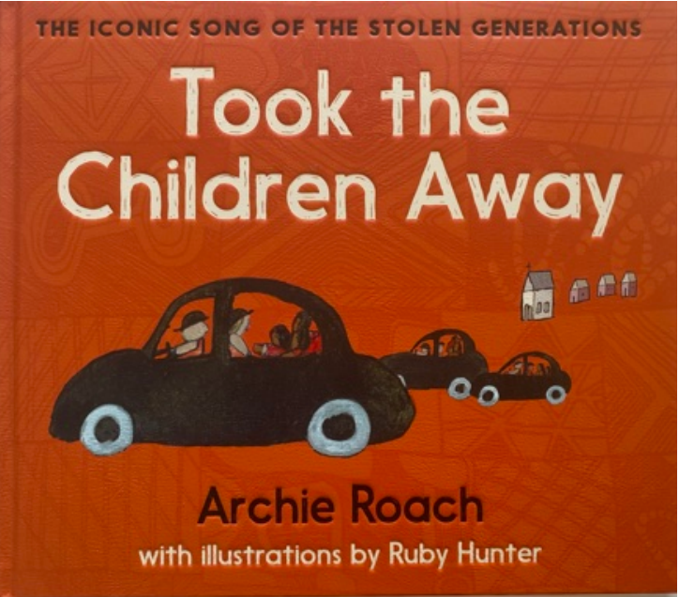
‘Took the Children Away’ by Archie Roach is reproduced with the permission of Simon & Schuster Australia.
Figure 2 – first page of the narrative of the children’s picture book Took the Children Away
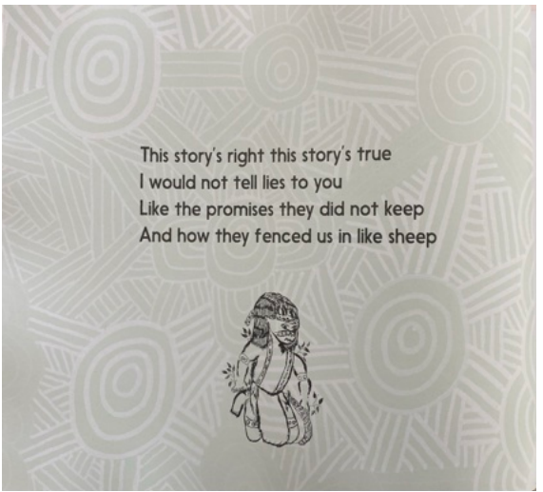‘
Took the Children Away’ by Archie Roach is reproduced with the permission of Simon & Schuster Australia.
Figure 3 – second page of the narrative of the children’s picture book Took the Children Away
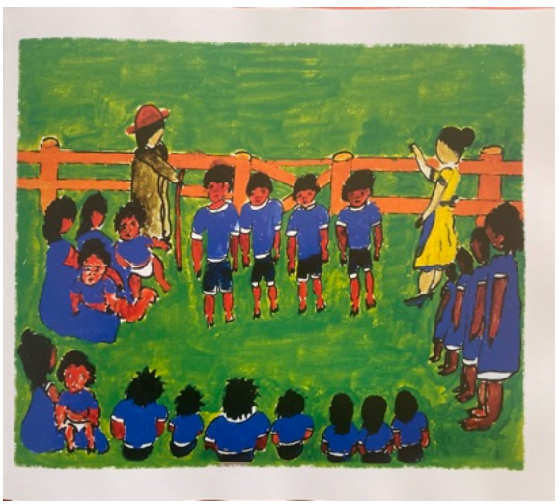
‘Took the Children Away’ by Archie Roach is reproduced with the permission of Simon & Schuster Australia.
Figure 4 – internal page of the children’s picture book Took the Children Away
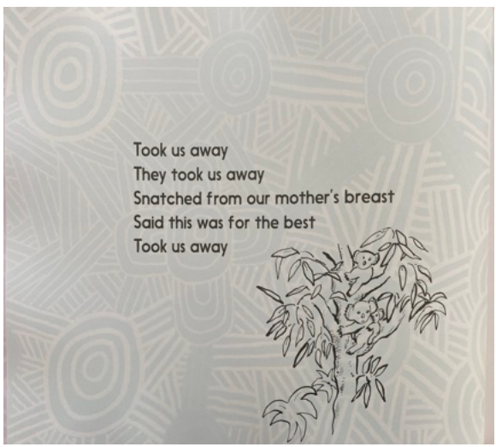
‘Took the Children Away’ by Archie Roach is reproduced with the permission of Simon & Schuster Australia.
Figure 5 – internal page of the children’s picture book Took the Children Away
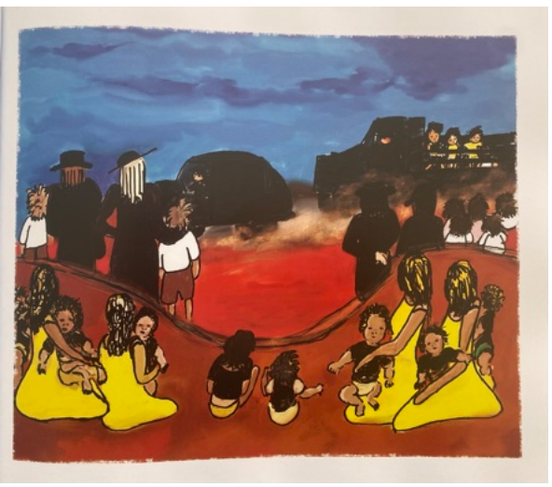
‘Took the Children Away’ by Archie Roach is reproduced with the permission of Simon & Schuster Australia.
Figure 6 – internal page of the children’s picture book Took the Children Away
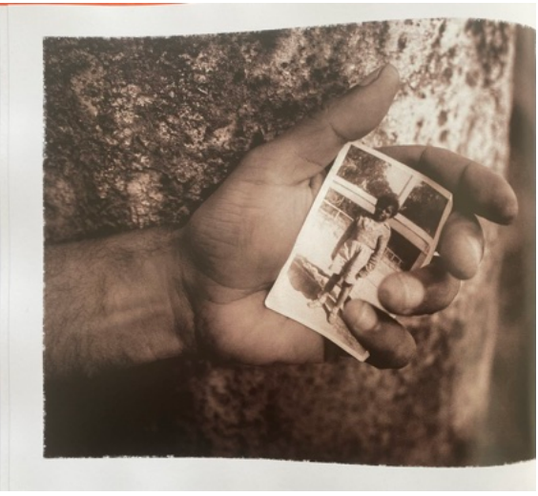
‘Took the Children Away’ by Archie Roach is reproduced with the permission of Simon & Schuster Australia.
Figure 7 – internal page of the children’s picture book Took the Children Away
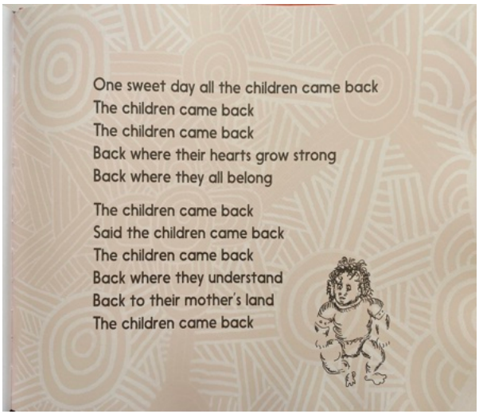
‘Took the Children Away’ by Archie Roach is reproduced with the permission of Simon & Schuster Australia.
Figure 8 – back cover of the children’s picture book Took the Children Away
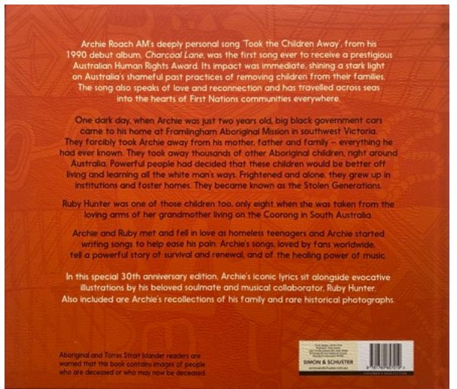
‘Took the Children Away’ by Archie Roach is reproduced with the permission of Simon & Schuster Australia.

Core text 3 – Mankind Is No Island directed by Jason van Genderen
Teacher note: this text is used in Phase 2 of the teaching and learning program for ‘The camera never lies’ – Year 8, Term 4.
Winner of Tropfest New York 2008, Mankind Is No Island is recorded entirely on a mobile phone. It uses street and shop signage from New York and Sydney to tell the common narrative of the 2 cities. It addresses themes such as homelessness and having empathy for others in a unique short film. The YouTube video has been provided below.
- ‘Mankind Is No Island | Documentary | Winner of Tropfest New York 2008’ (3:30)

References
This resource contains NSW Curriculum and syllabus content. The NSW Curriculum is developed by the NSW Education Standards Authority (NESA). This content is prepared by NESA for and on behalf of the Crown in right of the State of New South Wales. The material is protected by Crown copyright.
Please refer to the NESA Copyright Disclaimer for more information https://www.nsw.gov.au/education-and-training/nesa/copyright.
NESA holds the only official and up-to-date versions of the NSW Curriculum and syllabus documents. Please visit NESA https://www.nsw.gov.au/education-and-training/nesa and NSW Curriculum https://curriculum.nsw.edu.au.
English K–10 Syllabus © NSW Education Standards Authority (NESA) for and on behalf of the Crown in right of the State of New South Wales, 2022.
National Literacy Learning Progression (V9) © Australian Curriculum, Assessment and Reporting Authority (ACARA) 2010 to present, unless otherwise indicated. This material was downloaded from the Australian Curriculum website (National Literacy Learning Progression) (accessed 27 April 2026) and was not modified.
eOne ANZ (8 January 2013) 'SATELITE BOY – Own it on Digital & DVD' [video], eOne ANZ, YouTube, accessed 27 April 2026.
——(7 May 2013) ‘SATELLITE BOY – on shooting in Bungle Bungles ranges’ [video], eOne ANZ, YouTube, accessed 27 April 2026.
——(8 May 2013) ‘SATELLITE BOY –- clip: Where are you going?’ [video], eOne ANZ, YouTube, accessed 27 April 2026.
——(22 May 2013) ‘SATELLITE BOY – clip: This is your fire’ [video], eOne ANZ, YouTube, accessed 27 April 2026.
——(11 June 2013) ‘SATELLITE BOY– clip: Astronaut’ [video], eOne ANZ, YouTube, accessed 27 April 2026.
——(13 June 2013) ‘SATELLITE BOY – Clip: Mysterious Path’ [video], eOne ANZ, YouTube, accessed 27 April 2026.
——(20 June 2013) ‘SATELLITE BOY – Clip: Blackfella Style’ [video], eOne ANZ, YouTube, accessed 27 April 2026.
McKenzie C (director) (2012) Satellite Boy [motion picture], Satellite Films, Australia.
Roach A (2020) Took the Children Away: The Iconic Song of the Stolen Generations (Hunter R illus), Simon & Schuster Australia. This resource has been reproduced with the permission of Simon & Schuster Australia. We are grateful for their support in the development of this resource. This material is licensed up until 30 May 2027.
Stern J, Ferraro K and Mohnkern J (2017) Tools for teaching conceptual understanding: designing lessons and assessments for deep learning, Corwin, Thousand Oaks.
TROPFEST (30 September 2008) ‘Mankind Is No Island | Documentary | Winner of Tropfest New York 2008’ [video], TROPFEST, YouTube, accessed 27 April 2026.

© State of New South Wales (Department of Education), 2025
The copyright material published in this resource is subject to the Copyright Act 1968 (Cth) and is owned by the NSW Department of Education or, where indicated, by a party other than the NSW Department of Education (third-party material).
Copyright material available in this resource and owned by the NSW Department of Education is licensed under a Creative Commons Attribution 4.0 International (CC BY 4.0) license.

This license allows you to share and adapt the material for any purpose, even commercially.
Attribution should be given to © State of New South Wales (Department of Education), 2025.
Material in this resource not available under a Creative Commons license:
- the NSW Department of Education logo, other logos and trademark-protected material
- material owned by a third party that has been reproduced with permission. You will need to obtain permission from the third party to reuse its material.
Links to third-party material and websites
Please note that the provided (reading/viewing material/list/links/texts) are a suggestion only and implies no endorsement, by the New South Wales Department of Education, of any author, publisher, or book title. School principals and teachers are best placed to assess the suitability of resources that would complement the curriculum and reflect the needs and interests of their students.
If you use the links provided in this document to access a third-party's website, you acknowledge that the terms of use, including licence terms set out on the third-party's website apply to the use which may be made of the materials on that third-party website or where permitted by the Copyright Act 1968 (Cth). The department accepts no responsibility for content on third-party websites.

