iSTEM – Writing Engineering Reports: Teacher Guide


Table of contents
Table of contents 2
General information 3
Purpose 3
Structure 3
Writing style 4
Components 6
1. Title page 6
2. Executive summary 7
3. Table of contents 8
4. Introduction 8
5. Main body 9
6. Conclusion 10
7. Recommendations 10
8. References 11
9. Appendices 11
List of tables (optional) 12
List of figures (optional) 13
References 14
Further reading 14

General information
Technical engineering reports are one of the main forms of communication in engineering. This guide to writing an engineering report provides general advice on the most relevant components. The intent of this guide is not to be prescriptive, but rather to explain some generally accepted methods of presenting technical information, including common structures and conventions similar to those used in academia and industry reports. When considering adjustments and additional support to meet the needs of individual students, teachers should use their professional judgement and apply the elements of the guide with flexibility.

Purpose
An important consideration when preparing an engineering report is the audience and purpose. The level of technical language used and depth of conceptual explanation required will depend on the audience. There are a range of purposes for an engineering report which include:
- convincing a client that your solution is the best and will fulfill their needs
- persuading a client to choose one design over another
- presenting the outcomes of a project to key stakeholders.
In iSTEM, the writing of engineering reports is frequently used as a significant component of assessment tasks. Engineering reports can be written for a range of project types, such as a design challenge, investigation, product design, or environmental impact assessment. The report allows students to demonstrate a range of literacy skills to communicate with and persuade the reader to make a decision.
It is recommended that teachers select and emphasise components of engineering reports that allow students to demonstrate critical thinking applied to solving an engineering problem.

Structure
While engineering reports may vary in purpose and the information presented, they are all based on a similar structure. Professional engineering reports generally contain these sections and follow this order:
- Title page
- Executive summary
- Table of contents
- Introduction
- Main body
- Conclusions
- Recommendations
- References
- Appendices
The order of these sections is fixed. However, as the purpose of the report will vary, not all of the sections listed above will be necessary.

Writing style
Engineering reports use a formal style of writing referred to as ‘third person, passive voice’. Students may not be familiar with this style of writing. Students may find it useful to compare types of texts where it is commonly used. Scientific reports will share some common features.

Subjective language
Personal language is avoided in engineering reports, with preference given to impersonal language that emphasises scientific objectivity. This means restructuring the sentence to avoid personal pronouns (Winckel and Hart 2002).

Passive voice
The passive voice is usually used in engineering reports where the writing is intended to be impersonal and objective. Passive voice is used to highlight the object that experiences an action rather than the thing that performs the action. In other words, the most important thing becomes the subject of the sentence.

Verb tense
Verb tense changes according to the section in the report, the purpose of the section or sentence, and the type of information included. The following suggestions are a general guide only:
- use present tense to explain or discuss
- use past tense to state or describe.
For example, ‘The bridge (subject) was built (verb) in 1835.’ (We are interested in the bridge and not who built the bridge.)

Components
By convention, engineering reports will follow a general structure presented in order.

1. Title page
The title page of an engineering report should contain:
- the title of the report
- the subject
- the name(s) of the student(s)
- the date submitted.
The title of the report should be clear, concise, and indicate the subject of the report. The table below lists some examples of poor titles for engineering reports and how they could be improved.
Table 1 – Examples of poor and improved report titles
Poor title | Improved title
Engineering report | Engineering report: Skate park development proposal
Tower analysis | Analysis of a spaghetti tower
Aeronautical report | Analysis of balsa plane designs
Design for space major project | Evaluation of prototype flat sat solution

2. Executive summary
An executive summary, sometimes referred to as an abstract, provides a summary of the key points of the report. The name ‘executive summary’ comes from the fact that this section is designed for busy managers who may not have the time to read the whole report. It is important that its purpose and content should not be confused with the introduction.
Depending on the type of project, the executive summary could include:
- the purpose of the report
- highlight the major points of the report
- outline conclusions
- make recommendations.
The executive summary should include enough information so the reader can understand what is discussed in the full report without having to read it. Although the executive summary is the first section after the title page, it is usually the last one written.
Teacher note: Not all engineering reports need an executive summary, especially short reports.

3. Table of contents
The table of contents should include:
- all section headings and subheadings (numbered and worded exactly as they appear in the report)
- page numbers for all sections.
In Stage 5, the use of multiple levels of subheadings may not be necessary.
If students use Microsoft Word to create engineering reports, a table of contents can be inserted and updated by selecting References > Table of Contents. Each section can be included in the table of contents, by selecting heading text, selecting Home > Styles and choosing heading style Heading 1. Subheadings can be included using heading style Heading 2.
Microsoft Office support website has guides to insert a table of contents or, in the Microsoft Word app, go to the Help tab, and search for ‘table of contents’.

4. Introduction
This introduction provides the reader with the necessary background information. It tells the reader what the report is about and any background information the reader needs to understand the report. Depending on the type of project, the introduction can:
- introduce the topic of the report in context
- provide a statement of the problem
- state the main aims of the project
- indicate the purpose of the report
- review previous work/research/products (using proper referencing)
- outline method of approach
- outline the scope and limitations of the project.

5. Main body
A project is an opportunity for students to apply their understanding of new and existing knowledge to solve an authentic problem with an engineering approach. The report should demonstrate methodical processes to support critical thinking and problem solving as they build on their field or body of knowledge. The main body of an engineering report is where students articulate their thinking, informed by research and/or experimentation in the analysis leading towards the solution of the problem. This section could be presented in a variety of ways depending on the level of the student and intended audience. It should be well organised so that the reader can follow the development of the student’s project.
The main body of the engineering report is structured according to the nature of the project. The student still needs to decide how to structure it and what to include in the sub sections. Information in the report should be placed in context, and be well supported with evidence and documentation using references.
Research type reports can include:
- methodology
- materials
- findings and results
- discussion and analysis.
Project development reports can include:
- problem identification
- alternative design solutions
- evaluation.

6. Conclusion
The conclusion should be linked to the introduction and must be related to the findings from the experimentation and analysis documented in the report. The conclusion may include:
- reference to the original aims of the project
- the context and significance of the information
- the applications of the results
- an acknowledgment of the limitations of the findings
- a clear and concise summary of the key findings or information in the report.

7. Recommendations
Not all reports require recommendations, and generally they should emerge from the conclusions of the report. It is also acceptable to combine conclusions and recommendations for short reports. Recommendations in engineering reports are often presented in a bullet point list.
Some examples of recommendations could be:
- keep the existing design
- make some modifications or upgrades
- suggest an alternative solution.

8. References
All references to other authors or text cited in the report need to be acknowledged. You may use either a numbered reference list or an alphabetical reference list.
A numbered reference list is shown in this annotated engineering technical report.
APA 7th is a widely used alphabetical reference system and this getting started guide has clear explanations and annotated examples.

9. Appendices
Appendices are used to provide additional information which supplements the main report, for example:
- figures
- tables of results
- statistics.
Not all engineering reports will need appendices. Each separate appendix should be lettered, for example: Appendix A, Appendix B1, Appendix B2, Appendix C.

List of tables (optional)
The list is used mainly for reports containing a large number of tables. It includes the table number, caption, and page number, ordered as they appear in the text.
All tables should be identified with a table number above the table, along with a brief caption describing the table.
An example is given below.
Table 2 – Example table
Request | Dec 2018 | Jan 2019 | Feb 2019 | Mar 2019 | Apr 2019 | May 2019
Enrolment | 6 | 0 | 200 | 15 | 85 | 568
Management | 18 | 3 | 320 | 8 | 140 | 339
Scheduling | 7 | 2 | 175 | 4 | 47 | 143
Approvals | 2 | 0 | 30 | 43 | 4 | 34

List of figures (optional)
This list is used mainly for reports containing a large number of figures. It includes the figure number, caption, and page number ordered as they appear in the text.
All figures should be identified with a figure number and a brief caption describing the figure placed above it. An example is given below.
Figure 1 – Sydney Harbour Bridge hinge at the southern end of the bridge, 2013
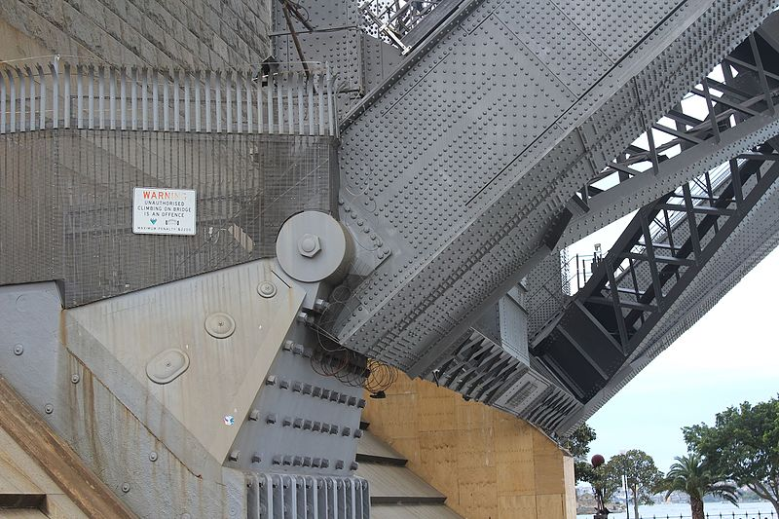
"Sydney Harbour Bridge hinge" by Martinvl is licensed under CC BY-SA 4.0
This is the end of the components section. The next section refers to references used to create this document.

References
Links to third-party material and websites
Please note that the provided (reading/viewing material/list/links/texts) are a suggestion only and implies no endorsement, by the New South Wales Department of Education, of any author, publisher or book title. School principals and teachers are best placed to assess the suitability of resources that would complement the curriculum and reflect the needs and interests of their students.
If you use the links provided in this document to access a third party's website, you acknowledge that the terms of use, including licence terms set out on the third party's website apply to the use which may be made of the materials on that third-party website or where permitted by the Copyright Act 1968 (Cth). The department accepts no responsibility for content on third-party websites.
All material © 2021 State of New South Wales (Department of Education), unless otherwise indicated. All other material used by permission or under licence.
Microsoft (2022) ‘Insert a table of contents’, Lay out pages, Microsoft Office Support website, accessed 23 May 2022.
Monash University (2022) ‘Engineering: Technical report’, Learn HQ, Monash University, accessed 23 May 2022.
Victoria University (2015) ‘APA 7th Referencing: Getting Started in APA 7th’, APA 7th Referencing, Victoria University Library Guides website, accessed 23 May 2022.
Winckel A and Hart B (2002) Report Writing Style Guide for Engineering Students [PDF 193KB], 4th edn, University of South Australia website, accessed 23 May 2022.

Further reading
The University of Melbourne 1994 - 2017 (2017) ‘Technical report writing’, Report writing, The University of Melbourne website, accessed 23 May 2022.
Skillem J, Wypych P and Drasima K (n.d.) Report Writing: Engineering [PDF 253 KB], University of Wollongong – Learning Development, accessed 23 May 2022.

