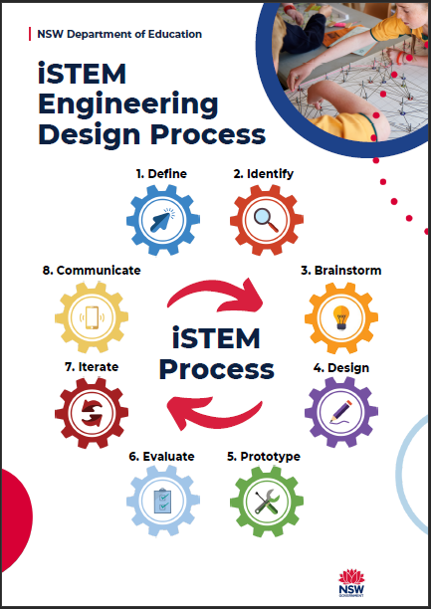

iSTEM engineering design process

A guide for teachers

iSTEM engineering design process 0
A guide for teachers 0
iSTEM engineering design process 2
Guide to the iSTEM engineering design process 4
1. Define – the problem 5
2. Identify – the constraints 6
3. Brainstorm – possible solutions 7
4. Design – most promising solutions 8
5. Prototype – your solution 9
6. Evaluate – and test your solution 10
7. Iterate – to improve your solution 11
8. Communicate – and share your solution 12

iSTEM engineering design process
The iSTEM engineering design process is developed for the Stage 5 iSTEM course. It was initially developed by the STEM Industry School Partnerships (SISP) program through extensive consultation with teachers from both primary and secondary education. It has since been refined by the NSW Department of Education’s STEM curriculum team in consultation with a range of educators and industry partners.
The iSTEM engineering design process has been designed to provide a consistent approach and language across all stages based on an industry practice. It provides a scaffold to develop student understanding and application of design thinking and problem solving.
Teaching and learning units developed for Stage 5 iSTEM embed this process into teaching and learning resources. The iSTEM engineering design process is available as an A4 poster design for display in iSTEM classrooms.
Different coloured cog icons have been used in the iSTEM engineering design process to enhance student understanding and are documented in the table on page 3.
Please note that not all eight processes (cogs) are needed to be used in every design activity. The numbering of the processes does not imply a linear process and they can be used in different orders depending on the problem being solved. Processes (cogs) may also be used more than once when solving a particular problem. For example, students could use the iterate cog in a number of areas to repeat other processes (cogs) within a cyclic design process.

Process | Icon
1 Define – the problem | 
2 Identify – the constraints | 
3 Brainstorm – multiple solutions | 
4 Design – the most promising solution | 
5 Prototype – your solution | 
6 Evaluate – and test your solution | 
7 Iterate – to improve your solution | 
8 Communicate – and share your solution | 

Guide to the iSTEM engineering design process
The following pages provide a guide for teachers to ‘key questions’ and ‘possible activities’ that students might typically complete for each of the processes that make up the iSTEM engineering design process. In order to respond to the key questions, all students would need to be explicitly taught new vocabulary, language and structures. The language, literacy and cultural demands of any activity would need to be considered, including any appropriate EAL/D support provided.
This is not an exhaustive list but is designed to stimulate ideas and give direction to teachers and students.
In order to solve complex problems, students must complete a series of steps. The cogs used in the iSTEM engineering design process provide a scaffold for solving typical problems within iSTEM.
Each engineering design journey is different and will require students to consider a range of key questions and activities depending on the type of problem they are attempting to solve. This guide provides a set of examples to assist teachers to develop students’ complex problem-solving skills. Plan learning activities that are inclusive for all students in your classroom from the beginning. Some students may also require more specific adjustments to allow them to participate on the same basis as their peers.


Define – the problem
Table 1 – Define the problem or need to gain understanding.
Key questions | Possible activities
- Why does the problem need to be solved?  - What experiences can you relate to in the problem?  - What are your initial thoughts of how you could possibly solve the problem?  - How can different members of the team contribute to the solution?  - Do you have more questions about the problem?  - Who does the problem concern?  - How will you know that your solution will suit them?  - What processes will need to occur to solve the problem?  - How will I know the solution was successful? | - Produce a clear statement describing the problem to be solved.  - Mind map initial thoughts and additional questions.  - Review prior knowledge and experience.  - Determine what assets are available.  - Identify resources available or needed.  - Write a clear and concise design brief statement.  - Identify sources of information.  - Articulate the scope and nature of the problem.  - Define the success criteria for the project.


2. Identify – the constraints
Table 2 – Outline specific boundaries by which the project will be confined.
Key questions | Possible activities
- What are the constraints of the problem you are trying to solve?  - What other solutions are people using and how will that affect their ability to use your solution?  - How much will it cost and what is the overall budget?  - What skills and knowledge does the team possess?  - How much time do I have for completion?  - What tools and equipment are required and available?  - What data or information will be needed?  - What is the aesthetic, functional and ergonomic considerations? | - Clearly identify all relevant constraints.  - Identify constraints of the end user.  - Produce a budget or finance plan.  - Identify start and finish dates and any milestones for the project.  - Develop a resource list, including tools, materials, and people.  - Identify data and information that needs to be collected.  - Produce matrix identifying aesthetic, functional, ergonomic considerations.


3. Brainstorm – possible solutions
Table 3 – Create, develop, and communicate ideas.
Key questions | Possible activities
- How are you going to generate ideas?  - What information will you use to generate ideas?  - What strategies can you use to develop the most innovative ideas from your team?  - How can we make sure that all ideas are valued when working in a team?  - What makes this project innovative?  - What is the best way to communicate your ideas?  - How can you make the idea generation session inclusive?  - Can we draw links and connections between generated ideas? | - Use divergent thinking to produce as many creative ideas as possible.  - Utilise a range of idea generation techniques.  - Explore existing solutions to create new design ideas.  - Investigate potential technologies and techniques that could be used in the solution.  - Produce thumbnail sketches and annotated drawings of initial ideas.  - Communicate and share ideas.  - Use a mind map to organise ideas.


4. Design – most promising solutions
Table 4 – Investigate options, refine ideas, create, communicate solutions and processes to solve problems.
Key questions | Possible activities
- Is the design concept a product, environment, system, or something else?  - What kind of subject matter experts can you bring on to help you design the best solution?  - How do we combine many ideas into design solutions?  - How do you resolve conflicting design ideas?  - How do you choose the best design?  - Do you have the skills required to produce the design solution?  - Are the tools, equipment and materials required and available? | - Use convergent thinking to develop ideas and refine solutions.  - Work collaboratively to enhance solutions.  - Produce sketches, detail drawings, digital graphics to communicate solutions.  - Use critical thinking, problem solving, and entrepreneurial activities to produce the ‘best solution’.  - Use a range of design tools to communicate ideas.  - Improve on creative, innovative, and enterprising ideas.



5. Prototype – your solution
Table 5 – Produce a model or prototype of the best possible solution.
Key questions | Possible activities
- What type of prototype are you going to construct, a product, device, video, computer model?  - What fidelity will you prototype at?  - What can you create to get the most feedback with the least investment in order to iterate quickly?  - Have you considered work, health and safety (WHS)?  - Are resources available to produce the model or prototype?  - Is the model or prototype within the previously determined constraints? | - Use appropriate tools and materials to produce models or prototypes.  - Utilise computer-aided manufacturing (CAM) to produce rapid prototyped models.  - Produce minimal viable products that demonstrate the aesthetic, functional and ergonomic attributes.  - Apply coding techniques to create solutions using physical computing or robotics technologies.  - Build simulations.

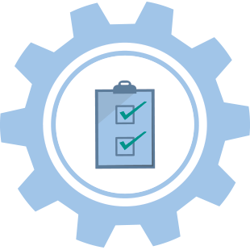

6. Evaluate – and test your solution
Table 6 – Evaluate the solution against the identified problem.
Key questions | Possible activities
- What is your evaluation criteria?  - What revisions or improvements can be made to the design?  - How innovative is the solution?  - Has the solution produced any unintended outcomes?  - Can your design choices be justified?  - What was discovered from the testing and experimentation of the solution?  - Is there more experimentation and testing required?  - How well did the solution meet the success criteria?  - Have legal and regulatory requirements been met? | - Complete testing and experimentation.  - Analyse and evaluate the impact of the solution on the environment and society.  - Complete evaluations and feedback to establish if the solution meets the design brief.  - Collect, organise, and interpret data to inform and evaluate design decisions.  - Use peer evaluation and self-reflection to identify any improvements.  - Critically reflect and evaluate the solution against the success criteria.


7. Iterate – to improve your solution
Table 7 – Refine design solutions, revise, and continually improve.
Key questions | Possible activities
- Do we need to revisit earlier phases of the process?  - Has the identified problem or need changed?  - Has the solution produced other opportunities?  - How can the solution be further improved?  - If you decide to make revisions, what will it look like?  - Are there plans and enough resources to make revisions?  - What is your plan for continuous improvement after the launch of an MVP? | - Assess previous iterations of the design solution.  - Repeat, design, prototype and evaluate, until the ‘best possible solution’ is achieved.  - Refine design ideas based on results of experimentation, testing and evaluation.  - Produce a minimal viable product (MVP) after numerous iterations of the design solution.  - Re-evaluate the design solution over its entire life cycle to ensure it remains the ‘best possible solution’.



8. Communicate – and share your solution
Table 8 – Communicate and share design solutions to key stakeholders.
Key questions | Possible activities
- Have all key stakeholders been informed throughout?  - Who needs to see the solution(s)?  - How can you best share or pitch the solution?  - What enterprise and entrepreneurial skills are required to successfully market the solution?  - What are the results of product and market testing?  - Would the solution benefit a broader market? How could you reach this market?  - Have all the product specifications been documented? | - Document all aspects of the engineering design process.  - Pitch the solution.  - Communicate evidence-based results to justify design decisions.  - Communicate to key stakeholders using presentations, reports, and drawings.  - Develop a communications and marketing plan.  - Document the design specifications, measurements and communicate to all groups.

