Critical thinking – Core 1 assessment task: Building a strong argument


Contents
Advice to teachers 2
Outcomes 2
Task instructions 3
Task steps 3
‘Would you rather’ 4
Consider all options 5
Build your argument 7
Toulmin argument model scaffold 8
Refine your argument 9
Options for marking 11
Marking guidelines 11
Grade descriptors 13
Rubric – Toulmin argument model 15
Additional information 18
Rationale 18
Aim 19
Purpose and audience 19
When and how to use this document 19
Assessment for learning 19
Differentiation 21
About this resource 22
References 25

Advice to teachers
Note: The assessment task is designed as a culmination of learning where students have examined the Toulmin argument model and used the model to assess arguments and build their own. Example ‘Would you rather’ cards are provided. Alternatives may be sourced online or a class may develop their own set of cards to use. Teachers may use the first part of this task to prepare students for the assessment. Familiarity with the Toulmin argument model may be achieved by its early introduction and practising sequencing and using the model.
Teachers can include their details of due date, weighting and submission guidelines as per their school practice.

Outcomes
A student:
- CT5-3 constructs and builds stronger arguments with evidence-based decision making by discerning fact from fiction
- CT5-5 communicates arguments logically in a range of modes.
Outcomes referred to in this document are from the Critical thinking Course Document © 2021 NSW Department of Education for and on behalf of the Crown in the State of New South Wales.
Learning intention
Students are learning to develop, construct and present arguments with evidence and reasoning.
Success criteria
Students can:
- consider both sides of an argument
- use the Toulmin model to construct an argument
Type of task: Presentation
Focus question: How can we build stronger arguments?

Task instructions
In this task you will assess and construct arguments. You will select one ‘Would you rather’ scenario card from the class deck of cards to suit your interests. This card will be used for the duration of the assessment task. Use the Toulmin argument model scaffold to explore and build a strong argument for the selected card.

Task steps
- Choose a range of ‘Would you rather’ cards that relate to your interests.
- Choose your best 2 or 3 cards and practise on a whiteboard in the classroom.
- Consider which card you could use to make a strong argument and communicate with a peer your reasons for selecting this card.
- Observe the Toulmin argument model examples in class and use the graphic organiser to construct an argument.
- Research your argument in more detail to obtain stronger evidence.
- Select your presentation method and discuss your idea with your teacher.
- Use the graphic organiser to assist you in creating your presentation.

‘Would you rather’
Note: Below are some ‘Would you rather’ cards that could be used as a prompt for a student’s argument or used as exemplars for students to develop their own cards. Visuals can be used to support student understanding.
Table 1 – Example 'Would you rather' cards
Examples | Examples
Would you rather have Latrell Mitchell or James Tedesco in your football team? | Would you rather listen to songs by Budjerah or Matt Corby?
Would you rather keep speed zones or remove them?   | Would you rather have a driverless car or drive yourself?  
Would you rather have a common world currency or keep it as individual currencies?   | Would you rather have an electric car or a petrol car?  
Would you rather have schooling by age or by ability?   | Would you rather spend money and time on space research or keep it focussed on earth?  
Would you rather grow crops for food or crops for fuel (ethanol)?   | Would you rather run junior contact sports by age or by weight?  
All images are from Pixabay and licensed in accordance with the Pixabay License.

Consider all options
Note: Further resources can be found at Toulmin Argument Model (Nesbitt 2022) to provide exemplars and further explanation of the different components in the model. Students may benefit from familiarising themselves with the model by practising to sequence its components.
Choose a ‘Would you rather’ statement of your choice from the class deck of cards.
Consider the 2 options available. Show your thinking and assessment of each option available below.
Example: Would you rather have a common world currency or keep it as individual currencies?
Table 2 – Assessment of currency options. Indicate the supporting reasons for both options.
Individual currencies | World currency

Build your argument
Select an option from the ‘Would you rather’ statement – this will be your claim. Use the Toulmin argument model to construct your argument. You must include:
☐ Claim
☐ Grounds (evidence or data that supports the claim)
☐ Warrant (explains why the grounds/evidence/data supports the claim)
☐ Backing (further unpacking of evidence)
☐ Qualifier (a qualifier is a statement about how strong the claim is)
☐ Rebuttal (this includes an argument against your claim, or a counter argument: an argument to go against someone’s rebuttal to you)

Toulmin argument model scaffold
Figure 1 – Toulmin argument model scaffold
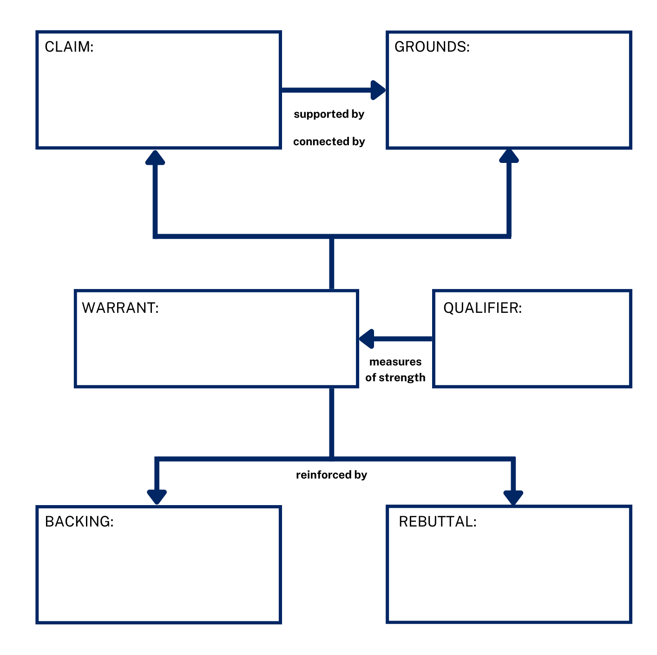

Refine your argument
In this section, you will need to give reasons why your choice is valid (accurate). It’s important to have strong evidence and reasoning.
You will need to:
☐ explicitly state your claim
☐ share evidence used to support your argument
☐ provide your reasoning that links the evidence to your claim
☐ consider rebuttals to your claim and counteract this with stronger evidence.
Note: Below is an example using language that can be unpacked with students.
Explicitly state your claim
I would rather keep it as individual currencies rather than have a common world currency.
Share evidence used to support your argument
There are many different exchange rates around the world because each country is in a different financial position and their economy has different worth when compared to other countries. Each country has greater control over their own currency which can be an important instrument in regulating their economy. The physical currency can be an important reflection of each country’s history and cultural identity.
Provide your reasoning that links the evidence to your claim
Having centralised control of all the world’s money means loss of control by individual countries. Greater central control means a concentration of power by entities that don’t have our own country’s best interests in mind when making decisions.
Consider rebuttals to your claim and counteract this with stronger evidence
Although we wouldn’t pay exchange rates we would potentially pay just as much, if not more, to central banks to administer the world currency. There is also the potential for a loss of control over your own country’s economy.
Present your justification in your own chosen method
This may include:
- filming your response
- writing your response
- creating a PowerPoint
- making a speech to the class
- recording an audio file
- discussing your communication method with your teacher.

Options for marking
Note: Three types of criteria are available for use and teachers will need to decide which one, or combination, best serves their students. Marking guidelines may be useful for teachers to holistically mark a student’s evidence of learning while the grade descriptors may be useful in reporting progress to parents. The rubric on the aspects of the Toulmin argument model may be useful for students to self-assess or peer assess and could be used formatively.

Marking guidelines
Table 3 – Marking guidelines
Grade | Marking guidelines
A | - Displays thoughtful and synthesised argument through careful and considered use of the Toulmin argument model  - Accurately interprets information and uses a range of well-selected evidence for purpose  - Presents an analysis and evaluation to support and extend the argument  - Uses a logical and engaging structure that is well timed and presented
B | - Displays a thorough and relevant argument through effective use of the Toulmin argument model  - Interprets information and uses evidence consistently to achieve a purpose  - Analyses and evaluates to support the argument  - Uses a logical structure with mostly consistent timing and delivery
C | - Displays a relevant argument through use of the Toulmin argument model  - Interprets some information and uses evidence to support the argument  - Explanation begins to become analytical/evaluative to support the argument  - Structure and delivery support an understanding of the argument
D | - Displays knowledge of the Toulmin argument model  - Uses information and/or evidence with basic connection to the argument  - Explains how the information/evidence supports the argument  - Some structural elements in the delivery of the argument
E | - Displays knowledge of some parts of the Toulmin argument model  - Uses some information or evidence that connects to the argument  - Some explanation of information or evidence is used  - Structure impedes understanding

Grade descriptors
Table 4 – Grade descriptors
Grade | Descriptors
A | The student has extensive knowledge and understanding of the Toulmin argument model and can construct accurate claims, with evidence and reasoning. They have displayed an extensive level of understanding when determining the relevance and reliability of the information that might be used to support an argument. In addition, the student has achieved a very high level of competence in the skills of evaluation, analysis and synthesising information and can apply these skills to new situations.
B | The student has thorough knowledge and understanding of the Toulmin argument model and can construct claims, with evidence and reasoning. They have displayed a thorough level of understanding when determining the relevance and reliability of the information that might be used to support an argument. In addition, the student has achieved a high level of competence in the skills of evaluation, analysis and synthesising information and can apply these skills to most situations.
C | The student has sound level of knowledge and understanding of the Toulmin argument model and can construct claims, with evidence and reasoning. They have displayed a sound level of understanding when determining the relevance and reliability of the information that might be used to support an argument. In addition, the student has achieved an adequate level of competence in the skills of evaluation, analysis and synthesising information.
D | The student has a basic level of knowledge and understanding of the Toulmin argument model and is attempting to construct claims, with evidence and/or reasoning. They have displayed some level of understanding when determining the relevance and reliability of the information that might be used to support an argument. In addition, the student has achieved some competence in the skills of evaluation, analysis and synthesising information.
E | The student has an elementary level of knowledge and understanding of the Toulmin argument model. They have named some points of argument without connection to reasons or evaluation.

Rubric – Toulmin argument model
Table 5 – Rubric – Toulmin argument model
Grade | Claim | Grounds | Warrant | Backing | Qualifier | Rebuttal
A | Makes a well thought out claim that has opportunity for multiple sources of strong evidence | Gathers sufficient, credible, relevant research from a range of sources. Shows how the research presented is credible and evidence based | Warrant logically links the evidence to the grounds of the claim and establishes the relevance of the claim for the audience | Backing increases the strength of the warrant | Qualifiers support the argument by balancing modality with the strength of the claim | Gathers sufficient, credible, relevant research opposing of viewpoints.  Presents the limitations to the argument but uses rebuttal to confirm why the argument is the most relevant conclusion
B | Makes a credible claim that is able to be backed by evidence | Gathers sufficient, credible, relevant research from a range of sources | Warrant logically links the evidence to the grounds of the claim and establishes the relevance of the claim | Backing supports the warrant | Qualifiers use appropriate modality in terms to remove absolutes from the argument, for example, ‘most’ instead of ‘all’ | Gathers sufficient, credible, relevant research opposing of viewpoints and uses them to develop the argument
C | Makes a claim that is partially able to be backed by evidence | Gathers sufficient, credible, and relevant research including information from a range of viewpoints | Warrant links the evidence to the grounds of the claim | Backing links to the warrant | Qualifiers are overstated (modality is too high) | Recognises and acknowledges credible points from an opposing view and offers a counterargument
D | Makes a claim that is difficult to be backed by evidence | Some information is gathered but the information may be basic and leaves a lot of opportunity for the claim to be proved incorrect with counterarguments | Warrant has some links with the evidence and the claims | Backing has some link to the warrant | Some statements about the strength of the argument are made | Outlines the limitations to their own argument
E | Makes a claim that does not relate to the topics for argument | Insufficient or confusing information which ignores strong, relevant counterarguments | Warrant has unclear links between the grounds and the claim | Backing does not link to the warrant | A point about the strength of the argument is made | Outlines their own argument only

Additional information
Please complete the following feedback form to help us improve our resources and support.
The information below can be used to support teachers when using this assessment package for Critical thinking.

Rationale
Critical thinking is a form of purposeful thinking that emphasises evidence and reasoning. In today’s world, where information is readily available, critical thinking is becoming more important than remembering and recalling facts. Society values critical thinking because it is an interdisciplinary and transferable skill. It means that no matter what path or profession is pursued, critical thinking skills will always be relevant and useful.
Critical thinking skills include the ability to deconstruct, analyse, synthesise and reconstruct ideas while emphasising evidence and reasoning. Those skills are part of every toolkit for success in educational and professional arenas.
The critical thinking course emphasises the fundamental attributes of critical thinkers and gives students a wide range of opportunities to transfer these skills across multiple disciplines. The course structure encourages students to think about thinking and transcend factual learning.
The core units introduce students to the key features of critical thinking, including how critical thinking is distinguished from other models of thinking. Students will learn about the process of argumentation and apply it to evaluate claims. Students will also gain practical research skills to collect information from various sources and evaluate their credibility.
A choice from the available options engages students in various areas of interest to reinforce the skills learnt from the core units. In addition, the options allow students and teachers to delve deeper into specific scenarios of interest. Students will be guided to ask probing questions to strengthen their critical thinking skills and challenge their perceptions of the world around them.
After completing the critical thinking elective, students will be able to apply critical thinking processes to analyse the strength and validity of information and claims. Those skills are valuable for learning in Stage 6. Critical and creative thinking is a general capability in most Stage 6 courses. By applying their critical thinking skills, students will deepen their understanding of content and skills across many disciplines.

Aim
The course aims to engage and encourage students to develop their critical thinking skills and recognise the key aspects of a critical thinking mind. They will develop the essential skills to evaluate the vast and diverse amount of information they encounter in their daily lives. This will help them face future challenges in a continually evolving world.

Purpose and audience
This assessment package provides a range of assessment strategies and supplementary material that can be used to support student achievement in the task outlined. This resource is for teachers when creating a program of assessment for the Critical thinking course.

When and how to use this document
Use the assessment package in the context that best supports your school context.

Assessment for learning
Possible formative assessment strategies that could be included:
- Learning Intentions and Success Criteria assist educators to articulate the purpose of a learning task to make judgements about the quality of student learning. These help students focus on the task or activity taking place and what they are learning and provide a framework for reflection and feedback. Online tools can assist implementation of this formative assessment strategy.
- Eliciting evidence strategies allow teachers to determine the next steps in learning and assist teachers in evaluating the impact of teaching and learning activities. Strategies that may be added to a learning sequence to elicit evidence include all student response systems, exit tickets, mini whiteboards (actual or digital), hinge questions, Kahoot, Socrative, Quizlet or quick quizzes to ensure that individual student progress can be monitored and the lesson sequence adjusted based on formative data collected.
- Feedback is designed to close the gap between current and desired performance by informing teacher and student behaviour (AITSL 2017). AITSL provides a factsheet to support evidence-based feedback.
- Peer feedback is a structured process where students evaluate the work of their peers by providing valuable feedback in relation to learning intentions and success criteria. It can be supported by online tools.
- Self-regulated learning opportunities assist students in taking ownership of their own learning. A variety of strategies can be employed and some examples include reflection tasks, Think-Pair-Share, KWLH charts, learning portfolios and learning logs.
The primary role of assessment is to establish where individuals are in their learning so that teaching can be differentiated and further learning progress can be monitored over time.
Feedback that focuses on improving tasks, processes and student self-regulation is the most effective. Students engaging with feedback can take many forms including formal, informal, formative, summative, interactive, demonstrable, visual, written, verbal and non-verbal.
What works best update 2020 (CESE 2020a)

Differentiation
Differentiated learning can be enabled by differentiating the teaching approach to content, process, product and the learning environment. For more information on differentiation go to Differentiating learning and Differentiation.
When using these resources in the classroom, it is important for teachers to consider the needs of all students in their class, including:
- Aboriginal and Torres Strait Islander students. Targeted strategies can be used to achieve outcomes for Aboriginal students in K-12 and increase knowledge and understanding of Aboriginal histories and cultures. Teachers should utilise students’ Personalised Learning Pathways to support individual student needs and goals.
- EAL/D learners. EAL/D learners will require explicit English language support and scaffolding, informed by the EAL/D enhanced teaching and learning cycle and the student’s phase on the EAL/D Learning Progression. In addition, teachers can access information about supporting EAL/D learners and literacy and numeracy support specific to EAL/D learners.
- Students with additional learning needs. Learning adjustments enable students with disability and additional learning and support needs to access syllabus outcomes and content on the same basis as their peers. Teachers can use a range of adjustments to ensure a personalised approach to student learning. In addition, the Universal Design for Learning planning tool can be used to support the diverse learning needs of students using inclusive teaching and learning strategies. Subject specific curriculum considerations can be found on the Inclusive Practice hub.
- High potential and gifted learners. Assessing and identifying high potential and gifted learners will help teachers decide which students may benefit from extension and additional challenge. Effective strategies and contributors to achievement for high potential and gifted learners help teachers to identify and target areas for growth and improvement. In addition, the Differentiation Adjustment Tool can be used to support the specific learning needs of high potential and gifted students. The High Potential and Gifted Education Professional Learning and Resource Hub supports school leaders and teachers to effectively implement the High Potential and Gifted Education Policy in their unique contexts.
All students need to be challenged and engaged to develop their potential fully. A culture of high expectations needs to be supported by strategies that both challenge and support student learning needs, such as through appropriate curriculum differentiation. (CESE 2020a:6).

About this resource
All curriculum resources are prepared through a rigorous process. Resources are periodically reviewed as part of our ongoing evaluation plan to ensure currency, relevance and effectiveness. For additional support or advice contact the Teaching and Learning Curriculum team by emailing secondaryteachingandlearning@det.nsw.edu.au.
Alignment to system priorities and/or needs:
This resource aligns to the School Excellence Framework elements of curriculum (curriculum provision) and effective classroom practice (lesson planning, explicit teaching).
This resource supports teachers to address Australian Professional Teaching Standards 5.1.2, 5.5.2.
This resource has been designed to support schools with successful implementation of new curriculum, specifically the NSW Department of Education approved elective course, Critical thinking © 2021 NSW Department of Education for and on behalf of the Crown in right of the State of New South Wales.
The resource is produced to assist schools with promoting and implementing the course for the first time. As the course may be taught by teachers from a range of key learning areas, the resource is designed to support teachers from a variety of KLA expertise.
Department approved elective course: Critical thinking
Course outcomes: CT5-3, CT5-5
Author: Curriculum Secondary Learners
Publisher: State of NSW, Department of Education
Resource: Teaching resource
Related resources: Further resources to support Critical thinking can be found on the Department approved elective courses webpage including course document, sample scope and sequences, assessment materials and other learning sequences.
Professional Learning: Join the Teaching and Learning 7-12 statewide staffroom for information regarding professional learning opportunities.
Universal Design for Learning Tool: Universal Design for Learning planning tool. Support the diverse learning needs of students using inclusive teaching and learning strategies.
Consulted with: Aboriginal Outcomes and Partnerships, Inclusion and Wellbeing, EAL/D, and Warrawong High School.
Reviewed by: This resource was reviewed by Curriculum Secondary Learners and by subject matter experts in schools to ensure accuracy of content.
Creation date: 21 October 2022
Rights: © State of New South Wales, Department of Education
Evidence base:
The range of assessment strategies outlined in the advice encourages ‘a variety of assessment methods each lesson to check for students’ understanding and inform what should be taught next’. (CESE 2020a:22). The assessment strategies outlined are student-centred, providing ‘students with opportunities to reflect on their progress to inform future learning goals’ (CESE 2020a:22).
The assessment advice complies with NESA’s assessment advice, outlined on NESA’s ACE website, NESA official notices and department memorandums. They:
- include statements of school procedures for allocating grades in Year 10
- set out requirements to retain student work samples to support grade allocation as required by NESA for the RoSA (NESA 2006).
The assessment strategies outlined provide teachers with important information about whether students learned what was intended. Wiliam (2013) claims ‘the term formative should apply not to the assessment but to the function that the evidence generated by the assessment actually serves’.

References
Links to third-party material and websites
Please note that the provided (reading/viewing material/list/links/texts) are a suggestion only and implies no endorsement, by the New South Wales Department of Education, of any author, publisher, or book title. School principals and teachers are best placed to assess the suitability of resources that would complement the curriculum and reflect the needs and interests of their students.
If you use the links provided in this document to access a third party's website, you acknowledge that the terms of use, including licence terms set out on the third party's website apply to the use which may be made of the materials on that third-party website or where permitted by the Copyright Act 1968 (Cth). The department accepts no responsibility for content on third-party websites.
All material © State of New South Wales (Department of Education), 2021 unless otherwise indicated. All other material used by permission or under licence.
AITSL (Australian Institute for Teaching and School Leadership (2017) ‘Feedback Factsheet’, AITSL, accessed 10 November 2022.
Banchi H and Bell R (2008) ‘The many levels of inquiry: Inquiry comes in many forms’, Science and Children, 46(2):26-29.
Hmelo-Silver CE, Duncan, RG and Chinn CA (2007) ‘Scaffolding and achievement in problem-based and inquiry learning: A response to Kirschner, Sweller, and Clark (2006)’, Educational Psychologist, 42(2):99-107.
Jiang F and McComas WF (2015) ‘The effects of inquiry teaching on student science achievement and attitudes: Evidence from propensity score analysis of PISA data’, International Journal of Science Education, 37(3):554-576.
NESA (NSW Education Standards Authority) (2020) Nurturing Wonder and Igniting Passion, designs for a new school curriculum: NSW Curriculum Review [PDF 1.12MB], NESA, accessed 10 November 2022.
Nesbitt L (2022) ‘The Toulmin Method’, Writing Guides, The WAC Clearinghouse website, accessed 10 November 2022.
Quizlet (2022) Quizlet [website], accessed 10 November 2022.
State of New South Wales (Department of Education) and CESE (Centre for Education Statistics and Evaluation) (2020a) ‘What works best: 2020 update’, CESE, NSW Department of Education, accessed 10 November 2022.
State of New South Wales (Department of Education) and CESE (Centre for Education Statistics and Evaluation) (2020b) ‘What works best in practice’, CESE, NSW Department of Education, accessed 10 November 2022.
Wiliam D (2013) ‘Assessment: The Bridge between Teaching and Learning’, Voices from the Middle, 21(2):15–20, https://doi.org/10.3389/fpsyg.2019.03087.

