Critical thinking – Option 1 assessment task – strategies used in business and war

Contents
Advice to teachers 3
Glossary 5
Formative assessment – military tactics 7
Background information 7
Task description 8
Planning information 9
Military tactics – sample response 14
Sample response 15
Military tactic overview 15
Tactics: Group A 16
Tactics: Group B 16
Tactics: Group C 18
Reasons for strategy success 19
Assessing student achievement – military tactics 21
Summative sample assessment task – invading with a new sporting franchise 22
Background information 23
Task instructions 23
Task steps 24
Invading with a new sporting franchise – sample response 25
Sample response 25
Options for marking 29
Marking guidelines 29
Grade descriptors 31
Rubric 33
Combined rubric 35
Additional information 37
Rationale 37
Aim 38
Purpose and audience 38
When and how to use this document 38
Assessment for learning 38
Differentiation 39
About this resource 40
References 43
Critical thinking course document © NSW Department of Education for and on behalf of the Crown in the State of New South Wales, 2021.

Advice to teachers
Assessment should be viewed as a link between teaching and learning. For students, assessment should provide an opportunity to receive feedback and set learning goals for future improvement. For the teacher, assessment should give an insight into student learning and direct future lessons.
This resource contains an example of a formative and a summative task.
Formative task: in this task students will devise an offensive military plan based around a fictional setting in Roman times.
Summative assessment task: building on from the formative task, students research into the thinking and strategy used when opening a new franchise in sport. They present their argument on both the type of sport and location of the new franchise, based on gathered evidence. While a sporting theme has been chosen, the viewpoints students need to take is that a franchise is a business. Successful businesses need to be profitable even if it is linked to a sporting team.
Both tasks are examples of how critical thinking can be assessed in Option 1. Modification and adjustments are recommended to cater to your class’s learning needs. This could include student choice of the context in the assessment task and how students will communicate their understanding. Tailoring the example tasks may provide an equitable opportunity for all students to demonstrate their understanding and receive quality feedback to improve learning.
Literacy Skills: the main literacy skill explored in this resource is Understanding texts from the National Literacy Learning Progression V3.
This resource represents learning activities at level UnT9 where students become increasingly proficient in decoding, using, interacting with, analysing and evaluating texts to build meaning. Through unpacking the given information and supporting research, students will need to draw inferences, synthesising clues and evidence across a range of text types and sources. For students who need to consolidate learning at UnT8, the glossary activities in this document are recommended. Accessing student data such as NAPLAN or Check-in assessments may give an indication for which starting point is suitable for each student. Access Critical thinking assessment advice for further support with assessment as part of the Critical thinking course.

Glossary
Table 1 – vocabulary tracker
Word/phrase | Definition | Synonyms | Antonyms | Use in a sentence
lethal | able to cause or causing death; extremely dangerous: | deadly, fatal, mortal. | healthy, nonlethal, beneficial | landmines continue to be a lethal weapon in modern warfare, causing death to both civilians and soldiers.
infantry | army on foot
cavalry | soldiers in an army who ride horses
offensive | attacking
residents | people who lives or has their home in a place
conscripts | soldiers forced to join an army
franchise | the contractual right granted to any person or persons to own or operate a business in a specified location.
consortium | a group of separate businesses or businesspeople joining together and cooperating to complete a project, work together to perform a contract or conduct an on-going business.

Formative assessment – military tactics
Teacher note: in this activity, students devise an offensive military tactic based on limited information. The hypothetical scenario presented is set in medieval times, which also provides some context for the weapons available for the military operation.
As a class activity, unpack and discuss the information provided, as this may be beneficial for students. The provided information can be edited to provide more information for your students to use or change the setting for the battle plans.
Given the open-ended nature of this formative task, careful consideration to allocating class time will be needed. Factors such as, students’ current level of ability and the time needed for students to act on feedback should be considered when planning to use this task.

Background information
Military tactics (or strategies) encompass the art of organising and employing fighting forces on or near the battlefield. They involve the application of 4 battlefield functions which are closely related:
- Kinetic or firepower –military action involving active warfare, including lethal force.
- Mobility – how quickly an army can travel.
- Protection or security – a measure of individual protection, which was also extended to include ‘barding of the mount’ (armour for horses). While the armour is protective, its weight and bulk can limit mobility and human and animal endurance.
- Shock action – is as much a psychological function of tactics as a physical one and can be significantly enhanced by the use of surprise. It has been carried out by charging infantry and cavalry to provide momentum to an assault. It has also been used in a defensive way, for example by the ‘drenching flights of arrows’ (arrows coming down like rainfall) to an attacking army.
Adapted from Military tactics (Wikipedia contributors 2022) under Creative Commons Attribution-ShareAlike 3.0 Unported (CC BY-SA 3.0)
Learning intention
Students use available information and critical thinking to devise military tactics.
Success criteria
Students can:
- recognise any biases which can impact their ability to make an evidence-based claim
- present a convincing argument based on evidence and reasoning.
- devise military tactics using their own reasoning and available evidence.

Task description
This activity is fictional and is based on some historical information. The Roman Empire is the context used in this activity to demonstrate critical thinking. The activity is not designed to be used to build historical understanding of the Roman Empire.
You have been tasked to capture the Crystal Kingdom for the Roman Empire, as it plans to further expand into the northern lands. The enemy is advanced and organised. Their soldiers and archers have similar weaponry, but they don’t have artillery.
Once the city area is secure, a larger force will march to your position, it will take about 10 days for them to reach your position. This area is to become the position from which further attacks on the capital and northern lands will begin.
Scouts and spies have collected information to aid in your planning. The following has been based on their observations and secret discussions with locals:
- a drawn map of the enemy kingdom
- descriptions of some major features
- information of the enemy’s armies in the city.

Present and justify an offensive military tactic based on the information collected. Include:
- the reasoning behind your first plan
- how and why the enemy may react
- how your plans could adjust depending on the enemy’s movements
- why your course of action will secure victory.
You may choose to present this as a PowerPoint presentation, written report or animated video.

Planning information
This information has been collected to aid your planning. When creating your offensive military tactic, use the following:
- terrain map
- map notes on Crystal Kingdom
- Crystal Castle information
- your army details.

Map
- The main features of the Crystal Kingdom are shown in Figure 1 below. The map is to scale.
Figure 1 – drawn map of the Crystal Kingdom
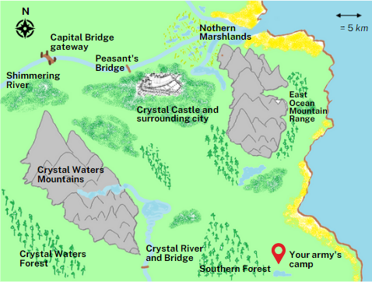

Map notes on Crystal Kingdom
Table 2 – descriptions of major features of Crystal Kingdom
Features | Description
Crystal City | - Situated on top of Crystal Hill on the banks of the Shimmering River.  - Crystal Castle has around 1,000 military personnel. They are well trained professional soldiers.  - Approximately 3,500 civilians live around the city and in local farmlands. The men can be called up to protect the city.  - Major trading city.
Capital Bridge gateway | - A large, guarded stone bridge connects Crystal Kingdom to the Capital. Additional troops from the Capital use this bridge to aid Crystal City.  - The bridge has an attached barracks which holds approximately 100 highly trained soldiers.
Peasant’s Bridge | - Small footbridge connecting Crystal City to the residents of the Northern Marshlands.
Shimmering River | - A gentle and wide river used by traders to access land to the west.
Northern Marshlands | - A fishing village with a population of 300 residents. The residents are strong fighters but have no formal training.
East Ocean Mountain Range | - Has small pathways throughout it towards the Crystal Kingdom. Carrying heavy goods is not recommended and animals could not journey via these paths.
Crystal Waters Mountains | - Snow-capped mountains with many small paths and a river throughout. The paths are dangerous and not recommended for large groups.
Crystal Waters Forest | - A rich forest with many fruits and small animals. The forest is patrolled by small groups of guards. It is the preferred hunting grounds for the city.
Crystal River and Bridge | - Small footbridge used by local farmers.
Southern Forest | - A dense forest with a large variety of local animals. Wolves, deer and boars can be found in the forest.

Crystal Castle information
- The city is situated on a hill.
- The castle walls are 6 metres high and made from stone. There are walkways and towers around the castle for archers. The archers are highly lethal, and many enemy armies have fallen (been defeated) around the wall.
- The walls are built into the landscape and the natural landscape helps in the castle’s defences, making attacks at the wall and the use of ladders difficult. This is shown in Figure 2 – southern entrance to Crystal Castle.
- Crystal Castle does not have, nor have they seen, any long-range artillery like that possessed by the Romans.
- There are 4 main entrances to the castle – the northern gate, southern gate, eastern gate and western gate. The southern gate is shown in Figure 2. The gates are made from hard wood and can be quickly closed and reinforced.
- Once alerted, the Capital’s large army can reach Crystal Castle in 15 days.
- The castle’s military tactics are unknown to the capital. Locals have reported they have met armies in the field and close to the castle gates. Spies did indicate that they prefer to stay within their walls, as attacking the city walls is very difficult. Attempts to invade the city have never been successful.
Figure 2 – southern entrance to Crystal Castle
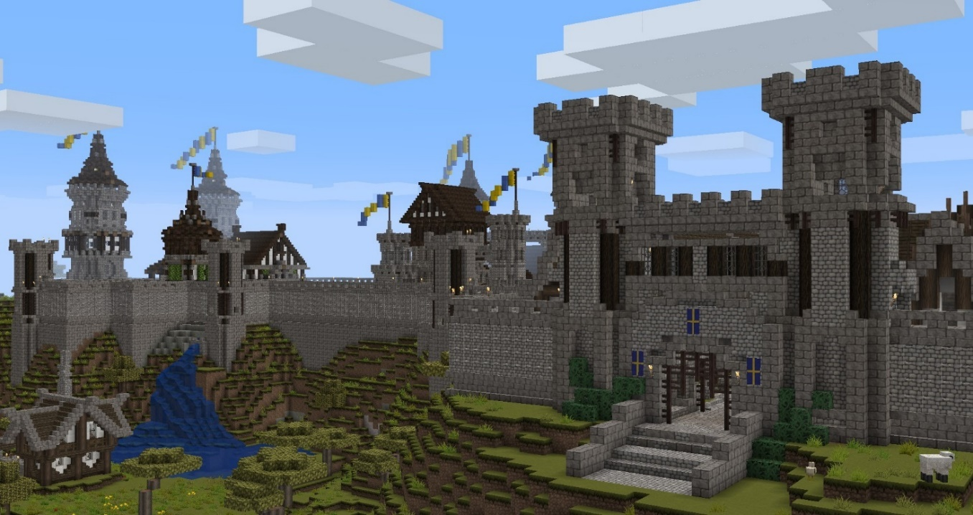

Your army details
- Soldiers and horses:
- 1000 professional soldiers
- 500 horse mounted soldiers (cavalry)
- 500 archers
- 1000 conscripts (fighters who were forced to join the army).
- Available artillery:
- 20 Roman scorpions
- 25 onagers
- 20 ballistas
Figure 3 – Roman scorpion
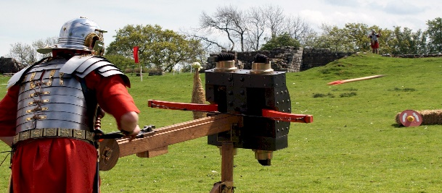
‘Replica Scorpion’ by Unknown Author is licensed under CC-BY-SA 3.0.
Figure 4 – Roman onager
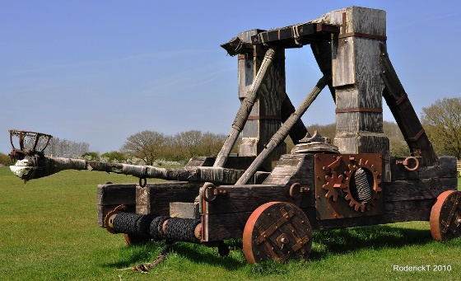
‘Roman Catapult’ by rodtuk is licensed under CC BY-NC-SA 2.0.
Figure 5 – Roman ballista
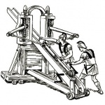
‘Roman ballista’ by Unknown Author is licensed under CC BY-NC-SA 4.0.
The following video can help better understand Roman military technology Roman Military Technology and Tactics (11:02).

Military tactics – sample response
Teacher note: students will have great variety in their answers and proposed tactics. It is important to note that students have limited information to work with. The military plan should demonstrate clear evidence of the thinking and reasoning behind decisions made.
The sample answer is not an example of an exemplary response, it contains some points students may present. Students may present different ideas or expand further on the points mentioned below.

Sample response
Figure 6 – drawn map of Crystal Kingdom

Military tactic overview
My tactics would involve splitting the army into 3 groups. Each group will have their battle goal which will contribute to securing the city. The objective is to shock the enemy and cause a large amount of damage quickly.
The army will move under the cover of darkness and start the assault at first light.
Group A will engage the Northern Marshlands, Group B will attack the western gate and Group C will secure the Capital Bridge gateway.
Group A and C will leave the camp site at first light (dawn) as they both have a greater distance to travel. Their movement will be behind the mountains. Group B is a significantly large force which will move slowly towards the city.
The army will now camp in its current position, to the west of the city blocking the path to the Capital Bridge gateway. Once camped, a heavy bombardment (attack) will begin and continue through the night. Soldiers will complete rotational shifts to maintain an attack after day one. Up to 40% of each unit from Group B may retreat to a rest camp just behind the main force.

Tactics: Group A
This is a smaller force consisting of:
- 100 archers
- 100 conscripts
- 100 professional soldiers
- 5 onagers
- The force will travel around the East Ocean Mountain Range. The 5 onagers and the archers will fire at the occupants of the Northern Marshlands. The soldiers will stay inline and are only present to protect this long-range attack. The purpose is to draw the people out to this position. The majority of the damage should be done by the onagers and archers. If they are not drawn out, the bombardment will continue. The commanding officer of this group will make the call for the soldiers to attack or remain in position.
- The city will be forced to reinforce the eastern gate, thinking an attack may come via the marshlands. This would take away soldiers from other positions and give greater opportunity for success to the main attack on the western gate.

Tactics: Group B
This force consists of:
- 15 ballistas
- 20 onagers
- 20 scorpions
- 300 archers
- 500 cavalry
- 800 conscripts
- 800 professional soldiers

Figure 7 – formation of Group B
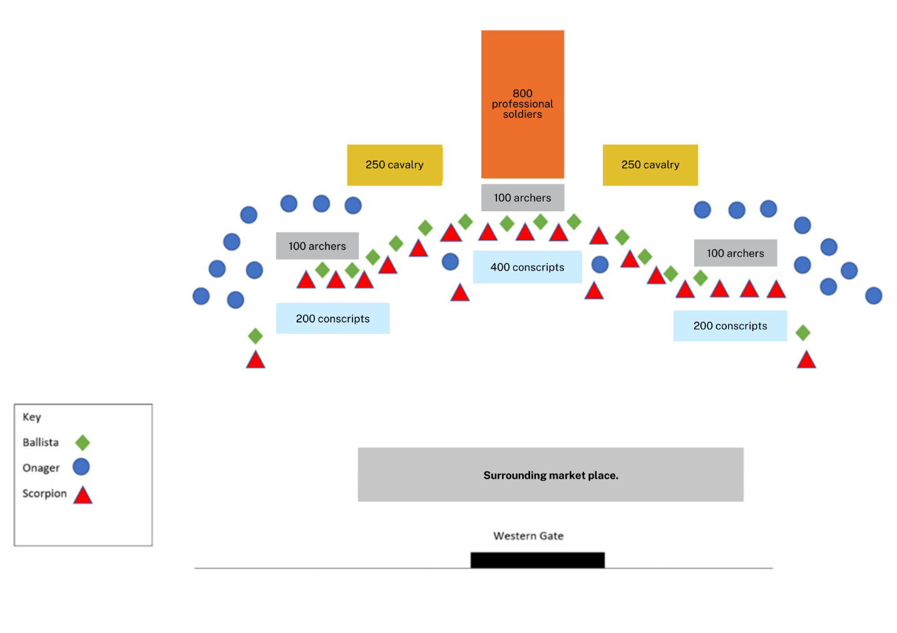
As the army approaches and moves across the city, the ballistas and onagers will fire at the surrounding town or the city. This shock of long-range weaponry will force their army to stay within their walls. If they choose to attack, Group B will stop marching forward and position themselves in the same way. All long-range weapons and archers will fire on the advancing enemy as they enter each weapon range.
This will break the enemy’s formation and cause catastrophic injury to the approaching soldiers. Depending on the numbers of soldiers left standing, a maximum of half of the conscripts and cavalry will engage with them in the battlefield. Considering the reports indicated 1,000 military personal at a maximum, they are unlikely to commit their entire force to an attack.
An attack of 650 soldiers should be a significantly greater number compared to the enemy soldiers left standing after the bombardment (a continuous attack) from the artillery. Winning this engagement, Group B will continue the approach to the western gate and attack as originally planned.
The army will set up around the western gate, as shown in Figure 7: formation of Group B. Outside the range of the city’s archers, this will help to get the artillery closer to the city as the enemy has no archers.
The flanks are placed as protection for the city’s army approaching from either the southern or northern gate. If any enemy forces approach from either gate, all the scorpions and the onagers positioned at the rear, will fire at them. This should shock the approaching forces back into the city or break their attack formation. If their formation breaks, archers will fire first followed by an attack from half the conscripts in each bank.
All the ballistas will fire at the gate and the walls either side. As the city does not have such weaponry, they should be shocked by the attack and remain in the walls. If they decide to come out of either of the gates, the scorpions, onagers and archers will fire at them.
When the gate or walls collapse, the onagers will move forward firing into the city. This should force the city archers further back. This opening will allow the cavalry to charge into the city followed by the 400 conscripts in the centre of the formation.
The initial bombardment should have the city and the defensive forces in disarray. Once inside the city walls, Group B should be able to gain control of the city given the mental state of the citizens and soldiers from this attack.

Tactics: Group C
This force consists of:
- 100 archers
- 100 conscripts
- 100 professional soldiers
- 5 ballistas
This group will travel around Crystal Waters Mountains and attack the Capital Bridge gateway. The ballistas, when in range, will fire at the bridge continuously. The objective is to destroy the bridge. Archers will approach until they are in range and also fire. Their aim is to keep the guards from coming out. The soldiers’ primary objective is to guard the ballistas from enemy attacks. If the guards leave the bridge and the opportunity arises to capture the target this will then be the new objective. This attack will begin simultaneously with the attack on the western gate.
The ballistas will concentrate their fire towards the guard towers on the opposite shore. Continuous fire should cause major damage to the towers and make the overall structure weak.

Reasons for strategy success
Attacking the city’s wall and having the forces travel up the hill is not a desired approach. Coming up the hill will slow the soldiers down and tire them out before the battle. Attacking on 3 fronts using the artillery to attack first, will psychologically impact the defensive forces. The artillery will both be damaging to the morale of the defending soldiers and their resolve to stay in defensive positions will be lessened. They also will not be able to hide behind the walls as they have done previously.
The attack into the marshlands will force the residents to flee north or attack the artillery’s position. This will require them to cross the river under fire from archers. If they manage to cross, the soldiers should win any fights quickly as the enemy attackers will be tired from crossing the river. The city will be informed of the attack and assume an attack is coming from the east. They will have no clear view on the size of the attacking force and will most likely have to reinforce the western gate.
Attacking the western gate and firing the artillery on the slow approach will force the city to rethink attacking the approaching army. They will most likely prefer to stay within the city walls. Once in position, the heavily concentrated fire should bring down the gate and surrounding walls quickly.
Attacking the western gate provides protection for the attack on the bridge. If the bridge is destroyed, the Capital’s army will have no easy direct access to support the city. The heavy bombardment will keep their soldiers inside and if they try to leave, the archers and scorpions will inflict damage to their army.
The victory in the battle will be swift and will occur before the Capital’s aid can arrive. With the bridge destroyed the artillery can move to the riverbanks and fire on any approaching army. The river will provide a natural defence and obstacle for the approaching soldiers.
Teacher note: students may present additional ideas, for example:
- greater detail into the formation of units and how they engage enemy soldiers
- how they would draw out the enemy army for an open battle in the field
- splitting the forces into smaller groups to wage war on multiple fronts
- using the timber in the forest to construct ladders
- attacking an important feature such as the Capital Bridge gateway first, forcing the army to come to its aid.

Assessing student achievement – military tactics
Teacher note: feedback provided, in the form of questions, should direct students to link their thinking process to decisions made. To assist students to improve their ability to link how their thinking directs their decisions, consider questions such as:
- Why did you make this decision?
- What evidence did you use to make this decision?
Students who demonstrate surface level thinking across both sections may demonstrate some of the following:
- simple tactics without considerations for enemy movements
- not using the supplied information to inform their tactical decisions
- tactics which do not demonstrate an understanding of military thought process and critical thinking
- not supporting assumptions with reasoning.
Students who demonstrate deep thinking would build upon the previous statements and support their decision with clear reasoning, which may include:
- tactics that consider possible outcomes and have contingencies depending on enemy movements
- explanations for tactics that are supported with clear intentions and thought processes covering the how, why and when
- tactics that include the supplied information to support decisions and that any assumptions made are clearly outlined.

Summative sample assessment task – invading with a new sporting franchise
Teacher note: this task requires students to use real data from a variety of sources. Not all students will be able to navigate and interpret multiple large data sets. Adjustments or additional support may be required for inclusion. This task provides an opportunity to revise key skills delivered in Core 2. It is important to note that while the sporting theme may be connected to Option 4, this task focuses on the business element of sporting franchises and the similarities between business decisions and strategies of war.
Type of task: a formal report (maximum 800 words) or pitch presentation (maximum 4 minutes) or an advertisement promo video (maximum 4 minutes).
Focus question: What are your recommendations for the best investment option for a sport and location and how can this be compared to a strategy of war?
Weighting: school-based decision
Outcomes assessed:
- CT5-3 constructs and builds stronger arguments with evidence-based decision-making by discerning fact from fiction
- CT5-4 undertakes research and engages in evident self-reflection throughout the critical thinking process
- CT5-7 evaluates the impact of critical thinking on society and explains the importance of transferable skills across disciplines.
Critical thinking course document © NSW Department of Education for and on behalf of the Crown in right of the State of New South Wales, 2021.
Learning intention
Students select and evaluate appropriate evidence, interpret information and data without bias to form robust conclusions and communicate a strong evidence-based argument to support a claim. Students compare reasoned business strategies to strategies of war.
Success criteria
Students can:
- make an informed judgement on the credibility of evidence
- recognise any biases which can impact their ability to make an evidence-based claim
- present a convincing argument based on evidence and reasoning.

Background information
Starting a new professional league or owning a successful sports team is a lucrative business. English premier league clubs are valued and often bought for large sums of money. A consortium led by Todd Boehly and backed by Clearlake Capital reportedly bought Chelsea FC for $5 billion.
A venture that carries more risk is to start a new sporting franchise such as the Dolphins in the NRL. A franchise is a new team in an existing league. Before even thinking about on field success, the decision to start a new franchise does not come lightly. Team location is one of the first decisions made, but what thinking goes into this? What other considerations must be made?
Watch one of the following clips and discuss the arguments presented:
- NRL Expansion: Phil 'Gus' Gould's radical solution to fix rugby league | 100% Footy (9:18)
- Women’s AFL (2:37)

Task instructions
A wealthy consortium (group) of businesspeople want to propose a new team franchise into either the A-League, A-League Women, NRL, Big Bash (men’s or women’s) or the AFL/AFLW. They see Australian sports as a future investment but are unsure of what league would be the best sport to introduce a new team franchise. They are also unsure which location in Australia would be best to establish this new team franchise. Alternatively, you may decide on another league, but please consult with your teacher.
As an advisor, you must recommend the best business investment option for the group of businesspeople. Your recommendation will include:
- which sport will they start their new team franchise in
- what the best location in Australia is for the new franchise.

Task steps
To complete the task, you will need to:
- Collect evidence about the sport and the location (for example, population data, demographics, facts, graphs).
- Present a balanced argument of the options available to the consortium (group) of businesspeople. As a part of your submission, discuss:
- an assessment of the evidence sets used
- how the evidence supports your reasoning
- any risks or concerns
- any other details that would strengthen your argument.
- Recommend the best investment option (for example, profitability, room for growth, potential market, branding, market share).

Invading with a new sporting franchise – sample response
Teacher note: students’ answers will vary depending on the evidence sets used. The choice of data and how they interpret the results should be evident in their answers. The sample answer provided is an example of a section a student may submit from a larger report.

Sample response
An Australian Football League (AFL) team in Darwin would be a good investment opportunity. In Australia, the AFL has the 12th highest participation rate among adults, as measured by the Australian Sports Commission, and participation is even higher in the Northern Territory (Australian Sports Commission, 2017).
Darwin currently has no major sporting franchise in AFL or any other sports. Darwin has an estimated population of over 140,000 people. Darwin is one of the fastest growing capital cities in Australia, with an annual growth rate of 2.6% since the 2006 census. Looking back on the last ten years, Darwin’s population growth rate is very consistent and strong, ranging from 1.35% to 3.08%, adding around 1,900 to 4,200 people each year to the overall population (Australian Bureau of Statistics, 2022).
AFL is truly a national sport, as shown in Table 3. While Melbourne is seen as the heart of AFL, cities across Australia are represented, as shown in column 2. There are 2 teams in South Australia, 2 in Queensland, 10 in Melbourne and 2 each in NSW and WA. Each of these cities also has competition for supporters against other sporting codes such as NRL, NBL, T20 Big Bash and A-league. While the population sizes are greater than Darwin, the competition for a fan base against the other established codes would be difficult.
Starting an AFL franchise in Darwin could capture the support of an entire city and territory.
Table 3 – stadiums used by AFL clubs
Club | City | Stadium used | Alternative stadium used/ City
Adelaide Crows | Adelaide | Adelaide Oval
Port Adelaide | Adelaide | Adelaide Oval
Brisbane Lions | Brisbane | The Gabba
Geelong Cats | Geelong | GMHBA Stadium
Gold Coast Suns | Gold Coast | Metricon Stadium
Carlton | Melbourne | Marvel Stadium
Collingwood | Melbourne | MCG
Essendon | Melbourne | Marvel Stadium
Hawthorn | Melbourne | MCG | UTAS Stadium (Launceston)
Melbourne | Melbourne | MCG
North Melbourne | Melbourne | Marvel Stadium | Blundstone Arena (Hobart)
Richmond | Melbourne | MCG
St Kilda | Melbourne | Marvel Stadium
Western Bulldogs | Melbourne | Marvel Stadium
Fremantle | Perth | Optus Stadium
West Coast Eagles | Perth | Optus Stadium
GWS Giants | Sydney | Giants Stadium | Manuka Oval (Canberra)
Sydney Swans | Sydney | SCG
Darwin has a stadium that could be used initially for the side, TIO Stadium. The venue has hosted a range of sports and the attendance data is shown in Table 4. The stadium has hosted at least one AFL premiership match per season since 2004, one NRL premiership game per season since 2012 and regularly hosts pre-season AFL fixtures as well as local NTFL games. Occasional One Day Internationals (ODI) and Test cricket matches have also been played at Marrara featuring the Australian cricket team (Austadiums, 2022).
Two AFL games were played at the venue in 2022, the Gold Coast Suns versus Hawthorn and Gold Coast Suns versus North Melbourne. Considering the sides were not local, both games attracted good crowds.
This also supports the basis of the city having a sporting venue which can host AFL games. Negotiating a rental agreement would be advantageous to the franchise as there is no other competition for its regular use.
NRL games have had on average a better attendance compared to AFL games, but historical franchises outside of NSW or QLD have failed. The largest crowd of 13,473 was drawn by an international game of rugby league. This was something the crowd could get behind and support their country. A home side in AFL would draw the same passion and support for their only professional sporting team.
Table 4 – TIO stadium attendance (Austadiums, 2022)
Date | Sport | Event | Crowd
4/6/2022 | AFL Football | AFL: Gold Coast Suns v North Melbourne | 5,523
28/5/2022 | AFL Football | AFL: Gold Coast Suns v Hawthorn | 7,516
22/8/2020 | AFL Football | AFL: Essendon v Richmond | 5,401
21/8/2020 | AFL Football | AFL: Gold Coast Suns v Carlton | 5,172
1/06/2019 | AFL Football | AFL: Melbourne v Adelaide Crows | 10,634
23/2/2019 | AFL Football | AFLW: Adelaide Crows v Fremantle | 1,734
7/7/2018 | AFL Football | AFL: Melbourne v Fremantle | 8,689
9/3/2018 | AFL Football | AFLW: Adelaide Crows v Fremantle | 2,159
15/7/2017 | AFL Football | AFL: Melbourne v Adelaide Crows | 12,104
30/4/2022 | Rugby League | NRL: Eels v Cowboys | 10,017
23/4/2021 | Rugby League | NRL: Eels v Broncos | 12,056
29/6/2019 | Rugby League | NRL: Eels v Raiders | 5,391
9/6/2018 | Rugby League | NRL: Eels v Cowboys | 8,393
17/11/2017 | Rugby League | RLWC QF1: Australia v Samoa | 13,473
10/6/2017 | Rugby League | NRL: Eels v Cowboys | 11,968
 | AFL Football | Average | 6, 548
 | Rugby League | Average | 10,216
References
Austadiums (2023) TIO Stadium Crowds, Austadiums website, accessed 6 October 2022.
Australian Sports Commission (2017) ‘Participation Annual Report 2017-2018’, Australian Sports Commission website, accessed 6 October 2022.
Commonwealth of Australia (2022) ‘National, state and territory population’, Population, Australian Bureau of Statistics (ABS) website, accessed on 19 December 2022.

Options for marking
Teacher note: three types of criteria are available for use and teachers will need to decide which one, or combination, best serves their students. Marking guidelines may be useful for teachers to holistically mark a student’s evidence of learning while the grade descriptors may be useful in reporting progress to parents. The rubric on the aspects of the task may be useful for students to self-assess or peer assess and could be used formatively. Figure 8 shows a combined rubric which is a combination of the marking rubric and the marking guidelines. It can be used to visualise the relationship between the 2 tables. Additionally, the combined rubric illustrates the outcomes and how they relate to the indicators, which drive each progression in the rubric.

Marking guidelines
Table 5 – marking guidelines
Grade | Marking guidelines
A | - Defines and analyses the core issue and makes connections to wider and deeper issues.  - Considers other significant points of view.  - Makes an argument for the consortium considering options and using several pieces of information analysed for their credibility.  - Analyses the similarities between a strategy from business and a strategy from war.  - Communicates in a clear, logical, well-sequenced format.
B | - Defines and explains the core issues of the task and connects some wider issues.  - Considers several points of view.  - Makes an argument for the consortium using research and explains why this research is credible.  - Explains the similarities between a strategy from business and a strategy from war.  - Communicates in a logically sequenced format.
C | - Explains the core issue presented and develops an argument.  - Considers more than one point of view.  - Makes an argument for the consortium and gives reasons.  - Finds several pieces of information and makes a statement about their credibility.  - Identifies the similarities between a strategy from business and a strategy from war.  - Communicates using an appropriate format.
D | - Answers the questions from the task from one point of view.  - States an opinion for the consortium and gives a reason.  - Finds several pieces of information.  - Names a strategy from business and a strategy from war.  - Communicates using a basic format.
E | - Answers a question from the task.  - States an opinion for the consortium.  - Finds one piece of information.  - Names a strategy from war.  - Uses limited communication or formatting.

Grade descriptors
Table 6 – grade descriptors
Grade | Descriptors
A | The student has extensive knowledge and understanding of establishing an evidence base and can construct accurate claims, with evidence and reasoning. They have displayed an extensive level of understanding when determining the relevance and reliability of the information that might be used to support an argument. In addition, the student has achieved a very high level of competence in the skills of critical thinking and can apply these skills to new situations.
B | The student has thorough knowledge and understanding of establishing an evidence base and can construct claims, with evidence and reasoning. They have displayed a thorough level of understanding when determining the relevance and reliability of the information that might be used to support an argument. In addition, the student has achieved a high level of competence in the skills of critical thinking and can apply these skills to most situations.
C | The student has sound level of knowledge and understanding of establishing an evidence base and can construct claims, with evidence and reasoning. They have displayed a sound level of understanding when determining the relevance and reliability of the information that might be used to support an argument. In addition, the student has achieved an adequate level of competence in the skills of critical thinking.
D | The student has a basic level of knowledge and understanding of establishing an evidence base and is attempting to construct claims, with evidence and/or reasoning. They have displayed some level of understanding when determining the relevance and reliability of the information that might be used to support an argument. In addition, the student has achieved some competence in the skills of critical thinking.
E | The student has an elementary level of knowledge and understanding of establishing an evidence base. They have named some points of argument without connection to reasons or evaluation.

Rubric
Table 7 – rubric
Grade | Identifying core issue (CT5-3) | Argument (CT5-3) | Communication (CT5-3) | Evidence-base (CT5-3) | Transfer of critical thinking (CT5-7)
A | Defines and analyses the core issue and makes connections to wider and deeper issues. | Makes an argument for the consortium considering options and using credible research. | Communicates in a clear, logical, well-sequenced format. | Builds a network of relationships between several pieces of information by understanding the relationship between a variety of ideas and analyses their credibility. | Analyses the similarities between a strategy from business and a strategy from war.
B | Defines and explains the core issues of the task and connects some wider issues.  Considers several points of view. | Makes an argument for the consortium using credible research. | Communicates in a logically sequenced format. | Finds several pieces of information and forms connections between them. Makes an argument for the consortium using credible research. | Explains the similarities between a strategy from business and a strategy from war
C | Explains the core issue presented and develops an argument.  Considers more than one point of view. | Makes an argument for the consortium and gives reasons. | Communicates using an appropriate format. | Finds several pieces of information and makes a statement about their credibility. | Identifies the similarities between a strategy from business and a strategy from war.
D | Answers the questions from the task from one point of view. | States an opinion for the consortium and gives a reason. | Communicates using a basic format. | Finds several pieces of information. | Names a strategy from business and a strategy from war.
E | Answers a question from the task. | States an opinion for the consortium. | Uses limited communication or formatting. | Finds one piece of information. | Names a strategy from war.

Combined rubric
Teacher note: in Figure 8 – example of a combined rubric, the columns show components of the outcomes in a progression from E to A (from Table 7) and the rows show how the holistic marking (from Table 5) can be described in more detail.

Figure 8 – example of a combined rubric
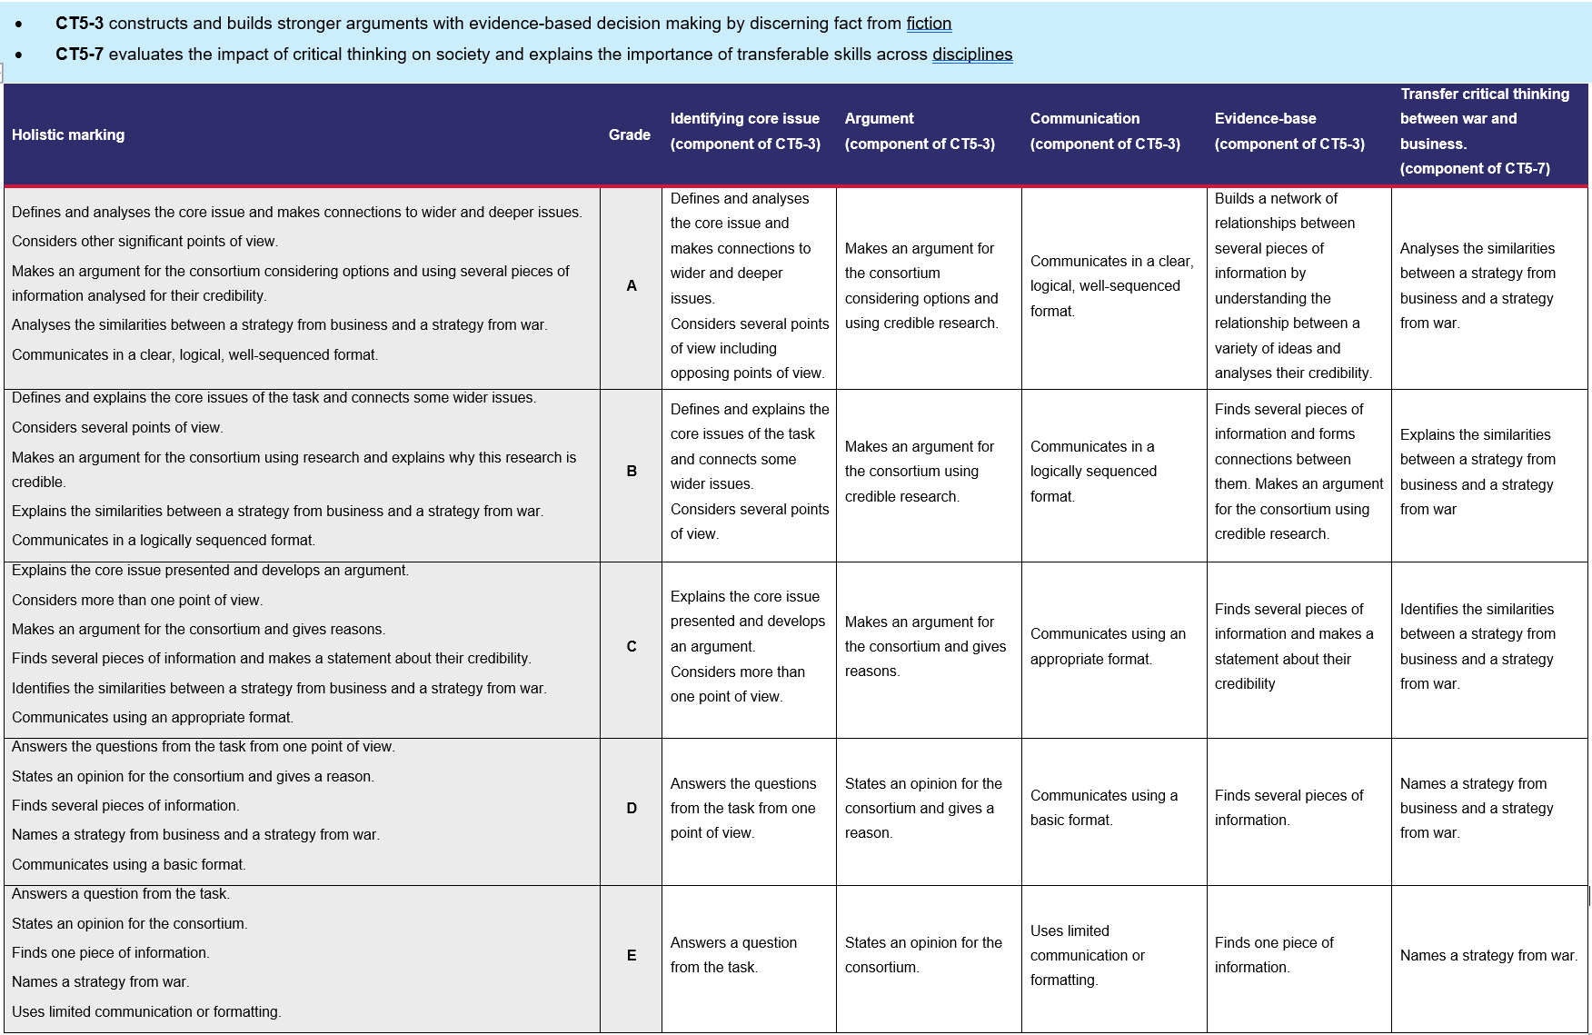

Additional information
The information below can be used to support teachers when using this assessment package for Critical thinking.

Rationale
Critical thinking is a form of purposeful thinking that emphasises evidence and reasoning. In today’s world, where information is readily available, critical thinking is becoming more important than remembering and recalling facts. Society values critical thinking because it is an interdisciplinary and transferable skill. It means that no matter what path or profession is pursued, critical thinking skills will always be relevant and useful.
Critical thinking skills include the ability to deconstruct, analyse, synthesise and reconstruct ideas while emphasising evidence and reasoning. Those skills are part of every toolkit for success in educational and professional arenas.
The Critical thinking course emphasises the fundamental attributes of critical thinkers and gives students a wide range of opportunities to transfer these skills across multiple disciplines. The course structure encourages students to think about thinking and transcend factual learning.
The core units introduce students to the key features of critical thinking, including how critical thinking is distinguished from other models of thinking. Students will learn about the process of argumentation and apply it to evaluate claims. Students will also gain practical research skills to collect information from various sources and evaluate their credibility.
A choice from the available options engages students in various areas of interest to reinforce the skills learnt from the core units. In addition, the options allow students and teachers to delve deeper into specific scenarios of interest. Students will be guided to ask probing questions to strengthen their critical thinking skills and challenge their perceptions of the world around them.
After completing the Critical thinking elective, students will be able to apply critical thinking processes to analyse the strength and validity of information and claims. Those skills are valuable for learning in Stage 6. Critical and creative thinking is a general capability in most Stage 6 courses. By applying their critical thinking skills, students will deepen their understanding of content and skills across many disciplines.

Aim
The course aims to engage and encourage students to develop their critical thinking skills and recognise the key aspects of a critical thinking mind. They will develop the essential skills to evaluate the vast and diverse amount of information they encounter in their daily lives. This will help them face future challenges in a continually evolving world.

Purpose and audience
This assessment package provides a range of assessment strategies and supplementary material that can be used to support student achievement in the task outlined. This resource is for teachers to use when creating a program of assessment for the Critical thinking course.

When and how to use this document
Use the assessment package in the context that best supports your school context.

Assessment for learning
Possible formative assessment strategies that could be included:
- Learning intentions and success criteria assist educators to articulate the purpose of a learning task to make judgements about the quality of student learning. These help students focus on the task or activity taking place and what they are learning and provide a framework for reflection and feedback. Online tools can assist implementation of this formative assessment strategy.
- Eliciting evidence strategies allow teachers to determine the next steps in learning and assist teachers in evaluating the impact of teaching and learning activities. Strategies that may be added to a learning sequence to elicit evidence include all student response systems, exit tickets, mini whiteboards (actual or digital), hinge questions, Kahoot, Socrative, or quick quizzes to ensure that individual student progress can be monitored and the lesson sequence adjusted based on formative data collected.
- Feedback is designed to close the gap between current and desired performance by informing teacher and student behaviour (AITSL 2017). AITSL provides a factsheet to support evidence-based feedback.
- Peer feedback is a structured process where students evaluate the work of their peers by providing valuable feedback in relation to learning intentions and success criteria. It can be supported by online tools.
- Self-regulated learning opportunities assist students in taking ownership of their own learning. A variety of strategies can be employed and some examples include reflection tasks, Think-Pair-Share, KWLH charts, learning portfolios and learning logs.
The primary role of assessment is to establish where individuals are in their learning so that teaching can be differentiated and further learning progress can be monitored over time.
Feedback that focuses on improving tasks, processes and student self-regulation is the most effective. Students engaging with feedback can take many forms including formal, informal, formative, summative, interactive, demonstrable, visual, written, verbal and non-verbal.
What works best 2020 update (CESE 2020a)

Differentiation
Differentiated learning can be enabled by differentiating the teaching approach to content, process, product and the learning environment. For more information on differentiation go to Differentiating learning and Differentiation.
When using these resources in the classroom, it is important for teachers to consider the needs of all students in their class, including:
- Aboriginal and Torres Strait Islander students. targeted strategies can be used to achieve outcomes for Aboriginal students in K–12 and increase knowledge and understanding of Aboriginal histories and cultures. Teachers should utilise students’ Personalised Learning Pathways to support individual student needs and goals.
- EAL/D learners. EAL/D learners will require explicit English language support and scaffolding, informed by the EAL/D enhanced teaching and learning cycle and the student’s phase on the EAL/D Learning Progression. In addition, teachers can access information about supporting EAL/D learners and literacy and numeracy support specific to EAL/D learners.
- Students with additional learning needs. learning adjustments enable students with disability and additional learning and support needs to access syllabus outcomes and content on the same basis as their peers. Teachers can use a range of adjustments to ensure a personalised approach to student learning. In addition, the Universal Design for Learning planning tool can be used to support the diverse learning needs of students using inclusive teaching and learning strategies. Subject specific curriculum considerations can be found on the Inclusive Practice hub.
- High potential and gifted learners. Assessing and identifying high potential and gifted learners will help teachers decide which students may benefit from extension and additional challenge. Effective strategies and contributors to achievement for high potential and gifted learners help teachers to identify and target areas for growth and improvement. In addition, the Differentiation Adjustment Tool can be used to support the specific learning needs of high potential and gifted students. The High Potential and Gifted Education Professional Learning and Resource Hub supports school leaders and teachers to effectively implement the High Potential and Gifted Education Policy in their unique contexts.
All students need to be challenged and engaged to develop their potential fully. A culture of high expectations needs to be supported by strategies that both challenge and support student learning needs, such as through appropriate curriculum differentiation. (CESE 2020a:6).

About this resource
All curriculum resources are prepared through a rigorous process. Resources are periodically reviewed as part of our ongoing evaluation plan to ensure currency, relevance and effectiveness. For additional support or advice contact the Teaching and Learning Curriculum team by emailing secondaryteachingandlearning@det.nsw.edu.au.
Alignment to system priorities and/or needs:
This resource aligns to the School Excellence Framework elements of curriculum (curriculum provision) and effective classroom practice (lesson planning, explicit teaching).
This resource supports teachers to address Australian Professional Teaching Standards 5.1.2, 5.5.2.
This resource has been designed to support schools with successful implementation of new curriculum, specifically the NSW Department of Education approved elective course, Critical thinking © NSW Department of Education for and on behalf of the Crown in right of the State of New South Wales, 2021.
The resource is produced to assist schools with promoting and implementing the course for the first time. As the course may be taught by teachers from a range of key learning areas, the resource is designed to support teachers from a variety of KLA expertise.
Department approved elective course: Critical thinking
Course outcomes: CT5-3, CT5-4, CT5-7
Author: Curriculum Secondary Learners
Publisher: State of NSW, Department of Education
Resource: Teaching resource
Related resources: further resources to support Critical thinking can be found on the Department approved elective courses webpage including course document, sample scope and sequences, assessment materials and other learning sequences.
Professional Learning: join the Teaching and Learning 7-12 statewide staffroom for information regarding professional learning opportunities.
Consulted with: Aboriginal Outcomes and Partnerships, Inclusion and Wellbeing, EAL/D, and Warrawong High School.
Reviewed by: this resource was reviewed by Curriculum Secondary Learners and by subject matter experts in schools to ensure accuracy of content.
Creation date: 23 June 2023
Rights: © State of New South Wales, Department of Education
Evidence base:
The range of assessment strategies outlined in the advice encourages ‘a variety of assessment methods each lesson to check for students’ understanding and inform what should be taught next’. (CESE 2020a:22). The assessment strategies outlined are student-centred, providing ‘students with opportunities to reflect on their progress to inform future learning goals’ (CESE 2020a:22).
The assessment advice complies with NESA’s assessment advice, outlined on NESA’s ACE website, NESA official notices and department memorandums. They:
- include statements of school procedures for allocating grades in Year 10
- set out requirements to retain student work samples to support grade allocation as required by NESA for the RoSA (NESA 2006).
The assessment strategies outlined provide teachers with important information about whether students learned what was intended. Wiliam (2013) claims ‘the term formative should apply not to the assessment but to the function that the evidence generated by the assessment actually serves’.

References
AITSL (Australian Institute for Teaching and School Leadership (2017) ‘Feedback Factsheet’, AITSL, accessed 10 November 2022.
Austadiums (2023) TIO Stadium Crowds, Austadiums website, accessed 6 October 2022.
Australian Sports Commission (2017) ‘Participation Annual Report 2017-2018’, Australian Sports Commission website, accessed 6 October 2022.
Banchi H and Bell R (2008) ‘The Many Levels of Inquiry: Inquiry comes in many forms’, Science and Children, 46(2):26-29.
CESE (Centre for Education Statistics and Evaluation) (2020a) What works best: 2020 update, NSW Department of Education, accessed 10 November 2022.
CESE (Centre for Education Statistics and Evaluation) (2020b) What works best in practice, NSW Department of Education, accessed 10 November 2022.
Commonwealth of Australia (2022) ‘National, state and territory population’, Population, Australian Bureau of Statistics (ABS) website, accessed on 19 December 2022.
Hmelo-Silver CE, Duncan RG and Chinn CA (2007) ‘Scaffolding and achievement in problem-based and inquiry learning: A response to Kirschner, Sweller, and Clark (2006)’, Educational Psychologist, 42(2):99-107.
Jiang F and McComas W (2015) ‘The Effects of Inquiry Teaching on Student Science Achievement and Attitudes: Evidence from Propensity Score Analysis of PISA Data’, International Journal of Science Education, 37(3):554-576.
NESA (NSW Education Standards Authority) (2020) Nurturing Wonder and Igniting Passion, designs for a new school curriculum: NSW Curriculum Review [PDF 1.12MB], NESA, accessed 10 November 2022.
Nesbitt L (1994–2023) ‘The Toulmin Method’, Writing Guides, The WAC Clearinghouse website, Colorado State University accessed 10 November 2022.
Wikipedia contributors (2022) Military tactics, Wikipedia, the Free Encyclopedia website, accessed 6 October 2022.
Wiliam D (2013) ‘Assessment: The bridge between teaching and learning’, Voices from the Middle, 21(2):15–20.

© State of New South Wales (Department of Education), 2023
The copyright material published in this resource is subject to the Copyright Act 1968 (Cth) and is owned by the NSW Department of Education or, where indicated, by a party other than the NSW Department of Education (third-party material).
Copyright material available in this resource and owned by the NSW Department of Education is licensed under a Creative Commons Attribution 4.0 International (CC BY 4.0) licence.

This licence allows you to share and adapt the material for any purpose, even commercially.
Attribution should be given to © State of New South Wales (Department of Education), 2023.
Material in this resource not available under a Creative Commons licence:
- the NSW Department of Education logo, other logos and trademark-protected material
- material owned by a third party that has been reproduced with permission. You will need to obtain permission from the third party to reuse its material.
Links to third-party material and websites
Please note that the provided (reading/viewing material/list/links/texts) are a suggestion only and implies no endorsement, by the New South Wales Department of Education, of any author, publisher, or book title. School principals and teachers are best placed to assess the suitability of resources that would complement the curriculum and reflect the needs and interests of their students.
If you use the links provided in this document to access a third-party's website, you acknowledge that the terms of use, including licence terms set out on the third-party's website apply to the use which may be made of the materials on that third-party website or where permitted by the Copyright Act 1968 (Cth). The department accepts no responsibility for content on third-party websites.

