Playgroup information for families
What is a playgroup?
Playgroups provide opportunities for children and their families to participate in unstructured learning through play to support their development. A playgroup is often run by a facilitator who plans fun and creative experiences on a regular basis. Many public schools run playgroups for parents and children before they start school. | 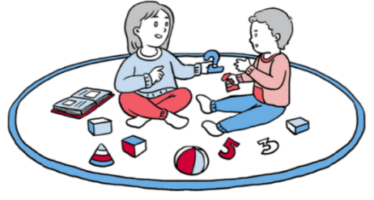
Benefits of attending playgroups
Playgroups provide children and families with:
- regular play sessions in a relaxed environment
- opportunities to support children’s learning and development
- regular sessions in a school setting to feel comfortable before a child starts school
- opportunities to meet other families and members of the school community.
Accessing playgroups
To find out if your local public primary school offers a playgroup, you can:
- check the school website, or phone or email to ask if they offer playgroup sessions
- request information about the operation of the program, venue, location and session times
- enquire about vacancies in the playgroup sessions.
Family roles and responsibilities
When parents or carers attend a playgroup session, they are required to:
- complete a playgroup registration form, outlining emergency contact information and medical conditions
- sign into and out of the school as any visitor would
- attend the playgroup session and participate in the learning experiences with their child.
© State of New South Wales (Department of Education), 2024
The copyright material published in this resource is subject to the Copyright Act 1968 (Cth) and is owned by the NSW Department of Education or, where indicated, by a party other than the NSW Department of Education (third-party material).
Copyright material available in this resource and owned by the NSW Department of Education is licensed under a Creative Commons Attribution 4.0 International (CC BY 4.0) licence.

This licence allows you to share and adapt the material for any purpose, even commercially.
Attribution should be given to © State of New South Wales (Department of Education), 2024.
Material in this resource not available under a Creative Commons licence:
- the NSW Department of Education logo, other logos and trademark-protected material
- material owned by a third party that has been reproduced with permission. You will need to obtain permission from the third party to reuse its material.
Links to third-party material and websites
Please note that the provided (reading/viewing material/list/links/texts) are a suggestion only and implies no endorsement, by the New South Wales Department of Education, of any author, publisher, or book title. School principals and teachers are best placed to assess the suitability of resources that would complement the curriculum and reflect the needs and interests of their students.
If you use the links provided in this document to access a third-party's website, you acknowledge that the terms of use, including licence terms set out on the third-party's website apply to the use which may be made of the materials on that third-party website or where permitted by the Copyright Act 1968 (Cth). The department accepts no responsibility for content on third-party websites.

