 | 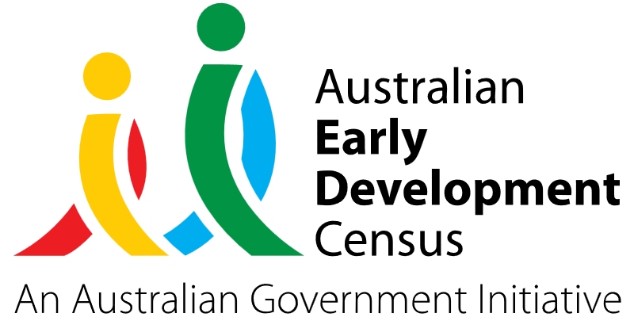
Supported Playgroup Early Intervention Program

Lansvale Public School

About the community
Lansvale Public School is situated in Canley Vale, 30 kilometres west of the Sydney central business district, in the local government area of the City of Fairfield.
Lansvale Public School comprises of 677 students from Preschool to Year 6, approximately 94% of whom are from culturally and linguistically diverse backgrounds. The school has strong links with the community through allied health professionals, community liaison officers and a Schools as Community Centres (SaCC) coordinator.

What did the data show?
The Australian Early Development Census (AEDC) is a national measure of early childhood development that is collected at the time children commence their first year of full-time schooling. The AEDC collects data relating to 5 key areas of early childhood development referred to as ‘domains’. The domains are physical health and wellbeing, social competence, emotional maturity, language and cognitive skills (school-based), and communication skills and general knowledge.
The 2021 AEDC outcomes for Lansvale Public School showed a significant increase in developmental vulnerabilities – 35.5% were vulnerable in one or more domains (compared to 24.5% in 2018) and 16.0% were vulnerable in 2 or more domains (compared to 10.4% in 2018).
There was a significant decline in the percentage of children on track in all the developmental domains, as reflected in the table below.

Domain | Developmentally on track (2018) | Developmentally on track (2021)
Physical health and wellbeing | 83.0% | 77.8%
Social competence | 71.7% | 63.0%
Emotional maturity | 80.2% | 71.6%
Language and cognitive skills (school-based) | 84.0% | 76.5%
Communication skills and general knowledge | 75.5% | 64.2%

Bringing about change
Facilitated by the SaCC coordinator, the Supported Playgroup Early Intervention Program involved bringing in an occupational therapist and speech pathologist to attend playgroup sessions. This provided an opportunity for parents to communicate their concerns with therapists, increase information sharing between families and therapists, and raise community awareness around early intervention services and strategies to support delays in particular areas of development.

The occupational therapist and speech pathologist provided support to playgroup children through group sessions, individual therapy for identified children, as well as individualised support and guidance within peer-facilitated parent groups. By modelling developmentally appropriate play activities with children, this supported parents to learn play and interaction strategies that they could continue implementing with their children at home.


Partnerships
Lansvale Public School partnered with Fairfield City Council’s Fairstart Early Intervention speech pathology and occupational therapy services to implement the program.

Achievements
The success of the Supported Playgroup Early Intervention Program was reflected in the observations of educators who reported children participating in activities when they were previously shy or withdrawn, as well as children improving their overall confidence in the activities conducted during playgroup. Playgroup attendance data showed that there was consistent engagement throughout the program.
Parents reported seeing positive changes in their child’s behaviour as well as improvements in their social skills and ability to follow instructions. Feedback received from parents also indicated an increase in their own confidence and knowledge in supporting their child’s development and wellbeing from learning new strategies and routines to implement in the home environment.

Looking ahead
Lansvale Public School will host a parent information session in 2024 targeting a wider audience to build relationships with parents, support parents to understand the benefits of attending a playgroup consistently and provide strategies to help families support their children at home.
During the Supported Playgroup Early Intervention Program, it was identified that there was a large academic focus from parents when bringing their children to playgroup. Lansvale Public School would like to collaborate with families to ensure parents have an informed understanding of all developmental skills and outcomes, especially the value of learning through play.
For more information, contact the AEDC NSW Project Team:
Phone: 1300 083 698
Email: aedc@det.nsw.edu.au

