 | 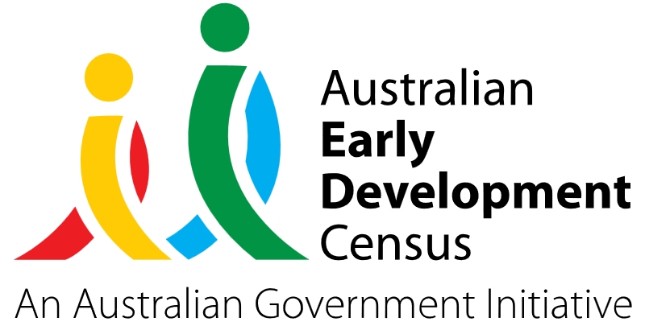
Move it Program

Dubbo and District Preschool

About the community
Located 400 kilometres north-west of Sydney, Dubbo is a vibrant regional city by the Macquarie River. According to the Australian Bureau of Statistics 2021 census, 16.1% of the population in Dubbo identified as being of Aboriginal or Torres Strait Islander origin which is significantly higher than the 3.4% in NSW and 3.2% in Australia.
Dubbo and District Preschool provides early childhood education and care for 100 children a day between the ages of 3 and 6. The preschool has 5 classrooms, used by up to 20 children each.

What did the data show?
The Australian Early Development Census (AEDC) is a national measure of early childhood development that is collected at the time children commence their first year of full-time schooling. The AEDC collects data relating to 5 key areas of early childhood development referred to as ‘domains’. The domains are physical health and wellbeing, social competence, emotional maturity, language and cognitive skills (school-based), and communication skills and general knowledge.
The 2021 AEDC outcomes for the Dubbo community showed a significant decline in the percentage of children on track in the physical health and wellbeing domain (from 77.5% in 2018 to 70.1% in 2021) and the communication skills and general knowledge domain (from 74.9% in 2018 to 67.1% in 2021).

Bringing about change
The Move It Program was developed by Dubbo and District Preschool to address gaps in the provision of support and therapy for a broadening number of children in the local community. Educators had reported seeing a
drop in fine and gross motor skills, particularly upper body strength and coordination which was also reflected in the 2021 AEDC data for the Dubbo community.
Under the program, an occupational therapist was brought into the preschool to assess children, develop a play-based movement program targeting their specific needs and to work with small groups of children in the preschool once a week to drive individual skill development.
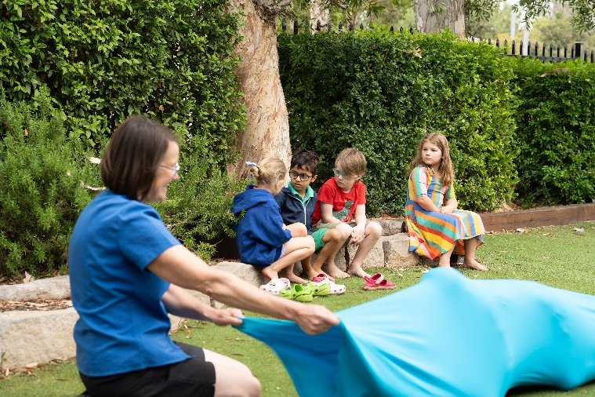
The occupational therapist also provided weekly professional development for educators and supported families to implement some of the program elements at home.
Activities undertaken with children included crawling through elastane tunnels while carrying objects to develop core body strength, sensory motor skills, coordination and the ability to follow instructions. Children also played with ‘Mat Man’ to build body awareness and learn drawing skills and used hammock swings to develop core muscles and upper body strength.
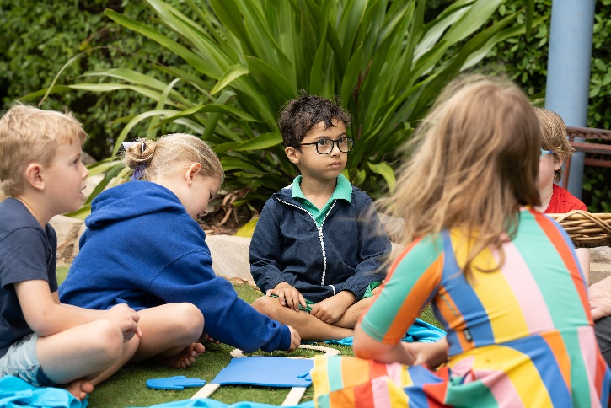

Partnerships
To deliver the Move It Program, Dubbo and District Preschool partnered with an occupational therapist from Seed Paediatric Services, based in Orange.

Achievements
There were 60 children involved directly in the program, however the upskilling of educators enabled aspects of the program to be introduced into each classroom to benefit all children at Dubbo and District Preschool.
All children involved in the Move It Program, with the exception of 2, made observable and significant progress throughout the year. By the end of the program, the group’s skills were more in line with their cohort of peers in terms of physical skills, core strength, emotional regulation, ability to focus, resilience and confidence.
For the 2 children who only made minor progress during the program, the observations and data collected by educators provided evidence for these families to take to paediatricians to support further investigation and potential diagnosis.

Looking ahead
Following on from the success of the Move It Program, Dubbo and District Preschool is keen to continue the program and extend it to their affiliated service at Buninyong Preschool, which caters for 20 children a day.
The preschool wants to initiate a social and emotional skills program named ‘You Can Do It’ in 2024 to run alongside and supplement the Move It Program. This program would provide educators with the knowledge and language to support children’s social competence and emotional skills in areas such as confidence, resilience, persistence, organisation and effectively getting along with others.
For more information, contact the AEDC NSW Project Team:
Phone: 1300 083 698
Email: aedc@det.nsw.edu.au

