Stephen Page – Artistic kinship systems

Viewing guide
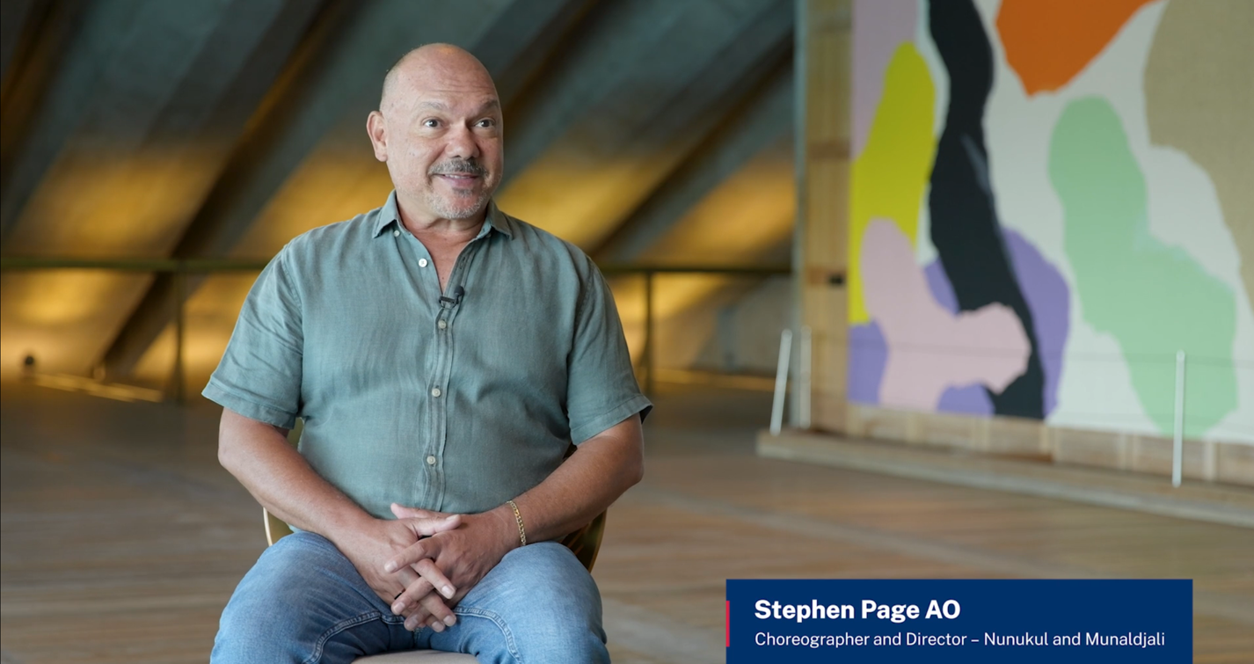

Conversation prompts
Teacher note: this resource could be used to guide student viewing of the interview with Munaldjali Ngugi Nunukal choreographer and director, Stephen Page, Artistic kinship systems (13:19). As they view the interview, the suggested prompts could be used to facilitate discussions and assess and build student knowledge and understanding of Protocols for collaborating with Aboriginal and Torres Strait Islander Communities and engaging with Cultural works. These prompts could also help spark conversations within the local school community.
Before showing the interview to the class, teachers should preview the film and consider how they introduce the interview. See NESA’s Aboriginal and Torres Strait Islander principles and protocols, the ‘Teaching advice (additional): Years 7–10 Working with Aboriginal and Torres Strait Islander content’ teaching and learning support documents for dance, drama and music, and Aboriginal Education teaching and learning support: Visual Arts 7–10, for support on approaching Aboriginal and Torres Strait Islander content across creative arts subjects. This is also an opportunity to introduce learning about cultural safety in creative arts.
Access the interview with Munaldjali Ngugi Nunukal choreographer and director, Stephen Page, Artistic kinship systems (13:19) and collectively reflect on your learning using the conversation prompts below.
Table 1 – Artistic kinship systems – conversation prompts
Time code | Conversation prompt
0:00–00:47 | What Aboriginal Cultural Protocols do we see and hear in the opening of this video, and in the way Stephen Page introduces himself? Why are these Cultural Protocols important?
1:03–2:22 | How does Stephen Page describe the ways his work, Baleen Moondjan, explores personal and Cultural connections to Place, Country and Languages?
2:23–3:35 | In Baleen Moondjan, Stephen Page uses an artistic metaphor to communicate a story about his mother. Why did he choose this metaphor and what does it tell the audience about Aboriginal Knowledges?
3:37–4:13 | What does Stephen Page describe as the first step in following Cultural Protocols when working with Aboriginal communities and telling First Nations stories? How might this Cultural Protocol influence the ways you work in the Creative arts?
4:15–5:16 | How does the name Bangarra represent artists from many different Countries, communities and Places coming together to tell stories? What does this tell you about collaboration and storytelling in Aboriginal Cultures?
5:17–6:15 | How does Stephen Page describe his experience of establishing Cultural Protocols for gaining permissions to engage with songs and stories from different communities and share with mob? How might these Cultural Protocols influence the ways you work in the creative arts?
6:08–7:17 | What are some of the challenges and Cultural Protocols Stephen Page considers when he is asked to take responsibility for sharing someone else’s story or Cultural Knowledges? How might these Cultural Protocols apply to the ways you work in the creative arts?
7:18–7:56 | Think about Stephen Page’s shopping trolley metaphor. What does he mean by this and why is this not the right approach? What could the right approach be?
7:59–8:26  10:53–11:44 | Stephen Page talks about forming a ‘creative clan’ with the different dancers, actors, composers, designers and writers he works with, to tell stories. Later, he talks about ‘old ways’ – artistic kinship systems with different roles representing different art forms. What connections can you see between these 2 ideas?
8:28–10:54 | What elements of Stephen Page’s collaborative form of First Nations theatrical storytelling can you see represented in the clips and images from Wudjang: Not the Past and Baleen Moondjan?
11:46–12:24 | How does Stephen Page describe the importance of the artistic kinship system for Aboriginal and Torres Strait Islander Peoples and Cultures?

References
This resource contains NSW Curriculum and syllabus content. The NSW Curriculum is developed by the NSW Education Standards Authority. This content is prepared by NESA for and on behalf of the Crown in right of the State of New South Wales. The material is protected by Crown copyright.
Please refer to the NESA Copyright Disclaimer for more information https://educationstandards.nsw.edu.au/wps/portal/nesa/mini-footer/copyright.
NESA holds the only official and up-to-date versions of the NSW Curriculum and syllabus documents. Please visit the NSW Education Standards Authority (NESA) website https://educationstandards.nsw.edu.au and the NSW Curriculum website https://curriculum.nsw.edu.au.
Dance 7–10 Syllabus © NSW Education Standards Authority (NESA) for and on behalf of the Crown in right of the State of New South Wales, 2023.
Drama 7–10 Syllabus © NSW Education Standards Authority (NESA) for and on behalf of the Crown in right of the State of New South Wales, 2023.
Music 7–10 Syllabus © NSW Education Standards Authority (NESA) for and on behalf of the Crown in right of the State of New South Wales, 2024.
Visual Arts 7–10 Syllabus © NSW Education Standards Authority (NESA) for and on behalf of the Crown in right of the State of New South Wales, 2024.
NESA (NSW Education Standards Authority) (n.d.) Aboriginal and Torres Strait Islander principles and protocols, NESA website, accessed 13 June 2025.

© State of New South Wales (Department of Education), 2025
The copyright material published in this resource is subject to the Copyright Act 1968 (Cth) and is owned by the NSW Department of Education or, where indicated, by a party other than the NSW Department of Education (third-party material).
Copyright material available in this resource and owned by the NSW Department of Education is licensed under a Creative Commons Attribution 4.0 International (CC BY 4.0) license.

This license allows you to share and adapt the material for any purpose, even commercially.
Attribution should be given to © State of New South Wales (Department of Education), 2025.
Material in this resource not available under a Creative Commons license:
- the NSW Department of Education logo, other logos and trademark-protected material
- material owned by a third party that has been reproduced with permission. You will need to obtain permission from the third party to reuse its material.
Links to third-party material and websites
Please note that the provided (reading/viewing material/list/links/texts) are a suggestion only and implies no endorsement, by the New South Wales Department of Education, of any author, publisher, or book title. School principals and teachers are best placed to assess the suitability of resources that would complement the curriculum and reflect the needs and interests of their students.
If you use the links provided in this document to access a third-party's website, you acknowledge that the terms of use, including licence terms set out on the third-party's website apply to the use which may be made of the materials on that third-party website or where permitted by the Copyright Act 1968 (Cth). The department accepts no responsibility for content on third-party websites.

