Blak Douglas – Meeting in the middle

Viewing guide
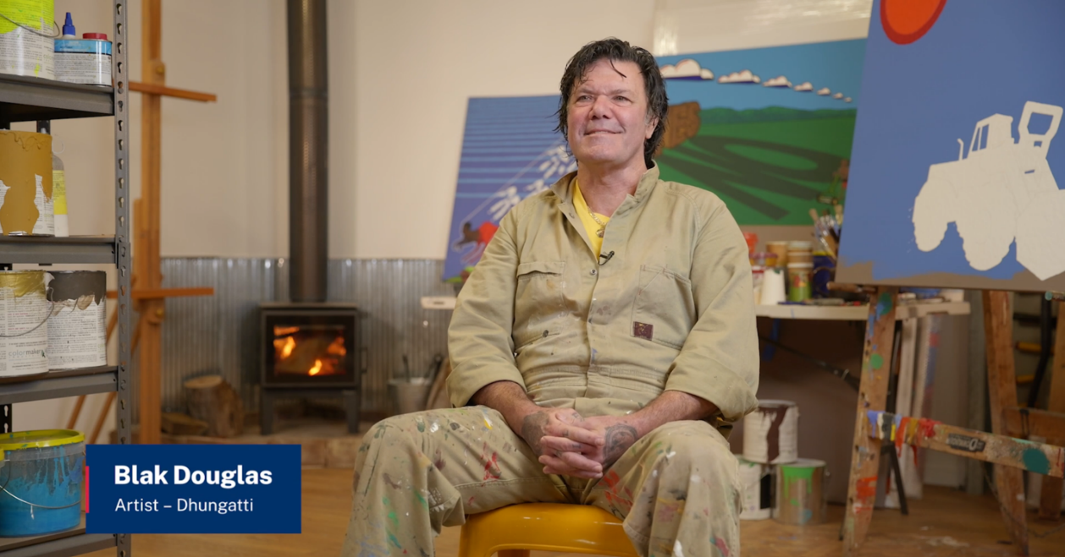

Conversation prompts
Teacher note: this resource could be used to guide student viewing of the interview with Dhungatti artist, Blak Douglas, Meeting in the middle (11:03). As they view the interview, the suggested prompts could be used to facilitate discussions and assess and build student knowledge and understanding of Protocols for collaborating with Aboriginal and Torres Strait Islander Communities and engaging with Cultural works. These prompts could also help spark conversations within the local school community.
Before showing the interview to the class, teachers should preview the film and consider how they introduce the interview. See NESA’s Aboriginal Education teaching and learning support: Visual Arts 7–10 document for support on approaching Aboriginal and Torres Strait Islander content, and explicit connections to Visual Arts 7–10 Syllabus content. This is also an opportunity to introduce learning about cultural safety in visual arts.
Access the interview with Dhungatti artist, Blak Douglas, Meeting in the middle (11:03), and collectively reflect on your learning using the discussion prompts below.
Table 1 – Meeting in the middle – conversation prompts
Time code | Conversation prompt
0:27–0:29 | Blak Douglas introduces himself as a Koori artist. What does ‘Koori’ mean, and why might he choose to use this word?  ‘Blak Douglas’ is a name he created in 2014. What significance do the words ‘Blak’ and ‘Douglas’ have?
0:29–0:34 | Blak Douglas mentions that he lives on Dabee Country. Where is Dabee Country and what connections do Dabee people have to other Aboriginal Peoples? What Cultural Protocol is he following when he says he lives on Dabee Country?
2:08–3:30 | When Blak Douglas discusses people he’s painted for the Archibald prize, he talks about memorialising Aboriginal artists who he’s known personally and been mentored by. What Cultural Protocols has he followed in making portraits of Aboriginal people? Why might he feel the need to memorialise them?  Think about the protocols for entering the Archibald Prize. What connections can you make to Cultural Protocols for working with Aboriginal Peoples?
3:33–4:30 | When Blak Douglas discusses meeting with Dujuan Hoosan, he talks about going on-Country, visiting Dreaming sites and uses the Arrente name Mparntwe. What Cultural Protocols has he followed when visiting Dujuan Hoosan?
4:00–4:29 | Blak Douglas talks about visiting the Country Albert Namatjira came from, and refers to the familiar desert landscape. Why might Albert Namatjira and the landscape near Mparntwe have a particular significance for an Aboriginal artist?
4:29–6:57 | What protocols does Blak Douglas refer to when he discusses his experiences of making art and working with Aboriginal communities? Why are these important?
7:00–9:53 | Blak Douglas discusses the importance of Aboriginal artists developing their own style, and learning about the types of art Aboriginal people from their own Country made instead of copying other styles. What other styles does he refer to?  He mentions the senior male painters from Papunya. What style of art did they make, and why is that important in this story?  What protocols for art making does Blak Douglas follow in his own practice, and what advice does he give others for developing their own style?
10:20–10:38 | Reflecting on all your learning from the Cultural Knowledges and creative processes shared by Blak Douglas, how will you use your new understanding to honour and respect protocols that recognise and respect Aboriginal ways of understanding art?  Blak Douglas invites us to research contemporary Aboriginal artists and pick your top 7. What do you think he means by ‘contemporary Aboriginal art’, and how is this different to art made for the tourist market? Who are your top 7 contemporary Aboriginal artists, and what do you like about their artworks?

References
This resource contains NSW Curriculum and syllabus content. The NSW Curriculum is developed by the NSW Education Standards Authority. This content is prepared by NESA for and on behalf of the Crown in right of the State of New South Wales. The material is protected by Crown copyright.
Please refer to the NESA Copyright Disclaimer for more information https://educationstandards.nsw.edu.au/wps/portal/nesa/mini-footer/copyright.
NESA holds the only official and up-to-date versions of the NSW Curriculum and syllabus documents. Please visit the NSW Education Standards Authority (NESA) website https://educationstandards.nsw.edu.au and the NSW Curriculum website https://curriculum.nsw.edu.au.
Visual Arts 7–10 Syllabus © NSW Education Standards Authority (NESA) for and on behalf of the Crown in right of the State of New South Wales, 2024.

© State of New South Wales (Department of Education), 2025
The copyright material published in this resource is subject to the Copyright Act 1968 (Cth) and is owned by the NSW Department of Education or, where indicated, by a party other than the NSW Department of Education (third-party material).
Copyright material available in this resource and owned by the NSW Department of Education is licensed under a Creative Commons Attribution 4.0 International (CC BY 4.0) license.

This license allows you to share and adapt the material for any purpose, even commercially.
Attribution should be given to © State of New South Wales (Department of Education), 2025.
Material in this resource not available under a Creative Commons license:
- the NSW Department of Education logo, other logos and trademark-protected material
- material owned by a third party that has been reproduced with permission. You will need to obtain permission from the third party to reuse its material.
Links to third-party material and websites
Please note that the provided (reading/viewing material/list/links/texts) are a suggestion only and implies no endorsement, by the New South Wales Department of Education, of any author, publisher, or book title. School principals and teachers are best placed to assess the suitability of resources that would complement the curriculum and reflect the needs and interests of their students.
If you use the links provided in this document to access a third-party's website, you acknowledge that the terms of use, including licence terms set out on the third-party's website apply to the use which may be made of the materials on that third-party website or where permitted by the Copyright Act 1968 (Cth). The department accepts no responsibility for content on third-party websites.

