Beau Dean Riley Smith – Come in with an open heart

Viewing guide
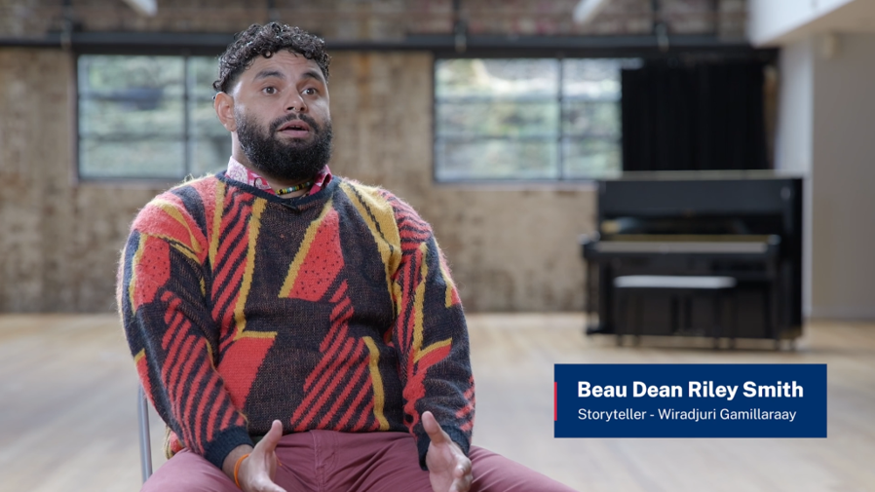

Conversation prompts
Teacher note: this resource could be used to guide student viewing of the interview with Wiradjuri/Gamillaraay, storyteller, Beau Dean Riley Smith, Come in with an open heart (12:01). As they view the interview, the suggested prompts could be used to facilitate discussions and assess and build student knowledge and understanding of Protocols for collaborating with Aboriginal and Torres Strait Islander Communities and engaging with Cultural works. These prompts could also help spark conversations within the local school community.
Before showing the interview to the class, teachers should preview the film and consider how they introduce the interview. See NESA’s Teaching advice (additional): Years 7–10 Working with Aboriginal and Torres Strait Islander content document for support on approaching Aboriginal and Torres Strait Islander content in the Dance 7–10 Syllabus (2023). This is also an opportunity to introduce learning about cultural safety in dance.
There is a simulated gunshot in this interview which some students and/or teachers may find distressing. Teachers are to use their professional discretion when engaging with this resource in their classroom.
Access the interview with Wiradjuri/Gamillaraay, storyteller, Beau Dean Riley Smith, Come in with an open heart (12:01), and collectively reflect on your learning using the conversation prompts below.
Table 1 – Come in with an open heart – conversation prompts
Time code | Conversation prompt
1:12–2:55 | What Cultural Protocols do we see and hear when Beau Dean Riley Smith is discussing the process of creating Bennelong (2017) with Bangarra Dance Theatre? Why is this important?
2:56–3:00 | In 2016, Beau Dean Riley Smith created Miyagan (2016) with Bangarra Dance Theatre. Discuss who Beau Dean Riley Smith references as family, and the importance of relationships when creating the work.
3:41–5:17 | Beau Dean Riley Smith talks about taking the company dancers and creatives to Dubbo to be on Country. Discuss Beau Dean Riley Smith’s process of community consultation and engagement on Country when creating Miyagan (2016).
5:25–7:26 | Beau Dean Riley Smith describes the process of creating Gubba (2023) for Sydney Dance Company as ‘very different’. Describe some of the differences Beau Dean Riley Smith outlines. Discuss why trust and relationships are important.
7:33–8:19 | Beau Dean Riley Smith’s advice to teachers and students when seeing his works is to ‘come in with an open heart’. Discuss what this means to you, and how this will assist with culturally safe ways of engaging with Aboriginal and Torres Strait Islander works.
8:37–9:06 | Discuss why there should be local community consultation when engaging with Aboriginal perspectives in schools. Using the clapsticks example Beau Dean Riley Smith mentioned, consider why this would be inappropriate.
9:06–11:10 | Reflect on your learning from the Cultural Knowledges and creative processes shared by Beau Dean Riley Smith.  How will your learning about Cultural Protocols inform the way you will engage with Aboriginal and/or Torres Strait Islander works?

References
This resource contains NSW Curriculum and syllabus content. The NSW Curriculum is developed by the NSW Education Standards Authority. This content is prepared by NESA for and on behalf of the Crown in right of the State of New South Wales. The material is protected by Crown copyright.
Please refer to the NESA Copyright Disclaimer for more information https://educationstandards.nsw.edu.au/wps/portal/nesa/mini-footer/copyright.
NESA holds the only official and up-to-date versions of the NSW Curriculum and syllabus documents. Please visit the NSW Education Standards Authority (NESA) website https://educationstandards.nsw.edu.au and the NSW Curriculum website https://curriculum.nsw.edu.au.
Dance 7–10 Syllabus (2023) © NSW Education Standards Authority (NESA) for and on behalf of the Crown in right of the State of New South Wales, 2023.

© State of New South Wales (Department of Education), 2025
The copyright material published in this resource is subject to the Copyright Act 1968 (Cth) and is owned by the NSW Department of Education or, where indicated, by a party other than the NSW Department of Education (third-party material).
Copyright material available in this resource and owned by the NSW Department of Education is licensed under a Creative Commons Attribution 4.0 International (CC BY 4.0) license.

This license allows you to share and adapt the material for any purpose, even commercially.
Attribution should be given to © State of New South Wales (Department of Education), 2025.
Material in this resource not available under a Creative Commons license:
- the NSW Department of Education logo, other logos and trademark-protected material
- material owned by a third party that has been reproduced with permission. You will need to obtain permission from the third party to reuse its material.
Links to third-party material and websites
Please note that the provided (reading/viewing material/list/links/texts) are a suggestion only and implies no endorsement, by the New South Wales Department of Education, of any author, publisher, or book title. School principals and teachers are best placed to assess the suitability of resources that would complement the curriculum and reflect the needs and interests of their students.
If you use the links provided in this document to access a third-party's website, you acknowledge that the terms of use, including licence terms set out on the third-party's website apply to the use which may be made of the materials on that third-party website or where permitted by the Copyright Act 1968 (Cth). The department accepts no responsibility for content on third-party websites.

