r e a resource booklet

Table of contents
r e a resource booklet 1
‘Look Who’s Calling the Kettle Black’ 3
Activity 1 – summarising 5
Activity 2 – interpreting 6
Activity 3 – analysing 8
PolesApart 9
Activity 4 – making connections 11
Activity 5 – summarising 12
Activity 6 – summarising 14
Activity 7 – analysing 15
References 16

‘Look Who’s Calling the Kettle Black’
‘Look Who’s Calling the Kettle Black’ (1992) is a series of colour, computer generated photographic prints on paper. Each work has an historic black and white image of an Aboriginal woman in servant's uniform imposed on a colour image of a domestic appliance on a different colour ground. Each has a dictionary definition of the title printed in black in the upper left of the print.
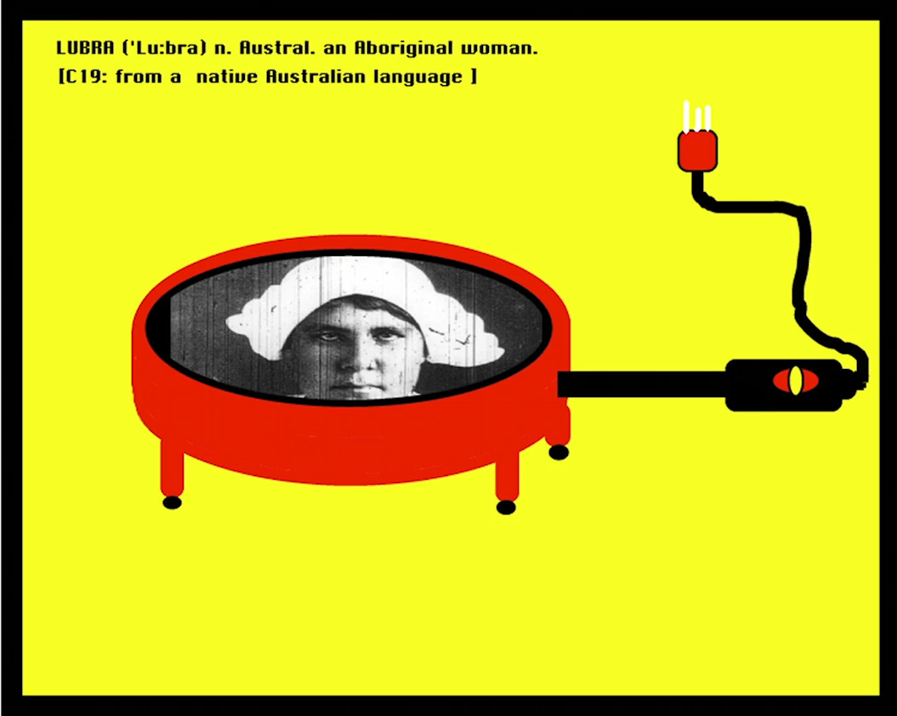
'Lubra', computer generated print on paper, 1992.
Artwork text states ‘LUBRA ('Lu:bra) n. Austral. an Aboriginal woman. [C19: from a native Australian language].’
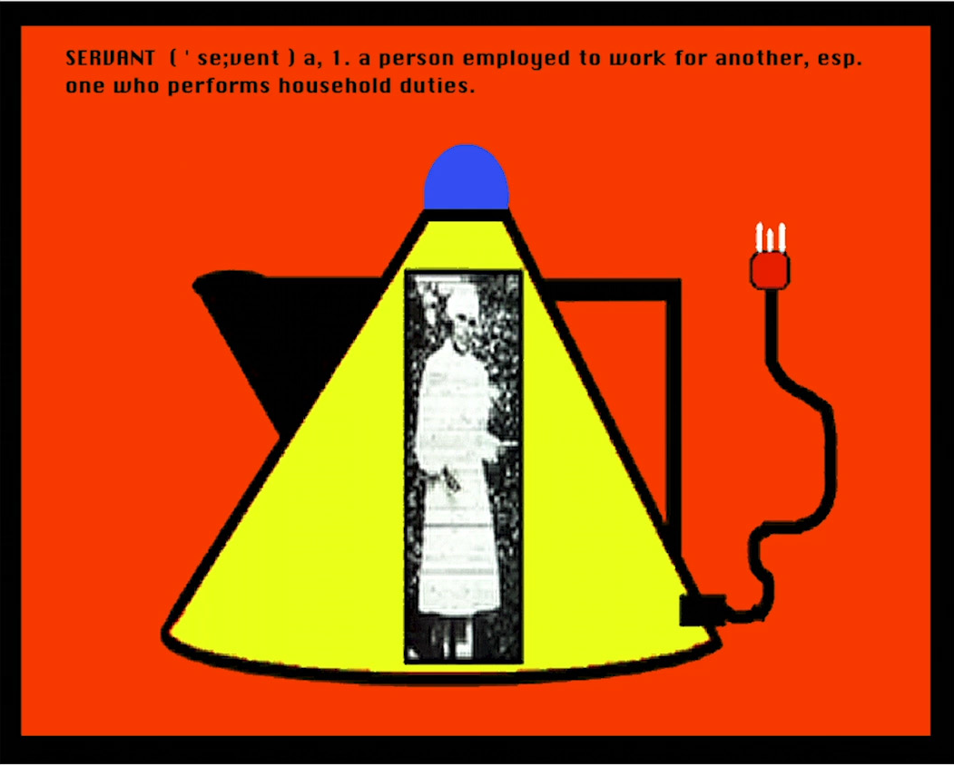
'Servant', computer generated print on paper, 1992.
Artwork text states ‘SERVANT ('se;vent) a, 1. a person employed to work for another, esp. one who performs household duties.’
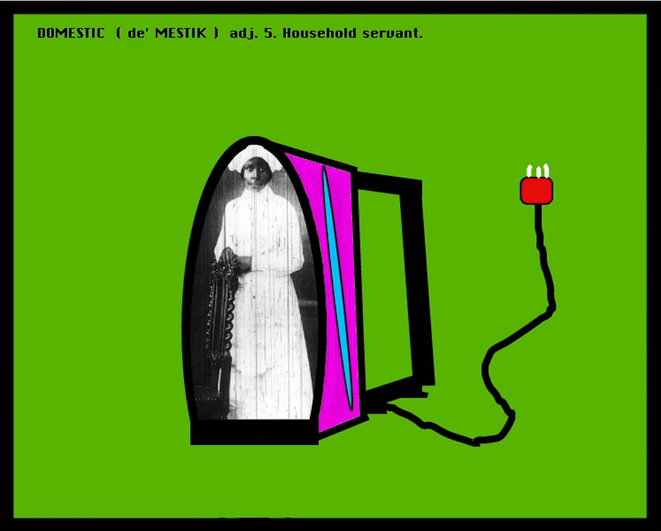
'Domestic' computer generated print on paper, 1992
Artwork text states ‘DOMESTIC (de'MESTIK) adj. 5. Household servant’
Artworks in the collection of the Museum of Applied Arts and Sciences (MAAS). Citation and description from MAAS. (date accessed 17/02/2021)

Activity 1 – summarising
Watch the video ‘r e a – Finding the form’ (09:02) and make notes responding to the artmaking practice questions below. Artmaking practice includes the artist’s intentions, choices, actions, ways of working and processes.
Aspect of practice | Notes
What are the artist’s intentions?
What does the idiom ‘the pot calling the kettle black’ refer to?
What ideas is the artist exploring?
What historical or social issues might have informed her choices?
Are subjective experiences represented in these works? How?
How does the artist use materials, techniques, and technology?
How has the choice of materials and techniques informed the representation of ideas?

Activity 2 – interpreting
Read r e a’s artist statement for ‘Look Who’s Calling the Kettle Black’. Use two different coloured markers to highlight quotes about r e a’s material and conceptual practice.
Essentially I am a photographer. I create my art by manipulating black and white photographs digitally. The process that I use to create most of my work tends to go something like this:
Firstly, I create my source material. Mostly I use a studio set-up where I take numerous photographs of either objects or the 'blak' body. The 'blak' female body tends to be the subject of most of my work, for example: REA: CODE (1998), EYE/I'MMABLAKPIECE (1996), RIP - Blak Body Series I - VI (1995), Resistance III (1994) and Definitions of Difference I - VI (1994). However, recently I have started to include textures in my work; these are representative of my birth country, Coonabarabran, which is located in the north-west of New South Wales.
The next stage of my work begins when the source material is burnt onto a CD ROM. I then start to use my computer to layer the work, to manipulate it, and to add layers to it (such as text and colour). To achieve this layering effect I use programs such as Adobe Photoshop, QuarkXPress and Adobe Illustrator. My computer is like a canvas, a paintbrush and a paintbox, as it allows me to experiment with form, style and content. I spend hours selecting the image that I am going to work on: I may have an image of the whole body for example, but when I start to play with the image I realise that my idea for the work needs to change, so then I might decide to use just the torso or the legs or the back - it all depends on what I am trying to achieve with each piece of work that I create - it is always different. I then put the finished artwork onto a cartridge and take it to a lab. They create a medium format transparency, another lab then prints the work, and the end result is a digital cibachrome print.
I am inspired by many different artists and art styles, and the works of these black women artists have given me the courage to always ask questions: Lorna Simpson, Adrian Piper, Bell Hooks. I have always loved the work of Albert Namatjira because he painted the land as I understand it. He gave me a strong sense of the importance of place and although I don't literally create landscapes, the sense of what my land means to me, my family and my people (Gamilaroi) always informs each piece of work I create. I have also been inspired by artists such as Joseph Cornell, Marcel Duchamp and Andy Warhol.
I grew up in the era of kitsch, Elvis, movie stars and red dresses, and my mother painted all her kitchens yellow and purple, so I can't help but relate to wild colours and pop art! Contemporary urban Aboriginal art is the art that I am most passionate about because we have had to fight long and hard to be visible and I am proud that I am part of a movement which continues to interrogate colonial constructs and explore the immense diversity of Aboriginal identities.
Rea (nga.gov.au), date accessed 11/02/2021.

Record two key quotes where r e a explains aspects of her material and conceptual practice
Material practice – how the artist has used processes, procedures, techniques and materials in their artmaking.

Conceptual practice – the artist’s intentions and ideas, and how they have communicated meaning in their artmaking.

Look at the images from ‘Look Who’s Calling the Kettle Black’.
Add to the list of key features and discuss the meaning/impact of these features.
Key features | Symbolic meaning/impact
Archival images of young Aboriginal women from the Cootamundra Domestic Training Home for Aboriginal Girls.
Images of domestic appliances.
Dictionary definitions, including choice of words.
Series title ‘Look Who’s Calling the Kettle Black’.
Juxtaposition of the photographs, appliances, and dictionary definitions.
Deliberately simplified graphic design with thick outlines and bright, flat colours.
Unplugged power cords.

Activity 3 – analysing
Refer to your notes from activities 1 and 2 to answer the following question as a paragraph response. The text box will expand when using a digital copy of this resource.
How has r e a used significant signs and symbols to communicate personal and cultural narratives about the Stolen Generation in her series ‘Look Who’s Calling the Kettle Black’?

PolesApart
‘PolesApart’ (2009) is a silent film that runs for 6 minutes and 22 seconds. Refer to the selected still frames below, and the excerpts from the ‘r e a – Finding the form’ (04:05 – 05:22) video resource to complete the activities on the following pages.
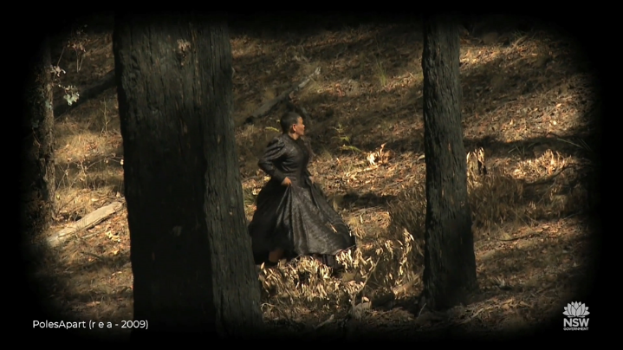
From ‘r e a – Finding the form’ 04:09
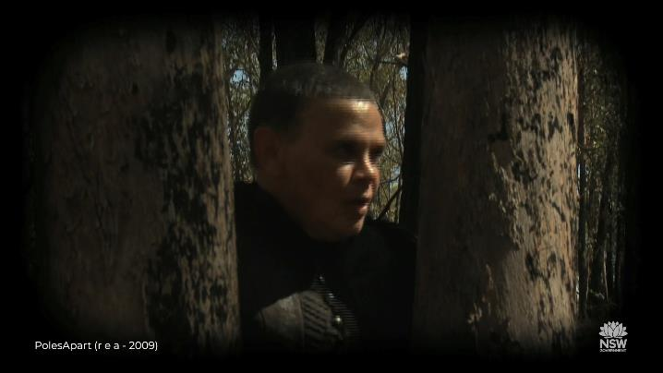
From ‘r e a – Finding the form’ 04:32
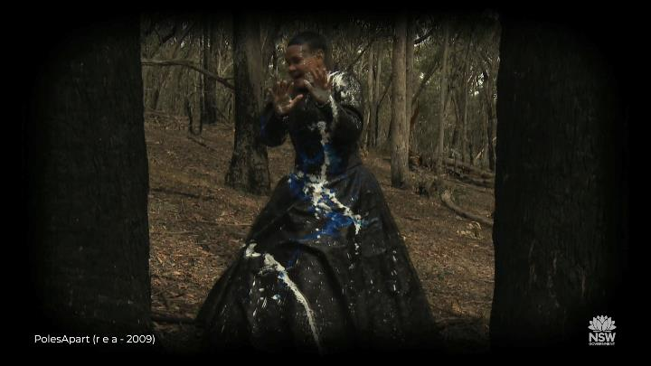
From ‘r e a – Finding the form’ 05:45

Activity 4 – making connections
Using the excerpts from PolesApart shown in the video resource, and the selected stills shown here, write a short narrative that re-tells the artwork from the perspective of r e a’s character in PolesApart. The text box will expand when using a digital copy of this resource.

Activity 5 – summarising
Read these two critical accounts of PolesApart. Use different colours to highlight key information about how r e a explores personal and cultural narratives in PolesApart.
Source 1 – exhibition review (extract)
Silence becomes presence in PolesApart (2017) by r e a. In this work the artist is silently shown wearing a full length Victorian-style black dress as she takes flight, weaving between trees in a fire-ravished forest. Deeper engagement with the work reveals r e a’s Aunty had fled colonial violence and servitude. In the final scene, we see the protagonist’s face contort in discomfort and anguish as she is dashed with red, white and blue paint, signifying Empire and alluding to American artist-hero Jackson Pollack’s Blue Poles (1952). The reference to Blue Poles rouses the political controversy its $1.3m acquisition by the National Gallery of Australia caused in 1973, cautioning the viewer not to over-politicise r e a’s work. PolesApart calls to mind colonial violence against Aboriginal women’s bodies, along with the attempt to paint Aboriginal bodies out of the landscape, contesting the historical and aesthetic erasure of Indigeniety. r e a’s performance of escape enacts collective memory through embodied experience, (re)inscribing an Aboriginal presence in the landscape.
Tristen Harwood – THE VIOLENCE OF DENIAL - un Projects. (date accessed 15/02/2021)

Source 2 – journal article (extract)
PolesApart, her most recent work, comprises a silent, high definition video, four photographic triptychs, and a Victorian morning/mourning gown created collaboratively with Melbourne dress designer Amanda Fairbanks. Complementing the moving image component of PolesApart are the four large triptych photographs, printed as C-type prints. These too record the central character's flight from undetectable, but nevertheless real and powerful external forces.
In the video the protagonist, played by r e a, is an apparently ageless, androgynous Aboriginal woman, runs through a bushfire-devastated forest. The woman wears a full-length black gown that places her in an earlier era. The fire-blackened trees through which this nameless woman silently weaves her way are tall, stark and forbidding. To this poetic, lyrical artwork r e a brings the qualities and virtues of silent film.
Darkness, and the colour black, and their conflictual cultural significance, play important symbolic roles in PolesApart. The blackened, burnt out forest, the charred tree stumps, the protagonist’s black dress, her shortcropped dark hair and the darkness that periodically envelops the entire landscape, engulfing the woman, working synergistically to create an atmosphere of psychological entrapment, compelling viewers to ask, who is this desperate, hunted, woman, this woman of shadows? From whom or from what is she fleeing?
The answer lies in r e a’s own family history, a history that mirrors the larger history of the Stolen Generations outlined in earlier sections of this article. Ruby, r e a’s grandmother, and her grandmother’s sister Sophie, were forcibly removed from their family and taken to the Cootamundra Girls’ Home (N.S.W.) circa 1916, soon after their mother died. At that time Ruby was just five years old, and she was to remain under the strictures of the Aboriginal Protection Board until approximately 1934. There, at the Cootamundra Girls’ Home, the children were trained to be maidservants, before being sent out as virtually unpaid labour for wealthy white people.
Sophie, like the protagonist in PolesApart, absconded from the family for whom she worked as a domestic servant, successfully making it back home, which she was never again to leave.
Christine Nicholls – Embodying Affect: The Stolen Generations, the History Wars and PolesApart by Indigenous New Media Artist r e a (flinders.edu.au) (date accessed 15/02/2021)

Activity 6 – summarising
Consider the stills, video excerpts, and critical and historical perspectives on ‘PolesApart’. and discuss the meaning/impact of these features
Key features | Symbolic meaning/impact
r e a’s characterisation, including body language, facial expression, pose, gesture and movement
Mise en scène elements:
Location, setting and props
Costume, hair, makeup
Lighting and atmosphere
Point of view, perspective
Technical choices:
Cinematography (Shot types, camera angles, camera movement)
Use of sound
Artwork title ‘PolesApart’

Activity 7 – analysing
Refer to your notes on PolesApart from activities 4 – 6 to answer the following question as an extended response. The text box will expand when using a digital version of this resource.
Explain how r e a’s intentions, choices, and actions in creating PolesApart explore personal and cultural narratives.

References
r e a – Finding the form (09:02) video resource, date accessed 17/12/2020
r e a – Artist statement date accessed 17/12/2020
r e a – ‘Look Who’s Calling the Kettle Black’ date accessed 17/12/2020
The Violence of Denial – exhibition review date accessed 17/12/2020
Nicholls, C. 2010. Embodying Affect: The Stolen Generations, the History Wars and PolesApart by Indigenous New Media Artist r e a. 2010 14th International Conference on Information Visualisation (IV), 415-421. date accessed 17/12/2020

