Alexia Sinclair resource booklet

Table of contents
Alexia Sinclair resource booklet 1
Alexia Sinclair – Storyteller 3
Activity 1 – see, think, wonder 3
Activity 2 – signs and symbols 5
Activity 3 – compare and contrast 6
References 9

Alexia Sinclair – Storyteller

Activity 1 – see, think, wonder
‘Variola Vera’ is a digital photograph by Alexia Sinclair from the 2014 series ‘The Art of Saving a Life’, part of a larger project commissioned by the Bill and Melinda Gates Foundation to illustrate the global impact of vaccines.
Alexia Sinclair - The Art of Saving a Life (accessed 22/02/2021)

Refer to this image, and the video resource Alexia Sinclair – Storyteller (10:37) to complete the see, think, wonder scaffold on the following page.
See | Think | Wonder
Observe the work. Describe what you see using the structural frame to guide you. For example – consider the subject matter, textures, colours, composition, size, use of repetition and other visual qualities. | Discuss what you think is happening in this artwork.  Provide evidence as to why you think this. You might refer to evidence in the first column. | What are you curious about?  What more do you want to know about this artwork, artist or the audience for this work?

Activity 2 – signs and symbols
Refer to the completed example below which interpret two symbols in Alexia Sinclair’s The Art of Saving a Life, and then use the scaffold on the following page to interpret symbols in her artwork The Cabinets of Curiosity (accessed 22/02/2021).
Symbols are marks, signs or codes that represent ideas to audiences. They can be used to communicate an artist’s ideas. Similarly, signs are also used to convey information to audiences. Signs and symbols carry meanings that are culturally bound and can be read or interpreted by specific audiences in certain times and places.
For examples of common symbols in 17th-18th century art, refer to the article ‘Symbols in a Vanitas’ (accessed 22/02/2021)
Symbol | Meaning
Skull  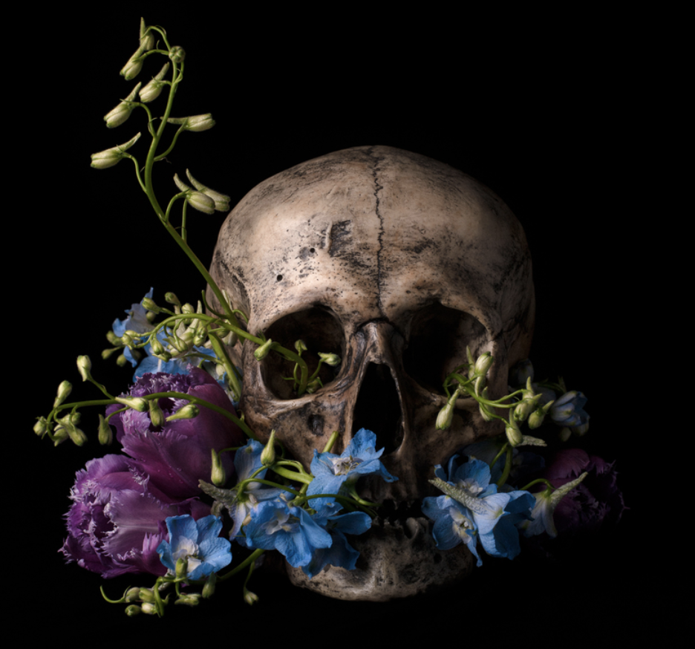 | Death, transience of life, passing of time, mortality, fragility of life.
Bottles  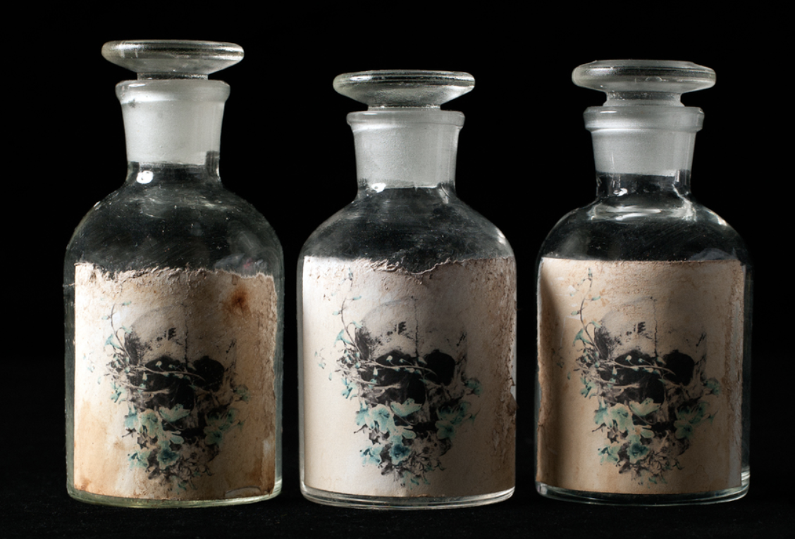 | Medicine, cure, science, vaccine, health.
Write a statement that explains how the symbols you have identified communicate meaning in this artwork. The text box will expand when using a digital copy of this resource.
Example – the skull labels on the medicine bottles juxtaposed against an ornate floral background suggest new life that comes from death. With this medicine we can overcome the fragility of life and fight mortality.
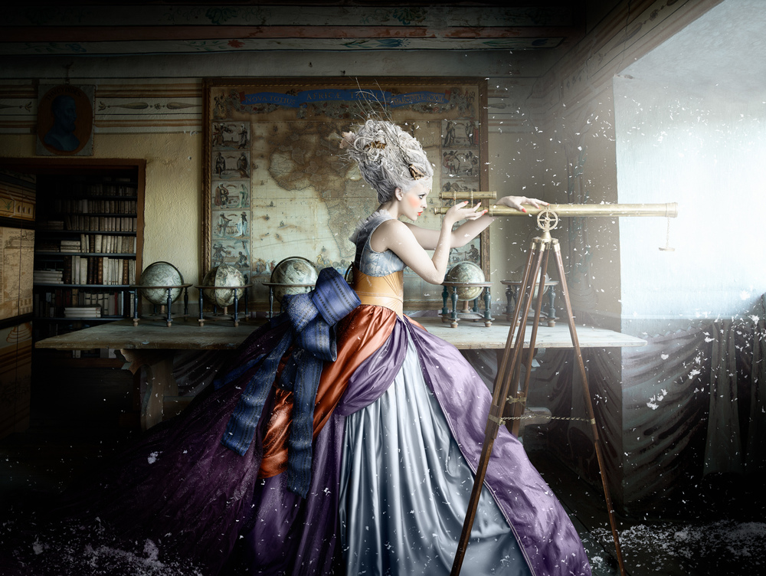
Alexia Sinclair – The Cabinets of Curiosity, 2013, (accessed 22/02/2021)
Symbol | Meaning
Write a statement that explains how the symbols you have identified communicate meaning in this artwork. The text box will expand when using a digital copy of this resource.

Activity 3 – compare and contrast
In her artmaking practice, Alexia Sinclair carefully considers the composition and placement of figures and objects to create highly detailed images that evoke a particular time and place. Her work is influenced by, and makes references to, trends and movements drawn from her study of art history, including the Pre-Raphaelite movement.
Compare these works by Alexia Sinclair and Pre-Raphaelite artist William Holman Hunt.
List some of the features in each work. Pay attention to the composition, placement of figures, and the use of objects and other details. When complete, write a short paragraph that explains similarities between the two artist’s works.
Artwork | Visual features
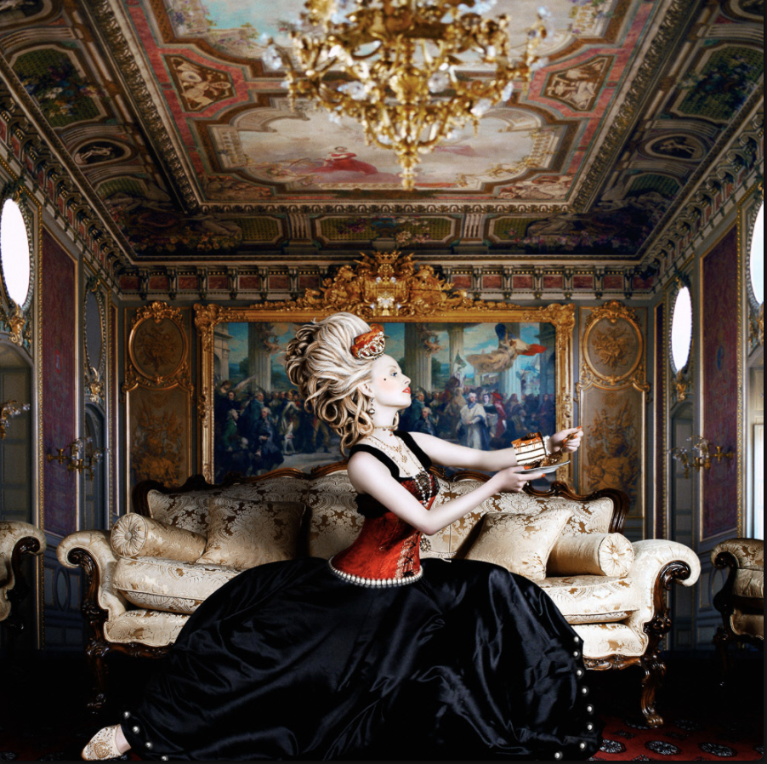
Alexia Sinclair, ‘Marie Antionette’, 2005. Accessed 23/02/2021
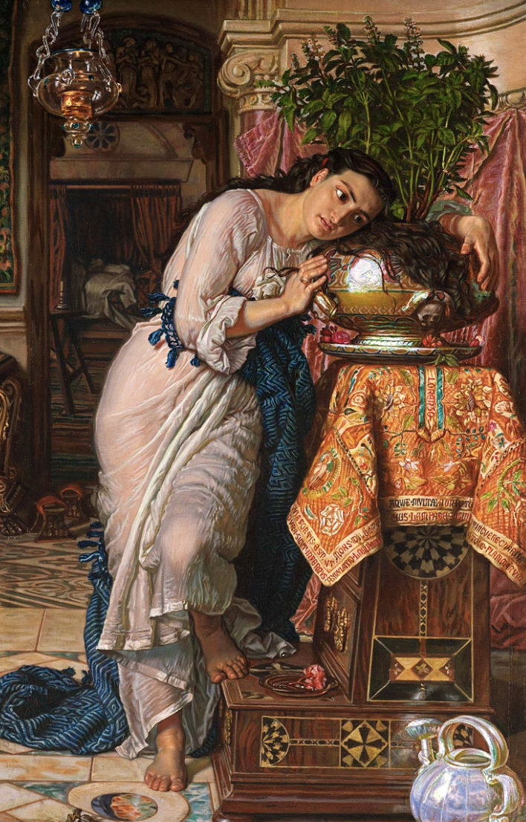
William Holman Hunt, ‘Isabella and the pot of basil’ 1867-68. Accessed 23/03/2021
Using your list of visual features in these two works, write a short paragraph that explains some of the similarities between Alexia Sinclair’s photograph and William Holman Hunt’s painting. The text box will expand when using a digital copy of this resource.

References
Alexia Sinclair – Storyteller (10:37).
Alexia Sinclair – Variola Vera – The Art of Saving a Life (accessed 22/02/2021).
Alexia Sinclair – The Cabinets of Curiosity (accessed 22/02/2021).
Symbols in a Vanitas (accessed 22/02/2021).
Alexia Sinclair – Skull – The Art of Saving a Life (accessed 23/02/2021).
Alexia Sinclair – Bottles – The Art of Saving a Life (accessed 23/02/2021).
Alexia Sinclair – Marie Antionette (accessed 23/02/2021).
William Holman Hunt – Isabella and the pot of basil (accessed 22/02/2021).

