Music Stage 5 – student booklet
Depth study – Australian perspectives
Contents
NESA advice 2
My depth study plan 3
Driving question – branching questions 3
My product – planning 4
Depth study proposal 5
Working in groups 6
Project management tools 6
Group norms contract 8
Depth study planner 9
Facilitator check-in 10
Peer feedback 11
Cool and warm feedback starters 11
Peer feedback reflection 11
Final product marking 12
References 13

NESA advice
A depth study is any type of music investigation that provides students with an opportunity to pursue their interests and deepen their music knowledge, understanding and skills in an area of interest. Students are required to undertake a depth study in Stage 5 200-hour course. The purpose of the depth study is to provide students with the opportunity to deepen their understanding of music 7–10 content. Students draw on content studied in class and apply it to a self-devised and/or teacher-supported area of individual interest.
Depth studies may be completed individually or collaboratively. Students may choose to work with others on a depth study with the same focus. Alternatively, students may work collaboratively on a depth study of the same topic but within a different focus area. For example, one student in a group may wish to deepen their knowledge, understanding and skills in composing with another student focusing on performing (NESA 2024).

My depth study plan

Driving question – branching questions
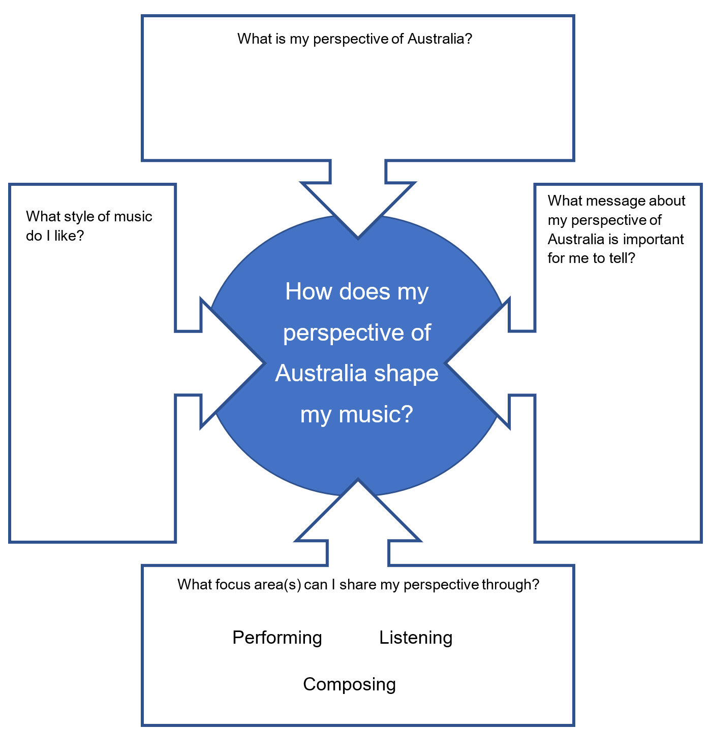

My product – planning
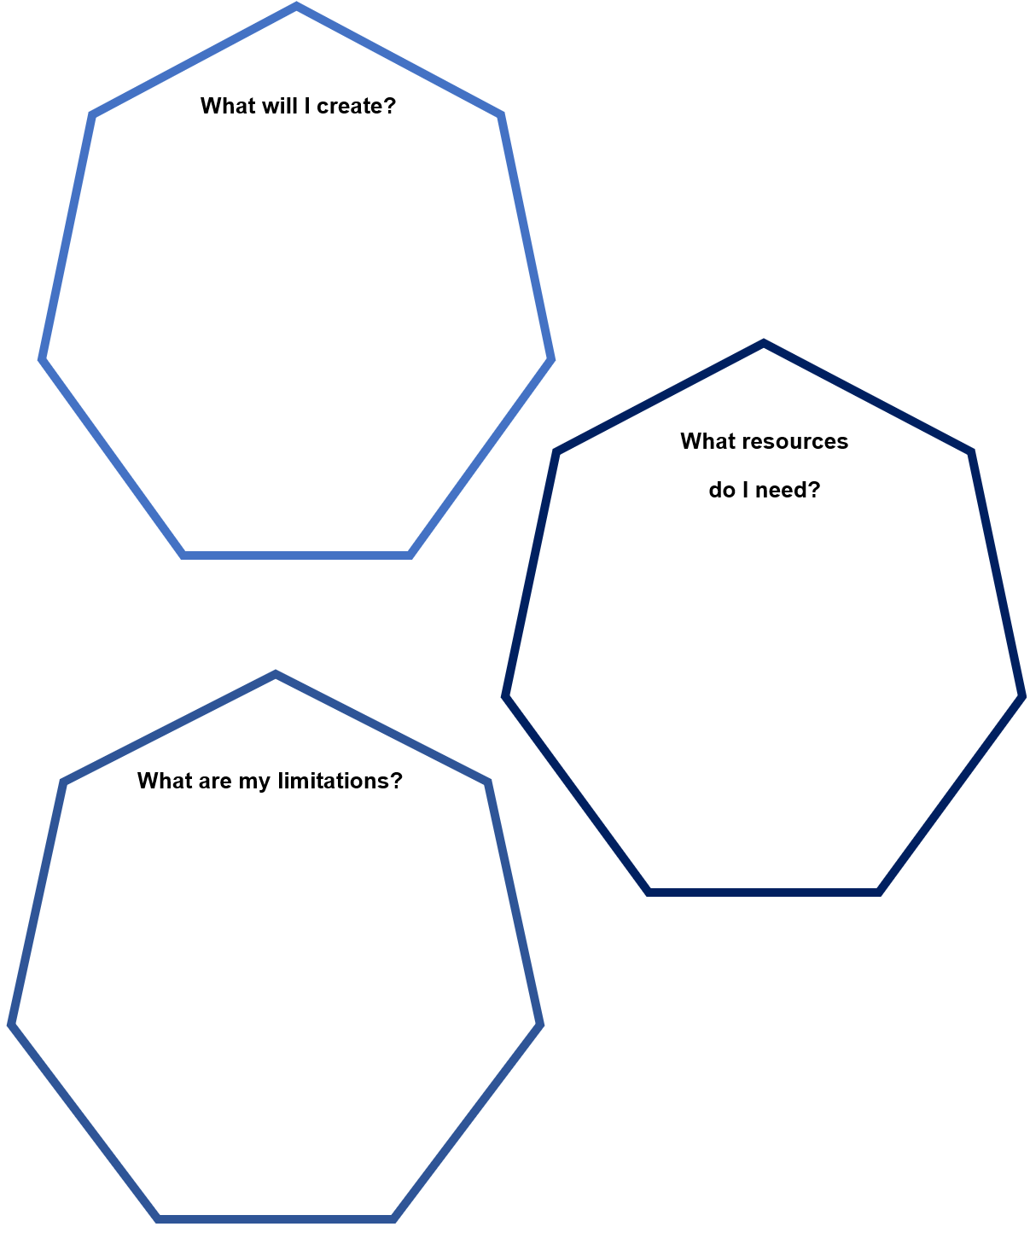

Depth study proposal
Name:
Outline the proposed product (what are you going to create?)
What is the focus area of my product? (circle one or more)
Performing Listening Composing
Combination of 2–3 focus areas: 1. 2. 3.
What skills/knowledge will I need?
What research will I need to complete?
Will I be collaborating with others (list names) or working solo?

Working in groups

Project management tools
Your group will need to decide on a cloud-based project management tool to use for the depth study work. This storage tool will reduce the risk of lost work and allows all group members to access the project work regardless of a group member’s presence or absence in each lesson.
Popular cloud-based project management tools that are easily accessible to NSW Department of Education students are G Suite for Education and Microsoft 365 which can be seen in the images below.
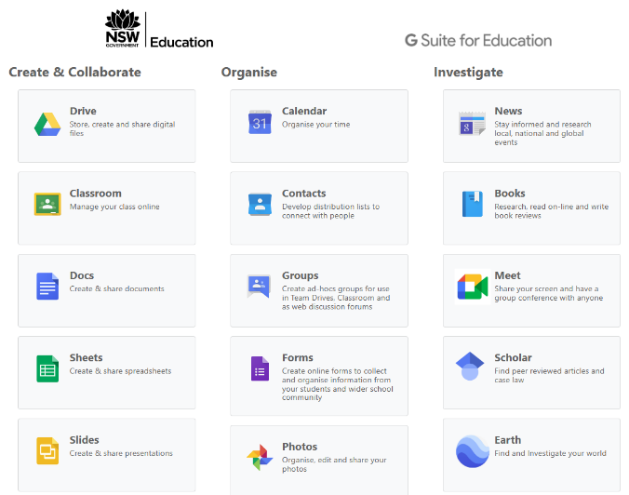
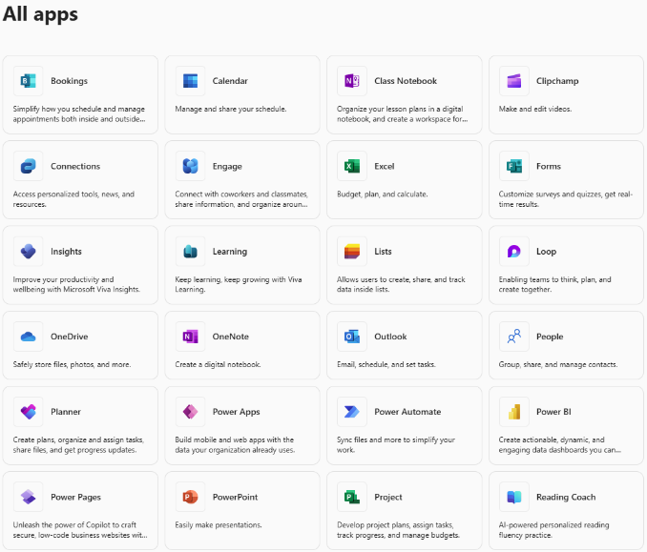

Group norms contract
Agreement
1.
2.
3.
4.
5.
If someone on our team goes away from one or more of our norms, the team may have a meeting and ask the person to follow our agreement. If the person still acts outside of the norms, we will ask our teacher to help ﬁnd a solution.
Name | Signature | Date

Depth study planner
Week | Lesson 1 | Lesson 2 | Lesson 3
Week 6 | What is a depth study?  Branching and planning questions | Project proposal  Depth study planner  Group norms contract  Submit this lesson | This is not a depth study lesson
Week 7 | This is not a depth study lesson | This is not a depth study lesson | This is not a depth study lesson
Week 8 | This is not a depth study lesson | Independent lesson  What do I want to achieve this lesson? | *Facilitator check-in  What do I want to achieve this lesson?
Week 9 | *Facilitator check-in  What do I want to achieve this lesson? | *Facilitator check-in  What do I want to achieve this lesson? | *Facilitator check-in  What do I want to achieve this lesson?
Week 10 | Present product for peer feedback | Finish and refine product | Submit or present product
* Your facilitator will tell you which 2 lessons your check-in will occur.

Facilitator check-in
What questions do I need to ask?

What feedback did my facilitator give me?

Peer feedback

Cool and warm feedback starters
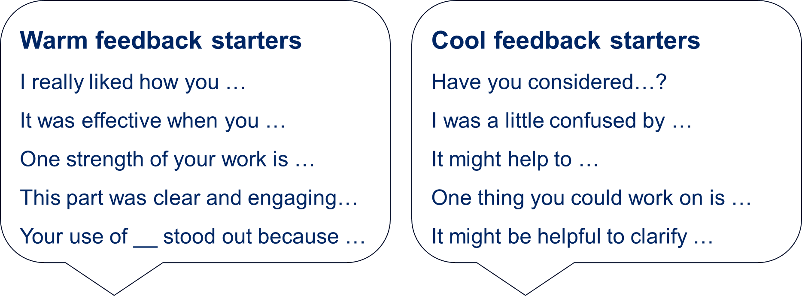

Peer feedback reflection
Peer feedback reflection
Date:
What warm feedback did I receive?
What cool feedback did I receive?
What feedback do I want to action and how will I do that?

Final product marking
Your final product will be marked using the following criteria:
- How well does the product meet the goal proposed in the ‘Depth study proposal’?
- Does the product clearly use the focus area(s) identified in the proposal?
- Is there evidence in the final product that the outlined skills, knowledge and research in the proposal have been used and completed?
- Does the product answer the driving question – ‘How does my perspective of Australia shape my music?’
- How effective is the product in answering the driving question?
- How consistent was the approach to creating the product during class time?

References
This resource contains NSW Curriculum and syllabus content. The NSW Curriculum is developed by the NSW Education Standards Authority (NESA). This content is prepared by NESA for and on behalf of the Crown in right of the State of New South Wales. The material is protected by Crown copyright.
Please refer to the NESA Copyright Disclaimer for more information https://www.nsw.gov.au/education-and-training/nesa/copyright.
NESA holds the only official and up-to-date versions of the NSW Curriculum and syllabus documents. Please visit NESA https://www.nsw.gov.au/education-and-training/nesa and NSW Curriculum https://curriculum.nsw.edu.au.
Music 7–10 Syllabus © NSW Education Standards Authority (NESA) for and on behalf of the Crown in right of the State of New South Wales, 2024.
NSW Education Standards Authority (NESA) (2024) ‘Teaching advice (additional): Stage 5 – Depth study’ NESA, accessed 4 September 2025.

© State of New South Wales (Department of Education), 2025
The copyright material published in this resource is subject to the Copyright Act 1968 (Cth) and is owned by the NSW Department of Education or, where indicated, by a party other than the NSW Department of Education (third-party material).
Copyright material available in this resource and owned by the NSW Department of Education is licensed under a Creative Commons Attribution 4.0 International (CC BY 4.0) license.

This license allows you to share and adapt the material for any purpose, even commercially.
Attribution should be given to © State of New South Wales (Department of Education), 2025.
Material in this resource not available under a Creative Commons license:
- the NSW Department of Education logo, other logos and trademark-protected material
- material owned by a third party that has been reproduced with permission. You will need to obtain permission from the third party to reuse its material.
Links to third-party material and websites
Please note that the provided (reading/viewing material/list/links/texts) are a suggestion only and implies no endorsement, by the New South Wales Department of Education, of any author, publisher, or book title. School principals and teachers are best placed to assess the suitability of resources that would complement the curriculum and reflect the needs and interests of their students.
If you use the links provided in this document to access a third-party's website, you acknowledge that the terms of use, including licence terms set out on the third-party's website apply to the use which may be made of the materials on that third-party website or where permitted by the Copyright Act 1968 (Cth). The department accepts no responsibility for content on third-party websites.

