Music Stage 5 – teacher resource booklet
Influence and innovation

Contents
Learning sequence 1 – the beauty of taiko 4
Influence and innovation glossary 4
Influence and innovation glossary – answers 8
Activity 1.1 – an introduction to taiko worksheet 14
The 5 W’s worksheet 16
The 5 W’s worksheet – answers 18
Activity 1.2 – ‘Hana Hachijo’ – The Beauty of 8 19
Answers 19
Activity 1.3 – the sound of taiko 20
Answers 20
Activity 1.5 – compositional analysis worksheet 21
Answers 22
Learning sequence 2 – from tradition to tomorrow 23
Activity 2.1 – the influence of cultural change worksheet 23
Taiko through time 23
Activity 2.2 – ‘Become’ that other side 25
Answers 25
Activity 2.4 – the significance of 7 26
Answers 26
Activity 2.5 – practising ‘Pearl’ worksheet 28
Learning sequence 3 – Suzume unlocked – the sound of anime 29
Activity 3.1 – discovering Suzume worksheet 29
Discovering Suzume worksheet – answers 31
Activity 3.2 – Suzume – the main theme worksheet 33
Suzume – the main theme worksheet – answers 34
Activity 3.3 – comparison worksheet 35
Comparison worksheet – answers 37
Activity 3.4 – inside the composing process worksheet 38
Inside the composing process worksheet – answers 40
Learning sequence 4 – from 8-bit to epic – music in Japanese gaming 42
Activity 4.1 – What is a motif? worksheet 42
What is a motif? worksheet – answers 44
Activity 4.2 – loop-based composition worksheet 47
Loop-based composition worksheet – answers 48
Activity 4.3 – metre madness worksheet 49
Metre madness worksheet – answers 51
Learning sequence 5 – boss battles and beats – music in Japanese gaming 52
Activity 5.1 – Nobuo Uematsu worksheet 52
The composer who made game music legendary 52
Answers 56
Activity 5.2 – composing ‘One-Winged Angel’ 57
Answers 57
Activity 5.3 – Who inspired Uematsu? 58
Activity 5.3 – who inspired Uematsu? worksheet 63
Answers 64
Activity 5.4 – harmonic revision worksheet 65
Chord building 65
Answers 72
Activity 5.5 – harmonic exploration in ‘One-winged angel’ 75
Answers 75
Learning sequence 6 – gagaku – the traditional court music of Japan 76
Activity 6.1 – exploring gagaku 76
Instrument, musical features and timbre adjectives cards 76
Answers 83
Activity 6.3 – listening match-up worksheet 85
Listening match-up worksheet – answers 86
Learning sequence 7 – the future voice – Hatsune Miku and J-pop 87
Activity 7.1 – What is a Vocaloid? Who is Hatsune Miku? 87
Answers 87
Answers 89
Activity 7.2 – from folk to future 90
Answers 90
Extension listening 92
Activity 7.3 – a ‘Polkka’ performance 93
Answers 93
Activity 7.4 – reimagining the ‘Ieven polkka’ 94
Answers 94
Learning sequence 10 – final mix – listening and reflection 96
Activity 10.1 – peer listening and feedback worksheet 96
Activity 10.2 – reflection and class discussion worksheet 97
Unit reflection 97
References 99

Learning sequence 1 – the beauty of taiko

Influence and innovation glossary
Table 1 – influence and innovation glossary
Term | Definition
Aeolian
anime
augmentation
automation
auto tune
bass drop or beat drop
bit crushing
BPM
call and response
cross rhythms
cue bar
DAW (Digital Audio Workstation)
delay
diminution
distortion
don
filtering
filter sweep
fragmenting
grace note
hemiola
imitation
ji-uchi
ka
kuchi shōga
looping
MIDI (Musical Instrument Digital Interface)
mixdown/export
miyadaiko
mode
monophonic
motif
octave shifting/pitch shifting
odaiko
onna-uchi
ostinato
palindrome rhythm
parallel 5ths
pedal point
piano roll
quantise
reverb
rhythmic complexity
rhythmic displacement
rhythmic groupings
sampling
semitone
sequencing
shimedaiko
Suzume
syncopation
synthesised sound
synth pad
taiko
Taikoz
tone
timbre
tsu
unison
unison rhythms
velocity
vocoder
yokouchi

Influence and innovation glossary – answers
Table 2 – influence and innovation glossary
Term | Definition
aeolian | A mode which follows a specific tone and semitone pattern – T S T T S T T. It is all the white notes from A to A.
anime | Anime is simply a shortened form of the word animēshon, which means animation in English. So, in Japan, anime refers to all animation, regardless of origin. However, internationally, the term is typically used to refer specifically to Japanese animation.
augmentation | Repetition of a phrase where the rhythmic values have been doubled in length. For example, a crotchet becomes a minim.
automation | A process in a DAW that allows changes to be programmed over time. For example, volume, panning or effects.
auto tune | An effect where the pitch of an instrument/voice is manipulated to sound ‘in tune’. This can create an unnatural vocal timbre.
bass drop or beat drop | A point in a track where a sudden change of bass line or rhythm occurs, preceded by a build-up section and break. It is used as a structural device to build and release tension.
bit crushing | A digital effect that degrades the original sound by reducing its resolution (similar to a pixelated image). Its distinctive tone can sound like a corrupted audio file.
BPM | An acronym for beats per minute.
call and response | A musical structure where one musical phrase (the call) is directly followed by a responding phrase (the response).
cross rhythms | Rhythms that cross over each other when played simultaneously.
cue bar | The bar before a new section that cues that new section.
DAW (Digital Audio Workstation) | Software used to record, edit and produce music.
delay | The repetition of a sound to create ‘echoes’ which can fade out.
diminution | Repetition of a phrase where the rhythmic values have halved. For example, a crotchet becomes a quaver.
distortion | An effect where sound is manipulated to thicken the tone, often resulting in an abrasive timbre.
don | A strong, full hit in the middle of the taiko drum.
filtering | Using filters to remove specific frequency content from a sound, manipulating its timbre.
filter sweep | Where the frequencies being filtered out are swept from high to low or low to high, causing a change in brightness through time. This can often be identified as a ‘whoosh’ during a transition in the music.
fragmenting | Taking a small motif and developing it using repetition or some other technique like extension.
grace note | A grace note is a very short note that is played quickly and softly just before the main note. It is a type of ornamentation.
hemiola | When a grouping of 2 plays against a grouping of 3.
imitation | When one voice or instrument repeats or closely copies a melody, motif or phrase that has just been introduced by another voice or instrument.
ji-uchi | Base rhythm.
ka | A rim hit creating a sharp timbre.
kuchi shōga | Rhythms and melodies used for teaching music in the aural tradition.
looping | When a fragment or section of sound is repeated identically. Multiple loops can be layered to vary the texture.
MIDI (Musical Instrument Digital Interface) | Digital data that represents musical performance information, such as pitch and duration, used to control virtual and hardware instruments.
mixdown/export | The process of combining all tracks in a project into a single audio file. For example, MP3 or WAV.
miyadaiko | Middle size taiko drum.
mode | A mode is a specific type of scale characterized by a unique sequence of intervals using tones and semitones.
monophonic | A melodic line of texture – it can be one instrument playing or a group of instruments playing the exact same thing in the same register.
motif | A short, recurring musical idea.
octave shifting/pitch shifting | The manipulation of a sound up or down an octave or to a different pitch.
odaiko | A large taiko drum, usually responsible for playing the base rhythm.
onna-uchi | Women’s side-on style of taiko playing.
ostinato | A repeated melodic or rhythmic pattern.
palindrome rhythm | A rhythmic pattern that reads the same forwards and backwards.
parallel 5ths | Interval of a 5th that moves in the same direction. It can be 2 notes played by one instrument, like piano, or it can be an interval held between 2 instruments.
pedal point | Another name for a drone. This is where one note is held using ties across a bar. Usually over 3 or 4 bars. Usually occurs in the bass over changing harmonies.
piano roll | A grid view in a DAW used to input and edit MIDI notes.
quantise | A DAW function that adjusts notes to align with the beat or rhythmic grid.
reverb | An effect used to simulate an acoustic space.
rhythmic complexity | The use of advanced or intricate rhythmic patterns in music that go beyond simple or predictable beats. It can involve variations, layering and unexpected elements.
rhythmic displacement | When a rhythm or motif is repeated but shifted so that it starts on a different beat or subdivision of the bar than before.
rhythmic groupings | How beats or notes are organised and grouped together within a piece of music. They can also be grouped using articulation and rests.
sampling | The use of recorded sounds to add layers or generate new musical material.
semitone | A single step between 2 notes – For example – C to C#.
sequencing | Sequencing is the immediate repetition of a short melodic or rhythmic idea (a motif) at a higher or lower pitch level.
shimedaiko | A higher pitched taiko drum. Can be played standing up or sitting down.
Suzume | The Japanese word for ’sparrow’. It's a common name, and in Japanese culture, the sparrow is associated with grace, agility, resilience and freedom. It is also the name of the animated feature.
syncopation | A rhythmic technique where the expected pattern of beats is disrupted by placing emphasis on weak beats or offbeats, often using ties, rests or accents to shift the natural flow of the rhythm.
synthesised sound | The electronic generation of sound where no acoustic source is used.
synth pad | A sustained synthesised sound or chord, used as a harmonic and textural layer.
taiko | The Japanese word for drum.
Taikoz | The Australian Taiko Drumming Ensemble.
tone | A distance between 2 notes of 2 steps – For example, C to D.
timbre | Unique quality or character of a sound that allows us to distinguish one instrument or voice from another.
tsu | A softer centre hit for quieter passages.
unison | Instruments and/or voices singing the same pitches and rhythm simultaneously.
unison rhythms | Where all parts are rhythmically identical.
velocity | The force or intensity with which a note is played, affecting its volume or tone.
vocoder | A synthesiser that generates timbres and pitches based on the audio input (usually vocals). It can harmonise the voice or make the voice sound ‘robotic’.
yokouchi | A style of taiko playing that includes figure of eight movements.

Activity 1.1 – an introduction to taiko worksheet
Read the information below and make some observations
Table 3 – an introduction to Taiko
The Beauty of 8 | Your observations
The Beauty Of 8 is a special performance that shows off the amazing talents of Chieko Kojima, a Japanese taiko player. Taiko is a type of Japanese drumming, and Chieko is known around the world for her skills. The name The Beauty Of 8 comes from the beautiful shapes and movements she makes while playing taiko in her unique style. Chieko's style is called Onna-uchi, which means ‘women's side-on'. This refers to how she positions herself to play the drums, creating mesmerising visuals as she performs. Her movements are described as flowing, round, graceful and powerful, all at the same time. Chieko Kojima is a member of a famous Japanese group called KODO. With KODO, she travels the world, playing in big concert halls and working with different kinds of artists. Her energy and love for playing seem to inspire everyone around her.
The Beauty Of 8 production was created with Chieko in mind, along with Riley Lee, who is a master of the shakuhachi, a Japanese bamboo flute. Riley and Chieko have a history of performing together, making this collaboration even more special. Riley and Chieko were both part of a taiko group called Ondekoza back in Japan in the 1970s. Ondekoza was a legendary group that later became KODO. They played together in many famous theatres and concert halls around the world. After about 40 years, they are now working together again on The Beauty Of 8.
Riley introduced Chieko to the Australian Performing Group, Taikoz, another taiko group, in 2009. He loved Chieko's ‘alive-ness’, her spontaneous and creative spirit. This led to the idea of creating a show that would highlight her special skills and capture her unique personality. As Chieko and Riley worked together, they discovered a shared love for poetry. This inspired them to include poetry in the performance, adding another layer of meaning and beauty to The Beauty Of 8. This piece was performed with Taikoz at the Melbourne Recital Centre in 2017.

The 5 W’s worksheet
After reading, complete this 5 W’s worksheet using all the vocabulary words. Be sure to use complete sentences.
Table 4 – the 5 W’s worksheet
Taiko | Onna-uchi | KODO | Shakuhachi | Ondekoza
A type of Japanese drum that involves large drums and energetic performances. | A style of playing taiko drums, specifically referring to a woman’s side-on positioning when playing. | A famous Japanese performance group known for their taiko drumming. | A Japanese bamboo flute often used in traditional music. | A legendary taiko group from the 1970s that later became KODO.
- Who was involved?
- Where did it happen?
- When did it happen?
- What happened?
- Why did it happen?

The 5 W’s worksheet – answers
- Who was involved? Chieko, a Japanese taiko performer, worked with Riley to create The Beauty of 8. Riley is a master of the Shakuhachi, Japanese bamboo flute. They were both members of Onna-uchi which later became known as KODO.
- Where did it happen? Chieko and Riley began performing in Japan with KODO and later in Melbourne with Taikoz.
- When did it happen? Their connection began in the 1970s. Riley introduced Chieko to the Australian Taiko group, Taikoz, in 2009. They performed The Beauty of 8 in 2017.
- What happened? They combined Chieko’s unique performing style, onna-uchi, Riley’s skills on Shakuhachi and poetry to create a unique show.
- Why did it happen? Taikoz wanted to highlight Chieko’s special skills and capture her unique personality. They wanted to showcase her connection with Riley and their love of poetry.

Activity 1.2 – ‘Hana Hachijo’ – The Beauty of 8
Rhythmic dictation answers and practical clapping activity.
Table 5 – ‘Hana Hachijo’ – The Beauty of 8
Part | Rhythmic dictations
1 | 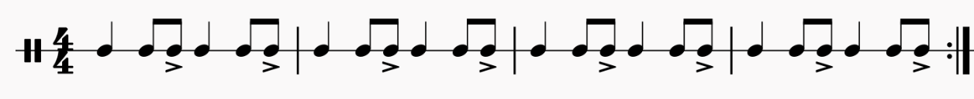
2

Answers
The Beauty of 8 – Taikoz – Melbourne 2017 (from 1:24:20–1:25:30)
Reflection questions
- What do you notice about Chieko’s choices of rhythmic elements? Chieko mostly accents the offbeat and uses small motifs that she repeats.
- What physical movements accompany Chieko’s playing? Bending at the knees and swinging the sticks in a fluid movement – uses yokouchi: a style of taiko playing that includes figure of eight movements.
- Why are these physical movements important to the performance? Spiritual connection, connection of the rhythmic patterns to the pulse.
- Is Chieko’s part improvised or planned? Explain your thoughts. Chieko’s part could be classified as improvised or planned. She has chosen specific rhythms to create cross rhythms that maintain musical interest.
- What effect does Chieko’s rhythmic choices have on the pulse? The use of syncopation creates a loss of beat one and the ostinato appears to disappear.

The Beauty of 8 – Taikoz – Melbourne 2017 (from 1:25:30–1:28:20)
Reflection questions
- How does Ian know when to start his solo section? Chieko rejoins the ostinato.
- How would you describe Ian’s playing style and rhythmic choices? He uses bigger movements with stronger arms and he focuses on the pulse more with less syncopation.
- Why did they start tapping on the side of the drums? The tapping creates musical interest and to engages in call and response.
- How would you describe the timbre of the tapping? Sharp, wooden, sparce, crisp.
- What happened toward the end and why was it so engaging as an audience member? The tempo sped up and the pulse became driving quavers. This allowed the intensity to increase therefore drawing the audience into the performance.

Activity 1.3 – the sound of taiko

Answers
Answer the following questions about the role of each layer. Answers could include:
- Which ostinato do you think might be the bass line and why? The most likely ostinato is number one as it emphasises the strongest beat, beat one with the upbeat.
- Which ostinato do you think might contain rhythmic interest and why? There may be multiple answers for this question. Ostinato 4 as it contains the most syncopation and it is longer – a 2-bar pattern. The ka sample one as it has syncopation, uses the Ka for a change in timbre and the accents.
- Explain what similarities you see between the ostinati? Ostinato 3 and 4 are similar. Number 3 has offbeat quavers while number 4 contains syncopation across the bar and beats. This syncopation is achieved using ties and accents. The 2 ka samples are similar in that they both contain the quaver upbeat leading to a downbeat. The first sample has ‘don ka’ and the second sample has it inverted with ‘ka don’.

Activity 1.5 – compositional analysis worksheet
- Access the ‘Kagemusha’ score. Using a highlighter and pen, identify, highlight and label on the score, one example of each of the following musical symbols or terms.
Table 6 – compositional analysis
Music symbol or term | Check
ostinato 1, 2, 3, 4 | ☐
the first use of ka | ☐
a cue bar | ☐
syncopation using accents, rests and ties | ☐
a hemiola | ☐
bass role | ☐
pulse | ☐
rhythmic feature | ☐
fragmenting | ☐
call and response | ☐
unison rhythms | ☐
cross rhythms and rhythmic complexity | ☐
- Using the information gathered from the score, how has the composer used duration and texture to create musical interest?

Answers
- The answers for the compositional analysis can be found in the PowerPoint under ‘Activity 1.5 – compositional analysis’.
- Using the information gathered from the score, how has the composer used duration and texture to create musical interest?
- ‘Kagemusha’ uses simple rhythms – crotchets, quavers, and rests – arranged in patterns and ostinati, combined with textural variety to create musical interest. The piece opens with ostinato 1 which uses a down beat crotchet and an upbeat quaver on ‘4 and’. This ostinato creates a pulse.
- Section A continues the ostinato 1 in the odaiko, with the composer creating musical interest through the staggering of the entry of ostinato 2. Ostinato 2 enters in the miyadaiko, shimedaiko 1 and shimedaiko 2, at 2-bar intervals. Rhythmic interest is achieved with the use of syncopation using accents and ties in ostinato 2. The final bar of section A is in rhythmic unison creating a cue for the next section.
- Section B has the miyadaiko playing ostinato 3, a series of repeat quavers with offbeat accents, which acts as the pulse. In the 3rd bar of B, further rhythmic interest is achieved using textural variety. The small fragment of ‘ka don’ is repeated in 3 instruments with a call and response being used between shimedaiko 1, odaiko and shimedaiko 2. This is followed by a short hemiola (2 against 3) between the miyadaiko and shimedaiko in the 5th bar of B. Section B concludes with another unison pattern cue.
- Section C and D increase in rhythmic complexity using cross rhythms which creates rhythmic interest. Section E uses mostly unison rhythms which contain syncopation to end with musical interest.

Learning sequence 2 – from tradition to tomorrow

Activity 2.1 – the influence of cultural change worksheet

Taiko through time
The birth of taiko
Taiko, a percussion instrument, dates back over 2000 years in ancient Japan, with its origins likely linked to communication and religious rituals during the Jomon era. It is believed that taiko was introduced from the Asian continent, influenced by Chinese and Korean cultures around the 5th to 6th century, coinciding with the spread of Buddhism. The establishment of an imperial court music department in 702 marked a significant development in taiko's history, with various types being used in court music, forming a root for modern taiko.
Following the rise of the samurai class in the Kamakura era, ethnic Japanese cultural expressions emerged, leading to the creation of original art forms like Noh and Kabuki, where taiko played a crucial role. The diversity of taiko expanded alongside the development of other traditional instruments. Taiko playing methods have been passed down through generations under the iemoto system, despite the predominance of Western music in modern Japan.
Taiko has also been integral to religious ceremonies and local festivals, often found at Shinto shrines and Buddhist temples, reflecting its deep spiritual significance. In ancient times, authorised men played taiko during sacred occasions, while common people participated in dances at festivals.
The kumi-daiko
‘Kumi-daiko,’ meaning a taiko ensemble with various drums, was invented in the 1950s by Daihachi Oguchi, the founder of Osuwa Daiko. A jazz drummer, Oguchi was tasked with interpreting an old taiko music sheet for Osuwa Shrine but initially struggled due to the archaic notation. After consulting a former performer and successfully interpreting the piece, he found the rhythm too simple for his jazz background. This prompted him to innovate by creating a group where each player used different taikos, resembling a western drum set. The high-pitched shime-daiko established the basic rhythm, while the nagado-daiko added accents. This groundbreaking approach transformed taiko music significantly.

Taiko in the 21st century
Inspired by the global success of taiko groups like Za Ondekoza and KODO, numerous taiko ensembles have emerged in Japan and worldwide, particularly in North America, where around 1,000 groups are estimated to exist. The taiko boom is spreading across Europe, Australia and South America, driven by various factors, including appreciation for Japanese culture, the unique sound of taiko and its appeal as a health exercise. A key attraction is its simplicity – anyone can play by striking the drums, making it accessible to all, including a person who is deaf or hard of hearing who can feel the vibrations.
Taiko serves as Japan's heartbeat and is becoming a universal musical language that fosters connection among people globally. Its potential is evident in the rapid development of styles like kumi-daiko. As taiko music continues to evolve in the 21st century, there are opportunities for new generations to contribute to its ongoing transformation.

Activity 2.2 – ‘Become’ that other side

Answers
The Beauty of 8 – Taikoz – Melbourne 2017 (from 46:25–47:40)
Reflection questions
- What do you notice about the different drums used in this performance? There are 3 drums used. The miyadaiko, the shimedaiko and the odeko-daiko (from right to left when looking at the video).
- How is sound being produced on the taiko drums? They are using their hands and fingertips.
- What and/or who is making the fluttering sound? This is made by Ian who is kneeling on the floor on the left-hand side. He is playing flat hand drum rolls on the floor therefore creating the fluttering sound.
- Why is Chieko using bells and what do they signify for the performers? The bells are not only an artistic choice, but they also signal to the performers the changes in choreography.
- Why is this segment without a pulse? It appears to be a positional change for Chieko, allowing her the chance to move from the very back into centre front.
Access the next performance segment of the video and complete the following reflection questions.
The Beauty of 8 – Taikoz – Melbourne 2017 (from 47:40–48:28)
Reflection questions
- How many different drum sounds do you hear? There are at least 3 sounds, possibly 4.
- Is there still fluttering or has that changed? No. This performer is now standing, and they are playing a short pattern at times on their drum.
- What is the role of the bells in this section of the performance? The bells are still signifying changes in choreography, but it is less controlling and accenting certain points in the rhythmic patterns.
- How does the performer on the odeko-daiko create dynamic contrast? The performer on the odeko-odaiko uses softer hits and slaps. There is also controlled crescendos on repeated patterns which act as a cue into the next bar or section.

Activity 2.4 – the significance of 7

Answers
The Beauty of 8 – 'Pearl' – Digital Arts Unit
Reflection question
- Explain the significance of the title ‘Pearl’ and how it connects to Ian's cultural background and the odaiko.
- The piece was originally titled Shinju (Japanese for ‘pearl’) but Ian changed it to ‘Pearl’ to reflect his own identity as an Australian, Caucasian composer, rather than labelling it strictly as Japanese music.
- This change symbolises Ian’s acknowledgement that while his work is influenced by Japanese taiko traditions, it is rooted in his personal, cultural and musical experiences.
- ‘Pearl’ features 6 odaiko drums arranged across the stage like a horizon – an image that became a key structural and visual concept in The Beauty of 8.
- The demanding physicality of playing the odaiko mirrors themes of endurance, struggle and transformation, reinforcing ‘Pearl’ as a powerful metaphor within the larger work.
Access the performance by Taikoz and complete the activities below.
‘Pearl’ from The Beauty of 8 (from 54:06–57:36)
Access the score for ‘Pearl’. Listen to the performance and follow along with the score. As a class, discuss the rhythmic elements and compositional devices you can identify on the score. You may like to watch the video for visual cues to help follow the score. Rhythmic elements and compositional devices used in 'Pearl’ include:
- grouping changes incorporating 2 and 3
- ${7 \atop 8}$ motif where the sticking defines the groupings
- syncopation using rests
- unison rhythms
- tempo change at ${7 \atop 8}$
- layered rhythmic patterns – ${7 \atop 4}$ over a ${7 \atop 8}$
- quavers changing to semiquavers in the 4th last bar
- ending in unison rhythms with 2 quavers on the end.

Activity 2.5 – practising ‘Pearl’ worksheet
Table 7 – Activity 2.5 – engage and explore
Cell | Rhythmic fragment
1 | 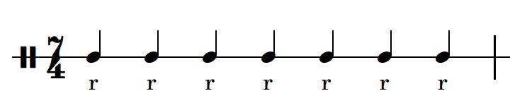
2 | 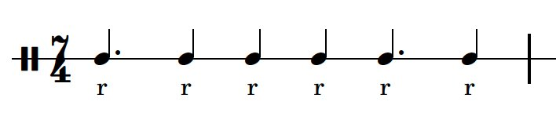
3 | 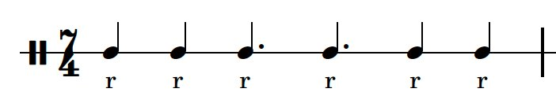
4 | 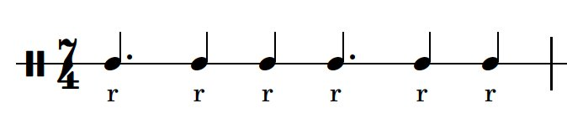
5 | 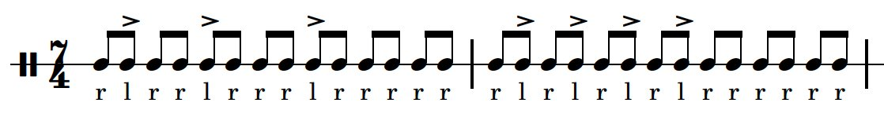
6 | 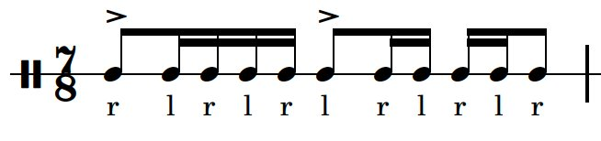
7 | 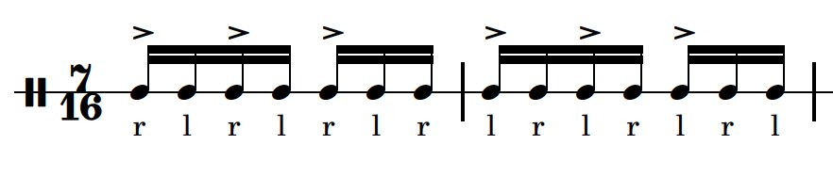
Own cell

Learning sequence 3 – Suzume unlocked – the sound of anime

Activity 3.1 – discovering Suzume worksheet
Read through the text and definitions of anime and Suzume in the PowerPoint to complete the following questions.
- What does anime mean?
- What does Suzume mean?
Access the Trailer for Suzume on YouTube – Suzume | Official Trailer 1 | Netflix. Play the trailer with the sound turned off. Make a note of what action is happening in the trailer.
- What action is taking place in the trailer?
- What do you think the film is about?

Sing theme A and choose which rhythm is correct.
Table 8 – Activity 3.1 – discovering Suzume
Rhythm choices
The melody uses these notes – D E F G A Bb C D.
What scale is this? To help you identify the scale, work out the tone and semitone pattern. Draw the treble clef and use an accidental in the scale.
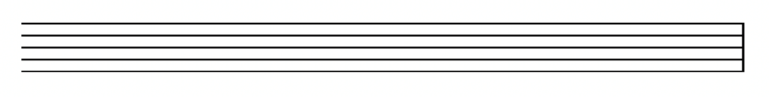
Notate theme A from Suzume. Draw the treble clef and use the key signature for D minor.

Discovering Suzume worksheet – answers
- What does anime mean? In Japanese, the word ‘anime’ (アニメ) is simply a shortened form of the word ‘animēshon’ (アニメーション), which means animation in English. So, in Japan, ‘anime’ refers to all animation, regardless of origin. However, internationally, the term is typically used to refer specifically to Japanese animation.
- What does Suzume mean? In Japanese, Suzume (すずめ/雀) means ‘sparrow’. It's a common name, and in Japanese culture, the sparrow is associated with grace, agility, resilience and freedom.
- What action is taking place in the trailer? A young girl is coasting on a bike down a big hill when she sees a man walking up the hill. She stops and looks behind after the man had walked past her. There is scene of a door in a pond then a cat with big yellow eyes sitting on a windowsill wagging its tail. There is a shot of the girl going to open the door and then a shot of a kid’s wooden chair laying on its back. There appears to be a leg missing. The girl is walking through the streets then there are 2 shots of keys turning in locks – one is a door and the other appears to be a motorcycle or a bike. The girl steps into the water and walks up to the door. There is a change in the music and there is a shot of her eyes going wide and a bird flying high in the sky. The girl is seen running in different locations and sliding and the chair tumbles down through some washing onto a wooden deck. The girl is seen pushing on the door in what appears to be a storm. She locks the door, and the scene ends with her and the man standing outside the door in the pond.
- What do you think the film is about? Answers could include the girl meets a man and she opens a door that causes a storm. She and the man end up closing the door.
Sing theme A and choose which rhythm is correct.
Table 9 – Activity 3.1 – discovering Suzume
Rhythmic choice
The melody uses these notes – D E F G A Bb C D.
What scale is this? To help you identify the scale, work out the tone and semitone pattern. Draw the treble clef and use an accidental in the scale. The scale is a D transposed aeolian mode or D natural minor scale. 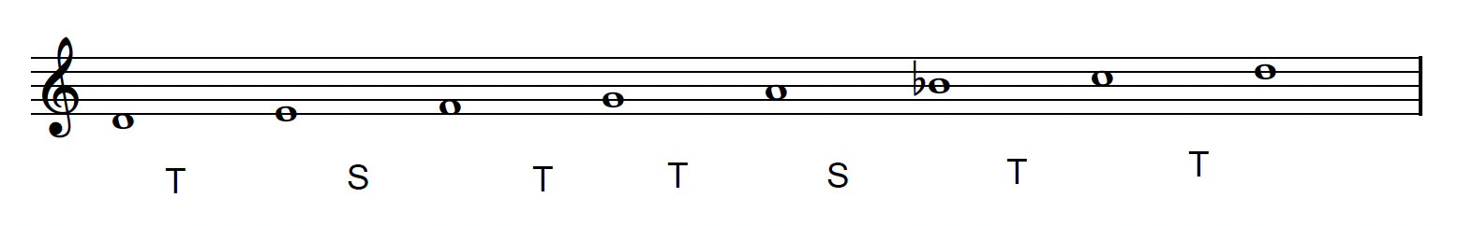
Use your choice of performing media to notate theme A from Suzume. Draw the treble clef and use the key signature for D minor.
You will need to access the Suzume – Full Main Theme [Piano Sheet Music] on YouTube to see the answer to the notation question above.

Activity 3.2 – Suzume – the main theme worksheet
Access the Suzume | Official Trailer 1 | Netflix (1:00) with the sound up and complete the questions below. Play the piece at least 4 times. Identify the musical elements used in each section and provide musical details. For example, ‘The melody is sung by a young female voice.’
- Section 1 (from 0:00–0:13) – What instruments do you hear? Identify pitch, duration and texture elements.
- Section 2 (from 0:14–0.26) – What has been added or changed in this section?
- Section 3 (from 0:26–0:40) – What has been added or changed in this section?
Access the RADWIMPS ~ Suzume no tojimari theme song (tiktok live) すずめ - feat. Toaka (from 0:00–0:24) on YouTube and complete the following question.
- How is the version by RADWIMPS different from the trailer?

Suzume – the main theme worksheet – answers
Access the Suzume | Official Trailer 1 | Netflix (1:00) with the sound up and complete the questions below. Play the piece at least 4 times. Identify the musical elements used in each section and provide musical details. For example, ‘The melody is sung by a young female voice’.
- Section 1 (from 0:00–0:13) – What instruments do you hear? Identify pitch, duration and texture elements. The melody (theme A) is sung by a young female voice. Sweet timbre. Monophonic texture.
- Section 2 (from 0:14–0:26) – What has been added or changed in this section? Repeat of theme A sung by female voice. Addition of a second counter melody sung by female voice with long tones in a descending pitch. Accompaniment is a 1-bar ostinato. Downbeat by a muffled, thudding sound. There sounds like there are bells or metallic sounds in the background following a moving pattern. Tight drum sound like bongos plays a flam with quavers. Electronic drum kit with blended synthesized sounds.
- Section 3 (from 0:26–0:40) – What has been added or changed in this section? A breath and a thudding sound with a whooshing sound. Piano in upper register, monophonic texture plays running leaping semiquavers.
- How is this version by RADWIMPS different from the trailer? The piece is longer and contains more themes. It also repeats theme A with lyrics in Japanese and English translation. There appears to be a bridge or a pre chorus. There is a chorus of a theme B that appears to be higher than the theme A and this is accompanied by a sparce accompaniment with more sweeping and the moving semiquaver piano part in the background at one point. There appears to be a section where the voice is accompanied by strings and harp with a sparce accompaniment. This is followed by an instrumental section before the chorus idea returns. There is an ending with vocals.

Activity 3.3 – comparison worksheet
Access the Suzume – Full Main Theme [Piano Sheet Music] and complete the reflection questions.
- In bars 5 to 8, what are the harmonic choices made by the composer?
- How is the theme different from bars 1 to 4?
- Identify a better way to write the rolled seconds used in bars 5 to 8.
- Describe the pitch and duration elements used in the 4 transition bars – bars 9 to 12.
- How is the theme treated in bars 13 to 16?
- How do bars 17 to 20 use repetition?
- Theme B (bars 21 to 26) is 6 bars long. Identify the chord progression used. How is the melodic structure different from theme A?

Comparison worksheet – answers
Reflection questions
- In bars 5 to 8, what are the harmonic choices made by the composer? Dm / Dm7 / | Bbm / Am / | Dm / Dm7 / | Bbm / Am Dm ||
- How is the theme different from bars 1 to 4? The accompaniment is minim octaves or octaves with 5ths.
- Identify a better way to write the rolled seconds used in bars 5 to 8. This would be better written as a grace note.
- Describe the pitch and duration elements used in the 4 transition bars – bars 9 to 12. There is use of semiquavers over a D pedal point which drops down the octave in bar 10 on the last semiquaver beat. The semiquavers use a combination of steps and leaps. They are travelling in a wave formation in a descending direction.
- How is the theme treated in bars 13 to 16? The melody has some notes added. For example, the first beat has 2 semiquavers and quaver instead of dotted figures. There is a left-hand accompaniment that uses the octave and 5th chord combination. On beat 4 of each bar the left-hand plays either semiquavers or 2 semiquavers and a quaver in an ascending direction to cue the next phrase. Parallel 5ths are used in the accompaniment in bar 16.
- How do bars 17 to 20 use repetition? The right hand has the same rhythm but the chord at the start of the bar is different. B diminished, Bb major, Am.
- Theme B (bars 21 to 26) is 6 bars long. Identify the chord progression used. How is the melodic structure different from theme A? Chord progression – Dm / Bb / | F / C / | Dm / Bb / | F / C / | Gm/D / Gm7/D / | Bb/F / Am C |
The second melody uses mostly semiquavers with a small range from D to A for most of the melody. There is syncopation at the end of bars 21 and 23 with syncopation used in the middle of bars 24 and 25.

Activity 3.4 – inside the composing process worksheet
Access The Sound of Suzume: An Interview with Radwimps on Creating The Film's Soundtrack (from 3:55–6:54) and complete the reflection questions.
- What were their initial thoughts about sketching out the sound of ‘Suzume’?
- Why and how did they use the traditional sounds of Japanese music?
- How did they capture the feeling of an abandoned place in Japan?
Access the next interview segment of The Sound of Suzume: An Interview with Radwimps on Creating The Film's Soundtrack (from 7:47–11:15) and complete the reflection questions.
- What was the creative process between RADWIMPS and Kazuma Jinnouchi like?
- What did they learn during the recording process in London?
Access The Sound of Suzume: An Interview with Radwimps on Creating The Film's Soundtrack (from 29:47–31:16) and complete the reflection question below.
- What do they hope viewers of the film ‘Suzume’ take away from the experience?

Inside the composing process worksheet – answers
Access the The Sound of Suzume: An Interview with Radwimps on Creating The Film's Soundtrack (from 3:55–6:54) and complete the reflection questions.
Reflection questions
- What were their initial thoughts about sketching out the sound of Suzume? They didn't want to make the theme a typical pop song. They wanted to use nostalgic and native sounds of Japan and wanted to connect to vast landscapes and big sky.
- Why and how did they use the traditional sounds of Japanese music? They wanted to reflect statelessness and multinational. They felt that using western instruments dated the music. They wanted to use instruments that were not easily identified, vague without association to a time or place. Abandoned places can be 50, 100 or 500 years old so statelessness, multinational, timelessness had to be a part of the music.
- How did they capture the feeling of an abandoned place in Japan? The feelings they wanted to capture came from an understanding that someday where they live could become abandoned, so they wanted to use sorrowful voices.
Access the next interview segment of The Sound of Suzume: An Interview with Radwimps on Creating The Film's Soundtrack (from 7:47–11:15) and complete the reflection questions below.
Reflection questions
- What was the creative process between RADWIMPS and Kazuma Jinnouchi like? It wasn't much of a partnership. They worked independently on certain elements. However, they did learn a lot during the recording process in London with the orchestrations.
- What did they learn during the recording process in London? They learned about how the layering of strings, brass and synthesizer gave more presence. They learned about playing with the BPM in one song. They normally keep the BPM consistent in a pop song, but in film music it changes. This can affect the audience’s reaction to the music. A faster BPM creates more excitement, and slower BPM can calm the audience down. They also learned about using different beats – 4 beats, triples and 7 beats. They all sounded natural and was linked to changes in emotion.
Access The Sound of Suzume: An Interview with Radwimps on Creating The Film's Soundtrack (from 29:47–31:16) and complete the reflection question below.
Reflection question
- What do they hope viewers of the film Suzume take away from the experience? In their eyes, it feels there is no safe place on earth, so it makes us even more appreciative of what’s important. One of the artists thinks that it might cause someone to call a person they love and invite them to watch the film. Another artist says that a place to call home is a blessing. In Japan, natural disasters are unavoidable, so ordinary life is happiness. Even if you don’t have earthquakes, that view can be applied to other challenges.

Learning sequence 4 – from 8-bit to epic – music in Japanese gaming

Activity 4.1 – What is a motif? worksheet
Access the YouTube links below and identify the use of pitch, duration, dynamics and expression.
- Excerpt 1 – John Williams – Star Wars Imperial March (with score) (from 0:00–0:09)
- Excerpt 2 – "James Bond Theme" | Score Reduction and Analysis (from 0:00–0:12)
- Excerpt 3 – Quick Guide: Beethoven's Fifth Symphony (from 0:00–0:12)
Table 10 – Activity 4.1 – What is motif?
Title | Pitch | Duration | Dynamics and expression
Darth Vader theme
James Bond theme
Beethoven’s 5th Symphony

What is a motif? worksheet – answers
Table 11 – Activity 4.1 – What is a motif? – answers
Title | Pitch | Duration | Dynamics and Expression
Darth Vader theme | 2 notes – G and Eb  Use of repeated tone | Unison rhythm  Use of quavers with semiquaver triplets  Rhythmic motif repeated and inverted | forte and sfz  Use of bowing instructions  tenuto used on downbeat
James Bond theme | 4 notes – B, C, C#, C  Chromatic movement | Use of minims | Two minims slurred  mp with crescendo to forte and decrescendo back to mp.
Beethoven’s 5th Symphony | 4 notes – G to Eb then F to D  Interval minor 3rd | Repeated rhythmic pattern – quaver rest followed by 3 quavers then a minim with a fermata (pause) | fortissimo  Implied use of tenuto on quavers and accent on the minim

Access the Beethoven Symphony No. 5, Op 67 score in the score booklet and the link below to answer the reflection questions.
- YouTube link – L. Van Beethoven - 5th Symphony, Op.67 – Sheet Music (from 0:16–0:59)
Reflection questions
- How many times do you hear the motif? There are up to 44 notations of the motif, if you include the pitch changes.
- Does it change? The motif does change but the rhythmic identity is generally preserved.
- How does it change? The motif has pitch alterations – intervallic expansion, intervallic contraction and inversion are the most obvious in this extract. It changes tonal centre – from Cm to Eb Major. It moves through a range of dynamics. It is played by a variety of different instruments creating textural changes – unison, imitation, repetition and counterpoint.
- What emotion and/or mood does it create? It predominantly created tension, a sense of urgency and rhythmic drive.
- What musical elements has he used to make this happen? The use of the short–short–short–long pattern is distinctive and repetitive, building intensity. The motivic development with the transformation of the motif. Sudden changes in dynamics including sforzando accents increase the drama. The orchestration choices, moving the motif between instruments creates a variety in timbre and texture. Strong use of tonic and dominant chords including some dramatic harmonic shifts contributes to the tension. The obsessive repetition of the motif creates unity and momentum. The use of crisp accented phrasing enhances the forcefulness of the music.
Access Piranha Plant Cove – Mario Kart 8 Deluxe OST and answer the questions below.
Reflection questions
- Describe the motif that you hear, focusing on pitch and duration. The first 2 bars contain the motif. It is grouped in 3’s then grouped in 2’s. It ascends for 2 bars and descends for 2 bars. It starts with a dotted crotchet, quaver, quaver rest and quaver to imply 6/8. Bar 2 uses 3 crotchets. It moves in leaps of a third or steps.
- How did the motif evolve? The motif is rhythmically altered but the syncopation or grouping is preserved. It is harmonised using closed (3rds) and open intervals (5ths, 6ths and octaves). Addition is used with the inclusion of faster notes picking up to the down beat at times.
- Compare the use of the motif to Beethoven. Did Kento Nagata use the same type of compositional devices to develop the motif or motifs? Beethoven uses sequencing, imitation, fragmentation, rhythmic displacement and pitch changes. Nagata uses repetition, pitch and rhythmic alterations, layering, small changes to the loop, timbre changes and modal changes.
- Why does this motif and its treatment suit a video game? The motif is short, repetitive and adaptable which are perfect for interactive and looping environments like games. Unlike classical concert music, video game music must support continuous play, often without a clear beginning or end.

Activity 4.2 – loop-based composition worksheet
Compare the loops from Super Mario Bros (NES) Music – Overworld Theme (0:00–1:28) and Tetris Theme (0:00–1:23) and complete the table below.
Table 12 – Activity 4.2 – loop-based composition
Title | What is the structure of the example? (use A, B, C) | How is the loop constructed? (For example: bass line, chords, percussion) | What mood does each loop support? Why?
Super Mario Bros. theme
Tetris theme

Loop-based composition worksheet – answers
Table 13 – Activity 4.2 – loop-based composition
Title | What is the structure of the example? (use A, B, C) | How is the loop constructed? (For example, bass line, chords, percussion) | What mood does each loop support? Why?
Super Mario Bros. theme | A B C A D C D | A – melody harmonised with percussion hits  B – melody harmonised with syncopated bass and percussion hits  C – melody harmonised with syncopated bass line and percussion hits rhythmic unison with bass  D – melody and bass line with percussion hits | Energetic, cheerful, adventurous – light-hearted exploration and fast-paced movement  The syncopated rhythms, major key and 6/8 to 3/4 feel creates a sense of fun
Tetris theme | A A B A A B A A | A - moving bass line following the quaver pulse with some use of rests to create syncopation. Has percussion hits  B – long tones with quaver pulse bass line and percussion keeping pulse | Energetic but slightly tense at times. The folk-dance style, tonic/dominant bass line at times, minor key, fast tempo and driving rhythm

Activity 4.3 – metre madness worksheet
Watch Odd Time Signatures in Video Game Music (1:01–3:08) and answer the following questions.
Reflection questions
- Kingdom Hearts – ‘Hollow Bastion Music’ is driven by the 5/4 clave pattern – notate it.
- Identify the groupings of quavers used in this pattern.
- Which role plays the clave rhythm – the bass part, the inner plucked string part or the melody?
- Which role accents the clave rhythm – the bass part, the inner plucked string part or the melody?
- Using the musical material you created in the loop builder challenge, copy or adapt it to fit into these different time signatures: ${5 \atop 4}$ , ${3 \atop 4}$ , ${6 \atop 8}$ using the manuscript on the next page.
My loop composition – 3 versions of metre madness
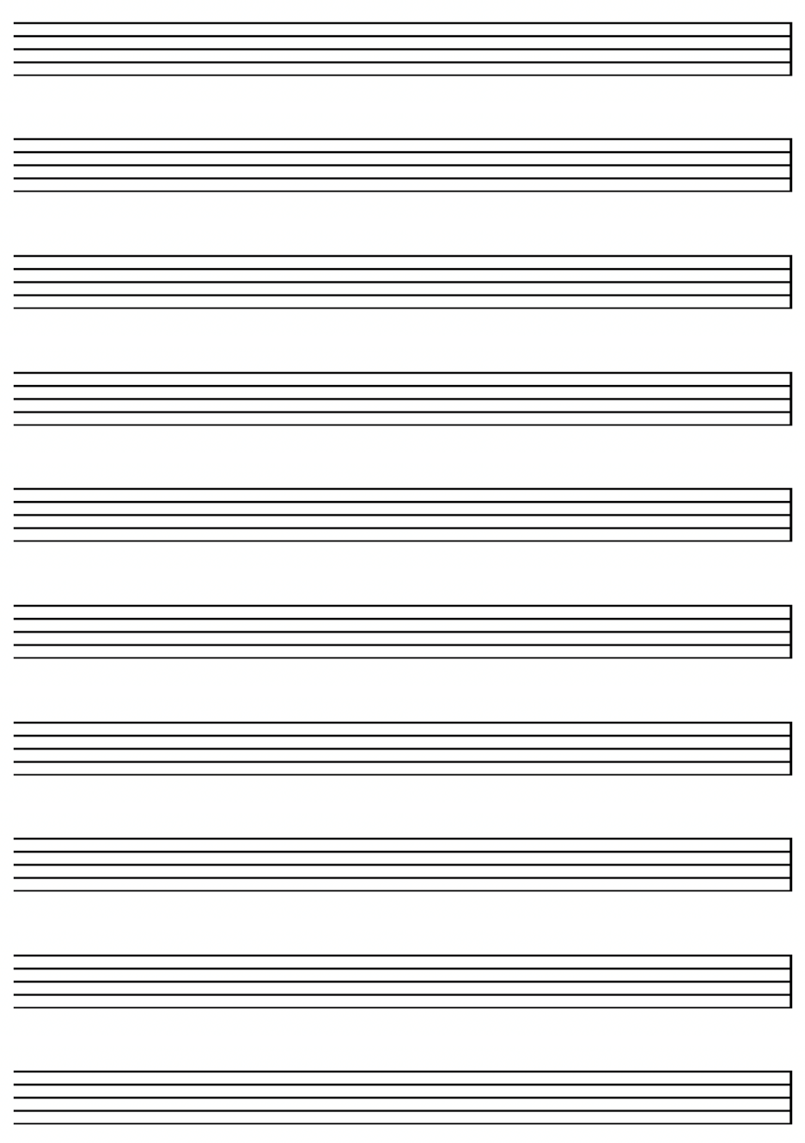

Metre madness worksheet – answers
Reflection questions
- Kingdom Hearts – ‘Hollow Bastion Music’ is driven by the 5/4 clave pattern – notate it.
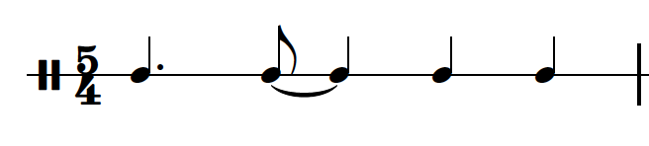
- Identify the groupings of quavers used in this pattern. Two groups of 3 quavers followed by 2 groups of 2 quavers.
- Which role plays the clave rhythm – the bass part, the inner plucked string part or the melody? The bass line and the inner plucked string part.
- Which role accents the clave rhythm – the bass part, the inner plucked string part or the melody? The melody.

Learning sequence 5 – boss battles and beats – music in Japanese gaming

Activity 5.1 – Nobuo Uematsu worksheet
Read the text and answer the questions.

The composer who made game music legendary
Nobuo Uematsu, born in 1959 in Kochi City, Japan, is a self-taught musician best known for composing music for the ‘Final Fantasy’ video game series. Despite having no formal training, Uematsu learned guitar and piano by ear in childhood, often experimenting with songbooks and instruments he found at his grandparents' home. His natural ability to hear and recreate melodies developed into a lifelong passion for composing.
After graduating from university, Uematsu supported himself by writing music for commercials and working in a music rental shop. A chance offer to write music for a new video game company, Square Co (now Square Enix), changed his life. Though he initially took the job for extra money, it led to his career-defining work on ‘Final Fantasy’. The game was named ‘Final’ as it was expected to be the last game, however, its success in 1987 saved the company and launched Uematsu into fame as a game composer.
Uematsu's music stood out because it brought deep emotional resonance to the limited 8-bit technology of early game consoles. Where most game music was quirky or functional, his scores were rich in atmosphere and story, elevating game soundtracks to the level of cinematic scores. He used simple means—like arpeggios and careful note choice – to evoke vast, immersive fantasy worlds. His iconic themes created vivid mental imagery for players, even with pixelated graphics.
He is known for drawing on both classical and rock influences, referencing composers like Stravinsky and artists like Jimi Hendrix. As gaming technology advanced, Uematsu embraced orchestral textures and choral arrangements, composing epic tracks like ‘Liberi Fatali’ from ‘Final Fantasy VIII’. ‘Liberi Fatali’ is the powerful opening choral piece. It’s significant because it showcases his skill in blending orchestral and choral music with video game storytelling. His music eventually reached global audiences, performed by major orchestras and celebrated by fans.
Despite criticism from classical purists, Uematsu’s music resonated deeply with players who saw it as the emotional heart of their gaming experiences. To many, it was more than background music – it was the soundtrack to their childhood and the reason games felt alive. Uematsu always maintained that music should be accessible and meaningful, regardless of whether it’s played by a full orchestra or through a computer chip.

Questions
Part 1 – multiple choice
- What was Nobuo Uematsu’s first instrument?
- trumpet
- guitar
- piano
- violin
- What company gave Uematsu his first job in video game composition?
- Nintendo
- Sony
- Square co
- Sega
- Why was the first Final Fantasy game named ‘Final’?
- it was the final chapter in a book series
- it was based on a mythological ending
- the company thought it would be their last game
- the soundtrack was the last one composed by Uematsu.

- What 2 musical influences are most clearly mentioned in relation to Uematsu’s style?
- Mozart and The Beatles
- Jimi Hendrix and Stravinsky
- Bach and Nirvana
- Beethoven and Lady Gaga

Part 2 – short answer
- Describe how Uematsu learned music as a child.
- What made Uematsu’s early video game music stand out from others at the time?
- What is ‘Liberi Fatali’, and why is it significant in Uematsu’s career?
- What was Uematsu’s response to criticism from classical musicians about game music?

Answers
Part 1 – multiple choice
- What was Nobuo Uematsu’s first instrument?
- Trumpet
- Guitar
- Piano
- Violin
- What company gave Uematsu his first job in video game composition?
- Nintendo
- Sony
- Square Co
- Sega
- Why was the first Final Fantasy game named ‘Final’?
- It was the final chapter in a book series
- It was based on a mythological ending
- The company thought it would be their last game
- The soundtrack was the last one composed by Uematsu
- What 2 musical influences are most clearly mentioned in relation to Uematsu’s style?
- Mozart and The Beatles
- Jimi Hendrix and Stravinsky
- Bach and Nirvana
- Beethoven and Lady Gaga

Part 2 – short answer
- Describe how Uematsu learned music as a child. Uematsu learned guitar and piano by ear in childhood, often experimenting with songbooks and instruments he found at his grandparents' home.
- What made Uematsu’s early video game music stand out from others at the time? Uematsu's music stood out because it brought deep emotional resonance. It was quirky or functional, his scores were rich in atmosphere and story.
- What is ‘Liberi Fatali’, and why is it significant in Uematsu’s career? ‘Liberi Fatali’ is the powerful opening choral piece. It’s significant because it showcases his skill in blending orchestral and choral music with video game storytelling.
- What was Uematsu’s response to criticism from classical musicians about game music? Uematsu always maintained that music should be accessible and meaningful, regardless of whether it’s played by a full orchestra or through a computer chip.

Activity 5.2 – composing ‘One-Winged Angel’

Answers
Access How Nobuo Uematsu Composed FF7's "One-Winged Angel” (4:18) and answer the following questions.
- What inspired Nobuo Uematsu's compositional process for ‘One-Winged Angel’? Uematsu was inspired by a mix of classical music, especially Stravinsky, and rock music like Jimi Hendrix. He wanted to create something intense and chaotic that reflected Sephiroth’s character.
- How long did Uematsu spend composing short musical phrases for the piece? He spent about 2 to 3 weeks just writing small musical ideas every morning without worrying about how they would fit together.
- Describe Uematsu’s daily routine during the composition process. Every day he would wake up and think deeply about Sephiroth, then sit down and write 3 to 4 short musical phrases. It was like creating pieces of a puzzle.
- Why did Uematsu choose to compose the piece using modular phrases rather than writing a continuous melody? He said it helped him avoid writer’s block. By focusing on small ideas first, he could later choose the best ones and piece them together. It made the process more creative and less stressful.
- How did Uematsu describe the role of vocal elements (the Latin chorus) within the orchestral texture? He used the choir to add drama and a sense of ritual or ceremony. It made the music sound sacred and powerful, like a dark mass or summoning.
- What compositional influences did he cite – such as specific classical or rock works – and how did they shape the piece’s mood? He mentioned Stravinsky’s The Rite of Spring for its wild orchestration and dissonance. He also referenced rock music like Jimi Hendrix’s ‘Purple Haze’ to give it a gritty, electric energy. These made the piece feel violent and unpredictable.
- How did Uematsu’s portrayal of Sephiroth inform the musical development of the theme? Uematsu imagined Sephiroth’s complex personality and evil presence while composing. That helped him write music that sounded unstable, threatening and grand – just like the character.
- According to Uematsu, what emotional tone or atmosphere was he trying to evoke with this piece? He wanted it to feel chaotic, mysterious and kind of sacred. The mix of choir and orchestra gives it a dark, gothic atmosphere, like something apocalyptic is happening.

Activity 5.3 – Who inspired Uematsu?
Teacher note: you will need to prepare the aural jigsaw and the score jigsaw in advance. This can be tactile (printed, cut up and placed in bags for as many groups as you need) or digital (copy and paste the information onto an interactive whiteboard style program).

Aural jigsaw
Access ‘One-Winged Angel (Final Fantasy VII)’ (4:25). Sort the aural jigsaw into the correct order according to the recording of ’One-Winged Angel’. The correct order (answers) is the order provided below.
Timpani plays a fortissimo crotchet pulse. High pitched strings enter playing the melodic motif. Timpani returns playing the crotchet pulse. Flute and oboe enter with descending scalic runs in antiphony.

Timpani returns with brass playing the melodic material.

Flute and oboe play the melody with the clarinets joining, accompanied by fast string passages and timpani.

Snare drum enters with cymbals and a syncopated rising passage in $\begin{matrix}7 \\ 4\end{matrix}$.

Piano enters with descending octaves. Brass play short motif which is followed by the piano playing rolling chords.

Waves of string ascending and descending runs increase in pitch and tension.

Snare drum enters with a marching style pattern accompanied by timpani before the choir enters. On the repeat of this vocal material, the horns and trombone play a fanfare countermelody. Tubular bells toll with a string motif between the vocal ‘Sephiroth’.

Winds, percussion and vocal alternates motivic material with the choir singing ‘sors immanis’ and ‘et inanis’.

Choir enters with ‘estuans interius’, accompanied with marching style snare drum and brass fanfare figure. Brass play a fanfare countermelody. This section ends in ‘ahs’ by the choir.

Lower string section melody with dovetailing by the clarinets and wind section. Snare drum enters with brass playing the romantic style melody from the strings.

Trombones enter with a melody using minims. Accompaniment is by strings and winds playing a crotchet pulse and the military snare drum pattern. This section ends with triplets in brass and strings, playing a crescendo to end on a tense chord.

A snap sound is followed by xylophone playing fast passages. Bassoon is playing a repeated tone pulse and upper winds have the melody. Winds and brass then play a ‘waltz’ style pattern in groupings of 3, followed by strings playing the melody. This rhythm is played by the orchestra with a cymbal crash on the semibreve.
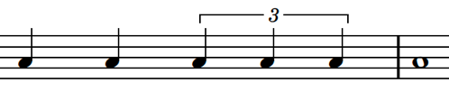

Male voices and bassoon enter with the main melody ‘veni vani venias’. Glissandi on xylophone, playing on the pulse.

Female voices enter with a counter melody ‘gloriousa generosa’, accompanied by a pulse on the timpani. Xylophone and strings play glissandi.

Snare drum enters with a march pattern, trumpets play a repeated tone fanfare and the dynamics and tension increases.

Orchestra plays rising and falling passages when the voice enters with Sephiroth.

Dynamics drop to mezzo piano with rising string tremelo. Winds join and choir ends on Sephiroth.

Score jigsaw
Access Stravinsky – The Rite of Spring (Official Score Video w/ Live Chat Commentary) (from 3:14–4:00). Using a copy of the score extract from The Rite of Spring, locate the musical observations according to the descriptions on the jigsaw pieces. These can be stuck on the score to form a score analysis.
Clarinets play descending triplets. Strings play a chord using harmonics. Violins play minor 3rd perfect 4th semiquaver pitch patterns using pizzicato.

Strings play down bow quaver cluster chords with horn staccato interjections. Horn 1 and 2 don’t use mutes.

Bassoons play semiquaver staccato arpeggios using dovetailing. Oboe plays minor 3rd perfect 4th motif from the string in the opening. Cello plays pizzicato arpeggios using quavers.

Cluster chords in strings return with horn interjections. Flute and piccolo play grace note interjections. Trumpets and oboe play a repeated tone triplet and trumpets continue with a descending chromatic run which is then played by the oboe and then violins.

Double bass and cello dovetail quavers, viola plays arpeggiated tremelos, bassoon plays trills and cor anglais plays the minor 3rd perfect 4th pattern.

Brass play semiquaver triplet interjections with clarinet staccato arpeggios. Flutes and piccolos play triplet and sextuplet runs in between the muted brass interjections.

Activity 5.3 – who inspired Uematsu? worksheet
Discuss the similarities and differences between ‘One-Winged Angel’ and Stravinsky’s ‘The Augurs of Spring – Dances of the Young Girls’.
Table 14 – Activity 5.3 – Who inspired Uematsu?
 | One-Winged Angel | Dances of the Young Girls
Similarities
Differences

Answers
Table 15 – Activity 5.3 – Who inspired Uematsu?
Similarities | Differences
- use of ostinato  - avoidance of functional harmony – both sound ‘primitive’ or ritualistic  - repeated chords and strong ostinato use  - modal tonality and chromatic movement to create tension  - both employ layered textures with multiple rhythmic/melodic strands  - both pieces convey ritualistic intensity – The Rite of Spring (pagan sacrificial dance) and ‘One-Winged Angel’ (villain’s theme, ritualistic and ominous for final battle)  - sudden shifts between orchestral ‘blocks’ in Stravinsky; similar sectional contrasts in Uematsu  - both works use motifs | - ‘One-Winged Angel’ is orchestra and chorus whereas Stravinsky is just orchestral and was a ballet.  - ‘One-Winged Angel’ mostly in common time signature but Stravinsky uses multimetre, irregular groupings and polyrhythms.  - ‘One-Winged Angel’ uses harmonies that serve the narrative tension in a cinematic sense.  - ‘Dances of the Young Girls’ uses bitonality, tone clusters, and extreme dissonance to produce a modernist, revolutionary sound.  - ‘One-Winged Angel’ uses the ‘Sephiroth’ theme (leitmotif) in repeated variations of the character  - ‘Dances of the Young Girls’ uses motifs but it is fragmented and more about rhythmic drive.

Activity 5.4 – harmonic revision worksheet

Chord building
What are scale degrees?
Scale degrees are numbers used to label each note within a scale. The tonic note is always labelled 1. In the space provided, write out the letters of the C major scale. Underneath each letter, number them from one to 8. They are your scale degrees.

How to build chords on a major scale
Once you have the scale, you build chords by putting either 2-line notes or 2 space notes on top of the bass note.
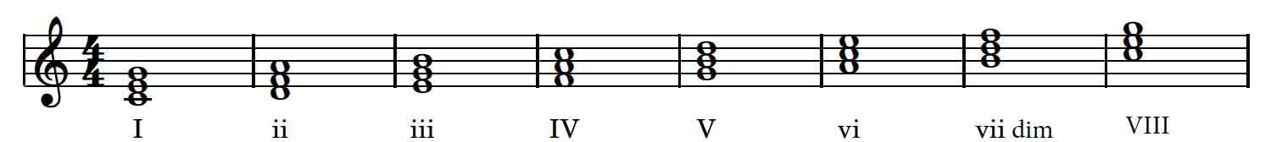

What is the quality of a chord?
When you build these chords and play them, the quality of the chord will always be the same if the scale is a major scale.
- Chords 1, 4 and 5 will always be major.
- Chords 2, 3 and 6 will always be minor.
- Chord 7 will always be a diminished chord.

Identifying a scale from a key signature and working out chords from a scale
- Identify the key signature – how many sharps or flats does it have?
- Write the 8 notes from tonic to tonic.
- Add the key signature.
- Add the roman numerals which will identify the quality of each chord. Label them.
Let’s apply these steps to the key signature below. For example:
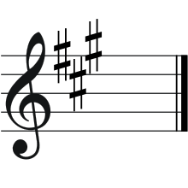
Identify the key signature: this is a sharp key signature. Use the rule: identify the last sharp and raise a semitone. The last sharp is G#, raise it by a semitone which becomes ‘A’. The key signature is A major.
Write the 8 notes from tonic to tonic.
The key is A major, so I write the letters from A to A.
A B C D E F G A
Add the key signature.
The key signature has 3 sharps – F#, C# and G#.
Simply add these sharps to the corresponding letter and you have an A major scale.
A B C# D E F# G# A
Add the roman numerals which will identify the quality of each chord. Label them.
I, IV, V – major ii, iii, vi – minor vii – diminished
A Bm C#m D E F#m G#dim A

Example number 1
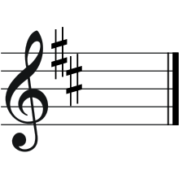
- Identify the key signature – this is a sharp key signature. Use the rule: identify the last sharp, raise it by a semitone.
The last sharp is _________, if I raise it a semitone it becomes ________.
The key signature is __________ major.
- Write the 8 notes from tonic to tonic.
The key is ________ major, so I write the letters from ______ to ________.
- Add the key signature.
The key signature has ________ sharps – __________________.
Add these sharps to the corresponding letter and you have your major scale.
- Add the roman numerals which will identify the quality of each chord. Label them.
I, IV, V – major ii, iii, vi – minor vii – diminished
Example number 2
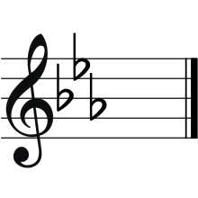
- Identify the key signature – this is a flat key signature. Use the rule: identify the second last flat and that is the key.
The second last flat is _________.
The key signature is __________ major.
- Write the 8 notes from tonic to tonic.
The key is _________ major, so I write the letters from ______ to ________.
- Add the key signature.
The key signature has ________ flats – ___________________.
Add these flats to the corresponding letter and you have your major scale.
- Add the roman numerals which will identify the quality of each chord. Label them.
I, IV, V – major ii, iii, vi – minor vii – diminished

Extension – identifying chords
Identify the below chords – the bottom note is the bass note.

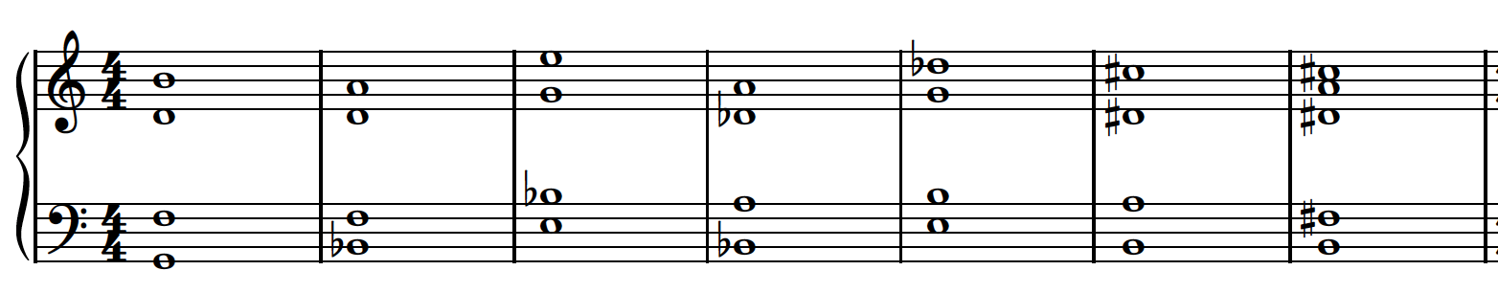

Modes and how they sound
There are 7 modes, and these are more commonly known as the ‘white note form of scales.’ These modes are:
- Ionian – C – C (C D E F G A B C)
- Dorian – D – D (D E F G A B C D)
- Phrygian – E – E (E F G A B C D E)
- Lydian – F – F (F G A B C D E F)
- Mixolydian – G – G (G A B C D E F G)
- Aeolian – A – A (A B C D E F G A)
- Locrian – B – B (B C D E F G A B)
Each of these modes have different qualities of sound depending on their combination of tones and semitones. These qualities can be easily explained by dividing these scales in half. For example, the ‘Ionian’ mode is all the white notes from C to C. We know this is C major and when divided in half, it has 2 ‘tetrachords’ – a sequence of 4 notes that span a perfect 4th.
C D E F G A B C

The 2 ‘tetrachords’ in the images below, when played individually have a ‘major’ sound quality because of the combination of tones and semitones.
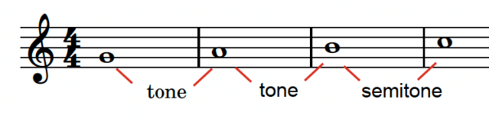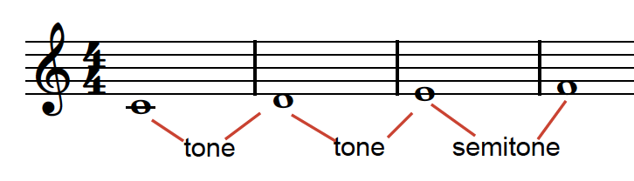
However, when you apply this strategy to the modes, you find that the timbre is very different.
For example – the ‘Dorian’ mode, shown in the images below, when divided into half, produces a minor timbre for both halves.
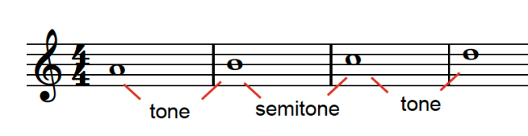
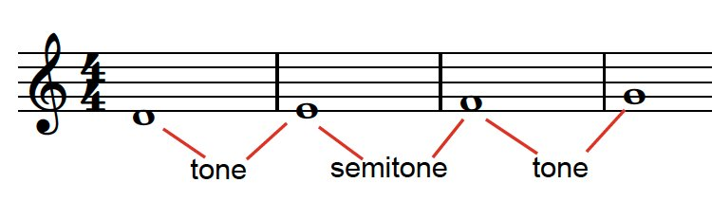
Some modes have ambiguous combinations that do not fit into the major or minor mould.
For example – the ‘Phrygian’ mode, shown in the images below, is considered an ambiguous mode which is one of the reasons why it used in a lot of film music. This mode, when divided into 2 halves, does not fit into either of the major or minor tone and semitone sequence.
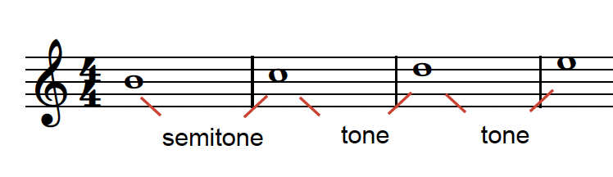
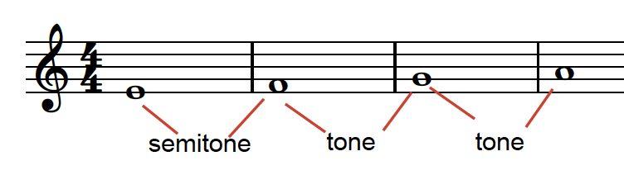
Apply this strategy to the remaining modes.
What do you notice?

Why and how is this information useful?

Identifying chords from modes
Using the ‘Phrygian’ mode, name the below chords: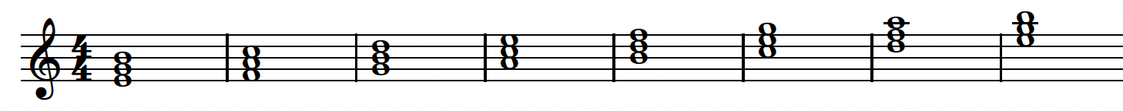

Answers

Identifying a scale from a key signature and working out chords from a scale

Example number 1
- Identify the key signature
The last sharp is C#, if I raise it a semitone it becomes D.
The key signature is D major.
- Write the 8 notes from tonic to tonic.
The key is D major, so I write the letters from D to D.
D E F G A B C D
- Add the key signature.
The key signature has 2 sharps – F and C.
Add these sharps to the corresponding letter and you have your major scale.
D E F# G A B C# D
- Add the roman numerals which will identify the quality of each chord. Label them.
I, IV, V – major ii, iii, vi – minor vii – diminished
D Em F#m G A Bm C#dim D

Example number 2
- Identify the key signature – this is a flat key signature. Use the rule: identify the second last flat and that is the key.
The second last flat is Eb.
The key signature is Eb major.
- Write the 8 notes from tonic to tonic.
The key is Eb major, so I write the letters from E to E.
E F G A B C D E
- Add the key signature.
The key signature has 3 flats – B E A.
Add these flats to the corresponding letter and you have your major scale.
Eb F G Ab Bb C D E
- Add the roman numerals which will identify the quality of each chord. Label them
I, IV, V – major ii, iii, vi – minor vii – diminished
Eb Fm Gm Ab Bb Cm D dim Eb

Extension – identifying chords
Identify the below chords – the bottom note is the bass note.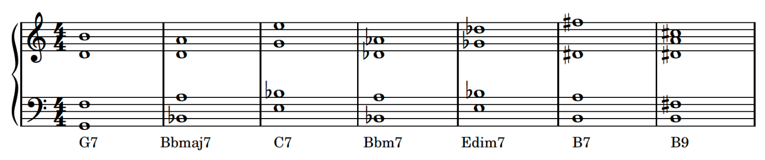

Modes and how they sound
- What do you notice? The Lydian mode starts with 3 tones producing an augmented interval between F and B. This is followed by a major quality. The Mixolydian mode is major and minor quality. The aeolian modes is minor and ambiguous and the Locrian is ambiguous and augmented.
- Why and how is this information useful? This is useful because when you compose, this understanding helps you when selecting the intention behind the work. A mode with ambiguity will be useful if you want a confused, anxious or tense intention, where a major is suited more to a bright and hopeful situation. The other reason is when you are composing melodies, you don’t have to start on the first note. You can start with the second half and that will affect the character of the melody.

Identifying chords from modes
Using the ‘Phrygian’ mode, name the below chords:
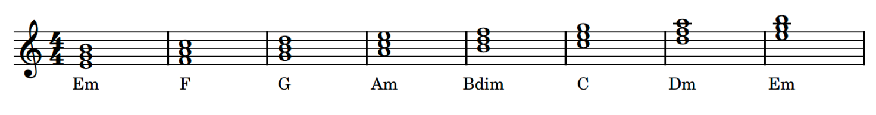

Activity 5.5 – harmonic exploration in ‘One-winged angel’

Answers
‘One-Winged Angel’ uses shifting keys (E Locrian, D minor, E minor), intense dissonances (for example, a chord made up of E–G–A–Bb) and the juxtaposition of time signatures to create harmonic and rhythmic variety.
Listen to the 3 excerpts from ‘One-Winged Angel’ and answer the following questions.
- How does the harmony make you feel? It makes me feel tense, due to the dissonance created by the minor and diminished chords.
- Does the rhythm feel predictable or chaotic? Why? The rhythm feels chaotic due to the use of complex rhythms, syncopation, polyrhythms and uneven phrase lengths.
- Can you explain the influence from Stravinsky? The introduction sounds very much like Stravinsky due to the opening strong, harsh rhythms played by the lower strings and timpani and answered by the upper woodwind and strings.
- Why is E–G–A–Bb considered dissonant? Because the notes are made up of small intervals including a minor 3rd, major 2nd and minor 2nd.

Learning sequence 6 – gagaku – the traditional court music of Japan

Activity 6.1 – exploring gagaku

Instrument, musical features and timbre adjectives cards
Teacher note: the tables below are to be copied and cut up so that each square forms a separate card. Cards are grouped into instrument images, musical features and timbre adjectives. You may like to separate the timbre adjectives and musical features into 2 different piles when you place them on the floor for the activity.

Table 16 – Activity 6.1 – exploring gagaku – instrument cards
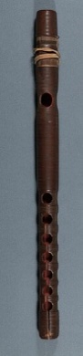 | 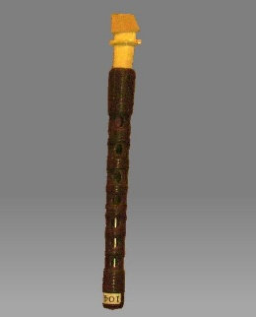
ryūteki | hichiriki
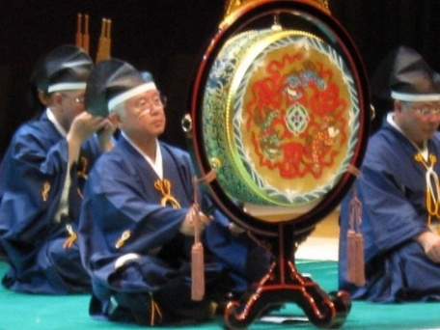 | 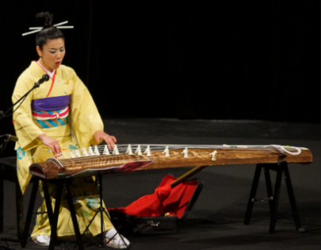
taiko | koto
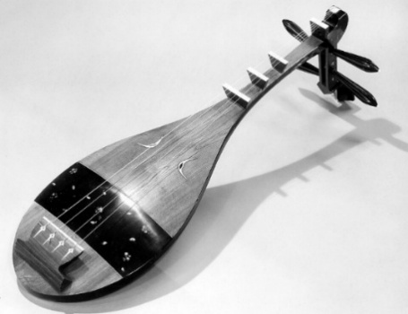 | 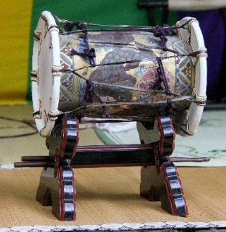
biwa | kakko
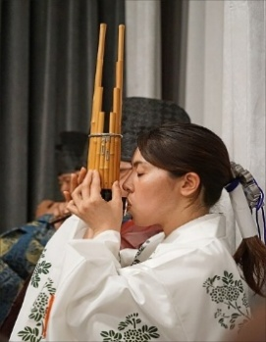 | 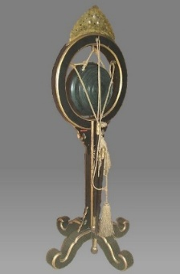
shō | shōko
Image attribution details provided in footnote.
Table 17 – Activity 6.1 – exploring gagaku – musical features cards
aerophone | played by blowing
long note values | high pitch
pitch bending | melodic role
repeated phrases | rhythmic role
ornamentation | aerophone
played by blowing | long note values
high pitch | pitch bending
melodic role | repeated phrases
aerophone | ornamentation
aerophone | played by blowing
long note values | high pitch
plays sustained harmonic material | played by picking or plucking
plays rhythmic role | chordophone
played by strumming with a plectrum | medium pitch
plays repeated harmonic material | plays crotchets on main beats
chordophone | pitch bending
harmonic material is played as broken chords | notes values consist of quavers and crotchets
short note values | medium pitch
membranophone | rhythmic role
plays single crotchet beats to outline the phrases | plays single crotchet beats to outline the phrases
harmonic role | membranophone
played with mallets | short note values
note values accelerate | played with a mallet
idiophone | played with mallets
rhythmic role

Table 18 – Activity 6.1 – exploring gagaku – timbre adjectives cards
metallic timbre | abrasive timbre
resonant timbre | percussive timbre
rumbling timbre | dry timbre
hollow timbre | warm timbre
mellow timbre | full timbre
majestic timbre | twangy timbre
shimmering timbre | sweet timbre
sparking timbre | nasal timbre
lush timbre | clear timbre
light timbre | airy timbre
reedy timbre | thin timbre
buzzing timbre | bright timbre
squeaky timbre | harsh timbre
breathy timbre | piercing timbre
muffled timbre | shrill timbre

Answers
- ryuteki – aerophone, played by blowing, long note values, high pitch, pitch bending, melodic role, repeated phrases, bright timbre, airy timbre, light timbre, breathy timbre, piercing timbre, muffled timbre, shrill timbre, ornamentation.
- hichiriki – aerophone, played by blowing, long note values, high pitch, pitch bending, melodic role, repeated phrases, ornamentation, piercing timbre, squeaky timbre, harsh timbre, shrill timbre, nasal timbre, reedy timbre, thin timbre, buzzing timbre.
- shō – aerophone, played by blowing, long note values, high pitch, pitch bending, plays sustained harmonic material, thin timbre, reedy timbre, nasal timbre, lush timbre, light timbre, sparkling timbre, sweet timbre, shimmering timbre, bright timbre, clear timbre.
- biwa – chordophone, played by strumming with a plectrum, medium pitch, plays repeated harmonic material, plays crotchets on main beats, muffled timbre, twangy timbre, majestic timbre, full timbre.
- koto – chordophone, played by picking or plucking, harmonic role, harmonic material is played as broken chords, notes values consist of quavers and crotchets, short note values, medium pitch, twangy timbre, resonant timbre, mellow timbre, warm timbre.
- taiko – membranophone, played with a mallet, short note values consisting of single crotchet beats to outline the phrases, rhythmic role, hollow timbre, dry timbre, rumbling timbre, percussive timbre, full timbre, mellow timbre
- kakko – membranophone, played with mallets, short notes values, note values accelerate, rhythmic role, light timbre, dry timbre, percussive timbre, hollow timbre, thin timbre, plays rhythmic role
- shokō – idiophone, played with mallets, short note values consisting of single crotchet beats to outline the phrases, rhythmic role, percussive timbre, metallic timbre, abrasive timbre, thin timbre, piercing timbre, sparkling timbre, clear timbre, bright timbre.

Activity 6.3 – listening match-up worksheet
- Access ETENRAKU in Hyojo mode by Reigakusha (4:17) and number the musical observations in the order they appear in the recording.
Table 19 – Activity 6.3 – listening match up
Musical observation | Number
Rhythmic interjections are sparsely played by the kakko, shōko and taiko
The biwa plays slowly strummed arpeggiated chords
The ryūteki begins playing the melody
The koto plays quavers between the melodic phrases
The shō softly enters playing chords
The kakko rhythms accelerate
The texture thins to one shō, hichiriki, biwa and koto to conclude the piece
The hichiriki joins the ryūteki playing the melody using a heterophonic texture
- In pairs, identify any musical features that stand out to you as being specific to gagaku music. Refer to the elements of music in your response. Share your response with the class.

Listening match-up worksheet – answers
- Access ETENRAKU in Hyojo mode by Reigakusha (4:17) and number the musical observations in the order they appear in the recording.
Table 20 – Activity 6.3 – listening match up
Musical observation | Number
Rhythmic interjections are sparsely played by the kakko, shōko and taiko | 2
The biwa plays slowly strummed arpeggiated chords | 6
The ryūteki begins playing the melody | 1
The koto plays quavers between the melodic phrases | 7
The shō softly enters playing chords | 4
The kakko rhythms accelerate | 3
The texture thins to one shō, hichiriki, biwa and koto to conclude the piece | 8
The hichiriki joins the ryūteki playing the melody using a heterophonic texture | 5
- In pairs, identify any musical features that stand out to you as being specific to gagaku music. Refer to the elements of music in your response.
- Very slow tempo
- Staggered instrument entries
- Heterophonic texture
- Use of modal scales
- Long, drawn out phrases
- Use of space and silence

Learning sequence 7 – the future voice – Hatsune Miku and J-pop

Activity 7.1 – What is a Vocaloid? Who is Hatsune Miku?
Access Explaining Vocaloid in under 3 minutes (2:19) to understand what a Vocaloid is and how Vocaloid technology functions. As a class, use the questions below to discuss authorship and performance identity in this context.

Answers
- Who is the ‘artist’ in Vocaloid music – the programmer, the character or the audience? A Vocaloid is not a human singer but a virtual voice created through synthesis. The sound is programmed, not performed live. This shifts the idea of performance from the singer to the creator or ‘producer’. Software is performing, but the human creator determines expression, pitch and structure.
- How does technology change our idea of performance and authorship? Technology expands authorship by allowing anyone to create and control performances digitally, blurring the line between performer, producer and composer.
Access [Hatsune Miku] ‘World is Mine’ / ryo (supercell) (2:56) and complete the following questions:
Reflection questions
- What instruments or sounds can you identify? Performing media includes synthesised vocals, programmed drums, bass synth and layered keyboard textures.
- How does the synthetic vocal sound compare to a human singer? The vocal timbre is smooth, bright and pitch-perfect, but lacks natural variation, creating a slightly robotic quality.
- How is the audience responding in live concert footage? Audiences engage as though she were a live performer – showing how technology changes perceptions of performance.
Vocaloid rhythm starter support material
Use the call-and-response rhythm activity to reinforce understanding of Vocaloid texture. Model using the phrases ‘Hatsune Miku’, ‘Vocaloid’ and ‘future voice’ as rhythmic motifs. Layer patterns to simulate the texture of digital looping.
Example rhythm patterns
Below are some example rhythms of different levels of complexity that could be used for this activity. Encourage students to create their own.
Table 21 – Activity 7.1 – What is Vocaloid? Who is Hatsune Miku?
Number | Example rhythms
1 | 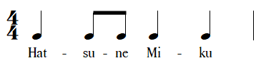
2 | 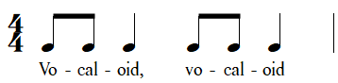
3 | 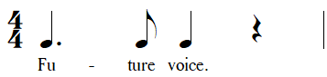
4 | 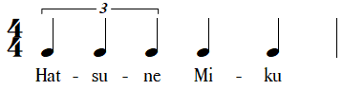
5 | 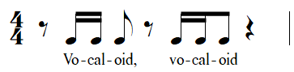
6 | 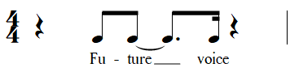
7 | 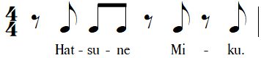

Answers
Reflection questions
- How does this sound like the loops and layers used in Vocaloid music? The rhythms are repetitive and layered, similar to how Vocaloid tracks stack short, looped ideas (drums, bass, synths and vocal phrases) to build texture. This is consistent with a lot of electronic dance music in the pop genre.
- What do you notice about the rhythms used in Vocaloid music? Rhythms are often energetic, syncopated and precise, creating a sense of drive. There is strong use of programmed drum patterns and mechanical tightness due to quantisation which is the process of automatically adjusting the timing of notes or beats in digital music software, so they line up exactly with the rhythmic grid. Quantising makes rhythms sound precise and evenly timed, removing small performance imperfections.
- How is repetition used to build energy and drive? Repeating short rhythmic ideas (loops or ostinati) builds momentum and familiarity. As layers repeat and change slightly over time, the texture becomes fuller and more exciting. Subtle changes in repetition create anticipation which also builds energy.
- How do different layers (voice, percussion, synth) fit together to create texture? Each layer occupies its own rhythmic or tonal space: percussion provides a rhythmic layer, synths often serve as a harmonic layer and vocals are the melodic layer (although synths can also take on this role as well).
- How does digital precision (perfect timing, quantised beats) affect the feel of the music? It gives the music a machine-like accuracy and polished sound, contributing to the futuristic, electronic quality that defines Vocaloid tracks.
- In our class performance, which parts remind you of the layers you hear in Vocaloid tracks? The percussion or body percussion patterns are similar to digital drum loops, vocal chants are like the programmed voice or rhythmic loops and classroom instruments represent synth layers.
Access Anamanaguchi – Miku ft. Hatsune Miku (Lyric Video) (from 0:14–3:58) and complete the following activities.
- Graphically notate the main melodic motif. Traditional notation can be accessed via ‘Miku’ Sheet Music by Anamanaguchi to guide the student responses.
- Identify 2 different performing media that use this motif. Performing media includes the use of Vocaloid where Miku’s programmed voice sings this melody and the lyrics, and the use of synthesizer. Examples of adjectives that would describe these synth timbres include sawtooth, sync lead, trance lead, buzzy, metallic and brassy. It’s also a monophonic synth (only producing one note at the time) using portamento, which means it will often glide or slide between certain notes.

Activity 7.2 – from folk to future
Access PowerPoint ‘Activity 7.2 – from folk to future’ and complete the jigsaw listening activity comparing 2 versions of ‘Ievan Polkka’:
- Hatsune Miku – Ievan Polkka (Remastered 2024) (2:32)
- Korpiklaani – Ievan Polkka (3:08)

Answers
Reflection questions
- How does technology and style change the way we experience this traditional Finnish song?
Hatsune Miku
- Bright, synthetic, mezzo-soprano vocal timbre with precisely quantised rhythm and pitch
- Programmed drum machine patterns with a driving four-to-the-floor feel or tight EDM-style backbeats. Handclap samples accent the backbeat along with the electronic snare
- Synth bass playing oom-pah style bass line on the beat with some passing notes between chord changes or to create interest
- Layered ‘vocal-ah’ synths and chiptune-like colours (square wave synth lead sound)
- A loop-built texture with repeated short musical phrases
- Steady, moderately fast tempo that supports a dance-pop style (118 bpm)
- Encourage terminology such as synthesised voice, electronically manipulated timbre, quantised/grid rhythm and layered synth pads
- This version is in the aeolian mode based around a tonal centre of F#. It only uses 2 different chords – the minor i and the minor v. See the chord progression notes further down for more detail.
Korpiklaani
- Distorted electric guitars (combination of palm muting and open accented power chords), bass guitar and full drum kit creating a rock/metal stylistic interpretation
- Accented snare on beats 2 and 4, fast, energetic tempo occasional double-time feel (about 260 bpm). Alternating between open and closed hi-hats, heavy tom-tom and double kick fills and accents with crash cymbals
- Violin/fiddle and/or accordion double or embellish the tune (heterophonic) above power-chord riffs
- Tenor range vocals are rough, growling, powerful, almost guttural at times
- Encourage language such as distorted timbre, power-chord harmony, backbeat drive, live ensemble and folk-metal fusion
- This version is in the aeolian mode based around a tonal centre of D. It also uses slightly different chords in the progression with the b7 chord of C major being used as an alternative to the minor v
- What other elements of music could you discuss in detail with these 2 excerpts?
Performing media and timbre shape texture. The Miku version layers include programmed parts and a synthetic lead creating a polished EDM/J-pop texture. The Korpiklaani version combines a live rhythm section with folk soloists creating a dense texture that is more representative of a live performance.
Regarding duration, rhythm and feel, both versions keep a danceable 2-in-the-bar polka/oom-pah energy, but the Miku track is tightly quantised and metronomic, whereas Korpiklaani’s drum kit, fills and guitar power chords produce rhythmic push-and-pull and rock accents.
Technology changes the listener experience. Vocaloid reframes a village dance tune as a global digital pop track, while folk-metal reframes it as festival rock with communal chant energy.

Extension listening

Answers
Access the sheet music for ‘Ievan Polkka’ on Musescore (or similar). Make sure there is a concert pitch instrument in whatever version you choose. Here are a few options: ‘Ievan Polkka’ version 1 (score) or ‘Ievan Polkka’ version 2 (score).
- Identify the key signature of this piece of music. 3 sharps – F# minor
- What is the tonality of this piece of music? Major? Minor? Modal? If the edition you are using matches the Hatsune recording, then the piece is in F# minor (aeolian/natural minor).
- What is the first note used in the bass line? How would you describe this bass line? Is it similar to other styles of music you are familiar with? The first note is an F#. The bass line could be described as oom-pah or boom-chuck, particularly with how it interacts with the off-beat chords. This is commonly used in styles including polka, klezmer, bluegrass, country and western, ska, ragtime/stride piano and marching band. It is not to be confused with oom-pah-pah which is most commonly heard in waltzes and traditional German folk music.
- Thinking about what you already know about scales and modes, identify the scale or mode the main melody of ‘Ievan Polkka’ uses. F# natural minor or aeolian mode.
- Write out 2 octaves of this scale or mode on a blank stave using crotchets and accidentals in both treble and bass clef. Pay close attention to stem direction and ledger lines as required.
- Label each note and identify the interval between each.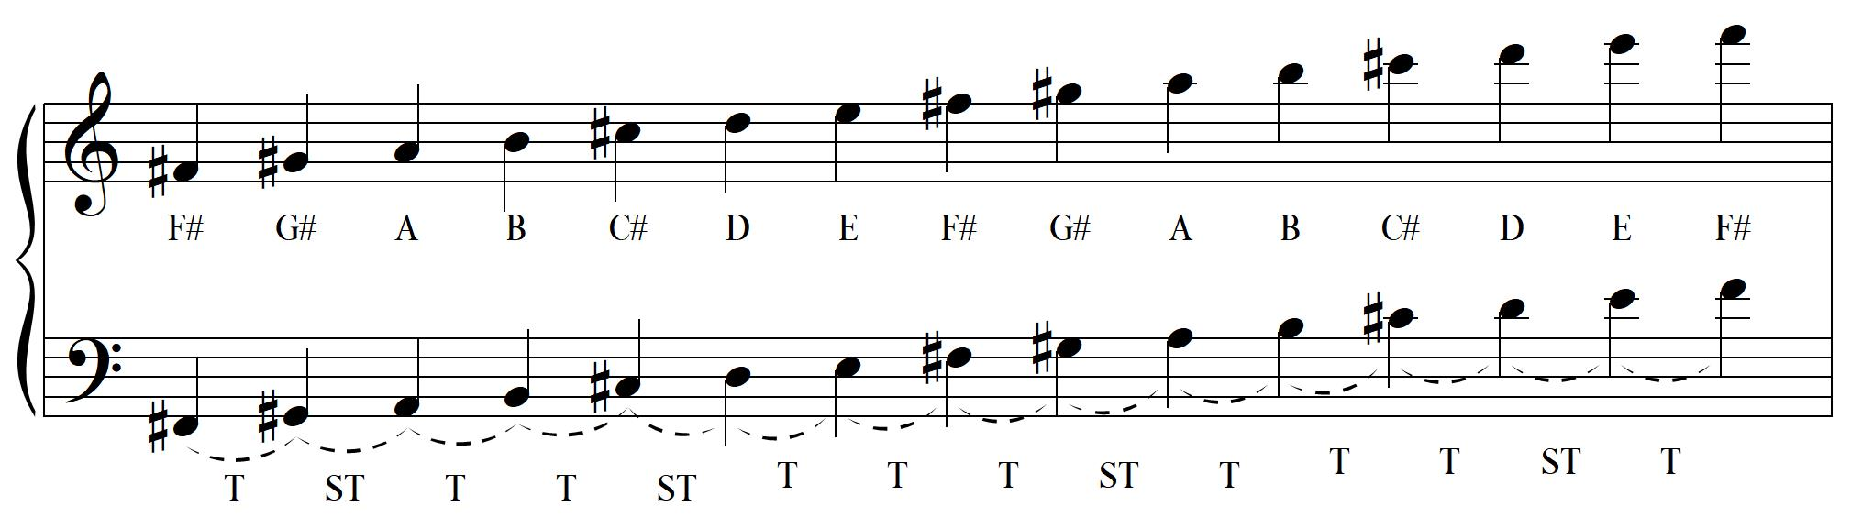
- Write out the harmonic progression for 2 different 8-bar sections of ‘Ievan Polkka.’
The below score is an example of the chord progression used in the Hakune Miku version.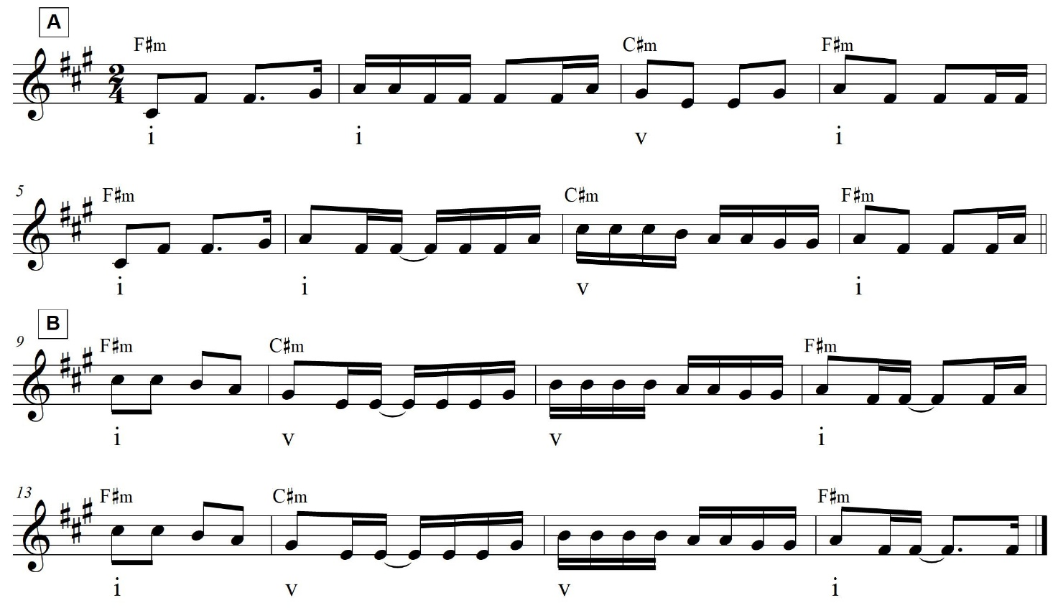

Activity 7.3 – a ‘Polkka’ performance

Answers
Reflection questions
- How did the bass line and melody interact? The bass line repeated an oom-pah bass line that was mostly on the beat, alternating between the tonic and dominant notes of the chord. The melody moved mostly stepwise above it, creating tension and release against the harmonic cycle while using a wider variety of rhythms that including syncopation via dotted notes and anticipation of the beat. The chords are played off the beat, which is what creates the polka feel.
- What role did each performer have in maintaining groove and texture? The bass and percussion kept the pulse, while melodic instruments added variation and shape. Each layer depended on the others to maintain timing and energy.
- What musical decisions made your version feel more ‘future’ than ‘folk’, or did it feel more ‘folk’ than ‘future’? Students may refer to performing media choices. For example, ‘We used digital sounds’, duration elements included a faster tempo, syncopated percussion, and looped short phrases like an EDM track.
- Were there any limitations that impacted this? (For example, the instrumentation you have available may lend itself to more of a folk or future sound) Own response based on ensemble context.
- How did your live performance compare to the Vocaloid recording? Own response.

Activity 7.4 – reimagining the ‘Ieven polkka’

Answers
Reflection questions
- Which elements of ‘Ievan Polkka’ did you keep, and which did you transform? I kept the original melody but changed the tempo and added electronic drums. The texture became thicker and more syncopated, making it sound more modern.
- How do your choices in texture, pitch or duration show influence from both folk and electronic styles? The melody stayed modal and stepwise like folk music, but the repeating loops and steady backbeat came from electronic dance music.
- What performing media or technologies helped you achieve your sound? I used BandLab to layer drum samples and synth pads, then added reverb and EQ to make it sound more polished.
- How does your version reflect influence and innovation in music today? It takes an old folk song and reshapes it with digital tools such as, showing how tradition and technology can work together.

Learning sequence 10 – final mix – listening and reflection

Activity 10.1 – peer listening and feedback worksheet
Table 22 – Activity 10.1 – peer listening and feedback table
Questions | Observations
What stylistic influences can you hear in the composition? For example, taiko, gagaku, J-pop or video game music.
What are some key musical features in the piece?
Describe how the elements of music are used to communicate ideas and expression. Refer to at least 3 elements of music in your response.
What are the strengths of this composition?
What are some ways the composition could be refined?
In what ways do you think influence and innovation are demonstrated through the manipulation of the elements of music?

Activity 10.2 – reflection and class discussion worksheet

Unit reflection
Reflecting on what you have learnt this term, complete the sentence starters below.
- Thinking about influence and inspiration …
One influence that inspired my work was …
I was drawn to this style because …
A specific musical idea I borrowed or adapted was …

- Thinking about creativity and innovation …
A new skill I developed during this unit was …
I experimented with _____________________ to make my music sound more original.
The most creative moment in my composition was …

- Thinking about growth as a musician …
My understanding of composition changed when …

Performing or listening activities helped me to improve by …

Next time, I want to focus on developing …

References
This resource contains NSW Curriculum and syllabus content. The NSW Curriculum is developed by the NSW Education Standards Authority. This content is prepared by NESA for and on behalf of the Crown in right of the State of New South Wales. The material is protected by Crown copyright.
Please refer to the NESA Copyright Disclaimer for more information https://educationstandards.nsw.edu.au/wps/portal/nesa/mini-footer/copyright.
NESA holds the only official and up-to-date versions of the NSW Curriculum and syllabus documents. Please visit the NSW Education Standards Authority (NESA) website https://educationstandards.nsw.edu.au and the NSW Curriculum website https://curriculum.nsw.edu.au.
Music 7–10 Syllabus © NSW Education Standards Authority (NESA) for and on behalf of the Crown in right of the State of New South Wales, 2024.
8-bit Music Theory (15 January 2019), ‘Odd Time Signatures in Video Game Music’ [video], 8–bit Music Theory, YouTube, accessed 27 July 2025.
aidenventures (2020) Ievan Polkka – Hatsune Miku, musescore website, accessed 4 November 2025.
Anamanaguchi (n.d.) Miku Sheet Music by Anamanaguchi, Scribd website, accessed 4 November 2025.
Bandlab Technologies (2025) BandLab For Education [website], accessed 7 August 2025.
Boosey & Hawkes (31 March 2020), ‘Stravinsky – The Rite of Spring (Official Score Video w/ Live Chat Commentary)’ [video], Boosey & Hawkes, YouTube, accessed 7 August 2025.
Classical – The World of Music (13 June 2022), 'L. Van Beethoven – 5th Symphony, Op.67 – Sheet Music' [video], Classical – The World of Music, YouTube, accessed 27 July 2025.
Classical Scores (18 July 2015), 'John Williams – Star Wars Imperial March (with score)' [video], Classical Scores, YouTube, accessed 24 July 2025.
Crunchyroll: Inside Anime (8 April 2023) 'The Sound of Suzume: An Interview with Radwimps on Creating The Film's Soundtrack' [video], Crunchyroll: Inside Anime, YouTube, accessed 4 July 2025.
Das M (8 July 2024) ‘RADWIMPS ~ Suzume no tojimari theme song (tiktok live) すずめ – feat. Toaka’ [video], Moumita Das, YouTube, accessed 30 June 2025.
Dave’s OSTs (30 November 2023) ‘Piranha Plant Cove – Mario Kart 8 Deluxe OST’ [video], Dave’s OSTs, YouTube, accessed 7 August 2025.
GBelair (23 December 2009) 'Super Mario Bros (NES) Music – Overworld Theme' [video], GBelair, YouTube, accessed 7 August 2025.
Hooktheory (2025) One Winged Angel by Nobuo Uematsu Chords and Melody, Hooktheory website, accessed 7 August 2025.
IMSLP (International Music Score Library Project) (n.d.) Symphony No. 5, Op. 67 (Beethoven, Ludwig van), IMSLP website, accessed 2 June 2025.
Inside the score (19 July 2020), ‘Quick Guide: Beethoven's Fifth Symphony [video]’, Inside the score, YouTube, accessed 24 July 2025.
Korpiklaani (20 March 2019) 'Ievan Polkka' [video], Korpiklaani, YouTube, accessed 15 October 2025.
Miku H (10 June 2013) '[Hatsune Miku] World is Mine / ryo (supercell)' [video], Hatsune Miku, YouTube, accessed 3 September 2025.
Miku H (24 May 2016) 'Anamanaguchi – Miku ft. Hatsune Miku (Lyric Video)' [video], Hatsune Miku, YouTube, accessed 3 September 2025.
Miku H (27 April 2024) 'Ievan Polkka (Remastered 2024)' [video], Hatsune Miku, YouTube, accessed 15 October 2025.
Nobuo Uematsu – Topic (16 October 2018) ‘One-Winged Angel (Final Fantasy VII)’ [video], Nobuo Uematsu – Topic, YouTube, accessed 4 August 2025.
Piano Sheet Music By Torby Brand (5 February 2024) 'Suzume – Full Main Theme [Piano Sheet Music]' [video], Piano Sheet Music by Torby Brand, YouTube, accessed 4 July 2025.
pockatist7 (2015) Ievan Polkka HATSUNE MIKU VERSION!, musescore website, accessed 4 November 2025.
Polygon (10 January 2017), ‘How Nobuo Uematsu Composed FF7's "One-Winged Angel"’ [video], Polygon, YouTube, accessed 4 August 2025.
Rice (9 January 2021) 'Explaining Vocaloid in under 3 minutes' [video], Rice, YouTube, accessed 26 September 2025.
Smith B (4 August 2025) ‘“James Bond Theme” | Score Reduction and Analysis’ [video], Ben Smith, YouTube, accessed 24 July 2025.
State of New South Wales (Department of Education) (n.d.) The Beauty of 8 – Activities: Pearl, Digital Arts Unit website, accessed 2 June 2025.
Suzume (6 April 2024) ‘Suzume | Official Trailer 1 | Netflix’ [video], Suzume, YouTube, accessed 30 June 2025
Taikoz (18 December 2018) 'The Beauty of 8' [video], Taikoz, YouTube, accessed 2 June 2025.
Video Game Players – Topic (22 April 2015), ‘Tetris Theme’ [video], Video Game Players – Topic, YouTube, accessed 7 August 2025.

© State of New South Wales (Department of Education), 2025
The copyright material published in this resource is subject to the Copyright Act 1968 (Cth) and is owned by the NSW Department of Education or, where indicated, by a party other than the NSW Department of Education (third-party material).
Copyright material available in this resource and owned by the NSW Department of Education is licensed under a Creative Commons Attribution 4.0 International (CC BY 4.0) license.

This license allows you to share and adapt the material for any purpose, even commercially.
Attribution should be given to © State of New South Wales (Department of Education), 2025.
Material in this resource not available under a Creative Commons license:
- the NSW Department of Education logo, other logos and trademark-protected material
- material owned by a third party that has been reproduced with permission. You will need to obtain permission from the third party to reuse its material.
Links to third-party material and websites
Please note that the provided (reading/viewing material/list/links/texts) are a suggestion only and implies no endorsement, by the New South Wales Department of Education, of any author, publisher, or book title. School principals and teachers are best placed to assess the suitability of resources that would complement the curriculum and reflect the needs and interests of their students.
If you use the links provided in this document to access a third-party's website, you acknowledge that the terms of use, including licence terms set out on the third-party's website apply to the use which may be made of the materials on that third-party website or where permitted by the Copyright Act 1968 (Cth). The department accepts no responsibility for content on third-party websites.

'A Japanese Ryuteki fue' by The US Library of Congress is licensed in the public domain. 'Hichiriki musical instruments' by picryl is licensed under CC0 1.0. 'Gagaku concert' by Antanana is licensed under CC BY-SA 3.0. 'Koto by Fumie Hihara' by Jean-Pierre Dalbéra is licensed under CC BY 2.0. 'Satsuma Biwa' by Rogers Fund is licensed under CC0 1.0. 'Musicienne jouant du shô de l'ensemble de Gagaku "Owari Miyabie"' byJean-Pierre Dalbéra is licensed under CC BY 2.0. 'Shoko musical instruments' by picryl is licensed under CC0 1.0.

