Music Stage 5 – teacher resource booklet
Groove expedition
Contents
Learning sequence 1 – What is jazz? 4
Jazz music glossary 4
Answer sheet 8
Activity 1.1 – exploring jazz – fact vs feel 14
Answer sheet – exploring jazz – fact vs feels 17
Activity 1.2 – What is jazz? 26
Answer sheet – What is jazz? 27
Activity 1.5 – ‘From the Start’ 28
Answer sheet 28
Learning sequence 2 – bossa nova 29
Activity 2.1 – extended chords – 7th chords worksheet 29
Building 7th chords 29
Activity 2.2 – diatonic chords in C major worksheet 32
Extension jazz chords 33
Activity 2.3 – ii–V–I worksheet 34
Piano 34
Guitar 35
Bass guitar/double bass/lower brass 36
Ukulele 37
Activity 2.6 – ‘The Girl from Ipanema’ worksheet 38
Answer sheet 40
Learning sequence 3 – swing 42
Activity 3.1 – the jazz orchestra or big band 42
Instrument cards 42
Answer sheet – the jazz orchestra or big band 47
Activity 3.2 – elements of swing 48
Answer sheet 48
Activity 3.3 – melodic interpretation 48
Answer sheet 48
Learning sequence 5 – swing musical features 50
Activity 5.2 – score scavenger hunt worksheet 50
Answer sheet 51
Activity 5.3 – Who am I? – performing media in jazz worksheet 54
Answer sheet 57
Activity 5.3 – Who am I? – performing media in jazz 61
Who am I? 61
Learning sequence 6 – funk 62
Activity 6.1 – What is funk? 62
Answer sheet 62
Activity 6.2 – funk stations 64
Funk station 1 – 16th note (semiquaver) groove 64
Funk station 2 – syncopation 65
Funk station 3 – vamp 66
Funk station 4 – strong, syncopated bass line 67
Activity 6.3 – ‘Chameleon’ by Herbie Hancock 68
Answer sheet 68
Activity 6.3 – ‘Chameleon’ by Herbie Hancock worksheet 69
Answer sheet 70
Learning sequence 8 – improvise, rehearse and refine 71
Activity 8.2 – score scavenger hunt worksheet 71
Answer sheet 72
Learning sequence 9 – assessment preparation 75
Activity 9.2 – peer feedback 75
Whole group feedback 75
Activity 9.2 – peer feedback – Two stars and a wish 76
Individual feedback 76
References 77

Learning sequence 1 – What is jazz?

Jazz music glossary
Table 1 – jazz music glossary
Term | Definition
acciaccatura
accompaniment
appoggiatura
approach notes
auxiliary notes
background
backing figures
beat
bossa nova
brass section
Charleston rhythm
chord
chord progression
chord tone
comping
cross rhythm
diatonic chords
dissonance
doit
extended chords or chord extensions
fall
fills
funk
groove
harmony
horns
improvisation
inversion
legato
marcato
melody
ornamentation
ostinato
passing notes
rhythm
rhythmic
rhythm section
root note
root position
sax section
scat singing
scoop
slur
soli
solo
staccato
swing rhythm
syncopation
tempo
tenuto
tonic
triad
triplet
turn
virtuosity
voicing
walking bass

Answer sheet
Table 2 – jazz music glossary answers
Term | Definition
acciaccatura | A musical ornament, also known as a crushed note, played quickly before the main note.
accompaniment | The layers of sound that make up the harmonic and rhythmic backing to a lead melody or solo.
appoggiatura | A musical ornament or grace note that emphasises a non-chord tone before resolving to the chord tone.
approach notes | Notes played leading into a root note or target note. Used in bass lines and melodic improvisation.
auxiliary notes | Additional notes above or below (or both) melody notes.
background | A countermelody, often repeating, that occurs behind an improvising soloist.
backing figures | Harmonic figures played by the horns as harmonic accompaniment to support the melody.
beat | A regular pulse that keeps the music moving forward.
bossa nova | Bossa nova is a relaxed style of Brazilian music that emerged in the late 1950s and early 1960s, blending samba with American jazz.
brass section | Trumpets and trombones
Charleston rhythm | A common jazz rhythm named after the popular Swing-era tune composed by James P. Johnson in 1923. This syncopated rhythm consists of a dotted crotchet followed by a quaver tied to a minim.
chord | 3 or more notes sounded simultaneously. Examples include major or minor chords.
chord progression | A sequence of chords, often with a resolution in harmony. Some jazz chord progressions repeat for unity and to create opportunities for improvisation.
chord tone | A note that is a part of a chord.
comping | To create an improvised rhythmic chordal accompaniment.
cross rhythm | A rhythm in which the regular pattern of accents of the metre is contradicted by a conflicting pattern.
diatonic chords | Building chords from the tonic key. The notes are derived directly from the notes of the scale without the use of accidentals (sharps or flats) outside of the key.
dissonance | Created by intervals or chords that clash, creating tension.
doit | A rapid ascending glissando or pitch bend played after a note.
extended chords or chord extensions | Chords built on triads with added notes that extend beyond the seventh. For example, 9ths, 11ths, 13ths.
fall | A rapid descending glissando or pitch bend played after a note.
fills | Short improvisations played by any instrument, providing moments of higher energy and denser polyphony and rhythm.
funk | A genre that originated in the mid-1960s, blending elements of soul, jazz, and rhythm and blues. It emphasises strong, syncopated bass lines and rhythmic grooves, prioritising rhythm over melody and harmony, and often featuring horn sections.
groove | A pattern of rhythms with a steady beat that maintains momentum and mood. It is often characterised by the way the rhythm section instruments interact and interlock to create a cohesive rhythmic pattern.
harmony | Simultaneous sounds of varying notes that combine to create harmonic intervals and chords. Jazz harmony has rich sounding chords, and the harmonic progression can be fast and/or abstract.
horns | A collective term for any wind instrument in jazz. For example, trumpet, trombone, saxophone, flute, clarinet.
improvisation | The spontaneous creation of musical material using pitch and/or rhythm as a solo or accompaniment.
inversion | A specific voicing or arrangement of a chord where the root note is not the lowest note.
legato | To play smoothly.
marcato | An articulation that indicates the note should be played with a strong, sharp, accented attack.
melody | The main tune or theme of a piece. In jazz, melodies can be improvised.
mordent | A musical ornament that involves rapid alternation between a note and the note above or below it.
ornamentation | Adding notes and modifying rhythms to enhance the style and/or expression of a melody.
ostinato | A repeated melodic or rhythmic phrase.
passing notes | Additional notes placed between notes of a melody. In jazz, they may be chromatic.
plop | A rapid descending glissando from the note above the intended note.
rhythm | The placement of sounds and silence in time, often consisting of combinations of long and short durations.
rhythmic | The adjective form of rhythm.
rhythm section | A group of instruments that mostly form the accompanying role, usually drum kit, bass (double/electric), piano and guitar. Sometimes a vibraphone, banjo, synthesiser, electric piano or organ may be included.
Rhythmic | The adjective form of rhythm.
root note | The lowest note of a diatonic chord.
root position | A chord with its root note at the lowest pitch.
sax section | A group of saxophones, usually of various sizes – baritone, tenor, alto, and occasionally soprano.
scat singing | Improvised vocal melodies with made up syllables. For example, doo, dah, dee, dow, bee, boo, bah, bop.
scoop | A rapid ascending glissando from a lower pitch to the intended note.
slur | In musical notation, a slur is a curved line that connects two or more notes which indicates that the notes are to be played smoothly without any separation.
soli | A composed melody that many instruments play together, often sounding like a harmonised improvisation.
solo | A section in a piece of music where a musician improvises over accompaniments and/or other melodies.
staccato | An articulation to be played short and detached, represented by a small dot placed above or below a note.
swing rhythm | A rhythmic device in jazz whereby quavers (1/8 notes) are in long-short pairs.
syncopation | Rhythms and/or accents that fall on weak beats or subdivisions.
tempo | The speed of the beat. For example, fast or slow.
tenuto | An articulation that indicates that the note is to be held for its full value indicated by a horizontal line placed above or below the note.
tonic | The first note of the diatonic scale.
triad | A 3-note chord built with a 3rd and 5th from a root note.
triplet | A rhythm in which you play 3 notes of equal length in the space of 2 notes of the same rhythmic value.
turn | A musical ornament that consists of a short, 4 note figure played rapidly around a main note.
virtuosity | An advanced level of skill in music, particularly in relation to high level technical skill in singing or playing an instrument.
voicing | A particular inversion of a jazz chord that includes chords tones of 3rds, 5ths, 7ths and/or extensions.
walking bass | A form of bass accompaniment where all crotchets are played in a bar and the chord tones are outlined melodically.

Activity 1.1 – exploring jazz – fact vs feel
Access the following pieces and determine the ‘facts and feels’ in relation to each piece.
Table 3 – Activity 1.1 – exploring jazz – fact vs feel
Example | Facts | Feels
Louis Armstrong “When The Saints Go Marching In” on The Ed Sullivan Show (3:29) (from 0:00–2:40)
Ella Fitzgerald and Duke Ellington “It Don’t Mean a Thing (If it Ain’t Got That Swing)” (2:33)
Veronica Swift – Moanin’ (5:06)
(from 0:00–1:42)
Esperanza Spalding performing “On The Sunny Side Of The Street” (2016) (4:27)
(from 1:04–2:49)
14 year old Adrian Galante sits in with James Morrison, Emma Pask and WASO 2011 Mack the knife (2:05) (from 0:00–2:05)
Desmond: Take Five | The Dave Brubeck Quartet, Live in Germany 1966 (5:14)
(from 0:00–1:18)
Zela Margossian Quintet (Live) | #PhoenixHALO (17:48) (from 14:02–15:02)
Laufey – From The Start (Live From Dick Clark’s New Year’s Rockin’ Eve 2024) (2:57) (from 0:00–1:40)
Michel Camilo feat. by WDR Big Band – And Sammy Walked In (8:40) (from 6:27–8:24)
Snarky Puppy – What About Me? (We Like it Here) (6:56) (from 0:00–1:30)
Hot Potato Band – LIVE from Woodford Folk Festival (December 2022) (13:12)
(from 4:09–5:37)
Love Yourself – Vintage 1929 Postmodern Jukebox Justin Bieber cover ft. Sara Niemietz (4:28) (from 0:00–1:23)

Answer sheet – exploring jazz – fact vs feels
Access the following pieces and determine the ‘facts and feels’ in relation to each piece.
Table 4 – Activity 1.1 – exploring jazz – fact vs feel answers
Example | Facts | Feels
Louis Armstrong “When The Saints Go Marching In” on The Ed Sullivan Show (3:29) (from 0:00–2:40) | - Bright tempo in ${4 \atop 4}$ time  - Constant swing rhythm pattern on the drum kit  - Trumpet has a bright brassy sound  - Male voice has a gritty sound | - Happy  - They are playing with lots of joy and expression while interacting with each other  - The constant rhythm is energetic and makes the music bounce along
Ella Fitzgerald and Duke Ellington “It Don’t Mean a Thing (If it Ain’t Got That Swing)” (2:33) (from 0:00–2:33) | - Female voice has a strong booming sound  - Double bass and drum kit have a strong percussive sound  - Bright fast tempo in ${4 \atop 4}$ time  - Piano has a clear bright sound  - Trumpets, trombones and saxophones play in sections adding a brassy and reedy sound | - Energetic  - The vocalist constantly changes her melody with lots of creative and expressive ideas  - The mood of the music is energetic and percussive
Veronica Swift – Moanin’ (5:06)  (from 0:00–1:42) | - Strong female voice incorporating raspy and husky sounds  - Bright and brassy trumpet  - Strong rhythm and beat despite drum kit and all instruments not always featuring | - Groovy  - Vocalist shows creativity and variation adding lots of energy and expression  - Trumpet player displays lots of flair and expressive playing
Esperanza Spalding performing “On The Sunny Side Of The Street” (2016) (4:27)  (from 1:04–2:49) | - Expressive female vocals that include husky qualities  - Percussive and clear double bass  - Shimmering sound from the constant use of ride cymbal on the drum kit  - Piano has a light and sparkling sound  - ${4 \atop 4}$ time with the beat being supported by the double bass and drums  - Tenor saxophone has rich reedy sound | - Happy  - The way the vocalist explores different expression with her voice adds to the feeling and keeps your attention  - The tenor saxophone adds a pleasing new smooth sound and contrasts with the vocalist
14 year old Adrian Galante sits in with James Morrison, Emma Pask and WASO 2011 Mack the knife (2:05) (from 0:00–2:05) | - Female vocalist accompanied by a large ensemble featuring brass, woodwind, string and percussion instruments | - Relaxed  - The vocalist explores a range of timbres demonstrating a personal, creative interpretation  - The trumpet expresses charisma and flair in the improvised solo  - The music has a relaxed swagger due to the swing pattern
Desmond: Take Five | The Dave Brubeck Quartet, Live in Germany 1966 (5:14)  (from 0:00–1:18) | - Opening driving and percussive pattern played by the drum kit, that includes use of the hi-hat, producing a constant shimmering sound  - Piano and double bass have a clear, percussive approach that adds to their role accompanying the solo alto saxophone  - The alto saxophone plays the melody and is supported by a reedy and rich sound. At times, there is some airy and light sounds in the solo to provide some contrast in timbre  - Bright fast tempo in ${5 \atop 4}$ time  - Constant swing feel played throughout the piece on the drum kit | - Upbeat and happy  - The alto saxophone explores variety in sound through using expression and playing in different registers. This shifts from smooth to harsh  - The swing pattern that is being played on the drum kit creates an energetic and bouncy feel to the piece  - The piano and double bass interact well and provide some rhythmic variety to compliment the constant pattern played on the drum kit
Zela Margossian Quintet (Live) | #PhoenixHALO (17:48) (from 14:02–15:02) | - Piece has a fast tempo and the drums help to support this with the ride cymbal creating a shimmering sound and the punctuated buzzing sound that is created on the snare drum  - The piano stands out because the melody is played in the upper register of the instrument, where the sound is brighter. This helps it stand out from the drums  - The alto saxophone has a reedy and strong sound. At times the sound is harsh and abrasive. This helps it stand out from the drums and adds to the energy of the piece | - Busy and frantic  - All the musicians in this piece play with an energetic and expressive feel. This supports a strong rhythmic drive and allows each instrument to stand out  - The alto saxophonist is engaging, demonstrating creativity through exploring musical ideas across the range of the instrument. This further highlights changes in timbre and variety during the solo
Laufey – From The Start (Live From Dick Clark’s New Year’s Rockin’ Eve 2024) (2:57) (from 0:00–1:40) | - Female vocals supported with a warm, breathy and smooth sound  - Strong rhythmic use of a bossa nova feel  - Electric guitar, drum kit and electric bass guitar support this providing a percussive approach and accompaniment layer to the piece | - Happy and relaxed  - The rhythm is catchy and the vocal line is captivating  - The vocalist displays lots of joy and commitment to the performance. She has a pure quality in her sound and her smooth approach contrasts well against the more percussive sounds
Michel Camilo feat. by WDR Big Band – And Sammy Walked In (8:40) (from 6:27–8:24) | - This piece is in a bossa nova feel and includes lots of rhythmic energy  - There is use of unison rhythm patterns with the saxophones, and collectively they have a warm full sound  - This is contrasted well by using short notes and varied rhythmic patterns in the trumpets and trombones  - Piano solo features using chordal ideas for the melody. This creates a strong and more powerful sound  - The drum kit incorporates regularly playing on the bell of the ride cymbal. This helps to define the rhythms and create a bright and metallic sound  - Use of Latin percussion instruments (congas) provide a hollow percussive drum sound | - Exciting and energetic. It makes me feel happy and want to tap my feet  - Each section of the musicians is exploring creativity through using a range of expressive features and techniques. An example is the trumpets using trills and bending notes in some of their upper register figures  - There is constant interactivity between the instruments and this helps to highlight the quality of their unique timbre. For example, the powerful brassy sound of the trumpets against the more mellow and reedy sound of the saxophones in the ’call and response’ section
Snarky Puppy – What About Me? (We Like it Here) (6:56) (from 0:00–1:30) | - This is a high energy jazz fusion piece in ${4 \atop 4}$ time with a fast-driving tempo. There are many percussive sounds and expressive rhythms played on the instruments to support this. It also highlights the timbre qualities between them. For example, the powerful patterns played by the brass section versus the distorted and abrasive sound by the electric guitars | - This piece makes me want to move, as it has a strong beat and groovy rhythms  - There is clear intent with how the musicians are communicating with each other and the techniques they are using to add expression and interest  - There is strong interaction between the instruments and each section. The musical structure (ABA) helps to show this – more acoustic and brassy sounds in section A, against strong use of electronic instruments that have a gritty and distorted sound in section B
Hot Potato Band – LIVE from Woodford Folk Festival (December 2022) (13:12)  (from 4:09–5:37) | - This is a high energy piece that features the brass and woodwind (saxophones) playing punchy and powerful unison figures to accompany the vocalist  - The vocalist has the main melody and repeats the phrase ‘Let it Go’ each time with some varied tone or expression. At times, there is some raspy sound to the way they sing  - A small range of percussion instruments and players, include bass drum, snare drum, cymbals and some Latin percussion  - The alto saxophone has a solo. During this there is a large range of musical material explored, including strong, raspy, reedy and at times squeaky sounds to create variety and show contrast sounds in different registers | - This piece just makes me want to dance. It is really energetic and has a strong, catchy beat  - It looks like everyone on stage is having fun. They are dancing as they play and copy each other, both with what they are playing and their movements  - The saxophonist shows lots of creativity in the solo section. There are so many different sounds and melodies being created, including some familiar ones, with little snippets from ‘In the Hall of the Mountain King’ being played  - The bass drum has a strong booming thud sound that is used throughout and accompanies the saxophone solo  - The repeated rhythm that is played by the percussion in sections creates a strong groove to the piece, which has a funk mixed ska sound
Love Yourself – Vintage 1929 Postmodern Jukebox Justin Bieber cover ft. Sara Niemietz (4:28) (from 0:00–1:23) | - Traditional jazz style with a strong 2-beat feel  - The double bass plays a variation of a walking bass in a 2 feel  - Use of playing on the rim of the snare drum creates a clear tapping sound  - Trumpet uses a harmon mute creating a buzzing sound  - Banjo has a twangy sound and at times stands out from the other instruments  - Female vocals have some husky qualities and then become more powerful and expressive as the piece progresses  - Strong bright piano sound exploring a stride like technique | - Energetic and catchy  - The musicians accompanying the vocalist are focused and supporting her. She is moving and responding to this, creating some flair and using more expression. This results in more musical contrast in her singing  - The music has a strong dance-like feel and the double bass, drum kit, banjo and piano help to define this

Activity 1.2 – What is jazz?
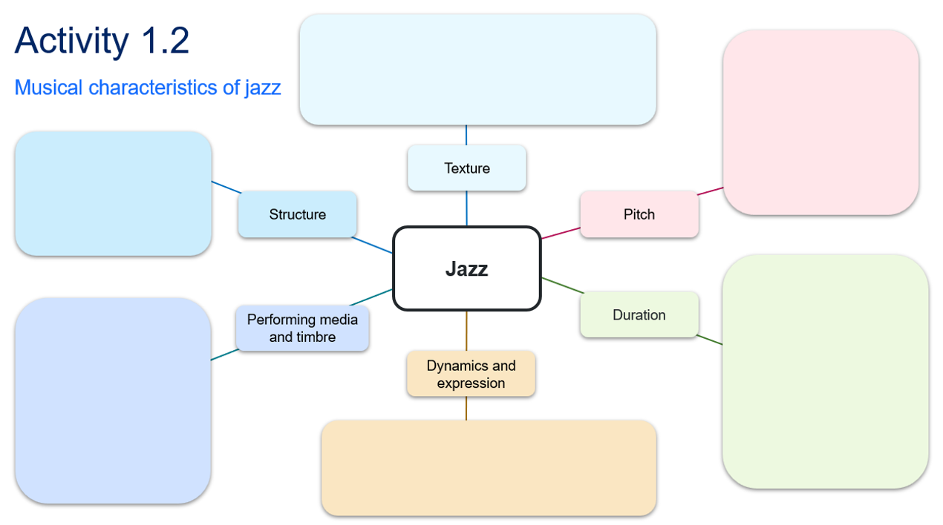

Answer sheet – What is jazz?
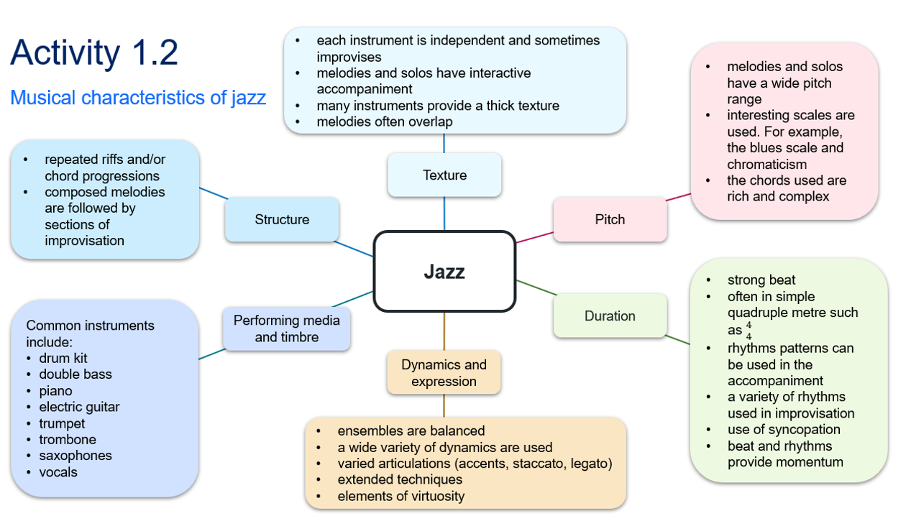

Activity 1.5 – ‘From the Start’

Answer sheet
Access Laufey – From The Start (Official Music Video) (2:49) and answer the following questions.
- Identify the musical features that you find interesting in the excerpt. Extended chords, smooth vocal tone, bossa nova patterns
- What performing media are used in this piece? Vocals, acoustic guitar, drums, bass, piano/keys, strings (violin and cello)
- What is the time signature and tempo of this piece? ${2 \atop 2}$, simple duple, medium bossa nova
- Outline the structure (including bar numbers) of the song: Intro – 4, verse 1 – 16, verse 2 – 16 bars, chorus – 16 bars, solo – 16 bars, verse 3 – 16, chorus – 16, outro 8 bars (with ritardando)
- How would you describe the vocal solo in the middle of the song? What is the vocalist doing? Improvising, scat singing

Learning sequence 2 – bossa nova

Activity 2.1 – extended chords – 7th chords worksheet

Building 7th chords
Using a keyboard, play the following chord progressions using the steps provided.
Creating major 7th chords – example Cmaj7
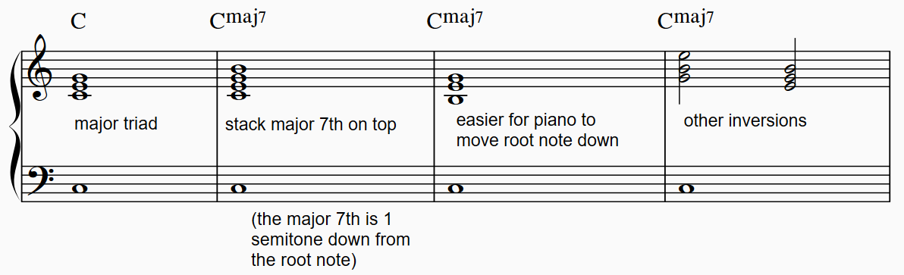
- Play a C major triad with an accompanying root note.
- Play a C major chord and then add a B above to create a Cmaj7 chord.
- Invert the chord and remove the extra tonic in the right hand.
- Repeat this exercise for Gmaj7.
Creating dominant 7th chords – example G7
To build a dominant 7th chord, play a G major triad and add the minor 7th on top (G7). Experiment with inverting the chord.
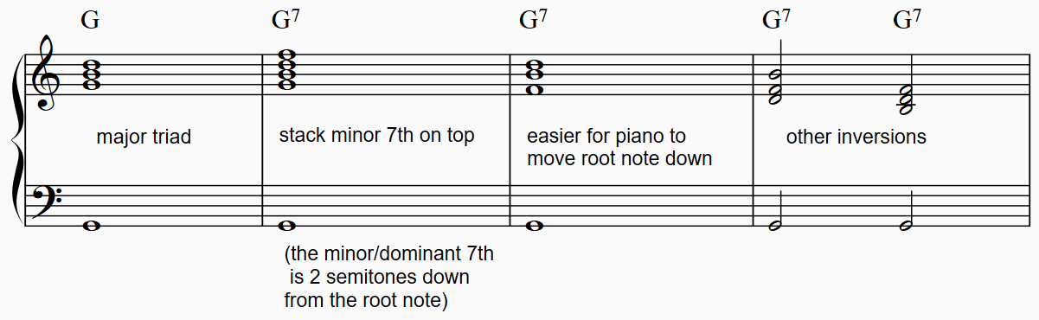

Creating minor 7th chords – example Dm7
Repeat this again for D minor triad expanding and inverting to Dm7 (minor 3rd, minor 7th).
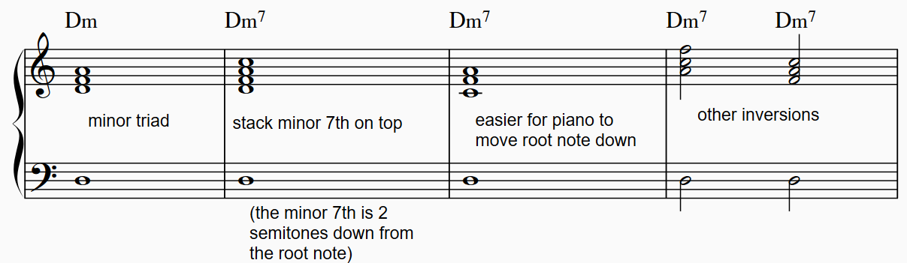

Chord inversions
The 7th chord voicing in the right hand can be inverted to create alternate voicings. An inversion is created by building a chord from any of the notes that are not the root note. For clarity of learning these new chord tonalities, keep the left hand note on the root note of the chord. Play and listen to how the chord is altered just by changing the position of the 7th. We can hear the difference between each chord type by keeping the root note the same.
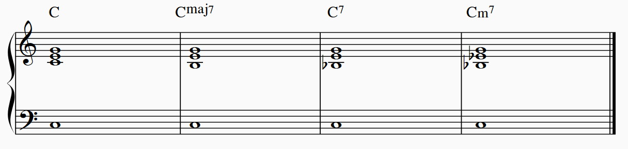

Aural skills answers
- Aurally identify the chords played by your teacher as either Cmaj7, G7 or Dm7.
Cmaj7, Dm7, Cmaj7, G7, Dm7
- Aurally identify the chords played by your teacher as either Cmaj7, C7 or Cm7.
C7, Cmaj7, Cm7, Cmaj7, C7

Activity 2.2 – diatonic chords in C major worksheet
By harmonising the major scale, we can create chords that can be used functionally, that is, in chord progressions. The simplest way to give chords a relationship, is to build them from the one scale. These are called diatonic chords.
Play and listen carefully to the following diatonic chords built on the scale of C major using the following steps.
- Play a C major scale using the right hand in treble clef.
- Play the C major scale in triads to create each diatonic chord. As you play each chord, recite the number of each chord out loud. For example, C major ‘chord one’, D minor ‘chord 2’. We use upper case roman numerals for major chords and lower case for minor chords.
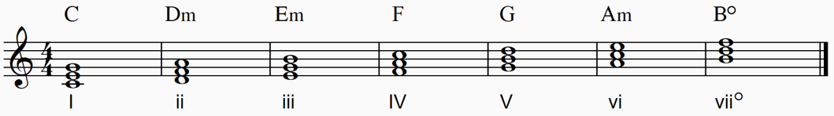
Chord I is called the tonic chord. This chord will sound like the ‘home’ chord, particularly when played directly after chord V.
- We will now add a 7th note to each chord, producing a mix of major7 and minor7 chords, plus one dominant chord (chord V) and a half-diminished chord (chord vii). Play each chord on the keyboard and listen to the scale now harmonised as 7th chords.
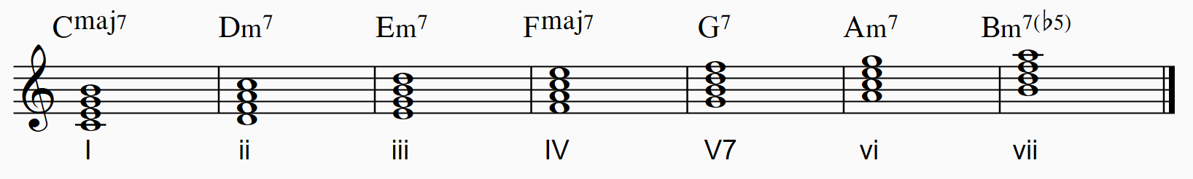
- A common jazz chord progression used is the ii–V–I. Listen to this chord progression as it is played on a loop by your teacher on the keyboard.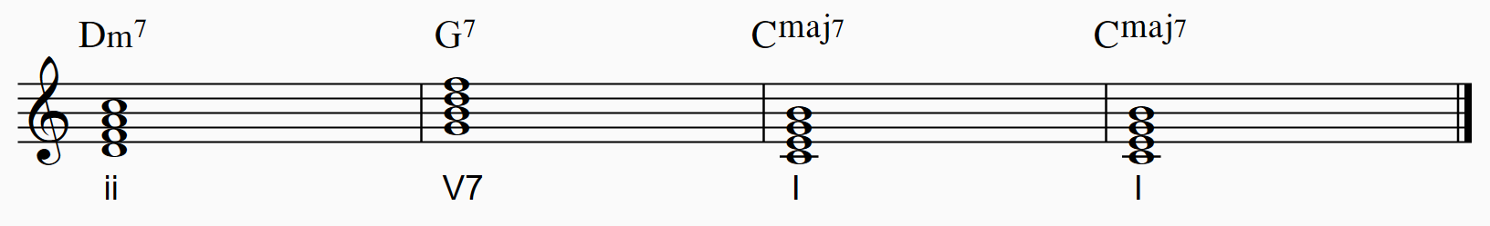
Play these chords on the keyboard. Start by playing the triads, then the 7th chords, then the ii–V–I progression.

Extension jazz chords
Examine the notation for diatonic chords that extend even further than the 7th. These chords may include intervals of 9ths, 11ths and/or 13ths.
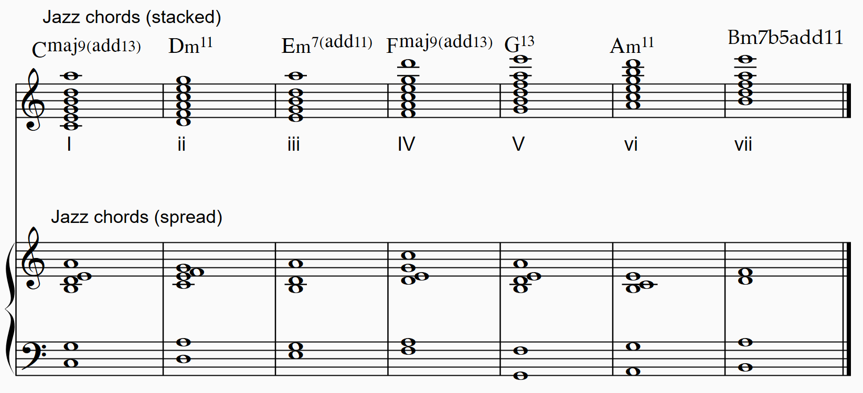
- Perform the jazz piano voicings of these chords in root position. Compare the sound to the 7th chords.
- Play the same chords using different inversions as notated above.
- Experiment with other voicings as outlined in Activity 2.1.

Activity 2.3 – ii–V–I worksheet
Access the ‘ii–V–I chord progression jazz bossa nova style’ score in score booklet 1 – Groove expedition for specific instructions for your instrument. Learn the common jazz chord progression ii–V–I in the key of C major. An example of this is in the verse and chorus of Laufey – From The Start (Official Music Video) (2:49). Use the reflection questions below as you progress through each step. Perform the chord progression in the bossa nova style. You may like to play along with the Activity 2.3 – ii-V-I bossa nova backing track (1:42).

Piano
Table 5 – Activity 2.3 – ii–V–I – piano instructions and observations
Step | Activity | Did you notice?
1 | Perform the progression using triads in root position. The left hand plays the root note | That it does not sound like rich jazz harmony yet
2 | Add the 7th interval to the top of the triad | The right hand will need to stretch. The chords are more colourful, although you may hear this as dissonance
3 | Remove the tonic from the right hand, turning it into a voicing | This results in less hand stretching and more harmonic space for the jazz chord
4 | Invert the voicings | The right hand no longer jumps around which produces smoother voice leading
5 | Add jazz extensions (9ths or 13ths) | You will notice very colourful sounds
6 | Add a stylistic bossa nova rhythm. Example are provided on the score | You may find coordinating your hands quite challenging. To assist with this, you could write in the counting on the score
7 | Play step 6 (long chords) or step 7 with the ensemble | You can experiment with improvising your own bossa nova pattern

Guitar
Table 6 – Activity 2.3 – ii–V–I – guitar instructions and observations
Step | Activity | Did you notice?
1 | Perform the progression using open chords and single strums | That is does not sound like rich jazz harmony yet
2 | Change the chord shapes to include 7ths | These chords will sound more colourful. You may even hear this as dissonance
3 | Now use shell voicings. These are 3 notes of each chord that are easier to play. Use 3 fingers of your strumming hand to pluck the chord | You’ve moved up the neck and are no longer strumming
4 | Use the picking hand thumb to add root notes to the shell voicing. Pluck all 4 strings at the same time | These 4-note chords sound very stylistic
5 | Play the thumb bass notes in an independent rhythm to the shell voicing in the bossa nova style | The bossa nova rhythm can be difficult to execute
6 | Add a different bossa nova rhythm | This one is a little easier to play
7 | Play step 3, 4, 5 or 6 with the ensemble | You can experiment by improvising your own bossa nova pattern

Bass guitar/double bass/lower brass
Table 7 – Activity 2.3 – ii–V–I – bass guitar/double bass/lower brass instructions and observations
Step | Activity | Did you notice?
1 | Perform the progression using long root notes | This is very easy to play. Make sure you are using both the index and middle finger to gently pluck the top part of the string (for electric bass). For lower brass, choosing the correct register to play each pitch is important in creating a smooth contour
2 | Add a minim pulse | Try to feel the pulse, without counting 1, 2, 3, 4
3 | Add a dotted crotchet rhythm to apply a bossa nova style | You may need to alternate fingers in the plucking hand
4 | Add 5th intervals above the root note. This gives the bass line a more melodic role | The 5th interval is always 1 string and 2 frets higher than the root note
5 | Add another dotted rhythm each bar. This propels the rhythm of bass line | You may now need to move your left hand quite quickly to get to the next bar
6 | Add approach notes. These are notes above or below the next bars’ beat 1 note | This joins the root notes and 5ths in a colourful melodic contour
7 | Play step 3, 4, 5 or 6 with the ensemble | You can improvise which strategy you use as you play

Ukulele
Table 8 – Activity 2.3 – ii–V–I – ukelele instructions and observations
Step | Activity | Did you notice?
1 | Perform the progression using open chords and single strums | That is does not sound like rich jazz harmony yet
2 | Change the chord shapes to include 7ths | These chords are more colourful. You may even hear this as dissonance
3, 4 and 5 | Add a stylistic rhythm pattern with a combination of up and down strums. Examples are provided on the score | You may find this pattern challenging to play
6 | Play step 2 or 3 with the ensemble | You can experiment by improvising your own bossa nova pattern

Activity 2.6 – ‘The Girl from Ipanema’ worksheet
Complete a comparative listening analysis of ‘The Girl from Ipanema’ by Jobim using 2 versions: João Gilberto – Garota de Ipanema (Alemanha, 1967) (3:24) and The Girl from Ipanema – Stan Getz & Astrud Gilberto (Cover by Elise) (2:03) (from 0:44–2:02).
- What are the common bossa nova musical features that are heard in each excerpt?
- What are the differences between the 2 versions in relation to the elements of music? Use the table below to record your ideas.
Table 9 – Activity 2.6 – 'The Girl from Ipanema' comparative listening analysis
Element of music | João Gilberto version | Elise version
Performing media and timbre
Duration
Pitch
Texture
Dynamics and expression
Structure

Answer sheet
Complete a comparative listening analysis of ‘The Girl from Ipanema’ by Jobim using 2 versions: The Girl from Ipanema – João Gilberto (3:24) and The Girl from Ipanema – Stan Getz & Astrud Gilberto (Cover by Elise) (0:44–2:02).
- What are the common bossa nova musical features that are heard in each excerpt?
${4 \atop 4}$ time signature, medium tempo, syncopated clave rhythms present, jazz chord progression of rich harmony (use of extended chords), lilting melody in a limited range with both syncopation and long notes phrased evenly, soft volume with delicate rhythmic accents, delicate timbre and expressive vocal delivery
- What are the differences between the versions in relation to the elements of music? Use the table below to record your ideas.
Table 10 – Activity 2.6 – 'The Girl from Ipanema' comparative listening analysis answers
Elements of music | João Gilberto version | Elise version
Performing media and timbre | - Sung in a baritone voice with Portuguese lyrics – warm timbre  - Acoustic guitar – light timbre  - Hi-hat – dry timbre  - Tenor saxophone – muffled timbre | - Sung in an alto voice with English lyrics. Backing vocal layers create chords in the accompaniment. Mellow timbres  - Various percussion layers including shaker, finger clicks – scratchy and dry timbres  - Electric bass – warm timbre
Duration | - The hi-hat plays simple quavers with syncopated accents to provide a bossa nova rhythm  - The tempo is faster  - Syncopation in vocals, guitar and saxophone | - Layers of shaker and finger clicking provide the bossa nova rhythm  - The tempo is slower  - Syncopation in all parts
Pitch | - The tonality is major  - The bossa nova rhythm is present in the guitar accompaniment and the chords provide the harmonic accompaniment  - Melody is sung by the vocals | - The tonality is major but in a lower key that the first version  - The electric bass provides the harmonic foundation while also contributing to the rhythmic movement  - Melody is sung by the vocals
Texture | - The thin texture highlights the gentle vocals  - Homophonic texture | - There are more instrumental layers creating a thick texture and louder volume  - Homophonic texture
Dynamics and expression | - Soft dynamics | - Soft to moderate dynamics. The addition of layers make the dynamic become louder
Structure | - The 32-bar song is performed in the same manner, with a sax solo occurring afterward (1:35–2:33); then a reprise of the final stanza and an improvised coda | - The 32-bar song includes an improvised intro and coda. The percussion and bass stop for the final stanza before the coda, to create contrast

Learning sequence 3 – swing

Activity 3.1 – the jazz orchestra or big band

Instrument cards
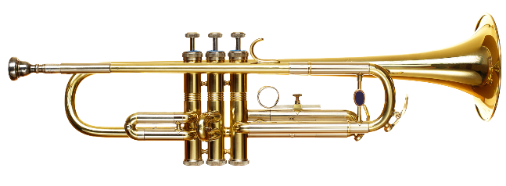  Trumpet 1 | Trumpet 2
Trumpet 3 | Trumpet 4
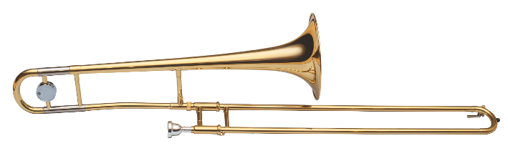  Trombone 1 | Trombone 2
Trombone 3 | Trombone 4
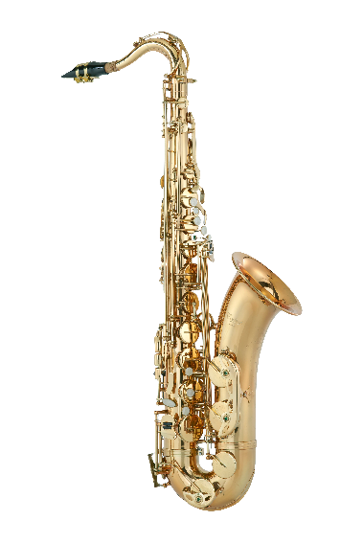  Tenor saxophone 1 | Tenor saxophone 2
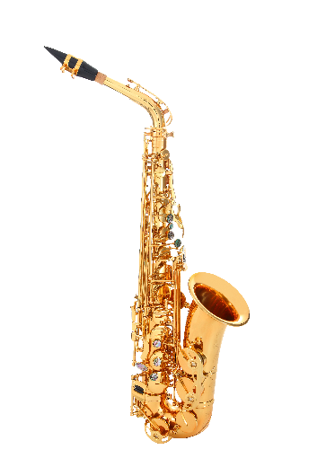  Alto saxophone 1 | Alto saxophone 2
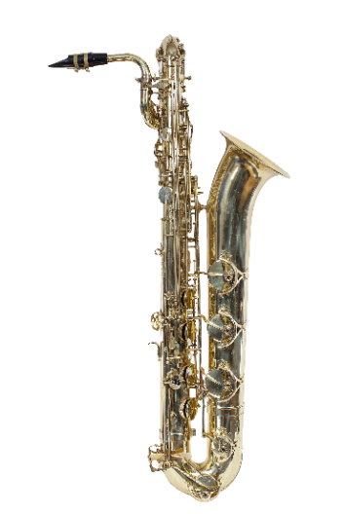  Baritone saxophone | 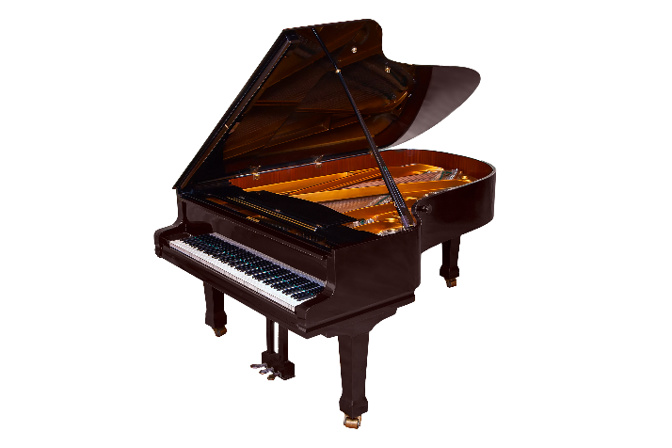  Piano
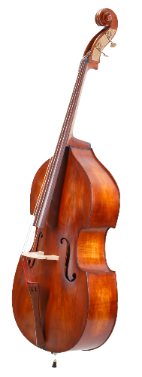  Double bass | 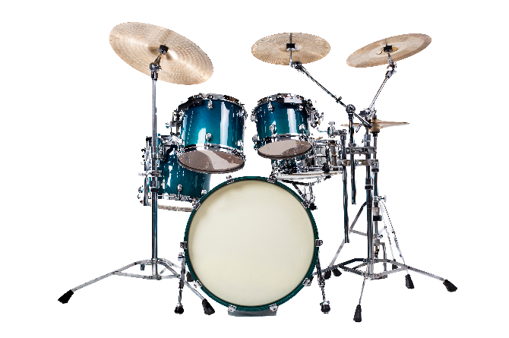  Drumkit
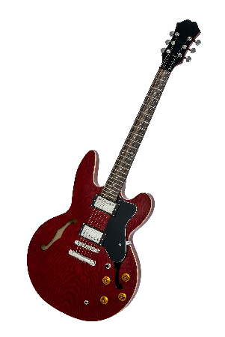
Electric guitar
For ‘Activity 3.1 – the jazz orchestra or big band’, the students group themselves into rhythm section, saxophones, trombones, trumpets.

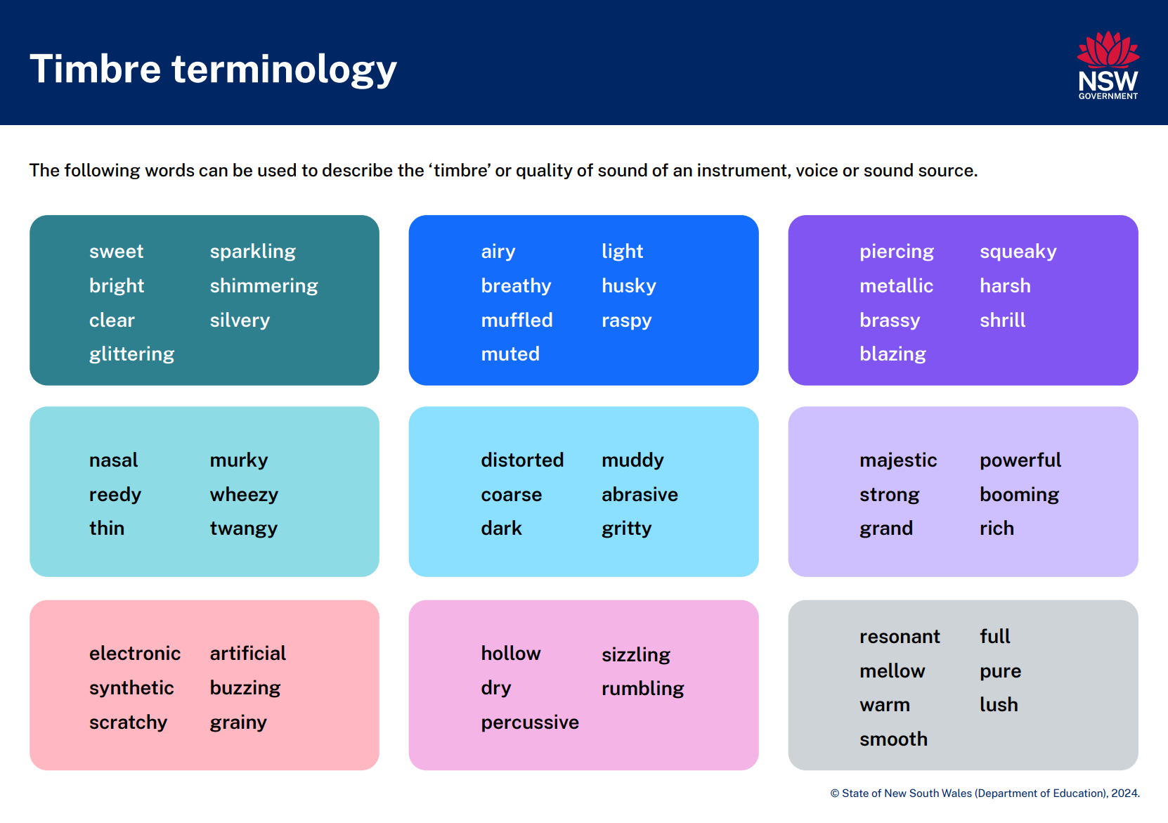
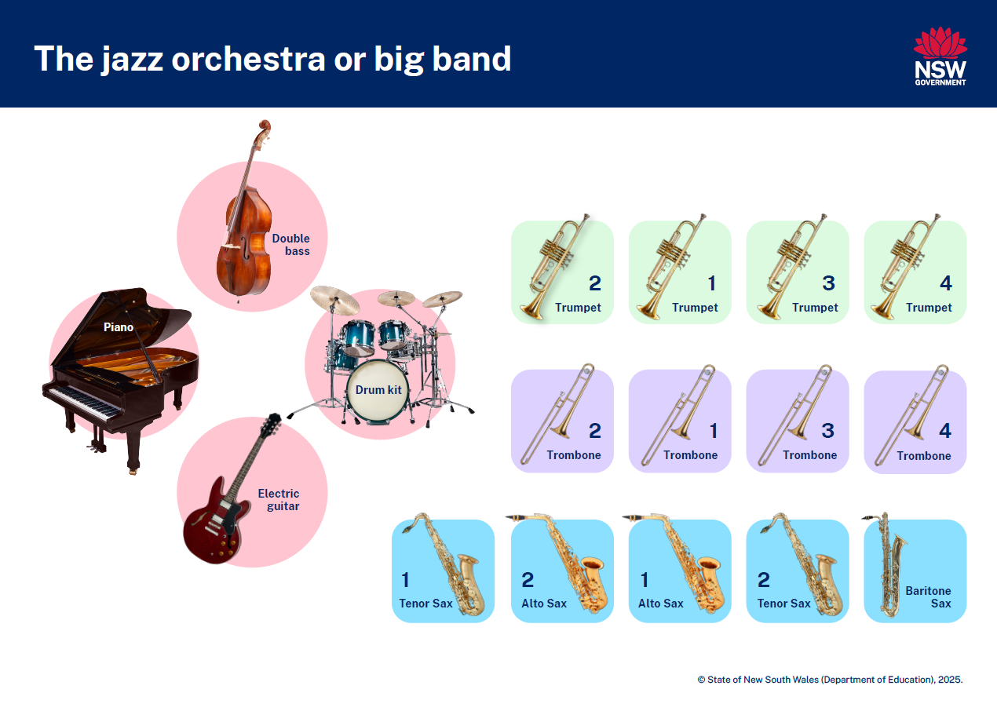

Answer sheet – the jazz orchestra or big band
Access Take the A Train – The Jazz Ambassadors (2:46) by Duke Ellington and answer the following questions.
- Did you identify the band line up correctly? Draw the big band layout and label each instrument. See the graphic on the previous page
- What is the time signature and tempo of this piece of music? ${4 \atop 4}$ time signature, fast tempo
- Which 2 instruments play in the intro? Describe what they are playing using the elements of music. Swing feel on drums, repeated 2-bar melodic motif on piano
- Identify the role of each instrument section from the top of the first head by completing the table below. Identify any new terminology and add it to your jazz music glossary.
Table 11 – Activity 3.1 – the jazz orchestra or big band instruments and roles
Instrument | Role
Saxophones | Melody
Trombones | Harmony using backing figures
Trumpets | Harmony using backing figures
Rhythm section | Harmonic and rhythmic accompaniment including walking bass, swing feel on drums, harmonic accompaniment using chords from guitar and piano. Piano plays some fills
- Which instrument provides a solo in the piece? How does the mute affect the timbre of the instrument? Refer to the timbre terminology worksheet. The trumpet provides a solo which changes the sound from bright to muffled
- Describe how the melody is played differently at the end of the piece after the trumpet solo. Which elements of music have been manipulated and how? The dynamics become softer over the course of the melody which is aided by the use of mutes and light articulation creating a breathy timbre

Activity 3.2 – elements of swing

Answer sheet

Walking bass line
Refer to ‘Activity 3.2 – elements of swing’ in the PowerPoint to learn about the walking bass.
Walking bass lines are common in swing jazz. Every crotchet is played, with the pitches of each note outlining the root notes of the chord progression with scale or chord tone movement in-between. An example has been provided below.
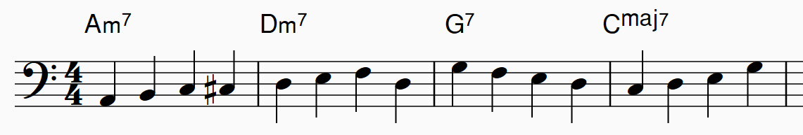
Listen to this bass line played by your teacher and answer the following questions.
- How would you describe the pitch contour? Ascending and descending, in a wave contour
- What is the register of a walking bass line? Low/very low
- Describe the rhythm. Repeated crotchets

Activity 3.3 – melodic interpretation

Answer sheet
In this activity, excerpts of various melodic interpretations of ‘Fly Me to the Moon’ by Bart Howard will be played. Analyse and compare the opening melody of these 3 versions with reference to the elements of music.
- Fly me To The Moon (2008 Remastered) (2:27) by Frank Sinatra (from 0:00–0:38). Swing introduction from drums; walking bass line; full toned baritone with legato phrasing and expressive pitch bends; jagged vocal phrasing with syncopation; guitar chords; flute countermelody
- Diana Krall – Fly Me To The Moon (Quartet Performances, Las Vegas) (2:03) (from 0:00–0:34). Piano chords introduction; faster tempo swing, more exaggerated vocal projection with heavy syncopation and variety; walking bass line; drums swing with wire brush on snare drum, guitar chords syncopated, use of melisma on the final word ‘me–e–e–ee’
- FLY ME TO THE MOON 2020 Version | Evangelion Finally (4:38) (from 0:26–1:33). Bossa nova rhythms; twangy vocals; mix of detached and legato vocal phrasing with syncopation; long string chords provide accompaniment
Conclusion – it is very common for jazz melodies and rhythms from songs and compositions to be reinterpreted. Usually there is a sense that these variations are improvised.

Learning sequence 5 – swing musical features

Activity 5.2 – score scavenger hunt worksheet
Access the Jazz – full performance (5:34) video and pages 1 to 3 of the score for ‘Until My Life’s a Song’ and follow along with the score while listening. Using a highlighter and a pen, identify, highlight and label on the score, one example of each of the musical features listed in the table below.
Table 12 – Activity 5.2 – score scavenger hunt
Music symbol or term | Check
clefs including treble clef, bass clef and percussion clef | ☐
time signature including its definition | ☐
key signature | ☐
chord symbols | ☐
extended chords | ☐
repeat sign | ☐
syncopation | ☐
melody | ☐
backing figures | ☐
unison | ☐
comping | ☐
swing beat | ☐
articulations such as accent, staccato | ☐
all dynamics found on the score – identify their name and definition | ☐
What jazz swing musical features are evident in this score excerpt? Identify these on the score.

Answer sheet
Please refer to the next page for the answers to labelling the score.
What jazz swing musical features are evident in this score excerpt? Identify these on the score. Swing beat, extended chords, comping, backing figures, syncopation, sfz

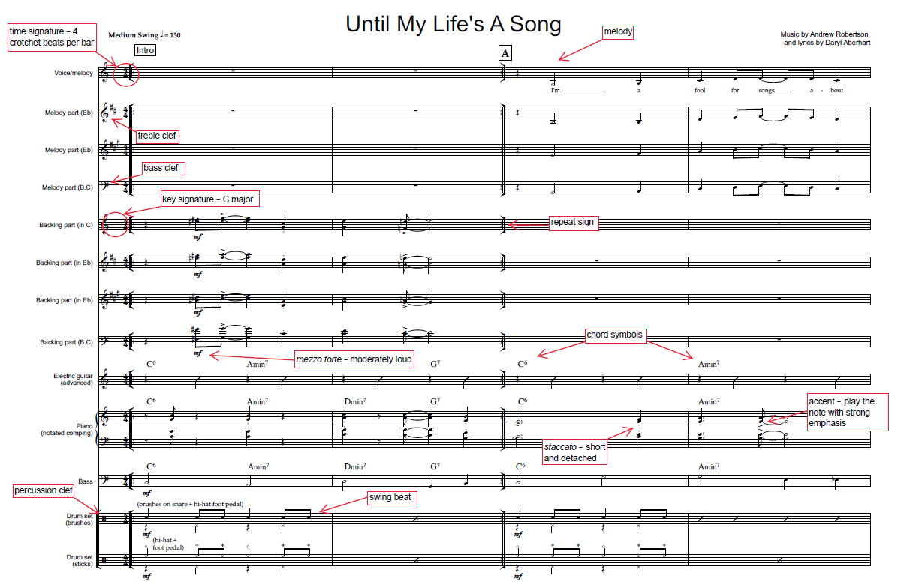
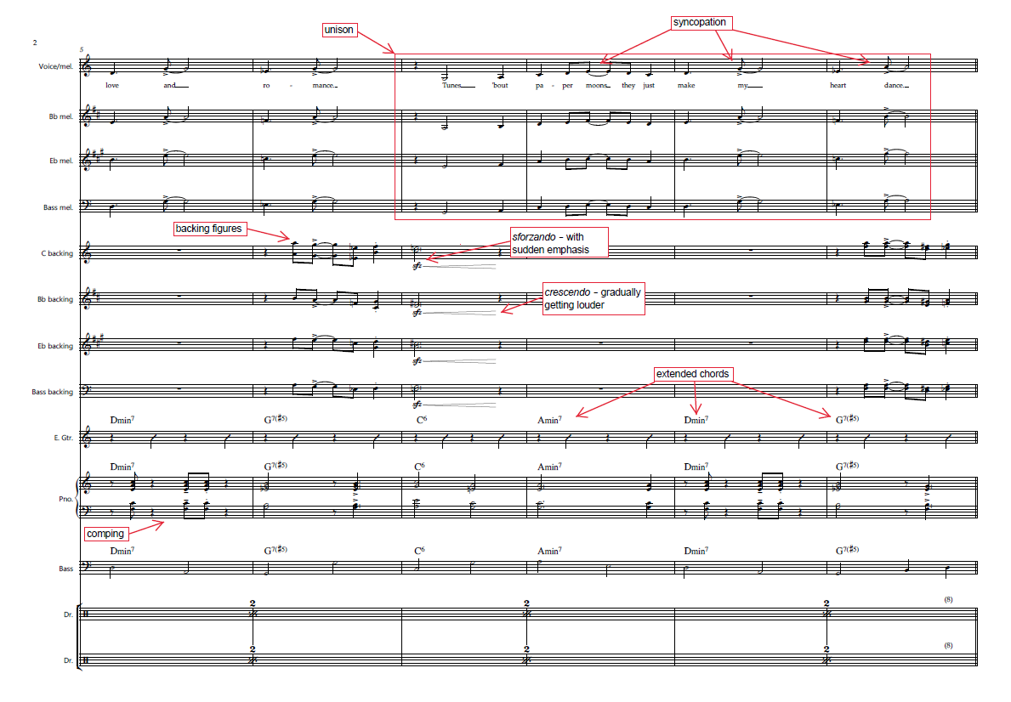

Activity 5.3 – Who am I? – performing media in jazz worksheet
Access In The Mood | America’s Big Band, The Jazz Ambassadors (3:05) and identify the performing media and associated features by completing the table below.
Table 13 – Activity 5.3 – Who am I? – performing media in jazz
Image and name | Role in jazz | Timbres | How is the instrument played? | Describe the pitch (high/low)
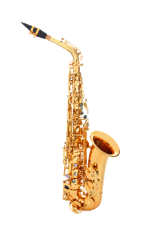
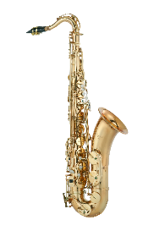
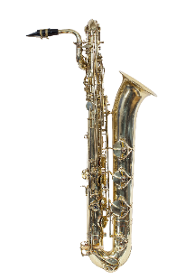
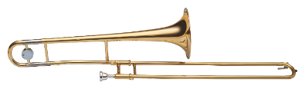
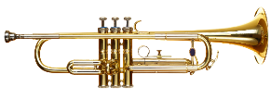
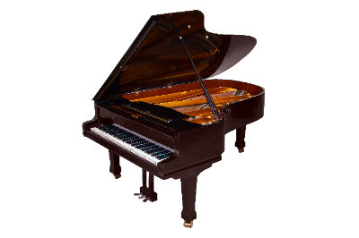
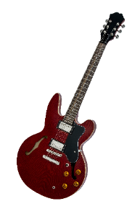
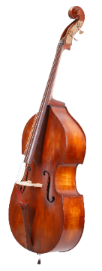
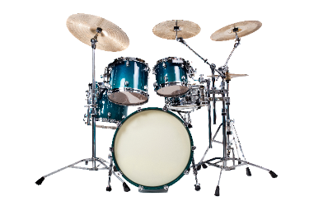

Answer sheet
Access In The Mood | America’s Big Band, The Jazz Ambassadors (3:05) and identify the performing media and associated features by completing the table below.
Table 14 – Activity 5.3 – Who am I? – performing media in jazz answers
Image and name | Role in jazz | Timbres | How is the instrument played? | Describe the pitch (high/low)
Alto saxophone | Melody, harmonic accompaniment played as backing figures or countermelodies, solo | Thin and clear | Blowing | High pitch
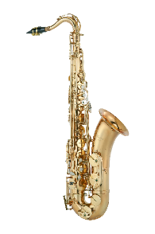  Tenor saxophone | Melody, harmonic accompaniment played as backing figures or countermelodies, solo | Mellow and husky | Blowing | Medium pitch
Baritone saxophone | Melody, harmonic accompaniment played as backing figures or countermelodies | Strong and booming | Blowing | Low pitch
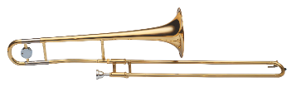  Trombone | Melody, harmonic accompaniment played as backing figures or countermelodies | Full and resonant | Blowing | Low to medium pitch
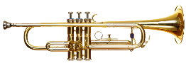  Trumpet | Melody, harmonic accompaniment played as backing figures or countermelodies, solo | Bright and brassy | Blowing | High
Piano | Harmonic accompaniment with chords and comping, fills | Bright and shimmering | Pressing | Medium to high pitch in this performance
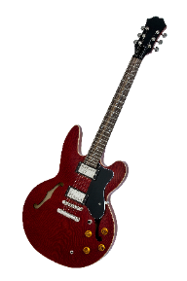  Electric guitar | Harmonic and rhythmic accompaniment with chords and comping | Twangy and muted | Strumming | Medium pitch
Double bass | Harmonic and rhythmic accompaniment, walking bass line | Warm and smooth | Plucking | Low pitch
Drumkit | Rhythmic accompaniment using a swing pattern, fills | Percussive and metallic | Hitting | N/A

Activity 5.3 – Who am I? – performing media in jazz

Who am I?
Teacher note: read out these ‘Who am I?’ descriptions for the students to complete activity 5.3.
Table 15 – Activity 5.3 – Who am I?
Who am I? | Instrument
I am made of metal. The sound is produced by blowing. There are 4 of us in a big band line up. I often play melodies and also play solos. My sound is high pitched. | Trumpet
I have lots of keys. I am part of the woodwind family. There is only one of me in the big band. I often play harmonies and backing figures. My sound is low pitched. | Baritone saxophone
I play lots of fills. I maintain the tempo by playing a swing pattern. I sometimes use a technique called ‘feathering’. The sound is produced by hitting, using sticks or brushes. | Drum kit
I have a low pitch. I play backing figures and melodies and also play solos. There are 4 of us in a big band line up. I use a slide to change the pitch of my sound. The sound is produced by blowing. | Trombone
I am a member of the rhythm section. I play chordal accompaniment with comping. I am an electric instrument. I have 6 strings. | Electric guitar

Learning sequence 6 – funk

Activity 6.1 – What is funk?

Answer sheet
Access the following excerpts and as a class. Discuss which musical features make these examples different to the swing style of jazz. Consider elements and features such as groove, performing media, texture and rhythm.
- Herbie Hancock – Chameleon (Live at Montreux Jazz Festival 2010) (6:07) (from 0:00–1:37). Keytar synth, bass, electric guitar, drums, additional synth, ${4 \atop 4}$ time, straight groove, extended chords, short articulations, funky bass line, comping
- Dirty Loops – ‘Living for the City’ (Stevie Wonder cover) (5:08) (from 0:00–0:42). ${4 \atop 4}$ time, 2-bar vamp and funky bass line, extended chords, comping on keys, straight groove on drums, short articulations, vocals, bass, drums
- Emma Donovan and the Putbacks – ‘Out The Door’ (Live at Triple R) (3:04) (from 0:00–0:55). ${4 \atop 4}$ time, 16th groove, synths, electric guitar, bass, vocals, drums, congas, extended chords, unison riffs
- VULFPECK /// Funky Duck (2:14) (from 0:00–1:03). ${4 \atop 4}$ time, synthesizers, bass, vocals, backing vocals, 16th groove, congas
- Flashlight (5:47) by Parliament (from 0:00–1:13). Synthesizers, guitar, bass line, funky bass, vocals and backing vocals, 2 bar vamp, hand claps
- Snarky Puppy - What About Me? (Alternate Take) [We Like It Here (Remixed + Remastered + Reimagined)] (7:07) (from 0:00–0:47). Guitars, bass, drums, vamp, bass, extended chords, synths, 16th groove, short articulations, horns
- Mark Ronson – Uptown Funk (Official Video) ft. Bruno Mars (4:30) ${4 \atop 4}$, vocals, backing vocals, drums, electric guitar, synth bass, synthesizer, horns, 16th note groove, short articulations, syncopations, comping
- Jamiroquai – Canned Heat (3:53) (from 0:10–1:08). Extended chords, electric guitar, synth, bass, drums, vocals, synth strings, comping, 16th groove, short note values, syncopation
- James Brown – I Got You (I Feel Good) (Visualizer) (2:46). ${4 \atop 4}$ time, straight 8ths feel, syncopation, guitar comping, funky bass line, vocals, drums, guitar, bass, horns
What are the common musical features across these examples that could be defined as ‘funk musical characteristics?’ 16th (semiquaver) groove, ${4 \atop 4}$ time, moderate – fast tempo, syncopation, comping, often based on a vamp, strong, syncopated bass line, impro (solos), rhythm section is expanded to include synthesizers, backing vocals and/or horns provide harmonised backing figures, extended chords (7ths), strong downbeat, strummed guitar patterns

Activity 6.2 – funk stations
Teacher note: distribute the funk stations instructions on the following pages to each group:

Funk station 1 – 16th note (semiquaver) groove
Each person in your group will need a pair of drum sticks for this activity.
Access the ‘16th note (semiquaver) grooves’ score, ‘Funk rhythms’ score and Funk – drums demo (2:56) video, and learn the first 16th note (semiquaver) groove and/or 8th note groove using table drumming or chair drumming.
Have one student continue the 16th note groove to keep the beat. Using call and response with your teacher or someone in your group, improvise 2-bar rhythms and/or perform the following funk rhythms provided on the ‘Funk rhythms’ score.

Funk station 2 – syncopation
Syncopation involves playing rhythms and/or accents on weak beats or subdivisions. In funk music, this is typically seen using rests placed on the beat or accents placed on notes off the beat.
Clap the following syncopated rhythmic pattern.
Create a 2-bar syncopated rhythm in ${4 \atop 4}$ time using any combination of crotchets, quavers and semiquavers and their rests, using the rhythm cards provided by your teacher as a stimulus. Remember each card represents one beat of rhythm and you need 8 beats in total. Once you have composed your rhythm, clap it through with a peer while keeping a steady beat.

Rhythm cards
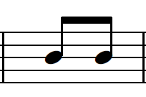 | 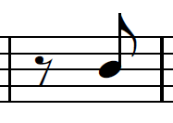 | 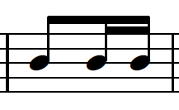 | 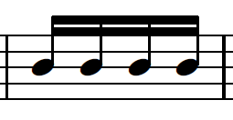
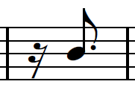 | 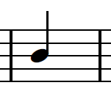 | 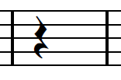 | 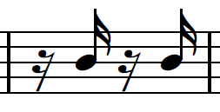
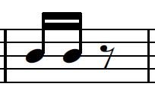 | 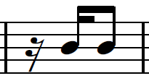 | 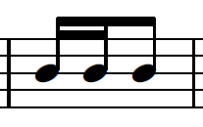 | 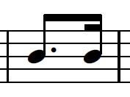

Funk station 3 – vamp
In funk music, a vamp is a repeated musical sequence, often represented as a short chord progression which provides a rhythmic and harmonic foundation for a song. A vamp usually contains 1 to 2 extended chords played across 2 bars, repeated. Examples have been provided below.
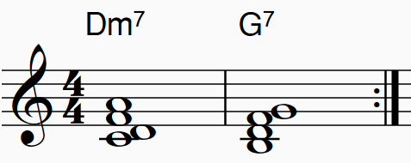
or
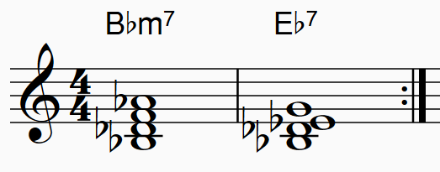
Using guitars or keyboards, play one of the vamps above and improvise the rhythm by comping, using short, syncopated rhythms. One person in the group may like to play a 16th note groove to keep the beat for the group. This can also be done as a round robin where each person in the group takes turns to comp for 4 bars.
Extension: create your own vamp using 2 extended chords.

Funk station 4 – strong, syncopated bass line
The strong, syncopated bass line is one of the most important and prominent features of the funk style. The role of the bass is harmonic and rhythmic, and is used to emphasise repeated patterns, establish the groove, and can include extended techniques such as popping or slapping.
Using bass, keyboards or an instrument of your choice, perform the bass line taken from Herbie Hancock – Chameleon (Live at Montreux Jazz Festival 2010) (6:07). You may like to use one of the following tutorials for either bass or keyboard.
- A bass line tutorial can be found at: CHAMELEON (Herbie Hancock) How to Play Bass Groove Cover with Score & Tab Lesson (1:06)
- A keyboard tutorial can be found at: How To Play Chameleon By Herbie Hancock On Piano - Piano Tutorial (Part 1) (4:01) (from 0:55–4:01). If using a keyboard, you may like to choose an appropriate bass synth sound.

Activity 6.3 – ‘Chameleon’ by Herbie Hancock

Answer sheet
Access Herbie Hancock – Chameleon (Live at Montreux Jazz Festival 2010) (6:07) and answer the following questions.
- What instrument plays the main riff at the beginning of the song? Keytar (synthesizer)
- What makes the bass line in ‘Chameleon’ so memorable or distinctive? How does it contribute to the overall feel of the song? Repetition of the 2-bar riff in both the macro and micro structure, the 2 one bar motifs that make up the riff start with chromatic movement and use a repeated rhythm, the rhythm is syncopated and catchy, the riff is doubled by bass and keytar. These features contribute to the funk feel and provide momentum
- Describe what the other instruments in the rhythm section are playing in the opening of ‘Chameleon’ (from 0:00–0:50). The drum kit plays a funk groove providing rhythmic accompaniment with a sharp, percussive timbre; the electric guitar provides harmonic and rhythmic accompaniment by comping a vamp with a syncopated rhythm and wah wah sound; the bass begins with an improvised solo before doubling the riff using a clear, rounded timbre
- Outline the structure of the song. Intro (riff with bass solo), head (A), solo (keytar), outro
- What are some characteristics of jazz improvisation you can hear in the keytar solo? Use of modes, repeated rhythms, syncopation, expressive techniques such as accents, doits, pitch bending using digital manipulation, responsive ensemble playing through unison figures, call and response motifs and dynamics, consideration of the structure and climax points
Access Herbie Hancock – Chameleon (Live Loop Cover) | Minilab 3 (2:30) and identify the 8 layers as they enter. Name each layer and describe what it is playing. Notate the pattern for each part using either traditional notation or graphic notation. An example can be found on the next page.

Activity 6.3 – ‘Chameleon’ by Herbie Hancock worksheet
Access Herbie Hancock – Chameleon (Live Loop Cover) | Minilab 3 (2:30). Identify the order in which in the 8 layers of sound enter by numbering them in the table provided. Notate the pattern for the bass synth and synth melody using graphic notation or traditional notation.
Table 16 – Activity 6.3 – 'Chameleon' loop cover listening activity
Entry of layer | Name and role of layer | Notation
 | Drums (kick and snare) – rhythmic accompaniment
 | Synth chords 3 – harmonic acc.
 | Synth countermelody – harmonic acc.
 | Bass synth – main riff
 | Synth chords 1 – harmonic acc.
 | Synth melody
 | Drums (hit hat) – rhythmic acc. | 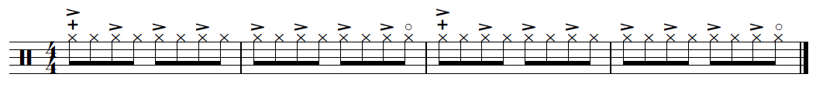
 | Synth chords 2 – harmonic acc.

Answer sheet
Table 17 – Activity 6.3 – ‘Chameleon’ loop cover listening activity answers
Entry of layer | Name and role of layer | Notation
2 | Drums (kick and snare) – rhythmic accompaniment
7 | Synth chords 3 – harmonic acc.
4 | Synth countermelody
1 | Bass synth – main riff | ‘Chameleon’ by Herbie Hancock score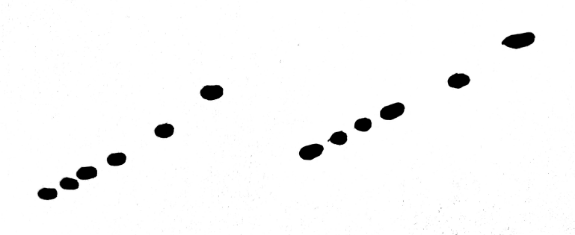
5 | Synth chords 1 – harmonic acc.
8 | Synth melody | ‘Chameleon’ by Herbie Hancock score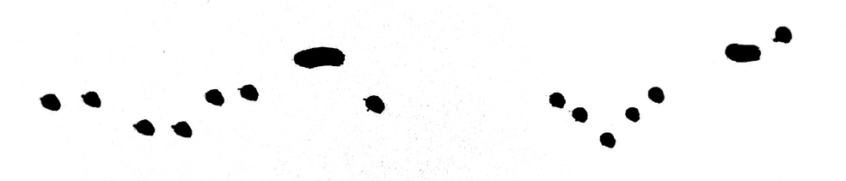
3 | Drums (hit hat) – rhythmic acc.
6 | Synth chords 2 – harmonic acc.

Learning sequence 8 – improvise, rehearse and refine

Activity 8.2 – score scavenger hunt worksheet
Access the Funk – full performance (4:20) video and pages 1 to 3 of the score for ‘Look What The Cat Dragged In’ and follow along with the score while listening. Using a highlighter and a pen, identify, highlight and label on the score, one example of each of the musical features listed in the table below:
Table 18 – Activity 8.2 – score scavenger hunt
Music symbol or term | Check
clefs including treble clef, bass clef and percussion clef | ☐
time signature including its definition | ☐
key signature | ☐
chord symbols | ☐
extended chords | ☐
repeat sign | ☐
syncopation | ☐
melody | ☐
unison | ☐
comping | ☐
16th note (semiquaver) groove | ☐
funky bass line | ☐
articulations and expressive techniques – identify their name and definition | ☐
all dynamics found on the score – identify their name and definition | ☐

Answer sheet
Identify the funk musical features found in this score excerpt. 16th note (semiquaver) groove, ${4 \atop 4}$ time, funky bass line, syncopation, vamp, extended chords, staccato and accent articulation
Please refer to the next page for the answers to labelling the score.

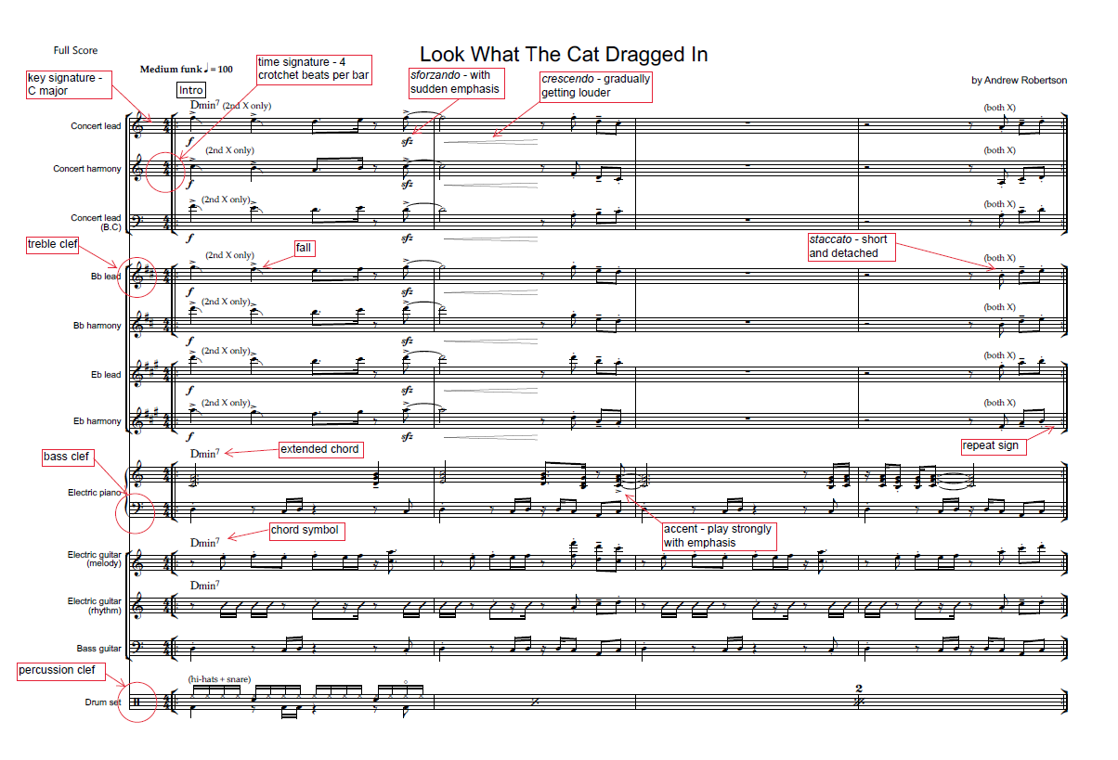
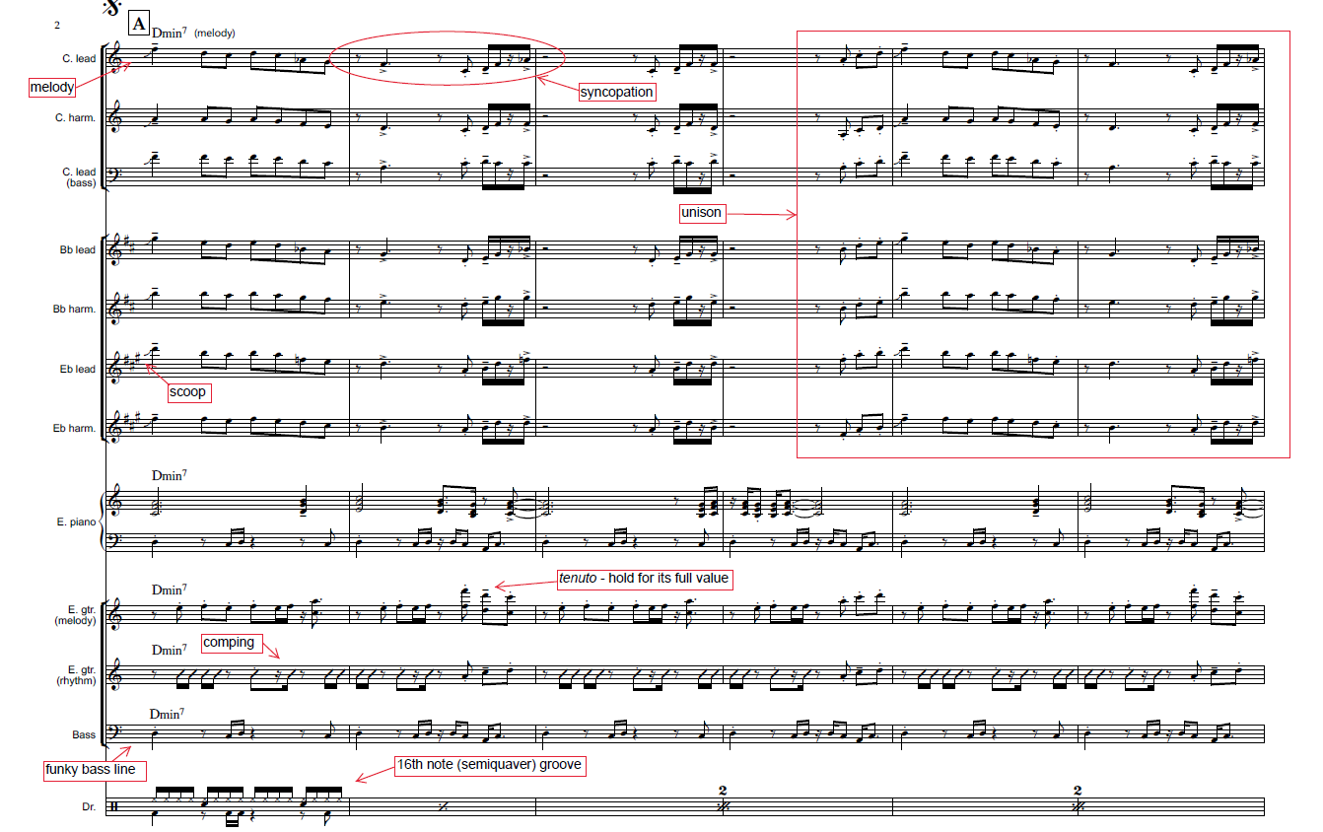

Learning sequence 9 – assessment preparation

Activity 9.2 – peer feedback

Whole group feedback
Table 19 – peer feedback – whole group feedback
Plus | Minus | Interesting

Activity 9.2 – peer feedback – Two stars and a wish

Individual feedback
Table 20 – peer feedback – Two stars and a wish
Something that is going well | Something that is not going well | Something to improve on

References
This resource contains NSW Curriculum and syllabus content. The NSW Curriculum is developed by the NSW Education Standards Authority. This content is prepared by NESA for and on behalf of the Crown in right of the State of New South Wales. The material is protected by Crown copyright.
Please refer to the NESA Copyright Disclaimer for more information https://educationstandards.nsw.edu.au/wps/portal/nesa/mini-footer/copyright.
NESA holds the only official and up-to-date versions of the NSW Curriculum and syllabus documents. Please visit the NSW Education Standards Authority (NESA) website https://educationstandards.nsw.edu.au and the NSW Curriculum website https://curriculum.nsw.edu.au.
Music 7–10 Syllabus © NSW Education Standards Authority (NESA) for and on behalf of the Crown in right of the State of New South Wales, 2024.
Hancock H (2020) ‘Chameleon’ [score], The Real Book of Jazz, AriaMus.
Brown J (4 March 2023) ‘James Brown – I Got You (I Feel Good) (Visualizer)’ [video], James Brown, YouTube, accessed 13 May 2025.
Brubeck D (24 November 2018) ‘Desmond: Take Five | The Dave Brubeck Quartet, Live in Germany 1966’ [video], Dave Brubeck, YouTube, accessed 30 June 2025.
Chris P (10 November 2022) ‘Veronica Swift – Moanin'’ [video], Chris P, YouTube, accessed 13 May 2025.
Dirty Loops (2 November 2024) ‘Dirty Loops – Living For The City (Stevie Wonder Cover)’ [video], Dirty Loops, YouTube, accessed 13 May 2025.
esqueletolavrador (22 December 2024) ‘João Gilberto – Garota de Ipanema (Alemanha, 1967)’ [video], esqueletolavrador, YouTube, accessed 13 May 2025.
Galante A (18 May 2013) ‘14 year old Adrian Galante sits in with James Morrison, Emma Pask and WASO 2011 Mack the knife’ [video], Adrian Galante, YouTube, accessed 13 May 2025.
GroundUP Music NYC (25 February 2014) ‘Snarky Puppy – What About Me? (We Like It Here)’ [video], GroundUP Music NYC, YouTube, accessed13 May 2025.
GroundUP Music NYC (6 December 2024) ‘Snarky Puppy – What About Me? (Alternate Take) [We Like It Here (Remixed + Remastered + Reimagined)]’ [video], GroundUP Music NYC, YouTube, accessed 13 May 2025.
Hot Potato Band (7 May 2023) ‘Hot Potato Band – LIVE from Woodford Folk Festival (December 2022)’ [video], Hot Potato Band, YouTube, accessed 13 May 2025.
Jamiroquai (21 December 2010) ‘Jamiroquai – Canned Heat (Official Video)’ [video], Jamiroquai Official, YouTube, accessed 13 May 2025.
Krall D (24 November 2009) ‘Diana Krall – Fly Me To The Moon (Quartet Performances, Las Vegas)’ [video], Diana Krall, YouTube, accessed 13 May 2025.
Laufey (2 January 2025) ‘Laufey – From The Start (Live From Dick Clark’s New Year’s Rockin’ Eve 2024)’ [video], Laufey, YouTube, accessed 13 May 2025.
Milan Records USA (16 March 2023) ‘FLY ME TO THE MOON 2020 Version | Evangelion Finally’ [video], Milan Records USA, YouTube, accessed 30 June 2025.
Montreux Jazz Festival (20 July 2013) ‘Herbie Hancock – Chameleon (Live at Montreux Jazz Festival 2010)’ [video], Montreux Jazz Festival, YouTube, accessed 30 June 2025.
MunomaMusic (23 March 2024) ‘Herbie Hancock – Chameleon (Live Loop Cover) | Minilab 3’ [video], MunomaMusic, YouTube, accessed 30 June 2025.
muzline (11 January 2016) ‘Esperanza Spalding performing “On The Sunny Side Of The Street” (2016)’ [video], muzline, YouTube, accessed 13 May 2025.
Parliament – Topic (5 September 2018) ‘Flash Light’ [video], Parliament – Topic, YouTube, accessed 13 May 2025.
Phoenix Central Park (11 November 2021) ‘Zela Margossian Quintet (Live) | #PhoenixHALO’ [video], Phoenix Central Park, YouTube, accessed 13 May 2025.
PostmodernJukebox (22 January 2016) ‘Love Yourself – Vintage 1929 Postmodern Jukebox Justin Bieber Cover ft. Sara Niemietz’ [video], PostmodernJukebox, YouTube, accessed 13 May 2025.
Ronson M (20 November 2014) ‘Mark Ronson – Uptown Funk (Official Video) ft. Bruno Mars’ [video], Mark Ronson, YouTube, accessed 13 May 2025.
Sinatra F (12 December 2018) ‘Fly Me To The Moon (2008 Remastered)’ [video], Frank Sinatra, YouTube, accessed 13 May 2025.
The Ed Sullivan Show (27 June 2020) ‘Ella Fitzgerald and Duke Ellington “It Don't Mean A Thing (If It Ain't Got That Swing)”’ [video], The Ed Sullivan Show, YouTube, accessed 13 May 2025.
The Ed Sullivan Show (25 April 2021) ‘Louis Armstrong “When The Saints Go Marching In” on The Ed Sullivan Show’ [video], The Ed Sullivan Show, YouTube, accessed 13 May 2025.
The United States Army Field Band (22 April 2021) ‘In The Mood | America's Big Band, The Jazz Ambassadors’ [video], The United States Army Field Band, YouTube, accessed 13 May 2025.
The United States Army Field Band (12 August 2021) ‘Take the A Train – The Jazz Ambassadors’ [video], The United States Army Field Band, YouTube, accessed 13 May 2025.
Triple R 102.7FM (27 January 2023) ‘Emma Donovan and The Putbacks – “Out The Door” (Live at Triple R)’ [video], Triple R 102.7FM, YouTube, accessed 13 May 2025.
Trouw E (2 September 2016) ‘The Girl from Ipanema – Stan Getz & Astrud Gilberto (Cover by Elise)’ [video], Elise Trouw, YouTube, accessed 13 May 2025.
vidgam (15 June 2019) ‘Neon Genesis Evangelion – FLY ME TO THE MOON – CLAIRE (ED Ending Full NGE OST Soundtrack Lyrics)’ [video], vidgam, YouTube, accessed 13 May 2025.
Vulf (10 October 2015) ‘VULFPECK /// Funky Duck’ [video], Vulf, YouTube, accessed 13 May 2025.
WDR BIG BAND (24 June 2015) ‘Michel Camilo feat. by WDR Big Band – And Sammy Walked In’ [video], WDR BIG BAND, YouTube, accessed 13 May 2025.

© State of New South Wales (Department of Education), 2025
The copyright material published in this resource is subject to the Copyright Act 1968 (Cth) and is owned by the NSW Department of Education or, where indicated, by a party other than the NSW Department of Education (third-party material).
Copyright material available in this resource and owned by the NSW Department of Education is licensed under a Creative Commons Attribution 4.0 International (CC BY 4.0) license.

This license allows you to share and adapt the material for any purpose, even commercially.
Attribution should be given to © State of New South Wales (Department of Education), 2025.
Material in this resource not available under a Creative Commons license:
- the NSW Department of Education logo, other logos and trademark-protected material
- material owned by a third party that has been reproduced with permission. You will need to obtain permission from the third party to reuse its material.
Links to third-party material and websites
Please note that the provided (reading/viewing material/list/links/texts) are a suggestion only and implies no endorsement, by the New South Wales Department of Education, of any author, publisher, or book title. School principals and teachers are best placed to assess the suitability of resources that would complement the curriculum and reflect the needs and interests of their students.
If you use the links provided in this document to access a third-party's website, you acknowledge that the terms of use, including licence terms set out on the third-party's website apply to the use which may be made of the materials on that third-party website or where permitted by the Copyright Act 1968 (Cth). The department accepts no responsibility for content on third-party websites.

