Dance Stage 5 (Year 10) – student resource booklet
Dance through the lens – Composition and Appreciation

Contents
Learning sequence 1 – Appreciation – the context of dance film 3
Activity 1.1d – What did you notice? 3
Activity 1.2b – the history of dance film – William Forsythe 4
Activity 1.2b – the history of dance film research activity 5
Learning sequence 2 – Composition – from stimuli to capturing motif(s) and phrase(s) 6
Activity 2.3c – filming and editing in practise activity 6
Activity 2.5b – exploring stimuli to develop an intent 8
Activity 2.5d – from idea to intent 9
Activity 2.5e – exploring the intent through dance film 10
Activity 2.7c – elements of dance 11
Activity 2.7g – process of abstraction to develop a motif 12
Learning sequence 3 – Composition – structuring the dance film 14
Activity 3.1d – planning and structuring sentences 14
Activity 3.2b – peer activity and reflection and refinement 15
Activity 3.2c – evaluating structure – sequencing it all together 18
Activity 3.5d – storyboard template and tips 19
Learning sequence 4 – Composition – editing the dance film 20
Activity 4.1a – structuring the dance 20
Determine a structure for your dance film 20
Activity 4.5a – reflect on the manipulation of space, time and dynamics 21
Space 21
Time 21
Dynamics 21
Learning sequence 5 – Appreciation – analysing dance on film 22
Activity 5.1b – Somebody That I Used To Know 22
Activity 5.2a – film versus live performance 23
Activity 5.3b – debate structure 27
Activity 5.5b – strengthening your dance language 28
Verbs – action and evaluation words 28
Adverbs – how movements are performed 29
Adjectives – describing words 30
Impact words – audience response and the choreographer’s intent 31
Activity 5.5g – PEEL paragraph example 32
Activity 5.5l (Task 2) – writing independently – ‘you do’ – space analysis table 33
Activity 5.5l (Task 3) – writing independently – ‘you do’ – space analysis developing sentences 34
Activity 5.5l (Task 4) – writing independently – ‘you do’ – PEEL paragraph scaffold 35
Activity 5.7e – essay scaffold 36
References 37

Learning sequence 1 – Appreciation – the context of dance film

Activity 1.1d – What did you notice?
- Access slides 1.1c and view 3 sample dance films.
- Record your detailed observations and key insights in the table below.
Type of dance film | What did you notice about the movement? | What did you notice about the filming? | What did you notice about the editing? | Does the dance film communicate any ideas?

Activity 1.2b – the history of dance film – William Forsythe
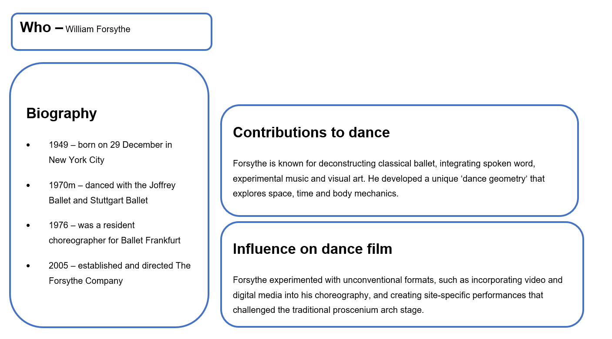
‘William Forsythe’ by KCBalletMedia is licensed under CC BY 2.0.

Activity 1.2b – the history of dance film research activity
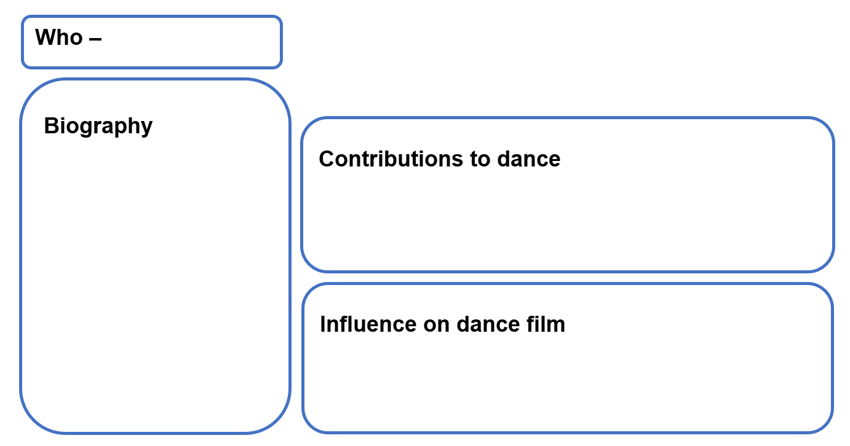
Note: remember to include images and videos to illustrate your findings.

Learning sequence 2 – Composition – from stimuli to capturing motif(s) and phrase(s)

Activity 2.3c – filming and editing in practise activity
After taking part in the practical activity, complete the following reflection questions.
- How did you develop your short phrase as a class using Forsythe as a stimulus? Consider your own training and how this has influenced your own choreographic style.
- What 2 angles did you edit together? What was the impact on the movement that was filmed?
- What 2 angles did your partner use? How did this enhance or alter your movement?
- How did you edit your footage together? Were the cuts successful?
- What angles and edits did you like most and why?

Activity 2.5b – exploring stimuli to develop an intent
Using your selected ideational stimulus, explore and research your ideas. Represent your ideas through visual, tactile or auditory stimuli to extend your ideas. Record this below.

Activity 2.5d – from idea to intent
- Write your intent in one clear, concise sentence that summarises the main idea or message of your dance film.

Activity 2.5e – exploring the intent through dance film
Use the spider map provided to guide your brainstorming and help you organise your ideas.
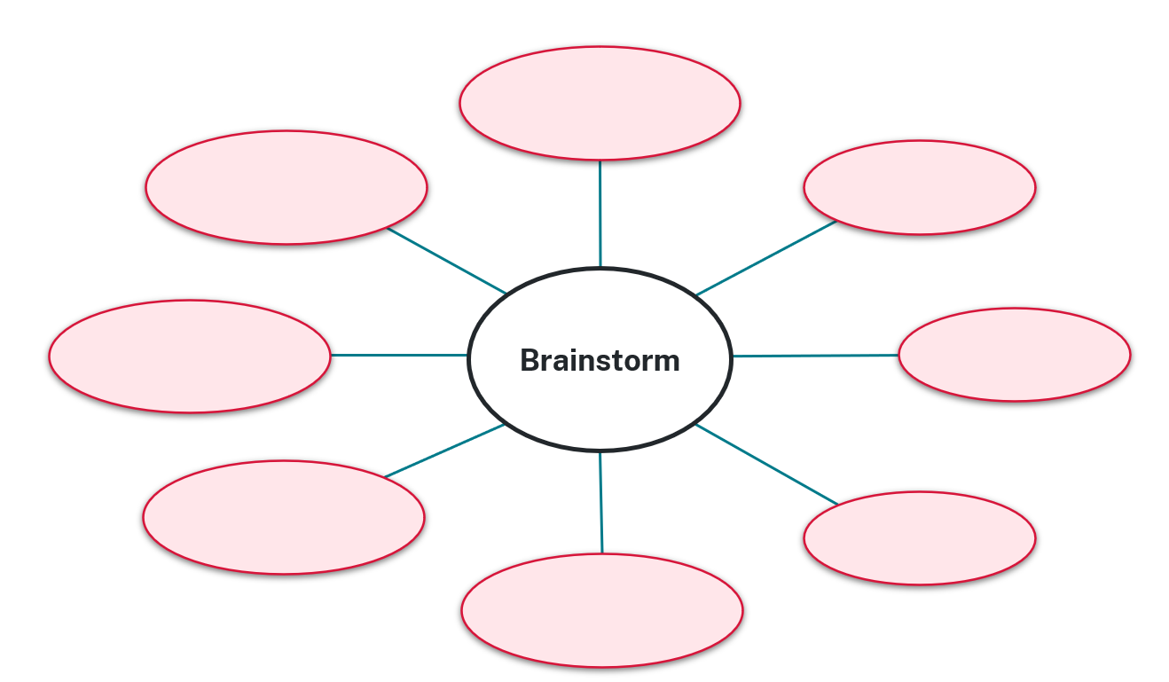

Activity 2.7c – elements of dance
To assist you in communicating your intent, brainstorm ways to manipulate the elements of dance so that your idea is clear and develops.
- How will you manipulate space to communicate your intent? Consider shape, dimensions, level and direction.
- How will you manipulate time to communicate your intent? Consider tempo, rhythm, accents and stillness.
- How will you manipulate dynamics to communicate your intent? Consider the qualities of movement and use of weight.

Activity 2.7g – process of abstraction to develop a motif
- Develop a word bank in the second table below to assist you in generating movement to communicate your intent. Use the research from the previous activity to record associated words and phrases. See the example in the first table below to guide you.
Example intent: to show the cycle of rain as it falls, pools, spreads and evaporates
Start | Rising action | Climax | Falling action | Resolution
trickle | splatting | deluge | buoyant | reverse
dripping | sporadic | pool | float | suspend
falling | intermittent | ripple/wave | spread | dissolve
Your intent:
Start | Rising action | Climax | Falling action | Resolution
- What 3 movements or shapes developed during the abstraction process were the most interesting? Take a photo or sketch them below.
- What feedback did your teacher and/or peer give you based on your abstraction process?
- Which movement or shape will become your motif(s) and why?

Learning sequence 3 – Composition – structuring the dance film

Activity 3.1d – planning and structuring sentences
Complete the table below. First, write what your intent is above the table. Then, add sentences that explain what you want to communicate in your dance film. These sentences will later be turned into movement phrases to help structure and clarify your ideas before you start creating your dance. Add extra rows if you need them.
Intent:
Phrase | Sentence description

Activity 3.2b – peer activity and reflection and refinement
- When observing the dance performed by the other pair, complete the following questions. Be mindful of providing balanced, positive and constructive feedback.
After the first performance
- What did you think the dance was about? Why?
- Was your interpretation similar or different to their stated intent?
- What feedback can you offer to help them make the intent clearer?
After the second performance, while reading the table in Activity 3.1d
- Did the sentences match the phrases you observed?
- Which phrases were the clearest in communicating the sentences and why?
Consider the motif(s)
- What was the motif(s)?
- Did it change, grow, evolve or develop across each phrase?
- Did the development clearly communicate the idea behind each sentence? Explain what you observed.
- Were any phrases unclear? If yes, suggest how they could refine the movement to make the idea clearer (for example, refining motif manipulation, clarifying the use of the elements of dance.)
- After performing your dance for the other pair, complete the following questions.
Evaluate your intent
- Is your stated intent clearly communicated through your phrases?
- Has your intent evolved beyond your original statement? If yes, explain your updated intent.
Evaluate your phrases
- Do your sentences match the phrases you performed?
- Are there any phrases that did not clearly communicate the sentence they were intended to represent?
Evaluate your motif(s)
- Was your motif(s) clear and recognisable within each phrase?
- How did you use the elements of dance to change, grow or develop your motif(s) across your phrases?
Evaluate your sequencing
- Is the order of your phrases logical?
- Could your phrases be arranged into a clearer or more effective sequence?
Enacting feedback
- What feedback did you receive, and what refinements will you make to your phrases, motif(s) manipulation using the elements of dance and/or sequencing to improve the communication of your intent?

Activity 3.2c – evaluating structure – sequencing it all together
Use the timeline to experiment with the order of your movement phrases, thinking about how each phrase connects and develops your intended idea. Adjust the sequence based on the feedback you received from your peers, and make sure your sequence is logical so your overall dance clearly communicates your intent. 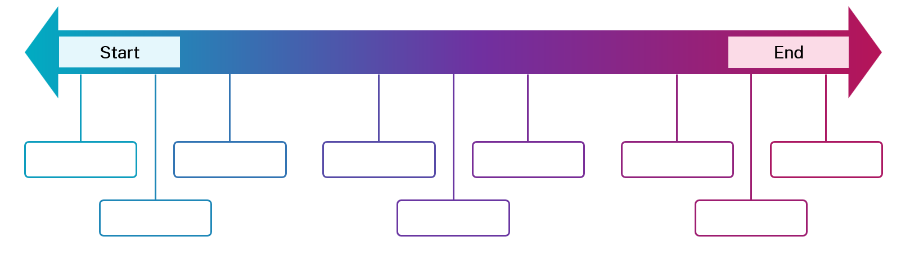

Activity 3.5d – storyboard template and tips
Project title:
Name:
Scene | Shot | Angle | Description

Learning sequence 4 – Composition – editing the dance film

Activity 4.1a – structuring the dance

Determine a structure for your dance film
- How will your dance film start?
- What happens in the middle? Is there a complication? How does the idea develop, evolve or take the viewer on a journey?
- How does the dance film end?

Activity 4.5a – reflect on the manipulation of space, time and dynamics
As you refine your dance film, consider how you have manipulated the elements of dance using filming and editing techniques. It is important that all choices are purposeful in communicating your intent.

Space
- Describe: What movement, filming or editing choice did I make?
- Interpret: How does this choice communicate my intent?
- Evaluate: How effective is this choice for the audience to understand my intent?
- Refine: What could I adjust to improve the clarity or development of my intent?

Time
- Describe: What movement, filming or editing choice did I make?
- Interpret: How does this choice communicate my intent?
- Evaluate: How effective is this choice for the audience to understand my intent?
- Refine: What could I adjust to improve the clarity or development of my intent?

Dynamics
- Describe: What movement, filming or editing choice did I make?
- Interpret: How does this choice communicate my intent?
- Evaluate: How effective is this choice for the audience to understand my intent?
- Refine: What could I adjust to improve the clarity or development of my intent?

Learning sequence 5 – Appreciation – analysing dance on film

Activity 5.1b – Somebody That I Used To Know
After learning about Sergio Reis and CDK Company, view the dance film, Somebody That I Used To Know (3:50). As you watch, complete the See, Think, Wonder activity below.
- What do you see in the dance film?
- What do you think is the choreographer’s intent?
- What do you wonder about this dance?

Activity 5.2a – film versus live performance
After viewing the film and live performance of Somebody That I Used To Know, complete the following activities.
- How does the framing of a camera in a film change your perception of specific movements or interactions between dancers? Choose a specific moment from the work to discuss.
- What are the benefits of watching a dance film? What are some drawbacks? Complete the Plus, Minus, Interesting (PMI) table below.

Plus

Minus

Interesting
- Consider the question: ‘How do the 2 different mediums influence the emotional response of the viewer? Do you feel different watching a film versus a live performance?’
- Think: take a few minutes to think quietly about the question on your own. Write down your thoughts.
- Pair: turn to your partner and share your ideas. Listen carefully to each other and build on each other’s thoughts.
- Share: join the class discussion. Be ready to share the main ideas from your pair conversation or something interesting your learned from your partner.
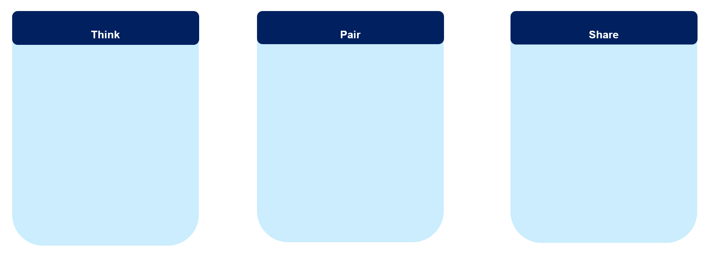
- Which medium do you prefer and why? What specific aspects influence your preference?

Activity 5.3b – debate structure
Use the table below to help you structure your debate. Ensure you find appropriate examples from the film to help support your point of view.
Structure | What to say
Opening – state your position clearly
Argument 1 – point and example
Argument 2 – point and example
Counterpoint – acknowledge and respond to the opposing team
Closing – reaffirm your team’s position with evidence

Activity 5.5b – strengthening your dance language

Verbs – action and evaluation words
balances | contracts | explores | glides | manipulates | represents | suspends
captures | contrasts | exaggerates | highlights | pivots | reveals | spirals
challenges | demonstrates | establishes | inspires | rebounds | rolls | stomps
collapses | emphasises | extends | intensifies | reaches | rotates | turns
communicates | enhances | falls | isolates | reflects | supports | twists
conveys | evokes | freezes | lunges | reinforces | suggests | weaves
In the table below are examples of verbs that can support your analysis of a dance work and help describe what movements are being performed. For example: ‘The choreographer emphasises a sense of detachment through the use of sharp, isolated gestures.’

Adverbs – how movements are performed
Use these adverbs in the table below to describe the way a dancer executes movement. For example: ‘The soloist pushes forward suddenly and defensively, extending splayed fingers with pulsating shoulders to emphasise the sadness experienced with rejection and emotional distance.’
abruptly | effortlessly | gently | mechanically | purposefully | sequentially
assertively | elegantly | gracefully | organically | rapidly | slowly
confidently | energetically | gradually | perfectly | rhythmically | smoothly
deliberately | fluidly | impulsively | precisely | restrainedly | subtly
dramatically | forcefully | intentionally | powerfully | seamlessly | vibrantly

Adjectives – describing words
Use these adjectives in the table below to explain how the movement looks or feels. For example: ‘Movement shifts between controlled and collapsing actions, creating a dynamic contrast that reflects instability in the relationship.’
abrupt | collapsing | delicate | explosive | gently | percussive | sustained
aggressive | confined | disjointed | expressive | grounded | powerful | unpredictable
angular | controlled | dynamic | fragmented | heavy | sharp | vibratory
buoyant | continuously | elastic | fluid | light | subtle | weighted

Impact words – audience response and the choreographer’s intent
Use impact words in the table below to discuss the emotional or conceptual impact of a dance and its meaning on the audience. For example: ‘The choreographer uses chaotic movements and sustained dynamic tension to reflect the unpredictability and confusion experienced in the deterioration of a relationship.’
abstraction | clarity | emotion | narrative | tension
ambiguity | complexity | harmony | mood | transformation
atmosphere | confrontation | intensity | resistance | unity
chaos | contrast | intention | symbolism | vulnerability

Activity 5.5g – PEEL paragraph example
As you read the PEEL paragraph example, use different coloured highlighters to identify and colour-code each part of the PEEL structure.
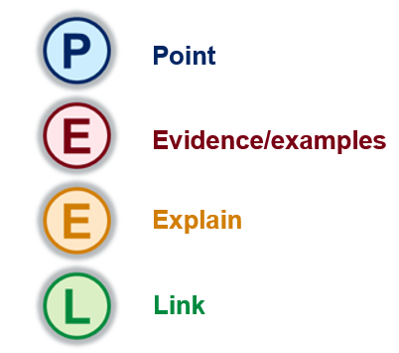
Remember, a paragraph might have more than one example or explanation, so read carefully and highlight all relevant sections. This will help you understand how to use the PEEL structure in your own writing.
PEEL paragraph example
In Somebody That I Used To Know, Reis uses the element of space through contrasting levels, shapes and the dancer’s relationship with one another in conjunction with film techniques to communicate a sense of chaos and disconnection experienced in the deterioration of a relationship. Within the opening phrases, the dancers move quickly between low and high levels, collapsing and rebounding in and out of a wide frame, conveying disorientation and confusion. Angular hands connect slowly, contrasted by a percussive breaking apart, juxtaposed by the word ‘together’ heard in the accompaniment. These contrasting choices in level and shape as they move in and out of frame emphasise the emotional turmoil experienced by the dancers, creating tension and instability that is reflective of Reis’s intent of a lack of emotional regulation when experiencing loss. Furthermore, film techniques intensify the emotional isolation experienced by the dancers. A sudden and quick close-up of the female dancer pushing the camera away with splayed fingers captures the contrast between emotional connection and disconnection, emphasised through the manipulation of the viewer as the ‘other’ in the relationship. This elicits an emotional response from the audience. The combination of these contrasting shots conveys instability and tension, creating a sense of confusion and chaos. Thus, through the manipulation of space and film techniques, Reis successfully emulates the turbulent emotions experienced in the emotional aftermath of a relationship breakdown.

Activity 5.5l (Task 2) – writing independently – ‘you do’ – space analysis table
- Independently find and view a different excerpt from Sergio Reis’s work Somebody That I Used To Know (3:50).
- Record your detailed observations and key insights using the table below.
Space component | Who (nouns: name, people, places) | What (verbs: what they are doing) | How (adjectives: describe how they are moving) | Film techniques camera angle, camera movements | Why (intent, meaning, ideas being communicated)

Activity 5.5l (Task 3) – writing independently – ‘you do’ – space analysis developing sentences
Use the words from the table above to write clear and detailed sentences using the table below.
Developing sentences prompts | Responses
Who and what
How
Camera technique(s)
Why

Activity 5.5l (Task 4) – writing independently – ‘you do’ – PEEL paragraph scaffold
Using the PEEL scaffold below, turn your sentences into a clear and connected paragraph, ensuring there is a clear Point, evidence or example, explanation and link.
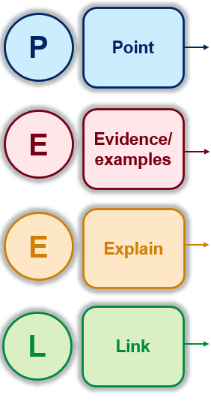

Activity 5.7e – essay scaffold
Use the essay scaffold in the table below to help you organise your ideas and structure your essay effectively. It is designed to support you in developing a clear, logical and detailed response from beginning to end.
Essay question: ‘Discuss how Sergio Reis uses the element of space in conjunction with film techniques to communicate his intent in the dance film Somebody That I Used To Know.’
Support your response with specific examples from the film.
Scaffold | Write your response here
Introduction
(Title, name of choreographer, company performing, intent, thesis)
Use the PEEL structure to outline what you will discuss in Paragraph 1. | P:  E:  E:  L:
Use the PEEL structure to outline what you will discuss in Paragraph 2. | P:  E:  E:  L:
Conclusion
(A restatement of your thesis, summary of key points from your body paragraphs, a summarising statement)

References
This resource contains NSW Curriculum and syllabus content. The NSW Curriculum is developed by the NSW Education Standards Authority (NESA). This content is prepared by NESA for and on behalf of the Crown in right of the State of New South Wales. The material is protected by Crown copyright.
Please refer to the NESA Copyright Disclaimer for more information https://www.nsw.gov.au/education-and-training/nesa/copyright.
NESA holds the only official and up-to-date versions of the NSW Curriculum and syllabus documents. Please visit NESA https://www.nsw.gov.au/education-and-training/nesa and NSW Curriculum https://curriculum.nsw.edu.au.
Dance 7–10 Syllabus © NSW Education Standards Authority (NESA) for and on behalf of the Crown in right of the State of New South Wales, 2023.
Clear Talent Group (n.d.) Sergio Reis, Clear Talent Group website, accessed 22 January 2026.
William Forsythe (n.d.) William Forsythe – Biography, William Forsythe website, accessed 20 March 2025.
© State of New South Wales (Department of Education), 2026
The copyright material published in this resource is subject to the Copyright Act 1968 (Cth) and is owned by the NSW Department of Education or, where indicated, by a party other than the NSW Department of Education (third-party material).
Copyright material available in this resource and owned by the NSW Department of Education is licensed under a Creative Commons Attribution 4.0 International (CC BY 4.0) license.

This license allows you to share and adapt the material for any purpose, even commercially.
Attribution should be given to © State of New South Wales (Department of Education), 2026.
Material in this resource not available under a Creative Commons license:
- the NSW Department of Education logo, other logos and trademark-protected material
- material owned by a third party that has been reproduced with permission. You will need to obtain permission from the third party to reuse its material.
Links to third-party material and websites
Please note that the provided (reading/viewing material/list/links/texts) are a suggestion only and implies no endorsement, by the New South Wales Department of Education, of any author, publisher, or book title. School principals and teachers are best placed to assess the suitability of resources that would complement the curriculum and reflect the needs and interests of their students.
If you use the links provided in this document to access a third-party's website, you acknowledge that the terms of use, including licence terms set out on the third-party's website apply to the use which may be made of the materials on that third-party website or where permitted by the Copyright Act 1968 (Cth). The department accepts no responsibility for content on third-party websites.

