Dance Stage 5 (Year 9) – student resource booklet
Appreciating Country

Contents
Learning sequence 1 – appreciating dance in context 3
Activity 1.1a – What does it mean to ‘appreciate’ dance? 3
Activity 1.2b – See Think Wonder 4
Activity 1.3 – Aboriginal and/or Torres Strait Islander perspectives 6
Activity 1.4 – What are Cultural Protocols? 7
Activity 1.5 – What is ICIP? 7
Activity 1.9 – the significance of Country 8
Learning sequence 2 – step into SILENCE 9
Activity 2.1 – Who are Karul Projects? 9
Activity 2.2 – introducing the work SILENCE 10
Activity 2.2b – SILENCE synopsis 11
Activity 2.3b – Karul Projects Treaty 12
Activity 2.5 – the choreographer’s intent 13
Tiered vocabulary 15
Activity 2.6 – social, cultural and historical factors 16
Learning sequence 3 – Chapter 1 – ‘Lore’ 17
Activity 3.1 – Lore 17
Word bank for Chapter 1 – ‘Lore’ 18
Activity 3.2 – Heartbeat 20
Activity 3.4 – the grandmothers 20
Sentence starters 21
Learning sequence 4 – Chapter 2 – ‘Treaty’ 22
Activity 4.1 – Treaty 22
Activity 4.2 – Constitution/White Noise 26
Activity 4.4 – Power 27
Activity 4.5 – Nature 28
Learning sequence 5 – Chapter 3 – ‘Always Was’ 30
Activity 5.1 –‘Always Was’ 30
Activity 5.2 – Songline 31
Activity 5.3 – Protest 32
Student sample response 1 32
Student sample response 2 33
References 34

Learning sequence 1 – appreciating dance in context

Activity 1.1a – What does it mean to ‘appreciate’ dance?
- Think about the question ‘What does it mean to “appreciate” dance?’ and add your ideas to the ‘Think’ column.
- In pairs, brainstorm and write down words that relate to dance appreciation in the ‘Pair’ column.
- Share your ideas and words with the class.
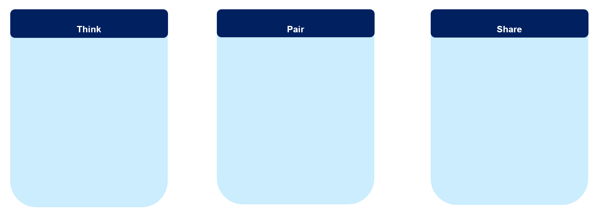

Activity 1.2b – See Think Wonder
Access the videos in the table below. Make notes about what you see, think and wonder in the table. You can use single words or sentences.
Video | See  What do you see in the dance video? | Think  What do you think is the purpose of this dance? | Wonder  What do you wonder about this dance?
Dance Makers Collective THE RIVOLI Social Trailer 2022 (4:05)
Yugambeh Sing the Land | Wudjang: Not the Past (2:17)
Solo Echo, by Crystal Pite (1:32)
Akram Khan Company | Chotto Desh 2023 Trailer (2:03)
Do we appreciate these dances in the same way? Why or why not?

Activity 1.3 – Aboriginal and/or Torres Strait Islander perspectives
- Access the video Impacts of intergenerational trauma (4:09), then individually answer the reflection questions in the following table.
Reflection questions | Individual reflection
What is something new that you have learned?
How does this make you feel?
- As a class, discuss how this knowledge will help you to understand the context of Aboriginal and/or Torres Strait Islander dance works?

Activity 1.4 – What are Cultural Protocols?
Access slide 1.4c to hear Thomas E.S. Kelly discussing his approach to Cultural Protocols in creating dance works, then answer the questions in the table below.
Questions | My responses
What do you understand about Kelly’s approach to Cultural Protocols?
What is an example Kelly uses to demonstrate respect for Cultural Protocols?

Activity 1.5 – What is ICIP?
Access slide 1.5 to explore the definition for Indigenous Cultural and Intellectual Property (ICIP). Access the video on the slide to learn about why protecting ICIP is important to Aboriginal and Torres Strait Islander Peoples.
Reflect on the question ‘Why protect Indigenous Cultural and Intellectual Property?’. Identify 3 reasons why protecting ICIP is important.

Activity 1.9 – the significance of Country
Access slide 1.9 to explore the significance of Country answering the questions in the table below.
Questions | My responses
What Country are we learning on?
What do we know about this Country?
How can we learn more about this Country?

Learning sequence 2 – step into SILENCE

Activity 2.1 – Who are Karul Projects?
Explore the Karul Projects website to learn more about the company and its work, then respond to the below.
- On the home page of Karul Projects’ website, you will find ‘Storytelling from first sunrise to last sunset’. What do you think this means about the work this company creates?
- What does ‘Karul’ mean and why has the company used this word in its title?
- Explore and reflect on the focus (goals) of Karul Projects. Discuss with a partner what each of these points could look like in the dance works of Karul Projects.

Activity 2.2 – introducing the work SILENCE
Document your initial responses in the table below after watching the trailer for SILENCE. You can write in words or sentences.
What ideas is Kelly exploring in this work? | Which images or moments stood out to you? | What did you notice about the movement and/or theatrical elements?

Activity 2.2b – SILENCE synopsis
- Read the synopsis (below) for the dance work SILENCE.
- Highlight some words that stand out to you about the ideas and potential movement to be seen in this work.
SILENCE is about the space in between. Conversations not being heard and responses that are muted. A drum beats and bodies thrash through frequencies to uncover what lies in the SILENCE. There is SILENCE between stars as the emu travels across the night sky, or the dancer’s energy when they hit the cut between rhythms. It’s also the deafening silence under white noise. The same questions echoed through generations.
We’ve marched across Country. We’ve had promises made and broken. We’ve drafted our own Treaty, and still we’re the only sovereign peoples without one.
Choreographed, written and directed by Minjungbal-Yugambeh, Wiradjuri and Ni-Vanuatu man Thomas E.S. Kelly, this new dance work pulls it from under the rug and slams it back on the table. Because the conversation about a TREATY will never be silenced.
(Karul Projects n.d.)

Activity 2.3b – Karul Projects Treaty
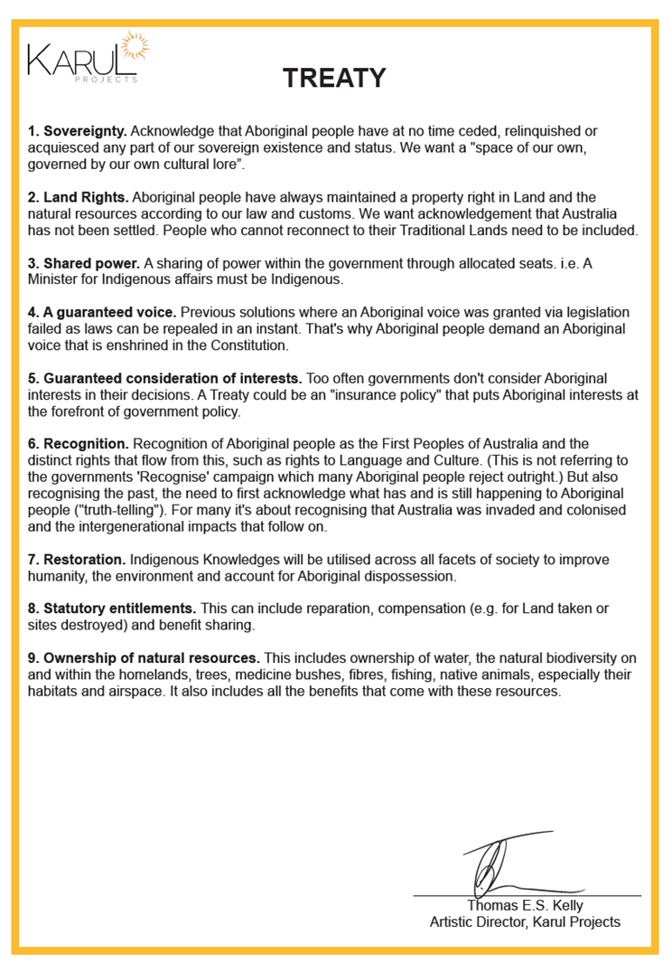
Karul Projects Treaty [image] shared with permission from Thomas E.S. Kelly.

Activity 2.5 – the choreographer’s intent
Listen to Thomas E.S. Kelly explain why he wanted to create SILENCE, then answer the questions in the table below.
Questions | My notes | My responses (in full sentences)
Why did Kelly want to create this work?
Why has Kelly used a drum kit on stage?
What ideas is Kelly exploring in this work?
Why did Kelly title the work SILENCE?

Tiered vocabulary
Add the example words from slide 2.5b to the scaffold below.
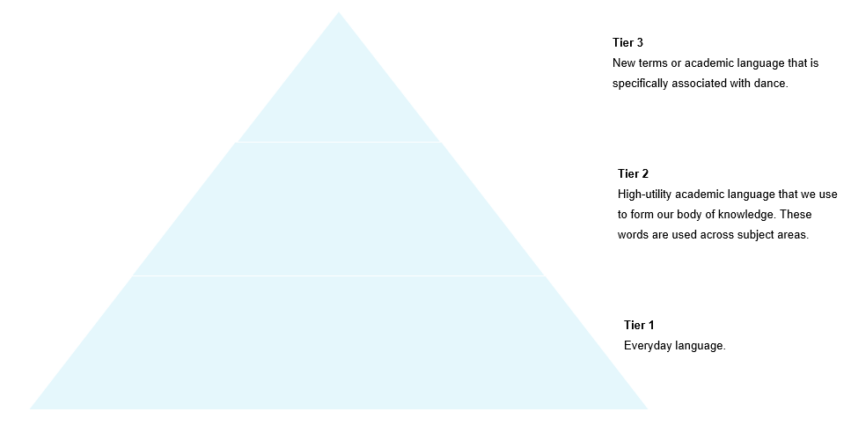

Activity 2.6 – social, cultural and historical factors
Select and research one of the following events, before addressing the prompts in the table below.
- Black Lives Matter protests
- COVID-10 pandemic
- 2023 Voice to Parliament referendum
Prompts | My responses
Provide a brief explanation of the event
When was the event in relation to when SILENCE was being created and/or on tour?
How could this event have influenced the creation of the dance work SILENCE?

Learning sequence 3 – Chapter 1 – ‘Lore’

Activity 3.1 – Lore
- Access the interview with Thomas E.S. Kelly introducing the first chapter of the work. Engage with the video and begin to create a word bank in the table below. A few words have been included to get you started.
Lore | connection | Country
- As you are viewing the work, you can start to add some initial thoughts and ideas to the table below.

Word bank for Chapter 1 – ‘Lore’
Scene | Dancers and movement | Theatrical and auditory elements | Ideas and intent
Street
(0:00–1:00)
Uncle Bunyip
(1:00–6:42)
Heartbeat
(6:42–10:24)
Grandmothers 1
(10:24–15:00)
Lore/Welcome from the Storyteller
(15:00–18:33)

Activity 3.2 – Heartbeat
Use the table below to identify and describe how space, time and dynamics have been used in the Heartbeat scene.
Space | Time | Dynamics

Activity 3.4 – the grandmothers
The teacher will lead a class discussion for the question below. You can add notes from your class discussion under the headings ‘Artistic context’ and ‘Cultural context’.
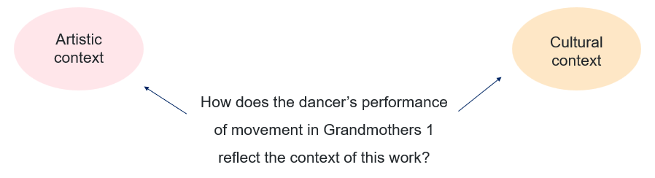
How does the use of dancers communicate the choreographer’s intent in the scene Grandmothers 1 of the work SILENCE?
Consider the following and make notes in the table below:
- the number of dancers
- who is dancing and their relationship to other dancers
- costume, props or accompaniment to communicate the intent.

Sentence starters
- The intentional use of 4 female dancers to perform the role of the grandmothers in SILENCE highlights …
- The use of the soloist at the start of Grandmothers 1 establishes …
- When 3 more female dancers enter the space from the upstage left corner this creates a relationship between …
- The use of (describe the accompaniment) enhances the …

Learning sequence 4 – Chapter 2 – ‘Treaty’

Activity 4.1 – Treaty
As you are viewing the work you can start to add some initial thoughts and ideas to the table below.
Scene | Movement | Theatrical and auditory elements | Ideas and intent
Nanny Jane
(18:33–21.08)
Emu 1
(21:08–23:00)
Constitution/White Noise
(23:00–29:00)
Grandmothers 2
(29:00–30:16)
Power
(30:16–34:12)
Emu 2
(34:12–35:55)
Nature
(35:55–37:99)
Nicky
(37:39–39:44)
Grandmothers 3
(39:44–41.05)
Bills
(41:05–45:50)
Emu 3
(45:50–48:45)

Activity 4.2 – Constitution/White Noise
After viewing the Constitution/White Noise scene of SILENCE, use the table below to draft your PEEL response to the question: ‘How does the choreographer communicate ideas about trying to be heard?’
Point
Evidence/examples
Explanation
Link

Use your TAG peer feedback to refine your paragraph in the box below.

Activity 4.4 – Power
Motif: a thematic device.
A distinctive, recognisable movement or pattern of movements that introduces and develops the idea and intent in a dance phrase and work (NESA 2023).
Use your notes and class discussions to write a response in the box below to: ‘Identify and describe how motif is used in the scene Power.’
Describe 2 specific movement examples to support your response. Remember to use verbs, adverbs and adjectives to assist your descriptive writing.

Activity 4.5 – Nature
Verbs
run | descend | push | dash | bend | dart | march
jump | fall | pull | bounce | rotate | hit | stride
walk | rise | lift | crawl | bolt | hop | slink
travel | float | carry | shake | leap | sprint | stomp
climb | fly | throw | roll | collapse | stroll
Adverbs
quickly | calmly | intensely | nervously | urgently | immediately | elegantly
abruptly | carefully | joyfully | safely | recklessly | passionately | briskly
angrily | curiously | lazily | lively | sharply | nearly | slowly
anxiously | furiously | naturally | loosely | energetically | loudly | easily
bravely | gently | deliberately | lovingly | heavily | continually
Adjectives
tangled | slow | sincere | careless | mature | silky | enchanting
piercing | weak | disappointing | confident | nervous | vivid | rapid
floating | hard | dazzling | friendly | unpredictable | graceful | rough
strong | enthusiastic | assertive | proud | floppy | clear | slimy
heavy | gentle | careful | timid | frantic | poised
After viewing the Nature scene of SILENCE, use your notes and class discussions to answer the following.
- Why do you think the choreographer selected this dancer for the role of the Storyteller?
- What is the relationship between the spoken words (auditory element) of the Storyteller and the movement in Nature?
- Write a detailed description that demonstrates the connection between the dialogue and movement in Nature. Use a specific example from the work in your response.
- This scene contrasts a lot of the faster, more physically intense scenes of the work. Select another scene from Treaty to evaluate how the use of contrast aids the communication of Kelly’s intent in SILENCE.

Learning sequence 5 – Chapter 3 – ‘Always Was’

Activity 5.1 –‘Always Was’
As you are viewing the work, you can start adding some initial thoughts and ideas to the table below.
Scene | Movement | Theatrical and auditory elements | Ideas and intent
Songline
(48:45–52:13)
Grandmothers 4
(52:13–55:00)
Protest
(55:00–1:03:37)

Activity 5.2 – Songline
In the table below, write a PEEL response to the question: ‘How does Songline communicate the choreographer’s intent?’
Some suggestions to get you started:
- physical connection to Country
- how and why the sand and dirt is used by the performers
- how the dancer’s perform the movement in this scene communicate the voice of the Land.
Point
Evidence/examples
Explanation
Link

Activity 5.3 – Protest
After viewing Protest, answer the question: ‘How does Protest resolve the ideas explored in SILENCE?’
Consider the following points when forming your response:
- Does it resolve? Why or why not?
- What statement is Kelly making at the end of the work?
- How is he making it?
- Why do you think he chose to end the work in this way?

Student sample response 1
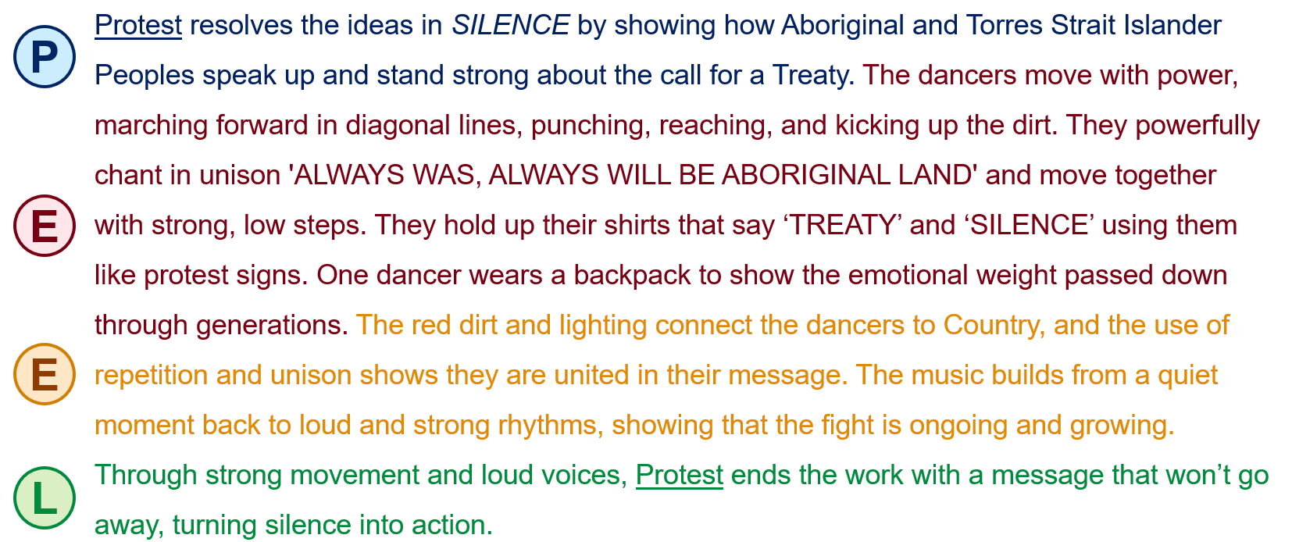

Student sample response 2
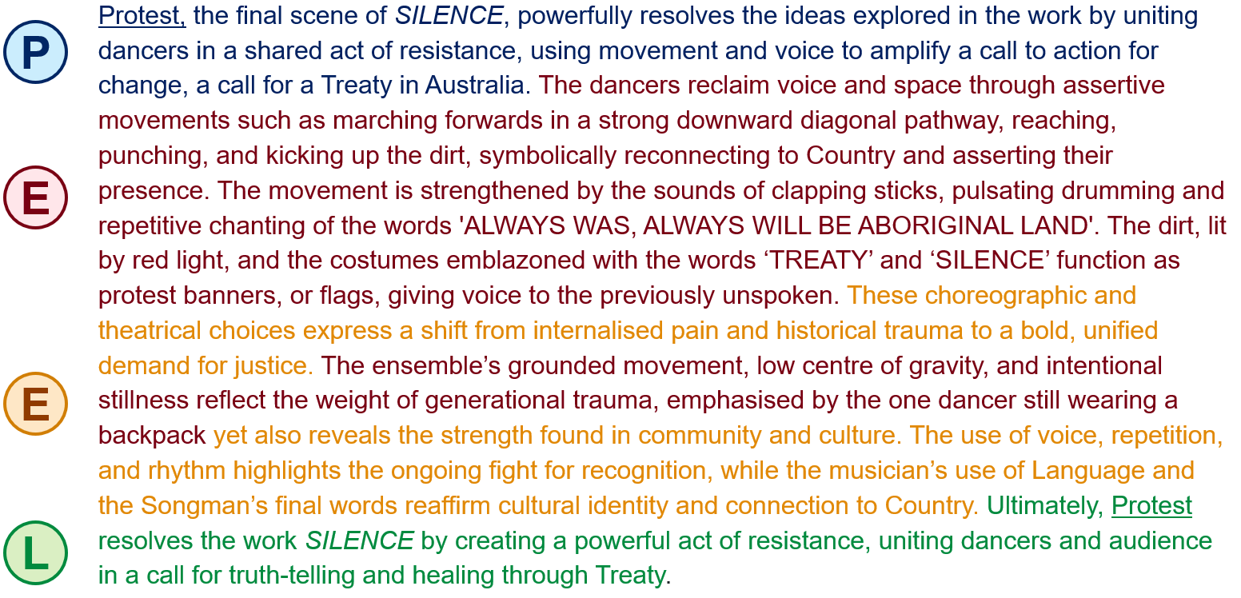

References
This resource contains NSW Curriculum and syllabus content. The NSW Curriculum is developed by the NSW Education Standards Authority. This content is prepared by NESA for and on behalf of the Crown in right of the State of New South Wales. The material is protected by Crown copyright.
Please refer to the NESA Copyright Disclaimer for more information https://educationstandards.nsw.edu.au/wps/portal/nesa/mini-footer/copyright.
NESA holds the only official and up-to-date versions of the NSW Curriculum and syllabus documents. Please visit the NSW Education Standards Authority (NESA) website https://educationstandards.nsw.edu.au/ and the NSW Curriculum website https://curriculum.nsw.edu.au/home.
Dance 7–10 Syllabus © NSW Education Standards Authority (NESA) for and on behalf of the Crown in right of the State of New South Wales, 2023.
Akram Khan Company (10 October 2023) 'Akram Khan Company | Chotto Desh 2023 Trailer’ [video], Akram Khan Company, YouTube, accessed 27 June 2025.
artsontour (15 March 2022) 'Dance Makers Collective THE RIVOLI Social Trailer 2022’ [video] artsontour, YouTube, accessed 27 June 2025.
bangarradance theatre (8 February 2022) 'Yugambeh Sing the Land | Wudjang: Not the Past’ [video], bangarradance theatre, YouTube, accessed 27 June 2025.
Corker J (10 August 2023) 'SILENCE reviewed: ‘You will really enjoy this fresh and joyous work of dance theatre’, The Illawarra Flame, accessed 24 September 2025.
Foundation for Indigenous Sustainable Health (30 September 2022) 'To Heal the Nation we need Understanding - Uncle Jack Charles’ [video], Foundation for Indigenous Sustainable Health, YouTube, accessed 17 October 2025.
GöteborgsOperans Danskompani (23 October 2018) 'Solo Echo, by Crystal Pite’ [video], GöteborgsOperans Danskompani, YouTube, accessed 27 June 2025.
Infra, Transport, Regional, Comms, Sport & Arts (5 December 2024) 'Why protect Indigenous cultural and intellectual property?’ [video], Infra, Transport, Regional, Comms, Sport & Arts, YouTube, accessed 11 June 2025.
Karul Projects (n.d.) SILENCE, Karul Projects website, accessed 24 July 2025.
NESA (NSW Education Standards Authority) (2023) ‘Dance 7–10 Syllabus: Glossary’, Resources, NSW Curriculum website, accessed 12 November 2025.
Oliver W (2010) Writing About Dance, Human Kinetics, United States of America.

© State of New South Wales (Department of Education), 2025
The copyright material published in this resource is subject to the Copyright Act 1968 (Cth) and is owned by the NSW Department of Education or, where indicated, by a party other than the NSW Department of Education (third-party material).
Copyright material available in this resource and owned by the NSW Department of Education is licensed under a Creative Commons Attribution 4.0 International (CC BY 4.0) license.

This license allows you to share and adapt the material for any purpose, even commercially.
Attribution should be given to © State of New South Wales (Department of Education), 2025.
Material in this resource not available under a Creative Commons license:
- the NSW Department of Education logo, other logos and trademark-protected material
- material owned by a third party that has been reproduced with permission. You will need to obtain permission from the third party to reuse its material.
Links to third-party material and websites
Please note that the provided (reading/viewing material/list/links/texts) are a suggestion only and implies no endorsement, by the New South Wales Department of Education, of any author, publisher, or book title. School principals and teachers are best placed to assess the suitability of resources that would complement the curriculum and reflect the needs and interests of their students.
If you use the links provided in this document to access a third-party's website, you acknowledge that the terms of use, including licence terms set out on the third-party's website apply to the use which may be made of the materials on that third-party website or where permitted by the Copyright Act 1968 (Cth). The department accepts no responsibility for content on third-party websites.

