Music Stage 4 – score booklet
Garage to Grammys

Resource overview
This score booklet is not a standalone resource. It has been designed for use by department teachers in connection to Stage 4 resources designed by the Creative arts curriculum team for the Music 7–10 Syllabus (2024). These include the Stage 4 scope and sequence, Stage 4 ‘Garage to Grammys’ sample unit, PowerPoint and sample assessment task. All documents associated with this resource can be found on the Music 7–10 (2024) webpage of Planning, programming and assessing creative arts 7–10.

Activity 1.4 – 12-bar blues progression in C major
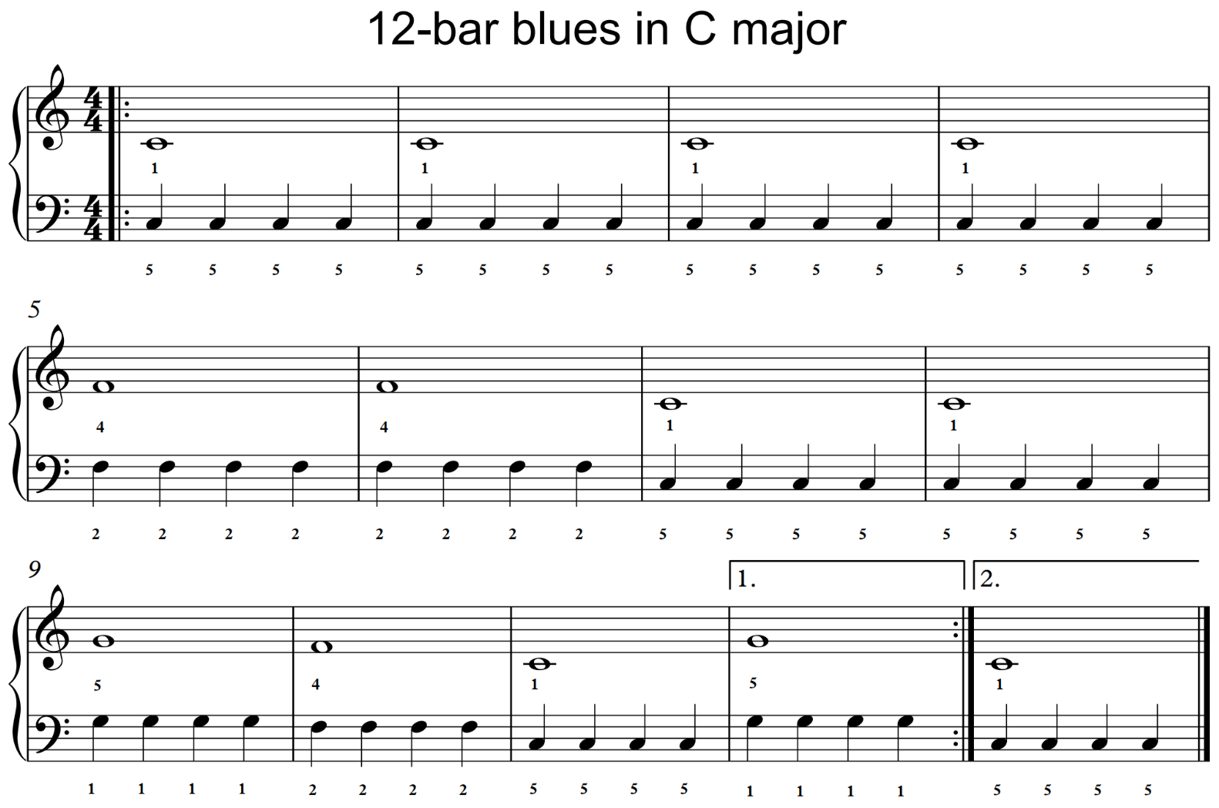

Activity 2.2 – 12-bar blues in A major and reading tablature
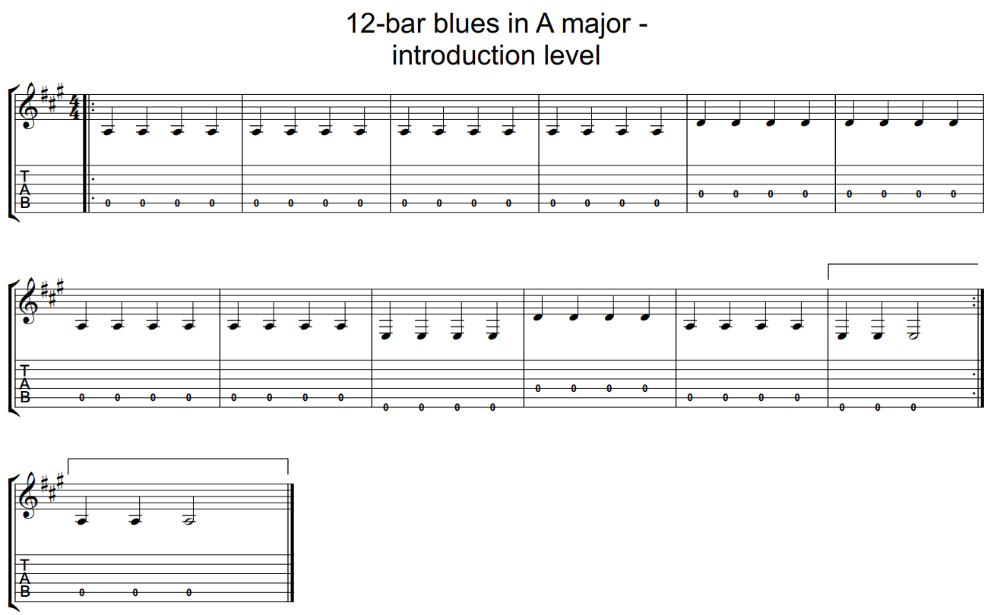

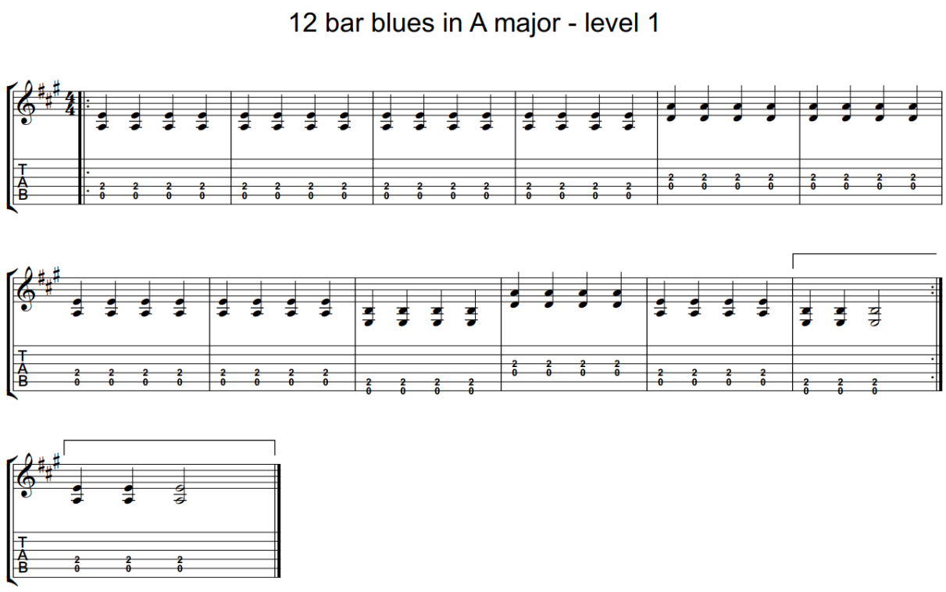

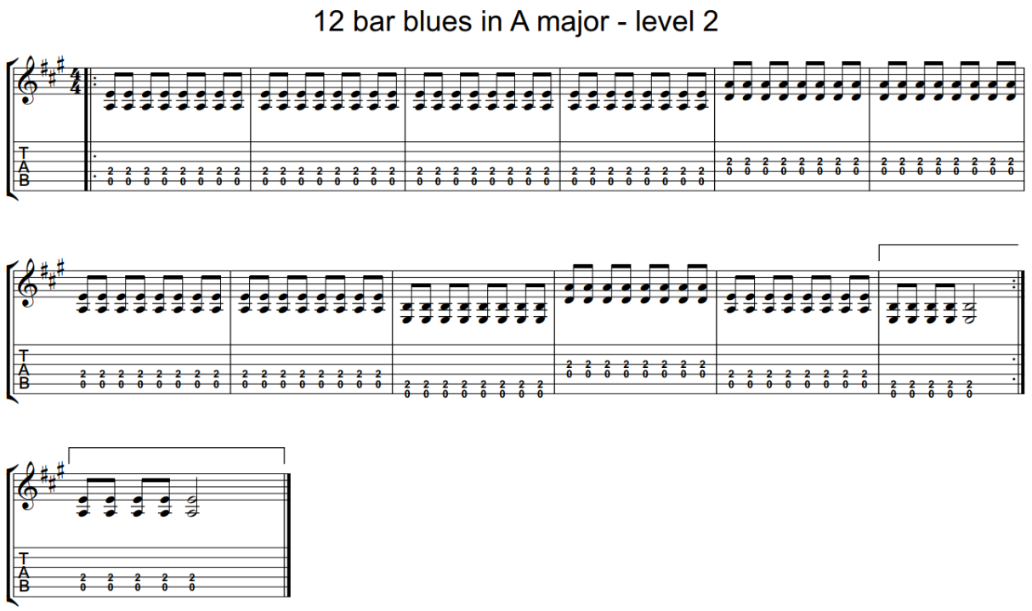

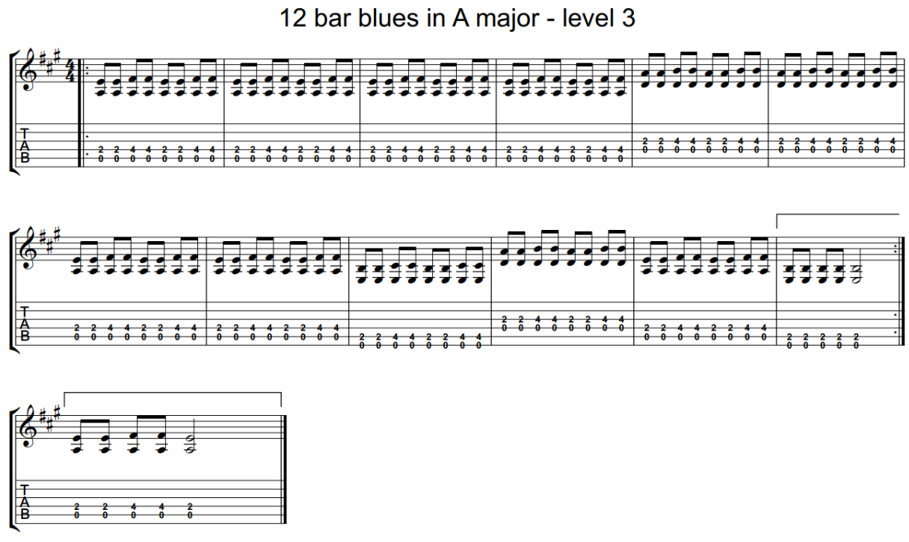

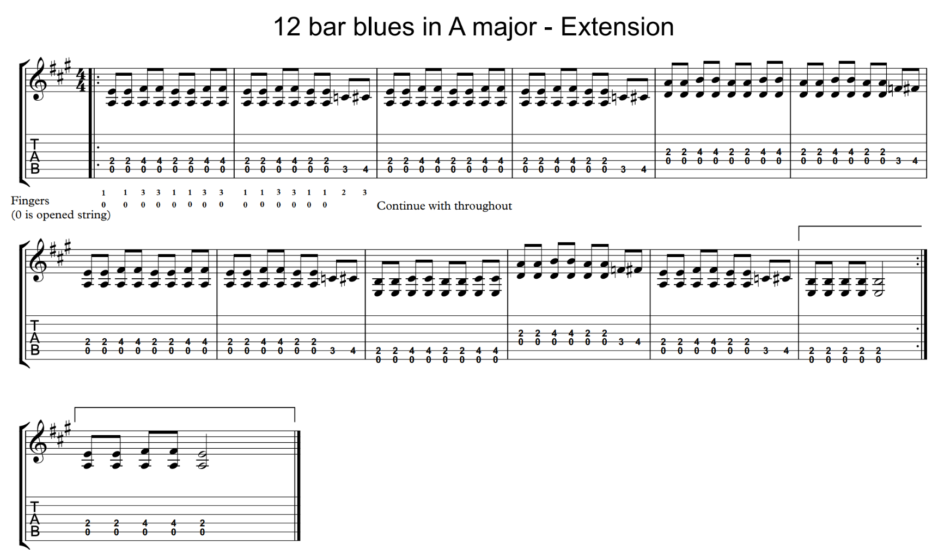

Activity 2.5 – learning ‘Feelin’ Blues-E’
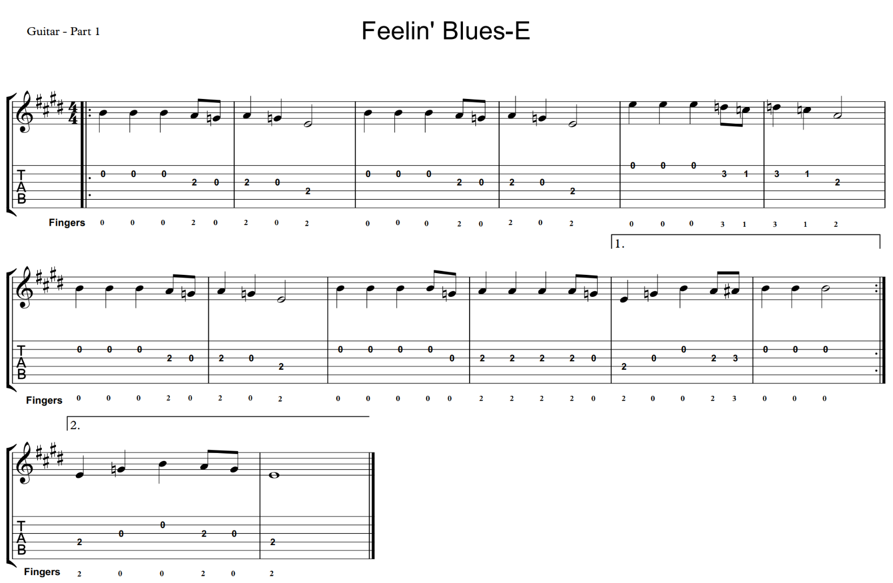
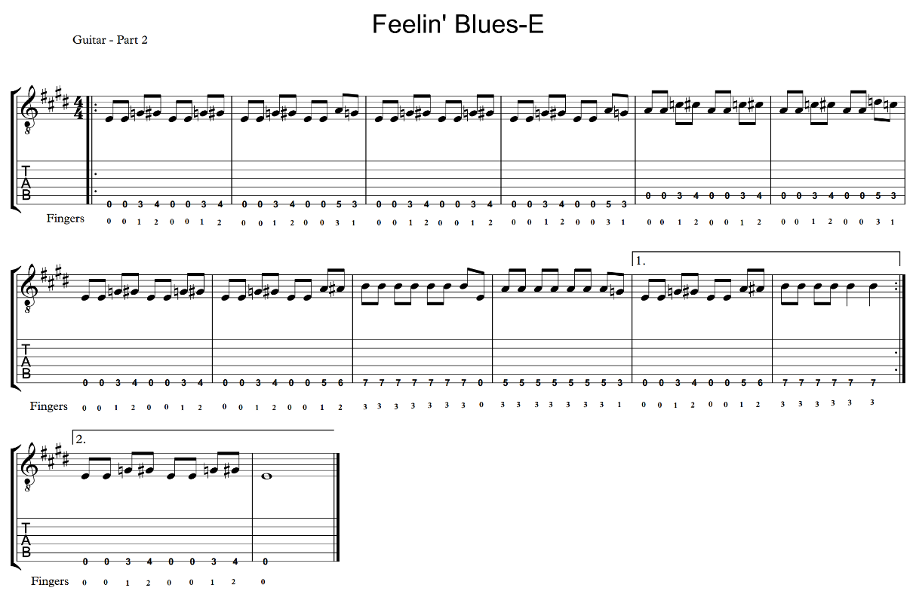
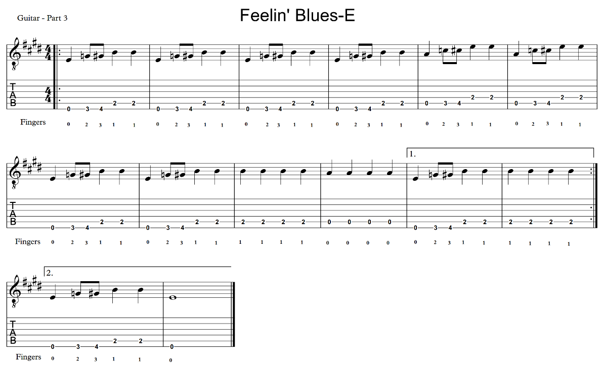
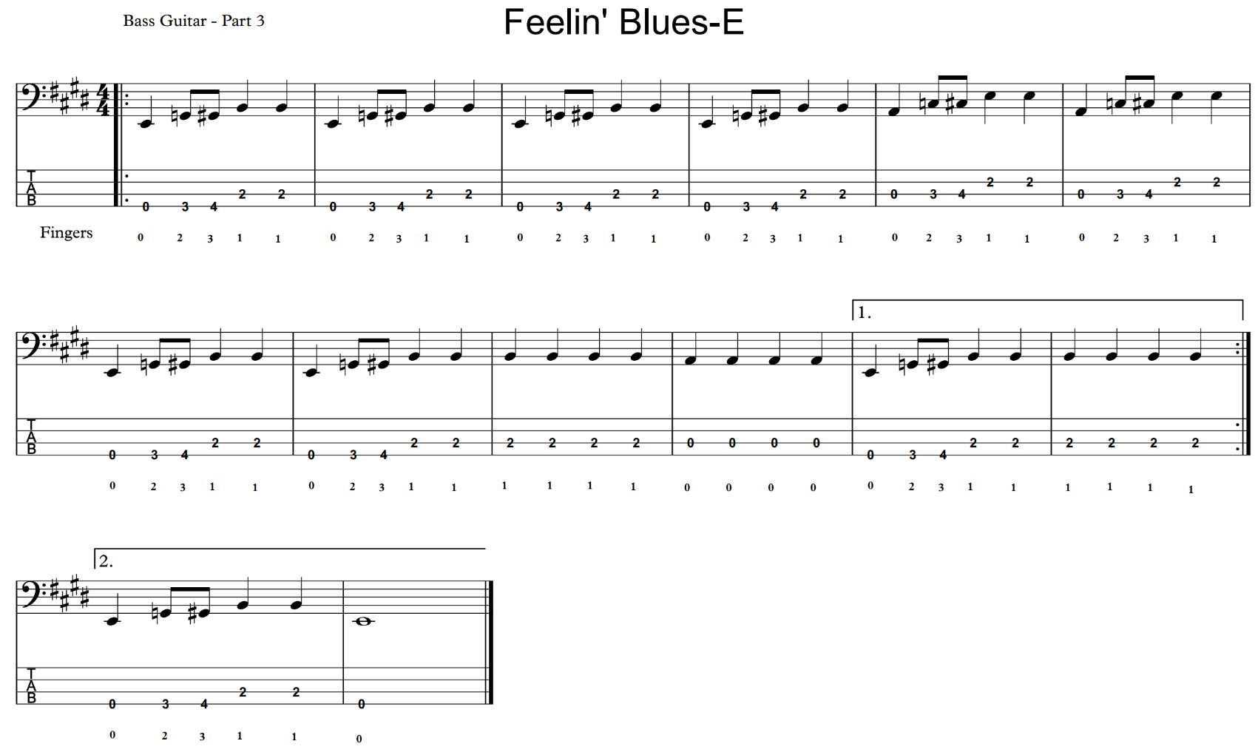

Activity 5.2 – playing chords using correct technique and fingers
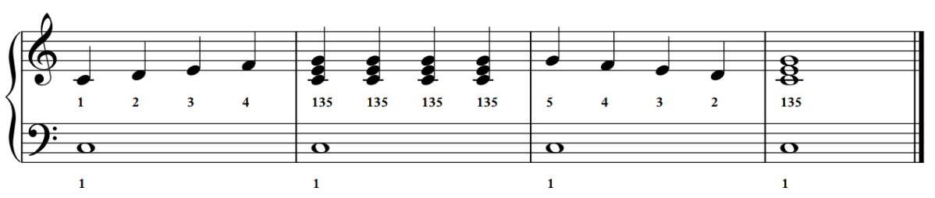
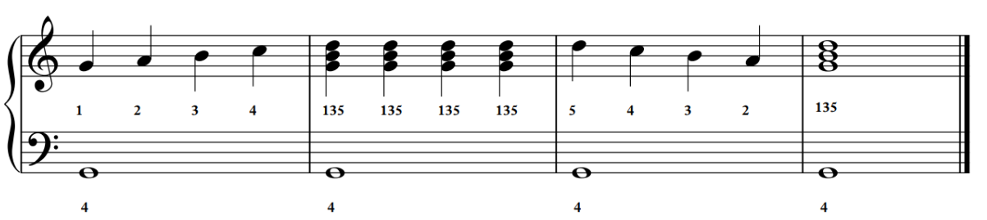
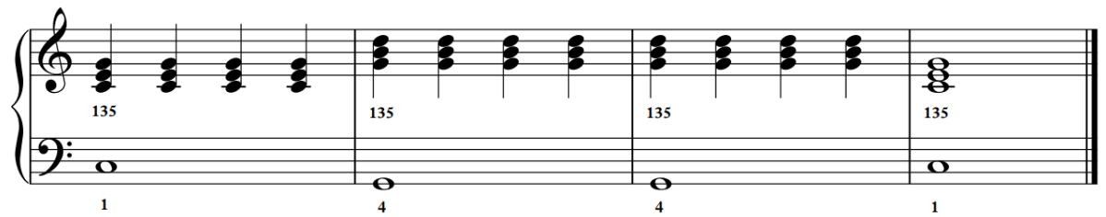
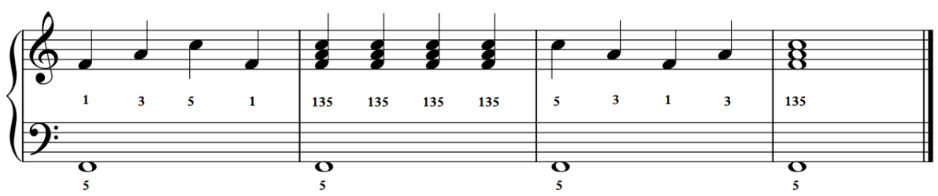
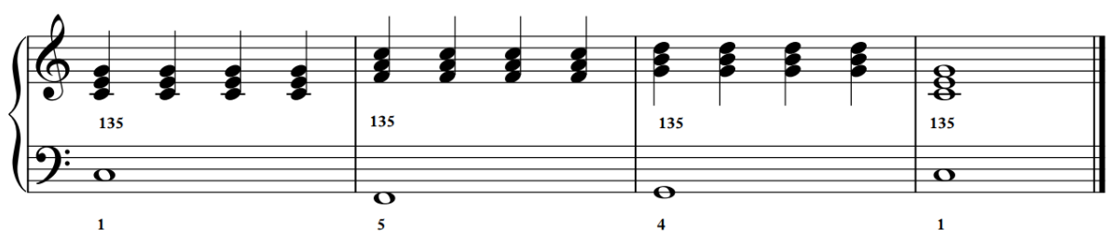

© State of New South Wales (Department of Education), 2025
The copyright material published in this resource is subject to the Copyright Act 1968 (Cth) and is owned by the NSW Department of Education or, where indicated, by a party other than the NSW Department of Education (third-party material).
Copyright material available in this resource and owned by the NSW Department of Education is licensed under a Creative Commons Attribution 4.0 International (CC BY 4.0) license.

This license allows you to share and adapt the material for any purpose, even commercially.
Attribution should be given to © State of New South Wales (Department of Education), 2025.
Material in this resource not available under a Creative Commons license:
- the NSW Department of Education logo, other logos and trademark-protected material
- material owned by a third party that has been reproduced with permission. You will need to obtain permission from the third party to reuse its material.
Links to third-party material and websites
Please note that the provided (reading/viewing material/list/links/texts) are a suggestion only and implies no endorsement, by the New South Wales Department of Education, of any author, publisher, or book title. School principals and teachers are best placed to assess the suitability of resources that would complement the curriculum and reflect the needs and interests of their students.
If you use the links provided in this document to access a third-party's website, you acknowledge that the terms of use, including licence terms set out on the third-party's website apply to the use which may be made of the materials on that third-party website or where permitted by the Copyright Act 1968 (Cth). The department accepts no responsibility for content on third-party websites.

