Music Stage 4 – teacher resource booklet
Garage to Grammys

Contents
Learning sequence 1 – the blues 3
Activity 1.1 – the blues – class discussion facilitator support 3
Activity 1.2 – early blues style – listening worksheet 5
Activity 1.2 – early blues style – listening answer sheet 8
Activity 1.3 – 12-bar blues chord progression worksheet 11
Activity 1.3 –12-bar blues chord progression answer sheet 15
Activity 1.3 – 12-bar blues chord progression – listening examples 16
Activity 1.3 – 12-bar blues chord progression – class discussion facilitator support 16
Activity 1.4 – 12-bar blues chord progression in C major worksheet 18
Activity 1.4 –12-bar blues chord progression in C major answer sheet 20
Learning sequence 2 – the guitar 23
Activity 2.4 – chords on the guitar worksheet 23
Learning sequence 4 – the drum kit 25
Activity 4.2 – learning a basic rock pattern worksheet 25
Activity 4.3 – drum fills worksheet 28
Activity 4.4 – composing a drum pattern worksheet 29
Learning sequence 5 – developing keyboard skills 30
Activity 5.2 – playing chords using correct technique and fingers – support guides 30
Activity 5.3 – the pentatonic scale – support material 34
Activity 5.4 – composing using the pentatonic scale – support material 35
Learning sequence 6 – ensemble composition and performance 37
Activity 6.1 – comparing versions worksheet 37
Activity 6.1 – comparing versions answer sheet 42
Activity 6.2 – ensemble composition and performance 53
Activity 6.3 – composing an original piece worksheet 54
Chord guide 55
Scales used 56
Using the pentatonic scale 56
Melody 57
Riffs 57
Lyrics 58
Activity 6.4 – composing an arrangement worksheet 59
Chord guide 60
Scales used 61
Melody 62
Riffs 62
References 63

Learning sequence 1 – the blues

Activity 1.1 – the blues – class discussion facilitator support
Teacher note: using the points in the table below, support a class discussion to identify the musical features found in the 3 listening examples.
Table 1 – musical features found in 3 listening examples
Listening example | Musical features
Call & Response. Work song – Prision song (1966) (0:57) | - The solo voice (call) sings the main lyrics and melody line, while the other voices (response) answer with a collective response in unison singing ‘yeah, yeah, yeah, yeah’.  - Their physical movement/work of chopping with an axe creates a clear beat and constant tempo.
Bessie Smith - St. Louis Blues (Audio) (3:10) (from 0:00–0:47) | - The tempo is very slow, and the vocalist helps to highlight the blues feeling by sliding between notes and adding expressive features to her voice, including use of vibrato. This is a wavy musical effect where a note changes pitch subtly and quickly. This adds warmth and emotional quality to a note. The muted cornet (a brass instrument with valves that looks like a smaller version of a trumpet) supports this by using the same technique on certain notes.  - The vocals are complemented with the muted trumpet playing answering melodies – this also helps to clearly show the AAB structure.  - The singer is accompanied by minimal instruments – muted cornet and the pump organ (a type of reed organ that uses a manual pump mechanism to supply air to the reeds to create its sound)
Tracy Chapman - Give Me One Reason (Official Music Video) (4:07) (from 0:00–1:40) | - AAB structure is clearly defined with the lyrics. The electric guitar helps to highlight this by joining on the second verse playing answering ‘blues licks’ at the end of each line of lyrics.  - The piece is based on the 12-bar blues chord progression. This becomes more evident when all instruments join for verse 2 and the harmony is filled out, through addition on the bass and guitars.  - The use of a semi-acoustic electric guitar (also known as a hollow body electric guitar, typically used in many jazz styles) played by the singer provides accompaniment for the first verse. The addition of the lead electric guitar in verse 2 adds contrasting timbre and helps to show their separate musical roles in the piece.

Activity 1.2 – early blues style – listening worksheet
Listen to these early blues styles and complete the following table.
Walk On (3:18) performed by Sonny Terry and Brownie McGhee (from 0:17–1:45)
Sweet Home Chicago (2:59) performed by Robert Johnson (from 0:00–2:00)
Spoonful (2:50) performed by Howlin’ Wolf (from 0:00–1:57)
Table 2 – Activity 1.2 – early blues style
Questions | Walk On | Sweet Home Chicago | Spoonful
What instruments do you hear?
Describe how the vocalist sounds.
Is the tempo fast, slow, moderate?
What instrument(s) help to keep the rhythm?
Is there repeated musical material or ideas? If so, what is it and when do you hear it?
Identify what style of early blues this is (for example, East Coast, Delta, Chicago). What musical features support your decision?
After answering the questions for each piece, review your responses and code them to the relevant elements of music using the number reference provided: (1) pitch, (2) duration, (3) structure, (4) performing media and timbre. You can use multiple numbers if your answer relates to more than one element. An example is provided in the PowerPoint.
Elements of music reminder
(1) – pitch refers to the relative highness and lowness of sounds
(2) – duration refers to the lengths of sounds and silences in music
(3) – structure refers to the design or form of music. Construction of sections or parts
(4) – performing media and timbre refers to the instrument(s)/voices used and the quality their sound created
Write a paragraph in the space below identifying common musical features that you found across all 3 pieces.
[Write your paragraph here.]

Activity 1.2 – early blues style – listening answer sheet
Walk On (3:18) performed by Sonny Terry and Brownie McGhee (from 0:17–1:45)
Sweet Home Chicago (2:59) performed by Robert Johnson (from 0:00–2:00)
Spoonful (2:50) performed by Howlin’ Wolf (from 0:00–1:57)
Table 3 – Activity 1.2 – early blues style
Questions | Walk On | Sweet Home Chicago | Spoonful
What instruments do you hear? | - acoustic guitar (4)  - harmonica (4)  - vocals (4) | - acoustic guitar (4)  - vocals (4) | - electric guitars (lead and rhythm) (4)  - drum kit (4)  - piano (4)  - vocals (4)
Describe how the vocalist sounds. | The male vocalist sings a repetitive melody (1) with a harsh vocal quality (4) in the higher register | The male vocalist sings the melody (1) using expression and sliding up to the note to emphasise the words. This creates some interest and changes in timbre of the voice (4) | The male vocalist has a harsh and raspy timbre (4) to the quality of their voice. The vocalist sings the melodic line (1) which is supported with the use of expression and sliding between notes (1) to create contrast
Is the tempo fast, slow, moderate? | Moderate tempo that remains consistent throughout (2) | Moderate tempo that remains consistent throughout (2) | Moderate tempo that remains consistent throughout (2)
What instrument(s) help to keep the rhythm? | The guitar is playing a bouncy rhythm (long–short ‘shuffle feel’) (2) as accompaniment – this helps to reinforce the beat (2) and keep the piece moving | After a brief introduction, the accompanying guitar is helping to establish a strong pulse/beat (2) through playing a bouncy rhythm (long–short ‘shuffle feel’) (2) | There is a strong back beat (2) on the snare drum (using brushes) – there is also a repeated riff (1) idea which helps to keep rhythmic (2) momentum
Is there repeated musical material or ideas? If so, what is it and when do you hear it? | The instruments keep the same role – vocals melody (1), guitar and harmonica provide accompaniment  Harmonica uses ‘call and response’ to either echo the vocals or play a similar melodic (1) idea to complement the voice  The guitar maintains the same rhythm pattern (2) throughout  The piece is based on a 12-bar blues chord progression (3)  The vocalist sings (1) ‘walk on’ figure often during the piece | The guitar maintains the same rhythm pattern (2) throughout  The piece is based on a 12-bar blues chord progression (3) that repeats in a similar way each cycle  The vocalist sings in a similar way each cycle through, features like the shape of the melody (1) and the repeated passage (3) – ‘Baby don’t you want to go’, followed by ‘back to the land of California, Sweet Home Chicago’ | The riff (1) is reinforced by the lead electric guitar and vocalist, at times, to help it stand out more  the role of lead electric guitar and piano throughout the piece continue to complement the vocalist in sections with answering melodic ideas (1). At times this is separately, and other times combined  The lead guitar uses lots of pitch bends on notes when playing these ideas (1)  The drum pattern (2) doesn’t change throughout the piece
Identify what style of early blues this is (for example, East Coast, Delta, Chicago). What musical features support your decision? | The piece is in an East Coast blues style. The main music features that help to show this is the accompanying instruments, with the use of guitar and harmonica | The piece is in a Delta blues style. The use of fingerpicking style guitar and raw sounding vocals in this piece are typical of this style of blues | The piece is in a Chicago blues style. This song uses the electric guitar, piano and drums as accompaniment for the vocalists. This is a common feature of this style
Write a paragraph in the space below identifying common musical features that you found across all 3 pieces.
Although all 3 pieces are from different subgenres, they share core blues characteristics. This includes the expressive and emotive way the vocalist sings and the use of a 12-bar blues form. ‘Sweet Home Chicago’ follows a standard 12-bar blues progression, ‘Spoonful’ uses a repetitive riff-based structure closely following a 12-bar form and ‘Walk On’ has verses structured around the blues chord progression. All 3 pieces have a strong use of chords I, IV and V. Each piece also has a focus on the use of vocals and guitar.

Activity 1.3 – 12-bar blues chord progression worksheet
While listening to some 12-bar blues examples played by your teacher, place an asterisk in the bar when you hear the chord changes within the 12-bar blues chord progression.
‘I Feel Good (I Got You)’ by James Brown
Table 4 – Activity 1.3 – 12-bar blues chord progression
‘Hound Dog’ by Elvis Presley
Table 5 – Activity 1.3 – 12-bar blues chord progression

‘Johnny Be Goode’ by Chuck Berry
Table 6 – Activity 1.3 – 12-bar blues chord progression

‘Wipe Out’ by The Surfaris
Table 7 – Activity 1.3 – 12-bar blues chord progression
Reflection question
Were there any musical features or instruments that you heard that helped to show the chord changes? If so, what were they?

Activity 1.3 –12-bar blues chord progression answer sheet
Table 8 – Activity 1.3 – 12-bar blues chord progression
*
* |  | *
* | * | * | *

Activity 1.3 – 12-bar blues chord progression – listening examples
I Feel Good (I Got You) (2:44) (from 0:00–0:41)
Repeat this listening activity with one of the following examples:
Elvis Presley – Hound Dog (Official Audio) (2:13) (from 0:00–0:49)
Johnny Be Goode (2:42) (from 0:00–1:27)
Wipe Out (2:46) (from 0:00–1:08)
Note that these examples include a brief vocal or instrumental introduction to start the piece.

Activity 1.3 – 12-bar blues chord progression – class discussion facilitator support
Table 9 – Activity 1.3 – 12-bar blues chord progression – reflection question
Piece | Musical features
Hound Dog (2:13) performed by Elvis Presley (from 0:00–0:49) | The most obvious feature that helps to show the chord change is the bass line. It is an ascending idea that is based on notes in the chord and is repeated throughout. It is adjusted to suit each relevant chord.  There is an electric guitar lightly playing the chords as part of the accompaniment.
Johnny Be Goode (2:42) performed by Chuck Berry (from 0:00–1:27) | After a brief electric guitar solo to introduce the piece, there is a second guitar part playing in the accompaniment. It is playing a 12-bar blues pattern in straight quavers. This helps to drive the piece along and outline the chord changes.  There is also a double bass outlining the changes by playing notes from the chord in a walking bass pattern. This technique is typically found in jazz music.  The piano is used, at times, to play answering ideas to vocals and supplement the chords in sections.
Wipe Out (2:46) performed by The Surfaris (from 0:00–1:08) | The electric guitar plays the main melody. It is repetitive and the melody is adjusted to suit the chord changes. This helps to highlight the 12-bar blues pattern and make the changes obvious.  There is a second electric guitar playing in a repeated rhythm pattern and strumming the chords of the 12-bar blues chord progression.  When the drums feature playing an accented semiquaver pattern on the floor tom, the electric guitars play a single strum on appropriate bars to help show the chord changes.

Activity 1.4 – 12-bar blues chord progression in C major worksheet
Complete the below steps to work out the 12-bar blues chord progression in C major.
- Write chords for the 12-bar blues chord progressions as roman numerals (I, IV and V), in the table below.
Table 10 – Activity 1.4 – 12-bar blues chord progression in C major
- Write out the notes of the C major scale on the staff provided below.
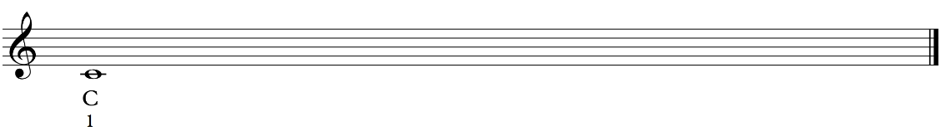
- Under each of the notes, write the note name and roman numerals from I to VIII.
- Circle the notes I, IV and V.
- Write chords for the 12-bar blues chord progression in C major as note names in the table below.
Table 11 – Activity 1.4 – 12-bar blues chord progression in C major
- Write out the C major scale on the staff below and this time notate the triad notes in the chords for C, F and G.

Activity 1.4 –12-bar blues chord progression in C major answer sheet
Step 1
Table 12 – Activity 1.4 – 12-bar blues chord progression in C major
I | I | I | I
IV | IV | I | I
V | IV | I | I
Steps 2, 3 and 4
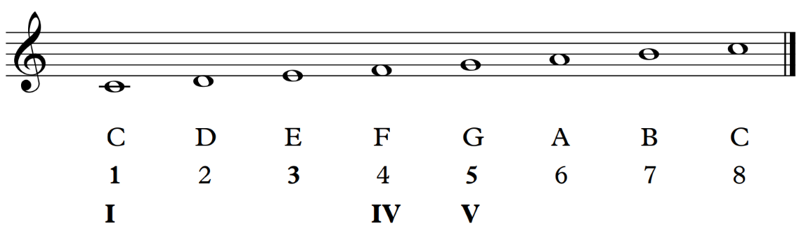

Step 5
Table 13 – Activity 1.4 – 12-bar blues chord progression in C major
C | C | C | C
F | F | C | C
G | F | C | G  C
Step 6
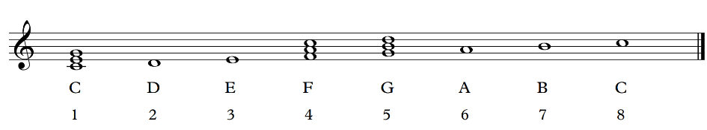

Extension activity
Table 14 – Activity 1.4 – 12-bar blues chord progression in A major
A | A | A | A
D | D | A | A
E | D | A | E  A
Table 15 – Activity 1.4 – 12-bar blues chord progression in G major
G | G | G | G
C | C | G | G
D | C | G | D  G

Learning sequence 2 – the guitar

Activity 2.4 – chords on the guitar worksheet
Use the chord diagrams to learn the chords A7 and D7 and practise the chord progression below changing between these chords.
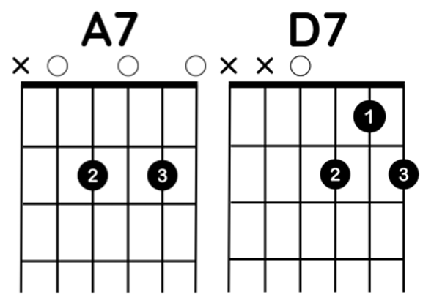

Now learn E7 and add this to the chord progression using the score below.
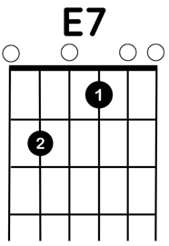

Learning sequence 4 – the drum kit

Activity 4.2 – learning a basic rock pattern worksheet
Follow the exercises in the drum kit – rhythm pattern diagrams below to learn a basic rock pattern in ${4 \atop 4}$ time.
Exercise 1 – play the rhythm in the pattern diagram below, using your hand and foot while counting the beats out loud.
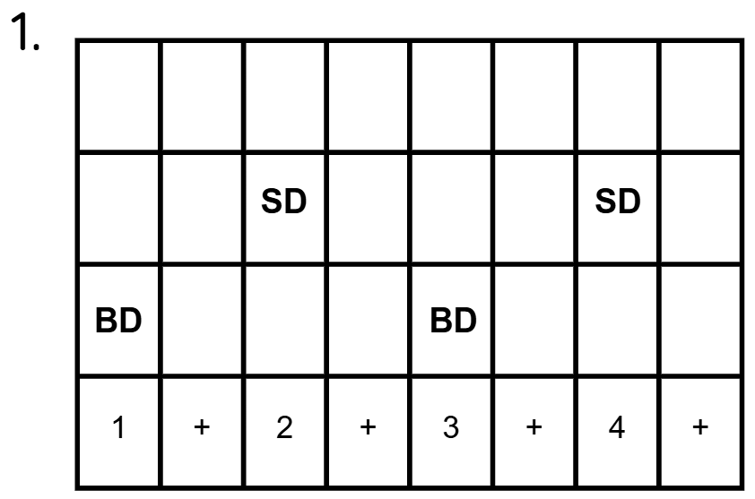
Exercise 2 – play the rhythm in the pattern diagram below. Start with your left hand on your right knee (snare). Cross your right hand to your left knee (hi-hat). Count the beat while playing and add in the bass drum with your right foot.
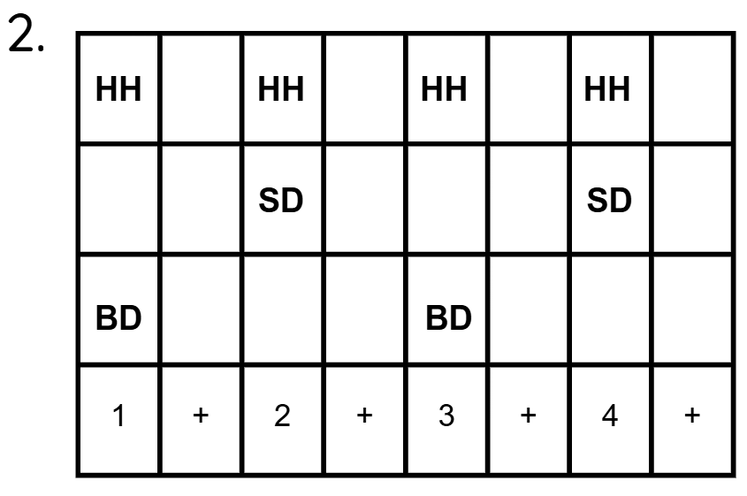
Exercise 3 – play the rhythm in the pattern diagram below. Play quavers (1 + 2 + 3 + 4 +) with your right hand for the hi-hat. Repeat this until it feels secure, then add the snare and bass drum patterns one by one.
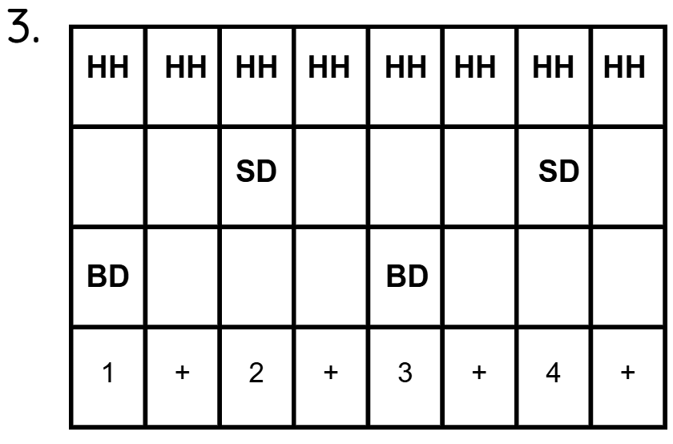
Exercise 4 – play the rhythm in the pattern diagram below.
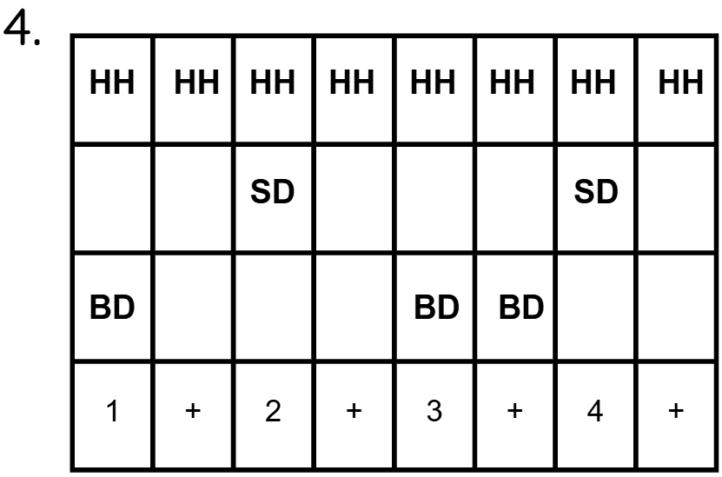
Exercise 5 – play the rhythm in the pattern diagram below.
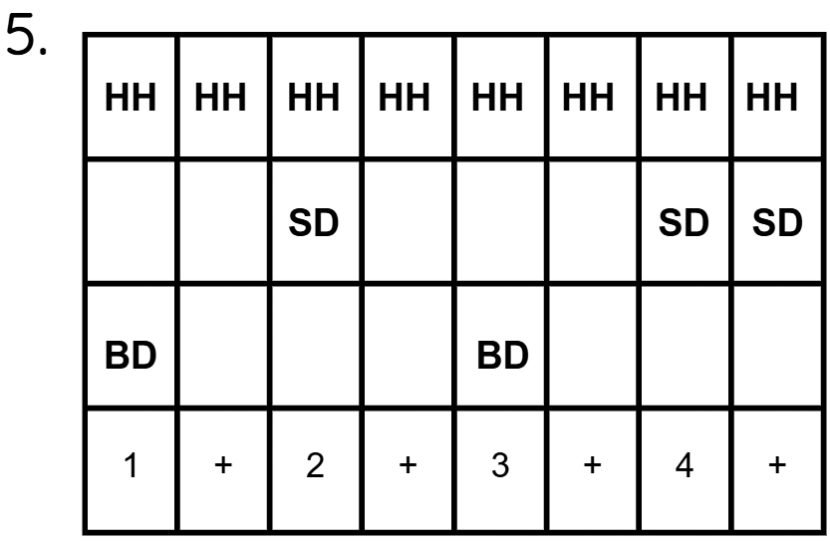
Exercise 6 – play the rhythm in the pattern diagram below.
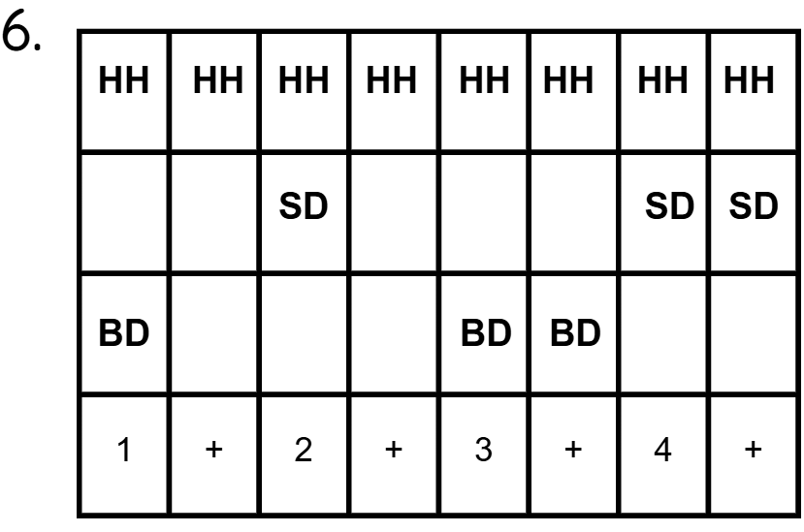
Use the drum kit rhythm grid below to notate your drum kit rhythm. Be sure to refer to the diagram grid key to remain consistent with the drum kit – rhythm pattern diagrams. Adjust it accordingly when you want to add or change various components of the drum kit.
Table 16 – Activity 4.2 – learning a basic rock pattern – drum kit rhythm grid
1 | + | 2 | + | 3 | + | 4 | +
Table 17 – Activity 4.2 – learning a basic rock pattern – grid key
Grid key code | Component
HH | hi-hat
HT | hi-tom
MT | mid-tom
SD | snare drum
BD | bass drum

Activity 4.3 – drum fills worksheet
Use the drum kit – rhythm pattern diagrams below to learn how to play drum fills.
Exercise 7 – play the rhythm in the pattern diagram below.
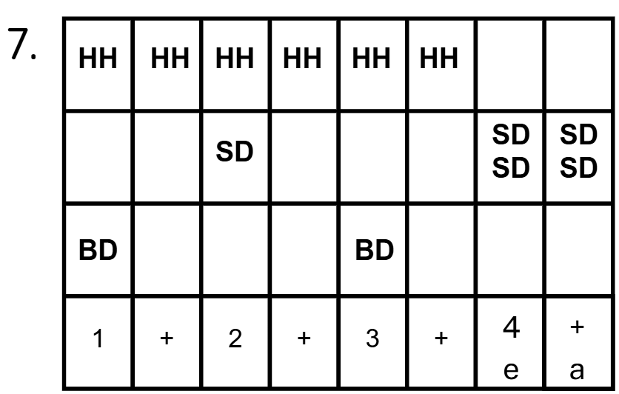
Exercise 8 – play the rhythm in the pattern diagram below.
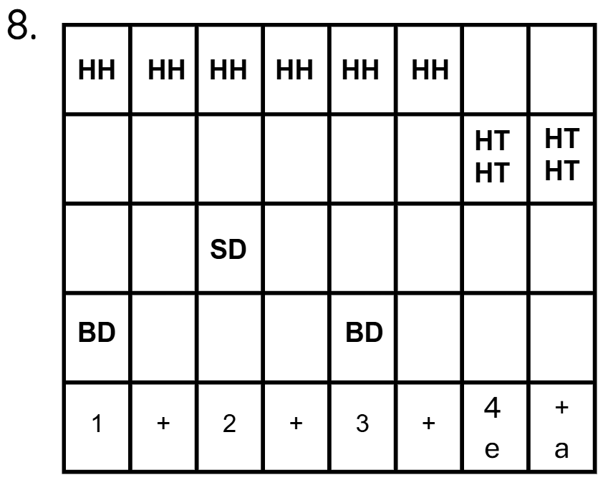
Exercise 9 – play the rhythm in the pattern diagram below.
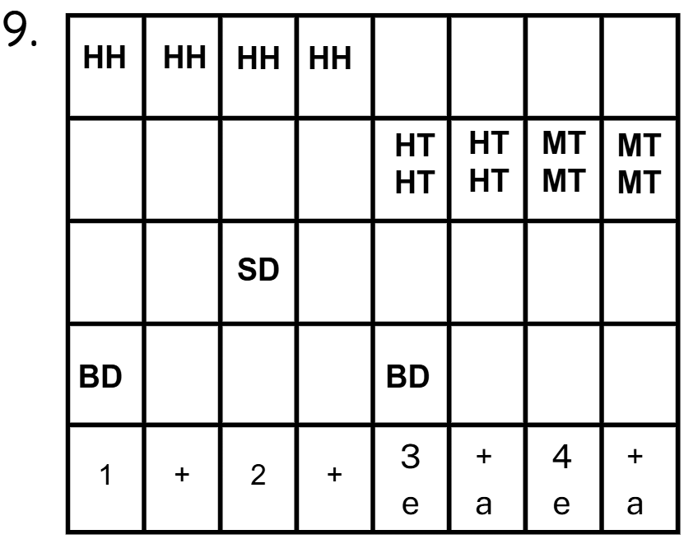

Activity 4.4 – composing a drum pattern worksheet
Use the drum kit – rhythm pattern diagram below to compose your own 4-bar rock pattern in ${4 \atop 4}$ using ideas you have learned. Include a drum fill in your 4th bar.
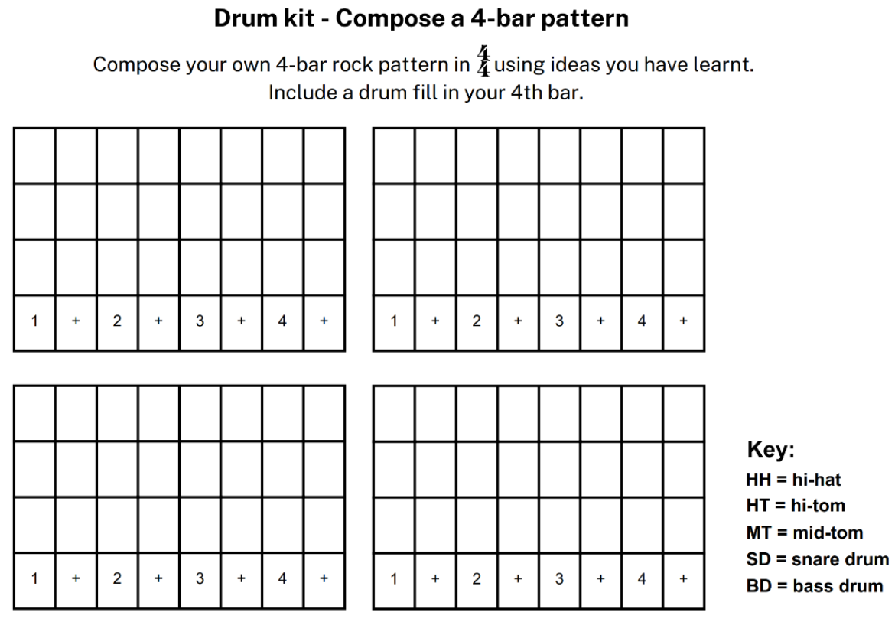

Learning sequence 5 – developing keyboard skills

Activity 5.2 – playing chords using correct technique and fingers – support guides
Teacher note: print these guides as you need them. You may use the diagrams of the keyboard below and colour keys for additional chords learned. This will provide a visual guide for finger placement and use of correct keys.
Provide a laminated copy of the Keyboard chord guide. This is a standalone resource within the unit package. Ensure to print this to scale, so that the guide matches the keys on the piano/keyboard.
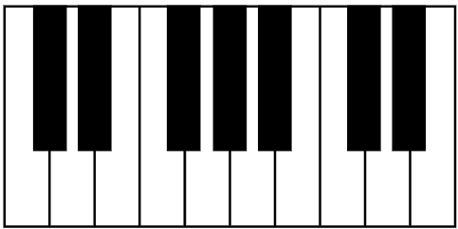
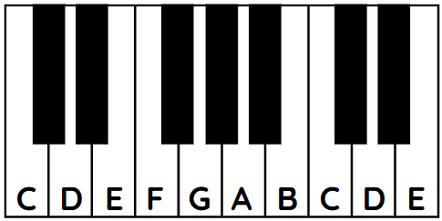

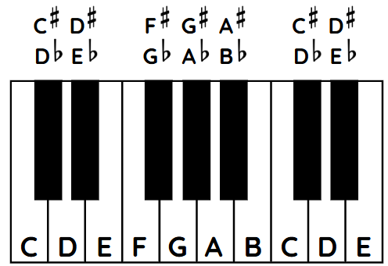
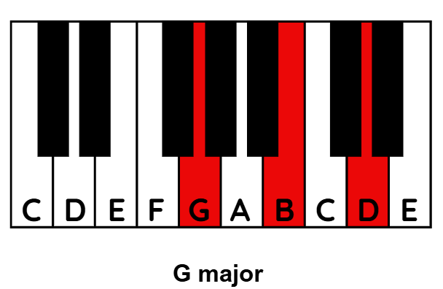
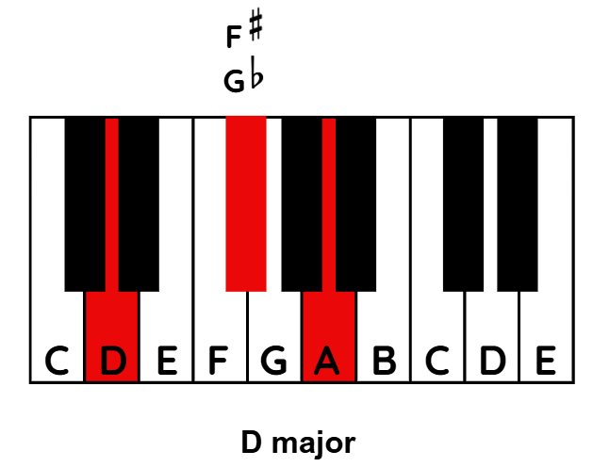
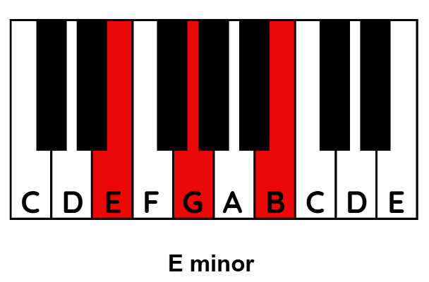
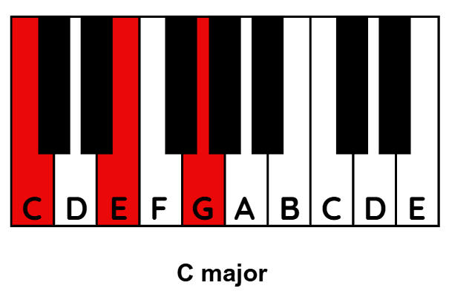

Activity 5.3 – the pentatonic scale – support material
Teacher note: show the G major pentatonic scale and keyboard scale guide found in the PowerPoint. Additionally, you can use the images below to create a handout for the students.
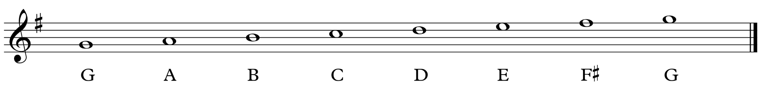
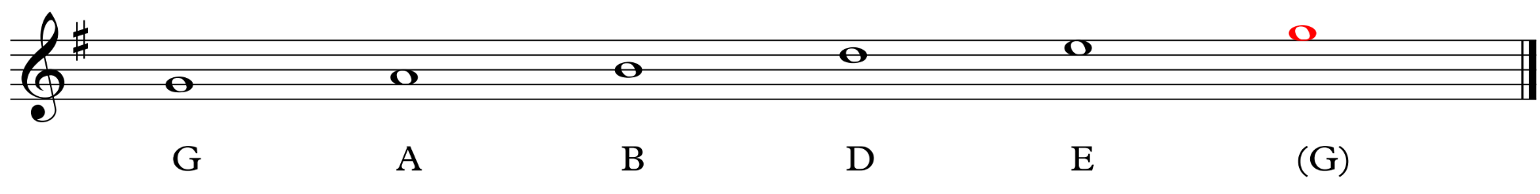
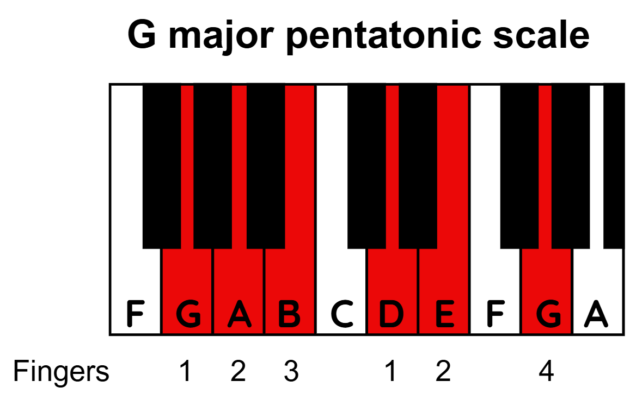

Activity 5.4 – composing using the pentatonic scale – support material
Lesson context: students work on keyboards and compose a 2-bar melody using the G major pentatonic scale. Encourage students to write down their composition using order of notes or on manuscript (provide for them). Once complete, divide the class up into small groups of 3 to 4 students. Students take turns playing their composition while other members of the group sing it back using ‘call and response’. Students are then encouraged to experiment through improvising and sing a different response. Students work in pairs to explore this further. Use the 4-chord progression that they learned last lesson as accompaniment on either the bottom half of the keyboard or on guitar.
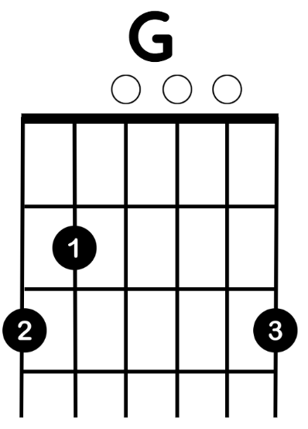
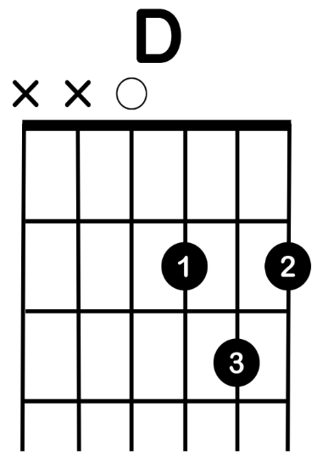
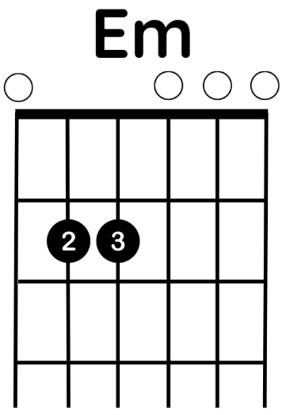
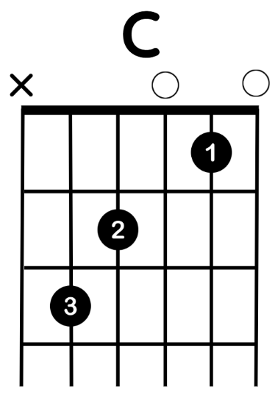
G major pentatonic scale for guitar
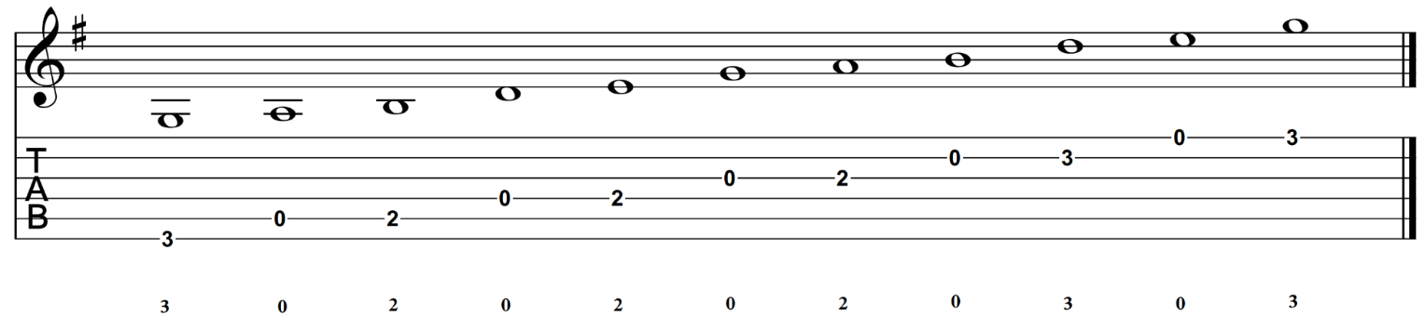

Learning sequence 6 – ensemble composition and performance

Activity 6.1 – comparing versions worksheet
Use the tables below to complete the listening activity, comparing 2 versions of the same song.
Song 1
Sweet Child O’ Mine (5:02) performed by Guns N’ Roses (from 0:00–2:33)
Sweet Child O’ Mine (4:20) performed by PostmodernJukebox (New Orleans version) (from 0:00–2:22)
Table 18 – Activity 6.1 – comparing versions (Sweet Child O’ Mine)
Questions | Version 1 – ‘Sweet Child O’ Mine’ performed by Guns N’ Roses | Version 2 – ‘Sweet Child O’ Mine’ performed by PostmodernJukebox (New Orleans version)
What performing media (instruments and voices) do you hear in this example?
What style of music do you think this piece is? What musical features help to show this?
What similarities do you hear in both versions?
What differences do you hear in both versions?
Song 2
Livin' On a Prayer (4:08) performed by Bon Jovi
Livin’ on a Prayer (3:56) performed by PostmodernJukebox
Table 19 – Activity 6.1 – comparing versions (Livin’ On a Prayer)
Questions | Version 1 – ‘Livin' On a Prayer’ performed by Bon Jovi | Version 2 – ‘Livin’ on a Prayer’ performed by PostmodernJukebox
What performing media (instruments and voices) do you hear in this example?
What style of music do you think this piece is? What musical features help to show this?
What similarities do you hear in both versions?
What differences do you hear in both versions?
Song 3
Can't Buy Me Love (2:11) performed by The Beatles
Can't Buy Me Love (3:20) performed by Michael Bublé
Table 20 – Activity 6.1 – comparing versions (Can’t Buy Me Love)
Questions | Version 1 – ‘Can't Buy Me Love’ performed by The Beatles | Version 2 – ‘Can't Buy Me Love’ performed by Michael Bublé
What performing media (instruments and voices) do you hear in this example?
What style of music do you think this piece is? What musical features help to show this?
What similarities do you hear in both versions?
What differences do you hear in both versions?

Song 4
Titanium (4:05) performed by Sia
Titanium (4:06) performed by PostmodernJukebox
Table 21 – Activity 6.1 – comparing versions (Titanium)
Questions | Version 1 – ‘Titanium’ performed by Sia | Version 2 – ‘Titanium’ performed by PostmodernJukebox
What performing media (instruments and voices) do you hear in this example?
What style of music do you think this piece is? What musical features help to show this?
What similarities do you hear in both versions?
What differences do you hear in both versions?

Song 5
Black and Gold (3:39) performed by Sam Sparro
Black and Gold (4:02) performed by Brenna Whitaker (from 0:33–4:02)
Table 22 – Activity 6.1 – comparing versions (Black and Gold)
Questions | Version 1 – ‘Black and Gold’ performed by Sam Sparro | Version 2 – ‘Black and Gold’ performed by Brenna Whitaker
What performing media (instruments and voices) do you hear in this example?
What style of music do you think this piece is? What musical features help to show this?
What similarities do you hear in both versions?
What differences do you hear in both versions?

Activity 6.1 – comparing versions answer sheet
Song 1
Sweet Child O’ Mine (5:02) performed by Guns N’ Roses (from 0:00–2:33)
Sweet Child O’ Mine (4:20) performed by PostmodernJukebox (New Orleans version) (from 0:00–2:22)
Table 23 – Activity 6.1 – comparing versions (Sweet Child O’ Mine)
Questions | Version 1 – ‘Sweet Child O’ Mine’ performed by Guns N’ Roses | Version 2 – ‘Sweet Child O’ Mine’ performed by PostmodernJukebox (New Orleans version)
What performing media (instruments and voices) do you hear in this example? | Electric guitar, electric bass guitar, drum kit and vocals | Piano, clarinet, drum kit, double bass, vocals, trumpet (with plunger mute) and trombone
What style of music do you think this piece is? What musical features help to show this? | Hard rock  Strong rock pattern played on the drum kit, distorted electric guitar, harsh sounding vocals, and use of guitar riffs | Traditional New Orleans jazz  A bouncy swing pattern with a 2-beat feel, clarinet and trumpet play brief solo passages using lots of expression and changes in timbre, expressive vocals incorporating lots of sliding between notes and at times raspy timbre
What similarities do you hear in both versions? | ${4 \atop 4}$ time and a constant tempo | ${4 \atop 4}$ time and a constant tempo
What differences do you hear in both versions? | Piece starts with an opening riff played on an electric guitar that reoccurs throughout the piece in sections of the chorus  Strong rock beat used  Male vocals with a distinct harsher timbre  Lead distorted guitar solo in instrumental section, exploring a range of playing techniques, including pitch bends | A laid back and relaxed bluesy feel to the piece that is supported by instruments found in a traditional jazz band line up – piano, drum kit, double bass (often referred to as an upright bass), clarinet, trumpet and trombone  Clarinet, muted trumpet and trombone (different one each verse) complement the vocalist at the end of phrases with answering melodic ideas  Vocalist explores melisma material and expression to decorate and enhance the melody  Instrumental breaks featured with distinct changes in feel and treatment of musical material

Song 2
Livin' On a Prayer (4:08) performed by Bon Jovi
Livin’ on a Prayer (3:56) performed by Postmodern Jukebox
Table 24 – Activity 6.1 – comparing versions (Livin’ On a Prayer)
Questions | Version 1 – ‘Livin' On a Prayer’ performed by Bon Jovi | Version 2 – ‘Livin’ on a Prayer’ performed by Postmodern Jukebox
What performing media (instruments and voices) do you hear in this example? | Synthesiser, electric bass, finger cymbals, drum kit, accompanying vocals with digital effect, vocals, electric guitar | Piano, drum kit (with brushes), double bass, clarinet, vocals and trombone
What style of music do you think this piece is? What musical features help to show this? | Hard rock  There is a strong rock beat played on the drum kit, bass guitar plays a continuous riff (changes for the chorus), song form (verse/chorus), use of distorted electric guitar used throughout the piece, including a solo, strong synthesiser use | Jazz/blues  Piano establishes a laid-back feel and includes blues notes, swing feel, clarinet plays improvised passages to answer and complement the vocals, vocalist constantly develops the melody throughout with large use of expression and changes in timbre, trombone takes over role of answering the vocals
What similarities do you hear in both versions? | ${4 \atop 4}$ time  Use of a modulation where the music moves up a step | ${4 \atop 4}$ time  Use of a modulation where the music moves up a step
What differences do you hear in both versions? | Strong rock beat provided by the drum kit  Use of a ‘talk box’ (device to allow the guitarist to alter the sound of the instrument via a tube connected to their mouth) create a distinct accompaniment layer in sections  Distorted guitar solo  Additional vocals join in on key phrases during choruses | A swing feel in a bluesy jazz style that is supported by instruments found in a traditional jazz band line up – piano, drum kit, double bass (often referred as an upright bass), clarinet, trumpet and trombone  Vocalist explores melisma material and expression to decorate enhance the melody  Trombone provides complementary melodic lines over the top of vocals during one of the verses
Song 3
Can't Buy Me Love (2:11) performed by The Beatles
Can't Buy Me Love (3:20) performed by Michael Bublé
Table 25 – Activity 6.1 – comparing versions (Can’t Buy Me Love)
Questions | Version 1 – ‘Can't Buy Me Love’ performed by The Beatles | Version 2 – ‘Can't Buy Me Love’ performed by Michael Bublé
What performing media (instruments and voices) do you hear in this example? | Vocals, acoustic rhythm guitar, electric guitar, bass guitar and drum kit | Trumpets, trombones, saxophones, drum kit, double bass, vocals, piano
What style of music do you think this piece is? What musical features help to show this? | Pop/rock (with blues features)  Fast tempo in ${4 \atop 4}$ time with a strong back beat played on the snare drum, simple chord structure, catchy and simple melody for vocals, simple bass line, blues style electric guitar solo | Swing/Big Band jazz  Fast swing pattern in ${4 \atop 4}$ time, use of call and response between instrument groups and vocalists, walking bass pattern, syncopated rhythms, use of shot notes (accented unison notes played by instrument sections), large use of vocal expression and sliding between notes, a half-time feel (slower tempo) through to provide some contrast and highlight swing feel, instrumental break with use of varied playing techniques and expressive features on the brass (characteristic of the style), syncopated drum fills, piece continues to build before dropping back to a slower laid back jazz feel, improvised piano passages near the end to complement the vocals
What similarities do you hear in both versions? | Fast tempo  Vocals provide melody  Major tonality | Fast tempo  Vocals provide melody (initially similar shape to the original but becomes more varied as the piece develops)  Major tonality (although there is use of modulation to new key centres)
What differences do you hear in both versions? | This version is quite repetitive and follows a verse/chorus structure  The texture remains consistent overall  Guitar solo | More complex musical structure with distinct sections exploring some variety in the jazz style and including modulations  Constant changes in texture and use of instruments throughout  Instrumental break where all accompanying instruments feature  Instruments exploring varied playing techniques, changes in timbre, and contrast between instrument groups, for example, brass and woodwind

Song 4
Titanium (4:05) performed by Sia
Titanium (4:06) performed by PostmodernJukebox
Table 26 – Activity 6.1 – comparing versions (Titanium)
Questions | Version 1 – ‘Titanium’ performed by Sia | Version 2 – ‘Titanium’ performed by PostmodernJukebox
What performing media (instruments and voices) do you hear in this example? | Electric guitar with effects, electronic drums, synthesisers and vocals | Piano, drum kit (using brushes on snare), double bass and vocals
What style of music do you think this piece is? What musical features help to show this? | Electronic/dance music  There is a large use of electronic instrument sounds incorporating string like and piano qualities, use of digital effects to manipulate the layers of electronic instruments and their sounds, strong tempo in ${4 \atop 4}$ time that supported with bass sounds on every beat in sections, use of reverb and delay on some parts to create interesting rhythmic layers | Smooth jazz  Piano introduction incorporating jazz chords, swing pattern played on snare drum using brushes, walking bass lines, smooth sounding vocals supported with use of dynamics and expression, piece builds and leads to a stronger swing feel, this is supported with drums now using sticks and the double bass playing a walking bass line, the piece builds and the vocalist explores more variety in developing the musical material and exploring timbre
What similarities do you hear in both versions? | Use of verse and chorus sections  ${4 \atop 4}$ time and steady tempo | Use of verse and chorus sections (although there is musical variety in how each is performed)  ${4 \atop 4}$ time
What differences do you hear in both versions? | Extensive use of electronic sounds for instrumental layers  Main vocals are enhanced with various digital effects throughout the piece  Strong rhythmic pulse and dance beat throughout the piece  Changes in texture and use of digital effects creates ongoing interest and musical variety | Jazz style with a distinct swing feel – this becomes more evident when the drummer switches from brushes to drumsticks  Vocals use vibrato and variation in dynamics to add expression on notes at the end of each phrase  Inclusion of a piano solo  Ongoing changes in how the musical material is developed, especially with the vocalist exploring rhythmic and melodic variations

Song 5
Black and Gold (3:39) performed by Sam Sparro
Black and Gold (4:02) performed by Brenna Whitaker (from 0:33–4:02)
Table 27 – Activity 6.1 – comparing versions (Black and Gold)
Questions | Version 1 – ‘Black and Gold’ performed by Sam Sparro | Version 2 – ‘Black and Gold’ performed by Brenna Whitaker
What performing media (instruments and voices) do you hear in this example? | Electronic instrument layers with a prominent synthesised bassline  As the piece progresses additional layers of synthesisers add musical interest and increased texture  Vocal melody with a slightly raspy timbre | Double bass (upright bass) provide a prominent pulse and repeated note bass line  Vocal melody that is supported with use of dynamics and expression to highlight changes in timbre and development of musical material  Gradual addition of instrumental layers as the piece progresses – drum kit (primarily the hi-hat and mid tom-tom, then sustained strings)  This is followed with the addition of trumpet, trombone, tenor saxophone and electric guitar. This also introduces a new section and is supported by a strong ${4 \atop 4}$ pattern played on the drum kit
What style of music do you think this piece is? What musical features help to show this? | Electronic dance music  The extensive use of electronic instruments, synthesisers and driving rhythmic beat | Jazz influenced style that has orchestral aspects with the use of strings and bold brass sounds from the trumpet, trombone and tenor saxophone  The vocalist develops the melodic line through exploring changing in timbre, expression, melodic shape and rhythmic qualities
What similarities do you hear in both versions? | Vocal melody  Follows a similar structure with the use of verse and chorus  Inclusion of an instrumental break to provide some contrast  Changes in texture helped to create musical variety | Vocal melody, although it is constantly being developed  Follows a similar structure with the use of verse and chorus (although musical material is developed as the piece progresses)  Inclusion of an instrumental break to provide some contrast  Changes in texture helped to create musical variety – this was also enhanced with the development of new musical material and stylistic features
What differences do you hear in both versions? | Distinct difference in style and the use of electronic instruments  Instrumental break with the use of electronic sounds/layers  Final chorus and outro see a drop in texture and focus is on vocals, which is enhanced with digital effects | Thin  Instrumental break in a swing band style with instruments playing a range of techniques associated with this type of music  Texture increase and see the addition of further instrumental layers

Activity 6.2 – ensemble composition and performance
Lesson context: as a final exercise, students will work in an ensemble setting, bringing together the skills they have learned throughout the unit. Go through the PowerPoint slide outlining the activity. Explain to students that they will be required to work in small groups to create an original composition or arrangement of an existing piece. They will work together to explore and document their musical ideas to create a piece that supports their instrumental skills and current knowledge of using the elements of music. They will be provided class time to work on their compositions and will be encouraged to use the instruments to help experiment and refine their ideas. Students will then be given time to rehearse and prepare their piece for an end of year class performance. Additional support and ideas for your students can be found at Songs Archive | Music Will JamZone.

Activity 6.3 – composing an original piece worksheet
Use the tables below as your ‘composition toolbox worksheets’ to assist you in developing and documenting your ideas and progress.
Table 28 – Activity 6.3 – composing an original piece
Focus | Your response
Student’s name
Others in the group/ensemble
Roles and instruments used
Chord progression used
Structure of your composition

Chord guide
Use the chord guide to record how to play each chord on your instrument(s). This will serve as both a reference for your composition and a resource while learning to play.
Table 29 – Activity 6.3 – composing an original piece (Composition toolbox worksheets)
Chord name | Keyboard | Guitar | Bass
 | 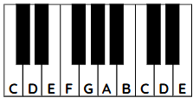 | 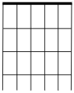 | 

Scales used
Use the manuscript and tablature below to write out the scales you may want to use.
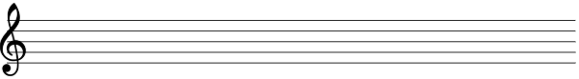
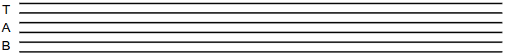

Using the pentatonic scale
Consider the notes of the G pentatonic scale, pictured below along with it being in TAB for guitar. You may use this to help create a melody, accompanying riffs, or a solo for an instrument. You will need to be using a chord progression based on G major to use the G pentatonic scale. If you choose a different key to write in, you will need to adjust the scale to suit.
Table 30 – Activity 6.3 – composing an original piece (Composition toolbox worksheets)
keyboard | 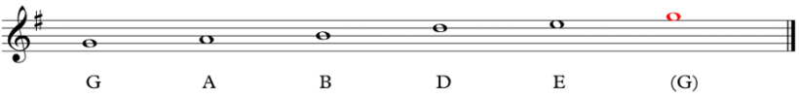
guitar | 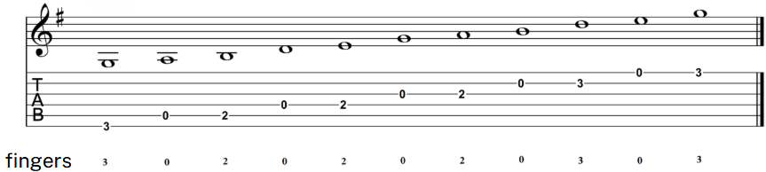

Melody
Use this manuscript to compose your melody.

Riffs
Use the staff or TAB below to compose riff ideas.

Lyrics
Use the space below to develop lyrics for your composition You may like to write down the chords used over the appropriate words, sentences/phrases.

Activity 6.4 – composing an arrangement worksheet
Use the tables below as your ‘composition toolbox’ worksheet to assist you in developing and documenting your ideas and progress.
Table 31 – Activity 6.4 – composing an arrangement
Focus | Your response
Student’s name
Others in the group/ensemble
Roles and instruments used
Piece you will arrange
Style of your arrangement
Use the below guide when considering what features of the music you intend to keep the same as the original or change.
Table 32 – Activity 6.4 – composing an arrangement
What to keep? | What to change? | How to do this?

Chord guide
Use the chord guide to record how to play each chord on your instrument(s). This will serve as both a reference for your composition and a resource while learning to play.
Table 33 – Activity 6.4 – composing an arrangement
Chord name | Keyboard | Guitar | Bass

Scales used
Include blank manuscript and tablature in the ‘composition toolbox worksheets’ for students to write out a scale they may want to use if including new musical material in their arrangement, such as a solo.

Melody
Include blank manuscript in the ‘composition toolbox worksheets’ to support students who may want to adjust or modify the melody of the song they are arranging.

Riffs
Include blank manuscript and tablature in the ‘composition toolbox worksheets’ to support students in composing new riff ideas or additional accompaniment ideas for the arrangement of their song.

References
This resource contains NSW Curriculum and syllabus content. The NSW Curriculum is developed by the NSW Education Standards Authority. This content is prepared by NESA for and on behalf of the Crown in right of the State of New South Wales. The material is protected by Crown copyright.
Please refer to the NESA Copyright Disclaimer for more information https://educationstandards.nsw.edu.au/wps/portal/nesa/mini-footer/copyright.
NESA holds the only official and up-to-date versions of the NSW Curriculum and syllabus documents. Please visit the NSW Education Standards Authority (NESA) website https://educationstandards.nsw.edu.au and the NSW Curriculum website https://curriculum.nsw.edu.au.
Music 7–10 Syllabus © NSW Education Standards Authority (NESA) for and on behalf of the Crown in right of the State of New South Wales, 2024.
aa (13 October 2011) 'David Guetta - Titanium (Audio)' [video], aa, YouTube, accessed 14 May 2025.
Berry C (29 April 2020) 'Johnny Be Goode' [video], Chuck Berry, YouTube, accessed 14 May 2025.
BessieSmithVEVO (1 May 2015) 'Bessie Smith - St. Louis Blues (Audio)' [video], BessieSmithVEVO, YouTube, accessed 14 May 2025.
Brown J (9 November 2014) 'I Feel Good (I Got You)' [video], James Brown, YouTube, accessed 14 May 2025.
Chapman T (14 November 2015) 'Tracy Chapman - Give Me One Reason (Official Music Video)' [video], Tracy Chapman, YouTube, accessed 14 May 2025.
Classic Hits Studio (6 March 2022) 'Glenn Miller - In The Mood | Colorized (1941) 4K' [video], Classic Hits Studio, YouTube, accessed 14 May 2025.
Classic Mood Experience (17 April 2021) 'Robert Johnson - Sweet Home Chicago [1937]' [video], Classic Mood Experience, YouTube, accessed 14 May 2025.
Conor Rocks (10 March 2024) 'Guitar Riff vs Lick: EASY Beginners Guide' [video], Conor Rocks, YouTube, accessed 21 August 2025.
Deep Purple Official (2 March 2024) Deep Purple – 'Smoke On the Water (Official Music Video)' [video], Deep Purple Official, YouTube, accessed 14 May 2025.
Drumeo (20 October 2018) '7 Rock Drum Fills for Beginners' [video], Drumeo, YouTube, accessed 14 May 2025.
Guitar Center (21 August 2021) 'How to Play the Blues Shuffle | Beginner Guitar Tips' [video], Guitar Center, YouTube, accessed 25 August 2025.
Guitar Improvisation (28 June 2017) 'Blues Shuffle in A' [video], Guitar Improvisation, YouTube, accessed 14 May 2025.
Guns N’ Roses (25 December 2009) 'Guns N' Roses - Sweet Child O' Mine (Official Music Video)' [video], Guns N’ Roses, YouTube, accessed 14 May 2025.
Hancock H (11 March 2017) 'Watermelon Man (Remastered 2007)' [video], Herbie Hancock, YouTube, accessed 14 May 2025.
Howlin’ Wolf – Topic (8 August 2018) 'Spoonful' [video], Howlin’ Wolf – Topic, YouTube, accessed 14 May 2025.
Island Records UK (23 February 2008) 'Sam Sparro - Black and Gold' [video], Island Records UK, YouTube, accessed 14 May 2025.
Jazz at Lincoln Center’s JAZZ ACADEMY (23 February 2015) 'Jazz Fundamentals: What Is Improvisation?' [video], Jazz at Lincoln Center’s JAZZ ACADEMY, YouTube, accessed 21 August 2025.
Jovi B (17 June 2009) 'Bon Jovi - Livin' On A Prayer' [video], Bon Jovi, YouTube, accessed 14 May 2025.
Metallica (8 June 2022) 'Enter Sandman (Remastered)' [video], Metallica, YouTube, accessed 14 May 2025.
Musical Futures International Inc. (n.d.) The Jam Grid, Musical Features International website, accessed 14 May 2025.
National Youth Jazz Collective (24 October 2014) 'NYJC Glossary of Terms - Blue Notes' [video], National Youth Jazz Collective, YouTube, accessed 21 August 2025.
Phiddy1990 (3 November 2012) 'Axis of Awesome (Clean)' [video], Phiddy1990, YouTube, accessed 14 May 2025.
PostmodernJukebox (13 February 2014) '"Sweet Child O' Mine" - New Orleans Style Guns N' Roses Cover ft. Miche Braden' [video], PostmodernJukebox, YouTube, accessed 14 May 2025.
PostmodernJukebox (30 July 2014) 'Livin' on a Prayer - Vintage Jazz Bon Jovi Cover ft. Miche Braden' [video], PostmodernJukebox, YouTube, accessed 14 May 2025.
PostmodernJukebox (5 November 2014) 'Titanium - Vintage 1940s Jazz Crooner - Style Sia / David Guetta Cover ft. Von Smith' [video], PostmodernJukebox, YouTube, accessed 14 May 2025.
Presley E (5 June 2013) 'Elvis Presley - Hound Dog (Official Audio)' [video], Elvis Presley, YouTube, accessed 14 May 2025.
RHINO (23 January 2018) 'Booker T. & The MG's - Green Onions (Official Audio)' [video], RHINO, YouTube, accessed 14 May 2025.
Sonny Terry & Brownie McGhee – Topic (3 January 2015) 'Walk On' [video], Sonny Terry & Brownie McGhee – Topic, YouTube, accessed 14 May 2025.
Swing this Music (8 February 2017) 'Call & Response. Work song - Prision song (1966)' [video], Swing this Music, YouTube, accessed 14 May 2025.
The Beatles (17 June 2018) 'Can't Buy Me Love (Remastered 2015)' [video], The Beatles, YouTube, accessed 14 May 2025.
THE JAZZ WORLD (6 April 2022) 'Michael Bublé ‎– Can't Buy Me Love' [video], THE JAZZ WORLD, YouTube, accessed 14 May 2025.
The Surfaris – Topic (4 March 2020) 'Wipe Out' [video], The Surfaris – Topic, YouTube, accessed 14 May 2025.
The White Stripes (22 October 2008) 'The White Stripes - Seven Nation Army (Official Music Video)' [video], The White Stripes, YouTube, accessed 14 May 2025.
Whitaker B (30 October 2015) 'Brenna Whitaker - Black And Gold' [video], Brenna Whitaker, YouTube, accessed 14 May 2025.
World Heart Beat (17 June 2022) 'Introduction to the blues - an easy and accessible explanation of the classic 12-bar blues format' [video], World Heart Beat, YouTube, accessed 21 August 2025.

© State of New South Wales (Department of Education), 2025
The copyright material published in this resource is subject to the Copyright Act 1968 (Cth) and is owned by the NSW Department of Education or, where indicated, by a party other than the NSW Department of Education (third-party material).
Copyright material available in this resource and owned by the NSW Department of Education is licensed under a Creative Commons Attribution 4.0 International (CC BY 4.0) license.

This license allows you to share and adapt the material for any purpose, even commercially.
Attribution should be given to © State of New South Wales (Department of Education), 2025.
Material in this resource not available under a Creative Commons license:
- the NSW Department of Education logo, other logos and trademark-protected material
- material owned by a third party that has been reproduced with permission. You will need to obtain permission from the third party to reuse its material.
Links to third-party material and websites
Please note that the provided (reading/viewing material/list/links/texts) are a suggestion only and implies no endorsement, by the New South Wales Department of Education, of any author, publisher, or book title. School principals and teachers are best placed to assess the suitability of resources that would complement the curriculum and reflect the needs and interests of their students.
If you use the links provided in this document to access a third-party's website, you acknowledge that the terms of use, including licence terms set out on the third-party's website apply to the use which may be made of the materials on that third-party website or where permitted by the Copyright Act 1968 (Cth). The department accepts no responsibility for content on third-party websites.

