Deep dive into the Creative K–6 Syllabus
Participant workbook
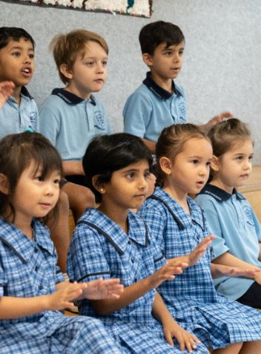

Contents
About this workbook 2
Introduction 2
Unpacking the elements and artworld concepts in the Creative Arts K–6 Syllabus 3
Learning outcomes 3
Creative arts K–6 – the elements 4
Dance 4
Drama 4
Music 5
Visual arts 5
Activity – scavenger hunt – syllabus navigation 6
Activity – artworld concepts 8
Visible thinking routines 8
Example artworks 8
Blank template 9
Worked examples 10
Reflection – connect, extend, challenge 12
References 13

About this workbook
This workbook is designed to guide your thinking, reflections and plans for future action. Your facilitator will guide you through the activities.
This workbook can be printed double-sided or used digitally.

Introduction
This workshop will support teachers to deepen their understanding of the Creative Arts K–6 Syllabus.
Participants will:
- explore how the elements and artworld concepts in the Creative Arts K–6 Syllabus contribute to building knowledge, understanding and skills.

Unpacking the elements and artworld concepts in the Creative Arts K–6 Syllabus
Please use the Creative Arts K–6 Syllabus to support your learning in this session.

Learning outcomes
By completing this professional learning, you will:
- understand how the elements and artworld concepts contribute to building knowledge, understanding and skills in creative arts K–6
- examine the elements of dance, drama, music and visual arts as outlined in the Creative Arts K–6 Syllabus
- explore the elements and artworld concepts in practice.

Creative arts K–6 – the elements
The elements of each focus area are fundamental to learning in creative arts. The teaching advice for Dance in the Creative Arts K–6 Syllabus provides specific guidance with focus questions and examples to support understanding and vocabulary development.

Dance
Each element of dance has a number of components. The elements and components of dance develop as students progress through the stages of learning.

The elements of dance
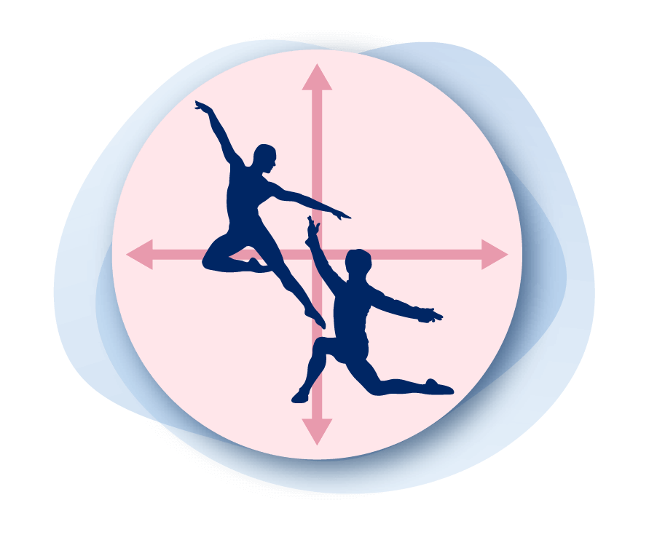  Space | 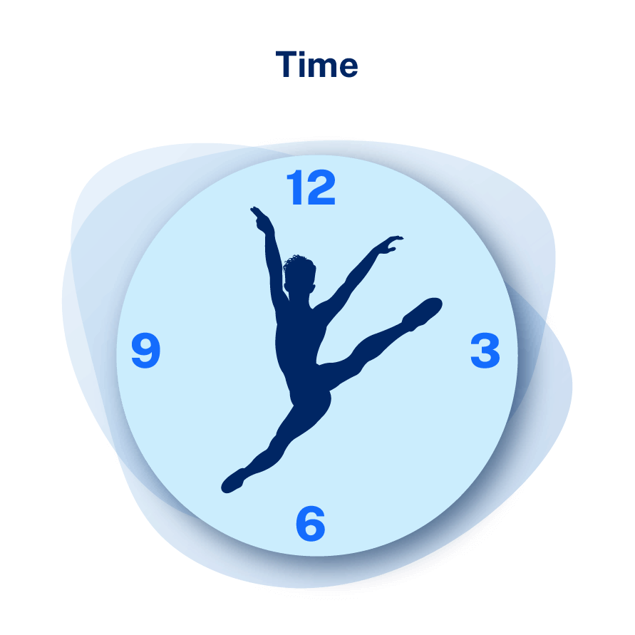  Time | 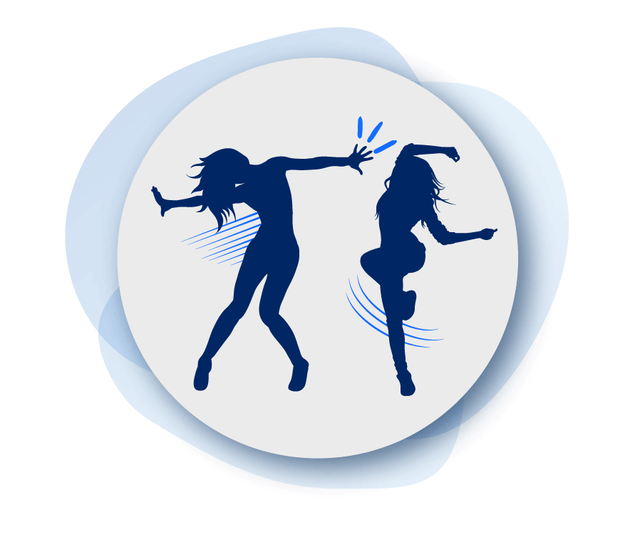  Dynamics

Drama
The Creative Arts K–6 Syllabus also includes content related to the elements of production: set, costume, lighting, props and technologies.
The dramatic elements
Role | Character | Tension | Situation | Space
Time | Structure | Language | Atmosphere | Symbol

Music
The elements of music
Duration | Pitch | Texture | Performing media
Timbre | Dynamics | Expression | Structure

Visual arts
Artists use the elements of art and design to communicate ideas and intent.
The elements of art
Line | Shape | Form | Space and perspective
Colour | Tone | Texture | Rhythm

The elements of design
Rhythm and movement | Balance | Unity | Contrast
Emphasis | Proportion | Signs and symbols | Repetition and pattern

Activity – scavenger hunt – syllabus navigation
- Open the Creative Arts K–6 Syllabus.
- Use the questions below to explore the content, examples and teaching advice.
- Record your responses in the spaces beneath each prompt.
Drama – Use the teaching advice to identify the dramatic elements as they are introduced in each stage.
Early Stage 1 | Stage 1 | Stage 2 | Stage 3
Dance – What vocabulary examples are suggested for the element of dynamics in Stage 1?
Music – Which element is defined as 'the relative highness or lowness of sounds’ in Stage 2??
Visual arts – What content point explicitly references the elements of art and design in Stage 3? What examples are provided?

Activity – artworld concepts
Figure 1 – artworld concepts diagram (NESA 2024)
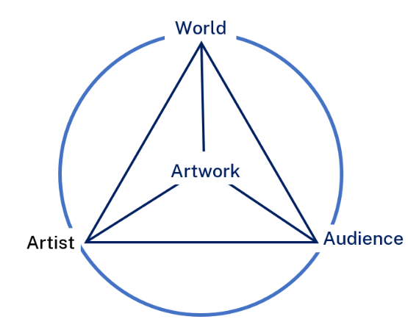
- Select an artwork.
- Access the syllabus and select relevant content.
- Develop guiding questions to scaffold student analysis of an artwork through the lens of the artworld concepts.

Visible thinking routines
- Project Zero’s Visible Thinking Routines

Example artworks
- Swimming before school (1995), Ian Abdulla
- Flowers that Bloom in the Cosmos (2022), Yayoi Kusama

Blank template
Chosen artwork

Content points | Guiding questions
Making connections | Content points and learning experiences for ‘Making’ content group

Worked examples
Ballarat, My Country (2020), Marlene Gilson
View the artwork and background information on the Art Gallery of NSW website.

Examples of Stage 3 content points  - Explain structural features of an artwork and how artists use the elements of art and design to communicate meaning to audiences through art forms, using Tier 2 and Tier 3 vocabulary  - Describe how meaning is conveyed through signs and symbols in artworks  - Investigate an artist's practice and explain the roles and connections between artist, artwork, the world and audiences  Making connections: HSIE  Research how the discovery of gold changed colonial life in Australia using sources from the gold rush period from the 1850s to the 1890s. | Framing questions around a visible thinking routine  I see … What do you see when looking at the artwork? How has the artist used colour, line and symbol?  I think … What is the subject of this painting and what makes you think that? What meaning is the artist trying to convey? Why?  I feel … How does the artwork make you feel? How did hearing about the artist and artwork change how you view the painting?  I wonder … How are the artist’s personal ideas or experiences represented in the artwork?

Stand strong for who you are (2020), Vincent Namatjira
View the artwork and background information on the Art Gallery of NSW website.

Examples of Stage 2 content points  - Discuss ways artworks connect to own personal, social or cultural contexts  - Describe how signs and symbols such as objects, words and colours are used to influence meaning in artworks  - Investigate ways Aboriginal and/or Torres Strait Islander Peoples engage in art making for story sharing, celebrations or Cultural expression  - Describe how artists make choices in their practice that influence how audiences interpret artworks  Making connections: English  English Sample Unit – Stage 2 First year – Unit 8 – Theme – Kicking Goals with Goodesy and Magic. | Framing questions around the artworld concepts  Artwork – How are ideas represented in the artwork? How have colour and symbol been used to convey meaning?  Artist – How have the artist’s personal experiences influenced their work? How are their personal ideas or experiences represented in the artwork? Why might they have chosen to represent them in that way?  Audience – Who is the intended audience? How has the audience been positioned in the composition of the artwork? What effect does this have?  World – Does the subject matter reflect a particular time or place? Are there any national or global events, issues or ideas represented in the artwork?

Reflection – connect, extend, challenge
Connect – How did the information presented today connect to what you already know?
Extend – How did it extend your thinking? What new learning emerged for you?
Challenge – What challenges or puzzles emerged for you?
Notes

References
This resource contains NSW Curriculum and syllabus content. The NSW Curriculum is developed by the NSW Education Standards Authority. This content is prepared by NESA for and on behalf of the Crown in right of the State of New South Wales. The material is protected by Crown copyright.
Please refer to the NESA Copyright Disclaimer for more information https://educationstandards.nsw.edu.au/wps/portal/nesa/mini-footer/copyright.
NESA holds the only official and up-to-date versions of the NSW Curriculum and syllabus documents. Please visit the NSW Education Standards Authority (NESA) website https://educationstandards.nsw.edu.au and the NSW Curriculum website https://curriculum.nsw.edu.au.
Creative Arts K–6 Syllabus © NSW Education Standards Authority (NESA) for and on behalf of the Crown in right of the State of New South Wales, 2024.
Abdulla I (1995) Swimming before school [synthetic polymer paint on canvas], Art Gallery of NSW website, Art Gallery of NSW, New South Wales, accessed 9 May 2025.
Gilson M (2020) Ballarat, My Country [synthetic polymer paint on linen], Art Gallery of NSW website, Art Gallery of NSW, New South Wales, accessed 16 April 2024.
Kusama Y (2022) Flowers that Bloom in the Cosmos [stainless steel, polyurethane paint], Art Gallery of NSW website, Art Gallery of NSW, New South Wales, accessed 15 May 2025.
Namatjira V (2020) Stand Strong For Who You Are [acrylic on linen], Art Gallery of NSW website, Art Gallery of NSW, New South Wales, accessed 16 April 2024

© State of New South Wales (Department of Education), 2025
The copyright material published in this resource is subject to the Copyright Act 1968 (Cth) and is owned by the NSW Department of Education or, where indicated, by a party other than the NSW Department of Education (third-party material).
Copyright material available in this resource and owned by the NSW Department of Education is licensed under a Creative Commons Attribution 4.0 International (CC BY 4.0) license.

This license allows you to share and adapt the material for any purpose, even commercially.
Attribution should be given to © State of New South Wales (Department of Education), 2025.
Material in this resource not available under a Creative Commons license:
- the NSW Department of Education logo, other logos and trademark-protected material
- material owned by a third party that has been reproduced with permission. You will need to obtain permission from the third party to reuse its material.
Links to third-party material and websites
Please note that the provided (reading/viewing material/list/links/texts) are a suggestion only and implies no endorsement, by the New South Wales Department of Education, of any author, publisher, or book title. School principals and teachers are best placed to assess the suitability of resources that would complement the curriculum and reflect the needs and interests of their students.
If you use the links provided in this document to access a third-party's website, you acknowledge that the terms of use, including licence terms set out on the third-party's website apply to the use which may be made of the materials on that third-party website or where permitted by the Copyright Act 1968 (Cth). The department accepts no responsibility for content on third-party websites.

