Exploring the creative arts, HSIE, PDHPE and science and technology K–6 sample scope and sequences
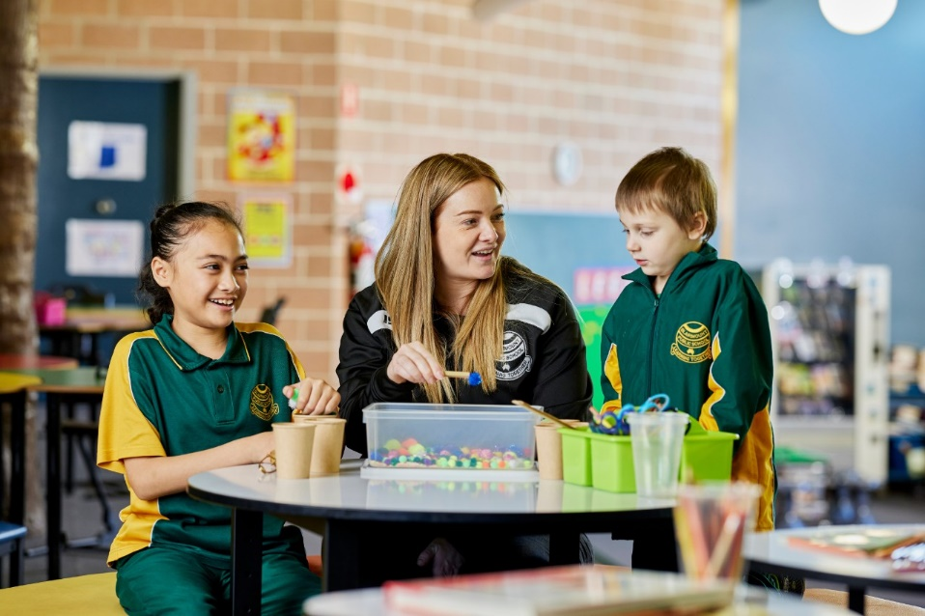
Contents
About this workbook 2
Introduction 2
Agenda 3
Purpose 4
Outcomes 4
CHPS sample scope and sequences 5
Activity 1 – scope and sequence exploration 5
Connections 7
Activity 2 – Aboriginal and/or Torres Strait Islander content 7
Activity 3 – creating written texts 8
Activity 4 – connections across sample scope and sequences 9
School planning 10
Activity 5 – professional borrowing 10
School planning time 11
Activity 6 – whole-school planning 11
References 13

About this workbook
This workbook is designed to guide your thinking, reflections and plans for future actions. Your facilitator will guide you through the activities.
This workbook can be printed double-sided or used digitally.

Introduction
This workshop will guide leaders and stage teams through sample scope and sequences for creative arts, HSIE, PDHPE and science and technology, with dedicated time for school planning.
Please use the following resources to support your learning in this session:
- Teaching resources – NSW Education Standards Authority (NESA) syllabus support
- Teaching and learning – Curriculum – NSW Department of Education sample scope and sequences.

Agenda
Session (9 am–3 pm)
Introduction to CHPS sample scope and sequences
CHPS sample scope and sequences
- Creative arts
- PDHPE
- HSIE
- Science and technology
Morning tea – 20 minutes
Connections
School planning
Lunch – 30 minutes
School planning time
Conclusion/Reflection

Purpose
To understand the structure and intent of the CHPS sample scope and sequences.

Outcomes
By the end of this workshop, participants will:
- understand the essential content and key features of the CHPS scope and sequences
- identify the content connections across the sample scope and sequences
- determine the next steps for implementation.

CHPS sample scope and sequences

Activity 1 – scope and sequence exploration
- Open a selected scope and sequence from the key learning area pages
- Creative arts K–6 sample scope and sequence
- HSIE K–6 sample scope and sequence
- PDHPE K–6 sample scope and sequence
- Science and technology K–6 sample scope and sequence.
- Select your chosen sample scope and sequence.
- Choose a stage.
- Review the 8-term approach for that stage.
- Select a year of learning (Terms 1 to 4 or 5 to 8) and identify the content groups scoped for that year.
- Record the KLA, stage, year and content groups scoped in that year and list any similarities and differences to current school scope and sequences.
Notes

Connections

Activity 2 – Aboriginal and/or Torres Strait Islander content
- Select one CHPS sample scope and sequence and examine the Aboriginal and/or Torres Strait Islander content thread across the stages.
- What connections did you find?
- What do you notice about the increase in complexity of content across the stages?
- Repeat the process with another CHPS sample scope and sequence.
- Compare the 2 KLAs scope and sequences Aboriginal and/or Torres Strait Islander content.
- What are the similarities and differences across both key learning areas?
Notes

Activity 3 – creating written texts
- Select either the creative arts or PDHPE sample scope and sequence.
- Examine the creating written texts content embedded within the Stage 2 and Stage 3 content groups.
- Select either HSIE or science and technology sample scope and sequence.
- Examine the creating written texts content groups.
- Explore the increase in complexity in content across the stages.
- Review the key learning area specific language, skills and knowledge required.
Notes

Activity 4 – connections across sample scope and sequences
- Explore a connection between CHPS syllabus content.
- Examine the CHPS sample scope and sequences and explore the content connections. Consider
- How does the learning connect with another CHPS key learning area?
- What connections can you see?
- How do these connections influence your whole-school planning?
Notes

School planning

Activity 5 – professional borrowing
Task 1 – in table groups, using sticky notes, discuss and record some of the considerations when whole-school planning for CHPS using the sample scope and sequences. What are the unique factors for your settings? Group these into themes if applicable.
Task 2 – borrowing time – take a gallery walk around the other table groups to see others’ ideas.
Task 3 – building on ideas – return to your table groups and build on your previous ideas by recording any new borrowed ideas. Discuss as a table anything you borrowed.
Notes

School planning time

Activity 6 – whole-school planning
Use the school planning matrix below to plan your next steps:
- What do you need to consider at your school to implement the CHPS sample scope and sequences?
- How will you support colleagues’ understanding and implementation?
- What are the considerations for RFF/specialist teachers?
- How will you support staff to plan for new content that has been introduced to avoid gaps forming in student learning?
Plan now | Do now
Park for later | Do soon

Notes

References
This resource contains NSW Curriculum and syllabus content. The NSW Curriculum is developed by the NSW Education Standards Authority. This content is prepared by NESA for and on behalf of the Crown in right of the State of New South Wales. The material is protected by Crown copyright.
Please refer to the NESA Copyright Disclaimer for more information https://educationstandards.nsw.edu.au/wps/portal/nesa/mini-footer/copyright.
NESA holds the only official and up-to-date versions of the NSW Curriculum and syllabus documents. Please visit the NSW Education Standards Authority (NESA) website https://educationstandards.nsw.edu.au and the NSW Curriculum website https://curriculum.nsw.edu.au.
Creative Arts K–6 Syllabus © NSW Education Standards Authority (NESA) for and on behalf of the Crown in right of the State of New South Wales, 2024.
Human Society and its Environment K–6 Syllabus © NSW Education Standards Authority (NESA) for and on behalf of the Crown in right of the State of New South Wales, 2024.
Personal Development, Health and Physical Education K–6 Syllabus © NSW Education Standards Authority (NESA) for and on behalf of the Crown in right of the State of New South Wales, 2024.
Science and Technology K–6 Syllabus © NSW Education Standards Authority (NESA) for and on behalf of the Crown in right of the State of New South Wales, 2024.
Kick Frame (2025) Prioritization Matrix, Kick Frame Toolbox website, accessed 18 August 2025.
NSW Education Standards Authority (NESA) (2025) Teaching resources, NSW Curriculum website, accessed 7 August 2025.
State of New South Wales (Department of Education) (2025) ‘Creative arts K–6 sample scope and sequence’, Planning, programming and assessing creative arts K–6 (2024), NSW Department of Education website, accessed 7 August 2025.
——(2025) ‘HSIE K–6 sample scope and sequence’, Planning, programming and assessing HSIE K–6 (2024), NSW Department of Education website, accessed 7 August 2025.
——(2025) ‘Science and technology K–6 sample scope and sequence’, Planning, programming and assessing science and technology K–6 (2024), NSW Department of Education website, accessed 7 August 2025.
——(2025) ‘Scope and sequence – PDHPE K–6’, PDHPE K–6 curriculum resources, NSW Department of Education website, accessed on 7 August 2025.

© State of New South Wales (Department of Education), 2025
The copyright material published in this resource is subject to the Copyright Act 1968 (Cth) and is owned by the NSW Department of Education or, where indicated, by a party other than the NSW Department of Education (third-party material).
Copyright material available in this resource and owned by the NSW Department of Education is licensed under a Creative Commons Attribution 4.0 International (CC BY 4.0) license.

This license allows you to share and adapt the material for any purpose, even commercially.
Attribution should be given to © State of New South Wales (Department of Education), 2025.
Material in this resource not available under a Creative Commons license:
- the NSW Department of Education logo, other logos and trademark-protected material
- material owned by a third party that has been reproduced with permission. You will need to obtain permission from the third party to reuse its material.
Links to third-party material and websites
Please note that the provided (reading/viewing material/list/links/texts) are a suggestion only and implies no endorsement, by the New South Wales Department of Education, of any author, publisher, or book title. School principals and teachers are best placed to assess the suitability of resources that would complement the curriculum and reflect the needs and interests of their students.
If you use the links provided in this document to access a third-party's website, you acknowledge that the terms of use, including licence terms set out on the third-party's website apply to the use which may be made of the materials on that third-party website or where permitted by the Copyright Act 1968 (Cth). The department accepts no responsibility for content on third-party websites.

