
Scholarship Name (e.g. 2026 Premier’s NESA Quality Teaching Scholarship)

Your Title here
  - Your subtitle here
Author Name
School or institution, suburb name
Sponsored by

When inserting your logo image, please use ‘Format Picture’ settings to include alt text for screen readers.

Introduction
Use this section to introduce your report. Recommended length is 200 – 300 words.

Focus of Study
What were you looking for? Recommended length is 100 – 200 words.

Significant Learning
What did your find during your study tour? Recommended length is 2,000 – 2,500 words.
Remember that you are writing a report, not an essay or a narrative. Your report should be a short, concise document and relatively formal in tone, not the informal language of a narrative.
Use concise, active and engaging language. Drawing comparisons with the current NSW education setting is critical to engaging your audience with the findings of your report.
When reporting on numerous site visits, organise your findings into common themes, rather than listing many events without drawing any conclusions.
See below for further formatting details on how to include photos (maximum of five), headings, number lists and bullet lists
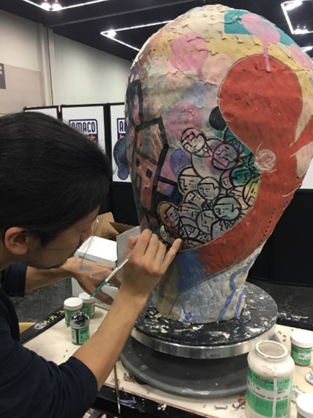
Figure 1: Live demonstration by En Iwamura at NCECA 2017 (Photo by Melissa Grahovac)
A maximum of five photos may be included in the report. As these photos will be published on a public web page there must be approval from all subjects in the photos for this use. An email agreement is the miniumum requirement. Photos should: be 100KB in size; include alt (alternate) text for screen readers; include a caption; be placed on a separate line to the text as shown above; and acknowledge the photopgrapher.

Heading 2
Text following headings
“I hate quotations. Tell me what you know.” – Ralph Waldo Emerson (Quote style)
Never use italics to emphasise! Use Strong text style instead.

Heading 3
If you use figures and graphs, they must be captioned to provide information in an alternate non-visual format. For example, if you use a graph then also include a table with the same information.

Age of Students Taught (60 responses)
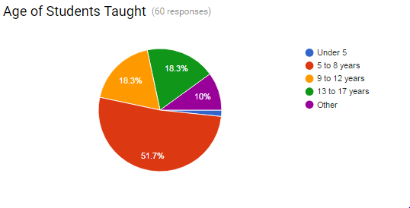
Under 5 | 1.7%
5 to 8 years | 51.7%
9 to 12 years | 18.3%
13 to 17 years | 18.3%
Other | 10%

Unordered Lists
- Unordered List item 1
- Unordered List item 2
  - Unordered List item 2a
  - Unordered List item 2b
    - Unordered List item 2b(i)

Ordered List
- Ordered List item 1
- Ordered List item 2
  - Ordered List item 2a
  - Ordered List item 2b
    - Ordered List item 2b(i)

Conclusion
Use this section to conclude your report. Recommended length is 300 – 400 words.
It should provide your thought-provoking insights gained as a result of your study. This section may also include your plans for sharing your learning.

Acknowledgements
Standard acknowledgement text is provided.
Recognition and thanks are given:
- for the support and collaboration of all who assisted in preparing for and engaging in the study tour, and contributed to enriching the overall experience, and
- for the sponsorship of [SPONSOR NAME], whose generous funding of this scholarship made the study tour possible.

References
Include where cited references are linked to the body of your report. While you may have read extensively on your subject, a reading list is different from a reference list and is not required. The Harvard AGPS is recommended.

