
2025 Premier’s Anika Foundation Youth Depression Awareness Scholarship

Teach us wellbeing
  - Research based strategies that ever educator should teach
Yang (Young) Sun
Marist College Eastwood
Sponsored by The Ankia Foundation
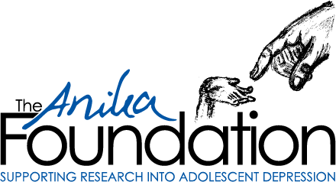

Introduction
This report seeks to bridge the gap between wellbeing research and practice, providing educators with practical research-based strategies they can implement to build awareness of positive wellbeing and mental health in school-aged children. According to Oxford University’s The World Happiness Report (2023), ‘the best predictor for adult life satisfaction is subjective wellbeing and emotional health during childhood’. However, the trend in future life satisfaction for Australian children and adolescents is dire. Data from the Australian Household, Income and Labour Dynamics Survey (2021) shows how depression and anxiety disorders among individuals aged 15-34 have sharply increased, while other illnesses have remained stable (Figure 1).
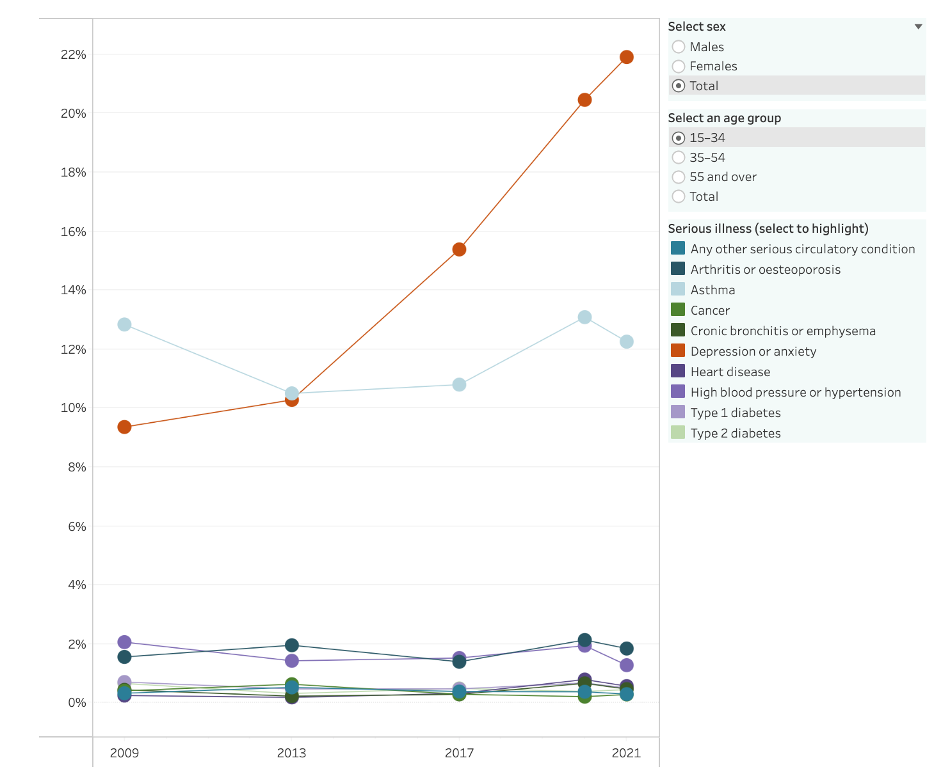
Figure 1: Estimated proportion of Australians reporting serious illnesses, 2009 - 2021.
The Black Dog Institute’s Future Proofing Study (2022) states that ‘schools are a vital part of the solution’ in combating adolescent mental illnesses as educational settings are the physical places that young people spend most of their time in. Therefore, educators must be well equipped with the professional knowledge and skills to provide holistic support to adolescents, rather than simply focussing on an academic curriculum. Indeed, as Daniszewski (2013) notes: ‘more than ever, teachers are placed on the frontlines of mental health care provision, including identification and intervention delivery.’

Focus of Study
The aim of the Anika Foundation scholarship is to advocate for all educators to be teachers of mental health and wellbeing. Therefore, by interviewing leading global academics and researchers in the wellbeing and mental health field, and visiting schools that have successfully implemented mental health and wellbeing programs, their expertise and experiences allowed me to investigate three key areas:
- How can we bridge the gap between research and practice?
- How are schools around the world effectively implementing mental health and wellbeing programs?
- What are some practical strategies that educators can use in their schools/classrooms so we can all be teachers of mental health and wellbeing?

Significant Learning

1. A mentor for every student
‘...being seen is huge, being cared for, and I would even say being loved is really important. Children need to be recognised and known. I think that is probably the biggest mental health strategy.’ - Mrs Suellen Inwood, Director of Easton Country Day School, Connecticut, USA
Research findings:
The latest Labour Force Status of Families Survey (ABS, 2024) indicates that 73% of children aged 0-14 years have both parents employed. Consequently, our current youth are missing out on genuine, purposeful conversations with parents because they are not at home. During a face-to-face interview, Nurse Melanie Eigestad (International School of Stavanger) discussed the loss of family time as a significant threat to youth mental health in our contemporary context because ‘increasingly around the world, parents are working more in order to meet the demands of the cost of living.’ Therefore, as a school community, it is vital that we provide every child with an adult mentor in the same way that students are provided with a Mathematics teacher or a homeroom teacher.
At one Australian school, students in Years 7-10 currently participate in a paid mental health program. This program is meant to run every fortnight under the guidance of homeroom teachers with supplementary resources such as an online portal, journal and other evidence-based activities. One Year 10 student who has been part of this program for two years has provided a recommendation on how schools could foster youth mental health better:
‘The students do not care about something that needs little effort to be done. The program is like the same as filling out another boring worksheet that doesn't need thought or effort put into it. It doesn't let students express their feelings in a safe and confidential environment or have a 1-on-1 conversation with a teacher or with someone that the students trust. This is important for mental health as it lets us vent and let all of our thoughts and feelings go. I feel that if every student gets a designated 10 minutes with a teacher that the student knows well, this will improve the overall happiness and wellbeing of the students.’

What could this look like in the school/ classroom environment?
It is essential for school executives to facilitate every child having an individual mentor so they feel seen and heard. This may require schools to rethink the purpose of homeroom, and how it may instead be a space for students to meet with their homeroom teacher one-on-one each week or fortnight. When I asked Nurse Eigestad what her number one mental health tip is, she said ‘we need to listen to teenagers and try to put ourselves in their positions. Avoid listening to what they are saying with adult ears, try to think about it from their perspective and really make them feel seen and heard.’
For example, a high school could change their morning homerooms to allow every student to receive a one-on-one check-in every fortnight. In their one-on-one check-ins, students may be given the choice to have unstructured conversations with their mentor on aspects of their lives or more structured sessions can be implemented. Two methods that mentors may like to use are PMI charts (plus, minus, interesting) or the SWOT analysis (identifying strengths, weaknesses, threats and opportunities in their lives). It is crucial that mentors avoid judgment during these meetings; instead, they should guide students in navigating life’s vicissitudes.
Figure 2 (below) is a sample homeroom schedule for a teacher with thirty students in their homeroom class. The schedule also provides students with a late school start for the days when they do not have their check-ins. This is beneficial given that half of Australian teenagers do not obtain the recommended eight to 10 hours of sleep per night, with bad sleep being a significant risk factor for suicide, among other things (Paterson 2024).
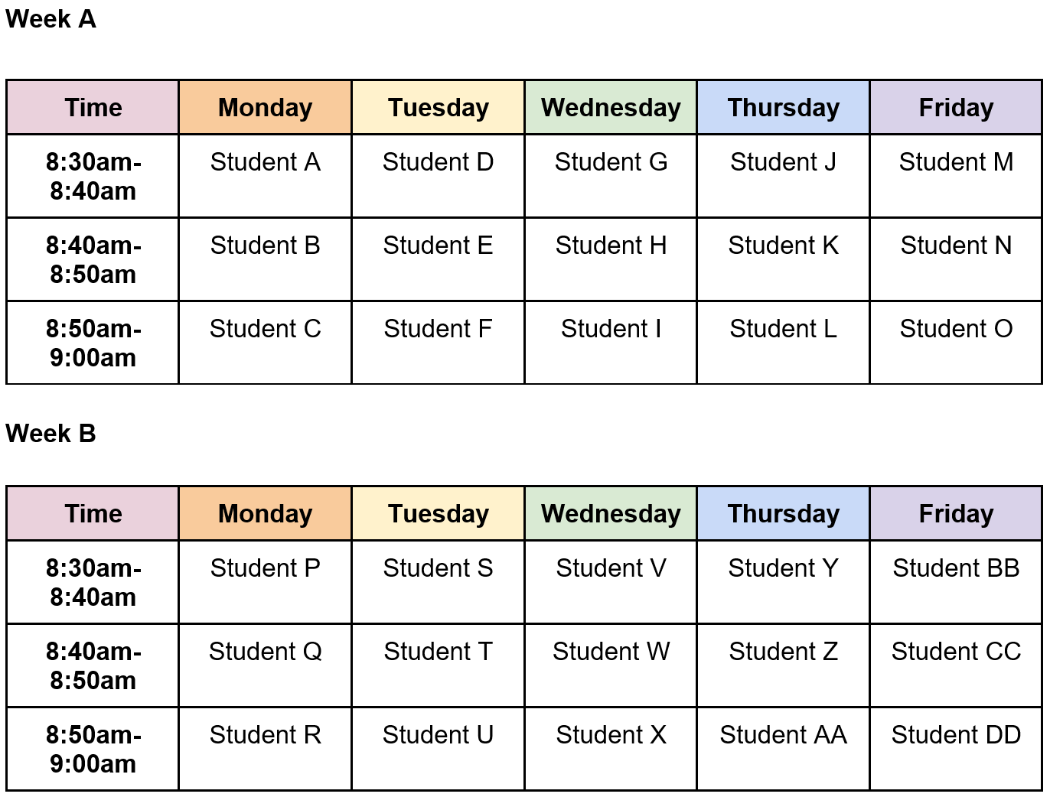
Figure 2: Sample mentor schedule

2. Looking after our neurodivergent students
‘I want the world to encourage and familiarise the idea of being neurodivergent, and stereotypical depictions of people with disabilities to start fading away.’ - Year 10 Student
Research findings:
As educators, we have a collective responsibility to ensure that every student has the ‘right to education’ and that ‘education shall be directed to the full development of the human personality and to the strengthening of respect for human rights and fundamental freedoms.’ (Article 26, United Nations Universal Declaration of Human Rights 1948). As Mrs Ilka Neunteufel (Associate Director at Easton Country Day School, USA) stated: ‘We want to meet every child where they are, not what grade they are.’
The organisation Children and Young People with Disability Australia states that ‘Every student deserves to feel included, supported, and able to thrive at school. But right now, too many students with disabilities are being left behind.’ In Australia, 25.7%, or 1,062,638 school students received an educational adjustment due to disability in 2024 (The Nationally Consistent Collection of Data on School Students with Disability 2024). According to ABS (2024), 68.9% Autistic people aged five to 20 years experienced difficulty at their place of learning. Some of the main difficulties reported were: fitting in socially (53.4%); communication difficulties (51.0%) and learning difficulties (44.1%).
Research shows that children with disabilities experience higher levels of psychological stress compared to peers without disabilities (Humphrey et al. 2013; Maxey and Beckert 2017; Mueller and Prout 2009). Below is a testimony from a Year 10 student who describes their experiences of being a teenager with diagnosed Autism and ADHD:
‘As a teen with AuDHD, its gifts come with great responsibility and challenges to overcome. A few people that I wanted to be friends with kept dismissing me as if I didn't understand anything. I have always felt like an outsider from the time I was conceived. I was, and always will be an outsider in society, as I live with a disability that triggers people in different ways, good or bad. I’ve always been the laughing stock as people peer pressured me to do things for their pleasure. I will not be naming names, but it sits there, on the back of my mind. I want the world to encourage and familiarise the idea of being neurodivergent, and stereotypical depictions of people with disabilities to start fading away.’
What could this look like in the school/ classroom environment?
School rules and policies need to be flexible for our neurodivergent students, as they are traditionally created for neurotypical students. Dr Rebecca Wood, a leading expert in creating neurodiversity-affirming environments in schools (University of Glasgow), emphasised during an in-person lecture the need for schools to provide silent spaces such as the library or a quiet room, access to green spaces and flexibility as every Autistic child is different.
Below are some strategies, collated from lectures, interviews with researchers and classroom observations that schools and teachers can use to promote positive mental health for our neurodivergent students:
- Every school should have a quiet space and a sensory room for our neurodivergent students.
- Every employee at a school should undergo annual mandatory training on supporting neurodivergent students in the same way we have mandatory child protection training.
- Neurodivergent students should be given the right to use headphones/earplugs when needed as noise is a significant factor contributing to negative mental wellbeing for neurodivergent children. Schools need to provide accommodations for neurodivergent students for events such as the athletics carnival and the swimming carnival.
- Lighting can also influence stress level, mood and concentration for neurodivergent students. At Easton Country Day School in Connecticut, some classrooms have warm, soft lighting to provide a sense of calmness and promote relaxation as it mirrors the warm comforting glow of a sunset.
- Teachers should provide regular brain breaks for all students including neurodivergent students. These will reduce anxiety, enhance cognitive function and calm moods.

3. Cultivating Purpose in Schools
‘Young people with a clear purpose in life tend to look better from a mental health perspective.’ - Dr Kendall Cotton Bronk, Claremont Graduate University
Research findings:
In one Stanford University research on the adolescent development of purpose (2003), Professor William Damon, Dr Jenny Menon and Dr Kendall Cotton Bronk defined purpose as ‘a stable and generalised intention to accomplish something that is at once meaningful to the self and of consequence to the world beyond the self.’ However, only about 20% of high school students in America report having a purpose in life (Bronk et al. 2010). Research indicates that adolescents with a meaningful purpose in life are psychologically healthier (Shek 1993) and purpose plays a crucial role in overcoming adversity (Bronk et al. 2010).
Dr Kendall Cotton Bronk is a world-renowned expert in adolescent moral development and purpose. During a face-to-face interview at the Quality of Life Research Centre at Claremont Graduate University, Dr Bronk outlined the correlation between purpose and adolescent wellbeing:
‘Young people with a clear purpose in life tend to look better from a mental health perspective. Purpose takes different shapes; it looks different in different cultures. But that need to live a meaningful life, that desire to contribute to the world beyond ourselves, that is a basic human need. When we find ways of doing it, we tend to thrive. Purpose is associated with hope, positive affect, and life satisfaction.’
What could this look like in the school/ classroom environment?
On the Adolescent Moral Development Lab website, there is a range of activities for both teachers and students where researchers at Claremont Graduate University have developed a number of ‘Fostering Purpose Toolkits’. Teachers may like to use these activities during a one-on-one mentor session with students or deliver these as part of a pastoral program over the course of one - two weeks.
Below are some activities that teachers can use in their own education settings:
- Students watch a short video on ‘Introduction to Purpose in Life’
- A reflection activity on helping students brainstorm what matters the most to them
- The best possible self magic wand activity on changing the world for the better
- An email activity helping students to find out what their purpose in life may be

4. How Reading for Pleasure Can Promote Wellbeing
‘Reflecting on your own reading experiences can support your wellbeing because it can remind you of things that have meant something to you in your life.’ - Professor Sarah McGeown, University of Edinburgh
Research findings:
Professor Sarah McGeown at the University of Edinburgh is a leading researcher on the correlation between reading and wellbeing across the lifespan. Many of her research projects explore the ‘wide range of rich and diverse positive experiences and outcomes associated with reading books but particularly fiction books’ (McGeown and Wilkinson 2021). In her Reading and Wellbeing Project (2022 - 2024), Professor McGeown and her researchers concluded that reading for pleasure can provide:
- Positive emotions: reading fiction can elicit emotions through characters and events, ‘even sad narratives can elicit emotions which readers report to be positive.’
- Connection: reading fiction can generate for the reader both connections with characters in the book and/or connections with others through discussions about their reading experiences.
- Personal growth: reading fiction develops empathy, improves our literacy and knowledge of the world around us.
In a face-to-face interview with Professor McGeown, she outlined the benefits of reading in improving readers’ eudemonic wellbeing as they are able to find ‘meaning in life and self-realisation. It allows them to realise one’s potential, a sense of autonomy and mastery in one’s life leading to feelings of personal growth.’
Katherine Wilkinson who is the Head of Research and Evaluation at the Scottish Book Trust, a charity that promotes reading, writing and literacy discussed the importance of organisations in partnering up with schools which help educators to promote a love of reading. In particular, their Reading Schools program focuses on building and sustaining a culture of reading in schools by promoting a love of reading within a community which in turn fosters positive connections.
At St Anne’s Primary School in Glasgow, Scotland, classroom assistant Lorraine McAdam (winner of The Scottish Book Trust’s Learning Professional Award 2024) and Literacy Coordinator Fiona Stevenson discussed the benefits of reading in promoting wellbeing. They said: ‘reading it’s not about sitting on a chair with a book at a table. That’s why we created, with the children, the lovely libraries that we have in this school. And the children can go to the libraries to read and relax.’ Every corner of their school is filled with a relaxing place for students to read. Additionally, Lorraine and Fiona outlined the benefits of reading in promoting connections between parents and their child as there is a parent library where they are able to come and borrow books and read with their child.
What could this look like in the school/ classroom environment?
- Every school should have a library where there is at least one space that students can read quietly.
- The look and feel of a reading space should be co-designed with students.
- Schools should be teaching students how to choose a book based on their interests and source these books for the students. The Scottish Book Trust offers a range of activities that help students choose books.
- Activities which promote the love of reading should be conducted throughout the year rather than ad-hoc events such as Book Week.
- Educators could upskill themselves on the wellbeing impact of reading. Professor Sarah McGeown’s inaugural lecture ‘The Power and Pleasures of Reading: How Books can Engage, Empower, and Enrich Us’ could be a starting point.
- Schools should have a book club where students are able to openly discuss their experiences with books and this is a space that fosters connections between teachers, students and potentially parents.

Conclusion
‘Growing up, I’ve noticed that a lot of my friends don’t really know how to talk about mental health or even approach the topic. It’s not that they don’t feel things, because everyone does, but they often don’t have the words, confidence or the space to say something like ‘I’m not okay’ or ‘I need help.’ - Year 11 Student
To truly transform the mental health landscape of Australian adolescence for the better, we need a village of support. At Kongshavn High School (Years 10-12) in Oslo, Ms Emilie Bjørnstadjordet who is the school’s social worker disclosed that part of her job is to seek out students who are alone at recess/lunch and provide them with the space to discuss their experiences and more importantly, try to connect them with social aspects of school because these students ‘just feel invisible.’ This Norwegian public high school has one social worker, three school counsellors and one school nurse who work together on promoting and maintaining students’ mental health.
Below are recommendations that schools and government bodies should consider in order to make a difference in the mental health of our youth:
- Every educator needs to be trained as a mental health first aider.
- There are many mental health programs, but we need an Australian curriculum on mental health and wellbeing in the same way we have one for Mathematics and English. Below (figure 3) is a survey result of 96 Year 10 students who have participated in a paid mental health program for the last two years and it is not working.
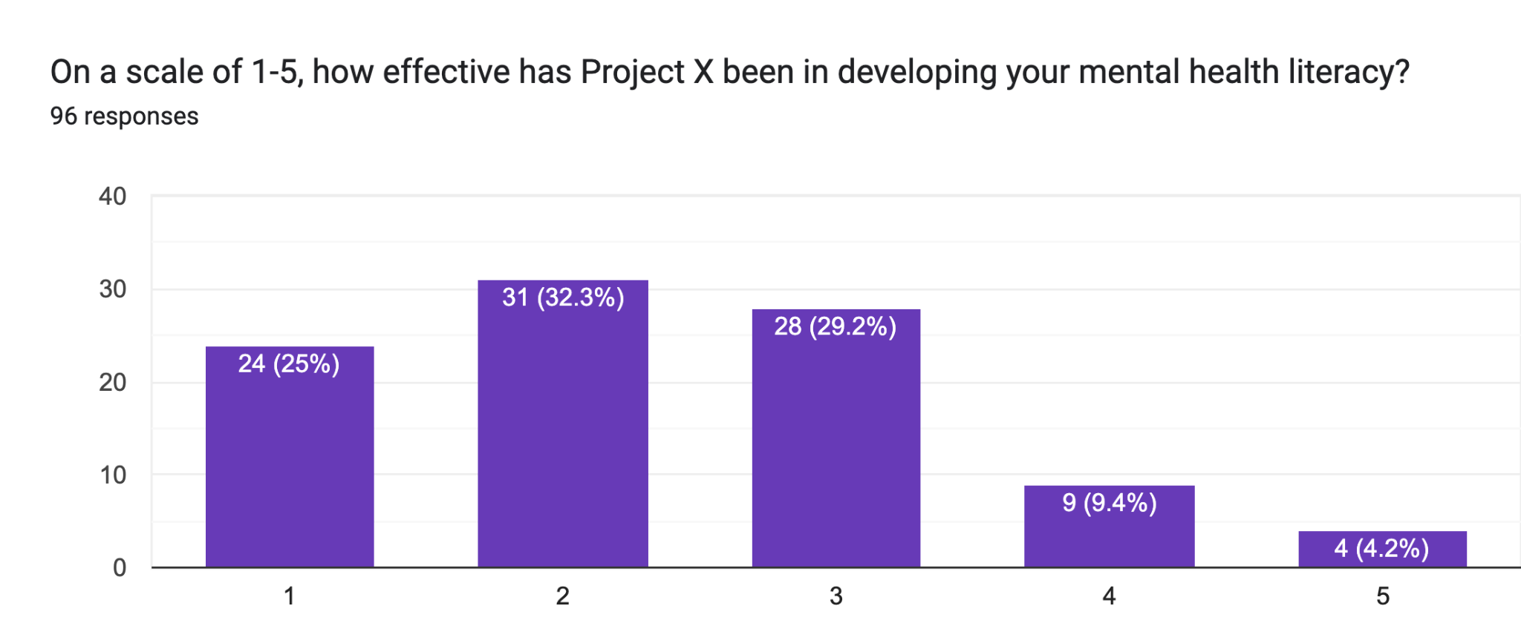
Figure 3: Survey results on how effective the mental health program has been for the last two years. 5 being extremely effective, 1 is not effective.
- Mental health literacy needs to be integrated into the students’ schedule. At Easton Country Day School in the USA, students have Upstream lessons every week, and at International School of Stavanger in Norway, Mrs Carol Wallace (Middle School Wellbeing Coordinator) oversees SEL lessons for students every fortnight. Every second Wednesday, parents are invited to learn about the SEL lesson that their child has been learning in the week before so that they can continue the practice at home.
- Every school should have a digital citizenship awareness program as high school counsellor Mrs Sophie Hillier (International School of Stavanger) discussed the ‘inappropriate and scary content’ that students are exposed to online which could be detrimental to their wellbeing.
- Every student should be taught the language of mental health as this can reduce the stigma surrounding mental health, generate greater understanding and promote inclusivity. As one Year 11 Australian student stated:
‘Growing up, I’ve noticed that a lot of my friends don’t really know how to talk about mental health or even approach the topic. It’s not that they don’t feel things, because everyone does, but they often don’t have the words, confidence or the space to say something like ‘I’m not okay’ or ‘I need help.’ Instead, they’ll laugh it off, change the subject, or act like everything’s fine, because that feels easier than admitting they’re struggling. I’ve seen this happen so many times, and it worries me, because people prefer to suffer in silence than reach out for help. That’s why I believe it’s so important to teach young people the language of mental health, including how to recognise when something’s wrong, and how to ask for support without feeling weak or embarrassed.’
Ongoing scholarship work will be shared through my Teach Us Wellbeing webpage.

Acknowledgements
I wish to thank and acknowledge the following people, schools and organisations:
- The Anika Foundation for their generous sponsorship
- The NSW Department of Education Premier’s Teacher Scholarships Team
- Dr Michelle Tye at Black Dog Institute
- Pauline Kotselas at NSW Department of Education - Child Wellbeing and Mental Health Services
- Ilka Neunteufel and her colleagues at Easton Country Day School, Connecticut, USA
- Dr Kendall Cotton Bronk at Claremont Graduate University, California, USA
- Jared Hales at Claremont Graduate University, California, USA
- Dr Sarah McGeown at the University of Edinburgh, Scotland
- Katherine Wilkinson at the Scottish Book Trust, Edinburgh, Scotland
- Lorraine McAdam and Mrs Fiona Stevenson at St Anne’s Primary School, Erskine, Scotland
- Sophie Hillier and her colleagues at International School of Stavanger
- Emilie Bjørnstadjordet at Kongshavn High School in Oslo, Norway
- My family, friends and colleagues who have supported me in many ways throughout this research project
- My students - past, present and future who continue to inspire me to be better every single day
- Silvana Rossetti, principal at Marist College Eastwood for always believing in me

References
ACARA 2024, School students with disability, www.acara.edu.au.
AIHW 2025, Prevalence and Impact of Mental Illness, Australian Institute of Health and Welfare.
Australian Bureau of Statistics 2024, Labour force status of families, Australian Bureau of Statistics.
Autism in Australia, 2022 2022, Australian Bureau of Statistics.
Black Dog Institute 2022, Turning the tide on depression A vision that starts with Australia’s youth.
Bronk, KC, Holmes Finch, W & Talib, TL 2010, ‘Purpose in life among high ability adolescents’, High Ability Studies, vol. 21, no. 2, pp. 133–145.
Cotton Bronk, K, Hill, PL, Lapsley, DK, Talib, TL & Finch, H 2009, ‘Purpose, hope, and life satisfaction in three age groups’, The Journal of Positive Psychology, vol. 4, no. 6, pp. 500–510.
CYDA 2023, Children and Young People with Disability Australia, cyda.org.au.
Damon, W, Menon, J & Cotton Bronk, K 2003, ‘The Development of Purpose During Adolescence’, Applied Developmental Science, vol. 7, no. 3, pp. 119–128.
Daniszewski, TD 2013, ‘Teachers’ Mental Health Literacy and Capacity towards Student Mental Health’.
Helliwell, JF, Layard, R, Sachs, JD, Aknin, LB, De Neve, JE, & Wang, S, 2023, ‘World Happiness Report 2023’.
Humphrey, N, Lendrum, A, Barlow, A, Wigelsworth, M & Squires, G 2013, ‘Achievement for All: Improving psychosocial outcomes for students with special educational needs and disabilities’, Research in Developmental Disabilities, vol. 34, no. 4, pp. 1210–1225.
McGeown, S & Wilkinson, K 2021, ‘Inspiring and sustaining reading for pleasure in children and young people: A guide for teachers and school leaders’.
Maxey, M & Beckert, TE 2016, ‘Adolescents with Disabilities’, Adolescent Research Review, vol. 2, no. 2, pp. 59–75.
Mueller, CE & Prout, HT 2009, ‘Psychosocial Adjustment of Adolescents and Young Adults With Intellectual Disabilities’, Journal of Mental Health Research in Intellectual Disabilities, vol. 2, no. 4, pp. 294–311.
NCCD 2020, Nationally consistent collection of data for school students with disability, NCCD.
Robinson, L & Matthews, C 2024, ‘Schools encouraged to start later as teens struggle with sleep deprivation - ABC News’, ABC News, 10 September.
Shek, DT 1993, ‘The Chinese purpose-in-life test and psychological well-being in Chinese college students’, International Forum for Logotherapy, vol. 16, no. 1, pp. 35–42.
United Nations 1948, Universal declaration of human rights, United Nations.

