
2025 Premier’s History Teachers’ Association History Scholarship

Resurrecting Ancient Rome
  - Exploring Latin inscriptions to illuminate the past
Suanne Knight
Ulladulla High School
Sponsored by the NSW History Teachers’ Association


Introduction
Latin inscriptions are more than just old words carved into stone; they are voices from the past. Unlike ancient literary texts written by elite Roman men, inscriptions can provide a message from everyday people: women, freedmen and freedwomen, and local officials. These brief but powerful messages were meant to be public and permanent. They help students understand not only what Roman society valued but also how ordinary individuals saw themselves and those they loved, as well as how they wanted to be remembered.
I spent five weeks travelling through Türkiye, Croatia and Italy to study these inscriptions in person. I visited archaeological sites, museums and necropoleis - photographing and analysing epigraphic evidence. While these have been analysed in academic circles, many of them have not been seen in the classroom. This report seeks to share my findings and reflects on how the inscriptions can directly support teaching of Ancient History in New South Wales. This tour was not only about gathering historical data, but it was also about finding new ways to connect students to the ancient world through real sources.
- Stage 4: The Ancient Roman World – Latin inscriptions from Italy, Türkiye and Croatia provide tangible evidence of Roman daily life, beliefs and social structures. These sources support students in developing historical skills such as source analysis and interpretation, aligning with outcomes like HT4-5 and HT4-6.
- Stage 6: Preliminary Ancient History – The study tour can enrich Investigating Ancient History by offering authentic examples of inscriptions as both archaeological and textual evidence. This supports students in understanding the nature of ancient history and the methods used to investigate the past, aligning with outcomes such as AH11-1 and AH11-6.
- Stage 6: HSC Ancient History – In the Core Study: Cities of Vesuvius – Pompeii and Herculaneum, inscriptions provide insights into the roles of women and freed persons, complementing archaeological findings. For electives like The Augustan Age and The Julio-Claudians, provincial inscriptions illustrate how social and political structures, roles of women and the place of freed persons adapted outside Rome, supporting outcomes such as AH12-2 and AH12-6.

Focus of Study
The focus of this project was to explore what Latin inscriptions, particularly funerary and dedicatory texts, can tell us about the lived experience of ordinary Romans in the provinces.
The sites I visited, including Hierapolis, Ephesus, Pergamon, Pula, Split, Zadar, Rome and Pompeii, were chosen for their rich epigraphic remains and diversity of Romanisation. At each location I photographed, transcribed, translated and sought to contextualise inscriptions, for the purpose of building a teaching archive of Latin epigraphic evidence. What makes these sources so compelling is their ability to bridge the divide between archaeological material and written texts. While I have collected hundreds of images of inscriptions covering a broad array of topics, for this report I have chosen to focus on three key themes: women, freed persons and expressions of local identity in the provinces.
The Turkish archaeological sites of Pergamon and Ephesus and the museum at Pamukkale offered a rich display of inscriptions and artefacts from different empires. The museum guide explained how each period, from the Bronze Age to the Roman and early Christian eras, left its mark on the region. It was interesting to see so many Greek inscriptions for Roman individuals, showing how local language and culture continued even under Roman rule. These sites made the layers of history in Anatolia feel real and connected.
In Croatia, I visited the archaeological sites at Pula, Zadar and Solona (Split). The archaeological museums in Zadar and Split were incredibly helpful, with clear explanations alongside the Latin inscriptions that made it easier to understand the people and social structures of Roman Dalmatia. Although the main archaeological museum in Split was closed, I was given access to the grounds around it, where many inscriptions and funerary stelae are stored while renovations are being completed. This unexpected opportunity provided a valuable hands-on look at how everyday Romans in the provinces commemorated life, death and identity.
It was a real privilege to return to Pompeii after ten years and witness the changes in site access and conservation. The ongoing excavations in Regions V and IX were particularly exciting, revealing new insights into the city’s layout and social life. Visiting the Naples Archaeological Museum was a highlight; many of the artefacts and frescoes on display, while still relevant, are the same ones used that have been used the Ancient History Cities of Vesuvius course for decades. Seeing them in person gave me a renewed appreciation for their value in the classroom, and I also discovered new inscriptions, sculptures and everyday objects I hadn’t seen before which I am keen to incorporate into future lessons and teaching materials.
While in Rome, I made the most of the museum collections, including the museum sites at the Baths of Diocletian and Palazzo Massimo. Each had something different to offer. The Baths of Diocletian gave me a real sense of the scale of public buildings and daily social life, while Palazzo Massimo had one of the most useful epigraphy sections I have seen, full of inscriptions that told personal stories about identity, status and family. These visits helped me see how objects and texts work together to bring ancient Roman life to the surface in ways students can really connect with.
I took part in the Oxford Latinitas immersion school in Rome to build confidence in spoken Latin and improve my ability to engage directly with Latin inscriptions. The program was held at Villa Palazzola, a former Benedictine monastery overlooking Lake Albano, and involved a full week of communicating only in Latin. As a beginner placed in the lowest fluency group, it was very challenging at first, but the use of gestures, repetition and clear phrasing helped me gradually follow along and improve. Mornings were spent learning language skills, while afternoons explored cultural topics like Roman hairstyles in literature and Latin songs, which made the language feel more alive. One of the highlights was a tour of Hadrian’s Villa entirely in Latin, it was a powerful way to connect language with place. Being surrounded by learners from all over the world, each committed to using Latin in everyday conversation, made the experience both supportive and inspiring. While I’m still a long way from fluency, this immersion was a big step forward in understanding how Latin functioned as a living language and gave me tools I can use when working with ancient inscriptions.

Significant Learning
Selecting just a few examples, to show how these inscriptions might be used in the classroom, from such a rich collection has been challenging. However, for each theme, I have provided examples of inscriptions - those that reflect the purpose of the study tour and the goal of developing meaningful, classroom-ready teaching resources.
Every effort has been made to accurately transcribe, translate and interpret the inscriptions featured in this report (and in the teaching materials being developed). Any errors or uncertainties in translation or interpretation are my own, reflecting both the difficulties of working with fragmentary or weathered inscriptions and my ongoing development in understanding the subtleties of Latin. Excerpts from Alison E. Cooley’s The Cambridge Manual of Latin Epigraphy was useful in helping me understand how Latin inscriptions functioned in the Roman world and how they might be made accessible for students. I’ve also included a Greek inscription, for which I sought guidance on transcription and translation, to highlight that in many parts of the Roman provinces (particularly in regions like modern-day Türkiye) ancient Greek remained a key language for expressing identity and commemoration.

1. Women and Social Visibility
Croatia offered a unique window into the past, where layers of Illyrian, Greek, Roman, Byzantine and Venetian influence can still be seen in its buildings, inscriptions and archaeological sites - showing how history in this region has built up over thousands of years. Roman women did not often get a say in the histories written by their male peers. But in funerary inscriptions, their voices and the voices of their families, come through strongly. Across the sites I visited, of the many, two inscriptions stood out for how they reveal the lives, status and values attached to women in provincial Roman society.
A dedication to Julia in Salona, Croatia
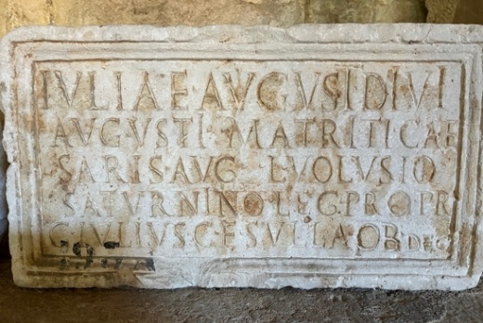
Figure 1: Juliae Inscription - Salona, Croatia
Inscription text:
IVLIAE AVGUSTI DIVI
AVGVSTI MATRICIAE
SARIS AVG LVOLVSIO
SATURNINO LEG PRO PR
C IVLIVS C ESVLLA OB DEC
Translation: ‘To Julia, daughter of the deified Augustus, mother of the Emperor; from Lucius Volusius, Augustalis of Saris, and Saturninus, imperial legate with pro praetorian authority. Gaius Julius Cesulla [set this up] by decree [of the council].’
This inscription from Salona, likely dating to the early Imperial period, provides a valuable example of how local elites in Roman provinces engaged with imperial power through public acts of commemoration. It honours “Julia, daughter of the deified Augustus, mother of the Emperor,” almost certainly referring to Julia the Elder, Augustus’ only biological child and a key figure in the Julio-Claudian dynasty.
The reference to her as mater Augusti (mother of the emperor) reflects the way elite women were celebrated not for holding office themselves, but for their symbolic importance in the imperial household. The inscription also names Lucius Volusius, described as an Augustalis (a member of the local imperial cult and most likely a freedman) from a place likely identified as Saris, and Saturninus, an imperial legatus pro praetore, suggesting the dedication was both religious and administrative in nature.
Finally, the dedication is attributed to Gaius Julius Cesulla, who set up the monument ob decreto “by decree”, likely of the local council, showing that this was an officially sanctioned civic act.
For students studying Roman provincial life, the role of imperial women, or the spread of the imperial cult, this inscription shows how figures like Julia the Elder were woven into the public and political fabric of cities far from Rome. It also highlights how provincial elites used dedications to express loyalty and elevate their status.
Fuficia Agre in Split, Croatia
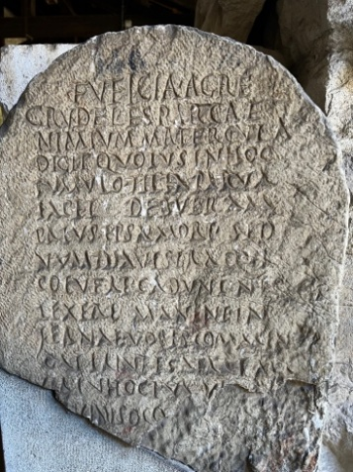
Figure 2: Fufica Agre inscription - Split, Croatia
Inscription text: Fuficia Agre / crudeles Parcae / nimium matercula / dicit quoius in hoc / tumulo filia parva / iacet debueram / prius ipsa mori sed / numina vestra qui / coluere cadunt neg / lexere manent in / fernae voces commen / do virtute satactam / circu hoc tumul(um) quae / cinis occu(litur)
Translation: “Fuficia Agre says: 'Cruel Fates, too cruel,' says the little mother, whose young daughter lies in this tomb. 'I ought to have died first, but those who have honoured your divinities fall; those who have neglected them remain. I entrust her, who strove with virtue, to your infernal voices. Around this tomb, she whose ashes are concealed.'"
This inscription, attributed to Fuficia Agre, offers an emotional glimpse into the personal grief of a Roman mother mourning the loss of her young daughter. The term matercula (little mother) conveys affection of the speaker. Her cry against the Crudeles Parcae (cruel Fates) reflects a common Roman motif where untimely death is attributed to the will of the Fates.
The mother's assertion that she "ought to have died first" underscores the natural expectation that parents outlive their children, and her subsequent reflection on the capriciousness of the gods - "those who have honoured your divinities fall; those who have neglected them remain" reveals her depth of grief. This sentiment provides valuable insight into the personal religious beliefs and practices of ordinary Romans, illustrating that piety did not always equate to divine protection. The phrase virtute satactam (she who strove with virtue) highlights the moral qualities attributed to the deceased child.
For students of the NSW Stage 6 Ancient History syllabus, particularly those studying "Death and Commemoration," this inscription serves as a compelling primary source. It illuminates the emotional depth of maternal bonds, the societal expectations of women in mourning, and the complexities of Roman religious beliefs surrounding death. Moreover, it exemplifies how personal grief was publicly expressed through funerary inscriptions, providing a tangible connection to the lived experiences of women in ancient Rome.
For NSW students, these sources open nuanced conversations about how ancient women were represented and remembered as well as how those representations varied across the empire.

2. Freed persons and Social Mobility
One of the most fascinating insights Latin inscriptions give us is how slaves, who had been manumitted, navigated their place in Roman society. Cooley emphasises the role of inscriptions in expressing identity, especially for freedmen and freedwomen. “Such individuals were particularly keen to celebrate their achievement in becoming Roman citizens. They could do this through the medium of their tombs and consequently are probably over-represented in the funerary record.” While literature often brushes past them or stereotypes their roles, the following couple of inscriptions show how manumitted individuals used writing on stone to declare their achievements and express gratitude. Mary Beard also notes the integration of freed persons into civic life: "Freedmen could become Augustales, members of a religious college that allowed them a role in public ceremonies and a degree of civic recognition."
For Stage 6 students, they provide powerful examples of social mobility, Roman naming practices, as well as the ways freedmen and freedwomen developed relationships with patrons, families and the community. These examples work particularly well for the Stage 6 Core Study (Cities of Vesuvius); The Augustan Age and The Julio-Claudian topics.
Quintus Tullius Primigenius (Zadar, Croatia)
This funerary cippus from Zadar commemorates Quintus Tullius Primigenius, honoured by Quintus Tullius Ausimus, who identifies himself in the inscription as “libertus et heres” - freedman and heir.
The naming pattern, with both men sharing the nomen Tullius, shows that Ausimus was manumitted by Primigenius and adopted his former master’s name, a typical practice for freedmen. That Ausimus was also named heres (heir) points to a strong bond, whether through loyalty, affection or legal necessity. In Roman law, freedmen could inherit if named in a will, particularly when no direct descendants were present.
The act of commissioning a monument like this one was both personal and performative - by recording his role as heir, Ausimus made his position publicly visible. This simple yet telling inscription offers students a clear example of how freedmen navigated Roman social customs, blending legal rights, emotional duty and public commemoration to assert identity and legacy.
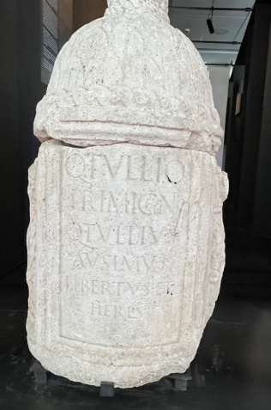
Figure 3: Quintus Tullius Inscription - Zadar, Croatia
Titus Fuficius (Split, Croatia)
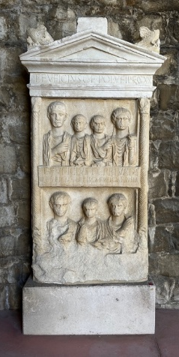
Figure 4: Titus Fuficius Inscription - Split, Croatia
Inscription text: Titus Fuficius Cai(i) filius Pollia veteranus legionis XX Titus Fuficius Titi libertus Privatus Fuficia Gai(ae) liberta Prisca Fuficia Titi liberta Prima
Translation: Titus Fuficius, son of Gaius, of the Pollia voting tribe, veteran of Legio XX. Titus Fuficius Privatus, freedman of Titus. Fuficia Prisca, freedwoman of Gaia, Fuficia Prima, freedwoman of Titus.
The funerary stele of the son of Gaius, Titus Fuficius, a veteran of Legio XX, offers a valuable glimpse into Roman social structure and the close relationships between patrons and those they had manumitted. Carved in stone and found at Salona, Croatia, the inscription names not only Titus Fuficius, but also his freedman Titus Fuficius Privatus, and two freedwomen - Fuficia Prisca, freed by Gaius, and Fuficia Prima, freed by Titus himself. While we can't say for certain whether all four individuals were deceased at the time the stele was erected, Roman funerary customs allow for several possibilities.
The freed persons may have commissioned the monument to honour their former master, a common act of gratitude and loyalty. Alternatively, they could all have been buried in the same tomb, or the stele may have simply recorded household connections and patronage ties for public display.
In Roman society, including freed persons on a stele like this signalled status and duty - reinforcing the veteran's role as head of a household and a man of standing. These kinds of inscriptions are particularly useful for historians because they preserve personal relationships often missing from literary sources and help build a fuller picture of life and identity in the Roman provinces.
The Epitaph of Pompeia Euhodia, Baths of Diocletian, Rome
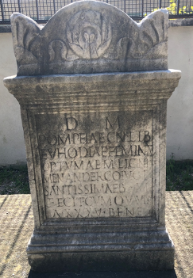
Figure 5: Pompeia Euhodia Inscription - Rome, Italy
Inscription text:
D M
POMPEIAE CN LIB EUHODIAE
FEMINAE OPTUMAE
M LICINI MENANDER CONIUGI
SANCTISSIMAE B M FECIT
CUM QUA VIXIT ANNIS XXXV
B F N E
Translation:
“To the spirits of the dead.
For Pompeia Euhodia, freedwoman of Gnaeus, an excellent woman.
Marcus Licinius Menander made [this] for his most virtuous wife,
of blessed memory,
with whom he lived for 35 years.
She lived well, she did no wrong.”
This funerary inscription commemorates Pompeia Euhodia, a freedwoman of Gnaeus, whose husband Marcus Licinius Menander honours her with a short but affectionate epitaph. Both the language and structure follow typical Roman funerary conventions among freed people, who often used inscriptions to assert dignity and moral virtue in the public eye. Menander’s name and the Greek origin of “Menander” suggest he too was likely a freedman, and their 35-year union may have begun shortly after manumission.
The affectionate phrasing – femina optumae, coniugi sanctissimae – combined with the rare formula B F N E (likely bene fecit, nihil egit or non egit), meaning “she did well, she did no wrong,” reflects a desire to present Euhodia as a model Roman wife. In a society where freed persons had to navigate their new status carefully, commemorations like this one offered a way to claim a respected identity, both socially and emotionally.
For students studying Roman society, this epitaph brings to life the experience of freedwomen, the importance of virtue in Roman funerary culture and how even those from non-elite backgrounds used stone and words to participate in the broader values of Roman life.

3. Local Identity and Imperial Power
While Roman imperial power was everywhere, from statues and temples to official titles, people in the provinces still found ways to express their own local identities. Visiting sites such as Troy, Pergamon, Ephesus and Pamukkale revealed how Anatolia holds deeply layered histories, with each civilisation building upon those before it. Long before the Greeks arrived, the region was home to powerful cultures like the Hittites and Luwians, evidence of which was found in the museums I visited in these locations. Later, Roman streets were laid over Hellenistic foundations, and Christian buildings reused earlier sacred spaces.
What struck me most was the number of inscriptions written in Greek for people with Roman names. Despite being part of the Roman Empire, Greek remained the main language of public life across much of Anatolia, showing how local culture endured and adapted under Roman rule. These inscriptions from provincial towns in Croatia and Türkiye give a clearer picture of how people blended Roman practices with their own cultural heritage and made clear links with imperial power. In the classroom, these examples support the Stage 6 syllabus focus on cultural interaction, Romanisation and the diversity of provincial life.
Dedication to Agrippa and Julia – Library of Celsus, Türkiye
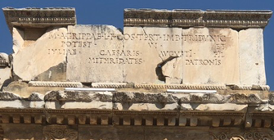
Figure 6: Agrippa and Julia Inscription - Ephesus, Turkiye
Inscription text: M. AGRIPPAE L. F. COS. TERT. IMB. TRIBUNIC. POTEST. ET IVLIAE CAESARIS AVGVSTI FIL. MITHRIDATES PATRONIS
Translation: “To Marcus Agrippa, son of Lucius, consul for the third time, and holder of tribunician power, and to Julia, daughter of Caesar Augustus - from Mithridates, to their patrons.”
This Latin inscription from the Library of Celsus in Ephesus offers an example of how Roman imperial power and local identity were closely connected in the provinces. Dedicated by Mithridates to “Marcus Agrippa, son of Lucius, consul for the third time, and holder of tribunician power, and to Julia, daughter of Caesar Augustus,” it reflects both political loyalty and personal ambition.
Mithridates, likely a local elite of Eastern origin, acknowledges Agrippa and Julia as his patronis, using the formal language of the patron-client relationship to publicly declare his alignment with the ruling dynasty. By including Julia, an imperial woman central to Augustus’ dynastic plans, the inscription highlights how women could also serve as political symbols, not just within Rome but across the empire.
For students studying ancient history, particularly the Augustan Age or Julio-Claudians, this inscription shows how monuments can serve as more than commemorative texts – they are also political tools that reveal how individuals in the provinces negotiated their identity and status within the structures of Roman power.
Bringing these examples into the classroom helps students see how culture, status and family all shaped how people wanted to be remembered, and how those choices still speak to us today.

4. Educational Applications
As a teacher of Ancient History, I am always looking for ways to make the ancient world more tangible and relatable for my students. Unlike textbook summaries or secondary interpretations, inscriptions are direct and deeply personal. They give students the chance to engage with primary evidence in a way that feels real.
For the Core Study: Cities of Vesuvius – Pompeii and Herculaneum, new inscriptions help students explore political life, economic activity, gender roles and religious beliefs. While inscriptions offer valuable insight into how emperors were honoured by provincial elites their greater significance lies in what they reveal about everyday lives and identities. Through brief yet powerful texts, students encounter women who served as religious leaders, patrons or dedicators, often challenging the limited portrayals found in elite literary sources.
Inscriptions also illuminate the lives of freed persons who used public monuments to assert status, gratitude and memory. Students see how those once enslaved could integrate into civic and religious life, shaping their legacy through deliberate self-representation. These perspectives enrich the study of topics like the Augustan Age or the Julio-Claudians and align with the NSW Stage 6 Ancient History syllabus by encouraging critical engagement with sources that challenge traditional narratives.
Even without having studied Latin, students can be provided with a key to translate inscriptions, explore naming conventions and reflect on how people used writing to define themselves. They can also engage in practical source evaluation – what is missing, what is personal?
I am also seeking to develop a digital resource hub for Ancient History teachers with annotated images, classroom prompts and ready-to-use tasks, directly linked to syllabus outcomes. Most importantly, these inscriptions give students a voice from the past that’s often overlooked, the people who were not emperors, generals or historians, but who still wanted to be remembered. That, to me, is where history becomes human - and where learning becomes lasting.

Conclusion
This study tour, and the ensuing analysis of the Latin inscriptions, has been one of the most professionally energising experiences of my teaching career. Travelling through Türkiye, Croatia and Italy to study the inscriptions in their local settings allowed me to connect deeply with ancient voices - voices that now inform how I teach, plan and support my students in uncovering the past. What stood out most was how inscriptions give us something textbooks often can’t: direct access to personal stories. These sources do not just support the content in the NSW Stage 6 Ancient History syllabus - they expand it and humanise it.

Acknowledgements
I am particularly grateful to the NSW Premier’s Teacher Scholarship Program and the History Teachers’ Association for making this study tour possible, and to Denise Mootz and Bernie Howitt for their generous sponsorship and valuable guidance. I also extend heartfelt thanks to my husband for his unwavering support throughout the journey. This collective support has not only granted me access to an extraordinary body of material, but also the opportunity to bring it back into NSW classrooms - to make history more vivid, inclusive and meaningful for our students.

References
Beard, M., 2008. Pompeii: The life of a Roman town. London: Profile Books.
Cooley, A.E. and Cooley, M.G.L., 2014. Pompeii and Herculaneum: A sourcebook. 2nd ed. London: Routledge.
Cooley, A.E., 2012. The Cambridge Manual of Latin Epigraphy. Cambridge: Cambridge University Press.
NSW Education Standards Authority (NESA), 2019. History Years 7–10 Syllabus. [online] Sydney: NESA. Available at: https://educationstandards.nsw.edu.au/wps/portal/nesa/k-10/learning-areas/hsie/history-years-7-10 [Accessed 2 July 2025].
NSW Education Standards Authority (NESA), 2017. Ancient History Stage 6 Syllabus. [online] Sydney: NESA. Available at: https://educationstandards.nsw.edu.au/wps/portal/nesa/11-12/stage-6-learning-areas/hsie/ancient-history [Accessed 2 July 2025].
Oxford Latinitas, 2025. Latin Immersion School – Rome. Oxford Latinitas. Available at: https://www.oxfordlatinitas.org/latin-immersion-trip-rome/ [Accessed 10 May 2025].
Woolf, G., 1994. Becoming Roman, staying Greek: Culture, identity and the civilizing process in the Roman East. Proceedings of the Cambridge Philological Society, 40, pp.116–143. Available at: http://www.jstor.org/stable/44712049 [Accessed 2 July 2025].

